Name of journal: World Journal of Gastroenterology
ESPS Manuscript NO: 26158
Manuscript Type: MINIREVIEWS

Hepatobiliary and pancreatic ascariasis

Khuroo MS et al. Biliary ascariasis

Mohammad S Khuroo, Ajaz A Rather, Naira S Khuroo, Mehnaaz S Khuroo

Mohammad S Khuroo, Department of Medicine, Sher-I-Kashmir Institute of Medical Sciences, Srinagar, Kashmir 190010, India

Mohammad S Khuroo, Digestive Diseases Centre, Dr. Khuroo’s medical Clinic, Srinagar, Kashmir 190010, India

Ajaz A Rather, Associate Professor and Head, Department of Surgery, SKIMS Medical College and Hospital, Bemina, Srinagar, Kashmir 190010, India

Naira S Khuroo, Consultant Radiology, Digestive Diseases Centre, Dr. Khuroo’s Medical Clinic, Srinagar, Kashmir 190010, India

Mehnaaz S Khuroo, Department of Pathology, Govt. Medical College, Srinagar, Kashmir 190001, India

Author contributions: All authors contributed equally; Rather AA, Khuroo MS and Khuroo NS made literature search; Khuroo NS conducted the radiological studies and critically reviewed the images; Khuroo MS and Khuroo NS wrote the paper; all authors read the paper and made necessary corrections.

Supported by Dr. Khuroo’s Medical Trust, a nonprofit organization which supports academic activities, disseminates medical education and helps poor patients for medical treatment.

Conflict-of-interest statement: The authors report no conflict of interest.

Open-Access: This article is an open-access article which was selected by an in-house editor and fully peer-reviewed by external reviewers. It is distributed in accordance with the Creative Commons Attribution Non Commercial (CC BY-NC 4.0) license, which permits others to distribute, remix, adapt, build upon this work non-commercially, and license their derivative works on different terms, provided the original work is properly cited and the use is non-commercial. See: http://creativecommons.org/licenses/by-nc/4.0/

Manuscript source: Invited manuscript

Correspondence to: Mohammad S Khuroo, Director, Digestive Diseases Centre, Dr. Khuroo’s Medical Clinic, Sector 1, SK Colony, Qamarwari, Srinagar, Kashmir 190010, India
Telephone: +91-194-2492398
Fax: +91-194-2491190

Received: March 29, 2016
Peer-review started: March 30, 2016
First decision: May 12, 2016
Revised: June 15, 2016
Accepted: July 20, 2016
Article in press:
Published online:

Abstract
Hepatobiliary and pancreatic ascariasis (HPA) was described as a clinical entity from Kashmir, India in 1985. HPA is caused by invasion and migration of nematode, Ascaris lumbricoides, in to the biliary tract and pancreatic duct. Patients present with biliary colic, cholangitis, cholecystitis, hepatic abscesses and acute pancreatitis. Ascarides traverse the ducts repeatedly, get trapped and die, leading to formation of hepatolithiasis. HPA is ubiquitous in endemic regions and in Kashmir, one such region, HPA is the etiological factor for 36.7%, 23%, 14.5% and 12.5% of all biliary diseases, acute pancreatitis, liver abscesses and biliary lithiasis respectively. Ultrasonography is an excellent diagnostic tool in visualizing worms in gut lumen and ductal system. The rational treatment for biliary ascariasis is to give appropriate treatment for clinical syndromes along with effective anthelmintic therapy. Endotherapy in HPA is indicated if patients continue to have symptoms on medical therapy or when worms do not move out of ductal lumen by 3 weeks or die within the ducts. The worms can be removed from the ductal system in most of the patients and such patients get regression of symptoms of hepatobiliary and pancreatic disease.

Key words: Ascaris lumbricoides; Cholecystitis; Cholangitis; Pancreatitis; Biliary calculi; Recurrent pyogenic cholangitis

© The Author(s) 2016. Published by Baishideng Publishing Group Inc. All rights reserved.

Core tip: Ascaris lumbricoides infects more than 1.4 billion people throughout the world. The impact of diseases caused by the parasite had been underestimated. Hepatobiliary and pancreatic ascariasis (HPA) as a clinical entity came in to limelight of late with developments in biliary imaging. Now the disease is recognized as major health problem in endemic regions of the world. However, clinicians all over the world need to be aware of HPA as the disease can be seen in nonendemic areas in migrant population. This article shall focus on the impact of HPA in healthcare in endemic zones and highlight the diagnosis and management options.

Khuroo NS, Rather AA, Khuroo NS, Khuroo MS. Hepatobiliary and pancreatic ascariasis. World J Gastroenterol 2016; In press

INTRODUCTION
Hepatobiliary and pancreatic ascariasis (HPA) is caused by entry of the nematode, Ascaris lumbricoides (A. lumbricoides), from the duodenum in to the biliary and pancreatic ductal lumen^{[1]}. Patient present with wide spectrum of symptoms biliary and pancreatic disease^{[2]}. On repeated invasion, worms often cannot come out of the ductal lumen and die. Subsequent to worm death, sludge and stones form within the bile and hepatic ducts and evolves in to clinical entity of recurrent pyogenic cholangitis^{[3,4]}.

HISTORICAL BACKGROUND
HPA as a clinical disease was described from Kashmir, India in 1985^{[1]}. Ascariasis is common infection in Kashmir, India. Around 70% population especially children are infected with this helminth^{[5]}. Surgeons of this region had encountered worms in the bile ducts rarely in their entire surgical practice and impact of this disease in the community had never been highlighted. The organism is highly motile and can move in and out of ducts over short periods and was not expected to be present in the ducts at surgery. With advancement in biliary endoscopy, we investigated the epidemiology of hepatobiliary and pancreatic disease caused by ascariasis in Kashmir, India. Over a 6-mo period, endoscopic retrograde cholangio-pancreatogrphies (ERCP) were performed in 160 patients presenting with upper abdominal pain to the emergency room of a tertiary care hospital^{[1]}. Thus, ascariasis was nearly as common as gall stones in causing biliary and pancreatic disease. The clinical features, radiological features and treatment outcome of these patients was evaluated^{[1]}. Originally we named this disease as “Biliary ascariasis”. Over the years, we appreciated that ascariasis, in addition to biliary disease causes pancreatic disease in a substantial percentage of patients^{[6]} and to include pancreatic component of the disease in definition, named it as HPA^{[7]}. We appreciated that ERCP had limitation as a diagnostic tool for HPA, as it was invasive and not available to primary care physicians in the community^{[8]}. To circumvent this, we established ultrasound as an excellent diagnostic modality^{[9,10]} We defined HPA as an important healthcare concern in this community and over a period of 9 years (1983 to 1989), identified 500 patients with HPA^{[2]} and 273 patients with hepatolithiasis^{[3]} (an aftermath of biliary ascariasis in this community) from a single center from Kashmir, India. We reported on the natural course of HPA^{[11]} and established the algorithm for management of this entity including role of biliary endotherapy^{[7,12-15]}.

ASCARIS LUMBRICOIDES
Morphology
Ascaris lumbricoides inhabits gastrointestinal tract of humans^{[16]}. The adult worm life is around 6 to 18 mo. The adult worm is long, elongated, cylindrical organism with sexual dimorphism. The dimensions of male ascaris are around 15-30 cm × 2-4 cm and female dimensions are 20-40 cm × 3-6 cm. The worm has outer chitinous layer forming the integument of the organism. They reveal strong motor activity through single layer of longitudinal muscle. The worm is devoid of circular muscle fiber layer. The body cavity contains all the viscera including alimentary canal, excretory system, nervous system and the reproductive system. Alimentary tract is a longitudinal canal and consists of mouth, pharyngeal cavity, esophagus, midgut, rectum and cloaca. Excretory system extends all along body as 2 linear streaks. The male and female genital organs are well developed in both sexes. The female releases an estimated 240000 eggs per worm per day. The egg may be fertilized or unfertilized. The fertilized egg (size: 30-40 × 40-60 µm) is ovoid, mamillated, and golden brown and shows evidence of embryonation. The unfertilized egg is elongated (88 to 95 × 44 µm) with thin shell, irregular outer surface and poorly differentiated retractable granules inside^{[17,18]}.

Life cycle
A. lumbricoides is a geohelminth and requires moist, shady soil for embryonation of the eggs. Normal habitat for the adult is the jejunum. Four stages in the life cycle include: embryonation, ingestion, larva migration and maturation (Figure 1). Ascaris eggs pass out with the feces. The fertilized eggs embryonate in around 2 wk’ time period and molt twice to transform to infective larvae. Eggs remain viable and infective in soil for 10 years. Infective larvae are ingested and start human infection. Eggs are dissolved in stomach by gastric juice and rhabdoid larva of 200 to 300 um are released. The larvae reach the caecum and penetrate across mucosa in to portal vein radicle and reach liver. Larvae again molt twice and considerably enlarge in size. They cross the hepatic sinusoids in to hepatic veins and right heart and reach lungs. Larvae penetrate in to alveoli and traverse along tracheobronchial mucosa to reach larynx, where they are swallowed. Larvae attain sexual maturity in upper small bowel and transform in to adult male and female ascarides. The time taken from ingestion to maturation is around 4 mo^{[5,16]}.

Global prevalence
Ascariasis is prevalent worldwide with an overall prevalence of 25%. An estimated 1.4 billion people are infected. Ascariasis is ubiquitous in the Indian subcontinent, China, African continent and Latin America. The prevalence in Japan has dropped over time and now is around 0.04% only. The infection is uncommon in large cities in Europe; however, some rural area have high prevalence. In USA, around 4 million people are infected and ascariasis is the third common helminth infection. Most of those infected are immigrant from developing countries^{[5,7]}.

Clinical disease
Majority of ascaris infections are asymptomatic^{[16]}. Clinical disease is restricted to small percentage of individuals with heavy worm-load (Table 1). Estimated 1.2 to 2 million cases of clinical disease occur per year with around 20000 deaths. Ascaris during pulmonary migration and maturation causes the syndrome of Ascaris pneumonia^{[19,20]}. It occurs 4 to 16 d after ingestion of the infective larvae and lasts for 2 to 3 wk. Patients present with seasonal frequent spasmodic cough and wheezing, shortness of breath, and retrosternal distress. Children may present with status asthmaticus, needing intensive care. Diagnosis is established by peripheral eosinophilia and presence of filariform larvae in sputum or gastric aspirate (Figure 2). Ascaris-induced intestinal obstruction is common occurrence in children in endemic areas^{[21-24]}. It is caused by aggregated worm mass blocking the bowel lumen. Massive worm aggregates may cause bowel infarction and gangrene, needing bowel resection (Figure 3). Peritoneal ascariasis occurs due migration of worms in to the peritoneum. In endemic areas worms may enter appendix lumen and cause appendicular colic, acute appendicitis and may lead to gangrene of appendix^{[25]}. Syndrome of gastric ascariasis occurs when worms migrate to stomach and esophagus^{[26]}. Gastric ascariasis causes unique dyspeptic symptoms which include worm-related pyloric obstruction, recurrent nocturnal chocking and retrosternal irritation. HPA is a common and well-described entity caused by ascariasis^{[5]}. Children in endemic area with heavy worm-load present with stunting of linear growth and defects in cognitive functions. Children may also show signs of malnutrition as a result of due to loss of nutrients by the worms^{[5]}.

HEPATOBILIARY AND PANCREATIC ASCARIASIS
Prevalence
HPA is a disease prevalent in endemic areas of world. Large series of patients have been published from several states of India including Kashmir^{[2]}, Kolkata^{[27]} and Assam^{[28]} and several other endemic countries namely Saudi Arabia^{[22,29]}, Syria^{[30]} , Philippines^{[31]} and South Africa^{[24,32-35]} . However,, HPA has not been reported from several regions of India. This is related to density of worm load in the community. HPA is restricted to population with high endemicty with high worm load in the population^{[5]}. Prevalence of HPA was estimated by ultrasound in urban population in Kashmir. Five (0.45%) of the 1104 subjects evaluated had evidence of Hepato-biliary and pancreatic ascariasis^{[36]} . The impact of HPA on healthcare in Kashmir, India is phenomenal. A. lumbricoides is the etiological factor for 36.7% of patients with hepatobiliary diseases^{[1]}, 23% of patients with acute pancreatitis^{[6]}, 14.5% patients with liver abscesses^{[37]} and 12.5% patients with biliary lithiasis^{[3]} (Figure 4).

Pathogenesis
Ascaris natural habitat is jejunum^{[16]}. HPA is initiated by proximal movement of the organisms in to duodenum (duodenal ascariasis). Heavy worm-load is the main factor for forward march of the ascarides (Figure 5)^{[5]}. They have a propensity to explore the orifices and in duodenum, the organism repeatedly enters in to and out of the orifice of ampulla of Vater. The adult worm blocks the ampullary orifice and obstructs both the bile and the pancreatic duct. In addition, the writhing movements of the worm excites marked sphincter spasm and dysmotility^{[38]} . Patient with duodenal ascariasis present with severe biliary colic^{[2]} (Figure 6). Some of these patients may present with acute pancreatitis^{[6]}. Ascarides often enter the bile duct and traverse up along the bile duct lumen (choledochal ascariasis). Ascarides placed in the bile duct lumen enter and obstruct the cystic duct orifice causing obstructive cholecystitis (Figure 7). The ascarides often move in to intrahepatic ducts (hepatic ascariasis). Left ductal system is more often reached than right ductal system. While in hepatic ducts, worms lead to various grades of acute cholangitis. A proportion of such patients present with suppurative cholangitis, septicemia and septic shock and need intensive care management and urgent endotherapy to decompress biliary tract^{[2]} (Figure 8). Less often ascarides enter the gall bladder (gall bladder ascariasis) and such patients present with biliary pain and cholecystitis^{[10]}. Rarely ascarides may enter pancreatic duct (pancreatic ascariasis) (Figure 9). Patients with pancreatic ascariasis often present with severe necrotizing pancreatitis, which may be fatal^{[6,39,40]}.
Ascarides make repeated traverses in to and out of the ductal lumen, as long as they are alive. Ascaris mobility within the ducts is maintained usually till 10 d on serial ultrasound examinations and have a chance to move out of ducts. Often, the ascarides get trapped inside the bile ducts, die and become the nidus and source of biliary sludge and brown pigment biliary calculi (Figure 10)^{[4,41-43]}. Gallbladder is often spared of the stone formation. The stones in the hepatic ducts are related to number of reasons. Dead worm fragments and ascaris ova form a nidus and ideal sites for stone formation. The enteric organisms usually Escherichia coli which enter the bile ducts have high beta glucoronidase activity which deconjugate bile pigments. Ascarides in the bile ducts lead to impaired drainage, stasis and formation of biliary sludge and stones. In addition, ascaris invasion causes papillary edema and Sphinter of Oddi motor dysfunction which in turn leads to impaired biliary drainage^{[38]}. Malnutrition with low protein intake lowers glucaro 1, 4 lactone, a natural inhibitor of glucoronidase, levels in bile in such patients and accelerates stone formation^{[4,41]}.

Clinical profile
HPA is a disease of adults (men age 35 years with age range 4 to 70 years) with female predominance (female: male ratio 3:1)^{[1,2]}. Ascariasis is more often prevalent in children, however, HPA is seen less often in children^{[13]}. This may be due to smaller size of the ampullary orifice. HPA is seen commonly seen in pregnant women, possibly due to hormone-induced relaxation and dilatation of ampullary orifice, making it easier for ascarides to enter the ducts. On the same analogy, worms in pregnant women reach gall bladder more often than in non-pregnant population^{[44-46]}. Biliary surgery/interventions namely cholecystectomy, choledocholithotomy, sphincteroplasty, and endoscopic sphincterotomy performed for gallstone disease predisposes patient to ductal invasion by ascarides^{[11,31,47]}. These procedures cause widened ampullary orifice and lead to easier passage of worms into the bile ducts.
HPA can cause five distinct clinical presentations including^{[2]} (Table 1): (1) Biliary colic: Biliary colic presents as sudden severe pain right hypochondrium associated with nausea and vomiting. Vomitus often contains adult live worm and points to occurrence of migration of worms in to duodenum and stomach. The pain may be recurrent in nature or prolonged demanding large doses of narcotic analgesics. Such patients do not develop fever and jaundice to suggest cholangitis. In most patients, ascarides are located in the duodenum and enter in and out ampulla of Vater (duodenal ascariasis) (Figure 5); (2) Acute cholangitis: The patients present with right hypochondrium pain, chills and fever, icterus, hepatomegaly, high white cell count and elevated liver tests including bilirubin, transaminases and alkaline phosphatase^{[48]}. A subset of such patients develop suppurative cholangitis and develop systemic sepsis with low blood pressure and acidosis. ERCP shows multiple ascarides in the intrahepatic ducts (Hepatic ascariasis). At duodenoscopy, pus is seen coming out of the ampullary orifice and pus can be aspirated out of the ductal lumen (Figure 8); (3) Acalculous cholecystitis: The patients present with pain of in the right upper quadrant and chills and fever. The pain is referred to right shoulder and scapular region. Fever is low grade in nature. Abdominal examination reveals tender right hypochondrium with a tender mass and rebound tenderness and guarding. Ultrasound reveals distended, thick-walled gallbladder, filled with sludge^{[10,49]}. In most patient’s ascarides are placed in the bile ducts (Choledochal ascariasis) and block cystic duct orifice, leading to cystic duct dilatation and gallbladder distension (Figure 7). Occasionally worms may traverse the cystic duct lumen and manage to enter the gallbladder (Gallbladder ascariasis). Most of these patients respond to treatment without complications. However, some patients may present with gangrenous cholecystitis needing urgent cholecystectomy; (4) Hepatic abscess: Patients with hepatic abscesses develop right hypochondrium, high fever, point tenderness in one intercostal space and edema of the right lateral chest wall^{[37]} . Ascarides are placed in the intrahepatic ducts in most of such patients. Pus from the abscess often reveals ova of ascaris and /or fragments of dead ascarides; (5) Acute pancreatitis: The patients present with epigastric pain referred to the back, vomiting, and raised serum amylase and alkaline phosphatase. Pancreatitis may be obstructive in nature by ascarides in the ampullary orifice or may be severe necrotizing type due worms entering the pancreatic duct. Ninety percent of patients had mild edematous pancreatitis and 10% develop necrotizing pancreatitis^{[39,50,51]}. A subset of patients with worms in the pancreas develop hemorrhagic pancreatitis, which may be fatal (Figure 9)^{[40]}; and (6) Recurrent pyogenic cholangitis: Recurrent pyogenic cholangitis is manifested by biliary tract infection and formation of sludge and stones in the hepatic ducts^{[3]}. In addition, intrahepatic bile ducts develop strictures, excessive branching and arrowhead formation. There are secondary changes in the hepatic parenchyma which include formation of microabscesses, atrophy of liver secondary to chronic biliary obstruction and biliary cirrhosis with progressive end stage liver disease. Recurrent pyogenic cholangitis in Kashmir is an aftermath of repeated worm invasion of bile and hepatic ducts^{[4,11]}. Several pathogenic mechanisms play part in formation of brown pigment stones^{[38]}. Patients develop attacks of pain right upper quadrant with shaking chills and high grade fever and jaundice. Patients may develop septicemia with septic shock. Disease is usually progressive and if untreated, ends up in advanced liver disease.

Natural course
Long-term follow-up of 500 patients with HPA revealed that majority of the patients (54.8%) have duodenal ascariasis and in such patients, ascarides only invade the ampulla of Vater leaving the ducts free of organisms^{[2]}. Ascarides persist within the ductal lumen in a small percentage (2.4%) of patients, while in remaining patients (42.2%) worms move out of ducts within 10 d’ follow-up. Ductal reinvasion was observed in 15.4% of patients. Over a 2-year period, seven patients (1.4%) had developed intrahepatic brown pigment stones. None of patients had common bile duct, gallbladder or pancreatic duct calculi. Histopathological analysis of stones revealed segments of adult ascaris forming nidus of the stones.

Diagnosis
Laboratory tests ae not useful in the diagnosis of HPA. However, estimations of blood counts, liver and kidney function tests and serum amylase do help in evaluating the pattern and severity of hepatobiliary and pancreatic disease. Identification of ascaris eggs in the stool has little diagnostic value in endemic areas, as prevalence of ascariasis in such regions may vary from 30% to 90%.
Diagnosis of HPA can be made by ultrasonography, duodenoscopy and ERCP^{[8-10]}. Of late, MRI and MRCP can help in diagnosis of HPA and may replace ERCP if therapeutic procedure is not envisaged (Figure 11)^{[52-54]}.
Ultrasound biliary imaging is a useful to visualize ascarides in stomach, the duodenal lumen, biliary tree, pancreatic ducts and gall bladder (Figure 12) (Table 2)^{[55]}. Ultrasound also depicts changes secondary to worm invasion including cholecystitis, hepatic abscesses, and pancreatitis. Ascarides in stomach and duodenum are well visualized in water filled lumen as actively motile linear or curved structures. The alimentary canal of the parasite is shown as anechoic tubular structure. In one study from Kashmir, worms were visualized in all the 22 patients with multiple duodenal and gastric ascariasis^{[26]}. However, ultrasound has limitation in detecting single worm in the duodenal lumen and invading the ampullary orifice^{[2]}. Ascarides in the bile duct lumen show characteristic sonographic appearances^{[56-58]}. The bile ducts are often dilated and gallbladder may be distended with wall edema and sludge within the lumen. The worm is seen as thick, long, linear or curved, non-shadowing echogenic structure/’s (four-line sign) devoid of acoustic shadowing, often with anechoic tubular structure, which represents the alimentary canal of the worm^{[59]}. Ascarides in the bile ducts show characteristic writhing movement and these can be well appreciated on real time ultrasound examination. Ascarides in the bile ducts need to be differentiated from bile duct stones which are visualized as high level echogenic structures throwing acoustic after shadowing. The stones lack characteristic writhing mobility in the ducts, however, may can change position within bile ducts with change in the body posture. When compared with ERCP, ultrasound identified ascarides in the bile ducts in 24 (92.3%) of the 26 patients of choledochal ascariasis. Sonography detected ascarides within the bile duct in all 20 patients with 2 or more than 2 worms in the duct and in 4 of the 6 patients with single worm in the duct. In 2 patients with single worm in the bile duct ultrasound findings were reported as normal. Ultrasound was false positive in another 2 patients with biliary obstruction and sludge in the bile ducts^{[9]}. Ultrasonography was accurate in evaluating exit of worms from the ducts in all patients who showed sonographic appearances of HPA. The ascarides in the gallbladder are seen on ultrasound as long, curved and coiled up echogenic structures and their fast, dancing movements are well seen on real time ultrasound examination^{[60]}. Gallbladder is markedly distended with wall edema and sludge within the lumen. Ultrasonography is accurate to detect ascarides in the gallbladder. We visualized ascarides in all 13 such patients within gallbladder lumen. In contrast ERCP had limitation in detecting worms in the gallbladder^{[10]}. Serial ultrasound examination accurately determined the exit of worms from gallbladder lumen. Thus real time ultrasound has advantages over ERCP in this condition, may it be diagnosis or follow up. Pancreatic ascariasis reveals edematous pancreas and ascardies may be visualized within pancreatic ductal lumen. However, ultrasound has limitation in diagnosis of pancreatic ascariasis and picked up worms in the pancreatic duct in only 2 of the seven patients with pancreatic ascariasis. In contrast ERCP has distinct advantage as ascarides can be accurately picked up in the duodenal lumen as well as in the pancreatic ducts^{[7]}.
On ERCP, the worms in the dilated bile or pancreatic ducts cause filling defects which have smooth, long and liner characteristics. In addition to above, ascarides may cause a variety of defects namely curved or forming loops^{[8]}. Duodenoscopy often reveals ascarides in the duodenum invading the ampullary orifice. Till late, ERCP has been the investigation of choice for diagnosis of HPA. However, it has several limitations. The procedure is invasive, not available in peripheral health centers in developing countries and difficult to perform on multiple occasions to evaluate worm exit form ducts. Thus ultrasonography should be the initial investigation in diagnosis and follow up of patients with of HPA. ERCP should be employed in selected cases of HPA. ERCP is often needed in patients with duodenal ascariasis, as a single worm in the duodenum and entering in and out of ampullary orifice and causing severe biliary colic may not be visible on ultrasonography. Once the worm is visualized on duodenoscopy, the worm can be extracted to give immediate relief of pain and it is not necessary to fill the ductal system. ERCP is also needed in cases where ultrasound fails to show characteristic worm appearances or is normal in cases with high clinical suspicion. In addition, ERCP has distinct advantages in diagnosis of pancreatic ascariasis as ultrasound has low diagnostic pick up in such patients.

Treatment
The treatment for HPA is to treat various clinical syndromes by appropriate means and administration of anthelmintic drugs. The ascarides once paralyzed are usually expelled out by peristaltic activity of the gut^{[2,15]} . A number of anthelmintic drugs have been developed to effectively manage ascariasis. Anthelmictic drugs which are very effective include pyrantel pamoate, mebendazole, albendazole and ivermectin^{[5]}. Administering anthelmintic directly in to the bile ducts is not advised as it can impede movement of live worms out of the ducts^{[12,13]}. Endotherapy should be performed in case patient’s symptoms do not subside on intensive medical treatment and/or ascrides fail to move out of the ductal lumen up to 3 wk of follow up. Patients with suppurative cholangitis often need emergency ERCP and emergency nasobiliary drainage as a first line procedure (Figure 13). Endoscopic removal of live and dead ascarides from ampullary orifice or ductal system is needed in case of severe symptomatic disease or when ascarides are dead within the ductal system (Figure 14). The worms can be removed from the ductal system in most of the patients and such patients get regression of symptoms of hepatobiliary and pancreatic

Control
Control of ascariasis is possible by improving sanitation combined with health education and personal hygiene. Drugs namely pyrantel pamoate, mebendazole, albendazole and ivermectin are safe and effective and can be used for mass chemotherapy. However, several factors jeopardize the fight against this pathogen including cultural taboos, poor resources and financial problems, and huge biotic potential of the pathogen.

REFERENCES
1 Khuroo MS, Zargar SA. Biliary ascariasis. A common cause of biliary and pancreatic disease in an endemic area. Gastroenterology 1985; 88: 418-423 [PMID: 3965331]
2 Khuroo MS, Zargar SA, Mahajan R. Hepatobiliary and pancreatic ascariasis in India. Lancet 1990; 335: 1503-1506 [PMID: 1972440]
3 Khuroo MS, Dar MY, Yattoo GN, Khan BA, Boda MI, Zargar SA, Javid G, Allai MS. Serial cholangiographic appearances in recurrent pyogenic cholangitis. Gastrointest Endosc 1993; 39: 674-679 [PMID: 8224691]
4 Khuroo MS, Khuroo NS, Khuroo MS. Biliary ascariasis in the etiology of recurrent pyogenic cholangitis in an endemic area. International Journal of Hepatobiliary and Pancreatic Diseases 2015; 5: 22 [DOI: 10.5348/ijhpd-2015-30-OA-5]
5 Khuroo MS. Ascariasis. Gastroenterol Clin North Am 1996; 25: 553-577 [PMID: 8863040]
6 Khuroo MS, Zargar SA, Yattoo GN, Koul P, Khan BA, Dar MY, Alai MS. Ascaris-induced acute pancreatitis. Br J Surg 1992; 79: 1335-1338 [PMID: 1486433]
7 Khuroo MS. Hepatobiliary and pancreatic ascariasis. Indian J Gastroenterol 2001; 20 Suppl 1: C28-C32 [PMID: 11293175]
8 Bhushan B, Watal G, Mahajan R, Khuroo MS. Endoscopic retrograde cholangiopancreaticographic features of pancreaticobiliary ascariasis. Gastrointest Radiol 1988; 13: 327-330 [PMID: 3169480]
9 Khuroo MS, Zargar SA, Mahajan R, Bhat RL, Javid G. Sonographic appearances in biliary ascariasis. Gastroenterology 1987; 93: 267-272 [PMID: 3297910]
10 Khuroo MS, Zargar SA, Yattoo GN, Dar MY, Javid G, Khan BA, Boda MI, Mahajan R. Sonographic findings in gallbladder ascariasis. J Clin Ultrasound 1992; 20: 587-591 [PMID: 1331185]
11 Khuroo MS, Mahajan R, Zargar SA, Pathania AGS, Javid G. Biliary and Pancreatic Ascariasis: A Long Term Follow-Up. National Medical Journal of India 1989; 2: 4-7
12 Zargar SA, Khuroo MS. Treatment of biliary ascariasis and its rationale. Gastroenterology 1987; 93: 668-669 [PMID: 3609672]
13 Zargar SA, Khuroo MS. Management of biliary ascariasis in children. Indian J Gastroenterol 1990; 9: 321 [PMID: 2258221]
14 Zargar SA. Management of biliary ascariasis. Am J Gastroenterol 1998; 93: 2001-2002 [PMID: 9772084 DOI: 10.1111/j.1572-0241.1998.02001.x]
15 Khuroo MS, Zargar SA, Yattoo GN, Javid G, Dar MY, Boda MI, Khan BA. Worm extraction and biliary drainage in hepatobiliary and pancreatic ascariasis. Gastrointest Endosc 1993; 39: 680-685 [PMID: 8224692]
16 Pawlowski ZS. Ascariasis. In: Warren KS, Mehmoud AF, editor. Tropical and Geographical Medicine. 2nd ed. New York: McGrew-Hill, 1990: 369
17 Sun T. Ascariasis. In: Sun T, editor Pathology and clinical features of parasitic diseases New York Masson 1980: 115-120
18 Pawlowski ZS. Ascariasis: host-pathogen biology. Rev Infect Dis 1982; 4: 806-814 [PMID: 6812197]
19 Gelpi AP, Mustafa A. Seasonal pneumonitis with eosinophilia. A study of larval ascariasis in Saudi Arabs. Am J Trop Med Hyg 1967; 16: 646-657 [PMID: 4861323]
20 Gelpi AP, Mustafa A. Ascaris pneumonia. Am J Med 1968; 44: 377-389 [PMID: 5641301]
21 Pinus J. Surgical complications of ascariasis. Prog Pediatr Surg 1982; 15: 79-86 [PMID: 7146450]
22 al-Karawi M, Sanai FM, Yasawy MI, Mohammed AE. Biliary strictures and cholangitis secondary to ascariasis: endoscopic management. Gastrointest Endosc 1999; 50: 695-697 [PMID: 10536331]
23 Pandit SK, Zarger HU. Surgical ascariasis in children in Kashmir. Trop Doct 1997; 27: 13-14 [PMID: 9030012]
24 Louw JH. Abdominal complications of Ascaris lumbricoides infestation in children. Br J Surg 1966; 53: 510-521 [PMID: 5936979]
25 Ochoa B. Surgical complications of ascariasis. World J Surg 1991; 15: 222-227 [PMID: 2031358]
26 Khuroo NS, Khuroo MS, Khuroo MS. Gastric ascariasis presenting as unique dyspeptic symptoms in an endemic area. Am J Gastroenterol 2010; 105: 1675-1677 [PMID: 20606670 DOI: 10.1038/ajg.2010.112]
27 Mukhopadhyay M. Biliary Ascariasis in the Indian Subcontinent: A study of 42 cases. Saudi J Gastroenterol 2009; 15: 121-124 [PMID: 19568577 DOI: 10.4103/1319-3767.48970]
28 Das AK. Hepatic and Biliary Ascariasis. J Global Inf Dis 2014; 6: 65-72 [PMID: 24926166 DOI: 10.4103/0974-777X.132042]
29 Jessen K, Al Mofleh I, Al Mofarreh M. Endoscopic treatment of ascariasis causing acute obstructive cholangitis. Hepatogastroenterology 1986; 33: 275-277 [PMID: 3542773]
30 Sandouk F, Haffar S, Zada MM, Graham DY, Anand BS. Pancreatic-biliary ascariasis: experience of 300 cases. Am J Gastroenterol 1997; 92: 2264-2267 [PMID: 9399767]
31 Leung JW, Chung SC. Endoscopic management of biliary ascariasis. Gastrointest Endosc 1988; 34: 318-320 [PMID: 3410242]
32 Schulman A. Ultrasound appearances of intra- and extrahepatic biliary ascariasis. Abdom Imaging 1998; 23: 60-66 [PMID: 9437065]
33 Schulman A. Intrahepatic biliary stones: imaging features and a possible relationship with ascaris lumbricoides. Clin Radiol 1993; 47: 325-332 [PMID: 8508594]
34 Schulman A. Non-western patterns of biliary stones and the role of ascariasis. Radiology 1987; 162: 425-430 [PMID: 3541030 DOI: 10.1148/radiology.162.2.3541030]
35 Louw JH. Biliary ascariasis in childhood. S Afr J Surg 1974; 12: 219-225 [PMID: 4445929]
36 Khuroo MS, Mahajan R, Zargar SA, Javid G, Sapru S. Prevalence of biliary tract disease in India: a sonographic study in adult population in Kashmir. Gut 1989; 30: 201-205 [PMID: 2649414]
37 Javid G, Wani NA, Gulzar GM, Khan BA, Shah AH, Shah OJ, Khan M. Ascaris-induced liver abscess. World J Surg 1999; 23: 1191-1194 [PMID: 10501884]
38 Khuroo MS, Zargar SA, Yattoo GN, Allai MS, Khan BA, Dar MY, Boda MI, Javid G. Oddi's sphincter motor activity in patients with recurrent pyogenic cholangitis. Hepatology 1993; 17: 53-58 [PMID: 8423041]
39 Wani NA, Bazaz MR, Ahmed MI, Peer GQ. Biliary ascariasis with worm-induced pancreatitis. J Indian Med Assoc 1990; 88: 320-321 [PMID: 2086666]
40 Maddern GJ, Dennison AR, Blumgart LH. Fatal ascaris pancreatitis: an uncommon problem in the west. Gut 1992; 33: 402-403 [PMID: 1568664]
41 Leung JW, Yu AS. Hepatolithiasis and biliary parasites. Baillieres Clin Gastroenterol 1997; 11: 681-706 [PMID: 9512805]
42 Shrivastava UK, Jain N. Biliary stones and ascariasis--our experience. Indian J Physiol Pharmacol 2002; 46: 252-254 [PMID: 12500504]
43 Schulman A. Intrahepatic biliary stones in South Africa. S Afr Med J 1994; 84: 52 [PMID: 8197508]
44 Shah OJ, Robanni I, Khan F, Zargar SA, Javid G. Management of biliary ascariasis in pregnancy. World J Surg 2005; 29: 1294-1298 [PMID: 16142431 DOI: 10.1007/s00268-005-0015-z]
45 Asrat T, Rogers N. Acute pancreatitis caused by biliary ascaris in pregnancy. J Perinatol 1995; 15: 330-332 [PMID: 8558344]
46 Alper F, Kantarci M, Bozkurt M, Ozturk G, Onbas O, Balik AA. Acute biliary obstruction caused by biliary ascaris in pregnancy: MR cholangiography findings. Clin Radiol 2003; 58: 896-898 [PMID: 14581017]
47 Shah OJ, Dar MA, Wani NA, Robbani I, Zargar SA. Biliary ascariasis as a cause of post-cholecystectomy syndrome in an endemic area. Dig Surg 2004; 21: 108-13; discussion 113 [PMID: 15024175 DOI: 10.1159/000077334]
48 Khuroo MS, Mahajan R, Zargar SA, Javid G, Banday M. Endoscopic vs surgical drainage of biliary tract in acute pyogenic cholangitis: a controlled study. Indian J Gastroenterol 1989; 8: 119 [PMID: 2707842]
49 Mani S, Merchant H, Sachdev R, Rananavare R, Cunha N. Sonographic evaluation of biliary ascariasis. Australas Radiol 1997; 41: 204-206 [PMID: 9153828]
50 Shad JA, Lee YR. Pancreatitis due to Ascaris lumbricoides: second occurrence after 2 years. South Med J 2001; 94: 78-80 [PMID: 11213951]
51 Tortajada-Laureiro L, Olveira-Martín A, Marín-Serrano E, Ruiz-Fernández G, Eun JH, Segura-Cabral JM. Biliary parasite (Ascaris) as a cause of acute pancreatitis. Ultrasound diagnosis. Rev Esp Enferm Dig 2012; 104: 389-390 [PMID: 22849505]
52 Adaletli I, Selçuk D, Gülşen M, Savaş C, Korman U. MRCP findings of biliary ascariasis before and after medical treatment. Turk J Gastroenterol 2005; 16: 98-101 [PMID: 16252201]
53 Arya PK, Kukreti R, Arya M, Gupta SN. Magnetic resonace appearance of gall bladder ascariasis. Indian J Med Sci 2005; 59: 208-210 [PMID: 15985729]
54 Ding ZX, Yuan JH, Chong V, Zhao DJ, Chen FH, Li YM. 3 T MR cholangiopancreatography appearances of biliary ascariasis. Clin Radiol 2011; 66: 275-277 [PMID: 21295208 DOI: 10.1016/j.crad.2010.11.004]
55 Ferreyra NP, Cerri GG. Ascariasis of the alimentary tract, liver, pancreas and biliary system: its diagnosis by ultrasonography. Hepatogastroenterology 1998; 45: 932-937 [PMID: 9755984]
56 Al Absi M, Qais AM, Al Katta M, Gafour M, Al-Wadan AH. Biliary ascariasis: the value of ultrasound in the diagnosis and management. Ann Saudi Med 2007; 27: 161-165 [PMID: 17568166]
57 Ali M, Khan AN. Sonography of hepatobiliary ascariasis. J Clin Ultrasound 1996; 24: 235-241 [PMID: 8723511 DOI: 10.1002/(SICI)1097-0096(199606)24: 5<235: : AID-JCU2>3.0.CO; 2-F]
58 Aslam M, Doré SP, Verbanck JJ, De Soete CJ, Ghillebert GG. Ultrasonographic diagnosis of hepatobiliary ascariasis. J Ultrasound Med 1993; 12: 573-576 [PMID: 8246335]
59 Goyal A, Gamanagatti S, Sriram J. Tube within tube: Ascaris in bowel and biliary-tract. Am J Trop Med Hyg 2010; 83: 962 [PMID: 21036820 DOI: 10.4269/ajtmh.2010.10-0358]
60 Gomez NA, Leon CJ, Ortiz O. Ultrasound in the diagnosis of roundworms in gallbladder and common bile duct. Report of four cases. Surg Endosc 1993; 7: 339-342 [PMID: 8351609]
P-Reviewer: Chauhan V, Yoon JH S-Editor: Yu J L-Editor: E-Editor:

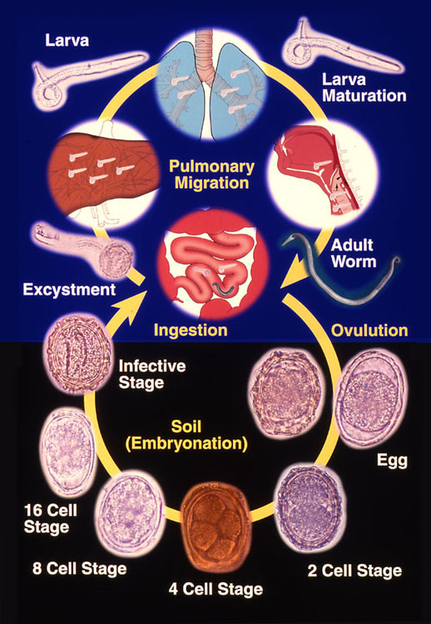
Figure 1 Life cycle of Ascaris lumbricoides. Adapted from khuroo et al^{[5]}.

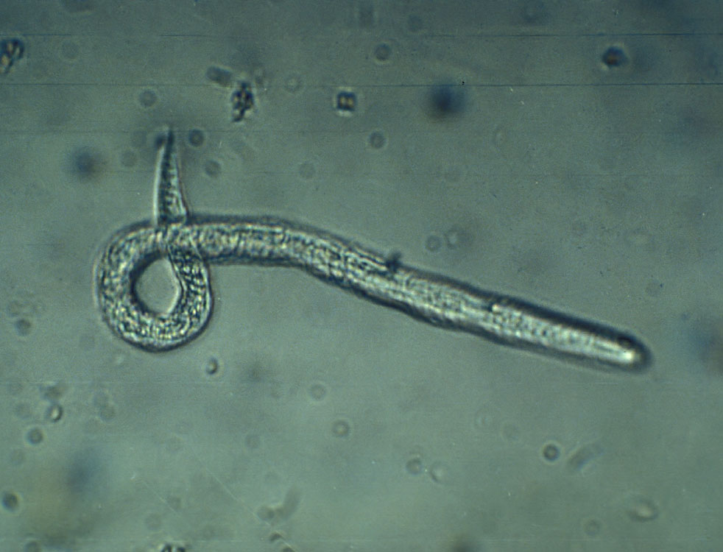
Figure 2 Sputum examination of a child with ascaris pneumonia showing filariform larva.

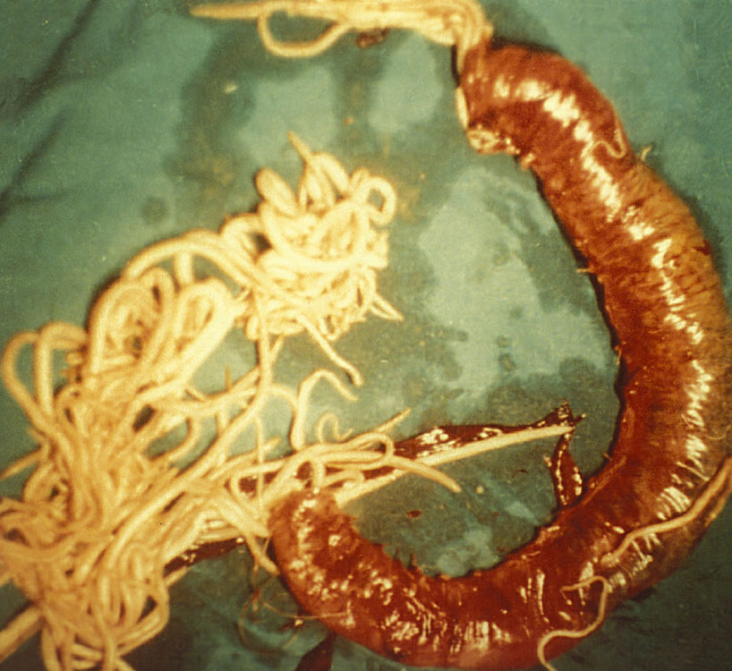
Figure 3 Massive aggregate of ascarides within jejunum causing obstruction, infarction and gangrene of bowel necessitating bowel resection.

Figure 4 The impact of hepatobiliary and pancreatic ascariasis as an etiologic factor in biliary disease, hepatic abscesses, biliary lithiasis and acute pancreatitis. Numbers in parenthesis shows number of patients with disease and percentages are those caused by ascariasis.

Figure 5 Duodenal ascariasis presenting as biliary colic. A: Duodenoscopy showing adult ascaride in the ampullary orifice; B: Endoscopic retrograde cholangiogram showing long linear filling defect in the common bile duct; C: cholangiogram after extraction of worms from bile duct. Patient had immediate relief of biliary colic.

Figure 6 Choledochus ascariasis blocking orifice of cystic duct, causing acute obstructive cholecystitis, needing emergency cholecystectomy. A: Endoscopic retrograde cholangiogram showing linear filling defect in common bile duct (black arrows). Cystic duct and gall bladder is grossly dilated (white arrows); B: Gall bladder showing inflamed gall bladder with 2 adult ascarides and few stones around macerated dead worm.

Figure 7 Hepatic ascariasis presenting as suppurative cholangitis. A: Endoscopic retrograde cholangiogram showing palisading of ascarides in common bile ducts and hepatic ducts; B: Duodenoscopic view showing pus exuding from ampullary orifice.

Figure 8 Pancreatic ascariasis presenting as necrotizing pancreatitis. A linear filling defect is seen all along the pancreatic duct (straight arrows). A stricture is seen in the tail region (curved arrow) reminiscent of pancreatic necrosis.

Figure 9 Recurrent pyogenic cholangitis aftermath of biliary ascariasis. A: Endoscopic retrograde cholangiogram obtained 5 years prior to present admission revealing two long linear smooth filling defect in the common and left hepatic duct (arrows); B: Cholangiogram performed during present admission. Cholangiogram revealed biliary dilatation with multiple filling defects and cholangitic changes in the common hepatic, right and left hepatic duct. Naso-biliary tube is in place to treat pyogenic cholangitis.

Figure 9 Ultrasonography images in hepatobiliary and pancreatic ascariasis. A: Biliary ultrasound depicting four-line sign; B: Ultrasound showing tube like structure within common bile duct with distended gall bladder; C: Ascarides in gall bladder showing active movements as seen in serial images.

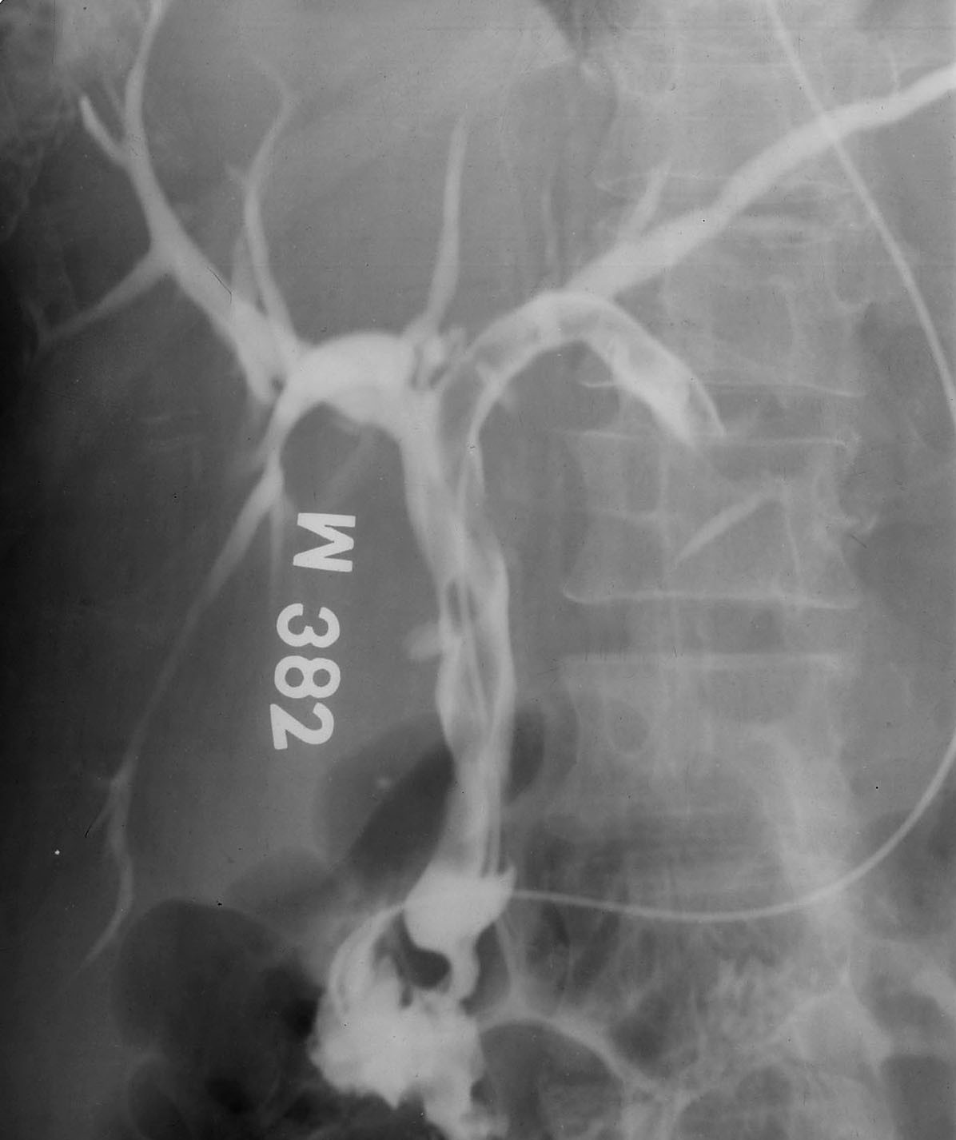
Figure 10 Hepatic ascariasis presenting as suppurative cholangitis managed with nasobiliary tube drainage. Note ascaride placed in common bile duct and left hepatic duct. Nasobiliary tube is in place to decompress and drain the duct.

Figure 11 Endotherapy in hepatobiliary ascariasis. A: Cholangiogram showing dilated ducts multiple linear filling defects; B: Dead ascaride extracted from biliary tract; C: Cholangiogram obtained after extraction of dead ascaris. Ducts are free of filling defects.

Table 1 Clinical syndromes related to ascariasis in endemic areas
Disease classification | Pathogenesis | Clinical syndromes
Ascaris pneumonia | Larval migration in lungs | Self-limiting pneumonia
 |  | Status asthmaticus needing ICU admission
Intestinal Obstruction | Ascarides aggregation in small bowel lumen | Intestinal obstruction, bowel infarction and gangrene
Appendicular ascariasis | Ascaris blocking appendix orifice | Appendicular colic, appendicitis, appendicular gangrene
Peritoneal ascariasis | Ascaride-related gut perforation | Peritonitis, septic shock
Gastric ascariasis | Ascarides in stomach and esophagus | Pyloric obstruction (Ascaris in antrum and blocking pylorus)
 |  | Nocturnal chocking (Ascaris traversing in to gullet at night)
 |  | Unique retrosternal itching (ascarides in fundus and lower esophagus)
Hepatobiliary and pancreatic ascariasis | Duodenal ascariasis invading ampullary orifice | Biliary colic (duodenal ascariasis)
 |  | Acute cholangitis (hepatic ascariasis); massive worm load can cause septic cholangitis and shock
 |  | Acalculous cholecystitis (choledochal or gall bladder ascariasis); ascarides in gall bladder may cause gall bladder gangrene
 |  | Hepatic abscess (hepatic ascariasis)
 |  | Acute pancreatitis (duodenal ascariasis or pancreatic ascariasis); ascaride in pancreatic duct can cause necrotizing pancreatitis
 |  | Hepatolithiasis (Dead ascarides in hepatic ducts forming nidus of sludge/stones)
Stunting of growth, cognitive dysfunction and malnutrition | High ascaride load in children | -

Table 2 Ultrasonography findings of hepatobiliary and pancreatic ascariasis
Site of ascarides | Ultrasonography findings
Stomach and duodenum | Long linear or curved echogenic strips without acoustic shadowing within water filled duodenum and stomach. The structures show active motility.
Hepatobiliary ascariasis | Single or multiple long linear or curved echogenic structures without acoustic shadowing
 | Thick long linear or curve non-shadowing echogenic strip containing a central longitudinal anechoic tube (four-line sign), representing the digestive tract of the worm
 | Characteristic writhing movement of the echogenic strips within the ducts
 | Gall bladder and cystic duct distension; gall bladder wall edema; sludge within gall bladder
 | Multiple liver abscesses
Gall bladder ascariasis | Long coiled echogenic structure within gall bladder lumen
 | Tubular echogenic structures within gall bladder lumen
 | Echogenic structures exhibiting rapid movements
 | Distended gall bladder, gall bladder wall edema
Pancreatic ascariasis | Long linear nonshadowing echogenic strips within a dilated pancreatic duct
 | Edematous pancreas

