Name of Journal: World Journal of Clinical Cases
Manuscript NO: 52231
Manuscript Type: CASE REPORT

Irreversible electroporation for liver metastasis from pancreatic cancer: A case report

Ma YY et al. IRE for liver metastasis

Yang-Yang Ma, Juan-Juan Shi, Ji-Bing Chen, Ke-Chen Xu, Li-Zhi Niu

Yang-Yang Ma, Ji-Bing Chen, Central Laboratory, Fuda Cancer Hospital, Jinan University, Guangzhou 510665, Guangdong Province, China

Juan-Juan Shi, Ke-Chen Xu, Li-Zhi Niu, Department of Oncology, Fuda Cancer Hospital, Jinan University, Guangzhou 510665, Guangdong Province, China

Author contributions: Niu LZ and Xu KC designed the research; Shi JJ and Niu LZ performed the research; Chen JB analyzed the data; Ma YY wrote the paper.

Corresponding author: Li-Zhi Niu, MD, PhD, Chief Physician, Department of Oncology, Fuda Cancer Hospital, Jinan University, No. 2, Tangde Road, Tianhe District, Guangzhou 510665, Guangdong Province, China. niuboshi@fudahospital.com

Received: October 24, 2019
Revised: December 23, 2019
Accepted: January 2, 2020
Published online: January 26, 2020

Abstract
BACKGROUND
Pancreatic cancer has a poor prognosis; 40%–50% of patients have liver metastases at the time of initial diagnosis and only 15%–20% undergo surgical resection. Irreversible electroporation (IRE) is a new, non-thermal local ablation method for solid tumors, which can induce cell membrane permeabilization, resulting in unrecoverable nanoscale perforation and apoptotic cell death without damaging the structural components of tissues.

CASE SUMMARY
We report the case of a 66-year-old female patient with liver metastasis from pancreatic cancer with a pathological diagnosis of poorly differentiated adenocarcinoma. Carbohydrate antigen 19-9 was elevated to 420.3 U/mL. Computed tomography showed a pancreas mass of 2.7 cm × 2.5 cm and single liver metastasis of 1.4 cm × 1.1 cm in the S6 area. The patient underwent IRE and arterial infusion chemotherapy and received tegafur. The therapeutic effect of the combination treatment has been evaluated as complete response. To date, the patient has survived for >12 mo and is receiving tegafur as maintenance therapy (at the time this case report was written).

CONCLUSION
IRE plus arterial infusion chemotherapy and tegafur may be synergistic, providing a reference for treating liver metastasis from pancreatic cancer.

Key words: Irreversible electroporation; Liver metastasis from pancreatic cancer; Chemotherapy; Complete response; Case report

Citation: Ma YY, Shi JJ, Chen JB, Xu KC, Niu LZ. Irreversible electroporation for liver metastasis from pancreatic cancer: A case report. World J Clin Cases 2020; 8(2): 390-397
URL: https://www.wjgnet.com/2307-8960/full/v8/i2/390.htm
DOI: https://dx.doi.org/10.12998/wjcc.v8.i2.390

Core tip: In this study, we report the case of a 66-year-old female patient with liver metastasis from pancreatic cancer who underwent irreversible electroporation and chemotherapy and showed a complete response after the combination therapy. Our findings suggest that irreversible electroporation plus arterial infusion chemotherapy and tegafur may be synergistic, providing a reference for treating liver metastasis from pancreatic cancer.

INTRODUCTION
Pancreatic cancer is one of the most aggressive cancers and has a poor prognosis. The 5-year survival rate is <8%, and the prognosis is extremely poor. Pancreatic cancer is known as the “king of cancers”. At the initial diagnosis, only 15%–20% of patients are resectable^{[1]}. Up to 80%–90% of patients lose their opportunity for surgery due to local invasion or distant metastasis^{[2,3]}. Up to 50% of patients have distant metastasis at the initial diagnosis, where liver metastasis is the most common (40%–50%)^{[4]}. The median survival time of patients with untreated, unresectable locally advanced or distant metastatic pancreatic cancer is only 2–6 mo^{[5]}. A study by Johns Hopkins University found that even by strict screening, the median survival time of patients with periampullary carcinoma with simultaneous liver metastases was only 5.9 mo, compared with 14.2 mo in patients without metastases^{[6]}.
As only a few patients with pancreatic cancer are eligible for surgery, and most patients have limited response to combination chemotherapy and radiation therapy, some ablation therapies have been examined as adjuvant or independent treatments. Radiofrequency ablation and microwave thermal ablation are the most commonly used ablation methods. Irreversible electroporation (IRE) is a non-thermal effect–based physical ablation method. Its principle is mainly causing irreversible electroporation of the tumor cell membrane by transient, high-frequency, and repeated high-voltage pulse to the tumor cells to achieve the purpose of ablation^{[7-9]}. Recently, a prospective study showed that the median overall survival (OS) from diagnosis in patients with pancreatic cancer treated with IRE combined with chemotherapy was extended to 20.3 mo (stage III) and 13.56 mo (stage IV); the results suggested that IRE combined with chemotherapy can prolong survival time^{[10]}.
Tegafur is an oral fluoropyrimidine derivative designed to improve the anti-tumor activity of 5-fluorouracil while reducing its gastrointestinal toxicity. Recently, studies investigating tegafur have indicated that it has a better clinical curative effect for advanced pancreatic cancer. Many high-quality clinical trials have investigated the therapeutic efficacy and safety of tegafur combined with multiple chemotherapeutic agents^{[11-13]}.
Here, we report the case of a 66-year-old female patient with liver metastasis from pancreatic cancer who underwent IRE and chemotherapy and showed a complete response (CR) after the combination therapy.

CASE PRESENTATION
Chief complaints
A 66-year-old female patient had pain under the xiphoid. Abdominal B ultrasound revealed a pancreatic space–occupying lesion; further abdominal computed tomography (CT) and magnetic resonance imaging examination were performed to determine the position. Liver metastasis was disclosed, and the tumor markers carbohydrate antigen (CA) 12-5 and CA19-9 were significantly increased; pancreatic cancer was considered. There was no indication for surgery at the local hospital. At our hospital, she was diagnosed with a pancreatic space-occupying lesion for investigation. She had a body mass index of 24.61 kg/m² (body weight, 63.5 kg; height, 160 cm) and was a nonsmoker.

History of present illness
Nothing to declare.

History of past illness
Twenty years ago, she underwent cholecystectomy for gallstones, and underwent appendectomy 10 years ago for acute appendicitis.

Personal and family history
Her mother had died of gallbladder cancer.

Laboratory examinations
Tumor marker screening showed elevated levels of CA12-5 (15.85 U/mL) and CA19-9 (420.3 U/mL). Immunohistochemistry demonstrated cytokeratin 7(+) and cytokeratin 19(+). Based on the clinical and immunohistochemical results, the lesions were consistent with poorly differentiated adenocarcinoma of the pancreas (Figure 1).

Imaging examinations
During this hospitalization, a CT scan revealed a nodular mass in the pancreas measuring about 2.7 cm × 2.5 cm (Figure 2A) and a small, nodular low-density lesion in the liver S6 measuring about 1.4 cm × 1.1 cm (Figure 3A). The lesion appeared non-homogeneous after enhancement, with mild reinforcement. Adjacent to the splenic artery, the proper hepatic artery and abdominal cavity were locally compressed. The tail of the pancreas was atrophied. No obvious effusion was seen in the abdominal cavity.

FINAL DIAGNOSIS
Liver metastasis from pancreatic cancer.

TREATMENT
Percutaneous IRE ablation was performed under general anesthesia, two electrodes were used during the operation, the needle tip distance was 1.0 to 2.0 cm, and the effective exposure distance of the electrodes was 1.5 to 2.0 cm. CT combined with ultrasound was used to confirm tumor size, and the parameters for IRE ablation were electric field intensity 1500 V/cm, pulse length 70 μs, and pulse number 90. During the operation, the success of the ablation was determined based on the hyperechoic coverage and real-time impedance changes in the ablation lesion. Gemcitabine intravenous chemotherapy was administered, followed by gemcitabine arterial infusion and simultaneous tegafur for a total of four cycles. Table 1 shows the method of administration.

OUTCOME AND FOLLOW-UP
After 12 mo of IRE ablation combined with gemcitabine and tegafur, the patient’s serum tumor markers were measured: CA19-9 was 48.48 U/mL and CA12-5 was 16.09 U/mL; during treatment, her serum CA19-9 level decreased to within normal levels (Figure 4). Her liver enzymes were measured: Alanine aminotransferase (ALT) was 538 U/mL and aspartate aminotransferase (AST) was 452 U/mL, demonstrating elevation at the time of blood collection on postoperative day 1, and peaked within 24 h (Figure 5). The ALT and AST levels returned to baseline on day 9 and day 20. After 12 mo of follow-up, a CT scan showed complete disappearance of the pancreatic mass (Figure 2), and significantly marked shrinkage of the liver mass (Figure 3). The patient had a CR according to the Response Evaluation Criteria in Solid Tumors 1.1, and partial response according to the Solid tumor diagnostic criteria 1.1^{[14]}. In addition, there were no severe adverse reactions during treatment.

DISCUSSION
We report the case of a 66-year-old female patient with liver metastasis from pancreatic cancer who underwent synchronous IRE ablation of liver and pancreatic lesions combined with gemcitabine arterial infusion chemotherapy and oral tegafur. The treatment relieved the abdominal pain effectively, shrank the pancreatic mass entirely, and reduced the size of the liver mass, with markedly reduced serum CA19-9 (48.18 U/mL) and CA125 (16.09 U/mL). In addition, her serum ALT and AST levels were significantly increased on post-intervention day 1; however, the elevated levels decreased rapidly. She showed a prolonged survival and good health 12 mo after IRE. This indicates that the treatment did not affect liver function and that both of the combined therapies were safe for liver metastasis from pancreatic cancer.
Liver metastasis from pancreatic cancer is a systemic disease and patients have a poor prognosis and short lifespan. The overall 5-year relative survival rate for pancreatic cancer is 7.6%, and is 29.3% for localized disease but only 2.6% for distant metastasis^{[15]}. The liver is the most common location for metastatic lesions of pancreatic cancer, as cancer cells can cross the portal artery or abdominal cavity endolymphatic pathway and metastasize to the liver^{[16]}. Therefore, systemic treatment is needed. Unfortunately, most patients would have lost the opportunity for surgical resection at the time of diagnosis. Therefore, managing the symptoms and improving the quality of life and survival are critical for these patients^{[16]}. IRE ablation has been widely used for treating pancreatic cancer and liver cancer because it is minimally invasive and has a good curative effect^{[17,18]}. Hong et al^{[19]} reported seven patients with pancreatic cancer metastasis after IRE treatment, three of whom had single liver metastasis with a lifespan of up to 16 mo. IRE treatment of Child-Pugh B (7/8) hepatocellular carcinoma resulted in equivalent ablation success, with improved liver tolerance compared with microwave ablation and other ablative modalities^{[20]}.
IRE is an emerging physical ablation technique. IRE does not produce a heat sink effect and retains the functions of blood vessels, bile ducts, and nerves located in the ablation area. Unfortunately, these patients with pancreatic cancer have lost their chance of surgical resection. In patients with metastatic pancreatic cancer, gemcitabine-based chemotherapy is the main treatment. Therefore, for this patient, managing symptoms and improving quality of life and survival are critical.
In recent years, with the deepening of research on transcatheter arteriovenous infusion chemotherapy drugs, the effective concentration of local drugs in tumor lesions has increased, and drug concentrations in the systemic blood system have decreased because of adverse reactions. Percutaneous transarterial infusion chemotherapy can inhibit tumor growth through local high-concentration chemotherapy drugs. In patients with metastatic pancreatic cancer, gemcitabine-based chemotherapy is the main treatment; in the present study, we used IRE to treat the patient with stage Ⅵ pancreatic cancer. Martin et al^{[21]} recommend using induction gemcitabine- or FOLFIRINOX (oxaliplatin, irinotecan, 5-fluorouracil, and leucovorin)-based chemotherapy, depending on the patient’s age and performance status, for at least 3–4 mo (three cycles of gemcitabine or 4–6 cycles of FOLFIRINOX). Although the required duration of adjuvant chemotherapy remains unclear, given the physical condition of our patient, we decided to administer four chemotherapy cycles after local IRE treatment.
A recent analysis based on randomized trials in Asia showed that gemcitabine in combination with tegafur significantly prolonged OS in patients with advanced or metastatic pancreatic cancer^{[22]}. The results suggest that tegafur can be the first-line treatment for metastatic pancreatic cancer in Asian populations. The Chinese Society of Clinical Oncology Pancreatic Cancer Expert Committee has reached a consensus to include tegafur monotherapy and tegafur combined with gemcitabine regimen in the selection of first-line treatment options for advanced pancreatic cancer. However, the program may be used only in Asian populations; the efficacy of tegafur needs further testing.
Here, our patient received IRE combined with gemcitabine and tegafur. To our surprise, she was evaluated as having CR after four cycles of treatment and has survived for 12 mo after treatment. Meanwhile, no serious clinical adverse reactions occurred.

CONCLUSION
The combination of IRE with gemcitabine and tegafur may be a viable option for treating metastatic pancreatic cancer, with acceptable adverse effects. However, large prospective studies should be carried out to clarify the efficiency, safety, and OS benefit.

ACKNOWLEDGEMENTS
The authors thank the patient for participating in the study and for agreeing to the publication of this report.

REFERENCES
1 Yeo TP. Demographics, epidemiology, and inheritance of pancreatic ductal adenocarcinoma. Semin Oncol 2015; 42: 8-18 [PMID: 25726048 DOI: 10.1053/j.seminoncol.2014.12.002]
2 Ferrone CR, Pieretti-Vanmarcke R, Bloom JP, Zheng H, Szymonifka J, Wargo JA, Thayer SP, Lauwers GY, Deshpande V, Mino-Kenudson M, Fernández-del Castillo C, Lillemoe KD, Warshaw AL. Pancreatic ductal adenocarcinoma: long-term survival does not equal cure. Surgery 2012; 152: S43-S49 [PMID: 22763261 DOI: 10.1016/j.surg.2012.05.020]
3 Sohn TA, Yeo CJ, Cameron JL, Koniaris L, Kaushal S, Abrams RA, Sauter PK, Coleman J, Hruban RH, Lillemoe KD. Resected adenocarcinoma of the pancreas-616 patients: results, outcomes, and prognostic indicators. J Gastrointest Surg 2000; 4: 567-579 [PMID: 11307091 DOI: 10.1016/s1091-255x(00)80105-5]
4 Rhim AD, Mirek ET, Aiello NM, Maitra A, Bailey JM, McAllister F, Reichert M, Beatty GL, Rustgi AK, Vonderheide RH, Leach SD, Stanger BZ. EMT and dissemination precede pancreatic tumor formation. Cell 2012; 148: 349-361 [PMID: 22265420 DOI: 10.1016/j.cell.2011.11.025]
5 Vincent A, Herman J, Schulick R, Hruban RH, Goggins M. Pancreatic cancer. Lancet 2011; 378: 607-620 [PMID: 21620466 DOI: 10.1016/S0140-6736(10)62307-0]
6 Gleisner AL, Assumpcao L, Cameron JL, Wolfgang CL, Choti MA, Herman JM, Schulick RD, Pawlik TM. Is resection of periampullary or pancreatic adenocarcinoma with synchronous hepatic metastasis justified? Cancer 2007; 110: 2484-2492 [PMID: 17941009 DOI: 10.1002/cncr.23074]
7 Edd JF, Horowitz L, Davalos RV, Mir LM, Rubinsky B. In vivo results of a new focal tissue ablation technique: irreversible electroporation. IEEE Trans Biomed Eng 2006; 53: 1409-1415 [PMID: 16830945 DOI: 10.1109/TBME.2006.873745]
8 Ansari D, Kristoffersson S, Andersson R, Bergenfeldt M. The role of irreversible electroporation (IRE) for locally advanced pancreatic cancer: a systematic review of safety and efficacy. Scand J Gastroenterol 2017; 52: 1165-1171 [PMID: 28687047 DOI: 10.1080/00365521.2017.1346705]
9 Stillström D, Nilsson H, Jesse M, Peterhans M, Jonas E, Freedman J. A new technique for minimally invasive irreversible electroporation of tumors in the head and body of the pancreas. Surg Endosc 2017; 31: 1982-1985 [PMID: 27572065 DOI: 10.1007/s00464-016-5173-6]
10 Liu S, Qin Z, Xu J, Zeng J, Chen J, Niu L, Xu M. Irreversible electroporation combined with chemotherapy for unresectable pancreatic carcinoma: a prospective cohort study. Onco Targets Ther 2019; 12: 1341-1350 [PMID: 30863100 DOI: 10.2147/OTT.S186721]
11 Nakamura K, Yamaguchi T, Ishihara T, Sudo K, Kato H, Saisho H. Phase II trial of oral S-1 combined with gemcitabine in metastatic pancreatic cancer. Br J Cancer 2006; 94: 1575-1579 [PMID: 16721372 DOI: 10.1038/sj.bjc.6603168]
12 Zhong S, Qie S, Yang L, Yan Q, Ge L, Wang Z. S-1 monotherapy versus S-1 combination therapy in gemcitabine-refractory advanced pancreatic cancer: A meta-analysis (PRISMA) of randomized control trials. Medicine (Baltimore) 2017; 96: e7611 [PMID: 28746215 DOI: 10.1097/MD.0000000000007611]
13 Kim MK, Lee KH, Jang BI, Kim TN, Eun JR, Bae SH, Ryoo HM, Lee SA, Hyun MS. S-1 and gemcitabine as an outpatient-based regimen in patients with advanced or metastatic pancreatic cancer. Jpn J Clin Oncol 2009; 39: 49-53 [PMID: 19060295 DOI: 10.1093/jjco/hyn126]
14 Eisenhauer EA, Therasse P, Bogaerts J, Schwartz LH, Sargent D, Ford R, Dancey J, Arbuck S, Gwyther S, Mooney M, Rubinstein L, Shankar L, Dodd L, Kaplan R, Lacombe D, Verweij J. New response evaluation criteria in solid tumours: revised RECIST guideline (version 1.1). Eur J Cancer 2009; 45: 228-247 [PMID: 19097774 DOI: 10.1016/j.ejca.2008.10.026]
15 Siegel RL, Miller KD, Jemal A. Cancer statistics, 2019. CA Cancer J Clin 2019; 69: 7-34 [PMID: 30620402 DOI: 10.3322/caac.21551]
16 Lu F, Poruk KE, Weiss MJ. Surgery for oligometastasis of pancreatic cancer. Chin J Cancer Res 2015; 27: 358-367 [PMID: 26361405 DOI: 10.3978/j.issn.1000-9604.2015.05.02]
17 Martin RC 2nd, Kwon D, Chalikonda S, Sellers M, Kotz E, Scoggins C, McMasters KM, Watkins K. Treatment of 200 locally advanced (stage III) pancreatic adenocarcinoma patients with irreversible electroporation: safety and efficacy. Ann Surg 2015; 262: 486-94; discussion 492-4 [PMID: 26258317 DOI: 10.1097/SLA.0000000000001441]
18 Cannon R, Ellis S, Hayes D, Narayanan G, Martin RC 2nd. Safety and early efficacy of irreversible electroporation for hepatic tumors in proximity to vital structures. J Surg Oncol 2013; 107: 544-549 [PMID: 23090720 DOI: 10.1002/jso.23280]
19 Hong Y, Rice J, Sharma D, Martin RCG 2nd. The use of IRE in multi-modality treatment for oligometastatic pancreatic cancer. Am J Surg 2018; 216: 106-110 [PMID: 29506753 DOI: 10.1016/j.amjsurg.2018.01.037]
20 Bhutiani N, Philips P, Scoggins CR, McMasters KM, Potts MH, Martin RC. Evaluation of tolerability and efficacy of irreversible electroporation (IRE) in treatment of Child-Pugh B (7/8) hepatocellular carcinoma (HCC). HPB (Oxford) 2016; 18: 593-599 [PMID: 27346140 DOI: 10.1016/j.hpb.2016.03.609]
21 Martin RC 2nd, Durham AN, Besselink MG, Iannitti D, Weiss MJ, Wolfgang CL, Huang KW. Irreversible electroporation in locally advanced pancreatic cancer: A call for standardization of energy delivery. J Surg Oncol 2016; 114: 865-871 [PMID: 27546233 DOI: 10.1002/jso.24404]
22 Li Y, Sun J, Jiang Z, Zhang L, Liu G. Gemcitabine and S-1 combination chemotherapy versus gemcitabine alone for locally advanced and metastatic pancreatic cancer: a meta-analysis of randomized controlled trials in Asia. J Chemother 2015; 27: 227-234 [PMID: 25790948 DOI: 10.1179/1973947815Y.0000000013]

Footnotes
Informed consent statement: Written informed consent was obtained from the patient for publication of this report and any accompanying images.

Conflict-of-interest statement: The authors declare that they have no conflict of interest.

CARE Checklist (2016) statement: The authors have read the CARE Checklist (2013), and the manuscript was prepared and revised according to the CARE Checklist (2016).

Open-Access: This article is an open-access article which was selected by an in-house editor and fully peer-reviewed by external reviewers. It is distributed in accordance with the Creative Commons Attribution Non Commercial (CC BY-NC 4.0) license, which permits others to distribute, remix, adapt, build upon this work non-commercially, and license their derivative works on different terms, provided the original work is properly cited and the use is non-commercial. See: http://creativecommons.org/licenses/by-nc/4.0/

Manuscript source: Unsolicited manuscript

Peer-review started: October 24, 2019
First decision: December 5, 2019
Article in press: January 2, 2020

Specialty type: Medicine, research and experimental
Country of origin: China
Peer-review report classification
Grade A (Excellent): 0
Grade B (Very good): 0
Grade C (Good): C
Grade D (Fair): 0
Grade E (Poor): 0

P-Reviewer: Demetrashvili Z S-Editor: Zhang L L-Editor: Wang TQ E-Editor: Liu JH
Figure Legends
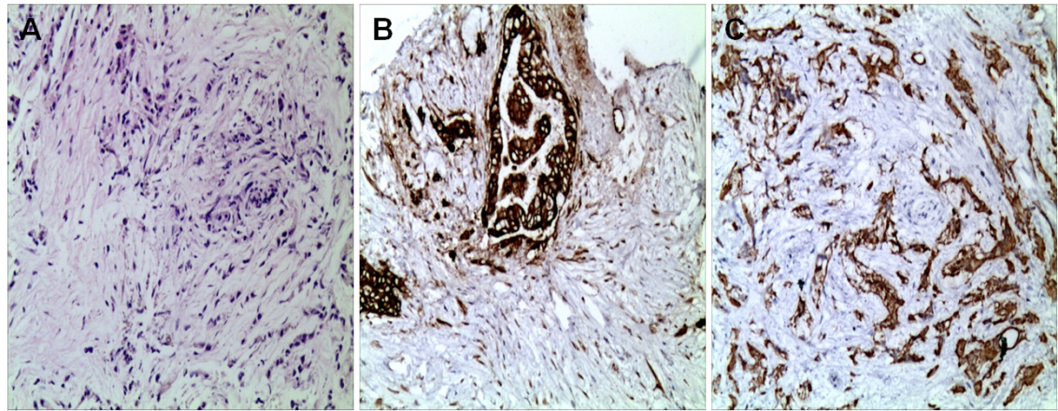
Figure 1 Pathological examination of the pancreatic mass. A: Hematoxylin and eosin staining; B: CK7 (+); C: CK19 (+) (200×).

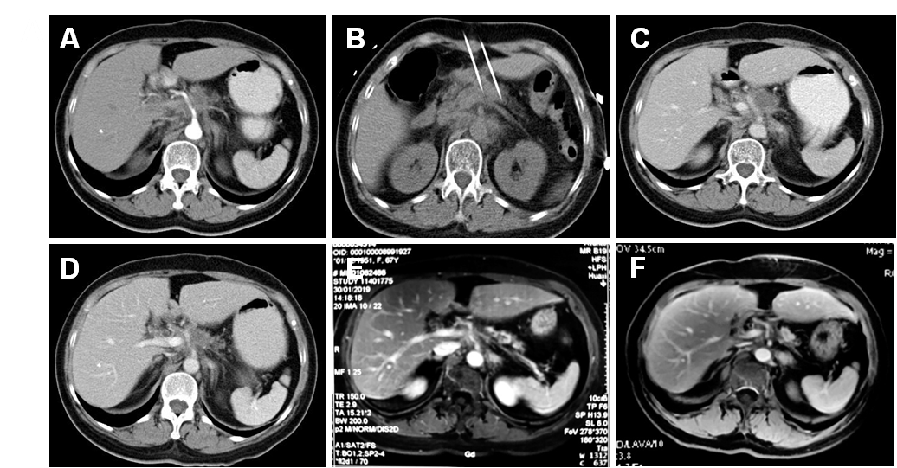
Figure 2 Pancreatic tumor before, during, and after irreversible electroporation. A: Before irreversible electroporation (IRE), computed tomography showed a pancreatic tumor measuring 2.7 cm × 2.5 cm (arrow); B: IRE was performed; C: At 1 mo after IRE, the tumor shrank to 2.9 cm × 2.0 cm; D: At 4 mo after IRE, the tumor shrank to 2.6 cm × 1.9 cm; E: At 6 mo after IRE, the tumor shrank to 1.5 cm × 1.6 cm; F: At 12 mo after IRE, a complete response was achieved.

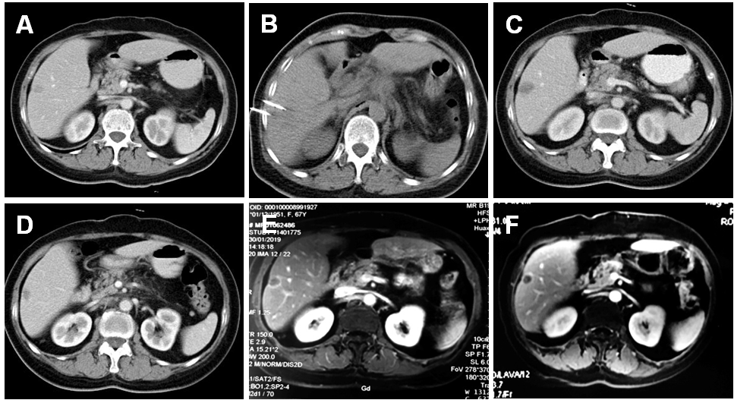
Figure 3 Liver tumor before, during, and after irreversible electroporation. A: Before irreversible electroporation (IRE), computed tomography showed a liver tumor measuring 1.4 cm × 1.1 cm (arrow); B: IRE was performed; C: At 1 mo after IRE, the tumor shrank to 1.9 cm × 1.5 cm; D: At 4 mo after IRE, the tumor shrank to 1.4 cm × 1.4 cm; E: At 6 mo after IRE, the tumor shrank to 1.4 cm × 1.2 cm; F: At 12 mo after IRE, the tumor shrank to 1.2 cm × 0.9 cm.

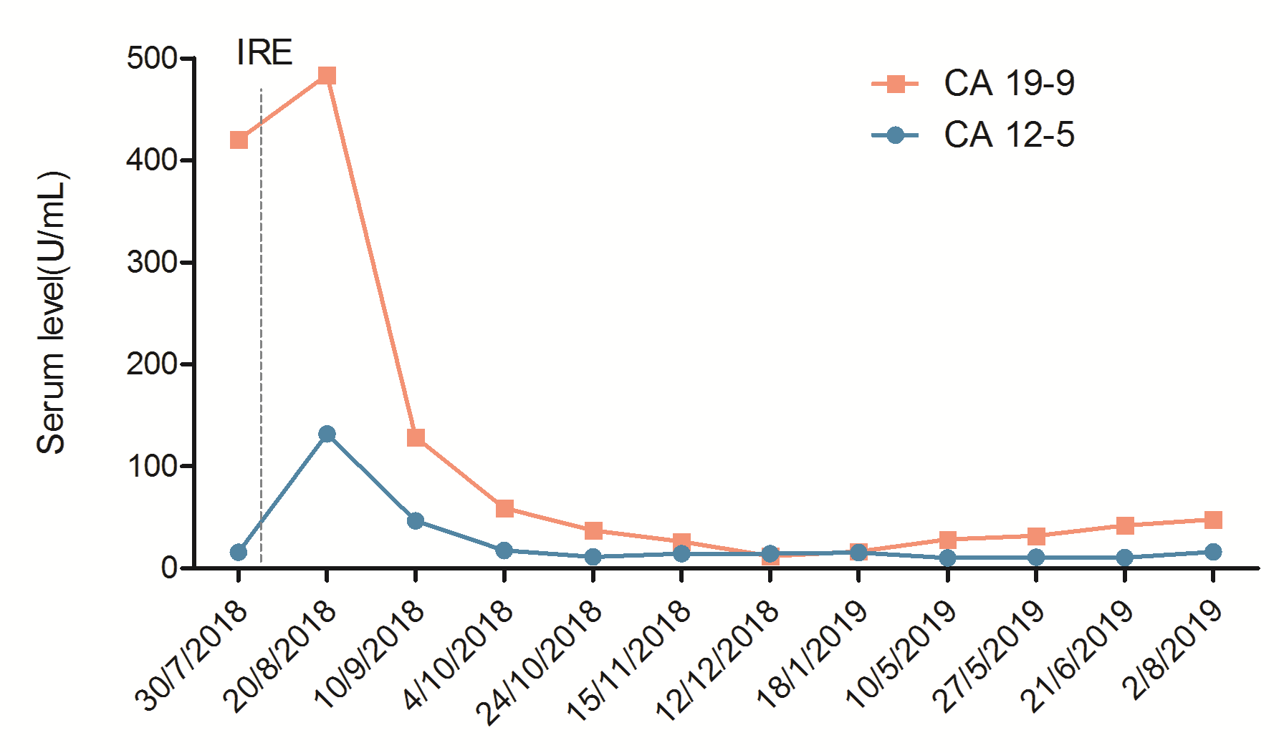
Figure 4 Serum carbohydrate antigen 19-9 and carbohydrate antigen 125 levels during treatment. CA: Carbohydrate antigen; IRE: Irreversible electroporation.

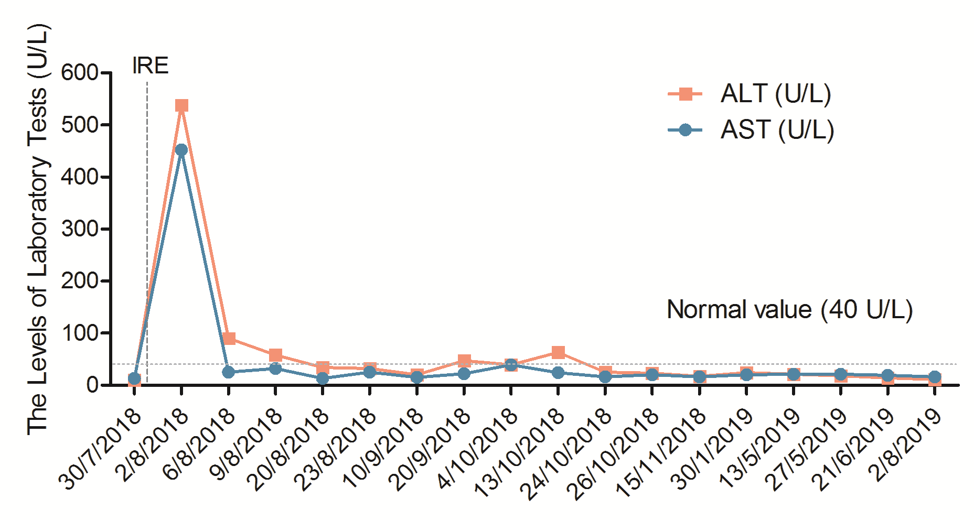
Figure 5 Changes in alanine aminotransferase and aspartate aminotransferase levels during the hospital stay. ALT: Alanine aminotransferase; AST: Aspartate aminotransferase; IRE: Irreversible electroporation.

Table 1 Patient-specific chemotherapy regimen
Chemotherapy regimen | Dosage | Delivery route | Time | Cycle
Gemcitabine | Day 1 (1.2 g); Day 8 (0.8 g) | Intravenous | Days 1 and 8 | Every 21 d
Gemcitabine + Tegafur | Days 1 and 8 (1.2 g) + 80 mg | Arterial infusion + oral | Days 1 and 8; days 1–14 | For four cycles

