Name of Journal: World Journal of Gastroenterology
Manuscript NO: 86203
Manuscript Type: ORIGINAL ARTICLE

Observational Study
Hepatitis D virus dual-infection among Chinese hepatitis B patient related to hepatitis B surface antigen, hepatitis B virus DNA and age

Zi J et al. Epidemiology of HDV in China

Jun Zi, Yu-Huan Li, Xiao-Mei Wang, Hong-Qin Xu, Wen-Hui Liu, Jia-Yue Cui, Jun-Qi Niu, Xiu-Mei Chi

Jun Zi, Yu-Huan Li, Xiu-Mei Chi, Gene Therapy Laboratory, Center for Pathogen Biology and Infectious Diseases, First Hospital of Jilin University, Changchun 130061, Jilin Province, China

Xiao-Mei Wang, Hong-Qin Xu, Jun-Qi Niu, Department of Hepatology, Center for Pathogen Biology and Infectious Diseases, First Hospital of Jilin University, Changchun 130061, Jilin Province, China

Wen-Hui Liu, Jia-Yue Cui, Department of Histology and Embryology, College of Basic Medical Sciences, Jilin University, Changchun 130061, Jilin Province, China

Author contributions: Chi XM and Li YH obtained fundings and designed the study; Chi XM, Zi J, Li YH, Wang XM, and Liu WH collected and diagnosed the specimens; Zi J and Xu HQ analyzed the data; Zi J and Li YH wrote this manuscript; Chi XM, Niu JQ, Cui JY, and Xu HQ revised the manuscript.

Supported by the National Natural Science Foundation of Jilin Provence, No. YDZJ202201ZTYS016; and Jilin Provincial Health Commission, No. 2022JC053.

Corresponding author: Xiu-Mei Chi, PhD, Assistant Professor, Gene Therapy Laboratory, Center for Pathogen Biology and Infectious Diseases, First Hospital of Jilin University, No. 519 of East Minzhu Street, Changchun 130061, Jilin Province, China. chixm@jlu.edu.cn

Received: June 6, 2023
Revised: August 21, 2023
Accepted: September 26, 2023
Published online:

Abstract
BACKGROUND
The screening practices for hepatitis D virus (HDV) are diverse and non-standardized worldwide, and the exact prevalence of HDV is uncertain.

AIM
To estimate HDV prevalence and investigate viral marker quantity trends in patients with hepatitis D.

METHODS
We collected 5594 serum samples from patients with hepatitis B in Jilin Province, China (3293 males and 2301 females, age range of 2 to 89 years). We then conducted tests for hepatitis B surface antigen (HBsAg), hepatitis B Virus (HBV) DNA, anti-hepatitis D antigen (HDAg), and HDV RNA.

RESULTS
We found that the prevalence of anti-HDAg and HDV RNA among hepatitis B patient were 3.6% (3.2-4.2%) and 1.2% (0.9-1.5%), respectively, 87.69% of hepatitis D patients were 51-70 years old. HDV infection screening positive rate of patients with HBV DNA levels below 2000 IU/mL (2.0%) was higher than those above 2000 IU/mL (0.2%). Among anti-HDAg positive patients, the HDV RNA positive rate was positively correlated with the HBsAg level and anti-HDAg level. There was a weak correlation between HBsAg and anti-HDAg levels among hepatitis D patients.

CONCLUSION
Our study highlights the importance of considering multiple factors when assessing the severity of HDV infection, comprehensive evaluation of patients’ clinical and laboratory parameters is necessary for proper diagnosis and treatment.

Key Words: Hepatitis D virus; Hepatitis B virus; Epidemiology; Anti-hepatitis D antigen; Hepatitis D virus RNA

Zi J, Li YH, Wang XM, Xu HQ, Liu WH, Cui JY, Niu JQ, Chi XM. Hepatitis D virus dual-infection among Chinese hepatitis B patient related to hepatitis B surface antigen, hepatitis B virus DNA and age. World J Gastroenterol 2023; In press

Core Tip: The screening practices for hepatitis D virus (HDV) are diverse and non-standardized worldwide, the exact prevalence of HDV is uncertain. To estimating HDV prevalence and investigate viral marker quantity trends in patients with hepatitis D, we collected serum samples from patients with hepatitis B, and tested hepatitis B surface antigen, hepatitis B virus (HBV) DNA, anti-hepatitis D antigen (HDAg), and HDV RNA. We found that the prevalence of anti-HDAg and HDV RNA among hepatitis B patient in Jilin Province were 3.6% and 1.2%, respectively. HDV infection screening positive rate was higher in patients with lower HBV DNA levels, and with higher anti-HDAg levels.

INTRODUCTION
Hepatitis D virus (HDV) has a diameter of 35-37 nm^{[1]} and is composed of RNA, hepatitis D antigen (HDAg), and an envelope containing hepatitis B surface antigen (HBsAg)^{[2]}. HDV is a satellite virus of hepatitis B virus (HBV), co-infection of HBV and HDV results in extensive liver tissue damage and severe fulminant hepatitis. Patients with chronic hepatitis B who are super-infected with HDV experience an accelerated progression of the disease to cirrhosis and an increased risk of developing hepatocellular carcinoma^{[3]}. Chronic hepatitis D (CHD) is the most severe form of viral hepatitis^{[4]}.
According to the World Health Organization (WHO), an estimated 296 million people were living with chronic hepatitis B infection globally in 2019^{[5]}. China has the highest number of hepatitis B patients in the world, about 86 million people were living with HBsAg^{[6,7]}. Since 1992, China has provided free HBV vaccination to newborns^{[8]}, at that time, the HBsAg carrier rates among general population was about 9.75%, which declined to about 7.18% in 2006^{[9]}, and was about 6.1% in 2016^{[7]}.
HDV is widespread worldwide, and its prevalence varies by geography^{[10]}. The screening practices for HDV are diverse and non-standardized. Guidelines from the European Association for the Study of the Liver and the Asia Pacific Association for the Study of Liver (EASL/APASL) recommend HDV screening for all individuals who are positive for HBsAg^{[11]}. The American Association for the Study of Liver Diseases recommends HDV screening for certain high-risk groups, with the recommended screening test being anti-HDAg. If the test is positive, HDV RNA testing should be performed^{[12,13]}. In many endemic areas, the screening rate is inaccessible.
The global prevalence of HDV remains uncertain due to deficiencies in screening, especially HDV RNA testing. Different meta-analyses have estimated varying prevalence rates. Chen et al^{[14]} estimated the prevalence of HDV to be 0.98% (0.61-1.42) among the general population and 14.57% (12.93-16.27) among HBsAg-positive individuals. Miao et al^{[15]} estimated the prevalence of HDV to be 0.80% (0.63-1.00) among the general population and 13.02% (11.96-14.11) among HBV carriers. Stockdale et al^{[16]} estimated the prevalence of anti-HDAg to be 0.16% (0.11-0.25) among the general population and 4.5% (3.6-5.7) among HBsAg-positive individuals, and the prevalence of HDV RNA to be 0.09% (0.07-0.15) among the general population.
China has the highest number of hepatitis D patients in the world, with estimated HDV prevalence rates of 0.69% (0.24-1.36) among the general population and 10.16% (8.50-11.95) among HBsAg-positive individuals^{[15]}. Regional studies had conducted and reported prevalence rates of HDV RNA among HBV carriers ranging from 0.0% (Beijing, Tibet, etc) to 13.55% (Inner Mongolia)^{[17-22]}.
This study aims to estimate the prevalence of HDV in Jilin Province, China. Promoting research on the prevalence of HDV can help raise awareness of CHD, improve screening rate and identify hepatitis D patients as early as possible to reduce HDV transmission. We also studied the trend in the quantity of HBsAg, HBV DNA, anti-HDAg, and HDV RNA among hepatitis D patients. This information may provide some guidance for screening practices: Hepatitis B patients with quantitatively characteristic viral markers are more likely to be dual-infected with HDV, and hence should be screened for HDV infection.

MATERIALS AND METHODS
Study specimens
Form April 2021 to August 2022, a total of 5594 hepatitis B serum samples were collected from outpatient center of the First Hospital of Jilin University, comprising 3293 males and 2301 females, with an age range of 2 to 89 years. Fasting venous blood was centrifuged at 4000 rpm for 10 min to obtain serum. This study was approved by the Ethics Committee of the First Hospital of Jilin University (AF-IRB-029-06). The serum samples were separated into several aliquots of approximately 400 μL each and stored at -80 °C for the detection of HBV DNA, HBsAg, anti-HDAg, and HDV RNA. The basic information of the patients was recorded, and the specimen inclusion criteria were HBsAg positive or HBV DNA positive.

Detection of hepatitis B surface antigen
We used the Architect i2000SR platform and Abbott Architect reagents (Abbott Laboratories, Abbott Park, IL, United States) to detect HBsAg, as previously described (Chemiluminescence Microparticle Immunoassay, CMIA)^{[23]}. HBsAg levels were measured with a dynamic range of 0-250 IU/mL. If the detection value of the original sample was higher than 250 IU/mL, it was properly diluted to obtain the final data.

Detection of hepatitis B virus DNA
Serum (400 μL) were used to detect HBV DNA by the Roche COBAS AmpliPrep/COBAS TaqMan system (Roche Diagnostics, Basel, Switzerland), as previously described (Quantitative Polymerase Chain Reaction, qPCR)^{[23]}. The lowest detection limit was 20 IU/mL.

Detection of anti-hepatitis D antigen
We used the HDV IgG Antibody Detection Kit (Wantai, Beijing, China) to detect anti-HDAg IgG (hereinafter referred to as anti-HDAg), according to the manufacturer’s instructions (Enzyme Linked Immunosorbent Assay, ELISA). The absorbance at 450 nm was measured using an SBYMB-001 microplate reader system (Thermo, Waltham, MA, United States), and the cut-off value was 0.12 plus the mean of the negative control.

Detection of HDV RNA
We selected anti-HDAg-positive specimens and used a nucleic acid extraction reagent (Jianwei, Shandong Province, China) to extract nucleic acid from 400 μL of serum, following the manufacturer’s instructions. The extraction was performed on an EZ Bead nucleic acid extraction instrument (Jianwei, Shandong Province, China).
We used the RoboGene HDV RNA Quantification Kit 2.0 (AJ Roboscreen GmbH, Leipzig, Germany) to detect HDV RNA, according to the manufacturer’s instructions (real time qPCR, RT-qPCR). The RT-qPCR was performed on an Mx3005P system (Agilent, Santa Clara, CA, United States), and the lowest detection limit was 6 IU/mL.

Statistical analysis
All statistical analyses were performed using SPSS version 26.0. Categorical variables were expressed as percentages and 95% confidence intervals (CI), and compared using the χ² test. Continuous variables with a normal distribution were expressed as mean ± SD. Continuous variables with non-normally distribution was expressed as median and interquartile range (IQR), Mann-Whitney U test was used for comparison of two groups, and Kruskal-Wallis test was used for comparison of multiple groups. Correlations between viral markers were assessed using simple linear regression models and Pearson’s correlation coefficient (r). All tests were two-tailed, and a P value of less than 0.05 was considered statistically significant. Graphs were generated using GraphPad Prism 8.0.

RESULTS
Prevalence of HDV among hepatitis B patients in Jilin Province, China
Among hepatitis B patients in Jilin Province, China, the prevalence of anti-HDAg was 3.6% (203/5594, 95%CI: 3.2%-4.2%), and the prevalence of HDV RNA was 1.2% (65/5594, 95%CI: 0.9%-1.5%). Among anti-HDAg positive patients, the HDV RNA positive rate was 32.0% (65/203, 95%CI: 25.7%-38.9%). We divided these 5594 hepatitis B patients into three infection groups: 5391 patients were anti-HDAg negative and HDV RNA negative (HBV mono-infected patients); 138 patients were anti-HDAg positive and HDV RNA negative (indicating resolved hepatitis D, persistent infection with very low viraemia, or a false negative PCR test result^{[24]}. Hereinafter referred to as HDV-resolved patients); and 65 patients were anti-HDAg positive and HDV RNA positive (HBV-HDV dual-infected patients).

Gender
Among the 5594 patients, there were 3168 males and 2223 females in the HBV mono-infected group, 86 males and 52 females in the HDV-resolved group, and 39 males and 26 females in the HBV-HDV dual-infected group. The differences in gender distribution among the three groups were not statistically significant (P > 0.05, χ² = 0.737).
Among the 3293 male and 2301 female hepatitis B patients, there was no significant difference in the anti-HDAg screening positive rates [3.8% (male) vs 3.4% (female), P > 0.05, χ² = 0.639] or the HDV RNA screening positive rates [1.2% (male) vs 1.1% (female), P > 0.05, χ² = 0.035]. Among male and female anti-HDAg positive patients, there was also no significant difference in the HDV RNA positive rates [31.2% (male) vs 33.3% (female), P > 0.05, χ² = 0.100] (Table 1).

Age
The age range of HBV mono-infected patients was from 2 years to 89 years, with a median of 50 years (IQR: 41-58 years). HDV-resolved patients had an age range from 32 years to 72 years, with a mean of 57.9 years ± 0.7 years. For HBV-HDV dual-infected patients, the age range was from 35 years to 72 years, with a mean of 57.0 years ± 0.9 years. Statistically significant differences were detected among their age (P < 0.05, H = 99.902), the age of HBV mono-infected patients was found to be lower than that of HDV-resolved patients and HBV-HDV dual-infected patients (P < 0.05), and there was no significant difference in age between HDV-resolved patients and HBV-HDV dual-infected patients (P > 0.05) (Figure 1A).
Among the Hepatitis B patients, those who were 30 years old or younger (323 patients) and those who were over 80 years old (13 patients) were all negative for anti-HDAg and HDV RNA. The remaining 5258 patients (aged 31-80) were divided into five groups based on age: 31-40, 41-50, 51-60, 61-70, and 71-80 years old, respectively. The screening positive rates of anti-HDAg in the five age groups were 0.7% (7/1009, 95%CI: 0.3%-1.4%), 1.5% (21/1412, 95%CI: 0.9%-2.3%), 6.1% (107/1762, 95%CI: 5.0%-7.3%), 6.4% (59/928, 95%CI: 4.9%-8.1%), and 6.1% (9/147, 95%CI: 2.8%-11.3%), respectively. Similarly, the screening positive rates of HDV RNA in the five age groups were 0.2% (2/1009, 95%CI: 0.0%-0.7%), 0.3% (4/1412, 95%CI: 0.1%-0.7%), 2.4% (42/1762, 95%CI: 1.7%-3.2%), 1.6% (15/928, 95%CI: 0.9%-2.7%), and 1.4% (2/147, 95%CI: 0.2%-4.8%), respectively (Figure 1B).
Based on preliminary observations, the screening positive rates of anti-HDAg and HDV RNA in the 31-40 and 41-50 age groups appear to be lower than those in the 51-60, 61-70, and 71-80 age groups. Upon combining the corresponding age groups, the anti-HDAg screening positive rate in patients aged 31-50 years old (1.2%, 95%CI: 0.8%-1.7%) was found to be lower than in patients aged 51-80 years old (6.2%, 95%CI: 5.3%-7.1%, P < 0.05, χ² = 88.403). Similarly, the HDV RNA screening positive rate in patients aged 31-50 years old (0.2%, 95%CI: 0.1%-0.5%) was lower than in patients aged 51-80 years old (2.1%, 95%CI: 1.6%-2.7%, P < 0.05, χ² = 35.902).
Among the five age groups of patients who tested positive for anti-HDAg, the HDV RNA positive rates were 28.6% (2/7, 95%CI: 3.7%-71.0%), 19.0% (4/21, 95%CI: 5.4%-41.9%), 39.3% (42/107, 95%CI: 30.0%-49.2%), 25.4% (15/59, 95%CI: 15.0%-38.4%), and 22.2% (2/9, 95%CI: 2.8%-60.0%), respectively (Supplementary Figure 1A). However, the differences in these HDV RNA positive rates were not statistically significant (P > 0.05, χ² = 5.809).

Hepatitis B surface antigen
In HBV mono-infected patients, the quantity of HBsAg ranged from 0 to 123935.00 IU/mL, with a median of 881.41 IU/mL (IQR: 0.01-3651.62 IU/mL). Among these patients, 38.6% had quantities ranging from 0 to 2.5 × 10² IU/mL, 13.2% had quantities ranging from 2.5 × 10² IU/mL to 1.0 × 10³ IU/mL, 37.8% had quantities ranging from 1.0 × 10³ IU/mL to 1.0 × 10⁴ IU/mL, and 10.4% had quantities ranging from 1.0 × 10⁴ IU/mL to 1.3 × 10⁵ IU/mL (Figure 2A).
For HDV-resolved patients, the HBsAg quantity ranged from 0 to 20685.00 IU/mL, with a median of 65.83 IU/mL (IQR: 0.00-1245.30 IU/mL). Among these patients, 61.8% had quantities ranging from 0 to 2.5 × 10² IU/mL, 13.0% had quantities ranging from 2.5 × 10² IU/mL to 1.0 × 10³ IU/mL, 13.0% had quantities ranging from 1.0 × 10³ IU/mL to 1.0 × 10⁴ IU/mL, and 12.2% had quantities ranging from 1.0 × 10⁴ IU/mL to 1.3 × 10⁵ IU/mL (Figure 2A).
For HBV-HDV dual-infected patients, the HBsAg quantity ranged from 0 to 22070.00 IU/mL, with a median of 892.90 IU/mL (IQR: 37.26-5525.50 IU/mL). Among these patients, 41.3% had quantities ranging from 0 to 2.5 × 10² IU/mL, 11.1% had quantities ranging from 2.5 × 10² IU/mL to 1.0 × 10³ IU/mL, 33.3% had quantities ranging from 1.0 × 10³ IU/mL to 1.0 × 10⁴ IU/mL, and 14.3% had quantities ranging from 1.0 × 10⁴ IU/mL to 1.3 × 10⁵ IU/mL (Figure 2A).
Statistically significant differences were detected among their HBsAg quantity (P < 0.05, H = 14.639), the quantity of HBsAg in HDV-resolved patients was found to be lower than that in HBV mono-infected patients and HBV-HDV dual-infected patients (P < 0.05), and there was no statistically significant difference in HBsAg quantity between HBV mono-infected patients and HBV-HDV dual-infected patients (P > 0.05) (Figure 2A).
Hepatitis B patients were categorized into four groups based on their HBsAg quantity: 0-2.5 × 10², 2.5 × 10²-1.0 × 10³, 1.0 × 10²-1.0 × 10⁴, and 1.0 × 10⁴-1.3 × 10⁵ IU/mL, respectively. The anti-HDAg screening positive rates in these four HBsAg groups were 6.4% (102/1589, 95%CI: 5.3%-7.7%), 4.3% (23/531, 95%CI: 2.8%-6.4%), 2.5% (37/1491, 95%CI: 1.8%-3.4%), and 5.6% (24/426, 95%CI: 3.6%-8.3%), respectively. The HDV RNA screening positive rates were 1.6% (26/1589, 95%CI: 1.1%-2.4%), 1.3% (7/531, 95%CI: 0.5%-2.7%), 1.4% (21/1491, 95%CI: 0.9%-2.1%), and 2.1% (9/426, 95%CI: 1.0%-4.0%), respectively (Figure 2B).
Among the four HBsAg groups with anti-HDAg positive patients, the HDV RNA positive rates were 25.5% (26/102, 95%CI: 17.4%-35.1%), 30.4% (7/23, 95%CI: 13.2%-52.9%), 56.8% (21/37, 95%CI: 39.5%-72.9%), and 37.5% (9/24, 95%CI: 18.8%-59.4%), respectively (Supplementary Figure 1B).

Hepatitis B virus DNA
In HBV mono-infected patients, the quantity of HBV DNA ranged from 0 to 1.10 × 10⁹ IU/mL, with a median of 3.38 × 10² IU/mL (IQR: 5.05 × 10¹ IU/mL-6.69 × 10³ IU/mL). Among these patients, 24.9% had quantities ranging from 0 to 5 × 10¹ IU/mL, 42.5% had quantities ranging from 5 × 10¹ IU/mL to 2 × 10³ IU/mL, 12.3% had quantities ranging from 2 × 10³ IU/mL to 2 × 10⁴ IU/mL, 15.4% had quantities ranging from 2 × 10⁴ IU/mL to 2 × 10⁷ IU/mL, and 4.9% had quantities ranging from 2 × 10⁷ IU/mL to 2 × 10⁹ IU/mL (Figure 3A).
For HDV-resolved patients, the median of the HBV DNA quantity was 1.41 × 10¹ IU/mL (IQR: 0-1.10 × 10² IU/mL), ranging from 0 to 3.33 × 10⁷ IU/mL. Among them, 67.2% of patients had a range of 0 to 5 × 10¹ IU/mL, 25.4% had a range of 5 × 10¹ IU/mL to 2 × 10³ IU/mL, 3.3% had a range of 2 × 10³ IU/mL to 2 × 10⁴ IU/mL, 3.3% had a range of 2 × 10⁴ IU/mL to 2 × 10⁷ IU/mL, and 0.8% had a range of 2 × 10⁷ IU/mL to 2 × 10⁹ IU/mL (Figure 3A).
In the HBV-HDV dual-infected patients, the median of the HBV DNA quantity was 1.86 × 10¹ IU/mL (IQR: 2.06-7.07 × 10¹ IU/mL), ranging from 0 to 1.80 × 10⁴ IU/mL. Among them, 68.3% of patients had a range of 0 to 5 × 10¹ IU/mL, 27.0% had a range of 5 × 10¹ IU/mL to 2 × 10³ IU/mL, 3.2% had a range of 2 × 10³ IU/mL to 2 × 10⁴ IU/mL, and 1.6% had a range of 2 × 10⁴ IU/mL to 2 × 10⁷ IU/mL (Figure 3A).
Statistically significant differences were detected among their HBV DNA quantity (P < 0.05, H = 190.771), the HBV DNA quantity of HBV mono-infected patients was higher than that of HDV-resolved patients and HBV-HDV dual-infected patients (P < 0.05), and there was no statistically significant difference in the HBV DNA quantity between HDV-resolved patients and HBV-HDV dual-infected patients (P > 0.05) (Figure 3A).
Hepatitis B patients were classified into five groups according to their HBV DNA quantity: 0-5 × 10¹, 5 × 10¹-2 × 10³, 2 × 10³-2 × 10⁴, 2 × 10⁴-2 × 10⁷, and 2 × 10⁷-2 × 10⁹ IU/mL, respectively. The anti-HDAg screening positive rates of the five HBV DNA groups were 10.9% (125/1142, 95%CI: 9.2%-12.9%), 2.7% (48/1786, 95%CI: 2.0%-3.5%), 1.2% (6/511, 95%CI: 0.4%-2.5%), 0.8% (5/637, 95%CI: 0.3%-1.8%), and 0.5% (1/200, 95%CI: 0.0%-2.8%), respectively. The HDV RNA screening positive rates were 3.8% (43/1142, 95%CI: 2.7%-5.0%), 1.0% (17/1786, 95%CI: 0.6%-1.5%), 0.4% (2/511, 95%CI: 0.0%-1.4%), 0.2% (1/637, 95%CI: 0.0%-0.9%), and 0.0% (0/200, 95%CI: 0.0%-1.8%), respectively (Figure 3B).
According to preliminary observations, the anti-HDAg and HDV RNA screening positive rates of the first two HBV DNA quantity groups (0-2 × 10³ IU/mL) appeared to be higher than the last three groups (2 × 10³ IU/mL-2 × 10⁹ IU/mL). After combining the corresponding groups, the anti-HDAg screening positive rate of patients with HBV DNA quantity between 0-2 × 10³ IU/mL (5.9%, 95%CI: 5.1%-6.8%) was higher than that of patients with 2 × 10³ IU/mL-2 × 10⁹ IU/mL (0.9%, 95%CI: 0.5%-1.5%, P < 0.05, χ² = 56.157), and the HDV RNA screening positive rate of 0-2 × 10³ IU/mL patients (2.0%, 95%CI: 1.6%-2.6%) was also higher than that of 2 × 10³ IU/mL-2 × 10⁹ IU/mL patients (0.2%, 95%CI: 0.0%-0.6%, P < 0.05, χ² = 21.216).
Among the five HBV DNA groups, the HDV RNA positive rates of anti-HDAg positive patients were 34.4% (43/125, 95%CI: 26.1%-43.4%), 35.4% (17/48, 95%CI: 22.2%-50.5%), 33.3% (2/6, 95%CI: 4.3%-77.7%), 20.0% (1/5, 95%CI: 0.5%-71.6%), and 0.0% (0/1, 95%CI: 0.0%-97.5%) respectively (Supplementary Figure 1C).

Anti-hepatitis D antigen
In HDV-resolved patients, the absorbance of anti-HDAg ranged from 0.170 to 3.740, with a median of 1.397 (IQR: 0.613-2.043). Among HBV-HDV dual-infected patients, the absorbance of anti-HDAg ranged from 0.370 to 3.800, with a mean of 2.219 ± 0.103. The absorbance of anti-HDAg in HDV-resolved patients was lower than that in HBV-HDV dual-infected patients (P < 0.05, Z = -5.461) (Figure 4A).
Anti-HDAg positive patients were categorized into four groups based on the absorbance of anti-HDAg: 0.170-1.711, 1.711-2.355, 2.355-2.865, and 2.865-3.800. The HDV RNA positive rates for the four anti-HDAg groups were 16.7% (16/96, 95%CI: 9.8%-25.6%), 32.1% (17/53, 95%CI: 19.9%-46.3%), 59.3% (16/27, 95%CI: 38.8%-77.6%), and 59.3% (16/27, 95%CI: 38.8%-77.6%) respectively (Figure 4B).

Hepatitis D virus RNA
Among HBV-HDV dual-infected patients, the HDV RNA quantity ranged from 7.10 to 2.35 × 10⁷ IU/mL, the median was 4.61 × 10² IU/mL (IQR: 4.95 × 10¹ IU/mL-8.99 × 10³ IU/mL) (Figure 5). The HDV RNA quantity of 3 (4.62%) patients ranged from 0 to 10¹ IU/mL, 20 (30.77%) patients ranged from 10¹ to 10² IU/mL, 14 (21.54%) patients ranged from 10² to 10³ IU/mL, 12 (18.46%) patients ranged from 10³ to 10⁴ IU/mL, 12 (19.46%) patients ranged from 10⁴ to 10⁵ IU/mL, 2 (3.08%) patients ranged from 10⁵ to 10⁶ IU/mL, 1 (1.54%) patient ranged from 10⁶ to 10⁷ IU/mL, 1 (1.54%) patient ranged from 10⁷ to 10⁸ IU/mL.

Correlations between viral markers
The Pearson’s correlation coefficients among the viral markers of HBV-HDV dual-infected patients were analyzed. The R values suggest that the correlations between the viral markers were weak, with all coefficients being less than 0.3. HBsAg and anti-HDAg had a weak correlation (r = 0.256, P = 0.043), but there were no significant correlations between HBsAg and HBV DNA, HBsAg and HDV RNA, or anti-HDAg and HDV RNA (r = 0.151, P = 0.241; r = 0.101, P = 0.431; r = 0.224, P = 0.073, respectively). The correlations between HBV DNA and anti-HDAg, and HBV DNA and HDV RNA were even weaker (r = 0.082, P = 0.529; r = 0.041, P = 0.750, respectively).

DISCUSSION
The prevalence of anti-HDAg among hepatitis B patients in Jilin Province, China was 3.6%, which is lower than the estimated prevalence in China (10.16%)^{[15]} and worldwide (4.50%-14.57%)^{[14-16]}. The prevalence of HDV RNA was 1.2%, which is slightly higher than the global meta-analysis estimates (0.09%)^{[14-16]}, and similar to other provinces in China (0%-13.55%)^{[17-22]}. Gender did not seem to influence the spread of HDV in Jilin Province, as the HDV screening positive rates were similar between different genders.
According to China Center for Disease Control, HBsAg prevalence among 1-4, 5-14, and 15-29 years old general population was 9.9%, 10.6%, and 9.8%, respectively in 1992. Which declined to 0.3%, 0.9%, and 4.4%, respectively in 2014^{[25]}. Before China offering free HBV vaccination to newborns, the prevalence of HBV was similar across different age groups, and the vaccine has been effective in preventing HBV transmission to newborns. Our data indirectly verifies this conclusion, the majority (91.19%) of HBV mono-infected patients falling between 31 years old and 70 years old, among which distributed relatively even.
The ages of HDV-resolved patients and HBV-HDV dual-infected patients were mainly (78.83% and 87.69%, respectively) between 51 and 70 years old, and the anti-HDAg and HDV RNA screening positive rates were higher in patients aged 51-80 than in those aged 31-50. Before 1992, the health, medical and hygiene conditions of China were suboptimal, and the awareness about viral hepatitis prevention was poor. HDV infected Chinese adults (currently in the 51-80 years age group) severely through risk behaviors such as unsafe sexual contact and injection, and infected minors (currently in the 31-50 years age group) occasionally through intrafamilial transmission. In 1992, along with HBV vaccination widespread and economic development, the suboptimal conditions and the awareness about viral hepatitis prevention were improved too. When HBV patients aged 31-50 became adults, the decline of risk behaviors might be one of the reasons for their relatively low HDV positive rate. Since HDV requires HBV for secretion and infection^{[26]}, HBV vaccination is effective in preventing HDV transmission to newborns.
The positive rate of HDV RNA among anti-HDAg positive patients was 32.0%, and there were no statistically significant differences between genders or age groups. A previous meta-analysis estimated that approximately one-third of anti-HDAg positive patients have undetectable HDV RNA^{[24]}, while another estimated that the pooled proportion of anti-HDAg positive patients with HDV RNA detection was 58.5%^{[16]}. The positive rate of HDV RNA among anti-HDAg positive patients in Jilin Province seems relatively low. More research is needed to understand it, one possible reason was, as we previously reported, most hepatitis D patients in Jilin Province were infected with HDV Genotype 1^{[18]}, which secretes high virus titers with extremely delayed kinetics^{[27]}. The delay of HDV secretion providing patients’ immune system with more time to respond to the HDV before it proliferates extensively and widespread.
We observed that the HBsAg level of HBV-HDV dual-infected patients and HBV mono-infected patients were similar, but the HBV DNA level of the former was significantly lower than the latter. This conclusion was consistent with previous studies that showed HBV DNA were significantly decreased after HDV infection, without decrease in HBsAg levels^{[28-32]}.
Before the study, we hypothesized that the HBsAg and HBV DNA levels of HDV-resolved patients and HBV mono-infected patients would be similar, due to minor HDV replication and interference in both groups of patients. But the study data showed that the levels of the former were both significantly lower than the latter. Additionally, we found that among anti-HDAg positive patients, the HDV RNA positive rate was positively correlated with the HBsAg level, except for an abnormal decrease in the 1 × 10⁴-1 × 10⁵ group. According to previous research results, the HBsAg level kept relatively stable in hepatitis B patients before and after HDV infection^{[28-32]}. We speculate that, before HDV acute infecting those HDV-resolved patients, their immune systems maintain the HBsAg on low level already, and were more capable of resolving HDV acute infection than those who with high level HBsAg. Otherwise, HDV-resolved patients might eliminate HDV alone with some HBV after HDV acute infection, leading to decrease in HBsAg and HBV DNA.
Our study data suggests that to effectively screen HDV and save medical resources, screening hepatitis B patients for HDV infection whose HBV DNA quantity is lower than 2 × 10³ IU/mL. Additionally, hepatitis B patients whose HBV DNA quantity is between 2 × 10³ IU/mL-2 × 10⁷ IU/mL can be screened for HDV infection if clinical symptoms imply HDV infection, while those whose HBV DNA quantity is higher than 2 × 10⁷ IU/mL seem don’t need HDV screening. For anti-HDAg positive patients, those with a higher HBsAg level have a higher possibility of dual-infection with HDV, but patients with a low HBsAg level should also be screened for HDV infection. Finally, using the Wantai kit (mentioned in 2.4), we found that patients with anti-HDAg level lower than 0.370 were HDV RNA negative and may have undetectable HDV RNA according to the patient’s condition.
The quantity of HDV RNA in HBV-HDV dual-infected patients from Jilin Province was mainly between 1 × 10¹ IU/mL to 1 × 10⁵ IU/mL (92.06%), with a significant proportion (30.77%) concentrated between 1 × 10¹ IU/mL to 1 × 10² IU/mL. These findings suggested that the HDV RNA level was not very high and may not accurately reflect the severity of the disease.
In our study, we investigated the correlations between HBsAg, HBV DNA, anti-HDAg, and HDV RNA in HBV-HDV dual-infected patients. Our analysis revealed a weak correlation between HBsAg and anti-HDAg, while the correlations between other viral markers were not statistically significant. The complex physiological process underlying HDV generation may contribute to the lack of strong quantitative correlation between viral markers. Additionally, other factors such as the patient’s health status, medication use, and viral load fluctuations can influence viral marker level.
We used the HDV IgG antibody detection kit produced by Wantai company in Beijing, which has a high market share in China. The test is easy to perform and can be conducted in conventional hospitals, ensuring the authenticity of the data. Despite good quality, it is an indirect ELISA kit and other components in the serum may competitively bind to HDAg, the cross-reactivity may lead to false positive results or overestimation^{[33]}. Further, we only detected anti-HDAg IgG, which present in the serum of individuals after resolution of acute HDV infection, or who have developed CHD^{[34]}. The absence of IgM (indicates acute or active infection^{[35]}) detection may result in missing some patients with HDV acute infection, and lead to underestimation of HDV positivity rates. In addition, all samples were from Jilin Province, which may not fully reflect the overall situation in China.

CONCLUSION
In Jilin Province, China, the prevalence of anti-HDAg was 3.6% and the prevalence of HDV RNA was 1.2% among hepatitis B patients. These rates were related to age, and the majority of hepatitis D patients were 51-70 years old. The experimental data suggests that screening for HDV infection is more likely to yield positive results in hepatitis B patients with lower HBV DNA level. Patients with lower HBsAg levels appear to resolve HDV acute infection, while those with higher anti-HDAg levels are more likely to test positive for HDV RNA. A weak correlation was observed between HBsAg and anti-HDAg in hepatitis D patients. Overall, our study highlights the importance of considering multiple factors when assessing the severity of HDV infection, comprehensive evaluation of patients’ clinical and laboratory parameters is necessary for proper diagnosis and treatment.

ARTICLE HIGHLIGHTS
Research background
The screening practices for hepatitis D virus (HDV) are diverse and non-standardized worldwide, and the exact prevalence of HDV is uncertain.

Research motivation
To estimate the prevalence of HDV in Jilin Province, China.

Research objectives
Promoting research on the prevalence of HDV can help raise awareness of chronic hepatitis D, improve screening rate and identify hepatitis D patients as early as possible to reduce HDV transmission.

Research methods
We collected 5594 serum samples from patients with hepatitis B in Jilin Province, China (3293 males and 2301 females, age range of 2 to 89 years) and then conducted tests for hepatitis B surface antigen (HBsAg), hepatitis B virus (HBV) DNA, anti-hepatitis D antigen (HDAg), and HDV RNA.

Research results
The prevalence of anti-HDAg and HDV RNA among hepatitis B patient were 3.6% (3.2%-4.2%) and 1.2% (0.9%-1.5%), respectively, 87.69% of hepatitis D patients were 51-70 years old. HDV infection screening positive rate of patients with HBV DNA levels below 2000 IU/mL (2.0%) was higher than those above 2000 IU/mL (0.2%). Among anti-HDAg positive patients, the HDV RNA positive rate was positively correlated with the HBsAg level and anti-HDAg level. There was a weak correlation between HBsAg and anti-HDAg levels among hepatitis D patients.

Research conclusions
Our study highlights the importance of considering multiple factors when assessing the severity of HDV infection, comprehensive evaluation of patients’ clinical and laboratory parameters is necessary for proper diagnosis and treatment.

Research perspectives
From the perspective of medical institutions.

ACKNOWLEDGEMENTS
We thank the Department of Biobank, Division of Clinical Research for the providing of human sera.

REFERENCES
1 Mentha N, Clément S, Negro F, Alfaiate D. A review on hepatitis D: From virology to new therapies. J Adv Res 2019; 17: 3-15 [PMID: 31193285 DOI: 10.1016/j.jare.2019.03.009]
2 Lempp FA, Ni Y, Urban S. Hepatitis delta virus: insights into a peculiar pathogen and novel treatment options. Nat Rev Gastroenterol Hepatol 2016; 13: 580-589 [PMID: 27534692 DOI: 10.1038/nrgastro.2016.126]
3 Botelho-Souza LF, Vasconcelos MPA, Dos Santos AO, Salcedo JMV, Vieira DS. Hepatitis delta: virological and clinical aspects. Virol J 2017; 14: 177 [PMID: 28903779 DOI: 10.1186/s12985-017-0845-y]
4 Elbahrawy A, Atalla H, Alboraie M, Alwassief A, Madian A, El Fayoumie M, Tabll AA, Aly HH. Recent Advances in Protective Vaccines against Hepatitis Viruses: A Narrative Review. Viruses 2023; 15 [PMID: 36680254 DOI: 10.3390/v15010214]
5 World Orgnazation Health. Hepatitis B. [cited 24 June 2022]. Available from: https://www.who.int/en/news-room/fact-sheets/detail/hepatitis-b.
6 Yao X, Huang S, Zhou H, Tang SH, Qin JP. Clinical efficacy of antiviral therapy in patients with hepatitis B-related cirrhosis after transjugular intrahepatic portosystemic shunt. World J Gastroenterol 2021; 27: 5088-5099 [PMID: 34497437 DOI: 10.3748/wjg.v27.i30.5088]
7 Polaris Observatory Collaborators. Global prevalence, treatment, and prevention of hepatitis B virus infection in 2016: a modelling study. Lancet Gastroenterol Hepatol 2018; 3: 383-403 [PMID: 29599078 DOI: 10.1016/S2468-1253(18)30056-6]
8 Cao WW, Zhou RR, Ou X, Shi LX, Xiao CQ, Chen TY, Tan H, Fan XG, Li BJ, Li N. Prevalence of hepatitis B virus, hepatitis C virus, human immunodeficiency virus and Treponema pallidum infections in hospitalized patients before transfusion in Xiangya hospital Central South University, China from 2011 to 2016. BMC Infect Dis 2018; 18: 145 [PMID: 29606088 DOI: 10.1186/s12879-018-3051-7]
9 Wang FS, Fan JG, Zhang Z, Gao B, Wang HY. The global burden of liver disease: the major impact of China. Hepatology 2014; 60: 2099-2108 [PMID: 25164003 DOI: 10.1002/hep.27406]
10 Sahin A, Gurocak S, Tunc N, Demirel U, Poyrazoglu OK, Akbulut H, Yalniz M, Toraman ZA, Bahcecioglu IH. Anti-HDV seroprevalance among patients with previous HBV infection. North Clin Istanb 2018; 5: 132-138 [PMID: 30374479 DOI: 10.14744/nci.2018.01328]
11 Lee AU, Lee C. Hepatitis D Review: Challenges for the Resource-Poor Setting. Viruses 2021; 13 [PMID: 34696341 DOI: 10.3390/v13101912]
12 Da BL, Rahman F, Lai WC, Kleiner DE, Heller T, Koh C. Risk Factors for Delta Hepatitis in a North American Cohort: Who Should Be Screened? Am J Gastroenterol 2021; 116: 206-209 [PMID: 33027083 DOI: 10.14309/ajg.0000000000000954]
13 Terrault NA, Lok ASF, McMahon BJ, Chang KM, Hwang JP, Jonas MM, Brown RS Jr, Bzowej NH, Wong JB. Update on prevention, diagnosis, and treatment of chronic hepatitis B: AASLD 2018 hepatitis B guidance. Hepatology 2018; 67: 1560-1599 [PMID: 29405329 DOI: 10.1002/hep.29800]
14 Chen HY, Shen DT, Ji DZ, Han PC, Zhang WM, Ma JF, Chen WS, Goyal H, Pan S, Xu HG. Prevalence and burden of hepatitis D virus infection in the global population: a systematic review and meta-analysis. Gut 2019; 68: 512-521 [PMID: 30228220 DOI: 10.1136/gutjnl-2018-316601]
15 Miao Z, Zhang S, Ou X, Li S, Ma Z, Wang W, Peppelenbosch MP, Liu J, Pan Q. Estimating the Global Prevalence, Disease Progression, and Clinical Outcome of Hepatitis Delta Virus Infection. J Infect Dis 2020; 221: 1677-1687 [PMID: 31778167 DOI: 10.1093/infdis/jiz633]
16 Stockdale AJ, Kreuels B, Henrion MYR, Giorgi E, Kyomuhangi I, de Martel C, Hutin Y, Geretti AM. The global prevalence of hepatitis D virus infection: Systematic review and meta-analysis. J Hepatol 2020; 73: 523-532 [PMID: 32335166 DOI: 10.1016/j.jhep.2020.04.008]
17 Wang Y. Survey of HDV Infection and Molecular Characterization of HDV, HBV and HIV-1 among Chronic Hepatitis B Patients in China. Doctoral Thesis, National Center for AIDS/STD Control and Prevention, China, 2019. [cited 24 June 2022]. Available from: https://kns.cnki.net/kcms2/article/abstract?v=3uoqIhG8C447WN1SO36whLpCgh0R0Z-ia63qwICAcC3-s4XdRlECrREwcOYYpgWONc6mn6bnC_SrOpFUE5RYCbnC4qu_UDxq&uniplatform=NZKPT
18 Roggenbach I, Chi X, Lempp FA, Qu B, Walter L, Wu R, Gao X, Schnitzler P, Ding Y, Urban S, Niu J. HDV Seroprevalence in HBsAg-Positive Patients in China Occurs in Hotspots and Is Not Associated with HCV Mono-Infection. Viruses 2021; 13 [PMID: 34578380 DOI: 10.3390/v13091799]
19 Chang SY, Yang CL, Ko WS, Liu WC, Lin CY, Wu CH, Su YC, Chang SF, Chen MY, Sheng WH, Hung CC, Chang SC. Molecular epidemiology of hepatitis D virus infection among injecting drug users with and without human immunodeficiency virus infection in Taiwan. J Clin Microbiol 2011; 49: 1083-1089 [PMID: 21191061 DOI: 10.1128/JCM.01154-10]
20 Zhou L, Wei Q, Huang H, Huang W. Investigation and molecular characteristics of mixed infection of Hepatitis B virus and Hepatitis D virus in Zhuhai South China. J Prev Med 2021; 47: 753-756 [DOI: 10.12183/j.scjpm.2021.0753]
21 Chen F, Zhang J, Guo F, Wen B, Luo S, Yuan D, Lin Y, Ou W, Tang P, Dai G, Li F, Liu W, Qu X. Hepatitis B, C, and D virus infection showing distinct patterns between injection drug users and the general population. J Gastroenterol Hepatol 2017; 32: 515-520 [PMID: 27248508 DOI: 10.1111/jgh.13460]
22 Wu S, Zhang Y, Tang Y, Yao T, Lv M, Tang Z, Zang G, Yu Y, Chen X. Molecular epidemiology and clinical characteristics of hepatitis delta virus (HDV) infected patients with elevated transaminases in Shanghai, China. BMC Infect Dis 2020; 20: 565 [PMID: 32746807 DOI: 10.1186/s12879-020-05275-1]
23 Chi XM, Wang XM, Wang ZF, Wu RH, Gao XZ, Xu HQ, Ding YH, Niu JQ. Serum hepatitis B core-related antigen as a surrogate marker of hepatitis B e antigen seroconversion in chronic hepatitis B. World J Gastroenterol 2021; 27: 6927-6938 [PMID: 34790015 DOI: 10.3748/wjg.v27.i40.6927]
24 Shen DT, Goyal H, Xu HG. Differences in delta virus hepatitis diagnosis methods and its effect on the hepatitis D prevalence. Gut 2020; 69: 1893 [PMID: 31719130 DOI: 10.1136/gutjnl-2019-320159]
25 Cui F, Shen L, Li L, Wang H, Wang F, Bi S, Liu J, Zhang G, Wang F, Zheng H, Sun X, Miao N, Yin Z, Feng Z, Liang X, Wang Y. Prevention of Chronic Hepatitis B after 3 Decades of Escalating Vaccination Policy, China. Emerg Infect Dis 2017; 23: 765-772 [PMID: 28418296 DOI: 10.3201/eid2305.161477]
26 Zi J, Gao X, Du J, Xu H, Niu J, Chi X. Multiple Regions Drive Hepatitis Delta Virus Proliferation and Are Therapeutic Targets. Front Microbiol 2022; 13: 838382 [PMID: 35464929 DOI: 10.3389/fmicb.2022.838382]
27 Wang W, Lempp FA, Schlund F, Walter L, Decker CC, Zhang Z, Ni Y, Urban S. Assembly and infection efficacy of hepatitis B virus surface protein exchanges in 8 hepatitis D virus genotype isolates. J Hepatol 2021; 75: 311-323 [PMID: 33845061 DOI: 10.1016/j.jhep.2021.03.025]
28 Alfaiate D, Lucifora J, Abeywickrama-Samarakoon N, Michelet M, Testoni B, Cortay JC, Sureau C, Zoulim F, Dény P, Durantel D. HDV RNA replication is associated with HBV repression and interferon-stimulated genes induction in super-infected hepatocytes. Antiviral Res 2016; 136: 19-31 [PMID: 27771387 DOI: 10.1016/j.antiviral.2016.10.006]
29 Lütgehetmann M, Mancke LV, Volz T, Helbig M, Allweiss L, Bornscheuer T, Pollok JM, Lohse AW, Petersen J, Urban S, Dandri M. Humanized chimeric uPA mouse model for the study of hepatitis B and D virus interactions and preclinical drug evaluation. Hepatology 2012; 55: 685-694 [PMID: 22031488 DOI: 10.1002/hep.24758]
30 Wu JC, Chen PJ, Kuo MY, Lee SD, Chen DS, Ting LP. Production of hepatitis delta virus and suppression of helper hepatitis B virus in a human hepatoma cell line. J Virol 1991; 65: 1099-1104 [PMID: 1847439 DOI: 10.1128/jvi.65.3.1099-1104.1991]
31 Pollicino T, Raffa G, Santantonio T, Gaeta GB, Iannello G, Alibrandi A, Squadrito G, Cacciola I, Calvi C, Colucci G, Levrero M, Raimondo G. Replicative and transcriptional activities of hepatitis B virus in patients coinfected with hepatitis B and hepatitis delta viruses. J Virol 2011; 85: 432-439 [PMID: 20962099 DOI: 10.1128/JVI.01609-10]
32 Schaper M, Rodriguez-Frias F, Jardi R, Tabernero D, Homs M, Ruiz G, Quer J, Esteban R, Buti M. Quantitative longitudinal evaluations of hepatitis delta virus RNA and hepatitis B virus DNA shows a dynamic, complex replicative profile in chronic hepatitis B and D. J Hepatol 2010; 52: 658-664 [PMID: 20346531 DOI: 10.1016/j.jhep.2009.10.036]
33 Escrivá L, Font G, Manyes L, Berrada H. Studies on the Presence of Mycotoxins in Biological Samples: An Overview. Toxins (Basel) 2017; 9 [PMID: 28820481 DOI: 10.3390/toxins9080251]
34 Koh C, Heller T, Glenn JS. Pathogenesis of and New Therapies for Hepatitis D. Gastroenterology 2019; 156: 461-476.e1 [PMID: 30342879 DOI: 10.1053/j.gastro.2018.09.058]
35 Miao Z, Xie Z, Ren L, Pan Q. Hepatitis D: advances and challenges. Chin Med J (Engl) 2022; 135: 767-773 [PMID: 35234694 DOI: 10.1097/CM9.0000000000002011]

Footnotes
Institutional review board statement: This study was approved by the Ethics Committee of the First Hospital of Jilin University (Approval No. AF-IRB-029-06).

Informed consent statement: All study participants, or their legal guardian, provided informed written consent prior to study enrollment.

Conflict-of-interest statement: No potential conflict of interest was reported by the authors.

Data sharing statement: Technical appendix, statistical code, and dataset available from the corresponding author at chixm@jlu.edu.cn.

STROBE statement: The authors have read the STROBE Statement—checklist of items, and the manuscript was prepared and revised according to the STROBE Statement—checklist of items.

Open-Access: This article is an open-access article that was selected by an in-house editor and fully peer-reviewed by external reviewers. It is distributed in accordance with the Creative Commons Attribution NonCommercial (CC BY-NC 4.0) license, which permits others to distribute, remix, adapt, build upon this work non-commercially, and license their derivative works on different terms, provided the original work is properly cited and the use is non-commercial. See: https://creativecommons.org/Licenses/by-nc/4.0/

Provenance and peer review: Unsolicited article; Externally peer reviewed.
Peer-review model: Single blind

Peer-review started: June 6, 2023
First decision: August 8, 2023
Article in press:

Specialty type: Infectious diseases
Country/Territory of origin: China
Peer-review report’s scientific quality classification
Grade A (Excellent): 0
Grade B (Very good): B, B, B
Grade C (Good): C
Grade D (Fair): 0
Grade E (Poor): 0

P-Reviewer: Kao JT, Taiwan; Senousy M, Egypt; Yoshioka K, Japan S-Editor: Chen YL L-Editor: A P-Editor:

Figure Legends
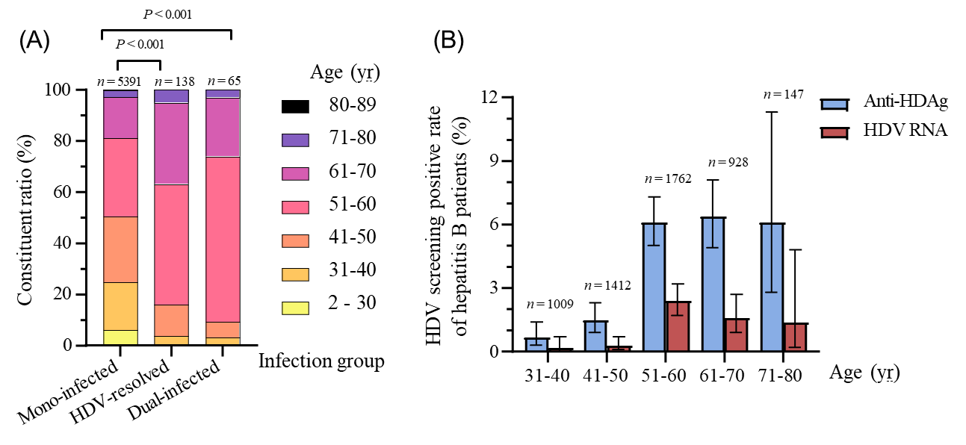
Figure 1 Constituent ratio of age among three infection groups’ patients and the hepatitis D virus screening positive rate of hepatitis B patients with different age. A and B: Age was compared using Kruskal-Wallis test, error bars represent 95% confidence interval. Note: The screening positive rate of hepatitis D virus in patients who were 30 years old or younger, and who were over 80 years old were 0.0%, and not shown in figure 1B. HDAg: Hepatitis D antigen; HDV: Hepatitis D virus.

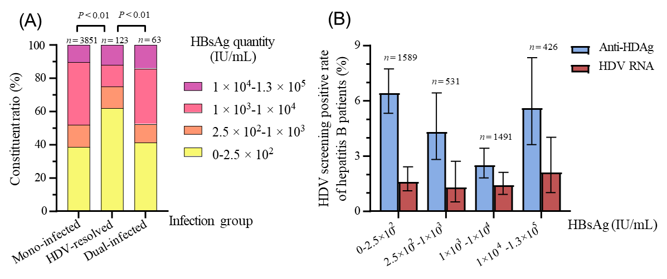
Figure 2 Constituent ratio of hepatitis B surface antigen among three infection groups’ patients and the hepatitis D virus screening positive rate of hepatitis B patients with different hepatitis B surface antigen. A and B: Hepatitis B surface antigen (HBsAg) was compared using Kruskal-Wallis test, error bars represent 95% confidence interval. HBsAg: Hepatitis B surface antigen; HDAg: Hepatitis D antigen; HDV: Hepatitis D virus.

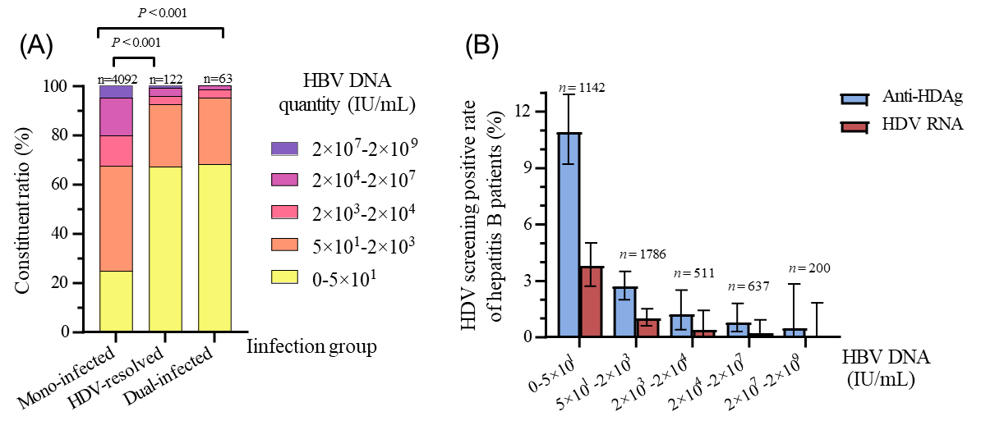
Figure 3 Constituent ratio of hepatitis B virus DNA among three infection groups’ patients and the hepatitis D virus screening positive rate of hepatitis B patients with different hepatitis B virus DNA. A and B: Hepatitis B virus DNA was compared using Kruskal-Wallis test, error bars represent 95% confidence interval. HBV: Hepatitis B virus; HDV: Hepatitis D virus.

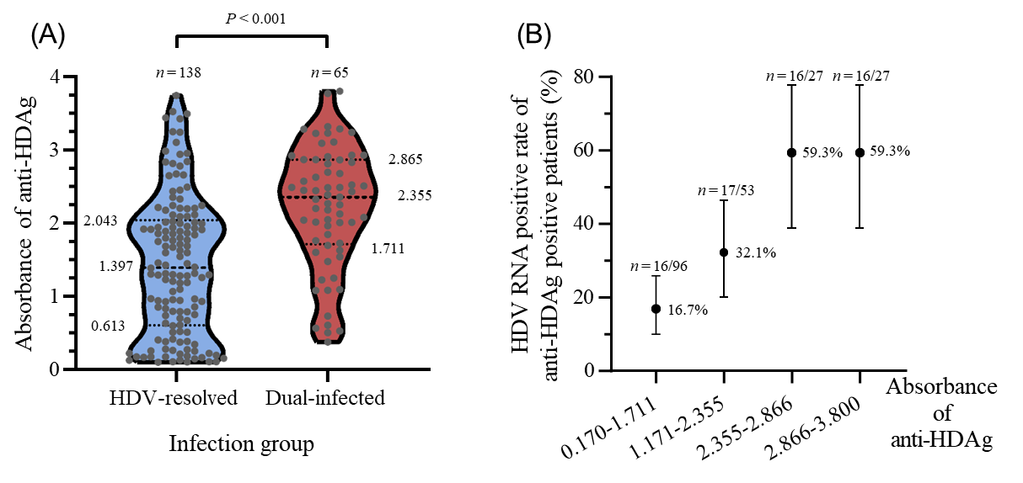
Figure 4 Distribution of anti-hepatitis D antigen among two infection groups’ patients and hepatitis D virus RNA positive rate of patients with different anti-HDAg. A and B: Anti-hepatitis D antigen was compared using Mann-Whitney U test, error bars represent 95% confidence interval. HDAg: Hepatitis D antigen; HDV: Hepatitis D virus.

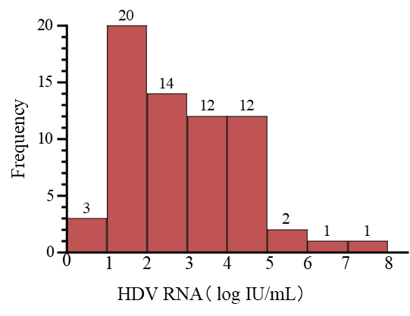
Figure 5 Distribution of the hepatitis D virus RNA among hepatitis B virus-hepatitis D virus dual-infected patients. HDV: Hepatitis D virus.

Table 1 Differences in the positive rate of hepatitis D virus between gender
 | Male |  |  | Female
 | +/total | % | 95%CI | +/total | % | 95%CI
Anti-HDAg screening positive rate among hepatitis B patients | 125/3293 | 3.8 | 3.2-4.5 | 78/2301 | 3.4 | 2.7-4.2
HDV RNA screening positive rate among hepatitis B patients | 39/3293 | 1.2 | 0.8-1.6 | 26/2301 | 1.1 | 0.7-1.7
HDV RNA positive rate among anti-HDAg positive patients | 39/125 | 31.2 | 23.2-40.1 | 26/78 | 33.3 | 23.1-44.9
HDAg: Hepatitis D antigen; HBV: Hepatitis B virus; HDV: Hepatitis D virus; 95%CI: 95% confidence interval.

