Name of Journal: World Journal of Orthopedics
Manuscript NO: 46981
Manuscript Type: ORIGINAL ARTICLE

Randomized Controlled Trial
Single- and double-dose of platelet-rich plasma versus hyaluronic acid for treatment of knee osteoarthritis: A randomized controlled trial

Tavassoli M et al. PRP vs hyaluronic acid for knee osteoarthritis treatment

Mehdi Tavassoli, Nasser Janmohammadi, Akram Hosseini, Soraya Khafri, Seyed Mokhtar Esmaeilnejad-Ganji

Mehdi Tavassoli, Student Research Committee, School of Medicine, Babol University of Medical Sciences, Babol 47176-47745, Iran

Nasser Janmohammadi, Department of Orthopedics, Babol University of Medical Sciences, Babol 47176-47745, Iran

Akram Hosseini, Department of Pathology, Faculty of Medicine, Babol University of Medical Sciences, Babol 47176-47745, Iran

Soraya Khafri, Biostatistics and Epidemiology Department, Medicine Faculty, Babol University of Medical Sciences, Babol 47176-47745, Iran

Seyed Mokhtar Esmaeilnejad-Ganji, Clinical Research Development Center, Shahid Beheshti Hospital, Babol University of Medical Sciences, Babol 47176-47745, Iran

ORICD number: Mehdi Tavassoli (0000-0001-7790-9237); Nasser Janmohammadi (0000-0002-8451-373X); Akram Hosseini (0000-0001-8697-9122); Soraya Khafri (0000-0002-2398-7560); Seyed Mokhtar Esmaeilnejad-Ganji (0000-0001-7562-0835).

Author contributions: Tavassoli M and Esmaeilnejad-Ganji SM contributed in study design; Janmohammadi N, Hosseini A and Khafri S contributed in advising on study design; Tavassoli M and Esmaeilnejad-Ganji SM contributed to data collection; Khafri S contributed in data analysis; Tavassoli M and Hosseini A contributed in writing the draft; Esmaeilnejad-Ganji SM and Janmohammadi N contributed in manuscript revision; all authors approved the final version of the manuscript.

Supported by Vice Chancellor for Research and Technology of Babol University of Medical Sciences, No. 970568.

Institutional review board statement: This study was reviewed and approved by the Ethical Research Committee of Babol University of Medical Sciences (code: IR.MUBABOL.HRI.REC.1397.082).

Clinical trial registration statement: This trial was registered in the Iranian Registry of Clinical Trials with the number IRCT20180129038548N1.

Informed consent statement: All study participants provided informed written consent prior to study enrollment.

Conflict-of-interest statement: All authors declare that they have no conflict of interest to declare.

CONSORT 2010 statement: The manuscript was prepared and revised according to the CONSORT 2010 Statement.

Open-Access: This article is an open-access article that was selected by an in-house editor and fully peer-reviewed by external reviewers. It is distributed in accordance with the Creative Commons Attribution Non Commercial (CC BY-NC 4.0) license, which permits others to distribute, remix, adapt, build upon this work non-commercially, and license their derivative works on different terms, provided the original work is properly cited and the use is non-commercial. See: http://creativecommons.org/licenses/by-nc/4.0/

Manuscript source: Unsolicited manuscript

Corresponding author: Seyed Mokhtar Esmaeilnejad-Ganji, MD, Associate Professor, Department of Orthopedics, Babol University of Medical Sciences, Ganjafrooz Street, Babol 47176-47745, Mazandaran, Iran. smsnganji@yahoo.com
Telephone: +98-11-32199936
Fax: +98-11-32190181

Received: March 6, 2019
Peer-review started: March 8, 2019
First decision: April 16, 2019
Revised: May 10, 2019
Accepted: August 12, 2019
Article in press:
Published online:

Abstract
BACKGROUND
Platelet-rich plasma (PRP) and hyaluronic acid have been shown to be useful in the treatment of knee osteoarthritis. However, investigations comparing the efficacy of these two drugs together are insufficient.

AIM
To compare the outcomes of PRP vs hyaluronic acid injections in three groups of patients with bilateral knee osteoarthritis.

METHODS
This randomized controlled trial study involved 95 patients. Thirty-one subjects received a single injection of PRP (group PRP-1), 33 subjects received two injections of PRP at an interval of 3 wk (group PRP-2) and 31 subjects received three injections of hyaluronic acid at 1-wk intervals (group hyaluronic acid). The patients were investigated prospectively at the enrollment and at 4-, 8- and 12-wk follow-up with the Western Ontario and McMaster Universities Arthritis Index (WOMAC) and Visual Analogue Scale questionnaires.

RESULTS
Percentages of patients experiencing at least a 30% decrease in the total score for the WOMAC pain subscale from baseline to wk 12 of the intervention were 86%, 100% and 0% in the groups PRP-1, PRP-2 and hyaluronic acid, respectively (p < 0.001). The mean total WOMAC scores for groups PRP-1, PRP-2 and hyaluronic acid at baseline were 63.71, 61.57 and 63.11, respectively. The WOMAC scores were significantly improved at final follow-up to 42.5, 35.32 and 57.26, respectively. The highest efficacy of PRP was observed in both groups at wk 4 with about 50% decrease in the symptoms compared with about 25% decrease for hyaluronic acid. Group PRP-2 had higher efficacy than group PRP-1. No major adverse effects were found during the study.

CONCLUSION
PRP is a safe and efficient therapeutic option for treatment of knee osteoarthritis. It was demonstrated to be significantly better than hyaluronic acid. We also found that the efficacy of PRP increases after multiple injections.

Key words: Platelet-rich plasma; hyaluronic acid; osteoarthritis; knee; pain

© The Author(s) 2019. Published by Baishideng Publishing Group Inc. All rights reserved.

Core tip: Studies comparing the efficacy of platelet-rich plasma (PRP) and hyaluronic acid in treatment of knee osteoarthritis are insufficient. In this randomized controlled trial study, we compared the outcomes of PRP versus hyaluronic acid injections in three groups of patients with bilateral knee osteoarthritis. It was observed that PRP is significantly more efficient than hyaluronic acid. We also found that the efficacy of PRP increases after multiple injections. PRP was a safe treatment in our study, and no major adverse effects were found.

Tavassoli M, Janmohammadi N, Hosseini A, Khafri S, Esmaeilnejad-Ganji SM. Single- and double-dose of platelet-rich plasma versus hyaluronic acid for treatment of knee osteoarthritis: A randomized controlled trial. World J Orthop 2019; In press

INTRODUCTION
Osteoarthritis is the most common articular disease, and it is an important cause of disability in the elderly^{[1,2]}. The knee is the most frequent joint affected by osteoarthritis^{[3]}. Osteoarthritis is a multifactorial chronic disease that starts with breakdown of joint cartilage and leads to decrease in joint space, subchondral sclerosis, synovitis and peripheral osteophytes formation^{[4,5]}. It was estimated that more than 10% of the people aged ≥ 60 years suffer from this disease, and it is a major expense for all healthcare systems^{[6,7]}. Clinical manifestations of the disease include functional pain and joint stiffness. Morning stiffness usually lasts less than 30 min followed by gel phenomenon that is a transient joint stiffness due to short-term immobility^{[8,9]}.
Current treatments for osteoarthritis include non-pharmacologic treatment, such as physical activity^{[10-12]}, and pharmacologic treatment, such as non-steroidal anti-inflammatory drugs, glucocorticoids and hyaluronic acid. These treatments aim to decrease pain and inflammation, but these drugs have restricted and short-term effects on control of symptoms and the patient’s quality of life^{[13,14]}. Platelet-rich plasma (PRP) is a plasma that is prepared from each patient’s own blood, and it has a higher platelet concentration in comparison to normal plasma. PRP injection is a simple, low cost and minimally invasive procedure that provides concentrated growth factors for use as an intra-articular injection^{[15]}. These growth factors are said to stimulate the healing of cartilage and thus improve arthritis^{[16,17]}. Some studies alluded to the potential effect of PRP in treatment of chronic tendonitis, tennis elbow, chronic rotator cuff tendinopathy, jumper’s knee, acute Achilles tendon rupture, muscle rupture, osteochondritis and osteoarthritis and meniscus repair^{[18-22]}. The positive effects of PRP in improvement of knee osteoarthritis have been reported in some studies^{[23-26]}. Studies have reported the effects of PRP on the proliferation of mesenchymal root cells and their chondrocyte differentiation in an in vitro environment^{[27,28]}, but evidence about the clinical use of PRP in the treatment of knee osteoarthritis is still insufficient.
Hyaluronic acid is a polysaccharide compound that includes glucuronic acid and acetylglucosamine. In osteoarthritis, the concentration and molecular weight of hyaluronic acid are reduced, and this is the basis of hyaluronic acid injection. Hyaluronic acid provides viscoelasticity of synovial fluid and stimulates formation of endogenous hyaluronic acid^{[29,30]}. In addition to its effects on viscoelasticity, hyaluronic acid may be effective for the treatment of osteoarthritis by biochemical effects, such as stimulation of formation and accumulation of proteoglycan, inhibition of inflammatory mediators and analgesic effect^{[29,31,32]}. However, because there are inadequate data on the effects of either different doses of PRP or hyaluronic acid in patients with osteoarthritis, we aimed in this study to compare the therapeutic efficacy of intra-articular injection of two different doses of PRP versus hyaluronic acid in the management of patients with osteoarthritis of the knee.

MATERIALS AND METHODS
This single-blinded parallel randomized controlled trial study was conducted on patients aged 40- to 80-years-old with knee osteoarthritis who were referred in 2018 to Shahid Beheshti teaching hospital affiliated to Babol University of Medical Sciences, Babol, Northern Iran.
The inclusion criteria were as follows: (1) patients with diagnosis of knee osteoarthritis as defined by the criteria of the American College of Rheumatology^{[33]}; (2) patients who were staged using the Ahlback radiological grading; (3) patients having bilateral knee osteoarthritis with the same Ahlback grade; and (4) all knees with full range of motion.
The exclusion criteria were as follows: (1) history of diabetes; (2) history of other joint diseases in the knee, such as rheumatoid arthritis or gout; (3) history of knee surgery; (4) history of knee fracture; (5) intra-articular injection of corticosteroids during the previous 2 wk; (6) intra-articular injection of other drugs, such as hyaluronic acid over the previous 1 year; (7) contraindications for intra-articular injection, such as thrombocytopenia, coagulopathy, articular infection of knee, skin infection in the injection site, impairment of immunity (e.g., acquired immune deficiency syndrome or receiving immunosuppressive medication) and severe intra-articular effusion (in this case, intra-articular injection was started after treatment and cure of effusion); and (8) patients with Ahlback grade 3 or more.
All of the patients were examined by the senior orthopedic surgeon, who was blinded to the intervention groups. Plain radiographs were then taken of the knees with anterior-posterior and lateral views. Drug treatments (such as non-steroidal anti-inflammatory drugs, corticosteroids and other anti-inflammatory drugs) and non-drug treatments (knee physiotherapy with modalities, such as transcutaneous electrical nerve stimulation, laser, etc) were stopped for the 48 h before study interventions.
Ahlback radiological grading of knee osteoarthritis is classified as follows^{[34,35]}: I: joint space narrowing < 3 mm; II: joint space obliterated or almost obliterated; III: minor bone attrition (< 5 mm); IV: moderate bone attrition (5–15 mm); and V: severe bone attrition (> 15 mm).
The patients’ information was collected by a checklist, including age, gender, weight, height, body mass index and Ahlback grade. All necessary laboratory tests (complete blood count, erythrocyte sedimentation rate, C-reactive protein) were conducted in the laboratory of Shahid Beheshti hospital.

Outcome measures
For the evaluation of function in all patients, the Persian version of the Western Ontario and McMaster Universities Arthritis Index (WOMAC) and Visual Analogue Scale (VAS) questionnaires were completed by an interview performed by the resident doctor in orthopedic surgery. The WOMAC index consists of 27 questions about three parameters, including pain (five questions), stiffness (two questions) and physical function (twenty questions). Each question is scored from 0 (none) to 4 (extreme). The sum of scores of subscales is the total WOMAC score (ranging from 0 to 108). Higher scores indicated worse conditions. Validity and reliability of WOMAC for knee osteoarthritis have been documented in Iran^{[36,37]}. The VAS index also assessed the patients’ pain. Its scores range from 0 (no pain) to 10 (worst possible pain)^{[38,39]}.
The primary outcome for this study was defined as the percentage of patients experiencing at least a 30% decrease in the summed score for the WOMAC pain subscale from baseline to wk 12 of the intervention. Generally, clinically meaningful pain relief is defined as ≥ 30% reduction in pain intensity from baseline^{[40, 41]}. The secondary outcomes included change in joint stiffness, physical function and total WOMAC. We also evaluated the patients for pain by VAS score, and this was a secondary outcome. Additionally, we assessed a reduction of ≥ 50% in the scales as another secondary outcome. These data were recorded before injection and at 4 wk, 8 wk and 12 wk after injection.

Sample size calculation
The sample size was estimated as at least 30 patients in each group by a superiority margin of δ = -0.15 that was based on clinical judgement with 80% power, type I error rate of 5% and percentage drop of 10%. The proportion of the primary study outcome in PRP single-dose and hyaluronic acid groups was considered as 35% and 20%.

PRP preparation
The PRP preparation was performed by the Rooyagen kit (Arya Mabna Tashkhis Corporation, Tehran, Iran). For preparation of the PRP, about 40 mL of venous blood was drawn from antecubital vein with an 18-gauge needle. Then 5 mL acid-citrate-dextrose solution was added as an anticoagulant. The blood sample was then centrifuged for 15 min at 1500 rpm, leading to two different layers, including RBC sediment (inferior layer) and plasma (superior layer). The plasma was separated and then centrifuged for 7 min at 3500 rpm, which created two new (superior and inferior) layers with the lower white sediment containing platelets. Then the upper layer was removed, and the remaining 4-6 mL was mixed with the white platelet sediment by shaking. The final product was 4-6 mL of PRP. A laboratory analyzer Sysmex KX 21 (Sysmex Corporation, Kobe, Japan) assessed the quality and quantity of each batch of PRP.

Randomization and intervention
The subjects included in the study were divided by random allocation using computer generated numbers into three groups: (1) group PRP-1 with 31 participants (62 knees) who received a single injection of PRP; (2) group PRP-2 with 33 participants (66 knees) who received two injections of PRP; and (3) group hyaluronic acid with 31 participants (62 knees) who received three injections of hyaluronic acid.
Each patient received the same randomized intra-articular injection into both knees. The injection site on the skin was prepped and draped and under aseptic conditions. PRP was injected using a 22-gauge needle with classic inter-articular approach (through the superolateral corner of patella or mid-portion of patella while the knee is extended). After 15-20 min rest, the patients were asked to flex and extend their knees so that PRP was completely distributed in the joint before becoming a gel. For group PRP-2 (double-dose of PRP), the second injection was performed after an interval of 3 wk. Patients in group hyaluronic acid received three injections of Hyalgan brand hyaluronic acid as a prepared needle, which contains a high molecular weight (500-730 kilodalton) fraction of purified sodium hyaluronate (30 mg/2 mL). Three Hyalgan injections were performed at 1-wk intervals. Before starting each procedure, the patients were evaluated for range of motion on knee joints and also by VAS and WOMAC questionnaires. The patients could use acetaminophen tablets (325 mg) if they experienced pain during the study. They could not use this analgesia for at least 12 h before being examined for follow-up.

Statistical analysis
The collected data were analyzed using SPSS statistical software. The descriptive analysis was used for the determination of the frequency, percentages, mean and standard deviation. Normality of the data was tested using the Kolmogorov-Smirnov test. For comparing the data before and after the treatment with normal distribution, paired t-test, independent t-test and ANOVA test were applied. To assess the non-parametric data, Wilcoxon signed rank, Mann–Whitney and Kruskal–Wallis were used. Chi-square test was used for qualitative variables. A p-value of < 0.05 was considered to be significant in all tests. Linear and box plot charts were prepared to illustrate the results.

Ethical issues
The informed written consent was provided by all participants. The patients’ information was kept confidential. This study was approved by the Ethical Research Committee of Babol University of Medical Sciences (code: IR.MUBABOL.HRI.REC.1397.082). This trial was registered in the Iranian Registry of Clinical Trials with the number IRCT20180129038548N1.

RESULTS
A total of 129 patients were screened initially, of whom 34 were excluded due to failing to meet inclusion criteria or declining to participate. Finally, 95 patients underwent randomization. The flow of subjects from evaluation to participation is shown in the Consolidated Standards of Reporting Trials diagram (Figure 1). Three patients from group PRP-1, five patients from group PRP-2 and four patients from group hyaluronic acid were lost during follow-up. Hence, the final study population for analysis contained 28 patients in groups PRP-1 and PRP-2 and 27 patients in group hyaluronic acid.
The baseline characteristics of the patients are shown in Table 1. There were no significant differences between the groups in age, gender, height, weight, BMI, Ahlback grading, WOMAC score and VAS pain score.

Clinical outcomes
The percentage of patients experiencing at least a 30% and/or 50% decrease in the summed score for VAS pain and all WOMAC subscales from baseline at each follow-up are shown in Table 2. Analysis of the primary outcome showed that the response rate to a single dose of PRP was 85.7% and to hyaluronic acid was 0% over the 12 wk of follow-up (p < 0.001). This significant difference was also observed when comparing first and second follow-up between the groups, and the two groups of PRP had a significantly higher response rate compared to the hyaluronic acid group. For group PRP-1, no significant differences were identified in the percentage of patients experiencing at least a 30% and/or 50% decrease in the summed score for the WOMAC pain subscale between knees with Ahlback grade 1 and 2 from baseline at each follow-up. It was observed for group II as well.
The mean scores for all WOMAC and VAS pain parameters decreased significantly in the three groups from baseline at wk 4. However, it started a slightly increasing trend thereafter. There were significant differences in percentage change in the mean scores from baseline to wk 4 between the three groups. Group PRP-2 had the highest decreases in the mean scores from baseline to wk 4, which were significantly higher than group PRP-1 and group hyaluronic acid. Group PRP-1 also had significant decreases in the mean scores in comparison with group hyaluronic acid at wk 4. Percentage change in the mean scores was highest in group PRP-2 compared with groups PRP-1 and hyaluronic acid and was significantly higher in group PRP-1 versus group hyaluronic acid at other follow-ups as well. The findings are shown in Table 3 and Figures 2-6.
Among the patients with Ahlback grade 1, the percentage change in scores from baseline for VAS pain score and all WOMAC subscales at each follow-up was significantly higher for group PRP-2 in comparison with group PRP-1. These differences were also found in the patients with Ahlback grade 2.
Over the study period, no major adverse events or complications were observed in the patients, and mild worsening of pain was noted in seven patients in the PRP groups, which was resolved by doses of acetaminophen.

DISCUSSION
In this study, we attempted to compare the clinical outcomes of PRP versus hyaluronic acid injections in patients with bilateral knee osteoarthritis. We divided patients with Ahlback grade 1 or 2 osteoarthritis into the three groups of single and double injection of PRP and three injections of hyaluronic acid. All the patients were followed-up for 3 mo. We used WOMAC and VAS pain scores to evaluate the clinical outcomes. We found that the efficacy of PRP (single or double injection) and hyaluronic acid started from intervention and continued until wk 4 and then started to decrease until wk 12. In other words, the highest efficacy of PRP was seen in both groups at wk 4 with about a 50% decrease in the symptoms compared with about a 25% decrease for those who had received hyaluronic acid. The efficacy of PRP treatment was significantly greater than the hyaluronic acid group at all follow-up times. In addition, two injections of PRP were more effective at each follow-up than a single injection. We did not witness any major complications during the follow-up. No similar studies exist from our region. Therefore, these data are beneficial in this point as well.
Few studies have been published comparing these treatments for osteoarthritis of the knee. In a recent systematic review, which collected the data related to the studies comparing outcomes between PRP and hyaluronic acid interventions, the reported studies were mostly in agreement with our research, showing that PRP injection is more effective for the treatment of osteoarthritis of the knee, especially in patients with lower grades of arthritis^{[42]}. Two articles did not show any superiority of treatment with PRP over hyaluronic acid^{[43,44]}. In our investigation, the trend of efficacy of PRP was demonstrated to continue until the first month after treatment with a decline thereafter. However, there was still a significant difference in the mean scores between follow-ups and baseline. However, in the study by Cerza et al^{[45]}, this benefit continued until the last follow-up at mo 6 without an eventual decline in efficacy. The systematic review by Di et al^{[42]}, showed that PRP could improve the WOMAC score at a minimum of 24 wk. However, PRP had no benefit over the control group when assessed by other pain measures, such as the International Knee Documentation Committee, the Knee Injury and Osteoarthritis Outcome Score and VAS^{[42]}. When reviewing the literature, it becomes clear that there are variations between the individual studies in terms of number of patients, grading of osteoarthritis (Kellgren-Lawrence^{[30,43-47]} or Ahlback^{[48]} classification), length of follow-up (variable between 6 mo^{[30,45,48]} and 12 mo^{[43,44,46,47]}, outcome scores used (WOMAC, Lequesne^{[45-49]}, VAS, the Knee Injury and Osteoarthritis Outcome Score^{[15,30,44,48,49]} and number of PRP injections (one^{[15]}, two^{[46]}, three^{[30,43,44,47,48]} or four^{[45]}). Hence, the results can only be compared with caution.
One of the mechanisms by which PRP could improve the osteoarthritis of the knee is reported to be its anti-inflammatory effect. It has been shown that PRP can decrease the pro-inflammatory cytokines of interleukin-1 beta and tumor necrosis factor-alpha^{[50]}. Leukocytes in PRP have been thought to have a role in anti-inflammatory activity, immune regulation and promotion of angiogenesis^{[51]}. However, potential harmful effects of leukocytes on cartilage regeneration through the NF-κB pathway (a major pathway involved in the pathogenesis of osteoarthritis) have also been noted^{[52]}. Therefore, further experimental and clinical studies are needed to clarify this molecular mechanism of PRP against osteoarthritis. It has been demonstrated that inactivated PRP increased formation of bone and cartilage in vitro and in vivo. Non-activated PRP was also reported to have an anabolic effect on proliferation of mesenchymal stem cells^{[53]}. In addition, thrombin activation of PRP has an inhibitory action on chondrogenesis and osteogenesis^{[54]}. Growth factors in PRP potentially affect tissue repair and growth through immigration and cell proliferation, angiogenesis, collagen production and stimulation of articular cartilage anabolism. They may slow down the catabolic process and decrease the synovial membrane hyperplasia^{[55,56]}. It was pointed out that plasma rich in growth factors may also decrease NF-kB activation^{[57]}. Additionally, platelet-derived growth factor has been stated to promote chondrocyte proliferation and the maintenance of their hyaline-like phenotype^{[47]}. Fibrin is another factor that exists in PRP, which is used as a network for the differentiation of root cells and biological glue^{[58,59]}.
One limitation of the present study is the lack of a control group that was treated with corticosteroids for comparison. The second one is the short-time period of study. Future studies with longer follow-up are suggested to evaluate long-term efficacy and potential compactions. We also propose that future studies use magnetic resonance imaging to assess and quantify cartilage regeneration, if costs and ethical issues allow.
In conclusion, the results of this study showed that PRP is a safe and efficient therapeutic option for treatment of early stages of knee osteoarthritis by reducing the symptoms and recovering articular function. PRP was indicated to be significantly better than hyaluronic acid. We also found that the efficacy of PRP increases after multiple injections. More studies with longer follow-up and a double-blind comparison of PRP with corticosteroids are suggested for the future.

ARTICLE HIGHLIGHTS
Research background
Knee osteoarthritis is the most common articular disease that manifests as functional pain and joint stiffness, leading to disability in the elderly. More than 10% of the people aged ≥ 60 years suffer from this disease.

Research motivation
Hyaluronic acid is a therapeutic option for knee osteoarthritis. However, it has short-term effects on control of symptoms. Platelet-rich plasma (PRP) is also suggested for treatment of knee osteoarthritis. However, evidence about the clinical use of PRP is still insufficient. Investigations comparing the efficacy of these two drugs together are also insufficient.

Research objectives
The objective of this study was to compare the therapeutic efficacy of intra-articular injection of two different doses of PRP versus hyaluronic acid in three groups of patients with knee osteoarthritis.

Research methods
This single-blinded randomized controlled trial study involved 95 patients with bilateral knee osteoarthritis. Thirty-one subjects received a single injection of PRP (group PRP-1), 33 subjects received two injections of PRP at an interval of 3 wk (group PRP-2) and 31 subjects received three injections of hyaluronic acid at 1-wk intervals (group hyaluronic acid). The patients were investigated prospectively at the enrollment and at 4-, 8- and 12-wk follow-up with the Western Ontario and McMaster Universities Arthritis Index and Visual Analogue Scale questionnaires.

Research results
In the groups PRP-1, PRP-2 and hyaluronic acid, 86%, 100% and 0% of the patients, respectively experienced at least a 30% decrease in the total score for the Western Ontario and McMaster Universities Arthritis Index pain subscale from baseline to wk 12 of the intervention (p < 0.001). The mean total Western Ontario and McMaster Universities Arthritis Index scores for groups PRP-1, PRP-2 and hyaluronic acid at baseline were 63.71, 61.57 and 63.11, respectively, which were significantly improved at final follow-up to 42.5, 35.32 and 57.26, respectively. The highest efficacy of PRP was observed in both groups at wk 4 with about a 50% decrease in the symptoms compared with about a 25% decrease for the hyaluronic acid group. Group PRP-2 had higher efficacy than group PRP-1. No major adverse effects were found during the study.

Research conclusions
PRP is a safe and efficient therapeutic option for treatment of knee osteoarthritis (significantly better than hyaluronic acid). The efficacy of PRP increases after multiple injections.

Research perspectives
Future studies with longer follow-up are suggested to evaluate long-term efficacy and potential compactions. We also propose that future studies use magnetic resonance imaging to assess and quantify cartilage regeneration if costs and ethical issues allow.

ACKNOWLEDGEMENTS
The authors would like to thank Mr. Mohammad Zamani, a member of Student Research Committee of Babol University of Medical Sciences, for his help in statistical analyses and data interpretation. We are also thankful to the Vice Chancellor for Research and Technology of Babol University of Medical Sciences for supporting our study.

References
1 Migliore A, Giovannangeli F, Granata M, Laganà B. Hylan g-f 20: review of its safety and efficacy in the management of joint pain in osteoarthritis. Clin Med Insights Arthritis Musculoskelet Disord 2010; 3: 55-68 [PMID: 21151854 DOI: 10.1177/117954411000300001]
2 Neogi T. The epidemiology and impact of pain in osteoarthritis. Osteoarthritis Cartilage 2013; 21: 1145-1153 [PMID: 23973124 DOI: 10.1016/j.joca.2013.03.018]
3 Wood AM, Brock TM, Heil K, Holmes R, Weusten A. A Review on the Management of Hip and Knee Osteoarthritis. Int J Chronic Dis 2013; 2013: 845015 [PMID: 26464847 DOI: 10.1155/2013/845015]
4 Chen D, Shen J, Zhao W, Wang T, Han L, Hamilton JL, Im HJ. Osteoarthritis: toward a comprehensive understanding of pathological mechanism. Bone Res 2017; 5: 16044 [PMID: 28149655 DOI: 10.1038/boneres.2016.44]
5 Man GS, Mologhianu G. Osteoarthritis pathogenesis - a complex process that involves the entire joint. J Med Life 2014; 7: 37-41 [PMID: 24653755]
6 Zhang Y, Jordan JM. Epidemiology of osteoarthritis. Clin Geriatr Med 2010; 26: 355-369 [PMID: 20699159 DOI: 10.1016/j.cger.2010.03.001]
7 Bitton R. The economic burden of osteoarthritis. Am J Manag Care 2009; 15: S230-S235 [PMID: 19817509]
8 Abhishek A, Doherty M. Diagnosis and clinical presentation of osteoarthritis. Rheum Dis Clin North Am 2013; 39: 45-66 [PMID: 23312410 DOI: 10.1016/j.rdc.2012.10.007]
9 Herrero-Beaumont G, Roman-Blas JA, Bruyère O, Cooper C, Kanis J, Maggi S, Rizzoli R, Reginster JY. Clinical settings in knee osteoarthritis: Pathophysiology guides treatment. Maturitas 2017; 96: 54-57 [PMID: 28041596 DOI: 10.1016/j.maturitas.2016.11.013]
10 Castrogiovanni P, Di Rosa M, Ravalli S, Castorina A, Guglielmino C, Imbesi R, Vecchio M, Drago F, Szychlinska MA, Musumeci G. Moderate Physical Activity as a Prevention Method for Knee Osteoarthritis and the Role of Synoviocytes as Biological Key. Int J Mol Sci 2019; 20: [PMID: 30691048 DOI: 10.3390/ijms20030511]
11 Musumeci G, Castrogiovanni P, Trovato FM, Imbesi R, Giunta S, Szychlinska MA, Loreto C, Castorina S, Mobasheri A. Physical activity ameliorates cartilage degeneration in a rat model of aging: a study on lubricin expression. Scand J Med Sci Sports 2015; 25: e222-e230 [PMID: 25039883 DOI: 10.1111/sms.12290]
12 Szychlinska MA, Castrogiovanni P, Trovato FM, Nsir H, Zarrouk M, Lo Furno D, Di Rosa M, Imbesi R, Musumeci G. Physical activity and Mediterranean diet based on olive tree phenolic compounds from two different geographical areas have protective effects on early osteoarthritis, muscle atrophy and hepatic steatosis. Eur J Nutr 2019; 58: 565-581 [PMID: 29450729 DOI: 10.1007/s00394-018-1632-2]
13 Ringdahl E, Pandit S. Treatment of knee osteoarthritis. Am Fam Physician 2011; 83: 1287-1292 [PMID: 21661710]
14 Reid MC, Shengelia R, Parker SJ. Pharmacologic management of osteoarthritis-related pain in older adults. Am J Nurs 2012; 112: S38-S43 [PMID: 22373746 DOI: 10.1097/01.NAJ.0000412650.02926.e3]
15 Say F, Gürler D, Yener K, Bülbül M, Malkoc M. Platelet-rich plasma injection is more effective than hyaluronic acid in the treatment of knee osteoarthritis. Acta Chir Orthop Traumatol Cech 2013; 80: 278-283 [PMID: 24119476]
16 Dhillon MS, Patel S, John R. PRP in OA knee - update, current confusions and future options. SICOT J 2017; 3: 27 [PMID: 28322719 DOI: 10.1051/sicotj/2017004]
17 Glynn LG, Mustafa A, Casey M, Krawczyk J, Blom J, Galvin R, Hannigan A, Dunne CP, Murphy AW, Mallen C. Platelet-rich plasma (PRP) therapy for knee arthritis: a feasibility study in primary care. Pilot Feasibility Stud 2018; 4: 93 [PMID: 29997901 DOI: 10.1186/s40814-018-0288-2]
18 Mishra A, Woodall J Jr, Vieira A. Treatment of tendon and muscle using platelet-rich plasma. Clin Sports Med 2009; 28: 113-125 [PMID: 19064169 DOI: 10.1016/j.csm.2008.08.007]
19 Knop E, Paula LE, Fuller R. Platelet-rich plasma for osteoarthritis treatment. Rev Bras Reumatol Engl Ed 2016; 56: 152-164 [PMID: 27267529 DOI: 10.1016/j.rbre.2015.07.002]
20 Hamid MS, Yusof A, Mohamed Ali MR. Platelet-rich plasma (PRP) for acute muscle injury: a systematic review. PLoS One 2014; 9: e90538 [PMID: 24587389 DOI: 10.1371/journal.pone.0090538]
21 Blanke F, Vavken P, Haenle M, von Wehren L, Pagenstert G, Majewski M. Percutaneous injections of Platelet rich plasma for treatment of intrasubstance meniscal lesions. Muscles Ligaments Tendons J 2015; 5: 162-166 [PMID: 26605189 DOI: 10.11138/mltj/2015.5.3.162]
22 Andia I, Latorre PM, Gomez MC, Burgos-Alonso N, Abate M, Maffulli N. Platelet-rich plasma in the conservative treatment of painful tendinopathy: a systematic review and meta-analysis of controlled studies. Br Med Bull 2014; 110: 99-115 [PMID: 24795364 DOI: 10.1093/bmb/ldu007]
23 Patel S, Dhillon MS, Aggarwal S, Marwaha N, Jain A. Treatment with platelet-rich plasma is more effective than placebo for knee osteoarthritis: a prospective, double-blind, randomized trial. Am J Sports Med 2013; 41: 356-364 [PMID: 23299850 DOI: 10.1177/0363546512471299]
24 Filardo G, Kon E, Pereira Ruiz MT, Vaccaro F, Guitaldi R, Di Martino A, Cenacchi A, Fornasari PM, Marcacci M. Platelet-rich plasma intra-articular injections for cartilage degeneration and osteoarthritis: single- versus double-spinning approach. Knee Surg Sports Traumatol Arthrosc 2012; 20: 2082-2091 [PMID: 22203046 DOI: 10.1007/s00167-011-1837-x]
25 Meheux CJ, McCulloch PC, Lintner DM, Varner KE, Harris JD. Efficacy of Intra-articular Platelet-Rich Plasma Injections in Knee Osteoarthritis: A Systematic Review. Arthroscopy 2016; 32: 495-505 [PMID: 26432430 DOI: 10.1016/j.arthro.2015.08.005]
26 Görmeli G, Görmeli CA, Ataoglu B, Çolak C, Aslantürk O, Ertem K. Multiple PRP injections are more effective than single injections and hyaluronic acid in knees with early osteoarthritis: a randomized, double-blind, placebo-controlled trial. Knee Surg Sports Traumatol Arthrosc 2017; 25: 958-965 [PMID: 26233594 DOI: 10.1007/s00167-015-3705-6]
27 Rubio-Azpeitia E, Andia I. Partnership between platelet-rich plasma and mesenchymal stem cells: in vitro experience. Muscles Ligaments Tendons J 2014; 4: 52-62 [PMID: 24932448]
28 Stessuk T, Puzzi MB, Chaim EA, Alves PC, de Paula EV, Forte A, Izumizawa JM, Oliveira CC, Frei F, Ribeiro-Paes JT. Platelet-rich plasma (PRP) and adipose-derived mesenchymal stem cells: stimulatory effects on proliferation and migration of fibroblasts and keratinocytes in vitro. Arch Dermatol Res 2016; 308: 511-520 [PMID: 27394438 DOI: 10.1007/s00403-016-1676-1]
29 Altman RD, Manjoo A, Fierlinger A, Niazi F, Nicholls M. The mechanism of action for hyaluronic acid treatment in the osteoarthritic knee: a systematic review. BMC Musculoskelet Disord 2015; 16: 321 [PMID: 26503103 DOI: 10.1186/s12891-015-0775-z]
30 Montañez-Heredia E, Irízar S, Huertas PJ, Otero E, Del Valle M, Prat I, Díaz-Gallardo MS, Perán M, Marchal JA, Hernandez-Lamas Mdel C. Intra-Articular Injections of Platelet-Rich Plasma versus Hyaluronic Acid in the Treatment of Osteoarthritic Knee Pain: A Randomized Clinical Trial in the Context of the Spanish National Health Care System. Int J Mol Sci 2016; 17: [PMID: 27384560 DOI: 10.3390/ijms17071064]
31 McArthur BA, Dy CJ, Fabricant PD, Valle AG. Long term safety, efficacy, and patient acceptability of hyaluronic acid injection in patients with painful osteoarthritis of the knee. Patient Prefer Adherence 2012; 6: 905-910 [PMID: 23271899 DOI: 10.2147/PPA.S27783]
32 Bowman EN, Hallock JD, Throckmorton TW, Azar FM. Hyaluronic acid injections for osteoarthritis of the knee: predictors of successful treatment. Int Orthop 2018; 42: 733-740 [PMID: 29299652 DOI: 10.1007/s00264-017-3731-8]
33 Altman R, Asch E, Bloch D, Bole G, Borenstein D, Brandt K, Christy W, Cooke TD, Greenwald R, Hochberg M. Development of criteria for the classification and reporting of osteoarthritis. Classification of osteoarthritis of the knee. Diagnostic and Therapeutic Criteria Committee of the American Rheumatism Association. Arthritis Rheum 1986; 29: 1039-1049 [PMID: 3741515 DOI: 10.1002/art.1780290816]
34 Köse Ö, Acar B, Çay F, Yilmaz B, Güler F, Yüksel HY. Inter- and Intraobserver Reliabilities of Four Different Radiographic Grading Scales of Osteoarthritis of the Knee Joint. J Knee Surg 2018; 31: 247-253 [PMID: 28460407 DOI: 10.1055/s-0037-1602249]
35 Ahlbäck S. Osteoarthrosis of the knee. A radiographic investigation. Acta Radiol Diagn (Stockh) 1968; Suppl 277: 7-72 [PMID: 5706059]
36 Nadrian H, Moghimi N, Nadrian E, Moradzadeh R, Bahmanpour K, Iranpour A, Bellamy N. Validity and reliability of the Persian versions of WOMAC Osteoarthritis Index and Lequesne Algofunctional Index. Clin Rheumatol 2012; 31: 1097-1102 [PMID: 22526476 DOI: 10.1007/s10067-012-1983-7]
37 Ebrahimzadeh MH, Makhmalbaf H, Birjandinejad A, Keshtan FG, Hoseini HA, Mazloumi SM. The Western Ontario and McMaster Universities Osteoarthritis Index (WOMAC) in Persian Speaking Patients with Knee Osteoarthritis. Arch Bone Jt Surg 2014; 2: 57-62 [PMID: 25207315]
38 Hawker GA, Mian S, Kendzerska T, French M. Measures of adult pain: Visual Analog Scale for Pain (VAS Pain), Numeric Rating Scale for Pain (NRS Pain), McGill Pain Questionnaire (MPQ), Short-Form McGill Pain Questionnaire (SF-MPQ), Chronic Pain Grade Scale (CPGS), Short Form-36 Bodily Pain Scale (SF-36 BPS), and Measure of Intermittent and Constant Osteoarthritis Pain (ICOAP). Arthritis Care Res (Hoboken) 2011; 63 Suppl 11: S240-S252 [PMID: 22588748 DOI: 10.1002/acr.20543]
39 Fadaizadeh L, Emami H, Samii K. Comparison of visual analogue scale and faces rating scale in measuring acute postoperative pain. Arch Iran Med 2009; 12: 73-75 [PMID: 19111034]
40 Rowbotham MC. What is a "clinically meaningful" reduction in pain? Pain 2001; 94: 131-132 [PMID: 11690725 DOI: 10.1016/S0304-3959(01)00371-2]
41 Salaffi F, Stancati A, Silvestri CA, Ciapetti A, Grassi W. Minimal clinically important changes in chronic musculoskeletal pain intensity measured on a numerical rating scale. Eur J Pain 2004; 8: 283-291 [PMID: 15207508 DOI: 10.1016/j.ejpain.2003.09.004]
42 Di Y, Han C, Zhao L, Ren Y. Is local platelet-rich plasma injection clinically superior to hyaluronic acid for treatment of knee osteoarthritis? A systematic review of randomized controlled trials. Arthritis Res Ther 2018; 20: 128 [PMID: 29921309 DOI: 10.1186/s13075-018-1621-0]
43 Filardo G, Di Matteo B, Di Martino A, Merli ML, Cenacchi A, Fornasari P, Marcacci M, Kon E. Platelet-Rich Plasma Intra-articular Knee Injections Show No Superiority Versus Viscosupplementation: A Randomized Controlled Trial. Am J Sports Med 2015; 43: 1575-1582 [PMID: 25952818 DOI: 10.1177/0363546515582027]
44 Filardo G, Kon E, Di Martino A, Di Matteo B, Merli ML, Cenacchi A, Fornasari PM, Marcacci M. Platelet-rich plasma vs hyaluronic acid to treat knee degenerative pathology: study design and preliminary results of a randomized controlled trial. BMC Musculoskelet Disord 2012; 13: 229 [PMID: 23176112 DOI: 10.1186/1471-2474-13-229]
45 Cerza F, Carnì S, Carcangiu A, Di Vavo I, Schiavilla V, Pecora A, De Biasi G, Ciuffreda M. Comparison between hyaluronic acid and platelet-rich plasma, intra-articular infiltration in the treatment of gonarthrosis. Am J Sports Med 2012; 40: 2822-2827 [PMID: 23104611 DOI: 10.1177/0363546512461902]
46 Raeissadat SA, Rayegani SM, Hassanabadi H, Fathi M, Ghorbani E, Babaee M, Azma K. Knee Osteoarthritis Injection Choices: Platelet- Rich Plasma (PRP) Versus Hyaluronic Acid (A one-year randomized clinical trial). Clin Med Insights Arthritis Musculoskelet Disord 2015; 8: 1-8 [PMID: 25624776 DOI: 10.4137/CMAMD.S17894]
47 Vaquerizo V, Plasencia MÁ, Arribas I, Seijas R, Padilla S, Orive G, Anitua E. Comparison of intra-articular injections of plasma rich in growth factors (PRGF-Endoret) versus Durolane hyaluronic acid in the treatment of patients with symptomatic osteoarthritis: a randomized controlled trial. Arthroscopy 2013; 29: 1635-1643 [PMID: 24075613 DOI: 10.1016/j.arthro.2013.07.264]
48 Sánchez M, Fiz N, Azofra J, Usabiaga J, Aduriz Recalde E, Garcia Gutierrez A, Albillos J, Gárate R, Aguirre JJ, Padilla S, Orive G, Anitua E. A randomized clinical trial evaluating plasma rich in growth factors (PRGF-Endoret) versus hyaluronic acid in the short-term treatment of symptomatic knee osteoarthritis. Arthroscopy 2012; 28: 1070-1078 [PMID: 22840987 DOI: 10.1016/j.arthro.2012.05.011]
49 Duymus TM, Mutlu S, Dernek B, Komur B, Aydogmus S, Kesiktas FN. Choice of intra-articular injection in treatment of knee osteoarthritis: platelet-rich plasma, hyaluronic acid or ozone options. Knee Surg Sports Traumatol Arthrosc 2017; 25: 485-492 [PMID: 27056686 DOI: 10.1007/s00167-016-4110-5]
50 Cole BJ, Karas V, Hussey K, Pilz K, Fortier LA. Hyaluronic Acid Versus Platelet-Rich Plasma: A Prospective, Double-Blind Randomized Controlled Trial Comparing Clinical Outcomes and Effects on Intra-articular Biology for the Treatment of Knee Osteoarthritis Am J Sports Med 2017; 45: 339-346 [PMID: 28146403 DOI: 10.1177/0363546516665809]
51 Everts PA, van Zundert A, Schönberger JP, Devilee RJ, Knape JT. What do we use: platelet-rich plasma or platelet-leukocyte gel? J Biomed Mater Res A 2008; 85: 1135-1136 [PMID: 17907242 DOI: 10.1002/jbm.a.31570]
52 Xu Z, Yin W, Zhang Y, Qi X, Chen Y, Xie X, Zhang C. Comparative evaluation of leukocyte- and platelet-rich plasma and pure platelet-rich plasma for cartilage regeneration. Sci Rep 2017; 7: 43301 [PMID: 28265109 DOI: 10.1038/srep43301]
53 Spaková T, Rosocha J, Lacko M, Harvanová D, Gharaibeh A. Treatment of knee joint osteoarthritis with autologous platelet-rich plasma in comparison with hyaluronic acid. Am J Phys Med Rehabil 2012; 91: 411-417 [PMID: 22513879 DOI: 10.1097/PHM.0b013e3182aab72]
54 Han B, Woodell-May J, Ponticiello M, Yang Z, Nimni M. The effect of thrombin activation of platelet-rich plasma on demineralized bone matrix osteoinductivity. J Bone Joint Surg Am 2009; 91: 1459-1470 [PMID: 19487525 DOI: 10.2106/JBJS.H.00246]
55 Kon E, Mandelbaum B, Buda R, Filardo G, Delcogliano M, Timoncini A, Fornasari PM, Giannini S, Marcacci M. Platelet-rich plasma intra-articular injection versus hyaluronic acid viscosupplementation as treatments for cartilage pathology: from early degeneration to osteoarthritis. Arthroscopy 2011; 27: 1490-1501 [PMID: 21831567 DOI: 10.1016/j.arthro.2011.05.011]
56 Leitner GC, Gruber R, Neumüller J, Wagner A, Kloimstein P, Höcker P, Körmöczi GF, Buchta C. Platelet content and growth factor release in platelet-rich plasma: a comparison of four different systems. Vox Sang 2006; 91: 135-139 [PMID: 16907874 DOI: 10.1111/j.1423-0410.2006.00815.x]
57 van Buul GM, Koevoet WL, Kops N, Bos PK, Verhaar JA, Weinans H, Bernsen MR, van Osch GJ. Platelet-rich plasma releasate inhibits inflammatory processes in osteoarthritic chondrocytes. Am J Sports Med 2011; 39: 2362-2370 [PMID: 21856929 DOI: 10.1177/0363546511419278]
58 Dohan Ehrenfest DM, Andia I, Zumstein MA, Zhang CQ, Pinto NR, Bielecki T. Classification of platelet concentrates (Platelet-Rich Plasma-PRP, Platelet-Rich Fibrin-PRF) for topical and infiltrative use in orthopedic and sports medicine: current consensus, clinical implications and perspectives. Muscles Ligaments Tendons J 2014; 4: 3-9 [PMID: 24932440 DOI: 10.11138/mltj/2014.4.1.0013]
59 Borie E, Oliví DG, Orsi IA, Garlet K, Weber B, Beltrán V, Fuentes R. Platelet-rich fibrin application in dentistry: a literature review. Int J Clin Exp Med 2015; 8: 7922-7929 [PMID: 26221349]

P-Reviewer: Musumeci G S-Editor: Gong ZM

L-Editor: Filipodia E-Editor:
Specialty type: Orthopedics
Country of origin: Iran
Peer-review report classification
Grade A (Excellent): 0
Grade B (Very good): B
Grade C (Good): 0
Grade D (Fair): 0
Grade E (Poor): 0

Allocated to intervention (n = 31 patients)
Received allocated intervention (n = 31 patients)
Did not receive allocated intervention (n= 0)
Allocated to intervention (n = 31 patients)
Received allocated intervention (n = 31 patients)
Did not receive allocated intervention (n = 0)
Allocated to intervention (n = 33 patients)
Received allocated intervention (n = 33 patients)
Did not receive allocated intervention (n = 0)
Lost to follow-up (give reasons) (n = 3 patients)
Discontinued intervention (n = 0)
Lost to follow-up (give reasons) (n = 4 patients)
Discontinued intervention (n = 0)

Lost to follow-up (give reasons) (n = 5 patients)
Discontinued intervention (n = 0)
Analyzed (n =28)
Analyzed (n = 27)

Analyzed (n = 28)

Assessed for eligibility (n = 129 patients)
Excluded (n = 34)
Not meeting inclusion criteria (n = 19)
Declined to participate (n = 15)
Randomized (n = 95)

Allocation

Analysis

Follow-up

Enrollment

Figure 1 CONSORT flowchart.

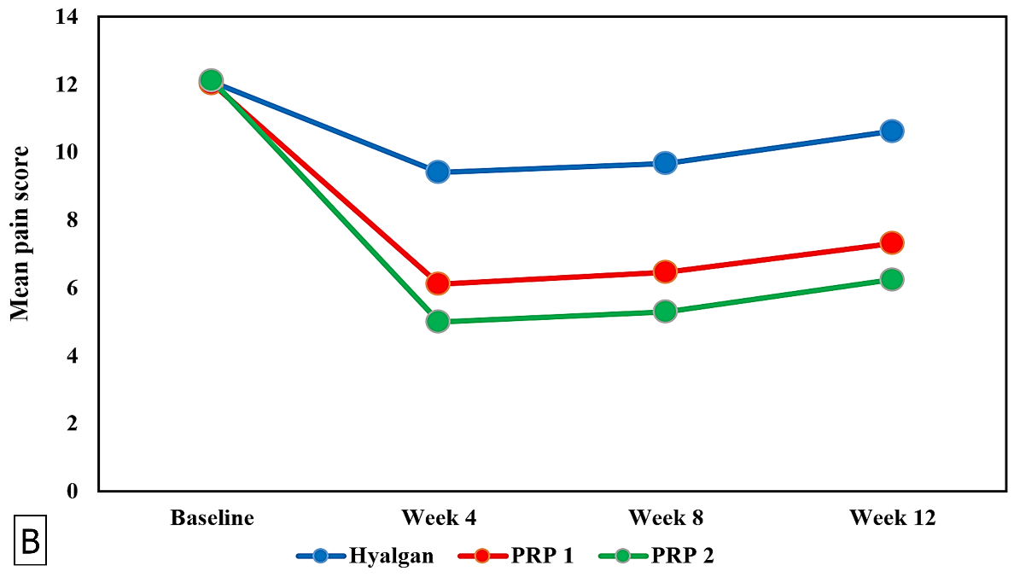
Figure 2 Comparison of the pain score indices between the three intervention groups at baseline and subsequent follow-ups. A: Comparison of the percentage change in pain from baseline to wk 4 (1st follow-up), wk 8 (2nd follow-up) and wk 12 (3rd follow-up) between the three groups; B: Comparison of the mean pain scores at baseline and subsequent follow-ups between the three groups. Negative shows a benefit from pre-treatment values.

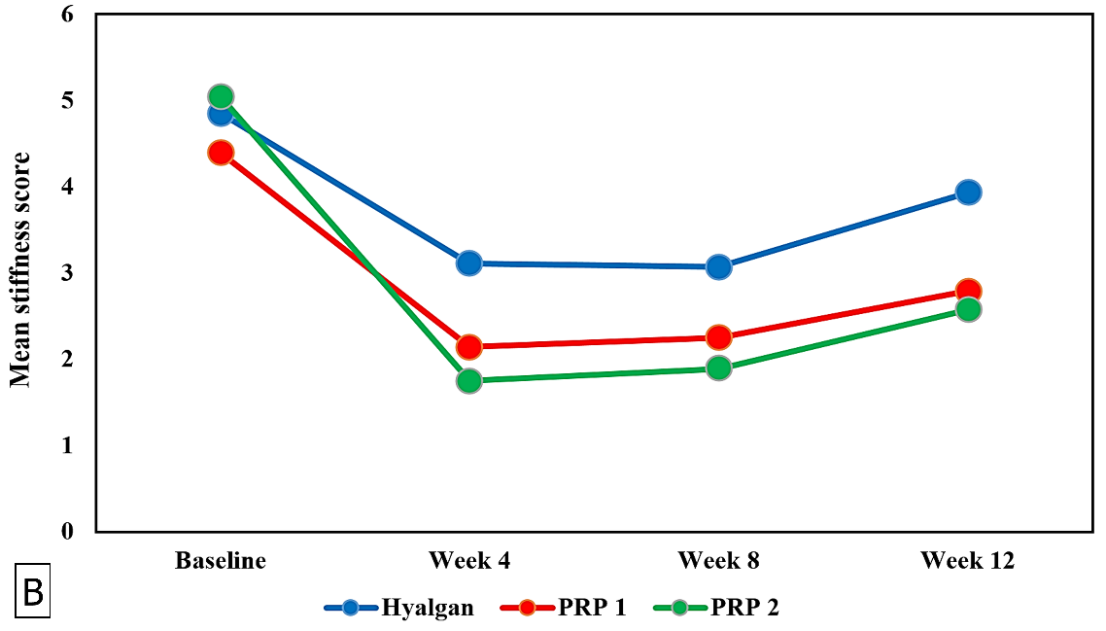
Figure 3 Comparison of the stiffness score indices between the three intervention groups at baseline and subsequent follow-ups. A: Comparison of the percentage change in stiffness from baseline to wk 4 (1st follow-up), wk 8 (2nd follow-up), and wk 12 (3rd follow-up) between the three groups; B: Comparison of the mean stiffness scores at baseline and subsequent follow-ups between the three groups. Negative shows a benefit from pre-treatment values.

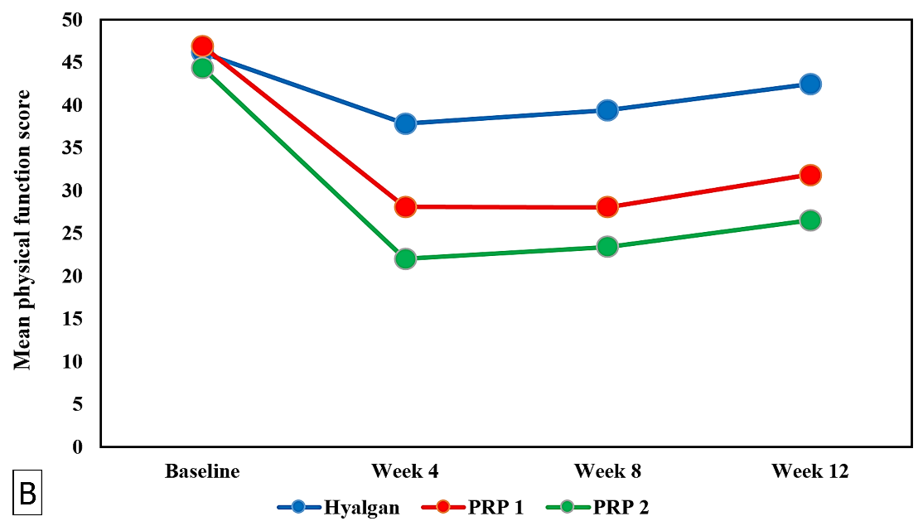
Figure 4 Comparison of the physical function score indices between the three intervention groups at baseline and subsequent follow-ups. A: Comparison of the percentage change in physical function from baseline to wk 4 (1st follow-up), wk 8 (2nd follow-up), and wk 12 (3rd follow-up) between the three groups; B: Comparison of the mean physical function scores at baseline and subsequent follow-ups between the three groups. Negative shows a benefit from pre-treatment values.
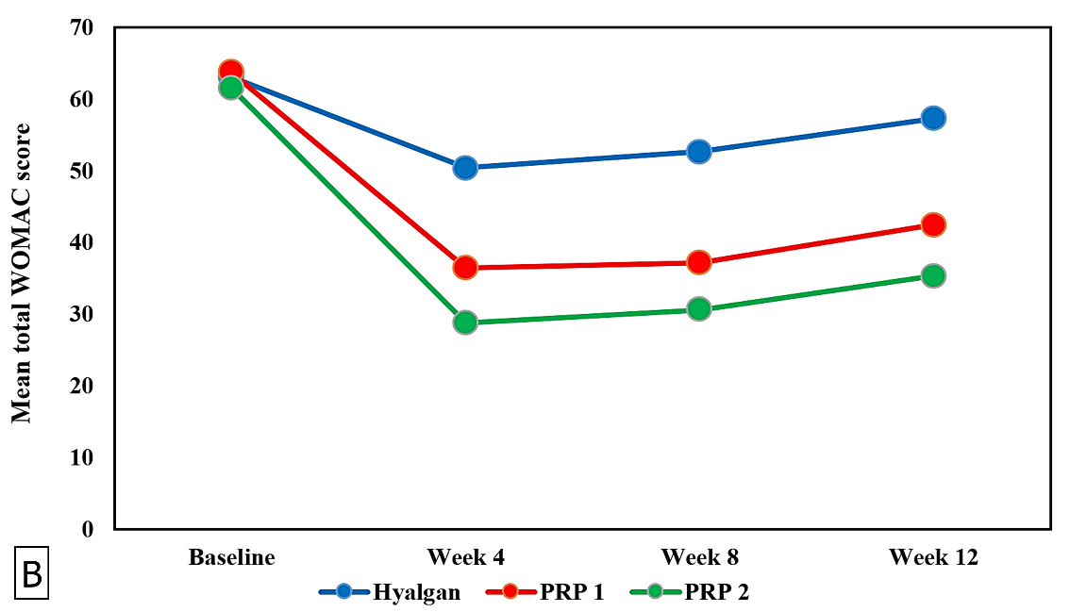
Figure 5 Comparison of the total Western Ontario and McMaster Universities Arthritis Index scores between the three intervention groups at baseline and subsequent follow-ups. A: Comparison of the percentage change in total scores from baseline to wk 4 (1st follow-up), wk 8 (2nd follow-up), and wk 12 (3rd follow-up) between the three groups; B: Comparison of the mean total scores at baseline and subsequent follow-ups between the three groups. Negative shows a benefit from pre-treatment values.

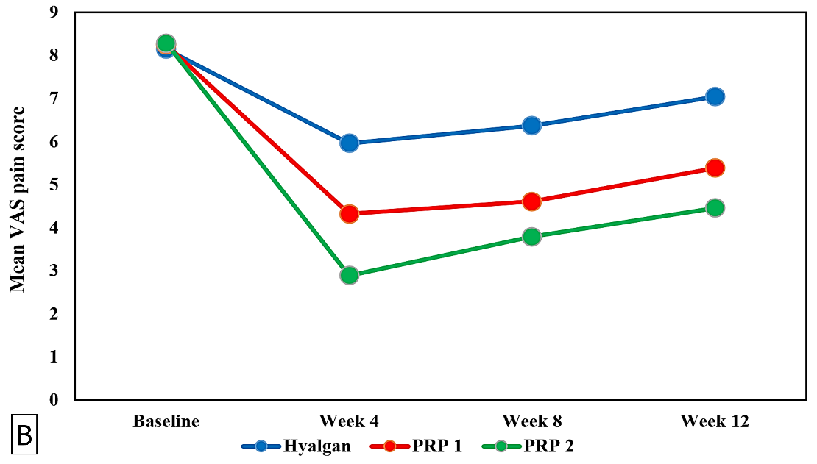
Figure 6 Comparison of the Visual Analogue Scale pain scores between the three intervention groups at baseline and subsequent follow-ups. A: Comparison of the percentage change in scores from baseline to wk 4 (1st follow-up), wk 8 (2nd follow-up), and wk 12 (3rd follow-up) between the three groups; B: Comparison of the mean scores at baseline and subsequent follow-ups between the three groups. Negative shows a benefit from pre-treatment values.

Table 1 Comparison of baseline characteristics of the patients in the three groups
Variables | Group PRP-1 (Single injection; n = 28 patients) | Group PRP-2 (Double injection; n = 28 patients) | Group hyaluronic acid (n = 27 patients) | P value
Gender, M/F, n | 5/23 | 6/22 | 8/19 | 0.323
Age, mean ± SD, yr-old | 63.23 ± 8.03 | 66.04 ± 7.58 | 63.30 ± 8.87 | 0.121
Weight, mean ± SD, kg | 73.36 ± 7.02 | 76.57 ± 6.58 | 75.37 ± 8.10 | 0.252
Height, mean ± SD, cm | 160.57 ± 7.25 | 160.43 ± 6.57 | 159.37 ± 17.27 | 0.504
BMI, mean ± SD, kg/m² | 28.43 ± 2.11 | 29.61 ± 1.64 | 28.94 ± 2.26 | 0.097
Ahlback grade, n | (n = 56 knees) | (n = 56 knees) | (n = 54 knees) | 0.509
1 | 21 | 17 | 22
2 | 35 | 39 | 32
WOMAC score, mean ± SD | (n = 56 knees) | (n = 56 knees) | (n = 54 knees)
Pain | 12.03 ± 2.31 | 12.11 ± 2.53 | 12.07 ± 2.41 | 0.958
Stiffness | 4.39 ± 1.53 | 5.04 ± 2.01 | 4.85 ± 1.84 | 0.077
Physical function | 46.93 ± 7.59 | 44.39 ± 7.82 | 46.19 ± 6.32 | 0.236
Total | 63.71 ± 9.87 | 61.57 ± 11.29 | 63.11 ± 8.94 | 0.695
VAS score, mean ± SD | 8.25 ± 0.92 | 8.29 ± 0.80 | 8.15 ± 0.81 | 0.631
BMI: body mass index; F: female; M: male; PRP: platelet-rich plasma; VAS: visual analog scale; WOMAC: Western Ontario and McMaster Universities Arthritis Index.

Table 2 Number of patients having at least a 30% and 50% decrease in the summed score for the Western Ontario and McMaster Universities Arthritis Index and Visual Analog Scale, n (%)
 | Follow-up
Variables | 1st (wk 4) | 2nd (wk 8) | 3rd (wk 12) | 1st (wk 4) | 2nd (wk 8) | 3rd (wk 12) | 1st (wk 4) | 2nd (wk 8) | 3rd (wk 12)
 | Group PRP-1 (Single injection; n = 28 patients) |  |  | Group PRP-2 (Double injection; n = 28 patients) |  |  | Group hyaluronic acid (n = 27 patients)
 | Patients having at least a 30% decrease in the summed score for the scales
WOMAC pain score | 28 (100) | 27 (96.4) | 24 (85.7) | 28 (100) | 28 (100) | 28 (100) | 6 (22.2) | 5 (18.5) | 0 (0)
P value¹ | < 0.001 | < 0.001 | < 0.001 | < 0.001 | < 0.001 | < 0.001 | - | - | -
WOMAC stiffness score | 26 (92.9) | 25 (89.3) | 19 (67.9) | 28 (100) | 28 (100) | 25 (89.3) | 16 (59.3) | 17 (63) | 5 (18.5)
P value¹ | < 0.001 | < 0.001 | < 0.001 | < 0.001 | < 0.001 | < 0.001 | - | - | -
WOMAC physical function score | 26 (92.9) | 23 (82.1) | 12 (42.9) | 28 (100) | 26 (92.9) | 23 (82.1) | 2 (7.4) | 0 (0) | 0 (0)
P value¹ | < 0.001 | < 0.001 | < 0.001 | < 0.001 | < 0.001 | < 0.001 | - | - | -
Total WOMAC score | 27 (96.4) | 26 (92.9) | 17 (60.7) | 28 (100) | 28 (100) | 24 (85.7) | 2 (7.4) | 0 (0) | 0 (0)
P value¹ | < 0.001 | < 0.001 | < 0.001 | < 0.001 | < 0.001 | < 0.001 | - | - | -
 | Patients having at least a 50% decrease in the summed score for the scales
WOMAC pain score | 14 (50) | 11 (39.3) | 6 (21.4) | 25 (89.3) | 23 (82.1) | 16 (19.3) | 0 (0) | 0 (0) | 0 (0)
P value¹ | < 0.001 | < 0.001 | < 0.001 | < 0.001 | < 0.001 | < 0.001 | - | - | -
WOMAC stiffness score | 17 (60.7) | 16 (57.1) | 7 (25) | 26 (92.9) | 26 (92.9) | 16 (57.1) | 8 (29.6) | 8 (29.6) | 1 (3.7)
P value¹ | < 0.001 | < 0.001 | < 0.001 | < 0.001 | < 0.001 | < 0.001 | - | - | -
WOMAC physical function score | 5 (17.9) | 5 (17.9) | 1 (3.6) | 17 (60.7) | 11 (39.3) | 5 (17.9) | 0 (0) | 0 (0) | 0 (0)
P value¹ | < 0.001 | < 0.001 | < 0.001 | < 0.001 | < 0.001 | < 0.001 | - | - | -
Total WOMAC score | 6 (21.4) | 5 (17.9) | 0 (0) | 19 (67.9) | 17 (60.7) | 7 (25) | 0 (0) | 0 (0) | 0 (0)
P value¹ | < 0.001 | < 0.001 | < 0.001 | < 0.001 | < 0.001 | < 0.001 | - | - | -
VAS pain score | 17 (60.7) | 11 (39.3) | 2 (7.1) | 28 (100) | 25 (89.3) | 17 (60.7) | 3 (11.1) | 2 (7.4) | 0 (0)
P value¹ | < 0.001 | < 0.001 | < 0.001 | < 0.001 | < 0.001 | < 0.001 | - | - | -
¹In comparison with hyaluronic acid group. VAS: visual analog scale; WOMAC: Western Ontario and McMaster Universities Arthritis Index.

Table 3 Comparison of mean scores and percentage change in each parameter of the Western Ontario and McMaster Universities Arthritis Index and Visual Analog Scale with baseline at each follow-up for the three groups
 | Follow-up
Variables | 0 | Wk 4 | Wk 8 | Wk 12 | 0 | Wk 4 | Wk 8 | Wk 12 | 0 | Wk 4 | Wk 8 | Wk 12
 | Group PRP-1 (Single injection; n = 28 patients) |  |  |  | Group PRP-2 (Double injection; n = 28 patients) |  |  |  | Group hyaluronic acid (n = 27 patients)
WOMAC subscales
Pain
Mean | 12.03 | 6.11 | 6.46 | 7.32 | 12.11 | 5 | 5.29 | 6.25 | 12.07 | 9.41 | 9.67 | 10.63
P value | Mean scores decreased significantly (p < 0.05) |  |  |  | Mean scores decreased significantly (p < 0.05) |  |  |  | Mean scores decreased significantly (p < 0.05)
% change¹ (vs baseline) |  | -49.09 | -45.81 | -39.09 |  | -59.47 | -56.95 | -48.61 |  | -22.01 | -19.80 | -11.34
P value | At each follow-up, the percentage change from baseline was greater in group PRP-2 than in group PRP-1, and greater in group PRP-1 than in group hyaluronic acid (p < 0.001).
Stiffness
Mean | 4.39 | 2.14 | 2.25 | 2.79 | 5.04 | 1.75 | 1.89 | 2.57 | 4.85 | 3.11 | 3.07 | 3.93
P value | Mean scores decreased significantly (p < 0.05) |  |  |  | Mean scores decreased significantly (p < 0.05) |  |  |  | Mean scores decreased significantly (p < 0.05)
% change¹ (vs baseline) |  | -50.64 | -47.36 | -32.87 |  | -67.96 | -65.12 | -47.65 |  | -32.50 | -33.16 | -14.42
P value | At each follow-up, the percentage change from baseline was greater in group PRP-2 than in group PRP-1, and greater in group PRP-1 than in group hyaluronic acid (p < 0.001).
Physical function
Mean | 46.93 | 28.14 | 28.04 | 31.89 | 44.39 | 22 | 23.39 | 26.54 | 46.19 | 37.85 | 39.41 | 42.52
P value | Mean scores decreased significantly (p < 0.05) |  |  |  | Mean scores decreased significantly (p < 0.05) |  |  |  | Mean scores decreased significantly (p < 0.05)
% change¹ (vs baseline) |  | -39.28 | -39.30 | -30.97 |  | -49.46 | -46.31 | -38.91 |  | -18.31 | -14.53 | -7.69
P value | At each follow-up, the percentage change from baseline was greater in group PRP-2 than in group PRP-1, and greater in group PRP-1 than in group hyaluronic acid (p < 0.001).
Total
Mean | 63.71 | 36.46 | 37.14 | 42.5 | 61.57 | 28.75 | 30.61 | 35.32 | 63.11 | 50.44 | 52.67 | 57.26
P value | Mean scores decreased significantly (p < 0.05) |  |  |  | Mean scores decreased significantly (p < 0.05) |  |  |  | Mean scores decreased significantly (p < 0.05)
% change¹ (vs baseline) |  | -42.34 | -41.13 | -32.66 |  | -52.77 | -49.79 | -41.75 |  | -20.35 | -16.61 | -9.12
P value | At each follow-up, the percentage change from baseline was greater in group PRP-2 than in group PRP-1, and greater in group PRP-1 than in group hyaluronic acid (p < 0.001).
VAS
Mean | 8.25 | 4.32 | 4.61 | 5.39 | 8.29 | 2.89 | 3.79 | 4.46 | 8.15 | 5.96 | 6.37 | 7.04
P value | Mean scores decreased significantly (p < 0.05) |  |  |  | Mean scores decreased significantly (p < 0.05) |  |  |  | Mean scores decreased significantly (p < 0.05)
% change¹ (vs baseline) |  | -47.6 | -44.25 | -34.44 |  | -65.28 | -54.31 | -46.25 |  | -26.69 | -21.99 | -13.71
P value | At each follow-up, the percentage change from baseline was greater in group PRP-2 than in group PRP-1, and greater in group PRP-1 than in group hyaluronic acid (p < 0.001).
¹Negative percent shows improvement from baseline. VAS: visual analog scale;

WOMAC: Western Ontario and McMaster Universities Arthritis Index.

