Name of Journal: World Journal of Clinical Cases
Manuscript NO: 78416
Manuscript Type: CASE REPORT

Perirectal epidermoid cyst in a patient with sacrococcygeal scoliosis and anal sinus: A case report

Ji ZX et al. Perirectal epidermoid cyst with sacrococcygeal scoliosis

Zhou-Xin Ji, Song Yan, Xu-Can Gao, Li-Fen Lin, Qiang Li, Qi Yao, Dong Wang

Zhou-Xin Ji, Song Yan, Song Yan, Xu-Can Gao, Li-Fen Lin, Qiang Li, Qi Yao, Dong Wang, Department of Anorectal Surgery, Shenzhen People's Hospital, Shenzhen 518000, Guangdong Province, China

Author contributions: Yao Q was the first to treat patients in the clinic, Yan S and Ji ZX were involved in managing the patients and assisting in the operation; Wang D was the main surgeon; Ji ZX prepared the manuscript and drafted it; Lin LF and Li Q prepared the images; Wang D revised the manuscript and is the corresponding author; All authors contributed to the article and approved the submitted version.

Corresponding author: Zhou-Xin Ji, MD, Researcher, Department of Anorectal Surgery, Shenzhen People's Hospital, No. 1017 Dongmen North Road, Luohu District, Shenzhen 518000, Guangdong Province, China. 675893363@qq.com

Received: June 25, 2022
Revised: August 9, 2022
Accepted: September 20, 2022
Published online:

Abstract
BACKGROUND
Perirectal epidermoid cysts are rare masses arising from the ectodermal germ cell layer of the hindgut and are predominantly found in middle-aged women. It is often difficult to make an accurate diagnosis of these cysts and it is equally challenging to distinguish it from other developmental cysts.

CASE SUMMARY
We report the case of an 18-year-old female patient with a perirectal mass who presented to the hospital with constipation. The patient experienced sacrococcygeal falls and burns on the left buttocks during growth. Three-dimensional computed tomography scans indicated abnormal sacral vertebrae with the sacral canal partially enlarged and opened. Pelvic magnetic resonance imaging showed a 55 mm × 40 mm × 35 mm unilocular cystic mass in the perirectal space and a solitary sinus in the left ischiorectal fossa. The cyst was completely resected posteriorly using the sacrococcygeal approach. The pathology was verified to be an epidermoid cyst. The patient remained recurrence-free after 6 mo of follow-up.

CONCLUSION
Successful treatment of perirectal epidermoid cysts depends on comprehensive evaluation. This is significant for the surgical approach and prognosis.

Key Words: Perirectal mass; Epidermoid cyst; Surgery; Anal sinus; Case report

Ji ZX, Yan S, Gao XC, Lin LF, Li Q, Yao Q, Wang D. Perirectal epidermoid cyst in a patient with sacrococcygeal scoliosis and anal sinus: A case report. World J Clin Cases 2022; In press

Core Tip: Perirectal cystic mass is a rare congenital developmental abnormality. An 18-year-old female was found with a perirectal mass due to defecation difficulties. She had suffered from sacrococcygeal falls and burns on the left buttocks during the growth experience. We performed a complete preoperative evaluation of this patient. Three-dimensional computed tomography scans showed that there was no damage to the sacral surface bone. Pelvic magnetic resonance imaging showed that the perirectal mass had a complete membrane without enhancement signs and no potential connection with the perianal sinus and sacral canal. Finally, the mass was completely removed through the sacrococcygeal approach and verified as an epidermoid cyst in histology. This case highlights the need to improve evaluation in the differential diagnosis of perirectal mass.

INTRODUCTION
Epidermoid cysts are commonly found in different parts of the body; however, perirectal epidermoid cysts are extremely rare. Perirectal cysts are congenital abnormalities considered to originate from caudal embryonic vestiges^{[1]}. Perirectal epidermoid cysts occur mostly in middle-aged women; however, they are rare in younger women^{[2]}. An abnormal mass in the pelvic floor space is often incidentally discovered during routine examinations. Most patients with perirectal cysts do not exhibit clinical symptoms. However, some patients may present with non-specific symptoms resulting from the compression of adjacent tissues, including urinary retention, constipation and a palpable mass near the anus^{[3]}. To help improve clinical diagnostic strategies and prevent misdiagnoses of the condition, we report a rare case of a perirectal epidermoid cyst occurring in a younger female.

CASE PRESENTATION
Chief complaints
An 18-year-old female patient presented to the clinic with a complaint of constipation.

History of present illness
The patient had difficulty in evacuating her bowels for 2 mo.

History of past illness
Three months after birth, the patient suffered from sacrococcygeal deformity due to an accidental fall and underwent an imaging examination at the local hospital without any therapy. At age five, her left buttock was scalded with boiling water.

Personal and family history
The patient had no family history of inflammatory bowel disease or hereditary tumors.

Physical examination
No abnormalities were found upon abdominal examination. Her buttocks were asymmetrical with irregular scar hyperplasia and shrinkage observed at the four o'clock position, which was approximately 3 cm away from the anal opening. Physical examination revealed a soft, mobile and poorly circumscribed mass without tenderness in the right perirectal region. The sacrum and coccyx were displaced to the right. Digital rectal examination revealed a bulge in the retrorectal area resulting in mild stenosis of the lumen (Figure 1).

Laboratory examinations
Laboratory test results were normal.

Imaging examinations
Colonoscopy revealed a slight stenosis of the area between the rectum and anal canal without erosion, ulceration or tumor formation. Three-dimensional (3D) computed tomography (CT) revealed abnormal sacral vertebrae with the sacral canal partially enlarged and opened. No destruction of the local sacral bone was observed (Figure 2). Magnetic resonance imaging (MRI) revealed a 55 mm × 40 mm × 35 mm well-circumscribed unicameral cystic mass in the pelvis that adhered to the left rectal wall posteriorly to the sacrum resulting in a right anterior displacement of the rectum. The vaginal wall was compressed and wrinkled (Figure 3). Enhanced strips in the scan extended from the levator ani muscle to the skin of the left buttock (Figure 4). Based on the MRI findings, preoperative diagnoses included a presacral epidermoid cyst, anal sinus and sacrococcygeal scoliosis.

FINAL DIAGNOSIS
The cystic mass was identified to be an epidermoid cyst.

TREATMENT
The cystic mass did not affect the patient’s spine and the sinus in her left buttock showed no signs of infection. Complete surgical excision was performed using the posterior transsacrococcygeal approach. The patient was placed in the jackknife position after spinal anesthesia. A longitudinal median incision was made over the mass of the body surface on the left side of the coccyx. The skin, subcutaneous tissue, fat layer and levator ani muscle were cut layer by layer to reveal the space of pelvic floor. The cystic mass was firmly attached to the puborectalis and left posterior wall of the lower rectum. Using both blunt and sharp dissection to carefully dissect the surrounding anatomical structures, the cyst was completely excised. The cyst measured 55 mm × 40 mm × 35 mm and was filled with a soybean curd residue-like material. The rectum was confirmed to be intact by using an intraoperative anoscope. The space of the pelvic floor was stitched into layers with a drainage tube left in situ. Histologically, the cystic cavity was covered with squamous epithelium and composed of gray and white cheese-like layered keratinocytes mixed with exfoliated broken epidermal cells, keratin and cholesterol.
After surgery, the patient was hospitalized for purgative and preventive antibacterial treatment. We changed the dressing after defecation twice daily. The patient was discharged 2 wk after the surgery with a drain and the stitches were removed.

OUTCOME AND FOLLOW-UP
Six months after surgery, the patient remained recurrence-free.

DISCUSSION
The presacral space is a triangular space between the posterior sacrum and anterior rectum that is bounded by the peritoneal reflection superiorly and levator ani muscles inferiorly^{[4]}. Developmental cystic masses arising from the presacral space include several kinds of tumors including dermoid cysts, epidermoid cysts, chordomas, adrenal rest tumors, anterior sacral meningoceles, cystic hamartomas, tailgut and rectal duplication cysts^{[5]}. Epidermoid cysts in the presacral space are uncommon with an incidence of 1 in 40000-63000 hospital admissions and 60% of perirectal epidermoid cysts are congenital developmental cysts^{[6]}.
Perirectal epidermoid cysts are typically slow-growing; approximately 26%-50% of patients are asymptomatic and they are usually incidentally discovered during imaging^{[7]}. Compression of pelvic structures by an enlarging cyst may present with urinary complaints, constipation, perianal pain or a palpable mass in the precoccygeal region. When there is an infection, these masses may result in perianal discharge, fistulous opening and bleeding in the rectum. Although epidermoid cysts are common skin lesions, they rarely develop into squamous cell carcinomas. Malignant tumors arising from epidermoid cysts are reported to appear at a rate of 0.011%-2.2%^{[8,9]}. The exact pathogenesis of epidermoid cysts becoming malignant tumors remains unclear. However, the disease progression may be attributed to chronic inflammatory responses to repeated cyst ruptures and a subtotal resection of the cyst wall^{[10]}.
Elevated levels of AFP or HCG may be indicative of germ cell tumors. Colonoscopy may reveal extrinsic rectal compression and exclude intestinal space-occupying lesions. Transrectal ultrasonography may be useful for assessing the location and extent of small cystic masses and their connection with the anal sphincter^{[11]}. CT examination clearly showed bone destruction by malignant presacral masses. MRI is superior to CT in differentiating between any bone, spinal canal or meningeal involvement and its relationship with surrounding soft tissues and organs to determine the appropriate surgical plan^{[12]}. Although infections, hemorrhages or calcifications in these lesions may alter the signal intensity, subtle changes in the signal intensity favor epidermoid cysts. However, these findings are not specific. Except for suspicious cancerous lesions, preoperative biopsy should not be performed to prevent tumor dissemination, abscess, fecal fistula or meningitis^{[1]}.
Choosing a surgical plan for presacral tumors largely depends on the tumor’s location, size and relationship with surrounding tissues and organs. Common surgical approaches are transsacrococcygeal, transabdominal, transsphincter and combined transabdominal and transsacral approaches^{[13]}. If the mass is small (≤ 10 cm), located at the caudal level (below S4) and does not invade surrounding structures, the sacral approach is usually adopted^{[14]}. When the mass is located at a high spinal level (above S3), the transabdominal approach is a better option. When the mass is large, its location near surrounding organs such as the ureter and iliac vessels is unclear and it is difficult to employ a single approach; thus, the combined abdominal sacrococcygeal approach can be selected[A4]. The sphincter approach is an option for patients with small, low-lying lesions^{[15]}. Gynecologists choose the transvaginal approach because it provides a sufficient field of vision, shorter operative time and lower blood loss in low-lying retrorectal lesions^{[16]}.
The differential diagnoses of perirectal cystic lesions include tailgut cysts, cystic teratomas, chordomas and anterior sacral meningoceles^{[17–20]}. In female patients, a high (in terms of location) perirectal mass is misdiagnosed as ovarian cystadenoma^{[21]}. The unique feature of this case is that a perirectal mass with perianal sinus and sacrococcygeal malformation was found in a young female patient. To accurately determine the extent of the mass lesion and rule out other pathologies, the patient underwent several imaging examinations. MRI revealed a solitary abscess in the left ischiorectal fossa which had no sinus interacting with the presacral mass. Given the patient’s history of scalding, sterile necrotic tissue may have accumulated in the perianal sinus. Three-dimensional CT scans revealed an abnormal sacral vertebra with the sacral canal partially enlarged and opened; however, there was no damage to the sacral surface bone. The wall of the cyst was remote from the sacral canal, the opened sacral canal was at the S3 Level and the cyst was below S4. Evidence of an anterior sacral meningocele is insufficient. Although extremely rare, benign cysts can also progress into malignant tumors^{[22]}. In our case, a well-defined smooth margin with an absence of invasion may have helped differentiate it from malignant masses. This case highlights the importance of pre-operative imaging and evaluation to identify the nature of the presacral mass which is crucial for surgery and prognosis.
Laparoscopic surgery is an option because of its minimal invasiveness, low risk of complications and complete tumor removal. Considering that the patient was a young female who had not given birth, surgery was performed using the transsacrococcygeal approach to avoid damaging the pelvic organ. During surgery, we cut the cystic mass to reduce its volume for a larger operative space. In cases of suspected malignant tumors, it should be carefully stripped along the capsule to prevent rupture and metastasis. In this regard, the importance of preoperative differential diagnosis is emphasized.

CONCLUSION
Distinguishing an epidermoid cyst from other perirectal cystic masses is a significant diagnostic challenge. The clinical manifestations of presacral masses vary and once found, colonoscopy, sacrococcygeal CT and pelvic MRI findings should be further evaluated. Using the tumor’s location, size and relationship with the surrounding organs, an appropriate surgical plan should be selected.

ACKNOWLEDGEMENTS
We would like to thank Dr. He De, a chief physician from General Surgery, The Second Affiliated Hospital of Shenzhen University, Shenzhen, China.

REFERENCES
1 Hawkins WJ, JACKMAN RJ. Developmental cysts as a source of perianal abscesses, sinuses and fistulas. Am J Surg 1953; 86: 678-683 [PMID: 13104773 DOI: 10.1016/0002-9610(53)90377-8]
2 Riojas CM, Hahn CD, Johnson EK. Presacral epidermoid cyst in a male: a case report and literature review. J Surg Educ 2010; 67: 227-232 [PMID: 20816358 DOI: 10.1016/j.jsurg.2010.06.005]
3 Yang DM, Yoon MH, Kim HS, Oh YH, Ha SY, Oh JH, Chung HS, Kim HS. Presacral epidermoid cyst: imaging findings with histopathologic correlation. Abdom Imaging 2001; 26: 79-82 [PMID: 11116367 DOI: 10.1007/s002610000118]
4 Atolagbe AO, Ogunleye O, Apakama CT. Bi-lobed Perirectal Epidermoid Cyst: An Unusual Cause of Hematochezia in a Middle-aged Woman. Ann Med Health Sci Res 2016; 6: 190-192 [PMID: 27398253 DOI: 10.4103/2141-9248.183941]
5 Yang BL, Gu YF, Shao WJ, Chen HJ, Sun GD, Jin HY, Zhu X. Retrorectal tumors in adults: magnetic resonance imaging findings. World J Gastroenterol 2010; 16: 5822-5829 [PMID: 21155003 DOI: 10.3748/wjg.v16.i46.5822]
6 Jao SW, Beart RW Jr, Spencer RJ, Reiman HM, Ilstrup DM. Retrorectal tumors. Mayo Clinic experience, 1960-1979. Dis Colon Rectum 1985; 28: 644-652 [PMID: 2996861 DOI: 10.1007/BF02553440]
7 Baek SW, Kang HJ, Yoon JY, Whang do Y, Park DH, Yoon SG, Kim HS, Lee JK, Lee JD, Kim KY. Clinical Study and Review of Articles (Korean) about Retrorectal Developmental Cysts in Adults. J Korean Soc Coloproctol 2011; 27: 303-314 [PMID: 22259746 DOI: 10.3393/jksc.2011.27.6.303]
8 Morgan MB, Stevens GL, Somach S, Tannenbaum M. Carcinoma arising in epidermoid cyst: a case series and aetiological investigation of human papillomavirus. Br J Dermatol 2001; 145: 505-506 [PMID: 11531847 DOI: 10.1046/j.1365-2133.2001.04400.x]
9 Bullard Dunn K. Retrorectal tumors. Surg Clin North Am 2010; 90: 163-171, Table of Contents [PMID: 20109640 DOI: 10.1016/j.suc.2009.09.009]
10 Abramson RC, Morawetz RB, Schlitt M. Multiple complications from an intracranial epidermoid cyst: case report and literature review. Neurosurgery 1989; 24: 574-578 [PMID: 2651960 DOI: 10.1227/00006123-198904000-00014]
11 Glasgow SC, Birnbaum EH, Lowney JK, Fleshman JW, Kodner IJ, Mutch DG, Lewin S, Mutch MG, Dietz DW. Retrorectal tumors: a diagnostic and therapeutic challenge. Dis Colon Rectum 2005; 48: 1581-1587 [PMID: 15937630 DOI: 10.1007/s10350-005-0048-2]
12 Paul PG, Pravinkumar T, Sheetal B. Sacrococcygeal neurofibroma: rare cause for chronic pelvic pain. J Minim Invasive Gynecol 2012; 19: 517-520 [PMID: 22748957 DOI: 10.1016/j.jmig.2012.03.006]
13 Saxena D, Pandey A, Bugalia RP, Kumar M, Kadam R, Agarwal V, Goyal A, Kankaria J, Jenaw RK. Management of presacral tumors: Our experience with posterior approach. Int J Surg Case Rep 2015; 12: 37-40 [PMID: 25996775 DOI: 10.1016/j.ijscr.2015.05.015]
14 Akbulut S. Unusual cause of defecation disturbance: a presacral tailgut cyst. Eur Rev Med Pharmacol Sci 2013; 17: 1688-1699 [PMID: 23832739]
15 Kanemitsu T, Kojima T, Yamamoto S, Koike A, Takeshige K, Naruse T. The trans-sphincteric and trans-sacral approaches for the surgical excision of rectal and presacral lesions. Surg Today 1993; 23: 860-866 [PMID: 8298229 DOI: 10.1007/bf00311362]
16 Aslan E. Transvaginal excision of a retrorectal tumor presenting as rectocele. Int Urogynecol J Pelvic Floor Dysfunct 2008; 19: 1715-1717 [PMID: 18504515 DOI: 10.1007/s00192-008-0648-1]
17 Grossi U, Santoro GA, Sarcognato S, Iacomino A, Tomassi M, Zanus G. Perianal Tailgut Cyst. J Gastrointest Surg 2021; 25: 558-560 [PMID: 32383075 DOI: 10.1007/s11605-020-04589-4]
18 Park YJ. Multiple Presacral Teratomas in an 18-year-old Girl: A Case Report. J Korean Soc Coloproctol 2011; 27: 90-93 [PMID: 21602968 DOI: 10.3393/jksc.2011.27.2.90]
19 Permi HS, Kishan Prasad H, Veena S, Teerthanath S. Presacral chordoma diagnosed by transrectal fine-needle aspiration cytology. J Cytol 2011; 28: 89-90 [PMID: 21713157 DOI: 10.4103/0970-9371.80754]
20 Rege S, Tadghare J, Jatav G, Pounikar M. An Unusual Presentation as Recurrent Abortions in a Case of Giant Presacral Epidermoid Cyst Mimicking an Anterior Sacral Meningocele. World Neurosurg 2019; 122: 77-80 [PMID: 31108068 DOI: 10.1016/j.wneu.2018.10.120]
21 Jha A, Khalid M, Gupta P, Saud M, Gupta G. Presacral epidermoid cyst in an elderly female, mistaken for ovarian cystadenoma. J Obstet Gynaecol India 2014; 64: 118-120 [PMID: 25404834 DOI: 10.1007/s13224-013-0409-z]
22 Wu X, Chen C, Yang M, Yuan X, Chen H, Yin L. Squamous Cell Carcinoma Malignantly Transformed From Frequent Recurrence of a Presacral Epidermoid Cyst: Report of a Case. Front Oncol 2020; 10: 458 [PMID: 32318346 DOI: 10.3389/fonc.2020.00458]

Footnotes
Informed consent statement: Informed written consent was obtained from the patient for publication of this report and any accompanying images.

Conflict-of-interest statement: The authors have no conflict of interest, financial or otherwise.

CARE Checklist (2016) statement: The authors have read the CARE Checklist (2016), and the manuscript was prepared and revised according to the CARE Checklist (2016).

Open-Access: This article is an open-access article that was selected by an in-house editor and fully peer-reviewed by external reviewers. It is distributed in accordance with the Creative Commons Attribution NonCommercial (CC BY-NC 4.0) license, which permits others to distribute, remix, adapt, build upon this work non-commercially, and license their derivative works on different terms, provided the original work is properly cited and the use is non-commercial. See: https://creativecommons.org/Licenses/by-nc/4.0/

Provenance and peer review: Unsolicited article; Externally peer reviewed.
Peer-review model: Single blind

Peer-review started: June 25, 2022
First decision: August 1, 2022
Article in press:

Specialty type: Surgery
Country/Territory of origin: China
Peer-review report’s scientific quality classification
Grade A (Excellent): A
Grade B (Very good): B
Grade C (Good): C
Grade D (Fair): D
Grade E (Poor): 0

P-Reviewer: Grossi U, Italy; Jain N; Koukoulis GD, Greece; Mijwil MM, Iraq S-Editor: Ma YJ L-Editor: Filipodia P-Editor: Ma YJ
Figure Legends
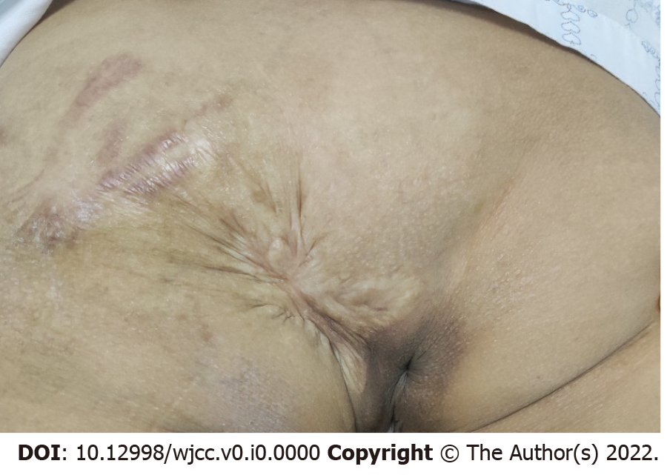
Figure 1 Preoperative image of the mass.

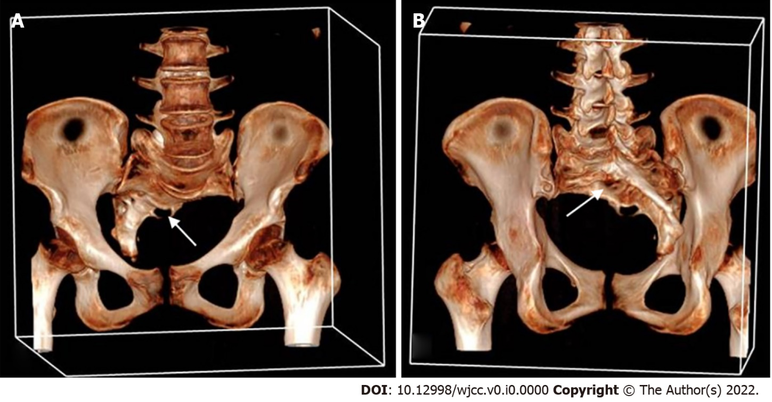
Figure 2 Computed tomography scan examination of the sacral vertebra. A: Frontal view; B: Dorsal view: Three-dimensional computed tomography scan showed a sacrococcygeal scoliosis below the S2 level (white arrows); the sacral canal is partially enlarged and opened.
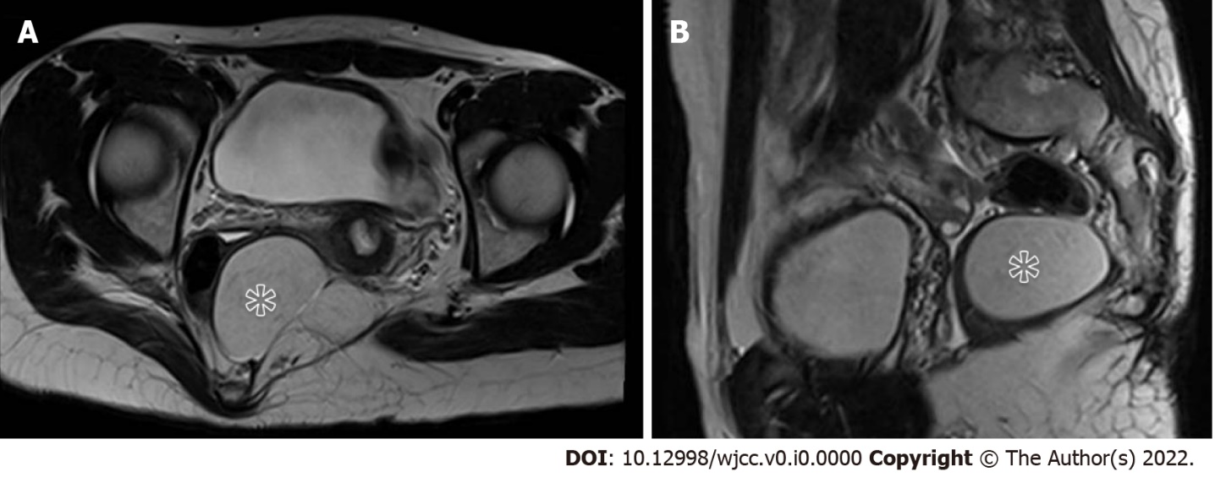
Figure 3 Magnetic resonance imaging. A: T2-weighted imaging: a well-circumscribed mass (asterisk) compressing the rectum and displacing it right-anteriorly; B: T2-weighted imaging showed a well-defined mass anterior to the sacrum.

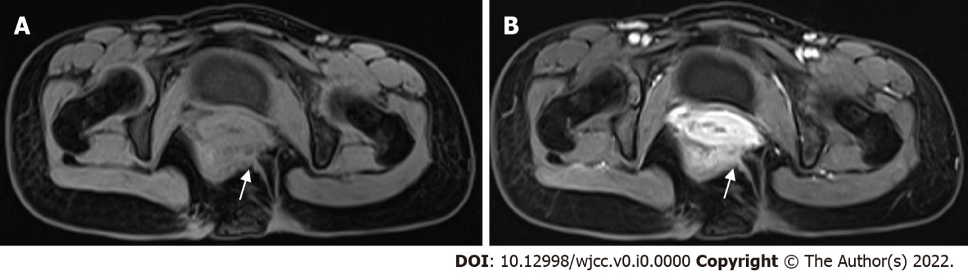
Figure 4 Axial T1-weighted imaging. A: Circular signal (white arrows) on the outside of the levator ani muscle with strips signs connecting to the skin of the left buttock; B: Contrast-enhanced T1-weighted imaging showed enhancement of the strips signs.

