A
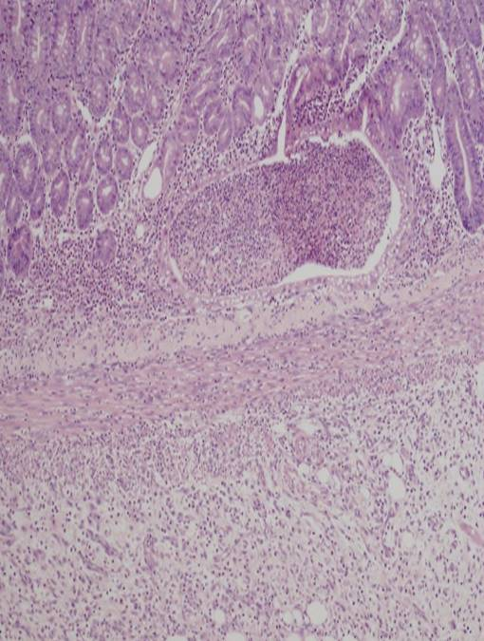
B
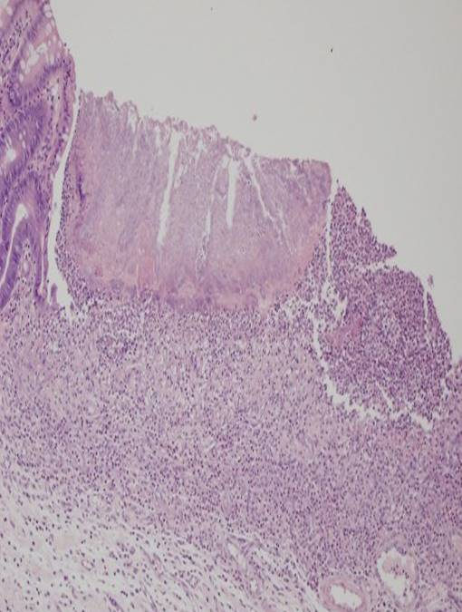Supplementary Figure 1 Microscopic image from the indomethacin group. A: Active inflammation area- granulation area in the indomethacin group; B: Ulcer area in the large intestine tissue in indomethacin group.

A
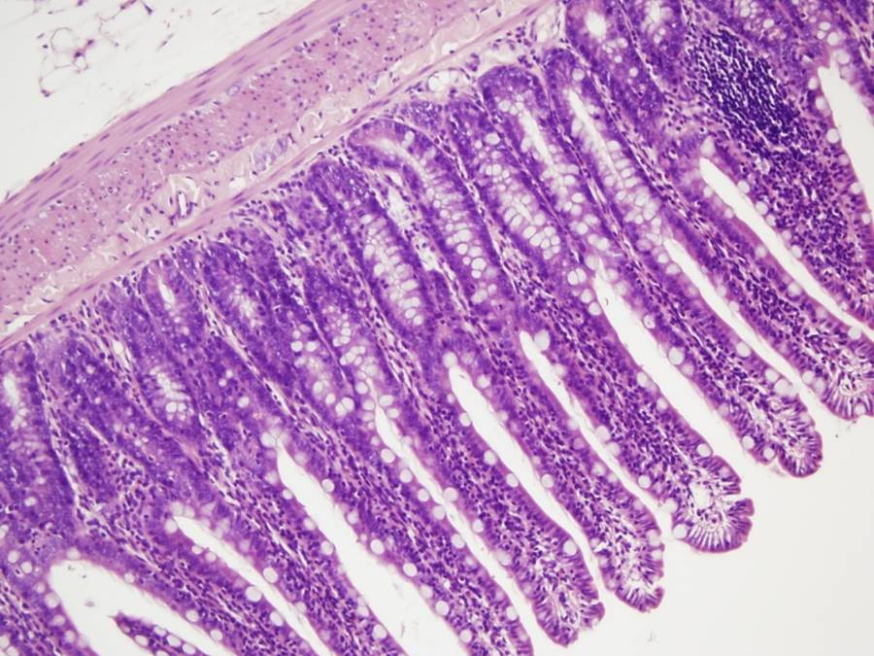
B
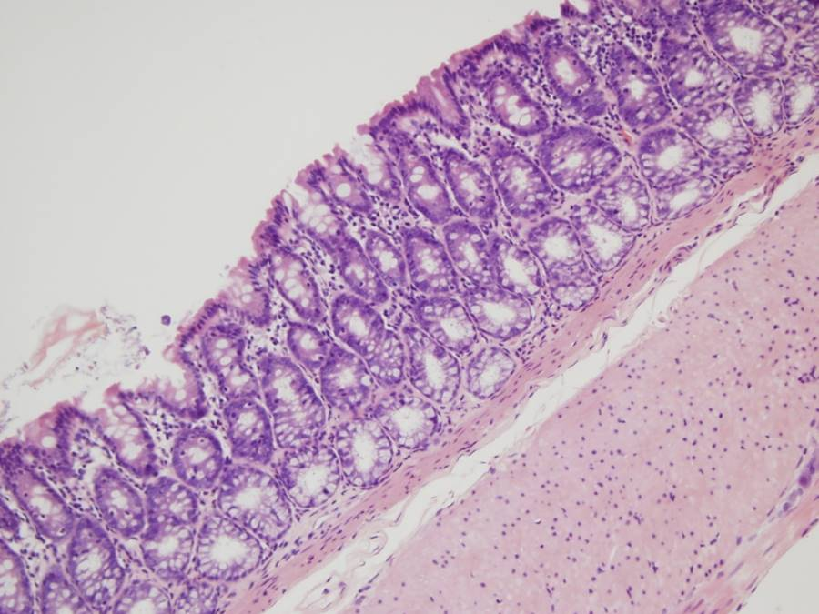
Supplementary Figure 2 Microscopic image from the nilotinib group. A: Nilotinib group – small ıntestine; b: Nilotinib group - large ıntestine

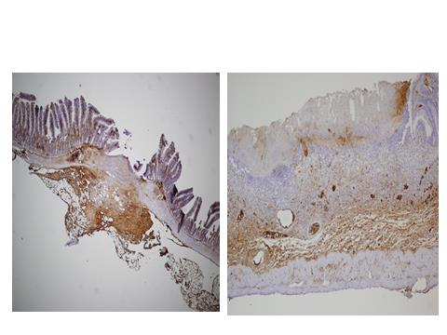
Supplementary Figure 3 +3 positive PDGFR beta score from the indomethacin group.

