Name of Journal: World Journal of Biological Chemistry
Manuscript NO: 60242
Manuscript Type: ORIGINAL ARTICLE

Basic Study
Polyglutamylase activity of tubulin tyrosine ligase-like 4 is negatively regulated by the never in mitosis gene A family kinase never in mitosis gene A -related kinase 5

Melo-Hanchuk TD et al. NEK5 regulates TTLL4 activity

Talita Diniz Melo-Hanchuk, Jörg Kobarg

Talita Diniz Melo-Hanchuk, Faculty of Pharmaceutical Sciences, Unicamp, Campinas 13083-862, Brazil

Jörg Kobarg, Faculty of Pharmaceutical Sciences, University of Campinas, Campinas 13083-862, Brazil

Author contributions: Melo-Hanchuk TD performed the experiments and interpreted them together with Kobarg J; both authors wrote the manuscript; Kobarg J supervised the project.

Supported by Fundação de Amparo à Pesquisa do Estado São Paulo (FAPESP; São Paulo, Brazil) through Grant Temático, No. 2017/03489-1.

Corresponding author: Jörg Kobarg, PhD, Full Professor, Faculty of Pharmaceutical Sciences, University of Campinas, 200 Cândido Portinari, Campinas 13083-862, Brazil. jorgkoba@unicamp.br

Received: October 25, 2020
Revised: January 6, 2021
Accepted: February 25, 2021
Published online:

Abstract
BACKGROUND
Tubulins, building blocks of microtubules, are modified substrates of diverse post-translational modifications including phosphorylation, polyglycylation and polyglutamylation. Polyglutamylation of microtubules, catalyzed by enzymes from the tubulin tyrosine ligase-like (TTLL) family, can regulate interactions with molecular motors and other proteins. Due to the diversity and functional importance of microtubule modifications, strict control of the TTLL enzymes has been suggested.

AIM
To characterize the interaction between never in mitosis gene A-related kinase 5 (NEK5) and TTLL4 proteins and the effects of TTLL4 phosphorylation.

METHODS
The interaction between NEK5 and TTLL4 was identified by yeast two-hybrid screening using the C-terminus of NEK5 (a.a. 260–708) as bait and confirmed by immunoprecipitation. The phosphorylation sites of TTLL4 were identified by mass spectrometry and point mutations were introduced.

RESULTS
Here, we show that NEK5 interacts with TTLL4 and regulates its polyglutamylation activity. We further show that NEK5 can also interact with TTLL5 and TTLL7. The silencing of NEK5 increases the levels of polyglutamylation of proteins by increasing the activity of TTLL4. The same effects were observed after the expression of the catalytically inactive form of NEK5. This regulation of TTLL4 activity involves its phosphorylation at Y815 and S1136 amino acid residues.

CONCLUSION
Our results demonstrate, for the first time, the regulation of TTLL activity through phosphorylation, pointing to NEK5 as a potential effector kinase. We also suggest a general control of tubulin polyglutamylation through NEK family members in human cells.

Key Words: Kinase; Polyglutamylation; Never in mitosis gene A-related kinase 5; Tubulin tyrosine ligase-like 4; Microtubules; Post translational regulation

Melo-Hanchuk TD, Kobarg J. Polyglutamylase activity of tubulin tyrosine ligase-like 4 is negatively regulated by the never in mitosis gene A family kinase never in mitosis gene A -related kinase 5. World J Biol Chem 2021; In press

Core Tip: Tubulins are modified extensively by post-translational processes such as polyglutamylation. Considering the diversity of microtubule polyglutamylation and the existence of many non-tubulin substrates, it is important to understand how the effector enzymes, the tubulin ligase-like (TTLL) proteins, are regulated. TTLL4 interacts with never in mitosis gene A (NIMA)-related kinase 5, a member of the mitotic NIMA-related kinases. We demonstrate that NIMA-related kinase 5 is a potential regulator of polyglutamylation through the control of TTLL4 activity. Here we show, for the time, the regulation of TTLL4 activity through phosphorylation, and demonstrate the potential control of polyglutamylation through NEK family members in human cells.

INTRODUCTION
The microtubule cytoskeleton is essential for the internal organization of eukaryotic cells and is involved in cell division, differentiation and active transport processes. The great diversity of tubulin inside the cells is due to the expression of tubulin isotypes and a large array of post-translational modifications including acetylation/deacetylation, removal and addition of tyrosines to the C-terminal tail of αα-tubulin, phosphorylation, polyglycylation and polyglutamylation^{[1-5]}.
Polyglutamylation was initially discovered in tubulins and consists of the addition of glutamate side chains to acceptor glutamate residues in the main chain of the modified proteins^{[1,2]}. Glutamylation is found on microtubules of cilia and flagella^{[6]}, centrioles, basal bodies and centrosomes^{[7]}. The levels of glutamylated tubulin of the mitotic spindle are increased during cell division^{[8-10]}.
In vitro experiments have shown that polyglutamylation of α- or β-tubulin can act as a regulator of microtubule interactions with microtubule-associated proteins^{[11,12]} and motor proteins^{[11,13-15]}. The enzymes responsible for polyglutamylation are members of the tubulin ligase-like (TTLL) family^{[16,17]}. Their name is derived from tubulin tyrosine ligase^{[18]}, a related tubulin-modifying enzyme^{[19]}, with which they share a strong sequence homology. A total of nine enzymes that can catalyze polyglutamylation have been identified^{[16,17]}. TTLL4, 5, 6, 7, 11, and 13 generate tubulin glutamylation when overexpressed in mammalian cells. Studies of the catalytic activity of TTLL family members revealed that these enzymes have intrinsic preferences for either α- or β-tubulin and for the generation of either short or long glutamate chains^{[17]}. Polyglutamylation is not restricted to tubulins. Several substrates have been identified, including nucleosome assembly proteins such as nucleosome assembly protein (NAP) 1 and 2 among others^{[20,21]}. From the family of glutamylases, TTLL4 and TTLL5 glutamylases have also been demonstrated to glutamylate non-tubulin proteins^{[21]}.
Kinases are key regulators of many cellular processes, and could thus also be potential regulators of polyglutamylases. The never in mitosis gene A (NIMA)-related kinases (NEKs) are mammalian enzymes, which were identified by their high identity (40%-45%) to the Aspergillus nidulans mitotic protein NIMA within their catalytic domain^{[22-24]}. In humans, the NEK family is represented by 11 members that have been functionally associated to one of the three core functions established for this family in mammals: (1) Centrioles/mitosis; (2) Primary ciliary function/ciliopathies; and (3) Deoxyribonucleic acid (DNA) damage response^{[25]}.
The participation of NEKs in the microtubule-related process is broadly described; however, the first link with polyglutamylation was identified during the purification of polyglutamylase from the protist Crithidia fasciculata^{[26]}. Purified extracts of NIMA-related kinase were capable of glutamylating tubulins in vitro. The later discovery of TTLLs as tubulin polyglutamylases strongly suggested that extracts of NIMA-related kinase were associated with a Crithidia fasciculata TTLL enzyme.
Here, we describe the identification and confirmation of the interaction between NEK5 and TTLL4. This prompted us to investigate the activity of TTLL4. In a broader context, our analysis showed, for the first time, a mechanism for direct regulation of a glutamylase from the TTLL family through phosphorylation, pointing to NEK5 as a potential candidate as an effector kinase.

MATERIALS AND METHODS
DNA constructs, mutagenesis, short hairpin ribonucleic acid and stable cells
TTLL4 full size, TTLL4 C347-1193, TTLL4 C555-1193, TTLL4 C606-1193, TTLL5, TTLL5 N800 and TTLL7 genes were amplified from mouse brain or testis complementary DNA (cDNA) and previously cloned in a vector containing a C-terminal enhanced yellow fluorescent protein (EYFP) tag^{[17]}. The TLL domains of TTLL4, TTLL5 and TTLL7 have many conserved residues (Supplementary Figure 1). TTLL5 N800 corresponds to the first 800 N-terminal amino acids and TTLL5 is the full size, but both are active versions of TTLL5. Point mutations were introduced by the QuikChange II Site-Directed Mutagenesis Kit (Stratagene, LaJolla, CA, United States) to generate the NEK5-kinase-dead (NEK5-KD) (K33A-inactive mutant of NEK5), TTLL4-T813E, TTLL4-T815A, TTLL4-Y815F, TTLL4-Y815A, TTLL4-S912E, TTLL4-S960E, TTLL4-S960A, TTLL4-T968E, TTLL4-S1136A, TTLL4-S1139E and TTLL4-S1136A. All mutants were confirmed by DNA sequencing.
The production of HEK293 silenced for NEK5 was carried out by short hairpin ribonucleic acid (shRNA) lentiviral particles (Santa Cruz Biotechnology, Incorporated). Stable cells were obtained with the Flp-In. System. The procedure to obtain all the cell lines has been described previously^{[27]}. Stable cells expressing NEK5 were used as controls.

Antibodies
The following antibodies were used for both immunoprecipitation and Western blot assay: mouse anti-NEK5 (SC130492), mouse anti-green fluorescent proteins (GFP) (G1546), mouse GT335 (Adipogen) and anti-TTLL4 (Novus Biologicals).

Yeast two-hybrid screen
The cDNA encoding the C-terminus of NEK5 (a.a. 260–708) was cloned in the pGBKT7. The yeast two-hybrid screen was performed following the Matchmaker™ Gold Yeast Two-Hybrid System (Clontech Laboratories, Incorporated, Mountain View, CA, United States) according to the manufacturer’s instructions. Selective medium without tryptophan, leucine, adenine and histidine but containing aureobasidin A antibiotic and X-α-Gal was used to screen interactors from the human universal cDNA library. To identify the “prey” genes, the DNA was extracted and sequenced.

DNA transfection
TTLL genes amplified from mouse brain or testis cDNA were used because mouse proteins show a better expression level. Mouse and human TTLL4 protein are very similar and share 79.98% identity and 85.80% similarity (Supplementary Figure 2). Expression plasmids were transfected using JetPEI (Polyplus transfection) or homemade PEI.

Immunoprecipitation
Cells were lysed in RIPA buffer supplemented with a protease inhibitor cocktail (Roche Applied Science, Mannheim, Germany), subjected to freeze/thaw, submitted to three cycles of 5 min in an ultrasound bath (UltraSonic Clear 750, UNIQUE) for complete pellet suspension and centrifuged at 20000 × g for 30 min at 4°C. Protein concentration was determined using the Bradford method^{[28]}. The supernatants were used for immunoprecipitation. Briefly, the supernatant was added to GFP-Trap® (ChromoTek GmbH, Germany) coupled to agarose beads or anti-NEK5, previously coupled to G-sepharose beads and incubated overnight. The beads were collected, washed five times with wash buffer (10 mmol/L Tris/Cl pH: 7.5; 150 mmol/L NaCl; 0.5 mmol/L ethylene diamine tetraacetic acid) and then eluted with 2 × sodium dodecyl sulfate (SDS)-sample buffer (120 mmol/L Tris/Cl pH: 6.8; 20% glycerol; 4% SDS, 0.04% bromophenol blue; 10%β-mercaptoethanol). The proteins were immunoblotted onto an Immobilon-P membrane (Millipore Corporation, Bedford, MA, United States) and probed with antibodies. Blots were developed using an emitter coupled logic (ECL) chemiluminescence kit (Amersham Biosciences).

Immunoblotting analysis
50 µg of protein were separated by SDS-polyacrylamide gel electrophoresis (PAGE) and blotted onto an Immobilon-P membrane (Millipore Corporation, Bedford, MA, United States). In the case of mammalian tubulin, a special protocol was used, as described in Eddé et al^{[1]}. The protein bands were probed using the following primary antibodies diluted in 3% bovine serum albumin blocking solution: mouse anti-GFP (1:1000, Sigma), mouse anti-NEK5 (1:500, Santa Cruz Biotechnology) and rabbit anti-TTLL4 (1:500, Novus Biologicals). The monoclonal mouse GT335 (anti-polyglutamylation, 1:1000) and monoclonal mouse 12G10 (anti-tubulin, 1:500) were produced in the laboratory^{[17,29]} and were used at 1:1000 dilutions. Detection of the protein bands was performed with HRP-labeled anti-rabbit or anti-mouse IgG (1:5000; Sigma), followed by the chemiluminescent ECL Western Blotting System (ECL Western blot detection kit; GE Healthcare). Protein bands were quantified using ImageJ software (National Institutes of Health, United States).

Mass spectrometry analysis
The proteins from the GFP affinity-purified fraction were separated by SDS-PAGE and stained using Colloidal blue. Protein bands at the expected size for TTLL4 and TTLL5 were excised from the gel and submitted to in-gel trypsin or chymotrypsin digestion. Peptides were concentrated and analyzed by MS/MS on a Q-TOF II mass spectrometer (Micromass Limited, Manchester, United Kingdom). Data analysis was performed with Mascot (Matrix Science Limited, London, United Kingdom) against the National Center for Biotechnology Information database.

Flow cytometry and sorting
Transfected control and shRNA-NEK5 cells were collected and dissociated using trypsin. Cells were suspended in saline solution, passed through a 0.45 µmol/L filter and analyzed by flow cytometry. Gates were created to separate single cells using the FSC and SSC parameters followed by a new gate for yellow fluorescent protein (YFP) positive cells. The sorting was performed by separation in positive and negative YFP cells on a binding domain-FACS Aria flow cytometer using FACS Diva 6.0 software and data were analyzed using FlowJo (Tree Star Incorporated, Ashland, OR, United States).

RESULTS
TTLL4 and NEK5 physically interact
The molecular functions of NEK5 are still not fully elucidated. In order to identify putative functional partners of NEK5, the yeast two-hybrid experiment was performed. The C-terminal fragment of NEK5 (a.a. 260-708) was used as a bait protein fused to the Gal4-DNA binding domain against a human cDNA library. The prey proteins from the library were expressed as a fusion to a Gal4-activation domain (AD)^{[30,31]}. In this stringent protein-protein interaction screen, four independent reporter genes must be activated (AUR1-C, ADE2, HIS3, and MEL1). The screening resulted in the identification of TTLL4 (amino acid residues 895 to 1189) as NEK5’s interactor (Figure 1A). The controls of yeast two-hybrid screening are presented in the supplementary material (Supplementary Figure 3). The interaction between endogenous TTLL4 and NEK5 was confirmed only for the C-terminal regulatory (260-708) region of NEK5 (Figure 1A). This is possibly due to a closed folded state of full-length NEK5, where the N-terminal kinase domain folds back to the regulatory C-terminal region (site of interaction with TTLL4), thereby preventing interaction. Such an auto-inhibitory conformation has been described for several other NEKs (e.g. NEK8 and NEK9). Additional interactions or post-translational modification may also be required to expose the C-terminus of NEK5 thus allowing the interaction with TTLL4. In summary, the most plausible explanation for the lack of interaction of TTLL4 with the full-length NEK5 in the yeast two-hybrid screen is the possibility that yeast lacks the biochemical apparatus necessary to induce the putative NEK5 conformational changes necessary for the interaction to occur. Using immunoprecipitation we confirmed the interaction of endogenous full-length TTLL4 and full-length NEK5 fused to FLAG (Figure 1B).

NEK5 interacts with other members of the TTLL family
Polyglutamylase from the TTLL enzyme family displays reaction preferences such as the length of side chains (long or short) and substrates (α- or β-tubulin)^{[17,32]}. TTLL4, TTLL5 and TTLL7 are involved in the initiation of the polyglutamylation chain but with different substrate specificity. While TTLL4 has a preference for α-tubulin and NAP proteins, TTLL5 and TTLL7 have a preference for α- and β-tubulin, respectively^{[17]}. The diversity of specificity suggests alternative interaction partners as well as mechanisms of regulation. To investigate if the interaction of NEK5 with TTLLs is exclusive for TTLL4, HEK293T cells were transfected with EYFP-TTLL4, EYFP-TTLL5 and EYFP-TTLL7 and the proteins were immunoprecipitated by the anti-NEK5 antibody. The protein extract was analyzed by Western blot using the anti-GFP antibody in order to identify interaction of NEK5 with other TTLL members. Surprisingly TTLL4, 5 and 7 were immunoprecipitated with NEK5 as observed in Figure 1C, showing that NEK5 interacts not only with TTLL4 but also with other members of this family and its potential effects on regulation of TTLL activity may not be exclusive for this protein but more related to the process of polyglutamylation as a whole. Therefore, this work opens up a vast perspective for more detailed studies related to the mechanisms underlying the regulation of TTLLs through phosphorylation triggered by NEK kinases.

NEK5 interferes negatively with TTLL4 and TTLL5-mediated polyglutamylation
TTLLs are responsible for the polyglutamylation of tubulin as well as other proteins. As we have shown that NEK5 and TTL4 interact (Figure 1A and B), we hypothesized that NEK5 could regulate TTLL4 activity. To confirm this, cells stably expressing the inactive version of NEK5-KD, as well as cells silenced for NEK5 (shRNA-NEK5) and control cells were transfected with TTLL4 and TTLL5 and the polyglutamylation profiles of cell lysates were analyzed by Western blot using GT335, a glutamylation-specific antibody.
Cells expressing NEK5 were used as controls and showed low levels of all the polyglutamylated protein bands (Figure 2A, lane 1). The catalytically inactive NEK5-KD cells, on the other hand, showed increased levels of protein polyglutamylation (Figure 2A, lane 2). The difference in polyglutamylation status between controls vs either shNEK5 knockdown or NEK5-KD was more pronounced upon overexpression of TTLL4 (Figure 2A, compare lane 4 with lane 5 and 6) or TTLL5 (Figure 2A, compare lane 7 with lanes 8 and 9).
TTLL4 and TTLL5 have preferences for glutamylation of β and α-tubulin, respectively^{[17]}. The ratio of α and β glutamylated-tubulin was also altered after TTLL4 and TTLL5 transfection in the presence or absence of functional NEK5. For example, despite the preference of TTLL5 for α-tubulins, upon decreased expression of functional NEK5, cells transfected with TTLL5 showed that not only the level of polyglutamylation of all protein substrates was increased, but β-tubulin also turned out to be an additional new target (Figure 2A, lanes 7 vs 9). TTLL4 on the other hand, even in the absence of NEK5 (Figure 2A, lane 5) or in the presence of catalytically non-functional NEK5 (lane 6) continued to prefer β-tubulin as substrate.
Although only TTLL4 has been identified as a NEK5 interactor in the yeast two-hybrid screen, the inhibitory effects of NEK5 on TTLL activity were also observed on TTLL5, suggesting that, NEK5 may play a regulatory role on more than one member of the TTLL family (Figure 2A). Polyglutamylation levels of other than tubulins have also been altered in the absence of functional NEK5 and upon overexpression of TTLL4 or TTLL5 (Figure 2A and B).

The knockdown of NEK5 increases the levels of polyglutamylated proteins
The putative catalytic region of TTLL4 is subdivided into two sub-domains: one common to all TTLLs and TTL, called ‘‘core TTL domain’’ (green region in Figure 3A) and a conserved bipartite upstream region called the “extended TTL domain” (purple and light blue regions in Figure 3A), which is necessary for TTLL4 activity^{[17]}.
The TTLL4 protein fragment found to interact with NEK5 in the yeast two-hybrid screen is localized in the C-terminal region between residues 895-1189. This suggests that the possible regulatory region of TTLL4 partially coincides with the catalytic TTL domain (a.a. 599-942). In order to map regions of TTLL4 required for its polyglutamylation activity and to test the influence of NEK5 on the activity of TTLL4 we compared the activity of the full-length protein and 3 deletion mutants.
Expression of the catalytically inactive NEK5 (Figure 3C) or the depletion of NEK5 expression (Figure 3D) resulted in an increased polyglutamylation activity for all TTLL4 truncated versions, except for the mutation C606-1193 (Figure 3C and D, lane 5), which is the inactive version, because it is missing the “extended domain” (Figure 3B-D, lane 5).
The overexpression of TTLL4 leads to the polyglutamylation of tubulin and many non-tubulin substrates in the presence of NEK5-KD and shRNA-NEK5. On the other hand, TTLL7, TTLL5 full size or its shortest version (TTLL5-N800) overexpression lead to more pronounced differences in polyglutamylation levels of tubulins (Figure 3C and D). The presence of NEK5 reduced the polyglutamylation of tubulins not only after TTLL4 transfection, but also TTLL7 and TTLL5, suggesting that the regulation by NEK5 may not be exclusive for TTLL4.
In order to confirm the regulatory role of NEK5 on the enzymatic activity of TTLL4 and TTLL5 toward tubulins, we performed an in vitro polyglutamylation assay. Purified tubulins from mouse brains were subjected to in vitro polyglutamylation assays with extracts from control and shRNA-NEK5 expressing cells, transiently transfected with EYFP-TTLL4 and EYFP-TTLL5. Once again the activity level of TTLL4 was increased in shRNA-NEK5-cell extract and reduced in the presence of NEK5 (Supplementary Figure 4). Inactive versions of TTLL4 and TTLL5 were used as a control in this experiment. Furthermore, NEK5 did not affect the activity level of TTLL5 using the in vitro assay (Supplementary Figure 4).

TTLL4 and TTLL5 are phosphorylated at Ser, Thr and Tyr sites
According to the Uniprot database, TTLL4 is phosphorylated on S691 and S696 residues and using the Kinase-specific Phosphorylation Site Prediction tool GPS 3.0^{[33]} several other residues could also be phosphorylated. The amino acid residues with the highest score for phosphorylation were S1184, S1117, S1125 and S1151.
The prediction of TTLL4 phosphorylation sites associated with its inactivation in the presence of NEK5 suggests that NEK5 could phosphorylate TTLL4 directly or indirectly (through the phosphorylation/interaction with the effector kinase), thereby inhibiting its activity. To identify the possible phosphorylation sites in TTLL4 and TTLL5, stably NEK5-expressing cells and shRNA-NEK5 cells were transiently transfected with EYFP-TTLL4 or EYFP-TTLL5 (Figure 4A, only the TTLL4 experiment is shown). As the efficiency of the transfection is low, transfected cells were submitted to sorting by flow cytometry to enrich the cells expressing EYFP-TTLL4 or EYFP-TTLL5. The positive (TTLL4⁺ or TTLL5⁺) and negative (TTLL4⁻ or TTLL5⁻) cells were collected in different tubes, lysed and the proteins separated by SDS-PAGE and analyzed for polyglutamylation levels by Western blot (Figure 4A).
TTLL4⁺ cells showed an increase in polyglutamylation levels, especially of tubulins, when NEK5 was depleted (Figure 4, compare lane 3 with lane 2). As expected, cells negative for YFP signal (TTLL4⁻) showed undetectable levels of polyglutamylation (Figure 4A, lanes 1 and 4). In the presence of NEK5, TTLL4, detected by the anti-GFP antibody, migrates as two bands, suggesting a phosphorylation event or another type of post-translational modification. The lower of those two bands is lost in cells in which NEK5 has been silenced (Figure 4A, upper panel, compare lanes 2 and 3). This could suggest the loss of phosphorylation of TTLL4 by NEK5.
In order to identify the phosphorylation sites in EYFP-TTLL4 and EYFP-TTLL5 proteins, the proteins of YFP positive cells were immunoprecipitated using anti-GFP beads and separated by SDS-PAGE (Figure 4B). The bands corresponding to the expected sizes of TTLL4 and TTLL5 (identified with the arrows in Figure 4B) were excised, submitted to trypsin and chymotrypsin digestion and analyzed by mass spectrometry. The analysis of the TTLL4 amino acid sequence allowed the identification of amino acid residues T813, S912, S960, T968, S1136 and S1139 as phosphorylated. Some of the residues identified as phosphorylated in TTLL4 are conserved in TTLL5 and TTLL7 (Supplementary Figure 1).

The activity of TTLL4 is regulated through phosphorylation
To evaluate the polyglutamylation activity of phosphorylated TTLL4, the residues T813, S912, S960, T968 and S1139 of EYFP-TTLL4 were mutated to glutamic acid (E), mimicking phosphorylation. For inactivation of the phosphosites the residues T813, Y815, S960, S1136 and S1139 were mutated to alanine (A) or phenylalanine (F) for the residue Y815. The mutated residues, as well as their location in the full-length protein, are represented in Figure 5A. To investigate the in vivo enzyme activity of TTLL4 mutants, we expressed EYFP-tagged TTLL4 mutants in HEK293T cells and the levels of polyglutamylation were analyzed by Western blot using the GT335 antibody (Figure 5B).
The expression of unphosphorylated mutants TTLL4-Y815F, TTLL4-Y815A and TTLL4-S1136A in HEK293T cells caused an important decrease in the polyglutamylation levels (Figure 5B, lanes 5, 6 and 11 compared to lane 2). In HeLa cells, the active TTLL4 has α-tubulin as the preferential substrate. However, here we showed that TTLL4-Y815F, TTLL4-Y815A and TTLL4-S1136A mutants reduced the polyglutamylation of not only α-tubulin but also β-tubulin and other substrates of TTLL4. The results indicate that the amino acid residues Y815 and S1136 are potential key residues in the regulation of TTLL4 activity through phosphorylation, switching on or off its polyglutamylation activity. Especially for the TTLL4-S1136A mutant, the polyglutamylation levels of α - and β-tubulin drop to undetectable levels, compared to untransfected cells. Together, these data suggest that the regulation of TTLL4 may occur directly or indirectly through phosphorylation and/or interaction with another effector kinase intermediated by NEK5.

DISCUSSION
Tubulin polyglutamylation has been suggested to regulate the interactions of some microtubule-associated proteins and molecular motors with microtubules, thus selectively controlling specific microtubule functions inside cells^{[32]}. To control these complex modification patterns in time and space, strict control of the polyglutamylation enzymes (TTLL) is expected. For instance, aberrations in the fine regulation of the polyglutamylation profile contribute to defects in ciliary beating in Chlamydomonas reinhardtii^{[34]}, Tetrahymena^{[35]} and zebrafish^{[36]}. Hyperglutamylation has been associated with neurodegeneration in mouse models and can be reversed by TTLL1 inhibition^{[37]}.
Despite the importance of controlling polyglutamylation in cells, the regulatory mechanism that controls the activity of TTLL enzymes has not yet been identified. In this study we show that NEK5 interacts and has the potential to phosphorylate TTLL4, regulating its polyglutamylation activity. The expression of the enzymatically inactive version of NEK5 as well as shRNA-NEK5 cells showed increased levels of polyglutamylation when transfected with TTLL4. We further showed that the phosphorylation of residues serine 1136 and tyrosine 815 of TTLL4 are key for its activity. When the phosphorylation of these residues was prevented, the activity of TTLL4 was dramatically reduced. Thus, we demonstrated a mechanism for the regulation of the activity of TTLL enzymes.
NEK kinases have multiple biological functions but, until now, information regarding their substrates was scarce. Although they were first described as serine/threonine kinases, recent studies are classifying some members of the family as tyrosine-kinases as well^{[38]}. The phosphorylation of TTLL4 at the tyrosine 815 site seems to control its activity and our data pointed to NEK5 as the potential effector kinase. Similar effects of enzyme inactivation by phosphorylation were observed for Protein-tyrosine Phosphatase 1B in response to insulin^{[39]}.
Our results indicate that the implications of NEKs in the regulation of TTLL enzymes could be of general importance for the control of tubulin glutamylation in cells. NEKs and TTLLs are often located or have functions in cilia, cytoplasmic microtubules or centrosomes. NEK kinases are extensively related to centrosomes and primary cilia^{[25,40-48]}. Prosser et al^{[49]} demonstrated that NEK5 is located at the centrosomes and is involved in ensuring its integrity during interphase and its separation during mitosis^{[49]}. Centrosomes and basal bodies are highly polyglutamylated with long glutamate chains, and these modifications play a role in generating or maintaining the stability of this organelle^{[7,50]}.
Strikingly, we found that interactions between NEK and TTLL family members are of a general nature, which implies that the NEK5 enzyme might be involved in regulation of the activity of different TTLL members. Thus, specific localization of the NEK kinases, together with locally-controlled interactions with TTLL is expected to control how and when a NEK kinase phosphorylates a TTLL enzyme.
Our work thus delivers a strong incentive to further explore the relationship between NEK kinases and members of the TTLL family. The centrosomal localization, the role of tubulin polyglutamylation in centrosome stability^{[7]}, associated with the fact that some kinases from different organisms are involved in centrosome maturation and integrity^{[51,52]}, all indicate that the relation between these two families need to be analyzed more profoundly especially in the cell cycle context, midbody formation and ciliary functions. Understanding the role of NEK kinases in the tubulin code will be essential in understanding the signaling networks controlling this complex regulatory mechanism.

CONCLUSION
In conclusion, our data suggest a mechanism for regulation of TTLL activity through phosphorylation by a member of the NEK family. shRNA knockdown of NEK5 or expression of a “KD” NEK5 in cells transfected with TTLL4 showed increased polyglutamylation levels, while HEK293T cells resulted in low polyglutamylation of proteins, especially tubulins. The regulation of TTLL4 occurs in the C-terminal region through the phosphorylation of its Y815 and S1136 residues and NEK5 emerged as the potential effector kinase.

ARTICLE HIGHLIGHTS
Research background
Enzymes of the tubulin tyrosine ligase-like (TTLL) family are responsible for the polyglutamylation of tubulins and many other protein substrates. The never in mitosis gene A-related kinases (NEKs) are protein kinases involved in diverse aspects of regulation of the cell cycle, microtubules, primary cilia and the deoxyribonucleic acid damage response. Previous data from the literature and protein interaction data between TTLLs and NEKs suggested a possible crosstalk and regulatory connection between these two protein families.

Research motivation
In a yeast two-hybrid assay for protein interactors of human NEK5, TTLL4 was identified as a partner. Additionally, a previously report showed that purified extracts of NEK in Crithidia fasciculata was capable of glutamylating tubulins in vitro. Here, we set out to confirm the interaction between NEK5 and TTLL4 and to explore possible functional consequences of this interaction.

Research objectives
Confirm and map the interaction between TTLL4 and NEK5 proteins and explore a possible regulation mechanism of TTLL4 through phosphorylation.

Research methods
We used transient transfection of full-length TTLL4, deletions and point mutants in cells with stable expression of NEK5 as well as knock down of NEK5 expression by short hairpin ribonucleic acid. Site-directed mutagenesis was used to generate a series of point mutants of TTLL4. The polyglutamylation activity of TTLL4 variants was assessed by Western blot, using antibody GT335, which detects polyglutamylation of protein substrates.

Research results
We confirmed the interaction between TTLL4 and NEK5 through yeast two hybrid screening and imunoprecipitation. Furthermore, we showed that expression of NEK5 interferes negatively in the polyglutamylation activity of TTLL4 towards tubulins and other protein substrates, whereas NEK5 knock down or over-expression of a kinase dead variant of NEK5 result in the contrary: an increase in TTLL4 activity. Mass spectrometry showed phosphorylation of TTLL4 on specific Thr, Ser and Tyr residues. Modification of some of these residues affected TTLL4 activity.

Research conclusions
We describe, for the first time, the interaction between members of the NEK and TTLL families. A mechanism for regulation of TTLL4 activity through phosphorylation has emerged and NEK5 is a potential effector kinase, affecting polyglutamylation of many substrates.

Research perspectives
This is the first evidence of a functional and regulatory crosstalk between TTLL and NEK protein families. Members of both families have localization and important functions at microtubules, primary cilia and centrosomes. The functional interplay of the protein families in the context of the cell cycle and microtubule functions should be explored in further detail. This work opens a new perspective of study on the NEK family, mainly in areas related to polyglutamylation, such as cilia, neuronal, blood and muscle disorders.

ACKNOWLEDGEMENTS
We would like to thanks Annemarie Wehenkel, Magiera MM and Janke C (Institut Curie, Orsay, France) for technical support, insightful suggestions and critical discussion of the manuscript.

REFERENCES
1 Eddé B, Rossier J, Le Caer JP, Desbruyères E, Gros F, Denoulet P. Posttranslational glutamylation of alpha-tubulin. Science 1990; 247: 83-85 [PMID: 1967194 DOI: 10.1126/science.1967194]
2 Redeker V, Levilliers N, Schmitter JM, Le Caer JP, Rossier J, Adoutte A, Bré MH. Polyglycylation of tubulin: a posttranslational modification in axonemal microtubules. Science 1994; 266: 1688-1691 [PMID: 7992051 DOI: 10.1126/science.7992051]
3 Piperno G, LeDizet M, Chang XJ. Microtubules containing acetylated alpha-tubulin in mammalian cells in culture. J Cell Biol 1987; 104: 289-302 [PMID: 2879846 DOI: 10.1083/jcb.104.2.289]
4 Piras R, Piras MM. Changes in microtubule phosphorylation during cell cycle of HeLa cells. Proc Natl Acad Sci 1975; 72: 1161-1165 [PMID: 1055373 DOI: 10.1073/pnas.72.3.1161]
5 Rodriguez JA, Borisy GG. Tyrosination state of free tubulin subunits and tubulin disassembled from microtubules of rat brain tissue. Biochem Biophys Res Commun 1979; 89: 893-899 [PMID: 486207 DOI: 10.1016/0006-291x(79)91862-x]
6 Lechtreck KF, Geimer S. Distribution of polyglutamylated tubulin in the flagellar apparatus of green flagellates. Cell Motil Cytoskeleton 2000; 47: 219-235 [PMID: 11056523 DOI: 10.1002/1097-0169(200011)47:3<219::AID-CM5>3.0.CO;2-Q]
7 Bobinnec Y, Khodjakov A, Mir LM, Rieder CL, Eddé B, Bornens M. Centriole disassembly in vivo and its effect on centrosome structure and function in vertebrate cells. J Cell Biol 1998; 143: 1575-1589 [PMID: 9852152 DOI: 10.1083/jcb.143.6.1575]
8 Regnard C, Desbruyères E, Denoulet P, Eddé B. Tubulin polyglutamylase: isozymic variants and regulation during the cell cycle in HeLa cells. J Cell Sci 1999; 112 (Pt 23): 4281-4289 [PMID: 10564646]
9 Verhey KJ, Gaertig J. The tubulin code. Cell Cycle 2007; 6: 2152-2160 [PMID: 17786050 DOI: 10.4161/cc.6.17.4633]
10 Janke C. The tubulin code: molecular components, readout mechanisms, and functions. J Cell Biol 2014; 206: 461-472 [PMID: 25135932 DOI: 10.1083/jcb.201406055]
11 Boucher D, Larcher JC, Gros F, Denoulet P. Polyglutamylation of tubulin as a progressive regulator of in vitro interactions between the microtubule-associated protein Tau and tubulin. Biochemistry 1994; 33: 12471-12477 [PMID: 7522559 DOI: 10.1021/bi00207a014]
12 Backer CB, Gutzman JH, Pearson CG, Cheeseman IM. CSAP localizes to polyglutamylated microtubules and promotes proper cilia function and zebrafish development. Mol Biol Cell 2012; 23: 2122-2130 [PMID: 22493317 DOI: 10.1091/mbc.E11-11-0931]
13 Bonnet C, Boucher D, Lazereg S, Pedrotti B, Islam K, Denoulet P, Larcher JC. Differential binding regulation of microtubule-associated proteins MAP1A, MAP1B, and MAP2 by tubulin polyglutamylation. J Biol Chem 2001; 276: 12839-12848 [PMID: 11278895 DOI: 10.1074/jbc.M011380200]
14 Larcher JC, Boucher D, Lazereg S, Gros F, Denoulet P. Interaction of kinesin motor domains with alpha- and beta-tubulin subunits at a tau-independent binding site. Regulation by polyglutamylation. J Biol Chem 1996; 271: 22117-22124 [PMID: 8703022 DOI: 10.1074/jbc.271.36.22117]
15 Sirajuddin M, Rice LM, Vale RD. Regulation of microtubule motors by tubulin isotypes and post-translational modifications. Nat Cell Biol 2014; 16: 335-344 [PMID: 24633327 DOI: 10.1038/ncb2920]
16 Janke C, Rogowski K, Wloga D, Regnard C, Kajava AV, Strub JM, Temurak N, van Dijk J, Boucher D, van Dorsselaer A, Suryavanshi S, Gaertig J, Eddé B. Tubulin polyglutamylase enzymes are members of the TTL domain protein family. Science 2005; 308: 1758-1762 [PMID: 15890843 DOI: 10.1126/science.1113010]
17 van Dijk J, Rogowski K, Miro J, Lacroix B, Eddé B, Janke C. A targeted multienzyme mechanism for selective microtubule polyglutamylation. Mol Cell 2007; 26: 437-448 [PMID: 17499049 DOI: 10.1016/j.molcel.2007.04.012]
18 Goettler D, Rao AV, Bird RP. The effects of a "low-risk" diet on cell proliferation and enzymatic parameters of preneoplastic rat colon. Nutr Cancer 1987; 10: 149-162 [PMID: 2819830 DOI: 10.1080/01635588709513952]
19 Ersfeld K, Wehland J, Plessmann U, Dodemont H, Gerke V, Weber K. Characterization of the tubulin-tyrosine ligase. J Cell Biol 1993; 120: 725-732 [PMID: 8093886 DOI: 10.1083/jcb.120.3.725]
20 Regnard C, Desbruyères E, Huet JC, Beauvallet C, Pernollet JC, Eddé B. Polyglutamylation of nucleosome assembly proteins. J Biol Chem 2000; 275: 15969-15976 [PMID: 10747868 DOI: 10.1074/jbc.M000045200]
21 van Dijk J, Miro J, Strub JM, Lacroix B, van Dorsselaer A, Edde B, Janke C. Polyglutamylation is a post-translational modification with a broad range of substrates. J Biol Chem 2008; 283: 3915-3922 [PMID: 18045879 DOI: 10.1074/jbc.M705813200]
22 O'Connell MJ, Krien MJ, Hunter T. Never say never. The NIMA-related protein kinases in mitotic control. Trends Cell Biol 2003; 13: 221-228 [PMID: 12742165 DOI: 10.1016/s0962-8924(03)00056-4]
23 O'regan L, Blot J, Fry AM. Mitotic regulation by NIMA-related kinases. Cell Div 2007; 2: 25 [PMID: 17727698 DOI: 10.1186/1747-1028-2-25]
24 Belham C, Roig J, Caldwell JA, Aoyama Y, Kemp BE, Comb M, Avruch J. A mitotic cascade of NIMA family kinases. Nercc1/Nek9 activates the Nek6 and Nek7 kinases. J Biol Chem 2003; 278: 34897-34909 [PMID: 12840024 DOI: 10.1074/jbc.M303663200]
25 Meirelles GV, Perez AM, de Souza EE, Basei FL, Papa PF, Melo Hanchuk TD, Cardoso VB, Kobarg J. "Stop Ne(c)king around": How interactomics contributes to functionally characterize Nek family kinases. World J Biol Chem 2014; 5: 141-160 [PMID: 24921005 DOI: 10.4331/wjbc.v5.i2.141]
26 Westermann S, Weber K. Identification of CfNek, a novel member of the NIMA family of cell cycle regulators, as a polypeptide copurifying with tubulin polyglutamylation activity in Crithidia. J Cell Sci 2002; 115: 5003-5012 [PMID: 12432086 DOI: 10.1242/jcs.00170]
27 Melo Hanchuk TD, Papa PF, La Guardia PG, Vercesi AE, Kobarg J. Nek5 interacts with mitochondrial proteins and interferes negatively in mitochondrial mediated cell death and respiration. Cell Signal 2015; 27: 1168-1177 [PMID: 25725288 DOI: 10.1016/j.cellsig.2015.02.021]
28 Bradford MM. A rapid and sensitive method for the quantitation of microgram quantities of protein utilizing the principle of protein-dye binding. Anal Biochem 1976; 72: 248-254 [PMID: 942051 DOI: 10.1006/abio.1976.9999]
29 Wolff A, de Néchaud B, Chillet D, Mazarguil H, Desbruyères E, Audebert S, Eddé B, Gros F, Denoulet P. Distribution of glutamylated alpha and beta-tubulin in mouse tissues using a specific monoclonal antibody, GT335. Eur J Cell Biol 1992; 59: 425-432 [PMID: 1493808]
30 Chien CT, Bartel PL, Sternglanz R, Fields S. The two-hybrid system: a method to identify and clone genes for proteins that interact with a protein of interest. Proc Natl Acad Sci 1991; 88: 9578-9582 [PMID: 1946372 DOI: 10.1073/pnas.88.21.9578]
31 Fields S, Song O. A novel genetic system to detect protein-protein interactions. Nature 1989; 340: 245-246 [PMID: 2547163 DOI: 10.1038/340245a0]
32 Janke C, Bulinski JC. Post-translational regulation of the microtubule cytoskeleton: mechanisms and functions. Nat Rev Mol Cell Biol 2011; 12: 773-786 [PMID: 22086369 DOI: 10.1038/nrm3227]
33 Xue Y, Liu Z, Cao J, Ma Q, Gao X, Wang Q, Jin C, Zhou Y, Wen L, Ren J. GPS 2.1: enhanced prediction of kinase-specific phosphorylation sites with an algorithm of motif length selection. Protein Eng Des Sel 2011; 24: 255-260 [PMID: 21062758 DOI: 10.1093/protein/gzq094]
34 Kubo T, Yanagisawa HA, Yagi T, Hirono M, Kamiya R. Tubulin polyglutamylation regulates axonemal motility by modulating activities of inner-arm dyneins. Curr Biol 2010; 20: 441-445 [PMID: 20188560 DOI: 10.1016/j.cub.2009.12.058]
35 Suryavanshi S, Eddé B, Fox LA, Guerrero S, Hard R, Hennessey T, Kabi A, Malison D, Pennock D, Sale WS, Wloga D, Gaertig J. Tubulin glutamylation regulates ciliary motility by altering inner dynein arm activity. Curr Biol 2010; 20: 435-440 [PMID: 20189389 DOI: 10.1016/j.cub.2009.12.062]
36 Pathak N, Obara T, Mangos S, Liu Y, Drummond IA. The zebrafish fleer gene encodes an essential regulator of cilia tubulin polyglutamylation. Mol Biol Cell 2007; 18: 4353-4364 [PMID: 17761526 DOI: 10.1091/mbc.E07-06-0537]
37 Rogowski K, van Dijk J, Magiera MM, Bosc C, Deloulme JC, Bosson A, Peris L, Gold ND, Lacroix B, Bosch Grau M, Bec N, Larroque C, Desagher S, Holzer M, Andrieux A, Moutin MJ, Janke C. A family of protein-deglutamylating enzymes associated with neurodegeneration. Cell 2010; 143: 564-578 [PMID: 21074048 DOI: 10.1016/j.cell.2010.10.014]
38 van de Kooij B, Creixell P, van Vlimmeren A, Joughin BA, Miller CJ, Haider N, Simpson CD, Linding R, Stambolic V, Turk BE, Yaffe MB. Comprehensive substrate specificity profiling of the human Nek kinome reveals unexpected signaling outputs. Elife 2019; 8 [PMID: 31124786 DOI: 10.7554/eLife.44635]
39 Tao J, Malbon CC, Wang HY. Insulin stimulates tyrosine phosphorylation and inactivation of protein-tyrosine phosphatase 1B in vivo. J Biol Chem 2001; 276: 29520-29525 [PMID: 11395511 DOI: 10.1074/jbc.M103721200]
40 Habbig S, Bartram MP, Sägmüller JG, Griessmann A, Franke M, Müller RU, Schwarz R, Hoehne M, Bergmann C, Tessmer C, Reinhardt HC, Burst V, Benzing T, Schermer B. The ciliopathy disease protein NPHP9 promotes nuclear delivery and activation of the oncogenic transcriptional regulator TAZ. Hum Mol Genet 2012; 21: 5528-5538 [PMID: 23026745 DOI: 10.1093/hmg/dds408]
41 Hilton LK, White MC, Quarmby LM. The NIMA-related kinase NEK1 cycles through the nucleus. Biochem Biophys Res Commun 2009; 389: 52-56 [PMID: 19699716 DOI: 10.1016/j.bbrc.2009.08.086]
42 Kim S, Kim S, Rhee K. NEK7 is essential for centriole duplication and centrosomal accumulation of pericentriolar material proteins in interphase cells. J Cell Sci 2011; 124: 3760-3770 [PMID: 22100915 DOI: 10.1242/jcs.078089]
43 Lee MY, Moreno CS, Saavedra HI. E2F activators signal and maintain centrosome amplification in breast cancer cells. Mol Cell Biol 2014; 34: 2581-2599 [PMID: 24797070 DOI: 10.1128/MCB.01688-13]
44 Mahjoub MR, Trapp ML, Quarmby LM. NIMA-related kinases defective in murine models of polycystic kidney diseases localize to primary cilia and centrosomes. J Am Soc Nephrol 2005; 16: 3485-3489 [PMID: 16267153 DOI: 10.1681/ASN.2005080824]
45 Patil M, Pabla N, Ding HF, Dong Z. Nek1 interacts with Ku80 to assist chromatin loading of replication factors and S-phase progression. Cell Cycle 2013; 12: 2608-2616 [PMID: 23851348 DOI: 10.4161/cc.25624]
46 Sdelci S, Bertran MT, Roig J. Nek9, Nek6, Nek7 and the separation of centrosomes. Cell Cycle 2011; 10: 3816-3817 [PMID: 22064517 DOI: 10.4161/cc.10.22.18226]
47 Sdelci S, Schütz M, Pinyol R, Bertran MT, Regué L, Caelles C, Vernos I, Roig J. Nek9 phosphorylation of NEDD1/GCP-WD contributes to Plk1 control of γ-tubulin recruitment to the mitotic centrosome. Curr Biol 2012; 22: 1516-1523 [PMID: 22818914 DOI: 10.1016/j.cub.2012.06.027]
48 Zalli D, Bayliss R, Fry AM. The Nek8 protein kinase, mutated in the human cystic kidney disease nephronophthisis, is both activated and degraded during ciliogenesis. Hum Mol Genet 2012; 21: 1155-1171 [PMID: 22106379 DOI: 10.1093/hmg/ddr544]
49 Prosser SL, Sahota NK, Pelletier L, Morrison CG, Fry AM. Nek5 promotes centrosome integrity in interphase and loss of centrosome cohesion in mitosis. J Cell Biol 2015; 209: 339-348 [PMID: 25963817 DOI: 10.1083/jcb.201412099]
50 Geimer S, Teltenkötter A, Plessmann U, Weber K, Lechtreck KF. Purification and characterization of basal apparatuses from a flagellate green alga. Cell Motil Cytoskeleton 1997; 37: 72-85 [PMID: 9142440 DOI: 10.1002/(SICI)1097-0169(1997)37:1<72::AID-CM7>3.0.CO;2-J]
51 Fry AM, Mayor T, Meraldi P, Stierhof YD, Tanaka K, Nigg EA. C-Nap1, a novel centrosomal coiled-coil protein and candidate substrate of the cell cycle-regulated protein kinase Nek2. J Cell Biol 1998; 141: 1563-1574 [PMID: 9647649 DOI: 10.1083/jcb.141.7.1563]
52 Uto K, Nakajo N, Sagata N. Two structural variants of Nek2 kinase, termed Nek2A and Nek2B, are differentially expressed in Xenopus tissues and development. Dev Biol 1999; 208: 456-464 [PMID: 10191058 DOI: 10.1006/dbio.1999.9231]
Footnotes
Institutional review board statement: The study was reviewed and approved by the Institutional Review Board at Cidade University ”Zeferino Vaz”.

Conflict-of-interest statement: Both authors declare they have no conflict of interest.

Data sharing statement: Data will be made available upon reasonable request.

Open-Access: This article is an open-access article that was selected by an in-house editor and fully peer-reviewed by external reviewers. It is distributed in accordance with the Creative Commons Attribution NonCommercial (CC BY-NC 4.0) license, which permits others to distribute, remix, adapt, build upon this work non-commercially, and license their derivative works on different terms, provided the original work is properly cited and the use is non-commercial. See: http://creativecommons.org/Licenses/by-nc/4.0/

Manuscript source: Unsolicited manuscript

Peer-review started: October 25, 2020
First decision: December 24, 2020
Article in press:

Specialty type: Biochemistry and molecular biology
Country/Territory of origin: Brazil
Peer-review report’s scientific quality classification
Grade A (Excellent): 0
Grade B (Very good): B
Grade C (Good): 0
Grade D (Fair): 0
Grade E (Poor): 0

P-Reviewer: Grawish M S-Editor: Zhang L L-Editor: Webster JR P-Editor:

Figure Legends
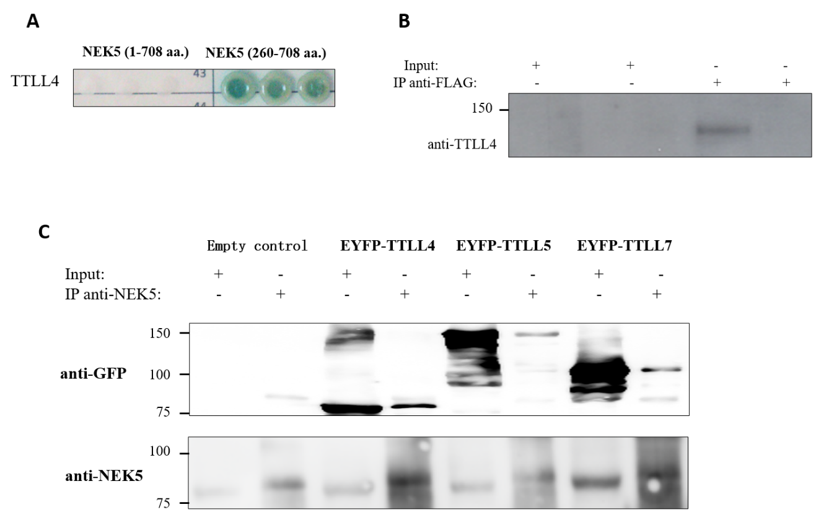
Figure 1 Never in mitosis gene A-related kinase 5 interacts with tubulin tyrosine ligase-like 4. A: Yeast colonies grew in selective medium SD-WLAH with aureobasidin and X-α-Gal. In addition to the reporter gene Auri-C we also activated the genes MEL1, ADE2 and His3 as indicators of interaction between the proteins. Controls of the yeast two-hybrid assay are presented in Supplementary Figure 3; B: Stable cells expressing never in mitosis gene A-related kinase 5 (NEK5)-FLAG were induced with 2 μg/mL of tetracycline and fractionated in cytoplasm and mitochondria. 1 µg of protein was used to immunoprecipitate NEK5 using an anti-FLAG resin, after elution the proteins were separated by sodium dodecyl sulfate polyacrylamide gel electrophoresis and blotted onto a nitrocellulose membrane. Tubulin tyrosine ligase-like (TTLL) 4 was co-immunoprecipitated with NEK5 as assessed with anti-TTLL4 antibody. Controls of cell fractioning are presented in Supplementary Figure 5; and C: NEK5 interacts with TTLL4, TTLL5 and TTLL7 by immunoprecipitation. HEK293T were transfected with EYFP-TTLL4, EYFP, TTLL5 and EYFP-TTLL7. Endogenous NEK5 was immunoprecipitated using anti-NEK5 antibody. Immunoprecipitated proteins were separated by sodium dodecyl sulfate polyacrylamide gel electrophoresis and blotted onto a nitrocellulose membrane. The identification of TTLLs was assessed by an anti-green fluorescent protein antibody to confirm interaction between the proteins. NEK5: Never in mitosis gene A-related kinase 5; GFP: Green fluorescent proteins; EYFP: Enhanced yellow fluorescent protein; TTLL: Tubulin tyrosine ligase-like.

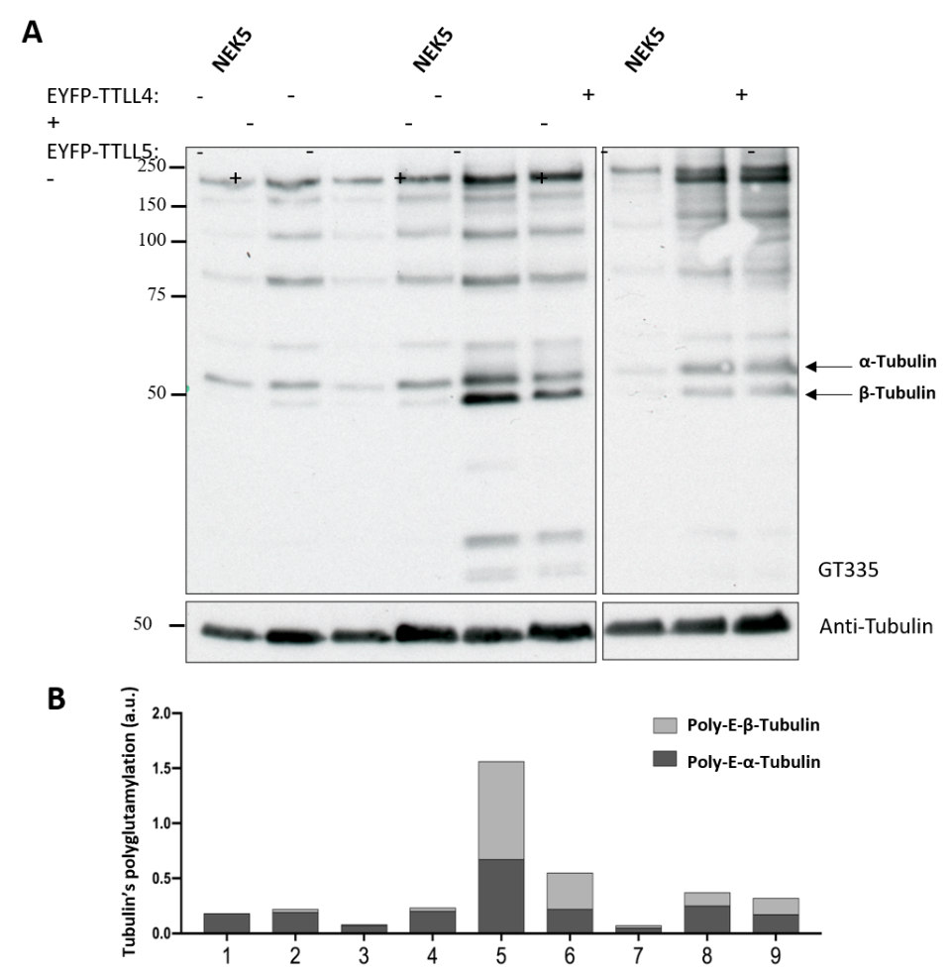
Figure 2 Never in mitosis gene A-related kinase 5 changes the tubulin tyrosine ligase-like 4 and tubulin tyrosine ligase-like 5-mediated polyglutamylation. A: Analysis by Western blot of tubulin tyrosine ligase-like 4 and 5 in polyglutamylation in cells that stably express either never in mitosis gene A-related kinase 5 (NEK5) or NEK5-kinase-dead (catalytically inactive) or cells silenced for NEK5 expression. The graph next to the Western blot corresponds to the intensity of polyglutamylated α- and β-tubulins selected among the bands labeled by GT335 antibody which were measured and normalized to total α-tubulin. The arrows indicate α- and β-tubulins polyglutamylated used in this graph; and B: The intensity (area of the bands) of Western blot of the figure presented in “c” was measured using ImageJ software. NEK5: Never in mitosis gene A-related kinase 5; EYFP: Enhanced yellow fluorescent protein; TTLL: Tubulin tyrosine ligase-like.
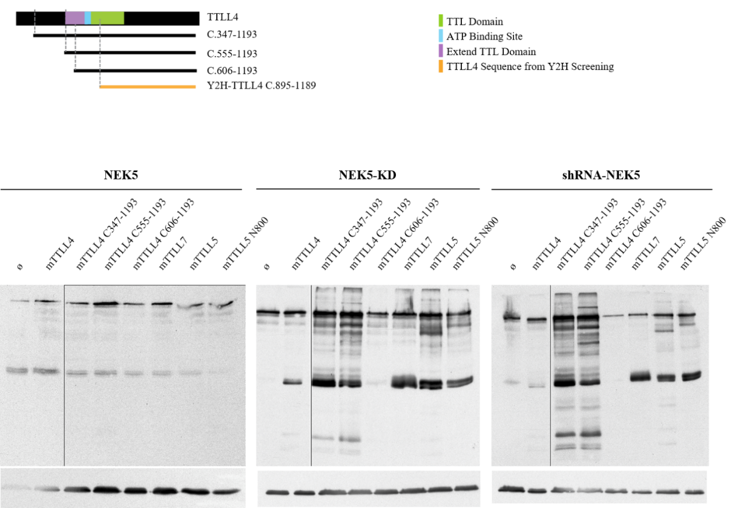
Figure 3 The effect of never in mitosis gene A-related kinase 5 on the activity of different truncations of the tubulin tyrosine ligase-like 4. A: Schematic representation of the tubulin tyrosine ligase-like (TTLL) 4 constructs used. The sequences expressed for each truncated version used in this work are depicted as black bars underneath the pictograms of the full-length TTLL proteins. Domains unnecessary or required for autonomous activities are shown. Green area corresponds to tubulin tyrosine ligase domain (599-942 a.a.), the purple area is extended tubulin tyrosine ligase domain, the blue area is the ATP binding site and the orange construction is the TTLL4 sequence identified by yeast two-hybrid screening. See text for more details; and B-D Analysis by Western blot of truncations of TTLL4 and TTLL5 promoting polyglutamylation in (b) control, (c) cells stably expressing never in mitosis gene A-related kinase 5-kinase-dead or (d) cells silenced for expression of never in mitosis gene A-related kinase 5. NEK5: Never in mitosis gene A-related kinase 5; KD: Kinase-dead; shRNA: Short hairpin ribonucleic acid; EYFP: Enhanced yellow fluorescent protein; TTLL: Tubulin tyrosine ligase-like.
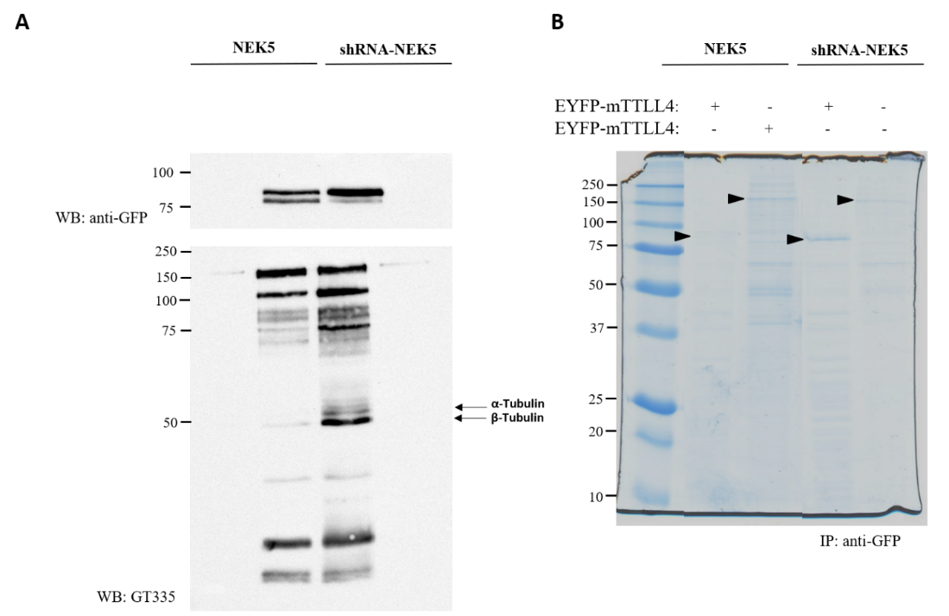
Figure 4 Presence of never in mitosis gene A-related kinase 5 decreases tubulin tyrosine ligase-like 4 activity in a phosphorylation dependent manner. Short hairpin ribonucleic acid-never in mitosis gene A-related kinase 5 and control cells transfected with enhanced yellow fluorescent protein (EYFP)-tubulin tyrosine ligase-like (TTLL) 4 or EYFP-TTLL5 were sorted in TTLL5/TTLL4⁺ and TTLL5/TTLL4⁻ cells by flow cytometry. A: Sorted EYFP-TTLL4 transfected cells were lysed and analyzed by Western-blot. Stable cells expressing never in mitosis gene A-related kinase 5 were used as controls; and B: The protein extracts from EYFP-mTTLL-4 or -5 positive cells were immunoprecipitated by anti-green fluorescent protein-beads for TTLL4 or TTLL5 enrichment. The bands indicated by the black arrow correspond to TTLL4 and TTLL5, respectively, and were cut, digested and submitted to mass spectrometry. NEK5: Never in mitosis gene A-related kinase 5; GFP: Green fluorescent proteins; shRNA: Short hairpin ribonucleic acid; EYFP: Enhanced yellow fluorescent protein; TTLL: Tubulin tyrosine ligase-like.
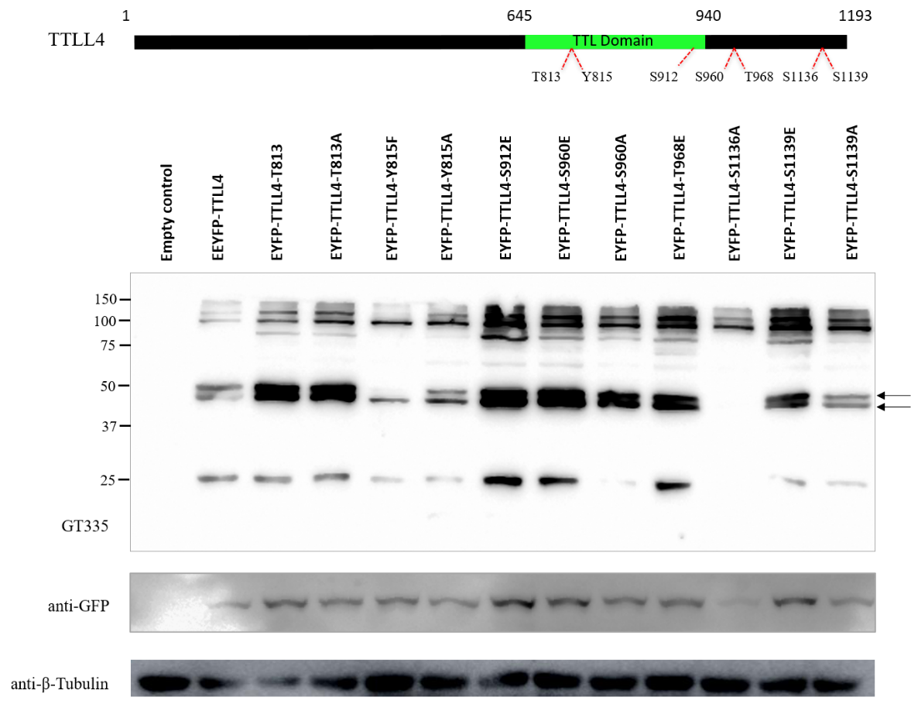
Figure 5 Tyrosine 815 is important for tubulin tyrosine ligase-like 4 activity. Based on the residues identified by mass spectrometry, phosphomimetic or inactivating point mutants (Ser/Thr/Tyr to Alanine, Phenylalanine) were generated. A: Schematic representation of the tubulin tyrosine ligase-like 4 and sites of target amino acids for point mutations. The green region corresponds to the tubulin tyrosine ligase domain; and B: HEK293T proteins of cells transfected with enhanced yellow fluorescent protein-tubulin tyrosine ligase-like 4 containing different mutations were separated by sodium dodecyl sulfate- polyacrylamide gel electrophoresis, transferred onto nitrocellulose membranes and stained with GT335, anti-green fluorescent proteins and anti-tubulin antibodies. GFP: Green fluorescent proteins; shRNA: Short hairpin ribonucleic acid; EYFP: Enhanced yellow fluorescent protein; TTLL: Tubulin tyrosine ligase-like; TTL: Tubulin tyrosine ligase.

