Name of Journal: World Journal of Gastrointestinal Surgery
Manuscript NO: 89672
Manuscript Type: CASE REPORT

Percutaneous ultrasound-guided coaxial core needle biopsy for the diagnosis of multiple splenic lesions: A case report

Pu SH et al. US-guided coaxial CNB in splenic diseases

Sha-Hong Pu, Wu-Yong-Ga Bao, Zhen-Peng Jiang, Rui Yang, Qiang Lu

Sha-Hong Pu, Wu-Yong-Ga Bao, Zhen-Peng Jiang, Rui Yang, Qiang Lu, Department of Medical Ultrasound, West China Hospital of Sichuan University, Chengdu 610041, Sichuan Province, China

Author contributions: Lu Q contributed to the study conceptualization and supervision; Pu SH contributed to manuscript writing; Yang R contributed to data collection; Bao WYG, Jiang ZP and Lu Q contributed to manuscript revision; and all authors have approved the final manuscript.

Corresponding author: Qiang Lu, MD, Professor, Department of Medical Ultrasound, West China Hospital of Sichuan University, No. 37 Guoxue Xiang, Chengdu 610041, Sichuan Province, China. luqiang@scu.edu.cn

Received: November 8, 2023
Revised: December 18, 2023
Accepted: January 25, 2024
Published online: February 27, 2024

Abstract
BACKGROUND
The overlap of imaging manifestations among distinct splenic lesions gives rise to a diagnostic dilemma. Consequently, a definitive diagnosis primarily relies on histological results. The ultrasound (US)-guided coaxial core needle biopsy (CNB) not only procures sufficient tissue to help clarify the diagnosis, but reduces the incidence of puncture-related complications.

CASE SUMMARY
A 41-year-old female, with a history of pulmonary tuberculosis, was admitted to our hospital with multiple indeterminate splenic lesions. Gray-scale ultrasonography demonstrated splenomegaly with numerous well-defined hypoechoic masses. Abdominal contrast-enhanced computed tomography (CT) showed an enlarged spleen with multiple irregular-shaped, peripherally enhancing, hypodense lesions. Positron emission CT revealed numerous abnormal hyperglycemia foci. These imaging findings strongly indicated the possibility of infectious disease as the primary concern, with neoplastic lesions requiring exclusion. To obtain the precise pathological diagnosis, the US-guided coaxial CNB of the spleen was carried out. The patient did not express any discomfort during the procedure.

CONCLUSION
Percutaneous US-guided coaxial CNB is an excellent and safe option for obtaining precise splenic tissue samples, as it significantly enhances sample yield for exact pathological analysis with minimum trauma to the spleen parenchyma and surrounding tissue.

Key Words: Spleen; Splenic disease; Ultrasound; Biopsy; Ultrasound-guided coaxial core needle biopsy; Case report

©The Author(s) 2024. Published by Baishideng Publishing Group Inc. All rights reserved.

Citation: Pu SH, Bao WYG, Jiang ZP, Yang R, Lu Q. Percutaneous ultrasound-guided coaxial core needle biopsy for the diagnosis of multiple splenic lesions: A case report. World J Gastrointest Surg 2024; 16(2): 616-621
URL: https://www.wjgnet.com/1948-9366/full/v16/i2/616.htm
DOI: https://dx.doi.org/10.4240/wjgs.v16.i2.616

Core Tip: Multiple splenic lesions caused by infection, lymphoma, sarcoid, metastasis and infarction may have similar imaging features. The overlapping imaging characteristics of splenic lesions cause a diagnostic dilemma. Consequently, a definitive diagnosis primarily relies on histological results. We describe a case of multiple indeterminate splenic lesions and confirmed the diagnosis with an ultrasound (US)-guided coaxial core needle biopsy (CNB). US-guided CNB is a safe and efficient puncture technique providing valuable diagnostic information and patient treatment guidance.

INTRODUCTION
Multiple splenic lesions can be caused by a variety of benign or malignant diseases, including infection, primary tumor, and metastasis^{[1]}. Non-specific characteristics on imaging frequently pose a diagnostic dilemma^{[2,3]}. Histological examination of the spleen is considered a valuable approach in achieving precise diagnoses. Splenic tissue specimens can be obtained by either splenectomy or percutaneous puncture biopsy^{[4]}. However, splenectomy may potentially cause complications, such as infection, arterial and venous thrombosis, as well as pulmonary hypertension^{[5,6]}. Compared with splenectomy, percutaneous ultrasound (US)-guided coaxial core needle biopsy (CNB) is a less invasive procedure that reduces the occurrence of complications^{[4,7]}. We present a case of multiple splenic lesions in which US-guided coaxial CNB successfully obtained larger, unfragmented samples with high diagnostic accuracy^{[8]}.

CASE PRESENTATION
Chief complaints
A 41-year-old female was admitted to our hospital with focal splenic lesions discovered during routine abdominal ultrasonography as a part of health checkup.

History of present illness
The patient was in good health and did not report any discomfort.

History of past illness
One year ago, the patient was admitted to the tuberculosis (TB) medical unit due to recurrent fever and cough, and was diagnosed with pulmonary TB. Subsequently, 2HRZE/7HRE (strengthening period: Isoniazid 300 mg, rifampicin 450 mg, pyrazinamide 0.75 g, ethambutol 0.75 g, once a day, given for 2 months; consolidation period: Isoniazid 300 mg, rifampicin 450 mg, ethambutol 0.75 g, once a day, given for 7 months) therapy was administered. The patient discontinued anti-TB medication 3 months ago following a reexamination at the TB clinic.

Personal and family history
Patient and family histories were negative.

Physical examination
The patient did not complain of any abdominal pain or distension.

Laboratory examinations
Carbohydrate antigen 125 was mildly elevated, and other tumor markers including alpha-fetoprotein, carcinoembryonic antigen, and carbohydrate antigen 199 were within the normal range. Other biochemical results were unremarkable.

Imaging examinations
Grayscale US demonstrated splenomegaly with numerous well-defined hypoechoic masses (Figure 1A). Color Doppler imaging indicated no significant blood flow signals within these lesions (Figure 1B). Contrast-enhanced US (CEUS) showed peripheral heterogeneous slight hyper-enhancement in the arterial phase (Figure 1C) and hypo-enhancement in the venous phase (Figure 1D), while no enhancement was observed in the central area during the CEUS procedure. CEUS findings suggested an infectious disease. Abdominal contrast-enhanced computed tomography (CT) was performed which showed an enlarged spleen with multiple irregular nodular and patchy low density shadows, the largest measuring approximately 1.7 cm × 1.7 cm, with a suspicion of chronic infection (Figure 2). A great many abnormal hyperglycemia foci detected by positron emission CT indicated an infectious disease, but the possibility of neoplastic lesions could not be definitively excluded.

Further diagnostic work-up
The differential diagnoses based on clinical and radiological results included splenic tuberculosis, fungal infection, metastasis, lymphoma and hemangioma. For further diagnostic analyses, the US-guided coaxial CNB for histological diagnosis was performed by a doctor with over 5 years of experience in interventional US. Platelet count and prothrombin time were within normal limits at the time of the procedure. The procedure was conducted with the patient in the right lateral decubitus position, ensuring optimal visualization and access to the target area. First, conventional US was performed to determine the optimal puncture route. Subsequently, 5 mL of 2% lidocaine was infiltrated into the subcutaneous tissues. A 18G coaxial needle was introduced through the coaxial system under real-time US guidance. Three cores were obtained with the 18G biopsy needle via the access established by the sheath of the aforementioned coaxial needle (Figure 3A). The biopsy specimens were fixed in 95% ethanol and sent to the Pathology Department for histological and immunohistochemical evaluation. In order to reduce the risk of bleeding, a muddy mixture of gelfoam and saline was injected into the coaxial needle sheath to block the needle path immediately after the sampling procedure (Figure 3B).

FINAL DIAGNOSIS
Histological analysis showed no evidence of malignancy, but the proliferation of fibrous tissue and hyaline degeneration were observed in some areas. Granulomas were noted in focal areas, accompanied by peripheral lymphoid hyperplasia involving infiltration of neutrophils, monocytes, and plasma cells (Figure 4). Immunohistochemistry revealed CD20+ and CD3+ cells, in addition to some CD8+ cells. Acid-fast and methenamine silver stain did not reveal any pathogens. No mycobacterium TB DNA fragments were observed in the TB-quantitative real-time polymerase chain reaction. These findings supported the diagnosis of chronic granulomatous inflammation with necrosis, but did not exclude specific infections (TB).

TREATMENT
The patient opted for follow-up observation and underwent regular conventional US for ongoing monitoring.

OUTCOME AND FOLLOW-UP
Follow-up US 6 months later revealed that the lesions found on the initial examination were unchanged. The patient is presently in good physical condition without any discomfort.

DISCUSSION
Multiple splenic lesions caused by infection, lymphoma, sarcoid, metastasis and infarction may have similar imaging features^{[1]}. The overlapping imaging characteristics of splenic lesions cause a diagnostic dilemma^{[2,3]}. Hence, there is a need for confirmation by tissue biopsy. The US-guided coaxial CNB is considered a valuable technique for obtaining ample tissue for definitive diagnosis and to reduce puncture-related complications^{[8,9]}.
Spleen tissue samples can be obtained by splenectomy or percutaneous biopsy^{[4]}. Splenectomy is an invasive technique and can potentially cause complications, including infection, arterial and venous thrombosis, and pulmonary hypertension^{[5,6]}. The infrequency of image-guided percutaneous spleen biopsies can be attributed to concerns regarding potential bleeding^{[10]}. In addition, adjacent tissues or organs may be injured during the procedure, such as the pleura, lung, or splenic flexure of the colon^{[11,12]}. However, a recent meta-analysis reported a high overall diagnostic accuracy and a low complication rate of 4.2% with image-guided percutaneous spleen biopsy. The overall sensitivity and specificity were 87.0% and 96.4%, respectively^{[4]}.
Percutaneous biopsy is performed under US or CT guidance. US guidance is sometimes preferred over CT due to real-time guidance and no radiation risk. US-guided coaxial CNB demonstrates a high diagnostic accuracy, reduces complications and provides a specific therapeutic direction for patients^{[7,13-15]}. The coaxial technique has had a positive impact on percutaneous image-guided biopsy since its introduction. The outer cannula is inserted into the spleen, and on the one hand, specimen collection yields can be improved using the same path by making slight adjustments to the angle of the introducer needle; on the other hand, changes in tissue cutting length can be achieved by adjusting the degree to which the introducer needle protrudes the outer cannula^{[16]}. Adequate tissue samples ensure comprehensive pathological analysis and avoid another puncture at the same time. Liang et al^{[8]} investigated the difference in spleen biopsy using 18G CNB and 21G fine needle aspiration. Their findings revealed that using 18G CNB enabled the acquisition of larger, unfragmented tissue samples with high diagnostic accuracy. Importantly, protection of the outer cannula and reduction in the puncture frequency can mitigate tissue damage. With regard to bleeding after spleen puncture, Kunin et al^{[17]} retrospectively analyzed 232 spleen biopsies and showed that higher systolic blood pressure, lower platelet count, and the lack of US guidance were independent predictors of major hemorrhage. Therefore, careful evaluation of preoperative indications, real-time US guidance throughout the procedure, coupled with tract embolization at the end of the procedure can prevent hemorrhage, thereby reducing the incidence of complications^{[17-19]}. Tract embolization can be achieved by gelfoam, embolization coils, autologous blood clots, microfibrous collagen and other materials. The most commonly used embolic agent is gelfoam, which can be used in the form of either a gelfoam slurry or gelfoam torpedo. Compared with alternative materials such as autologous blood clots, gelfoam slurry is inexpensive and can be easily prepared by mixing gelfoam with saline^{[18,20]}. Even pediatric patients benefit from the application of gelfoam in closing transhepatic and transsplenic parenchymal access^{[21]}. Furthermore, the coaxial technique expedites the procedure by minimizing the time required to reposition the biopsy needle after each specimen acquisition. US-guided coaxial CNB also protects patients from splenectomy with potential complications, providing patients with a treatment choice.
US-guided coaxial CNB for the diagnosis of multiple splenic lesions is rarely performed clinically, and this case report provides a direction for clinical patient management and treatment. However, we lack the support of corresponding research data, which may not be very convincing.

CONCLUSION
US-guided coaxial CNB is a safe and efficient puncture technique for the diagnosis of multiple splenic lesions. It not only provides valuable diagnostic information but guides patient treatment based on histological analysis.

ACKNOWLEDGEMENTS
Thank Bao WYG, Jiang ZP and Lu Q for their suggestions on revising the draft.

REFERENCES
1 Dhyani M, Anupindi SA, Ayyala R, Hahn PF, Gee MS. Defining an imaging algorithm for noncystic splenic lesions identified in young patients. AJR Am J Roentgenol 2013; 201: W893-W899 [PMID: 24261396 DOI: 10.2214/AJR.12.10105]
2 Kamaya A, Weinstein S, Desser TS. Multiple lesions of the spleen: differential diagnosis of cystic and solid lesions. Semin Ultrasound CT MR 2006; 27: 389-403 [PMID: 17048454 DOI: 10.1053/j.sult.2006.06.004]
3 Tan M, Low HM, Shelat V, Tan CH. Imaging patterns in non-traumatic spleen lesions in adults-a review. Jpn J Radiol 2022; 40: 664-677 [PMID: 35099683 DOI: 10.1007/s11604-022-01250-9]
4 McInnes MD, Kielar AZ, Macdonald DB. Percutaneous image-guided biopsy of the spleen: systematic review and meta-analysis of the complication rate and diagnostic accuracy. Radiology 2011; 260: 699-708 [PMID: 21693659 DOI: 10.1148/radiol.11110333]
5 Long B, Koyfman A, Gottlieb M. Complications in the adult asplenic patient: A review for the emergency clinician. Am J Emerg Med 2021; 44: 452-457 [PMID: 32247651 DOI: 10.1016/j.ajem.2020.03.049]
6 Cadili A, de Gara C. Complications of splenectomy. Am J Med 2008; 121: 371-375 [PMID: 18456028 DOI: 10.1016/j.amjmed.2008.02.014]
7 Olson MC, Atwell TD, Harmsen WS, Konrad A, King RL, Lin Y, Wall DJ. Safety and Accuracy of Percutaneous Image-Guided Core Biopsy of the Spleen. AJR Am J Roentgenol 2016; 206: 655-659 [PMID: 26901024 DOI: 10.2214/AJR.15.15125]
8 Liang P, Gao Y, Wang Y, Yu X, Yu D, Dong B. US-guided percutaneous needle biopsy of the spleen using 18-gauge versus 21-gauge needles. J Clin Ultrasound 2007; 35: 477-482 [PMID: 17583561 DOI: 10.1002/jcu.20390]
9 Muraca S, Chait PG, Connolly BL, Baskin KM, Temple MJ. US-guided core biopsy of the spleen in children. Radiology 2001; 218: 200-206 [PMID: 11152802 DOI: 10.1148/radiology.218.1.r01ja16200]
10 Strnad BS, Itani M, Middleton WD. Detection and management of bleeding in the setting of image-guided percutaneous needle biopsy. Abdom Radiol (NY) 2022; 47: 2681-2696 [PMID: 34882270 DOI: 10.1007/s00261-021-03357-5]
11 Singh AK, Shankar S, Gervais DA, Hahn PF, Mueller PR. Image-guided percutaneous splenic interventions. Radiographics 2012; 32: 523-534 [PMID: 22411947 DOI: 10.1148/rg.322115135]
12 Tam A, Krishnamurthy S, Pillsbury EP, Ensor JE, Gupta S, Murthy R, Ahrar K, Wallace MJ, Hicks ME, Madoff DC. Percutaneous image-guided splenic biopsy in the oncology patient: an audit of 156 consecutive cases. J Vasc Interv Radiol 2008; 19: 80-87 [PMID: 18192471 DOI: 10.1016/j.jvir.2007.08.025]
13 Gómez-Rubio M, López-Cano A, Rendón P, Muñoz-Benvenuty A, Macías M, Garre C, Segura-Cabral JM. Safety and diagnostic accuracy of percutaneous ultrasound-guided biopsy of the spleen: a multicenter study. J Clin Ultrasound 2009; 37: 445-450 [PMID: 19582827 DOI: 10.1002/jcu.20608]
14 Patel N, Dawe G, Tung K. Ultrasound-guided percutaneous splenic biopsy using an 18-G core biopsy needle: our experience with 52 cases. Br J Radiol 2015; 88: 20150400 [PMID: 26337505 DOI: 10.1259/bjr.20150400]
15 Sangiorgio VFI, Rizvi H, Padayatty J, Thayur N, Fujiwara T, Anyanwu FA, Calaminici M. Radiologically guided percutaneous core needle biopsy of the spleen: a reliable and safe diagnostic procedure for neoplastic and reactive conditions. Histopathology 2021; 78: 1051-1055 [PMID: 33393079 DOI: 10.1111/his.14327]
16 Habibi HA, Cevener M, Yilmaz S. Image-guided percutaneous cutting needle biopsy in difficult locations. Jpn J Radiol 2022; 40: 560-567 [PMID: 35064440 DOI: 10.1007/s11604-021-01238-x]
17 Kunin H, Wijetunga NA, Erinjeri JP, Noy A, Deipolyi AR. Predictors of Major Hemorrhage After Spleen Core Biopsy in Cancer Patients. J Vasc Interv Radiol 2022; 33: 1055-1060.e1 [PMID: 36049840 DOI: 10.1016/j.jvir.2022.06.002]
18 Guo RQ, Li XG. Seven case reports on the prevention of hemorrhage after percutaneous computed tomography-guided core-needle biopsy of the spleen. J Cancer Res Ther 2020; 16: 1182-1185 [PMID: 33004768 DOI: 10.4103/jcrt.JCRT_815_19]
19 Civardi G, Vallisa D, Bertè R, Giorgio A, Filice C, Caremani M, Caturelli E, Pompili M, De Sio I, Buscarini E, Cavanna L. Ultrasound-guided fine needle biopsy of the spleen: high clinical efficacy and low risk in a multicenter Italian study. Am J Hematol 2001; 67: 93-99 [PMID: 11343380 DOI: 10.1002/ajh.1085]
20 Handke NA, Koch DC, Muschler E, Thomas D, Luetkens JA, Attenberger UI, Kuetting D, Pieper CC, Wilhelm K. Bleeding management in computed tomography-guided liver biopsies by biopsy tract plugging with gelatin sponge slurry. Sci Rep 2021; 11: 24506 [PMID: 34969958 DOI: 10.1038/s41598-021-04155-1]
21 Uller W, Müller-Wille R, Grothues D, Schelling J, Zausig N, Loss M, Stroszczynski C, Wohlgemuth WA. Gelfoam for closure of large percutaneous transhepatic and transsplenic puncture tracts in pediatric patients. Rofo 2014; 186: 693-697 [PMID: 24458376 DOI: 10.1055/s-0033-1355905]

Footnotes
Informed consent statement: Informed written consent was obtained from the patient for publication of this report and any accompanying images.

Conflict-of-interest statement: The authors declare that they have no conflict of interest.

CARE Checklist (2016) statement: The authors have read the CARE Checklist (2016), and the manuscript was prepared and revised according to the CARE Checklist (2016).

Open-Access: This article is an open-access article that was selected by an in-house editor and fully peer-reviewed by external reviewers. It is distributed in accordance with the Creative Commons Attribution NonCommercial (CC BY-NC 4.0) license, which permits others to distribute, remix, adapt, build upon this work non-commercially, and license their derivative works on different terms, provided the original work is properly cited and the use is non-commercial. See: https://creativecommons.org/Licenses/by-nc/4.0/

Provenance and peer review: Unsolicited article; Externally peer reviewed.

Peer-review model: Single blind

Peer-review started: November 8, 2023
First decision: December 6, 2023
Article in press: January 25, 2024

Specialty type: Gastroenterology and hepatology
Country/Territory of origin: China
Peer-review report’s scientific quality classification
Grade A (Excellent): A
Grade B (Very good): 0
Grade C (Good): 0
Grade D (Fair): 0
Grade E (Poor): 0

P-Reviewer: Eysselein VE, United States S-Editor: Qu XL L-Editor: A P-Editor: Qu XL
Figure Legends
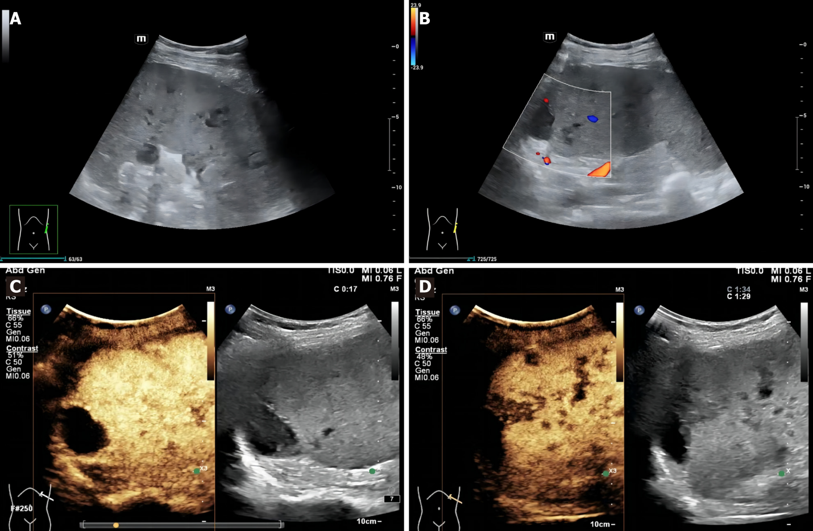
Figure 1 Ultrasonography images of the patient. A: Conventional grayscale ultrasound (US) showed multiple hypoechoic nodules and masses in the spleen; B: There were no blood flow signals in the splenic lesions on Color Doppler US; C: Arterial phase imaging on contrast-enhanced US; D: Venous phase imaging on contrast-enhanced US.
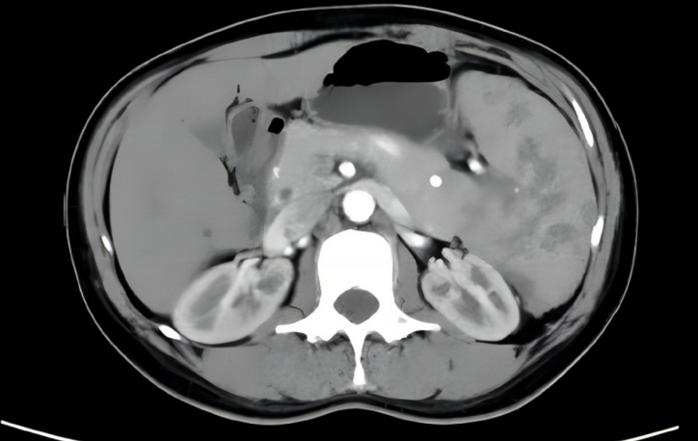
Figure 2 Contrast-enhanced computed tomography images of the patient. Contrast-enhanced computed tomography revealed an enlarged spleen, with multiple irregular nodular and patchy low density shadows, the largest measuring approximately 1.7 cm × 1.7 cm.

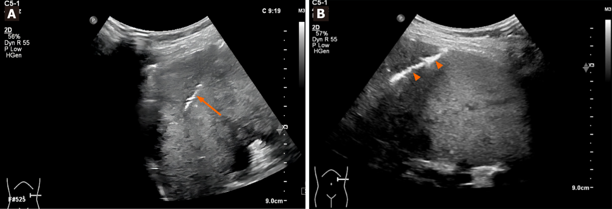
Figure 3 Images of the puncture procedure. A: A 18G coaxial needle (arrow) was applied under real-time ultrasound guidance; B: A muddy mixture(arrowheads) of gelfoam and saline was injected into the coaxial needle sheath to prevent hemorrhage at the end of procedure.

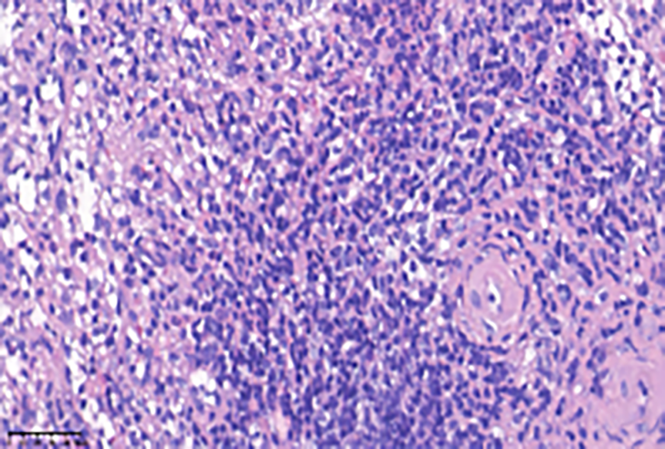
Figure 4 Histopathological findings by hematoxylin-eosin staining (40 ×). Granulomas were noted in focal areas, accompanied by peripheral lymphoid hyperplasia involving infiltration of neutrophils, monocytes, and plasma cells.

Published by Baishideng Publishing Group Inc
7041 Koll Center Parkway, Suite 160, Pleasanton, CA 94566, USA
Telephone: +1-925-3991568
E-mail: office@baishideng.com
Help Desk: https://www.f6publishing.com/helpdesk
https://www.wjgnet.com

© 2024 Baishideng Publishing Group Inc. All rights reserved.

