Name of Journal: World Journal of Orthopedics
Manuscript NO: 79383
Manuscript Type: STANDARD AND CONSENSUS

Baishideng’s Reference Citation Analysis database announces the first Journal Article Influence Index of 104 core journals and a list of high-quality academic journals in orthopedics

Wang JL et al. RCA announces the 2022 JAII of 104 journals in orthopedics

Jin-Lei Wang, Yu-Jie Ma, Li Ma, Na Ma, Diao-Mei Guo, Lian-Sheng Ma

Jin-Lei Wang, Yu-Jie Ma, Li Ma, Na Ma, Diao-Mei Guo, Lian-Sheng Ma, Baishideng Publishing Group Inc, Pleasanton, CA 94566, United States

Author contributions: Wang JL analyzed the data and drafted the manuscript; Ma YJ participated in the data collection; Ma LS revised the manuscript for important intellectual content; and all authors participated in manuscript revision.

Corresponding author: Lian-Sheng Ma, Doctor, Founder and CEO, Baishideng Publishing Group Inc, 7041 Koll Center Parkway, Suite 160, Pleasanton, CA 94566, United States. l.s.ma@baishideng.com

Received: August 18, 2022
Revised: September 6, 2022
Accepted: September 21, 2022
Published online: October 18, 2022

Abstract
After three rounds of rigorous evaluation of core journals in orthopedics conducted by the Reference Citation Analysis (RCA) editorial team of Baishideng Publishing Group (Baishideng), the RCA database of Baishideng officially released the 2022 Journal Article Influence Index (2022 JAII) of 104 core journals and a list of high-quality academic journals in orthopedics, for the first time on August 9, 2022. The list of 104 core journals can be found at: https://www.referencecitationanalysis.com/SearchJournal. Among them, the highest 2022 JAII is 55.015 and the lowest is 3.076. This article introduces the 21 high-quality academic journals and describes the calculation method for the 2022 JAII, the evaluation process, and the inclusion principles for journals in the RCA. These steps are the underpinning of the RCA’s empirical journal academic evaluation service by which the digital platform addresses the needs of authors to select reliable journals for submission, readers to select high-quality literature for reading, and editors to track their own journal citation performance. As such, the RCA core journal list will serve as a useful Find-a-Journal tool. Any interested party is welcome to use this journal list and recommend it to their peers.

Key Words: Reference Citation Analysis; Journal Article Influence Index; Orthopedics; Journal list; Find a journal; Announcement

©The Author(s) 2022. Published by Baishideng Publishing Group Inc. All rights reserved.

Citation: Wang JL, Ma YJ, Ma L, Ma N, Guo DM, Ma LS. Baishideng’s Reference Citation Analysis database announces the first Journal Article Influence Index of 104 core journals and a list of high-quality academic journals in orthopedics. World J Orthop 2022; 13(10): 891-902
URL: https://www.wjgnet.com/2218-5836/full/v13/i10/891.htm
DOI: https://dx.doi.org/10.5312/wjo.v13.i10.891

Core Tip: The Reference Citation Analysis (RCA) database of Baishideng Publishing Group officially released the 2022 Journal Article Influence Index (2022 JAII) of 104 core journals and the list of high-quality academic journals in orthopedics, for the first time. This article highlights the top 21 journals, describes the calculation method for the 2022 JAII, the evaluation process, and the inclusion principles of RCA journals. The RCA journal academic evaluation service platform addresses the needs of authors to select reliable journals for submission, readers to select high-quality literature for reading, and editors to track their own journal citation performance, effectively serving as a useful Find-a-Journal tool. You are welcome to use this journal list and recommend it to your peers.

INTRODUCTION
We are very pleased to announce that the Reference Citation Analysis (RCA) database of Baishideng Publishing Group (Baishideng) has, for the first time, officially released the 2022 Journal Article Influence Index (2022 JAII) of 104 core journals in the field of orthopedics on August 9, 2022. The detailed information on these 104 core journals in orthopedics can be found at: https://www.referencecitationanalysis.com/SearchJournal.
RCA is an AI technology-based open multidisciplinary citation analysis database. As such, RCA will lead the development of wisdom, knowledge innovation, and emerging disciplines. The functions of RCA include: Find an Article (55334324), Find a Category (254), Find a Journal (14077), Find a Scholar (632), and Find an Academic Assistant (18) (Data collection: August 9, 2022)^{[1]}. RCA updates its list of journals daily, according to relevant data including total number of articles, total citations, and the JAII. RCA acquires the newly released abstracts and references from Crossref and adds them to the RCA database weekly. RCA also acquires the abstracts and references released that year from Crossref and adds them to the RCA database monthly, and then updates the total number of articles, citations, and JAII. In this study, we introduce the top 21 journals ranked by the 2022 JAII from the total 104 core journals in the field of orthopedics included in RCA, the calculation method for the 2022 JAII, and the evaluation process and the inclusion principles of RCA journals.

TOP 21 JOURNALS RANKED BY THE 2022 JAII IN THE FIELD OF ORTHOPEDICS INCLUDED IN The RCA
The RCA classifies academic journals with a JAII of 20.0 or above as high-quality academic journals, which will be highly recommended to authors and readers. There are 104 core journals in the field of orthopedics in the RCA, of which 21 were identified to be high-quality academic journals, accounting for 20.2%. These 21 high-quality academic journals, ranked by the JAII among the core journals in the field of orthopedics in the RCA, are described below.

2022 JAII and rankings of The Journal of Bone and Joint Surgery-American Volume
In the RCA database, the 2022 JAII for The Journal of Bone and Joint Surgery-American Volume is 55.015, ranking 1st among 104 core journals in the field of orthopedics included in the RCA, with a total of 1110044 citations (1/104) and a total of 20177 articles (2/104) (Figure 1). For more information on The Journal of Bone and Joint Surgery-American Volume, please visit: https://www.referencecitationanalysis.com/SearchJournal.

2022 JAII and rankings of The American Journal of Sports Medicine
In the RCA database, the 2022 JAII for The American Journal of Sports Medicine is 52.976, ranking 2nd among 104 core journals in the field of orthopedics included in the RCA, with a total of 589467 citations (4/104) and a total of 11127 articles (6/104) (Figure 2). For more information on The American Journal of Sports Medicine, please visit: https://www.referencecitationanalysis.com/SearchJournal.

2022 JAII and rankings of Spine
In the RCA database, the 2022 JAII for Spine is 44.570, ranking 3rd among 104 core journals in the field of orthopedics included in the RCA, with a total of 864839 citations (2/104) and a total of 19404 articles (3/104) (Figure 3). For more information on Spine, please visit: https://www.referencecitationanalysis.com/SearchJournal.

2022 JAII and rankings of European Cells & Materials
In the RCA database, the 2022 JAII for European Cells & Materials is 42.896, ranking 4th among 104 core journals in the field of orthopedics included in the RCA, with a total of 22735 citations (43/104) and a total of 530 articles (90/104) (Figure 4). For more information on European Cells & Materials, please visit: https://www.referencecitationanalysis.com/SearchJournal.

2022 JAII and rankings of Journal of Orthopaedic Research
In the RCA database, the 2022 JAII for Journal of Orthopaedic Research is 35.509, ranking 5th among 104 core journals in the field of orthopedics included in the RCA, with a total of 261809 citations (7/104) and a total of 7373 articles (14/104) (Figure 5). For more information on Journal of Orthopaedic Research, please visit: https://www.referencecitationanalysis.com/SearchJournal.

2022 JAII and rankings of Physical Therapy & Rehabilitation Journal
In the RCA database, the 2022 JAII for Physical Therapy & Rehabilitation Journal is 31.086, ranking 6th among 104 core journals in the field of orthopedics included in the RCA, with a total of 197801 citations (10/104) and a total of 6363 articles (20/104) (Figure 6). For more information on Physical Therapy & Rehabilitation Journal, please visit: https://www.referencecitationanalysis.com/SearchJournal.

2022 JAII and rankings of Arthroscopy
In the RCA database, the 2022 JAII for Arthroscopy is 29.982, ranking 7th among 104 core journals in the field of orthopedics included in the RCA, with a total of 285163 citations (5/104) and a total of 9511 articles (9/104) (Figure 7). For more information on Arthroscopy, please visit: https://www.referencecitationanalysis.com/SearchJournal.

2022 JAII and rankings of Osteoarthritis and Cartilage
In the RCA database, the 2022 JAII for Osteoarthritis and Cartilage is 28.691, ranking 8th among 104 core journals in the field of orthopedics included in the RCA, with a total of 194522 citations (12/104) and a total of 6780 articles (18/104) (Figure 8). For more information on Osteoarthritis and Cartilage, please visit: https://www.referencecitationanalysis.com/SearchJournal.

2022 JAII and rankings of Journal of Shoulder and Elbow Surgery
In the RCA database, the 2022 JAII for Journal of Shoulder and Elbow Surgery is 27.384, ranking 9th among 104 core journals in the field of orthopedics included in the RCA, with a total of 195354 citations (11/104) and a total of 7134 articles (16/104) (Figure 9). For more information on Journal of Shoulder and Elbow Surgery, please visit: https://www.referencecitationanalysis.com/SearchJournal.

2022 JAII and rankings of Journal of Orthopaedic & Sports Physical Therapy
In the RCA database, the 2022 JAII for Journal of Orthopaedic & Sports Physical Therapy is 26.966, ranking 10th among 104 core journals in the field of orthopedics included in the RCA, with a total of 105707 citations (20/104) and a total of 3920 articles (27/104) (Figure 10). For more information on Journal of Orthopaedic & Sports Physical Therapy, please visit: https://www.referencecitationanalysis.com/SearchJournal.

2022 JAII and rankings of The Journal of The American Academy of Orthopaedic Surgeons
In the RCA database, the 2022 JAII for The Journal of The American Academy of Orthopaedic Surgeons is 25.946, ranking 11th among 104 core journals in the field of orthopedics included in the RCA, with a total of 86581 citations (24/104) and a total of 3337 articles (33/104) (Figure 11). For more information on The Journal of The American Academy of Orthopaedic Surgeons, please visit: https://www.referencecitationanalysis.com/SearchJournal.

2022 JAII and rankings of The Gait & Posture
In the RCA database, the 2022 JAII for Gait & Posture is 25.815, ranking 12th among 104 core journals in the field of orthopedics included in the RCA, with a total of 165136 citations (14/104) and a total of 6397 articles (19/104) (Figure 12). For more information on Gait & Posture, please visit: https://www.referencecitationanalysis.com/SearchJournal.

2022 JAII and rankings of The Journal of Hand Surgery
In the RCA database, the 2022 JAII for The Journal of Hand Surgery is 25.713, ranking 13th among 104 core journals in the field of orthopedics included in the RCA, with a total of 270686 citations (6/104) and a total of 10527 articles (8/104) (Figure 13). For more information on The Journal of Hand Surgery, please visit: https://www.referencecitationanalysis.com/SearchJournal.

2022 JAII and rankings of Clinical Biomechanics
In the RCA database, the 2022 JAII for Clinical Biomechanics is 25.387, ranking 14th among 104 core journals in the field of orthopedics included in the RCA, with a total of 124397 citations (18/104) and a total of 4900 articles (26/104) (Figure 14). For more information on Clinical Biomechanics, please visit: https://www.referencecitationanalysis.com/SearchJournal.

2022 JAII and rankings of Foot & Ankle International
In the RCA database, the 2022 JAII for Foot & Ankle International is 25.123, ranking 15th among 104 core journals in the field of orthopedics included in the RCA, with a total of 142573 citations (16/1041) and a total of 5675 articles (16/104) (Figure 15). For more information on Foot & Ankle International, please visit: https://www.referencecitationanalysis.com/SearchJournal.

2022 JAII and rankings of Clinical Orthopaedics and Related Research
In the RCA database, the 2022 JAII for Clinical Orthopaedics and Related Research is 23.901, ranking 16th among 104 core journals in the field of orthopedics included in the RCA, with a total of 612124 citations (3/104) and a total of 25611 articles (1/104) (Figure 16). For more information on Clinical Orthopaedics and Related Research, please visit: https://www.referencecitationanalysis.com/SearchJournal.

2022 JAII and rankings of Acta Orthopaedica
In the RCA database, the 2022 JAII for Acta Orthopaedica is 23.437, ranking 17th among 104 core journals in the field of orthopedics included in the RCA, with a total of 35953 citations (34/104) and a total of 1534 articles (56/104) (Figure 17). For more information on Acta Orthopaedica, please visit: https://www.referencecitationanalysis.com/SearchJournal.

2022 JAII and rankings of Knee Surgery Sports Traumatology Arthroscopy
In the RCA database, the 2022 JAII for Knee Surgery Sports Traumatology Arthroscopy is 22.713, ranking 18th among 104 core journals in the field of orthopedics included in the RCA, with a total of 172777 citations (13/104) and a total of 7607 articles (13/104) (Figure 18). For more information on Knee Surgery Sports Traumatology Arthroscopy, please visit: https://www.referencecitationanalysis.com/SearchJournal.

2022 JAII and rankings of The Journal of Arthroplasty
In the RCA database, the 2022 JAII for The Journal of Arthroplasty is 22.683, ranking 19th among 104 core journals in the field of orthopedics included in the RCA, with a total of 257022 citations (8/104) and a total of 11322 articles (5/104) (Figure 19). For more information on The Journal of Arthroplasty, please visit: https://www.referencecitationanalysis.com/SearchJournal.

2022 JAII and rankings of Journal of Orthopaedic Trauma
In the RCA database, the 2022 JAII for Journal of Orthopaedic Trauma is 22.363, ranking 20th among 104 core journals in the field of orthopedics included in the RCA, with a total of 137263 citations (17/104) and a total of 6138 articles (22/104) (Figure 20). For more information on Journal of Orthopaedic Trauma, please visit: https://www.referencecitationanalysis.com/SearchJournal.

2022 JAII and rankings of Clinical Journal of Sport Medicine
In the RCA database, the 2022 JAII for Clinical Journal of Sport Medicine is 21.471, ranking 21st among 104 core journals in the field of orthopedics included in the RCA, with a total of 55095 citations (27/104) and a total of 2566 articles (41/104) (Figure 21). For more information on Clinical Journal of Sport Medicine, please visit: https://www.referencecitationanalysis.com/SearchJournal.

RCA’S MISSION
The mission of RCA is to provide a high-quality academic article evaluation service platform for various categories. At present, there are many evaluation methods for academic articles, but their calculation methods are complicated. The RCA is a new method of evaluating the quality of academic articles, which allows academic evaluation of journals, scholars, institutions, drugs, medical devices, and publishers based on the JAII of each article in the citation analysis database, thus greatly enriching the academic evaluation systems across different categories and guiding the healthy development of the academic community^{[2]}.

OPENNESS AND TRANSPARENCY OF RCA EVALUATION
RCA is unique in its objective, impartial, fair, and transparent release of citation analysis data of important academic journals to authors and readers, including evaluation data, evaluation indices, evaluation methods, and evaluation results, in order to ensure the reliability of academic evaluation^{[2]}.

CALCULATION METHOD FOR 2022 JAII
The 2022 JAII, calculated as Total citations/Total articles, is not a 2-year or 5-year average of citations, but is an average of citations for all articles since the journal was assigned its DOI number. Article types are not only limited to original articles and review articles, but for all types of articles. In this way, it is a more objective, fair, and transparent calculation of the academic influence index of an academic journal. Furthermore, the journal list itself is evaluated dynamically, with its bibliographic metrics being updated daily, including total number of articles, total citations, and JAII^{[2]}.

EVALUATION PROCESS OF RCA JOURNALS
The journals included in the RCA core journal list need to undergo three rounds of strict evaluation. The evaluation process is as follows^{[2]}:

First-round evaluation: The basic information on the journal is verified, including Journal Name, Abbreviated Title, Print ISSN, Online ISSN, Language, Category, Peer-Reviewed Journal, Ownership, Publisher, Journal Website, Editorial Board Members, Submit a Manuscript, and Indexed by.

Second-round evaluation: The activity of the journal is verified, including Total Articles, Total Citations, Cited by in F6Publishing, and the JAII.

Third-round evaluation: Based on the reliability of journal information, the activity of publication data, whether the journal is a peer-reviewed journal or not, and JAII, the editorial team evaluates every journal, makes the decision to accept or reject the journal, and creates a list of core journals by category. The function of the list of core academic journals is to classify journals according to categories and rank them according to various bibliometrics, including Total Views, JAII, Total Citations, Cited by in F6Publishing, Total Articles, and Number of Years.

INCLUSION PRINCIPLES OF RCA JOURNALS
The RCA editorial team of Baishideng conducted three rounds of rigorous evaluation of core journals in orthopedics. The resultant RCA core journal list for the field of orthopedics includes a total of 104 journals, among which the highest 2022 JAII is 55.015 and the lowest JAII is 3.076, the highest total number of citations is 1110044 and the lowest is 678, and the highest total number of articles is 612124 and the lowest is 164. The RCA core journal list does not include any journals with a JAII lower than 3.0. We implement dynamic evaluation inclusively for the RCA core journal list. Evaluation is initiated once an RCA-nonincluded journal receives a JAII over 3.0. Similarly, if a journal included in the RCA core journal list receives a JAII lower than 3.0, it will be excluded. The RCA core journal list is designed by publishers, scientific editors, and engineers for use by readers, authors, and editorial offices, and is free of charge to users^{[2]}.
Upon completion of the three rounds of rigorous evaluation of core journals in orthopedics by the RCA editorial team, all data in each journal are organized for public consumption according to category rank, including the 2022 JAII, total citations, cited by in F6Publishing, total articles, and the 2021 Journal Impact Factor™. All information in each journal, including Journal Name, Print ISSN, Online ISSN, Language, Free Access, Peer-Reviewed Journal, Ownership, Publisher, Journal Website, Editorial Board Members, Submit a Manuscript, and Indexed by, is made available in RCA. Moreover, the citations of each journal can be then ranked in RCA by the Impact Index Per Article, Cited by in Crossref, and Cited by in F6Publishing parameters. Results analysis available for each journal includes Year Published Analysis, Article Type Analysis, Journal Title Analysis, and Category Analysis. The references of each journal are also able to be refined by Year Published and Article Type. Each reference’s citation information is displayed, including PMID, DOI, Cited by in Crossref, Impact Index Per Article, RCA, and Track Full Text^{[2]}.

CONCLUSION
The ultimate purpose of RCA is to provide an open, objective, fair, and reliable academic evaluation service platform for readers, authors, and journal editors, in order to address the needs of authors to select reliable journals for submission, readers to select high-quality literature for reading, and editors to track their own journal citation performance.

REFERENCES
1 Baishideng Publishing Group Inc. Welcome to the Reference Citation Analysis. Available from: https://www.referencecitationanalysis.com
2 Baishideng Publishing Group Inc. Reference Citation Analysis’s evaluation process for inclusion of academic journals. [cited 19 August 2022]. Available from: https://www.wjgnet.com/bpg/GerInfo/303

Footnotes
Conflict-of-interest statement: The authors are all employees of the Baishideng Publishing Group Inc and declare that they have no other real or potential conflicts of interest to disclose.

Open-Access: This article is an open-access article that was selected by an in-house editor and fully peer-reviewed by external reviewers. It is distributed in accordance with the Creative Commons Attribution NonCommercial (CC BY-NC 4.0) license, which permits others to distribute, remix, adapt, build upon this work non-commercially, and license their derivative works on different terms, provided the original work is properly cited and the use is non-commercial. See: https://creativecommons.org/Licenses/by-nc/4.0/

Provenance and peer review: Unsolicited article; Externally peer reviewed.
Peer-review model: Single blind

Peer-review started: August 18, 2022
First decision: August 25, 2022
Article in press: September 21, 2022

Specialty type: Orthopedics
Country/Territory of origin: United States
Peer-review report’s scientific quality classification
Grade A (Excellent): A, A
Grade B (Very good): B, B
Grade C (Good): 0
Grade D (Fair): 0
Grade E (Poor): 0

P-Reviewer: Al-Jabi SW, Palestine; Liu XQ, China; Long X, China; Scribante A, Italy S-Editor: Wang JJ L-Editor: Webster JR P-Editor: Wang JJ

Figure Legends
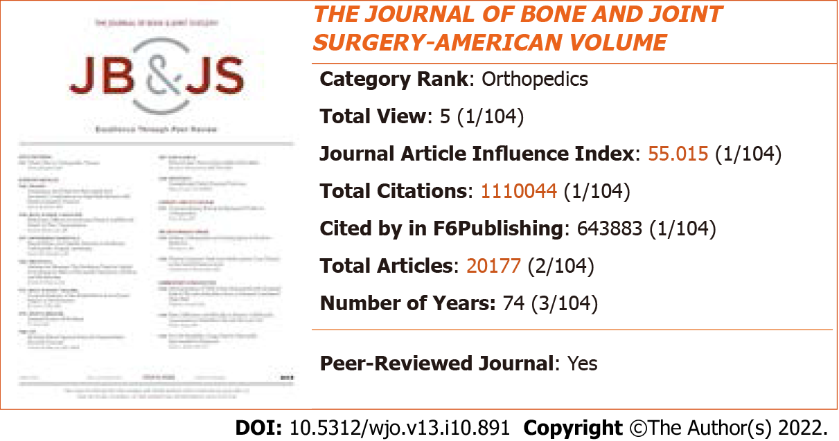
Figure 1 2022 Journal Article Influence Index and rankings of The Journal of Bone and Joint Surgery-American Volume. The image of the journal cover is originally from the home page of the journal: https://journals.lww.com/jbjsjournal/pages/default.aspx.

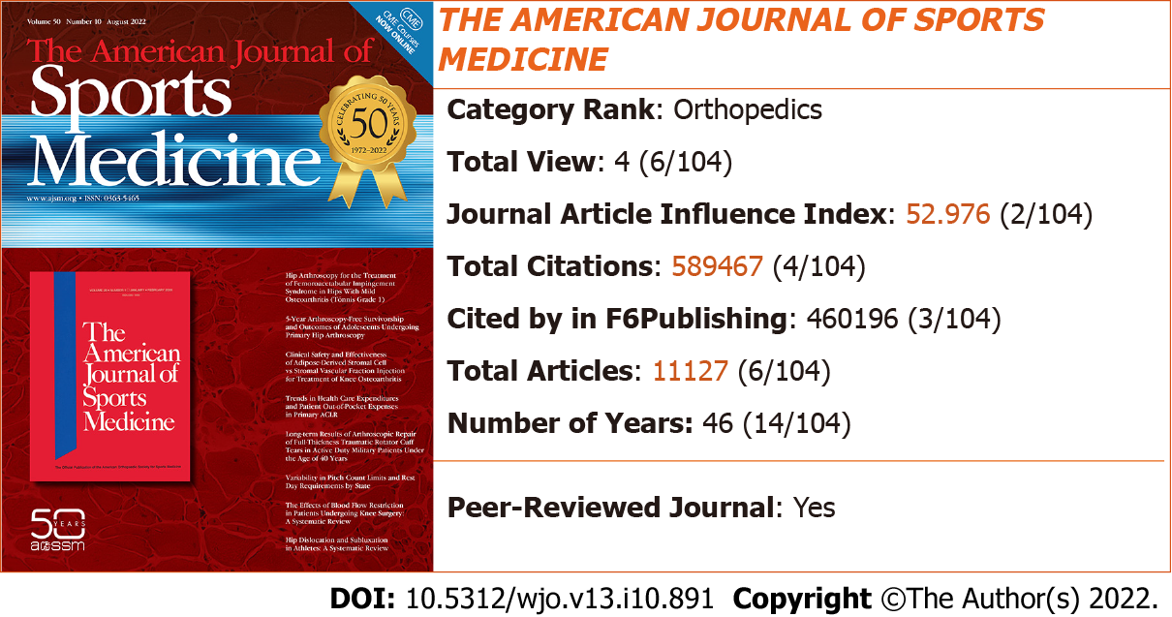
Figure 2 2022 Journal Article Influence Index and rankings of The American Journal of Sports Medicine. The image of the journal cover is originally from the home page of the journal: https://journals.sagepub.com/home/ajs.

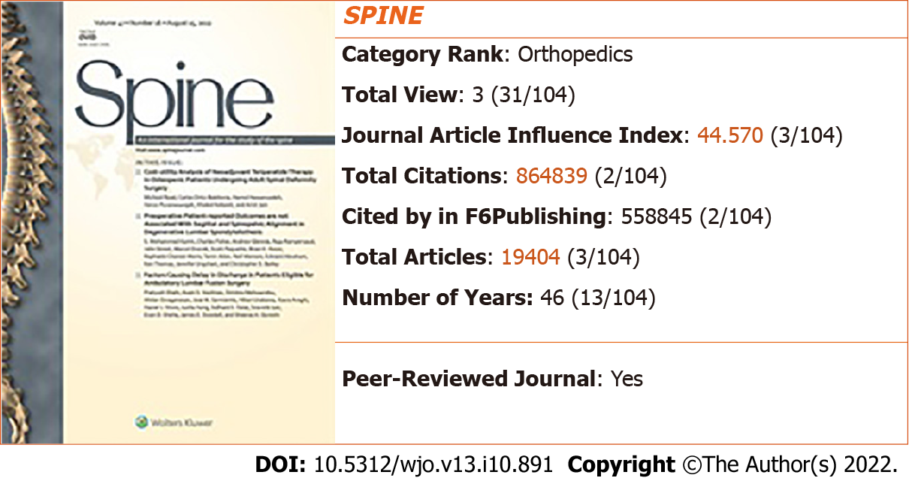
Figure 3 2022 Journal Article Influence Index and rankings of Spine. The image of the journal cover is originally from the home page of the journal: https://journals.lww.com/spinejournal/pages/issuelist.aspx.

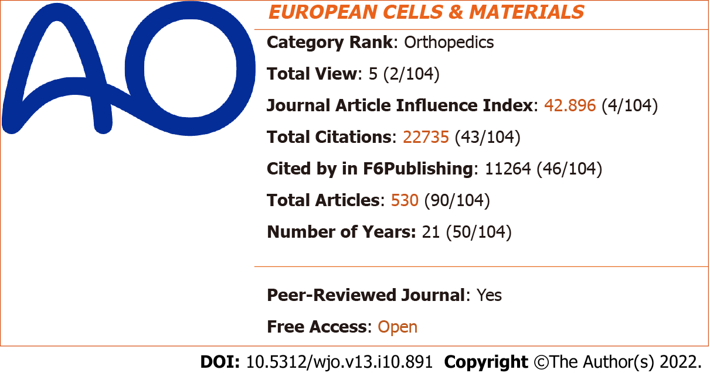
Figure 4 2022 Journal Article Influence Index and rankings of European Cells & Materials. The image of the logo of AO Foundation is originally from the home page of the journal: http://www.ecmjournal.org/.

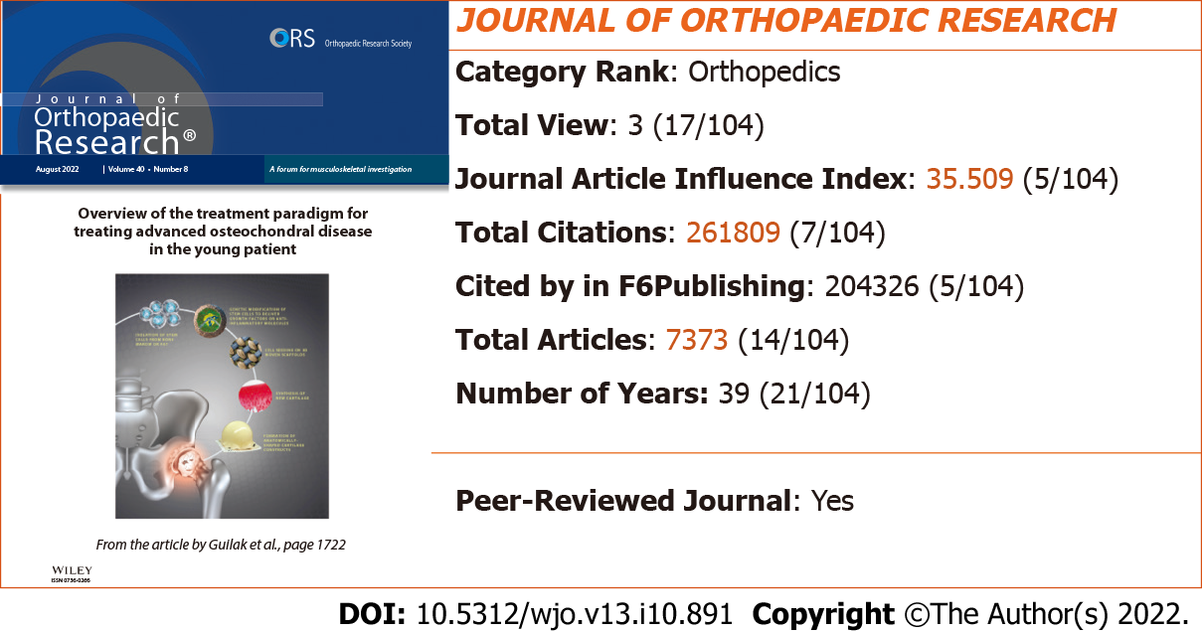
Figure 5 2022 Journal Article Influence Index and rankings of Journal of Orthopaedic Research. The image of the journal cover is originally from the home page of the journal: https://onlinelibrary.wiley.com/journal/1554527x.

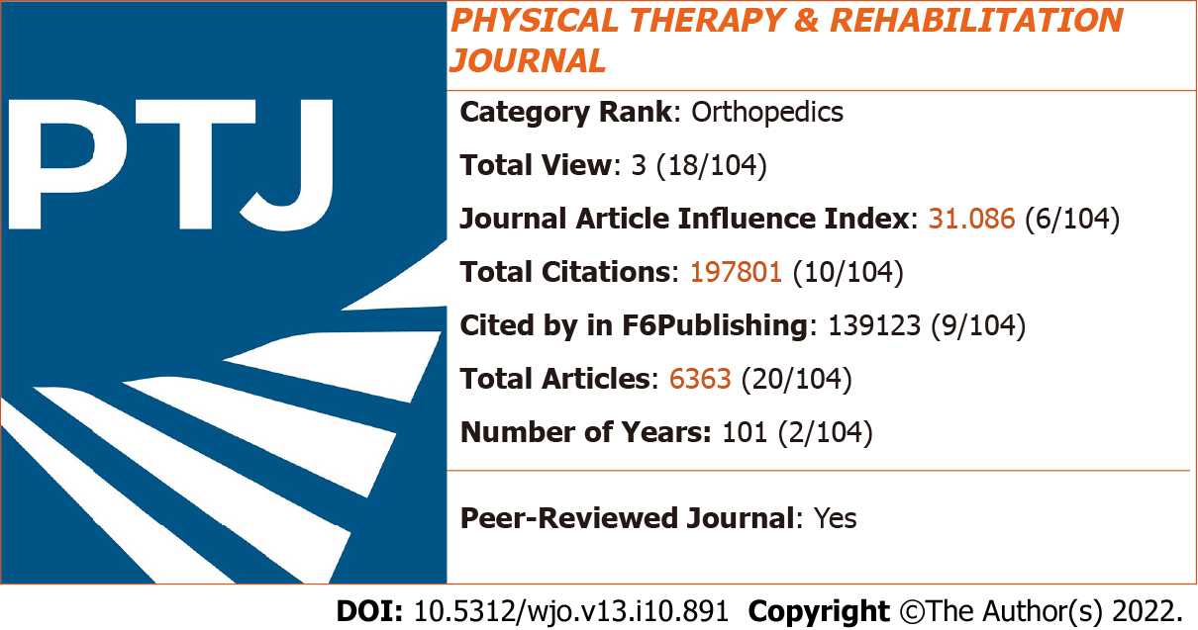
Figure 6 2022 Journal Article Influence Index and rankings of Physical Therapy & Rehabilitation Journal. The image of the journal cover is originally from the home page of the journal: https://academic.oup.com/ptj.

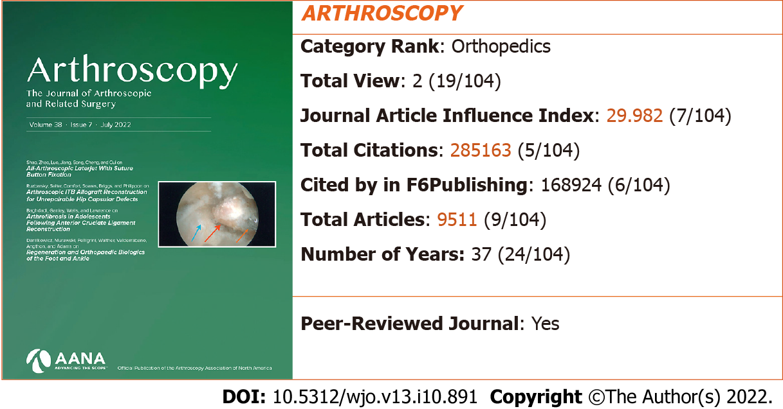
Figure 7 2022 Journal Article Influence Index and rankings of Arthroscopy. The image of the journal cover is originally from the home page of the journal: http://www.sciencedirect.com/science/journal/07498063.

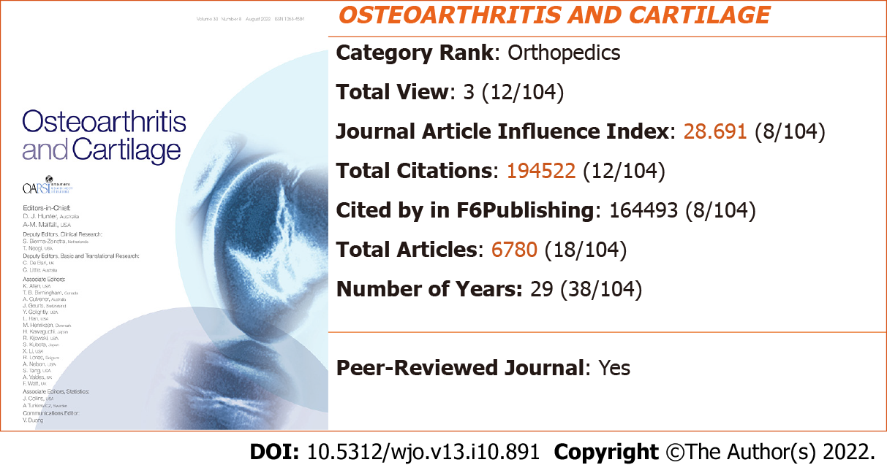
Figure 8 2022 Journal Article Influence Index and rankings of Osteoarthritis and Cartilage. The image of the journal cover is originally from the home page of the journal: http://www.sciencedirect.com/science/journal/10634584.

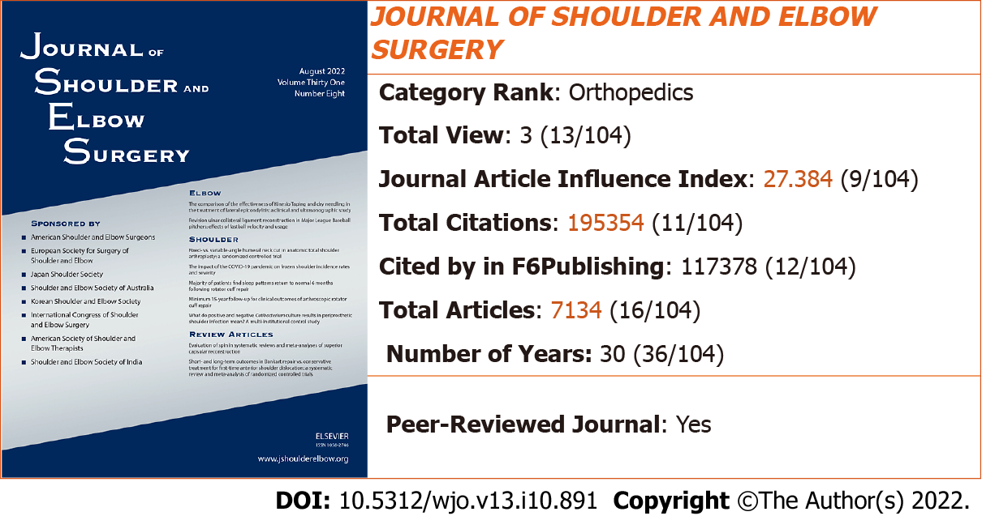
Figure 9 2022 Journal Article Influence Index and rankings of Journal of Shoulder and Elbow Surgery. The image of the journal cover is originally from the home page of the journal: http://www.sciencedirect.com/science/journal/10582746.

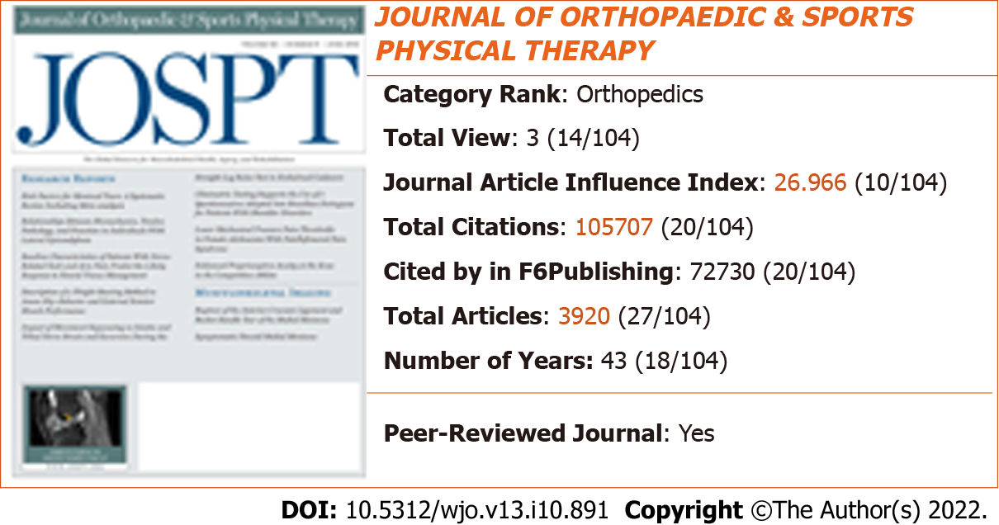
Figure 10 2022 Journal Article Influence Index and rankings of Journal of Orthopaedic & Sports Physical Therapy. The image of the journal cover is originally from the home page of the journal: http://www.jospt.org/.

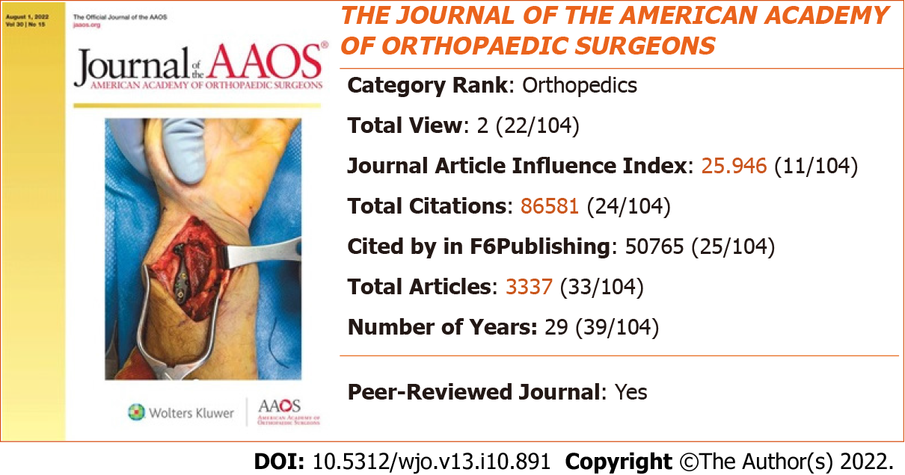
Figure 11 2022 Journal Article Influence Index and rankings of The Journal of The American Academy of Orthopaedic Surgeons. The image of the journal cover is originally from the home page of the journal: https://journals.lww.com/jaaos.

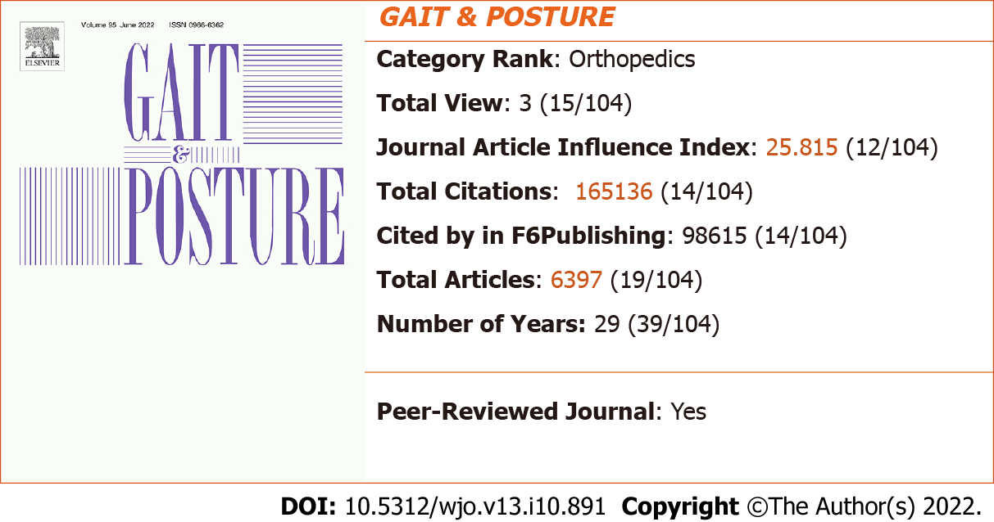
Figure 12 2022 Journal Article Influence Index and rankings of Gait & Posture. The image of the journal cover is originally from the home page of the journal: https://www.sciencedirect.com/journal/gait-and-posture.

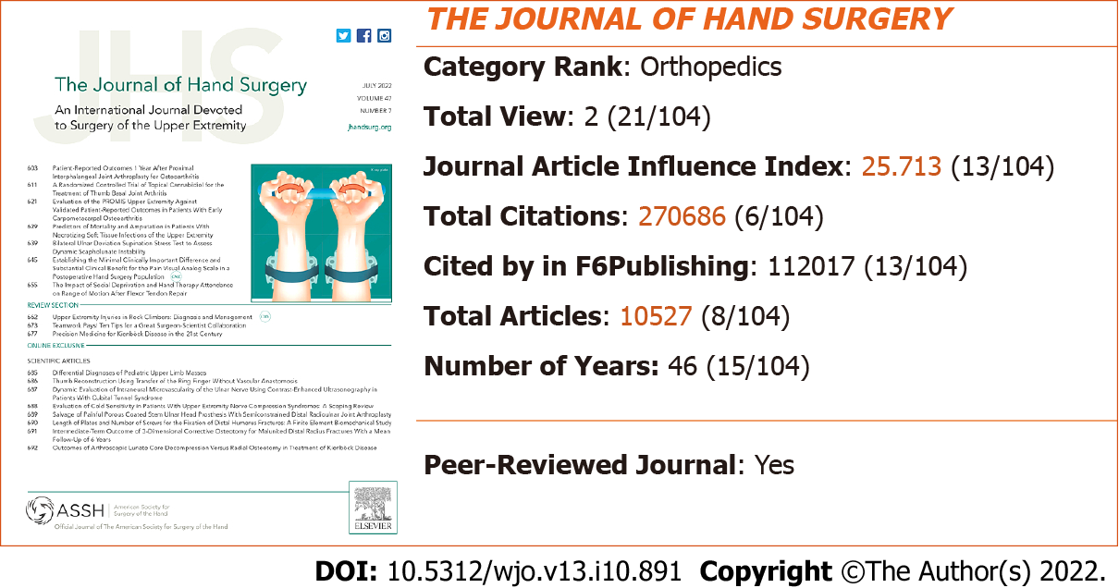
Figure 13 2022 Journal Article Influence Index and rankings of The Journal of Hand Surgery. The image of the journal cover is originally from the home page of the journal: http://www.sciencedirect.com/science/journal/03635023.

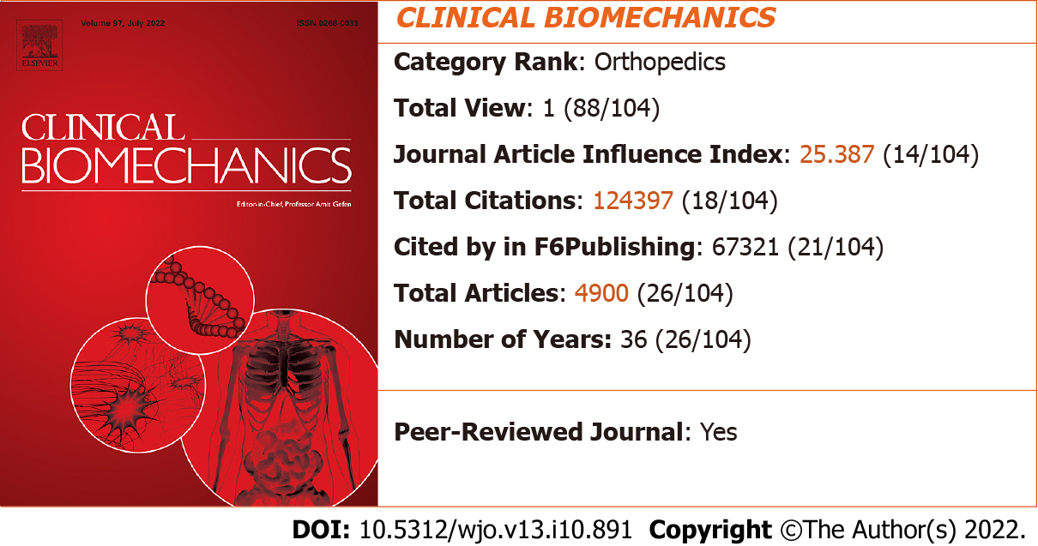
Figure 14 2022 Journal Article Influence Index and rankings of Clinical Biomechanics. The image of the journal cover is originally from the home page of the journal: https://www.sciencedirect.com/journal/clinical-biomechanics.

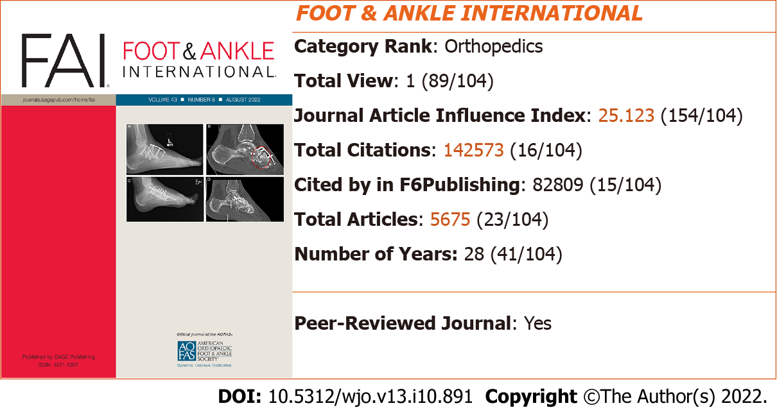
Figure 15 2022 Journal Article Influence Index and rankings of Foot & Ankle International. The image of the journal cover is originally from the home page of the journal: https://journals.sagepub.com/home/fai.

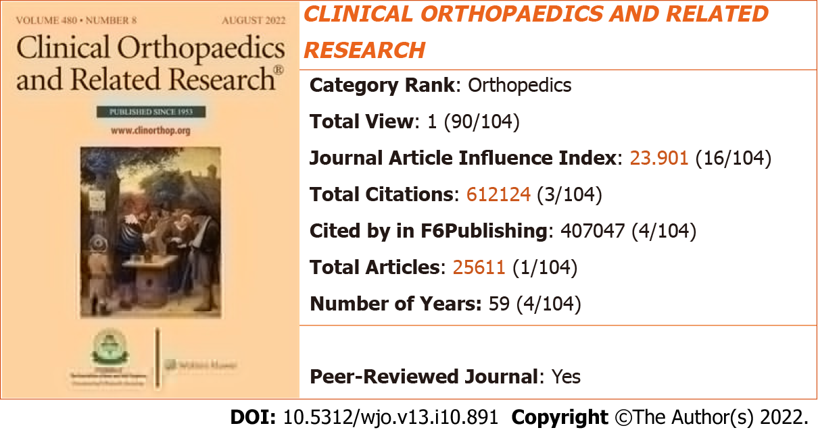
Figure 16 2022 Journal Article Influence Index and rankings of Clinical Orthopaedics and Related Research. The image of the journal cover is originally from the home page of the journal: https://journals.lww.com/clinorthop/pages/default.aspx.

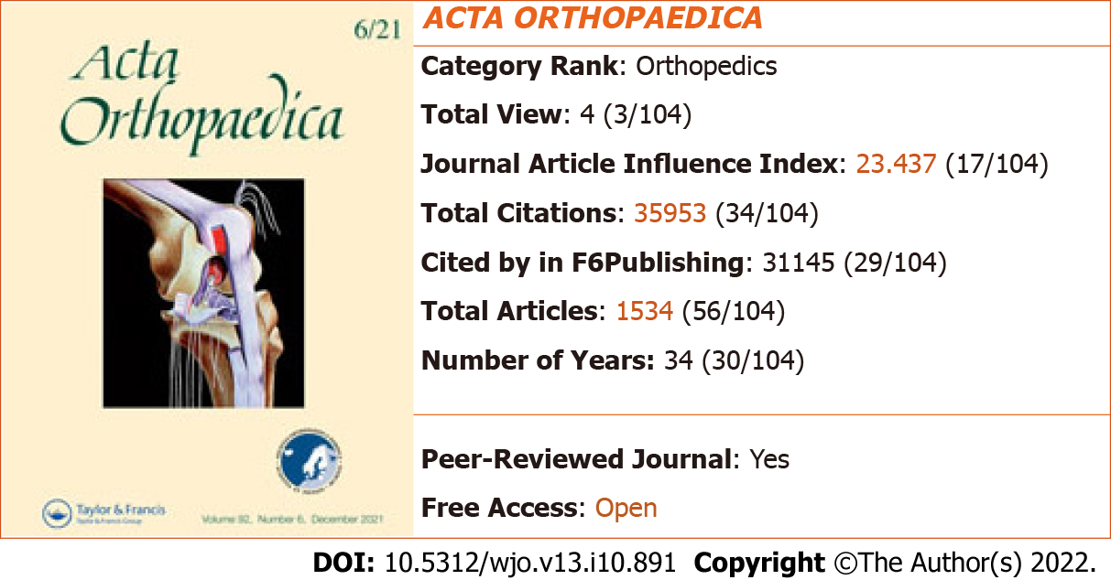
Figure 17 2022 Journal Article Influence Index and rankings of Acta Orthopaedica. The image of the journal cover is originally from the home page of the journal: https://www.tandfonline.com/journals/iort20.

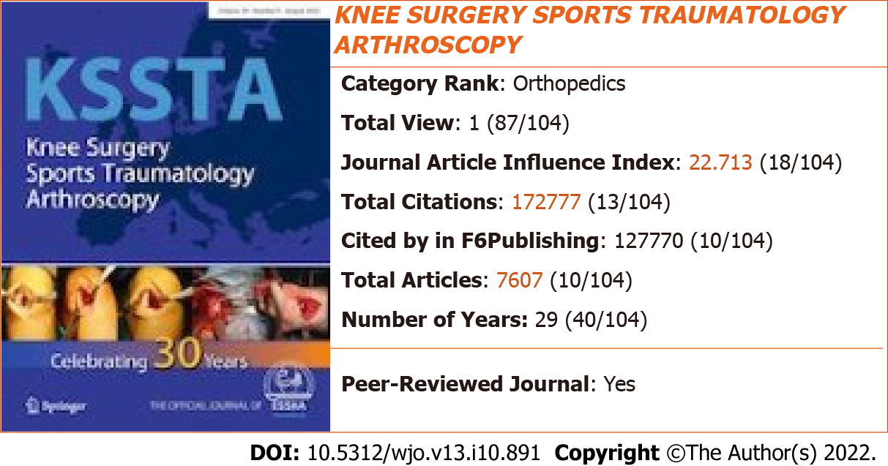
Figure 18 2022 Journal Article Influence Index and rankings of Knee Surgery Sports Traumatology Arthroscopy. The image of the journal cover is originally from the home page of the journal: https://Link.springer.com/journal/167.

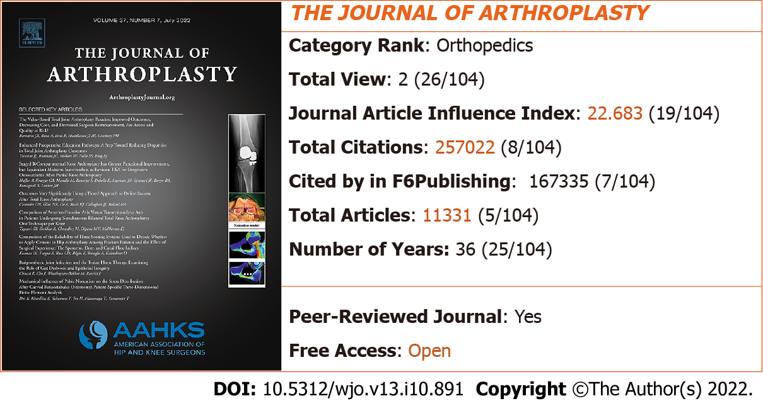
Figure 19 2022 Journal Article Influence Index and rankings of The Journal of Arthroplasty. The image of the journal cover is originally from the home page of the journal: http://www.sciencedirect.com/science/journal/08835403.

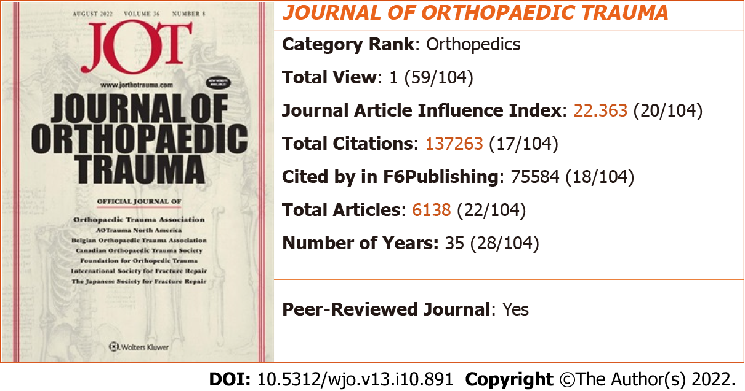
Figure 20 2022 Journal Article Influence Index and rankings of Journal of Orthopaedic Trauma. The image of the journal cover is originally from the home page of the journal: https://journals.lww.com/jorthotrauma/pages/issuelist.aspx.

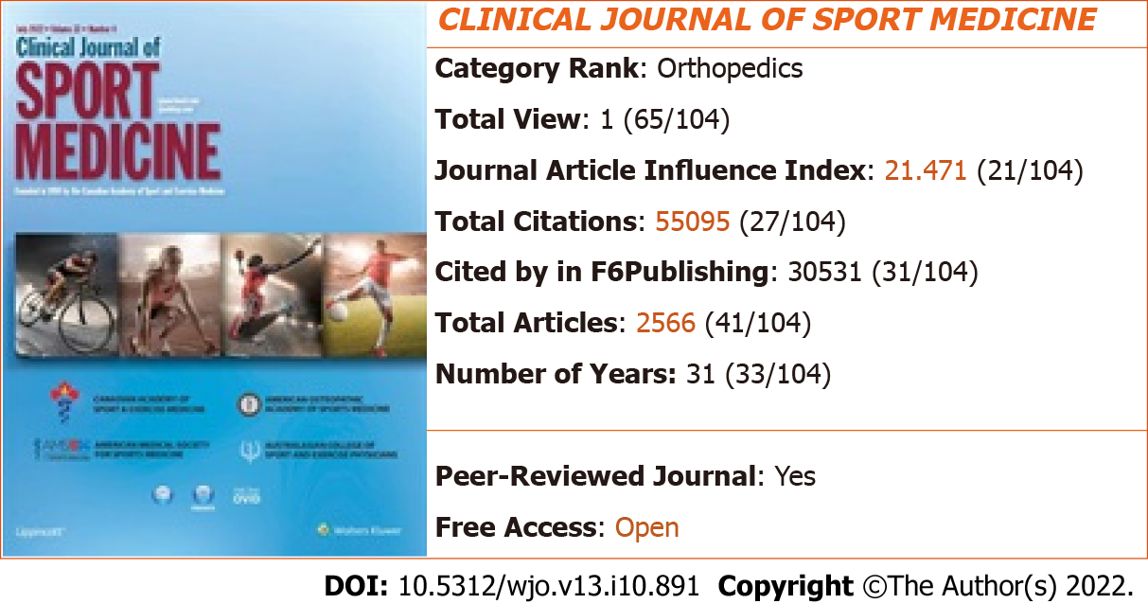
Figure 21 2022 Journal Article Influence Index and rankings of Clinical Journal of Sport Medicine. The image of the journal cover is originally from the home page of the journal: https://journals.lww.com/cjsportsmed/pages/issuelist.aspx.

Published by Baishideng Publishing Group Inc
7041 Koll Center Parkway, Suite 160, Pleasanton, CA 94566, USA
Telephone: +1-925-3991568
E-mail: bpgoffice@wjgnet.com
Help Desk: https://www.f6publishing.com/helpdesk
https://www.wjgnet.com

© 2022 Baishideng Publishing Group Inc. All rights reserved.

