Name of journal: World Journal of Orthopedics
ESPS Manuscript NO: 16190
Manuscript Type: Case Report

Surgical treatment of sacral fractures following lumbosacral arthrodesis: Case report and literature review

Wang Y et al. Sacral fractures following lumbosacral arthrodesis

Yu Wang, Xian-Yi Liu, Chun-De Li, Xiao-Dong Yi, Zheng-Rong Yu

Yu Wang, Xian-Yi Liu, Chun-De Li , Xiao-Dong Yi, Zheng-Rong Yu, Department of Orthopaedics, Peking University First Hospital, Beijing 100034, China

Author contributions: Wang Y, Li CD, and Yi XD designed the research study; Liu XY performed the surgeries; Yu ZR revised manuscript.

Institutional review board statement: The study was reviewed and approved by the Peking University First Hospital Institutional Review Board.

Informed consent statement: All study participants, or their legal guardian, provided informed written consent prior to study enrollment.

Conflict-of-interest statement: The authors declare that they have no conflicts of interest concerning this article.

Open-Access: This article is an open-access article which was selected byan in-house editor and fully peer-reviewed by external reviewers. It is distributed in accordance with the Creative Commons Attribution Non Commercial (CC BY-NC 4.0) license, which permits others to distribute, remix, adapt, build upon this work non-commercially, and license their derivative works on different terms, provided the original work is properly cited and the use is non-commercial. See: http://creativecommons.org/licenses/by-nc/4.0/

Correspondence to: Xian-Yi Liu, MD, Department of Orthopaedics, Peking University First Hospital, Xishiku Street 8, Xicheng District, Beijing 100034, China. wangyuspine@sina.com
Telephone: +86-10-83575763
Fax: +86-10-66551554

Received: January 2, 2015
Peer-review started: January 2, 2015
First decision: January 20, 2015
Revised: June 28, 2015
Accepted: July 21, 2015
Article in press:
Published online:

Abstract
Sacral fractures following posterior lumbosacral fusion are an uncommon complication. Only a few case series and case reports have been published so far. This article presents a case of totally displaced sacral fracture following posterior L4-S1 fusion in a 65-year-old patient with a 15-year history of corticosteroid use who underwent open reduction and internal fixation using iliac screws. The patient was followed for 2 years. A thorough review of the literature was conducted using the Medline database between 1994 and 2014. Immediately after the revision surgery, the patient’s pain in buttock and left leg resolved significantly. The patient was followed for 2 years. The weakness of left lower extremity improved gradually from 3/5 to 5/5. In conclusion, the incidence of postoperative sacral fractures could have been rather underestimated, because most of these fractures are not visible on plain radiograph. Computed tomography has been proved to be able to detect most of such fractures and should probably be performed routinely when patients complain of renewed buttock pain within 3 mo after lumbosacral fusion. The majority of the patients responded well to conservative treatments, extending the fusion construct to the iliac wings using iliac screws may be needed when there is concurrent fracture displacement, sagittal imbalance, neurologic symptoms, or painful nonunion.

Key words: Sacral fracture; Lumbosacral fusion; Complication; Surgical treatment; Insufficiency fracture; Revision surgery

© The Author(s) 2015. Published by Baishideng Publishing Group Inc. All rights reserved.

Core tip: Sacral fractures following posterior lumbosacral fusion are rare. This article presents a case of totally displaced sacral fracture following posterior L4-S1 fusion. Computed tomography has been proved to be able to detect most of such fractures and should probably be performed routinely when patients complain of renewed buttock pain within 3 mo after lumbosacral fusion. The majority of the patients responded well to conservative treatments, extending the fusion construct to the iliac wings using iliac screws may be needed when there is concurrent fracture displacement, sagittal imbalance, neurologic symptoms, or painful nonunion.

Wang Y, Liu XY, Li CD, Yi XD, Yu ZR. Surgical treatment of sacral fractures following lumbosacral arthrodesis: Case report and literature review. World J Orthop 2015; In press

INTRODUCTION
Sacral fractures following posterior lumbosacral fusion are an uncommon complication, previously described in only a few case series and case reports. Although these sacral fractures are rarely reported, their incidence could be much higher than we thought. One of the reasons for the under-diagnosis of these fractures is that they are usually unrecognized on plain radiographs, establishment of diagnosis is often dependent on computed tomography (CT) or magnetic resonance imaging (MRI). Another reason is that many of these fractures can heal without intervention in a few months, which makes them difficult to be noticed by doctors.
Risk factors for developing sacral fractures following lumbosacral fusions have been identified by several authors. They include old age, female sex, obesity, smoking, postmenopausal osteoporosis, chronic corticosteroid use, prior radiation therapy, graft harvesting, multisegmental lumbosacral fusion, and abnormal spinopelvic alignment. According to the reported experience, most of these fractures occurred within 3 mo after surgery, and the majority of these patients responded well to conservative therapy. Surgical intervention may be needed when there are persistent neurological deficits, significant displacements, severe pain, or fracture nonunion.
This article presents a case of totally displaced sacral fracture following posterior L4-S1 fusion in a 65-year-old patient with a 15-year history of corticosteroid use who underwent open reduction and internal fixation using iliac screws.

CASE REPORT
The current case is a 65-year-old overweight female (body mass index = 25.63) who presented with the chief complaint of 5 years of progressively increased left lower extremity pain and difficulty walking, which were refractory to conservative management. The patient was ambulant with 4/5 lower extremity weakness. Both Hoffmann’s sign and Babinski’s sign were negative. The patient suffered from asthma and had a 15-year history of corticosteroid use. The bone density test of hip (T-score – -3.7) showed a poor bone quality.
Roentgenograms revealed Grade 2 anterolisthesis of L5 on S1. The MRI of the spine found central lumbar spinal stenosis at L5/S1 level and L4–S1 foraminal narrowing (Figure 1). L4–S1 posterior fusion with poly-axial pedicle screws and double rods (XIA II, Stryker) was performed with posterolateral bone grafting using autologous lamina/spinous process. A cage was inserted intoL5/S1 disc as well.
The patient tolerated the procedure well and was walking well on the first postoperative day. On the 5th day after surgery, however, the patient reported a sudden exacerbation of bilateral buttock pain, left-leg radicular pain and sphincter disturbances without precedent trauma. Physical examination revealed a 3/5 weakness of left lower extremity. A CT scanning revealed a horizontal fracture at the S1/S2 level with S2 being totally displaced (Figure 2).
We tried to reduce the fracture with traction but failed. Considering the significant neurological deficits and severe S2 displacement, we performed posterior neural decompression and hardware revision with deformity reduction for the patient at 2 wk after the index operation. The fusion construct was extended to the iliac wings using iliac screws (Figure 3, 4).
Immediately after the revision surgery, the patient’s pain in buttock and left leg resolved significantly. The patient was followed for 2 years. The weakness of left lower extremity improved gradually from 3/5 to 5/5.
The sagittal radiographic parameters are listed in Table 1. The preoperative values indicate that she had a high PI (64.1°) and SS (37.1°).

DISCUSSION
Sacral fractures following posterior lumbosacral fusion are rarely seen, there has been a paucity of data on the association of this condition in the published literature. Before 2013, there were only 34 cases that had been reported. No cohort with more than 5 cases had been published until recently. Many spine surgeons have never encountered or noticed such kind of fractures.

Incidence and diagnosis
The incidence of postoperative sacral fractures could have been rather underestimated. Because most of these fractures are not visible on plain radiograph, diagnosis is mostly established based on CT, MRI, or nuclear scintigraphy. There are 2 studies with larger cohort that have been published lately. Meredith et al^{[1]} included all the patients undergoing posterior lumbosacral arthrodesis at their institution between 2002 and 2011. Twenty-four out of 392 (6.1%) patients presented sacral fractures after surgery, which were confirmed by CT, MRI, or nuclear scintigraphy. However, in only 1 out of the 24 cases, the sacral fracture could be noticed on the postoperative radiographs. Wilde et al^{[2]} reported a cohort of 23 patients who had sacral fractures after lumbosacral fusion. Similarly, in only 1 out of 23 patients, the sacral fracture was noticed on the postoperative radiographs. As such, sacral fractures after lumbosacral fusion could have been greatly under-diagnosed. And CT has proven to be able to detect most of such fractures and should probably be performed routinely when patients complain of renewed buttock pain within 3 mo after lumbosacral fusion.

Risk factors and prevention
Old age, female sex, osteoporosis, obesity, and long moment arm of multisegmental lumbosacral fusion are the most frequently cited risk factors for sacral fractures after posterior lumbosacral fusion. The current case had a 15-year history of corticosteroid use for her asthma. The bone density test of hip (T-score – -3.7) showed a poor bone quality. Furthermore, abnormal spinopelvic alignment could also be a risk factor for fracture development.
To prevent the onset of postoperative sacral fractures, fixation of the iliac wings can be considered in high-risk patients.

Surgical treatment
The reported experience showed us that these postoperative sacral fractures responded well to conservative treatments, which include activity modification, external immobilization, and medical treatment of osteoporosis^{[8-10]}. However, sacral insufficiency fractures with significant displacement, sagittal imbalance, neurologic symptoms, or painful nonunion may necessitate surgical stabilization. The most commonly performed procedure is to extend the fusion construct to the iliac wings using iliac screws. Fracture union and pain relief were achieved in all the surgically treated cases reported in the literature[1⁻3,6⁻10].
In conclusion, the incidence of postoperative sacral fractures could have been rather underestimated, because most of these fractures are not visible on plain radiograph. CT has been proved to be able to detect most of such fractures and should probably be performed routinely when patients complain of renewed buttock pain within 3 mo after lumbosacral fusion. The majority of the patients responded well to conservative treatments, extending the fusion construct to the iliac wings using iliac screws may be needed when there is concurrent fracture displacement, sagittal imbalance, neurologic symptoms, or painful nonunion.

COMMENTS
Case characteristics
A 65-year-old patient with a 15-year history of corticosteroid use reported a sudden exacerbation of bilateral buttock pain, left-leg radicular pain and sphincter disturbances without precedent trauma on the 5th day after posterior L4-S1 fusion.

Clinical diagnosis
Physical examination revealed a 3/5 weakness of left lower extremity.

Differential diagnosis
Osteoporotic vertebral compressive fracture, epidural hematoma, malposition of pedicle screws, and migration of pedicle screws.

Laboratory diagnosis
The patient had no remarkable findings for the laboratory tests.

Imaging diagnosis
A computed tomography (CT) scanning revealed a horizontal fracture at the S1/S2 level with S2 being totally displaced.

Pathological diagnosis
No histological examination was performed.

Treatment
The authors performed posterior neural decompression and hardware revision with deformity reduction for the patient at 2 wk after the index operation. The fusion construct was extended to the iliac wings using iliac screws.

Related reports
Sacral fractures following posterior lumbosacral fusion are rarely seen, there has been a paucity of data on the association of this condition in the published literature. Before 2013, there were only 34 cases that had been reported. No cohort with more than 5 cases had been published until recently.

Term explanation
Sacral fractures following posterior lumbosacral fusion are an uncommon complication. Risk factors include old age, female sex, obesity, smoking, postmenopausal osteoporosis, chronic corticosteroid use, prior radiation therapy, graft harvesting, multisegmental lumbosacral fusion, and abnormal spinopelvic alignment.

Experiences and lessons
The incidence of postoperative sacral fractures could have been rather underestimated, because most of these fractures are not visible on plain radiograph. CT has been proved to be able to detect most of such fractures and should probably be performed routinely when patients complain of renewed buttock pain within 3 mo after lumbosacral fusion. The majority of the patients responded well to conservative treatments, extending the fusion construct to the iliac wings using iliac screws may be needed when there is concurrent fracture displacement, sagittal imbalance, neurologic symptoms, or painful nonunion.

Peer-review
It’s a well-organised study.
REFERENCES
1 Meredith DS, Taher F, Cammisa FP, Girardi FP. Incidence, diagnosis, and management of sacral fractures following multilevel spinal arthrodesis. Spine J 2013; 13: 1464-1469 [PMID: 23623635 DOI: 10.1016/j.spinee.2013.03.025]
2 Wilde GE, Miller TT, Schneider R, Girardi FP. Sacral fractures after lumbosacral fusion: a characteristic fracture pattern. AJR Am J Roentgenol 2011; 197: 184-188 [PMID: 21701029 DOI: 10.2214/AJR.10.5902]
3 Wood KB, Schendel MJ, Ogilvie JW, Braun J, Major MC, Malcom JR. Effect of sacral and iliac instrumentation on strains in the pelvis. A biomechanical study. Spine (Phila Pa 1976) 1996; 21: 1185-1191 [PMID: 8727193 DOI: 10.1097/00007632-199605150-00010]
4 Erickson MA, Oliver T, Baldini T, Bach J. Biomechanical assessment of conventional unit rod fixation versus a unit rod pedicle screw construct: a human cadaver study. Spine (Phila Pa 1976) 2004; 29: 1314-1319 [PMID: 15187631 DOI: 10.1097/01.BRS.0000127182.36142.95]
5 Khan MH, Smith PN, Kang JD. Sacral insufficiency fractures following multilevel instrumented spinal fusion: case report. Spine (Phila Pa 1976) 2005; 30: E484-E488 [PMID: 16103844 DOI: 10.1097/01.brs.0000174272.63548.89]
6 Gotis-Graham I, McGuigan L, Diamond T, Portek I, Quinn R, Sturgess A, Tulloch R. Sacral insufficiency fractures in the elderly. J Bone Joint Surg Br 1994; 76: 882-886 [PMID: 7983111]
7 Odate S, Shikata J, Kimura H, Soeda T. Sacral fracture after instrumented lumbosacral fusion: analysis of risk factors from spinopelvic parameters. Spine (Phila Pa 1976) 2013; 38: E223-E229 [PMID: 23169071 DOI: 10.1097/BRS.0b013e31827dc000]
8 Mathews V, McCance SE, O'Leary PF. Early fracture of the sacrum or pelvis: an unusual complication after multilevel instrumented lumbosacral fusion. Spine (Phila Pa 1976) 2001; 26: E571-E575 [PMID: 11740374 DOI: 10.1097/00007632-200112150-00027]
9 Fourney DR, Prabhu SS, Cohen ZR, Gokaslan ZL, Rhines LD. Early sacral stress fracture after reduction of spondylolisthesis and lumbosacral fixation: case report. Neurosurgery 2002; 51: 1507-1510; discussion 1510-1511 [PMID: 12445359]
10 Elias WJ, Shaffrey ME, Whitehill R. Sacral stress fracture following lumbosacral arthrodesis. Case illustration. J Neurosurg 2002; 96: 135 [PMID: 11795703]

P- Reviewer: Emara K, Erkan S S- Editor: Gong XM
L- Editor: E- Editor:

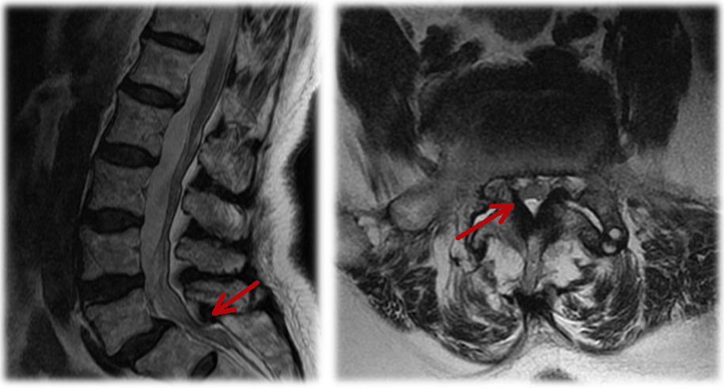
Figure 1 The magnetic resonance imaging of the spine found central lumbar spinal stenosis at L5/S1 level and L4–S1 foraminal narrowing.

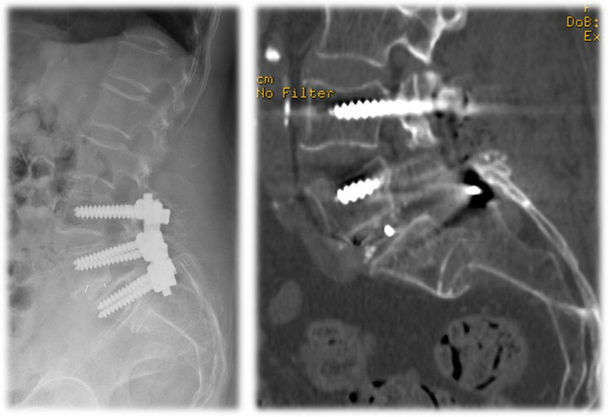
Figure 2 A computed tomography scanning revealed a horizontal fracture at the S1/S2 level with S2 being totally displaced.

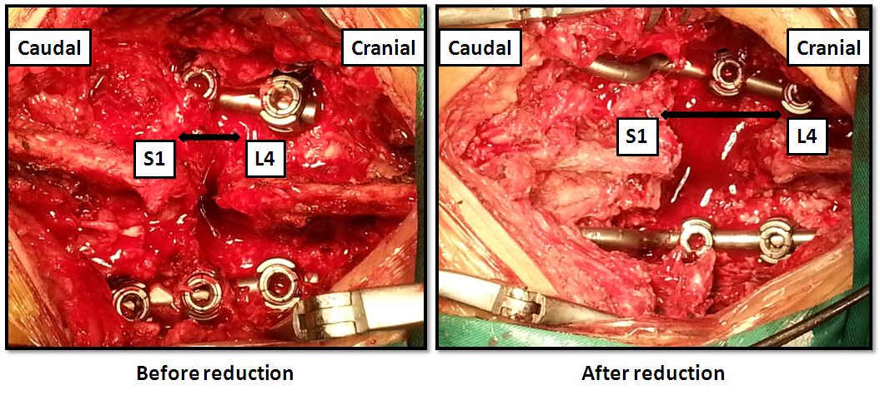
Figure 3 After exposure, we found that the interspinous process of the sacrum was totally displaced. It moved backward and cranially onto the backside of the instrumentation. To reduce the fracture, we used a spreader to distract the spinal processes of the S1 and L4, which turned out to be effective. After the distraction, the distance between the spinal processes of the S1 and L4 increased significantly.

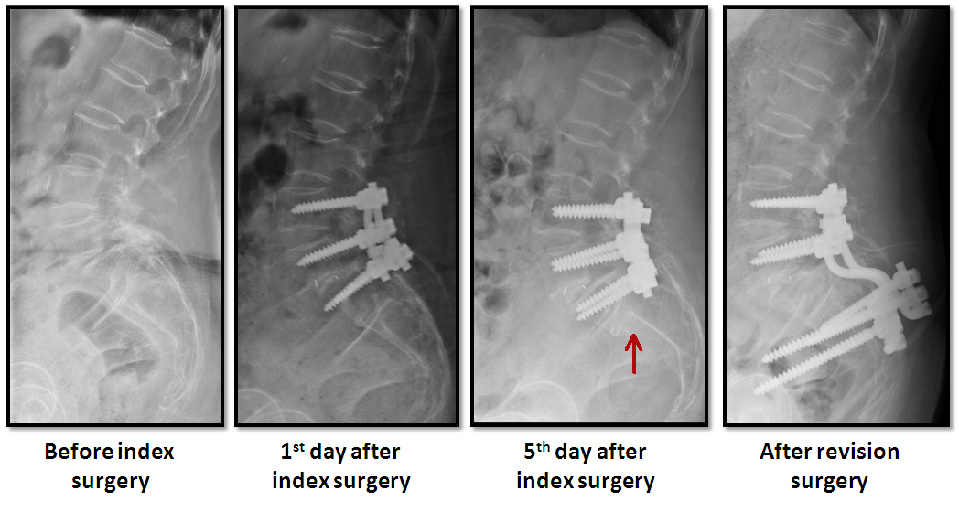
Figure 4 Sacral fracture was found on the 5th day after surgery. Two weeks after the index operation, the fusion construct was extended to the iliac wings using iliac screws.

Table 1 The Sagittal Parameters in the lateral radiographs

 | Pelvic incidence | Sacral slope | Pelvic tilt | Lumbar lordosis
Before index surgery | 64.1° | 37.1° | 27° | 53.9°
After index surgery | N/A | 36.7° | N/A | 51.3°
After revision surgery | N/A | 30.3° | N/A | 47.4°
2 years | N/A | 31.4° | N/A | 45.9°

N/A: Not applicable because of the displacement of S1. Pelvic incidence is the angle formed by the perpendicular line to the tangent line to the centre of the sacral plateau and the line connecting this centre of the bicoxofemoral axis. Pelvic tilt is the angle between the vertical plane and the line connecting the centre of the sacral plateau and the centre of the bicoxofemoral axis. The lumbar lordosis is measured between the cranial endplate of L1 and caudal endplate of L5.

