Name of Journal: World Journal of Clinical Cases
Manuscript NO: 67012
Manuscript Type: CASE REPORT

Metachronous mixed cellularity classical Hodgkin’s lymphoma and T-cell leukemia/lymphoma: A case report

Dong Y et al. Metachronous lymphoma

Yang Dong, Lai-Jun Deng, Mi-Mi Li

Yang Dong, Department of Clinical Pharmacy, Weifang Hospital of Traditional Chinese Medicine, Weifang 261000, Shandong Province, China

Lai-Jun Deng, Department of Hematology, Weifang Hospital of Traditional Chinese Medicine, Weifang 261000, Shandong Province, China

Mi-Mi Li, Department of Pathology, Weifang Hospital of Traditional Chinese Medicine, Weifang 261000, Shandong Province, China

Author contributions: Dong Y designed the research study; Deng LJ performed the research and wrote the manuscript; Li MM analyzed the data; all authors have read and approve the final manuscript.

Corresponding author: Lai-Jun Deng, MS, Staff Physician, Department of Hematology, Weifang Hospital of Traditional Chinese Medicine, No. 1055 Weizhou Road, Kuiwen District, Weifang 261000, Shandong Province, China. denglaijun1982@163.com

Received: April 12, 2021
Revised: July 13, 2021
Accepted: August 23, 2021
Published online:

Abstract
BACKGROUND
The development of peripheral T-cell lymphoma (PTCL) after chemotherapy for Hodgkin’s lymphoma (HL) is rare, and highly aggressive TCL/leukemia has not been reported to date. The relationship between HL and PTCL needs further exploration to understand the pathogenesis of metachronous lymphoma (ML) and find effective treatment options. We report a patient with ML, whose biopsy of a right cervical lymph node initially confirmed classical HL (CHL).

CASE SUMMARY
We report a patient with ML, whose biopsy of a right cervical lymph node initially confirmed CHL, with typical reed–sternberg cells expressing CD30 and PAX-5. T-cell leukemia/lymphoma occurred 3 years after treatment, and a lymph node biopsy at the onset confirmed PTCL, nonspecific type, expressing CD3, CD4 and CD8. The patient was treated with standard doses of chemotherapy, programmed cell death-ligand 1 monoclonal antibody, and chidamide, all of which failed to achieve complete remission. The patient was diagnosed with refractory state, and eventually died of leukocyte stasis.

CONCLUSION
The accuracy of the diagnosis needs to be confirmed when chemotherapeutic drugs are not effective.

Key Words: Classical Hodgkin’s lymphoma; T-cell lymphoma/leukemia; Bone marrow; Chemotherapy; Drug resistance; Case report

Dong Y, Deng LJ, Li MM. Metachronous mixed cellularity classical Hodgkin’s lymphoma and T-cell leukemia/lymphoma: A case report. World J Clin Cases 2021; In press

Core Tip: We report a patient with metachronous lymphoma. The development of peripheral T-cell lymphoma (TCL) after chemotherapy for Hodgkin’s lymphoma is rare, and highly aggressive TCL/leukemia has not been reported to date. We reviewed the literature and discussed whether immunodeficiency and malignant transformation of reactive T-cells may be major factors contributing to the development of TCL/leukemia.

INTRODUCTION
In 1954, Custer first proposed the term composite lymphoma (CL) to describe a “lymphoma in which more than one histological form occurs in the patient”^{[1]}. In 1982, the “Non-Hodgkin lymphoma Work Program” defined CL as “two completely different types of non-Hodgkin’s lymphoma (NHL) or, rarely, a combination of NHL and Hodgkin’s lymphoma (HL) in a single organ or tissue.” The two histological subtypes of CL include two different types of NHL or a combination of HL and NHL. Different combinations are named differently. When HL or NHL appears before the other, it is called metachronous lymphoma (ML), two histological forms of HL or NHL appearing together is referred to as synchronous lymphoma. However, CL refers to both histological types of synchronous lymphoma that occur in the same anatomical site^{[2]}. In this article, we report a patient with ML, whose biopsy of a right cervical lymph node initially confirmed classical HL (CHL), with typical reed–sternberg (RS) cells expressing CD30 and PAX-5. T-cell leukemia (TCL)/lymphoma occurred 3 years after treatment, and a lymph node biopsy at the onset confirmed peripheral TCL (PTCL), nonspecific type, expressing CD3, CD4 and CD8. A bone marrow biopsy revealed abnormal T-cell proliferation (25.5%) and immunophenotyping. T-cell receptor variable (TCRV) β (1–24) subfamily analysis, and TCR beta (TCRβ) and gamma (TCRγ) gene rearrangement all confirmed a large number of malignant T-cell infiltrated in the bone marrow.

CASE PRESENTATION
Chief complaints
The patient was a 59-year-old man who presented with right neck swelling and was diagnosed with enlarged lymph nodes in March 2017.

History of present illness
The patient was diagnosed with enlarged lymph nodes in March 2017. Subsequent computed tomography scans confirmed the nodes at multiple sites (bilateral neck, axilla, and abdomen), with a maximum cervical lymph node of approximately 3.8 cm × 2.4 cm and an enlarged spleen of approximately 15 cm in diameter. The patient had no other feeling of discomfort.

History of past illness
Five years before the discovery of the enlarged lymph nodes he suffered from allergic purpura (simple skin type); however, the symptoms disappeared after treatment and did not recur.

Personal and family history
He was a non-smoking non-drinking patient and had no history of other major diseases nor any significant family history of disease.

Physical examination
The rest of physical examination was normal.

Laboratory examinations
The laboratory tests showed white blood cells 4.10 × 10⁹/L, hemoglobin 120 g/L, and platelets 115 × 10⁹/L. Polymerase chain reaction (PCR) was used to detect Epstein–Barr virus (EBV) DNA in peripheral blood mononuclear cells at 6.66 × 10⁴ cells/mL (reference range: < 5.0 × 10² cells/mL).

Imaging examinations
Imaging examinations were normal.

FINAL DIAGNOSIS
The pathology of the right cervical lymph node excision showed popcorn-like RS cell morphology, with abundant blood vessels, CD30 and PAX-5 expression, EBER⁺ and Ki67 proliferation index of approximately 20%, and negative for CD3, CD5, CD20 and CD21 (Figure 1). Biopsy of the right cervical lymph node initially confirmed CHL. In the subsequent 3 years of clinical observation after prophase treatment, the patient did not experience discomfort; only occasional weakness. The cervical lymph node lesion occurred in September 2020 and we excised both lymph nodes. The diagnosis of TCL/leukemia was confirmed.

TREATMENT
After pathological diagnosis of CHL, the patient was given eight courses of ABVD [adriamycin 40 mg intravenous injection (iv) d1, 15; bleomycin 15 mg iv d1, 15; vincristine 4 mg iv d1, 15; dacarbazine 0.5 g iv d1 and 15]. The systemic lymph nodes and spleen shrank and he was classified as partial remission according to the response evaluation criteria for lymphoma^{[3]}. After 6 mo, bone marrow and lymph node biopsies were re-evaluated and the diagnosis remained unchanged. Programmed cell death-ligand 1 (PD-1) monoclonal antibody (sugemalimab, 1200 mg iv q21d) was administered eight times, and was discontinued due to a significant decrease in platelets. The cervical lymph node lesion occurred in September 2020 and we excised both lymph nodes. The pathology showed diffuse consistent T-cells with abundant blood vessels, expressing CD3 (diffuse), CD4 (little) and CD8 (little), but not CD20, CD79α, CD56, PD-1, Bcl-6 or CD10; Ki67 index was 60%–70%, and EBER⁻. The diagnosis was PTCL, nonspecific type (Figure 1). Because the peripheral blood lymphocytes were as high as 85.87 × 10⁹/L, we considered the possibility of leukemia. Further cytomorphological testing was performed and a significantly higher percentage of lymphocytes (63%) could be seen in the bone marrow, with abundant atypical lymphocytes. Bone marrow biopsy with hematoxylin and eosin and periodic-acid–Schiff staining revealed proliferation of bone marrow with diffuse abnormal lymphocytes (Figure 2). Flow cytometry (FCM) was performed and the results were analyzed using CD45/side scattering gating procedure, with bone marrow immunophenotyping expressing CD3, CD2, CD5, TCRαβ and CD45RO (Figure 3), weakly expressing perforin, and no expression of CD7, CD4, CD8, CD10, CD30, CD57, CD16, CD56, CD19, CD20, TCRγβ, CD45RA, CD25, CD26, CD or GranzymeB. FCM detected 24 TCRVβ subfamilies, of which vβ14 was 91.55% (Table 1). A TCR cloning assay (Invivo Scribe Technologies, San Diego, CA, United States) was performed and a positive TCRβ and TCRγ gene rearrangement was detected by extracting total DNA from bone marrow mononuclear cells and PCR amplification of the target fragment (Figure 4). No abnormal chromosomal results. The diagnosis of TCL/leukemia was confirmed. He was treated with eight courses of cyclophosphamide, vincristine, adriamycin, dexamethasone, cisplatin and chidamide; all of which failed to achieve remission.

OUTCOME AND FOLLOW-UP
The patient was diagnosed with refractory state, and eventually died of leukocyte stasis syndrome.

DISCUSSION
Incongruent lymphoma is a rare solid tumor characterized by the appearance of two different types of lymphoma at different anatomic sites, which may manifest clinically as concurrent or sequential disease. ML refers to the appearance of either HL or NHL before the other. The appearance of B-cell lymphoma after CHL can be explained by the clonal progression of malignant B cells. Such more-aggressive and higher-grade B-cell lymphoma originates from RS cells in CHL, as RS cells are thought to originate from B-cells^{[4]}. The reason for the presence of both B- and TCL at different anatomical sites is unclear and there are several explanations^{[5]}. First, the presence of two unrelated clones leads to the presence of two different types of lymphomas. Second, the presence of a typical pluripotent tumor stem cells can differentiate into precursor cells containing both types of lymphoma. Third, secondary lymphomas are a transformation of primary lymphomas, and in clinical practice, it is more common for indolent lymphomas to transform into aggressive lymphomas.
Metachronous CHL and PTCL are uncommon in the literature, and the pathogenesis is difficult to explain. Overall, persistent immune dysregulation and chemotherapeutic injury are key factors for the occurrence of lymphoma, which may allow aggressive lesions in atypical lymphoproliferative disease. When CHL occurs, persistent immune dysregulation, chemotherapy induction, tumor biology, and RS cells can regulate T-cell growth by expressing multiple cytokines^{[6]}, and promoting the occurrence of PTCL in case of immunodeficiency and malignant transformation of cells.
The pathological substrate of HL is RS cells; some of which express abnormal T-cell antigens, as demonstrated by molecular studies with 15%–20% clonal TCR gene rearrangements^{[7]}. Davis et al^{[8]} reported a patient with HL and cutaneous TCL in 2014, which was confirmed by PCR as a single T-cell clone, suggesting that HL and TCL may originate from the same precursor material. A direct clonal relationship between HL and PTCL has rarely been examined, as only a few RS cells that express aberrant T-cell antigens have clonal TCR gene rearrangements and are of different T-cell lineages^{[9,10]}. One hypothesis is that the immunosuppressive state of HL may promote the occurrence of secondary lymphomas, including PTCL. Another hypothesis is the malignant transformation of a pre-existing inflammatory T-cell population in patients with HL. Brown et al^{[11]} studied a patient with metachronous HL and anaplastic large cell lymphoma, and suggested that the malignant transformation of T-cells originated from an oligoclonal population of reactive T-cells that developed through sustained clonal expansion. Oligoclonal T-cell expansion may arise from genetic alterations such as those caused by continuous stimulation of EBV and/or prior chemotherapeutic agents. Although EBV is a B-lymphotropic virus that does not infect the T-cell lineage in vivo as part of its natural life cycle, alterations in the immune microenvironment result in malignant transformation of inflammatory T-cells^{[12]}. The possible mechanisms of metachronous B-cell lymphoma and TCL are shown in Figure 5.
Our patient was diagnosed with PTCL 3 years after the first lymph nodes were detected, but it could not be determined whether there was synchronous lymphoma at the time of the CHL diagnosis. We only obtained a lymph node biopsy of the neck, and after the appearance of secondary PTCL, we subjected a sample of the bone marrow collected at the beginning of the disease to FCM, which revealed some reactive T-cells. Furthermore, EBER⁺ RS cells at the beginning of the disease and EBER⁻ PTCL cells both supported the possibility of sequential occurrence of CHL and PTCL. Thus, the PTCL that emerged after CHL may have been due to chemotherapy-induced immunodeficiency. T-cell genetic damage, due to chemotherapeutic drugs, induced clonal proliferation and transformation into malignant cells, and EBV was involved in the alteration of the immune microenvironment, as demonstrated by EBER⁻ PTCL cells.

CONCLUSION
The occurrence of ML is rare and the diagnostic accuracy needs to be confirmed. We should be alerted to the occurrence of secondary lymphoma when chemotherapeutic drugs are not effective. In addition, the eight patients reported had a poor prognosis, short survival time, and high incidence of bone marrow infiltration (identified in three patients), as shown in Table 2. The patient we studied matched the diagnosis of TCL/leukemia, which has not been examined before. The staging and diagnosis of TCL are complex, and although our understanding of the molecular pathogenesis of TCL/leukemia cases is increasing, first-line therapies have not progressed proportionately, and the effectiveness of such treatments is limited. The relationship between HL and PTCL needs further exploration to understand the pathogenesis of metachronous T-cell NHL and find effective treatment options.

REFERENCES
1 Custer R. Pitfallsin the diagnosis of lymphoma and leukemia from the pathologist′s point of view. New York: American Cancer Society, 1954: 35-37
2 Geladari E, Dimopoulou G, Margellou E, Paraskevas A, Kafetzis G, Rontogianni D, Vadiaka M. Coexistence of Hodgkin and Non-Hodgkin Lymphoma; Composite Lymphoma [CL] in a Patient Presenting with Waxing and Waning Lymphadenopathy. Cardiovasc Hematol Disord Drug Targets 2020; 20: 160-163 [PMID: 31633478 DOI: 10.2174/1871529X19666191014111118]
3 Younes A, Hilden P, Coiffier B, Hagenbeek A, Salles G, Wilson W, Seymour JF, Kelly K, Gribben J, Pfreunschuh M, Morschhauser F, Schoder H, Zelenetz AD, Rademaker J, Advani R, Valente N, Fortpied C, Witzig TE, Sehn LH, Engert A, Fisher RI, Zinzani PL, Federico M, Hutchings M, Bollard C, Trneny M, Elsayed YA, Tobinai K, Abramson JS, Fowler N, Goy A, Smith M, Ansell S, Kuruvilla J, Dreyling M, Thieblemont C, Little RF, Aurer I, Van Oers MHJ, Takeshita K, Gopal A, Rule S, de Vos S, Kloos I, Kaminski MS, Meignan M, Schwartz LH, Leonard JP, Schuster SJ, Seshan VE. International Working Group consensus response evaluation criteria in lymphoma (RECIL 2017). Ann Oncol 2017; 28: 1436-1447 [PMID: 28379322 DOI: 10.1093/annonc/mdx097]
4 Wang HW, Balakrishna JP, Pittaluga S, Jaffe ES. Diagnosis of Hodgkin lymphoma in the modern era. Br J Haematol 2019; 184: 45-59 [PMID: 30407610 DOI: 10.1111/bjh.15614]
5 Boyer DF, Lindeman NI, Harris NL, Ferry JA. Peripheral T-cell lymphomas with cytotoxic phenotype in patients with chronic lymphocytic leukemia/small lymphocytic lymphoma. Am J Surg Pathol 2014; 38: 279-288 [PMID: 24418862 DOI: 10.1097/PAS.0000000000000140]
6 Aoki T, Chong LC, Takata K, Milne K, Hav M, Colombo A, Chavez EA, Nissen M, Wang X, Miyata-Takata T, Lam V, Viganò E, Woolcock BW, Telenius A, Li MY, Healy S, Ghesquiere C, Kos D, Goodyear T, Veldman J, Zhang AW, Kim J, Saberi S, Ding J, Farinha P, Weng AP, Savage KJ, Scott DW, Krystal G, Nelson BH, Mottok A, Merchant A, Shah SP, Steidl C. Single-Cell Transcriptome Analysis Reveals Disease-Defining T-cell Subsets in the Tumor Microenvironment of Classic Hodgkin Lymphoma. Cancer Discov 2020; 10: 406-421 [PMID: 31857391 DOI: 10.1158/2159-8290.CD-19-0680]
7 Seitz V, Hummel M, Marafioti T, Anagnostopoulos I, Assaf C, Stein H. Detection of clonal T-cell receptor gamma-chain gene rearrangements in Reed-Sternberg cells of classic Hodgkin disease. Blood 2000; 95: 3020-3024 [PMID: 10807764]
8 Davis TH, Morton CC, Miller-Cassman R, Balk SP, Kadin ME. Hodgkin's disease, lymphomatoid papulosis, and cutaneous T-cell lymphoma derived from a common T-cell clone. N Engl J Med 1992; 326: 1115-1122 [PMID: 1532439 DOI: 10.1056/NEJM199204233261704]
9 Hummel M, Marafioti T, Ziemann K, Stein H. Ig rearrangements in isolated Reed-Sternberg cells: conclusions from four different studies. Ann Oncol 1996; 7 Suppl 4: 31-33 [PMID: 8836406 DOI: 10.1093/annonc/7.suppl_4.s31]
10 Küppers R, Schwering I, Bräuninger A, Rajewsky K, Hansmann ML. Biology of Hodgkin's lymphoma. Ann Oncol 2002; 13 Suppl 1: 11-18 [PMID: 12078890 DOI: 10.1093/annonc/13.s1.11]
11 Brown JR, Weng AP, Freedman AS. Hodgkin disease associated with T-cell non-Hodgkin lymphomas: case reports and review of the literature. Am J Clin Pathol 2004; 121: 701-708 [PMID: 15151210 DOI: 10.1309/W1GW-43HT-793U-F86R]
12 Meconi F, Provenzano I, Nasso D, Mariotti B, Pupo L, Secchi R, Cerretti R, Lucia A, Arcese W, Cantonetti M. A case of metachronous peripheral T-Cell non-Hodgkin lymphoma following chemotherapy for Hodgkin disease successfully treated with brentuximab vedotin. Clin Case Rep 2020; 8: 1353-1356 [PMID: 32884752 DOI: 10.1002/ccr3.2898]
13 Wlodarska I, Delabie J, De Wolf-Peeters C, Mecucci C, Stul M, Verhoef G, Cassiman JJ, Van den Berghe H. T-cell lymphoma developing in Hodgkin's disease: evidence for two clones. J Pathol 1993; 170: 239-248 [PMID: 8133397 DOI: 10.1002/path.1711700305]
14 Oka K, Nagayama R, Iijima S, Yonekawa N, Hirosawa K, Yatabe Y, Mori N. Epstein-Barr virus-associated lymphoproliferative disorder presenting with classical Hodgkin lymphoma and developing as peripheral T-cell lymphoma 9 years later: a case report of composite lymphoma. Pathol Int 2011; 61: 752-755 [PMID: 22126384 DOI: 10.1111/j.1440-1827.2011.02723.x]
15 Park J, Lee JE, Kim M, Lim J, Kim Y, Han K, Park G, Jung YH, Roh SY, Hong YS. Discordant lymphocyte-depleted classical Hodgkin's and peripheral T-cell lymphoma arising in a patient 11 years after diagnosis of multicentric Castleman's disease. Int J Hematol 2013; 98: 114-121 [PMID: 23733446 DOI: 10.1007/s12185-013-1358-0]
16 Chang SH, Lee HR. Peripheral T Cell Non-Hodgkin's Lymphoma following Treatment of Hodgkin's Lymphoma. Case Rep Oncol Med 2015; 2015: 438385 [PMID: 25664194 DOI: 10.1155/2015/438385]

Footnotes
Informed consent statement: All study participants, or their legal guardian, provided informed written consent prior to study enrollment.

Conflict-of-interest statement: The authors do not have any possible conflicts of interest.

CARE Checklist (2016) statement: The authors have read the CARE Checklist (2016), and the manuscript was prepared and revised according to the CARE Checklist (2016).

Open-Access: This article is an open-access article that was selected by an in-house editor and fully peer-reviewed by external reviewers. It is distributed in accordance with the Creative Commons Attribution NonCommercial (CC BY-NC 4.0) license, which permits others to distribute, remix, adapt, build upon this work non-commercially, and license their derivative works on different terms, provided the original work is properly cited and the use is non-commercial. See: http://creativecommons.org/Licenses/by-nc/4.0/

Manuscript source: Unsolicited manuscript

Peer-review started: April 20, 2021
First decision: July 5, 2021
Article in press:

Specialty type: Medicine, research and experimental
Country/Territory of origin: China
Peer-review report’s scientific quality classification
Grade A (Excellent): 0
Grade B (Very good): B
Grade C (Good): 0
Grade D (Fair): 0
Grade E (Poor): 0

P-Reviewer: Watanabe T S-Editor: Gong SS L-Editor: P-Editor:

Figure Legends
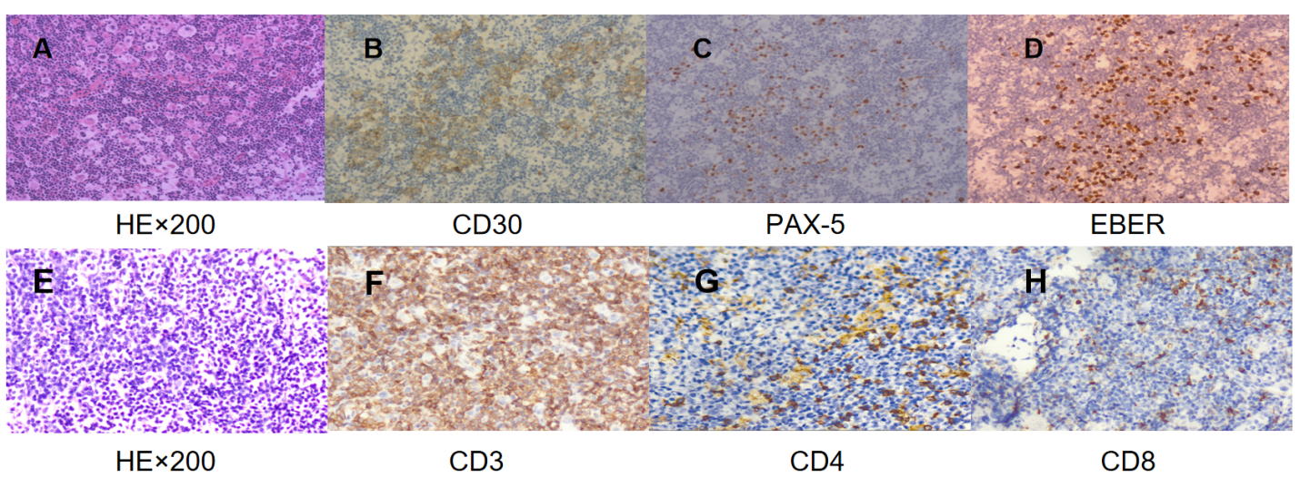
Figure 1 Pathological findings of Hodgkin’s lymphoma and the peripheral T-cell lymphoma. A-D: Pathological findings of Hodgkin’s lymphoma; the lymph node structure was disrupted, and a large number of small lymphocytes and popcorn-like cells were observed, with abundant blood vessels (HE, × 200) (A), positive expression of CD30 (B) and PAX-5 (C) in reed-sternberg (RS) cells, EBER⁺ expression in RS cells (D); E-H: Pathological findings of the peripheral T-cell lymphoma; the lymph node structure was disrupted, and diffuse consistent T-cells were observed, with abundant blood vessels (HE, × 200) (E), CD3⁺ T-cells (F), CD4⁺ (G) and CD8⁺ T-cells (few) (H).
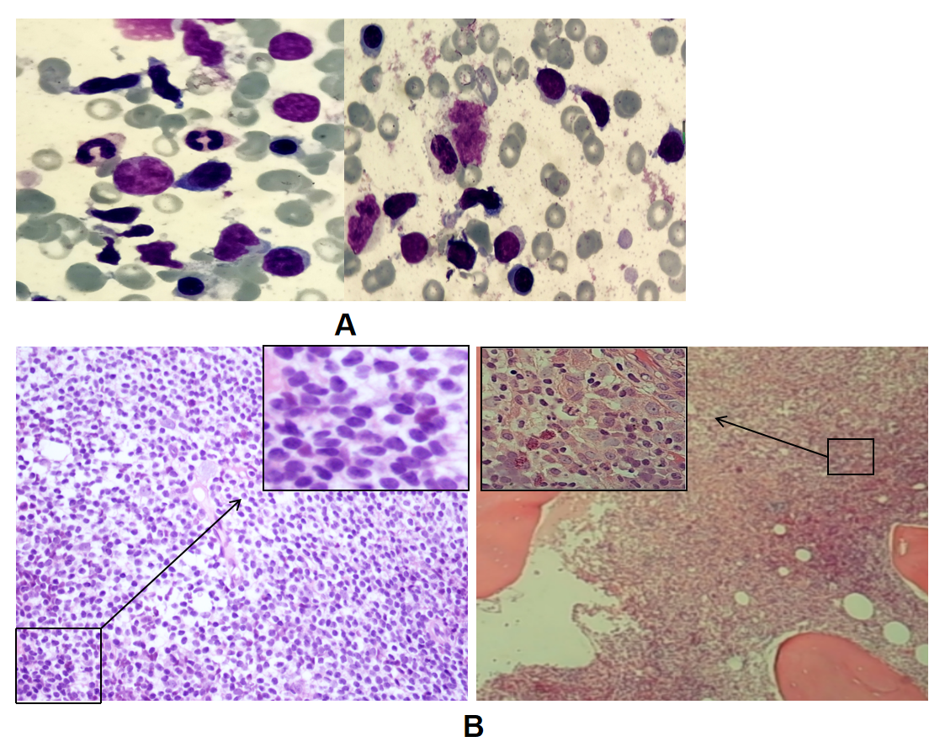
Figure 2 Morphological and biopsy results of peripheral T-cell lymphoma bone marrow. A: Atypical lymphocytes, with irregular, spindle-shaped, small to medium morphology, visible pseudopods and cytoplasmic granules, and no reed-sternberg cells observed (× 100); B: The lymphoma cells were diffusely proliferating, with small cytosol, low cytoplasmic volume, irregular nuclei, and coarse chromatin (HE/periodic acid-schiff, × 40 and × 400).
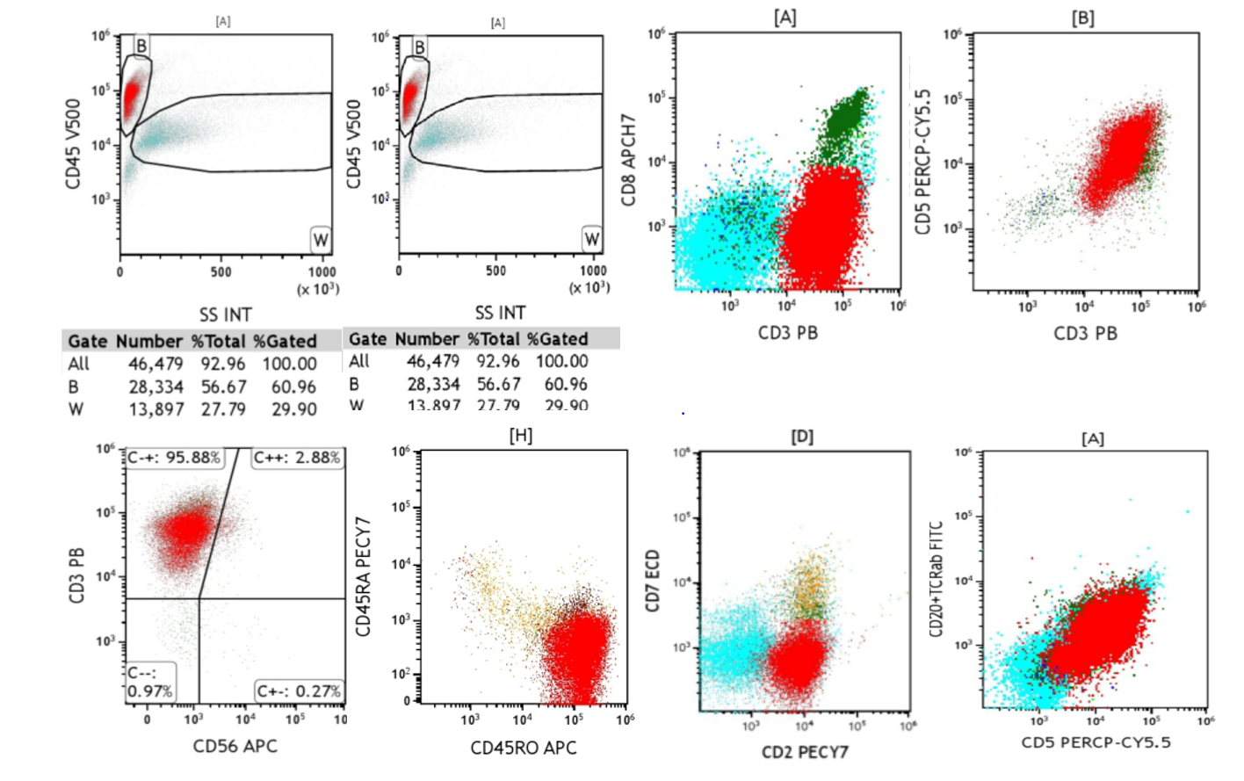
Figure 3 Immunophenotyping of T/natural killer lymphoma through 8-color flow cytometry. Abnormal T lymphocytes accounted for 57.8% of the nucleated cells and expressed CD3⁺, CD2⁺, CD5⁺, TCRαβ, and CD45RO.
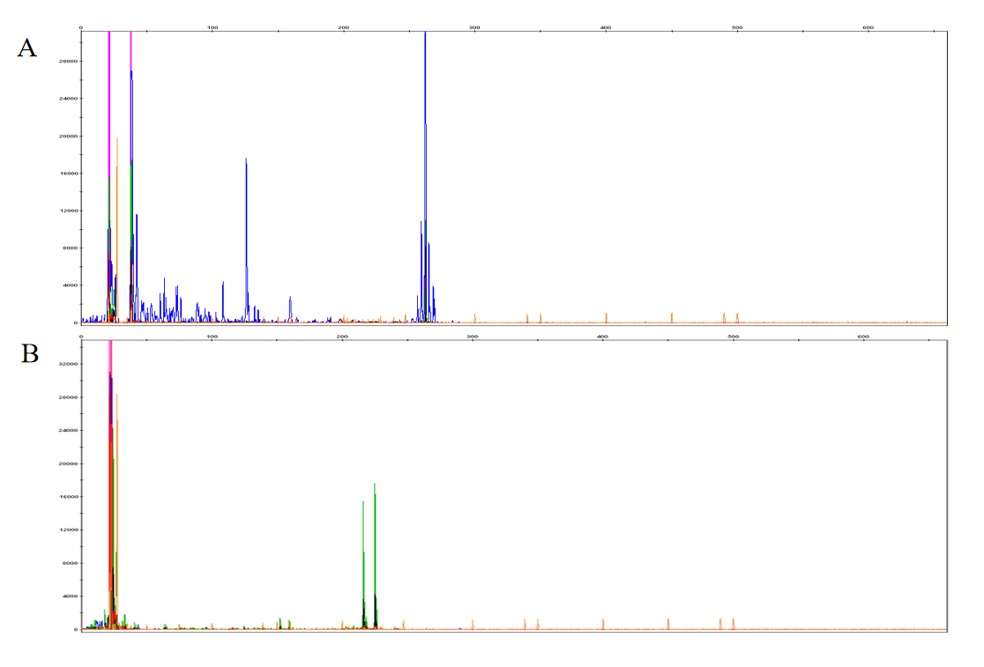
Figure 4 Identification of the T-cell receptor clone gene rearrangement by applying BIOMED-2 primer system. A: TCRβ gene rearrangement were detected; B: TCRγ gene rearrangement were detected.
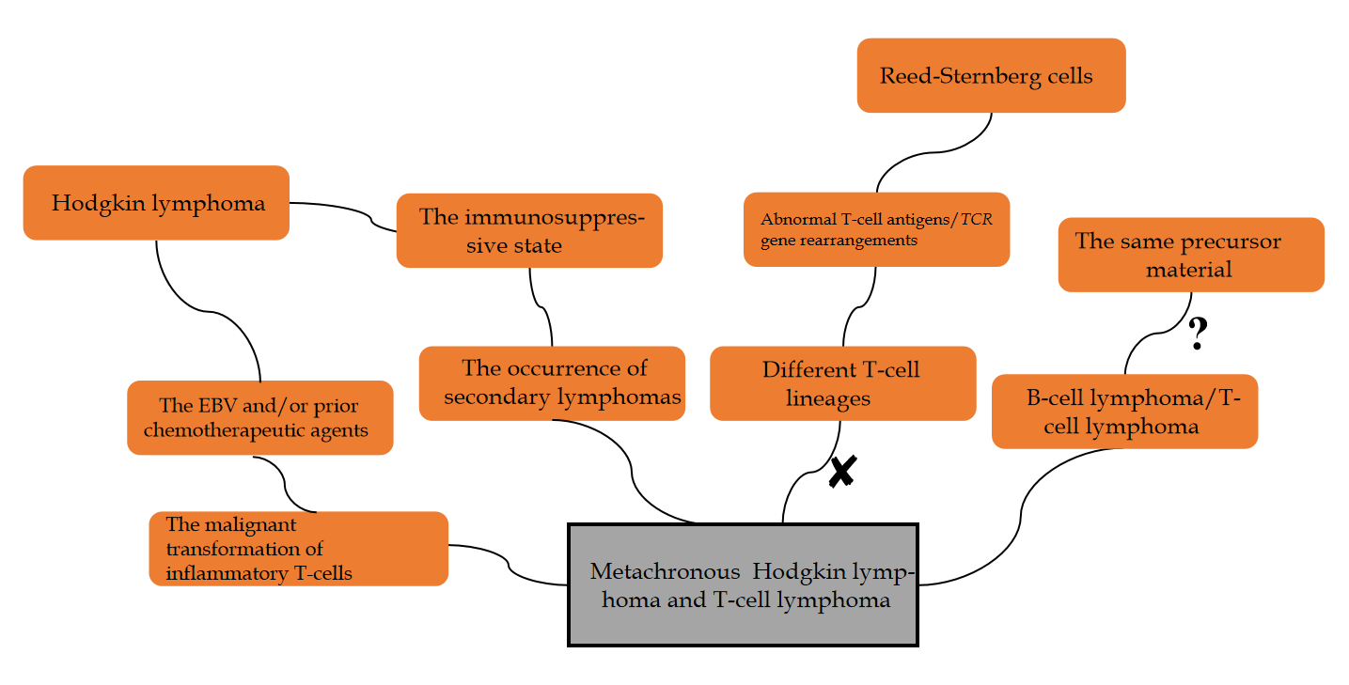
Figure 5 The possible mechanisms of metachronous B-cell lymphoma and T-cell lymphoma. EBV: Epstein-Barr virus.
Table 1 Proportion of CD3⁺CD4⁻CD8 to 24 T-cell receptor variable β subfamilies in T-cells, with a significant increase in vβ14 (91.55%)
No | Name | Results | CD3⁺ | Biological reference interval of CD3⁺CD4⁺ | CD3⁺CD8⁺ | Unit
1 | Vβ5.3 | 0.19 | 0.37-2.98 | 0.36-2.10 | 0.32-2.64 | %
2 | Vβ7.1 | 0.34 | 0.64-20.01 | 0.59-3.80 | 0.87-7.14 | %
3 | Vβ3 | 0.59 | 0.52-15.71 | 0.66-10.04 | 0.32-13.80 | %
4 | Vβ9 | 0.38 | 1.10-9.30 | 0.78-8.24 | 1.16-7.67 | %
5 | Vβ17 | 0.36 | 2.28-12.61 | 3.12-8.32 | 1.83-11.18 | %
6 | Vβ16 | 0.15 | 0.42-1.90 | 0.34-1.80 | 0.02-2.24 | %
7 | Vβ18 | 0.03 | 0.58-5.23 | 0.72-3.35 | 0.02-2.76 | %
8 | Vβ5.1 | 0.45 | 3.19-14.93 | 4.67-10.94 | 1.12-8.92 | %
9 | Vβ20 | 0.07 | 0-9.73 | 0.04-5.30 | 0.08-5.61 | %
10 | Vβ13.1 | 0.36 | 1.62-8.16 | 1.93-7.70 | 0.41-5.35 | %
11 | Vβ13.6 | 0.30 | 0.84-8.80 | 0.86-3.40 | 0.47-4.56 | %
12 | Vβ8 | 0.46 | 2.26-29.47 | 2.94-6.73 | 0.86-11.43 | %
13 | Vβ5.2 | 0.15 | 0.49-4.98 | 0.50-2.87 | 0.18-3.53 | %
14 | Vβ2 | 1.25 | 4.03-23.48 | 5.43-12.84 | 1.65-12.42 | %
15 | Vβ12 | 0.24 | 1-4.76 | 1.08-2.80 | 0.33-3.33 | %
16 | Vβ23 | 0.02 | 0.28-4.76 | 0.13-1.90 | 0.04-5.13 | %
17 | Vβ1 | 0.49 | 1.89-11.70 | 1.62-14.20 | 1.40-8.21 | %
18 | Vβ21.3 | 0.23 | 1.08-5.97 | 1.53-4.7 | 0.54-4.93 | %
19 | Vβ11 | 0.05 | 0.25-5.11 | 0.30-1.90 | 0.14-2.25 | %
20 | Vβ22 | 0.23 | 1.99-9.89 | 1.98-8.48 | 0.54-6.47 | %
21 | Vβ14 | 91.55 | 1.33-8.03 | 1.57-4.68 | 1.50-14.3 | %
22 | Vβ13.2 | 0.39 | 0.80-5.28 | 0.72-7.27 | 0.96-9.62 | %
23 | Vβ4 | 0.04 | 0.79-3.26 | 1.20-2.83 | 0.61-4.34 | %
24 | Vβ7.2 | 0.06 | 0.05-5.45 | 0.00-3.10 | 0.01-12.10 | %
25 | The sum of the 24 subfamilies | 98.38 | 69.95 | 72.25 | 66.58 | %

Table 2 Previously reported and current cases of classical metachronous Hodgkin lymphoma and peripheral T-cell lymphoma
Age, y/sex | One (EBV) | Therapy for one | Other (EBV) | Therapy for other | Interal (mo) | BM infiltration | Outcome | Ref.
32/M | CHL (+) | ABVD | PTCL (-) | Unknown | 24 | Unknown | Unknown | Brown et al^{[11]}, 2004
77/F | PTCL (nd) | CHOP | CHL (nd) | Radiation therapy | 48 | Unknown | Unknown | Brown et al^{[11]}, 2004
34/F | CHL (?) | ABVD | PTCL (+) | CHOP, IVE, intermediate-dose MTX, ASCT, BV | 47 | No | Died after 26 mo | Meconi et al^{[12]}, 2020
54/M | CHL (nd) | MOPP, ABVD | PTCL (nd) | Unknown | 24 | No | Unknown | Wlodarsk et al^{[13]}, 1993
76/F | CHL (+) | ABVD | PTCL (+) | CHOP | 108 | No | Died after 5 mo | Oka et al^{[14]}, 2011
37/M | PTCL (nd) | IVAM, BEAM, ASCT | CHL (+) | ABVD | 60 | Yes | Died after 17 mo | Park et al^{[15]}, 2013
64/F | CHL (-) | ABVD | PTCL (-) | Etoposide, etc | 15 | Yes | Died after 9 mo | Chang and Lee^{[16]}, 2015
59/M | CHL (+) | ABVD, PDL-1 | PTCL (-) | E-CHOP, DICE, chidamide | 42 | Yes | Died after 7 mo | Present study
EBV: Epstein-Barr virus; CHL: Classical metachronous hodgkin lymphoma; PTCL: Peripheral T-cell lymphoma. Nd: Not done; +: Positive; -: Negative; MOPP/ABVD: Mechlorethamine, vincristine, procarbazine, prednisone/doxorubicin, bleomycin, vinblastine, dacarbazine; CHOP: Cyclophosphamide, doxorubicin, vincristine, prednisone; IVAM: Ifosfamide, etoposide, cytarabine, methotrexate; BEAM: Bendamustine, etoposide, cytarabine, melphalan; ASCT: Autologous peripheral blood stem cell transplant; IVE: Icyclophosphamide epirubicin etoposide; MTX: Methotrexate; BV: Brentuximab vedotin; E-CHOP: Etoposide CHOP; DICE: Icyclophosphamide, etoposide, cisplatin, dexamethasone; M: Male; F: Female.

