Name of Journal: World Journal of Psychiatry
Manuscript NO: 83355
Manuscript Type: ORIGINAL ARTICLE

Observational Study
Effects of cumulative COVID-19 cases on mental health: Evidence from multi-country survey

Rathod S et al. Cumulative COVID-19 and mental health

Shanaya Rathod, Saseendran Pallikadavath, Elizabeth Graves, Mohammad M Rahman, Ashlea Brooks, Pranay Rathod, Rachna Bhargava, Muhammad Irfan, Reham Aly, Haifa Mohammad Saleh Al Gahtani, Zahwa Salam, Steven Wai Ho Chau, Theone S E Paterson, Brianna Turner, Viktoria Gorbunova, Vitaly Klymchuk, Peter Phiri

Shanaya Rathod, Elizabeth Graves, Ashlea Brooks, Department of Research and Innovation, Southern Health NHS Foundation Trust, Southampton SO30 3JB, United Kingdom

Saseendran Pallikadavath, Portsmouth-Brawijaya Centre for Global Health, University of Portsmouth, Portsmouth PO1 2UP, United Kingdom

Mohammad M Rahman, Salford Business School, University of Salford, Salford M5 4WT, United Kingdom

Pranay Rathod, Patient and Public Involvement, Southern Health NHS Foundation Trust, Southampton SO30 3JB, United Kingdom

Rachna Bhargava, Department of Psychiatry, All India Institute of Medical Sciences, New Delhi 110029, India

Muhammad Irfan, Department of Mental Health, Psychiatry and Behavioral Sciences, Peshawar Medical College, Riphah International University, Islamabad 46000, Pakistan

Reham Aly, Department of Clinical Services, Ministry of Health, Cairo 4262114, Egypt

Haifa Mohammad Saleh Al Gahtani, College of Medicine and Medical Sciences, Arabian Gulf University, Bahrain 329, Bahrain

Zahwa Salam, Peshawar Dental College, Ripah International University, Islamabad 46000, Pakistan

Steven Wai Ho Chau, Department of Psychiatry, The Chinese University of Hong Kong, Hong Kong, China

Theone S E Paterson, Brianna Turner, Department of Psychology, University of Victoria, Victoria BC V8P 5C2, Canada

Viktoria Gorbunova, Department of Social Psychology, Zhytomyr State University, Zhytomyr 10002, Ukraine

Vitaly Klymchuk, National Psychological Association, Mental Health for Ukraine Project, European Federation of Psychologists' Association, GFA, Kyiv 04071, Ukraine

Peter Phiri, School of Psychology, Faculty of Environmental and Life Sciences, University of Southampton, Southampton SO17 1BJ, United Kingdom

Author contributions: Rathod S, Rathod P and Phiri P developed the study protocol and questionnaire; Rathod S, Phiri P, and Rahman MM contributed to the manuscript development; All authors reviewed and approved the final manuscript.

Supported by MRC Global Health Research Program, No. MR.N006267/1.

Corresponding author: Peter Phiri, BSc, PhD, Senior Research Fellow, School of Psychology, Faculty of Environmental and Life Sciences, University of Southampton, University Road, Southampton SO17 1BJ, United Kingdom. p.phiri@soton.ac.uk

Received: January 20, 2023
Revised: February 27, 2023
Accepted: April 24, 2023
Published online: July 19, 2023

Abstract
BACKGROUND
Depression and anxiety were both ranked among the top 25 leading causes of global burden of diseases in 2019 prior to the coronavirus disease 2019 (COVID-19) pandemic. The pandemic affected, and in many cases threatened, the health and lives of millions of people across the globe and within the first year, global prevalence of anxiety and depression increased by 25% with the greatest influx in places highly affected by COVID-19.

AIM
To explore the psychological impact of the pandemic and resultant restrictions in different countries using an opportunistic sample and online questionnaire in different phases of the pandemic.

METHODS
A repeated, cross-sectional online international survey of adults, 16 years and above, was carried out in 10 countries (United Kingdom, India, Canada, Bangladesh, Ukraine, Hong Kong, Pakistan, Egypt, Bahrain, Saudi Arabia). The online questionnaire was based on published approaches to understand the psychological impact of COVID-19 and the resultant restrictions. Five standardised measures were included to explore levels of depression [patient health questionnaire (PHQ-9)], anxiety [generalized anxiety disorder (GAD) assessment], impact of trauma [the impact of events scale-revised (IES-R)], loneliness (a brief loneliness scale), and social support (The Multi-dimensional Scale of Perceived Social support).

RESULTS
There were two rounds of the online survey in 10 countries with 42866 participants in Round 1 and 92260 in Round 2. The largest number of participants recruited from the United Kingdom (112985 overall). The majority of participants reported receiving no support from mental health services throughout the pandemic. This study found that the daily cumulative COVID-19 cases had a statistically significant effect on PHQ-9, GAD-7, and IES-R scores. These scores significantly increased in the second round of surveys with the ordinary least squares regression results with regression discontinuity design specification (to control lockdown effects) confirming these results. The study findings imply that participants’ mental health worsened with high cumulative COVID-19 cases.

CONCLUSION
Whist we are still living through the impact of COVID-19, this paper focuses on its impact on mental health, discusses the possible consequences and future implications. This study revealed that daily cumulative COVID-19 cases have a significant impact on depression, anxiety, and trauma. Increasing cumulative cases influenced and impacted education, employment, socialization and finances, to name but a few. Building a database of global evidence will allow for future planning of pandemics, particularly the impact on mental health of populations considering the cultural differences.

Key Words: COVID-19; Mental health; Global research; International; Pandemic; Impact

©The Author(s) 2023. Published by Baishideng Publishing Group Inc. All rights reserved.

Citation: Rathod S, Pallikadavath S, Graves E, Rahman MM, Brooks A, Rathod P, Bhargava R, Irfan M, Aly R, Mohammad Saleh Al Gahtani H, Salam Z, Chau SWH, Paterson TSE, Turner B, Gorbunova V, Klymchuk V, Phiri P. Effects of cumulative COVID-19 cases on mental health: Evidence from multi-country survey. World J Psychiatry
2023; 13(7): 461-477
URL: https://www.wjgnet.com/2220-3206/full/v13/i7/461.htm
DOI: https://dx.doi.org/10.5498/wjp.v13.i7.461

Core Tip: This study explores the effect of cumulative coronavirus disease 2019 cases on mental health, more specifically on anxiety, depression, and trauma. Negative impact on mental health was found internationally, with individuals struggling to receive support from mental health services. Results also show that as the pandemic continued, mental health scores got worse.

INTRODUCTION
Depression and anxiety conditions both ranked among the top 25 leading causes of global burden of diseases in 2019 prior to the coronavirus disease 2019 (COVID-19) pandemic^{[1]}. On January 30, 2020, the World Health Organization (WHO) declared a public health emergency of international concern and governments were urged to prepare for the global spread of COVID-19 from East Asia^{[2]}. The COVID-19 pandemic affected, and in many cases threatened the health and lives of millions of people across the globe^{[2]}.
In the first year of the COVID-19 pandemic, global prevalence of anxiety and depression increased by 25%, and overall, the pandemic was estimated to have caused 137.1 (95%UI: 92.5–190.6) additional disability adjusted life years per 100000 population for Major Depressive Disorder and 116.1 per 100000 population (95%UI: 79.3–163.80) for anxiety disorders according to a scientific brief released by the WHO^{[3]}. A number of factors have been implicated including, but not limited to, the stress of social and self-isolation, loneliness, restrictions due to lockdowns^{[4,5]}, fear of infection and death of self and near ones, grief and bereavement, worries regarding jobs and finances, as well as impact on education, relationships and on carers^{[6]}.
Long COVID described the presence of persistent symptoms following infection from the severe acute respiratory syndrome coronavirus 2 (SARS-CoV-2) virus^{[7]}. This can last weeks or months after initial infection^{[7,8]}. Common symptoms of long COVID include breathlessness, fatigue, headaches, and weakness as well as reduced quality of life^{[7,9]}. The most common mental health problems experienced by individuals with long COVID were anxiety, depression, and post-traumatic stress disorder (PTSD)^{[9,10]}. A scoping review of 239 patients found that 3-mo post-COVID, 37.2% experienced PTSD, 35.6% experienced anxiety, and 46.9% were experiencing depression^{[11,12]}. These effects were maintained at 6-mo^{[11]}. Overall, symptoms were more prevalent in women and hospitalized patients^{[9]} A number of population groups have been shown to have been more adversely affected, including young people and women^{[7]}, individuals with vulnerabilities and pre-existing mental health conditions^{[9,11]}. Evidence on healthcare workers, who were frontline during the pandemic has been equivocal with different studies showing a range of impact in this group^{[11,13]}. The greatest increases in depression and anxiety were found in places highly affected by COVID-19 as indicated by decreased human mobility and daily COVID-19 infection rates^{[3]}.
Each country across the globe has responded to the pandemic guided by their population, resources, number of cases, socio demographics, political landscape, and culture^{[14]}. Given the unique situation we faced, the authors sought to explore the psychological impact of the pandemic and resultant restrictions in different countries, using an opportunistic sample and online questionnaire that was established at the beginning of the pandemic.

MATERIALS AND METHODS
Study design
This international study aimed to investigate and report the psychological impact of cumulative COVID-19 cases in the participant sites. A repeated, cross-sectional online international survey of adults, 16 years and above, was carried out in 10 countries (United Kingdom, India, Canada, Bangladesh, Ukraine, Hong Kong, Pakistan, Egypt, Bahrain, Saudi Arabia). The online questionnaire was based on published approaches, to understand the psychological impact of COVID-19 and the resultant restrictions. Five standardised measures were included to explore levels of depression [patient health questionnaire-9 (PHQ-9)]^{[15]}, anxiety [generalized anxiety disorder (GAD)-7; Generalised Anxiety Disorder Assessment]^{[16]}, impact of trauma [the impact of events scale-revised (IES-R)]^{[17]}, loneliness (a brief loneliness scale)^{[18]}, and social support (The Multi-dimensional Scale of Perceived Social support)^{[19]}. Further details of the methodology are documented in earlier publications by the group^{[9,13]}.

Materials
The survey was repeated to capture the dynamic impact of the pandemic. The questionnaire was changed for each round depending on the stage of pandemic, government policies, and circumstances in each country at the time. In order to make the questionnaire relevant to each country, it was available in different languages and various adaptations were made to ensure that local culture and responses to the pandemic were considered. For this reason, each country published the questionnaire at a slightly different time and some of the questions were variable. As an example, the “Keyworker” status did not exist in many countries and was only used where relevant. Another example, in the Ukraine questionnaire version, the question about exceeding the recommended limits of alcohol was excluded because of the absence of such recommended limits.

Study distribution
In the United Kingdom, the survey was conducted thrice with the corresponding two rounds of the survey in the other countries. The dates of the surveys in the participant countries are noted below. The surveys were publicised to the general population including students and healthcare professionals through social media. Most countries collaborated internally to capture a wide population. As an example, the leads in Ukraine collaborated with Ukrainian organizations including Mental health for Ukraine Project, National Psychological Association of Ukraine, Ukrainian Association of Cognitive-Behavioural Therapy, and Zhytomyr State University to help further with dissemination. Due to the unusual circumstances of the time, this was the best way to disseminate the survey.
Southern Health NHS Foundation Trust in the United Kingdom led and co-ordinated the online survey with support from the participant countries. The survey was advertised to staff, patients, and the public with a weblink to the survey platform.

Data analysis
Cumulative COVID-19 case data has been derived from Microsoft Azure Open dataset, which is a population open dataset^{[20]}. Mental health scores are derived from the online survey and is sample data. In both data, time is day. Although cumulative COVID-19 cases data is available daily (for around last two years), mental health scores in the study were not available for each day during that time. The availability of mental health scores on a specific day depended on whether the survey was conducted on that day by a participant.
The study has used regression analyses, using cross section data of all countries that participated in the study. Separate regression analysis was conducted for survey round 1 and 2. In both regressions, we used dummies for all individual characteristics listed in Table 1 as control variables. Vulnerabilities including requiring shielding, experience of coronavirus, pre-existing mental health conditions, and mental health support, had extremely low response rates therefore, we have recoded missing values into no category, to increase sample sizes in regressions.
In both regressions, the main independent variable, daily cumulative COVID-19 cases, is converted into million unit (by dividing COVID-19 case by 1000000). The purpose is to scale up its coefficients.
The relationship between average mental health scores and average cumulative COVID-19 cases maybe be contaminated or biased by lockdown effects. To control for such effects, we added lockdown dummy, trend and their interaction following the specification in regression discontinuity design (RDD).

RESULTS
Demographics
There were two rounds of the online survey in eight country groups as shown in Table 1. Egypt, Saudi Arabia, and Bahrain were analysed as a single group (labelled Arabic speaking countries). Hong Kong did not participate in the second round due to difficulties in recruitment. While there were three rounds in the United Kingdom, we have only used data from the corresponding two rounds with other participant countries. The United Kingdom has the largest number of participants in both rounds (29134 and 83851, respectively).
In the first round of the survey, participants who reported being healthcare professionals are higher in the United Kingdom (43%). In the second round, Arabic speaking countries had the highest number of participants who reported as healthcare professionals (66%), with a sample size of 909.
Age follows a bell shaped or downward distribution. Female participants were higher than male in most countries. In Canada, United Kingdom and Ukraine, most participants were White. Christian religion was reported the dominant religion in the Western countries. In round one in the Arabic speaking countries, most survey participants reported as Christians too. In most countries, survey participants did not report University education. Most survey participants lived in their own homes. Low proportion of participants reported experiencing COVID-19, but a high percent of participants followed social distancing guidelines. Most of the participants did not report any pre-existing physical health conditions. Alcohol consumption was reported by participants in Canada, United Kingdom, and Ukraine. Most participants did not report taking drugs. Majority participants did not report receiving support from mental health services. Where received, mental health support was reported through general practitioners and many participants did not respond to this question as it was only relevant if they reported experiencing mental health problems.

Mental health scales
Table 2 shows means and SD of PHQ-9, GAD-7 and IES-R by country and survey rounds, with number of respondents (n), missing observations and nonrespondents. In both rounds in each country, there were fewer respondents of PHQ-9 compared to nonrespondents. For the other two mental health scales, the gap between respondents and nonrespondents is not that large, with respondents being higher than nonrespondents in some cases. PHQ-9 can vary from 0 to 27, GAD-7 from 0 to 21, and IES-R from 0-88; however, average figures of PHQ-9 are lower than those of other two. IES-R has higher mean scores than others. Hong Kong, Indian, and Ukrainian participants have reported lower scores on the three scales compared with other countries. Bangladesh has highest mean scores on PHQ9, GAD7 and IES -R. All scores increased in round 2 of the surveys.

Cumulative COVID-19 cases
For each country, cumulative COVID-19 cases (the cumulative number of people who suffered coronavirus in official records) varied over time. Mental health scores (on the 3 scales: PHQ-9, GAD-7 and IES-R) in each country varied over time and by individuals’ responses during the survey period.
Figure 1 shows a histogram of day/time by country. Two long bars in Bangladesh indicate that survey responses in both rounds were received during short windows, although the survey was open for three months each time in each site. The same pattern is seen in Canada and Hong Kong. Survey periods in Arabic speaking sites and Ukraine seem longer but scattered, meaning that for several days, survey data including mental health scores were not available during the three month period. India and Pakistan showed good density for moderately wider periods in round 1. United Kingdom showed the longest periods of survey responses in both rounds, which indicates that survey data including mental health scores were available for relatively more days in United Kingdom despite the fact that the survey was available for the same number of months at each site.
Daily cumulative COVID-19 cases (in million) have been plotted for each country, from April 1, 2020 to April 1, 2021 (Figure 2). As India had high COVID-19 cases, we have scaled down the COVID-19 cases by converting its unit into million, to raise the coefficients of cumulative COVID-19 case in regressions. United Kingdom also had high figures (reached nearly 10 million in March 2021). Ukraine and Canada reached relatively high figures. Other countries including Hong Kong had lower figures for cumulative COVID-19 cases. Therefore, the lines are relatively flat (near zero). Hong Kong had low figures at those periods as different countries had their spikes at different times. The figure shows downward movement of lines in India and United Kingdom, because COVID-19 cases were revised.
In survey data of the countries, scores of three mental health scales were available for several individuals in a day. They are reported as averages in a day. Country averages of those averages are taken to get single values in each day. Country average of cumulative COVID-19 cases are also taken. In Figure 3, scatter plots of average values of PHQ-9, GAD-7 and IES-R are shown in three different subplots. Average cumulative COVID-19 cases are plotted in line with three subplots. While left vertical axes measure the average cumulative COVID-19 cases, the right vertical axes measure three average values of mental health scores/indices. As mental health is an individual characteristic, average mental health scores fluctuated over time, and were not uniform like average cumulative COVID-19 cases. However, average mental health scores had less fluctuation/scatter at the beginning of each round (especially at the beginning of the second round). At that time, average mental health scores showed upward movement with average cumulative COVID-19 cases. In more scatter areas, such positive relation between average cumulative COVID-19 cases and average mental health scores is not seen. As less scatter zones showed a positive relation, we can expect an overall positive relation between them. To control for bias or contamination effect of lockdown, we added lockdown dummy, trend and their interaction following the specification in RDD.
Table 3 shows lockdown and survey periods of participant countries in the study. In each round, we have made normalized trend by subtracting lockdown easing/withdraw dates of countries (as lockdown start dates do not fall in survey periods) from trend. Zero is a common cut-off date; based on that we made a discontinuity dummy (1 = above cut-off, 0 = below cut-off), that captured negative effects of lockdown or withdraw on mental health. To capture different slopes on either side of the cut-off, we took interaction of normalized trends and the discontinuity dummy.

Regression results
Table 4 shows regression results for round 1 and Table 5 for round 2. Both tables show two regression results for each mental health score/index, the dependent variable. The first one does not include RDD specification, while the second one does. When RDD specification is included, the results are for United Kingdom only.
In round 1, the cumulative COVID cases had statistically significant effect on all three mental health scores with RDD specification. For example, as United Kingdom had 7.70 average GAD-7, the increase size 1.75 in regression was nearly 23% (1.75 × 100/7.70). So, for a one million increase in cumulative daily COVID cases, GAD-7 increased by 23 percent.
In round 2 (Table 5), all three mental health indices increased statistically and significantly due to increase in cumulative COVID cases, with and without RDD specification. Without RDD specification, for a one million increase in cumulative COVID cases, the increase in PHQ-9 was 0.195 (2.38%), GAD-7 0.129 (2.14%), and IES-R 0.454 (2.37%). With RDD specification, for a one million increase in cumulative COVID cases, the increase in PHQ-9 was 0.433 (5.27%), GAD-7 0.577 (9.55%), and IES-R 1.265 (6.59%). Results with RDD specification implied that United Kingdom had higher effects than other countries.
In both regression tables, lockdown withdraw dummy in RDD specification showed that lockdown withdraw had statistical and significant effects on mental health indices, which supported the findings of our previous paper that showed that lockdown increased participants mental health scores, or worsened participant’s mental health^{[8]}.
In both regression tables, compared to the youngest age group (under 25), other age groups had lower scores on the mental health scales, meaning better mental health. Non-White participants reported better mental health than White participants, in most cases. Non-Christians reported better mental health than Christians in both rounds. In both rounds, higher educated participants had better mental health than the lowest educated group.

Heterogenous effects
To demonstrate heterogeneous effects of cumulative COVID cases on mental health scores for different countries, we ran regressions without RDD specification for each country separately, but we included all characteristics used in previous regressions. RDD specification was only applicable to United Kingdom data.
For China (Hong Kong), cumulative COVID cases was extremely low, and therefore, the coefficients of daily cumulative COVID cases were extremely high. Similarly high and low coefficients in different countries depended on scales of cumulative COVID cases in the relevant countries.
Most countries did not show any significant effects. United Kingdom had very good distribution of survey respondents over a long period of time. Therefore, regression results for United Kingdom are more reliable than others. The results are statistically positive in both rounds in the United Kingdom. The first round in the United Kingdom showed statistically and significantly higher positive results. As we have seen in Table 4, such significance vanishes with the inclusion of RDD specification.

DISCUSSION
Using repeated cross sectional survey data of eight country groups and cumulative COVID-19 cases of same countries from Microsoft AZURE, this study found that the daily cumulative COVID-19 cases had a statistically significant effect on three mental health scale indices: Depression, anxiety, and trauma. Ordinary least squares regression results with RDD specification to control for lockdown effects confirms the results. The results are dominated by data in the United Kingdom, which has the largest number of respondents with wider distribution over time. The study findings imply that participants’ mental health worsened with high cumulative COVID-19 cases. Daily cases did not show any impact on mental health scores of participants. The study also highlights other important demographic information and differences due to impact of the COVID-19 pandemic on different countries’ participants.
These findings are understandable, considering the significant impact of COVID-19 pandemic on the lives of people across the globe and similar results from other data. Evidence from the Centre for Disease Control and Prevention has shown that fear and stress related to the COVID-19 has led to symptomatology, including change in sleep and eating patterns, worsening of premorbid psychiatric conditions, and increased use of substances (e.g., alcohol, tobacco, drugs), which add to the mental health burden^{[21]}. Quadros et al^{[22]} conducted a scoping review and concluded that females, younger adults, urban residents, divorcees, healthcare workers, those in quarantine settings, those in suspicion of being infected, and those with mental health problems, were found to be at an increased risk of COVID-19-related fear^{[22]}.
High cumulative COVID-19 cases not only presented a fear of infection and mortality, especially in vulnerable groups, but also impacted on education, jobs, ability to socialize, relationships, loneliness, and other socio-cultural and socioeconomic variables. Most studies have shown an impact on young people’s mental health as does this study and the same study in United Kingdom participants has shown an increase in suicidal thoughts^{[23,24]}. High cumulative cases additionally meant the implementation of public health interventions and lockdowns restricting activities. Our findings from the United Kingdom data of the same study demonstrate the positive association of lockdown relaxation and face covering policies on the mental health of participants evidencing the impact of these interventions on mental health of populations as also demonstrated by the international data in this study^{[9]}.
These results add to existing global evidence of the psychological impact of the COVID-19 pandemic and previous studies that have demonstrated the adverse impact of population shocks on population mental health^{[25-27]}. A systematic review of data published between January 2020 to January 2021 during the COVID-19 pandemic found that daily SARS-CoV-2 infection rates and reductions in human mobility were associated with increased prevalence of major depressive disorder^{[28]}. These findings have been confirmed by the WHO^{[3]}.
In our study, participants from Hong Kong, India and Ukraine had lower mental health scores than other countries’ participants. It is not possible to make conclusions on these findings as the number of participants were small and there would be an element of time of participation in the survey.
Different countries had their case number surges and lockdowns at different times during the pandemic. Similarly different countries followed a different trajectory depending on their populations, readiness to respond, political, cultural, financial, and technical landscape. As an example, Ukraine underwent change in ministers three times during the pandemic. There were other determinants of response to the pandemic including levels of awareness, stigma, fear in the early phases of pandemic and attributions to the illness based on cultural explanations^{[11]}.
Since the COVID-19 pandemic, the need for mental health support services has increased significantly^{[29]}. This has been particularly difficult due to isolation and distancing measures, causing a physical barrier to help-seeking and treatment implementation^{[29,30]}. Mental health rehabilitation interventions aim to increase social skills and teach coping strategies through training and increased social interactions^{[29]}. This can help individuals with various mental health conditions but is especially useful for those with anxiety or depression^{[30]}. Social and peer support is an integral part of mental health rehabilitation, yet the isolating protection measures of the COVID-19 pandemic pose a barrier^{[30]}.
Measures, such as regular testing or online programmes, are some actions which help to overcome these unprecedented circumstances^{[30,31]}. Many organisations and facilities moved their services online in order to provide continuous psychological support for their clients^{[30,31]}. This will ensure that services can continue to operate whilst controlling the spread of the pandemic^{[31]}. The United Kingdom government has published a COVID-19 Mental Health and Wellbeing Recovery Action Plan to accommodate for mental health interventions throughout and post-pandemic^{[32]}. The plan outlines various measures including support for young people, assistance within the employment sector, and accessible and widely available support for frontline healthcare workers^{[32]}. Whilst mental health has always been a pressing matter, the pandemic has amplified its prevalence and affects across all demographic groups^{[32]}. As there were rigid isolation regulations in place, this made the implementation of support difficult so organisations had to be innovative with the ways in which they would continue to assist clients^{[33]}. Likewise, the pandemic also helped to highlight vulnerable groups, leading to the implementation of better support strategies and frameworks for these groups^{[33].}
The results of this study should be interpreted considering its limitations. The timing of the study was such that most countries were in different phases of the pandemic. To conduct a study in that unusual environment meant that some may not consider this a cross sectional study in the epidemiological sense, and it could be difficult to judge the true population prevalence and make international comparisons. For this reason, we have explained the landscape of the different countries separately. This limitation could not have been avoided given the unpredictable nature of the spread of virus, even if confined parameters had been used. Additionally, where many cultural adaptations were made to account for the differences in the countries, it may still be difficult to draw conclusions about the differences in these populations which might be attributable to COVID as the measures are all taken after the onset of the pandemic. Another limitation concerning cumulative cases is that in many low and middle income countries, public health infrastructures and disease notification are very different to those used in high income countries, meaning that the potential for under-ascertainment of cases is much higher. The study has a high number of missing cases and non-random selection of participants are further limitations. In some participating centres the numbers are small. Many surveys were in circulation during this time in all the participating countries, especially during the second round, which may have affected the participation in the survey. Most studies of similar kind have reported small numbers.

CONCLUSION
The results from the current study add to developing evidence of the psychological impact of COVID-19, especially daily cumulative cases on three mental health indices. Building a database of evidence will allow for future planning of pandemics, particularly the impact on mental health of populations and the cultural differences.

ARTICLE HIGHLIGHTS
Research background
The coronavirus disease 2019 (COVID-19) pandemic had a huge effect on mental health across the globe. As the pandemic developed over time, international rates of mental health conditions increased. It would be insightful to explore how the increasing cases of COVID-19 impacted mental health throughout the pandemic.

Research motivation
Exploring the impacts of COVID-19 on mental health with help construct a better understanding of the current mental health situation across the globe. It will also help to inform pandemic preparedness policies around mental health services.

Research objectives
This study aimed to explore the psychological implications of the increasing COVID-19 case throughout the pandemic across various countries.

Research methods
A repeated, cross-sectional online international survey of adults was carried out in 10 countries. Five standardised psychological measures were included to explore the psychological impact of cumulative COVID-19 cases. This was carried out at two timepoints in all countries, aside from the United Kingdom which collected data at 3 timepoints.

Research results
There were two rounds of the online survey in eight country groups with 42866 participants recruited in Round 1 and 92260 recruited in Round 2. This study found that the daily cumulative COVID-19 cases had a statistically significant effect on three depression, anxiety, and trauma. Trauma scores were higher across all countries compared to those for anxiety and depression. All scores increased in Round 2 in all countries.

Research conclusions
Considering the significant impact of COVID-19, understanding the effects will enable for adequate services and support to be put in place. This evidence dataset will also help inform the policies and strategies for pandemic preparedness.

Research perspectives
COVID-19 has had enduring effects in all aspects of life including physical and mental health.

ACKNOWLEDGEMENTS
We would like to thank all the participants who gave their time to complete the survey. We also thank our collaborators–NHS and non-NHS organisations that disseminated the survey. We would specially like to thank Sana Sajid, for administrative support.

REFERENCES
1 GBD 2019 Diseases and Injuries Collaborators. Global burden of 369 diseases and injuries in 204 countries and territories, 1990-2019: a systematic analysis for the Global Burden of Disease Study 2019. Lancet 2020; 396: 1204-1222 [PMID: 33069326 DOI: 10.1016/S0140-6736(20)30925-9]
2 World Health Organization. WHO Director-General's statement on IHR emergency committee on novel coronavirus (2019-nCoV). 2020. Available from: https://www.who.int/dg/speeches/detail/who-director-general-s-statement-on-ihr-emergency-committee-on-novel-coronavirus-(2019-ncov)
3 World Health Organization. Mental Health and COVID-19: Early evidence of the pandemic’s impact: Scientific brief. In (pp. 1-13): 2020. Mental Health and COVID-19: Early evidence of the pandemic’s impact: Scientific brief, 2 March 2022. Available from: https://www.who.int/
4 Memish ZA, Ahmed QA, Schlagenhauf P, Doumbia S, Khan A. No time for dilemma: mass gatherings must be suspended. Lancet 2020; 395: 1191-1192 [PMID: 32240624 DOI: 10.1016/S0140-6736(20)30754-6]
5 Reynolds DL, Garay JR, Deamond SL, Moran MK, Gold W, Styra R. Understanding, compliance and psychological impact of the SARS quarantine experience. Epidemiol Infect 2008; 136: 997-1007 [PMID: 17662167 DOI: 10.1017/S0950268807009156]
6 Phiri P, Ramakrishnan R, Rathod S, Elliot K, Thayanandan T, Sandle N, Haque N, Chau SW, Wong OW, Chan SS, Wong EK, Raymont V, Au-Yeung SK, Kingdon D, Delanerolle G. An evaluation of the mental health impact of SARS-CoV-2 on patients, general public and healthcare professionals: A systematic review and meta-analysis. EClinicalMedicine 2021; 34: 100806 [PMID: 33842872 DOI: 10.1016/j.eclinm.2021.100806]
7 United Nations. Policy Brief: The Impact of COVID-19 on Women. In Prevention, C. f. D. C. a. 2022. Coping with Stress. Policy Brief: The Impact of COVID-19 on Women-World. Available from: https://reliefweb.int/
8 Raveendran AV, Jayadevan R, Sashidharan S. Long COVID: An overview. Diabetes Metab Syndr 2021; 15: 869-875 [PMID: 33892403 DOI: 10.1016/j.dsx.2021.04.007]
9 Rathod S, Pallikadavath S, Graves E, Rahman MM, Brooks A, Soomro MG, Rathod P, Phiri P. Impact of lockdown relaxation and implementation of the face-covering policy on mental health: A United Kingdom COVID-19 study. World J Psychiatry 2021; 11: 1346-1365 [PMID: 35070782 DOI: 10.5498/wjp.v11.i12.1346]
10 Shanbehzadeh S, Tavahomi M, Zanjari N, Ebrahimi-Takamjani I, Amiri-Arimi S. Physical and mental health complications post-COVID-19: Scoping review. J Psychosom Res 2021; 147: 110525 [PMID: 34051516 DOI: 10.1016/j.jpsychores.2021.110525]
11 Vindegaard N, Benros ME. COVID-19 pandemic and mental health consequences: Systematic review of the current evidence. Brain Behav Immun 2020; 89: 531-542 [PMID: 32485289 DOI: 10.1016/j.bbi.2020.05.048]
12 Houben-Wilke S, Goërtz YM, Delbressine JM, Vaes AW, Meys R, Machado FV, van Herck M, Burtin C, Posthuma R, Franssen FM, Vijlbrief H, Spies Y, van 't Hul AJ, Spruit MA, Janssen DJ. The Impact of Long COVID-19 on Mental Health: Observational 6-Month Follow-Up Study. JMIR Ment Health 2022; 9: e33704 [PMID: 35200155 DOI: 10.2196/33704]
13 Rathod S, Pallikadavath S, Young AH, Graves L, Rahman MM, Brooks A, Soomro M, Rathod P, Phiri P. Psychological impact of COVID-19 pandemic: Protocol and results of first three weeks from an international cross-section survey - focus on health professionals. J Affect Disord Rep 2020; 1: 100005 [PMID: 33313579 DOI: 10.1016/j.jadr.2020.100005]
14 Rathod S. Impact of culture on response to COVID-19. Br Med J 2022; 369: 1556. [DOI: 10.1136/bmj.m1556]
15 Kroenke K, Spitzer RL. The PHQ-9: a new depression diagnostic and severity measure. SLACK 2002; 32: 509-515
16 Kroenke K, Spitzer RL, Williams JB. The PHQ-9: validity of a brief depression severity measure. J Gen Intern Med 2001; 16: 606-613 [PMID: 11556941 DOI: 10.1046/j.1525-1497.2001.016009606.x]
17 Weiss DS, Marmar CR. The Impact of Event Scale—Revised. In J. P. Wilson & T. M. Keane (Eds.), Assessing psychological trauma and PTSD. The Guilford Press, 1997: 399–411. Available from: https://psycnet.apa.org/record/1997-97162-013
18 Hughes ME, Waite LJ, Hawkley LC, Cacioppo JT. A Short Scale for Measuring Loneliness in Large Surveys: Results From Two Population-Based Studies. Res Aging 2004; 26: 655-672 [PMID: 18504506 DOI: 10.1177/0164027504268574]
19 Zimet GD, Dahlem NW, Zimet SG, Farley GK. The multidimensional scale of perceived social support. J Pers Assess 1988; 52: 30-41 [DOI: 10.1207/s15327752jpa5201_2]
20 Microsoft. COVID Tracking Project. 2022. Available from https://Learn.microsoft.com/en-us/azure/open-datasets/dataset-covid-tracking?tabs=azure-storage
21 Centre for Disease Control and Prevention. Coping with Stress 2022. Available from: https://www.cdc.gov/mentalhealth/stress-coping/cope-with-stress/index.html
22 Quadros S, Garg S, Ranjan R, Vijayasarathi G, Mamun MA. Fear of COVID 19 Infection Across Different Cohorts: A Scoping Review. Front Psychiatry 2021; 12: 708430 [PMID: 34557117 DOI: 10.3389/fpsyt.2021.708430]
23 Aknin LB, De Neve JE, Dunn EW, Fancourt DE, Goldberg E, Helliwell JF, Jones SP, Karam E, Layard R, Lyubomirsky S, Rzepa A, Saxena S, Thornton EM, VanderWeele TJ, Whillans AV, Zaki J, Karadag O, Ben Amor Y. Mental Health During the First Year of the COVID-19 Pandemic: A Review and Recommendations for Moving Forward. Perspect Psychol Sci 2022; 17: 915-936 [PMID: 35044275 DOI: 10.1177/17456916211029964]
24 Rathod S, Phiri P, Pallikadavath S, Graves E, Brooks A, Rathod P, Lin S. The Psychological Impact of COVID-19 Pandemic on Suicidal Thoughts in the United Kingdom. BJPsych Open 2022; 8(S1): S69-S69 [DOI: 10.1192/bjo.2022.238]
25 Economou M, Madianos M, Peppou LE, Patelakis A, Stefanis CN. Major depression in the era of economic crisis: a replication of a cross-sectional study across Greece. J Affect Disord 2013; 145: 308-314 [PMID: 22939388 DOI: 10.1016/j.jad.2012.08.008]
26 Lee S, Guo WJ, Tsang A, Mak AD, Wu J, Ng KL, Kwok K. Evidence for the 2008 economic crisis exacerbating depression in Hong Kong. J Affect Disord 2010; 126: 125-133 [PMID: 20381157 DOI: 10.1016/j.jad.2010.03.007]
27 Madianos M, Economou M, Alexiou T, Stefanis C. Depression and economic hardship across Greece in 2008 and 2009: two cross-sectional surveys nationwide. Soc Psychiatry Psychiatr Epidemiol 2011; 46: 943-952 [PMID: 20614103 DOI: 10.1007/s00127-010-0265-4]
28 COVID-19 Mental Disorders Collaborators. Global prevalence and burden of depressive and anxiety disorders in 204 countries and territories in 2020 due to the COVID-19 pandemic. Lancet 2021; 398: 1700-1712 [PMID: 34634250 DOI: 10.1016/S0140-6736(21)02143-7]
29 Chaturvedi SK. Covid-19, Coronavirus and Mental Health Rehabilitation at Times of Crisis. J Psychosoc Rehabil Ment Health 2020; 7: 1-2 [PMID: 32292688 DOI: 10.1007/s40737-020-00162-z]
30 Aamir A, Awan S, de Filippis R, Diwan MN, Ullah I. Effect of COVID-19 on Mental Health Rehabilitation Centers. J Psychosoc Rehabil Ment Health 2021; 8: 97-100 [PMID: 33106766 DOI: 10.1007/s40737-020-00203-7]
31 Pinals DA, Hepburn B, Parks J, Stephenson AH. The Behavioral Health System and Its Response to COVID-19: A Snapshot Perspective. Psychiatr Serv 2020; 71: 1070-1074 [PMID: 32781926 DOI: 10.1176/appi.ps.202000264]
32 H.M. Government. COVID-19 mental health and wellbeing recovery action plan. London: H M Government; 2021. COVID-19 mental health and wellbeing recovery action plan-GOV.UK. Available from: https://www.gov.uk/
33 McDaid D. Viewpoint: Investing in strategies to support mental health recovery from the COVID-19 pandemic. Eur Psychiatry 2021; 64: e32 [PMID: 33971992 DOI: 10.1192/j.eurpsy.2021.28]

Footnotes
Institutional review board statement: The study received ethics and HRA approval. IRAS project ID: 282858; REC reference: 20/HRA/1934 from London-Westminster Research Ethics Committee on 27 April 2020. Each country followed their own ethics procedure.

Informed consent statement: All participants gave informed consent.

Conflict-of-interest statement: Professor Shanaya Rathod declares in the past 5 years to have received sponsorship for educational events and honoraria for lecture from Lundbeck, Janssen, Boehringer and Otsuka. She has been on advisory group for Boehringer. To have been CI for Otsuka Hummingbird study and CI and PI for Janssen TRD studies. No shareholdings in pharmaceutical companies. Dr. Phiri declares grants from NovoNordisk, paid lectures Queen Mary University of London, other from John Wiley & Sons, outside the submitted work. Visiting Academic University of Southampton. Professor Saseendran Pallikadavath, Dr Elizabeth Graves, Miss Ashlea Brooks, Mr Pranay Rathod, Rachna Bhargava, Muhammad Irfan, Reham Aly, Haifa Mohammed Saleh Al Gahtan, Zahwa Salam, Steven Wai Ho Chau, Theone S E Paterson, Brianna Turner, Viktoria Gorbunova, Vitaly Klymchuk declare no conflicts of interest or financial declarations.

Data sharing statement: The Correspondence author and first author will consider sharing anonymised datasets upon reasonable request after approval by the ethics committee.

STROBE statement: The authors have read the STROBE Statement—checklist of items, and the manuscript was prepared and revised according to the STROBE Statement—checklist of items.

Open-Access: This article is an open-access article that was selected by an in-house editor and fully peer-reviewed by external reviewers. It is distributed in accordance with the Creative Commons Attribution NonCommercial (CC BY-NC 4.0) license, which permits others to distribute, remix, adapt, build upon this work non-commercially, and license their derivative works on different terms, provided the original work is properly cited and the use is non-commercial. See: https://creativecommons.org/Licenses/by-nc/4.0/

Provenance and peer review: Unsolicited article; Externally peer reviewed.

Peer-review model: Single blind

Corresponding Author's Membership in Professional Societies: Nursing and Midwifery Council (NMC), No. 98I1393.

Peer-review started: January 20, 2023
First decision: February 21, 2023
Article in press: April 24, 2023

Specialty type: Psychiatry
Country/Territory of origin: United Kingdom
Peer-review report’s scientific quality classification
Grade A (Excellent): A
Grade B (Very good): B, B
Grade C (Good): 0
Grade D (Fair): 0
Grade E (Poor): 0

P-Reviewer: Chen JK, China; Rahmati M, Iran; Stoyanov D, Bulgaria S-Editor: Fan JR L-Editor: A P-Editor: Liu JH

Figure Legends
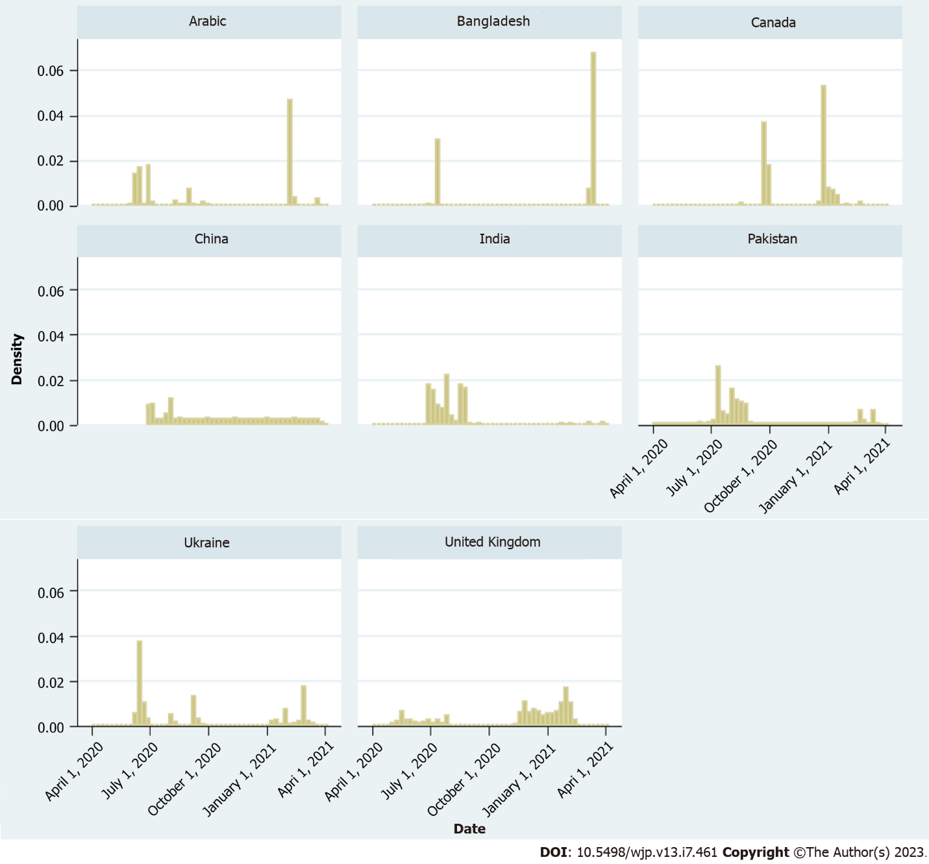
Figure 1 Distribution of survey respondents over time, by country.
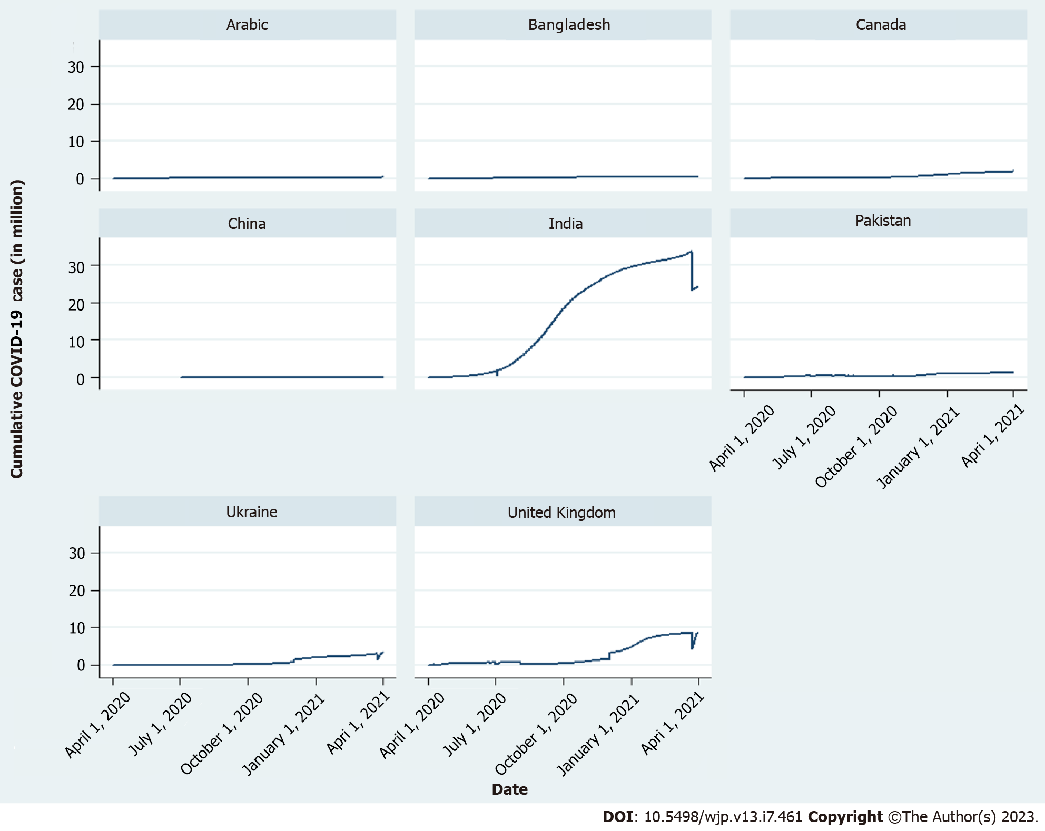
Figure 2 Cumulative coronavirus disease 2019 case (in million) over time, by country. COVID-19: Coronavirus disease 2019.

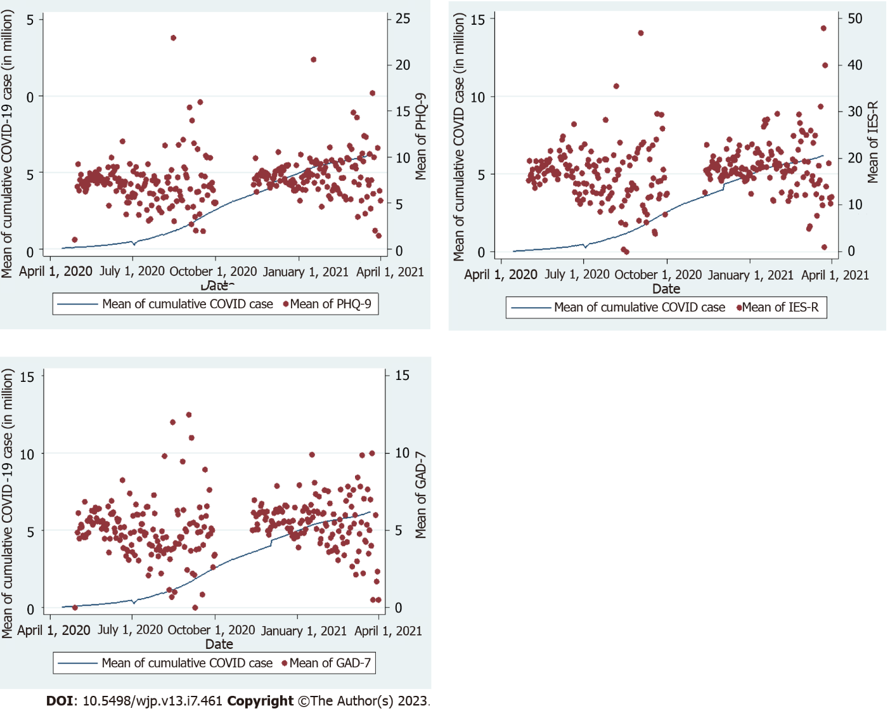Figure 3 The association between mental health scores and coronavirus disease 2019 case. A: Mean of patient health questionnaire-9; B: Mean of impact of events scale-revised; C: Mean of generalized anxiety disorder-7. PHQ-9: Patient health questionnaire-9; IES-R: Impact of Events Scale-Revised; GAD-7: Generalized anxiety disorder-7; COVID-19: Coronavirus disease 2019.

Table 1 Percent of categories in individual characteristics by country and survey rounds (1 and 2)
 | Arabic |  | Bangladesh |  | Canada |  | China | India |  | Pakistan |  | United Kingdom |  | Ukraine
 | 1 | 2 | 1 | 2 | 1 | 2 | 1 | 1 | 2 | 1 | 2 | 1 | 2 | 1 | 2
Observations | 1121 | 909 | 299 | 746 | 8648 | 5920 | 178 | 1427 | 68 | 803 | 160 | 29134 | 83851 | 1256 | 606
 | Percent of above observations
Healthcare professional
No | 40 | 9 | 67 | 69 | 88 | 91 | 65 | 65 | 40 | 44 | 41 | 47 | 66 | 79 | 74
Yes | 38 | 66 | 4 | 5 | 7 | 9 | 19 | 19 | 44 | 0 | 34 | 43 | 22 | 9 | 10
Missing | 22 | 25 | 29 | 26 | 5 | 0 | 16 | 16 | 16 | 56 | 25 | 10 | 12 | 12 | 16
Age category
Under 25 | 10 | 4 | 69 | 68 | 8 | 16 | 2 | 20 | 7 | 20 | 51 | 6 | 6 | 35 | 15
25-44 | 44 | 61 | 14 | 14 | 36 | 36 | 43 | 44 | 44 | 35 | 26 | 36 | 31 | 43 | 54
45-54 | 16 | 9 | 2 | 1 | 15 | 16 | 12 | 11 | 16 | 3 | 4 | 23 | 19 | 9 | 13
55 and over | 7 | 3 | 1 | 1 | 37 | 32 | 26 | 13 | 21 | 2 | 1 | 26 | 34 | 2 | 3
Missing | 22 | 22 | 14 | 17 | 5 | 0 | 17 | 13 | 12 | 40 | 18 | 10 | 11 | 11 | 15
White ethnicity
No | 77 | 21 | 92 | 89 | 20 | 21 | 9 | 88 | 88 | 81 | 73 | 9 | 15 | 3 | 3
Yes | 1 | 57 | 0 | 0 | 76 | 78 | 79 | 0 | 0 | 0 | 0 | 82 | 74 | 88 | 82
Missing | 22 | 22 | 8 | 11 | 4 | 0 | 12 | 12 | 12 | 19 | 27 | 10 | 11 | 9 | 15
Christian religion
No | 8 | 73 | 92 | 87 | 48 | 52 | 8 | 80 | 78 | 81 | 75 | 48 | 46 | 21 | 22
Yes | 70 | 4 | 0 | 0 | 47 | 47 | 32 | 7 | 9 | 0 | 0 | 41 | 39 | 69 | 62
Missing | 22 | 22 | 8 | 13 | 5 | 1 | 60 | 13 | 13 | 19 | 25 | 11 | 15 | 11 | 16
Gender
Female | 50 | 27 | 22 | 23 | 56 | 54 | 61 | 60 | 56 | 49 | 61 | 74 | 61 | 77 | 74
Male | 28 | 51 | 68 | 63 | 39 | 45 | 24 | 27 | 31 | 31 | 18 | 15 | 26 | 13 | 9
Missing | 22 | 22 | 10 | 14 | 5 | 1 | 15 | 13 | 13 | 20 | 21 | 11 | 13 | 11 | 16
Attended university
No | 78 | 79 | 91 | 88 | 51 | 53 | 85 | 38 | 79 | 80 | 83 | 90 | 89 | 90 | 85
Yes | 0 | 0 | 0 | 0 | 43 | 47 | 0 | 50 | 9 | 0 | 0 | 0 | 0 | 0 | 0
Missing | 22 | 21 | 9 | 12 | 6 | 0 | 15 | 13 | 12 | 20 | 18 | 10 | 11 | 10 | 15
Living at own home
No | 43 | 52 | 64 | 53 | 35 | 41 | 37 | 49 | 0 | 43 | 41 | 25 | 29 | 54 | 41
Yes | 35 | 26 | 26 | 35 | 61 | 59 | 51 | 39 | 0 | 38 | 40 | 66 | 61 | 36 | 44
Missing | 22 | 22 | 10 | 12 | 5 | 0 | 13 | 12 | 100 | 19 | 19 | 10 | 11 | 10 | 15
Vulnerable according to government category
No | 63 | 34 | 74 | 52 | 63 | 66 | 71 | 68 | 0 | 68 | 46 | 70 | 67 | 76 | 54
Age ≥ 70 | 1 | 40 | 9 | 36 | 15 | 34 | 5 | 7 | 0 | 2 | 31 | 4 | 21 | 1 | 29
Chronic disease | 2 | 0 | 1 | 0 | 6 | 0 | 2 | 1 | 0 | 2 | 0 | 6 | 0 | 4 | 0
Diabetes | 2 | 0 | 0 | 0 | 3 | 0 | 4 | 1 | 0 | 0 | 0 | 2 | 0 | 0 | 0
Other | 3 | 0 | 3 | 0 | 7 | 0 | 1 | 2 | 0 | 3 | 0 | 5 | 0 | 3 | 0
Missing | 28 | 26 | 13 | 12 | 6 | 0 | 16 | 19 | 100 | 25 | 23 | 13 | 12 | 16 | 17
Vulnerable according to government category and require shielding
No | 64 | 0 | 85 | 0 | 75 | 0 | 77 | 72 | 0 | 67 | 0 | 77 | 0 | 72 | 0
Yes | 6 | 0 | 2 | 0 | 13 | 0 | 5 | 6 | 0 | 6 | 0 | 7 | 0 | 11 | 0
Missing | 30 | 100 | 14 | 100 | 12 | 100 | 18 | 22 | 100 | 26 | 100 | 16 | 100 | 17 | 100
Whether experienced coronavirus
No | 23 | 0 | 42 | 0 | 28 | 0 | 58 | 35 | 0 | 28 | 0 | 22 | 0 | 31 | 0
Yes | 49 | 29 | 40 | 23 | 63 | 12 | 26 | 43 | 25 | 43 | 48 | 64 | 25 | 52 | 47
Missing | 28 | 71 | 17 | 77 | 8 | 88 | 16 | 22 | 75 | 29 | 53 | 14 | 75 | 17 | 53
Pre-existing mental health condition
No | 42 | 0 | 46 | 1 | 62 | 1 | 74 | 67 | 3 | 40 | 0 | 53 | 0 | 60 | 0
Yes | 28 | 3 | 41 | 5 | 31 | 21 | 8 | 11 | 4 | 35 | 11 | 31 | 18 | 23 | 9
Missing | 30 | 97 | 13 | 95 | 7 | 79 | 18 | 22 | 93 | 25 | 89 | 16 | 82 | 17 | 91
Drinking alcohol
No | 68 | 64 | 76 | 77 | 20 | 54 | 28 | 57 | 47 | 0 | 0 | 13 | 75 | 17 | 0
Yes | 5 | 1 | 12 | 6 | 74 | 22 | 56 | 24 | 35 | 0 | 5 | 75 | 11 | 69 | 1
Missing | 27 | 35 | 13 | 17 | 5 | 24 | 16 | 19 | 18 | 100 | 95 | 12 | 14 | 14 | 99
Whether taking drug
No | 71 | 65 | 81 | 73 | 83 | 86 | 79 | 78 | 82 | 71 | 69 | 85 | 83 | 83 | 77
Yes | 0 | 4 | 8 | 11 | 12 | 14 | 6 | 2 | 1 | 3 | 6 | 2 | 3 | 3 | 2
Missing | 28 | 31 | 11 | 15 | 5 | 0 | 15 | 20 | 16 | 26 | 25 | 13 | 13 | 14 | 21
Ever experienced suicidal thoughts
No | 9 | 61 | 70 | 69 | 67 | 77 | 74 | 68 | 66 | 55 | 55 | 59 | 60 | 60 | 53
Yes | 62 | 7 | 18 | 16 | 27 | 23 | 10 | 12 | 16 | 19 | 18 | 27 | 26 | 24 | 28
Missing | 29 | 32 | 13 | 15 | 6 | 1 | 16 | 21 | 18 | 26 | 27 | 13 | 14 | 16 | 19
Having mental health support from
No support | 18 | 1 | 27 | 3 | 13 | 4 | 6 | 5 | 3 | 30 | 4 | 14 | 5 | 13 | 2
Health service provider | 6 | 1 | 5 | 1 | 11 | 6 | 2 | 3 | 1 | 8 | 3 | 12 | 8 | 6 | 5
Other | 3 | 1 | 7 | 1 | 7 | 10 | 2 | 2 | 1 | 4 | 3 | 5 | 4 | 7 | 1
Missing | 73 | 97 | 61 | 95 | 69 | 80 | 90 | 89 | 94 | 58 | 90 | 69 | 83 | 75 | 91
Each panel in a column shows percentages of categories/responses of a characteristic/question. Total respondents in each category were divided by observations shown at the beginning of the table and then multiplied by 100, to get the percentage.

Table 2 Summary statistics of mental health scores by country and survey rounds
 |  | PHQ-9 |  | GAD-7 |  | IES-R
 |  | Round 1 | Round 2 | Round 1 | Round 2 | Round 1 | Round 2
Arabic | Mean | 7.85 | 6.27 | 5.28 | 4.56 | 20.81 | 17.14
 | SD | 6.97 | 6.88 | 5.78 | 5.56 | 18.79 | 19.12
 | n | 596 | 481 | 596 | 486 | 539 | 430
 | Missing | 525 | 428 | 525 | 423 | 582 | 479
Bangladesh | Mean | 8.07 | 7.45 | 5.76 | 5.45 | 23.28 | 21.86
 | SD | 5.79 | 6.91 | 5.38 | 5.69 | 18.08 | 20.35
 | n | 205 | 462 | 205 | 485 | 179 | 419
 | Missing | 94 | 284 | 94 | 261 | 120 | 327
Canada | Mean | 6.11 | 6.97 | 4.40 | 4.94 | 15.10 | 16.96
 | SD | 6.44 | 6.70 | 5.32 | 5.46 | 17.87 | 18.24
 | n | 7653 | 5721 | 7684 | 5770 | 7329 | 5554
 | Missing | 995 | 199 | 964 | 150 | 1319 | 366
China | Mean | 4.38 |  | 3.25 |  | 11.61
 | SD | 4.91 |  | 4.20 |  | 13.63
 | n | 127 |  | 124 |  | 117
 | Missing | 51 |  | 54 |  | 61
India | Mean | 4.99 | 4.07 | 3.46 | 2.43 | 14.65 | 10.24
 | SD | 5.56 | 5.34 | 4.38 | 3.31 | 16.49 | 12.00
 | n | 820 | 41 | 823 | 42 | 741 | 38
 | Missing | 607 | 27 | 604 | 26 | 686 | 30
Pakistan | Mean | 8.55 | 8.64 | 5.10 | 5.37 | 19.02 | 19.59
 | SD | 7.34 | 7.51 | 5.56 | 5.42 | 17.26 | 19.18
 | n | 412 | 85 | 413 | 90 | 376 | 75
 | Missing | 391 | 75 | 390 | 70 | 427 | 85
United Kingdom | Mean | 7.70 | 8.21 | 5.46 | 6.04 | 17.01 | 19.19
 | SD | 6.47 | 7.03 | 5.51 | 5.92 | 17.51 | 18.93
 | n | 22166 | 64382 | 22343 | 65056 | 20780 | 59966
 | Missing | 6968 | 19469 | 6791 | 18795 | 8354 | 23885
Ukraine | Mean | 6.63 | 7.81 | 4.17 | 5.02 | 14.93 | 15.55
 | SD | 6.10 | 6.51 | 4.65 | 5.20 | 15.34 | 15.41
 | n | 860 | 421 | 863 | 426 | 782 | 382
 | Missing | 396 | 185 | 393 | 180 | 474 | 224
Total | Mean | 7.24 | 8.09 | 5.11 | 5.93 | 16.55 | 18.98
 | SD | 6.49 | 7.01 | 5.45 | 5.88 | 17.57 | 18.88
 | n | 32839 | 71593 | 33051 | 72355 | 30843 | 66864
 | Missing | 10027 | 20667 | 9815 | 19905 | 12023 | 25396
PHQ-9: Patient health questionnaire-9; IES-R: Impact of Events Scale-Revised; GAD-7: Generalized anxiety disorder-7.

Table 3 Lockdown and survey dates by country
Country | First lockdown |  | Second lockdown |  | Survey period |  | Can we capture lockdown effects?
 | Start | End | Start | End | Round 1 | Round 2
Bangladesh | March 26, 2020 | May 16, 2020 | April 5, 2021 | July 14, 2021 | July 1, 2020-July 25, 2020 | January 19, 2021-March 18, 2021 | No
Canada | March 18, 2020 | May 18, 2020 | November 7, 2020 | January 8, 2021 | August 18, 2020-October 2, 2020 | December 21, 2020-March 30, 2021 | No
China | January 23, 2020 | April 8, 2020 |  |  | June 24, 2020-August 7, 2020 |  | No
India | March 25, 2020 | June 7, 2020 | April 19, 2021 | May 31, 2021 | July 1, 2020-September 20, 2020 | January 22, 2021-April 1, 2021 | No
Pakistan | March 24, 2020 | May 9, 2020 | May 8, 2021 | May 18, 2021 | June 10, 2020-September 24, 2020 | February 2, 2021-March 29, 2021 | No
Saudi Arabia | March 29, 2020 | June 21, 2020 |  |  | June 3, 2020-October 7, 2020 | January 16, 2021-April 1, 2021 | Yes, in Round 1
Ukraine | March 17, 2020 | April 24, 2020 |  |  | June 11, 2020-September 30, 2020 | January 7, 2021-March 25, 2021 | No
United Kingdom | March 23, 2020 | July 4, 2020 | November 5, 2020 | December 2, 2020 | April 28, 2020-August 6, 2020 | November 12, 2020-February 18, 2021 | Yes, in both rounds

Table 4 Ordinary least squares regression of mental health scores on cumulative coronavirus disease 2019 case, lockdown, and individual characteristics (survey round 1)
 | PHQ-9 |  | GAD-7 |  | IES-R
 | Round 1 | Round 2 | Round 1 | Round 2 | Round 1 | Round 2
Daily cumulative COVID-19 case/1000000 | 0.075ª | 2.121^{c} | 0.041 | 1.750^{c} | 0.225ª | 1.543ª
 | [-0.01, 0.16] | [1.58, 2.66] | [-0.03, 0.11] | [1.28, 2.22] | [-0.02, 0.47] | [-0.05, 3.14]
Dummy for first lockdown withdraw |  | -0.658^{c} |  | -0.450^{c} |  | -1.224^{b}
 |  | [-0.97, -0.34] |  | [-0.73, -0.17] |  | [-2.16, -0.29]
Dummy for first lockdown withdraw¹ (date-first lockdown withdraw date) |  | -0.018^{c} |  | -0.014^{c} |  | -0.043^{c}
 |  | [-0.03, -0.01] |  | [-0.02, -0.01] |  | [-0.07, -0.02]
Date-first lockdown withdraw date |  | 0.006^{b} |  | 0.000 |  | 0.004
 |  | [0.00, 0.01] |  | [-0.00, 0.01] |  | [-0.01, 0.02]
Healthcare professional (1 = yes, 0 = no) | -0.402^{c} | -0.737^{c} | -0.328^{c} | -0.631^{c} | -1.394^{c} | -2.185^{c}
 | [-0.54, -0.26] | [-0.89, -0.58] | [-0.45, -0.21] | [-0.77, -0.49] | [-1.81, -0.98] | [-2.65, -1.72]
Age (base: Below 25) | 0.000 | 0.000 | 0.000 | 0.000 | 0.000 | 0.000
25-44 | -1.084^{c} | -1.428^{c} | -0.482^{c} | -0.713^{c} | -2.350^{c} | -2.091^{c}
 | [-1.34, -0.83] | [-1.75, -1.11] | [-0.71, -0.26] | [-0.99, -0.43] | [-3.10, -1.60] | [-3.02, -1.16]
45-54 | -1.958^{c} | -2.345^{c} | -1.456^{c} | -1.737^{c} | -3.992^{c} | -3.366^{c}
 | [-2.24, -1.68] | [-2.69, -1.99] | [-1.70, -1.21] | [-2.05, -1.43] | [-4.83, -3.15] | [-4.39, -2.34]
55 and over | -2.956^{c} | -3.108^{c} | -2.179^{c} | -2.284^{c} | -5.568^{c} | -4.085^{c}
 | [-3.24, -2.67] | [-3.47, -2.75] | [-2.43, -1.93] | [-2.60, -1.97] | [-6.42, -4.72] | [-5.15, -3.02]
White (1 = yes, 0 = no) | 0.360^{c} | 0.482^{c} | 0.299^{c} | 0.413^{c} | -1.120^{c} | -0.054
 | [0.17, 0.55] | [0.23, 0.74] | [0.13, 0.47] | [0.19, 0.64] | [-1.69, -0.55] | [-0.80, 0.69]
Christian (1 = yes, 0 = no) | -0.206^{c} | -0.036 | 0.018 | 0.222^{c} | 0.522^{c} | 0.829^{c}
 | [-0.34, -0.07] | [-0.19, 0.12] | [-0.10, 0.13] | [0.08, 0.36] | [0.13, 0.91] | [0.37, 1.29]
Male (1 = yes, 0 = no) | -1.189^{c} | -1.231^{c} | -1.039^{c} | -1.042^{c} | -2.997^{c} | -3.719^{c}
 | [-1.34, -1.03] | [-1.43, -1.03] | [-1.18, -0.90] | [-1.22, -0.86] | [-3.46, -2.53] | [-4.31, -3.13]
Attended university (1 = yes, 0 = no) | -1.141^{c} | 0.000 | -0.545^{c} | 0.000 | -1.254^{c} | 0.000
 | [-1.34, -0.94] | [0.00, 0.00] | [-0.72, -0.37] | [0.00, 0.00] | [-1.85, -0.65] | [0.00, 0.00]
Living at own home (1 = yes, 0 = no) | -0.885^{c} | -1.105^{c} | -0.489^{c} | -0.692^{c} | -1.432^{c} | -2.270^{c}
 | [-1.04, -0.73] | [-1.30, -0.91] | [-0.63, -0.35] | [-0.86, -0.52] | [-1.89, -0.97] | [-2.83, -1.71]
Vulnerable according to government category (base: Not vulnerable) | 0.000 | 0.000 | 0.000 | 0.000 | 0.000 | 0.000
Aged 70 or above | -0.898^{c} | -1.105^{c} | -0.764^{c} | -0.985^{c} | -1.954^{c} | -2.909^{c}
 | [-1.18, -0.62] | [-1.52, -0.69] | [-1.01, -0.52] | [-1.35, -0.62] | [-2.81, -1.10] | [-4.19, -1.63]
Chronic disease | 0.361^{b} | 0.345^{b} | 0.533^{c} | 0.543^{c} | 1.245^{c} | 1.644^{c}
 | [0.08, 0.64] | [0.03, 0.66] | [0.29, 0.78] | [0.26, 0.83] | [0.41, 2.08] | [0.70, 2.59]
Diabetes | 0.034 | -0.064 | 0.102 | 0.139 | 0.867 | 1.185
 | [-0.43, 0.49] | [-0.63, 0.50] | [-0.30, 0.50] | [-0.36, 0.64] | [-0.50, 2.23] | [-0.49, 2.86]
Other | 0.915^{c} | 0.846^{c} | 0.390^{c} | 0.355^{b} | 0.811ª | 1.208^{b}
 | [0.62, 1.21] | [0.49, 1.20] | [0.13, 0.65] | [0.04, 0.67] | [-0.07, 1.70] | [0.15, 2.27]
Vulnerable according to government category and require shielding (1 = yes, 0 = no) | 1.087^{c} | 1.096^{c} | 0.909^{c} | 0.945^{c} | 4.281^{c} | 3.513^{c}
 | [0.83, 1.34] | [0.76, 1.43] | [0.68, 1.13] | [0.65, 1.24] | [3.51, 5.05] | [2.52, 4.50]
Experienced coronavirus (1 = yes, 0 = no) | 0.324^{c} | 0.220^{b} | 0.237^{c} | 0.181^{b} | 0.410ª | 0.547^{b}
 | [0.18, 0.47] | [0.05, 0.39] | [0.11, 0.36] | [0.03, 0.33] | [-0.01, 0.83] | [0.05, 1.05]
Pre-existing mental health condition (1 = yes, 0 = no) | 3.447^{c} | 3.256^{c} | 3.158^{c} | 3.091^{c} | 8.608^{c} | 8.227^{c}
 | [3.26, 3.63] | [3.04, 3.47] | [3.00, 3.32] | [2.90, 3.28] | [8.06, 9.16] | [7.60, 8.86]
Drinking alcohol (1 = yes, 0 = no) | 0.251^{c} | -0.082 | 0.234^{c} | -0.101 | 0.410 | -0.277
 | [0.08, 0.42] | [-0.30, 0.13] | [0.08, 0.38] | [-0.29, 0.09] | [-0.10, 0.92] | [-0.91, 0.36]
Taking drug (1 = yes, 0 = no) | 0.794^{c} | 1.303^{c} | 0.725^{c} | 0.729^{c} | 2.262^{c} | 2.527^{c}
 | [0.48, 1.11] | [0.76, 1.84] | [0.45, 1.00] | [0.25, 1.21] | [1.33, 3.19] | [0.95, 4.11]
Ever experienced suicidal thoughts (1 = yes, 0 = no) | 3.101^{c} | 2.976^{c} | 1.623^{c} | 1.503^{c} | 6.054^{c} | 5.812^{c}
 | [2.95, 3.25] | [2.80, 3.15] | [1.49, 1.75] | [1.35, 1.66] | [5.61, 6.50] | [5.30, 6.32]
Mental health support from (base: No support) | 0.000 | 0.000 | 0.000 | 0.000 | 0.000 | 0.000
Health service provider | 0.134 | 0.245ª | -0.052 | -0.021 | 0.008 | -0.030
 | [-0.11, 0.37] | [-0.03, 0.52] | [-0.26, 0.16] | [-0.26, 0.22] | [-0.71, 0.72] | [-0.85, 0.79]
Other | 1.072^{c} | 1.269^{c} | 0.521^{c} | 0.666^{c} | 3.042^{c} | 3.542^{c}
 | [0.77, 1.38] | [0.91, 1.63] | [0.25, 0.79] | [0.35, 0.98] | [2.14, 3.95] | [2.49, 4.59]
Constant | 7.050^{c} | 7.213^{c} | 4.651^{c} | 4.590^{c} | 16.577^{c} | 16.791^{c}
 | [6.73, 7.37] | [6.69, 7.73] | [4.37, 4.93] | [4.13, 5.05] | [15.62, 17.54] | [15.26, 18.32]
Observations | 28560 | 21077 | 28710 | 21202 | 26913 | 19785
Adjusted R² | 0.279 | 0.261 | 0.214 | 0.203 | 0.180 | 0.172
ªP < 0.10.
^{b}P < 0.05.
^{c}P < 0.01.
¹See Table 3 for dates of first lock down period.
95% confidence intervals are in brackets. PHQ-9: Patient health questionnaire-9; IES-R: Impact of Events Scale-Revised; GAD-7: Generalized anxiety disorder-7; COVID-19: Coronavirus disease 2019.
Table 5 Ordinary least squares regression of mental health scores on cumulative coronavirus disease 2019 case, lockdown, and individual characteristics (survey round 2)
 | PHQ-9 |  | GAD-7 |  | IES-R
 | Round 1 | Round 2 | Round 1 | Round 2 | Round 1 | Round 2
Daily cumulative COVID-19 case/1000000 | 0.195^{c} | 0.433^{c} | 0.129^{c} | 0.557^{c} | 0.454^{c} | 1.265^{c}
 | [0.18, 0.21] | [0.23, 0.63] | [0.11, 0.15] | [0.38, 0.74] | [0.40, 0.51] | [0.67, 1.86]
Dummy for second lockdown withdraw |  | -0.507^{c} |  | -0.343^{b} |  | -1.077^{b}
 |  | [-0.83, -0.18] |  | [-0.63, -0.05] |  | [-2.04, -0.11]
Dummy for second lockdown withdraw¹ (date-second lockdown withdraw date) |  | -0.034^{c} |  | -0.038^{c} |  | -0.104^{c}
 |  | [-0.06, -0.01] |  | [-0.06, -0.02] |  | [-0.18, -0.03]
Date-second lockdown withdraw date |  | 0.013 |  | -0.002 |  | 0.034
 |  | [-0.01, 0.03] |  | [-0.02, 0.02] |  | [-0.03, 0.10]
Healthcare professional (1 = yes, 0 = no) | -0.693^{c} | -0.747^{c} | -0.540^{c} | -0.587^{c} | -2.325^{c} | -2.551^{c}
 | [-0.80, -0.58] | [-0.86, -0.63] | [-0.64, -0.44] | [-0.69, -0.48] | [-2.65, -2.00] | [-2.89, -2.21]
Age (base: Below 25)
25-44 | -1.147^{c} | -1.339^{c} | -0.333^{c} | -0.445^{c} | -1.043^{c} | -0.715^{b}
 | [-1.34, -0.96] | [-1.55, -1.13] | [-0.50, -0.16] | [-0.63, -0.26] | [-1.60, -0.49] | [-1.33, -0.10]
45-54 | -2.059^{c} | -2.245^{c} | -1.310^{c} | -1.421^{c} | -2.263^{c} | -1.750^{c}
 | [-2.27, -1.85] | [-2.47, -2.02] | [-1.50, -1.12] | [-1.63, -1.22] | [-2.88, -1.65] | [-2.42, -1.08]
55 and over | -3.455^{c} | -3.639^{c} | -2.424^{c} | -2.521^{c} | -4.792^{c} | -4.223^{c}
 | [-3.66, -3.25] | [-3.87, -3.41] | [-2.61, -2.24] | [-2.72, -2.32] | [-5.40, -4.18] | [-4.89, -3.55]
White (1 = yes, 0 = no) | -0.291^{c} | -0.243^{c} | -0.326^{c} | -0.249^{c} | -2.114^{c} | -1.667^{c}
 | [-0.42, -0.16] | [-0.38, -0.11] | [-0.44, -0.21] | [-0.37, -0.13] | [-2.49, -1.74] | [-2.07, -1.27]
Christian (1 = yes, 0 = no) | -0.017 | 0.018 | 0.174^{c} | 0.183^{c} | 0.752^{c} | 0.795^{c}
 | [-0.11, 0.08] | [-0.08, 0.12] | [0.09, 0.26] | [0.10, 0.27] | [0.47, 1.03] | [0.50, 1.09]
Male (1 = yes, 0 = no) | -1.470^{c} | -1.476^{c} | -1.491^{c} | -1.523^{c} | -4.418^{c} | -4.798^{c}
 | [-1.57, -1.37] | [-1.58, -1.37] | [-1.58, -1.40] | [-1.62, -1.43] | [-4.72, -4.12] | [-5.12, -4.48]
Attended university (1 = yes, 0 = no) | -0.699^{c} | 0.000 | -0.543^{c} | 0.000 | -0.174 | 0.000
 | [-0.96, -0.43] | [0.00, 0.00] | [-0.78, -0.31] | [0.00, 0.00] | [-0.95, 0.60] | [0.00, 0.00]
Own home (1 = yes, 0 = no) | -1.328^{c} | -1.391^{c} | -0.899^{c} | -0.957^{c} | -2.985^{c} | -3.338^{c}
 | [-1.44, -1.22] | [-1.51, -1.27] | [-1.00, -0.80] | [-1.06, -0.85] | [-3.32, -2.65] | [-3.69, -2.99]
Vulnerable according to government category and require shielding (1 = yes, 0 = no) | 1.355^{c} | 1.393^{c} | 1.083^{c} | 1.124^{c} | 3.932^{c} | 3.929^{c}
 | [1.25, 1.46] | [1.28, 1.51] | [0.99, 1.18] | [1.02, 1.23] | [3.61, 4.26] | [3.59, 4.27]
Experienced coronavirus (1 = yes, 0 = no) | 0.747^{c} | 0.715^{c} | 0.566^{c} | 0.535^{c} | 2.601^{c} | 2.398^{c}
 | [0.64, 0.85] | [0.61, 0.82] | [0.47, 0.66] | [0.44, 0.63] | [2.30, 2.91] | [2.08, 2.71]
Pre-existing mental health condition (1 = yes, 0 = no) | 2.808^{c} | 2.745^{c} | 2.278^{c} | 2.266^{c} | 7.150^{c} | 7.160^{c}
 | [2.62, 2.99] | [2.55, 2.94] | [2.11, 2.44] | [2.10, 2.44] | [6.60, 7.70] | [6.60, 7.73]
Drinking alcohol (1 = yes, 0 = no) | 2.300^{c} | 2.506^{c} | 1.714^{c} | 1.875^{c} | 5.976^{c} | 6.400^{c}
 | [2.17, 2.43] | [2.36, 2.65] | [1.60, 1.83] | [1.75, 2.00] | [5.59, 6.37] | [5.98, 6.82]
Taking drug (1 = yes, 0 = no) | 1.232^{c} | 1.359^{c} | 0.539^{c} | 0.562^{c} | 3.126^{c} | 3.270^{c}
 | [1.01, 1.46] | [1.10, 1.62] | [0.34, 0.74] | [0.33, 0.79] | [2.46, 3.79] | [2.51, 4.03]
Ever experienced suicidal thoughts (1 = yes, 0 = no) | 4.405^{c} | 4.379^{c} | 2.749^{c} | 2.716^{c} | 9.625^{c} | 9.747^{c}
 | [4.29, 4.52] | [4.26, 4.49] | [2.65, 2.85] | [2.61, 2.82] | [9.30, 9.95] | [9.41, 10.09]
Mental health support from (base: No support)
Health service provider | 0.322^{c} | 0.342^{c} | -0.024 | -0.051 | -0.124 | -0.288
 | [0.10, 0.55] | [0.11, 0.57] | [-0.22, 0.17] | [-0.26, 0.15] | [-0.79, 0.54] | [-0.97, 0.39]
Other | 1.041^{c} | 1.300^{c} | 0.686^{c} | 0.854^{c} | 2.979^{c} | 3.572^{c}
 | [0.78, 1.31] | [1.02, 1.58] | [0.45, 0.92] | [0.61, 1.10] | [2.20, 3.76] | [2.75, 4.40]
Constant | 8.201^{c} | 8.292^{c} | 6.023^{c} | 5.496^{c} | 17.577^{c} | 16.168^{c}
 | [7.98, 8.42] | [7.84, 8.74] | [5.83, 6.22] | [5.10, 5.90] | [16.94, 18.21] | [14.84, 17.50]
Observations | 62938 | 57985 | 63545 | 58547 | 58966 | 54202
Adjusted R² | 0.315 | 0.318 | 0.228 | 0.230 | 0.222 | 0.228
^{b}P < 0.05.
^{c}P < 0.01.
¹See Table 3 for dates of first lock down period.
95% confidence intervals are in brackets. PHQ-9: Patient health questionnaire-9; IES-R: Impact of Events Scale-Revised; GAD-7: Generalized anxiety disorder-7; COVID-19: Coronavirus disease 2019.

Published by Baishideng Publishing Group Inc
7041 Koll Center Parkway, Suite 160, Pleasanton, CA 94566, USA
Telephone: +19253991568
Email: bpgoffice@wjgnet.com
Help Desk: https://www.f6publishing.com/helpdesk
https://www.wjgnet.com

© 2023 Baishideng Publishing Group Inc. All rights reserved.

