Name of journal: World Journal of Gastroenterology
ESPS Manuscript NO: 9904
Columns: ORIGINAL ARTICLE

Differential control of growth, apoptotic activity and gene expression in human colon cancer cells by extracts derived from medicinal herbs, Rhazya stricta and Zingiber officinale and their combination

Elkady AI et al. Apoptogenicity of Rhazya stricta and Zingiber officinale herbs

Ayman I Elkady, Rania Abd El Hamid Hussein, Osama A Abu-Zinadah

Ayman I Elkady, Osama A Abu-Zinadah, Department of Biological Sciences, Faculty of Sciences, King Abdulaziz University, Jeddah 21589, Saudi Arabia

Rania Abd El Hamid Hussein, Department of Clinical Nutrition, Faculty of Applied Medical Sciences, King Abdulaziz University, Jeddah 21589, Saudi Arabia

Ayman I Elkady, Zoology Department, Faculty of Science, Alexandria University, Alexandria, Egypt

Rania Abd El Hamid Hussein, Gamal Abd El Nasser Hospital, Alexandria, Egypt

Author contributions: Elkady AI designed and performed research; Abu-Zinadah OA contributed analytic tools; Elkady AI and Hussein RA analyzed data; and Elkady AI and Hussein RA wrote the the paper.

Supported by Deanship of Scientific Research, King Abdulaziz University, Jeddah, No. 1431/130/159

Correspondence to: Osama A Abu-Zinadah, Professor of Cell Biology and Histology, Department of Biological Sciences, Faculty of Sciences, King Abdulaziz University, Jeddah 21589, Saudi Arabia. oaboznada@kau.edu.sa
Telephone: +966-2-692662 Fax: +966-2-6952290

Received: March 3, 2014 Revised: June 29, 2014
Accepted: July 11, 2014

Published online:

Abstract
AIM: To investigate the effects of crude alkaloid (CAERS) and flavonoid (CFEZO) extracts prepared from medicinal herbs, Rhazya stricta and Zingiber officinale, respectively, on the human colorectal cancer cells, HCT116.

METHODS: The HCT116 were subjected toincreasing doses of CAERS and CFEZO, in single and double treatments, harvested after 24, 48 and 72 h, and assayed for cell viability, clonogenic and soft agar colony-forming assays. Apoptotic assays, including Hoechst 33342 and acridine orange/ethidium bromide staining, DNA ladderingand Comet assay were carried out to confirm apoptogenic effects of the extracts. Quantitative reverse transcription-polymerase chain reaction (qRT-PCR) and Western blot analyses were performed to assess the impact of CAERS and CFEZO on the expression levels of the key regulatory proteins in HCT116 cells.

RESULTS: A combination of CAERS and CFEZO synergistically suppressed proliferation, colony formation and anchorage-independent growth of HCT116 cells. CAERS- and CFEZO-treated cells exhibited morphologic and biochemical features of apoptotic cell death. The apoptotic induction was associated with the release of mitochondrial cytochrome c, increase of Bax/Bcl-2 ratio, activation of caspases 3 and 9 and cleavage of PARP. CAERS and CFEZO treatments down-regulated expression levels of the anti-apoptotic genes, Bcl-2, Bcl-X, Mcl-1, survivin and XIAP but up-regulated expression levels of the pro-apoptotic genes, Bad and Noxa. CAERS and CFEZO treatmentselevated expression levels of the onco-suppressor proteins, p53, p21 and p27 and reduced those of the onco-proteins, cyclin D1, Cdk-4 and c-Myc.

CONCLUSION: These data support the hypothesis that combination of CAERS and CFEZO worked as a promising treatment for the prevention of colon cancer.

© 2014 Baishideng Publishing Group Inc. All rights reserved.

Key words: Colorectal cancer; Phytochemicals; Apoptosis; Oncogenes; Tumor suppressor proteins

Core tip: Many medicinal plantsrepresent a cornerstone for chemoprevention of colorectal cancer (CRC). Nonetheless, mono-therapy of these agents has turned to be unsatisfactory; therefore attention has turned towards combining these plant-based extracts. In this study, we found that a combination of the crude alkaloid and flavonoid extracts prepared from the medicinal herbs Rhazya stricta and Zingiber officinale, respectively, acted synergistically to suppress proliferation, induce apoptosis and modulate expression levels of cell cycle regulatory proteins in CRC cells, HCT116. These results shed a light on the basis of exploiting these extracts for the prevention of CRC.

Elkady AI, Hussein RA, Abu-Zinadah OA. Differential control of growth, apoptotic activity and gene expression in human colon cancer cells by extracts derived from medicinal herbs, Rhazya stricta and Zingiber officinale and their combination. World J Gastroenterol 2014; In press

INTRODUCTION
Colorectal cancer (CRC) is the third most common phenotype of cancersand the second cause of cancer death worldwide^{[1]}. Although chemotherapy plays an important role in the comprehensive treatment of CRC, increasing incidence was reported in the last years; above 40% of the cases being still diagnosed in advanced stages^{[2,3]}. Therefore, there is an urgent need to find chemopreventive agents having high specificity for CRC tumor cells.
Available evidences have proved that chemopreventive agents inhibit colon tumor growth by enhancing apoptosis^{[4]}. Consistant with this notion,almost all human colon cancers involve the acquisition of specific genetic aberrations that inhibit apoptosis^{[5,6]}. The typical executioners of apoptosis are intracellular cysteine proteases called caspases^{[7,8]}. These caspases are activated by two pathways; the death receptor (extrinsic) and mitochondrial (intrinsic) pathways^{[7,8]}. The latter pathway initiates apoptosis in most physiological and pathological situations and is triggered by a variety of apoptotic stimuli. Both extrinsic and intrinsic pathways eventually converge on a common pathway, or the execution phase of apoptosis (activation of caspase-3) that provokes engagement of the effector caspases. These latter caspases mediate cleavage of proteins that are essential for cell viability, resulting in morphological hallmarks of apoptosis^{[9]}. These hallmarks include cytoplasm and chromatin condensation, nuclear breakdown, shrinkage of the cell and fragmentation into membrane-bound apoptotic bodies, eventually subjected to rapid phagocytosis by surrounding cells^{[9]}.
Recently, considerable attention has been focused on dietary and medicinal phytochemicals as arich reservoir for discovery of novel anticancer drugs^{[10]}. However, most human tumors are highly heterogenous and embody the culmination of multiple genetic abnormalities^{[11]}. Therefore, relying on a single dietary agent to target a distinct molecular target, for therapeutic purposes, might not be sufficient to elicit the desired outcome. Furthermore, the dietary agents have relative low potency compared with pharmacological compounds^{[12]}. In these regards, it might be possible to attain synergistic or additive preventive effect and improve therapeutic indexby combining dietary agents^{[13]}. Indeed, considerable data from human and animal studies denote that combinations of dietary agents are more effective than a single agent for chemoprevention of CRC^{[13-17]}.
Rhazya stricta (R. stricta) Decne (Harmal), a member of the Apocynaceae family, is an important medicinal species used in folkloric medicine to cure various diseases in South Asia and the Middle East^{[18,19]}. Extracts of R. stricta leaves have been prescribed for the treatment of various disorders including diabetes, sore throat, helminthesis, inflammatory conditions and rheumatism^{[18,19]}. In addition, we previously have reported that an aqueous extract of R. stricta inhibited cell proliferation and induced apoptotic cell death in the breast cancer cell lines, MCF-7 and MDA MB-231^{[20]}. The herb is particularly rich in alkaloid, where over 100 alkaloids have been isolated, characterized and identified from roots, stems and leaves of the herb^{[18]}. The fact that R. stricta is an alkaloid-rich herb deserves attention since alkaloids are among the most important phytochemcials known to display antiproliferation and antimetastasis effects on various types of cancers both in vitro and in vivo^{[21]}. For example, some alkaloids, such as camptothecinand vinca alkaloids, vincristine and vinblastine (like R. stricta, belonging to Apocynaceae family)^{[22]} have already been successfully developed into anticancer drugs. In our earlier study, we found that a crude alkaloid extract from R. stricta inhibited cell growth and sensitized human lung cancer cells, A549, to cisplatin through induction of apoptosis^{[23]}. Finally, a recent study by El Gendyand and his associates demonstrated that the strongly basic alkaloid fraction in R. stricta inducedactivity of the chemopreventative enzyme, Nqo1^{[24]}; anthe authors concluded this activity could be a novel mechanism for the traditional use of R. stricta's alkaloid as an antitumor agent^{[24]}.
Zingiber officinale (Z. officinale) Rosc (Ginger), a member of the Zingiberaceae family, is a medicial herb used for treatment of various illnesses, including gastrointestinal ailments, arthritis, rheumatism, pain, and muscle discomfort cardiovascular diseases and metabolic disorders^{[25]}. Some compounds present in the herb possess strong anti-inflammatory and anti-oxidative properties and exert substantial anti-mutagenic and anti-carcinogenic activities^{[25-27]}. Recent studies demonstrated that the bioactive molecules of Z. officinale are 6-gingerol, flavonoids and phenolic acids^{[28]}. In particular, it has been confirmed that 6-gingerols and 6-shogaols and related compoundsinhibited growth andinduced apoptosis in human colorectal carcinoma cells^{[25]}. Based on these studies, most researchers dealt with phenolic acid ingredients, such asgingerols and 6-shogaols, asthe anticancer bioactive compoundsin Z. officinale and have paid little attention, if any, to flavonoids in the herb. Flavonoids are the polyphenolic phytochemicals that possess a wide range of pharmacological properties, such as antimicrobial, antiviral, anti-inflammatory, anti-allergic, analgesic, antioxidant and hepatoprotective activities^{[29]}. In addition, many flavonoids have been found to holdvarious biological activities, mediating apoptosis induction, cell cycle arrest, anti-proliferation, anti-angiogenesis and anti-oxidation^{[30,31]}, which indicate that they may be promising anticancer agents^{[30,31]}. Futhermore, it has previously, been demonstrated chemopreventive efficacy of Z. officinale supplementation during the initiation stages of colon cancer in Wistar rats^{[32]} and in colon cancer cell lines^{[33]}. Despite these studies, no report addressed the anticancer potentiality of flavonoids present in Z. officinale on colon cancer has been reported yet, therefore further studies are required to investigate impact of Z. officinale’s flavonoids on colon cancer cells.
Thus far, basic reports of combining R. stricta and Z. officinale are lacking and not credible enough to allow a general recommendation for using both herbs as effective agents for chemoprevention of CRC. The cuurent study was carried out to assess the combined effect of R. stricta's alkaloids and Z. officinale's flavonoids on treatment of CRC. We hypothesized since alkaloids and flavonoids have substantially different biochemical entities, a combinational approach may simultaneously target multiplemolecular and cellular pathways involved in the process of CRC carcinogenesis.
MATERIALS AND METHODS
Preparation of crude flavonoid and alkaloid extracts
For preparation of crude flavonoid extract from Z. officinale, a rhizome of the herb was purchased from local market and powdered. The dried powder was extracted by cold percolation with 70% (2 L) ethanol for 72 h at room temperature and then filtered. The extraction was repeated twice and the combined filtrates were concentrated in a vacuum evaporator. This residue was suspended in 250 Ml hot water (60 °C), for h, filtered and defatted by using petroleum ether (250 mL × 3). The aqueous portion was then separated, collectedand fractionated with N-butanol saturated water (250 mL × 3). The aqueous portion was discarded and the N-butanol portion was then separated, collected before being fractionated with 1% KOH. The KOH portion was then fractionated with dilute HCl (2%) and N-butanol saturated water. The dilute HCl portion was discarded. The N-butanol portion was then separated, collectedand dried to obtain a crude extract of flavonoids. Before use, the stock was further diluted in DMSO to give the final indicated concentrations and termed as crude flavonoid extract of Z. officinale (CFEZO).
A crude alkaloid extract of R. stricta leaves was prepared essentially as described elsewhere^{[23]}, with some modifications. Briefly, air-dried leaves of R. stricta (350 g) were soaked in 80% methanol (1 L) at ambient temperature for seven days after which the methanolic extract was evaporated in a rotatory evaporator and the remaining residue was suspended in water and filtered. The aqueous extract was then acidified with 10% glacial acetic acid and extracted with chloroform. The chloroform was discarded, while the aqueous solution was alkalinized using NaOH and the pH was adjusted to 11. The alkaline aqueous layer was extracted with chloroform to yield a chloroform fraction enriched in strongly basic alkaloids. The chloroform was then evaporated to dryness to obtain a crude extract of alkaloids. Before use, the stock was further diluted in dimethyl sulfoxide (DMSO) to give the final indicated concentrations and termed as crude alkaloid extract of R. stricta (CAERS).
Phytochemical examination for testing the presence of alkaloids in CAERS was carried out using Dragendorff’s Test and Mayer’s Test. 5 mL of CAERS was stirred with 5 mL of 1% aqueous HCl on water bath, before being filtered and and aliquoted in two test tubes. Then, Dragendorff’s reagent (solution of Potassium Bismuth Iodide) was added to the first tube to give orange precipitate, an indication for the presence of alkaloid materials^{[34]}. To confirm these results, Mayer’s reagent (Potassium Mercuric Iodide) was added to the second tube to give buff-colored precipitate, a further indication for the presence of alkaloid materials^{[34]}.
Phytochemical examination for testing the presence of flavonoids in CFEZO was carried out using sodium hydroxide test. Five mL of the prepared CFEZO was dissolved in water, filtered and mixed with 2 mL of the 10% aqueous sodium hydroxide. Formation of yellow color, which change into colorless after addition a dilute hydrochloric acid is an indication for the presence of flavonoid materials^{[34]}.

Cell culture
The human CRC cell line, HT116, was obtained from King Fahd Center for Medical Research, King Abdulaziz University, Saudi Arabia. The cells were grown in Dulbecco's modified Eagle's medium (DMEM, Promega) containing 10% fetal bovine serum (FBS, Promega) and 1% penicillin-streptomycin antibiotics (Promega) in tissue culture flasks under a humidifying atmosphere containing 5%CO₂ and 95% air at 37°C. The cells were subcultured at 3-4 d interval.

Cell viability, clonogenic and soft agar colony-forming assays
Cell viability and the effects of CAERS and/or CFEZO on the growth of HCT116 cells were assessed with the trypan blue dye exclusion assay. Briefly, HCT116 cells were seeded onto 24-wellplates (50 × 10³ cells/well) and grown overnight. The cellswere then treated with indicated concentrations of the extracts and incubated for 24, 48 or 72 h. At the end of each incubation, the floating and adherentcells were collected (with care being taken that none ofthe floating cells were lost during washes) and pelleted bycentrifugation (700 g, 5 min). The cells were re-suspended in 25 μL of phosphate-buffered saline (PBS), mixed with 5 μL of 0.4% trypan blue solution and counted using ahemocytometer under an inverted microscope. Cell growth rates were determined by counting the number of viable cells in each CAERS- and/or CFEZO-treated wells and expressed as a percentage of the total number of viable cells in the control well (no treatment). The effects of CAERS- and/or CFEZO on growth inhibition were assessed as percent cell viability, where non-treated cells were taken as 100% viable. For these studies, all experiments were repeated three or more times.
For clonogenic assay, approximately 500 cells were seeded into six-well plates. After 24 h, media were changed and cells were treated with indicated concentrations of CAERS and/or CFEZO extract(s). The cells were grown for 15 d to form colonies. Then, plates were washed with PBS, fixed with -20 °C methanol and stained with 0.1% Coomassie Brilliant Blue. The colonies that had > 50 cells/colony were counted and expressed as percent control.
For soft agar colony-forming assay, HCT116 cells were seeded at 5000 cells per well in 0.35% top agarose (Promega) with a base agarose of 0.7% agarose supplemented with complete medium. Cultures were treated with indicated concentrations of CAERS and/or CFEZO extract(s) and incubated in a humidified incubator at 37 °C for 3 wk. Cells were then stained with 0.5 mL of 0.0005% crystal violet, and colonies were counted visually. All experiments were done in triplicate with two independent experiments.

Assessment of cell morphological changes and electron microscopeimages
Cells (2 × 10⁴) were plated on coverslips, allowed to attach overnight, and exposed to indicated concentrations of the CAERS and/or CFEZO extract(s) for 48 h. After incubation, cells were harvested and centrifuged for 5 min at room temperature. Then, the supernatant was decanted and pellets were dried and fixed with 2.5% glutaraldehyde and 2% formaldehyde in 0.1 mol/L sodium cacodylate buffer (pH 7.2). Then, fixed samples were washed in 0.1 mol/L sodium cacodylate buffer (pH 7.2) and postfixed in 1% osmium tetroxide. The cells were dehydrated in a graded ethanol series and propylene oxide. The resin infiltration was performed with a 1:1 mixture of propylene oxide and epon for 5 h, followed by 100% epon for another 5 h. Next, the material was embedded, followed by 48 h of polymerization. Thin sections were produced using an ultramicrotome, (LEICA EM UC6) and these were stained with Toluidine Blue.
For scanning electron microscopy (SEM) studies, cells grown on coverslips were fixed with 2.5% glutaraldehyde in 0.1 mol/L cacodylate buffer (pH 7.3) added with 2% sucrose at room temperature for 20 min. After postfixation with 1% OsO₄ in 0.1 mmol/L cacodylate buffer (pH 7.3) at room temperature for 30 min, cells were dehydrated through graded ethanol concentrations, critical point-dried in CO₂ (CPD 030 Baltec device, Balzers, Liechtenstein) and gold coated by sputtering (SCD 040 Balzers device). The samples were then examined with a Cambridge Stereoscan 360 scanning electron microscope (Cambridge Instruments, Cambridge, UK).

Apoptotic assay
The nuclear morphological changes associated with apoptosis were analyzed using Hoechst 33342 as well as acridine ornage/ethidium bromide (Sigma-Aldrich) staining^{[35]}. Briefly, cells (2 × 10⁴) were plated on coverslips, allowed to attach overnight, and exposed to indicated concentrations of the CAERS and/or CFEZO extract(s) for 48 h. The cells were washed with PBS and fixed with phosphate-buffered saline for 15 min at room temperature. Fixed cells were washed with PBS, and stained with Hoechst 33342 or acridine ornage/ethidium bromide for 15 min at room temperature. The cells were washed twice more with PBS and analyzed via a fluorescence microscope (Carl Zeiss, Germany).

DNA fragmentation assay
DNA gel electrophoresis was used to determine the presence of internucleosomal DNA cleavage as described previously^{[23]}. Briefly, HCT116 cells (3 × 10⁶ cells/100 mm dish) treated with indicated concentrations of CAERS and/or CFEZO extract(s) for 24 h were collected, washed in PBS and centrifugated at 12500 g for 5 min. Cell pellets were then lysed in 600 μL lysis buffer [10 mmol/L Tris (pH 7.4), 150 mmol/L NaCl, 5 mmol/L EDTA and 0.5% Triton X-100], kept on on ice for 30 min, and centrifuged at 12500 g for 20 min. The supernatant with DNA fragment was transferred into 1.5 mL tubes which contained 2 μL RNase A (20 mg/mL) and incubated at 37 ºC for 1 h, then kept with 2 μL proteinase K (20 mg/mL) at -20 °C over night. After centrifugation at 12500 g for 20 min, the sediment was dissolved in 30 μL TE buffer [10 mmol/L Tris (pH 7.4) and 1 mmol/L EDTA (pH 8.0)] and the concentration of DNA was determined spectroscopically. Then DNA was resolved by electrophoresis on 1.5% agarose gel. After electrophoresis at 80-100 V, the gel was stained with ethidium bromide, and DNA was visualized by a UV trans-illuminator (BIO-RAD).

Single-cell gel electrophoresis (Comet assay)
CAERS-/CFEZO-induced DNA damage was determined using the comet assay. Cells were treated with indicated concentrations of CAERS and CFEZO for 24 h in complete medium, harvested resuspended in ice-cold PBS and processed under a dimmed light as described earlier^{[36]}. Prepared comet slides were viewed and nuclei images were visualized and captured at 400 × magnifications with an Axioplan 2 fluorescence microscope (Zeiss) equipped with a CCD camera (Optronics). Hundreds of cells were scored to calculate the overall percentage of comet tail-positive cells.

RNA extraction and qRT-PCR
Cells were seeded (20 × 10⁴/well) onto 6-well plates and treated with indicated concentrations of CAERS and/or CFEZO extract(s) for 24 h. After this period, floating and adherent cells were collected (with care being taken that none of the floating cells were lost during washes) and pelleted by centrifugation (700 g, 5 min). RNA extraction and reverse transcriptase-PCR were done as previously described^{[23]}. Briefly, total RNA was extracted using SV Total RNA Isolation System (Promega) before being reverse transcribed and amplified by PCR using GoTaq^{R} 1-Step RT-qPCR System (Promega) according to the manufacturer’s instructions. PCR was started with a reverse transcription step at 37 °C for 15 min followed by a reverse transcription inactivation/hot-start activation step at 95 °C for 10 min. Then, the PCR condition was optimized for each gene and was stopped within the linear portion of the amplification. Briefly, PCR was started with an initial denaturation step at 95 °C for 5 min followed by 28 cycles as following: a dentaturation step at 95 °C for 30 s, a primer-annealing step (at a temperature optimized for each pair of primers), and an elongation step at 72 °C for a minute. The polymerase chain reaction (PCR) was done using gene-specific primers. The primer sequences for Bcl-2, Bcl-xL, Mcl-1, survivin (BIRC5), Bad, Noxa, XIAP and GAPDH were described earlier^{[37]}. Amplification products obtained by PCR were separated electrophoretically on 1% agarose gels and visualized by ethidium bromide (0.5 μg/mL) staining.

Preparation of mitochondrial and cytosolic extracts
To detect cytchromec release by western immunoblotting, mitochondrial and cytosolic extracts were obtained as described previously^{[23]}. Briefly, cells were seeded (20 × 10⁴/well) onto 6-well plates, treated with the indicated concentrations of CAERS and/or CFEZO extract(s)and incubated for 24 h. After this incubation, the cells were collected by centrifugation, washed twice with cold PBS, resuspended in 500 μL of ice-cold cytosol extraction buffer (20 mmol/L HEPES, pH 7.5, 10 mmol/L KCl, 1.5 mmol/L MgCl₂, 1 mmol/L EDTA and 1 mmol/L EGTA) containing a protease inhibitor cocktail (1 mmol/L PMSF, 1% aprotinin, 1 mmol/L leupeptin and 1 μg of pepstatin A/mL). After 30 min incubation on ice, the cells were homogenized in the same buffer using a dounce homogenizer (30 strokes) and centrifuged (1000 g, 10 min, 4 °C). The supernatant was collected and centrifuged again (14000 g, 30 min) to collect the mitochondria-rich (pellet) and cytosolic (supernatant) fractions. The supernatant was used as cytosolic lysate while the pellet was suspended in lysis buffer [137 mmol/L NaCl, 20 mmol/L Tris, pH 7.9, 10 mmol/L NaF, 5 mmol/L EDTA, 1 mmol/L EGTA, 10% (v/v) glycerol and 1% Triton X-100] supplemented with a protease inhibitor cocktail (Protease Inhibitor Cocktail Set III, Calbiochem) before being centrifuged to obtain the mitochondrial lysate. Proteins concentrations were determined with a BCA protein assay kit (Pierce) and equal amounts of protein fractions were subjected for further analyses as described below.

Western blot analysis
The Western blot analyses were carried out as detailed previously^{[23]}. Briefly, cells were seeded (20 × 10⁴/well) onto 6-well plates, treated with the indicated concentrations of CAERS and/or CFEZO extract(s) and incubated for 24 h. The cells were washed three times with PBS and lysed in cold lysis buffer containing 0.05 mmol/L Tris-HCl, 0.15 mmol/L NaCl, 1 mol/L EGTA, 1 mol/L EDTA, 20 mmol/L NaF, 100 mmol/L Na₃VO₄, 0.5% NP40, 1% Triton X-100, 1 mol/L phenylmethylsulfonyl fluoride (pH 7.4)] with freshly added protease inhibitor cocktail (ProteaseInhibitor Cocktail Set III, Calbiochem). The lysates were collectedand cleared by centrifugation, and the supernatantswerealiquotedand stored at -80 °C. The protein contents in the lysateswere measured by BCA protein assay (Pierce, Rockford, IL, USA), as per the manufacturer'sprotocol. Western immunoblotting was done essentially as described elsewhere^{[23]}. Briefly, aliquots of the lysates containing the same quantity of proteins were boiled for 5 min in sodium dodecyl sulfate polyacrylamide gel electrophoresis (SDS-PAGE) sample buffer containing 5% β-mercaptoethanol and electrophoresed on 10% SDS-PAGE at 110 V for 2 h, a time where the loading dye reached bottom edge of the gel. Then, electrophoresed proteins were transferred to PVDF membranes and incubated with primary antibody against tested proteins. The following antibodies were used: Anti-Caspase 3 antibody (C9598, Sigma), Anti-Caspase 9 antibody (C7729, Sigma), Anti-BCL-2 antibody (SAB45000053, Sigma), Anti-Bax antibody (B3428, Sigma), Anti-Cytochrome c (C9616, Sigma), Anti-p53 C-Terminal (SAB4503001, Sigma), Monoclonal Anti-β-Actin (1A5441, Sigma), p21 (SAB4500065 Sigma), p27 (SAB4500067 Sigma), Anti cyclin D1 C-terminal (M-20) sc-718, (Santa Cruz Biotechnology, Inc), c-Myc C-terminal (C-19) sc-788 (Santa Cruz Biotechnology, Inc), PARP (E4224, Spring BioScience). The PVDF membranes were incubated with the secondary antibodies, horse radishperoxidase-conjugated antibodies. The secondary antibodies were used: Anti-Rabbit IgG (A4914, Sigma) and Anti-Mouse IgG (A9044, Sigma) and Anti-sheep IgG (A3415, Sigma). The membranes were developed by the enhanced chemiluminescence (ECL) detection kit (Amersham). In all experiments, the membranes were stripped with stripping buffer (62.5 mmol/L Tris, pH 6.7, 2% SDS and 90 mmol/L 2-mercaptoethanol) and reprobed with anti-β-actin (Spring Bioscience) antibody as a control for protein loading.

Statistical analyses
All experiments were carried out in 3 replicates in 3 independent experiments. The results were presented as mean ± SD. Statistical analyses were evaluated by Student’s t-test. The level of statistical significance was set at P ≤ 0.05.

RESULTS
Combination of CAERS and CFEZO acted synergistically to inhibit cell proliferation and colony formation in HCT116 cells
Although CRC carcinogenesis is a multistage process and numerous molecular events are involved in its progression, enhanced cell proliferation and ablation of apoptosis are early events underlying its evolution^{[6]}. Therefore, to study whether CAERS or CFEZO might inhibit proliferation of CRC cells, we examined the sensitivity of HCT116 cells to different doses of both extracts. Cells were treated with increasing concentrations of CAERS (0, 50, 75, 100 and 125 μg/mL) or CFEZO (0, 50, 75, 100 and 125 μg/mL) for 24, 48 and 72 h. The trypan blue exclusion dye assay showed that CAERSorCFEZOefficiently inhibited cell viability in dose- and time-dependent manners (Figure 1A). Calculated concentration of test compound that inhibits 50% of the cell growth (IC₅₀) after 24, 48 and 72 h of incubation with the CAERS were 70, 90 and 130 μg/mL and with CFEZO were 6585 and 120 μg/mL (Figure 1A). To find whether CAERS and CFEZO might have additive or synergistic anti-proliferative potentiality, HCT116 cells were incubated with increasing doses of CAERS and CFEZO.Cells were treated with increasing concentrations of CAERS (0, 7.5, 12.5, 20 and 25 μg/mL) and CFEZO (0, 7.5, 12.5, 20 and 25 μg/mL) for 24, 48 and 72 h. The data in Figure 1A demonstrate that combination of CAERS and CFEZO worked synergistically to inhibit viability of HCT116 cells; the lower IC₅₀ value indicated higher synergistic effect of the combination of treatment. The IC₅₀ values, after 24, 48 and 72 h of combined treatment were 20, 25 and 45 μg/mL, respectively. Although we found combination of 20 μg/mL of CAERS and 20 μg/mL CFEZO brought about lower IC₅₀ value than combination of 12.5 μg/mL CAERS and 12.5 μg/mL CFEZO we did not want to continue with the combination of 20 μg/mL CAERS and 20 μg/mL CFEZO that showed too much cytotoxicity (necrotic cells) as we found using Wright staining (data not shown). Therefore, we selected 100 μg/mL CAERS and 100 μg/mL CFEZO for single treatments and 12.5 μg/mL CAERS and 12.5 μg/mL CFEZO for combined treatments in all subsequent experiments.
Having established growth inhibiting potentialities of CAERS and CFEZOin the HCT116 cells, we next determinedthe effects of CAERS and CFEZOon colony formation (clonogenicity assay) in HCT116 cells. This assay measures the ability of tumor cellsto grow and form foci in a manner unrestricted by growthcontact inhibition as is characteristically found in normal, untransformed cells. As such, clonogenicity provides anindirect estimation of the tendency of tumor cells to undergo neoplastic transformation. To measure clonogenicity, HCT116 cells at a given cell density were plated onto multiple welltissue culture dishes, with and without addition of increasingdoses of CAERS and/or CFEZO. Control and treated cells were maintained inculture for an additional 14 d to allow formation of colonies. Figure 1B shows that single and combined, in particular, treatments with CAERS and CFEZO wereable to reduce both numbers and sizes of growing colonies. These data suggest that low doses of CAERS and/or CFEZO have cytostatic effect on growth of HCT116 cells.
To further validate effects of CAERS and CFEZO extracts on HCT116 colony formation, we carried out Agar colony-forming assays. This assay is used to measure the ability of cells to grow in soft agar in an anchorage independent manner, which isconsidered the most stringent assay for detecting malignant transformation of cells. In this assay cells are seeded in a soft agar media, where they are unable to attach to an underlying substrate. If cells are able to proliferate they will grow andform colonies.As seen in Figure 1C, growth of HCT116 cells in soft agar was robust; on the other hand, after treatments with CAERS and/or CFEZO extracts inhibited colony growth of HCT116 cells. These data suggest that these extractshave ability to inhibit anchorage-dependent and independent growth of colon cancer cells.

CAERS and CFEZO treatments induced morphological features of apoptosis
It is generally believed that the induction of apoptosis is the primary cytotoxic mechanism of phytochemicals^{[4]}. To determine whether CAERS and CFEZO inhibited the cell growth of HCT116 cells by inducing apoptosis, we examined the potentialities of CAERS and CFEZO in single and double treatments to inducte apoptosis. Cells were treated with increasing concentrations of CAERS and CFEZO alone and in combination for 48 h, and frequency of apoptotic cell death was initially assessed by light microscopy. As seen under an inverted phase microscope, untreatedHCT116 cells grew well to form confluent monolayer with ahomogenous morphology containing lightly and evenlystained nuclei (Figure 2A). In contrast, the characteristic apoptotic morphological changes appeared after CAERS or CFEZO treatment and highly increased with the combination of CAERS and CFEZO. Pair-wise comparison between control and treated cells demonstrates that, while control HCT116 cells were appeared adherent and assumed a normal epithelial morphology, CAERS- and CFEZO-treated cells were much more readily detached relative to control cells and exhibited a rounded-up, balloon-like shape. Next, we further ascertained apoptotic effect of CAERS and CFEZO extracts by electron microscopy. As shown in Figure 2B, images of toluidine blue-stained semithin sections confirm results of light microscopy obsevations. Figure 2C presents scanning electron microscope images; we observed that whilst control cells displayed global form, integrate surface and wealthy microvilli, the CAERS- and/or CFEZO-treated cells appeared wrinkle and smaller, with irregular outline, broken surface, and losing microvilli.

CAERS and CFEZO treatments induced DNA damage
A hallmark of Apoptotic cell death is the shrinkage and fragmentation of both cells and their nuclei^{[9]}. Therefore, apoptotic cells, treated with CAERS and CFEZO extracts, were visualized by a nuclear stain, Hoechst 33342 stain. As depicted in Figure 3A (top two rows), Hoechst 33342 revealed the occurrence of nuclear condensation, DNA fragmentation, and perinuclear apoptotic bodies in HCT116 cultures treated with CAERS and CFEZO, but not in control cultures. To further confirm these findings we stained cells with acridine orange (AO) and ethidium bromide (EB). AO permeates all cells and the nuclei become green, whereas EB is only taken up by cells that their cytoplasmic membrane integrity is lost, and their nuclei are stained red. Thus, live cells will show a normal uniformlygreen nucleus, whileapoptotic nonviable cells will be stained red because membrane blebbing starts to occur and EB can enter the cell. Consistent with this,our results in Figure 3A (last row) demonstrate that untreated cells displayed bright green nuclei, while CAERS and CFEZO extracts-treated cells appeared red.
A characteristic feature of apoptosis is fragmentation of DNA to yield DNA ladders^{[9]}. To examine whether CAERS or CFEZO might induce such fragmentation in HCT116 cells, genomic DNA from HCT116 cells treated with CAERS and/or CFEZO was extracted and separated by agarose gel electrophoresis. Figure 3B shows that there were clear DNA ladders in samples from cells treated with CAERS and/or CFEZO. To substantiate DNA laddering findings, we carried out comet assay. This assay is a sensitive method for monitoring single strand (ss) DNA breaks at the single cell level and used as a biomarker of apoptosis^{[38,39]}. As shown in Figure 3C, combined treatment of HCT116 cells with CAERS and CFEZO for 48 h resulted in marked DNA damage compared with control cells, as estimated by measuring the length of the comet. Thus, these independent methods (nuclear staining, DNA laddering and comet assays) of assessing apoptosis provided similar results, suggesting that the anti-proliferative potential of CAERS and CFEZO is linked to their ability to induce apoptosis in HCT116 cells.

CAERS and CFEZO treatments down-regulated expression of anti-apoptotic proteins and activated caspase cascades
Apoptosis is tightly regulated by Bcl-2 family of proteins (such as Bcl-2, Bax), executed by caspases and, in most physiological and pathological situations, triggered by mitochondrial pathway with eventual release of mitochondrial cytochrome cinto the cytoplasm^{[7]}. To this end, we employed Western blotting to examine the changes in expression of these proteins following CAERS and CFEZO treatments. Thus, cells were treated with CAERS and CFEZO, thecytosolic and mitochondrial fractions were separated and expression levels of the cytochrome c in both fractions were examined. The data in Figure 4A reveal that treatments of cells with CAERS and CFEZO most dramatically caused mitochondrial release of cytochrome c into the cytosol. To confirm the purity of the cytoplasmic fraction and equal loading of the mitochondrial fraction, we striped off the cytochrome cimmuneblot and rep-probed it with antibody against anti-cytochrome oxidase IV (COXIV). The uniform expressionlevels shown by the COXIV immuneblot assures the purity and equality of all assayedfractions (Figure 4A). Then, we determined activation of the cysteine proteases, caspase-3 and -9. CAERS and CFEZO treatments most remarkably activated caspase-9, the central player of intrinsic pathway, and caspase-3, the executioner caspase (Figure 4A). We further examined the proteolytic activity of caspase-3 in thefragmentation of the nuclear DNA repair enzyme poly (ADP-ribose) polymerase (PARP). Fragmentation of PARP further confirmed an increase in caspase-3 activity for induction apoptosis (Figure 4A). Next, we examined the effect of the CAERS and CFEZO treatments on expression levels of the Bcl-2 (anti-apoptotic) and Bax (pro-apoptotic); as shown in Figure 4B, CAERS and CFEZO treatments highly increased expression of Bax and concomitantly reduced expression of Bcl-2 favoring apoptotic program. All these observation are related to CAERS and CFEZO treatments, sincealmost uniform expression of β-actin, the cytosolic protein loading control, was observed in all cases. To substantiate these data we assayed expression levels of the Bcl-2 and Bax genes' products by qRT-PCR. The image of qRT-PCR productsand histograms depicted in Figure 4B confirm up-regulation and down-regulation of Bax and Bcl-2, respectively, due to CAERS and CFEZO treatments.
Finally, we carried out qRT-PCR analysis to assess expression levels of several antiapoptotic and proapoptotic gene products following CAERS and CFEZO treatments. We observed that CAERS and CFEZO treatments down-regulated transcripts of the proapoptotic genes, Bcl-xL, Mcl-1, survivin and XIAP but up-regulated those of the pro-apoptotic genes, Bad and Noxa (Figure 4C).

CAERS and CFEZO treatments down-regulated molecules involved in cell survival and proliferation
To further confirm the effect of CAERS and CFEZO treatments on expression of molecules involved in cell survival and proliferation.Thus, we monitored expression level of p53, the tumor suppressor protein, which can initiate either cell cycle arrest and DNA repair or apoptosis^{[40]}, after CAERS and CFEZO treatments. We found that the expression level of p53 protein markedly increased in cells treated with CAERS and CFEZO (Figure 5). We next examined the effects of CAERS and CFEZO on expression and activities of the Cdks and cyclins that regulate the G₁/S phase transitions of the cell cycle. Treatments of cells with CAERS and CFEZOapparently decreased expression levels of cyclin D1and Cdk-4 (Figure 5). The activity of Cdk4-cyclin complex is controlled by Cdk-inhibitory proteins, such as p21 and p27. Thus, we examined the effect of CAERS and CFEZO on expression levels those proteins. Expression level of p21, but not p27, noticeably increased after treatments after CAERS and CFEZO treatments (Figure 5). Other central player involved in cell cycle control is the c-Myc oncoproteinand increased expression of the c-Myc has been documented as an early event of colon carcinogenesis in both human and rodent^{[41,42]}. As shown in Figure 5, CAERS and CFEZO treatments dramatically decreased expression level of c-Myc after CAERS and CFEZO treatments. Overall, these findings indicate that CAERS and CFEZO treatments modulated several molecular and cellular targets involved in CRC carcinogenesis. They modulated expression levels of the survival and cell cycle regulatory proteins through a possible synergistic effectleading toinhibition ofthe HCT116 cell growth.

DISCUSSION
Many studies suggest the utility of natural compounds as chemopreventive agents against CRC^{[43]}. The present study is part of a large-scale approach to develop novel strategies for treatment CRC cancer using combination of phytochemicals. The rationale for using a combination of phytochemicals is to increase chemopreventive efficacy and to neutralize the adverse effects and toxicities ofspecific individual chemicals present in the formula. Many earlier studies documented that dietary/natural agents can work in a synergistic or additive manner to inhibit CRC carcinogenesis. However, the challenge is to pinpoint an effective combination, with chemopreventive agents working through complementary mechanisms to produce an additive or synergistic chemopreventive effect. We have previously reported that ethanol/aqueous extract of R. stricta (and ethanol/aqueous of Z. officinale) independently suppressed proliferation and induced apoptosis in human breast cancer cell lines, MCF-7 and MB-MDA-231^{[20,44]}. In light of these earlier studies, we carried out the current work to evaluate the beneficial effect of a combination of Z. officinale and R. stricta in an in vitro model of CRC, HCT116 cells. The results in this study demonstrate that the crude alkaloid extract isolated fromR. stricta (CAERS) and crude flavonoid extract from Z. officinale (CFEZO), alone and in their combinations, inhibited cell proliferation and colony formation in HCT116 cells, in a dose- and time-dependent manner. More importantly, the results reveal that a combination of low doses (at which single agent, CAERS or CFEZO, induced an insignificant growth suppression) suppressed HCT116 proliferation and colony formation and induced apoptosis more effectively than high doses of the singleagent. This was obviously clear from IC₅₀ values of cell viability assays, where IC₅₀ value for the combined treatment of CAERS and CFEZO was lower than the IC₅₀ value for the single of treatment of CAERS or CFEZO (Figure 1A). These results indicate that there was a synergistic effect for the combined treatment and raise a possibility that the chemical entities found in the CAERS and CFEZO formula represent an effective combination for neutralizing the adverse effects and toxicities of individual alkaloid and flavonoid stuffs. A further proof demosntrating the synergistic action of alkaloids and flavonoids was concluded from the observations of the soft agar colony formation assay.This assay was developed to measurethe ability of tumor cells to grow and form foci in a manner unrestricted by growth contact inhibition as is characteristically found in normal, untransformed cells^{[45]}. In this assay cells are seeded in a soft agar media matrix where they are unable to attach to an underlying substrate, which is an essential perquisite for cell growth. If cells are able to proliferate they will grow and form colonies. The data generated from this assay ascertain thatonly control, but not treated, HCT116 cells were able to grow in soft agar. This suggests that CAERS and CFEZO treatments inhibited the anchorage-independent growth potentiality of HCT116 cells. Therefore, in the present study, we have identified a novel combination of two phytochemical agents, CAERS and CFEZO, which exhibit highly synergistic mode of actionto to target growthof HCT116 CRC cells. Thereby, these agentscould be promising candidates for designing new remedies against CRC.
We further examined the molecular mechanisms that may underlie inhibition of HCT116 cell growth by CAERS and CFEZO treatments. Accumulating evidences demonstrate that interactions between cancer cells and extracellular substrates are essential for cell growth and survival, and disruption of this connection has deleterious effects on cell survival^{[46]}. When we inspected cells by light microscopy, we noted that CAERS- and CFEZO-treated cells were much more readily detached relative to control cells. These observations suggest that CAERS and CFEZO treatments caused an interruption of HCT116 cell-substrate adhesions, which might contribute to the inhibition of cell proliferation. A growing list of studies demonstrated that deregulated apoptotic pathways play a central role in developing CRC^{[5,6]}. The onset of apoptosis is characterized by shrinkage of the cell and condensation of the nuclear chromatin into sharply delineated masses, followed by karyorrhexis and eventual cleavage of the cells into apoptotic bodies^{[9]}. The data herein prove that the HCT116 cells exhibited characteristic features correlated with onset of apoptosis after treatment withthe CAERS and CFEZO. This is because, while control HCT116 cells assumed an epithelial morphology, CAERS- and CFEZO-treated cells exhibited a rounded-up, balloon-like shape, a loss of viability, shrinkage and irregularity in cellular shape, which are hallmarks of cells undergoing apoptotic cell death^{[9]}. In addition, scanning electron microscope images of CAERS and CFEZO treated cells showed typical signs of apoptosis like membrane blebbing and shrinkage, whilst control cells were found almost spherical without marked. Furthermore, when CAERS- and CFEZO-treated cells were stained with a nuclear stain, Hoechst 33342 or acridine ornage/ethidium bromide, a well-accepted technique for quantitation of apoptosis^{[47]}, we found occurrence of nuclear condensation, DNA fragmentation, and perinuclear apoptotic bodies. The degradation of DNA at the inter-nucleosomal linker regions has been observed in cells undergoing apoptosis induced by a variety of agents and has been considered the biochemical hallmarke of apoptosis^{[9]}. Coherent to this, we found that CAERS and CFEZO treatments caused DNA laddering, which isthe final event in apoptotic cell death. Finally, we assayed DNA damage by comet assay. This assay is more sensitive than DNA ladder assay in detecting DNA damage and distinguishes apoptosis from necrosis, which makes it a reliable assay for detection of apoptotic cell death^{[48]}. It can detect various forms of DNA strand breakages, excision repair site, and alkaline-labile sites^{[38]}. When we carried out comet assay, we did not notice a tail in the untreated cells, but we could observeappearance of thetail after CAERS and CFEZO treatments, indicating that there is DNA damage. Since in response to DNA damage, cells could undergo apoptosis if damaged-DNA is hardly to be repaired, therefore, all these findings suggest that CAERS and CFEZO treatments might trigger events leading to DNA damage andinitiation of apoptotic cascades, which may contribute, at least in part, to reduction of HCT116 cell viability.
It is generally accepted that most anticancer agents either directly induce DNA damage or indirectly induce secondary stress-responsive signaling pathways to trigger apoptosis by activation of the intrinsic (mitochondrial) apoptotic pathway^{[4]}. The key element in the intrinsic pathwayis the release of cytochrome c from the mitochondria tothe cytosol. Once cytochrome c is released into the cytosol,cytochrome c together with Apaf-1 activates caspase-9. Following the initial activation of caspase-9, it cleaves procaspase-3, which normally exists as a 32-kDa inactive precursor and its active form, a 17-kDa fragment. Caspase-3 is a prevalent cysteine protease ultimately responsible for the majority of apoptotic processes and mediates the cleavage or degradation of several important substrates. Once activated, caspase-3 proteolytically cleaves the 116-kDa PARP protein into an 85-kDa fragment, which is a nuclear enzyme that is involved in DNA repair in response to various stresses^{[49]} and considered to be a biochemical characteristic of apoptosis^{[9]}. Our findings fit very well with this scenario, sinceWestern blot analysis confirmed the levels of the cytochrome cincreased in the cytosolic fraction and decreasedin in the mitochondrial oneafter treatment HCT116 cells with the CAERS and CFEZO, which points to the release of the mitochondrial cytochrome c.Additionally, we found increase in activities of the caspases 9 and 3 and cleavage of PARP. Intact PARP can help cells tomaintain their viability, but cleavage of PARP facilitates cellulardisassembly and serves as a marker of cells undergoingapoptosis. Therefore, cleavage of PARP might be the key for the ultimate apoptotic death of HCT116 cells induced by CAERS and CFEZO treatments. Collectively, these resultssupport the idea that the mitochondrial pathway was involved in apoptosis induced by CAERS and CFEZO in HCT116 cells.
Cumulating evidences demonstrate that the fine-tuning of the balance between the pro-apoptotic (Bax and Bak, and others) and anti-apoptotic (Bcl-2, Bcl-XL, Mcl-1) proteins within apoptotic pathways in a cell leads to programmed cell death or survival^{50]}. The pro-survival Bcl-2 and its helpers competewith Bax and other pro-apoptosis proteins to regulatethe release of proteins and cytochrome c from mitochondria, which in turn activate “initiator” caspases including caspase-9^{[50]}. In the current study, we noticed thatCAERS and CFEZO treatments caused significant up-regulation of Bax with concomitant down-regulation of Bcl-2, in essence, leading to an increase in the Bax:Bcl-2 ratio, which tips the balance of apoptosis and anti-apoptosis toward apoptotic death of HCT116. This is a noteworthy finding, knowing that Bax expression obviously decreases in both the initiating and developmental stages in human CRC tissue^{[6]} and CRC exhibit intrinsic apoptosis resistance related, in part, to overexpression of Bcl-2 protein^{[6]}. Moreover, earlier studies have related a poor prognosis for colon cancer patients with low Bax and high Bcl-2^{[50,51]}. Other seminal finding, CAERS and CFEZO treatments led to decreased expression of other critical anti-apoptotic proteins including Bcl-xL, Mcl-1, survivin and XIAP. Overexpression of Bcl-xL has been found to suppress the activity of the proapoptotic molecules, Bax and Bak, which contributes to CRCprogression^{[5,6]} and poor prognosis for colon cancer patients^{[52]}. Furthermore, the NIH Developmental Therapeutics Program revealed that Bcl-xL may play a unique role in the general resistance of cancer cells to cytotoxic agents, wherease a variety of cancer cell lines demonstrating resistance to 70000 cytotoxic agents are characterized by high Bcl-xL expression^{[53]}. Like Bcl-xL, overexpressionof Mcl-1 contributes to the resistance of neoplastic cells towards apoptosis in multiple tumors including CRC^{[54]}. In addition, studies of molecular targeted therapies proved that the Bcl-2-family targeting compounds, such as BH3 mimetics, ABT-737, bind with high affinity to anti-apoptotic proteins Bcl-2, Bcl-xL and Bcl-w but not to Mcl-1^{[55]}. Furthermore, none of the BH3 mimetics under current development are potent and specific Mcl-1 antagonists^{[56]}. Hence, a molecular ABT-737 therapy would be ineffective in cells expressing significant amounts of Mcl-1 such as CRCcells^{[54]}. On the other hand, it has been demonstated that only Noxa, but not other BH3-only family members, finely tunes cell death decisions by targeting the Mcl-1 for proteasomal degradation^{[56]} and induction of Noxa sensitized human CRC cells over-expressing Mcl-1 to the ABT-737^{[57]}. Since CAERS and CFEZO treatments down-regulated expression of Mcl-1 (but up-regulated expression of Noxa), thus these treatments might be a practical remedy to promote apoptotic death or to sensitize CRC cells to a molecular targeted agents, such as ABT-737. Survivin and XIAP proteins are members of inhibitors of apoptosis (IAP) protein family; they block apoptosis by inhibiting activity of caspase-3. Furthermore, the targeted inhibition of XIAP or survivin genes has been shown to directly sensitize cancer cells to apoptosis induced by various conventional chemotherapeutic drugs^{[58]}. In particular, survivin has been found to confer radio-/chemo-therapy resistance to CRC and other neoplastic cells^{[59]}. The data herein demonstrate that expression levels of the survivin- and XIAP-gene products were down-regulated ensuing CAERS and CFEZO treatments. Thus, the ability of CAERS and CFEZO treatments to down-regulate expression levels of the anti-apoptotic proteins, Bcl-xL, Mcl-1, survivin and XIAP, play a role, at least in part, to the increase in apoptosis observed in the HCT116 cells.
The p53 protein can act like a transcription factor and upregulate the transcription of several genes implicated in the control of cell proliferation or apoptosis^{[60]}. Many of the proapoptotic Bcl-2 family members, including PUMA, Bax, Noxa, Bik, and Bid, have been reported to be transcriptional targets of p53^{[60]}. The importance of p53 in CRC stems from being a key molecular target for contemporary therapeutic agents. For instance, the cornerstone of the current systemic therapy of metastatic colorectal cancers is the antimetabolite 5-FU^{[61]}. However, the ability of 5-FU to induce apoptosis is dependent on p53, which is lost or inactivated in at least 85% of human colorectal cancers^{[61,62]}. Therefore, searching for chemotherapeutic agents that restore normal expression level of p53 is of major importance. In this study we found that treatment of HCT116 cells with a combination of CAERS and CFEZOresulted in a significant induction of p53 protein level, which was associated with the concomitant induction of its downstream transcriptional targets, anti-apoptotic key molecules, Bax, Bad and Noxa^{[60]}. Thus, these findings hint at the point that the induction of p53 is responsible, at least in part, for the combination of CAERS and CFEZO treatment-induced apoptosis in HCT116 cells.
Disruption of the normal regulation of cell-cycle progression and division are important events in the development of cancer^{[45]}. In all eukaryotic organisms the transition from the G₁ phase to the S phase of the cell cycle is controlled by sequential activation of cyclin/cyclin-dependent kinase (Cdk) complexes^{[63]}. Excessive cyclin D1 activates Cdk-4/cyclin D1 complex and initiates events that facilitate cell cycle progression and transition through the restriction point in the G₁ phase^{[63]}. In addition to cyclin/cyclin-dependent kinase (Cdk) complexes, cell cycle progression is tightly regulated by other hub proteins, such as c-Myc^{[64]}. Ample studies highlighted roles of cyclin D1, Cdk-4 and c-Myc on the evolution and progression of CRC. For example, the cyclin D1 gene has been found frequently overexpressed in human colon cancer; and antisense to cyclin D1 inhibits the growth and tumorigenicity of human colon cancer cells^{[65]}. Meanwhile, some compounds derived from natural sources have been found to block the cell cycle progression and inhibited proliferation of of human colon cancer cellsthrough targeting the Cdk-4 pathway^{[66-68]}. c-Myc expression is a particularly remarkable biomarker for CRC as increased expression of this gene has been identified as an early event of colon carcinogenesis in both human and rodent^{[41,42]}. In addition, conditional inactivation of c-Myc leads to a sustained regression of a neoplastic phenotype along with an increase in apoptosis in a mouse model of colon carcinogenesis^{[69,70]}. Related to this, pharmaceuticals that target structural features of the c-Myc promoter, and suppress expression of c-Myc, are being developed as potential colorectal cancer chemotherapies^{[71]}. The data herein explain that CAERS and CFEZO treatments down-regulated expression all of Cdk-4, cyclin D1 and c-Myc proteins. On the other hand, these treatments up-regulated expression level of the p21 protein, a transcriptional target of p53, and a cyclin-dependent kinase inhibitor that inhibits Cdk-4/cyclin D1 complexes (CDKIs); thereby, inhibits cell cycle progression. Importantly, reduced p21 protein level has been found to play an important role in progression of colon cancer^{[72]}. Thus, these results bring to mind that CAERS and CFEZO treatments may cause cell cycle arrest at the G₀ to G₁ stages of the cell cycle due, in part to, targeting of key molecules such as c-Myc, Cdk-4and cyclin D1. Thus, the CAERS and CFEZO treatment effects included significant alterations in cell cycle regulator proteins causing cell cycle arrest followed by cell growth inhibition and apoptotic cell death. Together, these findings suggest the multi-targeting effects of CAERS and CFEZO treatments with mechanistic insight and support its translational potential in CRC chemoprevention.
In conclusion, our current investigation clearly showed that both CAERS and CFEZO extracts acted synergistically to control the growth and to trigger apoptotsis of human CRC cells, HCT116. Molecular mechanisms underlying apoptosisinvolved dincreasing ratio of Bax:Bcl-2 proteins, release of mitochondrial cytochrom c, activation of caspase-3 and -9 and PARP cleavage. CAERS and CFEZO treatments down-regulatedexpression of theantiapoptotic gene products, Bcl-2, Bcl-xL, Mcl-1, survivin and XIAP, and up-regulatedexpression of proapoptotic ones, Bax, Bad and Noxa. Other effects of the CAERS and CFEZO treatments involveddecreased expression levels of the cell cycle regulatory proteins, Cdk-4, cyclin D1 and c-Mycand increased expression of p53 and p21. Although further in vivo evaluations of the potential of CAERS and CFEZO treatments as antitumorigenic agents are clearly warranted, this study indicates that alkaloid and flavonoid extracts of R. stricta and Z. officinale, respectively, comprise active components or potential leads that could be useful in CRC treatment. Further studies on the isolation and characterization of the active chemical constituents of CAERS and CFEZO are currently being carried out in our laboratories.

COMMENTS
Background
Colon cancer is one of the major causes of cancer mortality worldwide. Rhazya stricta (R. stricta) and Zingiber officinale (Z. officinale) are medicinal herbs traditionally used in folkloric medicine being pssessing anti-oxidant, anti-carcinogenic, and free radical scavenging properties.
Research frontiers
Crude alkaloid (CAERS) and flavonoid (CFEZO) extracts prepared from medicinal herbs, R. stricta and Z. officinale, respectively, worked synergistically to suppress proliferation and colony formation and effectively to induce morphological and biochemical features of apoptosis in human coloncancer cell line, HCT116.
Innovations and breakthroughs
Previous studies indicated that R. stricta and Z. officinale inhibited growth of several cancer cell lines. This is belived to be the first study investigating effects of the crude extracts of alkaloids and flavonoids prepared from medicinal herbs, R. stricta and Z. officinale, respectively, on growth of colon cancer cells and elucidating the molecular mechanisms underlying growth inhibition.
Peer review
The authors investigated the effects of extracts derived from medicinal herbs, Rhazya stricta and Zingiber officinale on growth, apoptotic and gene expression in human colon cancer cells. The results showed that a combination of crude alkaloid and flavonoid extracts prepared from these medicinal herbssynergistically inhibited proliferation, colony formation and anchorage-independent growth of the cancer cell line HCT116 viaapoptosis. The study is of interest and the authors provided many data that may be the basis of forthcoming research in colon cancer biology and therapy.

REFERENCES
1 Jemal A, Siegel R, Xu J, Ward E. Cancer statistics, 2010. CA Cancer J Clin 2010; 60: 277-300 [PMID: 20610543 DOI: 10.3322/caac.20073]
2 Chau I, Cunningham D. Treatment in advanced colorectal cancer: what, when and how? Br J Cancer 2009; 100: 1704-1719 [PMID: 19436303 DOI: 10.1038/sj.bjc.6605061]
3 Vasile L, Olaru A, Munteanu M, Pleşea IE, Surlin V, Tudoraşcu C. Prognosis of colorectal cancer: clinical, pathological and therapeutic correlation. Rom J Morphol Embryol 2012; 53: 383-391 [PMID: 22732811]
4 Khan N, Afaq F, Mukhtar H. Apoptosis by dietary factors: the suicide solution for delaying cancer growth. Carcinogenesis 2007; 28: 233-239 [PMID: 17151090 DOI: 10.1093/carcin/bgl243]
5 Huerta S, Goulet EJ, Livingston EH. Colon cancer and apoptosis. Am J Surg 2006; 191: 517-526 [PMID: 16531147 DOI: 10.1016/j.amjsurg.2005.11.009]
6 Yang SY, Sales KM, Fuller B, Seifalian AM, Winslet MC. Apoptosis and colorectal cancer: implications for therapy. Trends Mol Med 2009; 15: 225-233 [PMID: 19362056 DOI: 10.1016/j.molmed.2009.03.003]
7 Wong RS. Apoptosis in cancer: from pathogenesis to treatment. J Exp Clin Cancer Res 2011; 30: 87 [PMID: 21943236 DOI: 10.1186/1756-9966-30-87]
8 O’Brien MA, Kirby R. Apoptosis: a review of pro-apoptotic and antiapoptotic pathways and dysregulation in disease. J Vet EmergCrit Care 2008; 18: 572-585 [DOI: 10.1111/j.1476-4431.2008.00363.x]
9 Saraste A, Pulkki K. Morphologic and biochemical hallmarks of apoptosis. Cardiovasc Res 2000; 45: 528-537 [PMID: 10728374 DOI: 10.1016/S0008-6363(99)00384-3]
10 Aggarwal BB, Van Kuiken ME, Iyer LH, Harikumar KB, Sung B. Molecular targets of nutraceuticals derived from dietary spices: potential role in suppression of inflammation and tumorigenesis. Exp Biol Med (Maywood) 2009; 234: 825-849 [PMID: 19491364 DOI: 10.3181/0902-MR-78]
11 Loeb LA, Loeb KR, Anderson JP. Multiple mutations and cancer. Proc Natl Acad Sci U S A 2003; 100: 776-781 [PMID: 12552134 DOI: 10.]
12 Amin AR, Wang D, Zhang H, Peng S, Shin HJ, Brandes JC, Tighiouart M, Khuri FR, Chen ZG, Shin DM. Enhanced anti-tumor activity by the combination of the natural compounds (-)-epigallocatechin-3-gallate and luteolin: potential role of p53. J Biol Chem 2010; 285: 34557-34565 [PMID: 20826787 DOI: 10.1074/jbc.M110.141135]
13 Torrance CJ, Jackson PE, Montgomery E, Kinzler KW, Vogelstein B, Wissner A, Nunes M, Frost P, Discafani CM. Combinatorial chemoprevention of intestinal neoplasia. Nat Med 2000; 6: 1024-1028 [PMID: 10973323 DOI: 10.1038/79534]
14 Narayanan BA, Narayanan NK, Desai D, Pittman B, Reddy BS. Effects of a combination of docosahexaenoic acid and 1,4-phenylene bis(methylene) selenocyanate on cyclooxygenase 2, inducible nitric oxide synthase and beta-catenin pathways in colon cancer cells. Carcinogenesis 2004; 25: 2443-2449 [PMID: 15297372 DOI: 10.1093/carcin/bgh252]
15 Meyskens FL, McLaren CE, Pelot D, Fujikawa-Brooks S, Carpenter PM, Hawk E, Kelloff G, Lawson MJ, Kidao J, McCracken J, Albers CG, Ahnen DJ, Turgeon DK, Goldschmid S, Lance P, Hagedorn CH, Gillen DL, Gerner EW. Difluoromethylornithine plus sulindac for the prevention of sporadic colorectal adenomas: a randomized placebo-controlled, double-blind trial. Cancer Prev Res (Phila) 2008; 1: 32-38 [PMID: 18841250 DOI: 10.1158/1940-6207]
16 Gerner EW, Meyskens FL. Combination chemoprevention for colon cancer targeting polyamine synthesis and inflammation. Clin Cancer Res 2009; 15: 758-761 [PMID: 19188144 DOI: 10.1158/1078-0432.CCR-08-2235]
17 Hu Y, McIntosh GH, Le Leu RK, Nyskohus LS, Woodman RJ, Young GP. Combination of selenium and green tea improves the efficacy of chemoprevention in a rat colorectal cancer model by modulating genetic and epigenetic biomarkers. PLoS One 2013; 8: e64362 [PMID: 23717604 DOI: 10.1371/journal.pone]
18 Gilani SA, Kikuchi A, Shinwari ZK, Khattak ZI, Watanabe KN. Phytochemical, pharmacological and ethnobotanical studies of Rhazya stricta Decne. Phytother Res 2007; 21: 301-307 [PMID: 17186492 DOI: 10.1002/ptr.2064]
19 Marwat SK, Rehman F, Usman K, Shah SS, Anwar N, Ullah I. A review of phytochemistry, bioactivities and ethnomedicinal uses of RhazyastrictaDecsne (Apocynaceae). Afr J Microbiol Res 2012; 6: 1629-1641 [DOI: 10.5897/AJMRx11.024]
20 Baeshen NA, Elkady AI, Abuzinadah OS, Mutwakil MH.Potential anticancer activity of the medicinal herb, Rhazyastricta, against human breast cancer.Afr J Biotechnol 2012; 11: 8960-8972 [DOI: 10.5897/AJB12.570]
21 Lu JJ, Bao JL, Chen XP, Huang M, Wang YT. Alkaloids isolated from natural herbs as the anticancer agents. Evid Based Complement Alternat Med 2012; 2012: 485042 [PMID: 22988474 DOI: 10.1155/2012/485042]
22 Li W, Shao Y, Hu L, Zhang X, Chen Y, Tong L, Li C, Shen X, Ding J. BM6, a new semi-synthetic vinca alkaloid, exhibits its potent in vivo anti-tumor activities via its high binding affinity for tubulin and improved pharmacokinetic profiles. Cancer Biol Ther 2007; 6: 787-794 [PMID: 17387272 DOI: 10.4161/cbt.6.5.4006]
23 Elkady AI. Crude alkaloid extract of Rhazya stricta inhibits cell growth and sensitizes human lung cancer cells to cisplatin through induction of apoptosis. Genet Mol Biol 2013; 36: 12-21 [PMID: 23569403 DOI: 10.1590/S1415-47572013005000009]
24 El Gendy MA, Ali BH, Michail K, Siraki AG, El-Kadi AO. Induction of quinone oxidoreductase 1 enzyme by Rhazya stricta through Nrf2-dependent mechanism. J Ethnopharmacol 2012; 144: 416-424 [PMID: 23026305 DOI: 10.1016/j.jep.2012.09.032]
25 Baliga MS, Haniadka R, Pereira MM, D'Souza JJ, Pallaty PL, Bhat HP, Popuri S. Update on the chemopreventive effects of ginger and its phytochemicals. Crit Rev Food Sci Nutr 2011; 51: 499-523 [PMID: 21929329 DOI: 10.1080/10408391003698669]
26 Shukla Y, Singh M. Cancer preventive properties of ginger: a brief review. Food Chem Toxicol 2007; 45: 683-690 [PMID: 17175086]
27 Ali BH, Blunden G, Tanira MO, Nemmar A. Some phytochemical, pharmacological and toxicological properties of ginger (Zingiber officinale Roscoe): a review of recent research. Food Chem Toxicol 2008; 46: 409-420 [PMID: 17950516 DOI: 10.1016/j.fct.2007.09.085]
28 Ghasemzadeh A, Jaafar HZ, Rahmat A. Identification and concentration of some flavonoid components in Malaysian young ginger (Zingiber officinale Roscoe) varieties by a high performance liquid chromatography method. Molecules 2010; 15: 6231-6243 [PMID: 20877219 DOI: 10.3390/molecules15096231]
29 Kale A, Gawande S, Kotwal S. Cancer phytotherapeutics: role for flavonoids at the cellular level. Phytother Res 2008; 22: 567-577 [PMID: 18398903 DOI: 10.1002/ptr.2283]
30 Chahar MK, Sharma N, Dobhal MP, Joshi YC. Flavonoids: A versatile source of anticancer drugs. Pharmacogn Rev 2011; 5: 1-12 [PMID: 22096313 DOI: 10.4103/0973-7847.79093]
31 Ramos S. Effects of dietary flavonoids on apoptotic pathways related to cancer chemoprevention. J Nutr Biochem 2007; 18: 427-442 [PMID: 17321735 DOI: 10.1016/j.jnutbio.2006.11.004]
32 Manju V, Nalini N. Chemopreventive efficacy of ginger, a naturally occurring anticarcinogen during the initiation, post-initiation stages of 1,2 dimethylhydrazine-induced colon cancer. Clin Chim Acta 2005; 358: 60-67 [PMID: 16018877 DOI: 10.1016/j.cccn.2005.02.018]
33 Abdullah S, Zainal-Abidin SA, Murad NA, Makpol S, NgahWZ, Yusof YA. Ginger extract (Zingiberofficinale) triggers apoptosis and G0/G1 cells arrest in HCT 116 and HT 29 colon cancer cell lines. Afr J Biochem Res 2010; 4: 134-142
34 Trease GE, Evans WC. Pharmcognosy.16th ed. London: Saunder Elsevier, 2002: 135-147
35 Roche Applied Science. Apoptosis, Cytotoxicity and Cell Proliferation. 2008; 4: 49. Available from: URL: www.roche-applied-science.com/wcsstore/.../05242134001_05.08.pdf
36 Elkady AI. Crude extract of Nigella sativa inhibits proliferation and induces apoptosis in human cervical carcinoma HeLa cells. Afr J Biotechnol 2012; 11: 12710-12720 [DOI: 10.5897/AJB12.1346]
37 El-Kady A, Sun Y, Li YX, Liao DJ. Cyclin D1 inhibits whereas c-Myc enhances the cytotoxicity of cisplatin in mouse pancreatic cancer cells via regulation of several members of the NF-κB and Bcl-2 families. J Carcinog 2011; 10: 24 [PMID: 22190866 DOI: 10.4103/1477-3163.90437]
38 Collins AR. Comet assay principles, applications, and limitations.Methods Mol Biol 2002; 203: 163–177
39 Chakraborty S, Kundu T, Dey S, Bhattacharya RK, Siddiqi M, Roy M. Tea-induced apoptosis in human leukemia K562 cells as assessed by comet formation. Asian Pac J Cancer Prev 2006; 7: 201-207 [PMID: 16839211]
40 Laptenko O, Prives C. Transcriptional regulation by p53: one protein, many possibilities. Cell Death Differ 2006; 13: 951-961 [PMID: 16575405 DOI: 10.1038/sj.cdd.4401916]
41 Sato H, Tsuchiya A, Abe R. Correlation between c-myc protein expression and phases of the cell cycle in human colorectal carcinomas. Fukushima J Med Sci 1995; 41: 111-123 [PMID: 8823991]
42 Yander G, Halsey H, Kenna M, Augenlicht LH. Amplification and elevated expression of c-myc in a chemically induced mouse colon tumor. Cancer Res 1985; 45: 4433-4438 [PMID: 4028026]
43 Pan MH, Lai CS, Wu JC, Ho CT. Molecular mechanisms for chemoprevention of colorectal cancer by natural dietary compounds. Mol Nutr Food Res 2011; 55: 32-45 [PMID: 21207511 DOI: 10.1002/mnfr.201000412]
44 Elkady AI, Abuzinadah OA, Baeshen NA, Rahmy TR. Differential control of growth, apoptotic activity, and gene expression in human breast cancer cells by extracts derived from medicinal herbs Zingiberofficinale. J Biomed Biotechnol 2012; 2012: 614356 [PMID: 22969274 DOI: 10.1155/2012/614356]
45 Hanahan D, Weinberg RA. Hallmarks of cancer: the next generation. Cell 2011; 144: 646-674 [PMID: 21376230 DOI: 10.1016/j.cell.2011.02.013]
46 Reddig PJ, Juliano RL. Clinging to life: cell to matrix adhesion and cell survival. Cancer Metastasis Rev 2005; 24: 425-439 [PMID: 16258730 DOI: 10.1007/s10555-005-5134-3]
47 Gorman A, McCarthy J, Finucane D, Reville W, Cotter T. Morphological assessment of apoptosis in Techniques in Apoptosis. A user’s guide. New York: Portland Press, 1996: 1-20
48 Yasuhara S, Zhu Y, Matsui T, Tipirneni N, Yasuhara Y, Kaneki M, Rosenzweig A, Martyn JA. Comparison of comet assay, electron microscopy, and flow cytometry for detection of apoptosis. J Histochem Cytochem 2003; 51: 873-885 [PMID: 12810838 DOI: 10.1177/002215540305100703]
49 Soldani C, Scovassi AI. Poly(ADP-ribose) polymerase-1 cleavage during apoptosis: an update. Apoptosis 2002; 7: 321-328 [PMID: 12101391]
50 Ogura E, Senzaki H, Yamamoto D, Yoshida R, Takada H, Hioki K, Tsubura A. Prognostic significance of Bcl-2, Bcl-xL/S, Bax and Bak expressions in colorectal carcinomas. Oncol Rep 2002; 6: 365-369 [PMID: 10023006 DOI: 10.3892/or.6.2.365]
51 Sturm I, Köhne CH, Wolff G, Petrowsky H, Hillebrand T, Hauptmann S, Lorenz M, Dörken B, Daniel PT. Analysis of the p53/BAX pathway in colorectal cancer: low BAX is a negative prognostic factor in patients with resected liver metastases. J Clin Oncol 1999; 17: 1364-1374 [PMID: 10334520]
52 Maurer CA, Friess H, Bühler SS, Wahl BR, Graber H, Zimmermann A, Büchler MW. Apoptosis inhibiting factor Bcl-xL might be the crucial member of the Bcl-2 gene family in colorectal cancer. Dig Dis Sci 1998; 43: 2641-2648 [PMID: 9881495]
53 Amundson SA, Myers TG, Scudiero D, Kitada S, Reed JC, Fornace AJ. An informatics approach identifying markers of chemosensitivity in human cancer cell lines. Cancer Res 2000; 60: 6101-6110 [PMID: 11085534]
54 Okumura K, Huang S, Sinicrope FA. Induction of Noxa sensitizes human colorectal cancer cells expressing Mcl-1 to the small-molecule Bcl-2/Bcl-xL inhibitor, ABT-737. Clin Cancer Res 2008; 14: 8132-8142 [PMID: 19088028 DOI: 10.1158/1078-0432.CCR-08-1665]
55 Labi V, Grespi F, Baumgartner F, Villunger A. Targeting the Bcl-2-regulated apoptosis pathway by BH3 mimetics: a breakthrough in anticancer therapy? Cell Death Differ 2008; 15: 977-987 [PMID: 18369371 DOI: 10.1038/cdd.2008.37]
56 Azmi AS, Wang Z, Philip PA, Mohammad RM, Sarkar FH. Emerging Bcl-2 inhibitors for the treatment of cancer. Expert Opin Emerg Drugs 2011; 16: 59-70 [PMID: 20812891 DOI: 10.1517/14728214.2010.515210]
57 Ploner C, Kofler R, Villunger A. Noxa: at the tip of the balance between life and death. Oncogene 2008; 27 Suppl 1: S84-S92 [PMID: 19641509 DOI: 10.1038/onc.2009.46]
58 Fulda S, Vucic D. Targeting IAP proteins for therapeutic intervention in cancer. Nat Rev Drug Discov 2012; 11: 109-124 [PMID: 22293567 DOI: 10.1038/nrd3627]
59 Rödel C, Haas J, Groth A, Grabenbauer GG, Sauer R, Rödel F. Spontaneous and radiation-induced apoptosis in colorectal carcinoma cells with different intrinsic radiosensitivities: survivin as a radioresistance factor. Int J Radiat Oncol Biol Phys 2003; 55: 1341-1347 [PMID: 12654446 DOI: 10.1016/S0360-3016(02)04618-7]
60 Brady CA, Attardi LD. p53 at a glance. J Cell Sci 2010; 123: 2527-2532 [PMID: 20940128 DOI: 10.1242/jcs.064501]
61 Hwang PM, Bunz F, Yu J, Rago C, Chan TA, Murphy MP, Kelso GF, Smith RA, Kinzler KW, Vogelstein B. Ferredoxin reductase affects p53-dependent, 5-fluorouracil-induced apoptosis in colorectal cancer cells. Nat Med 2001; 7: 1111-1117 [PMID: 11590433 DOI: 10.1038/nm1001-1111]
62 Baker SJ, Preisinger AC, Jessup JM, Paraskeva C, Markowitz S, Willson JK, Hamilton S, Vogelstein B. p53 gene mutations occur in combination with 17p allelic deletions as late events in colorectal tumorigenesis. Cancer Res 1990; 50: 7717-7722 [PMID: 2253215]
63 Ekholm SV, Reed SI. Regulation of G(1) cyclin-dependent kinases in the mammalian cell cycle. Curr Opin Cell Biol 2000; 12: 676-684 [PMID: 11063931 DOI: 10.1016/S0955-0674(00)00151-4]
64 Liao DJ, Thakur A, Wu J, Biliran H, Sarkar FH. Perspectives on c-Myc, Cyclin D1, and their interaction in cancer formation, progression, and response to chemotherapy. Crit Rev Oncog 2007; 13: 93-158 [PMID: 18197790 DOI: 10.1615/CritRevOncog.v13.i2.10]
65 Arber N, Doki Y, Han EK, Sgambato A, Zhou P, Kim NH, Delohery T, Klein MG, Holt PR, Weinstein IB. Antisense to cyclin D1 inhibits the growth and tumorigenicity of human colon cancer cells. Cancer Res 1997; 57: 1569-1574 [PMID: 9108461]
66 Karim BO, Rhee KJ, Liu G, Zheng D, Huso DL. Chemoprevention utility of silibinin and Cdk4 pathway inhibition in Apc(-/+) mice. BMC Cancer 2013; 13: 157 [PMID: 23530816 DOI: 10.1186/1471-2407-13-157]
67 Shan BE, Wang MX, Li RQ. Quercetin inhibit human SW480 colon cancer growth in association with inhibition of cyclin D1 and survivin expression through Wnt/beta-catenin signaling pathway. Cancer Invest 2009; 27: 604-612 [PMID: 19440933 DOI: 10.1080/07357900802337191]
68 Hogan FS, Krishnegowda NK, Mikhailova M, Kahlenberg MS. Flavonoid, silibinin, inhibits proliferation and promotes cell-cycle arrest of human colon cancer. J Surg Res 2007; 143: 58-65 [PMID: 17950073 DOI: 10.1016/j.jss.2007.03.080]
69 Ignatenko NA, Holubec H, Besselsen DG, Blohm-Mangone KA, Padilla-Torres JL, Nagle RB, de Alboránç IM, Guillen-R JM, Gerner EW. Role of c-Myc in intestinal tumorigenesis of the ApcMin/+ mouse. Cancer Biol Ther 2006; 5: 1658-1664 [PMID: 17106247 DOI: 10.4161/cbt.5.12.3376]
70 Jain M, Arvanitis C, Chu K, Dewey W, Leonhardt E, Trinh M, Sundberg CD, Bishop JM, Felsher DW. Sustained loss of a neoplastic phenotype by brief inactivation of MYC. Science 2002; 297: 102-104 [PMID: 12098700 DOI: 10.1126/science.1071489]
71 Gerner EW, Ignatenko NA, Lance P, Hurley LH. A comprehensive strategy to combat colon cancer targeting the adenomatous polyposis coli tumor suppressor gene. Ann N Y Acad Sci 2005; 1059: 97-105 [PMID: 16382048 DOI: 10.1196/annals.1339.033]
72 Bukholm IK, Nesland JM. Protein expression of p53, p21 (WAF1/CIP1), bcl-2, Bax, cyclin D1 and pRb in human colon carcinomas. Virchows Arch 2000; 436: 224-228 [PMID: 10782880]

P-Reviewers: Teresa Valenti M, Wu S S-Editor: Ding Y L-Editor: E-Editor:

Figure Legends
Figure 1 Combination of crude alkaloid and flavonoid acted synergistically to inhibit cell proliferation and colony formation in HCT116 cells. HCT116 cells (50 × 10³ cells/well) were seeded onto 24-well plates and treated with the indicated concentrations of CAERS (A) and/or CFEZO (B) for 24 h (blue bars), 48 h (red bars) and 72 h (green bars). The inhibition of cell proliferation was assessed by the trypan blue dye exclusion assay. The experiments were repeated five times in triplicates, and cell viabilities at each dose of extract(s) were expressed in terms of percent of control and reported as the mean ± SD. For colony formation, HCT116 cells were seeded onto a 6-well plate at 1000 cells/well and treated with the indicated concentrations of CAERS and/or CFEZO as detailed in Materials and Methods. The colonies were counted under a dissection microscope and the experiment was repeated three times. (C) CAERS and/or CFEZO acted synergistically to inhibit anchorage-independent growth in HCT116 cells in growth in soft agarose assays. HCT116 cells were plated, in triplicate, in 0.35% soft agarose and treated with CAERS (25 μg/mL) or CFEZO (25 μg/mL) and a combination of CAERS (3 μg/mL) and CFEZO (3 μg/mL). After 2 wk, the colonies were stained with 0.0005% crystal violet and photographed using a digital camera coupled to a Carl Zeiss inverted microscope. Representative images of colonies in soft agar are shown. CAERS: Crude alkaloid extract of Rhazya stricta (R. stricta); CFEZO: Crude flavonoid extract of Zingiber officinale (Z. officinale).

Figure 2 Microphotographs showing crude alkaloid and/or flavonoid treatments induced morphological features of apoptosis in HCT116 cells. The cells were treated with the concentrations indicated at the top for 48 h, and assayed as detailed in Materials and Method section. A: Light microscope photographs taken directly from culture plates (first row: magnification 20×; second row: magnification 40×; third row: magnification 63×); B: Toluidine blue-stained semithin sections; C: Scanning electron microscope (SEM) images. Note deformed morphology of treated cells, blebbing of cellular membrane, granular surface and fragmentation of cells into apoptotic bodies shown by SEM images. Depicted results are representative for independent experiments with almost identical observations. CAERS: Crude alkaloid extract of Rhazya stricta (R. stricta); CFEZO: Crude flavonoid extract of Zingiber officinale (Z. officinale).

Figure 3 Combination of crude alkaloid and flavonoid induced an early biochemical feature of apoptosis. HCT116 cells were treated with indicated concentrations of CAERS and for 24 h and assayed for existence of apoptotic cell death. Depicted results are representative for independent experiments with almost identical observations. A: Fluorescent imagesshowing combination of CAERS and CFEZO induced apoptosis in HCT116 cells.Treated and control cells were stained with Hoechst 33342 (First and Second rows) or acridine orange/ethidium bromide (Third row) stains as detailed in Materials and Methods. Arrows indicate nuclear condensation, DNA fragmentation, and perinuclear apoptotic bodies; first row (magnification 20×), and second and third rows (magnification 40×); B: Agarose gel showing CAERS and CFEZO induced DNA fragmentation in HCT116 cells. Lane “M” indicates the DNA marker ladder; C: Comet assay showing formation of DNA tail in CAERS and CFEZO-treated HCT116 cells. Nuclei with damaged DNA have the appearance of a Comet with a bright head and a tail, whereas nuclei with undamaged DNA appear round with no tail. CAERS: Crude alkaloid extract of Rhazya stricta (R. stricta); CFEZO: Crude flavonoid extract of Zingiber officinale (Z. officinale).

Figure 4 Crude alkaloid and flavonoid treatments trigger mitochondrial-dependent apoptotic pathway. HCT116 cells were treated with indicated concentrations of CAERS, CFEZO and combination of CAERS CFEZO for 24 h and assayed as detailed in Materials and Methods. A: Immunoblots showing mitochondrial cyto c release after CAERS and/or CFEZO treatments. The immunoblots of cyto c were stripped and re-probed with anti-cytochrome oxidase IV (COXIV) to confirm the purity of the cytoplasmic fraction and equal loading of the mitochondrial fraction. CAERS and/or CFEZO treatment(s) mediated activation of caspases 9 and 3 and PARP cleavage; B: CAERS and/or CFEZO treatment(s) altered expression of Bax/Bcl-2 protein ratio, in favor of apoptosis. The histogram depicts the Bcl-2 (dark bars) and Bax (light bars) mRNA ratio measured by using densitometric analysis. In all Western blot analyses, the membranes were stripped and re-probed with anti-actin antibody as a loading control; C: CAERS and/or CFEZO treatment(s) modulated the expression of the displayed antiapoptotic and proapoptotic gene products. After CAERS and/or CFEZO treatment(s) total RNA was then isolated, reverse transcribed and subjected to PCR with gene-specific primers. The PCR products of the genes were then subjected to electrophoresis in 1% agarose gels and visualized by staining with ethidium bromide. GAPDH was used as the internal control, M, DNA ladder. The data are representative of three separate experiments. CAERS: Crude alkaloid extract of Rhazya stricta (R. stricta); CFEZO: Crude flavonoid extract of Zingiber officinale (Z. officinale); PCR: Polymerase chain reaction; GAPDH: Glyceraldehyde-3-phosphate dehydrogenase.

Figure 5 Crude alkaloid and/or flavonoid treatment(s) modulated the expression of the cell cycle-regulating proteins. The HCT116 cells (20 × 10⁴ cells/well) were seeded onto 6-well plates and treated with the indicated concentrations of CAERS and/or CFEZO for 24 h. Subsequently, 20 g of cell extract protein isolated from treated cells was subjected to SDS-PAGE in 10% polyacrylamide gels, transferred to PVDF membranes and immunoblotted with antibodies against the depicted proteins. The displayed immunoblots show that CAERS and/or CFEZO treatment(s) down-regulated expression of cyclin D1, Cdk-4 and c-Myc, up-regulated expression of p53, p21 and null modulated expression of p27. Representative blots from several independent experiments are shown. CAERS: Crude alkaloid extract of Rhazya stricta (R. stricta); CFEZO: Crude flavonoid extract of Zingiber officinale (Z. officinale); PVDF: Polyvinylidene difluoride.

Figure 1
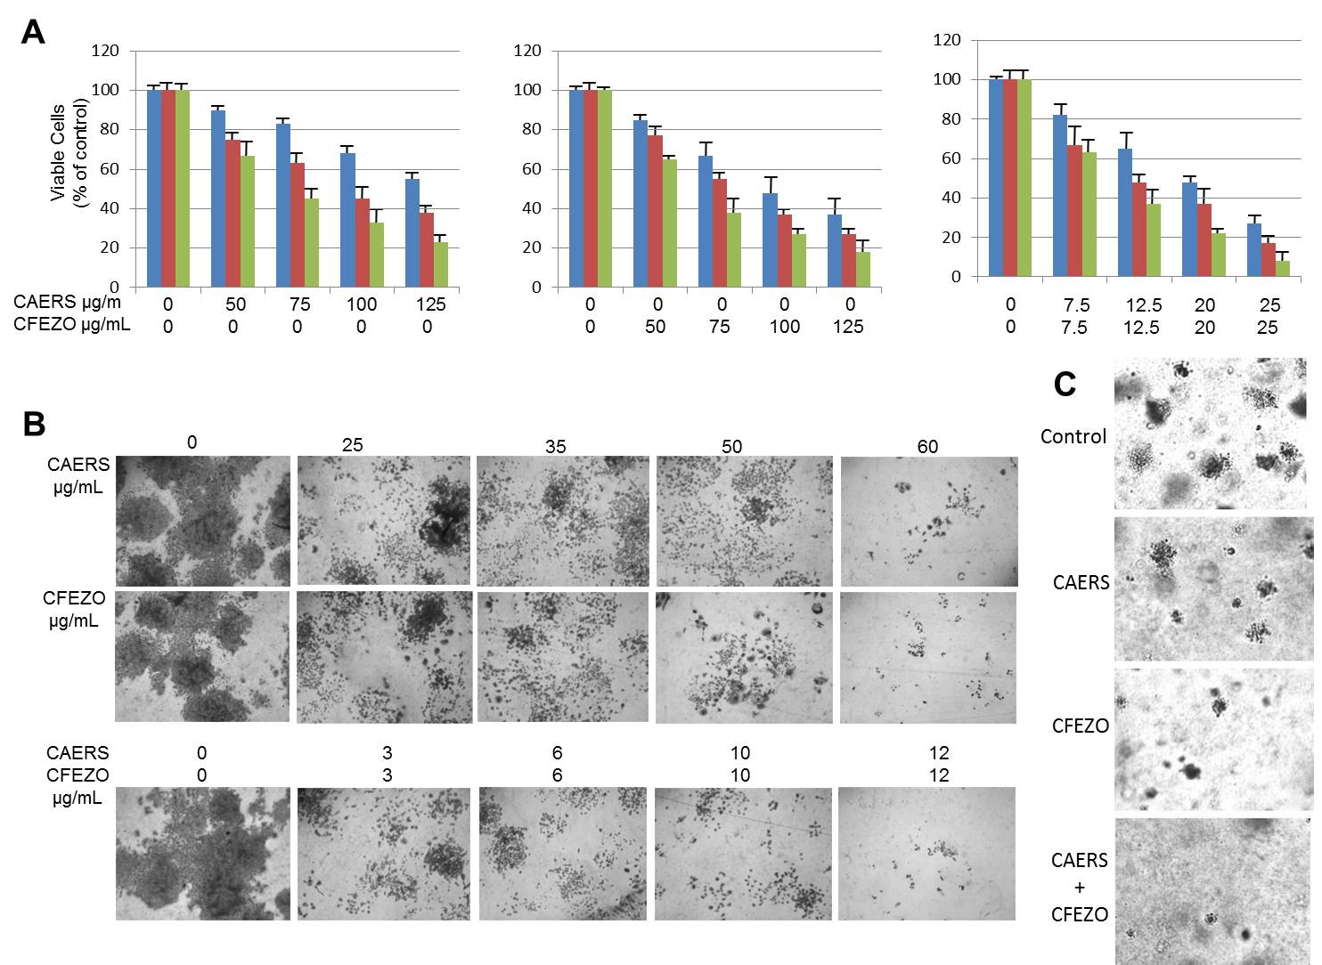

Figure 2
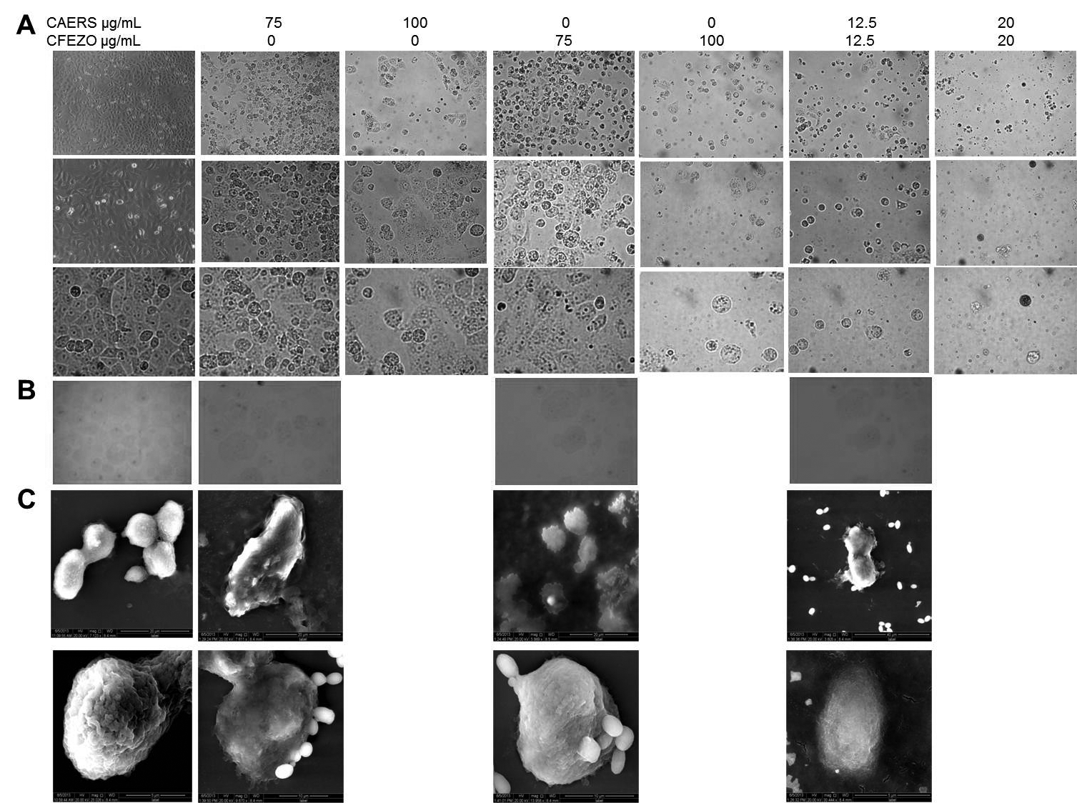

Figure 3
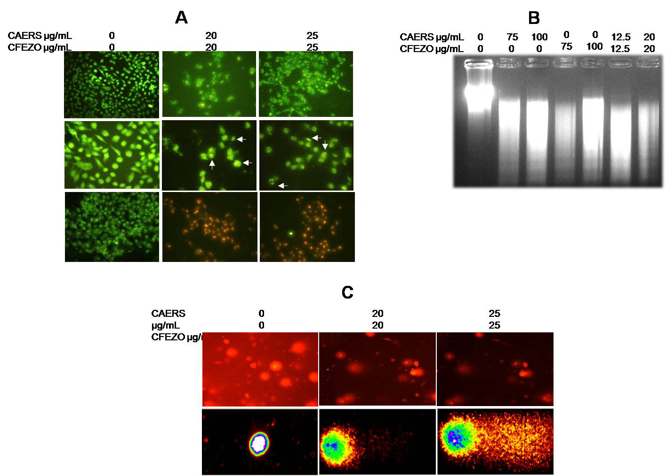

Figure 4
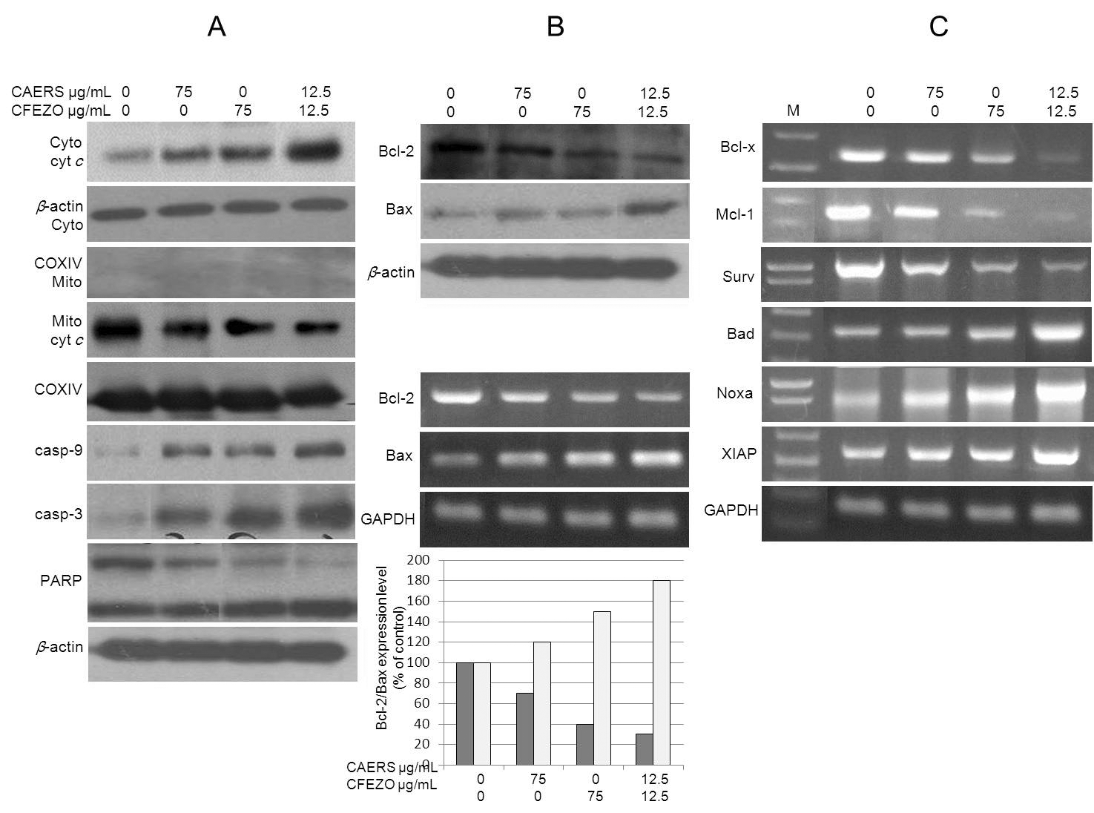

Figure 5
