Name of Journal: World Journal of Clinical Oncology
Manuscript NO: 31650
Manuscript Type: Case Report

Intimal sarcoma of the pulmonary artery with multiple lung metastases: Long-term survival case

García-Cabezas S et al. Long-term survival case of metastatic PAIS

Sonia García-Cabezas, Macarena Centeno-Haro, Simona Espejo-Pérez, Elvira Carmona-Asenjo, Alberto L Moreno-Vega, Rosa Ortega-Salas, Amalia Palacios-Eito

Sonia García-Cabezas, Amalia Palacios-Eito, Department of Radiation Oncology, Reina Sofia University Hospital, 14004 Cordoba, Spain

Macarena Centeno-Haro, Rosa Ortega-Salas, Department of Pathological Anatomy, Reina Sofia University Hospital, 14004 Cordoba, Spain

Simona Espejo-Pérez, Department of Radiology, Reina Sofia University Hospital, 14004 Cordoba, Spain

Elvira Carmona-Asenjo, Department of Nuclear Medicine, Reina Sofia University Hospital, 14004 Cordoba, Spain

Alberto L Moreno-Vega, Department of Medical Oncology, Reina Sofia University Hospital, 14004 Cordoba, Spain

Author contributions: All authors contributed to the acquisition of patient’s clinical data, writing, and revision of this manuscript.

Institutional review board statement: This publication has been approved by the Institutional Review Board.

Informed consent statement: The patient provided informed written consent prior to publication.

Conflict-of-interest statement: All authors declare that there are no conflicts of interest.

Open-Access: This article is an open-access article which was selected by an in-house editor and fully peer-reviewed by external reviewers. It is distributed in accordance with the Creative Commons Attribution Non Commercial (CC BY-NC 4.0) license, which permits others to distribute, remix, adapt, build upon this work non-commercially, and license their derivative works on different terms, provided the original work is properly cited and the use is non-commercial. See: http://creativecommons.org/licenses/by-nc/4.0/

Manuscript source: Invited manuscript

Correspondence to: Amalia Palacios-Eito, PhD, Department of Radiation Oncology, Reina Sofia University Hospital, Avda. Menéndez Pidal, s/n, 14004 Cordoba, Spain. amalia.palacios.sspa@juntadeandalucia.es
Telephone: +34-957-011415
Fax: +34-957-011414

Received: November 30, 2016
Peer-review started: December 1, 2016
First decision: February 17, 2017
Revised: June 12, 2017
Accepted: July 21, 2017
Article in press:
Published online:
Abstract
Pulmonary artery intimal sarcoma (PAIS) is a rare tumor with a very poor prognosis. Clinical and radiological findings usually mimic thromboembolic disease, leading to diagnostic delays. The treatment of choice is surgery, and adjuvant chemotherapy and radiotherapy have limited results. We report the case of a 48-year-old male patient, initially suspected with pulmonary thromboembolism. The angio-CT revealed a filling defect in the pulmonary artery trunk. The patient underwent surgery, resulting in with complete resection of the mass with a diagnosis of PAIS. The tumor progressed rapidly in the lung, requiring surgery of multiple lung metastases. The patient was treated with stereotactic body radiation therapy (SBRT) on two occasions for new pulmonary lesions. In the last follow-up (4 years after initial diagnosis), the patient was disease-free. In conclusion, SBRT proved to be an alternative treatment to metastasectomy, allowing palliative chemotherapy to be delayed or omitted, which may result in improved quality of life.

Key words: Intimal sarcoma of the pulmonary artery; Lung metastases; Treatment; Metastasectomy; Stereotactic body radiation therapy

© The Author(s) 2017. Published by Baishideng Publishing Group Inc. All rights reserved.

Core tip: Intimal sarcoma of the pulmonary artery is a rare tumor with a very poor prognosis. It has been described in a limited number of reports. This case is a uncommon patient with long-term survival despite having rapid metastatic progression, who maintains a complete remission after initial surgical treatment, completed after occurrence of progression with stereotaxic body radiotherapy.

García-Cabezas S, Centeno-Haro M, Espejo-Pérez S, Carmona-Asenjo E, Moreno-Vega AL, Ortega-Salas R, Palacios-Eito A. Intimal sarcoma of the pulmonary artery with multiple lung metastases: Long-term survival case. World J Clin Oncol 2017; In press

INTRODUCTION
Pulmonary artery intimal sarcoma (PAIS) is a rare tumor first described by Mandelstamm in 1923^{[1]}. Since then, about 300 cases have been reported in the literature^{[2,3]}. The prognosis is generally poor, with a median overall survival of approximately 17 mo^{[2-4]}. Clinical and radiological findings usually mimic thromboembolic disease, leading to diagnostic delays^{[5]}. Surgical resection of the primary tumor is the best therapeutic option to prolong survival and adjuvant chemotherapy and radiotherapy have limited results^{[2,3]}. The treatment of choice is surgery, as adjuvant chemotherapy and radiotherapy have limited results. When metastases occur, they may be resected in specific patients^{[6,7]}. Otherwise, treatment is generally systemic and palliative in nature. In recent years, stereotactic body radiation therapy (SBRT) for lung metastases, a high-precision external radiotherapy technique, alternative to metastasectomy, has undergone significant development. Prospective phase I/II studies have shown that SBRT is safe and effective as treatment of lung metastases in oligometastatic patients who are not candidates for surgery^{[8,9]}. SBRT of inoperable lung metastases is today considered routine in many centers. We report the case of a rapidly metastatic PAIS, with sustained complete remission following surgical resection and SBRT.

CASE REPORT
A 48-year-old male patient presenting with sudden-onset symptoms of sweating, dizziness and falling to the ground, with loss of consciousness, and spontaneous recovery. After observing electrocardiographic changes, he was hospitalized with suspected acute coronary syndrome. An angio-CT was performed, resulting in a diagnosis of pulmonary thromboembolism, with no improvement after anticoagulant therapy. The patient was transferred to our hospital, where a repeat angio-CT was performed, revealing a filling defect in the pulmonary artery trunk, extending from the subvalvular area to the origin of the right pulmonary artery, with no change in size with respect to the previous angio-CT (Figure 1). The patient was operated on for a suspected primary tumor of the pulmonary artery, resulting in with complete resection of the mass, whose pathological result was an intermediate-grade malignant tumor suggestive of PAIS (Figure 2). Following an extension study, CT showed only a nonspecific pulmonary nodule of 4 mm in diameter in the right upper lobe. No adjuvant treatment was given. Three months later, a positron emission tomography-computed tomography (PET-CT) found that the previously mentioned nodule measured 6 mm, suggestive of metastasis. Another 4 mm de novo nodule was found and two more of 2-3 mm in size, possibly granulomas, all without an increase in metabolic activity. The patient underwent surgery where 4 bilateral pulmonary lesions, compatible with metastasis, were resected. Fifteen month later, a new PET-CT reveals a subpleural nodule in the left upper lobe, again suspicious of metastasis (Figure 3A), as well as several millimeter-size nodules reported in the previous CT, not metabolically characterizable. After discussion in a multidisciplinary committee, the patient was given treatment with SBRT (12 Gy × 5 fractions), with excellent control. Six months later, growth of the two new pulmonary lesions noted in the previous CT was observed (Figures 3B and C). Chemotherapy was prescribed, which was rejected by the patient, and a second course of SBRT was given on both pulmonary lesions. Nine months after SBRT, the patient is disease-free by PET-CT.

DISCUSSION
PAIS is characterized by insidious growth, causing extensive local invasion and hematogeneous metastases. Because it is a rare tumor, only case reports and small case series have been published, most of them focused on the histopathological findings and surgical aspects of its management^{[3,4,10-12]}. Few patients achieve long-term survival and they are those without disease dissemination. The largest analysis of outcomes of this tumor reported better median survival of patients who received multimodality treatment with respect those who had single treatment (median survival of 24.7 and 8.0 mo, respectively). However, single treatment was defined as either surgery, chemotherapy or radiotherapy alone, instead of surgery without postoperative treatment^{[2]}. Mussot et al^{[3]} described a surgical series of 31 patients. They concluded that there appeared to be no statistical survival benefit in those who received adjuvant treatment compared to those who did not. A recent study^{[4]} analyzed 20 patients diagnosed with PAIS obtaining a median overall survival of 17 mo: patients who received postoperative chemo and radiotherapy showed a trend towards better survival compared to those who had surgery alone (24 mo vs 8 mo, P = 0.3417). Successful cases reported in metastatic patients are anecdotal. Thus, Said et al^{[13]} reported a case of pulmonary artery angiosarcoma, with a follow-up of 5 years and multiple repeat lung metastasectomies, which has a disease-free interval of 1 year. Choi et al^{[14]} published a case of PAIS with metastases in the thyroid and adrenal glands, 4.7 and 6.3 years, respectively, after initial surgery. Both metastases were surgically resected, with an unusual survival of 12.5 years up to the last follow-up. In our case, dissemination occurred much earlier, as the patient was operated on for lung metastases 5 mo after the initial surgery, though it is likely that patient was already metastatic at diagnosis. He is currently disease-free, 4 years after diagnosis. To our knowledge, this is the first published case of metastatic PAIS with long-term survival treated with surgery and SBRT.
In conclusion, SBRT proved to be an alternative treatment to metastasectomy, allowing palliative chemotherapy to be delayed or omitted, which may result in improved quality of life.

COMMENTS
Case characteristics
A 48-year-old male presenting sudden-onset symptoms of sweating, dizziness and fall, with momentary loss of consciousness.

Clinical diagnosis
Acute coronary syndrome.

Differential diagnosis
Thromboembolic disease.

Imaging diagnosis
Angio-CT: Filling defect in the pulmonary artery trunk, extending from the subvalvular area to the origin of the right pulmonary artery.

Pathological diagnosis
Intermediate-grade malignant tumor suggestive of pulmonary artery intimal sarcoma.

Treatment
The patient underwent surgery. The tumor progressed rapidly in the lung, requiring surgery of multiple lung metastases. Finally, he was treated with stereotactic body radiation therapy on two occasions for new pulmonary lesions.

Experiences and lessons
This case report describes a uncommon patient with exceptional long-term survival despite having rapid metastatic progression. This case teaches us that SBRT is an alternative treatment to metastasectomy, allowing palliative chemotherapy to be delayed or omitted.

Peer-review
The article presents an unusual case of intimal sarcoma of the pulmonary artery. There are a small number of cases reported. This is a rare sarcoma with very good response to treatment with radiotherapy.

REFERENCES
- Mandelstamm M. Über primäre Neubildungen des Herzens. Virchows Arch Pathol Anat 1923; 245: 43-54
- Blackmon SH, Rice DC, Correa AM, Mehran R, Putnam JB, Smythe WR, Walkes JC, Walsh GL, Moran C, Singh H, Vaporciyan AA, Reardon M. Management of primary pulmonary artery sarcomas. Ann Thorac Surg 2009; 87: 977-984 [PMID: 19231448 DOI: 10.1016/j.athoracsur.2008.08.018]
- Mussot S, Ghigna MR, Mercier O, Fabre D, Fadel E, Le Cesne A, Simonneau G, Dartevelle P. Retrospective institutional study of 31 patients treated for pulmonary artery sarcoma. Eur J Cardiothorac Surg 2013; 43: 787-793 [PMID: 22843511 DOI: 10.1093/ejcts/ezs387]
- Wong HH, Gounaris I, McCormack A, Berman M, Davidson D, Horan G, Pepke-Zaba J, Jenkins D, Earl HM, Hatcher HM. Presentation and management of pulmonary artery sarcoma. Clin Sarcoma Res 2015; 5: 3 [PMID: 25628857 DOI: 10.1186/s13569-014-0019-2]
- Jiang S, Li J, Zeng Q, Liang J. Pulmonary artery intimal sarcoma misdiagnosed as pulmonary embolism: A case report. Oncol Lett 2017; 13: 2713-2716 [PMID: 28454456 DOI: 10.3892/ol.2017.5775]
- Digesu CS, Wiesel O, Vaporciyan AA, Colson YL. Management of Sarcoma Metastases to the Lung. Surg Oncol Clin N Am 2016; 25: 721-733 [PMID: 27591495 DOI: 10.1016/j.soc.2016.05.005]
- Chudgar NP, Brennan MF, Munhoz RR, Bucciarelli PR, Tan KS, D'Angelo SP, Bains MS, Bott M, Huang J, Park BJ, Rusch VW, Adusumilli PS, Tap WD, Singer S, Jones DR. Pulmonary metastasectomy with therapeutic intent for soft-tissue sarcoma. J Thorac Cardiovasc Surg 2017; 154: 319-330.e1 [PMID: 28395901 DOI: 10.1016/j.jtcvs.2017.02.061]
- Okunieff P, Petersen AL, Philip A, Milano MT, Katz AW, Boros L, Schell MC. Stereotactic Body Radiation Therapy (SBRT) for lung metastases. Acta Oncol 2006; 45: 808-817 [PMID: 16982544 DOI: 10.1080/02841860600908954]
- Rusthoven KE, Kavanagh BD, Burri SH, Chen C, Cardenes H, Chidel MA, Pugh TJ, Kane M, Gaspar LE, Schefter TE. Multi-institutional phase I/II trial of stereotactic body radiation therapy for lung metastases. J Clin Oncol 2009; 27: 1579-1584 [PMID: 19255320 DOI: 10.1200/JCO.2008.19.6386]
- Grazioli V, Vistarini N, Morsolini M, Klersy C, Orlandoni G, Dore R, D'Armini AM. Surgical treatment of primary pulmonary artery sarcoma. J Thorac Cardiovasc Surg 2014; 148: 113-118 [PMID: 24075471 DOI: 10.1016/j.jtcvs.2013.07.054]
- Huo L, Moran CA, Fuller GN, Gladish G, Suster S. Pulmonary artery sarcoma: a clinicopathologic and immunohistochemical study of 12 cases. Am J Clin Pathol 2006; 125: 419-424 [PMID: 16613346]
- Tavora F, Miettinen M, Fanburg-Smith J, Franks TJ, Burke A. Pulmonary artery sarcoma: a histologic and follow-up study with emphasis on a subset of low-grade myofibroblastic sarcomas with a good long-term follow-up. Am J Surg Pathol 2008; 32: 1751-1761 [PMID: 18779732 DOI: 10.1097/PAS.0b013e31817d7fd0]
- Said SM, Sundt TM 3rd, Garces YI, Wigle DA. 5-year survival after multiple repeat metastasectomy for pulmonary artery angiosarcoma. Ann Thorac Surg 2011; 91: e49-e51 [PMID: 21440106 DOI: 10.1016/j.athoracsur.2010.11.020]
- Choi YM, Jang EK, Ahn SH, Jeon MJ, Han JM, Kim SC, Han DJ, Gong G, Kim TY, Shong YK, Kim WB. Long-term survival of a patient with pulmonary artery intimal sarcoma after sequential metastasectomies of the thyroid and adrenal glands. Endocrinol Metab (Seoul) 2013; 28: 46-49 [PMID: 24396650 DOI: 10.3803/EnM.2013.28.1.46]

P-Reviewer: Bramhall S, Cerwenka HR S-Editor: Kong JX L-Editor: E-Editor:

Specialty type: Oncology
Country of origin: Spain
Peer-review report classification
Grade A (Excellent): 0
Grade B (Very good): 0
Grade C (Good): C, C
Grade D (Fair): 0
Grade E (Poor): 0

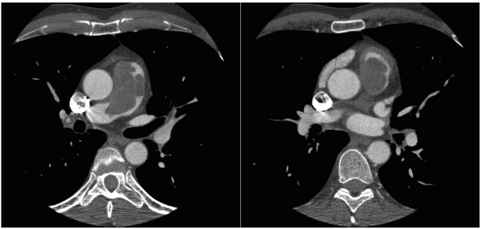
Figure 1 Angio-CT: Filling defect in pulmonary artery trunk measuring 58 mm × 32 mm × 44 mm, extending from the subvalvular area to the origin of the right pulmonary artery.
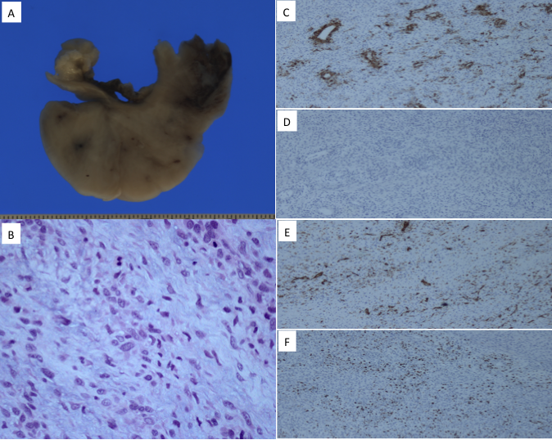
Figure 2 The patient was operated on for a suspected primary tumor of the pulmonary artery, resulting in with complete resection of the mass, whose pathological result was an intermediate-grade malignant tumor suggestive of Pulmonary artery intimal sarcoma. A: Macro: View of the pulmonary artery transversal section with infiltrating sarcoma on the lumen; B: High power of the tumor. Note the variable atypia 200 ×. Immunohistochemical stainings 100 ×; C: Smooth muscle actin: Focal tumor cell reaction 100 ×; D: Desmine: Negative 100 ×; E: CD31: Reaction of the endothelium surrounded by negative tumor cells 100 ×; F: Ki-67: Variable proliferation index in tumor cells 100 ×.

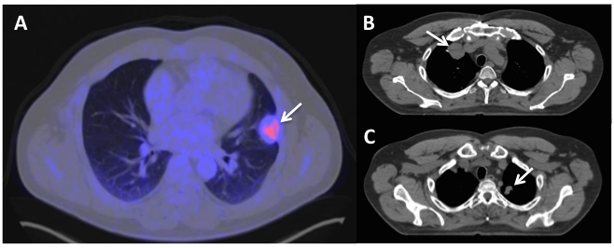
Figure 3 Positron emission tomography–computed tomography, three months later. A: Subpleural hypermetabolic nodular lesion in left upper lobe (SUV max 3.8) measuring 27 mm × 30 mm, suggestive of tumor activity; B, C: computed tomography, a 38-mm nodule in right upper lobe and another 20-mm nodule in left upper lobe, compatible with metastasis.

