Name of Journal: World Journal of Gastroenterology
Manuscript NO: 88575
Manuscript Type: ORIGINAL ARTICLE

Basic Study
Exosome-mediated transfer of circRNA563 promoting hepatocellular carcinoma by targeting the microRNA148a-3p/metal-regulatory transcription factor-1 pathway

Lyu ZZ et al. Exosome-mediated transfer of circRNA563 promoting HCC

Zhuo-Zhen Lyu, Meng Li, Ming-Yu Yang, Mei-Hong Han, Zhen Yang

Zhuo-Zhen Lyu, Meng Li, Ming-Yu Yang, Mei-Hong Han, Zhen Yang, Department of Infectious Diseases, Shandong Provincial Hospital Affiliated to Shandong First Medical University, Jinan 250021, Shandong Province, China

Author contributions: Yang Z designed and coordinated the study, and wrote the manuscript; Lyu ZZ, Li M, Yang MY, and Han MH performed the experiments; Lyu ZZ, Li M, Han MH, and Yang Z acquired and analyzed the data; Lyu ZZ, Han MH, and Yang Z interpreted the data; and all authors approved the final version of the article.

Supported by the National Natural Science Foundation of China, No. 81972606 and 82271774.

Corresponding author: Zhen Yang, MD, PhD, Doctor, Professor, Department of Infectious Diseases, Shandong Provincial Hospital Affiliated to Shandong First Medical University, No. 324 Jingwu Road, Jinan 250021, Shandong Province, China. yangzhen@sdfmu.edu.cn

Received: September 29, 2023
Revised: October 24, 2023
Accepted: November 17, 2023
Published online: December 14, 2023

Abstract
BACKGROUND
Mesenchymal stem cells (MSCs) exert anti-oncogenic effects via exosomes containing non-coding RNA (ncRNA), which play important roles in tumor biology. Our preliminary study identified the interaction of the ncRNA hsa_circ_0000563 (circ563) and the circ563-associated miR-148a-3p in exosomes, as miR-148a-3p and its target metal-regulatory transcription factor-1 (MTF-1) are implicated in hepatocellular carcinoma (HCC) progression.

AIM
To identify the clinical significance, functional implications, and mechanisms of circ563 in HCC.

METHODS
The expression levels of miR-148a-3p and MTF-1 in exosomes derived from MSC and HCC cells were compared, and their effects on HCC cells were assessed. Using a dual-luciferase reporter assay, miR-148a-3p was identified as an associated microRNA of circ563, whose role in HCC regulation was assessed in vitro and in vivo.

RESULTS
The silencing of circ563 blocked the HCC cell proliferation and invasion and induced apoptosis. Co-culturing of HCC cells with MSC-derived exosomes following circ563 overexpression promoted cell proliferation and metastasis and elicited changes in miR-148a-3p and MTF-1 expression. The tumor-promoting effects of circ563 were partially suppressed by miR-148a-3p overexpression or MTF-1 depletion. Xenograft experiments performed in nude mice confirmed that circ563-enriched exosomes facilitated tumor growth by upregulating the expression of MTF-1. In HCC tissues, circ563 expression was negatively correlated with miR-148a-3p expression but positively correlated with MTF-1 levels.

CONCLUSION
MSCs may exhibit anti-HCC activity through the exosomal circ563/miR-148a-3p/MTF-1 pathway, while exosomes can transmit circ563 to promote oncogenic behavior by competitively binding to miR-148a-3p to activate MTF-1.

Key Words: Exosome; Cell communication; Noncoding RNA; Metal-regulatory transcription factor-1; Mesenchymal stem cells

©The Author(s) 2023. Published by Baishideng Publishing Group Inc. All rights reserved.

Citation: Lyu ZZ, Li M, Yang MY, Han MH, Yang Z. Exosome-mediated transfer of circRNA563 promoting hepatocellular carcinoma by targeting the microRNA148a-3p/metal-regulatory transcription factor-1 pathway. World J Gastroenterol 2023; 29(46): 6060-6075
URL: https://www.wjgnet.com/1007-9327/full/v29/i46/6060.htm
DOI: https://dx.doi.org/10.3748/wjg.v29.i46.6060

Core Tip: We identified the functional implications and mechanisms of exosomal hsa_circ_0000563 (circ563) in hepatocellular carcinoma (HCC). Mesenchymal stem cells suppressed HCC proliferation and invasion via their exosomes. The circ563 interacts with miR-148a-3p, a molecule involved in HCC progression, and both are identified at different levels in exosomes. The tumor-promoting effects of circ563 were partially suppressed by miR-148a-3p overexpression or depletion of metal-regulatory transcription factor-1 (MTF-1). Xenograft experiments performed in nude mice confirmed that circ563-enriched exosomes facilitated tumor growth via MTF-1 upregulation. Our findings provide new insights into circ563/miR-148a-3p/MTF-1 signaling as a potential therapeutic target for HCC.
INTRODUCTION
Hepatocellular carcinoma (HCC) is a fatal disease and the most common form of primary liver cancer. Although novel chemotherapeutic agents and treatment modalities have been clinically implemented, the survival rate of patients with HCC has not yet improved^{[1]}. Therefore, a deeper understanding of the mechanisms facilitating HCC progression is paramount for the development of more effective therapeutic strategies.
The tumor microenvironment (TME) has been an important aspect of tumor research. Recent studies indicate that mesenchymal stem cells (MSCs) are essential stromal cells in the TME and exert their effects via exosomes, as demonstrated by multiple studies^{[2,3]}. Furthermore, the efficacy of therapeutic MSC transplantation has been reported in both experimental and clinical research^{[4-6]}. As a result, MSC-derived exosomes have attracted significant attention due to their implications in intercellular communication.
Exosomes are small extracellular vesicles approximately 30-150 nm in diameter that are formed by cells through a series of regulatory processes. These vesicles are enriched in bioactive molecules like non-coding RNA (ncRNA) with crucial biological functions, whose delivery to recipient cells is involved in various physiological and pathological processes, including carcinogenesis and metastasis^{[7,8]}. Circular RNA (circRNA) is a new class of endogenous ncRNA, which has selectively conserved microRNA (miRNA) target sites and exerts regulatory effects in cancer biology by regulating miRNA gene expression^{[9,10]}. Such interactions between circRNA and miRNA are known as the competitive endogenous RNA theory^{[11]}. miRNAs represent the ncRNA of 20-25 nucleotides, which mediate post-transcriptional gene silencing by binding to the 3’-untranslated regions of target mRNAs. Exosomal circRNA and miRNA are involved in tumor initiation and progression^{[7,8,12,13]}; however, their expression profiles, functions, and dysregulation in HCC require further clarification.
This study found that MSCs suppressed HCC proliferation and invasion via their exosomes. The ncRNA circ563 interacts with miR-148a-3p, and both are identified at different levels in exosomes. Metal-regulatory transcription factor-1 (MTF-1) as the direct target of miR-148a-3p is implicated in HCC progression. Therefore, further studies should be performed to determine the possible role and significance of circ563/miR-148a-3p/MTF-1 axis in the development of HCC.

MATERIALS AND METHODS
Cell lines and culture
The human HCC cell lines Hep3B (RRID: CVCL_0326, iCell Bioscience, Shanghai, China) and SNU387 (RRID: CVCL_0250, Procell, Wuhan, China), MSC (Procell, Wuhan, China), and the human embryonic kidney cell line HEK 293T (RRID: CVCL_0045, Cell Research, Shanghai, China) were cultured according to the manufacturer’s instructions. The cell lines used in this study were authenticated, and no cellular cross-contamination or mycoplasma infection was detected.

Isolation and characterization of exosomes
The exosomes were isolated as previously described^{[14]}, and their morphology was observed under a transmission electron microscope. The size distribution of exosomes was analyzed using the NanoSight LM10 system (NanoSight, Amesbury, United Kingdom) equipped with fast video capture and particle-tracking software.

Exosome internalization assay
MSCs were modified to express fused CD63-eGFP via lentiviral transduction following the manufacturer’s instructions. The HCC cells were seeded on glass coverslips coated with poly-L-lysine (Sigma, Shanghai, China). MSC-derived exosomes were co-cultured with HCC cells for 24 h at 37 °C before washing and fixation at room temperature. The uptake of labeled exosomes by recipient cells was observed under a fluorescence microscope (Leica TCS SP8 X, Leica, Shanghai, China).

Western blotting
Exosomes were harvested for protein extraction. Equal amounts of protein were subjected to sodium dodecyl-sulfate polyacrylamide gel electrophoresis and then electroblotted onto a polyvinylidene difluoride membrane (Merck, Nantong, Jiangsu, China) followed by western immunoblotting. Membranes were incubated with primary antibodies overnight at 4 °C, followed by incubation with horseradish peroxidase-conjugated secondary antibody (ZSGB-BIO, Beijing, China). The bands were visualized using a Tanon 5200 Chemiluminescent imaging system (Molecular Devices, Beijing, China) and analyzed using ImageJ software (version 1.52, National Institutes of Health, Bethesda, United States). The following primary antibodies were used: Anti-TSG101, anti-CD9, and anti-CD81 (Abcam, Shanghai, China).

Real-time polymerase chain reaction
Total RNA was extracted using the Ultrapure RNA Kit (CoWin Biotech, Beijing, China) according to the manufacturer’s protocol. Equal amounts of the samples were amplified, and real-time polymerase chain reaction (RT-PCR) was performed as previously described^{[14]}. The following primer pairs were used: MiR-148a-3p, forward: 5’-CTCAGTGCACTACAGAACTTTGT-3’, reverse: 5’-ATCCAGTGCAGGGTCCGAGG-3’; MTF-1, forward: 5’-GAAAAGCCATTTCGGTGCGA-3’, reverse: 5’-CAGCCATTACTGGGGCAGAA-3’ (DingGuo Biotechnology, Beijing, China); hsa_circRNA_0000562 (circ562), forward: 5’-TTTAGTACACAGCATGGCTCA-3’, reverse: 5’-ATTAGCACCCATTTTCTTCAGT-3’; hsa_circRNA_0000563 (circ563), forward: 5’-TTGGAATTTAACATGCTTGC-3’, reverse: 5’-GCATTAGCACCCATTTTCTT-3’; hsa_circRNA_00001110 (circ1110), forward: 5’-TCACTTGGGTTCATTCTATTCA-3’, reverse: 5’-GCTTGTCTTTTCTTCTGTTTCC-3’; U6, forward: 5’-GCTCGCTTCGGCAGCACA-3’, reverse: 5’-GAACGCTTCACGAATTTGCGTG-3’; glyceraldehyde-3-phosphate dehydrogenase (GAPDH), forward: 5’-AGAAGGCTGGGGCTCATTTG-3’, reverse: 5’-AGGGGCCATCCACAGTCTTC-3’; and actin, forward: 5’-CCCTATAAAACCCAGCGGCG-3’, reverse: 5’-TCGTCGCCCACATAGGAATC-3’ (Tsingke Biotechnology, Qingdao, China). Data were analyzed using the comparative CT method, and the 2^{-ΔΔCt} method showed the difference between treatment and control conditions.

Transfection assay
Overexpression plasmids of miR-148a-3p, knockdown plasmids of MTF-1, and control empty vectors were obtained from GenePharma (Shanghai, China). Small interfering RNA targeting circ562 (sense: 5’-GGCUCAGCAAAAUGGAUGAAAdTdT-3’; antisense: 5’-UUUCAUCCAUUUUGCUGAGCCdTdT-3’), circ563 (sense: 5’-GCUUGCACAAGAAAUGGAUGAdTdT-3’; antisense: 5’-UCAUCCAUUUCUUGUGCAAGCdTdT-3’), and circ1110 (sense: 5’-GGUUCAUUCUAUUCAGUGACUdTdT-3’; antisense: 5’-AGUCACUGAAUAGAAUGAACCdTdT-3’) were synthesized by Hippobio (Zhejiang, China). The cells with stable overexpression of miR-148a-3p (5’-UCAGUGCACUACAGAACUUUGU-3’) or circ563 or with stable knockdown of MTF-1 (5’-GCGGTACCAATGTACCTTTGA-3’) were transfected with lentiviral vectors for in vitro and in vivo studies. The cells in 6-well plates were transfected using Lipofectamine 2000 (Invitrogen, Shanghai, China), according to the manufacturer’s instructions.

Cell viability assay
Cell viability was determined using the 3-(4,5-dimethylthiazol-2-yl)-2,5-diphenyltetrazolium bromide (MTT) assay. The cells were seeded into 96-well plates (approximately 1500 cells/well) before treatment. At the end of each treatment, the MTT reagent was added to the medium. The cells were incubated for an additional 4 h, and the absorbance of the samples was measured at 490 nm using a plate reader (Thermo Fisher Scientific, MA, United States). Experiments were performed in triplicate, and data were expressed as the mean optical density ± SD.

Colony formation assay
The cells (approximately 1000 cells/well) were seeded into six-well plates with different treatments, either simultaneously or subsequently. After 14 d, the cells were fixed with 4% paraformaldehyde and stained with 0.5% crystal violet, and the individual clones (> 50 cells/clone) were counted. Each treatment was performed in triplicate. Data were expressed as the mean ± SD.

Transwell assays
Transwell assays were performed to assess cell invasion and migration abilities in 24-well plates with BD chambers (8-mm pores; BD Biosciences, Shanghai, China). Approximately 1 × 10⁵ cells/well were seeded into the upper chambers and cultured in a serum-free medium. The medium containing 30% serum was placed in the lower chambers. After migration through the Transwell membrane, the cells were fixed with 4% paraformaldehyde and stained with crystal violet (Solarbio, Beijing, China). Compared with the invasion assay, the Transwell chambers for the migration assay were not coated with Matrigel. All Transwell treatments were conducted in triplicate.

Flow cytometry
Following different treatments, cell apoptosis was detected using the phycoerythrin (PE) Annexin V Apoptosis Detection Kit I (BD Pharmingen, China) according to the manufacturer’s instructions. The cells were harvested after trypsin digestion, centrifuged, and washed with annexin V binding buffer three times. The cells were then stained with PE annexin V and 7-amino-actinomycin D at room temperature for 15 min and analyzed using flow cytometry (BD FACSAria II, Shanghai, China), and the results were analyzed using FlowJo software (version 10; Ashland, OR, United States).

Luciferase reporter assay
A wild-type (wt) or mutant circ563 fragment was constructed and cloned into plasmids containing luciferase. The recombinant circ563-wt/mt plasmids were co-transfected into HEK 293T cells with either a negative control or a miR-148a-3p mimic using Lipofectamine 2000 (Invitrogen Inc., CA, United States). After 48 h, the luciferase activity was measured using the Dual-Luciferase Reporter 1000 Assay System (Promega, Madison, WI, United States). The firefly luciferase enzyme activity was normalized to the Renilla luciferase activity, and the ratio of firefly to Renilla luciferase activity was evaluated. The experiments were independently performed in triplicate.

Patients and specimens
Human HCC tissues and paired tumor-adjacent noncancerous liver tissues were obtained from 14 patients with HCC who underwent tumor resection at the Shandong Provincial Hospital, China. None of the patients had undergone radio- or chemotherapy before surgery. Informed consent was obtained from each participant and approved by the Institutional Review Board. The study was approved by the Institutional Medical Ethics Committee of Shandong Provincial Hospital. Patients aged ≥ 18 years and diagnosed with HCC without any local or systemic treatment were included in the study. By contrast, patients with other types of cancers, liver failure, and taking medications that affect liver function were excluded.

HCC tumor-xenograft mouse model
The animal study was approved by the Animal Ethics Committee of Shandong Provincial Hospital. The animal protocol was designed to minimize pain or discomfort during the experiments. The animals were acclimatized to laboratory conditions (23 °C, 12 h/12 h light/dark, 50% humidity, ad libitum access to food and water) for 2 wk before experimentation. Five-week-old BALB/c nude mice (Provincial Laboratory Animal Center, Jinan, China) were used for this study. Following different treatments, the Hep3B cells were prepared at 3 × 10⁶ cells/100 μL. Initially, the HCC-bearing nude mice were prepared to develop subcutaneous tumors. After four weeks, circ563-enriched exosomes (approximately 10⁶) were injected intratumorally into the tumor mass twice a week for two weeks. The tumor size was measured weekly, and the tumor volume was calculated using the following formula: Volume (mm³) = tumor length × width²/2. After six weeks, all mice were sacrificed to compare the tumor volumes and weights. The tumors were fixed in 10% formalin and embedded in paraffin for subsequent immunohistochemical examination.

Immunohistochemistry and scoring
The sections were stained with an anti-MTF-1 sary antibody (Zhongshan Biotechnology Co., Beijing, China). The slides were imaged and analyzed using Aipathwell software (Servicebio, Wuhan, China). The staining intensity was characterized as not present (0), weak but detectable above control (1), moderate (2), and very strong (3). The H-scores were calculated as follows: H-score = ∑(pi × i) = (percentage of weak intensity cells × 1) + (percentage of moderate intensity cells × 2) + (percentage of strong intensity cells × 3). Data were presented as the mean ± SD.

Statistical analysis
Statistical analyses were performed using SPSS 21.0 software. Data were presented in bar plots as the mean ± SD of at least three independent experiments. A P value of < 0.05 (two-tailed) was considered significant. Student’s t-test was performed to determine whether the two groups were significantly different. Pearson’s correlation analysis was used to assess the correlations between circ563, miR-148a-3p, and MTF-1.

RESULTS
MSCs and MSC-derived exosomes exhibiting tumor-suppressive effects on HCC with corresponding changes in miR-148a-3p and MTF-1 levels
HCC cell proliferation was inhibited by co-culturing with MSCs, which was consistent with the reduced cell viability, migration, and invasion observed under these conditions (Figures 1A-G and Supplementary Figures 1A-G). However, as shown in Figure 1H and Supplementary Figure 1H, apoptosis was induced in HCC cells. To further verify the regulatory role of MSC-derived exosomes in HCC, the exosomes were isolated and characterized by specific marker expression (Figure 1I) and particle size analysis (Figure 1J). In addition, we observed and verified the uptake of labeled exosomes in HCC cells (Figure 1K and Supplementary Figure 1I). MSC-derived exosomes also exerted substantial anti-oncogenic effects in HCC cells by blocking cell proliferation, migration, and invasion while inducing apoptosis (Figures 1L-S and Supplementary Figures 1J-Q). Therefore, MSCs inhibit HCC proliferation and metastasis via their exosomes.
A previous study from our laboratory demonstrated that exosomal miR-148a-3p functions as a tumor suppressor in HCC progression, with MTF-1 being its direct target^{[14]}. In the present study, MSC-derived exosomes displayed increased miR-148a-3p and decreased MTF-1 expression levels compared with HCC-derived exosomes (Figure 1T and Supplementary Figure 1R). Co-culturing HCC cells with either MSCs or MSC-derived exosomes led to the corresponding changes in miR-148a-3p and MTF-1 expression levels (Figure 1U and Supplementary Figure 1S). This finding indicates that exosomes contain bioactive materials involved in the regulation of miR-148a-3p and MTF-1 expression in HCC cells.

Characterization of circ563 and its expression in clinical HCC
A search of the CircInteractome databases (https://circinteractome.nia.nih.gov/) yielded three potential circRNAs [circ563, hsa_circRNA_0000562 (circ562), and hsa_circRNA_00001110 (circ1110)] that are most likely to bind to miR-148a-3p based on potential complementary sequences. Further analysis was performed using dual-luciferase reporter assays and RT-PCR. The RT-PCR analyses showed that circRNA was positively correlated with MTF-1 but negatively correlated with miR-148a-3p (Figure 2A). The overexpression of miR-148a-3p considerably inhibited the luciferase activity of circ563-wt. However, the luciferase activity of circ563-mutant-type (mt) cells transfected with miR-148a-3p mimics remained unaffected, thus indicating that miR-148a-3p is a target miRNA of circ563 (Figure 2B). Subsequently, knockdown experiments were performed to investigate whether circ563 affects the biological processes of HCC cells. si-circ563 was transfected into Hep3B and SNU387 cells, both strongly expressing circ563, and the knockdown efficiency was determined by RT-PCR (Figure 2C and Supplementary Figure 2A). Exosomal circ563 (exo-circ563) expression levels were also compared with those of MSCs (Figure 2D and Supplementary Figure 2B). Silencing of circ563 expression blocked the proliferation and invasion of HCC cells and increased their apoptosis rate (Figures 2E-I and Supplementary Figures 2C-G).
Next, circ563 expression was analyzed in human HCC tissues, which showed higher circ563 levels with downregulated miR-148a-3p and upregulated MTF-1 expression levels compared with tumor-adjacent tissues (Figures 3A-C). Correlation analyses further revealed the relationships between circ563, miR-148a-3p, and MTF-1 levels in HCC (Figures 3D-F). These findings suggest that circ563 may be involved in potentiating HCC cell growth and metastasis, considering the observed correlation with miR-148a-3p and MTF-1.

Exo-circ563 potentiating HCC progression by sequestering miR-148a-3p that regulates MTF-1
To further explore whether exo-circ563 exerts an oncogenic role, we suppressed the expression of circ563 in HCC cells and detected a reduction in exo-circ563 levels using RT-PCR (Figure 4A). The HCC cells co-treated with exosomes containing downregulated circ563 levels led to a marked reduction in cell proliferation and invasion and enhanced apoptosis (Figures 4B-I and Supplementary Figures 3A-H).
Consistent with previous results, exo-circ563 overexpression facilitated HCC cell progression. The exo-circ563 overexpression efficiency and upregulation were ascertained through RT-PCR (Figures 4J and K). We co-cultured HCC cells with MSC-derived exosomes following the circ563 overexpression and observed an increase in HCC cell proliferation and metastasis and a suppression of apoptosis (Figures 4L-S and Supplementary Figures 3I-P). These effects were partially prevented by the overexpression of miR-148a-3p or depletion of MTF-1 (Figure 5 and Supplementary Figure 4). These data indicate the involvement of a circ563-dependent mechanism in regulating miR-148a-3p expression as described by the competitive endogenous RNA theory.

circ563 accelerating HCC tumorigenesis in vivo
To further confirm the significance of exo-circ563 in HCC tumorigenesis and progression, in vivo experiments were performed. The upregulation of circ563 dramatically accelerated tumor growth in nude mice as evidenced by the detection of larger tumors. This effect could be reversed by miR-148a-3p overexpression or MTF-1 depletion (Figures 6A-C). Therefore, the effects of circ563, by facilitating HCC progression via miR-148a-3p and MTF-1 regulation, were also present in vivo. Correspondingly, the expression of MTF-1 in murine tumor tissues had changed similarly to tumor growth (Figures 6D and E). All these results show that circ563 accelerates HCC progression by sponging miR-148a-3p to elicit MTF-1-dependent oncogenic effects via the circ563/miR-148a-3p/MTF-1 axis (Figure 7).

DISCUSSION
Liver cancer remains a global health challenge, and its incidence is expected to reach over 1 million cases by 2025^{[15]}. HCC is the most common primary liver cancer. It is characterized by aggressive progression, broad metastasis, frequent recurrence, and high mortality. Therefore, a better understanding of the processes involved in HCC tumorigenesis and metastasis is urgently needed to discover new treatment strategies and improve patient prognosis.
Recent studies have established a comprehensive role of TME in disease development, making it one of the most promising areas of oncological research^{[16,17]}. Moreover, HCC cells can alter their surrounding microenvironment to promote their growth and metastasis^{[18,19]}. The crosstalk between tumor cells and their microenvironment is important for MSC recruitment to HCC tissues, which has also been observed in HCC animal models^{[19,20]}. Although MSCs were initially considered as oncological delivery vehicles due to their migratory and homing capacity toward tumors^{[21]}, increasing evidence suggests that they can modulate tumorigenesis via the exosomes^{[2,3]}. In the present study, co-incubation with MSCs inhibited the proliferation and invasion of HCC cells but enhanced their apoptotic capabilities. Further investigation on the mediating role of MSC-derived exosomes in the regulation of HCC cells also led to the discovery of their anti-oncogenic potential by blocking the development of HCC cells. Based on our findings, an exosome-based adjuvant intervention could offer a novel therapeutic approach to HCC by delivering the protected “cargo” directly to the tumor site.
In addition, the exosomes from MSCs have shown tumor-homing capabilities in xenograft mouse models^{[22]}. The uptake of labeled exosomes from MSCs into HCC cells was also reported in the present study. Interestingly, the exosome function most likely depends on the biological materials they encapsulate^{[23,24]}. Mounting evidence suggests that exosomal ncRNAs (miRNA, lncRNA, and circRNA) are actively involved in the initiation and progression of various diseases by regulating cellular proliferation, differentiation, angiogenesis, and immune response^{[25-27]}.
circRNAs, a subset of ncRNA that is enriched and more stable in exosomes^{[28]}, were differentially expressed in tumor tissues than in normal tissues, suggesting their involvement in tumorigenesis and disease development^{[29]}. In vitro and in vivo experiments revealed that circRNA commonly sponges miRNA, a major class of small ncRNA closely associated with HCC^{[30,31]}, and mediates post-transcriptional gene silencing by binding to the 3’-untranslated region or open reading frames of target mRNA. Previously, our data revealed that exosomal miR-148a-3p functions as a tumor suppressor in HCC with MTF-1 as its direct target. MTF-1 maintains metal homeostasis to protect cells against injury by excess metals and exerts oncogenic potential by manipulating metal or redox homeostasis, enhancing angiogenesis, and inducing tumor development in HCC. The current findings confirmed an increase in miR-148a-3p and a decrease in MTF-1 expression levels in MSC-derived exosomes compared with HCC-derived exosomes. Following HCC cell co-culture with MSC or MSC-derived exosomes, consistent changes were observed in the miR-148a-3p and MTF-1 expression levels. This finding indicates that exosomes may contain specific bioactive materials involved in regulating the expression of miR-148a-3p and MTF-1.
Considering this, we searched the CircInteractome databases and identified hsa_circ_0000563 (circ563) as the specific target that competitively binds to or sponges miR-148a-3p. Circ563 has been implicated in the changes in the pathogenesis of atherosclerosis with significantly lower expression in patients with coronary artery disease than in those assigned as controls. However, the significance and mechanistic function of circ563 in carcinoma, especially in HCC, are yet to be studied^{[32]}. In the current study, the loss-of-function of circ563 in HCC alters cell proliferation, invasion, and apoptosis, as well as miR-148a-3p and MTF-1 expression. Elevated levels of circ563 were correlated with more aggressive tumor behavior, highlighting its oncogenic role in HCC, leading to the conclusion that circ563 activation might be a global event during hepatocarcinogenesis. Intracellularly, circ563 competitively binds to miR-148a-3p, resulting in the activation of MTF-1 in a pattern opposite to that of miR-148a-3p alone. In addition, circ563 enrichment was identified in HCC-derived exosomes with the corresponding changes in the levels of miR-148a-3p and MTF-1. This observation suggests that: (1) Circ563 originating from cells can be delivered by exosomes into the peripheral circulation and recipient cells; and (2) Circ563 affects cell function and accelerates HCC development, given its possible correlation with miR-148a-3p and MTF-1 expression.
Furthermore, rescue experiments demonstrated that the potentiating effects of exo-circ563 could be partially blocked by miR-148a-3p upregulation or MTF-1 knockdown. The oncogenic role of circ563 was verified in vivo, as exosomes enriched with circ563 facilitated HCC cell growth in nude mice. Additionally, we assessed the expression patterns of circ563, miR-148a-3p, and MTF-1 in HCC tissues and compared them with those in tumor-adjacent tissues; the trends were consistent with those in HCC cells and exosomes. Collectively, the relative stability, high abundance, and conserved nature of exosomal circRNA across species make them promising candidates as oncogenic biomarkers; a better understanding of the exo-circ563-mediated intercellular network could facilitate the development of therapeutic strategies for patients with HCC.

CONCLUSION
We clarified the regulatory mechanisms of circ563, which can sponge miR-148a-3p to elicit MTF-1-dependent oncogenic effects, eventually acting as a tumor-potentiating factor in HCC. Thus, the ncRNA circ563 could be a promising therapeutic target, and liquid biopsy of serum exosomes targeting circ563 can help diagnose HCC and predict the prognosis of affected patients.

ARTICLE HIGHLIGHTS
Research background
Mesenchymal stem cells (MSCs) exert anti-oncogenic effects via exosomes containing non-coding RNA (ncRNA), and the efficacy of MSC-derived exosome therapies has been demonstrated. Our preliminary study identified the interaction of the ncRNA hsa_circ_0000563 (circ563) and the circ563-associated miR-148a-3p which are both enclosed in exosomes, as miR-148a-3p and its target metal-regulatory transcription factor-1 (MTF-1) are implicated in hepatocellular carcinoma (HCC) progression.

Research motivation
This study is to identify the clinical significance, functional implications, and mechanisms of circ563 in HCC.

Research objectives
This study aims to investigate the role of circ563 in modulating HCC functions.

Research methods
The expression levels of miR-148a-3p and MTF-1 in exosomes derived from MSC and HCC cells were compared, and their effects on HCC cells were assessed. Using a dual-luciferase reporter assay, miR-148a-3p was identified as an associated miRNA of circ563, whose role in HCC regulation was assessed in vitro and in vivo.

Research results
Circ563 silencing blocked the HCC cell proliferation and invasion and induced apoptosis. Co-culturing of HCC cells with MSC-derived exosomes following circ563 overexpression contributed to cell proliferation and metastasis and elicited changes in miR-148a-3p and MTF-1 expression. The tumor-promoting effects of circ563 were partially suppressed by miR-148a-3p overexpression or MTF-1 depletion. Xenograft experiments confirmed that circ563-enriched exosomes facilitated tumor growth by upregulating the expression of MTF-1. In HCC tissues, circ563 expression was negatively correlated with miR-148a-3p expression but positively correlated with MTF-1 levels.

Research conclusions
Our findings suggested MSCs may exhibit anti-HCC activity through the exosomal circ563/miR-148a-3p/MTF-1 pathway.

Research perspectives
The study presents a new dataset related to HCC. We clarified the regulatory mechanisms of circ563, which can sponge miR-148a-3p to elicit MTF-1-dependent oncogenic effects in HCC. Thus, the ncRNA circ563 could be a potential therapeutic target, and liquid biopsy of serum exosomes targeting circ563 may help predict the prognosis of patients with HCC.

REFERENCES
1 Ingle PV, Samsudin SZ, Chan PQ, Ng MK, Heng LX, Yap SC, Chai AS, Wong AS. Development and novel therapeutics in hepatocellular carcinoma: a review. Ther Clin Risk Manag 2016; 12: 445-455 [PMID: 27042086 DOI: 10.2147/TCRM.S92377]
2 Atiya H, Frisbie L, Pressimone C, Coffman L. Mesenchymal Stem Cells in the Tumor Microenvironment. Adv Exp Med Biol 2020; 1234: 31-42 [PMID: 32040853 DOI: 10.1007/978-3-030-37184-5_3]
3 Li H, Li F. Exosomes from BM-MSCs increase the population of CSCs via transfer of miR-142-3p. Br J Cancer 2018; 119: 744-755 [PMID: 30220706 DOI: 10.1038/s41416-018-0254-z]
4 Lou G, Chen Z, Zheng M, Liu Y. Mesenchymal stem cell-derived exosomes as a new therapeutic strategy for liver diseases. Exp Mol Med 2017; 49: e346 [PMID: 28620221 DOI: 10.1038/emm.2017.63]
5 Dabrowska S, Andrzejewska A, Lukomska B, Janowski M. Neuroinflammation as a target for treatment of stroke using mesenchymal stem cells and extracellular vesicles. J Neuroinflammation 2019; 16: 178 [PMID: 31514749 DOI: 10.1186/s12974-019-1571-8]
6 Li A, Guo F, Pan Q, Chen S, Chen J, Liu HF, Pan Q. Mesenchymal Stem Cell Therapy: Hope for Patients With Systemic Lupus Erythematosus. Front Immunol 2021; 12: 728190 [PMID: 34659214 DOI: 10.3389/fimmu.2021.728190]
7 Xu Z, Chen Y, Ma L, Chen Y, Liu J, Guo Y, Yu T, Zhang L, Zhu L, Shu Y. Role of exosomal non-coding RNAs from tumor cells and tumor-associated macrophages in the tumor microenvironment. Mol Ther 2022; 30: 3133-3154 [PMID: 35405312 DOI: 10.1016/j.ymthe.2022.01.046]
8 Lin H, Yu J, Gu X, Ge S, Fan X. Novel insights into exosomal circular RNAs: Redefining intercellular communication in cancer biology. Clin Transl Med 2021; 11: e636 [PMID: 34898043 DOI: 10.1002/ctm2.636]
9 Fan HN, Chen ZY, Chen XY, Chen M, Yi YC, Zhu JS, Zhang J. METTL14-mediated m(6)A modification of circORC5 suppresses gastric cancer progression by regulating miR-30c-2-3p/AKT1S1 axis. Mol Cancer 2022; 21: 51 [PMID: 35164771 DOI: 10.1186/s12943-022-01521-z]
10 Wang Y, Liu J, Ma J, Sun T, Zhou Q, Wang W, Wang G, Wu P, Wang H, Jiang L, Yuan W, Sun Z, Ming L. Exosomal circRNAs: biogenesis, effect and application in human diseases. Mol Cancer 2019; 18: 116 [PMID: 31277663 DOI: 10.1186/s12943-019-1041-z]
11 Li LJ, Zhao W, Tao SS, Leng RX, Fan YG, Pan HF, Ye DQ. Competitive endogenous RNA network: potential implication for systemic lupus erythematosus. Expert Opin Ther Targets 2017; 21: 639-648 [PMID: 28406715 DOI: 10.1080/14728222.2017.1319938]
12 Xie M, Yu T, Jing X, Ma L, Fan Y, Yang F, Ma P, Jiang H, Wu X, Shu Y, Xu T. Exosomal circSHKBP1 promotes gastric cancer progression via regulating the miR-582-3p/HUR/VEGF axis and suppressing HSP90 degradation. Mol Cancer 2020; 19: 112 [PMID: 32600329 DOI: 10.1186/s12943-020-01208-3]
13 Shi L, Zhu W, Huang Y, Zhuo L, Wang S, Chen S, Zhang B, Ke B. Cancer-associated fibroblast-derived exosomal microRNA-20a suppresses the PTEN/PI3K-AKT pathway to promote the progression and chemoresistance of non-small cell lung cancer. Clin Transl Med 2022; 12: e989 [PMID: 35857905 DOI: 10.1002/ctm2.989]
14 Lyu Z, Yang M, Yang T, Ma M, Yang Z. Metal-Regulatory Transcription Factor-1 Targeted by miR-148a-3p Is Implicated in Human Hepatocellular Carcinoma Progression. Front Oncol 2021; 11: 700649 [PMID: 34660270 DOI: 10.3389/fonc.2021.700649]
15 Hepatocellular carcinoma. Nat Rev Dis Primers 2021; 7: 7 [PMID: 33479233 DOI: 10.1038/s41572-021-00245-6]
16 Romano V, Belviso I, Venuta A, Ruocco MR, Masone S, Aliotta F, Fiume G, Montagnani S, Avagliano A, Arcucci A. Influence of Tumor Microenvironment and Fibroblast Population Plasticity on Melanoma Growth, Therapy Resistance and Immunoescape. Int J Mol Sci 2021; 22 [PMID: 34067929 DOI: 10.3390/ijms22105283]
17 Ruocco MR, Lamberti A, Serrano MJ, Fiume G, Arcucci A. Editorial: Tumor Microenvironment and Cancer Cell Interactions in Solid Tumor Growth and Therapy Resistance. Front Cell Dev Biol 2022; 10: 896194 [PMID: 35465328 DOI: 10.3389/fcell.2022.896194]
18 Urtasun R, Latasa MU, Demartis MI, Balzani S, Goñi S, Garcia-Irigoyen O, Elizalde M, Azcona M, Pascale RM, Feo F, Bioulac-Sage P, Balabaud C, Muntané J, Prieto J, Berasain C, Avila MA. Connective tissue growth factor autocriny in human hepatocellular carcinoma: oncogenic role and regulation by epidermal growth factor receptor/yes-associated protein-mediated activation. Hepatology 2011; 54: 2149-2158 [PMID: 21800344 DOI: 10.1002/hep.24587]
19 Bayo J, Marrodán M, Aquino JB, Silva M, García MG, Mazzolini G. The therapeutic potential of bone marrow-derived mesenchymal stromal cells on hepatocellular carcinoma. Liver Int 2014; 34: 330-342 [PMID: 24112437 DOI: 10.1111/liv.12338]
20 Niess H, Bao Q, Conrad C, Zischek C, Notohamiprodjo M, Schwab F, Schwarz B, Huss R, Jauch KW, Nelson PJ, Bruns CJ. Selective targeting of genetically engineered mesenchymal stem cells to tumor stroma microenvironments using tissue-specific suicide gene expression suppresses growth of hepatocellular carcinoma. Ann Surg 2011; 254: 767-74; discussion 774-5 [PMID: 22042469 DOI: 10.1097/SLA.0b013e3182368c4f]
21 Studeny M, Marini FC, Dembinski JL, Zompetta C, Cabreira-Hansen M, Bekele BN, Champlin RE, Andreeff M. Mesenchymal stem cells: potential precursors for tumor stroma and targeted-delivery vehicles for anticancer agents. J Natl Cancer Inst 2004; 96: 1593-1603 [PMID: 15523088 DOI: 10.1093/jnci/djh299]
22 Zhou Y, Zhou W, Chen X, Wang Q, Li C, Chen Q, Zhang Y, Lu Y, Ding X, Jiang C. Bone marrow mesenchymal stem cells-derived exosomes for penetrating and targeted chemotherapy of pancreatic cancer. Acta Pharm Sin B 2020; 10: 1563-1575 [PMID: 32963950 DOI: 10.1016/j.apsb.2019.11.013]
23 Jeppesen DK, Fenix AM, Franklin JL, Higginbotham JN, Zhang Q, Zimmerman LJ, Liebler DC, Ping J, Liu Q, Evans R, Fissell WH, Patton JG, Rome LH, Burnette DT, Coffey RJ. Reassessment of Exosome Composition. Cell 2019; 177: 428-445.e18 [PMID: 30951670 DOI: 10.1016/j.cell.2019.02.029]
24 Liu Y, Gu Y, Cao X. The exosomes in tumor immunity. Oncoimmunology 2015; 4: e1027472 [PMID: 26405598 DOI: 10.1080/2162402X.2015.1027472]
25 Couzin J. Cell biology: The ins and outs of exosomes. Science 2005; 308: 1862-1863 [PMID: 15976285 DOI: 10.1126/science.308.5730.1862]
26 Ni YQ, Lin X, Zhan JK, Liu YS. Roles and Functions of Exosomal Non-coding RNAs in Vascular Aging. Aging Dis 2020; 11: 164-178 [PMID: 32010490 DOI: 10.14336/AD.2019.0402]
27 Dolati S, Shakouri SK, Dolatkhah N, Yousefi M, Jadidi-Niaragh F, Sanaie S. The role of exosomal non-coding RNAs in aging-related diseases. Biofactors 2021; 47: 292-310 [PMID: 33621363 DOI: 10.1002/biof.1715]
28 Bao C, Lyu D, Huang S. Circular RNA expands its territory. Mol Cell Oncol 2016; 3: e1084443 [PMID: 27308606 DOI: 10.1080/23723556.2015.1084443]
29 Li C, Ni YQ, Xu H, Xiang QY, Zhao Y, Zhan JK, He JY, Li S, Liu YS. Roles and mechanisms of exosomal non-coding RNAs in human health and diseases. Signal Transduct Target Ther 2021; 6: 383 [PMID: 34753929 DOI: 10.1038/s41392-021-00779-x]
30 Fang T, Lv H, Lv G, Li T, Wang C, Han Q, Yu L, Su B, Guo L, Huang S, Cao D, Tang L, Tang S, Wu M, Yang W, Wang H. Tumor-derived exosomal miR-1247-3p induces cancer-associated fibroblast activation to foster lung metastasis of liver cancer. Nat Commun 2018; 9: 191 [PMID: 29335551 DOI: 10.1038/s41467-017-02583-0]
31 Lin XJ, Fang JH, Yang XJ, Zhang C, Yuan Y, Zheng L, Zhuang SM. Hepatocellular Carcinoma Cell-Secreted Exosomal MicroRNA-210 Promotes Angiogenesis In Vitro and In Vivo. Mol Ther Nucleic Acids 2018; 11: 243-252 [PMID: 29858059 DOI: 10.1016/j.omtn.2018.02.014]
32 Zhou H, Gan X, He S, Wang Y, Zhang S, Chen J, Zhou Y, Hou C, Hua L, Zhang Q, Jia E. Identification of circular RNA BTBD7_hsa_circ_0000563 as a novel biomarker for coronary artery disease and the functional discovery of BTBD7_hsa_circ_0000563 based on peripheral blood mononuclear cells: a case control study. Clin Proteomics 2022; 19: 37 [PMID: 36329387 DOI: 10.1186/s12014-022-09374-w]

Footnotes
Institutional review board statement: The study was conducted in accordance with the Declaration of Helsinki and approved by the Institutional Medical Ethics Committee of Shandong Provincial Hospital (protocol code NSFC: NO.2019-012; date of approval: 02/19/2019).

Institutional animal care and use committee statement: The animal study was approved by the Animal Ethics Committee of Shandong Provincial Hospital (protocol code NSFC: NO.2019-021; approval date: 02/19/2019).

Conflict-of-interest statement: All the authors report no relevant conflicts of interest for this article.

Data sharing statement: The datasets used and/or analyzed during the present study are available from the corresponding author upon reasonable request.

ARRIVE guidelines statement: The authors have read the ARRIVE guidelines, and the manuscript was prepared and revised according to the ARRIVE guidelines.

Open-Access: This article is an open-access article that was selected by an in-house editor and fully peer-reviewed by external reviewers. It is distributed in accordance with the Creative Commons Attribution NonCommercial (CC BY-NC 4.0) license, which permits others to distribute, remix, adapt, build upon this work non-commercially, and license their derivative works on different terms, provided the original work is properly cited and the use is non-commercial. See: https://creativecommons.org/Licenses/by-nc/4.0/

Provenance and peer review: Unsolicited article; Externally peer reviewed.
Peer-review model: Single blind

Peer-review started: September 29, 2023
First decision: October 16, 2023
Article in press: November 17, 2023

Specialty type: Gastroenterology and hepatology
Country/Territory of origin: China
Peer-review report’s scientific quality classification
Grade A (Excellent): 0
Grade B (Very good): B
Grade C (Good): C
Grade D (Fair): 0
Grade E (Poor): 0

P-Reviewer: Jeyaraman M, India; Shalaby MN, Egypt S-Editor: Wang JJ L-Editor: A P-Editor: Xu ZH

Figure Legends
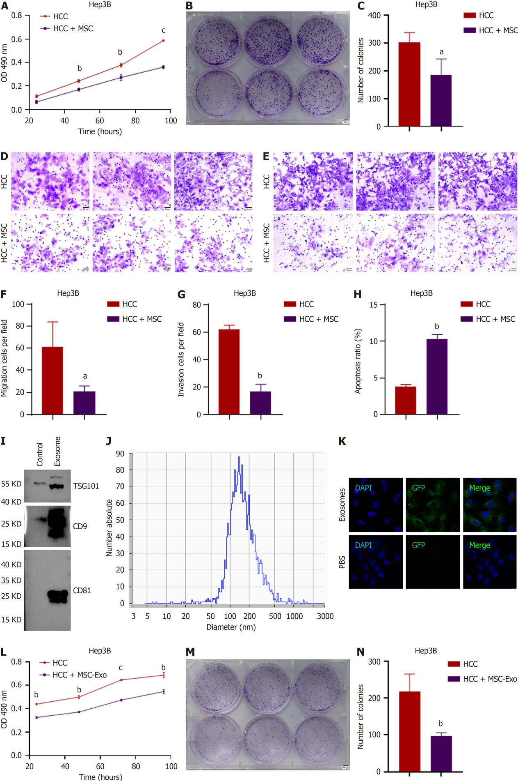
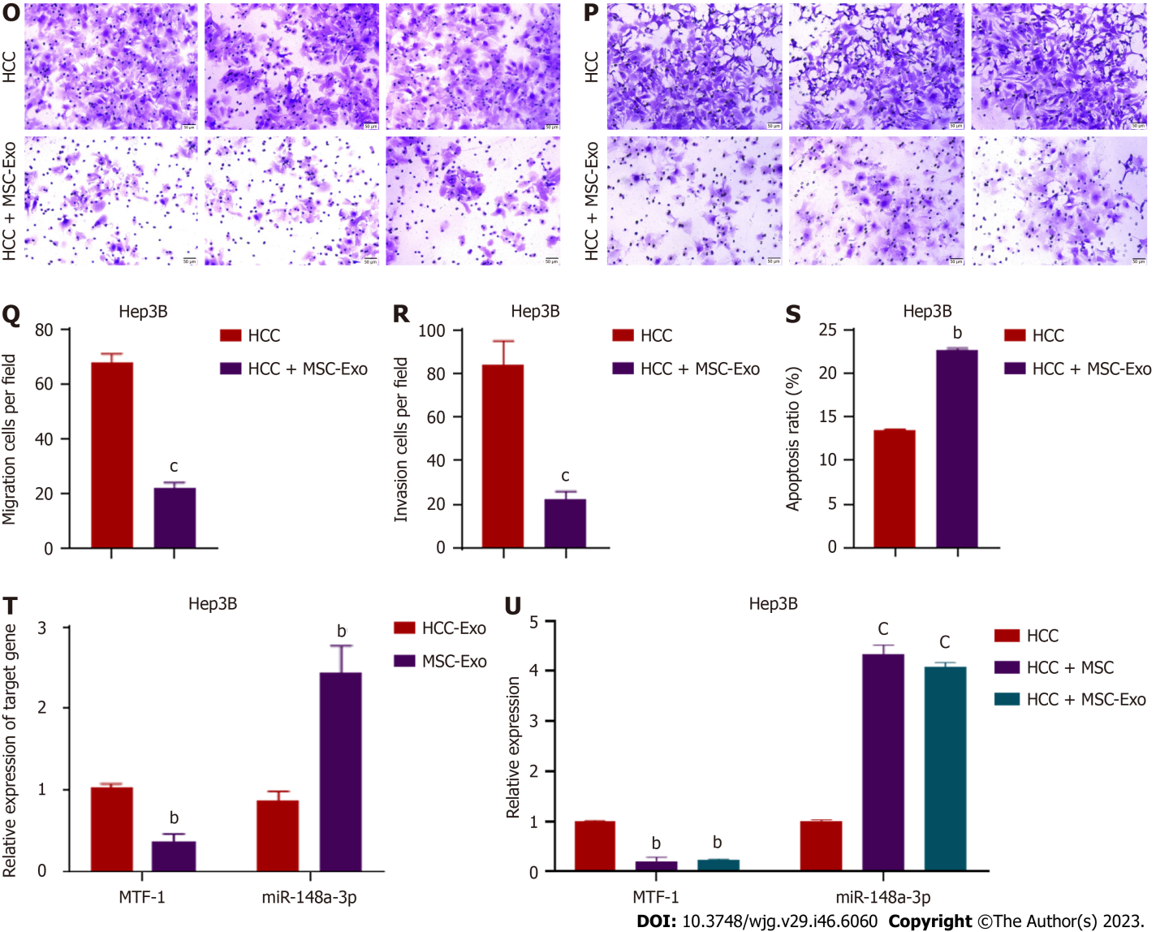
Figure 1 Effects of mesenchymal stem cells or mesenchymal stem cell-derived exosome co-incubation on Hep3B cells. A-C: The proliferation of Hep3B cells was measured using 3-(4, 5-dimethylthiazol-2-yl)-2, 5-diphenyltetrazolium bromide and colony formation assays; D-G: Invasion and metastasis were determined using the Transwell assay. Scale bar = 500 μm; H: Cell apoptotic rates were detected after co-incubation using flow cytometry; I: Exosomes were isolated, and specific exosome markers were identified using western blotting; J: The particle size analyzer showed that the average diameter of the vesicles was within the diameter range of exosomes; K: The uptake of labeled exosomes was observed and verified; L-S: Hep3B cell viability and metastasis were both suppressed after exposure to mesenchymal stem cell (MSC)-derived exosomes, and apoptosis was enhanced; T: Comparison of miR-148a-3p and metal-regulatory transcription factor-1 (MTF-1) expression levels in MSC- and hepatocellular carcinoma (HCC)-derived exosomes; U: Assessment of miR-148a-3p and MTF-1 expression by real-time polymerase chain reaction in HCC cells co-cultured with MSC and MSC-derived exosomes. Quantitative data from three independent experiments are shown as the mean ± SD (error bars). ªP < 0.05, ^{b}P < 0.01, ^{c}P < 0.001. HCC: Hepatocellular carcinoma; miRNA: MicroRNA; MSC: Mesenchymal stem cell; MTF-1: Metal-regulatory transcription factor-1; PBS: Phosphate buffered saline.

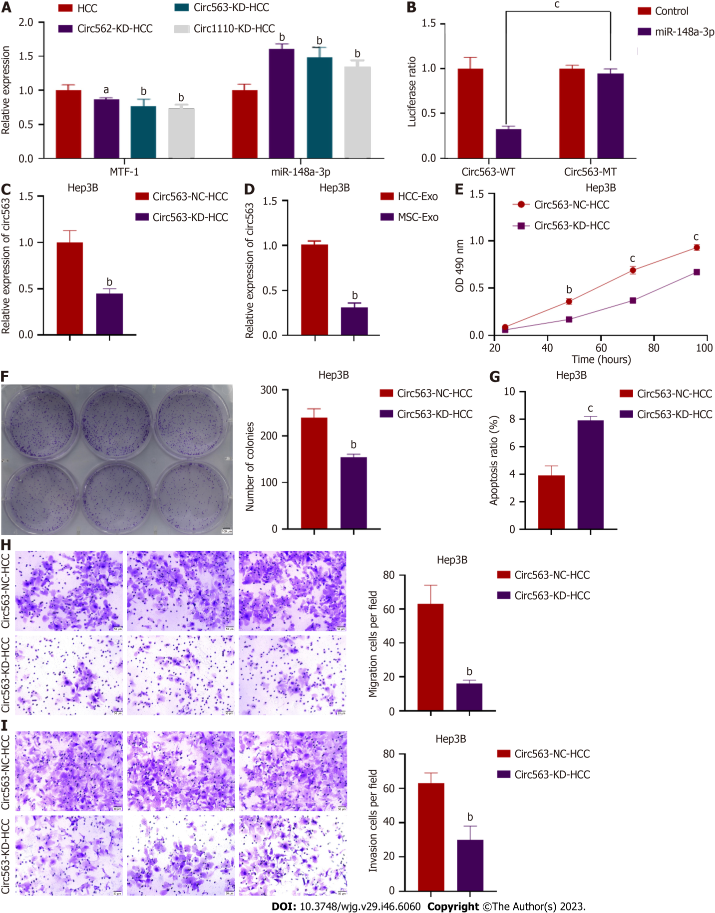
Figure 2 Identification of hsa_circRNA_0000563. A: Three circular RNAs (circRNAs) (circ562, circ563, and circ1110) were predicted to most likely bind to miR-148a-3p, and the miR-148a-3p and metal-regulatory transcription factor-1 (MTF-1) levels in hepatocellular carcinoma (HCC) cells transfected with the predicted circRNA were detected by quantitative real-time polymerase chain reaction (RT-PCR); B: A dual-luciferase reporter assay was performed to confirm the direct binding between circ563 and miR-148a-3p based on their complementary sequences; C: The knockdown efficiency was verified by RT-PCR; D: The expression levels of circ563 in exosomes were assessed by RT-PCR; E and F: 3-(4,5-Dimethylthiazol-2-yl)-2,5-diphenyltetrazolium bromide and colony-forming assay results showed that circ563 silencing suppressed cell proliferation and reduced the number of colonies; G: Knockdown of circ563 enhanced Hep3B cell apoptosis as determined by flow cytometry; H and I: Transwell assays revealed that reducing the levels of circ563 impaired the migratory potential and invasiveness of HCC cells. ªP < 0.05, ^{b}P < 0.01, ^{c}P < 0.001. circRNA: Circular RNA; HCC: Hepatocellular carcinoma; Exo: Exosome.

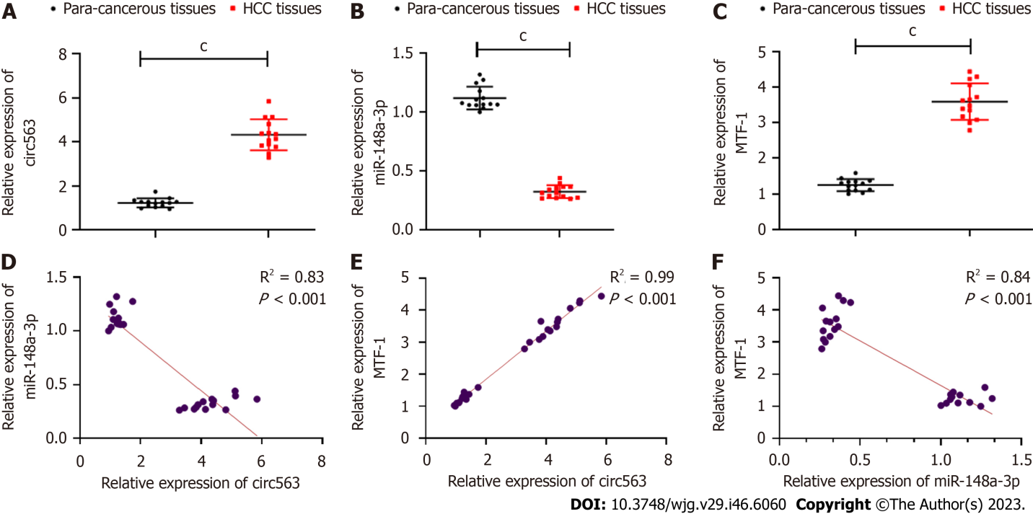
Figure 3 Clinical relevance of circ563 in hepatocellular carcinoma. To further delineate the role of circ563, hepatocellular carcinoma and paired tumor-adjacent tissues were subjected to real-time polymerase chain reaction. A-C: Enhanced circ563 expression in hepatocellular carcinoma (HCC) tissue was detected compared with that in tumor-adjacent tissues, in line with miR-148a-3p downregulation and metal-regulatory transcription factor-1 (MTF-1) upregulation; D-F: Correlation analyses indicated the relationships between circ563, miR-148a-3p, and MTF-1 expression in HCC. ^{c}P < 0.001. circRNA: Circular RNA; HCC: Hepatocellular carcinoma; MTF-1: Metal-regulatory transcription factor-1.

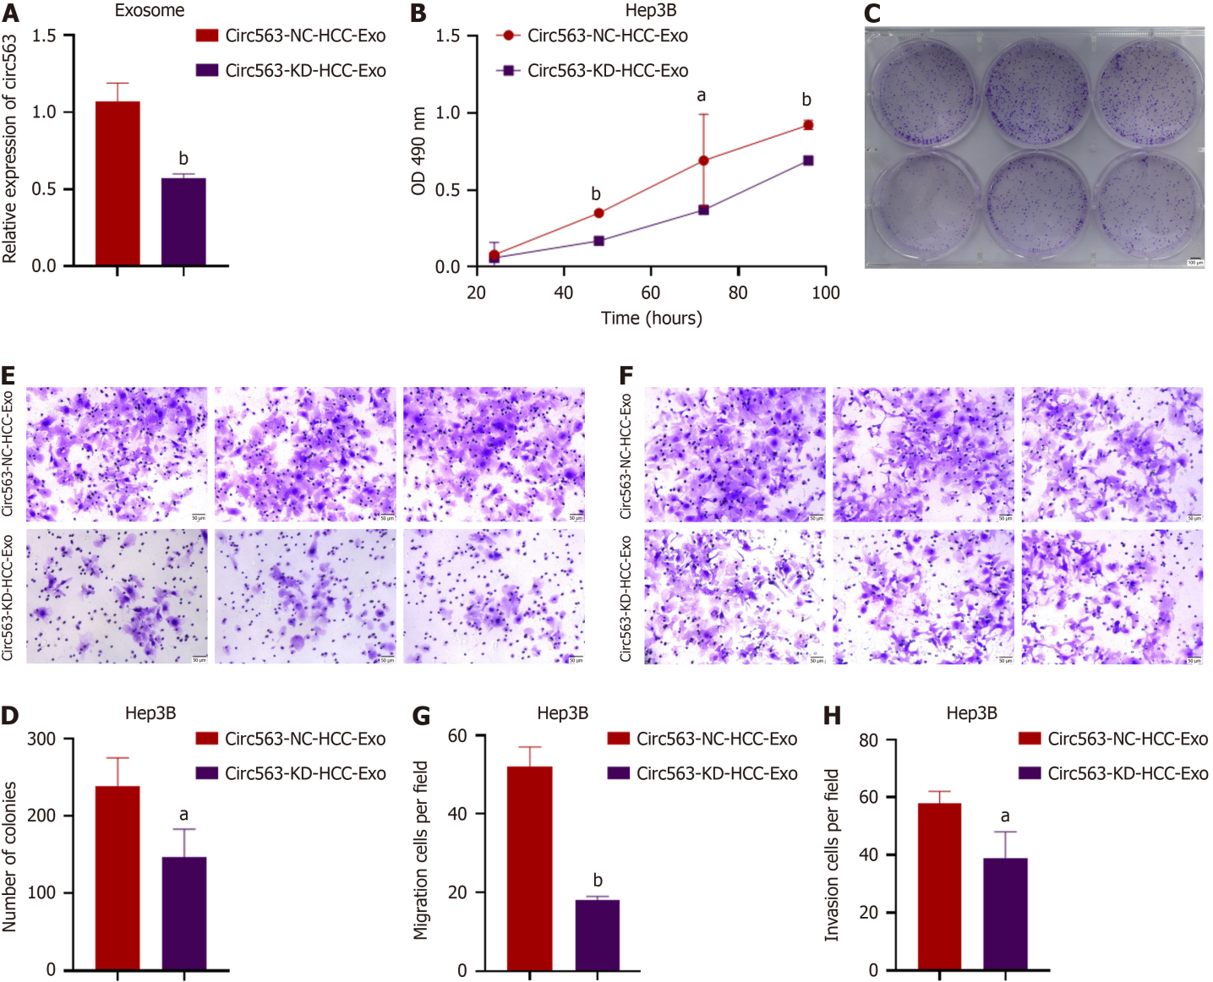
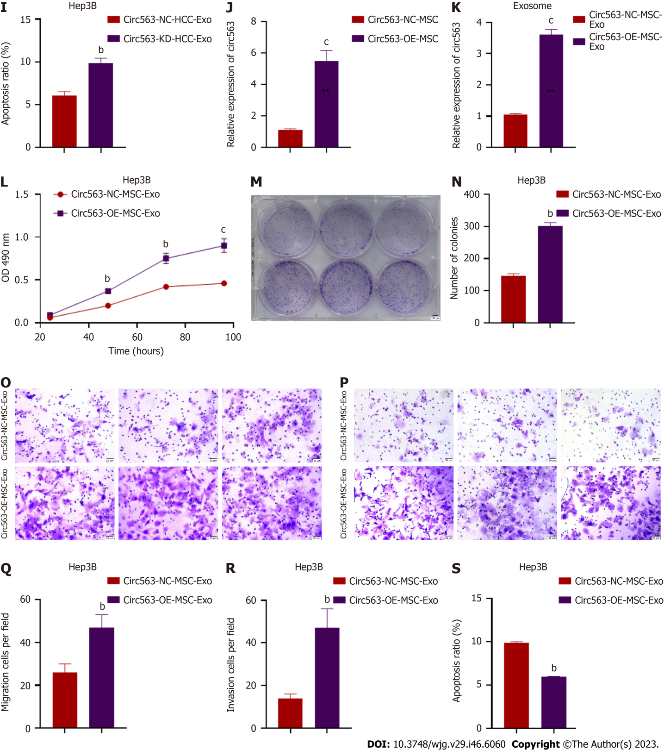
Figure 4 Exosomal circ563 facilitating hepatocellular carcinoma progression. A: First, a knockdown experiment was conducted in Hep3B cells, and the circ563 levels in Hep3B-derived exosomes were quantified by polymerase chain reaction. Hep3B cell function was assessed after co-treatment with exosomes isolated from the culture medium of circ563-knockdown Hep3B cells; B-D: Downregulation of exosomal circ563 (exo-circ563) reduced Hep3B cell proliferation and the number of colonies formed; E-H: Decreased exo-circ563 levels suppressed the migratory activity and invasiveness of the Hep3B cells; I: The downregulation of exo-circ563 was correlated with apoptosis induction; J: The efficiency of circ563 overexpression in the mesenchymal stem cells (MSCs) was determined by quantitative real-time polymerase chain reaction; K: The upregulation of circ563 in MSC-derived exosomes was confirmed; L-R: The hepatocellular carcinoma (HCC) cell proliferation, metastasis, and apoptosis rates were assessed following exosome treatment. Exo-circ563 significantly induced HCC cell proliferation, migration, and invasion; S: Flow cytometry analysis showed that the percentage of apoptotic cells was significantly decreased. ªP < 0.05, ^{b}P < 0.01, ^{c}P < 0.001. exo-circ563: Exosomal circ563; HCC: Hepatocellular carcinoma; MSC: Mesenchymal stem cell; Exo: Exosome.

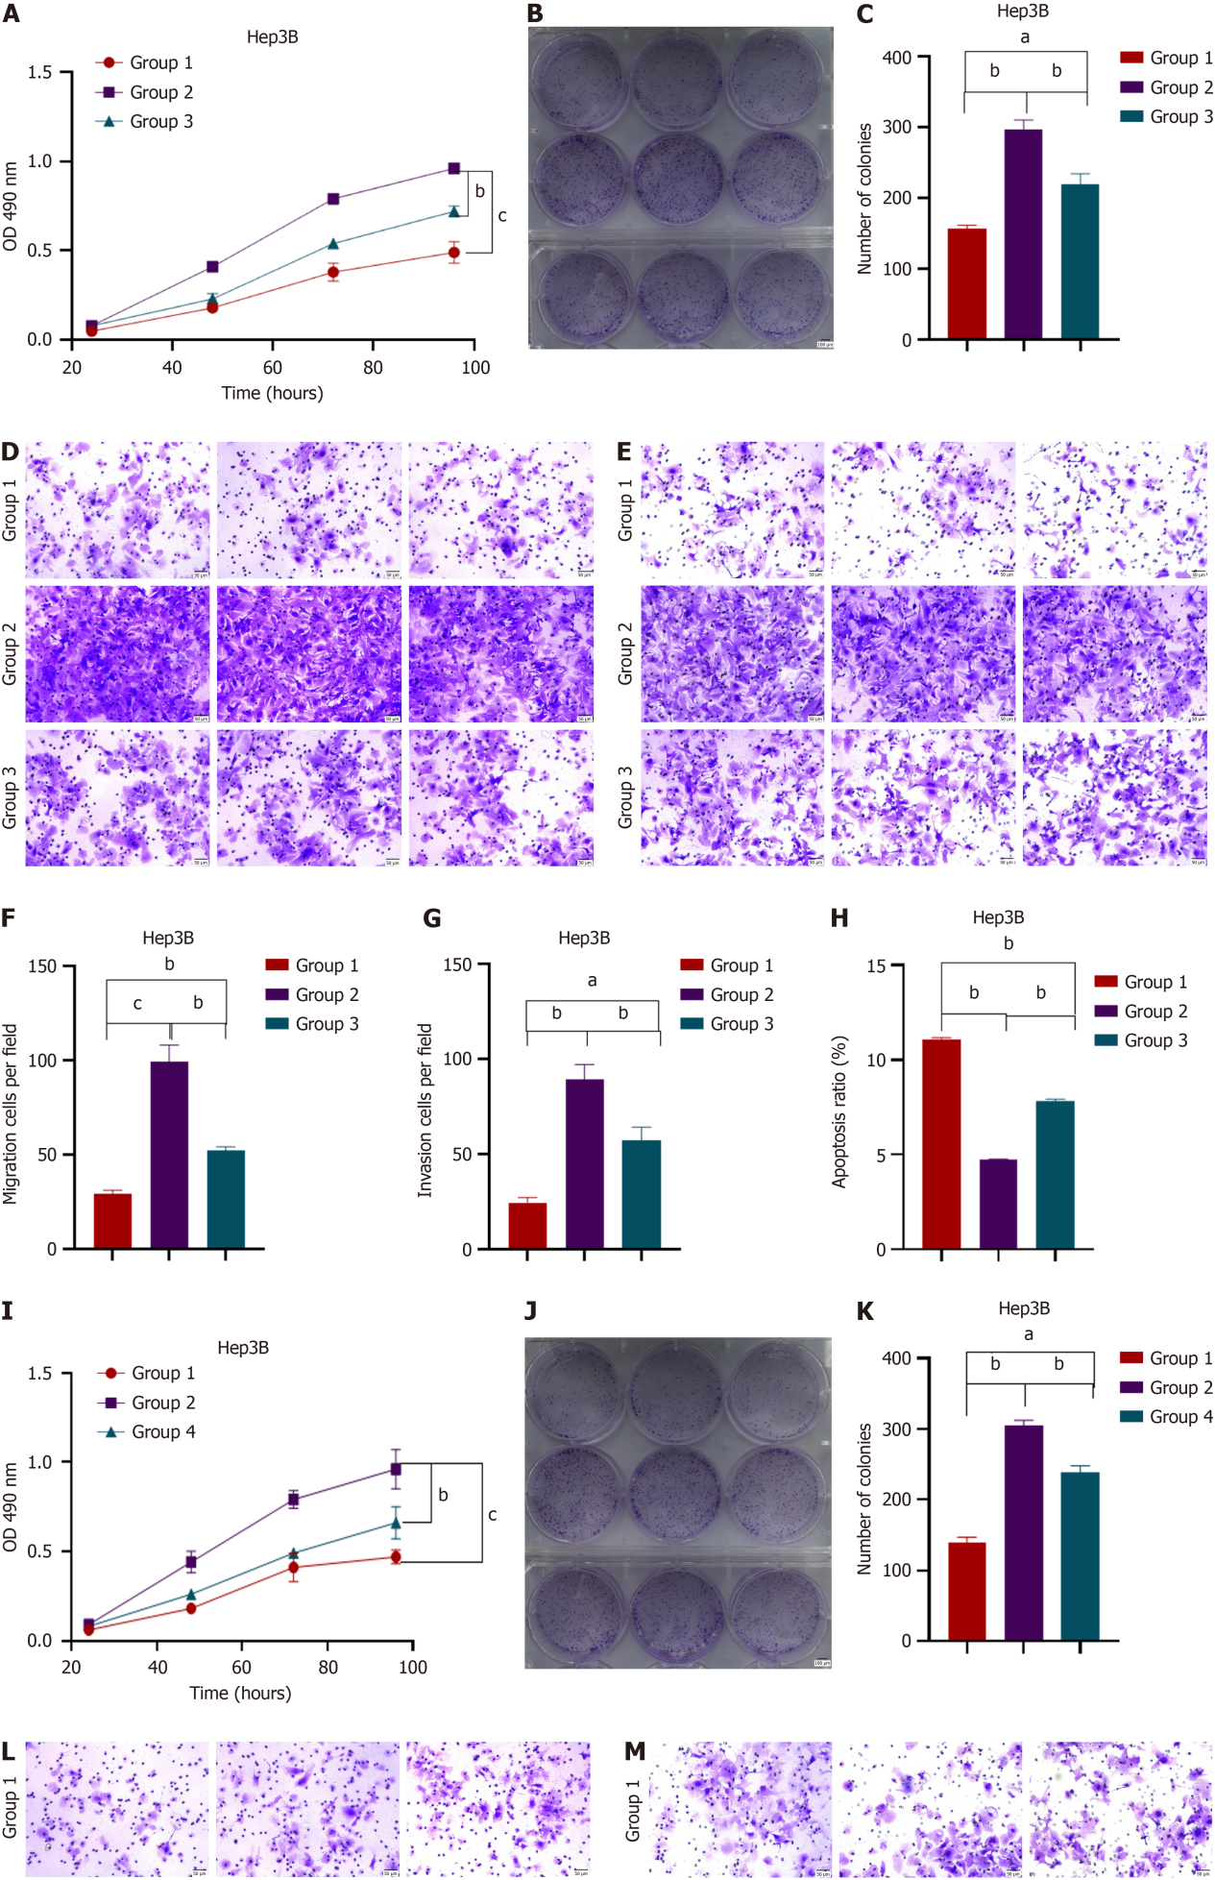
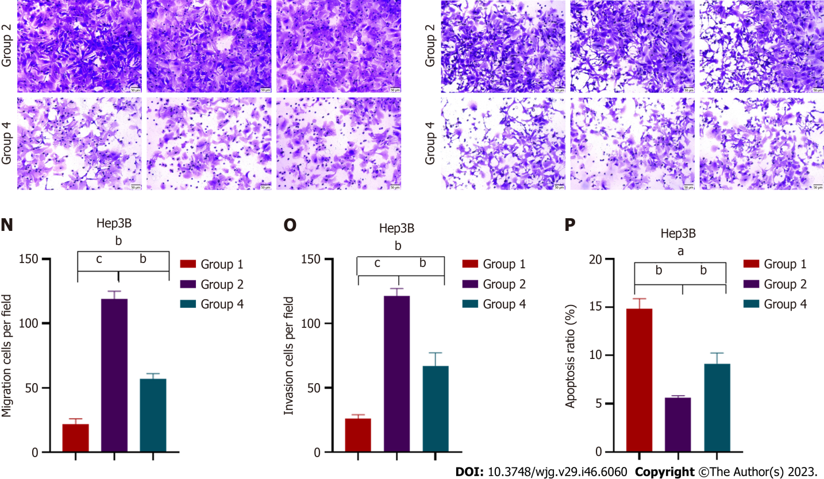
Figure 5 Oncogenic effect of exosomal circ563 prevented by either miR-148a-3p upregulation or metal-regulatory transcription factor-1 knockdown. A-P: Exosomal circ563 promoted Hep3B cell proliferation and invasion, which were reversed by miR-148a-3p overexpression or metal-regulatory transcription factor-1 depletion. Group 1: Co-culturing Hep3B cells with mesenchymal stem cell (MSC)-derived exosomes; Group 2: Co-culturing Hep3B cells with exosomes derived from circ563-overexpressing MSCs; Group 3: Co-culturing Hep3B cells after miR-148a-3p upregulation with exosomes derived from circ563-overexpressing MSCs; and Group 4: Co-culturing Hep3B cells after metal-regulatory transcription factor-1 knockdown with exosomes derived from circ563-overexpressing MSCs. ªP < 0.05, ^{b}P < 0.01, ^{c}P < 0.001.

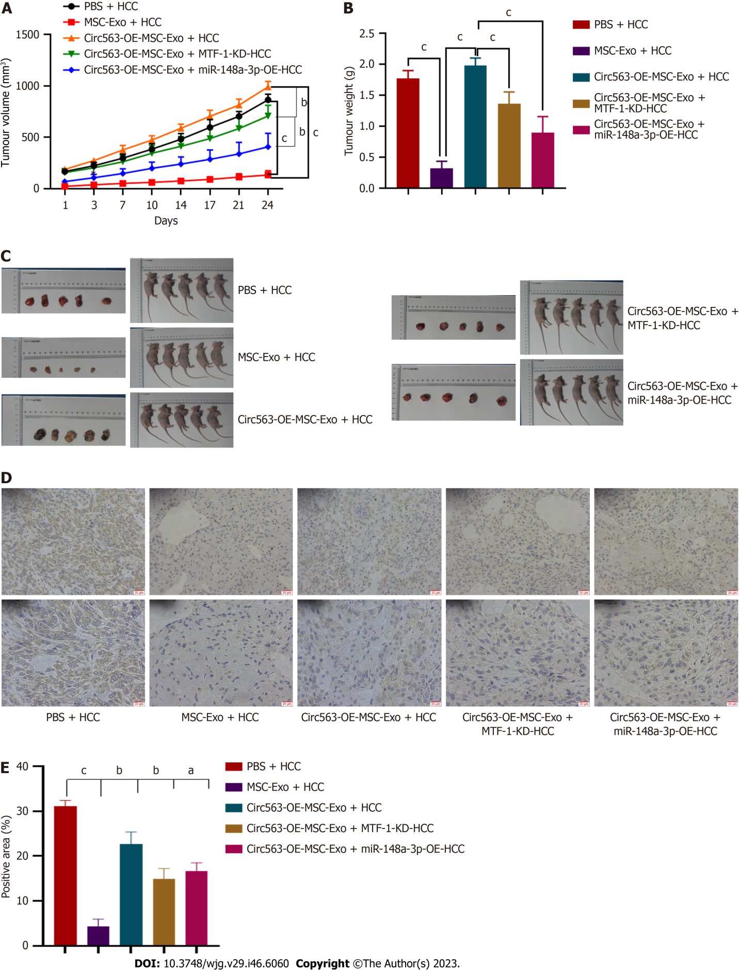
Figure 6 Circ563 promoting hepatocellular carcinoma tumor growth in vivo. Mouse xenografts were generated to verify the role of circ563 in vivo. Hepatocellular carcinoma cells stably transfected with miR-148a-3p overexpression, metal-regulatory transcription factor-1 knockdown, or control vectors were implanted into the subcutaneous tumors of mice. The xenografts were treated with exosomes after four weeks. A-C: Accelerated growth of circ563-overexpressing Hep3B-derived xenografts is shown with increased tumor volume and weight compared with the control group. Both miR-148a-3p overexpression and metal-regulatory transcription factor-1 (MTF-1) depletion partially reversed the increase in tumor volume and weight; D and E: MTF-1 staining reveals a similar trend with cell growth. ªP < 0.05, ^{b}P < 0.01, ^{c}P < 0.001. exo-circ563: Exosomal circ563; HCC: Hepatocellular carcinoma; MSC: Mesenchymal stem cell; Exo: Exosome; MTF-1: Metal-regulatory transcription factor-1.

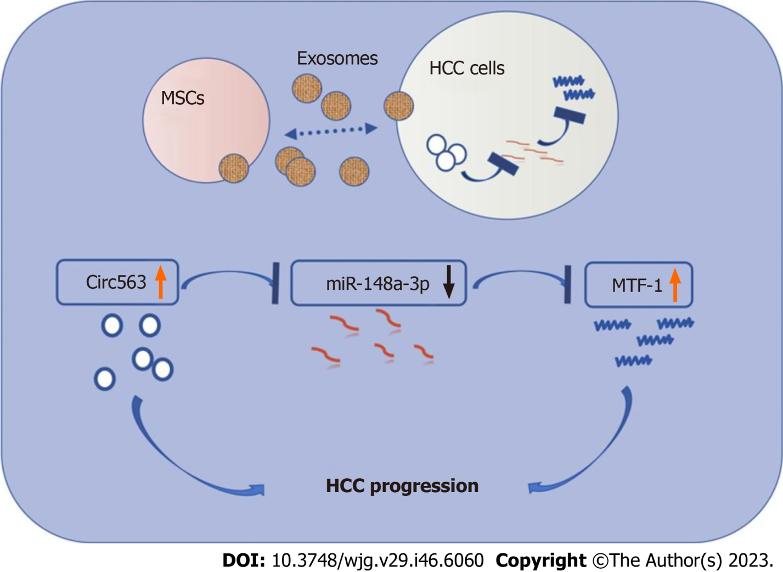
Figure 7 The schematic model of circ 563/miR-148a-3p/metal-regulatory transcription factor-1 in hepatocellular carcinoma. MTF-1: Metal-regulatory transcription factor-1; HCC: Hepatocellular carcinoma; MSCs: Mesenchymal stem cells.

Published by Baishideng Publishing Group Inc
7041 Koll Center Parkway, Suite 160, Pleasanton, CA 94566, USA
Telephone: +1-925-3991568
E-mail: bpgoffice@wjgnet.com
Help Desk: https://www.f6publishing.com/helpdesk
https://www.wjgnet.com

© 2023 Baishideng Publishing Group Inc. All rights reserved.

