Name of journal: World Journal of Critical Care Medicine
ESPS Manuscript NO: 3500
Columns: ORIGINAL ARTICLE

Molecular targeting therapy using bevacizumab for peritoneal metastasis from gastric cancer

Aoyagi K et al. Bevacizumab for peritoneal metastasis

Keishiro Aoyagi, Kikuo Kouhuji, Motoshi Miyagi, Junya Kizaki, Taro Isobe, Kousuke Hashimoto, Kazuo Shirouzu

Keishiro Aoyagi, Kikuo Kouhuji, Motoshi Miyagi, Junya Kizaki, Taro Isobe, Kousuke Hashimoto, Kazuo Shirouzu, Department of Surgery, Kurume University School of Medicine, 67 Asahi-machi, Kurume, Fukuoka 830-0011, Japan

Author contributions: Aoyagi K was responsibility for writing and revising the full-text original article, in response to an invitation from an editorial office member of the WJCCM; Kouhuji K was instructor of research and clinical work; Miyagi M established the high-potential peritoneal dissemination cell line MKN-45P; Kizaki J cultured the two cell lines and measured the concentration of various cytokines; Isobe T performed the in-vivo study on the peritoneal dissemination model using nude mice; Hasimoto K performed the pathological study on the intra-abdominal tumor of nude mice; and Professor Shirouzu K was Chair of the Department of Surgery and provided useful critique and advice to our research.

Correspondence to: Keishiro Aoyagi, Assistant Professor, Department of Surgery, Kurume University School of Medicine, 67 Asahi-machi, Kurume, Fukuoka 830-0011, Japan. keishiro@med.kurume-u.ac.jp

Telephone: +81-942-353311-3505 Fax: +81-942-340709
Received: May 2, 2013 Revised: June 5, 2013
Accepted: July 4, 2013
Published online:

Abstract
AIM: To clarify the significance of vascular endothelial growth factor (VEGF) in peritoneal metastasis from gastric cancer, using the gastric cancer cell line MKN-45 compared with the high-potential peritoneal dissemination gastric cancer cell line MKN-45P.

METHODS: The supernatant of culture medium of MKN-45 cells or MKN-45P cells was collected, and the concentrations were measured of various cytokines, matrix metalloproteinases, growth factor, and angiogenic factors including VEGF. We performed an initial pilot study to explore whether bevacizumab - a humanized monoclonal antibody against VEGF - had any suppressive effect on the peritoneal dissemination from gastric cancer, in an experimental nude mouse model of peritoneal metastasis.

RESULTS: The concentrations of interleukin-6 (IL-6), IL-8, VEGF, and of matrix metalloproteinase-2 protein in the culture supernatant were each significantly higher than each of those for MKN-45. In the in vivo study, the volume of ascites and the mitotic index were significantly lower in the therapy group than in the non-therapy group. The survival curve of the therapy group was significantly higher than that of the non-therapy group. These results suggested that VEGF was correlated with peritoneal metastasis from gastric cancer.

CONCLUSION: Findings suggested that bevacizumab for inhibiting VEGF could suppress peritoneal dissemination from gastric cancer.

© 2013 Baishideng. All rights reserved.

Key words: Gastric cancer; Peritoneal metastasis; Vascular endothelial growth factor; MKN-45P; Bevacizumab

Aoyagi K, Kouhuji K, Miyagi M, Kizaki J, Isobe T, Hashimoto K, Shirouzu K. Molecular targeting therapy using bevacizumab for peritoneal metastasis from gastric cancer. World J Crit Care Med 2013;
Available from: URL: http://www.wjgnet.com/esps/
DOI: DOI:10.5492/wjccm.v0.i0.0000

INTRODUCTION
Peritoneal metastasis is the most common form of recurrence from gastric cancer, and is associtaed with a poor prognosis. Therefore, the management of any dissemination in the peritoneal cavity is important in the treatment of gastric cancer. However, there is as yet no effective treatment against peritoneal metastasis from gastric cancer. The development of peritoneal metastasis is a multistep process, beginning with the detachment of cancer cells from the primary tumor, their attachment to peritoneal mesothelial cells, retraction of the meothelial cells, and exposure of the basement membrane. After attachment to the basement membrane, the cancer cells degrade in the extracellular matrix, and then proliferate^{[1-3]}. Finally, the cancer cells induce angiogenesis and lymphangiogenesis. Many cytokines, growth factors, matrix metalloproteinases, and angiogenic factors play important roles in these steps. Tumor growth requires new vessel formation, and this is driven predominantly by vascular endothelial growth factor (VEGF), the most potent angiogenic molecule known and the principle target for antiangiogenic therapy. VEGF levels in malignant ascites are remarkably elevated^{[4]}. VEGF has been reported to enhance vascular permeability and angiogenesis in the abdominal wall, and contributes to the establishment of peritoneal dissemination with malignant ascites^{[4,5]}. In ovarian cancer, three pathological events are thought to cause malignant ascites: obstruction of the lymphatic vessels by tumor cells inhibiting lymphatic drainage from the peritoneal cavity; hyperpermeability of microvessels lining the peritoneal cavity; and angiogenesis^{[6]}. In gastric cancer, there was a tendency for the tumor/normal ratio of VEGF mRNA to be correlated with distant metastasis^{[7]}, and positive expression of tissue VEGF, circulating VEGF, VEGF-C, and VEGF-D were each associated with poor prognosis in resected gastric cancer^{[8]}. We have previously reported that tissue VEGF was a useful indicator of peritoneal recurrence of gastric cancer^{[9]}. The aim of the present study was to clarify the significance of VEGF in peritoneal metastasis from gastric cancer. We compared cytokines, matrix metalloproteinases (MMPs), and VEGF in the gastric cancer cell line MKN-45, and in the high-potential peritoneal dissemination gastric cancer cell line MKN-45P, using an enzyme-linked immunosorbent assay (ELISA) method. Furthermore, we investigated whether administration of VEGF antibody could prevent peritoneal metastasis from gastric cancer. Bevacizumab is a humanized monoclonal antibody against VEGF, and was the first commercially available angiogenesis inhibitor. We investigated whether bevacizumab had a suppressive effect on peritoneal dissemination from gastric cancer, experimentally, using a mouse peritoneal metastasis model.

MATERIALS AND METHODS
Cell lines
We used the high-potential peritoneal dissemination cell line MKN-45P, established from the human gastric cancer cell line MKN-45 (derived from a poorly differentiated adenocarcinoma in a 62-year-old woman; Health Science Research Resources Bank, Tokyo, Japan), in our institute as described previously^{[10]}. Briefly, nude mice (BALB/c nu/nu) were subcutaneously inoculated with MKN-45 cells, and the subcutaneous nodules were removed and injected into other nude mice intraperitoneally. The cancer cells from the peritoneal nodules were injected into the abdominal cavity of other mice. The process was continued through to a seventh generation. The resulting high-potential peritoneal dissemination cell line was named MKN-45P. MKN-45 and MKN-45P cells were each maintained in RPMI-1640 medium (Nihon Seiyaku Co., Komaki, Aichi, Japan) supplemented with 10% heat-inactivated fetal bovine serum (FBS) (Gibco Uxbridge, Middlesex, United Kingdon), 2 mmol/L-glutamine, and penicillin-streptomycin (50 IU/mL and 50 μg/mL, respectively) at 37.0˚C in humidified air with 5% CO₂.

Measurement of cytokines in conditioned medium
For measurement of cytokines in conditioned medium, the MKN-45 cells (1 × 10⁶ cells/10 mL) or MKN-45P cells (1 × 10⁶ cells/10 mL) were placed in 100mm tissue culture dishes (IWAKI Co., Funabashi, Chiba, Japan) and cultured for 72 h in medium containing 10% FBS at 37.0˚C in humidified air with 5% CO₂. The number of cells in each cell line was evaluated visually at 12, 24, 48, and at 72 h (values: mean of three fields). The supernatant was then collected, and the concentrations of interleukin-1β (IL-1β), IL-6, IL-8, IL-10, hepatocyte growth factor (HGF), transforming growth factor-β1 (TGF-β1), VEGF, MMP-2, MMP-9, and tissue inhibitor of metalloproteinases-1 (TIMP-1) proteins were each measured using the ELISA method (IL-1β, IL-8 and IL-10: Bio Source Europe S. A., Nivelles, Belgium; IL-6: Fujirebio Inc., Tokyo, Japan; HGF: Otsuka Pharmaceutical Co. Ltd., Tokyo, Japan; TGF-β1 and VEGF: RD System Inc., Mineapolis, MN, United States; MMP-2, MMP-9 and TIMP-1: Daiichi Fine Chemical Co. Ltd., Takaoka, Toyama, Japan). Each cytokine was measured in 5 samples, and the means of these were compared between the MKN-45 cells and the MKN-45P cells.

Animals
Four-week-old athymic male BALB/c nu/nu nude mice, each weighing 18 g, were obtained from CLEA (Tokyo, Japan). The mice were housed in cages under specific pathogen-free conditions and provided with sterilized food and water ad libitum.

Drugs
The humanized murine monoclonal antibody against human VEGF (bevacizumab, Avastin) was purchased from Genetech (San Francisco, CA, United States).

Experimental design
The experimental group consisted of 5-wk-old male mice (n = 10). We determined a working concentration of bevacizumab according to Wildiers et al^{[11]}. On day 0, we injected 1 × 10⁷ MKN-45P cells into the abdominal cavity of each mouse, followed by a single intrapenitoneal (ip) injection of 200 μg bevacizumab in 1 mL saline on day 0 and on day 4. On day 21, five mice were sacrificed under ether anesthesia; these were weighed, and then we calculated the mean number of tumor nodules in a 1-cm² area in three fields on the mesentery, and calculated the volume of ascites. We also extracted retroperitoneal tissues for histological examination. Another five mice were monitored until they died, and the survival rate was calculated using the Kaplan-Meier method. A matching number of control mice were given 1 ml of drug-free saline.

Histology
After extraction, the retroperitoneal tissues were fixed for 12 h in 10% neutral buffered formaldehyde, then cut every 5 mm horizontally and embedded in paraffin. Paraffin sections were stained with hematoxylin-eosin (HE) and examined using light microscopy. We counted the frequency of hydronephrosis on the retroperitoneal tissues. The mitotic index was defined as the mean number of mitotic figures in a 400-times magnified field from ten arbitrary microscopic fields.

Immunohistochemistry
VEGF was analyzed using immunohistochemical staining and the avidin-biotin-peroxidase complex technique (Vectastain ABC Kit; Vector, Burlingame, CA, United States). Briefly, 3-μm-thick sections of the formalin-fixed paraffin-embedded tissue specimens were deparaffinized and dehydrated. The sections were washed with phosphate-buffered saline (PBS), treated with 0.3% hydrogen peroxide in methanol for 30 min to block endogenous peroxidase, and then incubated with primary antibody in a humidified chamber at 4˚C overnight. As the primary antibody, rabbit polyclonal antibody A-20 was used (Santa Cruz Biotechnology, Santa Cruz, CA, United States) for VEGF, diluted at 1:200. Sections were washed three times with PBS, then incubated with biotinylated horse anti-rabbit immunoglobulin G antibody for 30min, washed again three times with PBS, and then incubated with avidin-biotinylated peroxidase complex for 30 min. After three additional washings with PBS, staining was developed by incubating the sections in 3-amino-9-ethylcarbazole (Vector) for 5 min. The sections were then counterstained with hematoxylin, and mounted. The cell types showing positive staining for VEGF were defined morphologically by H&E staining, using serial sections. VEGF expression was classified as one of three categories using a method modified from the literature that was previously used on gastric tissue^{[9]}, depending on the percentage of tumor cells stained: category 1 being less than 30% of cells stained; category 2 being from 30% to 49% stained; and category 3 being 50% or more cells stained.

Ethics
This study was approved by Kurume Univerity Institutional Animal Care and Use Committee of Ethics.

Statistical analysis
Student’s t-test and the χ² test were used to analyze the data for any significant difference, and any difference was considered statistically significant when the P value was less than 0.05. The cumulative survival rate was calculated using the Kaplan-Meier method. The significance of any difference between the survival curves was determined using the log-rank test, and any difference was considered significant at the 5% level.

RESULTS
Measurement of cytokines in condition medium
The number of MKN-45 or MKN-45P cells was counted at 24, 48, and at 72 h. There was no difference in the number of cancer cells between the two cell lines.
The concentrations of cytokines in conditioned media from MKN-45, and from MKN-45P, are shown in Table 1. The concentrations of IL-6, IL-8, VEGF, and of MMP-2 protein in the culture supernatants from MKN-45P were each significantly higher than each of those from MKN-45 (P = 0.045, P = 0.011, P = 0.013, and P = 0.021, respectively) (Table 1).

Peritoneal dissemination model
Peritoneal dissemination with bloody ascites was recognized in all five mice using the MKN-45P cell line (Figure 1A). Numerous nodules were seen on the mesentery (Figure 1B). We confirmed histologically that the nodule in the peritoneum was composed of cancer cells. All five mice in the non-therapy group were cachexic; however, there was no significant difference in body weight (P = 0.591), and no difference in the number of peritoneal nodules (P = 0.783), between the therapy group and the non-therapy group. The volume of ascites in the therapy group was significantly less than that in the non-therapy group (P = 0.042). No side-effects by bevacizumab were evident such as bleeding, bowel perforation, or thrombosis (Table 2).

Histopathological findings
In the therapy group, two right kidneys (40%) and one left kidney (20%) showed hydronephrosis. In the non-therapy group, four right kidneys (80%) and two left kidneys (40%) showed hydronephrosis. The frequency of hydronephrosis in the therapy group was lower than that in the non-therapy group (Table 2). In the therapy group, the grade of hydronephrosis was mild, and only a small amount of tissue was recognized in the retroperitoneum. In contrast, in the non-therapy group, the grade of hydronephrosis was severe, and a large amount of tumor tissue was recognized in the retroperitoneum (Figure 2). High-magnification examination of the tumor tissue revealed a lower number of mitoses in the therapy group than in the control group (Figure 3).

Immunohistochemical findings
Immunoreactivity for VEGF was mainly identified as supranuclear staining or diffuse staining in the cytoplasm of the cancer cells (Figure 4). Based on the percentage of positive tumor staining, all the five mice in the therapy group were in category 2, whereas all the five mice in the non-therapy group were in category 3 (Figure 4).

Mitotic index
The mitotic index was 9.6 ± 2.1 in the therapy group, and this was significantly lower than that 21.0 ± 5.7 in the non-therapy group (P < 0.01) (Table 2).

Survival curves
We investigated the findings for any correlation between survival and bevacizumab treatment. The median survival of the treated mice was 30.8 d, and that of the untreated mice was 26.6 d. The survival of the therapy group was significantly longer than that of the non-therapy group (P = 0.005) (Figure 5).

DISCUSSION
Research in the field of tumor angiogenesis has provided a foundation for radical development in the management and treatment of human cancers. VEGF is the most sensitive angiogenic factor and is expressed in cancer cells. Several clinical trials have confirmed that targeting the vascular VEGF/VEGF receptor pathway can show some clinical benefit. VEGF was initially described as a vascular permeability factor by Senger et al^{[12]} in 1983, and was later cloned and found to be homologous to VEGF by Ferrara and Henzel^{[13]}. VEGF has been reported to enhance the permeability of tumor vessels ^{[5]}, to induce serine protease or metalloproteases^{[14,15]}, to inhibit apoptosis in endothelial cells^{[16,17]}, and to inhibit the maturation of dendritic cells^{[18]}. Since then, several randomized trials have shown a clinical benefit by various VEGF-targeted agents in patients with metastatic colorectal cancer, advanced non-small cell lung cancer, renal cell carcinoma, hepatocellular carcinoma, and metastatic breast cancer^{[19]}. VEGF-targeted therapy has thus become an important treatment option for several human malignancies.
Peritoneal metastasis in gastric cancer takes place through a multistep process involving the detachment of cancer cells from the primary tumor, their attachment to the distant peritoneum, invasion into the subperitoneal space, proliferation, and angiogenesis^{[1-3]}. Angiogenesis is a key step in the various stages of human cancer development and dissemination. Previous reports have indicated that the presence of angiogenenic factors is an essential event in the development of peritoneal metastasis^{[20-22]}.
In gastric cancer, there is a tendency for the tumor/normal ratio of VEGF mRNA to be correlated with distant metastasis^{[7]}. Positive expression of tissue VEGF, circulating VEGF, VEGF-C, and VEGF-D were each associated with poor prognosis in resected gastric cancer^{[8]}. We have previously reported that tissue VEGF was a useful indicator of peritoneal recurrence from gastric cancer^{[9]}. In our immunohistochemical study on clinical specimens, the VEGF score of patients with peritoneal recurrence was significantly higher than that of patients without peritoneal recurrence, and the VEGF score was a significant parameter of peritoneal recurrence, suggesting that VEGF was correlated with peritoneal metastasis from gastric cancer, and that VEGF was a useful indicator of peritoneal recurrence^{[9]}.
The present study reveals that the concentrations of IL-6, IL-8, VEGF, and MMP-2 protein in the culture supernatant of MKN-45P are each significantly higher than each of those of MKN-45. IL-6 has been reported as a prognostic factor in gastric carcinoma, and is significantly correlated with the incidence of lymph node metastasis and of liver metastasis^{[23]}. IL-8 has been reported as a prognostic factor in gastric carcinoma, and is significantly correlated with the depth of invasion and vessel infiltration^{[24]}. IL-6 and IL-8 are each related to the accomplishment of peritoneal dissemination by inducement of angiogenesis^{[25,26]}.
Degradation of the extracellular matrix is considered to be a prerequisite for peritoneal metastasis, and MMPs are thought to play an important role in this process^{[27,28]}. There are many reports that highly invasive cancer cells with a high potential for metastasis stimulate the production of MMPs^{[27]}, and that MMP-2 is significantly correlated with depth of invasion, lymph node metastasis, and with distant metastasis from gastric cancer^{[29]}.
These studies have provided clear evidence that VEGF is an essential element in the development of peritoneal metastasis. Accordingly, we investigated whether VEGF antibody might prevent peritoneal metastasis from gastric cancer.
Bevacizumab is a monoclonal antibody against VEGF that inhibits tumor growth by blocking angiogenesis. Cancer cells transferred with VEGF have been found to have an increased potential for the development of tumorigenesis in a xenograft model^{[21]}. According to several reports, antiangiogenic agents can decrease tumor vessel permeability and prevent tumor growth^{[11,30,31]}. Jain et al^{[31]} have reported that antiangiogenic therapy normalized tumor vessels and reduced interstitial fluid pressure, which finally decreased malignant ascites. In the present study, all the mice in the non-therapy group were cachexic. However, there was no significant difference in body weight between the therapy group and the non-therapy group, because the volume of ascites in the therapy group was significantly less than that in the non-therapy group. These findings suggested that bevacizumab suppressed cell proliferative activity by inhibiting angiogenesis of VEGF, thus contributing to the smaller amount of tumor tissue and to the low incidence of hydronephrosis in the therapy group. Although the number of peritoneal nodules did not differ significantly between the two groups, the nodules on the mesentery in the treated group appeared to have been smaller - but these were too small to be measured or weighed. The tumors on the retroperitoneum in the non-therapy group were larger than those in the therapy group, and large tumors need new blood vessels for their growth. On immunohistochemical staining, the percentage of tumor cells stained for VEGF in the therapy group was lower than that in the non-therapy group. The mitotic index in the therapy group was also significantly lower than that in the non-therapy group. These results suggested that bevacizumab might suppress the vascular permeability effect and the cell proliferative activity, by inhibiting angiogenesis of VEGF, and thereby prolong survival in the mice in the therapy group.
The findings from the present study indicate that the addition of bevacizumab to standard treatment might prolong the survival of gastric cancer patients, especially of those with peritoneal metastasis. In conclusion, combination of bevacizumab with anticancer drugs may suppress peritoneal dissemination from gastric cancer.
The results from the present study show that VEGF was correlated with peritoneal metastasis from gastric cancer. Accordingly, using bevacizumab to inhibit VEGF may suppress peritoneal dissemination from gastric cancer. Therefore, combination of bevacizumab with anticancer drugs might suppress peritoneal dissemination from gastric cancer.
COMMENTS
Background
The therapy for peritoneal metastasis is most important treatment to improve the prognosis of advanced gastric cancer. However, there is yet no effective treatment against peritoneal metastasis from gastric cancer. The relationship between vascular endothelial growth factor (VEGF) and peritoneal metastasis has been reported. Therefore, authors investigated whether bevacizumab which was a humanized monoclonal antibody against VEGF had a suppressive effect on peritoneal dissemination from gastric cancer, experimentally, using a mouse peritoneal metastasis model.

Research frontiers
The research hot spot is suppression of peritoneal metastasis and prolonged the survival of peritoneal metastasis model by bevacizumab.

Innovations and breakthroughs
They proved that bevacizumab reduced the volume of ascites and decreased the proliferative activity of cancer cells on the peritoneum macroscopically and microscopically. So this research proved the suppressive effect of bevacizumab for peritoneal metastasis from gastric cancer more clearly comparing to the other similar articles. Moreover, hydronephrosis is one of the most popular events of peritoneal metastasis from gastric cancer clinically. In this research, authors focused on the hydronephrosis, and proved the suppressive effect of bevacuzumab for hydronephrosis to reduce the tumor volume on the retroperitoneum.

Applications
The results show that using bevacizumab to inhibit the VEGF may suppress peritoneal dissemination from gastric cancer. Therefore bevacizumab could be used in preventing the peritoneal recurrence, and the combination of bevacizumab with anticancer drugs may suppress peritoneal dissemination from gastric cancer.

Peer review
Authors think that the design of this study is good, and the authors analyze the effect of molecular targeting therapy for VEGF against peritoneal metastasis from gastric cancer. The results are interesting and suggest that bevacizumab could be used in preventing the peritoneal recurrence, the combination of bevacizumab with anticancer drugs may suppress peritoneal dissemination from gastric cancer.

REFERENCES
1 Yonemura Y, Endo Y, Yamaguchi T, Fujimura T, Obata T, Kawamura T, Nojima N, Miyazaki I, Sasaki T. Mechanisms of the formation of the peritoneal dissemination in gastric cancer. Int J Oncol 1996; 8: 795-802 [PMID: 21544429]
2 Yonemura Y. Peritoneal dissemination. Tokyo: Health Publishers; 1996
3 Liotta LA. Tumor invasion and metastases--role of the extracellular matrix: Rhoads Memorial Award lecture. Cancer Res 1986; 46: 1-7 [PMID: 2998604]
4 Zebrowski BK, Liu W, Ramirez K, Akagi Y, Mills GB, Ellis LM. Markedly elevated levels of vascular endothelial growth factor in malignant ascites. Ann Surg Oncol 1999; 6: 373-378 [PMID: 10379858 DOI: 10.1007/s10434-999-0373-0]
5 Dvorak HF, Brown LF, Detmar M, Dvorak AM. Vascular permeability factor/vascular endothelial growth factor, microvascular hyperpermeability, and angiogenesis. Am J Pathol 1995; 146: 1029-1039 [PMID: 7538264]
6 Belotti D, Paganoni P, Manenti L, Garofalo A, Marchini S, Taraboletti G, Giavazzi R. Matrix metalloproteinases (MMP9 and MMP2) induce the release of vascular endothelial growth factor (VEGF) by ovarian carcinoma cells: implications for ascites formation. Cancer Res 2003; 63: 5224-5229 [PMID: 14500349]
7 Ryu KH, Shim KN, Jung SA, Yoo K, Joo YH, Lee JH. Significance of preoperative tissue levels of vascular-endothelial cadherin, liver-intestine cadherin and vascular endothelial growth factor in gastric cancer. Korean J Gastroenterol 2012; 60: 229-241 [PMID: 23089909 DOI: 10.4166/kjg.2012.60.4.229]
8 Liu L, Ma XL, Xiao ZL, Li M, Cheng SH, Wei YQ. Prognostic value of vascular endothelial growth factor expression in resected gastric cancer. Asian Pac J Cancer Prev 2012; 13: 3089-3097 [PMID: 22994715 DOI: 10.7314/APJCP.2012.13.7.3089]
9 Aoyagi K, Kouhuji K, Yano S, Miyagi M, Imaizumi T, Takeda J, Shirouzu K. VEGF significance in peritoneal recurrence from gastric cancer. Gastric Cancer 2005; 8: 155-163 [PMID: 16086118 DOI: 10.1007/s10120-005-0329-4]
10 Miyagi M, Aoyagi K, Kato S, Shirouzu K. The TIMP-1 gene transferred through adenovirus mediation shows a suppressive effect on peritoneal metastases from gastric cancer. Int J Clin Oncol 2007; 12: 17-24 [PMID: 17380436 DOI: 10.1007/s10147-006-0616-z]
11 Wildiers H, Guetens G, De Boeck G, Verbeken E, Landuyt B, Landuyt W, de Bruijn EA, van Oosterom AT. Effect of antivascular endothelial growth factor treatment on the intratumoral uptake of CPT-11. Br J Cancer 2003; 88: 1979-1986 [PMID: 12799646 DOI: 10.1038/sj.bjc.6601005]
12 Senger DR, Galli SJ, Dvorak AM, Perruzzi CA, Harvey VS, Dvorak HF. Tumor cells secrete a vascular permeability factor that promotes accumulation of ascites fluid. Science 1983; 219: 983-985 [PMID: 6823562 DOI: 10.1126/science.6823562]
13 Ferrara N, Henzel WJ. Pituitary follicular cells secrete a novel heparin-binding growth factor specific for vascular endothelial cells. Biochem Biophys Res Commun 1989; 161: 851-858 [PMID: 2735925 DOI: 10.1016/0006-291X(89)92678-8]
14 Pepper MS, Ferrara N, Orci L, Montesano R. Vascular endothelial growth factor (VEGF) induces plasminogen activators and plasminogen activator inhibitor-1 in microvascular endothelial cells. Biochem Biophys Res Commun 1991; 181: 902-906 [PMID: 1755866 DOI: 10.1016/0006-291X(91)91276-I]
15 Unemori EN, Ferrara N, Bauer EA, Amento EP. Vascular endothelial growth factor induces interstitial collagenase expression in human endothelial cells. J Cell Physiol 1992; 153: 557-562 [PMID: 1447317]
16 Shaheen RM, Davis DW, Liu W, Zebrowski BK, Wilson MR, Bucana CD, McConkey DJ, McMahon G, Ellis LM. Antiangiogenic therapy targeting the tyrosine kinase receptor for vascular endothelial growth factor receptor inhibits the growth of colon cancer liver metastasis and induces tumor and endothelial cell apoptosis. Cancer Res 1999; 59: 5412-5416 [PMID: 10554007]
17 Gerber HP, McMurtrey A, Kowalski J, Yan M, Keyt BA, Dixit V, Ferrara N. Vascular endothelial growth factor regulates endothelial cell survival through the phosphatidylinositol 3'-kinase/Akt signal transduction pathway. Requirement for Flk-1/KDR activation. J Biol Chem 1998; 273: 30336-30343 [PMID: 9804796 DOI: 10.1074/jbc.273.46.30336]
18 Lissoni P, Malugani F, Bonfanti A, Bucovec R, Secondino S, Brivio F, Ferrari-Bravo A, Ferrante R, Vigoré L, Rovelli F, Mandalà M, Viviani S, Fumagalli L, Gardani GS. Abnormally enhanced blood concentrations of vascular endothelial growth factor (VEGF) in metastatic cancer patients and their relation to circulating dendritic cells, IL-12 and endothelin-1. J Biol Regul Homeost Agents 2001; 15: 140-144 [PMID: 11501971]
19 Ellis LM, Hicklin DJ. Pathways mediating resistance to vascular endothelial growth factor-targeted therapy. Clin Cancer Res 2008; 14: 6371-6375 [PMID: 18927275 DOI: 10.1158/1078-0432.CCR-07-5287]
20 Yoneda J, Kuniyasu H, Crispens MA, Price JE, Bucana CD, Fidler IJ. Expression of angiogenesis-related genes and progression of human ovarian carcinomas in nude mice. J Natl Cancer Inst 1998; 90: 447-454 [PMID: 9521169 DOI: 10.1093/jnci/90.6.447]
21 Kondo Y, Arii S, Mori A, Furutani M, Chiba T, Imamura M. Enhancement of angiogenesis, tumor growth, and metastasis by transfection of vascular endothelial growth factor into LoVo human colon cancer cell line. Clin Cancer Res 2000; 6: 622-630 [PMID: 10690548]
22 Mori A, Arii S, Furutani M, Mizumoto M, Uchida S, Furuyama H, Kondo Y, Gorrin-Rivas MJ, Furumoto K, Kaneda Y, Imamura M. Soluble Flt-1 gene therapy for peritoneal metastases using HVJ-cationic liposomes. Gene Ther 2000; 7: 1027-1033 [PMID: 10871751 DOI: 10.1038/sj.gt.3301202]
23 Ashizawa T, Okada R, Suzuki Y, Takagi M, Yamazaki T, Sumi T, Aoki T, Ohnuma S, Aoki T. Clinical significance of interleukin-6 (IL-6) in the spread of gastric cancer: role of IL-6 as a prognostic factor. Gastric Cancer 2005; 8: 124-131 [PMID: 15864720 DOI: 10.1007/s10120-005-0315-x]
24 Kido S, Kitadai Y, Hattori N, Haruma K, Kido T, Ohta M, Tanaka S, Yoshihara M, Sumii K, Ohmoto Y, Chayama K. Interleukin 8 and vascular endothelial growth factor -- prognostic factors in human gastric carcinomas? Eur J Cancer 2001; 37: 1482-1487 [PMID: 11506954 DOI: 10.1016/S0959-8049(01)00147-2]
25 Huang SP, Wu MS, Wang HP, Yang CS, Kuo ML, Lin JT. Correlation between serum levels of interleukin-6 and vascular endothelial growth factor in gastric carcinoma. J Gastroenterol Hepatol 2002; 17: 1165-1169 [PMID: 12453275 DOI: 10.1046/j.1440-1746.2002.02873.x]
26 Kitadai Y, Haruma K, Sumii K, Yamamoto S, Ue T, Yokozaki H, Yasui W, Ohmoto Y, Kajiyama G, Fidler IJ, Tahara E. Expression of interleukin-8 correlates with vascularity in human gastric carcinomas. Am J Pathol 1998; 152: 93-100 [PMID: 9422527]
27 Nagase H, Woossner JF Jr. Matrix metallopreteinases. J Biol Chem 1999; 274: 21492-21494 doi: 10.1074/jbc.274.31.21491
28 Mizutani K, Kofuji K, Shirouzu K. The significance of MMP-1 and MMP-2 in peritoneal disseminated metastasis of gastric cancer. Surg Today 2000; 30: 614-621 [PMID: 10930227 DOI: 10.1007/s005950070101]
29 Mönig SP, Baldus SE, Hennecken JK, Spiecker DB, Grass G, Schneider PM, Thiele J, Dienes HP, Hölscher AH. Expression of MMP-2 is associated with progression and lymph node metastasis of gastric carcinoma. Histopathology 2001; 39: 597-602 [PMID: 11903578 DOI: 10.1046/j.1365-2559.2001.01306.x]
30 Ferrara N, Hillan KJ, Gerber HP, Novotny W. Discovery and development of bevacizumab, an anti-VEGF antibody for treating cancer. Nat Rev Drug Discov 2004; 3: 391-400 [PMID: 15136787 DOI: 10.1038/nrd1381]
31 Jain RK, Tong RT, Munn LL. Effect of vascular normalization by antiangiogenic therapy on interstitial hypertension, peritumor edema, and lymphatic metastasis: insights from a mathematical model. Cancer Res 2007; 67: 2729-2735 [PMID: 17363594 DOI: 10.1158/0008-5472.CAN-06-4102]

P-Reviewers Cimpean AM, Lu XM, Li Q, Tamiya M S-Editor Gou SX L-Editor E-Editor

Figure legends

Fig. 1a Fig. 1b
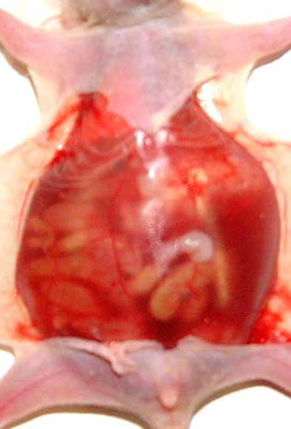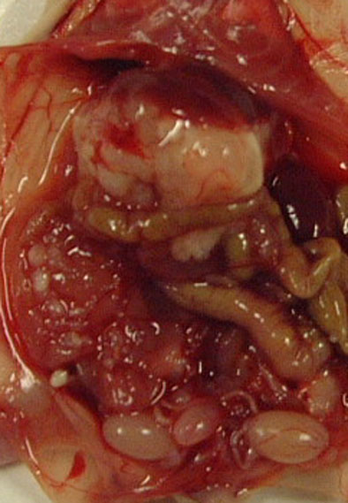

Figure 1 Peritoneal dissemination model. A: Bloody ascites was recognized in the peritoneal cavity of the peritoneal cavity of the peritoneal dissemination model, using the MKN-45P cell line; B: Numerous tumor nodules (arrowheads) were recognized on the mesentery.
Fig. 2

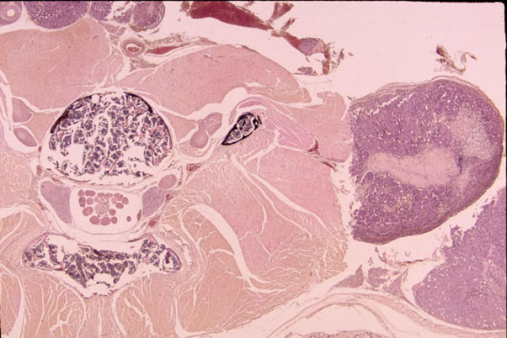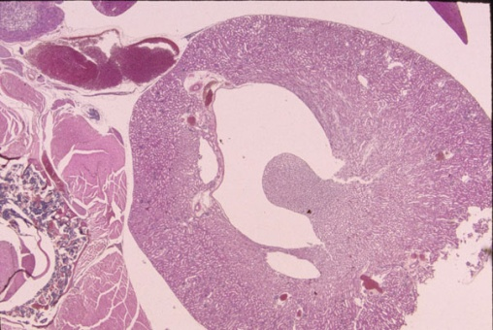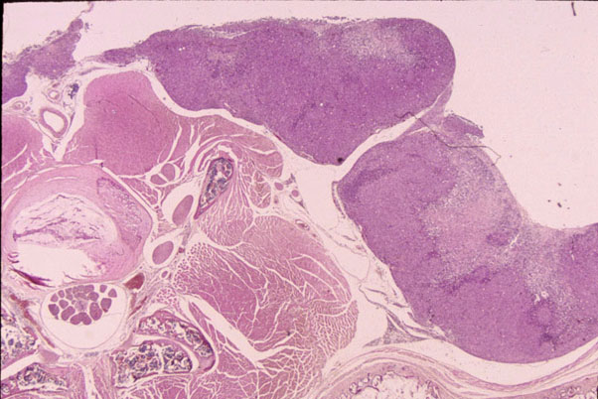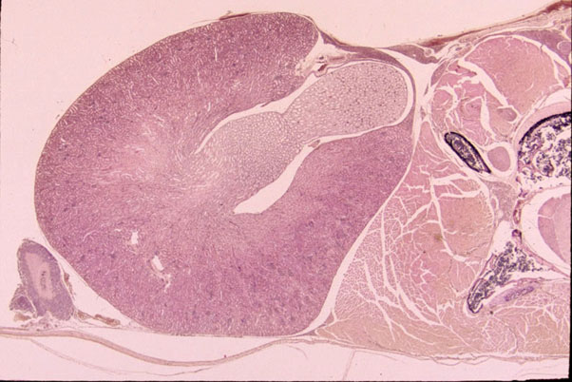
a)Non-therapy group
b)Non-Therapy group

d)Therapy group
c)Therapy group

Figure 2 Macroscopic and histological findings of the retroperitoneal tissue. A: Hydronephrosis in the left kidney in the non-therapy group (HE, × 40); B: A large amount of tumor tissues (arrowheads) was recognized on the retroperitoneum in the non-therapy group (HE, × 40); C: Mild hydronephrosis in the right kidney in the therapy group (HE, × 40); D: A small amount of tumor tissues (arrowheads) was recognized on the retroperitoneum in the therapy group (HE, × 40). HE staining, with low magnification, on the cut surface of retroperitoneal tissues in the non-therapy group, and in the therapy group.

Fig. 3
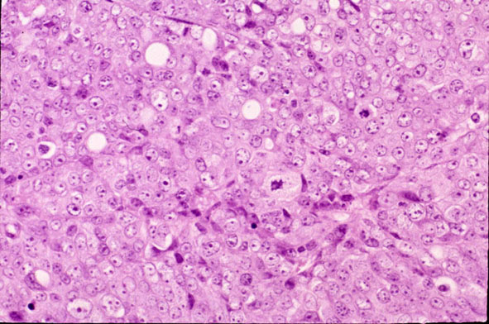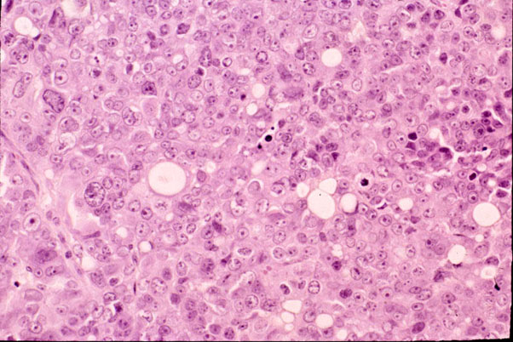
a) Non-therapy group
b) Therapy group

Figure 3 High magnification of tumor tissue. High magnification revealed tumor tissue in both the non-therapy group (A), and in the therapy (B) group. The number of mitoses (arrowheads) in the non-therapy group was larger than that in the therapy group (HE, × 400).
Fig. 4

- Non-therapy group b) Therapy group
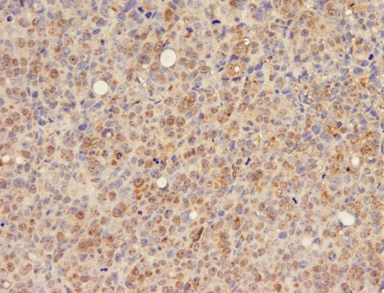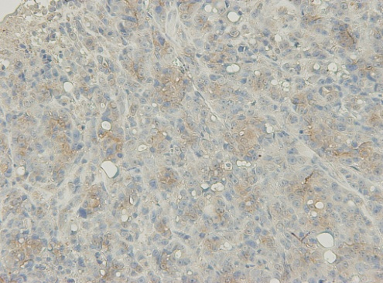

Figure 4 Immunohistochemical staining of tumor tissue. Immunoreactivity for vascular endothelial growth factor (VEGF) was mainly identified as supuranuclear staining or diffused staining in the cytoplasm of cancer cells. A: All 5 mice in the non-therapy group according to the percentage of positive tumor staining were in category 3, with 50% or more cells stained (VEGF, × 200); B: All 5 mice in the therapy group were in category 2, with 30 to 49 % stained (VEGF, × 200).

Fig. 5

0

.2

.4

.6

.8

1

0

5

10

15

20

25

30

35

40

day
Longrank test:P=0.005
Non-therapy group (n=5)
Therapy group (n=5)

Figure 5 Survival curves. Survival curves of the bevacizumab-treated (n = 5), and the untreated mice (n = 5). The mean survival duration of the treated mice was 30.8 d, and of the untreated mice was 23.6 d (P = 0.005).

Table 1 Comparison of cytokines between MKN-45 and MKN-45P

 | IL-1β  (pg/mL) | IL-6  (pg/mL) | IL-8  (pg/mL) | VEGF  (pg/mL) | MMP-2  (ng/mL) | TIMP-1  (ng/mL)
MKN-45 | 0.9 ± 0.7 | 1.2 ± 0.7 | 381.9 ± 147.1 | 1335.0 ± 624.3 | 0.3 ± 0.1 | 2.7 ± 1.8
MKN-45P | 0.4 ± 0.2 | 2.9 ± 0.6 | 891.4 ± 210.2 | 3806.0 ± 229.8 | 0.7 ± 0.5 | 6.0 ± 4.0
P value | 0.109 | 0.045 | 0.011 | 0.013 | 0.021 | 0.126
IL: Interleukin; VEGF: Vascular endothelial growth factor; MMP: Matrix metalloproteinase; TIMP: Tissue inhibitor of metalloproteinase.
.

Table 2 Number of tumor nodules, volume of ascites, body weight, frequency of hydronephrosis and mitotic index in the mice treated with bevacizumab and the untreated mice
Treatment | n | Tumor nodules | Ascites (mL) | Body weight (g) | Hydronephrosis |  | Mitosis index
 |  |  |  |  | Right kidney | Left kidney
Non-therapy | 5 | 16.64 ± 5.06¹ | 0.60 ± 0.51² | 12.21 ± 0.51³ | 4 (80) | 2 (40) | 21.0 ± 5.7^{b}
Therapy | 5 | 17.66 ± 3.45 | 0.04 ± 0.03 | 12.41 ± 0.61 | 2 (40) | 1 (20) | 9.6 ± 2.1

¹P = 0.783; ²P = 0.042; ³P = 0.591; ^{b}P < 0.01 vs therapy group.

