Supplementary Table 1. Comparison of the survival for each N classification in the same T category
T stage |  | N0 |  | N1 |  | N2 |  | N3a |  | N3b
 |  | χ² | P | χ² | P | χ² | P | χ² | P | χ² | P
T1 | N0 |  |  | 92.572 | .000 | 52.345 | .000 | 64.530 | .000 | 33.209 | .000
 | N1 | 92.572 | .000 |  |  | .204 | .652 | 10.732 | .001 | 8.602 | .003
 | N2 | 52.345 | .000 | .204 | .652 |  |  | 6.078 | .014 | 7.547 | .006
 | N3a | 64.530 | .000 | 10.732 | .001 | 6.078 | .014 |  |  | .844 | .358
 | N3b | 33.209 | .000 | 8.602 | .003 | 7.547 | .006 | .844 | .358
T2 | N0 |  |  | 25.557 | .000 | 45.016 | .000 | 51.500 | .000 | 79.780 | .000
 | N1 | 25.557 | .000 |  |  | 3.689 | .045 | 11.660 | .001 | 36.723 | .000
 | N2 | 45.016 | .000 | 3.689 | .045 |  |  | 3.177 | .055 | 23.927 | .000
 | N3a | 51.500 | .000 | 11.660 | .001 | 3.177 | .055 |  |  | 11.477 | .001
 | N3b | 79.780 | .000 | 36.723 | .000 | 23.927 | .000 | 11.477 | .001
T3 | N0 |  |  | 130.836 | .000 | 323.125 | .000 | 689.153 | .000 | 564.545 | .000
 | N1 | 130.836 | .000 |  |  | 35.706 | .000 | 194.492 | .000 | 219.734 | .000
 | N2 | 323.125 | .000 | 35.706 | .000 |  |  | 64.871 | .000 | 113.420 | .000
 | N3a | 689.153 | .000 | 194.492 | .000 | 64.871 | .000 |  |  | 27.299 | .000
 | N3b | 564.545 | .000 | 219.734 | .000 | 113.420 | .000 | 27.299 | .000
T4a | N0 |  |  | 38.851 | .000 | 110.338 | .000 | 213.015 | .000 | 256.033 | .000
 | N1 | 38.851 | .000 |  |  | 12.889 | .000 | 58.801 | .000 | 99.205 | .000
 | N2 | 110.338 | .000 | 12.889 | .000 |  |  | 21.510 | .000 | 59.556 | .000
 | N3a | 213.015 | .000 | 58.801 | .000 | 21.510 | .000 |  |  | 15.865 | .000
 | N3b | 256.033 | .000 | 99.205 | .000 | 59.556 | .000 | 15.865 | .000

Supplemental Table 2 Compared the OS of patients with T1N1’ and T1N2’ stages to the stages according to the eighth edition of the TNM staging system.
Stage | Ia |  | Ib |  | IIa |  | IIb |  | IIIa |  | IIIb |  | IIIc |  | T1N1’ |  | T1N2’
 | χ² | P | χ² | P | χ² | P | χ² | P | χ² | P | χ² | P | χ² | P | χ² | P | χ² | P
Ia |  |  | 88.097 | .000 | 706.267 | .000 | 1681.612 | .000 | 3078.382 | .000 | 4125.434 | .000 | 3692.349 | .000 | 316.428 | .000 | 231.581 | .000
Ib | 88.097 | .000 |  |  | 125.609 | .000 | 454.680 | .000 | 957.816 | .000 | 1467.736 | .000 | 1533.944 | .000 | 57.277 | .000 | 92.464 | .000
IIa | 706.267 | .000 | 125.609 | .000 |  |  | 187.998 | .000 | 766.365 | .000 | 1388.257 | .000 | 1353.591 | .000 | 1.936 | .164 | 21.700 | .000
IIb | 1681.612 | .000 | 454.680 | .000 | 187.998 | .000 |  |  | 192.084 | .000 | 593.036 | .000 | 670.901 | .000 | 99.903 | .000 | .473 | .492
IIIa | 3078.382 | .000 | 957.816 | .000 | 766.365 | .000 | 192.084 | .000 |  |  | 147.621 | .000 | 268.287 | .000 | 319.109 | .000 | 6.594 | .010
IIIb | 4125.434 | .000 | 1467.736 | .000 | 1388.257 | .000 | 593.036 | .000 | 147.621 | .000 |  |  | 55.519 | .000 | 585.672 | .000 | 28.421 | .000
IIIc | 3692.349 | .000 | 1533.944 | .000 | 1353.591 | .000 | 670.901 | .000 | 268.287 | .000 | 55.519 | .000 |  |  | 683.122 | .000 | 54.473 | .000
T1N1’ | 316.428 | .000 | 57.277 | .000 | 1.936 | .164 | 99.903 | .000 | 319.109 | .000 | 585.672 | .000 | 683.122 | .000 |  |  | 24.378 | .000
T1N2’ | 231.581 | .000 | 92.464 | .000 | 21.700 | .000 | .473 | .492 | 6.594 | .010 | 28.421 | .000 | 54.473 | .000 | 24.378 | .000

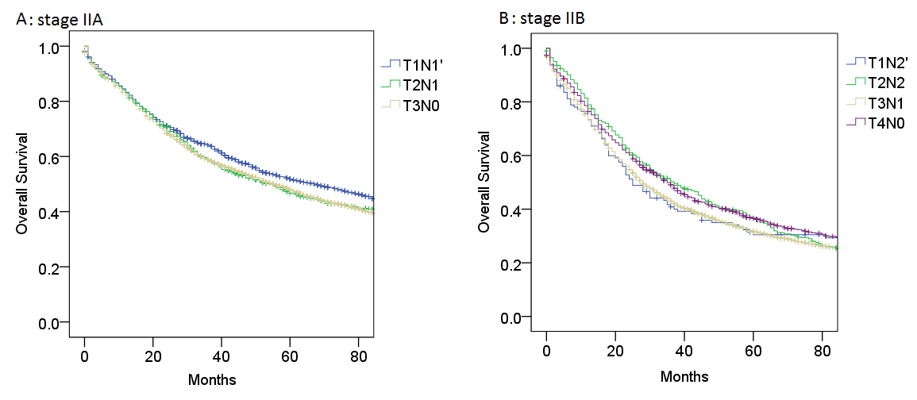
Supplemental Figure 1: Compared the T1N1’ to the subgroups of stage IIA (A), and T1N2’ to subgroups of stage IIB (B).

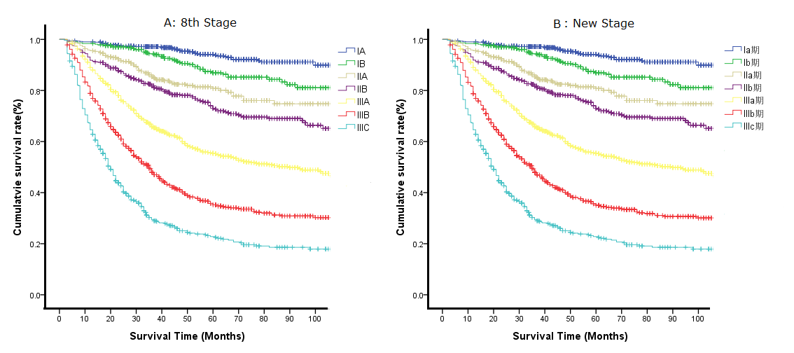
Supplemental Figure 2. The survival curves of the FMUUH data set for gastric cancer patients. (A) The eighth edition TNM staging system; (B) The new TNM staging system.

