Name of journal: World Journal of Gastroenterology
ESPS Manuscript NO: 8474
Columns: CASE REPORT

Fever as a first manifestation of advanced gastric adenosquamous carcinoma: A case report

Ajoodhea H et al. Advanced gastric ASC manifested as fever

Harsha Ajoodhea, Ren-Chao Zhang, Xiao-Wu Xu, Wei-Wei Jin, Ke Chen, Yong-Tao He, Yi-Ping Mou

Harsha Ajoodhea, Ren-Chao Zhang, Xiao-Wu Xu, Wei-Wei Jin, Ke Chen, Yi-Ping Mou, Department of General Surgery, Sir Run Run Shaw Hospital, School of Medicine, Zhejiang University, Hangzhou 310016, Zhejiang Province, China

Yong-Tao He, Department of Pathology, Sir Run Run Shaw Hospital, School of Medicine, Zhejiang University, Hangzhou 310016, Zhejiang Province, China

Author contributions: Zhang RC, Xu XW and Mou YP performed the operation; Jin WW and Chen K collected case data; He YT proofread all the pathological data; Ajoodhea H, Zhang RC wrote the manuscript; Mou YP proofread and revised the manuscript; all authors approved the version to be published.

Supported by Zhejiang Provincial Natural Science Foundation of China under Grant No. LQ13H160007

Correspondence to: Yi-Ping Mou, MD, FACS, Department of General Surgery, Sir Run Run Shaw Hospital, School of Medicine, Zhejiang University, 3 East Qingchun Road, Hangzhou 310016, Zhejiang Province, China. mouyp@srrsh.com

Telephone: +86-571-86006952 Fax: +86-571-86044817
Received: December 28, 2013 Revised: March 24, 2014
Accepted: April 21, 2014

Published online:

Abstract
Gastric adenosquamous carcinoma is a rare type of gastric cancer. It is a mixed neoplasia, consisting of glandular cells and squamous cells. It is often diagnosed at an advanced stage, thus carrying a worse prognosis. We, here, describe the case of a 73 year old male, who presented with refractory fever and an intra-abdominal mass upon imaging. He underwent a laparoscopic exploration and subsequently followed by a successful totally laparoscopic total gastrectomy with D2 lymphadenectomy for gastric cancer. Post operative pathology revealed primary gastric adenosquamous carcinoma (T4aN0M0). The patient underwent adjuvant radiotherapy and chemotherapy with S1 and is alive 20 mo post surgery without any recurrences. This is a rare case of advanced gastric adenosquamous carcinoma with fever as initial presentation and treated by totally laparoscopic total gastrectomy to be reported in English literature.

© 2014 Baishideng Publishing Group Co., Limited. All rights reserved.

Key words: Gastric adenosquamous carcinoma; Advanced gastric cancer; Malignant tumor; Laparoscopic gastrectomy; Totally laparoscopic total gastrectomy

Core tip: Totally laparoscopic total gastrectomy for a case of advanced primary adenosquamous carcinoma of the stomach with fever as manifestation is an interesting combination of surgical treatment of a rare lesion with an atypical presentation with a not so commonly performed complex procedure. Given the aggressive nature and advanced stage at diagnosis, no report has been recorded in the English literature for the same. In our opinion, this is a first to be reported in the English literature.

Ajoodhea H, Zhang RC, Xu XW, Jin WW, Chen K, He YT, Mou YP. Fever as a first manifestation of advanced gastric adenosquamous carcinoma: A case report. World J Gastroenterol 2014; In press
Available from: URL: http://www.wjgnet.com/esps/
DOI: DOI:10.3748/wjg.v20.i0.0000

INTRODUCTION
The first reported case of gastric adenosquamous carcinoma was by Rolleston and Trevor^{[1]}. Adenosquamous carcinoma accounts for less than 1 % of all gastric cancer worldwide^{[2]}, compared to the predominant adenocarcinoma type which has an incidence of more than 90%^{[3]}. Since the first reported case, it has only been reported as case reports (Table 1), mostly from Asian countries^{[4-6]} and very few case series (Table 2) has been reported in the English literature^{[5-41]}. It has a male to female preponderance with a 4:1 ratio, and peak in the 6th decade of life, occurring on average earlier than sporadic adenocarcinoma^{[2]}. It is usually aggressive in nature, diagnosed at an advanced stage and carries a worse prognosis than adenocarcinoma^{[2]}.
The application of laparoscopic approaches for distal gastric lesions- benign or early gastric cancers has been accepted all over the world. The advantages and long term benefits in these patients are also very well known and appreciated. Despite the advances in minimally invasive techniques and its advantages, several issues have been raised in the setting of a totally laparoscopic total gastrectomy. Moreover, in patients with advanced cancer, minimally invasive approach has not been so commonly and readily used. The case presented here is that of an advanced primary adenosquamous carcinoma, extending to the serosal layer. This is a rare case of adenosquamous carcinoma treated completely laparoscopically to be reported in the English literature.

CASE REPORT
We report the case of a 73 year old male, who was referred to the surgical department after refractory medical treatment for irregularly high fever. The patient was previously treated for pneumonia 2 mo before being admitted to the infectious disease department for irregularly high fever. Except for mild anemia (hemoglobin 8 g/L), white blood cell (WBC) 15.8 × 10⁹/L and C-reactive protein (CRP) 72.4 mg/L, all other laboratory tests, physical examination and past/family history were insignificant. Despite aggressive treatment, his fever (Figure 1A) was persistent and WBC level (Figure 1B) and CRP level (Figure 1C) increased. He was then referred to the surgical department due to the presence of an intra-abdominal mass found upon imaging. An abdominal ultrasound revealed a hypoechoic mass in the upper abdomen suggesting gastric cancer with surrounding lymph nodes involvement. The abdominal computed tomography showed a mass in upper abdomen between the stomach and the left lobe of the liver (Figure 2). The gastroscope showed a raised lesion on the gastric antrum surface, with ulceration and involving the lower part of the body of stomach (Figure 3). The preoperative biopsy pathological result was an adenocarcinoma, with Helicobacter pylori positive. The patient underwent a totally laparoscopic total gastrectomy accompanied by D2 lymphadenectomy and an esophagojejunal Roux-en-Y anastomosis was performed. The patient was placed in the supine position with the head slightly elevated under general anesthesia. The surgeon and the second assistant holding the laparoscope stood on the right side of the patient and the first assistant stood on the left. Carbon dioxide pneumoperitoneum was established (CO₂ at 15 mmHg) using Veress needle. A first 10-mm trocar was placed for the laparoscope at the umbilicus. A 30-degree telescope was inserted to examine the peritoneal cavity to rule out metastasis disease and feasibility of the procedure. After general examination, additional four trocars (one of 12 mm, three of 5 mm) were inserted and the five trocars were arranged in a V-shape. The operation was started by retracting the greater omentum superiorly using the grasper and bluntly dissected along the transverse colon border to enter the lesser sac (Figure 4A). The stomach together with the greater omentum was then retracted superiorly using the grasper to allow better visualization of anatomical landmarks. The right gastroepiploic vessels were identified, clipped using hem-o-lock and cut off (Figure 4B and C). Next, mobilization began at the superior edge of the pancreas, thus revealing the celiac trunk. The common hepatic artery, right gastric artery, left gastric artery and splenic artery and their respective lymph nodes were identified and excised. The right gastric artery、left gastric artery and vein were then clipped using the hem-o-lock and cut off (Figure 4D). The hepatoduodenal and hepatogastric ligament were then dissected off. The esophageal wall was detached from the surrounding and completely mobilized (Figure 4E). The cardia vagus nerve was cut off 3 cm up above the cardia. Once the structures have been completely mobilized, the duodenum was then transected using an endoscopic linear stapler 3cm away from the pylorus (Figure 4F). 20 cm away from the ligament of Treitz, the jejunum was stapled using an endoscopic linear stapler. A small opening was made 10 cm away from the stump on the distal jejunum and the latter was then pulled up to the esophagus, in which a small side opening was also made. A side to side antiperistaltic esophagojejunostomy was then performed using linear staplers (Figure 4G) and then the entry hole was also closed using staplers (Figure 4H). The esophagus wall was sutured to the diaphragm wall so as to avoid tension and thus preventing anastomotic failure. The specimen was put in a retrieval bag and pulled out through an enlarged umbilical incision. Pneumoperitoneum was re-established. A usual Roux-en-Y anastomosis was done laparoscopically between the distal jejujum (40 cm from the esophagojejunostomy) and the proximal jejujum. Any defect in mesentery was closed. The post operative pathology result was a 8 cm × 7.5 cm sized gastric adenosquamous carcinoma (Figure 5), located in the body and antrum, with a 3 cm × 2 cm central ulcer, invading the serosal layer. Pathological findings showed adenocarcinoma component with glandular formation, and squamous cell component with keratinization (Figure 6A, B). There was no obvious borderline seen between the two components. The adenocarcinoma cells were well to moderately differentiated, with a proportion of 40%, found in the upper one third and the squamous cells were well differentiated with a proportion of 60%, found in the lower two-thirds. Additional immunohistochemical staining for CK Low (Figure 6C) showed strong positive for adenocarcinoma and staining for P63 (Figure 6D) showed nuclear positive for squamous cell carcinoma. No lymph node metastasis (0/35), lymphatics or vascular invasion were found and a negative margin was achieved (TNM staging was Stage IV-T4a N0 M0 and Bormann type 4).
After surgery, there was an immediate decrease in temperature (Figure 7A), WBC (Figure 7B) and CRP level (Figure 7C). He was started on liquid food 3 days after surgery, followed by semi-liquid food on the 8th day. The length of total post operative hospital stay was 14 d. No postoperative morbidity was noted. Post operation, the patient underwent adjuvant radiotherapy and chemotherapy with S1. He was followed for nearly 20 mo and was in good health without any recurrence as confirmed by CT scan on follow up. His nutritional status was reported to be better compared to preoperative status.

DISCUSSION
Adenosquamous carcinoma is one of the special types of gastric cancers. It occurs mostly in the distal and the body of the stomach (Table 1). Macroscopically, most tumors are Bormann type 2 or 3 advanced gastric cancer^{[7]}. Very few reports are available in the English literature for early gastric adenosquamous carcinoma^{[41]}. The most common site of metastasis is the liver^{[7]} and lymphovascular metastases are usually common^{[8]}. For diagnosis of true adenosquamous carcinoma, collision tumors should be excluded. True adenosquamous carcinoma is a combination of an adenocarcinoma and squamous cell carcinoma, with transitions between the two components^{[9]}. Though, the lesion is a combination of the two different histologic types, the biologic behavior is decided by the adenocarcinoma component.

The main highlights of this case report are: (1) atypical presentation of the patient; (2) presence of adenosquamous carcinoma at final post operative diagnosis; and (3) totally laparoscopic total gastrectomy for advanced gastric cancer. The usual chief complaints of patients with gastric adenosquamous carcinoma are similar as any gastric adenocarcinoma patient, namely epigastric pain, nausea and vomiting and so on^{[8]}. This is a first case of advanced gastric adenosquamous carcinoma to be reported in the English literature with fever as the initial presentation. Preoperatively, it was difficult to rule out lung infection as the cause of the fever, given the patient’s previous history of pneumonia. Due to non responsiveness to medical treatment, the patient was taken to surgery as a case of suspected fever due to gastric cancer. The preoperative fever in this patient is believed to be associated with some necrotic tissues found in the lesion. Effectively, there was a decrease in temperature immediately post operation, along with the WBC and CRP levels, which confirmed the gastric mass as the cause of the fever.
What further makes this case an interesting one is the presence of squamous cells in a glandular cellular area not contiguous with squamous epithelium, final pathological diagnosis being gastric adenosquamous carcinoma. Despite the first reported case more than 1 century ago, no definite clarity is available till date on its histogenesis.
Few hypotheses^{[2]} have been mentioned regarding its origin, namely: (1) metaplastic transformation of an adenocarcinoma; (2) cancerization of metasplastic squamous cell; (3) cancerization of ectopic squamous epithelium; (4) collision of an adenocarcinoma and a squamous cell carcinoma; and (5) stem cell differentiation towards both cellular lines. Furthermore, another noteworthy point here is the mismatch in preoperative and post operative pathological result. This may be explained due to the fact that despite gastroscope being the gold standard for gastric cancer, the tissue sample taken during the biopsy was where differentiation into adenosquamous cells have not occurred or not yet occurred. Therefore, our preoperative biopsy result was only gastric adenocarcinoma. Hence, adenosquamous carcinoma cannot be precisely ruled out preoperatively and should be considered as a differential diagnosis, especially in patients with atypical presentations.
In our opinion, this is a first case of primary advanced gastric adenosquamous carcinoma with fever as initial manifestation treated by totally laparoscopic total gastrectomy to be reported in the English literature. In the treatment of gastric cancer, laparoscopic surgery has been adopted since 1991. In 1994, laparoscopy-assisted distal gastrectomy (LADG) with lymph node dissection was first applied by Kitano et al^{[10]}. Since the safety and surgical quality of LADG have been proved to be equivalent to open gastrectomy, LADG has been accepted as a less invasive treatment for early gastric cancer^{[11]}. Advances in laparoscopic surgical techniques have made it possible to now perform all of the necessary surgical procedures, including an intra-abdominal reconstruction^{[11]}. Thereby, leading to the introduction of totally laparoscopic distal gastrectomy. But unfortunately, totally laparoscopic total gastrectomy with D2 lymphadenectomy is yet to be popular due to the complexity of the procedure. Our case presented here underwent a totally laparoscopic total gastrectomy with D2 lymphadenectomy and esophagojejunostomy Roux-en-Y anastomosis (antiperistaltic side to side anastomosis). Our patient had an uneventful and quick recovery post operation without any morbidity. He underwent adjuvant radiotherapy and S1 chemotherapy and was still alive 20 mo post operation, without any recurrence. Therefore, laparoscopic surgery should be considered for advanced gastric cancer patients in selected high volume centers and by highly specialized laparoscopic surgeons.
To conclude, primary advanced gastric adenosquamous carcinoma can also present with atypical manifestations and should be considered as a differential diagnosis in atypical gastric cancer patients. Surgery should definitely be attempted in such patients.

COMMENTS
Case characteristics
A case of advanced gastric adenosquamous cancer in a 73 year old male who presented with irregularly high fever refractory to medical treatment.

Clinical diagnosis
He was diagnosed initially as lung infection due to the presence of irregularly high fever at presentation.

Differential diagnosis

For differential diagnosis, lung infection, fever of unknown origin, cancer related fever were considered and therefore, blood and sputum cultures, sputum acid fast staining, PPD test, TSPOT test , bone marrow aspiration, abdominal untrasound, computed tomography and bone scintigraphy were ordered.

Imaging diagnosis
An abdominal ultrasound revealed a hypoechoic mass in the upper abdomen suggesting gastric cancer with surrounding lymph nodes involvement and the abdominal computed tomography showed a mass in upper abdomen between the stomach and the left lobe of the liver.

Pathological diagnosis
The preoperative pathological was adenocarcinoma, with Helicobacter Pylori positive.

Treatment
A totally laparoscopic total gastrectomy was done and post operation the patient underwent radiotherapy and chemotherapy with S1.

Experiences and lessons
Primary gastric adenosquamous carcinoma can also present with atypical manifestations and should be considered as a differential diagnosis in atypical gastric cancer patients, even if the preoperative pathological results state otherwise and surgery should be attempted in such patients.

Peer review
Adenosquamous carcinoma of the stomach is very rare, and fever is an unusual presentation of gastric cancer. Furthermore, totally laparoscopic surgery is not usually performed for advanced gastric cancer. Thus, the present case is interesting and worth reporting.

REFERENCES
1 Lee YB, Choi IJ. Adenoacanthoma of pyloric antrum of the stomach. Report of a case. Yonsei Med J 1970; 11: 60-66 [PMID: 5516845]
2 Faria GR, Eloy C, Preto JR, Costa EL, Almeida T, Barbosa J, Paiva ME, Sousa-Rodrigues J, Pimenta A. Primary gastric adenosquamous carcinoma in a Caucasian woman: a case report. J Med Case Rep 2010; 4: 351 [PMID: 21034475 DOI: 10.1186/1752-1947-4-351]
3 Crew KD, Neugut AI. Epidemiology of gastric cancer. World J Gastroenterol 2006; 12: 354-362 [PMID: 16489633]
4 Mori M, Iwashita A, Enjoji M. Adenosquamous carcinoma of the stomach. A clinicopathologic analysis of 28 cases. Cancer 1986; 57: 333-339 [PMID: 3942965 DOI: 10.1002/1097-0142(19860115)57: 2<333: : AID-CNCR2820570224>3.0.CO; 2-U]
5 Yoshida K, Manabe T, Tsunoda T, Kimoto M, Tadaoka Y, Shimizu M. Early gastric cancer of adenosquamous carcinoma type: report of a case and review of literature. Jpn J Clin Oncol 1996; 26: 252-257 [PMID: 8765185 DOI: 10.1093/oxfordjournals.jjco.a023224]
6 Toyota N, Minagi S, Takeuchi T, Sadamitsu N. Adenosquamous carcinoma of the stomach associated with separate early gastric cancer (type IIc). J Gastroenterol 1996; 31: 105-108 [PMID: 8808437 DOI: 10.1007/BF01211195]
7 Endo K, Kohnoe S, Okamura T, Haraguchi M, Adachi E, Toh Y, Baba H, Maehara Y. Gastric adenosquamous carcinoma producing granulocyte-colony stimulating factor. Gastric Cancer 2005; 8: 173-177 [PMID: 16086120 DOI: 10.1007/s10120-005-0330-y]
8 Ebi M, Shimura T, Yamada S, Hirata Y, Tsukamoto H, Okamoto Y, Mizoshita T, Tanida S, Kataoka H, Kamiya T, Inagaki H, Joh T. A patient with gastric adenosquamous carcinoma with intraperitoneal free cancer cells who remained recurrence-free with postoperative S-1 chemotherapy. Intern Med 2012; 51: 3125-3129 [PMID: 23154717]
9 World Health Organization Classification of Tumours: Pathology and Genetics of Tumours of the Digestive System
10 Kitano S, Iso Y, Moriyama M, Sugimachi K. Laparoscopy-assisted Billroth I gastrectomy. Surg Laparosc Endosc 1994; 4: 146-148 [PMID: 8180768]
11 Sakaguchi Y, Ikeda O, Ohgaki K, Oki E, Chinen Y, Sakamoto Y, Minami K, Toh Y, Okamura T. Totally Laparoscopic Gastrectomy for Gastric Cancer Associated with Recklinghausen's Disease. Diagn Ther Endosc 2010; 2010: 682401 [PMID: 20672006 DOI: 10.1155/2010/682401]
12 Straus R, Heschel S, Fortmann DJ. Primary adenosquamous carcinoma of the stomach. A case report and review. Cancer 1969; 24: 985-995 [PMID: 5353950 DOI: 3.0.CO; 2-4']
13 Taira Y, Ogata H, Tsuchiyama H. Two autopsy cases of primary adenoacanthoma of the stomach. Acta Pathol Jpn 1976; 26: 223-228 [PMID: 1274582]
14 Fujitomi Y, Uchida Y, Shibata O, Baba K, Shigemitsu O, Hadama T, Shirabe J, Nakayama I, Kai T. [Case of adenosquamous carcinoma of the stomach showing Borrmann 4 type and elevated serum CEA]. Nihon Shokakibyo Gakkai Zasshi 1983; 80: 1327-1330 [PMID: 6620658]
15 Jalif AR, López OJ, Díaz de Battaglini SM, Bur EG. [Gastric adenoacanthoma. Report of a case and review of the literature]. Acta Gastroenterol Latinoam 1984; 14: 79-84 [PMID: 6524271]
16 Sato N, Wada K, Kobayashi K, Hirai H, Yagi M. [A case of primary adenosquamous carcinoma of the stomach associated with gastric polyposis]. Gan No Rinsho 1984; 30: 292-295 [PMID: 6716661]
17 Matsumoto K, Sugiyama Y, Miyagishima K, Murakami T, Yamagata N, Tsuchida H, Sasamura M. [Primary adenosquamous carcinoma of the stomach--a case report]. Gan No Rinsho 1984; 30: 1726-1731 [PMID: 6513026]
18 Masuda T, Kizaki M, Akaiwa Y, Kamiya T, Suzuki O, Okawa H, Kiryu Y, Kikuchi K, Kakumoto Y, Nakagawa Y. [A case of primary adenosquamous carcinoma of the stomach preoperatively diagnosed by endoscopic biopsy]. Gan No Rinsho 1985; 31: 212-216 [PMID: 3989990]
19 Horikawa M, Miyagi N, Nakatani K, Shiratori T, Tsutsumi M, Takahashi S, Konishi Y. [A case of early primary adenosquamous carcinoma of the stomach]. Gan No Rinsho 1987; 33: 305-310 [PMID: 3586347]
20 Johzaki H, Murayama H, Maekawa T, Kikuchi M, Satoh M. [A case of small squamous cell carcinoma with a grading of IIa + IIc, an early gastric cancer type]. Gan No Rinsho 1988; 34: 1025-1030 [PMID: 3404655]
21 Butov IuL, Sadchikov VD. [Adenosquamous early gastric carcinoma]. Arkh Patol 1989; 51: 76-77 [PMID: 2803046]
22 Shigematsu T, Nakamura K, Fukui K, Morita H, Samejima Y, Goto T, Inagaki J, Kimura K, Kasugai T, Nishikawa K. [A primary gastric adenosquamous carcinoma with remarkable lymphatic metastasis diagnosed by the stomach and lymph node biopsy]. Gan No Rinsho 1989; 35: 421-426 [PMID: 2648049]
23 Yamamoto K, Ohnishi A, Noda S, Umezaki H, Yamamoto T. [An autopsy case of carcinomatous sensory neuropathy associated with gastric adenosquamous carcinoma]. Rinsho Shinkeigaku 1989; 29: 493-496 [PMID: 2612103]
24 Honda H, Satomi T, Fujita T, Hamagaki H, Hayashi M, Ichimiya M, Numoto S. [A primary adenosquamous carcinoma of the stomach difficult to differentiate from gastric ulcer]. Gan No Rinsho 1990; 36: 193-197 [PMID: 2308211]
25 Tsukino H, Kusumoto S, Nagamachi S, Watanabe K, Koga Y, Kataoka H. [A case of primary adenosquamous carcinoma of the stomach showing Borrmann 4 type]. Rinsho Hoshasen 1990; 35: 649-652 [PMID: 2381113]
26 Kawabe K, Nakanuma Y, Terada T, Nakamura Y. Adenosquamous carcinoma of the stomach presenting "giant gastric folds". Gastroenterol Jpn 1990; 25: 739-745 [PMID: 2279636]
27 Coard KC, Titus IP. Adenosquamous carcinoma of the stomach. With a note on pathogenesis. Trop Geogr Med; 43: 234-237 [PMID: 1750122]
28 Tenma K, Nakamura T, Kano T, Suzuki T, Ohashi Y, Masaoka T, Sato K. [A case report of adenosquamous cell carcinoma of the stomach responding well to combination chemotherapy]. Gan To Kagaku Ryoho 1993; 20: 647-650 [PMID: 8470924]
29 Ito T, Nishida H, Kawada T, Senjyu S, Nanbu K, Nishikawa J, Onuki M, Mitamura K, Ito Y, Koike T. [A case of gastric adenosquamous carcinoma with cystic hepatic metastasis]. Nihon Shokakibyo Gakkai Zasshi 1993; 90: 1445-1449 [PMID: 8320854]
30 Cabello Rodríguez M, Somoza de Saint-Palais M, Rueda Pérez JM, Montero Vázquez JM, Merino Royo E, Carabot Rodríguez-Rubio A, Barrera Alvarez F, Cabezudo San José R. [Adenosquamous carcinoma of the stomach]. Rev Esp Enferm Dig 1994; 86: 757-760 [PMID: 7986617]
31 Manna ED, Seixas AA, de Araújo RP, Ferro MC. [Primary adenosquamous carcinoma of the stomach]. Rev Assoc Med Bras; 44: 152-154 [PMID: 9699336 DOI: 10.1590/S0104-42301998000200016]
32 Mori E, Watanabe A, Maekawa S, Itasaka H, Maeda T, Yao T. Adenosquamous carcinoma of the remnant stomach: report of a case. Surg Today 2000; 30: 643-646 [PMID: 10930231 DOI: 10.1007/s005950070105]
33 Blázquez S, Raventós A, Díaz ML, García-Fontgivell JF, Martínez S, Sirvent JJ. Adenosquamous gastric carcinoma in Caucasian patient. Rev Esp Enferm Dig 2005; 97: 211-212 [PMID: 15839815 DOI: 10.4321/S1130-01082005000300009]
34 Nomura M, Inoue Y, Fujita S, Sakao J, Hirota M, Souda S. [A case of gastric adenosquamous carcinoma with abdominal paraaortic lymph node metastases successfully treated by TS-1 plus CDDP neoadjuvant chemotherapy]. Gan To Kagaku Ryoho 2006; 33: 99-103 [PMID: 16410707]
35 Terada T. Adenosquamous Carcinoma of the Stomach: Report of Two Cases. Gastroenterol Res 2009; 2: 54-56 [doi: 10.4021/gr2009.01.1261]
36 Fukuda Y, Takeshima F, Ogihara K, Shoji H, Akazawa Y, Tsutsumi T, Abe K, Mizuta Y, Isomoto H, Nakao K. [Successful management of liver metastasis from gastric adenosquamous carcinoma with adjuvant chemotherapy and radiofrequency ablation]. Nihon Shokakibyo Gakkai Zasshi 2012; 109: 606-614 [PMID: 22481262]
37 Saito H, Oyama K, Fushida S, Tsukada T, Okamoto K, Nakanuma N, Kinoshita J, Makino I, Nakamura K, Hayashi H, Inokuchi M, Nakagawara H, Miyashita T, Fujita H, Tajima H, Takamura H, Ninomiya I, Kitagawa H, Fujimura T, Ohta T. [A case of gastric adenosquamous carcinoma producing granulocyte-colony stimulating factor]. Gan To Kagaku Ryoho 2013; 40: 799-802 [PMID: 23863662]
38 Aoki Y, Tabuse K, Wada M, Katsumi M, Uda H. Primary adenosquamous carcinoma of the stomach: experience of 11 cases and its clinical analysis. Gastroenterol Jpn 1978; 13: 140-145 [PMID: 669198]
39 Namatame K, Ookubo M, Suzuki K, Sagawa H, Nagashima T, Kataba Y, Maruyama U, Watanabe H. [A clinicopathological study of five cases of adenosquamous carcinoma of the stomach]. Gan No Rinsho 1986; 32: 170-175 [PMID: 3959337]
40 Rottenberg VI. [Glandular-squamous cell stomach cancer]. Arkh Patol 1987; 49: 19-24 [PMID: 3606413]
41 Kimura Y, Matsuda H, Saeki H, Oki E, Morita M, Sugimachi K, Yamashita Y, Ikegami T, Uchiyama H, Yoshizumi T, Soejima Y, Kawanaka H, Ikeda T, Tsutsui S, Fujihara M, Mimori K, Watanabe M, Ishida T, Maehara Y. Case of early adenosquamous carcinoma of the stomach. Fukuoka Igaku Zasshi 2013; 104: 315-320 [PMID: 24364267]

P-Reviewers: Takahashi Y, Zhu YL S-Editor: Gou SX L-Editor: E-Editor:

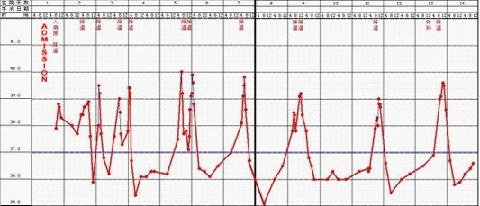
A

B

C
Figure 1 Pre operative graph. A: Pre operative temperature graph; B: Pre operative white blood cell (WBC); C: C-reactive protein (CRP) level graph.

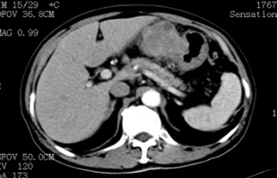
Figure 2 Abdominal computed tomography showing an upper abdominal mass between left lateral hepatic lobe and stomach.

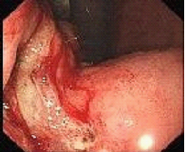
Figure 3 Gastroscope. Gastric antrum raised lesion, with ulceration, easy to bleeding and involving the lower part of the body of stomach.

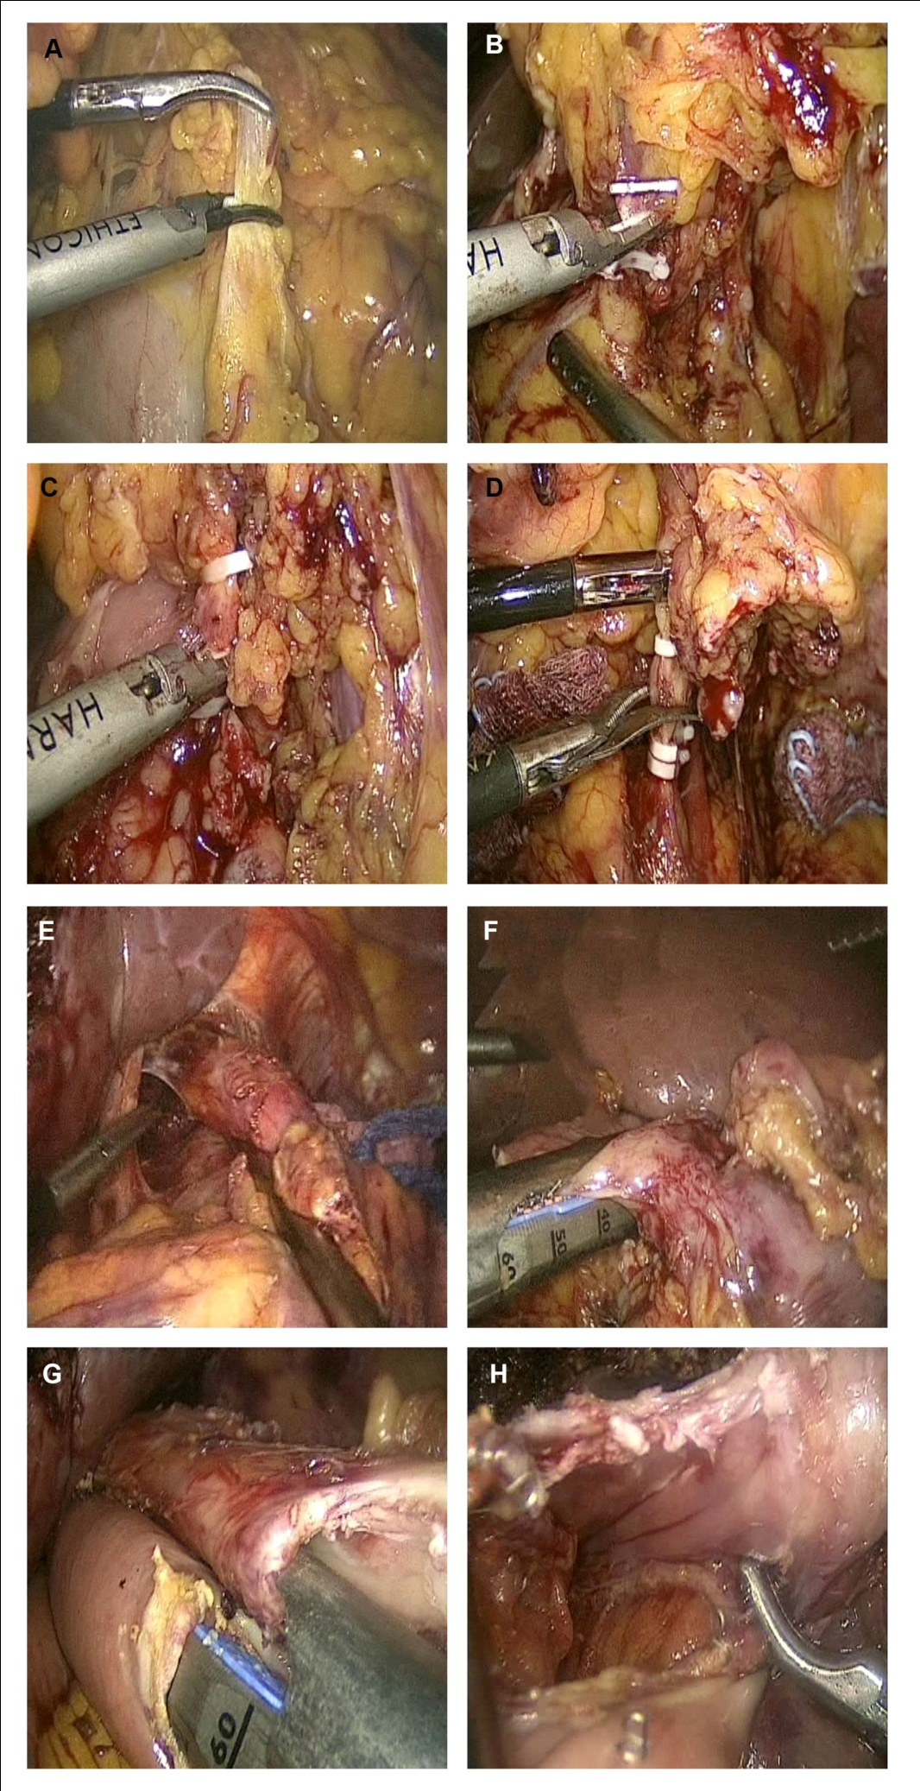
Figure 4 Surgical procedure. A: Dissection of the greater omentum; B, C: Clipping and cutting of right gastroepiploic vein and artery, respectively; D: Clipping and cutting of left gastric artery; E: Mobilization of esophagus; F: Transection of duodenum; G: Antiperistaltic reconstruction of esophagus and jejunum using linear stapler; H: Entry hole as seen after stapling.

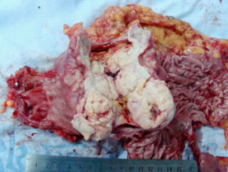

Figure 5 Gross operative specimen. A 8 cm × 7.5 cm sized mass with a 3 cm × 2 cm ulcer, invading the serosal layer (mass cut open).

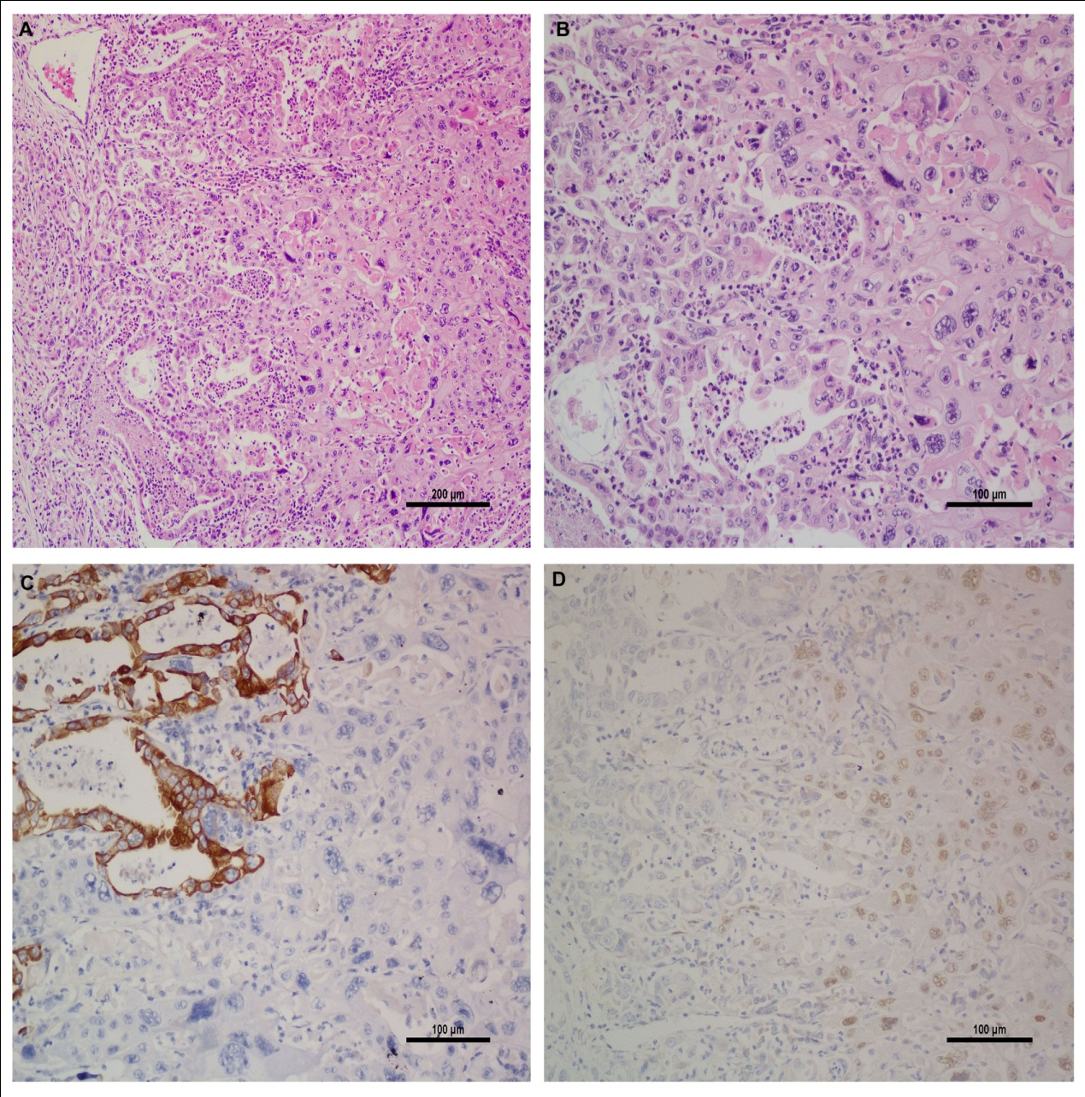
Figure 6 Microscopic specimen. A and B: Both adenocarcinoma and squamous cell carcinoma components. Adenocarcinoma component shows well gland formation and squamous carcinoma component shows keratinization (hematoxylin and eosin staining, A: × 10 magnification; B: × 20 magnification); C: Immunohistochemical (IHC) stain for cytokeratin (low)-on the left side adenocarcinoma is strong positive and on the right side squamous cell carcinoma is negative (IHC × 20 magnification); D: IHC stain for P63- on the left, adenocarcinoma is negative; on the right squamous cell carcinoma is nuclear positive (IHC × 20 magnification).

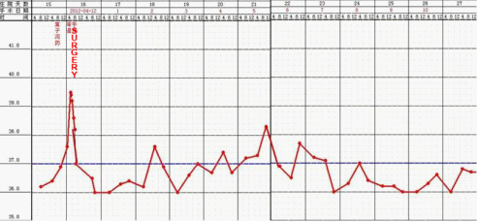
A

B

C
Figure 7 Post operative graph. A: Post operative temperature graph; B: Post operative white blood cell (WBC) level graph; C: Post operative C-reactive protein (CRP) level graph.

Table 1 Reported cases of gastric adenosquamous carcinoma
Country | Gender | Age | Signs and symptoms | Preop  Diagnosis | Surgical procedure | Tumor size (cm) | Location | Metastasis | Staging | Adjuvant treatment | Prognosis | Ref.
- | M | 39 | - | - | - | - | P | - | - | - | - | [12]
- | - | - | - | - | - | - | P | - | - | - | - | [12]
- | - | - | - | - | - | - | P | - | - | - | - | [12]
- | F | 35 | - | - | - | - | P | - | - | - | - | [12]
 | F | 65 | - | - | - | - | P | - | - | - | -
- | F | 67 | - | - | - | - | P | - | - | - | - | [12]
- | M | 48 | - | - | - | - | P | - | - | - | - | [12]
- | F | 64 | - | - | - | - | B | - | - | - | - | [12]
- | M | 33 | - | - | - | - | B | - | - | - | - | [12]
- | M | 74 | - | - | - | - | B | - | - | - | - | [12]
- | M | 51 | - | - | - | - | P | - | - | - | - | [12]
 | M | 37 | - | - | - | - | P | - | - | - | -
- | M | 85 | - | - | - | - | B | - | - | - | - | [12]
- | M | 40 | - | - | - | - | P | - | - | - | - | [12]
- | M | 50 | - | - | - | - | B | - | - | - | - | [12]
- | M | 42 | - | - | - | - | B | - | - | - | - | [12]
 | M | 49 | - | - | - | - | B | - | - | - | - | [12]
- | M | 37 | - | - | - | - | B-P | - | - | - | - | [12]
- | F | 70 | - | - | - | - | P | - | - | - | - | [12]
SK | M | 43 | A², EP, HP, TS |  | Sub-G+ O |  | A | LN |  |  |  | [1]
J | F | 45 | - | - | - | - | - | - | - | - | - | [13]
J | - | - | - | - | - | - | - | - | Bor IV | - | - | [14]
S¹ | F | 68 | - | - | - | - | - | - | - | - | - | [15]
J | F | 76 | - | - | TG + S | - | - | - | Bor III | - | - | [16]
J | M | 56 | UAD | - | TG | 5.0 × 4.0 | A and B | LN | Bor III | - | - | [17]
J | - | 53 | UAP | ASC | Sub-G | - | B | - | Bor III | - | - | [18]
J | F | 56 | - | - | - | - | - | - | EGC | - | - | [19]³
J | F | 78 | - | - | Par-G | - | - | - | EGC | - | - | [20]³
R | - | - | - | - | - | - | - | - | EGC | - | - | [21]³
J | F | 74 | EP + AL | - | - | - | - | LN | Bor III | - | - | [22]
J | M | 61 |  | - | Sub-G | - | - | L , L¹ LN | - | - | - | [23]⁴
J | M | 57 | UAP | - | - | - | angle region | - | Grade II ASC | - | - | [24]
J | M | 61 | - | - | - | - | - | LN | Bor IV | - | - | [25]
J | - | - | - | - | - | - | Fornix and B | - | - | - | - | [26]
JandC | - | - | - | - | - | - | - | - | - | - | - | [27]
J | M | 51 | - | - | TG post chemo | - | - | -ve | Bor III | - | - | [28]
J | - | - | - | - | - | - | - | - | - | - | - | [29]
S¹ | F | 84 | - | - | - | - | A | - | - | - | - | [30]
J | F | 72 | RHE | - | P | - | - | - | Bor 2 + EGC | - | - | [6]
J | M | 66 | EP | SCC | Par-DG | 2.1 × 2.0 | A | L, LN | - | - | Died 2 years post op² | [5]³
P | M | 55 | - | - | - | - | - | - | - | - | - | [31]
J | M | 59 | - | - | TG+H | - | RS | L, LN | - | - | Died 2mo post H¹ | [32]
S¹ | F | 56 | CA | - | - | - | A | - | - | - | Died few days post op | [33]
J | M | 55 | FandA¹ | ASC | Par-G+D3 | 7.0 × 8.0 | A | LN, L² | T2N2M0 | - | - | [7]
J | F | 62 | A¹ | - | DG | Band A | - | LN | T3N3M0 | Neoadjuvant chemo | - | [34]
J | F | 87 | NandV | SCC | TG+C¹ +S | 10 × 8 × 7 | - | SM , LV | Bor IV | - | Died 5 mo post op | [35]
 | F | 77 | EP | SCC | G | 6 × 5 × 7 | - | SM, LV | Bor III | - | Died 8 mo post op
P | F | 84 | EP | -ve | Sub-G | 8 × 5 × 1.1 | A | LN, L | T3N1M1 | - | - | [2]
J | M | 70 | - | - | TG+D2+ H | - | - | L | - | - | - | [36]
J | M | 74 | AP and M | SCC | Par-G | - | B | LN | Advanced type 3 | S1 monotherapy- | alive post op 2 yr 10 mo | [8]
J | M | 60 | UBP | ASC | No surgery | - | B-A | LN | - | DC-S1 | pt died 3 mo post chemo | [37]
J | M | 77 | - | - | LADG | - | - | LN; Recurrence in liver | ECG | S-1 and cisplatin (CDDP) | Alive 14 mo post op | [41]³
C | M | 73 | Fever | ADC | TLTG+D2 | 8 × 7.5 | B-A | -ve | T4a N0 M0 | Rand S1 | alive at 20 mo post op | Present case

¹Died of lymphangitis carcinomatosa of the lung 2 mo post right hepatectomy; ²Died of liver failure from multiple metastases 2 years post op; ³Early gastric cancer; ⁴Hypesthesia and pain in the both legs, and of progressive difficulty in walking. A¹: Anemia; A²: Anorexia; AL: Appetite loss; CA: Chronic anemia; EP: Epigastric pain; HP: Hunger pain; F: Fatigue; V: Vomitting; N: Nausea; RHE: Routine health examination; TS: Tarry stool; M: Melena; UAP: Upper abdominal pain; UAD: Upper abdominal discomfort; J: Japan; S¹: Spain; P: Portugal; M: Maroc; C: China; R: Russia; SK: South Korea; JC: Jamaica and Commonwealth Caribbean; S: Splenectomy; Sub-G: Subtotal gastrectomy; Par-G: Partial gastrectomy; P: Pylorogastrectomy; H: Hepatectomy; DG: Distal gastrectomy; C¹: cholecystectomy; ASC: adenosquamous carcinoma; Par-DG: partial distal gastrectomy; SSC: squamous cell carcinoma; ADC: adenocarcinoma; A: Antrum; B: Body; F: Fornix; C: Cardia; P: Pylorus; O: Omentectomy; RS: Remnant stomach; Borr: Borrmann type; L: liver; L¹: Lung; SM: Systemic metastases; LN: Lymph node metastases; LV: Lymphovascular metastases; L²: Lymphatics; R: Radiotherapy; S1: S1 chemotherapy; DC-S1: Docetaxel, cisplatin and S-1(DCS); EGC: Early gastric cancer; LADG: Laparoscopic assisted distal gastrectomy; TLTG: Totally laparoscopic total gastrectomy.

Table 2 Reported case series of gastric adenosquamous carcinoma
Country | No. of cases | Mean age | Location | Ref
- | 11¹ | 49.1 | P: 9 pts; LC: 1 pt; F: 1pt | [12]
- | 10² | 54.7 | PandB: 1pt; CandB: 1 pt  P: 6pts; C: 2 pts | [12]
Japan | 11³ | 61.2 | A: 5pts; B: 2pts; F: 4 pts | [37]
Japan | 28 | - | - | [38]
Japan | 5⁴ | 62.8 | Lower body along lesser curvature | [39]
Russia | 5 | : | B and P | [40]
¹10 males and 1 female; ²6 males and 1 female; ³10 males and 1 female; ⁴2 males and 3 females. Pt: Patient; A: Antrum of stomach; P: Pylorus; LC: Lesser curvature of stomach; F: Fundus of stomach; B: Body of stomach; C: Cardia of stomach.

