Name of Journal: World Journal of Clinical Cases
Manuscript NO: 52068
Manuscript Type: CASE REPORT

unexplained huge liver infarction presenting as a tumor with bleeding: A case report

Wang FH et al. Liver infarction-like tumor with bleeding

Fu-Hai Wang, Ning-Ning Yang, Feng Liu, Hu Tian

Fu-Hai Wang, Feng Liu, Hu Tian, Department of General Surgery, The First Affiliated Hospital of Shandong First Medical University, Jinan 250014, Shandong Province, China

Ning-Ning Yang, Department of Respiratory and Critical Care Medicine, Shandong Provincial Chest Hospital Affiliated to Shandong University, Jinan 250013, Shandong Province, China

Author contributions: Wang FH and Yang NN designed the report and wrote the paper; Wang FH, Liu F and Tian H performed the surgery; Yang NN collected the patient’s clinical data; Wang FH and Tian H analyzed the data and revised the paper; all authors have read and approved the final version of this manuscript; Wang FH and Yang NN contributed equally.

Corresponding author: Hu Tian, MD, PhD, Chief Doctor, Professor, Surgeon, Department of General Surgery, The First Affiliated Hospital of Shandong First Medical University, No. 16766, Jingshi Road, Jinan 250014, Shandong Province, China. tianhu6585@163.com

Received: January 10, 2020
Revised: March 26, 2020
Accepted: April 15, 2020
Published online: May 26, 2020

Abstract
BACKGROUND
Liver infarction is a rare necrotic lesion due to the dual blood supply consisting of the hepatic artery and portal vein. The absence of specific clinical manifestations and imaging appearances usually leads to misdiagnosis and poor prognosis. Thus, the precise diagnosis of liver infarction always requires imaging studies, serum studies, and possible liver biopsy.

CASE SUMMARY
We report a case of 31-year-old man who developed a huge liver infarction. Persistent right upper abdominal pain and intermittent fever were the main symptoms in this patient. Computed tomography revealed a huge irregular lesion with a maximum diameter of 12.7 cm in the right lobe of the liver. Three-dimensional reconstruction was performed and no significant interruption of the main hepatic vessels was observed. The lesion was initially considered to be a malignant tumor with internal bleeding. Laparoscopic right hepatectomy was performed, and pathology indicated a rare liver infarction. The patient recovered well and was discharged on postoperative day 21. No fever or abnormal liver function were reported in the subsequent 6 mo.

CONCLUSION
In patients with a huge liver infarction, early surgical intervention may be beneficial.

Key words: Liver infraction; Liver lesions; Surgery; Imaging; Diagnosis; Case report

Citation: Wang FH, Yang NN, Liu F, Tian H. unexplained huge liver infarction presenting as a tumor with bleeding: A case report. World J Clin Cases 2020; 8(10): 2016-2022
URL: https://www.wjgnet.com/2307-8960/full/v8/i10/2016.htm
DOI: https://dx.doi.org/10.12998/wjcc.v8.i10.2016

Core tip: We report a case of liver infarction that was initially considered to be a tumor with bleeding based on computed tomography. Liver infarction is caused by the obstruction of hepatic vessels, and a huge liver infarction is very rare due to the dual hepatic blood supply. The clinical manifestations and imaging appearances of liver infarction are nonspecific. The precise diagnosis always requires multiple imaging methods, serum studies, and pathological examination. In addition to conservative treatment, early surgical intervention is beneficial in patients with a huge liver infarction. This case report provides a valuable reference for the diagnosis and treatment of this disease.

INTRODUCTION
Primary liver cancer is one of the most common malignant tumors, and ranks third with respect to tumor mortality worldwide. The incidence of primary liver cancer is much higher in China due to hepatitis B infection^{[1]}. The precise diagnosis of liver lesions is helpful for the application of targeted therapeutic options and a good prognosis, while misdiagnosis is sometimes inevitable due to the similar imaging appearances of liver cancer and other benign lesions. We describe a patient with a huge liver infarction and bleeding that was initially considered to be liver cancer with bleeding. A review of the literature on liver infarction was also performed.

CASE PRESENTATION
Chief complaints
A 31-year-old man was admitted with persistent right upper abdominal pain, fever, and anorexia for 6 d.

History of present and past illness
He was healthy without a history of personal or family tumors. Abdominal ultrasound revealed fatty liver and mixed echoes in the right lobe of the liver, and a non-enhanced computed tomography (CT) scan of the abdomen also suggested a huge lesion in the right lobe of the liver with mixed density. Antibiotics had been administered in a local hospital to help relieve the patient’s symptoms.

Physical examination upon admission
Upon admission, his intermittent fever peaked at 38.5 °C without symptoms of respiratory infection. Percussion pain in the liver area was detected with no other abnormalities upon physical examination.

Laboratory examinations
Laboratory studies excluded hepatitis B and C infection, but showed leukocytosis, neutrophilia, elevated aspartate aminotransferase at 76 U/L, and alanine transaminase at 477.4 U/L. The triglyceride, total cholesterol, carcinoembryonic antigen, alpha-fetoprotein, and carbohydrate antigen-199 levels were in the normal range.

Imaging examinations
An enhanced CT scan indicated fatty liver, and a huge irregular lesion with a maximum diameter of 12.7 cm was observed in the right lobe of the liver. On non-enhanced CT, a slightly high density was also found in the lesion (Figure 1A), which was consistent with previous CT images. The entire tumor was not enhanced, and the peripheral tissues were delayed enhanced (Figure 1B and D). The typical CT image of hepatocellular carcinoma was enhanced at the early stage and with peripheral vascular contrast enhancement. However, for some unusual hepatic tumors, the image feature was delayed enhanced, such as liver metastasis from gastric cancer. The imaging findings suggested a malignant liver tumor with bleeding. Three-dimensional reconstruction was performed to identify the relationship between the lesion and adjacent hepatic vessels. No significant interruption of the main liver artery and portal vein was observed (Figure 2A-C).

FINAL DIAGNOSIS
The surgical specimen showed a huge necrotic lesion, and multiple adipose lesions were also observed (Figure 3A). Pathological examination indicated a rare liver infarction (Figure 3B-D).

TREATMENT
The antibiotics ceftriaxone sodium and levofloxacin, as well as hepatoprotective drugs, were administered to control the fever and improve liver function.

OUTCOME AND FOLLOW-UP
On the 9th day after admission, the patient underwent laparoscopic right hepatectomy. He recovered well following treatment with antibiotics, nutritional support, and human albumin, and was discharged on postoperative day 21. No fever or abnormal liver function were subsequently reported.

DISCUSSION
Liver infarction is a type of hepatic necrosis caused by the obstruction of vessels, which is rare due to the hepatic dual blood supply, the tolerance of hepatocytes to low oxygen, and the immediate opening of collateral vessels within the liver^{[2,3]}. Simultaneous occlusion of the hepatic artery and portal vein is sometimes considered to be essential in a huge liver infarction^{[4]}; however, the abrupt truncation of a single hepatic artery can also lead to severe liver infarction and even death^{[5]}. Liver infarction is usually reported at autopsy. Seeley et al^{[6]} investigated 19 autopsies of patients with hepatic infarcts, and found that ten autopsies showed arterial occlusion, four showed only portal vein thrombosis, and no vascular occlusion was found in the other five patients. In our case, we found no obvious hepatic vessel lesions on the CT scan and three-dimensional reconstruction of the liver. In a subsequent study, Saegusa et al^{[7]} reported 20 cases of hepatic infarction and 17 had circulatory failure. Furthermore, 15 had portal vein thrombosis, which indicated the importance of portal vein disturbance in the development of liver infarction. Based on these reports, simultaneous or single occlusion of the hepatic artery and portal vein appears to be the anatomical basis of hepatic infarction.
The early diagnosis of liver infarction is difficult due to its rarity and absence of typical symptoms. It can initially present as chest or right upper abdominal pain, fever, or with associated nausea and vomiting^{[8-10]}. In addition, related laboratory studies for hematological and biochemical markers are not speciﬁc, which makes the diagnosis challenging^{[11,12]}. In our report, the patient had right upper abdominal pain and fever, and related serum tests showed leukocytosis, neutrophilia, and elevated aspartate aminotransferase and alanine transaminase, but it is difficult to differentiate between liver abscess or a tumor with bleeding or infection. Thus, a CT scan was performed, which indicated the areas of liver infarction with low attenuation that were circumscribed and wedge-shaped, and extended to the periphery of the liver^{[11]}. The CT images in our patient showed an irregular lesion with an inside of slightly high density, which was considered to be bleeding. It was reported that gadophrin-2 displayed a persistent necrosis-speciﬁc contrast enhancement on magnetic resonance imaging, and was considered useful for diagnosis in a rat model of reperfused liver infarction^{[13]}. Hepatobiliary scintigraphy is also considered to be a sensitive method for detecting early hepatic infarction even before ultrasonographic changes occur, which is helpful in improving prognosis^{[14]}.
The causes of liver infarction are diverse, although primary lesions in hepatic vessels are rare. It has been suggested that liver infarction may be secondary to circulatory shock, sepsis, anesthesia, or biliary disease^{[8,10]}. We reviewed the literature on liver infarction (Table 1) and concluded that the common causes of this disorder are as follows: (1) Iatrogenic injury of hepatic vessels, mainly the hepatic artery. In normal liver, approximately 75% of the blood supply is from the portal vein, and 25% is from the hepatic artery. An anatomical abnormality of the hepatic artery is frequently observed, such as the right hepatic artery that can be derived from the proper or common hepatic artery or superior mesenteric artery. Wong et al^{[15]} reported liver infarction due to injury to the right hepatic artery and portal vein during laparoscopic cholecystectomy. Surgeons should avoid hepatic vessel injuries during gallbladder, bile duct, liver, and pancreas surgery. (2) Systemic diseases: Churg-Strauss syndrome is characterized by granulomatous vasculitis of multiple organ systems, which can lead to irregular narrowing of hepatic arteries and even liver infarction^{[3]}. In pregnant or postpartum woman, antiphospholipid syndrome (APS) and systemic lupus erythematosus (SLE) are also considered causes of liver infarction due to multiple thromboses in vivo^{[11,16,17]}. Related serum studies on anti-nuclear antibodies, anti-double-stranded DNA, anti-cardiolipin antibodies, and lupus anti-coagulant are useful for the diagnosis of APS and SLE^{[18]}. In the present report, the above markers were investigated and found to be in the normal range. A hypercoagulable state, such as disseminated intravascular coagulation caused by severe postpartum hemorrhage, can induce thrombosis formation in hepatic vessels, hepatic infarction, and even acute hepatic failure^{[19,20]}. (3) Treatment of liver diseases includes transarterial chemoembolization (TACE) and transjugular intrahepatic portosystemic shunt (TIPS). TIPS is performed for the treatment of variceal bleeding and refractory ascites in patients with portal hypertension^{[21]}, while TACE is used for the treatment of liver cancer, liver bleeding, or for diagnostic purposes^{[22]}. TIPS can induce hepatic hypoperfusion in the portal vein, while TACE interrupts liver artery blood flow. Therefore, the risk of liver infarction due to TACE is increased by TIPS^{[9,23]}. Before TACE or TIPS is undertaken, it is important to evaluate the condition of the hepatic artery and portal vein for a better prognosis. And (4) Other causes: Ashida et al^{[2]} reported a case of liver infarction due to liver abscess, without the occlusion of hepatic vessels. In our case, liver infarction was not due to the above three common causes; however, the patient had fatty liver and severe fatty degeneration of hepatocytes. Whether this was the origin of liver infarction requires further investigation.

CONCLUSION
The causes of liver infarction are complex with an outcome that is sometimes systemic, and can even be fatal. Simple imaging, such as ultrasound, CT scan, or magnetic resonance imaging, is sometimes insufficient, and at least two imaging methods are required. In addition, detailed history taking, physical examination, and related serum studies are also crucial. The treatment of primary diseases, such as APS and SLE, is essential, and treatment with antibiotics, hepatoprotective drugs, thrombolysis, hormones, and even surgery are also significant. We should also be aware of the clinical characteristics, imaging appearance, and serum results of other liver lesions, such as liver cancer and abscess, as the early precise diagnosis of liver infarction is difficult and important for controlling further progression and improving prognosis.

REFERENCES
1 Siegel RL, Miller KD, Jemal A. Cancer statistics, 2018. CA Cancer J Clin 2018; 68: 7-30 [PMID: 29313949 DOI: 10.3322/caac.21442]
2 Ashida A, Matsukawa H, Samejima J, Fujii K, Adachi H, Ishikawa Y, Kato N, Kawamoto M, Fujisawa J, Rino Y, Imada T. Liver infarction due to liver abscess. Dig Surg 2008; 25: 258-259 [PMID: 18628625 DOI: 10.1159/000144654]
3 Otani Y, Anzai S, Shibuya H, Fujiwara S, Takayasu S, Asada Y, Terashi H, Takuma M, Yokoyama S. Churg-Strauss syndrome (CSS) manifested as necrosis of fingers and toes and liver infarction. J Dermatol 2003; 30: 810-815 [PMID: 14684939 DOI: 10.1111/j.1346-8138.2003.tb00483.x]
4 Haratake J, Horie A, Furuta A, Yamato H. Massive hepatic infarction associated with polyarteritis nodosa. Acta Pathol Jpn 1988; 38: 89-93 [PMID: 2896426 DOI: 10.1111/j.1440-1827.1988.tb01075.x]
5 Wang MY, Potosky DR, Khurana S. Liver infarction after transjugular intrahepatic portosystemic shunt in a liver transplant recipient. Hepatology 2011; 54: 1887-1888 [PMID: 21932409 DOI: 10.1002/hep.24672]
6 Seeley TT, Blumenfeld CM, Ikeda R, Knapp W, Ruebner BH. Hepatic infarction. Hum Pathol 1972; 3: 265-276 [PMID: 5028623 DOI: 10.1016/s0046-8177(72)80080-7]
7 Saegusa M, Takano Y, Okudaira M. Human hepatic infarction: histopathological and postmortem angiological studies. Liver 1993; 13: 239-245 [PMID: 8259035 DOI: 10.1111/j.1600-0676.1993.tb00638.x]
8 Mor F, Beigel Y, Inbal A, Goren M, Wysenbeek AJ. Hepatic infarction in a patient with the lupus anticoagulant. Arthritis Rheum 1989; 32: 491-495 [PMID: 2495803 DOI: 10.1002/anr.1780320421]
9 Mayan H, Kantor R, Rimon U, Golubev N, Heyman Z, Goshen E, Shalmon B, Weiss P. Fatal liver infarction after transjugular intrahepatic portosystemic shunt procedure. Liver 2001; 21: 361-364 [PMID: 11589774 DOI: 10.1034/j.1600-0676.2001.210510.x]
10 Adler DD, Glazer GM, Silver TM. Computed tomography of liver infarction. AJR Am J Roentgenol 1984; 142: 315-318 [PMID: 6607598 DOI: 10.2214/ajr.142.2.315]
11 Khong SY, James M, Smith P. Diagnosis of liver infarction postpartum. Obstet Gynecol 2005; 105: 1271-1273 [PMID: 15863607 DOI: 10.1097/01.AOG.0000159656.69166.ff]
12 Woller SC, Boschert ME, Hutson WR. Hepatic epithelioid hemangioendothelioma presenting as liver infarction. Clin Gastroenterol Hepatol 2005; 3: xx [PMID: 15704041 DOI: 10.1016/s1542-3565(04)00447-1]
13 Ni Y, Adzamli K, Miao Y, Cresens E, Yu J, Periasamy MP, Adams MD, Marchal G. MRI contrast enhancement of necrosis by MP-2269 and gadophrin-2 in a rat model of liver infarction. Invest Radiol 2001; 36: 97-103 [PMID: 11224757 DOI: 10.1097/00004424-200102000-00005]
14 Arun BR, Padma S, Mallick A, Shanmuga Sundaram P. Unsuspected right lobe liver infarction in Byler's disease--identified by hepatobiliary scintigraphy. Indian J Pediatr 2014; 81: 512-513 [PMID: 24068627 DOI: 10.1007/s12098-013-1245-y]
15 Wong MD, Lucas CE. Liver infarction after laparoscopic cholecystectomy injury to the right hepatic artery and portal vein. Am Surg 2001; 67: 410-411 [PMID: 11379637]
16 Sakhel K, Usta IM, Hannoun A, Arayssi T, Nassar AH. Liver infarction in a woman with systemic lupus erythematosus and secondary anti-phospholipid and HELLP syndrome. Scand J Rheumatol 2006; 35: 405-408 [PMID: 17062444 DOI: 10.1080/03009740600588343]
17 He J, Xiao ZS, Shan YH, Song J. Misdiagnosis of liver infarction after cesarean section in a patient with antiphospholipid syndrome during pregnancy. Chin Med J (Engl) 2015; 128: 282-283 [PMID: 25591577 DOI: 10.4103/0366-6999.149244]
18 Marai I, Zandman-Goddard G, Shoenfeld Y. The systemic nature of the antiphospholipid syndrome. Scand J Rheumatol 2004; 33: 365-372 [PMID: 15794193 DOI: 10.1080/03009740410010290]
19 Peng IT, Chung MT, Lin CC. Severe Postpartum Hemorrhage Complicated with Liver Infarction Resulting in Hepatic Failure Necessitating Liver Transplantation. Case Rep Obstet Gynecol 2018; 2018: 2794374 [PMID: 29992067 DOI: 10.1155/2018/2794374]
20 Yoshihara M, Mayama M, Ukai M, Tano S, Kishigami Y, Oguchi H. Fulminant liver failure resulting from massive hepatic infarction associated with hemolysis, elevated liver enzymes, and low platelets syndrome. J Obstet Gynaecol Res 2016; 42: 1375-1378 [PMID: 27353746 DOI: 10.1111/jog.13042]
21 Sawhney R, Wall SD, Yee J, Hayward I. Hepatic infarction: unusual complication of a transjugular intrahepatic portosystemic shunt. J Vasc Interv Radiol 1997; 8: 129-132 [PMID: 9025052 DOI: 10.1016/s1051-0443(97)70528-1]
22 Bruix J, Sherman M; American Association for the Study of Liver Diseases. Management of hepatocellular carcinoma: an update. Hepatology 2011; 53: 1020-1022 [PMID: 21374666 DOI: 10.1002/hep.24199]
23 Park BV, Gaba RC, Lokken RP. Liver Infarction after Drug-Eluting Embolic Transarterial Chemoembolization for Hepatocellular Carcinoma in the Setting of a Large Portosystemic Shunt. Semin Intervent Radiol 2016; 33: 337-341 [PMID: 27904254 DOI: 10.1055/s-0036-1592319]

Footnotes
Informed consent statement: Informed written consent was obtained from the patient for publication of this report and any accompanying images.

Conflict-of-interest statement: The authors declare that they have no conflict of interest.

CARE Checklist (2016) statement: The authors have read the CARE Checklist (2016), and the manuscript was prepared and revised according to the CARE Checklist (2016).

Open-Access: This article is an open-access article that was selected by an in-house editor and fully peer-reviewed by external reviewers. It is distributed in accordance with the Creative Commons Attribution NonCommercial (CC BY-NC 4.0) license, which permits others to distribute, remix, adapt, build upon this work non-commercially, and license their derivative works on different terms, provided the original work is properly cited and the use is non-commercial. See: http://creativecommons.org/licenses/by-nc/4.0/

Manuscript source: Unsolicited manuscript

Peer-review started: January 10, 2020
First decision: March 18, 2020
Article in press: April 15, 2020

Specialty type: Medicine, research and experimental
Country/Territory of origin: China
Peer-review report’s scientific quality classification
Grade A (Excellent): 0
Grade B (Very good): 0
Grade C (Good): C, C
Grade D (Fair): 0
Grade E (Poor): 0

P-Reviewer: Dogan U, Neri V S-Editor: Zhang L L-Editor: Filipodia E-Editor: Xing YX

Figure Legends
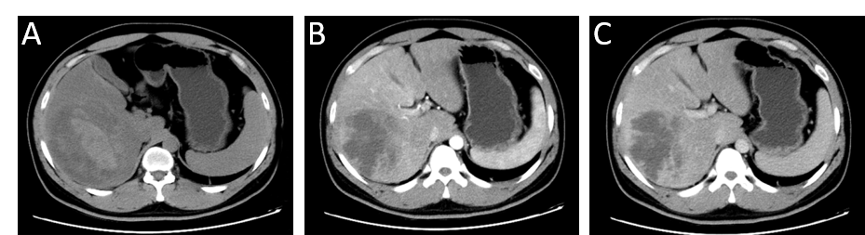
Figure 1 Computed tomography imaging of liver infarction. A: Plain scan phase of computed tomography (CT) detected an irregular lesion in the right lobe of the liver; B: Arterial phase of CT showed no obvious enhancement; C: Venous phase of CT showed no obvious enhancement.

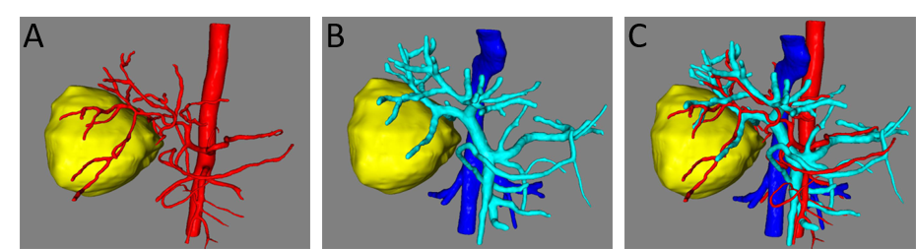
Figure 2 Three-dimensional reconstruction of liver and lesion. A: Arterial reconstruction of the liver revealed the relationship between lesion and hepatic artery; B: Venous reconstruction of the liver revealed the relationship between lesion and portal vein; C: Mixture of arterial and venous reconstruction.

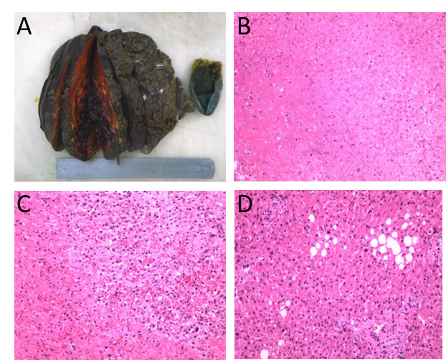
Figure 3 Pathological examination of lesion. A: Necrotic lesion was 16 cm × 12 cm × 8 cm in size without an envelope; B: Pathological section analysis of liver infarction; C: Pathological section analysis of tissue adjacent to lesion; D: Pathological section analysis of normal liver tissue, revealing fatty degeneration of hepatocytes.

Table 1 Literature review for liver infraction
Ref. | Case | Symptoms | Serum study | Computed tomography | Liver vessels | Main treatments
Otani et al^{[3]}, 2003 | A 59-year-old man with Churg-Strauss syndrome | Cold and pain of fingers and toes | Hypereosinophilia, elevated IgE and transaminase | Low density at the periphery of the right lobe | Irregular narrowing of hepatic arteries | Surgery, intravenous PGE1, prednisolone
Khong et al^{[11]}, 2005 | A 30-year-old postpartum woman with DVT history | Right-sided chest pain, mild pyrexia | Leukocytosis, neutrophilia, elevated ALT | Multiple peripheral liver infarcts | - | Antibiotics, heparin and warfarin
Mayan et al^{[9]}, 2001 | A 66-year-old male with TIPS | Fever and shock, tenderness of right upper quadrant | DIC, AST and ALT increased | Wedge-shaped hypodense lesion of liver | No sign of portal vein occlusion or arterio-stent shunt | Amikacin, vancomycin, ceftriaxone
Park et al^{[23]}, 2016 | A 61-year-old woman with TACE | Epigastric pain, abdominal pain and distention | Elevations of AST and ALT | Nonenhancement and expansion of left hepatic lobe with DEE TACE | Middle hepatic vein to left portal vein shunt | Supportive care
Wong et al^{[15]}, 2001 | A 66-year-old woman with laparoscopic cholecystectomy | Fever, right upper quadrant pain | Leukocytosis, bacteremia | A cystic defect of right hepatic lobe | Occlusion of the right hepatic artery and right portal vein | Surgery
Wang et al^{[5]}, 2011 | A 44-year-old man with liver transplantation and TIPS | Refractory hypotension | Rise in serum aminotransferase  level | A large, irregular hypodense lesion in the right lobe of the liver | Abrupt truncation of the native common hepatic artery | Aggressive resuscitation
Ashida et al^{[2]}, 2003 | A 74-year-old man with liver abscess | Diarrhea and abdominal pain | - | Low-density lesions | Interrupt of the hepatic artery and portal vein | Operation and drainage
Sakhel et al^{[16]}, 2006 | A 39-year-old primigravida with SLE and secondary APS | Upper abdominal pain, tachypnea, dyspnea, and tachycardia | Elevated AST and ALT | Multiple  irregularly shaped, small, low-density lesions |  | Heparin and broad-spectrum antibiotics
Peng et al^{[19]}, 2018 | A 30-year-old woman with post-partum hemorrhage |  | Liver enzyme levels peaked, DIC | Poor enhancement of the right hepatic lobe on the periphery |  | Liver transplantation
PGE 1: Prostaglandin E 1; DVT: Deep venous thrombosis; TIPS: Transjugular intrahepatic portosystemic shunt; TACE: Transarterial chemoembolization; DIC: Disseminated intravascular coagulation; AST: Aspartate aminotransferase; ALT: Alanine transaminase.

