Name of journal: World Journal of Gastroenterology
ESPS Manuscript NO: 16742
Columns: ORIGINAL ARTICLE

Prospective Study
Different roles of capsule endoscopy and double-balloon enteroscopy in obscure small intestinal diseases

Zhang ZH et al. Comparison the roles of CE and DBE

Zhi-Hong Zhang, Chun-Hua Qiu, Yi Li

Zhi-Hong Zhang, Chun-Hua Qiu, Yi Li, Department of Gastroenterology, Sichuan Provincial People’s Hospital, Sichuan Province Medical Science, Chengdu 610072, Sichuan Province, China

Author contributions: Zhang ZH was involved in designing the study, collecting the data, drafting the article, and making the critical revisions; Qiu CH supplied partial economic support, and took part in designing the study and revising the manuscript; Li Y provided technical support and gave some critical suggestions for revising the article; all members participated in the procedure.

Ethics approval: This study was reviewed and approved by the Ethics Committee of Sichuan Province Institution, Sichuan Provincial People's Hospital Institutional Review Board.

Clinical trial registration: This study is registered at the Chinese Clinical Trail Registion. The registration identification number is ChiCTR-DCD-15005999.

Informed consent: All study participants, or their legal guardian, provided informed written consent prior to study enrollment.

Conflict-of-interest: No potential conflicts of interest relevant to this article were reported.

Data sharing: The technical support and dataset available (from the study: Different roles of CE and DBE in obscure small intestinal diseases) were supplied by Zhi-Hong Zhang (750725308@qq.com), Chun-Hua Qiu (zyqch730@163.com), and Yi Li (1187201149@qq.com). The participants’ consent was not obtained; however, the presented data are anonymized and the risk of identification is low. No additional data are available.

Open-Access: This article is an open-access article which was selected by an in-house editor and fully peer-reviewed by external reviewers. It is distributed in accordance with the Creative Commons Attribution Non Commercial (CC BY-NC 4.0) license, which permits others to distribute, remix, adapt, build upon this work non-commercially, and license their derivative works on different terms, provided the original work is properly cited and the use is non-commercial. See: http://creativecommons.org/licenses/by-nc/4.0/

Correspondence to: Chun-Hua Qiu, MD, Department of Gastroenterology, Sichuan Provincial People’s Hospital, Sichuan Province Medical Science, 32 Yihuan Road, Chengdu 610072, Sichuan Province, China. zyqch730@163.com
Telephone: +86-28-87394207
Received: January 28, 2015
Peer-review started: January 29, 2015
First decision: February 10, 2015
Revised: February 27, 2015
Accepted: April 28, 2015

Article in press:
Published online:

Abstract
AIM: To compare the roles of capsule endoscopy (CE) and double-balloon enteroscopy (DBE) in obscure small bowel diseases.

METHODS: From June 2009 to Dec 2014, 88 patients were included in this study; the patients had undergone gastroscopy, colonoscopy, radiological small intestinal barium meal, abdominal computed tomography and magnetic resonance imaging scan and mesenteric angiography, but their diagnoses were still unclear. The patients with gastrointestinal obstructions, fistulas, strictures, or cardiac pacemakers, as well as pregnant women, and individuals who could not accept the capsule-retention or capsule-removal surgery were excluded. Patients with heart, lung and other vital organ failure diseases were also excluded. Everyone involved in this study had undergone CE and DBE. The results were divided into: (1) the definite diagnosis (the diagnosis was confirmed at least by one of the biopsy, surgery, pathology or the drug treatment effects with following-up for at least 3 mo); (2) the possible diagnosis (a possible diagnosis was suggested by CE or DBE, but not confirmed by the biopsy, surgery or following-up drug treatment effects); and (3) the unclear diagnose (no exact causes was provided by CE and DBE for the disease). The detection rate and the diagnostic yield were compared by the two methods. The difference in the etiologies between CE and DBE was estimated, and the different possible etiologies caused by the age groups were also investigated.

RESULTS: CE exhibited a better trend than DBE for diagnosing scattered small ulcers (P = 0.242, Fisher’s test), and small vascular malformations (χ² = 1.810, P = 0.179, Pearson chi-square test), but with no significant differences, possible due to few cases. However, DBE was better than CE for larger tumors (P = 0.018, Fisher’s test) and for diverticular lesions with bleeding ulcers (P = 0.005, Fisher’s test). All three hemangioma cases diagnosed by DBE in this study (including sponge hemangioma, venous hemangioma, and hemangioma with hamartoma lesions) were all confirmed by biopsy. Two parasite cases were found by CE, but were negative by DBE. This study revealed no obvious differences for the detection rate (DR) of CE (60.0%, 53/88) and DBE (59.1%, 52/88). However, the etiological diagnostic yield (DY) difference was apparent. The CE diagnostic yield was 42.0% (37/88), and the DBE diagnostic yield was 51.1% (45/88). Furthermore, there were differences among the age groups (χ² = 22.146, P = 0.008, Kruskal Wallis Test). Small-intestine cancer(5/6 cases), vascular malformations (22/29 cases), and active bleeding (3/4 cases) appeared more commonly in the aged patients over 50 years old, but the diverticular with bleeding ulcers were usually found in the 15-25-year group (4/7cases). The over-25-year group accounted for the stromal tumors (10/12 cases).

CONCLUSION: CE and DBE each have their own advantages and disadvantages. The appropriate choice depends on the patient’s age, tolerance, and clinical manifestations. Sometimes CE followed by DBE is necessary.

Key words: Capsule endoscopy; Double-balloon enteroscopy; Obscure small intestinal diseases

© The Author(s) 2015. Published by Baishideng Publishing Group, Inc. All rights reserved.

Core tip: Until now, because of the expensive cost and some difficult technology, a study of capsule endoscopy (CE) followed by double-balloon enteroscopy (DBE) simultaneously in one case has been rarely reported. To assess the role of CE and DBE in the diagnosis of small bowel diseases, this study was designed to choose the more appropriate examination (between CE and DBE) for obscure small bowel diseases.

Zhang ZH, Qiu CH, Li Y. Different roles of capsule endoscopy and double-balloon enteroscopy in obscure small intestinal diseases. World J Gastroenterol 2015; In press

INTRODUCTION
It is very difficult to diagnose the small intestinal diseases because of the small intestinal specific structure and anatomical location. With the development of capsule endoscopy (CE) and the double-balloon enteroscopy (DBE) in recent years, the prospect has been brought for the diagnosis and treatment of obscure intestinal diseases. However, until now, because of the expensive cost and some difficult technology, studies of CE followed by DBE simultaneously in one case have been rare.
To assess the role of CE and DBE in the diagnosis of small bowel diseases, 88 patients were collected in our hospital from June 2009 to Dec 2014. The purpose of this study was to provide more information for choosing the more appropriate examination for obscure small bowel diseases.

MATERIALS AND METHODS
Patients
Eighty-eight patients who underwent CE followed by DBE were enrolled in our hospital from June 2009 to Dec. 2014. The ratio of males to females was 64 to24, with an average age of 47.19 years (from 16 year to 78 year). The duration of symptoms ranged from 1 week to 180 mo. The number of obscure gastrointestinal bleeding (OGIB) cases was 70, and the number of abdominal pain, diarrhea, and abdominal discomfort cases was 18.

Inclusion criteria
All patients underwent gastroscopy and colonoscopy, and some of them were given a radiological small intestinal barium meal, abdominal computed tomography (CT) and a magnetic resonance imaging (MRI) scan, mesenteric angiography or other procedures. However, the causes of them were still not clear.

Exclusion criteria
Contraindications to CE, such as gastrointestinal obstructions, fistulas, stricture, cardiac pacemakers, pregnant women, and patients who could not accept the capsule retention or capsule removal surgery, were excluded.
The contraindications to DBE still included heart, lung and other vital organ failure diseases.
All the informed consents were obtained from the patients before the procedures were performed.

Methods
CE procedure: All of the patients underwent the Pill Cam SB capsule procedure (GIVEN imaging, Israel). Before the procedure, the patients prepared their bowels with 3 liters PEG (2 liters at 10:00PM the night before the procedure, and 1 liter with the simethicone at 4:00 AM on the morning of the procedure). The procedure was usually halted when the arrival of ileocecus was confirmed by the monitor 8-10 h later; otherwise, the procedure was continued until the next morning. The image was reviewed by two independent experienced reviewers. During the procedure, exposure to electromagnetic fields was avoided.

DBE procedure: The Fuji DBE system (Japan) was used. The antegrade DBE required the patients to fast for 6~8 hours, and the retrograde DBE required bowel preparation with 2 L PEG. Conscious sedation (including 10 mg i.m. diazepam, 100 mg i.m. pethidine, and 10 mg i.m. alisodamine) were performed before the procedure. The tip of the small intestinal endoscope and the overtube were inserted into the duodenum or ileum. The overtube was inflated and fixed to the small intestine, and then the endoscope was advanced until it could not continue. After the balloon was inflated and fixed, the empty overtube was inserted into the endoscopic tip and then inflated. The endoscopy and overtube were slowly straightened. The oral and anal procedures were marked by tattooing with a spot, if necessary.

Analysis of the clinical outcome indicators
The definite diagnosis: The diagnosis was confirmed at least by one of biopsy, surgery, pathology or the follow-up drug treatment effects.

The possible diagnosis: A possible diagnosis was suggested by CE or DBE, but not confirmed by the biopsy, surgery, or follow-up drug treatment.

The unclear diagnose: No exact causes of the diseases were revealed by CE and DBE.

Statistical analysis
The SPSS 15.0 statistical analysis software was applied. The statistical methods of this study were reviewed by Assistant professor Quan Ting from the Department of Clinical Trial Statistics in the Sichuan Province People’s Hospital.
Detection rate = positive detected cases / all cases × 100%
Diagnostic yield = definitely diagnosed cases /all cases × 100%
All data were statistically,analyzed by Fisher's test, Fisher's exact test, Pearson’s χ² test, and the Kruskal Wallis Test , with P < 0.05 considered statistically significant.

RESULTS
Characteristics of the procedure
CE: Eighty-six cases of CE successfully passed through the esophagus to the stomach (accounting for 97.7%, 86/88), and only two were delayed in the stomach for more than four hours and then were passed into the duodenum using a gastroscope. Sixty to three hundred minutes (average 256 min) were spent by CE to pass through the entire small intestine without any discomfort. One capsule remained and was removed by surgery two weeks later.

DBE: The mean duration for the antegrade DBE was approximately 56 min (40-80 min), and the mean length of insertion was 130-450 cm. For the retrograde DBE, the duration was 70 min (40-100 min) and the length was 40-260 cm. Two cases of failure by DBE were subsequently identified as terminal ileum cancer.

Diagnostic yield of CE and DBE
Diagnostic yield (62/88 cases): As presented in Table 1, CE exhibited a better trend than DBE for diagnosing the scattered small ulcers (P = 0.242, Fisher’s test), and small vascular malformations (χ² = 1.810, P = 0.179, Pearson χ² test), but with no significant difference. However, DBE was superior to CE for larger tumors (P = 0.018, Fisher’s test) and for diverticular lesions with bleeding ulcers (P = 0.005, Fisher’s test). In this study, the latter were almost misdiagnosed except for one case undergoing CE. Furthermore, all three hemangioma cases diagnosed by DBE in this study (including sponge hemangioma, venous hemangioma, and hemangioma with hamartoma lesions) were all confirmed by biopsy. Later, the three cases of CE images were again reviewed, and it was found that one case was misdiagnosed and that the other two cases were misdiagnosed as a protuberant lesion and active bleeding. Two parasite cases were found by CE but were negative by DBE. However, because the cases of hemangioma and parasites were very few, it was difficult to perform a statistical analysis (Figure 1).

Possible but not-confirmed cases (18) and not-confirmed cases (8): As shown in Table 2, CE was superior to DBE for diagnosing active bleeding, vascular malformation and submucosal bulges, but the differences were not significant (P=0.429, 0.170, and 0.143, respectively).

Detection rate and diagnostic yield: In this study, there was no obvious difference between CE and DBE for the DR. The CE detection rate was 60.0% (53/88), and the DBE detection rate was 59.1% (52/88). However, the etiological DY difference between both was apparent. The CE diagnostic yield was 42.0% (37/88), DBE diagnostic yield was 51.1% (45/88).

According to the age groups, the data were classified as presented in Table 3: In sum, there were differences among the age groups (χ² = 22.146, P = 0.008, Kruskal Wallis Test). Small intestine cancers (5/6 cases), vascular malformations (22/29 cases), and active bleeding (3/4cases) appeared more common in the aged patients over 50 years old, but the diverticula with bleeding ulcers were usually 15-25-year group(4/7 cases). The over-25-year group accounted for the stromal tumors (10/12 cases).

Comparison of the lesion appearance by CE and DBE (the pictures are shown at the end of this article)
(1) Ulcers: CE usually showed part of the lesions, but DBE did the whole appearance; (2) the small intestine tumors: From the different angle, the different manifestation was showed by CE and DBE. Sometimes, the difference was big; (3) active bleeding: In most conditions, CE showed the positive active bleeding appearance. However, DBE just for few cases; (4) inflammatory hyperplasia or polyps: DBE could show the positive result by biopsy. However, CE just gave some possible diagnosis, especially for adenoma or simple hyperplasia polyps; (5) vascular malformations and hemangiomas: CE could show vascular malformations clearly. However, hemangiomas were often identified by biopsy of DBE; and (6) diverticula with bleeding ulcers: It was difficult for CE to diagnosis.

DISCUSSION
CE and DBE have brought many prospects for diagnosing and treating intestinal diseases. According to previous research, CE accounts for 56%-70% of small intestinal bleeding disorders^{[1]}, whereas the definite diagnostic yield is only 20%-30%^{[2,3]}. DBE accounts for 60%-70% of the diagnostic yield for intestinal diseases^{[4,5]}. Therefore, there are still flaws in the diagnosis of the obscure small intestinal diseases. In this study, the advantages and disadvantages of examinations were reevaluated using CE followed by DBE in the same case, and the results were expected to provide more information for future clinical choices.
CE has its unique advantages, such as convenience, non-invasiveness, security, visibility, and comfortableness. This study confirmed its advantages. First, it is much easier for CE to diagnose scattered, small and multiple lesions than single and larger lesions. In this study, CE accounted for 83.3% of 0.2-2 cm diameter multiple scattered small ulcers, and 73.7% of the enlarged vascular malformation and small-mass blue venous angiomas; by contrast, DBE only accounted for 33.3% of ulcer and 52.6% of vascular malformation, which demonstrated a better trend for CE than DBE. However, the difference was not statistically significant, possibly due to the few cases. Second, the completion rate of CE was 97.7% without any assistance, but the completion rate of DBE was only 1.14% in this study, which accounted for the lower missing diagnostic rate for CE. The lower completion rate of DBE was due to the DBE technical difficulties, which made the completion rate of DBE lower (5.5%-20%) than that in the previous study^{[6]}. In particularly, it was sometimes difficult for the retrograde DBE to be intubated from the ileocecal valve^{[7,8]}. In this study, there were two lesions located in the terminal ileum were missed by DBE because of the retrograde endoscope intubation failure. Third, it seemed easier to diagnose active bleeding by CE than by DBE (100% vs 50%), but there was no significant difference, which implied that more cases may be necessary in the future. Previous studies have demonstrated that the CE etiology detection rate of active bleeding may be improved if an appropriate opportunity is chosen^{[9-11]}. During the early bleeding stage (87%) and the overt stage (56%), CE yielded a higher positive ratio (87% and 56%) than the occult or bleeding- cessation stage (12.9%)^{[12,13]}. In addition, in this study, the detection ratio of the blood clots by CE was higher than by DBE (25% vs 0%), which was also consistent with a previous study^{[14]}. Furthermore, even if the definite bleeding cause was not revealed by CE for the first time, some useful information about the bleeding site or single or multiple lesions might be provided by CE for the later performance of a surgical procedure or other treatment. Choosing an appropriate occasion for rechecking by CE might facilitate finding the missed lesions and improving the diagnostic yield^{[15,16]}.
Although CE is considered to have the irreplaceable advantages, it still has some disadvantages. First, the CE observation cannot be repeated, the direction and speed of movement is uncontrolled, the images are transient and random, and the quality of the CE image is easily affected by the intestinal cavity clean degree and the speed of GI tract movement. In addition, the risk of retention is still present, although the incidence is low (1.5% to 5%)^{[17,18]}.Therefore, the retention risk should be assessed and informed to the patients before the procedure^{[19,20]}. Second, it is difficult for CE to differentiate the elevated sub-mucosal lesions without erosions or ulcers on the surface from the external pressure^{[21,22]}. At that time, DBE is usually necessary to differentiate the lesions. Third, for the larger tumors sizes over 1/2 cavity, such as the cancers or stromal tumors with erosive lesions, it is easy to misdiagnosed the inflammation^{[23,24]}. Fourth, it is occasionally difficult for CE to identify the lesion’s position accurately, especially when CE failes to access the ileocecum. In this study, one lesion’s position was misdiagnosed in the lower segment of jejunum and was confirmed in the duodenum’s horizontal section by the later operation.
Compared with CE, the DBE procedure is more uncomfortable and less tolerated. In this study, the male-to-female of ratio was 2.6 to 1, and the lower completion rate of DBE lead to a much higher misdiagnosis rate. The lower completion ratio of DBE led to the lower detection rate of the active bleeding lesions, parasites, vascular malformations, etc. Moreover, the intestinal mucosal folds made some lesions difficult to be observed by DBE. In addition, the bleeding and perforation complications (3.8%-4.3%)^{[25,26]} still makes the DBE procedure more complex and difficultly popular. However, direct and repeated observation, stainability, biopsy and polypectomy have rendered available in itself^{[27-29]}. For the larger diverticular with the bleeding ulcers, DBE was better than CE. In our study, 7 cases with diverticula were identified by DBE (7.95%, 7/88), but for CE, the percentage was 1.14% (1/88), which was consistent with previous reports (CE 0.6% vs DBE 3.97%)^{[6,14]}. It is suggested that DBE can avoid some defects of CE, such as the limited observation angle was limited and the nondilated luminal. Additionally, in this study, the detection rates for CE and DBE were similar (60.0% vs 59.1%), but for the diagnostic yield ratios of CE and DBE were 42% vs 51.1%. Compared with the previously report, the etiological diagnosis rate of 69%-75% for DBE was lower in this research^{[30,31]}. The possible reason was the few cases, which might have caused bias. Additional cases may help to elucidate this finding in the future.
In conclusion, there are many advantages and disadvantages for CE and DBE, in small intestinal disease diagnosis. Sometimes, it is better to obtain an overall observation by CE firstly and then decide whether DBE is necessary for the further examination.

COMMENTS
Background
It is very difficult to diagnose small intestinal diseases because of the small intestine’s specific structure and anatomical location. With the development of capsule endoscopy (CE) and the double-balloon enteroscopy (DBE) in recent years, the prospect has been raised for diagnosing and treating obscure intestinal diseases. However, because of the expensive cost and difficult technology, studies involving CE followed by DBE simultaneously in one case have been rare. Therefore, this study was designed to provide suggestions for choosing the better examination.

Research frontiers
According to the previous research, CE accounts for 56%-70% of the small intestinal bleeding disorders, whereas the definite diagnostic yield is only 20%-30%. DBE accounts for 60%-70% of the diagnostic yield of the intestinal diseases. Consequently, by now, there are still flaws in the diagnosis of the obscure small intestinal diseases. However, when and how to choose the appropriate examination is the key.

Innovations and breakthroughs
Until now, because of the expensive cost and difficult technology, studies of CE followed by DBE simultaneously in one case have been rare. The present investigation was designed to reevaluated the advantages and disadvantages of the two methods in the same case and was expected to provide more information for future clinical choices. This study revealed that some lesions were more easily diagnosed by CE, such as scattered, small and multiple lesions and active bleeding. The larger diverticula with bleeding ulcers and large submucosa lesions were better diagnosed by DBE.

Applications
Until now, because of the expensive cost and difficult technology, there are still flaws in the diagnosis of obscure small intestinal diseases. In the future, as research continues to foster an in-depth understanding, increasingly more intestinal diseases will be diagnosed accurately and easily.

Terminology
On some occasions, the diagnosis of small diseases was very difficult. With the development of CE and DBE in recent years, the prospect has been raised for diagnosing and treating obscure intestinal diseases. The appropriate choice would depend on age, tolerance and clinical manifestations. Furthermore, CE followed by DBE is sometimes necessary.

Peer-review
This is a very good study; the author compared the effects of CE and DBE in diagnosing small intestinal diseases in the same case. These study results are helpful for patients and clinicians to choose suitable methods for obscure small intestinal diseases.

REFERENCES
1 Nadler M, Eliakim R. The role of capsule endoscopy in acute gastrointestinal bleeding. Therap Adv Gastroenterol 2014; 7: 87-92 [PMID: 24587821 DOI: 10.1177/1756283X13504727]
2 Triester SL, Leighton JA, Leontiadis GI, Fleischer DE, Hara AK, Heigh RI, Shiff AD, Sharma VK. A meta-analysis of the yield of capsule endoscopy compared to other diagnostic modalities in patients with obscure gastrointestinal bleeding. Am J Gastroenterol 2005; 100: 2407-2418 [PMID: 16279893 DOI: 10.1111/j.1572-0241.2005.00274.x]
3 de Leusse A, Vahedi K, Edery J, Tiah D, Fery-Lemonnier E, Cellier C, Bouhnik Y, Jian R. Capsule endoscopy or push enteroscopy for first-line exploration of obscure gastrointestinal bleeding? Gastroenterology 2007; 132: 855-62; quiz 1164-5 [PMID: 17324401 DOI: 10.1053/j.gastro.2006.12.002]
4 Domagk D, Mensink P, Aktas H, Lenz P, Meister T, Luegering A, Ullerich H, Aabakken L, Heinecke A, Domschke W, Kuipers E, Bretthauer M. Single- vs. double-balloon enteroscopy in small-bowel diagnostics: a randomized multicenter trial. Endoscopy 2011; 43: 472-476 [PMID: 21384320 DOI: 10.1055/s-0030-1256247]
5 Teshima CW, Kuipers EJ, van Zanten SV, Mensink PB. Double balloon enteroscopy and capsule endoscopy for obscure gastrointestinal bleeding: an updated meta-analysis. J Gastroenterol Hepatol 2011; 26: 796-801 [PMID: 21155884 DOI: 10.1111/j.1440-1746]
6 Kamalaporn P, Cho S, Basset N, Cirocco M, May G, Kortan P, Kandel G, Marcon N. Double-balloon enteroscopy following capsule endoscopy in the management of obscure gastrointestinal bleeding: outcome of a combined approach. Can J Gastroenterol 2008; 22: 491-495 [PMID: 18478135]
7 Tsujikawa T, Saitoh Y, Andoh A, Imaeda H, Hata K, Minematsu H, Senoh K, Hayafuji K, Ogawa A, Nakahara T, Sasaki M, Fujiyama Y. Novel single-balloon enteroscopy for diagnosis and treatment of the small intestine: preliminary experiences. Endoscopy 2008; 40: 11-15 [PMID: 18058613 DOI: 10.1055/s-2007-966976]
8 Takano N, Yamada A, Watabe H, Togo G, Yamaji Y, Yoshida H, Kawabe T, Omata M, Koike K. Single-balloon versus double-balloon endoscopy for achieving total enteroscopy: a randomized, controlled trial. Gastrointest Endosc 2011; 73: 734-739 [PMID: 21272875 DOI: 10.1016/j.gie.2010.10.047]
9 Ciobanu L, Pascu O, Diaconu B, Matei D, Pojoga C, Tanţău M. Bleeding Dieulafoy's-like lesions of the gut identified by capsule endoscopy. World J Gastroenterol 2013; 19: 4823-4826 [PMID: 23922483 DOI: 10.3748/wjg.v19.i29.4823]
10 Riccioni ME, Urgesi R, Cianci R, Rizzo G, D'Angelo L, Marmo R, Costamagna G. Negative capsule endoscopy in patients with obscure gastrointestinal bleeding reliable: recurrence of bleeding on long-term follow-up. World J Gastroenterol 2013; 19: 4520-4525 [PMID: 23901227 DOI: 10.3748/wjg.v19.i28.4520]
11 Heo HM, Park CH, Lim JS, Lee JH, Kim BK, Cheon JH, Kim TI, Kim WH, Hong SP. The role of capsule endoscopy after negative CT enterography in patients with obscure gastrointestinal bleeding. Eur Radiol 2012; 22: 1159-1166 [PMID: 22270143 DOI: 10.1007/s00330-011-2374-1]
12 Carey EJ, Leighton JA, Heigh RI, Shiff AD, Sharma VK, Post JK, Fleischer DE.A single-center experience of 260 consecutive patients undergoing capsule endoscopy for obscure gastrointestinal bleeding. Am J Gastroenterol 2007; 102: 89-95 [PMID: 17100969 DOI: 10.1111/j.1572-0241.2006.00941.x]
13 Pennazio M, Santucci R, Rondonotti E, Abbiati C, Beccari G, Rossini FP, De Franchis R. Outcome of patients with obscure gastrointestinal bleeding after capsule endoscopy: report of 100 consecutive cases. Gastroenterology 2004; 126: 643-653 [PMID: 14988816 DOI: 10.1053/j.gastro.2003.11.057]
14 Zhang Q, He Q, Liu J, Ma F, Zhi F, Bai Y. Combined use of capsule endoscopy and double-balloon enteroscopy in the diagnosis of obscure gastrointestinal bleeding: meta-analysis and pooled analysis. Hepatogastroenterology 2013; 60: 1885-1891 [PMID: 24719922]
15 Tae CH, Shim KN. Should capsule endoscopy be the first test for every obscure gastrointestinal bleeding? Clin Endosc 2014; 47: 409-414 [PMID: 25324999 DOI: 10.5946/ce.2014.47.5.409]
16 Rahmi G, Samaha E, Vahedi K, Delvaux M, Gay G, Lamouliatte H, Filoche B, Saurin JC, Ponchon T, Rhun ML, Coumaros D, Bichard P, Manière T, Lenain E, Chatellier G, Cellier C. Long-term follow-up of patients undergoing capsule and double-balloon enteroscopy for identification and treatment of small-bowel vascular lesions: a prospective, multicenter study. Endoscopy 2014; 46: 591-597 [PMID: 24830401 DOI: 10.1055/s-0034-1365514]
17 Lewis B. How to prevent endoscopic capsule retention. Endoscopy 2005; 37: 852-856 [PMID: 16116537]
18 Sears DM, Avots-Avotins A, Culp K, Gavin MW. Frequency and clinical outcome of capsule retention during capsule endoscopy for GI bleeding of obscure origin. Gastrointest Endosc 2004; 60: 822-827 [PMID: 15557969 DOI: 10.1055/s-2005-870330]
19 Kopylov U, Seidman EG. Role of capsule endoscopy in inflammatory bowel disease. World J Gastroenterol 2014; 20: 1155-1164 [PMID: 24574792 DOI: 10.3748/wjg.v20.i5.1155]
20 Zagorowicz ES, Pietrzak AM, Wronska E, Pachlewski J, Rutkowski P, Kraszewska E, Regula J. Small bowel tumors detected and missed during capsule endoscopy: single center experience. World J Gastroenterol 2013; 19: 9043-9048 [PMID: 24379629 DOI: 10.3748/wjg.v19.i47.9043]
21 Cangemi DJ, Patel MK, Gomez V, Cangemi JR, Stark ME, Lukens FJ. Small bowel tumors discovered during double-balloon enteroscopy: analysis of a large prospectively collected single-center database. J Clin Gastroenterol 2013; 47: 769-772 [PMID: 23426457 DOI: 10.1097/MCG.0b013e318281a44e]
22 Nakatani M, Fujiwara Y, Nagami Y, Sugimori S, Kameda N, Machida H, Okazaki H, Yamagami H, Tanigawa T, Watanabe K, Watanabe T, Tominaga K, Noda E, Maeda K, Ohsawa M, Wakasa K, Hirakawa K, Arakawa T. The usefulness of double-balloon enteroscopy in gastrointestinal stromal tumors of the small bowel with obscure gastrointestinal bleeding. Intern Med 2012; 51: 2675-2682 [PMID: 23037455 DOI: 10.2169/internalmedicine.51.7847]
23 Chen WG, Shan GD, Zhang H, Li L, Yue M, Xiang Z, Cheng Y, Wu CJ, Fang Y, Chen LH. Double-balloon enteroscopy in small bowel tumors: a Chinese single-center study. World J Gastroenterol 2013; 19: 3665-3671 [PMID: 23801870 DOI: 10.3748/wjg.v19.i23.3665]
24 He Q, Bai Y, Zhi FC, Gong W, Gu HX, Xu ZM, Cai JQ, Pan DS, Jiang B. Double-balloon enteroscopy for mesenchymal tumors of small bowel: nine years' experience. World J Gastroenterol 2013; 19: 1820-1826 [PMID: 23555171 DOI: 10.3748/wjg.v19.i11.1820]
25 Mensink PB, Haringsma J, Kucharzik T, Cellier C, Pérez-Cuadrado E, Mönkemüller K, Gasbarrini A, Kaffes AJ, Nakamura K, Yen HH, Yamamoto H. Complications of double balloon enteroscopy: a multicenter survey. Endoscopy 2007; 39: 613-615 [PMID: 17516287 DOI: 10.1055/s-2007-966444]
26 Tomba C, Elli L, Bardella MT, Soncini M, Contiero P, Roncoroni L, Locatelli M, Conte D. Enteroscopy for the early detection of small bowel tumours in at-risk celiac patients. Dig Liver Dis 2014; 46: 400-404 [PMID: 24440311 DOI: 10.1016/j.dld.2013.12.009]
27 Ohmiya N, Nakamura M, Tahara T, Nagasaka M, Nakagawa Y, Shibata T, Hirooka Y, Goto H, Hirata I. Management of small-bowel polyps at double-balloon enteroscopy. Ann Transl Med 2014; 2: 30 [PMID: 25333006 DOI: 10.3978/j.issn]
28 Neely D, Ong J, Patterson J, Kirkpatrick D, Skelly R. Small intestinal adenocarcinoma: rarely considered, often missed? Postgrad Med J 2013; 89: 197-201 [PMID: 23412393 DOI: 10.1136/postgradmedj-2012-131323]
29 He Q, Zhang YL, Xiao B, Jiang B, Bai Y, Zhi FC. Double-balloon enteroscopy for diagnosis of Meckel's diverticulum: comparison with operative findings and capsule endoscopy. Surgery 2013; 153: 549-554 [PMID: 23305600 DOI: 10.1016/j.surg.2012.09.012]
30 Cazzato IA, Cammarota G, Nista EC, Cesaro P, Sparano L, Bonomo V, Gasbarrini GB, Gasbarrini A. Diagnostic and therapeutic impact of double-balloon enteroscopy (DBE) in a series of 100 patients with suspected small bowel diseases. Dig Liver Dis 2007; 39: 483-487 [PMID: 17379586 DOI: 10.1016/j.dld.2007.01.019]
31 Rahmi G, Samaha E, Vahedi K, Ponchon T, Fumex F, Filoche B, Gay G, Delvaux M, Lorenceau-Savale C, Malamut G, Canard JM, Chatellier G, Cellier C. Multicenter comparison of double-balloon enteroscopy and spiral enteroscopy. J Gastroenterol Hepatol 2013; 28: 992-998 [PMID: 23488827 DOI: 10.1111/jgh.12188]

P-Reviewer: Leitman M, Nomura S S-Editor: Qi Y L-Editor: E-Editor:

Figure 1 One case showed by capsule endoscopy and double-balloon enteroscopy. A: Cancer; B: Stromal tumor; C: Active bleeding; D: Vascular malformation; E: Parasites; F: Ulcer; G: Diverticulum with a bleeding ulcer; H: Hemangioma. CE: Capsule endoscopy; DBE: Double-balloon enteroscopy.
A Cancer（CE） (DBE)
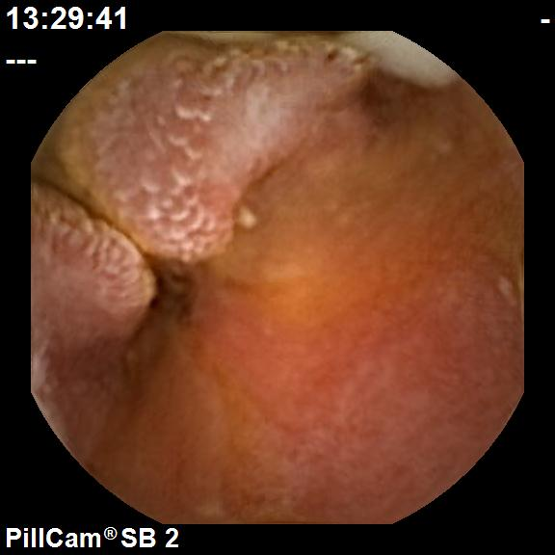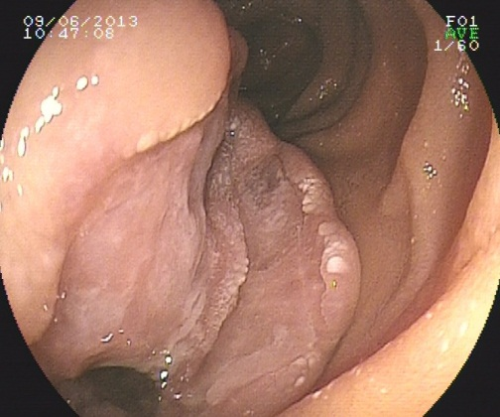
B Stromal tumor（CE） (DBE)
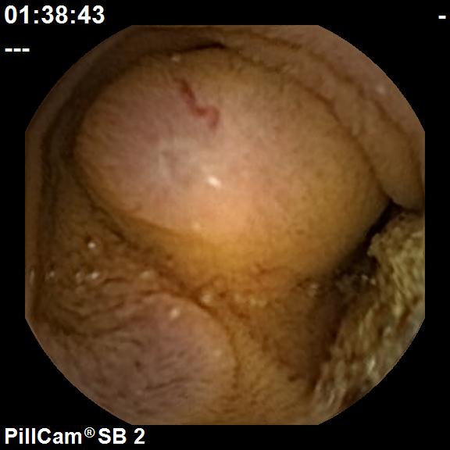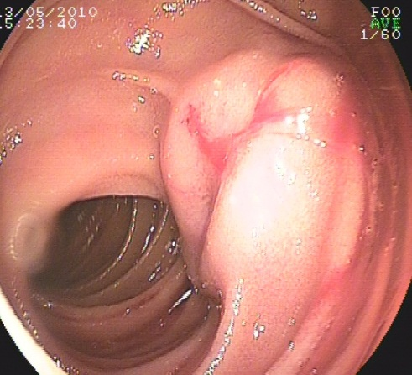
C active bleeding（CE） （DBE）
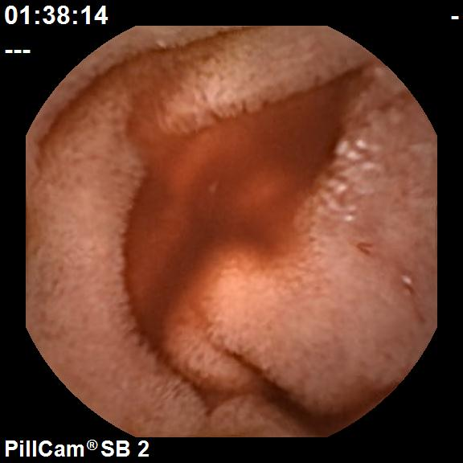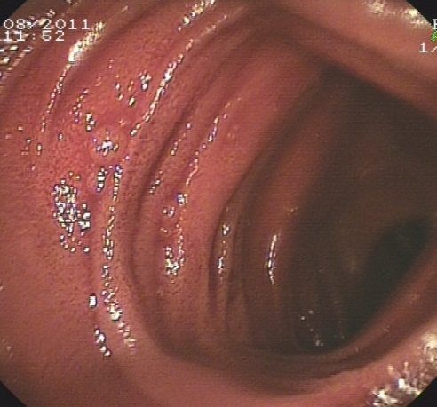

D Vascular malformation（CE）
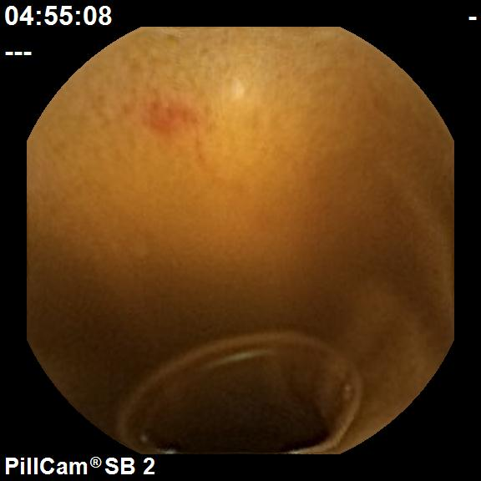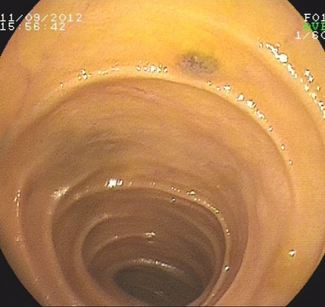

E Parasites（CE）
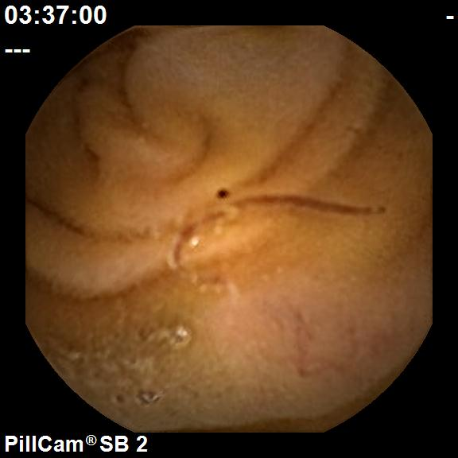
F ulcer（CE）
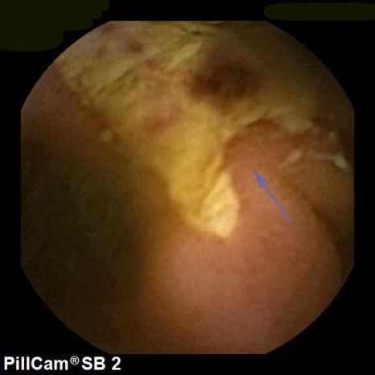

G Diverticulum with a bleeding ulcer（DBE）
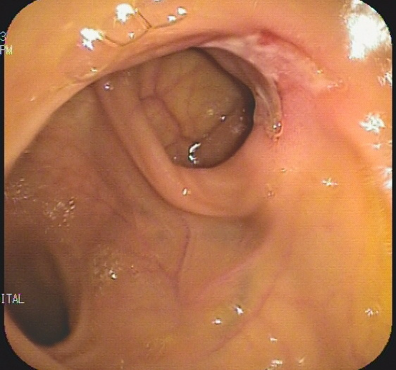
H Hemangioma（DBE）
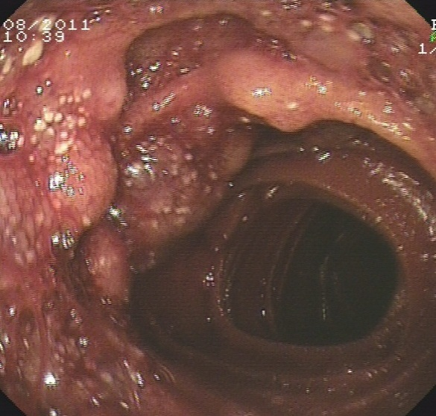

Table 1 Differences between the definite diagnostic cases between capsule endoscopy and double-balloon enteroscopy
Etiology | Tumor  (18 cases） | Ulcer(6) | Diverticulum with a bleeding ulcer (7) | Vascular  malforma  -tion (19) | Hemangioma (3) | Inflammtory  or  hyperplastic polyps (7) | Parasites (2)
CE (+) | 10 | 5 | 1 | 14 | 0 | 5 | 2
CE (-) | 8 | 1 | 6 | 5 | 3 | 3 | 0
DBE(+) | 17 | 2 | 7 | 10 | 3 | 6 | 0
DBE (-) | 1 | 4 | 0 | 9 | 0 | 2 | 2
P vaule | 0.018 | 0.242 | 0.005 | 0.179 | ¹ | 1.0 | ¹
¹Because of too few cases, the statistical calculation yield no significance. CE: Capsule endoscopy; DBE: Double-balloon enteroscopy.

Table 2 Eighteen cases with possible but not confirmed diagnoses

Etiology (cases) | Active bleeding (4) | Vascular malformations (10) | Submucosal bulge (4)
CE(+) | 4 | 8 | 4
CE(-) | 0 | 2 | 0
DBE(+) | 2 | 4 | 1
DBE(-) | 2 | 6 | 3
P vaule | 0.429 | 0.170 | 0.143
CE: Capsule endoscopy; DBE: Double-balloon enteroscopy.

Table 3 Etiologies were classified according to the patients’ age (Kruskal Wallis Test, χ² = 22.146, P = 0.008)

Etiologies  (cases) | 15-25 yr  (16) | 25-50 yr  (22) | > 50 yr  (41)
Ulcer | 2 | 1 | 3
Small intestinal | 0 | 1 | 5
cancer
Stromal tumor | 2 | 5 | 5
Inflammatory hyperplasia or polyps | 2 | 4 | 1
Vascular malformations | 2 | 5 | 22
Active bleeding | 1 | 0 | 3
Diverticulum with a bleeding ulcer | 4 | 2 | 1
Hemangioma | 1 | 1 | 1
Parasites | 1 | 1 | 0
Submucosal bulge? | 1 | 2 | 1

