Name of Journal: World Journal of Cardiology
ESPS Manuscript NO: 21173
Manuscript Type: ORIGINAL ARTICLE

Retrospective Study
Red cell distribution width in anemic patients undergoing transcatheter aortic valve implantation

Hellhammer K et al. RDW in anemic TAVI patients

Katharina Hellhammer, Tobias Zeus, Pablo E Verde, Verena Veulemanns, Lisa Kahlstadt, Georg Wolff, Ralf Erkens, Ralf Westenfeld, Eliano P Navarese, Marc W Merx, Tienush Rassaf, Malte Kelm

Katharina Hellhammer, Tobias Zeus, Verena Veulemanns, Lisa Kahlstadt, Georg Wolff, Ralf Erkens, Ralf Westenfeld, Eliano P Navarese, Marc W Merx, Tienush Rassaf, Malte Kelm, Division of Cardiology, Pulmonology and Vascular Medicine, Medical Faculty, University Düsseldorf, 40225 Düsseldorf, Germany

Pablo E Verde, Coordination Center for Clinical Trials, Medical Faculty, University 40225 Düsseldorf, Germany

Malte Kelm, Cardiovascular Research Institute Düsseldorf (CARID), University Düsseldorf, 40225 Düsseldorf, Germany

Author contributions: Hellhammer K and Zeus T performed the research and wrote the paper; Veulemanns V and Kahlstadt L designed the research and supervised the report; Verde PE designed the research and contributed to the analysis; Wolff G, Ralf Erkens, Westenfeld R, Navarese EP and Merx MW provided clinical advice; Rassaf T and Kelm M supervised the report.

Institutional review board statement: This study was reviewed and approved by the Ethics Committee of the University Hospital Düsseldorf.

Informed consent statement: Patients were not required to give informed
To the study because the analysis used anonymous clinical data that was obtained after each patient agreed to treatment by written consent.

Conflict-of-interest statement: None of the authors has conflicts of interest to declare. There is no existing relation with the industry.

Data sharing statement: No additional data are available.

Open-Access: This article is an open-access article which was selected by an in-house editor and fully peer-reviewed by external reviewers. It is distributed in accordance with the Creative Commons Attribution Non Commercial (CC BY-NC 4.0) license, which permits others to distribute, remix, adapt, build upon this work non-commercially, and license their derivative works on different terms, provided the original work is properly cited and the use is non-commercial. See: http://creativecommons.org/licenses/by-nc/4.0/

Correspondence to: Tienush Rassaf, MD, Division of Cardiology, Pulmonology and Vascular Medicine, Medical Faculty, University Düsseldorf, Moorenstr, 5, 40225 Düsseldorf, Germany. tienush.rassaf@med.uni-duesseldorf.de
Telephone: +49-211-8118801
Fax: +49-211-8118812

Received: June 29, 2015
Peer-review started: July 4, 2015
First decision: Septermber 17, 2015
Revised: October 4, 2015
Accepted: November 23, 2015
Article in press:
Published online:

Abstract
AIM: To determine the impact of red blood cell distribution width on outcome in anemic patients undergoing transcatheter aortic valve implantation (TAVI).

METHODS: In a retrospective single center cohort study we determined the impact of baseline red cell distribution width (RDW) and anemia on outcome in 376 patients with aortic stenosis undergoing TAVI. All patients were discussed in the institutional heart team and declined for surgical aortic valve replacement due to high operative risk. Collected data included patient characteristics, imaging findings, periprocedural in hospital data, laboratory results and follow up data. Blood samples for hematology and biochemistry analysis were taken from every patient before and at fixed intervals up to 72 h after TAVI including blood count and creatinine. Descriptive statistics were used for patient’s characteristics. Kaplan-Meier survival curves were used for time to event outcomes. A recursive partitioning regression and classification was used to investigate the association between potential risk factors and outcome variables.

RESULTS: Mean age in our study population was 81 ± 6.1 years. Anemia was prevalent in 63.6% (n = 239) of our patients. Age and creatinine were identified as risk factors for anemia. In our study population, anemia per se did influence 30-d mortality but did not predict longterm mortality. In contrast, a RDW > 14% showed to be highly predictable for a reduced short- and longterm survival in patients with aortic valve disease after TAVI procedure.

CONCLUSION: Age and kidney function determine the degree of anemia. The anisocytosis of red blood cells in anemic patients supplements prognostic information in addition to that derived from the WHO-based definition of anemia.

Key words: Anemia; Transcatheter aortic valve implantation; Red cell distribution width; Red blood cells; Aortic stenosis

© The Author(s) 2015. Published by Baishideng Publishing Group Inc. All rights reserved.

Core tip: This is a retrospective study to evaluate the impact of prevalent anemia and the importance of red cell distribution width (RDW) on the outcome in patients undergoing transcatheter aortic valve replacement. Anemia was prevalent 63.6% of the patients and did influence 30-d mortality but did not predict longterm mortality. In contrast, a RDW > 14% showed to be highly predictable for a reduced short- and longterm survival in patients with aortic valve disease after transcatheter aortic valve implantation procedure. Age and creatinine were identified as risk factors for anemia.

Hellhammer K, Zeus T, Verde PE, Veulemanns V, Kahlstadt L, Wolff G, Erkens R, Westenfeld R, Navarese EP, Merx MW, Rassaf T, Kelm M. Red cell distribution width in anemic patients undergoing transcatheter aortic valve implantation. World J Cardiol 2015; In press

INTRODUCTION
Anemia is common in elderly patients with cardiovascular disease. An association of increased mortality with decreasing levels of hemoglobin has been shown in patients with coronary artery disease (CAD), acute myocardial infarction (AMI), cardiac heart failure (CHF) and structural heart disease^{[1-4]}. Anemia also affects outcome after percutaneous coronary artery intervention (PCI), coronary artery bypass graft (CABG), and transcatheter aortic valve replacement (TAVI)^{[5-7]}. In patients with aortic valve disease anemia often occurs in combination with occult bleeding within the gastro-intestinal tract.
According to the WHO, anemia is defined by a level of hemoglobin < 13 g/dL in men and < 12 g/dL in women^{[8]}. Studies correcting anemia by either erythropoiesis stimulating agents (ESA) or by transfusion of packed red blood cells (RBC) yielded conflicting results^{[9]}. ESA failed to improve outcome in acute myocardial infarction^{[10]}, chronic kidney disease^{[11]}, and heart failure^{[12]}. RBC transfusions to patients undergoing primary PCI^{[13,14]}, CABG^{[15]}, and TAVI^{[7]}, respectively, may be even harmful and were associated with increased mortality. The storage lesion and subsequent scavenging of nitric oxide (NO) through occult hemolysis after transfusion may at least in part account for these detrimental effects^{[15-17]}. These data raise the question whether or not the mere determination of the hemoglobin levels is appropriate for risk stratification and guidance of anemia treatment in mostly elderly patients at high cardiovascular risk.
Red blood cell distribution width (RDW) is a quantitative measure of anisocytosis, the variability in size of circulating RBC. It is routinely measured in automated hematology analyzers and is reported together with hemoglobin, RBC number, and hematocrit as a component of complete blood count. RDW is typically elevated in conditions of ineffective RBC production, e.g., iron or vitamin B12 deficiency, increased RBC destruction such as in hemolysis, after blood transfusion or during severe inflammation. Conceivably, RDW may represent an integrative measure of multiple pathologic processes in the elderly patient with structural heart disease, explaining its strong association with clinical short and long term outcomes^{[18-24]}. Relevant comorbidities affecting RDW in those patients may include renal dysfunction, inflammatory stress, and nutritional deficiencies. Thus, the measurement of RDW as compared to hemoglobin may add or provide even superior information to stratification of those high risk patients with advanced aortic valve stenosis undergoing TAVI procedures.
Recent studies indicate that the detrimental effects of anemia is not only mediated by the absolute hemoglobin levels, but also by the quality of the endogenous and the substituted RBCs. Different subtypes of anemia affect the outcome after stenting in stable coronary artery disease distinctly^{[25]}. Red cell distribution width (RDW) has emerged as a novel marker not only of the size of erythrocytes, but also as an index of quality and function of RBC^{[19,26]}. RDW is a powerful and independent predictor of mortality in cardiac heart failure^{[18,20,21]}. The role of RDW in anemic patients undergoing TAVI is not clear. We therefore investigated whether RDW may have the potential to act as a novel prognostic parameter for risk stratification in addition to anemia, as defined by WHO criteria.

MATERIALS AND METHODS
Patient selection and study design
The study population consisted of 376 patients with severe symptomatic aortic stenosis who underwent TAVI with either the Medtronic CoreValve system (Medtronic Inc, Minneapolis, MN) or the Edwards SAPIEN Valve (Edwards Lifesciences, Irvine, CA) from August 2009 to August 2013 at the Heart Center Duesseldorf. All patients were discussed in the institutional heart team and declined for surgical aortic valve replacement due to high operative risk. All patients gave their written informed consent for TAVI and the use of clinical, procedural and follow up data for research. Study procedures were in accordance with the Declaration of Helsinki and the institutional Ethics Committee of the Heinrich-Heine University approved the study protocol. The study is registered at clinical trials (NCT01805739).

Data collection and definitions
Collected data included patient characteristics, imaging findings, periprocedural in hospital data, laboratory results and follow up data. Blood samples for hematology and biochemistry analysis were taken from every patient before and at fixed intervals up to 72 h after TAVI including blood count and creatinine. As reported by the World Health Organisation (WHO) baseline anemia was defined as a hemoglobin (Hb) level of < 13 g/dL for men and < 12 g/dL for women. Preoperative serum creatinine values were used to calculate the baseline serum creatinine clearance using the Cockcroft and Gault equation^{[27]}. Chronic kidney disease (CKD) was defined as a calculated serum clearance < 60 mL/min^{[28]}. Clinical endpoints were reported according to The Valve Academic Research Consortium (VARC) consensus statement^{[29]}. Follow up data for mortality were collected by contacting the attending physician and the civil registries. Technical appendix, statistical code, and dataset are available from the corresponding author. Participants gave informed consent for data sharing.

TAVI procedure
TAVI procedures were performed according to current guidelines^{[30]}. A single antibiotic shot was given shortly before TAVI procedure. All patients were referred to intensive care after the procedure. For antiplatelet therapy, patients received a combination therapy of aspirin 100 mg/d and clopidogrel 75 mg/d for three months after TAVI followed by permanent aspirin mono therapy. Patients on oral anticoagulation received clopidogrel 75 mg/d and oral anticoagulation for three months followed by oral anticoagulation.

Statistical analysis
The statistical methods of this study were reviewed by Pablo E Verde from the Coordination Center for Clinical Trials Düsseldorf. Descriptive statistics are based on frequency tables for categorical data, means and standard deviations for continuous variables and Kaplan-Meier survival curves for time to event outcomes. Association between continues variables are analyzed with Person's correlation coefficient and displayed graphically with scatter plots.
A recursive partitioning regression and classification was used to investigate the association between potential risk factors and outcome variables. This approach is based on the method describe by Horhorn et al^{[31]}. This technique combines an algorithm for recursive partitioning together with a well defined theory of permutation tests. Multiple test procedures are applied to determine whether a significant association between any of the covariables and the response variable can be stated. The resulting partitioning regression analysis is graphically displayed as a classification tree. The partitioning nodes are displayed by an optimal cut-off point for continues covariables and with a classification split for categorical covariables. Each node-split is assessed with a P-value calculated by a permutation test. In addition, regression analysis for binary outcomes was performed using the classical logistic regression and for time to event outcomes the proportional hazard Cox’s regression. In each case we report results for all covariables included in the model and with covariables selected by using a step-wise variable selection based on taking the minimum value of AIC (Akaike Information Criteria). As graphical outputs for regression analysis a forest plot is used, in this figure the odds ratio and the 95% confidence interval is displayed for each variable in the model. Data analysis was performed using the statistical software R version 3.1.0^{[32]}, SPSS Statistics 22 (IBM®) and GraphPad (Prism®).

RESULTS
Baseline characteristics
Anemia was prevalent in 63.6% (n = 239) of our study population (Table 1). Groups with and without anemia did not differ except for chronic kidney disease (P = 0.001), history of myocardial infarction (P = 0.029), and the need for dialysis due to end-stage chronic kidney disease (P = 0.009).
Serum levels for baseline serum creatinine (anemia: 1.5 mg/dL ± 1.2 mg/dL vs no anemia: 1.0 mg/dL ± 0.5 mg/dL; P < 0.001) and C-reactive Protein (anemia: 1.4 mg/dL ± 2.0 mg/dL vs no anemia: 0.8 mg/dL ± 1.1 mg/dL; P < 0.001) were higher in patients with anemia whereas baseline creatinine clearance was lower in anemic patients (54.5 mL/min ± 23.6 mL/min vs 65.9 mL/min ± 22.2 mL/min; P < 0.001). As a marker for the variability in size of the circulating erythrocytes the RDW was higher in patients with anemia (15.4% ± 1.8% vs 14.4% ± 1.6%; P < 0.001).

Procedural outcome and 30-d mortality
Clinical outcome was reported according to VARC criteria^{[29]}. The findings are summarized in Table 2. There was no difference with regard to vascular or bleeding complications in between both groups. Overall incidence of acute kidney injury (AKI) after TAVI was higher in patients with anemia (25.1% vs 10.9%; P = 0.001). Further clinical endpoints as stroke (anemia: 2.9% vs no anemia: 2.2%; P = 0.668), myocardial infarction (anemia: 0.4% vs no anemia: 0.0%; P = 0.448), endocarditis (anemia: 0.0% vs no anemia: 0.0%) and need for permanent pacemaker after TAVI (anemia: 21.3% vs no anemia: 19.0%; P = 0.585) did not differ between the groups. The incidence of a septical event was higher in patients with anemia (8.4% vs 2.2%; P = 0.016). Overall 30-d mortality was 7.2% (n = 27). In patients with anemia 30-d mortality was 9.2% (n = 22) whereas 3.6% (n = 5) of the patients without anemia died within 30 d (P = 0.045). The partitioning regression analysis, displayed as a classification tree, showed that life-threatening bleeding (P < 0.001) after TAVI and occurrence of AKI (p=0.002) were statistically relevant risk factors for 30-d mortality (Figure 1A). Stepwise multiple logistic regression analysis with all covariables and the best selected covariables (Figure 1B and C) confirmed these findings and showed that RDW was a statistically significant risk factor as well (P = 0.044).

Factors associated with anemia
The partitioning regression analysis using anemia as outcome parameter showed that a creatinine level > 1.1 mg/dL (P < 0.001) and age > 83 years (P = 0.027) were statistically relevant risk factors for anemia (Figure 2A). Stepwise multiple logistic regression analysis with all covariables and the best selected covariables confirmed these findings (Figure 2B and C). Mean Hb concentration in our study population was 11.9 ± 1.7 g/dL. In Figure 3A the distribution of Hb levels in our study population and marking lines for cut-off points defining anemia based on the WHO definition is shown. The distribution of RDW as a marker for the variability and function of circulating erythrocytes is shown in Figure 3B.

Hemoglobin level and 1-year survival
One-year follow up was completed in 100% (n = 376) of patients. The Kaplan-Meier survival curves for one-year mortality in patients with and without anemia are shown in Figure 4A. As the mean Hb concentration in our study population was 11.9 g/dL, the 1-year survival of patients grouped according to their Hb below or above this value is shown in Figure 4B. To find the best hemoglobin cut-off point to predict One-year mortality we performed a partitioning regression analysis which found a hemoglobin of 9.7 g/dL to be the optimal cut-off point (P = 0.012). The Kaplan-Meier survival curves of patients grouped according to their hemoglobin level above or below this cut-off point is shown in Figure 4C.

RDW and mortality
As already described, RDW was found to be a risk factor for 30-d mortality in our study population. The partitioning regression analysis using 30-d mortality as an outcome parameter showed a RDW cut-off point of 14% to predict 30-d mortality with the highest sensitivity and specificity (Figure 5A). In patients with RDW > 14% 30-d mortality and one-year mortality was significantly higher than in patients with a RDW < 14% (Figure 5B).
To assess the association between hemoglobin and RDW we performed a correlation analysis (Figure 6) which revealed a significant negative correlation between hemoglobin and RDW (-0.36; 95%CI: -0.45, -0.27; P < 0.001) reflecting that an increasing severity of anemia is associated with an increased heterogeneity of red blood cell size.

Anemia and RDW
RDW has been shown to be elevated in conditions of ineffective RBC production¹⁹. In our study population, anemic patients presented with a higher RDW than patients without anemia (P < 0.001). The distribution of RDW levels in patients with and without anemia is shown in Figure 7A and B. The Kaplan-Meier survival curves of anemic patients grouped according to the presence of a RDW below or above 14% are shown in Figure 7C (P = 0.013).

DISCUSSION
The major findings of the present study are: (1) Two thirds of TAVI patients are anemic according to the WHO definition; (2) Age and level of creatinine determine independently the incidence of anemia in this population; (3) Anemia affects incidence of TAVI related kidney injury and 30 d mortality according to VARC criteria for short term outcome; (4) A lower threshold of Hb (9.7 mg/dL) predicts 1 year mortality more precisely than the classical WHO definition of anemia in this patient cohort in our study; (5) Absolute levels of hemoglobin are related only loosely to size, distribution and presumably function of red blood cells; and (6) A red blood cell distribution width of > 14% is highly predictable for a reduced rate of survival in patients with aortic valve disease one year after TAVI procedure, particularly in those patients with already preexisting anemia. These findings raise the question whether or not the RDW should be integrated in the risk stratification in elderly anemic patients undergoing TAVI procedure.

Definition and incidence of anemia
In elderly patients with aortic valve disease the age and the kidney function are the major predictors on the prevalence of anemia, which is similar to reports in patients with CAD and CHF^{[1,3]}. Kidney function deteriorates with increasing age and the number of circulating RBC is critically dependent on the axis of renal stimulation of bone marrow synthesis of erythrocytes. According to the definition of the WHO, anemia was common in elderly patients with aortic valve stenosis and the mean value of hemoglobin level in the entire cohort was only 11.9 g/dL. Both the threshold levels suggested by the WHO and the mean value of Hb failed to precisely discriminate those patients at increased or reduced mortality rate in our study cohort. Only a level of < 9.7 g/dL hemoglobin identified patients with a reduced survival at one year after TAVI. This finding is in line with previous reports on an increased mortality one year after TAVI with decreasing levels of hemoglobin⁷. These data imply that categorizing patients as anemic or non-anemic according to the WHO criteria might be helpful to stratify patients undergoing TAVI for their periprocedural risk and short term survival, whereas long term mortality and overall risk is better achieved with a threshold of < 10 g/dL of hemoglobin.

Assessment of red blood cell function
The major task of erythrocytes is to deliver oxygen required to meet metabolic demands to tissues. Apart from the hemoglobin-dependent transport of oxygen, RBC serve many other functions. Number and distribution of RBC in the circulation are determined by their membrane and erythrocrine function^{[33-35]}. Alterations of the redox status and the conformation of membrane regulate their shape, their distribution, passage through the microcirculation and their removal from the circulation by the reticulo-endothelial. RBC release ATP, NO, nitrite, prostanoids, chemokinins and sulfide^{[36]}. More recently we and others have shown that RBCs modulate their deformability, vascular tone, infarct size and thrombus formation at the endothelium through NOS/sGC signaling^{[37-40]}. The RBC deformability and the rapid shape change are of paramount importance for the passage through the microcirculation and effective tissue perfusion. An increased RDW is associated with an impairment of RBC deformability^{[19]}. These data may raise concerns with the view that sole measurements of hemoglobin levels reflect appropriately consequences of anemia and their impact on outcome in cardiovascular diseases and interventions.
The distribution and width of RBC as a novel marker for adverse outcome in CHF has been described in the cohort of the CHARM trial only recently^{[20]}. Among 36 routine laboratory values including hematocrit and hemoglobin, higher RDW showed the greatest association with morbidity and mortality. Given the association of hemoglobin with adverse outcome in CHF and CAD we evaluated the relationship of RDW and level of hemoglobin (Figure 6). We observed a moderate negative correlation as was also reported for CHF^{[20]}. In all final multivariate models RDW was a significant predictor of short term outcome after TAVI.

Conclusion
Age and kidney function determine the degree of anemia. The anioscytosis of red blood cells in anemic patients is emerging as an important parameter to assess short and long term mortality in patients undergoing TAVI. These findings demonstrate that RDW supplements prognostic information in addition to that derived from the WHO-based definition of anemia.

Study limitations
Our results have to be confirmed in larger cohorts with a longer follow up period to establish RDW as an independent and powerful prognostic marker in elderly patients with structural heart disease. In our retrospective single center cohort study we did not systematically substitute anemia with packed red blood cells and left this decision at the discretion of the interventionalists and the colleagues supervising the patients after the TAVI procedure on the ICU and the regular ward. However, we did focus on the Hb levels and RDW at the time of admittance prior to the TAVI procedure and the percentage of patients that received transfusion within the hospital was comparable in the anemic and the non-anemic group. Therefore, we believe that this did not affect outcome differences with respect to RDW (prior to TAVI) between both groups. Further, we did not investigate the treatment of anemic patients and patients with chronic kidney disease which may have been an interesting aspect.
In addition mechanistic studies focusing on RBC signaling cascades that might be altered in these elderly patients appear highly mandatory to identify potential novel therapeutic targets to improve RBC function and to determine how treatment of anemia should be guided and monitored in this elderly population with aortic valve disease.

COMMENTS
Background
Anemia is common in elderly patients with cardiovascular disease. An association of increased mortality with decreasing levels of hemoglobin has been shown in patients with coronary artery disease, acute myocardial infarction, cardiac heart failure and structural heart disease. Red blood cell distribution width (RDW) is a quantitative measure of anisocytosis, the variability in size of circulating RBC. It may represent an integrative measure of multiple pathologic processes in the elderly patient with structural heart disease, explaining its strong association with clinical short and long term outcomes. Recent studies indicate that the detrimental effects of anemia are not only mediated by the absolute hemoglobin levels, but also by the quality of the endogenous and the substituted RBCs. The role of RDW in anemic patients undergoing TAVI is not clear. The authors therefore investigated whether RDW may have the potential to act as a novel prognostic parameter for risk stratification in addition to anemia, as defined by WHO criteria.

Research frontiers
Red cell distribution width has been shown to be a novel marker not only of the size of erythrocytes, but also as an index of quality and function of RBC. It has been shown to be a powerful and independent predictor of mortality in cardiac heart failure. The results of this study contributes to evaluate the impact of prevalent anemia on outcome and to clarify the prognostic value of RDW in anemic TAVI patients.

Innovations and breakthroughs
In this study, anemia was prevalent 63.6% of the patients and did influence 30-d mortality but did not predict longterm mortality. In contrast, a RDW > 14% showed to be highly predictable for a reduced short- and longterm survival in patients with aortic valve disease after TAVI procedure. Age and creatinine were identified as risk factors for anemia.

Applications
This study suggests that RDW is a useful additional parameter which gives prognostic information concerning the outcome of anemic patients undergoing transcatheter aortic valve implantation.

Terminology
Red cell distribution width (RDW): RDW is a quantitative measure of anisocytosis, the variability in size of circulating RBC. It has been shown to be a novel marker not only of the size of erythrocytes, but also as an index of quality and function of RBC.

Peer-review
The paper is well structured, the presentation is clear and the discussion is in accordance with the results presented. The paper brings some novelty in the field.

REFERENCES
1 Anker SD, Voors A, Okonko D, Clark AL, James MK, von Haehling S, Kjekshus J, Ponikowski P, Dickstein K. Prevalence, incidence, and prognostic value of anaemia in patients after an acute myocardial infarction: data from the OPTIMAAL trial. Eur Heart J 2009; 30: 1331-1339 [PMID: 19383732 DOI: 10.1093/eurheartj/ehp116]
2 Salisbury AC, Alexander KP, Reid KJ, Masoudi FA, Rathore SS, Wang TY, Bach RG, Marso SP, Spertus JA, Kosiborod M. Incidence, correlates, and outcomes of acute, hospital-acquired anemia in patients with acute myocardial infarction. Circ Cardiovasc Qual Outcomes 2010; 3: 337-346 [PMID: 20488919 DOI: 10.1161/circoutcomes.110.957050]
3 Anand IS. Anemia and chronic heart failure implications and treatment options. J Am Coll Cardiol 2008; 52: 501-511 [PMID: 18687241 DOI: 10.1016/j.jacc.2008.04.044]
4 Sabatine MS, Morrow DA, Giugliano RP, Burton PB, Murphy SA, McCabe CH, Gibson CM, Braunwald E. Association of hemoglobin levels with clinical outcomes in acute coronary syndromes. Circulation 2005; 111: 2042-2049 [PMID: 15824203 DOI: 10.1161/01.cir.0000162477.70955.5f]
5 Kulier A, Levin J, Moser R, Rumpold-Seitlinger G, Tudor IC, Snyder-Ramos SA, Moehnle P, Mangano DT. Impact of preoperative anemia on outcome in patients undergoing coronary artery bypass graft surgery. Circulation 2007; 116: 471-479 [PMID: 17620512 DOI: 10.1161/circulationaha.106.653501]
6 Bassand JP, Afzal R, Eikelboom J, Wallentin L, Peters R, Budaj A, Fox KA, Joyner CD, Chrolavicius S, Granger CB, Mehta S, Yusuf S. Relationship between baseline haemoglobin and major bleeding complications in acute coronary syndromes. Eur Heart J 2010; 31: 50-58 [PMID: 19825809 DOI: 10.1093/eurheartj/ehp401]
7 Nuis RJ, Sinning JM, Rodés-Cabau J, Gotzmann M, van Garsse L, Kefer J, Bosmans J, Yong G, Dager AE, Revilla-Orodea A, Urena M, Nickenig G, Werner N, Maessen J, Astarci P, Perez S, Benitez LM, Amat-Santos IJ, López J, Dumont E, van Mieghem N, van Gelder T, van Domburg RT, de Jaegere PP. Prevalence, factors associated with, and prognostic effects of preoperative anemia on short- and long-term mortality in patients undergoing transcatheter aortic valve implantation. Circ Cardiovasc Interv 2013; 6: 625-634 [PMID: 24280965 DOI: 10.1161/circinterventions.113.000409]
8 Nutritional anaemias. Report of a WHO scientific group. World Health Organ Tech Rep Ser 1968; 405: 5-37 [PMID: 4975372]
9 Cladellas M, Farré N, Comín-Colet J, Gómez M, Meroño O, Bosch MA, Vila J, Molera R, Segovia A, Bruguera J. Effects of preoperative intravenous erythropoietin plus iron on outcome in anemic patients after cardiac valve replacement. Am J Cardiol 2012; 110: 1021-1026 [PMID: 22771376 DOI: 10.1016/j.amjcard.2012.05.036]
10 Najjar SS, Rao SV, Melloni C, Raman SV, Povsic TJ, Melton L, Barsness GW, Prather K, Heitner JF, Kilaru R, Gruberg L, Hasselblad V, Greenbaum AB, Patel M, Kim RJ, Talan M, Ferrucci L, Longo DL, Lakatta EG, Harrington RA. Intravenous erythropoietin in patients with ST-segment elevation myocardial infarction: REVEAL: a randomized controlled trial. JAMA 2011; 305: 1863-1872 [PMID: 21558517 DOI: 10.1001/jama.2011.592]
11 Macdougall IC, Provenzano R, Sharma A, Spinowitz BS, Schmidt RJ, Pergola PE, Zabaneh RI, Tong-Starksen S, Mayo MR, Tang H, Polu KR, Duliege AM, Fishbane S. Peginesatide for anemia in patients with chronic kidney disease not receiving dialysis. N Engl J Med 2013; 368: 320-332 [PMID: 23343062 DOI: 10.1056/NEJMoa1203166]
12 Swedberg K, Young JB, Anand IS, Cheng S, Desai AS, Diaz R, Maggioni AP, McMurray JJ, O'Connor C, Pfeffer MA, Solomon SD, Sun Y, Tendera M, van Veldhuisen DJ. Treatment of anemia with darbepoetin alfa in systolic heart failure. N Engl J Med 2013; 368: 1210-1219 [PMID: 23473338 DOI: 10.1056/NEJMoa1214865]
13 Nikolsky E, Mehran R, Sadeghi HM, Grines CL, Cox DA, Garcia E, Tcheng JE, Griffin JJ, Guagliumi G, Stuckey T, Turco M, Fahy M, Lansky AJ, Stone GW. Prognostic impact of blood transfusion after primary angioplasty for acute myocardial infarction: analysis from the CADILLAC (Controlled Abciximab and Device Investigation to Lower Late Angioplasty Complications) Trial. JACC Cardiovasc Interv 2009; 2: 624-632 [PMID: 19628185 DOI: 10.1016/j.jcin.2009.05.004]
14 Shishehbor MH, Madhwal S, Rajagopal V, Hsu A, Kelly P, Gurm HS, Kapadia SR, Lauer MS, Topol EJ. Impact of blood transfusion on short- and long-term mortality in patients with ST-segment elevation myocardial infarction. JACC Cardiovasc Interv 2009; 2: 46-53 [PMID: 19463397 DOI: 10.1016/j.jcin.2008.09.011]
15 Koch CG, Li L, Sessler DI, Figueroa P, Hoeltge GA, Mihaljevic T, Blackstone EH. Duration of red-cell storage and complications after cardiac surgery. N Engl J Med 2008; 358: 1229-1239 [PMID: 18354101 DOI: 10.1056/NEJMoa070403]
16 Donadee C, Raat NJ, Kanias T, Tejero J, Lee JS, Kelley EE, Zhao X, Liu C, Reynolds H, Azarov I, Frizzell S, Meyer EM, Donnenberg AD, Qu L, Triulzi D, Kim-Shapiro DB, Gladwin MT. Nitric oxide scavenging by red blood cell microparticles and cell-free hemoglobin as a mechanism for the red cell storage lesion. Circulation 2011; 124: 465-476 [PMID: 21747051 DOI: 10.1161/circulationaha.110.008698]
17 Doyle BJ, Rihal CS, Gastineau DA, Holmes DR. Bleeding, blood transfusion, and increased mortality after percutaneous coronary intervention: implications for contemporary practice. J Am Coll Cardiol 2009; 53: 2019-2027 [PMID: 19477350 DOI: 10.1016/j.jacc.2008.12.073]
18 Rainer C, Kawanishi DT, Chandraratna PA, Bauersachs RM, Reid CL, Rahimtoola SH, Meiselman HJ. Changes in blood rheology in patients with stable angina pectoris as a result of coronary artery disease. Circulation 1987; 76: 15-20 [PMID: 3594763]
19 Patel KV, Mohanty JG, Kanapuru B, Hesdorffer C, Ershler WB, Rifkind JM. Association of the red cell distribution width with red blood cell deformability. Adv Exp Med Biol 2013; 765: 211-216 [PMID: 22879035 DOI: 10.1007/978-1-4614-4989-8_29]
20 Felker GM, Allen LA, Pocock SJ, Shaw LK, McMurray JJ, Pfeffer MA, Swedberg K, Wang D, Yusuf S, Michelson EL, Granger CB. Red cell distribution width as a novel prognostic marker in heart failure: data from the CHARM Program and the Duke Databank. J Am Coll Cardiol 2007; 50: 40-47 [PMID: 17601544 DOI: 10.1016/j.jacc.2007.02.067]
21 Aung N, Ling HZ, Cheng AS, Aggarwal S, Flint J, Mendonca M, Rashid M, Kang S, Weissert S, Coats CJ, Richards T, Thomas M, Woldman S, Okonko DO. Expansion of the red cell distribution width and evolving iron deficiency as predictors of poor outcome in chronic heart failure. Int J Cardiol 2013; 168: 1997-2002 [PMID: 23351789 DOI: 10.1016/j.ijcard.2012.12.091]
22 Magri CJ, Chieffo A, Durante A, Latib A, Montorfano M, Maisano F, Cioni M, Agricola E, Covello RD, Gerli C, Franco A, Spagnolo P, Alfieri O, Colombo A. Impact of mean platelet volume on combined safety endpoint and vascular and bleeding complications following percutaneous transfemoral transcatheter aortic valve implantation. Biomed Res Int 2013; 2013: 645265 [PMID: 24455712 DOI: 10.1155/2013/645265]
23 Aung N, Dworakowski R, Byrne J, Alcock E, Deshpande R, Rajagopal K, Brickham B, Monaghan MJ, Okonko DO, Wendler O, Maccarthy PA. Progressive rise in red cell distribution width is associated with poor outcome after transcatheter aortic valve implantation. Heart 2013; 99: 1261-1266 [PMID: 23735935 DOI: 10.1136/heartjnl-2013-303910]
24 Magri CJ, Chieffo A, Latib A, Montorfano M, Maisano F, Cioni M, Agricola E, Covello RD, Gerli C, Franco A, Spagnolo P, Alfieri O, Colombo A. Red blood cell distribution width predicts one-year mortality following transcatheter aortic valve implantation. Int J Cardiol 2014; 172: 456-457 [PMID: 24529824 DOI: 10.1016/j.ijcard.2013.12.216]
25 Shishehbor MH, Filby SJ, Chhatriwalla AK, Christofferson RD, Jain A, Kapadia SR, Lincoff AM, Bhatt DL, Ellis SG. Impact of drug-eluting versus bare-metal stents on mortality in patients with anemia. JACC Cardiovasc Interv 2009; 2: 329-336 [PMID: 19463445 DOI: 10.1016/j.jcin.2008.11.014]
26 Lippi G, Salvagno GL, Guidi GC. Red blood cell distribution width is significantly associated with aging and gender. Clin Chem Lab Med 2014; 52: e197-e199 [PMID: 24897405 DOI: 10.1515/cclm-2014-0353]
27 Cockcroft DW, Gault MH. Prediction of creatinine clearance from serum creatinine. Nephron 1976; 16: 31-41 [PMID: 1244564]
28 Levey AS, Eckardt KU, Tsukamoto Y, Levin A, Coresh J, Rossert J, De Zeeuw D, Hostetter TH, Lameire N, Eknoyan G. Definition and classification of chronic kidney disease: a position statement from Kidney Disease: Improving Global Outcomes (KDIGO). Kidney Int 2005; 67: 2089-2100 [PMID: 15882252]
29 Kappetein AP, Head SJ, Généreux P, Piazza N, van Mieghem NM, Blackstone EH, Brott TG, Cohen DJ, Cutlip DE, van Es GA, Hahn RT, Kirtane AJ, Krucoff MW, Kodali S, Mack MJ, Mehran R, Rodés-Cabau J, Vranckx P, Webb JG, Windecker S, Serruys PW, Leon MB. Updated standardized endpoint definitions for transcatheter aortic valve implantation: the Valve Academic Research Consortium-2 consensus document. J Thorac Cardiovasc Surg 2013; 145: 6-23 [PMID: 23084102 DOI: 10.1016/j.jtcvs.2012.09.002]
30 Vahanian A, Alfieri O, Andreotti F, Antunes MJ, Baron-Esquivias G, Baumgartner H, Borger MA, Carrel TP, De Bonis M, Evangelista A, Falk V, Iung B, Lancellotti P, Pierard L, Price S, Schafers HJ, Schuler G, Stepinska J, Swedberg K, Takkenberg J, Von Oppell UO, Windecker S, Zamorano JL, Zembala M. [Guidelines on the management of valvular heart disease (version 2012). The Joint Task Force on the Management of Valvular Heart Disease of the European Society of Cardiology (ESC) and the European Association for Cardio-Thoracic Surgery (EACTS)]. G Ital Cardiol (Rome) 2013; 14: 167-214 [PMID: 23474606 DOI: 10.1714/1234.13659]
31 Hothorn T, Hornik K, Zeileis A. Unbiased Recursive Partitioning: A Conditional Inference Framework. J Comput Graph Stat 2006; 15: 651–674 [DOI: 10.1198/106186006x133933]
32 Shavit L, Hitti S, Silberman S, Tauber R, Merin O, Lifschitz M, Slotki I, Bitran D, Fink D. Preoperative hemoglobin and outcomes in patients with CKD undergoing cardiac surgery. Clin J Am Soc Nephrol 2014; 9: 1536-1544 [PMID: 24993450 DOI: 10.2215/cjn.00110114]
33 Sprague RS, Bowles EA, Achilleus D, Ellsworth ML. Erythrocytes as controllers of perfusion distribution in the microvasculature of skeletal muscle. Acta Physiol (Oxf) 2011; 202: 285-292 [PMID: 20731624 DOI: 10.1111/j.1748-1716.2010.02182.x]
34 Mohandas N, Gallagher PG. Red cell membrane: past, present, and future. Blood 2008; 112: 3939-3948 [PMID: 18988878 DOI: 10.1182/blood-2008-07-161166]
35 Lutz HU, Bogdanova A. Mechanisms tagging senescent red blood cells for clearance in healthy humans. Front Physiol 2013; 4: 387 [PMID: 24399969 DOI: 10.3389/fphys.2013.00387]
36 Cortese-Krott MM, Kelm M. Endothelial nitric oxide synthase in red blood cells: key to a new erythrocrine function? Redox Biol 2014; 2: 251-258 [PMID: 24494200 DOI: 10.1016/j.redox.2013.12.027]
37 Wood KC, Cortese-Krott MM, Kovacic JC, Noguchi A, Liu VB, Wang X, Raghavachari N, Boehm M, Kato GJ, Kelm M, Gladwin MT. Circulating blood endothelial nitric oxide synthase contributes to the regulation of systemic blood pressure and nitrite homeostasis. Arterioscler Thromb Vasc Biol 2013; 33: 1861-1871 [PMID: 23702660 DOI: 10.1161/atvbaha.112.301068]
38 Cortese-Krott MM, Rodriguez-Mateos A, Sansone R, Kuhnle GG, Thasian-Sivarajah S, Krenz T, Horn P, Krisp C, Wolters D, Heiß C, Kröncke KD, Hogg N, Feelisch M, Kelm M. Human red blood cells at work: identification and visualization of erythrocytic eNOS activity in health and disease. Blood 2012; 120: 4229-4237 [PMID: 23007404 DOI: 10.1182/blood-2012-07-442277]
39 Merx MW, Gorressen S, van de Sandt AM, Cortese-Krott MM, Ohlig J, Stern M, Rassaf T, Gödecke A, Gladwin MT, Kelm M. Depletion of circulating blood NOS3 increases severity of myocardial infarction and left ventricular dysfunction. Basic Res Cardiol 2014; 109: 398 [PMID: 24346018 DOI: 10.1007/s00395-013-0398-1]
40 Yang J, Gonon AT, Sjöquist PO, Lundberg JO, Pernow J. Arginase regulates red blood cell nitric oxide synthase and export of cardioprotective nitric oxide bioactivity. Proc Natl Acad Sci USA 2013; 110: 15049-15054 [PMID: 23980179 DOI: 10.1073/pnas.1307058110]

P-Reviewer: Feher G, Ivanovski P, Medeiros M, Prasetyo AA S-Editor: Ji FF L-Editor: E-Editor:

Table 1 Baseline characteristics of patients undergoing transcatheter aortic valve replacement according to the presence of baseline anemia
 | Entire cohort (n = 376) | Anemia (n = 239) | No anemia (n = 137) | P-value
Age, years ± SD | 81 ± 6.1 | 82 ± 6.2 | 81 ± 5.9 | 0.101
Male, n (%) | 167 (44.4) | 112 (46.9) | 55 (40.1) | 0.207
Weight, kg ± SD | 74 ± 14.4 | 73 ± 14.2 | 75 ± 15.0 | 0.351
Height, cm ± SD | 168 ± 8.8 | 168 ± 8.7 | 168 ± 9.1 | 0.685
NYHA III and IV, n (%) | 288 (76.6) | 187 (78.6) | 101 (73.7) | 0.284
CAD, n (%) | 263 (69.9) | 170 (71.1) | 93 (67.9) | 0.209
Previous myocardial infarction, n (%) | 39 (10.4) | 31 (13.0) | 8 (5.8) | 0.029
Previous percutaneous intervention, n (%) | 168 (44.7) | 113 (47.3) | 55 (40.1) | 0.181
Previous CABG, n (%) | 89 (23.7) | 55 (23.1) | 34 (24.8) | 0.708
Previous valve, n (%) | 8 (2.1) | 5 (2.1) | 3 (2.2) | 0.954
Previous stroke, n (%) | 34 (9.0) | 23 (9.6) | 11 (8.0) | 0.604
Diabetes mellitus, n (%) | 93 (24.7) | 59 (24.7) | 34 (28.4) | 0.977
Hypertension, n (%) | 355 (94.4) | 224 (93.7) | 131 (95.6) | 0.441
Peripheral vascular disease, n (%) | 115 (30.6) | 75 (31.4) | 40 (29.2) | 0.658
Cerebroarterial vascular disease, n (%) | 81 (21.5) | 56 (23.4) | 25 (18.2) | 0.239
COPD, n (%) | 72 (19.1) | 46 (19.2) | 26 (19.0) | 0.949
Atrial fibrillation, n (%) | 87 (23.1) | 52 (21.8) | 35 (25.5) | 0.414
Permanent pacemaker, n (%) | 64 (17.0) | 43 (18.1) | 21 (15.3) | 0.497
Chronic kidney disease, n (%) | 203 (54.0) | 144 (60.3) | 59 (43.1) | 0.001
Dialysis, n (%) | 21 (5.6) | 19 (7.9) | 2 (1.5) | 0.009
Aortic valve area, cm² ± SD | 0.73 ± 0.2 | 0.71 ± 0.19 | 0.75 ± 0.22 | 0.094
Mitral regurgitation ≥ grade II, n (%) | 114 (30.3) | 73 (32.2) | 41 (31.5) | 0.904
LVEF < 30%, n (%) | 20 (5.3) | 16 (6.7) | 4 (2.9) | 0.253
LVEF 30%-44%, n (%) | 68 (18.1) | 47 (19.7) | 21 (15.3) | 0.292
LVEF 45%-55%, n (%) | 49 (13.0) | 29 (12.1) | 20 (14.6) | 0.493
LVEF > 55%, n (%) | 239 (63.6) | 147 (61.5) | 92 (67.2) | 0.273
Logistic EuroSCORE, % ± SD | 19.7 ± 12.9 | 20.5 ± 13.1 | 18.4 ± 12.5 | 0.133
Baseline hemoglobin, g/dL ± SD | 11.9 ± 1.7 | 11.0 ± 1.1 | 13.6 ± 1.1 | < 0.001
Baseline RDW, % ± SD | 15.0 ± 1.8 | 15.4 ± 1.8 | 14.4 ± 1.6 | < 0.001
Baseline serum creatinine, mg/dL ± SD | 1.3 ± 1.1 | 1.5 ±1.2 | 1.0 ± 0.5 | < 0.001
Baseline GFR, mL/min ± SD | 58.7 ± 23.7 | 54.5 ± 23.6 | 65.9 ± 22.2 | < 0.001
Baseline CRP, mg/dL ± SD | 1.2 ± 1.8 | 1.4 ± 2.0 | 0.8 ± 1.1 | < 0.001
TF access, n (%) | 270 (71.8) | 172 (72.0) | 98 (71.5) | 0.742
TA access, n (%) | 105 (27.9) | 66 (27.6) | 39 (28.5) | 0.862
TS access, n (%) | 1 (0.3) | 1 (0.4) | 0 (0.0) | 0.637
CABG: Coronary artery bypass grafting; CAD: Coronary artery disease; COPD: Chronic obstructive pulmonary disease; CRP: C-reactive protein; GFR: Glomerular filtration rate; LVEF: Left ventricular ejection fraction; NYHA: New York Heart Association; RDW: Red cell distribution width; TA: Transapical; TF: Transfemoral; TS: Transsubclavian.

Table 2 Clinical outcome of patients undergoing transcatheter aortic valve replacement according to the presence of baseline anemia
 | Entire cohort (n = 376) | Anemia (n = 239) | No anemia (n = 137) | P-value
Vascular complications
any vascular complications, n (%) | 34 (9.0) | 24 (10.0) | 10 (7.3) | 0.372
minor vascular complications, n (%) | 20 (5.3) | 14 (5.9) | 6 (4.4) | 0.639
major vascular complications, n (%) | 4 (1.1) | 3 (1.3) | 1 (0.7) | 0.633
Bleeding complications
any bleeding complications, n (%) | 45 (12.0) | 27 (11.3) | 18 (13.1) | 0.596
life-threatening bleeding, n (%) | 20 (5.3) | 12 (5.0) | 8 (5.8) | 0.732
minor bleeding, n (%) | 21 (5.6) | 12 (5.0) | 9 (6.6) | 0.529
major bleeding, n (%) | 4 (1.1) | 3 (1.3) | 1 (0.7) | 0.633
Percutaneous closure device failure, n (%) | 10 (2.7) | 7 (2.9) | 3 (2.2) | 0.668
Acute kidney injury, n (%) | 75 (31.4) | 60 (25.1) | 15 (10.9) | 0.001
Acute kidney injury stage I, n (%) | 44 (11.7) | 33 (13.8) | 11 (8.0) | 0.093
Acute kidney injury stage II, n (%) | 1 (0.3) | 1 (0.4) | 0 (0.0) | 0.636
Acute kidney injury stage III, n (%) | 30 (8.0) | 26 (10.9) | 4 (2.9) | 0.007
Need for dialysis, n (%) | 22 (5.9) | 18 (7.5) | 4 (2.9) | 0.069
Myocardial infaction, n (%) | 1 (0.3) | 1 (0.4) | 0 (0.0) | 0.448
Stroke, n (%) | 10 (2.7) | 7 (2.9) | 3 (2.2) | 0.668
Conversion to open surgery, n (%) | 8 (2.1) | 6 (2.5) | 2 (1.5) | 0.497
Sepsis, n (%) | 23 (6.1) | 20 (8.4) | 3 (2.2) | 0.016
Endocarditis, n (%) | 0 (0.0) | 0 (0.0) | 0 (0.0)
Need for pacemaker, I (%) | 77 (20.5) | 51 (21.3) | 26 (19.0) | 0.585
Length of stay > 14 d, n (%) | 235 (62.5) | 152 (63.6) | 83 (60.6) | 0.561
30-d mortality, n (%) | 27 (7.2) | 22 (9.2) | 5 (3.6) | 0.045

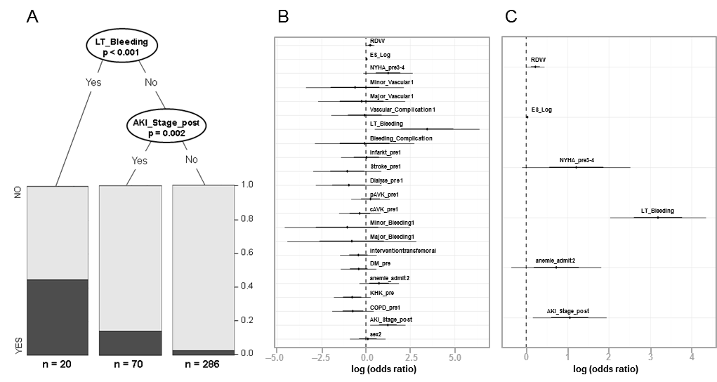

Figure 1 Regression analysis for risk factors associated with 30-d mortality. A: Results from the classification tree with significant node-splits and distribution of patients. Life-threatening bleeding (P < 0.001) and acute kidney injury (P = 0.002) were found to be statistically relevant risk factors for 30-d mortality; B: Logistic regression with all covariables which were supposed to be associated with 30-d mortality. Forest plot with odds ratios and 95% confidence intervals (logarithmic scale); C: Logistic regression with the best selected covariables using AIC. Life-threatening bleeding (P < 0.001), acute kidney injury post procedure (P = 0.018) and RDW (P = 0.044) were found to be statistically relevant risk factors for 30-dmortality. AIC: Akaike information criterion; AKI Stage post: Acute kidney injury stage I-III post; CAD: Coronary artery disease; Cavk: Cerebroarterial vascular disease; COPD: Chronic obstructive pulmonary disease; DM: Diabetes mellitus; ES log: Logistic EuroSCORE; LT_Bleeding: Life-threatening bleeding; NYHA: New York Heart Association; pAVK: Peripheral vascular disease; RDW: Red cell distribution width.

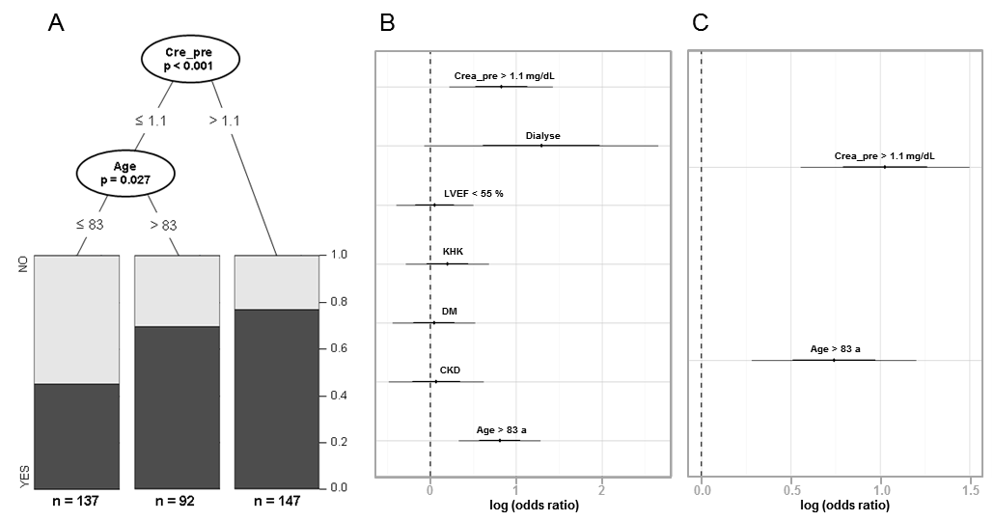

Figure 2 Regression analysis for risk factors associated with anemia. A: Classification tree with significant node-splits and distribution of patients with anemia. A creatinine > 1.1 mg/dL (P < 0.001) and age > 83 (P = 0.027) were found to be statistically relevant risk factors for anemia; B: Logistic regression with all covariables which were supposed to be associated with anemia. Forest plot with odds ratios and 95% confidence intervals (logarithmic scale); C: Logistic regression with the best selected covariables using AIC. A creatinine > 1.1 mg/dL (P < 0.001) and age > 83 (P = 0.001) were found to be statistically relevant risk factors for anemia. a: Years; AIC: Akaike information criterion; CAD: Coronary artery disease, CKD: Chronic kidney disease, Crea_pre: Creatinine (mg/dL) preoperative; DM: Diabetes mellitus; LVEF: Left ventricular ejection fraction (%).

Figure 3 Histogram of the distribution of hemoglobin and red cell distribution width levels. A: Histogram of the distribution of hemoglobin levels. Vertical lines at 12 g/dL and 13 g/dL for population based cut-off points for women and men according to WHO definition of anemia; B: Histogram of RDW levels. Hb: Hemoglobin; RDW: Red cell distribution width.

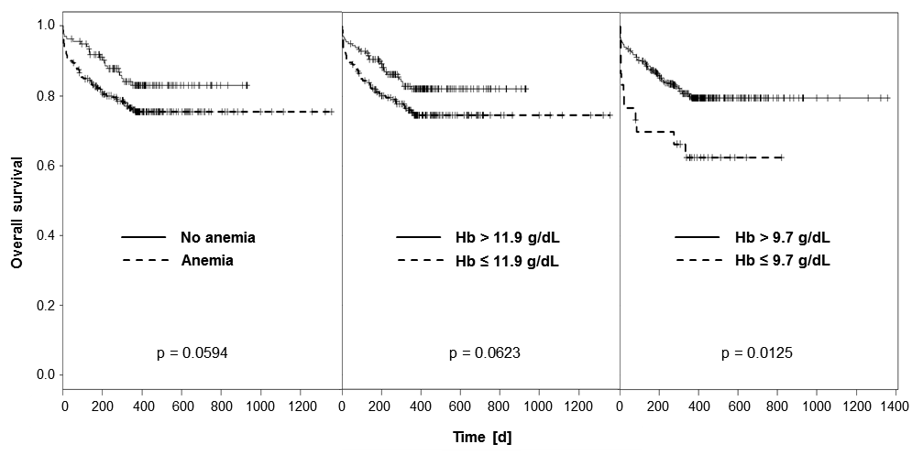

Figure 4 Anemia and one-year mortality. A: One-year survival curves of patients with and without anemia (P = 0.0594); B: One-year survival curves of patients grouped according to their hemoglobin level above or below mean Hb level of 11.9 g/dL; C: One-year survival curves of patients grouped according to their hemoglobin level above or below cut-off point of 9.7 g/dL.

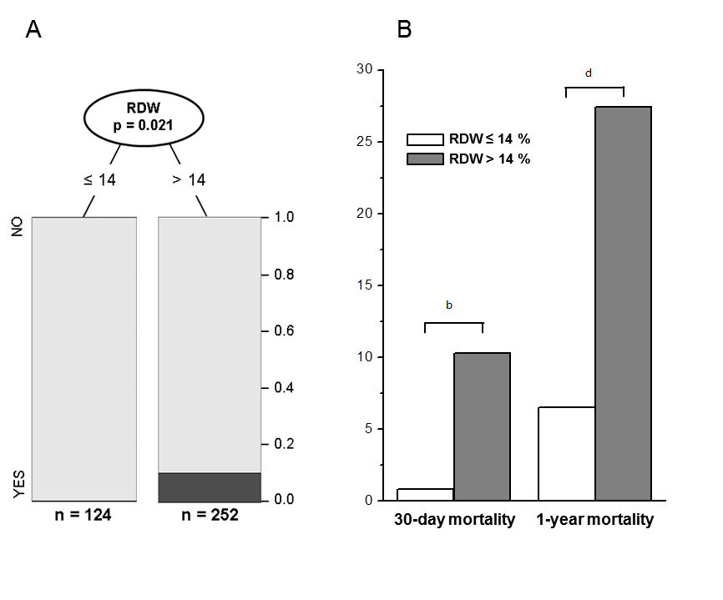
Figure 5 Red cell distribution width and mortality. A: Classification tree for 30-d mortality with significant node split at RDW 14% (P = 0.021); B: Thirty-day (P < 0.01) and one-year mortality (P < 0.001) of patients grouped according to the presence of RDW ≤ 14% or > 14%. RDW: Red cell distribution width.

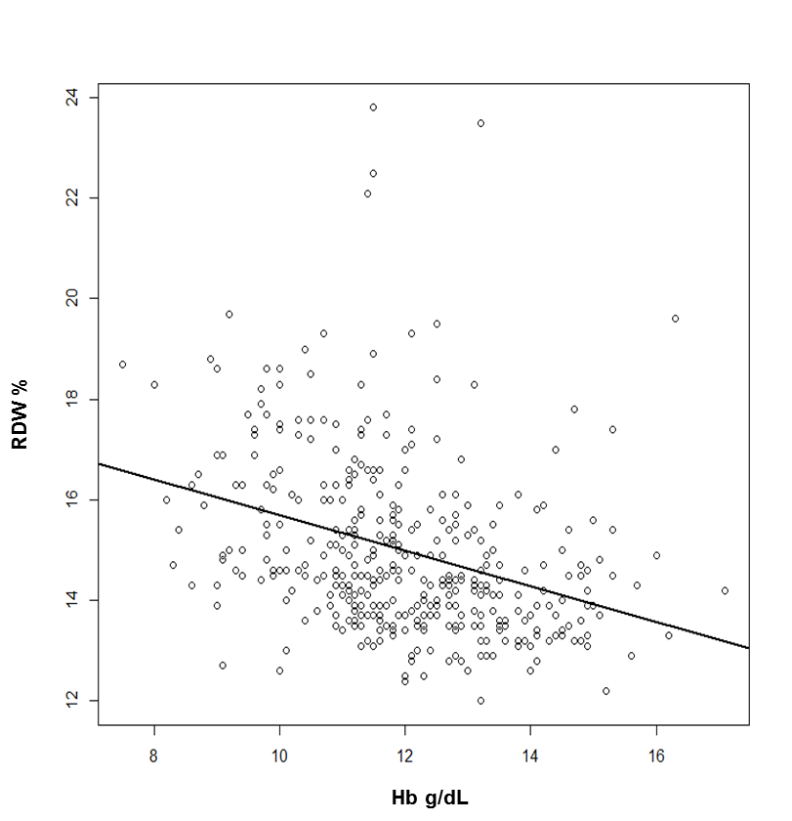

Figure 6 Correlation of hemoglobin with red cell distribution width. RDW and hemoglobin showed a significantly negative correlation (-0.36; 95%CI: -0.45, -0.27; P < 0.001). Hb: Hemoglobin; RDW: Red cell distribution width.

Figure 7 Distribution of red cell distribution width and survival of anemic patients according to their red cell distribution width. A: Distribution of RDW in patients without anemia; B: Distribution of RDW in patients with anemia; C: Survival curves of patients with anemia grouped to their RDW above or below cut off point of 14% (P = 0.013). RDW: Red cell distribution width.

