Name of Journal: World Journal of Gastroenterology
Manuscript NO: 74165
Manuscript Type: ORIGINAL ARTICLE

Basic Study
Snare-assisted flexible endoscope in trans-gastric endoscopic gallbladder-preserving surgery: A pilot animal study

Guo XW et al. Snare-assisted NOTES gallbladder-preserving surgery

Xian-Wen Guo, Yun-Xiao Liang, Peng-Yu Huang, Lie-Xin Liang, Yi-Qing Zeng, Zhen Ding

Xian-Wen Guo, Zhen Ding, Department of Gastroenterology, Union Hospital, Tongji Medical College, Huazhong University of Science and Technology, Wuhan 430022, Hubei Province, China

Xian-Wen Guo, Yun-Xiao Liang, Peng-Yu Huang, Lie-Xin Liang, Yi-Qing Zeng, Department of Gastroenterology, The People’s Hospital of Guangxi Zhuang Autonomous Region, Nanning 530021, Guangxi Zhuang Autonomous Region, China

Author contributions: Guo XW and Ding Z contributed equally to this work; Guo XW and Ding Z were responsible for the study concept and design, including endoscopic procedures; all authors conducted the endoscopic operations together; Guo XW drafted the manuscript; Ding Z revised and finalized the manuscript.

Supported by National Natural Science Foundation of China, No. 82060104; and Construction of Guangxi Clinical Medical Research Center for Digestive Diseases, No. AD17129027.

Corresponding author: Zhen Ding, PhD, Chief Doctor, Department of Gastroenterology, Union Hospital, Tongji Medical College, Huazhong University of Science and Technology, No. 1277 Jiefang Avenue, Wuhan 430022, Hubei Province, China. docd720@126.com

Received: December 19, 2021
Revised: March 23, 2022
Accepted: April 15, 2022
Published online: May 21, 2022
Abstract
BACKGROUND
Natural orifice transluminal endoscopic surgery (NOTES) gallbladder-preserving surgery by flexible endoscopy is an emerging technology. However, the gallbladder fails to obtain traction and positioning functions during the operation.

AIM
To evaluate the feasibility and safety of a new surgical method, “snare-assisted pure NOTES gallbladder-preserving surgery”.

METHODS
Eight miniature pigs were randomly divided into the experimental group [NOTES gallbladder-preserving surgery using the snare device, snare assisted (SA)] and the control group (NOTES gallbladder-preserving surgery without using the snare device, NC), with four cases in each group. The differences between the two groups of animals in operating time, operating workload, complications, adverse events, white blood cells, and liver function were determined.

RESULTS
No differences were found in the surgical success rate, gallbladder incision closure, white blood cell count, or liver function between the two groups. The total operating time, gallbladder incision blood loss, gallbladder disorientation time, gallbladder incision closure time, and workload scores on the National Aeronautics and Space Administration-Task Load Index were significantly reduced in the SA group (P < 0.05).

CONCLUSION
These results indicated that snare-assisted pure NOTES gallbladder-preservation surgery using standard endoscopic instruments reduced the difficulty of operation, shortened operation time, and did not increase complications in pigs. A new method for pure NOTES gallbladder-preservation surgery was provided.

Key Words: Snare; Flexible endoscope; Endoscopic gallbladder-preserving surgery; Natural orifice transluminal endoscopic surgery; Transgastric; Minimally invasive

©The Author(s) 2022. Published by Baishideng Publishing Group Inc. All rights reserved.

Citation: Guo XW, Liang YX, Huang PY, Liang LX, Zeng YQ, Ding Z. Snare-assisted flexible endoscope in trans-gastric endoscopic gallbladder-preserving surgery: A pilot animal study. World J Gastroenterol 2022; 28(19): 2112-2122
URL: https://www.wjgnet.com/1007-9327/full/v28/i19/2112.htm
DOI: https://dx.doi.org/10.3748/wjg.v28.i19.2112

Core Tip: This study aimed to evaluate the feasibility and safety of a new surgical method, “snare-assisted pure natural orifice transluminal endoscopic surgery (NOTES) gallbladder-preserving surgery”. Eight miniature pigs were randomly divided into an experimental group [snare assisted (SA)] and a control group. The total operating time, gallbladder incision blood loss, gallbladder disorientation time, gallbladder incision closure time, and workload scores on the National Aeronautics and Space Administration-Task Load Index were significantly reduced in the SA group. These results indicated that snare-assisted pure NOTES gallbladder-preservation surgery reduced the difficulty of the operation, shortened the operation time, and did not increase complications.

INTRODUCTION
The incidence of benign gallbladder diseases, such as gallbladder stones and gallbladder polyps, has been increasing yearly^{[1]}, and the total prevalence of gallbladder stones in adults worldwide has reached 10%–20%^{[2]}. Currently, cholecystectomy is still the main method used for the treatment of gallbladder stones and polyps. However, many complications occur after the patient loses the gallbladder^{[3,4]}; moreover, gallbladder loss leads to an increased incidence of colorectal, pancreatic, esophageal, and liver cancers^{[5-8]}. With the development of medicine, some doctors have realized that gallbladder removal may not be suitable for all patients with benign gallbladder diseases. The operation and concept of preserving the gallbladder and curing benign gallbladder diseases are now widely supported. In addition, some patients refuse open or laparoscopic cholecystectomy because it can cause surgical scars on the abdominal wall. They believe that these scars have a negative impact on their physical and mental health^{[9]}. As an emerging technology, gallbladder-preservation surgery via natural orifice transluminal endoscopic surgery (NOTES) has obvious advantages in the complete resection of gallbladder polyps, removal of gallbladder stones, and preservation of gallbladder function. It is minimally invasive, painless, and scar-free. However, there are some technical obstacles to the clinical application of this operation. For example, the gallbladder bed is close to the liver, is obscured by fatty tissue, and has a poor field of vision; therefore, it can be difficult to locate the gallbladder^{[10]}. In addition, the gallbladder collapses and shrinks quickly after incision, and the instruments used for gallbladder operation lose their focus, thereby making the operation very difficult^{[11]}. The single-channel flexible endoscope for gallbladder-preservation surgery via NOTES requires additional navigation and traction.
Our inspiration came from the use of snares to assist in traction and exposure of lesions during endoscopic submucosal dissection. We tried a similar surgical method, which involved using a snare to assist in the traction and positioning of the gallbladder. The aim of this study was to evaluate the feasibility and safety of a newly proposed operative method, “a snare-assisted pure NOTES gallbladder-preserving surgery by a single-channel flexible endoscope”.

MATERIALS AND METHODS
Animals
Eight Bama mini pigs weighing 15–20 kg that were in good health (with qualified certification) were chosen. The eight animals were randomly divided into two groups: The experimental group [NOTES gallbladder-preserving surgery using the snare device, snare assisted (SA)] and the control group (NOTES gallbladder-preserving surgery without using the snare device, NC). Each group had four animals. This study was conducted in the Experimental Center of the People's Hospital of Guangxi Zhuang Autonomous Region. The study was reviewed and approved by the Ethics Committee of the People's Hospital of Guangxi Zhuang Autonomous Region and the Ethics Committee of the Tongji Medical College, No. KY-LW-2019-4, ^{[2020]}-S322.

Equipment
A single-channel flexible endoscope (GIF-Q260J, Olympus, Tokyo, Japan) and an electrosurgical generator (Endocut ICC200; Erbe, Tubingen, Germany) were used. Other equipment included a snare (Boston Scientific, Ref; M00562650), a transparent cap (Olympus), an insulated IT-knife (model KD-610L, Olympus), a hook knife (model KD-620LR, Olympus), an injection needle (model 19G, Olympus), hemostatic clips and a release device (Olympus), and hot hemostatic forceps (KD610, Olympus). All endoscopes and accessories were sterilized prior to use.

Medications
The medications used in the study included xylazine hydrochloride injection, propofol injection, diazepam, 2% pentobarbital sodium, atropine, cimetidine, and ceftiofur sodium for injection (Chengdu Zhongmu Biological Pharmaceutical Co., Ltd.).

Anesthesia
The pigs fasted for 48–72 h. They were given 200 mL of milk and 500 mL of 50% glucose for their daily drink. Preoperative intramuscular injection of xylazine hydrochloride (2 mL) was completed, after which blood was immediately collected from the anterior vena cava of the neck. Then, an intravenous injection needle was placed in the dorsal ear vein, and intravenous infusion of propofol injection (4 mg/kg/h) was completed to maintain anesthesia. Endotracheal intubation was not performed. The ECG oxygen saturation meter was connected to monitor vital signs, and electrode pads were pasted on the abdominal skin after shaving. Preoperative intramuscular injection of ceftiofur sodium (5 mg/kg) was performed to prevent infection.

Description of technology (pure NOTES gallbladder-preserving surgery)
SA group: Each generally anesthetized pig was placed on its left side on the operating table. Each one wore a sterile mouth ring and was covered with sterile towels. An ordinary gastroscope was preinserted into the stomach. The stomach, esophagus, and duodenum were flushed with normal saline (> 1000 mL). A transparent cap was placed on the front end of the sterile gastroscope, and the anterior wall of the gastric antrum was incised using a hook knife and IT knife (Figure 1A). The snare was placed on the transparent cap and inserted into the abdominal cavity along with the endoscope (Figure 1B). The liver and gallbladder were examined (Figure 1C). The transparent cap clung to the gallbladder wall, and the gallbladder wall was sucked in it. The snare was released, and the gallbladder wall was ligated (Figure 1D). Under this ligation state (Figure 1E), a hook knife and IT knife were used to make an incision of approximately 13 mm in the gallbladder wall (Figure 1F and G). The endoscope entered the gallbladder and was used to observe and flush the gallbladder mucosa. Metal clips were employed to close the gallbladder incision (Figure 1H). The snare was loosened (Figure 1I and J). The abdominal cavity was flushed with normal saline (> 2000 mL). Further observation was performed to ensure that there was no bleeding or bile leakage at the gallbladder incision. Then, the gastric wall incision was closed with clips.

NC group: Except for the fact that the snare was not used, the operating procedures performed for this group were the same as those mentioned above.
During the operation, the intra-abdominal pressure was not measured. The anesthesiologist monitored the abdominal wall pressure and the oxygenation index of the ear skin, which prompted the endoscopist to suck the gas from the abdominal cavity with an endoscope in time to reduce the intra-abdominal pressure.

Video description
The video came from a single surgical procedure in the SA group. A pig model was used to demonstrate snare-assisted pure NOTES gallbladder-preserving surgery by a single-channel flexible endoscope (Videos 1 and 2).

Postoperative follow-up
All pigs were given liquid food after fasting for 24 h. All animals received ceftiofur sodium via injection (5 mg/kg, qd, 3 d) to prevent infection. An experienced physician conducted extensive monitoring of these animals daily to observe whether complications or adverse events occurred. Blood was collected at 24 h and 28 d after the operation. Gastroscopy was performed 28 d after the operation.

Animal care and use statement
The animal protocol was designed to minimize pain or discomfort to the animals. All animals were killed by barbiturate overdose (intravenous injection, 150 mg/kg pentobarbital sodium) for autopsy.

Outcome parameters
Changes in the number of white blood cells, blood amylase, and liver function were observed before and after the operation. The operation success rate, operation time, intraoperative and postoperative complications, and animal survival rate were recorded. The National Aeronautics and Space Administration-Task Load Index (NASA-TLX)^{[12]} was used to assess the difficulty of the operation. The conditions of the abdominal cavity, stomach wall, and gallbladder were observed by autopsy.

Statistical analysis
Quantitative data are expressed as the mean ± SD. The results were analyzed by SPSS 23.0 statistical software. The significance of the data was determined by Student’s t-test. P value < 0.05 was considered statistically significant.

RESULTS
Short-term operation outcomes
The operation was completed on all animals, and a success rate of 100% was achieved. It took 10.9 ± 4.3 min to cut the stomach wall, and the bleeding volume was 12.4 ± 6.6 mL. Although entry into the abdominal cavity occurred through the anterior wall of the gastric antrum, which was close to the gallbladder, the mirror body had no bending and showed good mobility. The operation space and visual field were small, and it took 11.0 ± 3.6 min to locate the gallbladder. Fortunately, under the assisted traction and navigation positioning of the snare, blood loss during gallbladder incision was reduced (P < 0.05). The total operating time, gallbladder disorientation time during the operation, and gallbladder incision closure time were significantly reduced in the SA group (P < 0.05) (Table 1). No differences were found between the two groups in the time involved in gallbladder incision and the number of clips required to close the gallbladder incision (P > 0.05), as shown in Table 1. However, removal of the clip was needed in 50% (2/4) of the animals in the NC group due to the incorrect placement of the clip; this situation did not occur in the SA group. The inside of the gallbladder of all animals was fully explored and flushed. None of the animals had bile leakage from the gallbladder incision.
Using the NASA-TLX to evaluate the difficulty of operation, the results showed that under the auxiliary traction and positioning of the snare, the mental demand, physical burden, temporal demand, effort, and frustration of the endoscopist were significantly reduced (P < 0.05), as shown in Table 1 and Figure 2.

Operation safety
During the operation, 75% (3/4) of the animals in the NC group showed a significant decrease in the “blood oxygen index” of the ear skin, which returned to normal after the gas in the abdominal cavity was sucked through an endoscope. However, the animals in the SA group did not show these adverse events. In addition, 100% (4/4) of the animals in the NC group had electric burn scars on their livers (Figure 3), whereas only 25% (1/4) of the animals in the SA group showed a similar condition.
All animals survived, and their body weight increased appropriately (an increase of 1.88 ± 0.69 kg) until euthanasia on Day 28. The follow-up found that the animals in the SA group were normal after the operation, and no complications occurred. In addition, no significant differences were found between the groups in the number of white blood cells and neutrophils, liver function, or the amount of amylase in the blood at 24 h and 28 d after surgery (P > 0.05) (Table 2).

Gastroscope review and necropsy
The gastric wall incisions of all animals healed without ulcers and incision fistulas (Figure 4A). A small number of omental adhesions existed on the gastric serosal surface of all animals. After the adhesions were released, the gastric wall incisions healed well. The gallbladder incisions of all animals were closed well, and no biliary fistulas, peritoneal effusions, abdominal hematomas, or abdominal abscesses were found. However, there were some adhesions around the gallbladder incisions, and the metal clip was wrapped in it (Figure 4B-D). The gallbladder was opened, and the gallbladder mucosa was smooth, with no formation of stones or polyps. The mucosa at the original incision healed well (Figure 4E), and the local mucosa was slightly edematous (Figure 4F), with an average thickness of 4.2 ± 0.7 mm. However, there was no difference in the thickness of the gallbladder mucosa between the two groups (P > 0.05).

DISCUSSION
At present, cholecystectomy is still the gold standard for the treatment of gallbladder stones and polyps. However, the gallbladder has an irreplaceable role in the digestion process of the human body. Many complications and adverse reactions can occur after gallbladder resection^{[5-8]}. Therefore, both physicians and patients expect to find a better treatment that will preserve the gallbladder and cure gallbladder stones and polyps. This paper reports the successful application of flexible endoscopy via NOTES gallbladder-preservation surgery. This seems to be a promising new surgery for patients who wish to preserve the gallbladder without scarring of the abdominal wall.
In previous single-channel flexible endoscopy via NOTES gallbladder-preservation surgery, the gallbladder was not effectively tracted and navigated, and the gallbladder and gallbladder incision were often lost during the operation, thereby significantly prolonging the operation time and increasing the damage to the surrounding organs^{[13]}. These disadvantages make it extremely difficult to promote this kind of surgery. If the gallbladder and gallbladder incision can be positioned quickly and accurately during the operation and the gallbladder can be pulled safely and effectively, then the difficulty and risk of the operation will be greatly reduced, and the operation time will be shortened. Both physicians and the patients will benefit.
In recent years, snares have been used in endoscopic submucosal dissection to assist in traction and exposure of lesions^{[14]}. Inspired by this use, we applied the snare device to gallbladder-preserving surgery, which is called “snare-assisted pure NOTES gallbladder-preserving surgery by flexible endoscope”. Compared with the non-snare group, the use of the snare significantly reduced the duration and difficulty of the operation. Moreover, the NASA-TLX workload score was significantly reduced, and no adverse reactions or complications occurred.
Although the endoscope enters the abdominal cavity through the stomach, the organs and structures in the four quadrants of the abdominal cavity can be clearly observed^{[15]}. However, this study found that the gallbladder of pigs is deeply buried in the liver lobe and is mostly covered by the surrounding omentum. This affected the surgical vision and caused the disorientation of the gallbladder during the operation. This increased the difficulty of locating the gallbladder and gallbladder incision again and significantly prolonged the operation time. Given the navigation guidance of the snare during the operation, the endoscopist quickly found the gallbladder and gallbladder incision again. Thus, the duration of gallbladder disorientation during the operation and the total operation time were significantly shortened.
This study found that after the incision of the gallbladder, the bile flowed out, the gallbladder collapsed and shrank, and the surgical instruments lost their focus, thereby increasing the difficulty of the operation. The use of a snare to pull or drag the gallbladder can significantly reduce the difficulty of operation, shorten the time of gallbladder exploration, and reduce electrical coagulation damage to the nearby liver. Particularly in the case of massive hemorrhage from the gallbladder incision, blood obstructs the vision of the endoscope. The gallbladder is raised or pulled into the stomach by the snare, which can better expose the bleeding point. This is conducive to the electrocoagulation and hemostasis of the hot hemostatic forceps. This study showed that the blood loss from the gallbladder incision in the SA group was smaller than that in the NC group. Another issue is the poor closure of the gallbladder incision, which can lead to a bile fistula^{[10]}. Although metal clips were used in this study to close the gallbladder incision, no complications, such as biliary fistula or peritonitis, occurred after the operation. However, the time involved in closing the gallbladder incision in the SA group was significantly shortened, and there were no adverse events that required the removal of the metal clip due to its incorrect placement.
This study found that 75% of the animals in the NC group experienced a significant drop in the blood oxygen index of the ears during the operation. The abdominal gas was sucked through the endoscope, and the operation was suspended to return to normal. It is possible that the abdominal pressure was too high, which inhibited the animals’ breathing and heartbeats^{[16]}. However, the blood oxygen index of the ear skin of the animals in the SA group remained normal. Given the traction and positioning of the snare, it can assist the surgical operation and expose the surgical field without blowing excess air into the abdominal cavity.
Although there are many microorganisms in the digestive tract, the strong acidity of gastric juice makes it difficult for most microorganisms to survive. Therefore, transgastric NOTES gallbladder-preserving surgery might not increase the risk of infection. A study showed that there was no significant difference in C-reactive protein and tumor necrosis factor-α levels after open surgery, laparoscopic surgery, and pure NOTES^{[17]}. The present study found that although the leukocytes and neutrophils in the blood of all animals increased 24 h after the operation, they quickly returned to normal, and no difference was found between the two groups of animals at 24 h and 28 d after surgery. Therefore, using the snare did not increase the risk of infection during surgery.
The gallbladders of all animals were opened, and their gallbladder mucosae were smooth without the formation of stones and polyps. The mucosal surface at the original incision healed well, and no difference was found in the thickness of the gallbladder healing area between the two groups. The snare did not affect the healing of gallbladder mucosa or gallbladder incision. Moreover, some adhesions appeared around the gallbladder incision in all animals, and the metal clip was wrapped in it. This finding may be due to the body's response to abdominal organ damage and foreign bodies^{[10]}. However, the snare did not aggravate this reaction.
To the best of our knowledge, this is the first experimental study of snare-assisted pure NOTES gallbladder-preserving surgery. However, several limitations of this study bear consideration. First, we only applied snare assistance for endoscopic trans-gastric gallbladder-preserving surgery. Thus, we cannot generalize the efficacy of snare assistance with other surgical paths, such as endoscopic transrectal gallbladder-preserving surgery and endoscopic transvaginal gallbladder-preserving surgery. Studies with other surgery paths are necessary in the future for a complete evaluation of the efficacy and safety of snare-assisted pure NOTES gallbladder-preserving surgery. Second, the number of animals used was small, and more studies with larger sample sizes are needed to confirm these findings. Third, it was undertaken on animals; thus, clinical trials are needed to demonstrate the effectiveness of snare-assisted pure NOTES gallbladder-preserving surgery in humans.

CONCLUSION
In summary, we successfully performed a flexible endoscopic gallbladder-preserving operation on pigs through pure NOTES. The use of a snare to assist the operation can reduce the difficulty of the operation and shorten the operation time; it does not increase the risk of the operation. Translating this new technology to human subjects seems straightforward and has great practical value in the clinic. However, further studies with large sample sizes are needed to confirm its clinical benefits, especially in humans.

ARTICLE HIGHLIGHTS
Research background
With the development of medicine, the operation and concept of preserving the gallbladder and curing benign gallbladder diseases are now widely supported. As an emerging technology, gallbladder-preservation surgery via natural orifice transluminal endoscopic surgery (NOTES) has obvious advantages in the complete resection of gallbladder polyps, removal of gallbladder stones, improvement of gallbladder inflammation, and preservation of gallbladder function. However, there are some technical obstacles to the clinical application of this operation. For example, the gallbladder bed is close to the liver, is obscured by fatty tissue, and has a poor field of vision, indicating that it can be difficult to locate the gallbladder. In addition, the gallbladder collapses and shrinks quickly after incision, and the instruments used for gallbladder operation lose their focus, thereby making the operation very difficult.

Research motivation
The single-channel flexible endoscope for gallbladder-preservation surgery via NOTES requires additional navigation and traction. We proposed a new operative method that involved using a snare to assist in the traction and positioning of the gallbladder.

Research objectives
This study aimed to evaluate the feasibility and safety of a new surgical method, “snare-assisted pure NOTES gallbladder-preserving surgery”.

Research methods
Eight miniature pigs were randomly divided into the experimental group [NOTES gallbladder-preserving surgery using the snare device, snare assisted (SA)] and the control group (NOTES gallbladder-preserving surgery without using the snare device, NC), with four cases in each group. The differences between the two groups of animals in operating time, operating workload, complications, adverse events, white blood cells, and liver function were determined.

Research results
No differences were found in the surgical success rate, gallbladder incision closure, white blood cell count, or liver function between the two groups. The total operating time, gallbladder incision blood loss, gallbladder disorientation time, gallbladder incision closure time, and workload scores of the National Aeronautics and Space Administration-Task Load Index were significantly reduced in the SA group (P < 0.05).

Research conclusions
These results indicated that snare-assisted pure NOTES gallbladder-preservation surgery using standard endoscopic instruments reduced the difficulty of the operation, shortened operation time, and did not increase complications in pigs.

Research perspectives
A new method for pure NOTES gallbladder-preservation surgery was provided. Translating this new technology to human subjects seems straightforward and has great practical value in the clinic.

ACKNOWLEDGEMENTS
The authors thank Dr Jiao Lan, Dr Fei Liu and Rui-Ping Xiao from Scientific Research Center of the People’s Hospital of Guangxi Zhuang Autonomous Region for their valuable technological assistance on our projects.

REFERENCES
1 Jian W, Song YZ, Xiang QF, Tian HY, Xie ZZ, Yang JB, Zhang YM, Zhang RK, Liu JL. Application of Transparent Cap-assisted Choledochoscopy in Endoscopic Gallbladder-preserving Surgery. Surg Laparosc Endosc Percutan Tech 2020; 30: 317-321 [PMID: 32287110 DOI: 10.1097/SLE.0000000000000786]
2 Lammert F, Gurusamy K, Ko CW, Miquel JF, Méndez-Sánchez N, Portincasa P, van Erpecum KJ, van Laarhoven CJ, Wang DQ. Gallstones. Nat Rev Dis Primers 2016; 2: 16024 [PMID: 27121416 DOI: 10.1038/nrdp.2016.24]
3 Stewart L. Iatrogenic biliary injuries: identification, classification, and management. Surg Clin North Am 2014; 94: 297-310 [PMID: 24679422 DOI: 10.1016/j.suc.2014.01.008]
4 Saxena P, Khashab MA. New NOTES Clinical Training and Program Development. Gastrointest Endosc Clin N Am 2016; 26: 385-400 [PMID: 27036904 DOI: 10.1016/j.giec.2015.12.009]
5 Shao T, Yang YX. Cholecystectomy and the risk of colorectal cancer. Am J Gastroenterol 2005; 100: 1813-1820 [PMID: 16086719 DOI: 10.1111/j.1572-0241.2005.41610.x]
6 Fan Y, Hu J, Feng B, Wang W, Yao G, Zhai J, Li X. Increased Risk of Pancreatic Cancer Related to Gallstones and Cholecystectomy: A Systematic Review and Meta-Analysis. Pancreas 2016; 45: 503-509 [PMID: 26684857 DOI: 10.1097/MPA.0000000000000502]
7 Lagergren J, Mattsson F. Cholecystectomy as a risk factor for oesophageal adenocarcinoma. Br J Surg 2011; 98: 1133-1137 [PMID: 21590760 DOI: 10.1002/bjs.7504]
8 Lagergren J, Mattsson F, El-Serag H, Nordenstedt H. Increased risk of hepatocellular carcinoma after cholecystectomy. Br J Cancer 2011; 105: 154-156 [PMID: 21610710 DOI: 10.1038/bjc.2011.181]
9 Yasuda K, Shiroshita H, Inomata M, Kitano S. [Natural orifice translumenal endoscopic surgery: historical and future perspectives]. Nihon Geka Gakkai Zasshi 2013; 114: 298-302 [PMID: 24358724]
10 Liu BR, Kong LJ, Song JT, Liu W, Yu H, Dou QF. Feasibility and safety of functional cholecystectomy by pure NOTES: a pilot animal study. J Laparoendosc Adv Surg Tech A 2012; 22: 740-745 [PMID: 22970657 DOI: 10.1089/lap.2012.0154]
11 Liu BR, Ullah S, Li DL, Liu D, Zhao LX, Yang W, Kong LJ, Zhang JY. A snare-assisted pure NOTES retrograde cholecystectomy using a single channel flexible endoscope: a pilot experiment in a porcine model. Surg Endosc 2020; 34: 3706-3710 [PMID: 32300939 DOI: 10.1007/s00464-020-07561-0]
12 Lowndes BR, Forsyth KL, Blocker RC, Dean PG, Truty MJ, Heller SF, Blackmon S, Hallbeck MS, Nelson H. NASA-TLX Assessment of Surgeon Workload Variation Across Specialties. Ann Surg 2020; 271: 686-692 [PMID: 30247331 DOI: 10.1097/SLA.0000000000003058]
13 Soltes M, Radoňak J. A risk score to predict the difficulty of elective laparoscopic cholecystectomy. Wideochir Inne Tech Maloinwazyjne 2014; 9: 608-612 [PMID: 25562000 DOI: 10.5114/wiitm.2014.47642]
14 Zhang Q, Cai JQ, Wang Z, Xiao B, Bai Y. Snare combined with endoscopic clips in endoscopic resection of gastric submucosal tumor: a method of tumor traction. Endosc Int Open 2019; 7: E1150-E1162 [PMID: 31475234 DOI: 10.1055/a-0849-9625]
15 Li Y, Han S. Transgastric endoscopic gallbladder polypectomy and cholecystolithiasis: A case report. Exp Ther Med 2020; 19: 95-98 [PMID: 31853277 DOI: 10.3892/etm.2019.8195]
16 Adelsdorfer C, Taura P, Ibarzabal A, Vendrell M, Delitala A, Deulofeu R, Adelsdorfer W, Delgado S, Lacy AM. Effect of transgastric natural orifice transluminal endoscopic surgery peritoneoscopy on abdominal organ microcirculation: an experimental controlled study. Gastrointest Endosc 2016; 83: 427-433 [PMID: 26272856 DOI: 10.1016/j.gie.2015.06.055]
17 Arroyo Vázquez J, Bergström M, Dot J, Abu-Suboh-Abadia M, Fonseca C, Esteves M, Azadani A, Armengol J, Masachs M, Armengol-Miró JR, Park PO. Surgical Trauma Caused by Different Abdominal Access Routes-Comparison of Open Surgical, Laparoscopic, and NOTES Transgastric Techniques in a Porcine Model. J Laparoendosc Adv Surg Tech A 2016; 26: 511-516 [PMID: 27163486 DOI: 10.1089/lap.2016.0034]

Footnotes
Institutional review board statement: The study was reviewed and approved by the Ethics Committee of the People's Hospital of Guangxi Zhuang Autonomous Region and the Ethics Committee of the Tongji Medical College, No. KY-LW-2019-4, ^{[2020]}-S322.

Institutional animal care and use committee statement: All procedures involving animals were reviewed and approved by the Institutional Animal Care and Use Committee of People's Hospital of Guangxi Zhuang Autonomous Region (No. KY-LW-2019-4) and the Institutional Animal Care and Committee at Huazhong University of Science and Technology Tongji Medical College (No.2625).

Conflict-of-interest statement: To the best of our knowledge, no conflict of interest exists.

Data sharing statement: No additional data are available.

ARRIVE guidelines statement: The authors have read the ARRIVE guidelines, and the manuscript was prepared and revised according to the ARRIVE guidelines.

Open-Access: This article is an open-access article that was selected by an in-house editor and fully peer-reviewed by external reviewers. It is distributed in accordance with the Creative Commons Attribution NonCommercial (CC BY-NC 4.0) license, which permits others to distribute, remix, adapt, build upon this work non-commercially, and license their derivative works on different terms, provided the original work is properly cited and the use is non-commercial. See: https://creativecommons.org/Licenses/by-nc/4.0/

Provenance and peer review: Unsolicited article; Externally peer reviewed.

Peer-review model: Single blind

Peer-review started: December 19, 2021
First decision: March 10, 2022
Article in press: April 15, 2022

Specialty type: Gastroenterology and hepatology
Country/Territory of origin: China
Peer-review report’s scientific quality classification
Grade A (Excellent): 0
Grade B (Very good): B, B
Grade C (Good): 0
Grade D (Fair): 0
Grade E (Poor): 0

P-Reviewer: Badessi G, Italy; Wang S, China S-Editor: Fan JR L-Editor: A P-Editor: Fan JR

Figure Legends
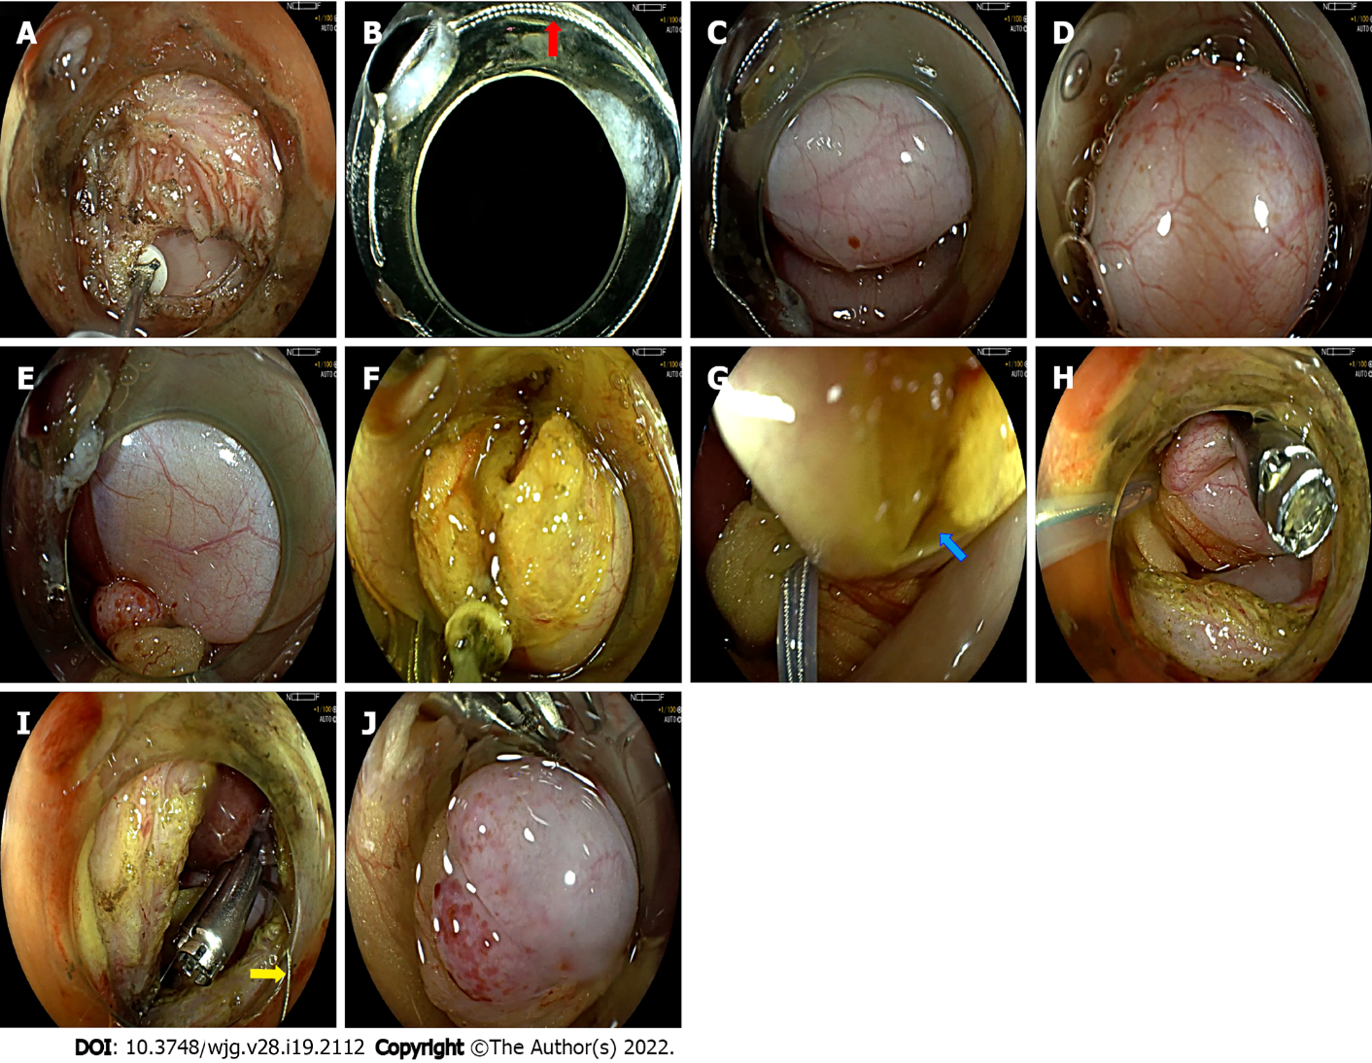
Figure 1 Snare-assisted flexible endoscope in transgastric endoscopic gallbladder-preserving surgery. A: The anterior wall of the gastric antrum was incised; B: The snare was placed on the transparent cap (red arrow); C: The endoscope was inserted into the abdominal cavity. The gallbladder was located; D: The transparent cap clung to the gallbladder wall, and the gallbladder wall was sucked in it. The snare was released, and the gallbladder wall was ligated; E: This ligation state was maintained; F: The gallbladder wall was incised with the assistance of the snare; G: With the navigation of the snare, the endoscopist quickly found the gallbladder and gallbladder incision again (blue arrow); H: With the help of the snare, clips were used to close the gallbladder wall incision; I: The snare was loosened (yellow array); J: The gallbladder wall returned to normal.
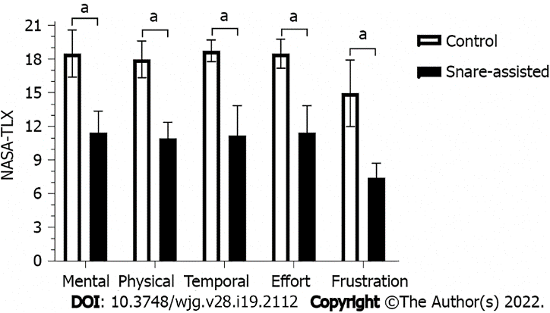
Figure 2 Overall multivariate analysis of all subjects in the control group vs the snare-assisted group. The workload for each subscale was significantly less when using snare-assisted compared with control group (ªP < 0.05). Lower performance workload subscores corresponded to an improvement in perceived performance. NASA-TLX: National Aeronautics and Space Administration-Task Load Index.
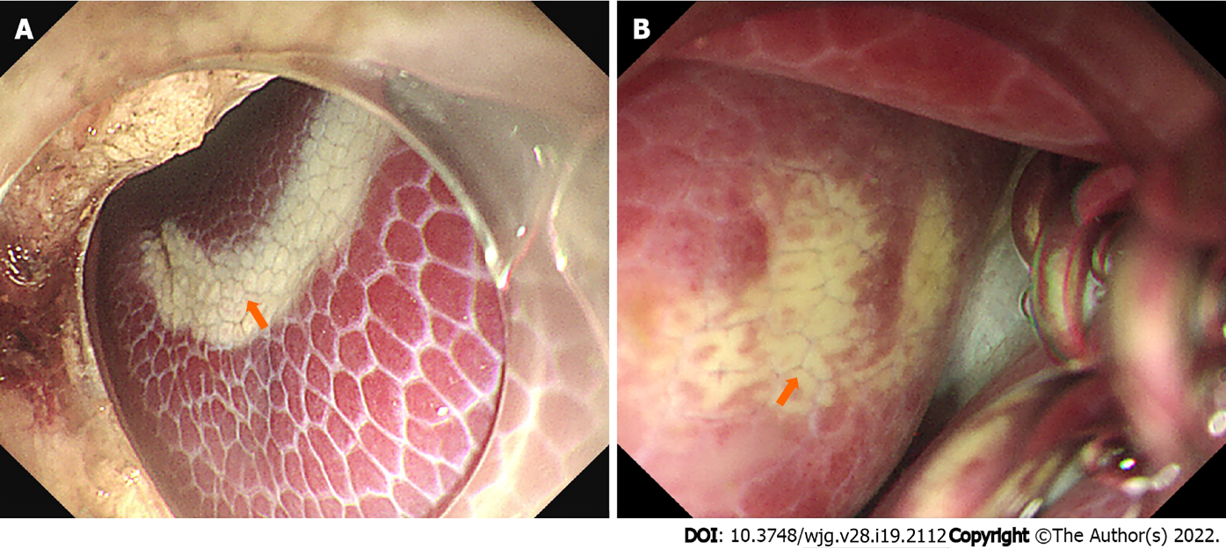
Figure 3 The livers of animals in the control group had electric burn scars (arrow). A: The electric burn scars were farther from the gallbladder; B: The electric burn scars were near the gallbladder.
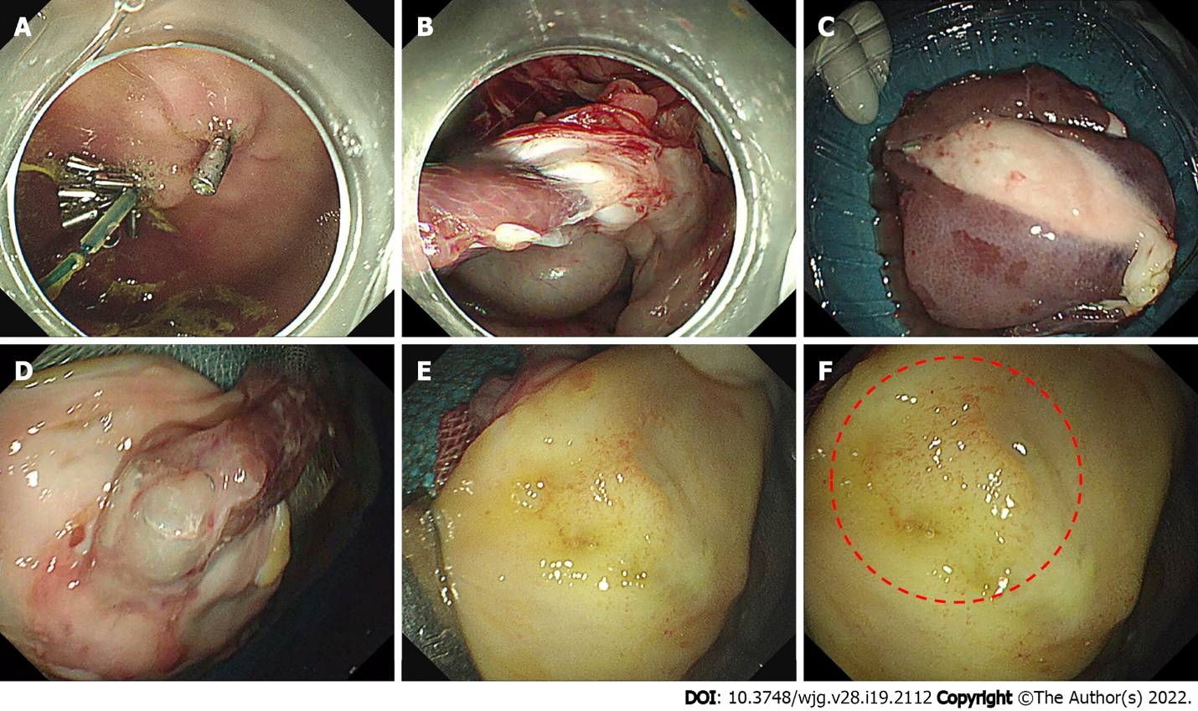
Figure 4 Gastroscopic review and necropsy were performed 28 d after the operation. A: The gastric wall incision healed well, with some clips remaining; B-D: A small number of adhesions appeared around the gallbladder incision, and the metal clip was wrapped in it; E: The gallbladder mucosa at the original incision healed well; F: The local mucosa surface was slightly edematous (red circle).
Table 1 Differences in surgical indicators between the two groups of animals
Content | NC group | SA group | t value | P value
Time required for gallbladder incision (min) | 18.5 ± 7.0 | 10.0 ± 1.8 | 2.335 | 0.058
Bleeding volume of gallbladder incision (mL) | 7.5 ± 2.9 | 2.0 ± 2.2 | 3.051 | 0.022
Number of gallbladder disorientations | 2.0 ± 0.8 | 1.3 ± 0.5 | 1.567 | 0.168
Longest time of gallbladder disorientation (min) | 11.5 ± 4.7 | 2.0 ± 0.8 | 4.020 | 0.007
Time involved in closing the gallbladder (min) | 18.3 ± 1.7 | 12.5 ± 2.1 | 4.271 | 0.005
Number of clamps used to close the gallbladder (pieces) | 6.3 ± 0.5 | 6.5 ± 1.0 | -0.447 | 0.670
Total operation time (min) | 142.3 ± 10.2 | 102.5 ± 5.5 | 6.853 | 0.000
NASA-TLX mental demand | 18.5 ± 2.1 | 11.5 ± 1.9 | 4.950 | 0.003
NASA-TLX physical | 18.0 ± 1.6 | 11.0 ± 1.4 | 6.481 | 0.001
NASA-TLX temporal demand | 18.8 ± 1.0 | 11.3 ± 2.6 | 5.359 | 0.002
NASA-TLX effort | 18.5 ± 1.3 | 11.5 ± 2.4 | 5.170 | 0.004
NASA-TLX frustration | 15.0 ± 2.9 | 7.5 ± 1.3 | 4.666 | 0.003
NASA-TLX: National Aeronautics and Space Administration-Task Load Index; NC: Control; SA: Snare assisted.

Table 2 Comparison of blood indices of the two groups of animals at 24 h and 28 d after operation
Blood | 24 h after operation |  |  |  | 28 d after operation
 | NC group | SA group | t value | P value | NC group | SA group | t value | P value
Number of white blood cells (× 10⁹/L) | 28.83 ± 3.43 | 30.10 ± 3.47 | -0.521 | 0.621 | 26.16 ± 3.64 | 25.59 ± 4.40 | 0.201 | 0.847
Number of neutrophils (× 10⁹/L) | 18.39 ± 1.67 | 19.76 ± 3.65 | -0.682 | 0.521 | 16.03 ± 1.31 | 16.67 ± 2.39 | -0.472 | 0.654
Number of lymphocytes (× 10⁹/L) | 8.63 ± 3.71 | 9.35 ± 1.30 | -0.368 | 0.732 | 8.79 ± 2.68 | 7.95 ± 2.34 | 0.472 | 0.654
Number of red blood cells (× 10¹²/L) | 7.12 ± 0.92 | 6.23 ± 0.41 | 1.763 | 0.128 | 6.27 ± 0.26 | 5.79 ± 0.43 | 1.909 | 0.105
Hemoglobin (g/L) | 129.3 ± 8.5 | 115.8 ± 6.9 | 2.466 | 0.049 | 120.50 ± 3.42 | 111.50 ± 5.69 | 2.714 | 0.035
Total bilirubin (μmol/L) | 1.85 ± 0.98 | 2.73 ± 0.74 | -1.426 | 0.204 | 2.30 ± 0.96 | 2.73 ± 0.62 | -0.743 | 0.486
Direct bilirubin (μmol/L) | 1.28 ± 0.99 | 2.15 ± 0.66 | -1.469 | 0.192 | 1.58 ± 0.87 | 2.05 ± 0.59 | -0.901 | 0.402
ALT (U/L) | 58.3 ± 22.9 | 41.5 ± 3.7 | 1.446 | 0.198 | 49.75 ± 11.32 | 40.50 ± 2.08 | 1.607 | 0.201
AST (U/L) | 78.3 ± 66.3 | 50.8 ± 12.7 | 0.815 | 0.446 | 61.25 ± 19.36 | 49.75 ± 8.26 | 1.093 | 0.317
Alkaline phosphatase (U/L) | 183.5 ± 35.9 | 189.8 ± 57.3 | -0.185 | 0.859 | 178.75 ± 36.29 | 176.00 ± 38.40 | 0.104 | 0.920
γ-GT (U/L) | 73.8 ± 32.9 | 77.8 ± 20.3 | -0.207 | 0.843 | 72.50 ± 16.76 | 64.25 ± 12.31 | 0.793 | 0.458
Amylase (U/L) | 2684.8 ± 465.9 | 2829.5 ± 170.6 | -0.584 | 0.581 | 2583.25 ± 130.31 | 2770.00 ± 102.56 | -2.252 | 0.065
ALT: Alanine aminotransferase; AST: Aspartate aminotransferase; γ-GT: Gamma-glutamyl transpeptidase; NC: Control; SA: Snare assisted.

Published by Baishideng Publishing Group Inc
7041 Koll Center Parkway, Suite 160, Pleasanton, CA 94566, USA
Telephone: +1-925-3991568
E-mail: bpgoffice@wjgnet.com
Help Desk: https://www.f6publishing.com/helpdesk
https://www.wjgnet.com

© 2022 Baishideng Publishing Group Inc. All rights reserved.

