Name of Journal: World Journal of Transplantation
Manuscript NO: 87309
Manuscript Type: SCIENTOMETRICS

Unveiling transplantation research productivity of United States: A bibliometric analysis

Rawashdeh B et al. United States transplantation research productivity

Badi Rawashdeh, Saif Aldeen AlRyalat, Mohammad Abuassi, Raj Prasad, Matthew Cooper

Badi Rawashdeh, Raj Prasad, Matthew Cooper, Department of Transplant Surgery, Medical College of Wisconsin, Milwaukee, WI 53202, United States

Saif Aldeen AlRyalat, School of Mediine, Jordan University, Amman 11100, Jordan

Mohammad Abuassi, Department of Internal Medicine, Jordan Hospital, Amman 00962, Jordan

Author contributions: Rawashdeh B and Alryalat SA contribute to planning and writing, VOSviewer analysis; Abuassi M contribute to literature review; Prasad R contribute to critical revision; Cooper M contribute to critical revision; all authors have read and approved the final manuscript.

Corresponding author: Badi Rawashdeh, MD, Surgeon, Department of Transplant Surgery, Medical College of Wisconsin, No. 9200 w wisconsin ave milwaukee, Milwaukee, WI 53202, United States. brawashdeh@mcw.edu

Received: August 2, 2023
Revised: September 11, 2023
Accepted: September 22, 2023
Published online:

Abstract
BACKGROUND
The United States has witnessed significant advancements in the field of organ transplantation over the course of the last five decades, as demonstrated by a notable increase in the quantity of academic research. The presence of a highly dynamic research environment necessitates continuous evaluations to maintain the integrity and progress of the field.

AIM
To evaluate the total output and thematic emphasis of transplant research conducted in the United States.

METHODS
On January 10, 2023, we conducted a bibliometric search of United States research output in transplantation journals from the Web of Science database's Science Citation Index Expanded. We excluded editorials, meeting abstracts, and other non-article types. We analyzed annual trends, authors, institutions, articles, keywords, and countries collaborating with the United States, using VOSviewer 1.6.18 to create figures and tables.

RESULTS
The United States published 25956 papers (3078 reviews and 22878 articles) representing 37.7% of the world's scientific output. Canada emerged as the top collaborator with the United States, co-authoring 1263 articles. Leading institutions in United States transplantation research were the University of Pittsburgh (1749 articles), Mayo Clinic (1605 articles), Harvard Medical School (1549 articles), and Johns Hopkins University (1280 articles). The top three keywords with over 2000 occurrences were "recipients," "survival," and "outcomes," indicating a focus on graft and recipient outcome markers by United States researchers.

CONCLUSION
Our findings demonstrate the United States leadership in organ transplantation research, contributing significantly to the global scientific output in this field. However, opportunities exist for fostering expansive partnerships, particularly with developing countries. This study provides valuable insights into the transplantation research landscape in the United States, emphasizing the importance of ongoing evaluations to maintain and propel advancements in this critical medical discipline. The results may facilitate future collaborations, knowledge exchange, and the pursuit of innovative solutions in the realm of organ transplantation.

Key Words: Scientometrics; Bibliometrics; Research output; Organ transplantation; United States

Rawashdeh B, AlRyalat SA, Abuassi M, Prasad R, Cooper M. Unveiling transplantation research productivity of United States: A bibliometric analysis. World J Transplant 2023; In press

Core Tip: This manuscript presents a compelling bibliometric analysis exploring the United States's pioneering productivity in the field of organ transplantation research. The study delves into 50 years of academic publications, providing valuable insights into annual trends, key authors, institutions, top keywords, and international collaborations. With 25956 papers published, representing 37.7% of the world's output, this research highlights the United States dominant position. The findings emphasize the significance of ongoing evaluations in sustaining advancements and fostering potential collaborations. Reviewers will appreciate the comprehensive approach and the potential to shape future research directions in transplantation.

INTRODUCTION
Organ transplantation in the United States has a long and storied history^{[1-3]}. Since the early twenty century, American researchers, along with others from around the world, have made incredible strides in understanding the fundamentals of transplantation^{[1,4]}. However, the first successful organ transplant did not occur until the middle of the twentieth century, when the Murray team in Boston performed the first kidney transplantation in the globe^{[5]}. The field of transplantation in the United States has advanced significantly in the last 50 years; this advancement in the field has resulted in a large number of publications.
The total number of scientific papers and citations is a marker in international scientific rankings and a measure of the academic productivity of the field for countries, organizations, and even researchers. Continuous evaluation of research publications is crucial to the growth and maintenance of the research enterprise. The SCImago Journal & Country Rank shows that in 2021, the United States published 726552 scientific papers, up from 603364 in 2010 and 371642 in 2000. According to the SCImago report, the number of medical publications published in 2021 was 296782, up from 190470 in 2010 and 134443 in 2000^{[6]}. However, the progress in academic performance of organ transplantation research in the United States has rarely been studied.
Bibliometric analysis is frequently employed to study patterns in scholarly publications and the relative significance of articles on a particular subject^{[7-9]}. Numerous medical specialties, including surgical oncology, anesthesia, cosmetic and reconstructive surgery, and others, have increasingly used bibliometric analysis to evaluate the output of national research in recent years^{[10-13]}. However, to our knowledge, bibliometric studies of articles written in the United States about organ transplantation have not been done before.
In this study, we aimed to evaluate the research output of the United States in the field of organ transplantation and the contributions of United States transplant centers and researchers from 1998 to 2022. We also aimed to assess the development of the research status of organ transplantation in the United States by evaluating research interests and hot topics over time.

MATERIALS AND METHODS
Data collection and retrieval methods
On January 10, 2023, a bibliographic search was undertaken to identify the publications published in transplantation journals in the United States. The journals were collected from the transplantation category of the Science Citation Index Expanded provided by Clarivate in the Web of Science database. The Web of Science database has a vast collection of academic journals, providing a comprehensive historical view of academic publications. The utilization of databases such as Scopus and PubMed provide valuable insights. However, because of its extensive breadth and historical coverage, Web of Science emerged as the most suitable option for our specific research investigation^{[14]}. We chose the Science Citation Index Expanded over the Emerging Sources Citation Index explicitly. The selection was made of the well-established reputation of the Expanded Index in the field of bibliometric studies. Within the transplantation category, every material from the Emerging Sources Citation Index was represented in the Expanded section, Notably, the sole exception was the Journal of Transplantation, which was listed under Emerging Sources Citation Index only and comprised only eight articles. Given the limited content from this journal and the comprehensive coverage offered by Expanded section, we deemed the latter more appropriate for our study rendering it unnecessary to reference both categories concurrently.
We have queried the Web of Science database using the publication titles to search all documents published in transplantation journals in the field "publication titles", listed in the supplement file. Articles published after 1998 were available only on the Web of Science Data and were included. We only included articles or reviews; we did not include abstracts of meetings, letters, notes, editorials, or errata. All the included articles were in English, but one was in Russian. We did not include journals related to bone marrow transplant and artificial organs, which were: Bone Marrow transplantation, Stem Cells and Development, Biology of Blood and Marrow Transplantation, Artificial Organs, International Journal of Artificial Organs, Journal of Artificial Organs, and Asaio Journal. A supplement file with the exact algorithm is attached.

Data analysis
We have analyzed annual trends, authors, institutions, journals, articles, keywords, and countries that collaborated with the United States. Figures and tables were generated using VOSviewer version 1.6.18 and MS Excel from Office 365. We have used a flow chart to elaborate on our included and excluded results. The categorization of articles was conducted by utilizing the institutional affiliations provided within the articles. In particular, an article was designated as a “United States article with international affiliation” if at least one of its authors was affiliated with an institution located outside of the United States. The primary objective of this classification system was to offer a comprehensive perspective on global cooperation, with a foundation based on simplicity. It is worth noting that in cases when authors have dual affiliations, an item was classified under the category of “United States article with international affiliation” if any of the affiliations indicated were non-American. In the keyword analysis, we have manually removed words that implied the study design such as “clinical trial” or “retrospective study”, and redundant words such as “human”, “disease”, “male”, “female”, “adult”, etc. we also removed the words that are related to the search like “transplant” and “transplantation” and “US” or “United states”.

VOSviewer network visualization interpretation
The terms in the network visualization are circles whose size depends on their weight. An item's color depends on its cluster. Linkages are shown by lines. The visualization's distance between circles roughly indicates the co-citation relationship between the terms represented by the circles. The closer two circles are, the more linked they are.

RESULTS
Included studies
The number of publications in transplant journals was 241864. After considering only the articles and review articles, we have included 69110 total publications. There was a total of 25956 papers published in the United States only, representing 37.7% of the world's research output, of which 3078 were reviews, and 22878 were articles (Figure 1). The United States research on transplantation got 776262 citations.

Annual trends
Figure 2 shows annual publications since 1998. United States published 434 articles in 1998. That number rose to 837 in 2003 and climbed to 1192 in 2013. In 2016, the number of publications declined to 1078, but they rose again to 1724 in 2021. However, the number of publications in 2022 displayed a significant decline, with just 1222 articles.

Institutions
In terms of the total number of publications, there were 111 United States institutions that published at least 100 articles, 55 that published at least 200 articles, and 41 that published at least 300 articles. 22 institutions published at least 500 articles. However, only six institutes published at least 1000 articles. The top contributing institutions were the University of Pittsburgh with 1749, Mayo Clinic with 1605; Harvard Medical School with 1549; and Johns Hopkins University with 1280 publications.
In terms of the number of citations, again, the University of Pittsburgh ranked first with 68810 citations, followed by Harvard Medical School with 54838 citations, the University of Michigan with 49111 citations, and the University of California, Los Angeles with 45440 citations (Table 1).

Authors
Seven hundred and thirty-seven authors published at least 20 documents, 81 authors published at least 50 articles, and eight authors published at least 100 articles. In terms of citations, 138 authors got at least 2000 citations, 57 got at least 3000 citations, 36 got at least 4000 citations, and at least 23 authors got at least 5000 citations. The top 20 most cited authors are listed in Table 2. The top 5 authors, in order of citations on their transplant publications, were Dory Segev with 12490, James Kirklin with 10323, David Cooper with 10307, Merion, Robert M. with 9580, and Leah Edward with 9547.

Journals
The list under the category “transplantation” has 32 journals; after the exclusion, we searched 25 journals. Most publications were published in Transplantation (n = 4795) and the American Journal of Transplantation (n = 3,954). Journal of heart and lung transplantation (n = 2388). The American Journal of Transplantation has received the highest number of citations (n = 194905), followed by Transplantation (n = 185248) and the Journal of Heart and Lung Transplantation (n = 96827) on papers addressing transplantation. The Indian Journal of Transplantation, Transplant Research, Risk Management, and International Journal of Organ Transplantation Medicine have the least number of articles published in the United States, with 9, 7, and 7 documents, respectively. The lowest United States publications were found in the Russian Journal of Transplantology and Artificial Organs, with 1 document. Table 3 lists the transplant journals and the number of United States articles and citations found.

Countries collaborations
We found that American researchers were collaborating with individuals in 114 different nations. Fifty-five countries had at least ten articles in collaboration, 35 had at least 50, 22 had at least 100, 8 had at least 500, and 2 had at least 1000. The country with the highest number of articles collaborated with the United States with the highest number of articles was Canada, with 1263 articles, followed by Germany with 1012, England with 807, and Italy and France with 719 and 598, respectively. The collaboration also extends to Asia with Japan and China, which collaborated with 594 and 579 articles. Middle eastern countries also collaborated with Saudi Arabia with 75, United Arab Emirates and Jordan with 28 and 19, respectively. Table 4 and Figure 3 show the list of countries with the most publications on collaboration with the United States and a visualization of each country's collaboration and interconnections.

Keywords
The top 20 most frequently occurring keywords in this topic are shown in Table 5. There are 3 of them that have occurred more than 2000 times, including "recipients", "survival", and "outcomes". Figure 4 shows the most occurring keywords and their interconnection across the years.

DISCUSSION
This study provides a comprehensive review of scientific publications on organ transplantation in the United States during the past 25 years. The significant increase in publications demonstrates the growing commitment of the United States to advancing transplantation knowledge. This has been sparked by a number of factors, including increased organ donation and transplantation^{[15]}, the growth of transplant centers, innovations in machine perfusion and xenograft, and increased research funding^{[1,16]}.
Nevertheless, the decline in publications in the year 2022 necessitates a crucial reconsideration. Does the decrease in publication numbers suggest a diminished emphasis on transplantation-specific journals, or does it signify broader changes in research interests? The drop that has been seen highlights the importance of employing a diverse methodological approach in the assessment of research outputs. This may involve considering the inclusion of interdisciplinary journals in future evaluations.
The volume of research conducted on kidney transplantation corresponds with the frequency of kidney transplant surgeries in clinical practice^{[15]}. However, this observation may also imply that there is an excessive focus on studies in specific areas, highlighting the necessity for a more diverse research strategy that encompasses less-explored organs or alternative transplantation approaches (Figure 5).
In 2022, American authors most frequently collaborated with authors from Canada, England, and Germany. In 2000, the United States collaborated most with Japan, Canada, and England. Canada, Germany, England, and Italy are the countries with the highest number of collaborative papers with the United States all over the years; nonetheless, it is noteworthy that Canada's collaboration with the United States increased steadily until its first peak in 2010 with 62 articles, after which it stabilized until a new spike in 2018 with 96 articles, double the number of articles published in 2014; this spike continued until its second peak in 2021 with 111 articles. On the other hand, cooperation with Germany has grown steadily since 2000, reaching a record high of 61 articles in 2011. However, the number of collaborative publications decreased from 2011 to 2015 before beginning to rise again, although not to the level of collaboration with Canada; the second peak was in 2021, with only 62 articles. With a peak of 81 articles in 2021, the number of articles written in collaboration with England has increased steadily and consistently since 2000.
Until 2004, only one article was published by Chinese and American authors. Since then, it has progressively increased, peaking at 34 papers in 2012 and 59 articles in 2019, before declining significantly to 29 by 2022. African countries and institutes collaborated poorly. Egypt and South Africa collaborated the most, with 86 and 44 articles, respectively. Zambia, Nigeria, and Morocco collaborated in a few articles. South American collaboration is represented mainly by Brazil with 238 articles, Argentina with 91, Mexico with 78, and Peru with nine articles. Egypt, India, Saudi Arabia, and the Philippines were the countries that collaborated most recently, more so since 2016, compared to Germany, Italy, Switzerland, and Japan, which showed that the collaboration extends to 2010 and before, as shown in Figure 3B.
Since there is an imbalance between organ transplantation demand and availability in the United States, Global Paired Exchange could be an excellent option to improve the immunologic diversity of donors by including donor and recipient pairs from countries with low healthcare resources for end-stage renal disease. Alongside all precautions, We believe that collaborative research between the United States and other countries can enhance this global paired exchanges program^{[17-19]}.
Interestingly, the majority of the top 20 highly referenced authors were in the fields of heart and lung transplantation, with seven authors receiving citations for their papers on cardiac transplantations and three authors receiving the majority of citations for their papers on lung transplantations. Five authors on the list were cited for their research in the field of kidney transplantation, while two were cited for their work in liver transplantation. One author is a research analyst, and the majority of citations received are for the work on registries, which may not provide any insight into the scientific work. Two authors published in the field of transplant epidemiology, including the most cited author, Dorry Segev, who published 378 documents that received 12490 citations in transplant journals.
There is no doubt that solid organ transplantation is the area of medicine in the United States that has paid the most attention to the process of evaluating recipient and graft outcomes. The results of this study confirmed this assertion, as "survival" and "outcome" were the most frequently used keywords in connection to graft and recipient outcome measurements. The United Network for Organ Sharing and Organ Procurement and Transplantation Network in the United States are responsible for monitoring the outcomes of organ transplantation centers and patients^{[20,21]}. Outcome management aims to ensure that transplant recipients receive the best possible care and that the transplant successfully improves the recipient's quality of life. This is achieved by using the data and information collected during the transplant process to make decisions about the recipient's care and treatment.
Although the United States has made significant advances in transplantation over the past few decades, readers should keep in mind that counts of publications and citations conceal unmeasured characteristics like the density of knowledge in each article and data sets that accompany articles when assessing the data presented in this report. Publication numbers are one indicator of a nation's research output, but not the only one.
Some of these articles' limitations should be addressed. First, the primary emphasis of our analysis was on academic journals categorized under the "transplant" category within the Web of Science database. This approach was taken to ensure that our study included fundamental research in the field of transplantation. Although this approach is thorough, it might overlook journals that are not primarily categorized under the field of 'transplantation' but occasionally publish articles that are pertinent to the topic. Second, we removed journals specific for bone marrow transplant and artificial organs journals; however, specific articles published in the journals included in our analysis may not be directly connected to solid organ transplant. Furthermore, articles pertinent to transplant may have been published in other journals not included in our analysis. Consequently, our investigation may offer a cautious approximation of transplantation studies. However, despite the presence of consistent criteria, our findings continue to provide significant insights.

CONCLUSION
The number of scientific research articles authored by American authors on the subject of organ transplantation has been steadily increasing over the past 25 years, which has paralleled the progression of the field as a whole. However, there has been a significant reduction in research production in 2022, which may demand observation and monitoring in the coming few years. The top three most frequent words in this study were "outcome," "survival," and "recipients," indicating that graft and recipient outcome measurements were of considerable significance to American researchers. The United States has made substantial contributions to the global advancement of organ transplantation practice. Nevertheless, there is room for substantial partnerships with other countries, particularly developing ones.

ARTICLE HIGHLIGHTS
Research background
Over the years, significant advancements have been made in the field of organ transplantation, saving innumerable lives and improving the quality of life for patients worldwide. The United States plays a pivotal role in advancing these advancements, contributing a substantial volume of research and clinical innovations. Given this position of leadership, ongoing assessments are essential for navigating the swiftly evolving landscape of transplantation research. These evaluations aid in identifying emerging trends, identifying areas of interest, and highlighting opportunities for international collaborations. Therefore, periodic evaluations, especially using techniques such as bibliometric analysis, are essential for maintaining the United States' cutting-edge contributions to this vital medical field and for guiding future research endeavors.

Research motivation
Bibliometric analysis is a useful method for systematically evaluating research output in order to navigate this ever-expanding landscape. This form of analysis provides a comprehensive overview of current research trends, influential publications, and key areas of concentration. It establishes a data-driven foundation for future research directions, ensuring that efforts are focused on areas with the greatest impact and need. Consequently, periodic bibliometric assessments are essential for maintaining the field's ongoing progress and sustaining the vitality of research efforts in this essential medical discipline.

Research objectives
This study's primary objective is to conduct a thorough analysis of the current status of organ transplantation research in the United States. Specific objectives include identifying the primary contributing authors and institutions, assessing the predominant research topics through keyword analysis, and determining the scope of international collaborations.

Research methods
In this first-of-its-kind study, we utilized the Web of Science database to perform a comprehensive bibliometric analysis. This resource was selected due to its extensive collection of academic journals. The software VOSviewer was used to visualize data, enabling the identification of key trends, such as top-contributing institutions and international collaborations. This bibliometric approach provided unprecedented insight into the prevalent research trends, major contributors, and key focus areas in United States organ transplantation research output.

Research results
This comprehensive analysis provides important insights into the current status of organ transplantation research in the United States. The University of Pittsburgh emerges as an important institution, indicating a concentration of expertise and potentially functioning as a hub for future cooperation. The American Journal of Transplantation's high number of citations demonstrates its reputation as a prominent venue for disseminating influential research, thereby influencing the field's practices and policies. Moreover, Canada's position as the United States' top international collaborator demonstrates the efficacy of global partnerships in advancing research. Despite these contributions, obstacles remain, such as the need for expanded international collaborations, particularly with developing nations, and the exploration of under researched areas in organ transplantation. These findings highlight the significance of ongoing evaluations in maintaining and advancing the field of study.

Research conclusions
In this study, a bibliometric analysis method was introduced to quantitatively evaluate the landscape of organ transplantation research authored by American researchers. Over the past 25 years, the number of scientific research articles written by American authors on the topic of organ transplantation has increased consistently, paralleling the overall development of the field. Nevertheless, a significant decline in research output was observed in 2022, necessitating close observation and monitoring in the years to come. Our study revealed that the three most frequently occurring keywords were outcome, survival and recipients, indicating the importance of graft and recipient outcome measurements to American researchers. Although the United States has made significant contributions to the global advancement of organ transplantation practice, there is still plenty of opportunity for collaboration with other nations, particularly developing countries.

Research perspectives
The study sheds new light on collaboration in organ transplantation research. By utilizing bibliometric methods, we were able to identify crucial collaboration patterns. Within the United States, the interdependence of prominent institutions is evident. An important international collaborator stands out. These insights suggest that future research could benefit from targeted collaborations that capitalize on the assets of prominent United States and international centers and authors. Particularly, unrealized potential exists for partnerships with developing nations to expand the global scope of organ transplantation research.

REFERENCES
1 Nordham KD, Ninokawa S. The history of organ transplantation. Proc (Bayl Univ Med Cent) 2022; 35: 124-128 [PMID: 34970061 DOI: 10.1080/08998280.2021.1985889]
2 Morris PJ. Transplantation--a medical miracle of the 20th century. N Engl J Med 2004; 351: 2678-2680 [PMID: 15616201 DOI: 10.1056/NEJMp048256]
3 Barker CF, Markmann JF. Historical overview of transplantation. Cold Spring Harb Perspect Med 2013; 3: a014977 [PMID: 23545575 DOI: 10.1101/cshperspect.a014977]
4 Dangoor JY, Hakim DN, Singh RP, Hakim NS. Transplantation: a brief history. Exp Clin Transplant 2015; 13: 1-5 [PMID: 25542855 DOI: 10.6002/ect.2014.0258]
5 HARRISON JH, MERRILL JP, MURRAY JE. Renal homotransplantation in identical twins. Surg Forum 1956; 6: 432-436 [PMID: 13391513]
6 Scimago Lab. SCImago Journal and Country Rank. 2023. [cited January 10, 2023]. Available from: https://www.scimagojr.com/
7 Hood WW, Wilson, CS. The Literature of Bibliometrics, Scientometrics, and Informetrics. Scientometrics 2001; 52: 291–314 [DOI:10.1023/a:1017919924342]
8 AlRyalat SAS, Malkawi LW, Momani SM. Comparing Bibliometric Analysis Using PubMed, Scopus, and Web of Science Databases. J Vis Exp 2019 [PMID: 31710021 DOI: 10.3791/58494]
9 Akmal M, Hasnain N, Rehan A, Iqbal U, Hashmi S, Fatima K, Farooq MZ, Khosa F, Siddiqi J, Khan MK. Glioblastome Multiforme: A Bibliometric Analysis. World Neurosurg 2020; 136: 270-282 [PMID: 31953095 DOI: 10.1016/j.wneu.2020.01.027]
10 Bakker IS, Wevers KP, Hoekstra HJ. Geographical distribution of publications in the scientific field of surgical oncology. J Surg Oncol 2013; 108: 505-507 [PMID: 24114560 DOI: 10.1002/jso.23441]
11 Zhang WJ, Ding W, Jiang H, Zhang YF, Zhang JL. National representation in the plastic and reconstructive surgery literature: a bibliometric analysis of highly cited journals. Ann Plast Surg 2013; 70: 231-234 [PMID: 22156891 DOI: 10.1097/SAP.0b013e3182309982]
12 Bould MD, Boet S, Riem N, Kasanda C, Sossou A, Bruppacher HR. National representation in the anaesthesia literature: a bibliometric analysis of highly cited anaesthesia journals. Anaesthesia 2010; 65: 799-804 [PMID: 20586744 DOI: 10.1111/j.1365-2044.2010.06424.x]
13 Liang Z, Luo X, Gong F, Bao H, Qian H, Jia Z, Li G. Worldwide Research Productivity in the Field of Arthroscopy: A Bibliometric Analysis. Arthroscopy 2015; 31: 1452-1457 [PMID: 25911391 DOI: 10.1016/j.arthro.2015.03.009]
14 Kulkarni AV, Aziz B, Shams I, Busse JW. Comparisons of citations in Web of Science, Scopus, and Google Scholar for articles published in general medical journals. JAMA 2009; 302: 1092-1096 [PMID: 19738094 DOI: 10.1001/jama.2009.1307]
15 Lentine KL, Smith JM, Hart A, Miller J, Skeans MA, Larkin L, Robinson A, Gauntt K, Israni AK, Hirose R, Snyder JJ. OPTN/SRTR 2020 Annual Data Report: Kidney. Am J Transplant 2022; 22 Suppl 2: 21-136 [PMID: 35266618 DOI: 10.1111/ajt.16982]
16 Israni AK, Zaun D, Rosendale JD, Schaffhausen C, McKinney W, Snyder JJ. OPTN/SRTR 2019 Annual Data Report: Deceased Organ Donors. Am J Transplant 2021; 21 Suppl 2: 521-558 [PMID: 33595189 DOI: 10.1111/ajt.16491]
17 Rees MA, Dunn TB, Kuhr CS, Marsh CL, Rogers J, Rees SE, Cicero A, Reece LJ, Roth AE, Ekwenna O, Fumo DE, Krawiec KD, Kopke JE, Jain S, Tan M, Paloyo SR. Kidney Exchange to Overcome Financial Barriers to Kidney Transplantation. Am J Transplant 2017; 17: 782-790 [PMID: 27992110 DOI: 10.1111/ajt.14106]
18 Pullen LC. Global Kidney Exchange: Overcoming the Barrier of Poverty. Am J Transplant 2017; 17: 2499-2500 [PMID: 28960935 DOI: 10.1111/ajt.14469]
19 Lo AL, Sonnenberg EM, Abt PL. Evolving swaps in transplantation: global exchange, vouchers, liver, and trans-organ paired exchange. Curr Opin Organ Transplant 2019; 24: 161-166 [PMID: 30730354 DOI: 10.1097/MOT.0000000000000621]
20 Leppke S, Leighton T, Zaun D, Chen SC, Skeans M, Israni AK, Snyder JJ, Kasiske BL. Scientific Registry of Transplant Recipients: collecting, analyzing, and reporting data on transplantation in the United States. Transplant Rev (Orlando) 2013; 27: 50-56 [PMID: 23481320 DOI: 10.1016/j.trre.2013.01.002]
21 Mathur AK, Talwalkar J. Quality measurement and improvement in liver transplantation. J Hepatol 2018; 68: 1300-1310 [PMID: 29559346 DOI: 10.1016/j.jhep.2018.02.034]

Footnotes
Conflict-of-interest statement: No conflict of interest to disclose. the authors didn't receive any fund for this study.

PRISMA 2009 Checklist statement: The authors have read the PRISMA 2009 Checklist, and the manuscript was prepared and revised according to the PRISMA 2009 Checklist.

Open-Access: This article is an open-access article that was selected by an in-house editor and fully peer-reviewed by external reviewers. It is distributed in accordance with the Creative Commons Attribution NonCommercial (CC BY-NC 4.0) license, which permits others to distribute, remix, adapt, build upon this work non-commercially, and license their derivative works on different terms, provided the original work is properly cited and the use is non-commercial. See: https://creativecommons.org/Licenses/by-nc/4.0/

Provenance and peer review: Unsolicited article; Externally peer reviewed.

Peer-review model: Single blind

Peer-review started: August 2, 2023
First decision: September 4, 2023
Article in press:

Specialty type: Transplantation
Country/Territory of origin: United States
Peer-review report’s scientific quality classification
Grade A (Excellent): 0
Grade B (Very good): 0
Grade C (Good): C, C
Grade D (Fair): 0
Grade E (Poor): 0

P-Reviewer: Alzerwi NAN, Saudi Arabia, Akbulut S, Turkey S-Editor: Lin C L-Editor: P-Editor:
Figure Legends
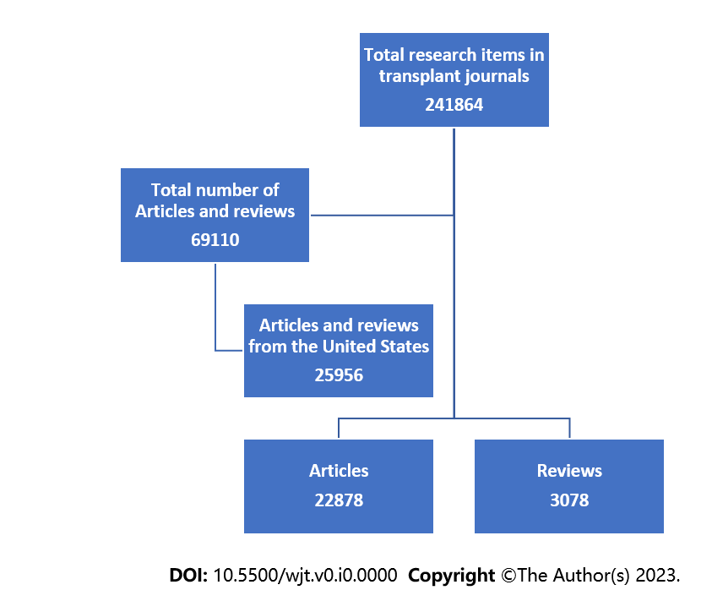
Figure 1 Flow chart of the United States transplantation research output and exclusion criteria.

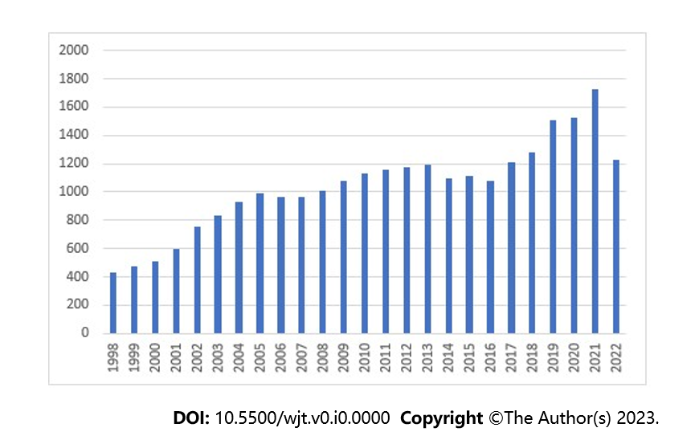
Figure 2 Publication trends in the United States in the field of transplantation, as documented in transplantation journals from 1998 to 2022.

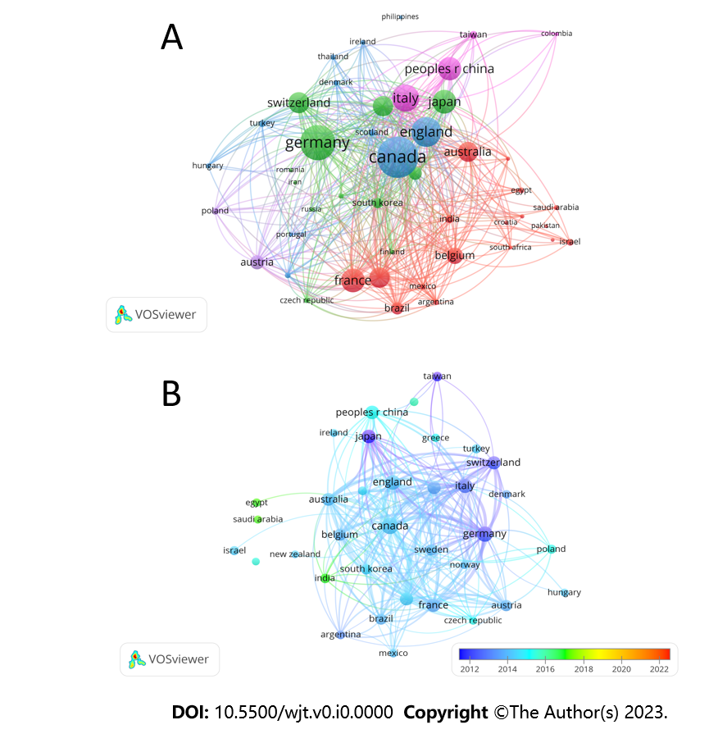
Figure 3 Network visualization showing most cited countries contributed with the United States in the field of transplantation research. A and B: The size of the circles represents the weight of citations.

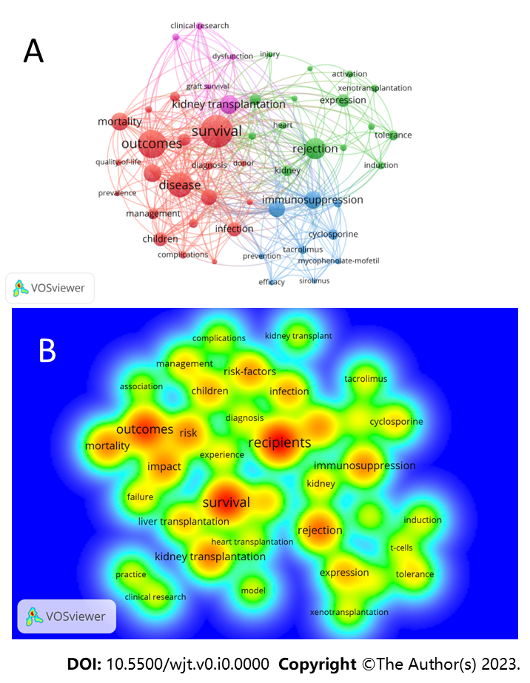
Figure 4 Cluster map of the most occurring keywords and their interconnection across the years. A: Each circle represents a keyword, and the size of the circles represents the frequency of occurrence. Larger circles indicate that the keyword appears more frequently. Keywords included in the same cluster are displayed in the same color. The distance between the 2 circles shows the degree of the relationship; B: Overlay map of keyword occurrence over time for papers published on the field of transplantation from the United States. The red color represents the key words that have been discussed more frequently.

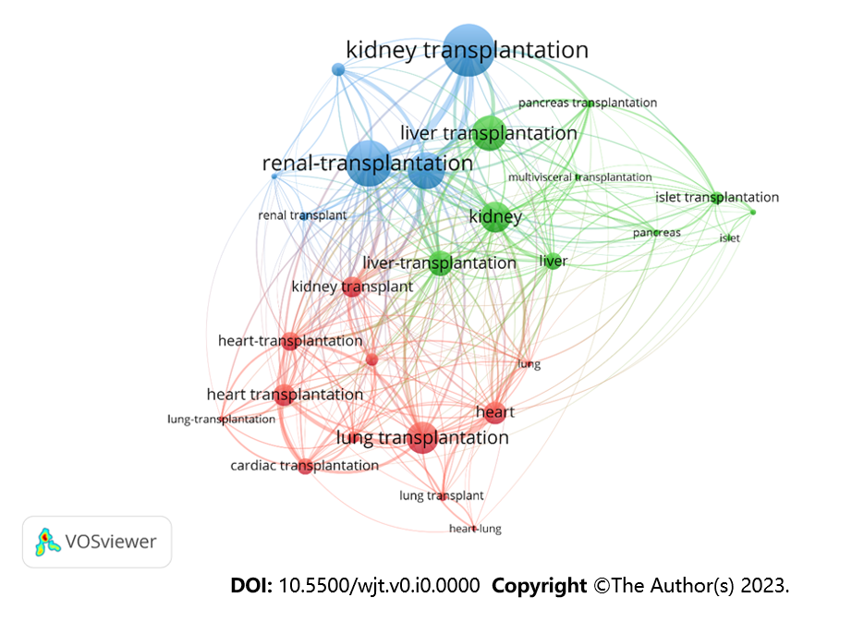
Figure 5 Network visualization of the most common keyword after restricting the search to organs transplanted name. Larger circles indicate that the keyword appears more frequently. Keywords included in the same cluster are displayed in the same color. The distance between the 2 circles shows the degree of the relationship.

Table 1 Top-contributing institutions in United States transplantation research according to the number of citations
Organization | Citations | Total link strength
University of Pittsburgh | 68810 | 23409
Harvard Medical School | 54838 | 13446
University of Michigan | 49111 | 17482
University of California Los Angeles | 45440 | 16112
University of Minnesota | 43839 | 16069
Mayo Clinic | 42903 | 14975
University Calif San Francisco | 41100 | 15648
University of Pennsylvania | 31353 | 14566
Washington University | 31142 | 12641
Stanford University | 30728 | 12815
Johns Hopkins University | 30682 | 14709
Columbia University | 25437 | 11562
University Washington | 24740 | 8223
Northwestern University | 24273 | 12338
Massachusetts Gen Hosp | 22332 | 9733
Emory University | 21746 | 10037
Duke University | 21557 | 10097
Cleveland Clinic | 20612 | 10384
University of Miami | 19751 | 5763
University of Alabama Birmingham | 19735 | 10386

Table 2 Top 20 most cited authors in the transplantation research from the United States
Author | Research field | Citations | Documents
Segev Dorry L | Transplant epidemiology | 12490 | 378
Kirklin James K | Heart transplantation | 10323 | 145
Cooper David | Heart transplantation Xenotransplantation | 10307 | 228
Merion Robert M | Liver transplantation | 9580 | 104
Edwards Leah B | Heart transplantation | 9547 | 71
Stehlik Josef | Heart transplantation | 9315 | 113
Naftel David C | Heart transplantation | 8179 | 80
Kasiske Bertram I | Kidney transplantation | 8144 | 179
Pagani Francis D | Heart transplantation | 8039 | 52
Sachs David H | Transplant immunology | 7942 | 207
Israni Ajay K | Kidney transplantation | 7328 | 157
Kormos Robert I | Heart transplantation | 7111 | 36
Snyder Jon J | Transplant epidemiology | 6738 | 137
Kuchervavava Anna V | Research analyst/heart and lung | 6248 | 35
Meier-Kriesche H-U | Kidney transplantation | 5630 | 59
Yusen Roger D | Lung transplantation | 5442 | 34
Wiesner Russel | Liver transplant | 5338 | 40
Christie Jason D | Lung transplantation | 5259 | 47
Skeans Melissa A | Kidney transplantation | 5247 | 71
Smith Judi M | Kidney transplantation | 4945 | 54

Table 3 Number of publications and citations in transplant journals for transplantation-related research performed in the United States
Source | Citations | Documents | Total link strength
American Journal of Transplantation | 194905 | 3954 | 41343
Transplantation | 185248 | 4795 | 36949
Journal Of Heart and Lung Transplantation | 96827 | 2388 | 11098
Liver Transplantation | 74441 | 1815 | 11807
Nephrology Dialysis Transplantation | 67526 | 1863 | 1779
Clinical Transplantation | 32154 | 2082 | 15473
Cell Transplantation | 25588 | 891 | 1668
Pediatric Transplantation | 20700 | 1539 | 7404
Current Opinion in Organ Transplantation | 13792 | 1029 | 10805
Transplant Infectious Disease | 13246 | 932 | 3799
Transplantation Proceedings | 12859 | 1166 | 4596
Transplant International | 11987 | 624 | 5674
Xenotransplantation | 11935 | 512 | 3930
Transplant Immunology | 7017 | 342 | 2345
Progress In Transplantation | 4622 | 550 | 2382
Transplantation Reviews | 3010 | 153 | 2258
Experimental And Clinical Transplantation | 1229 | 275 | 1272
Transplantation Direct | 1183 | 341 | 2574
Annals of Transplantation | 979 | 142 | 764
Transplantation And Cellular Therapy | 902 | 375 | 166
Current Transplantation Reports | 344 | 126 | 1366
International Journal of Organ Transplantation Medicine | 35 | 7 | 35
Transplant Research and Risk Management | 9 | 7 | 37
Indian Journal of Transplantation | 0 | 9 | 52
Russian Journal of Transplantology and Artificial Organs | 0 | 1 | 0

Table 4 Publications and citations of the top-collaborating countries with the United States
Country | Documents | Citations | Total link strength
Canada | 1263 | 55702 | 28468
Germany | 1012 | 44713 | 19065
England | 807 | 36042 | 17916
Italy | 719 | 33311 | 14855
France | 598 | 32373 | 14968
Japan | 594 | 21229 | 8395
China | 579 | 13450 | 6755
Switzerland | 506 | 25882 | 12413
Netherlands | 479 | 18867 | 9232
Spain | 478 | 24101 | 12506
Australia | 473 | 24439 | 13353
Belgium | 357 | 23002 | 9931
Austria | 290 | 12571 | 7877
Sweden | 266 | 11197 | 4958
Brazil | 238 | 10420 | 6457
South Korea | 197 | 6195 | 3019
India | 138 | 4197 | 3039
Taiwan | 129 | 4398 | 1949
Israel | 116 | 2539 | 1121

Table 5 Most occurring keywords in the research on transplantation from the United States
Keyword | Occurrences | Total link strength
Recipients | 3045 | 13158
Survival | 2779 | 11573
Outcomes | 2399 | 10308
Rejection | 1792 | 7691
Kidney transplantation | 1605 | 7823
Mortality | 1501 | 6280
Risk | 1497 | 6105
Impact | 1490 | 6486
Immunosuppression | 1484 | 7371
Renal-transplantation | 1403 | 6297
Therapy | 1347 | 4974
Risk-factors | 1340 | 5482
Infection | 1195 | 4580
Children | 1154 | 4366
Expression | 1083 | 3647
Kidney-transplantation | 1080 | 4763
Liver transplantation | 1020 | 3976
Lung transplantation | 931 | 3809

