Name of Journal: World Journal of Clinical Cases
Manuscript NO: 68216
Manuscript Type: CASE REPORT

Anterior abdominal abscess - a rare manifestation of severe acute pancreatitis: A case report

Jia YC et al. Complications of severe acute pancreatitis

Yu-Chen Jia, Yi-Xuan Ding, Wen-Tong Mei, Zhi-Gang Xue, Zhi Zheng, Yuan-Xu Qu, Jia Li, Feng Cao, Fei Li

Yu-Chen Jia, Yi-Xuan Ding, Wen-Tong Mei, Zhi-Gang Xue, Zhi Zheng, Yuan-Xu Qu, Jia Li, Feng Cao, Fei Li, Department of General Surgery, Xuanwu Hospital, Capital Medical University, Beijing 100053, China

Yu-Chen Jia, Yi-Xuan Ding, Wen-Tong Mei, Zhi-Gang Xue, Zhi Zheng, Yuan-Xu Qu, Jia Li, Feng Cao, Fei Li, Clinical Center for Acute Pancreatitis, Capital Medical University, Beijing 100053, China

Author contributions: Jia YC evaluated the patient and initiated the case report and reviewed the literature and drafted the manuscript; Ding YX, Mei WT, Xue ZG, Zheng Z, and Qu YX consulted the relevant literature and participated in the diagnosis and treatment of patient; Li J, Cao F, and Li F were responsible for formulating the patient’s treatment plan and revising the manuscript; All authors issued final approval for the version to be submitted.

Supported by Beijing Municipal Science and Technology Commission, No. Z171100001017077; Beijing Municipal Science and Technology Commission Clinical Diagnosis and Treatment Technology Research and Demonstration Application Project, No. Z191100006619038; Capital Medical Development and Research Special Project, No. 2020-1-2012; Construction Project of Clinical Advanced subjects of Capital Medical University, No. 1192070312.

Corresponding author: Fei Li, MD, PhD, Chief Doctor, Doctor, Professor, Surgeon, Department of General Surgery, Xuanwu Hospital, Capital Medical University, No. 45 Changchun Street, Xicheng District, Beijing 100053, China. feili36@ccmu.edu.cn

Received: May 17, 2021
Revised: July 1, 2021
Accepted: August 27, 2021
Published online: October 26, 2021

Abstract
BACKGROUND
Severe acute pancreatitis (SAP) is a common critical disease of the digestive system. In addition to the clinical manifestations and biochemical changes of acute pancreatitis, SAP is also accompanied by organ failure lasting more than 48 h. SAP is characterized by focal or extensive pancreatic necrosis, hemorrhage and obvious inflammation around the pancreas. The peripancreatic fat space, fascia, mesentery and adjacent organs are often involved. The common local complications include acute peripancreatic fluid collection, acute necrotic collection, pancreatic pseudocyst, walled off necrosis and infected pancreatic necrosis. After reviewing the literature, we found that in very few cases, SAP patients have complications with anterior abdominal wall abscesses.

CASE SUMMARY
We report a 66-year-old Asian male with severe acute pancreatitis who presented with intermittent abdominal pain and an increasing abdominal mass. The abscess spread from the retroperitoneum to the anterior abdominal wall and the right groin. In the described case, drainage tubes were placed in the retroperitoneal and anterior abdominal wall by percutaneous puncture. After a series of symptomatic supportive therapies, the patient was discharged from the hospital with a retroperitoneal drainage tube after the toleration of oral feeding and the improvement of nutritional status.

CONCLUSION
We believe that patients with SAP complicated with anterior abdominal abscess can be treated conservatively to avoid unnecessary exploration or operation.

Key Words: Severe acute pancreatitis; Abdominal abscess; Complication; Drainage; Case report

©The Author(s) 2021. Published by Baishideng Publishing Group Inc. All rights reserved.

Citation: Jia YC, Ding YX, Mei WT, Xue ZG, Zheng Z, Qu YX, Li J, Cao F, Li F. Anterior abdominal abscess - a rare manifestation of severe acute pancreatitis: A case report. World J Clin Cases 2021; 9(30): 9218-9227
URL: https://www.wjgnet.com/2307-8960/full/v9/i30/9218.htm
DOI: https://dx.doi.org/10.12998/wjcc.v9.i30.9218

Core Tip: Severe acute pancreatitis is a common critical disease of the digestive system. Its local complications are pancreatic pseudocyst, walled off necrosis and infected pancreatic necrosis. However, so far, there are few cases of severe acute pancreatitis with anterior abdominal abscess. We report a rare case of anterior abdominal abscess with severe acute pancreatitis. We think that for such cases, conservative treatment can be carried out to avoid unnecessary exploration or operation.
INTRODUCTION
Severe acute pancreatitis (SAP) is a common critical disease of the digestive system. It often has local complications such as acute peripancreatic fluid collection, acute necrotic collection, pancreatic pseudocyst, walled off necrosis and infectious pancreatic necrosis. Sometimes, SAP may have atypical complications due to the course of the disease, the degree of inflammation, the anatomical variation and other factors. Here, we present a rare complication of SAP, characterized by an abscess of the anterior abdominal wall.

CASE PRESENTATION
Chief complaints
A 66-year-old male patient was sent to our center for intermittent abdominal pain for 8 wk and an increasing abdominal mass for 5 wk.

History of present illness
Eight weeks ago, after the treatment of SAP, the patient presented with intermittent abdominal pain, fat diarrhea, diabetes, malnutrition and other chronic pancreatitis symptoms. Five weeks ago, the peri-umbilical and lower abdomen skin began to appear purple, and a lower abdominal mass gradually appeared. Computed tomography (CT) scan results 1 wk before admission suggested that the fluid in the right renal space was less than before. The range of encapsulated liquid density shadows in the right retrorenal space was significantly larger than previously, and it extended to the right iliac fossa. The range of subcutaneous and intramuscular fluid density shadows in the right abdominal wall was significantly larger than measured before, measuring approximately 20.1 cm × 7.3 cm, and it went down to the right groin without obvious pelvic effusion.

History of past illness
Ten weeks prior, the patient was sent to our center for treatment due to SAP. After drinking a lot of alcohol, the patient had sudden, continuous and severe abdominal colic. Vital signs were as follows: heart rate 136 times/min, respiratory rate 26 times/min, blood pressure 92/52 mmHg, temperature 38.0 ºC, body mass index 18.1. Laboratory examination was as follows: serum amylase 804 IU/L, serum lipase 259.9 U/L, serum calcium 1.44 mmol/L, lactate 3.2 mmol/L, serum glucose 23.29 mmol/L, serum sodium 119.7 mmol/L, triglyceride 0.79 mmol/L, lactate dehydrogenase 579 IU/L, prealbumin 38 mg/L, white cell count 18.77 × 10⁹/L, neutrophil count 16.03 × 10⁹/L and plasma D-dimer 5.45 µg/mL. The modified Marshall score was 3, the APACHE II score was 23, the Ranson score was 6 and the modified computed tomography severity index was 10. A CT scan showed bilateral pleural effusion and atelectasis of the right lower lung lobe. The outline of the uncinate process of the head of the pancreas was unclear, and a large amount of exudate could be seen around the pancreas. Pancreatic parenchyma atrophy, multiple spotted calcifications, and pancreatic duct widening were also noted. On the right side of the kidney, there was an encapsulated effusion in the anterior and posterior spaces, and a density shadow of fluid could be seen in the subcutaneous and intramuscular areas of the abdominal wall. On the right side of the kidney, the volume of fluid was approximately 6.9 cm × 1.6 cm (Figure 1). The patient did not receive puncture drainage or surgical treatment. After 2 wk of conservative treatment, the patient was discharged from the hospital with no organ failure and was tolerating an oral diet. CT scan showed that the ranges of liquid density shadow of the right anterior renal space, and the right posterior renal space were slightly larger than that of the front, extending to the right iliac fossa. The density of the abdominal wall was increased in the subcutaneous and intermuscular areas, and the size of the right side was approximately 8.3 cm × 3.1 cm. The right peritoneum and perirenal fascia were thickened, and the liquid density shadow in the right renal fat capsule was decreased slightly. After intravenous contrast agent administration, the right anterior renal space, right posterior renal space, right iliac fossa and abdominal wall were subcutaneously wrapped with a liquid density shadow wall (Figure 2).

Personal and family history
The patient had a history of chronic pancreatitis and had multiple acute pancreatitis episodes. The first diagnosis of acute pancreatitis in the patient was 14 years prior to presentation. Comorbidities of the patient included 12 years of diabetes, 30 years of smoking and 30 years of alcohol abuse.

Physical examination
At the time of admission, the size of the lower abdominal mass was approximately 22.5 cm × 14.2 cm, accompanied by obvious skin cyanosis and swelling, a significant increase in skin temperature and an obvious palpable tenderness. Heart rate 121 times/min, breathing 28/min, blood pressure 94/35 mmHg and body temperature 38.6 °C.

Laboratory examinations
Laboratory values were as follows: 13.86 × 10⁹/L white blood cell count, 10.23 × 10⁹/L neutrophil count, 76 g/L hemoglobin, 405 × 10⁹/L platelet count, 5.4 mmol/L lactate, 7.543 pH, 61 IU/L serum amylase, 34.9 U/L serum lipase, 25.10 g/L albumin, 19 mg/L prealbumin, 12.05 mmol/L glucose, 587 µmol/L uric acid, 124 mmol/L sodium, 3.990 ng/mL procalcitonin and 154.00 mg/L C-reactive protein.

Imaging examinations
Ten weeks before this hospitalization, the patient was sent to our center for treatment due to SAP. A CT scan showed bilateral pleural effusion and atelectasis of the right lower lung lobe. The outline of the uncinate process of the head of the pancreas was unclear, and a large amount of exudate could be seen around the pancreas. Pancreatic parenchyma atrophy, multiple spotted calcifications and pancreatic duct widening were also noted. On the right side of the kidney, there was an encapsulated effusion in the anterior and posterior spaces, and a density shadow of fluid could be seen in the subcutaneous and intramuscular areas of the abdominal wall. On the right side of the kidney, the volume of fluid was approximately 6.9 cm × 1.6 cm (Figure 1). Eight weeks before this hospitalization, CT scan showed that the ranges of liquid density shadow of the right anterior renal space, and the right posterior renal space were slightly larger than that of the front, extending to the right iliac fossa. The density of the abdominal wall was increased in the subcutaneous and intermuscular areas, and the size of the right side was approximately 8.3 cm × 3.1 cm. The right peritoneum and perirenal fascia were thickened, and the liquid density shadow in the right renal fat capsule was decreased slightly. After intravenous contrast agent administration, the right anterior renal space, right posterior renal space, right iliac fossa and abdominal wall were subcutaneously wrapped with a liquid density shadow wall (Figure 2). A week before this hospitalization, CT scan showed that the fluid in the right renal space was less than before. The range of encapsulated liquid density shadows in the right retrorenal space was significantly larger than previously, and it extended to the right iliac fossa. The range of subcutaneous and intramuscular fluid density shadows in the right abdominal wall was significantly larger than measured before, measuring approximately 20.1 cm × 7.3 cm, and it went down to the right groin without obvious pelvic effusion (Figure 3).

FINAL DIAGNOSIS
Gram-positive cocci were found in the smear of drained fluid. Enterococcus faecalis and Escherichia coli were found in the drainage medium.

TREATMENT
The patient had definite sepsis and septic shock, the Glasgow Coma Score was 12, and the Visual Analog Scale score was 6. After the initial fluid resuscitation, vasoactive drug infusion and broad-spectrum antibiotic administration, puncture and drainage of right lower abdominal wall abscess was performed under ultrasound guidance within 24 h at the most obvious wave motion of right lower abdominal wall abscess. A silicone rubber drainage tube of 8 Fr was placed (Figure 4). A total of 350 mL of gray-white purulent exudate was extracted, with an obvious odor. The amylase in the drained fluid was 5 IU/L, and gram-positive cocci were found in the smear of drained fluid. Enterococcus faecalis and Escherichia coli were found in the drainage medium. According to the drug sensitivity results, vancomycin combined with imipenem was used for treatment.
A CT scan showed new air bubbles in the right anterior renal space and in the right pararenal posterior space to the right of the iliac fossa. The amount of subcutaneous and intramuscular encapsulated effusion on the right side was significantly increased, and multiple air bubbles could be seen in it, which went down to the right groin. The lesion crossed the center into the left anterior inferior abdominal wall (Figure 5). Forty-eight hours after admission, ultrasound-guided drainage of right retroperitoneal abscess and right lower abdominal wall abscess was performed. First, the right retroperitoneal abscess was punctured to the abscess cavity under ultrasound guidance, and a 12 Fr silicone rubber drainage tube was placed in the right retroperitoneal abscess. Then, the drainage tube of the first abdominal abscess was removed, and the drainage opening of the first abdominal abscess was enlarged to 1.5 cm with a scalpel. Two 20 Fr silicone rubber drainage tubes were placed along the long axis of the abdominal abscess cavity (Figure 6). What needs special explanation is that all drainages were gravity drainages without rinsing by sterile physiological solution. Re-examination CT showed that the subcutaneous and intramuscular effusion and pneumatosis of the anterior abdominal wall were significantly reduced (Figure 7). In the subsequent 5 d, the patient had decreased consciousness, acute respiratory distress syndrome and coagulation dysfunction, and the patient’s temperature fluctuated between 35.5 °C and 39.0 °C. After continuous drainage, noninvasive ventilation, antibiotics and symptomatic support, the patient’s state began to stabilize on the ninth day of admission.

OUTCOME AND FOLLOW-UP
On the 12th day of admission, a liquid diet was given orally. Two more abdominal drainage tubes were removed on the 35th day after admission. The patient was discharged from the hospital with a retroperitoneal drainage tube after recovery and after the toleration of oral feeding and the improvement of nutritional status. At the time of discharge, the retroperitoneal drainage tube drained approximately 30 mL of exudate every day. After discharge, the patient continued to treat the diabetes by insulin injections and took pancreatin to improve digestive function.

DISCUSSION
SAP is characterized by acute peripancreatic fluid collection, acute necrotic collection, pancreatic pseudocysts, walled off necrosis, infected pancreatic necrosis, circulatory failure, acute lung injury, water electrolyte and acid-base balance derangements and other complications^{[1-6]}. However, the occurrence of anterior abdominal abscess in SAP is rare, and only two cases have been reported^{[7,8]}.
In 1918, Thomas Stephen Cullen^{[9]} had initially described a female patient with a ruptured ectopic pregnancy and with blue discoloration of the periumbilical skin, namely, Cullen’s sign. In 1920, George Grey Turner^{[10]} reported a case of acute pancreatitis with similar skin ecchymoses, but the location of the ecchymoses was located on the lateral side of the abdominal wall. Dickson et al^{[11]} found that approximately 1%-3% of patients with acute pancreatitis may have body wall ecchymoses. Meyers et al^{[12]} described the specific anatomical path of the two signs via CT scanning. Cullen’s sign originates from the retroperitoneum and travels along the stomach, liver and falciform ligament to the umbilicus. Grey-Turner’s sign originates from the retrorenal space, spreads to the lateral edge of the psoas muscle, enters the abdominal wall muscle tissue through the defect of the transversalis fascia and then enters the subcutaneous tissue of the flank abdomen. In addition, this study also found that retroperitoneal hemorrhage may spread and accumulate in the inguinal ligament (Fox’s sign) or scrotum (Bryant’s sign).
At the first admission for SAP caused by alcoholism, the patient had obvious fluid accumulations in the right anterior renal space, the right posterior renal space, the right anterior abdominal wall and the right groin (Figure 1). With the progression of the disease, the skin around the umbilicus and lower abdomen of the patient began to exhibit cyanosis, and a lower abdominal mass gradually appeared. According to the CT scan, we found that the abscess of the patient’s anterior abdominal wall gradually increased in size from the right side to the left through the midline of the abdominal wall, and the abscess eventually involved the right groin (Figures 2 and 3). This indicated that the appearance of the anterior abdominal wall abscess was continuous, which further excluded the possibility of anterior abdominal wall abscess caused by poor nutritional status, decreased immune function or diabetes mellitus.
According to the experience of our center, in the early stage of SAP (onset time < 4 wk), due to pancreatic duct disruption, the amylase content in the drainage fluid after percutaneous catheter drainage (PCD) is usually very high, but the amylase content in the drainage fluid is usually not high after infectious necrosis is formed about 4 wk after the onset. The patient was treated with PCD for the first time at the fifth week, and the amylase in the drainage fluid was 5 IU/L.
After reviewing the anatomy of the peritoneum and abdominal wall, we found that an adjacent potential connection between the retrorenal space and the abdomen may be the anatomical basis of the abdominal wall involvement before SAP. Four pairs of lumbar arteries originate from the posterior level of the abdominal aorta, enter the posterior part of the psoas major and quadratus psoas along the front and side of the 1st-4th lumbar body and then move forward between abdominal muscles. Its branches supply the muscles and skin of the lumbar and ventral walls. Inflammation spreads between the two layers of the prerenal fascia in the prerenal space, breaks through or dissolves the retrorenal fascia into the retrorenal space and may reach the lateral edge of the quadratus psoas through the gap between the lumbar artery and the peritoneum. Then, it may gradually break through the parietal layer and the peritoneum invading the posterior flank abdominal wall; then, inflammation will develop and may penetrate the transversus abdominis, internal oblique abdominis and then the anterior abdominal wall^{[13]}. The latissimus dorsi muscle is behind the transversus abdominis in the posterior wall, retroperitoneum, psoas major, quadratus psoas, erector spinae and spine in the lumbar back from front to back. The soft tissue in the lumbar back is thick, the fascia is tough, and the spinal ligament and other dense connective tissue are strengthened. Therefore, inflammation mainly manifests in the anterior abdominal wall but not in the posterior abdominal wall.
The abscess of the anterior abdominal wall of this patient was divided into two abscess cavities, and the right abscess cavity was significantly larger than the left abscess cavity. There was a certain pressure difference, and the production of the left abscess cavity may have been the result of the inflammation on the right side gradually eroding the abdominal white line to the left (Figure 3). Under the premise that the first puncture and drainage did not enter the retroperitoneum, the CT scan after the puncture showed extensive encapsulated hydrops and pneumatosis in the subcutaneous and intramuscular abdominal wall and in the right retrorenal space (Figures 4 and 5). This suggests that the anterior abdominal wall abscesses and the retroperitoneal abscesses may be interlinked.
In the case reported in this paper, the patient had obvious effusion in the right iliac fossa and in the right groin (Figure 2). In addition, the testicular artery originates below the starting point of the renal artery and originates from the anterior wall of the abdominal aorta, goes down along the surface of the psoas major muscle obliquely, crosses the front of the ureter at the height of the fourth lumbar spine, enters the scrotum through the inguinal canal and forms the spermatic cord, which is distributed in the testis and epididymis. Inflammation may also travel down the testicular artery into the inguinal area and even further involve the scrotum. In 2011, Kamble et al^{[8]} reported a case of acute pancreatitis with the initial symptoms of an anterior abdominal wall abscess and epididymorchitis. The fluid then accumulated in the retroperitoneum until preperitoneal, and retroperitoneal abscesses formed in the lower abdomen and scrotum. The patient recovered after puncture and drainage of the abscesses in the anterior abdominal wall and supportive care.
Among the local complications caused by SAP, anterior abdominal wall abscesses are very rare. The patient described here developed an anterior abdominal wall abscess with severe hypoproteinemia after the diagnosis of SAP. We believe that severe hypoproteinemia is an important factor in the development of anterior abdominal wall abscesses. First, hypoproteinemia can lead to an increased permeability of peritoneal and muscle structures, which are then more easily eroded and penetrated by inflammation. Second, hypoproteinemia makes it difficult for patients with SAP to develop localized inflammation and further aggravates the degree of abdominal wall swelling. We believe that the infectious effusion of this patient did not form a complete and mature cyst wall to prevent the progression of inflammation. We believe that for SAP patients with severe acute compartment syndrome, traditional open debridement can effectively reduce abdominal pressure, improve tissue perfusion and blood supply of pancreatic tissue and other important abdominal organs, and inhibit the further development of systemic inflammatory response syndrome and multiple organ dysfunction syndrome. However, studies have shown that the traditional open debridement will bring higher incidence of complications and mortality in SAP patients, which cannot make the patients really benefit from the operation^{[14]}. The infectious necrosis of this patient did not form a complete and mature cyst wall to limit the progress of inflammation, and the patient did not have severe acute compartment syndrome. Therefore, PCD was performed within 24 h after the initial diagnosis was made by CT scan, and the treatment of septic shock was corrected by active fluid resuscitation. In the later treatment, we found that drainage was effective for the treatment of anterior abdominal wall abscess, so we did not further use video assisted laparoscopic debridement for the treatment of the patient. In the process of treatment, the application of intravenous nutrition is very important, which can promote the formation of localized inflammation of infectious effusion, improve the nutritional status of patients, and reduce the incidence of complications and mortality of patients.

CONCLUSION
In conclusion, drainage and other conservative treatment strategies can be preferred for anterior abdominal wall abscess, which is a rare complication of SAP. We should pay attention to and evaluate the nutritional status of patients in time and carry out PCD and nutritional support treatment as early as possible to avoid unnecessary exploration or operation.

REFERENCES
1 Boxhoorn L, Voermans RP, Bouwense SA, Bruno MJ, Verdonk RC, Boermeester MA, van Santvoort HC, Besselink MG. Acute pancreatitis. Lancet 2020; 396: 726-734 [PMID: 32891214 DOI: 10.1016/S0140-6736(20)31310-6]
2 Garg PK, Singh VP. Organ Failure Due to Systemic Injury in Acute Pancreatitis. Gastroenterology 2019; 156: 2008-2023 [PMID: 30768987 DOI: 10.1053/j.gastro.2018.12.041]
3 Balthazar EJ, Robinson DL, Megibow AJ, Ranson JH. Acute pancreatitis: value of CT in establishing prognosis. Radiology 1990; 174: 331-336 [PMID: 2296641 DOI: 10.1148/radiology.174.2.2296641]
4 Nazar MA, D'Souza FR, Ray A, Memon MA. Unusual presentation of acute pancreatitis: an irreducible inguinoscrotal swelling mimicking a strangulated hernia. Abdom Imaging 2007; 32: 116-118 [PMID: 16680509 DOI: 10.1007/s00261-006-9003-5]
5 Athappan G, Ariyamuthu VK, Rajamani VK. Bilateral renal halo sign in acute pancreatitis. Med J Aust 2008; 189: 228 [PMID: 18707570 DOI: 10.5694/j.1326-5377.2008.tb01991.x]
6 Moorthy N, Raveesha A, Prabhakar K. Pancreaticopleural fistula and mediastinal pseudocyst: an unusual presentation of acute pancreatitis. Ann Thorac Med 2007; 2: 122-123 [PMID: 19727359 DOI: 10.4103/1817-1737.33701]
7 Manji N, Hulyalkar AR, Keroack MA, Vekshtein VI, Kirshenbaum JM, Sugarman DI, Chopra S. Cutaneous pseudo abscesses: an unusual presentation of severe pancreatitis. Am J Gastroenterol 1988; 83: 177-179 [PMID: 3341343]
8 Kamble PM, Patil A, Jadhav S, Rao SA. Anterior abdominal wall abscess with epididymo-orchitis: an unusual presentation of acute pancreatitis. J Postgrad Med 2011; 57: 335-337 [PMID: 22120865 DOI: 10.4103/0022-3859.90088]
9 Bosmann M, Schreiner O, Galle PR. Coexistence of Cullen's and Grey Turner's signs in acute pancreatitis. Am J Med 2009; 122: 333-334 [PMID: 19332225 DOI: 10.1016/j.amjmed.2008.08.032]
10 Bem J, Bradley EL 3rd. Subcutaneous manifestations of severe acute pancreatitis. Pancreas 1998; 16: 551-555 [PMID: 9598819 DOI: 10.1097/00006676-199805000-00015]
11 Dickson AP, Imrie CW. The incidence and prognosis of body wall ecchymosis in acute pancreatitis. Surg Gynecol Obstet 1984; 159: 343-347 [PMID: 6237447]
12 Meyers MA, Feldberg MA, Oliphant M. Grey Turner's sign and Cullen's sign in acute pancreatitis. Gastrointest Radiol 1989; 14: 31-37 [PMID: 2910743 DOI: 10.1007/BF01889150]
13 Marks SC Jr, Raptopoulos V, Kleinman P, Snyder M. The anatomical basis for retrorenal extensions of pancreatic effusions: the role of the renal fasciae. Surg Radiol Anat 1986; 8: 89-97 [PMID: 3097856 DOI: 10.1007/BF02421375]
14 van Santvoort HC, Besselink MG, Bakker OJ, Hofker HS, Boermeester MA, Dejong CH, van Goor H, Schaapherder AF, van Eijck CH, Bollen TL, van Ramshorst B, Nieuwenhuijs VB, Timmer R, Laméris JS, Kruyt PM, Manusama ER, van der Harst E, van der Schelling GP, Karsten T, Hesselink EJ, van Laarhoven CJ, Rosman C, Bosscha K, de Wit RJ, Houdijk AP, van Leeuwen MS, Buskens E, Gooszen HG; Dutch Pancreatitis Study Group. A step-up approach or open necrosectomy for necrotizing pancreatitis. N Engl J Med 2010; 362: 1491-1502 [PMID: 20410514 DOI: 10.1056/NEJMoa0908821]

Footnotes
Informed consent statement: Informed written consent was obtained from the patient for publication of this report and any accompanying images.

Conflict-of-interest statement: The authors declare that they have no conflict of interest.

CARE Checklist (2016) statement: The authors have read the CARE Checklist (2016), and the manuscript was prepared and revised according to the CARE Checklist (2016).

Open-Access: This article is an open-access article that was selected by an in-house editor and fully peer-reviewed by external reviewers. It is distributed in accordance with the Creative Commons Attribution NonCommercial (CC BY-NC 4.0) license, which permits others to distribute, remix, adapt, build upon this work non-commercially, and license their derivative works on different terms, provided the original work is properly cited and the use is non-commercial. See: http://creativecommons.org/Licenses/by-nc/4.0/

Manuscript source: Unsolicited manuscript

Peer-review started: May 17, 2021
First decision: June 24, 2021
Article in press: August 27, 2021

Specialty type: Gastroenterology and hepatology
Country/Territory of origin: China
Peer-review report’s scientific quality classification
Grade A (Excellent): 0
Grade B (Very good): 0
Grade C (Good): C, C
Grade D (Fair): D
Grade E (Poor): 0

P-Reviewer: Aseni P, Kikuyama M S-Editor: Ma YJ L-Editor: Filipodia P-Editor: Wu RR

Figure Legends
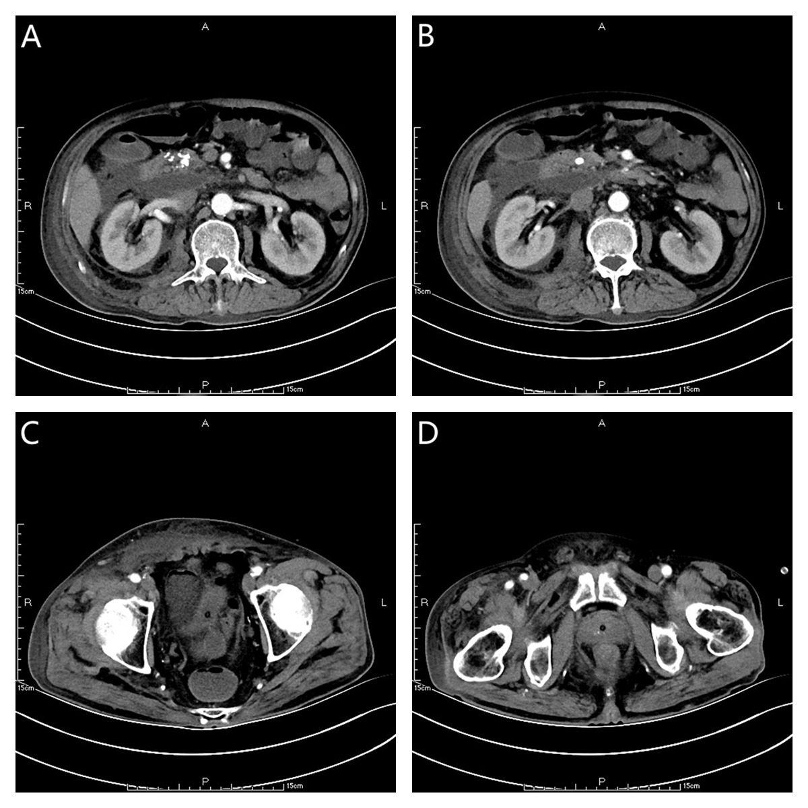
Figure 1 The outline of the uncinate process of the head of pancreas is unclear (a, b), and a large amount of exudation can be seen around the pancreas (C, D). Pancreatic parenchyma atrophy, multiple calcification spots and pancreatic duct widening were observed. There was a small amount of subcutaneous and intramuscular effusion in the right abdominal wall.
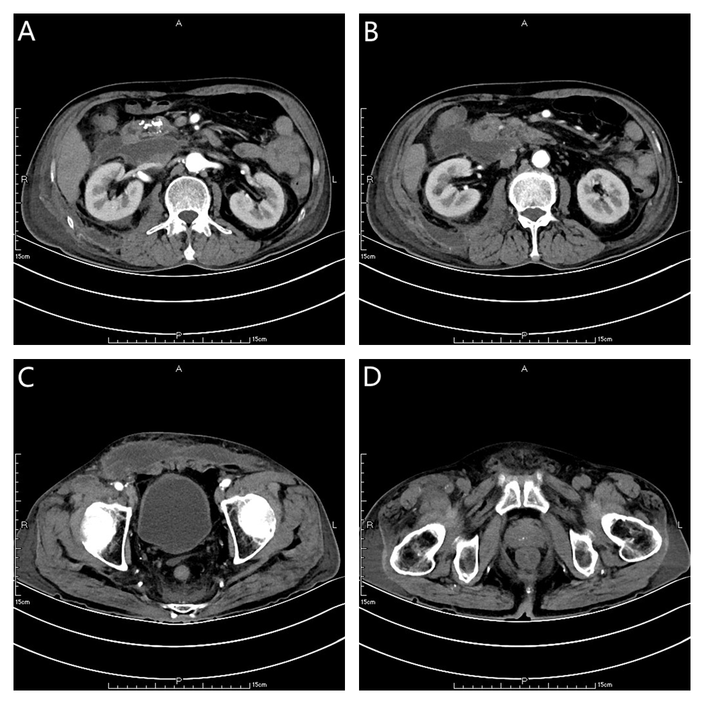
Figure 2 The range of encapsulated liquid density shadow in the right anterior (a, b), and posterior renal space was slightly larger than that in the front and extended to the right iliac fossa (C, D). The subcutaneous and intramuscular effusion of abdominal wall increased.
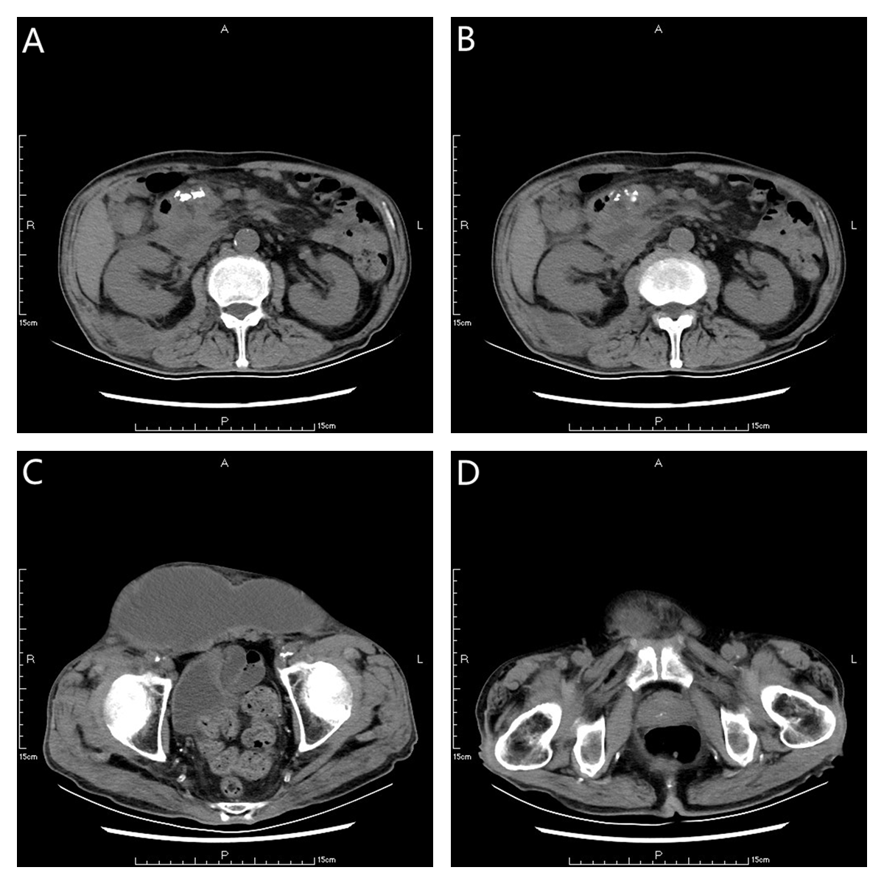
Figure 3 The range of encapsulated liquid density shadow in the right retrorenal space was significantly larger than that before (A, B), extending to the right iliac fossa (C, D). The density range of subcutaneous and intramuscular fluid in the right abdominal wall was significantly larger than that before. Right inguinal fluid density shadow.
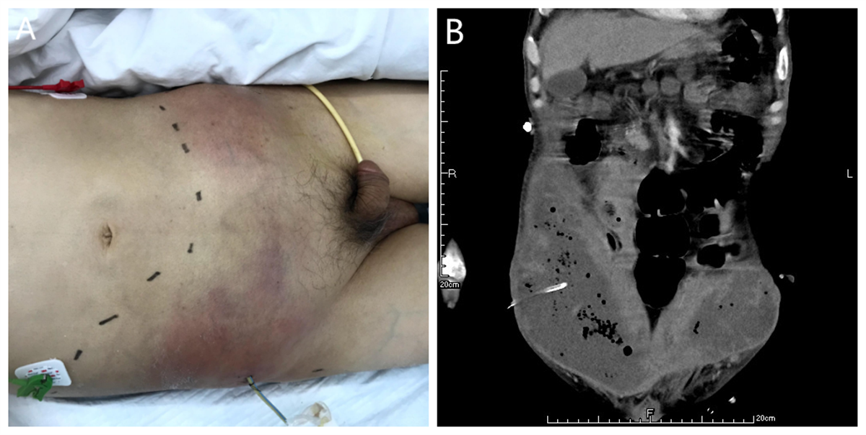
Figure 4 One abdominal wall drainage tube was placed after the first puncture and drainage (a, b).
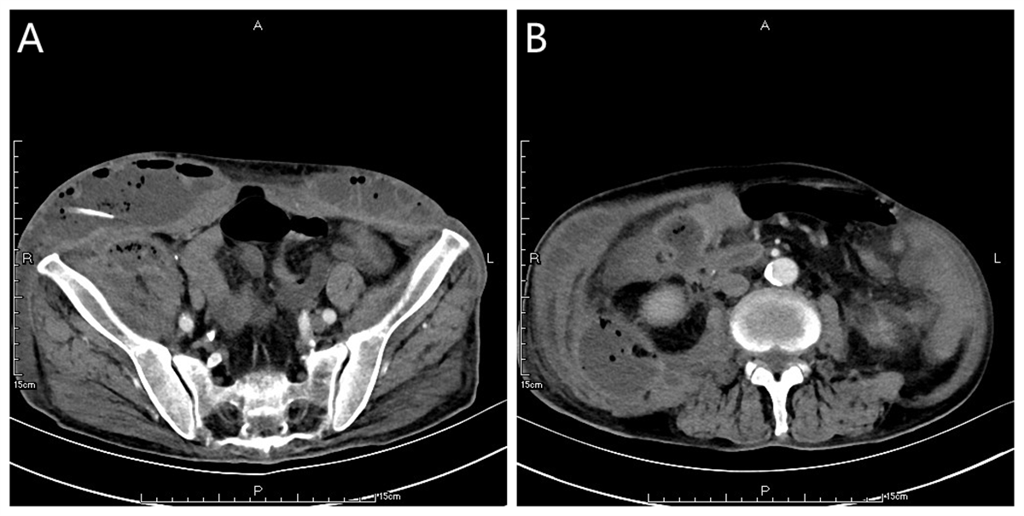
Figure 5 After the first puncture and drainage, there was encapsulated hydrops and pneumatosis in the abdominal wall (A, B). There was extensive encapsulated hydrops and pneumatosis in the right retrorenal space.
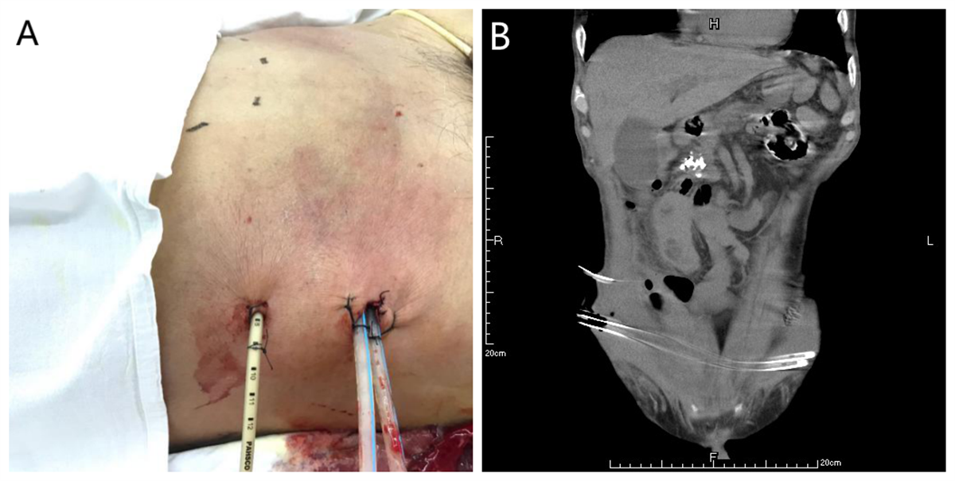
Figure 6 One retroperitoneal drainage tube and two abdominal wall drainage tubes were placed after the second puncture and drainage (A, B).
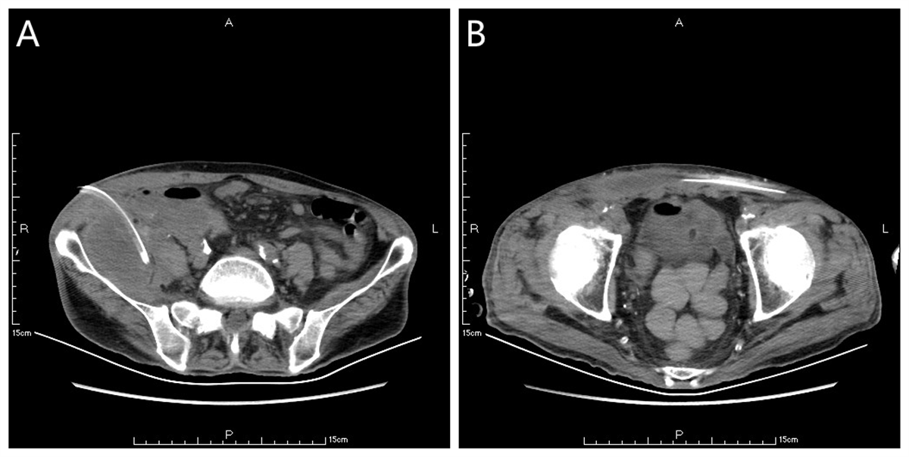
Figure 7 The subcutaneous and intramuscular effusion and pneumatosis of anterior abdominal wall were significantly reduced (A, B). The arrow shows the retroperitoneal drainage tube, and the arrow shows the abdominal wall drainage tube.

Published by Baishideng Publishing Group Inc
7041 Koll Center Parkway, Suite 160, Pleasanton, CA 94566, USA
Telephone: +1-925-3991568
E-mail: bpgoffice@wjgnet.com
Help Desk: https://www.f6publishing.com/helpdesk
https://www.wjgnet.com

© 2021 Baishideng Publishing Group Inc. All rights reserved.

