Name of Journal: World Journal of Gastrointestinal Surgery
Manuscript NO: 82161
Manuscript Type: MINIREVIEWS

The spectrum of pneumatosis intestinalis in the adult. A surgical dilemma

Tropeano G et al. Pneumatosis intestinalis

Giuseppe Tropeano, Marta Di Grezia, Caterina Puccioni, Valentina Bianchi, Gilda Pepe, Valeria Fico, Gaia Altieri, Giuseppe Brisinda

Giuseppe Tropeano, Marta Di Grezia, Caterina Puccioni, Valentina Bianchi, Gilda Pepe, Valeria Fico, Gaia Altieri, Giuseppe Brisinda, Emergency Surgery and Trauma Center, Fondazione Policlinico Universitario A Gemelli IRCCS, Rome 00168, Italy

Giuseppe Brisinda, Department of Surgery, Università Cattolica del Sacro Cuore, Rome 00168, Italy

Author contributions: Tropeano G and Di Grezia M equally contributed to the drafting of the manuscript and must both be considered first author; Tropeano G, Di Grezia M, Puccioni C, Bianchi V and Brisinda G designed the research; Bianchi V, Pepe G, Fico V and Altieri G performed the research and selected the articles; Tropeano G, Di Grezia M and Puccioni C analyzed the data; Tropeano G, Di Grezia M, Puccioni C and Brisinda G reviewed the selected manuscripts and wrote the paper; All the authors read and approved the final manuscript.

Corresponding author: Giuseppe Brisinda, MD, Professor, Surgeon, Emergency Surgery and Trauma Center, Fondazione Policlinico Universitario A Gemelli IRCCS, Largo Agostino Gemelli 8, Rome 00168, Rome, Italy. gbrisin@tin.it

Received: December 7, 2022
Revised: February 10, 2023
Accepted: March 21, 2023
Published online:

Abstract
Pneumatosis intestinalis (PI) is a striking radiological diagnosis. Formerly a rare diagnostic finding, it is becoming more frequently diagnosed due to the wider availability and improvement of computed tomography scan imaging. Once associated only with poor outcome, its clinical and prognostic significance nowadays has to be cross-referenced to the nature of the underlying condition.
Multiple mechanisms of pathogenesis have been debated and multiple causes have been detected during the years. All this contributes to creating a broad range of clinical and radiological presentations.
The management of patients presenting PI is related to the determining cause if it is identified. Otherwise, in particular if an association with portal venous gas and/or pneumoperitoneum is present, the eventual decision between surgery and non-operative management is challenging, even for stable patients, since this clinical condition is traditionally associated to intestinal ischemia and consequently to pending clinical collapse if not treated.
Considering the wide variety of origin and outcomes, PI still remains for surgeons a demanding clinical entity.
The aim of this manuscript is to present an updated narrative review and to give some suggestions which may help to make the decisional process easier, identifying patients who can benefit from surgical intervention and those who can benefit from non-operative management avoiding unnecessary procedures.

Key Words: Pneumatosis intestinalis; Risk factors; Treatment; Portal venous gas; Portomesenteric pneumatosis

Tropeano G, Di Grezia M, Puccioni C, Bianchi V, Pepe G, Fico V, Altieri G, Brisinda G. The spectrum of pneumatosis intestinalis in the adult. A surgical dilemma. World J Gastrointest Surg 2023; In press

Core Tip: Pneumatosis intestinalis (PI) represents a radiological diagnosis that must be understood correctly in order to follow the appropriate management. It is essential to identify the conditions that can evolve into transmural intestinal ischemia. It is also important to recognize those cases where PI can be managed conservatively. The integration of the clinical presentation, laboratory tests and abnormal abdominal physical examination can give indications on the path to follow. With this narrative review we have tried to provide a comprehensive analysis of the knowledge of this topic by proposing an algorithm to guide clinical decisions.

INTRODUCTION
Pneumatosis Intestinalis (PI) refers to a spectrum of diseases characterized by the presence of gas in the intestinal wall^{[1-4]}. It was firstly described the 1700s by Du Vernoy, that detected gas in the bowel wall during a cadaver dissection.
The radiographic finding of PI can indicate a spectrum of underlying processes ranging from a benign finding to a life-threating condition. It is possible to distinguish between “primary” and “secondary” PI^{[5-8]}. Primary PI, also known as idiopathic or pneumocystis cystoides, is a pathologic condition characterized by the presence of gas-filled cysts in the sub-mucosa or sub-serosa especially of the colon^{[9-11]}. Secondary PI is usually related to underlying pathological conditions (Table 1) and it is commonly characterized by the presence of linear or curvilinear gas balls in the intestinal wall^{[9,10,12-21]}. Typically, the primary PI is asymptomatic and is not as frequent as the secondary PI (15% vs 85%)^{[1,22]}.
Because of its rarity, PI is not yet completely clear from a pathophysiological, diagnostic and therapeutic point of view. Although radiographic PI is relatively common, there is no validated clinical tool to guide surgical management. This narrative review aims to summarize the existing evidence to better understand how to manage patients with this condition.

MATERIAL AND METHOD
The review of the literature was conducted with the following method. A search was conducted on Pubmed for all articles published up to September 2022 with the following terms: “Pneumatosis intestinalis” OR “Portomesenteric pneumatosis” OR “intestinal pneumatosis”. A total of 206 articles were detected.
After evaluation of the full text, only 20 manuscripts were included for the draft of this review according to their pertinence in regards of the main topics. Inclusion criteria take in type of publication, study setting, reported outcome and date to publication.
Exclusion criteria were clinical case report, studies focused on specific groups. In particular, excluding case report, some of the 186 articles were excluded for being age specific (i.e., pediatric patients), other for being focused on certain procedures or pathologies (e.g., post-endoscopic procedures, pneumatosis cystoides) or, furthermore, for being of different area of interest (e.g., articles focused just on imaging appearance).
The reference list of the articles evaluated in full text was screened for any other relevant article and those articles were evaluated according to the same criteria.

PATHOGENESIS
The pathogenesis of PI is still unclear and probably is a combination of different theories considering how many diseases can be associated with pneumatosis^{[7,23,24]}.
Three are the main theories about the gas origin within the intestinal wall. There is the “mechanical theory” that speculates an intraluminal origin of gas: It seems to be a combination of an increased intraluminal pressure and an increased gut permeability^{[25]}. It is possible that mucosal disruption due to inflammation or ischemia can predispose to an increase of intestinal wall permeability with the formation of small cysts in which the gas is trapped^{[26,27]}.
The second theory hypothesizes that the source of the gas is the chest through the retroperitoneum from the alveolar rupture along vascular channels^{[25,28]}. It is demonstrated for example in patients with asthma or bronchitis, in which alveolar air runs from the mediastinum descending to the mesenteric root and vessels^{[29]}.
The last theory is the “bacterial” one. It postulates that the gas produced from gas-producing bacteria can reach the intestinal wall if associated with mucosal injury. This theory was suggested from the evidence of the high hydrogen content of the cyst, that suggests a bacterial origin^{[30]}. It seems that bacteria cause a higher hydrogen tension than the nitrogen tension in blood, causing an exit of hydrogen in the intraluminal compartment^{[25]}.
All these theories try to explain different aspects of a complex finding, related to several diseases and several clinical conditions from asymptomatic to fatal. It is probably due to this complexity that it is a challenge for the surgeon to predict the severity of PI and the need for surgery^{[31-34]}.

CLINICAL AND LABORATORY ASSAY CORRELATION
Usually, PI was considered as a predictive sign of bowel ischemia, but with the improvement of the imaging techniques and its wider use, it was found also in asymptomatic patients^{[35,36]}. For that reason, different studies tried to find a correlation between clinical findings, laboratory data and imaging, in order to distinguish between PI that needs surgery from PI that doesn’t have any clinical significance^{[37,38]}.

Clinical findings
Hemodynamic instability, hypotension, sepsis, abdominal rigidity or peritonism, adynamic ileus are associated with pathological PI. These signs and symptoms are directly related to transmural intestinal infarction (Figure 1); these patients need to be evaluated from a surgeon and often need a surgical exploration^{[39]}. The surgical challenge is the patient that is hemodynamically stable, with or without abdominal pain but not peritonitis, in which it is more difficult to decide how to proceed^{[37]}.
The more common symptoms in patients with PI associated with bowel vascular impairment are abdominal pain, weight loss, constipation or diarrhea, less frequently bleeding or ileus^{[40]}. Despite the clinical presentation, it seems that the severity of symptoms is not correlated with the severity of the amount of intramural gas at the computed tomography (CT) scan^{[41,42]}. It is more reasonable to believe that the clinical manifestation of PI is related to the underlying diseases^{[25]}.

Laboratory data
Several studies tried to identify some laboratory values that could help among the management strategies. Morris et al^{[10]} found that pH values are higher in patients treated successfully conservatively than in patients that underwent to surgery as well as lactate are lower in the non-operative group than in the operative one. Moreover, Ferrada et al^{[39]} found that lactate, creatinine, blood urea nitrogen (BUN), potassium and white blood cells (WBC) are higher in patients with pathologic PI (underlying bowel ischemia/infarction) than in benign PI (self-limiting cause which not requires surgical intervention). On the contrary, hemoglobin, hematocrit and bicarbonate are lower in patients with pathologic PI. Treyaud et al^{[43]} analyzed many laboratory tests, finding that only WBC correlate significatively with an underlying bowel ischemia.
Laboratory tests can also correlate with clinical outcome. Among these studies, Bani Hani et al^{[44]} demonstrate that high lactate, low arterial CO₂, low serum albumin and BUN are correlated with a worst outcome in patients with PI and in particular BUN is the most strongly associated. Also, Horowitz et al^{[45]} tried to understand which laboratory test can predict the outcome of these patients. They found out that low bicarbonate levels (< 20 mmol/L), low pH (< 7.35) and lymphopenia (< 2.000/L) correlate with poor outcome. Although almost each laboratory test has been investigated in different studies, for some studies peritonitis and clinical exam remain the strongest predictors of outcome^{[39,44]}.

RADIOLOGICAL DIAGNOSIS
PI can be considered as a manifestation of a pathologic condition. It is not possible to discriminate the presence of PI on the basis of physical examination nor by the presence of a particular symptom. Diagnosis is typically radiological, and it is based on finding linear or circular collections of gas in the bowel wall. CT scan is the gold standard for establishing the presence of PI along with, in some cases, the associated pathological conditions^{[46-48]}. According to some studies, radiographic location seems also to have a clinical relevance since small bowel PI has a higher incidence of transmural ischemia than PI at colonic locations^{[39]}.
Moreover, according to some studies, also the radiological pattern of bubbles seems to be related to different underlying diseases. It is possible to recognize three different patterns: Cystoid or bubble-like pattern (Figure 2), in which gas looks like several cysts along the bowel wall and it is characteristic of the idiopathic PI; a linear pattern (Figure 3), in which gas has a curvilinear shape along the bowel and usually it is more associated with transmural infarction than the previous one; the circumferential pattern (Figure 4), in which gas appears circular along the bowel wall^{[49,50]}.
Conversely, Bani Hani et al^{[44]} found that all the radiological distinctions between cystic or bubbly vs linear or curvilinear types of PI and the presence or absence of mesenteric stranding and thickening of bowel wall are not predictive of bowel ischemia. A recent machine learning model suggests that combined radiographic and clinical features can identify pathologic PI and aid in patient selection for surgery^{[37]}.

MANAGEMENT
PI is not pathognomonic of bowel ischemia but should be a sign suspicious for alteration of the bowel vascularization. In this perspective, the treatment of PI should be guided by the underlying disease and the clinical conditions and not by the CT findings^{[51]}.
For what concerns the PI management, there should be a huge difference between symptomatic and asymptomatic patients. It is already known that PI is detectable in complete asymptomatic patients and CT scan alone cannot predict which patient will experience true intestinal ischemia^{[10]}. Indeed, it is rare, but still possible, to find signs of PI in the CT scans of patients with mixed connective tissue diseases or bone marrow transplant, without any kind of clinical significance and in which conservative treatment with intestinal rest and antibiotics was successful^{[52,53]}. Shinagare et al^{[54]} reported a correlation between molecular targeted therapy (Bevacizumab, Sunitinib, Erlotinib, Cetuximab, Sorafenib, Ipilimumab) and CT scan findings of PI with no clinical significance. Other clinical conditions associated with “benign” PI are bowel infections or inflammations, neoplastic bowel wall damage, ulceration, overdistension and previous gastrointestinal surgery^{[24,55-57]}.
Something that can help the surgeon in the decision-making process is the presence/absence of pneumatosis portalis. Pneumatosis portalis can be localized (Figure 5) or spread to multiple portal vessels (Figure 6). According to Knechtle et al^{[3]}, the presence of portomesenteric pneumatosis (PMP) is associated with a 37% of mortality. Usually, it is an ominous prognostic sign, due to a large amount of gas that migrate from the bowel wall to the veins, and it correlates with an advanced stage of PI and ischemia^{[50]}. Although over the years the significance of PMP was questioned several times, there are many studies that underling the relation between PMP and outcome^{[58-60]}. Wiesner at al^{[55]} noticed that PMP was pathognomonic of transmural infarction in the 81% of patients and if PI and PMP were detected simultaneously in the same CT-scan, patient has the 91% of possibilities to have transmural bowel ischemia. Moreover, also Lassandro group^{[50]} found a correlation between the PMP and the transmural ischemia, observing that the 91.5% of patients with PMP at the CT scan had also a proven bowel ischemia/infarction during surgery (Figure 7).
Summarizing, the management of peritonitic patients, with high lactate or low pH, and with PMP at the CT scan can be clear but it is still very hard to determine how to manage an asymptomatic patient with suspicious linear gas balls in the bowel wall. The results of the main clinical studies are shown in Table 2.

NEW PERSPECTIVES
Considering the high complexity of this topic, we tried to formulate an algorithm in order to guide the surgeon in his decisional process (Figure 8). Analyzing data available in literature and data based on our experience, we selected some risk factors correlated with the presence of bowel ischemia at surgical exploration. We were able to identify some anamnestic, laboratory and radiological risk factors synthesized in Table 3.
Laboratory parameters were then divided in major and minor risk factors. We wrote down a study protocol formulating an algorithm in order to help the surgeon decide if to undertake an operative or non-operative treatment. Patients are being enrolled treating them according to our algorithm (Figure 8).
In case of PI at the CT scan, distinction between hemodynamically stable or unstable patients is crucial. In case of instability surgical exploration is mandatory. In case of stability, clinical presentation plays a central role, considering as symptomatic the presence of abdominal tenderness or peritonism. If the patient is symptomatic, operative treatment is advocated. Otherwise, we rely on some anamnestic, laboratory and radiological parameters considered as risk factors (Table 3). We decided to surgically treat asymptomatic patients if the following scenario is present. At least one anamnestic and radiological risk factor plus at least one major risk factor or two minor risk factors.

CONCLUSION
Taking into account all the possible causes and outcomes, PI represents a radiological finding which has to be correctly figured out in order to pursue the right management. It is crucial to identify the underlying condition in order to discriminate between patients who are at risk of transmural infarction from those with whom this condition could be managed without surgery^{[36,61]}. Integration between clinical presentation, laboratory tests and abnormal abdominal physical examination can give hints about the pathway to follow. The aim is to promptly treat PI on vascular basis to avoid necrosis progression and to abstain from unnecessary and potentially harmful laparotomy/laparoscopy^{[32,62,63]}. With this narrative review we tried to give a comprehensive analysis of the knowledge of this topic proposing an algorithm to guide clinical decisions. This manuscript has some limitations. Only one of the studies included was prospective (all the other were retrospective). The algorithm proposed, even if based on guidelines concerning various conditions in the setting of emergency care, should be validated by a prospective study.

REFERENCES
1 Kaya B, Celik K, Karip AB, Altun H, Ozbay Özel N, Bat O, Memişoğlu K. Pneumatosis cystoides intestinalis mimicking acute abdomen. Turk J Gastroenterol 2014; 25: 426-428 [PMID: 25254527 DOI: 10.5152/tjg.2014.4667]
2 Maltz C. Benign pneumoperitoneum and pneumatosis intestinalis. Am J Emerg Med 2001; 19: 242-243 [PMID: 11326358 DOI: 10.1053/ajem.2001.22669]
3 Knechtle SJ, Davidoff AM, Rice RP. Pneumatosis intestinalis. Surgical management and clinical outcome. Ann Surg 1990; 212: 160-165 [PMID: 2375647 DOI: 10.1097/00000658-199008000-00008]
4 Anne N, Rajput A, Dunn KB, Litwin A. Idiopathic pneumatosis intestinalis of the small intestine. Am Surg 2008; 74: 1127-1129 [PMID: 19062680]
5 Amrein K, Högenauer C, Spreizer C, Spuller E, Langner C. Pneumatosis coli--an underrecognized lesion mimicking neoplastic disease. Wien Klin Wochenschr 2011; 123: 515-518 [PMID: 21720906 DOI: 10.1007/s00508-011-0007-y]
6 Schattner A, Glick Y. Gastric pneumatosis and its varied pathogenesis. QJM 2020; 113: 747-748 [PMID: 32240308 DOI: 10.1093/qjmed/hcaa108]
7 Khalil PN, Huber-Wagner S, Ladurner R, Kleespies A, Siebeck M, Mutschler W, Hallfeldt K, Kanz KG. Natural history, clinical pattern, and surgical considerations of pneumatosis intestinalis. Eur J Med Res 2009; 14: 231-239 [PMID: 19541582 DOI: 10.1186/2047-783x-14-6-231]
8 Gui X, Zhou Y, Eidus L, Falck V, Gao ZH, Qin L. Is pneumatosis cystoides intestinalis gas-distended and ruptured lymphatics? Reappraisal by immunohistochemistry. Arch Pathol Lab Med 2014; 138: 1059-1066 [PMID: 25076294 DOI: 10.5858/arpa.2013-0145-OA]
9 Huzar TF, Oh J, Renz EM, Wolf SE, King BT, Chung KK, White CE, Malin E, Lundy JB, Kim SH, Blackbourne LH, Cancio LC. Pneumatosis intestinalis in patients with severe thermal injury. J Burn Care Res 2011; 32: e37-e44 [PMID: 21422942 DOI: 10.1097/BCR.0b013e318217f8f6]
10 Morris MS, Gee AC, Cho SD, Limbaugh K, Underwood S, Ham B, Schreiber MA. Management and outcome of pneumatosis intestinalis. Am J Surg 2008; 195: 679-82; discussion 682-3 [PMID: 18424288 DOI: 10.1016/j.amjsurg.2008.01.011]
11 Lim CX, Tan WJ, Goh BK. Benign pneumatosis intestinalis. Clin Gastroenterol Hepatol 2014; 12: xxv-xxvi [PMID: 24429056 DOI: 10.1016/j.cgh.2013.12.031]
12 Kelly GS, Grandy B, Rice J. Diffuse Pneumatosis Coli. J Emerg Med 2018; 54: e137-e139 [PMID: 29523422 DOI: 10.1016/j.jemermed.2018.02.008]
13 Yang L, Zhong X, Yang H, Wu Q, Gong Y, Wang B. Pneumatosis cystoides intestinalis associated with etoposide in hematological malignancies: a case report and a literature review. BMC Gastroenterol 2022; 22: 150 [PMID: 35346061 DOI: 10.1186/s12876-022-02219-8]
14 Gao Y, Uffenheimer M, Ashamallah M, Grimaldi G, Swaminath A, Sultan K. Presentation and outcomes among inflammatory bowel disease patients with concurrent pneumatosis intestinalis: a case series and systematic review. Intest Res 2020; 18: 289-296 [PMID: 31671928 DOI: 10.5217/ir.2019.00073]
15 Bilici A, Karadag B, Doventas A, Seker M. Gastric pneumatosis intestinalis associated with malignancy: an unusual case report. World J Gastroenterol 2009; 15: 758-760 [PMID: 19222105 DOI: 10.3748/wjg.15.758]
16 Meini S, Zini C, Passaleva MT, Frullini A, Fusco F, Carpi R, Piani F. Pneumatosis intestinalis in COVID-19. BMJ Open Gastroenterol 2020; 7 [PMID: 32522754 DOI: 10.1136/bmjgast-2020-000434]
17 Balasuriya HD, Abeysinghe J, Cocco N. Portal venous gas and pneumatosis coli in severe cytomegalovirus colitis. ANZ J Surg 2018; 88: 113-114 [PMID: 26177795 DOI: 10.1111/ans.13224]
18 Wong K, Kim DH, Khanijo S, Melamud A, Zaidi G. Pneumatosis Intestinalis in COVID-19: Case Series. Cureus 2020; 12: e10991 [PMID: 33209547 DOI: 10.7759/cureus.10991]
19 Goh SSN, Shelat V. Prednisolone induced pneumatosis coli and pneumoperitoneum. World J Gastroenterol 2022; 28: 3739-3742 [PMID: 36161037 DOI: 10.3748/wjg.v28.i28.3739]
20 Hsueh KC, Tsou SS, Tan KT. Pneumatosis intestinalis and pneumoperitoneum on computed tomography: Beware of non-therapeutic laparotomy. World J Gastrointest Surg 2011; 3: 86-88 [PMID: 21765972 DOI: 10.4240/wjgs.v3.i6.86]
21 Shah A, Al Furajii H, Cahill RA. Symptomatic pneumatosis intestinalis (including portal venous gas) after laparoscopic total colectomy. World J Gastrointest Endosc 2014; 6: 564-567 [PMID: 25400871 DOI: 10.4253/wjge.v6.i11.564]
22 Arikanoglu Z, Aygen E, Camci C, Akbulut S, Basbug M, Dogru O, Cetinkaya Z, Kirkil C. Pneumatosis cystoides intestinalis: a single center experience. World J Gastroenterol 2012; 18: 453-457 [PMID: 22346251 DOI: 10.3748/wjg.v18.i5.453]
23 Gagliardi G, Thompson IW, Hershman MJ, Forbes A, Hawley PR, Talbot IC. Pneumatosis coli: a proposed pathogenesis based on study of 25 cases and review of the literature. Int J Colorectal Dis 1996; 11: 111-118 [PMID: 8811375 DOI: 10.1007/s003840050031]
24 Gazzaniga G, Villa F, Tosi F, Pizzutilo EG, Colla S, D'Onghia S, Di Sanza G, Fornasier G, Gringeri M, Lucatelli MV, Mosini G, Pani A, Siena S, Scaglione F, Sartore-Bianchi A. Pneumatosis Intestinalis Induced by Anticancer Treatment: A Systematic Review. Cancers (Basel) 2022; 14 [PMID: 35406436 DOI: 10.3390/cancers14071666]
25 St Peter SD, Abbas MA, Kelly KA. The spectrum of pneumatosis intestinalis. Arch Surg 2003; 138: 68-75 [PMID: 12511155 DOI: 10.1001/archsurg.138.1.68]
26 Feczko PJ, Mezwa DG, Farah MC, White BD. Clinical significance of pneumatosis of the bowel wall. Radiographics 1992; 12: 1069-1078 [PMID: 1439012 DOI: 10.1148/radiographics.12.6.1439012]
27 Pieterse AS, Leong AS, Rowland R. The mucosal changes and pathogenesis of pneumatosis cystoides intestinalis. Hum Pathol 1985; 16: 683-688 [PMID: 4007844 DOI: 10.1016/s0046-8177(85)80152-0]
28 Katada Y, Isogai J, Ina H, Tezuka M, Umehara I, Shibuya H. Potential extraperitoneal space continuous with the peri-intestinal space: CT evidence and anatomical evaluation in patients with pneumatosis intestinalis without intestinal ischemia. Surg Radiol Anat 2009; 31: 707-713 [PMID: 19415159 DOI: 10.1007/s00276-009-0511-1]
29 Tchabo NE, Grobmyer SR, Jarnagin WR, Chi DS. Conservative management of pneumatosis intestinalis. Gynecol Oncol 2005; 99: 782-784 [PMID: 16169578 DOI: 10.1016/j.ygyno.2005.08.008]
30 Yale CE, Balish E. Pneumatosis cystoides intestinalis. Dis Colon Rectum 1976; 19: 107-111 [PMID: 176016 DOI: 10.1007/BF02590860]
31 Pasquier M, Waeber G. Non-surgical pneumoperitoneum. Emerg Med J 2011; 28: 170 [PMID: 21068170 DOI: 10.1136/emj.2010.093500]
32 Pengermä P, Katunin J, Turunen A, Rouvelas I, Palomäki A, Kechagias A. Is surgical exploration mandatory in pneumatosis intestinalis with portomesenteric gas? Lesson learned in a neutropenic patient under chemotherapy. ANZ J Surg 2022; 92: 543-545 [PMID: 34170588 DOI: 10.1111/ans.17043]
33 Than VS, Nguyen MD, Gallon A, Pham MT, Nguyen DH, Boyer L, Le TD. Pneumatosis intestinalis with pneumoperitoneum: Not always a surgical emergency. Radiol Case Rep 2020; 15: 2459-2463 [PMID: 33014230 DOI: 10.1016/j.radcr.2020.09.034]
34 Yuan A, Keogh C, Sandstrom A, Bricknell L, Chakraborty J, Siriwardhane M. Pneumatosis sinistralis. ANZ J Surg 2022; 92: 252-254 [PMID: 34047045 DOI: 10.1111/ans.16969]
35 Atre ID, Eurboonyanun K, O'Shea A, Lahoud RM, Shih A, Kalva S, Harisinghani MG, Hedgire S. Predictors of transmural intestinal necrosis in patients presenting with acute mesenteric ischemia on computed tomography. Abdom Radiol (NY) 2022; 47: 1636-1643 [PMID: 32382818 DOI: 10.1007/s00261-020-02558-8]
36 Castater C, Gliga LA, Meyer C, Hazen B, Greene W, Fiza B. Successful Non-Operative Management of Extensive Pneumatosis Cystoides Intestinalis Due to Graft Versus Host Disease. Am Surg 2022; 88: 1000-1002 [PMID: 34982014 DOI: 10.1177/00031348211060454]
37 Clancy K, Dadashzadeh ER, Handzel R, Rieser C, Moses JB, Rosenblum L, Wu S. Machine learning for the prediction of pathologic pneumatosis intestinalis. Surgery 2021; 170: 797-805 [PMID: 33926706 DOI: 10.1016/j.surg.2021.03.049]
38 Rieser CJ, Dadashzadeh ER, Handzel RM, Clancy KJ, Kaltenmeier CT, Moses JB, Forsythe RM, Wu S, Rosengart MR. Development and validation of a five-factor score for prediction of pathologic pneumatosis. J Trauma Acute Care Surg 2021; 90: 477-483 [PMID: 33075028 DOI: 10.1097/TA.0000000000002989]
39 Ferrada P, Callcut R, Bauza G, O'Bosky KR, Luo-Owen X, Mansfield NJ, Inaba K, Pasley J, Bugaev N, Pereira B, Moore FO, Han J, Pasley A, DuBose J; AAST Multi-institutional Trials Committee. Pneumatosis Intestinalis Predictive Evaluation Study: A multicenter epidemiologic study of the American Association for the Surgery of Trauma. J Trauma Acute Care Surg 2017; 82: 451-460 [PMID: 28225738 DOI: 10.1097/TA.0000000000001360]
40 Braumann C, Menenakos C, Jacobi CA. Pneumatosis intestinalis--a pitfall for surgeons? Scand J Surg 2005; 94: 47-50 [PMID: 15865117 DOI: 10.1177/145749690509400112]
41 Adachi W, Matsushita T, Yashiro Y, Imura J, Shiozawa H, Kishimoto K. Clinical characteristics of pneumoperitoneum with pneumatosis intestinalis detected using computed tomography: A descriptive study. Medicine (Baltimore) 2020; 99: e22461 [PMID: 33019436 DOI: 10.1097/MD.0000000000022461]
42 Shetty DS, Naik LP, Amarapurkar AD. Bubbly bowel: A life-threatening condition. Indian J Pathol Microbiol 2020; 63: 325-326 [PMID: 32317547 DOI: 10.4103/IJPM.IJPM_474_19]
43 Treyaud MO, Duran R, Zins M, Knebel JF, Meuli RA, Schmidt S. Clinical significance of pneumatosis intestinalis - correlation of MDCT-findings with treatment and outcome. Eur Radiol 2017; 27: 70-79 [PMID: 27106233 DOI: 10.1007/s00330-016-4348-9]
44 Bani Hani M, Kamangar F, Goldberg S, Greenspon J, Shah P, Volpe C, Turner DJ, Horton K, Fishman EK, Francis IR, Daly B, Cunningham SC. Pneumatosis and portal venous gas: do CT findings reassure? J Surg Res 2013; 185: 581-586 [PMID: 23845870 DOI: 10.1016/j.jss.2013.06.006]
45 Horowitz NS, Cohn DE, Herzog TJ, Mutch DG, Rader JS, Bhalla S, Gibb RK. The significance of pneumatosis intestinalis or bowel perforation in patients with gynecologic malignancies. Gynecol Oncol 2002; 86: 79-84 [PMID: 12079304 DOI: 10.1006/gyno.2002.6728]
46 Caudill JL, Rose BS. The role of computed tomography in the evaluation of pneumatosis intestinalis. J Clin Gastroenterol 1987; 9: 223-226 [PMID: 3571898 DOI: 10.1097/00004836-198704000-00024]
47 Pickhardt PJ, Kim DH, Taylor AJ. Asymptomatic pneumatosis at CT colonography: a benign self-limited imaging finding distinct from perforation. AJR Am J Roentgenol 2008; 190: W112-W117 [PMID: 18212192 DOI: 10.2214/AJR.07.2843]
48 Kernagis LY, Levine MS, Jacobs JE. Pneumatosis intestinalis in patients with ischemia: correlation of CT findings with viability of the bowel. AJR Am J Roentgenol 2003; 180: 733-736 [PMID: 12591685 DOI: 10.2214/ajr.180.3.1800733]
49 Lassandro F, Mangoni de Santo Stefano ML, Porto AM, Grassi R, Scaglione M, Rotondo A. Intestinal pneumatosis in adults: diagnostic and prognostic value. Emerg Radiol 2010; 17: 361-365 [PMID: 20393776 DOI: 10.1007/s10140-010-0868-9]
50 Lassandro G, Picchi SG, Romano F, Sica G, Lieto R, Bocchini G, Guarino S, Lassandro F. Intestinal pneumatosis: differential diagnosis. Abdom Radiol (NY) 2022; 47: 1529-1540 [PMID: 32737548 DOI: 10.1007/s00261-020-02639-8]
51 Gomes AF, Fernandes S, Costa Gomes O, Coutinho J. Aeroportia and pneumatosis intestinalis: discrepancy between radiological and intraoperative findings. BMJ Case Rep 2020; 13 [PMID: 32554460 DOI: 10.1136/bcr-2019-233132]
52 van Leeuwen JC, Nossent JC. Pneumatosis intestinalis in mixed connective tissue disease. Neth J Med 1992; 40: 299-304 [PMID: 1436269]
53 Cañellas CB, Irastorza CM, Olivé T, Montero AM, Burrieza GG, Gaethe JA, Rocal JL, Martínez-Ibáñez V. [Conservative treatment of pneumatosis intestinalis and pneumoperitoneum after bone marrow transplantation]. Cir Pediatr 2008; 21: 219-222 [PMID: 18998372]
54 Shinagare AB, Howard SA, Krajewski KM, Zukotynski KA, Jagannathan JP, Ramaiya NH. Pneumatosis intestinalis and bowel perforation associated with molecular targeted therapy: an emerging problem and the role of radiologists in its management. AJR Am J Roentgenol 2012; 199: 1259-1265 [PMID: 23169717 DOI: 10.2214/AJR.12.8782]
55 Wiesner W, Mortelé KJ, Glickman JN, Ji H, Ros PR. Pneumatosis intestinalis and portomesenteric venous gas in intestinal ischemia: correlation of CT findings with severity of ischemia and clinical outcome. AJR Am J Roentgenol 2001; 177: 1319-1323 [PMID: 11717075 DOI: 10.2214/ajr.177.6.1771319]
56 Keam B, Lee JH, Oh MD, Kim I, Yoon SS, Kim BK, Park S. Pneumatosis intestinalis with pneumoperitoneum mimicking intestinal perforation in a patient with myelodysplastic syndrome after hematopoietic stem cell transplantation. Korean J Intern Med 2007; 22: 40-44 [PMID: 17427646 DOI: 10.3904/kjim.2007.22.1.40]
57 Liu T, Zhang S, Mao H. Gastrointestinal malignant neoplasms disguised as pneumatosis cystoids intestinalis: A case report and literature review. Medicine (Baltimore) 2017; 96: e9410 [PMID: 29390561 DOI: 10.1097/MD.0000000000009410]
58 Arai M, Kim S, Ishii H, Takiguchi T, Yokota H. Portal Venous Gas in Adults: Clinical Significance, Management, and Outcomes of 25 Consecutive Patients. J Nippon Med Sch 2021; 88: 88-96 [PMID: 32238741 DOI: 10.1272/jnms.JNMS.2021_88-201]
59 Aslam F, Apostolopoulos A, Zeeshan S. Pneumatosis intestinalis with extensive intrahepatic portal venous gas secondary to intra-abdominal sepsis: a rare occurrence. BMJ Case Rep 2017; 2017 [PMID: 29246936 DOI: 10.1136/bcr-2017-222865]
60 Gonda M, Osuga T, Ikura Y, Hasegawa K, Kawasaki K, Nakashima T. Optimal treatment strategies for hepatic portal venous gas: A retrospective assessment. World J Gastroenterol 2020; 26: 1628-1637 [PMID: 32327911 DOI: 10.3748/wjg.v26.i14.1628]
61 Duron VP, Rutigliano S, Machan JT, Dupuy DE, Mazzaglia PJ. Computed tomographic diagnosis of pneumatosis intestinalis: clinical measures predictive of the need for surgical intervention. Arch Surg 2011; 146: 506-510 [PMID: 21576602 DOI: 10.1001/archsurg.2011.95]
62 Hoover EL, Cole GD, Mitchell LS, Adams CZ Jr, Hassett J. Avoiding laparotomy in nonsurgical pneumoperitoneum. Am J Surg 1992; 164: 99-103 [PMID: 1636904 DOI: 10.1016/s0002-9610(05)80363-0]
63 Al-Talib A, Al-Ghtani F, Munk R. Pneumatosis Intestinalis: Can We Avoid Surgical Intervention in Nonsurgical Patients? Case Rep Gastroenterol 2009; 3: 286-292 [PMID: 21103243 DOI: 10.1159/000236596]
64 Bisgaard E, Hewgley WP, Gee KM, Pandya S, Akarichi C, Arnoldo B, Park C. Gastric Pneumatosis in a Critically Ill Pediatric Burn Patient: Case Report and Overview of Risk Factors, Diagnosis, and Management. J Burn Care Res 2021; 42: 342-344 [PMID: 32842147 DOI: 10.1093/jbcr/iraa151]
65 Furuya Y, Yasuhara H, Ariki K, Yanagie H, Naka S, Nojiri T, Shinkawa H, Niwa H, Nagao T. Hepatic portal venous gas caused by blunt abdominal trauma: is it a true ominous sign of bowel necrosis? Report of a case. Surg Today 2002; 32: 655-658 [PMID: 12111528 DOI: 10.1007/s005950200120]
66 Kelly BS Jr, Meyers P, Choe KA, Hurst J, Luchette FA. Traumatic pneumatosis cystoides intestinalis with portal venous air embolism. J Trauma 1997; 42: 112-114 [PMID: 9003268 DOI: 10.1097/00005373-199701000-00020]
67 Kim CT, Kim H, Wechsler B, Kim SW. Pneumatosis intestinalis (PI) following severe traumatic brain injury. Brain Inj 2005; 19: 1059-1061 [PMID: 16263649 DOI: 10.1080/02699050500110843]
68 Ağaoğlu N. Pneumatosis cystoides intestinalis associated with perforated chronic duodenal ulcer and Meckel's diverticulum. Acta Chir Belg 2005; 105: 415-417 [PMID: 16184730 DOI: 10.1080/00015458.2005.11679750]
69 al-Hakeem MS, McMillen MA. Evaluation of abdominal pain in systemic lupus erythematosus. Am J Surg 1998; 176: 291-294 [PMID: 9776162 DOI: 10.1016/s0002-9610(98)00155-x]
70 Alcocer-Gouyonnet F, Chan-Nuñez C, Hernández J, Guzmán J, Gamboa-Domínguez A. Acute abdomen and lupus enteritis: thrombocytopenia and pneumatosis intestinalis as indicators for surgery. Am Surg 2000; 66: 193-195 [PMID: 10695751]
71 Dietrich CF, Hollerweger A, Dirks K, Higginson A, Serra C, Calabrese E, Dong Y, Hausken T, Maconi G, Mihmanli I, Nürnberg D, Nylund K, Pallotta N, Ripollés T, Romanini L, Săftoiu A, Sporea I, Wüstner M, Maaser C, Gilja OH. EFSUMB Gastrointestinal Ultrasound (GIUS) Task Force Group: Celiac sprue and other rare gastrointestinal diseases ultrasound features. Med Ultrason 2019; 21: 299-315 [PMID: 31476211 DOI: 10.11152/mu-2162]
72 Bareggi E, Tonolini M, Ardizzone S. Pneumatosis intestinalis and perforation in Crohn's disease: worrisome or not? J Crohns Colitis 2014; 8: 338-339 [PMID: 24295647 DOI: 10.1016/j.crohns.2013.11.010]
73 Calame P, Malakhia A, Turco C, Grillet F, Piton G, Delabrousse E. Transmural Bowel Necrosis From Acute Mesenteric Ischemia and Strangulated Small-Bowel Obstruction: Distinctive CT Features. AJR Am J Roentgenol 2020; 214: 90-95 [PMID: 31553659 DOI: 10.2214/AJR.19.21693]
74 Choi JY, Cho SB, Kim HH, Lee IH, Lee HY, Kang HS, Lee HY, Lee SY. Pneumatosis intestinalis complicated by pneumoperitoneum in a patient with asthma. Tuberc Respir Dis (Seoul) 2014; 77: 219-222 [PMID: 25473410 DOI: 10.4046/trd.2014.77.5.219]
75 Lavelle LP, McEvoy SH, Ni Mhurchu E, Gibney RG, McMahon CJ, Heffernan EJ, Malone DE. Cystic Fibrosis below the Diaphragm: Abdominal Findings in Adult Patients. Radiographics 2015; 35: 680-695 [PMID: 25910185 DOI: 10.1148/rg.2015140110]
76 Brocchi S, Parmeggiani A, Gaudiano C, Balacchi C, Renzulli M, Brandi N, Dall'Olio FG, Rihawi K, Ardizzoni A, Golfieri R. Pneumatosis intestinalis and spontaneous perforation associated with drug toxicity in oncologic patients: a case series. Acta Gastroenterol Belg 2021; 84: 497-499 [PMID: 34599575 DOI: 10.51821/84.3.015]
77 Thein SL, Asquith P. Pneumatosis coli: complication of practolol. Br Med J 1977; 1: 268 [PMID: 837063 DOI: 10.1136/bmj.1.6056.268-a]
78 Fujimi A, Sakamoto H, Kanisawa Y, Minami S, Nagamachi Y, Yamauchi N, Ibata S, Kato J. Pneumatosis intestinalis during chemotherapy with nilotinib in a patient with chronic myeloid leukemia who tested positive for anti-topoisomerase I antibodies. Clin J Gastroenterol 2016; 9: 358-364 [PMID: 27638345 DOI: 10.1007/s12328-016-0683-2]
79 Liu H, Hsieh CT, Sun JM. Pneumatosis intestinalis after systemic chemotherapy for colorectal cancer: A case report. World J Clin Cases 2022; 10: 5337-5342 [PMID: 35812692 DOI: 10.12998/wjcc.v10.i16.5337]
80 Bilreiro C, Brito J. Endoscopy Induced Gastric Pneumatosis. Acta Med Port 2017; 30: 252 [PMID: 28550837 DOI: 10.20344/amp.7403]
81 Cho KC, Simmons MZ, Baker SR, Cappell MS. Spontaneous dissection of air into the transverse mesocolon during double-contrast barium enema. Gastrointest Radiol 1990; 15: 76-77 [PMID: 2298358 DOI: 10.1007/BF01888742]
82 Chang CY, Marzan KA. Benign pneumatosis intestinalis in a pediatric patient with multiple risk factors including granulomatosis with polyangiitis: a case report and review of the literature. Semin Arthritis Rheum 2015; 44: 423-427 [PMID: 25455684 DOI: 10.1016/j.semarthrit.2014.10.005]
83 Duan G, Qi M, Guo Q, Song Z. Primary amyloidosis involving the gastrointestinal tract, mesentery and omentum: A case report. Exp Ther Med 2021; 22: 1145 [PMID: 34504590 DOI: 10.3892/etm.2021.10579]
84 Burkett AE, Sher SB, Patel CR, Ildin-Eltoum I, Dhall D, Margaroli C, Peter S, Lee G, Bajpai P, Benson PV, Manne U, Al Diffalha S. Gastrointestinal Manifestations of COVID-19 Infection: Clinicopathologic Findings in Intestinal Resections Performed at Single Institution. Front Med (Lausanne) 2022; 9: 811546 [PMID: 35237625 DOI: 10.3389/fmed.2022.811546]
85 Pickhardt PJ, Kim DH, Menias CO, Gopal DV, Arluk GM, Heise CP. Evaluation of submucosal lesions of the large intestine: part 2. Nonneoplastic causes. Radiographics 2007; 27: 1693-1703 [PMID: 18025512 DOI: 10.1148/rg.276075028]

Footnotes
Conflict-of-interest statement: All the authors report no relevant conflicts of interest for this article.

Open-Access: This article is an open-access article that was selected by an in-house editor and fully peer-reviewed by external reviewers. It is distributed in accordance with the Creative Commons Attribution NonCommercial (CC BY-NC 4.0) license, which permits others to distribute, remix, adapt, build upon this work non-commercially, and license their derivative works on different terms, provided the original work is properly cited and the use is non-commercial. See: https://creativecommons.org/Licenses/by-nc/4.0/

Provenance and peer review: Invited article; Externally peer reviewed.

Peer-review model: Single blind

Peer-review started: December 7, 2022
First decision: February 8, 2023
Article in press:

Specialty type: Gastroenterology and hepatology
Country/Territory of origin: Italy
Peer-review report’s scientific quality classification
Grade A (Excellent): 0
Grade B (Very good): B
Grade C (Good): C; C
Grade D (Fair): 0
Grade E (Poor): 0

P-Reviewer: Hirosawa T, Japan; Yu F, China S-Editor: Li L L-Editor: A P-Editor: Li L

Figure Legends
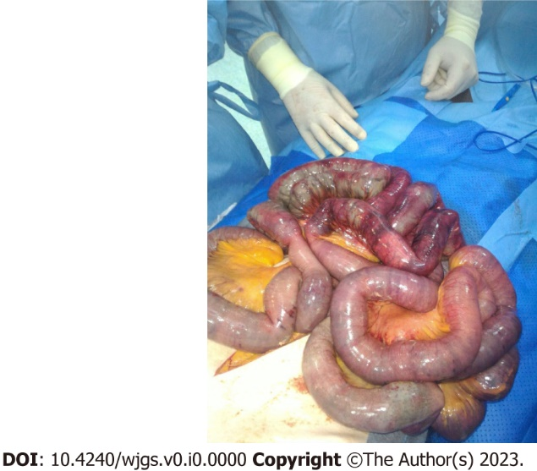
Figure 1 Intraoperative finding of diffuse ileal ischemia. (Personal observation)

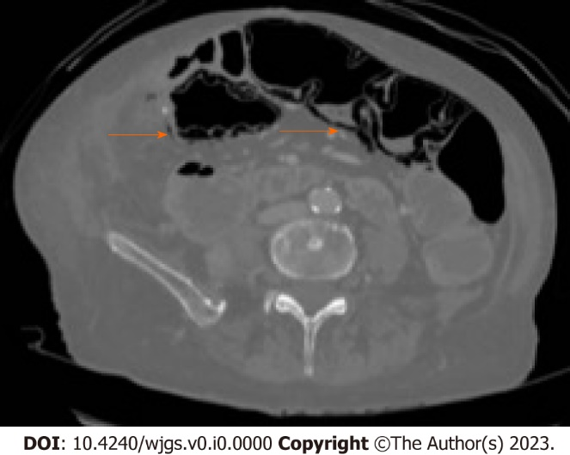
Figure 2 Computed tomography-scan with evidence of cystoid or bubble-like pattern PI, identified by the orange arrow. (Personal observation)

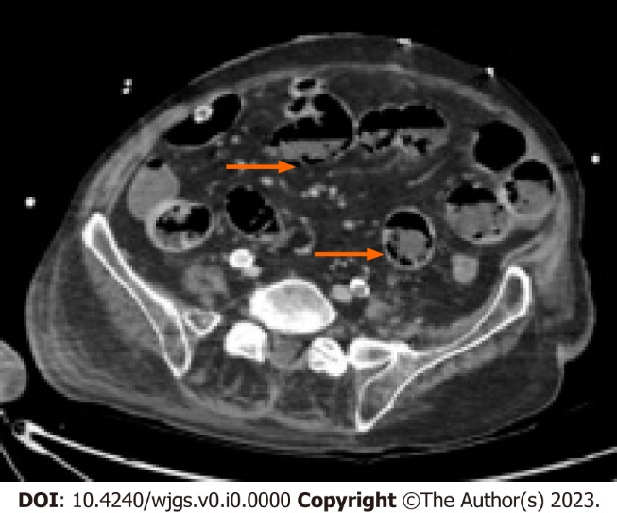
Figure 3 Computed tomography-scan documenting a linear pattern at the level of the colonic wall, identified by the orange arrow. (Personal observation)

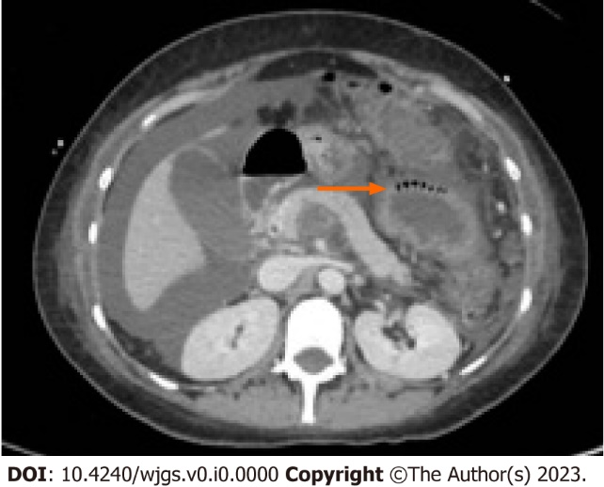
Figure 4 Computed tomography-scan documenting circumferential pattern PI, identified by the orange arrow. (Personal observation)

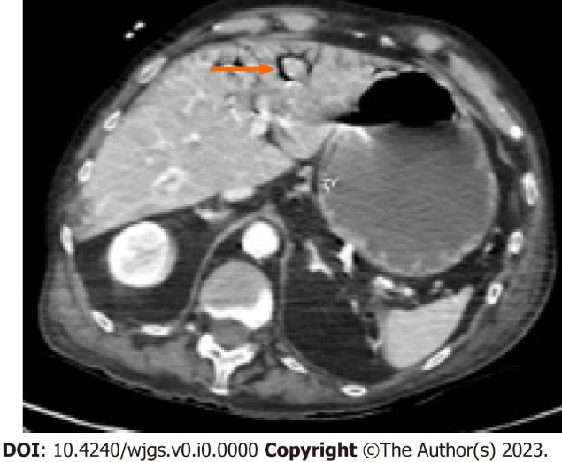
Figure 5 Computed tomography-scan documenting localized portal venous gas, identified by the orange arrow. (Personal observation)

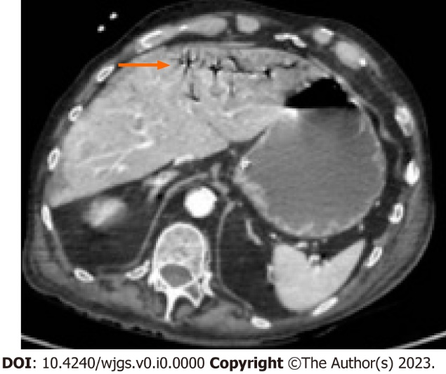
Figure 6 Computed tomography-scan documenting diffuse portal venous gas, identified by the orange arrow. (Personal observation)

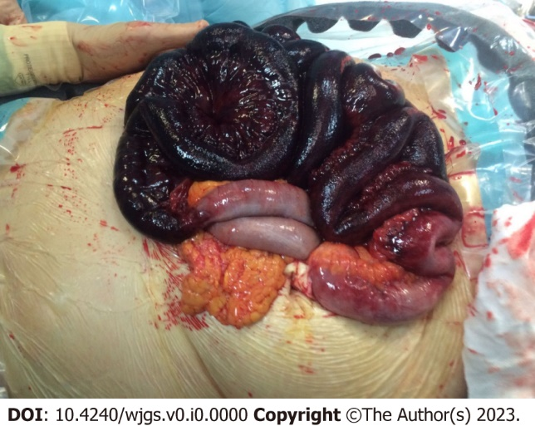
Figure 7 Intraoperative finding of transmural infarction with intestinal necrosis. (Personal observation)

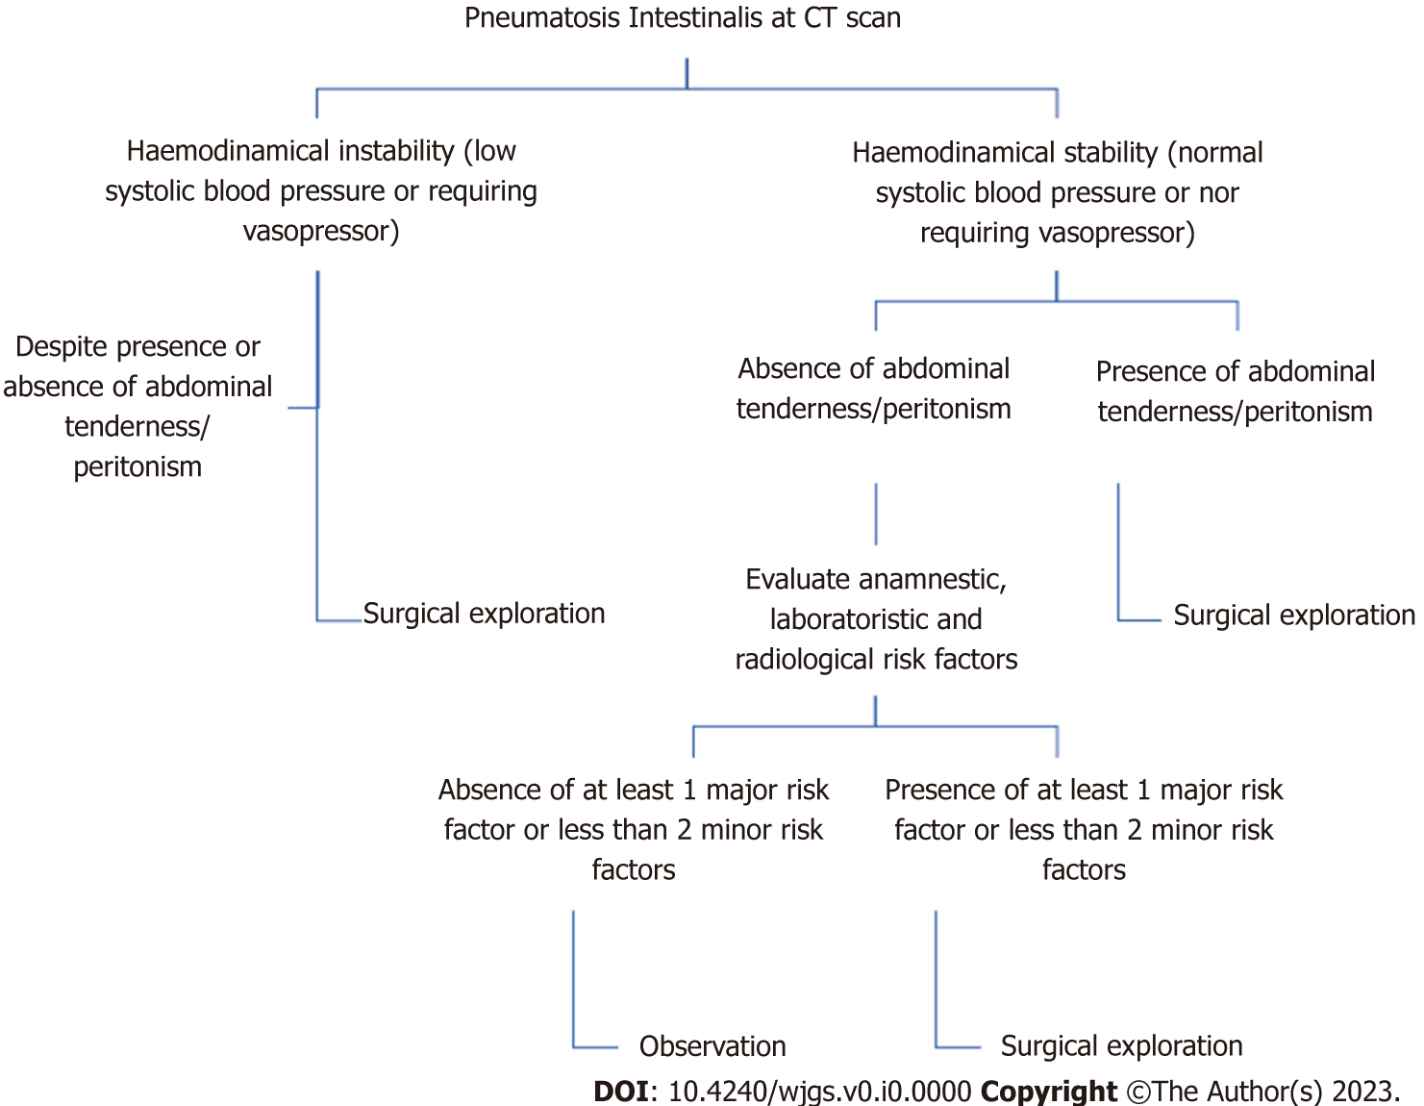
Figure 8 Algorithm to guide clinical decisions in patients with pneumatosis intestinalis.

Table 1 Underlying pathological conditions
Pathological conditions
Trauma^{[21,64-67]} | Blunt/penetrating abdominal trauma
 | Surgical anastomosis or bypass
Mechanical^{[68]} | Pyloric obstruction or stenosis
 | Duodenal obstruction or stenosis
 | Bowel obstruction (volvulus, carcinoma, malrotation, intussusception)
Autoimmune^{[69-71]} | Lupus enteritis
 | Celiac sprue
 | Polymyositis
 | Dermatomyositis
 | Polyarteritis nodosa
 | Mixed connective tissue diseases
 | Graft versus host disease
 | Primary immunodeficiency
Malignancies^{[15]} | Gastrointestinal cancer
 | Leukemia
 | Lymphoma
 | Other malignancies
Inflammation^{[14,72]} | Inflammatory bowel disease
 | Appendicitis
 | Diverticulitis
 | Cholelithiasis
 | Sarcoidosis
Vascular conditions^{[73]} | Ischemia or infarction
 | Diabetes
Pulmonary disease^{[74,75]} | Chronic obstructive pulmonary disease
 | Cystic fibrosis
 | Asthma
Drugs^{[13,19,76-79]} | Corticosteroids
 | Chemotherapy and immunotherapy
 | Immunosuppression
 | Lactulose
 | Trichloroethylene
 | Sorbitol
 | Alpha-glucosidase inhibitor
 | Practolol
Diagnostic/therapeutic procedures^{[80,81]} | Endoscopy
 | Enema/colon idrotherapy
 | Barium studies
Connective tissue disease/neurological^{[82,83]} | Scleroderma
 | Multiple sclerosis
 | Hirschsprung disease
 | Quadriplegia
 | Amyloidosis
Other conditions^{[17,84]} | Hemodialysis
 | Pseudo-obstruction
 | Whipple disease
 | Cytomegalovirus infection
 | COVID-19 infection
COVID-19: Corona Virus Infectious Disease-2019.

Table 2 Clinical studies in patients with pneumatosis intestinalis
Author | Type of study | Patients, n | Results
Ferrada et al^{[39]} | Prospective Multicenter | One hundred twenty-seven patients with PI at CT scan | Mortality in the pathologic PI group vs benign PI group: 34% vs 13.9%. Patients with pathologic PI had hemodynamic instability, sepsis, peritonitis. The radiographic location is significant: Small bowel has a higher incidence of transmural ischemia than colon. Hepatic portal venous gas is suggestive for pathologic PI
Treyaud et al^{[43]} | Retrospective Monocenter | One hundred eighty-seven patients with pi at CT scan | Location of PI nor the length of intestinal involvement correlate significantly with ischemia. The radiologic features that correlate with ischemia are PMP (P =0.009) and the decreased mural contrast-enhancement (P < 0.001). Among the laboratory tests, only WBC (> 12.000/mmc) correlates with bowel ischemia (P =0.03)
Morris et al^{[10]} | Retrospective Monocenter | One hundred four patients with PI at CT scan | Mortality rate: 22%; 52% of patients were treated conservatively, with a mortality rate of 6%. Mortality rate of patients with PMP was 43%. No difference found in laboratory values between groups
Lassandro et al^{[49]} | Retrospective Monocenter | One hundred two patients with PI at CT scan | Fifty-two percent of patients had surgical confirmation of bowel ischemia. 42.2% of patients had a bubblelike whereas in 59% it was linear. 75.5% of patients with linear pattern had bowel infarction. Mortality rate is 30.4%; it raises to 50% when PI is associated to PMP
Pickhardt et al^{[85]} | Retrospective Monocenter | Five thousand three hundred sixty-eight Colonography scans, 0.11% with colonic PI | PI with curvilinear configuration. No clear if it was a pre-existing condition. No significant complications
Kernagis et al^{[48]} | Retrospective Monocenter | Fifteen patients with PI at CT scan | Nine patients (60%) of symptomatic patients had transmural bowel infarction (4 small bowel, 5 colon)
Wiesner et al^{[55]} | Retrospective Monocenter | Twenty-three patients with PI or PMP at CT scan and bowel ischemia | Twenty-two percent of patients showed partial mural bowel infarction, 78% of patients showed transmural bowel infarction. 70% of bubblelike PI was associated with bowel ischemia instead of the 88% of linear pattern. 81% of patients with PMP showed transmural infarction. Overall mortality 53%
Shinagare et al^{[54]} | Retrospective Monocenter | Forty-eight patients with cancer and PI at CT scan | Thirty-nine patients were receiving molecular targeted therapy. Bevacizumab and Sunitinib were the most common drugs associated with PI. Median duration of molecular targeted therapy before PI or perforation was 3 mo. Asymptomatic patients 70.8%. Conservative PI treatment 100%
Huzar et al^{[9]} | Retrospective Monocenter | One thousand one hundred twenty-nine patients admitted to Burn ICU | PI at CT scan 1.3%. Mortality rate of patients with PI was 73%. Explorative laparotomy in 2-3 h from the CT scan in 94% of the patients. PI involved both small bowel and colon 60%. Nonsurvivors had greater base deficit (P = 0.03), open abdomen after surgery (P = 0.004)
Horowitz et al^{[45]} | Retrospective Monocenter | Twenty-eight gynecological cancer patients and PI at CT scan | Patients symptomatic for abdominal pain 80%. Patients that did poorer were patients with preoperative acidosis, lower level of bicarbonate and lymphopenia
PI: Pneumatosis intestinalis; CT: Computed tomography; PMP: Portomesenteric pneumatosis; WBC: White blood cells; ICU: Intensive care unit.

Table 3 Risk factors in patients with pneumatosis intestinalis
Risk Factors
Anamnestic | Vascular disease
 | Atrial fibrillation
Major laboratory risk factors (blood sample) | Lac > 4 mmol/L
 | LDH > 400 UI/L
 | pH < 7.31
 | BUN > 50 mg/dL
Minor laboratory risk factor (blood sample) | WBC > 15.000/L
 | Creatinine > 2 mg/dL
 | HCO³⁻ < 18 mmol/L
 | Potassium 5.5 mmol/L
Radiological | Portomesenteric pneumatosis
 | Pneumoperitoneum
 | Free peritoneal fluid
LDH: Lactate Dehydrogenase; BUN: Blood urea nitrogen; WBC: White blood cells.

