Name of journal: World Journal of Gastroenterology
ESPS Manuscript NO: 10381
Columns: RESEARCH REPORT

Beneficial effects of adenosine triphosphate-sensitive K⁺ channel opener on liver ischemia/reperfusion injury

Nogueira MA et al. Diazoxide on liver ischemia/reperfusion injury

Mateus Antunes Nogueira, Ana Maria Mendonça Coelho, Sandra Nassa Sampietre, Rosely Antunes Patzina, Fabiano Pinheiro da Silva, Luiz Augusto Carneiro D’Albuquerque, Marcel Cerqueira Cesar Machado

Mateus Antunes Nogueira, Ana Maria Mendonça Coelho, Sandra Nassa Sampietre, Rosely Antunes Patzina, Fabiano Pinheiro da Silva, Luiz Augusto Carneiro D’Albuquerque, Marcel Cerqueira Cesar Machado, Department of Gastroenterology (LIM/37), and Department of Clinical Emergency (LIM/51), Medical School, University of Sao Paulo, Sao Paulo 01246903, Brazil

Author contributions: Nogueira MA and Machado MMC designed research; Coelho AMM, Sampietre SN and Patzina RA performed research; D’Albuquerque LAC provided material and laboratory equipment/revised the manuscript; Nogueira MA, Coelho AMM, Machado MCC and Pinheiro da Siva F analyzed data; Coelho AMM and Machado MMC wrote the paper.

Supported by Fundação de Amparo à Pesquisa do Estado de São Paulo, No. 2010/19078-1

Correspondence to: Marcel Cerqueira Cesar Machado, MD, Professor of Medicine, Department of Clinical Emergency, University of Sao Paulo, R. Peixoto Gomide, 515 13 andar 01409001, Sao Paulo 01246903, Brazil. mccm37@uol.com.br
Telephone: +55-11-32891188 Fax: +55-11-32891188

Received: March 28, 2014 Revised: May 28, 2014
Accepted: July 11, 2014

Published online:

Abstract
AIM: To investigate the effect of diazoxide administration on liver ischemia/reperfusion injury.

METHODS: Wistar male rats underwent partial liver ischemia performed by clamping the pedicle from medium and left anterior lateral segments during an hour under mechanical ventilation. They were divided into 3 groups: Control Group: rats submitted to liver manipulation, Saline Group: rats received saline, and Diazoxide Group: rats received intravenous injection (iv) diazoxide (3.5 mg/kg) 15 min before liver reperfusion. Four and 24 h after reperfusion, blood were collected for determinations of aspartate transaminase (AST), alanine transaminase (ALT), tumor necrosis factor (TNF-α), interleukin-6 (IL-6), interleukin-10 (IL-10), nitrite/nitrate, creatinine and tumor growth factor-β1 (TGF-β1). Liver tissues were assembled for mitochondrial oxidation and phosphorylation, malondialdehyde (MDA) content, and histologic analysis. Pulmonary vascular permeability and myeloperoxidade (MPO) were also determined.

RESULTS: Four hours after reperfusion Diazoxide Group presented significant reduction of AST (2009 ± 257 vs 3523 ± 424 U/L, P = 0.005); ALT (1794 ± 295 vs 3316 ± 413 U/L, P = 0.005); TNF-α (17±9 vs 152 ± 43 pg/mL, P = 0.013; IL-6 (62 ± 18 vs 281 ± 92 pg/mL); IL-10 (40 ± 9 vs 78 ± 10 pg/mL P = 0.03), nitrito/nitrato (3.8 ± 0.9 vs 10.2 ± 2.4 µmol/L, P = 0.025) when compared to Saline Group. A significant reduction on liver mitochondrial dysfunction were observed in Diazoxide Group compared to Saline Group (P < 0.05). No differences in liver MDA content, serum creatinine and in pulmonary vascular permeability and MPO activity were observed between groups. Twenty four hours after reperfusion Diazoxide Group showed a reduction of AST (495 ± 78 vs 978 ± 192 U/L, P = 0.032); ALT (335 ± 59 vs 742 ± 182 U/L, P = 0.048), and TGF-β1 (11 ± 1 vs 17 ± 0.5 ng/mL, P = 0.004) serum levels when compared to Saline Group. Control Group did not present alterations when compared to Diazoxide and Saline Groups.

CONCLUSION: Diazoxide maintains liver mitochondrial function, increases liver tolerance to ischemia/reperfusion injury, and reduces systemic inflammatory response. These effects require further evaluations for using in a clinical setting.

© 2014 Baishideng Publishing Group Inc. All rights reserved.

Key words: Liver ischemia/reperfusion; Diazoxide; K⁺ channel opener; Mitochondrial ATP-sensitive potassium channel; Liver mitochondria

Core tip: Diazoxide is a selective mitoKATP channel opener and have a protective effect against organ ischemia/reperfusion (I/R) injury. This report shows that diazoxide maintains liver mitochondrial function, increases liver tolerance to I/R injury, and reduces systemic inflammatory response. Since diazoxide has also a hypotensive effect its administration may also reduce bleeding in liver surgery during hepatic parenchyma transection. These effects require further evaluations for using in a clinical setting.

Nogueira NA, Coelho AMM, Sampietre SN, Patzina RA, Pinheiro da Silva F, D’Albuquerque LAC, Machado MCC. Beneficial effects of adenosine triphosphate-sensitive K⁺ channel opener on liver ischemia/reperfusion injury. World J Gastroenterol 2014; In press

INTRODUCTION
The physiological function of mitochondrial ATP-sensitive potassium channel (mitoKATP) is to permit K⁺ transport into the mitochondrial matrix and therefore maintaining its volume^{[1]}. This mitochondrial channel has been identified in many tissues as heart^{[2]}, brain^{[3]}, skeletal muscle^{[4]} and liver^{[5]}.
This mitoKATP channel has been related to the preconditioning protection of the ischemic heart^{[6]}. It was also observed that the preconditioning-like effect of morphine in the intact heart can be the result of mitoKATP channel activation^{[7]}.
Diazoxide is a selective mitoKATP channel opener and could have a protective effect against organ ischemia/reperfusion (I/R) injury. In fact a protective effect has been demonstrated in heart^{[8]}. This protective effect is related to mitoKATP opening since other drugs with this action also reduce the heart I/R injury^{[9]}.
The protective effect of diazoxide in I/R injury has been reported in several organs as brain^{[10]} and spinal cord^{[11]} in which mitoKATP has been identified. Since mitoKATP channels are present in liver mitochondria^{[12]} is conceivable that diazoxide may have a protective effect on liver I/R injury. In the present study, we evaluated the effect of diazoxide on local and systemic effects of liver I/R injury.

MATERIAL AND METHODS
Animals
Seventy adults male Wistar rats weighing 230 to 270 g housed in individual cages in a 12 h dark-light controlled environment were used for the experimental protocol. Rats had free access to standard rat chow and water. The experimental protocol was approved by the Ethics Committee for Animal Research from the Medical School of São Paulo University and received humanized care according to the criteria outlined in the Guide for the Care and Use of Laboratory Animals. Institute of Laboratory Animal Resources, Commission on Life Sciences and National Research Council. National Academic Press, Washington, D.C., 1996.

Experimental design
The rats were randomly submitted to the following experimental protocols: Control Group (n = 18): rats underwent laparotomy and liver manipulation; Saline Group (n = 26): rats received intravenous injection (iv) saline 15 min before liver ischemia; Diazoxide Group (n = 26): rats received iv diazoxide (Sigma Chemical CO, St. Louis, MO, USA) (3.5 mg/kg) 15 min before liver ischemia. Saline and Diazoxide groups received the same iv volume in mL/kg.

Surgical procedure and sample collection
The animals were anesthetized with intra-peritoneal ketamine (Cristalia, São Paulo, Brazil) (30 mg/kg) and xylazine (Bayer, São Paulo, Brazil)(30 mg/kg) and submitted to orotracheal intubation, and ventilated with a tidal volume of 0.08 mL/g body weight, at a respiratory rate of 60/min, and FiO₂ of 0.21 (Small Animal Ventilator model 683, Harvard Apparatus, Holliston, MA, USA). During the surgical procedure, body temperature was monitored using a rectal digital thermometer (YSI Precision 4000A Thermometer, USA), being maintained at 37 ºC. Median laparotomy was performed and the hepatic pedicle of median and left anterolateral segments were isolated, exposed and clamped with a non-traumatic microvascular bulldog clamp during 1 h that induces ischemia to 70% of the total liver volume. In this model, intestinal congestion is avoided allowing the possibility to study the effects of isolated liver ischemia. The incision was closed, and after a 60-min ischemic period, the abdomen was reopened allowing clamp removal and liver reperfusion^{[13,14]}.
After liver reperfusion, rats were re-anesthetized for blood sampling through cardiac puncture and killed by exsanguination. At 4 and 24 h after reperfusion, blood was collected for determinations of aspartate aminotransferase (AST), alanine aminotransferase (ALT), tumor necrosis factor (TNF-α), interleukin-6 (IL-6), interleukin-10 (IL-10), tumor growth factor-β1 (TGF-β1), nitrite/nitrate and creatinine. Hepatic tissues were assembled for evaluation of mitochondrial oxidation and phosphorylation, malondialdehyde (MDA) content, and histologic analysis. The liver tissue for post-ischemic analysis was obtained from median and left anterolateral segments previously submitted to I/R injury. Lungs were perfused via tracheal with 30-50 mL of 0.9% NaCl at 10 mL/min, using a syringe pump (model 975) from Harvard Apparatus, and fragments were harvested and divided for analysis of microvascular permeability, mieloperoxidase (MPO) activity. No mortality is observed in this model of partial liver ischemia. No mortality is observed in this model of partial liver ischemia.

Serum AST and ALT levels
Serum AST and ALT levels were measured to assess the extension of hepatocellular injury. The enzyme activities were assayed by using the optimized ultraviolet method (COBAS MIRA) from Roche (Roche Diagnostics, Rotkrenz, Switzerland). Results are expressed as units per liter (U/L).

Liver mitochondrial oxidation and phosphorylation activities
Liver mitochondria were prepared as previously described^{[15]}. Briefly, rat livers were rapidly excised and placed in medium containing 250 mmol/L sucrose, 10 mmol/L Tris-HCl, and 1 mmol/L EGTA, pH 7.3, at 4 °C. The tissue was scissor-minced and homogenized in ice using a Teflon Potter homogenizer. The homogenate was centrifuged at 600 g for 10 min. The supernatant was centrifuged for 10 min at 10000 g to obtain the mitochondrial pellet. Mitochondrial suspension containing 30-40 mg/mL of mitochondrial protein was prepared, and stored on ice before the assay of mitochondrial respiration.
The mitochondrial oxygen consumption was polarographically^{[16]} measured using a Gilson 5/6H Oxygraph (Gilson Medical Eletronics, Inc., Middleton, WI) in a closed reaction vessel fitted with a Clark oxygen electrode (Yellow Springs Instruments Co., Yellow Springs, OH) at 28 °C. The incubation medium consisted of 120 mmol/L KCl, 2 mmol/L sodium phosphate, 10 µmol/L rotenone, and 1 mmol/L EGTA [Ethylene glycol-bis(2-aminoethylether)-N,N,N',N'-tetraacetic acid], and was buffered at pH 7.3 with 5 mmol/L Tris-HCl. Mitochondria were energized with potassium succinate as substrate at a final concentration of 10 mmol/L. After a brief equilibration period, state 3 (activated state, S3) respiration was induced by the addition of 280nmol adenosine diphosphate (ADP). The added ADP was phosphorylated to adenosine triphosphate (ATP) and the state 4 (basal state, S4) respiration was then measured. The oxygen consumption ratio in the presence of ADP to that in absence (respiratory control rate, RCR) and the ADP/O ratio were calculated as indices of mitochondrial oxidation and phosphorylation activities^{[17]}.
RCR = Oxygen consumption in the S3/ oxygen consumption in the S4.
ADP/O = Moles of ATP formed from ADP per atom of oxygen consumed.
S3 and S4 were measured and reported as nmol oxygen per milligram mitochondrial protein per minute. Mitochondria protein content was determined by the method of Lowry et al^{[18]}.

Lipid peroxidation analysis
MDA formation was used as indicative of the occurrence of lipid peroxidation in the tissues and was estimated as thiobarbituric acid-reactive substances (TBARS). Liver tissues (100 mg/mL) were homogenized in 1.15% KCl buffer, and centrifuged at 14000 g for 20 min. An aliquot of the supernatant was then added to a reaction mixture consisting of 1.5 mL 0.8% thiobarbituric acid, 200 μL 8.1% (v/v) sodium dodecyl sulfate, 1.5 mL 20% acetic acid (pH 3.5), and 600 μL distilled water. The mixture was then heated at 90 °C for 45 min. After cooling to room temperature, the samples were cleared by centrifugation (10000 g for 10 min), and the absorbance was measured at 532 nm using malondialdehyde bis (dimethyl acetal) as external standard. The content of lipid peroxides was expressed as nmol MDA per mg of protein^{[19]}.

Serum levels of nitrite-nitrate
Serum levels of nitrite-nitrate were determining using a commercial assay kits (R&D Systems Inc, MN, USA) according to the manufacturer’s guidelines.

Determination of inflammatory mediators
Serum levels of TNF-α, IL-6, IL-10, and TGF-β1 were determined by ELISA using commercial kits (Invitrogen, CA, USA).

Histological analysis of the liver
Liver samples were fixed in 10% buffered formalin for standard hematoxylin and eosin staining. Histological evaluation of the liver sections was performed by the same pathologist in a blinded manner. The severity of histological injury was analyzed according to the scoring system proposed by Quireze et al^{[20]}.

Lung tissue microvascular permeability analysis
Increases in lung microvascular permeability were quantified by the Evans blue dye (EBD) extravasation technique as described previously^{[18]}. EBD was injected, 20 mg/kg of body weight, via dorsal penial vein 15 min before euthanasia. After collecting blood sampling, lungs were perfused with 30-50 mL of NaCl 0.9% at 10 mL/min, using a syringe pump (model 975) from Harvard Apparatus, and weighed. One small fragment was dried at 60 °C for calculation of total dry weight. To extract the dye, the lung was incubated with formamide, 4 mL/mg of tissue, for 24 h at room temperature. The concentration of EBD extracted into formamide was quantified spectrophotometrically at 620 nm using the Ultra Microplate Reader ELX 808 from Bio-Tek Instruments (Winooski, VT). The results are expressed as microgram of EBD per gram of dry weight tissue. Expression of results as a function of dry weight avoids underevaluation due to edema formation^{[21]}.

Lung tissue MPO activity
Lung MPO activity was used as an indicator of the neutrophil content in lung parenchyma. MPO activity was used as an indicator of neutrophils presence in lung tissue. Samples of 300 mg wet lung tissue were homogenized with a polytron homogenizer (Polytron PT-2100 homogenizer, Kinematica AG, Luzern, Switzerland) for 60 s in 1 mL of sodium phosphate buffer, pH 6.2, containing 0.5 g/dL hexadecyltrimethyl ammonium bromide and 5 mmol/L of ethylenediaminetetraacetic acid. Homogenized samples were then sonicated at 40 Hz for 60 s, and centrifuged at 3000 g for 30 min at 4 ºC. MPO activity in the supernatant was assayed by measuring the change in absorption at 460 nm (A460) resulting from the metabolism of hydrogen peroxide in the presence of O-dianisidine^{[22,23]}. MPO content was expressed as units of MPO activity per gram tissue.

Serum levels of creatinine
Serum levels of creatinine were determined at 4 and 24 h after reperfusion by a modified Jaffe method.

Statistical analysis
Results are presented as mean values ± SEM. Continuous variables were compared using analysis of variance. Results from the histological analysis were compared using the Kruskal-Wallis test. The level of P < 0.05 was considered as statistically significant. The GraphPad 6 Prism Software (GraphPad Software, San Diego, CA) was used for statistical analysis.

RESULTS
Effect of diazoxide on hepatic enzymes
At 4 and 24 h after reperfusion serum AST and ALT activities were significantly elevated in groups with I/R compared to the control group, however diazoxide group presented elevation of AST, ALT serum levels significantly lower than saline group (Figures 1A and B).

Effect of diazoxide on liver mitochondrial oxidation and phosphorylation activities
Four hours after reperfusion, there was a decrease in the oxygen consumption rate by liver mitochondria in state 3 (S3), in respiratory control rate (RCR), and in ADP/O ratio in animals of saline group when compared to diazoxide and control groups (Figure 2A-C). No differences were found in state 4 (S4) between group saline and diazoxide.

Effect of diazoxide on liver MDA
MDA content in the liver was used as measure of lipid peroxidation in the organ and it was not affected by diazoxide administration (Table 1).

Effect of diazoxide on nitrite-nitrate serum levels
Four hours after reperfusion it was observed a significant reduction of nitrite-nitrate serum levels in the group of animals treated with diazoxide when compared to animals of saline group (Figure 3).

Effect of diazoxide on inflammatory mediators levels
At 4 h after liver reperfusion it was observed a significant increase in serum levels of TNF-α, IL-6, and IL-10 in saline group when compared diazoxide and control group (Figures 4A-C).
Transforming growth factor (TGF-β1) was also reduced 24 h after liver reperfusion in diazoxide treated animals and in control group when compared to saline group (Figure 4D).

Effect of diazoxide on liver histologic analysis
The severity of histological injury analyzed according to the scoring system proposed by Quireze et al^{[20]} was similar in both diazoxide and saline groups.

Effect of diazoxide on lung permeability and MPO activity
Lung microvascular permeability evaluated through Evans blue dye (EBD) extravasation, was increased 4 h after reperfusion compared to control group, however it was not affected by diazoxide treatment. Similar results were observed with the evaluation of lung neutrophil infiltration by lung MPO activity determination (Table 1).

Effect of diazoxide on serum levels of creatinine
Serum levels of creatinine were used as evaluation of kidney injury after I/R liver and it was not affected by diazoxide administration (Table 1).

DISCUSSION
Transient periods of nonlethal ischemia and reperfusion that confer protection against organ I/R injury have been named ischemic preconditioning. This ischemic preconditioning effect has been extensively studied as a method useful to reduce organs including liver I/R injury^{[24-27]}. In fact this is the only strategy used in clinical practice to reduce liver ischemic/reperfusion injury^{[28]}.
There are several experimental evidences that the main mechanism of organ protection in the ischemic preconditioning effect is the opening of the mitoKATP channel^{[29-32]}. The main physiologic action of mitoKATP channel is the regulation of the mitochondrial volume and therefore regulates electron transport being important in mitochondrial bioenergetic functions^{[33,34]}.
MitoKATP opening is followed by mitochondrial K⁺ uptake inducing matrix alkalization that causes complex I reactive oxygen species production and activation of protein kinase C-e and therefore inhibition of membrane permeability transition (MPT) pore opening^{[35]}. Inhibition of MPT pore opening keeps mitochondrial integrity during I/R injury since the MPT pore opening leads to dissipation of proton motive force resulting in ATP depletion and cell energetic failure.
Diazoxide is a strong mitoK ATP opener and therefore could protect organs from I/R injury. In fact its protective effect has been demonstrated in cerebral, renal and heart ischemia^{[29,36-38]}.
In the present study we observed a reduction in serum AST and ALT levels in diazoxide group reflecting the reduction in liver damage from I/R injury. Reduction of inflammatory mediators (TNF-α, IL-6, IL-10) observed in the present study is also related to reduction of liver damage however, the severity of histological injury analyzed according to the scoring system proposed by Quireze et al^{[20]} was similar in both groups diazoxide and saline. Despite reduction of inflammatory mediators no attenuation of lung and kidney injury was observed in diazoxide treated animals. The preservation of mitochondrial function observed in this study by an increase in the oxygen consumption rate by liver mitochondria in state 3, in respiratory control rate (RCR), and in ADP/O ratio in animals of diazoxide group when compared to saline group, suggests that diazoxide may act by sustaining the mitochondrial energetics through mitoKATP opening, MPT pore opening inhibition and reduction of ATP depletion.
The reversible redox conversion of nitrite and nitric oxide (NO) allows us to evaluate the production of NO in pathologic conditions by determination of serum nitrate-nitrite levels. In the present study we observed a significant reduction in nitrate-nitrite serum levels in the group of animals treated with diazoxide compared to saline group.
Reduction in TGF-β1 in diazoxide group also indicates a reduction in liver damage since TGF-β1 has been recognized as a key mediator in tissue fibrosis by stimulating matrix-producing fibrogenic cells and promoting extracellular matrix deposition that followed tissue injury.
MitoKATP opening inducing partial mitochondrial membrane depolarizatrion reduces the driving force for Ca²⁺ influx during ischemia. In fact, it has been reported that diazoxide reduces Ca²⁺ influx during cardiac reperfusion^{[38]}. Since intracellular Ca²⁺ overload may cause mitochondrial damage the beneficial effect of diazoxide in liver I/R injury may also be related to reduction in hepatocyte intracellular Ca²⁺. The suppression of hepatocyte calcium overload by diazoxide recently demonstrated^{[12]} is therefore an additional effect of diazoxide protecting liver mitochondria from I/R injury. The study of other activators of these mitoKATP channels may provide new therapeutic strategies for treatment of liver I/R injury.
In conclusion diazoxide administration by mitoKATP opening maintains liver mitochondrial function, increases liver tolerance to I/R injury, and reduces systemic inflammatory response. Since diazoxide has also a hypotensive effect its administration may also reduce bleeding in liver surgery during hepatic parenchyma transection. These effects require further evaluations before using in a clinical setting.

COMMENTS
Background
The mitochondrial ATP-sensitive potassium channel (mitoKATP) channel has been related to the preconditioning protection in several organs including liver. Diazoxide is a selective mitoKATP opener which has a protective effect on liver ischemia/reperfusion (I/R) injury however the mechanism of this protection is not well understood.
Research frontiers
Authors demonstrated in this study that diazoxide protects liver from I/R injury by reduction of mitochondrial dysfunction and also by significant reduction of inflammatory cytokines.
Innovation and breakthroughs
Although the protective effects of diazoxide on liver I/R injury had been previously shown we demonstrated that these effects include mitochondrial function preservation and also a significant reduction in inflammatory cytokines. The authors concluded that diazoxide reduces mitochondrial dysfunction and reduces inflammatory cytokines protecting the liver but has no effect on distant organ damage.
Application
Diazoxide as a hypotensive drug can be used during liver resection reducing bleeding and also protecting liver from I/R injury.
Peer review
This study evaluated the effects of mitochondrial K+ channel opener diazoxide on liver I/R injury using a rat in vivo warm I/R model. It shows that diazoxide decreased AST and ALT release after hepatic warm I/R but did not protect against liver histological changes and lung and kidney injury. It provides some interesting data, protective effects of diazoxide after hepatic warm I/R in rats.

REFERENCES
1 Kicińska A, Szewczyk A. Protective effects of the potassium channel opener-diazoxide against injury in neonatal rat ventricular myocytes. Gen Physiol Biophys 2003; 22: 383-395 [PMID: 14986888]
2 Noma A. ATP-regulated K+ channels in cardiac muscle. Nature 1983; 305: 147-148 [PMID: 6310409 DOI: 10.1038/305147a0]
3 Bajgar R, Seetharaman S, Kowaltowski AJ, Garlid KD, Paucek P. Identification and properties of a novel intracellular (mitochondrial) ATP-sensitive potassium channel in brain. J Biol Chem 2001; 276: 33369-33374 [PMID: 11441006 DOI: 10.1074/jbc.M103320200]
4 Debska G, Kicinska A, Skalska J, Szewczyk A, May R, Elger CE, Kunz WS. Opening of potassium channels modulates mitochondrial function in rat skeletal muscle. Biochim Biophys Acta 2002; 1556: 97-105 [PMID: 12460666 DOI: 10.1016/S0005-2728(02)00340-7]
5 Inoue I, Nagase H, Kishi K, Higuti T. ATP-sensitive K+ channel in the mitochondrial inner membrane. Nature 1991; 352: 244-247 [PMID: 1857420 DOI: 10.1038/352244a0]
6 Wang L, Kinnear C, Hammel JM, Zhu W, Hua Z, Mi W, Caldarone CA. Preservation of mitochondrial structure and function after cardioplegic arrest in the neonate using a selective mitochondrial KATP channel opener. Ann Thorac Surg 2006; 81: 1817-1823 [PMID: 16631678 DOI: 10.1016/j.athoracsur.2005.11.029]
7 Liang BT, Gross GJ. Direct preconditioning of cardiac myocytes via opioid receptors and KATP channels. Circ Res 1999; 84: 1396-1400 [PMID: 10381891 DOI: 10.1161/01.RES.84.12.1396]
8 Wakahara N, Katoh H, Yaguchi Y, Uehara A, Satoh H, Terada H, Fujise Y, Hayashi H. Difference in the cardioprotective mechanisms between ischemic preconditioning and pharmacological preconditioning by diazoxide in rat hearts. Circ J 2004; 68: 156-162 [PMID: 14745152 DOI: 10.1253circj.68.156]
9 Oldenburg O, Yang XM, Krieg T, Garlid KD, Cohen MV, Grover GJ, Downey JM. P1075 opens mitochondrial K(ATP) channels and generates reactive oxygen species resulting in cardioprotection of rabbit hearts. J Mol Cell Cardiol 2003; 35: 1035-1042 [PMID: 12967626 DOI: 10.1016/S0022-2828(03)00151-2]
10 Lenzsér G, Kis B, Bari F, Busija DW. Diazoxide preconditioning attenuates global cerebral ischemia-induced blood-brain barrier permeability. Brain Res 2005; 1051: 72-80 [PMID: 16004973 DOI: 10.1016/j.brainres.2005.05.064]
11 Roseborough G, Gao D, Chen L, Trush MA, Zhou S, Williams GM, Wei C. The mitochondrial K-ATP channel opener, diazoxide, prevents ischemia-reperfusion injury in the rabbit spinal cord. Am J Pathol 2006; 168: 1443-1451 [PMID: 16651612 DOI: 10.2353/ajpath.2006.050569]
12 Nakagawa Y, Yoshioka M, Abe Y, Uchinami H, Ohba T, Ono K, Yamamoto Y. Enhancement of liver regeneration by adenosine triphosphate-sensitive K⁺ channel opener (diazoxide) after partial hepatectomy. Transplantation 2012; 93: 1094-1100 [PMID: 22466787 DOI: 10.1097/TP.0b013e31824ef1d1]
13 Yoshizumi T, Yanaga K, Soejima Y, Maeda T, Uchiyama H, Sugimachi K. Amelioration of liver injury by ischaemic preconditioning. Br J Surg 1998; 85: 1636-1640 [PMID: 9876065 DOI: 10.1046/j.1365-2168.1998.00917.x]
14 Figueira ER, Bacchella T, Coelho AM, Sampietre SN, Molan NA, Leitão RM, Machado MC. Timing-dependent protection of hypertonic saline solution administration in experimental liver ischemia/reperfusion injury. Surgery 2010; 147: 415-423 [PMID: 20004454 DOI: 10.1016/j.surg.2009.10.018]
15 Coelho AM, Machado MC, Sampietre SN, Leite KR, Oliveira VL, Pinotti HW. Hepatic damage during acute pancreatitis in the rat. Braz J Med Biol Res 1997; 30: 947-953 [PMID: 9361723 DOI: 10.1590/S0100-879X1997000800006]
16 Estabrook RW. Mitochondrial respiratory control and the polarographic measurement of ADP/O ratios. In: Estabrook and ME Pullman: Methods in enzymology. New York: Academic Press, 1967: 41-47
17 CHANCE B, WILLIAMS GR. A simple and rapid assay of oxidative phosphorylation. Nature 1955; 175: 1120-1121 [PMID: 14394122 DOI: 10.1038/1751120a0]
18 LOWRY OH, ROSEBROUGH NJ, FARR AL, RANDALL RJ. Protein measurement with the Folin phenol reagent. J Biol Chem 1951; 193: 265-275 [PMID: 14907713]
19 Soriano FG, Liaudet L, Szabó E, Virág L, Mabley JG, Pacher P, Szabó C. Resistance to acute septic peritonitis in poly(ADP-ribose) polymerase-1-deficient mice. Shock 2002; 17: 286-292 [PMID: 11954828 DOI: 10.1097/00024382-200204000-00008]
20 Quireze C, Montero EF, Leitão RM, Juliano Y, Fagundes DJ, Poli-de-Figueiredo LF. Ischemic preconditioning prevents apoptotic cell death and necrosis in early and intermediate phases of liver ischemia-reperfusion injury in rats. J Invest Surg 2006; 19: 229-236 [PMID: 16835137 DOI: 10.1080/08941930600778206]
21 Jancar S, De Giaccobi G, Mariano M, Mencia-Huerta JM, Sirois P, Braquet P. Immune complex induced pancreatitis: effect of BN 52021, a selective antagonist of platelet-activating factor. Prostaglandins 1988; 35: 757-770 [PMID: 2969600 DOI: 10.1016/0090-6980(88)90148-7]
22 Goldblum SE, Wu KM, Jay M. Lung myeloperoxidase as a measure of pulmonary leukostasis in rabbits. J Appl Physiol 1985; 59: 1978-1985 [PMID: 3001018]
23 Warren JS, Yabroff KR, Mandel DM, Johnson KJ, Ward PA. Role of O2- in neutrophil recruitment into sites of dermal and pulmonary vasculitis. Free Radic Biol Med 1990; 8: 163-172 [PMID: 2158935 DOI: 10.1016/0891-5849(90)90089-2]
24 Kume M, Yamamoto Y, Saad S, Gomi T, Kimoto S, Shimabukuro T, Yagi T, Nakagami M, Takada Y, Morimoto T, Yamaoka Y. Ischemic preconditioning of the liver in rats: implications of heat shock protein induction to increase tolerance of ischemia-reperfusion injury. J Lab Clin Med 1996; 128: 251-258 [PMID: 8783632 DOI: 10.1016/S0022-2143(96)90026-8]
25 Yellon DM, Baxter GF, Garcia-Dorado D, Heusch G, Sumeray MS. Ischaemic preconditioning: present position and future directions. Cardiovasc Res 1998; 37: 21-33 [PMID: 9539854 DOI: 10.1016/S0008-6363(97)00214-9]
26 Peralta C, Prats N, Xaus C, Gelpí E, Roselló-Catafau J. Protective effect of liver ischemic preconditioning on liver and lung injury induced by hepatic ischemia-reperfusion in the rat. Hepatology 1999; 30: 1481-1489 [PMID: 10573528 DOI: 10/S0270913999005182]
27 Zhang WX, Yin W, Zhang L, Wang LH, Bao L, Tuo HF, Zhou LF, Wang CC. Preconditioning and postconditioning reduce hepatic ischemia-reperfusion injury in rats. Hepatobiliary Pancreat Dis Int 2009; 8: 586-590 [PMID: 20007074]
28 Petrowsky H, McCormack L, Trujillo M, Selzner M, Jochum W, Clavien PA. A prospective, randomized, controlled trial comparing intermittent portal triad clamping versus ischemic preconditioning with continuous clamping for major liver resection. Ann Surg 2006; 244: 921-928; discussion 921-928 [PMID: 17122617 DOI: 10.1097/01.sla.0000246834.07130.5d]
29 Rahgozar M, Willgoss DA, Gobé GC, Endre ZH. ATP-dependent K+ channels in renal ischemia reperfusion injury. Ren Fail 2003; 25: 885-896 [PMID: 14669848 DOI: 10.1081/JDI-120026024]
30 Facundo HT, Carreira RS, de Paula JG, Santos CC, Ferranti R, Laurindo FR, Kowaltowski AJ. Ischemic preconditioning requires increases in reactive oxygen release independent of mitochondrial K+ channel activity. Free Radic Biol Med 2006; 40: 469-479 [PMID: 16443162 DOI: 10.1016/j.freeradbiomed.2005.08.041]
31 Facundo HT, de Paula JG, Kowaltowski AJ. Mitochondrial ATP-sensitive K+ channels are redox-sensitive pathways that control reactive oxygen species production. Free Radic Biol Med 2007; 42: 1039-1048 [PMID: 17349931]
32 Nishida H, Sato T, Fukasawa M, Miyazaki M, Nakaya H. Oxytocin potentiates the opening of mitochondrial ATPsensitive K channels and reduces infarct size in rabbit hearts. J Pharmacol Sci 2007; 103 Suppl I: 102P [DOI: 10.1124/jpet.108.136218]
33 Nishida H, Matsumoto A, Tomono N, Hanakai T, Harada S, Nakaya H. Biochemistry and physiology of mitochondrial ion channels involved in cardioprotection. FEBS Lett 2010; 584: 2161-2166 [PMID: 20035754 DOI: 10.1016/j.febslet.2009.12.033]
34 Nishida H, Sato T, Ogura T, Nakaya H. New aspects for the treatment of cardiac diseases based on the diversity of functional controls on cardiac muscles: mitochondrial ion channels and cardioprotection. J Pharmacol Sci 2009; 109: 341-347 [PMID: 19270424 DOI: 10.1254/jhs.08R24FM]
35 Garlid KD, Costa AD, Quinlan CL, Pierre SV, Dos Santos P. Cardioprotective signaling to mitochondria. J Mol Cell Cardiol 2009; 46: 858-866 [PMID: 19118560 DOI: 10.1016/j.yjmcc.2008.11.019]
36 Domoki F, Bari F, Nagy K, Busija DW, Siklós L. Diazoxide prevents mitochondrial swelling and Ca2+ accumulation in CA1 pyramidal cells after cerebral ischemia in newborn pigs. Brain Res 2004; 1019: 97-104 [PMID: 15306243 DOI: 10.1016/j.brainres.2004.05.088]
37 Iwai T, Tanonaka K, Koshimizu M, Takeo S. Preservation of mitochondrial function by diazoxide during sustained ischaemia in the rat heart. Br J Pharmacol 2000; 129: 1219-1227 [PMID: 10725271 DOI: 10.1038/sj.bjp.0703148]
38 González G, Zaldívar D, Carrillo E, Hernández A, García M, Sánchez J. Pharmacological preconditioning by diazoxide downregulates cardiac L-type Ca(2+) channels. Br J Pharmacol 2010; 161: 1172-1185 [PMID: 20636393 DOI: 10.1111/j.1476-5381.2010.00960.x]

P-Reviewers: Zhong Z S-Editor: Ding Y L-Editor: E-Editor:

FIGURE LEGENDS
Figure 1 Effects of diazoxide on serum activities. Aspartate aminotransferase (AST) (A) and alanine aminotransferase (ALT) (B) 4 and 24 h after hepatic reperfusion. Control Group consisted of animals submitted to operative manipulation. Groups of animals submitted to liver ischemia/reperfusion were treated with normal saline (Saline Group) or diazoxide (Diazoxide Group) 15 min prior reperfusion. Data are expressed as mean ± SEM of 10 animals per group. ^{a,c}P < 0.05, vs Control group. CONTR: Control group; SAL: Saline Group; DIAZ: Diazoxide group.

Figure 2 Effects of diazoxide on liver mitochondrial oxidation and phosphorylation activities in liver ischemia/reperfusion. Control Group consisted of animals submitted to operative manipulation. A: Respiratory control rate (RCR); B: State 3 respiration (S3); C: ADP/O ratio. Groups of animals submitted to liver ischemia/reperfusion were treated with normal saline (Saline Group) or diazoxide (Diazoxide Group) 15 min prior reperfusion. Data are expressed as mean ± SEM of 6 animals per group. ªP < 0.05, vs Control group. CONTR: Control Group; SAL: Saline Group; DIAZ: Diazoxide Group.

Figure 3 Effects of diazoxide on serum levels of nitrite-nitrate in liver ischemia/reperfusion. Control Group consisted of animals submitted to operative manipulation. Groups of animals submitted to liver ischemia/reperfusion were treated with normal saline (Saline Group) or diazoxide (Diazoxide Group) 15 min prior reperfusion. Data are expressed as mean ± SEM of 10 animals per group. ªP < 0.05, vs Control group. CONTR: Control group; SAL: Saline group; DIAZ: Diazoxide group.

Figure 4 Effects of diazoxide on the systemic inflammation. Serum levels of tumor necrosis factor 2 alpha (TNF-α)(A), interleukin-6 (IL-6)(B), IL-10 (C) and transforming growth factor β1 (TGF-β1)(D) in liver ischemia/reperfusion. Control Group consisted of animals submitted to operative manipulation. Groups of animals submitted to liver ischemia/reperfusion were treated with normal saline (Saline Group) or diazoxide (Diazoxide Group) 15 min prior reperfusion. Data are expressed as mean ± SEM of 6 animals per group. ªP < 0.05 vs Control group. CONTR: Control group; SAL: Saline group; DIAZ: Diazoxide Group.

Figure 1
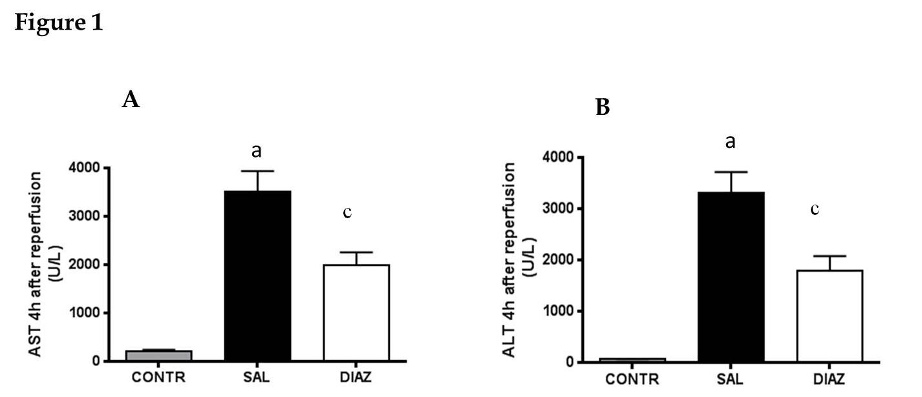

Figure 2
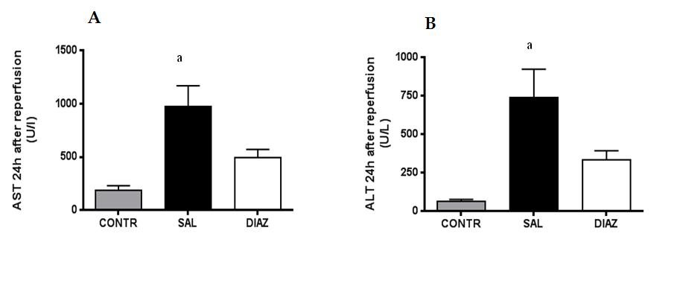

Figure 3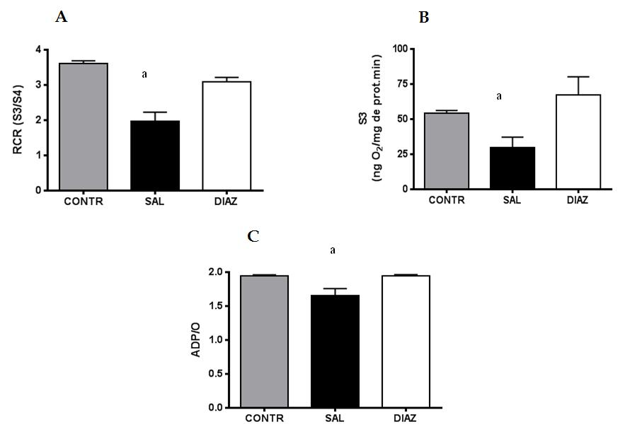

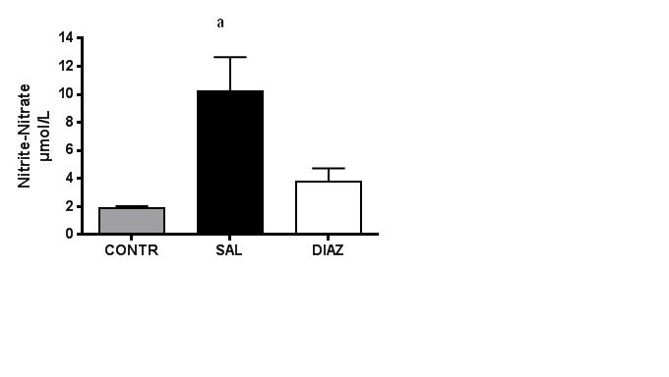
Figure 4
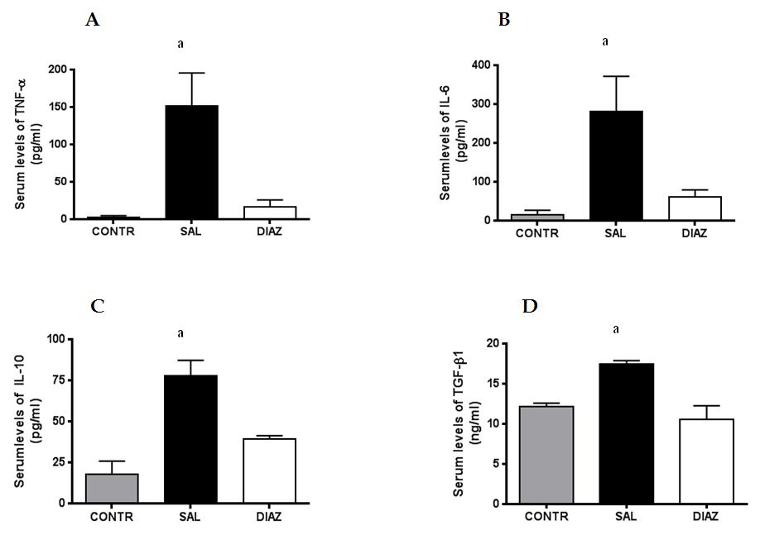
Figure 5
Table 1 Effect of Diazoxide treatment on hepatic ischemia/reperfusion
 | Control | Saline | Diazoxide
Liver MDA  (nmol/mg prot) | 1.49 ± 0.20ª | 3.24 ± 0.26 | 2.60 ± 0.19
Lung EBD  (µg/g dry weight) | 70.13 ± 10.19ª | 200.02 ± 54.44 | 155.70 ± 43.44
Lung MPO  Activity/g tissue | 0.032 ± 0.007ª | 0.062 ± 0.008 | 0.065 ± 0.012
Serum creatinine¹ | 0.3 ± 0.1ª | 0.8 ± 0.1 | 0.9 ± 0.1
Serum Creatinine² | 0.3 ± 0.1ª | 1.0 ± 0.1 | 0.8 ± 0.2
In Control group, rats underwent laparotomy and liver reperfusion. In Saline and Diazoxide groups, rats were submitted to liver ischemia/reperfusion and treated with saline or diazoxide 15 minutes before liver ischemia. Malonyldialdehyde (MDA) was analyzed in liver tissue and expressed as nmol/mg protein. Lung microvascular permeability was evaluated through Evans blue dye (EBD) extravasation and lung myeloperoxidase myeloperoxidade (MPO) activity was evaluation of lung neutrophil infiltration. Creatinine levels in serum are expressed as U/L (¹: 4 h after reperfusion; ²: 24 h after reperfusion). Data are expressed as mean ± SEM of 10 animals per group. ªP < 0.05 vs Control group.

