Name of Journal: World Journal of Clinical Cases
Manuscript NO: 61582
Manuscript Type: CASE REPORT

Association between scrub typhus encephalitis and diffusion tensor tractography detection of Papez circuit injury: A case report

Kwon HG et al. Papez circuit injury following scrub typhus encephalitis

Hyeok Gyu Kwon, Jeong-Hee Yang, Jee-Hun Kwon, Dongseok Yang

Hyeok Gyu Kwon, Department of Physical Therapy, College of Health Science, Eulji University, Sanseong-daero 13135, Gyeonggi-do, South Korea

Jeong-Hee Yang, Department of Plastic Surgery, Biomedical Research Institute, Seoul National University Hospital, Jongno-gu 03080, Seoul, South Korea

Jee-Hun Kwon, Department of Neurology, University of Ulsan College of Medicine, Ulsan University Hospital, Dong-gu 44033, Ulsan, South Korea

Dongseok Yang, Department of Physical Medicine and Rehabilitation, University of Ulsan College of Medicine, Ulsan University Hospital, Dong-gu 44033, Ulsan, South Korea

Author contributions: Yang D designed the report, collected the patient’s clinical data, and wrote the paper; Kwon HG provided the conceptualization and methodology, and analyzed the images and imaging-related information; Yang JH reviewed and revised the paper; Kwon JH reviewed the images and revised the paper.

Supported by National Research Foundation of Korea funded by the Ministry of Education, No. 2013R1A1A4A01013178.

Corresponding author: Dongseok Yang, MD, PhD, Full Professor, Department of Physical Medicine and Rehabilitation, University of Ulsan College of Medicine, Ulsan University Hospital, 877 Bangeojin sunhwando-ro, Dong-gu 44033, Ulsan, South Korea. fnew11@gmail.com

Received: December 21, 2020
Revised: January 22, 2021
Accepted: March 10, 2021
Published online:

Abstract
BACKGROUND
It is difficult to restore the cognitive functions of patients with impaired cognition caused by brain injury. Diffusion tensor imaging can visualize the integrity of neural tracts in the white matter (WM) three-dimensionally. It is unclear whether encephalitis following scrub typhus damages the WM. For the first time, we aimed to report diffusion tensor tractography (DTT) findings in a chronic patient with cognitive impairment following scrub typhus encephalitis, which revealed injury to the Papez circuit of the WM.

CASE SUMMARY
A 70-year-old male patient was affected by encephalitis caused by scrub typhus that occurred 23 years ago. He had poor cognition and his clinical examination findings were as follows: Mini-Mental Status Examination score, 14; and handgrip strength (right/left, kg), 32.3/31.3. DTT revealed serious injuries of the left thalamocingulate tract and right mammillothalamic tract in the Papez circuit, and a partial injury of the anterior part of the fornix.

CONCLUSION
Using DTT, we found a relationship between cognitive impairment and the integrity of the Papez circuit following scrub typhus.

Key Words: Diffusion tensor imaging; Scrub typhus; Encephalitis; White matter; Papez circuit; Cognition; Case report

Kwon HG, Yang JH, Kwon JH, Yang D. Association between scrub typhus encephalitis and diffusion tensor tractography detection of Papez circuit injury: A case report. World J Clin Cases 2021; In press

Core Tip: Scrub typhus is one of the most common causes of acute encephalitis in endemic countries. It is still debated whether white matter (WM) is injured in the encephalitis of the scrub typhus. Diffusion tensor tractography allows us to investigate the integrity of WM three-dimensionally. The Papez circuit consists mainly of the WM and is known to play a critical role in cognition. Using a diffusion tensor tractography, we detected the injury of the Papez circuit in a patient with cognitive impairment following encephalitis of scrub typhus 23 years ago.
INTRODUCTION
Scrub typhus is one of the most common etiologies of acute encephalitis syndrome in endemic countries^{[1,2]}. Encephalitis caused by scrub typhus may lead to brain parenchymal damage, which has various neurological manifestations^{[3]}. As a result of these neurological manifestations, cognitive functions can be seriously impaired. It is therefore important to reverse the cognitive impairment such that cognition returns to previous functional levels. The Papez circuit of the white matter (WM) plays a major role in cognition^{[4]}.
Using magnetic resonance imaging (MRI), few studies have previously demonstrated cognitive impairments following injuries to the Papez circuit in acute patients with brain injuries^{[5,6]}. However, conventional MRI cannot reconstruct neural tracts of the deep brain structures, such as the Papez circuit, three- dimensionally. Recently, studies have reported that diffusion tensor tractography (DTT), derived from diffusion tensor imaging (DTI), can visualize neural tracts, including the Papez circuit, three-dimensionally^{[7-9]}. Nonetheless, no study has investigated the injury of the Papez circuit in a patient following encephalitis of scrub typhus. In this study, using DTT, for the first time, we investigated the integrity of the Papez circuit related to cognitive dysfunctions in a chronic patient following encephalitis caused by scrub typhus.

CASE PRESENTATION
Chief complaints
A 70-year-old male patient visited our clinic because of poor cognitive function and gait disturbance.

History of present illness
He was diagnosed with encephalitis following scrub typhus 23 years ago. The patient complained of poor memory. The patient was initially admitted to a local hospital with a high fever and headache 23 years ago. He developed neurological symptoms as mental change, visual disturbance, and weakness, according to medical history. The first MRI was conducted 7-d after onset. He was then transferred to a tertiary hospital to treat his symptoms, and the diagnosis of scrub typhus encephalitis was confirmed.

History of past illness
No special previous medical history was reported.

Personal and family history
No special personal and family histories were found.

Physical examination
Physical examination revealed narrow visual fields; however, he could read books and newspapers. His motor power on both extremities was intact without any pain. But fine movements of the left hand were poor, and he could only manage to walk indoors because of sensory impairment.

Laboratory examinations
Motor and sensory findings tested using objective tools were as follows: handgrip strength (right/left, kg), 32.3/31.3; two-point discrimination test (right/left, mm), 5/absence; and monofilament test (right/left, mm), 3.22/absence. The patient had impaired cognition, with a mini-mental status examination score of 14 and a Montreal cognitive assessment score of 10^{[7-10]}. For a more detailed evaluation of cognition, we performed a computerized neuropsychological test (Table 1).

Imaging examinations
DTI data were acquired with a 3.0 T scanner Intera (Philips, Ltd., Best, The Netherlands) with a six-channel head coil and single-shot echo-planar imaging. For each of the 32 non-collinear diffusion-sensitizing gradients, we acquired 80 contiguous slices parallel to the anterior commissure-posterior commissure line. The imaging parameters were as follows: acquisition matrix = 112 × 112, field of view = 224 mm × 224 mm, TR/TE = 8973/80 ms, parallel imaging reduction factor (SENSE factor) = 2, EPI factor = 49, b = 1000 s/mm², NEX = 2, and slice thickness = 2.0 mm (acquired voxel size = 2 mm × 2 mm × 2 mm). Analysis of the DTI data was performed using the Oxford Centre for Functional Magnetic Resonance Imaging of the Brain (FMRIB) Software Library (FSL: www.fmrib.ox.ac.uk/fsl) based on the probabilistic tractography method. Head motion artifacts and image distortion due to eddy current were corrected by affine multiscale two-dimensional registration. To reconstruct the Papez circuit, the following locations were considered as the regions of interest (ROIs)^{[6]}: the thalamocortical tract-cingulate gyrus (seed ROI), the anterior limb of the internal capsule (target ROI 1) and the anterior thalamic nuclei (target ROI 2) on axial images; the fornix — mammillary body (seed ROI) on axial images and the crus of the fornix (target ROI) on coronal images; the mammillothalamic tract-anterior thalamic nucleus (seed ROI) and the portion of the isolated mammillothalamic tract (target ROI 1), and the mammillary body (target ROI 2) on axial images; the cingulum — the middle portion of the cingulum (seed ROI) and the posterior portion of the cingulum (target ROI) on coronal images. Additionally, we reconstructed the corticospinal tract (CST) as described in a previous study as we believed it would help to confirm whether specific neural tracts can reflect their related functions^{[11]}.
The 7-d MRI onset showed small lesions in the left frontal and parietal lobes, and large lesions in the right superior parietal lobule and both occipital lobes. Compared with the 7-d MRI, the 23-year MRI findings indicated expanded lesions of encephalomalacia with marked dilation of both ventricles (Figure 1A). Probabilistic DTT of the Papez circuit revealed that the left thalamocortical tract and right mammillothalamic tract could not be reconstructed; however, the anterior part of the fornix was found to be injured. Both CSTs were well preserved (Figure 1B).

FINAL DIAGNOSIS
Based on these findings, WM injury of the Papez circuit was identified.

TREATMENT
We did not supply special treatment because his cognitive impairment was a chronic condition.

OUTCOME AND FOLLOW-UP
One-year follow-up showed that his cognitive function has not gotten worse since his first visit to our clinic.

DISCUSSION
In this study, using DTT, we found that cognitive impairments in a chronic patient with encephalitis of scrub typhus were strongly associated with Papez circuit injury. Pathologic changes of scrub typhus are known to cause vasculitis, which affects multiple organs, including the central nervous system. It has been debated for a long time whether the WM is injured in the encephalitis following scrub typhus because encephalitis occurring after scrub typhus and epidemic typhus is usually limited to the gray matter^{[12]}. Only two case studies of scrub typhus encephalitis had abnormal MRI findings indicative of deep WM involvement^{[12,13]}. Despite a follow-up MRI, we were unable to identify deep WM lesions in areas, such as the Papez circuit. Using DTT, our study findings exclusively detect the injury in two major WM areas — the left thalamocingulate tract and right mammillothalamic tract in the Papez circuit — whereas the CST was found to be intact. In our case, relative to the initial MRI findings, we found an expanded medial temporal lesion in the follow-up MRI. This finding suggests the possibility of a secondary Wallerian degeneration of the Papez circuit, following the direct WM lesions. However, we could not perform follow-up DTT to confirm this possibility. Secondary WM Wallerian degeneration, which is the degeneration of WM distal to a primary lesion, can be caused by various axonal injuries such as trauma, ischemia, and inflammation^{[14]}. Previous studies on Wallerian degeneration of the Papez circuit have been reported in epileptic patients with temporal lobectomy^{[14-16]}. Using DTT, these studies showed complete Wallerian degeneration of the fornix and cingulum within 2-4 mo postoperatively. Moreover, temporal lobe resection indirectly affects the fornix and cingulum contralaterally, demonstrating downstream Wallerian degeneration via the interhemispheric components^{[15,16]}. In the Papez circuit, following encephalitis, concomitant injuries of the thalamocortical tract, mammillothalamic tract, and fornix were demonstrated, along with severe cognitive impairment. In line with our observations, previous studies have reported that thalamocortical tract injury in the Papez circuit is the most common cause of cognitive impairment following brain injury, including encephalitis^{[6]}. Other studies have supported the view that mammillothalamic tract damage following a thalamic infarct is a strong predictor of memory impairment^{[17]}. Regarding cognition following encephalitis, a 3.7-year follow-up study reported only a 12.8% incidence of dementia^{[18]}. However, these findings have limited application in our patient, as viral encephalitis was the etiology in 86.4% (38/44) of the patients in this study^{[18]}.
Our patient showed intact bilateral motor power on hand grip strength assessment. By reconstructing the CST using DTT data, we found relative preservation of both CSTs. Overall, we simultaneously analyzed the relationship between the integrity of the Papez circuit and CST, and the neurological manifestations three-dimensionally. Thus, it seems possible to predict the level of cognition and motor function in a chronic patient with encephalitis, which might help develop rehabilitative strategies for restoring function and normal activities of daily life after brain injury. However, our study has a few limitations. The probabilistic DTT usually reconstructs the WM but not the gray matter; thus, we were not able to show the nucleus in the Papez circuit; without quantitative analysis, it may lead to false-negative results.

CONCLUSION
In the current study, using DTT, we demonstrated injuries to specific neural tracts of the Papez circuit in a chronic patient with encephalitis following scrub typhus. Our findings may be helpful for the elucidation of the pathophysiological mechanisms of encephalitis following scrub typhus.

REFERENCES
1 Dittrich S, Rattanavong S, Lee SJ, Panyanivong P, Craig SB, Tulsiani SM, Blacksell SD, Dance DA, Dubot-Pérès A, Sengduangphachanh A, Phoumin P, Paris DH, Newton PN. Orientia, rickettsia, and leptospira pathogens as causes of CNS infections in Laos: a prospective study. Lancet Glob Health 2015; 3: e104-e112 [PMID: 25617190 DOI: 10.1016/S2214-109X(14)70289-X]
2 Jain P, Prakash S, Khan DN, Garg RK, Kumar R, Bhagat A, Ramakrishna V, Jain A. Aetiology of acute encephalitis syndrome in Uttar Pradesh, India from 2014 to 2016. J Vector Borne Dis 2017; 54: 311-316 [PMID: 29460860 DOI: 10.4103/0972-9062.225835]
3 Mahajan SK, Mahajan SK. Neuropsychiatric Manifestations of Scrub Typhus. J Neurosci Rural Pract 2017; 8: 421-426 [PMID: 28694624 DOI: 10.4103/jnrp.jnrp_44_17]
4 Weininger J, Roman E, Tierney P, Barry D, Gallagher H, Murphy P, Levins KJ, O'Keane V, O'Hanlon E, Roddy DW. Papez's Forgotten Tract: 80 Years of Unreconciled Findings Concerning the Thalamocingulate Tract. Front Neuroanat 2019; 13: 14 [PMID: 30833890 DOI: 10.3389/fnana.2019.00014]
5 Chang MC, Yeo SS, Do Lee H, Jang SH. Diffusion tensor tractography in a patient with memory impairment following encephalitis. Acta Neurol Belg 2016; 116: 629-631 [PMID: 26732618 DOI: 10.1007/s13760-015-0591-0]
6 Park DK, Byun KH, Yang D. Which Neural Tract Plays a Major Role in Memory Impairment After Multiple Cerebral Infarcts? A Case Report. Ann Rehabil Med 2018; 42: 617-620 [PMID: 30180532 DOI: 10.5535/arm.2018.42.4.617]
7 Brueggen K, Dyrba M, Kilimann I, Henf J, Hoffmann W, Thyrian JR, Teipel S. Hippocampal Mean Diffusivity for the Diagnosis of Dementia and Mild Cognitive Impairment in Primary Care. Curr Alzheimer Res 2018; 15: 1005-1012 [PMID: 29895247 DOI: 10.2174/1567205015666180613114829]
8 Jiang S, Liu WH, Zhang MY. Update clinical application of diffusion tensor imaging. Curr Med Imaging 2012; 8: 331-339 [DOI: 10.2174/157340512803759839]
9 Kljajevic V, Erramuzpe A. Dorsal White Matter Integrity and Name Retrieval in Midlife. Curr Aging Sci 2019; 12: 55-61 [PMID: 31589112 DOI: 10.2174/1874609812666190614110214]
10 Saito H, Kashiwakura I, Tsushima M, Mariya Y. Association between Regional Cerebral Blood Flow and Mini-Mental State Examination Score in Patients with Alzheimer's Disease. Curr Med Imaging 2020; 16: 1290-1299 [PMID: 32107995 DOI: 10.2174/1573405616666200124125130]
11 Bucci M, Mandelli ML, Berman JI, Amirbekian B, Nguyen C, Berger MS, Henry RG. Quantifying diffusion MRI tractography of the corticospinal tract in brain tumors with deterministic and probabilistic methods. Neuroimage Clin 2013; 3: 361-368 [PMID: 24273719 DOI: 10.1016/j.nicl.2013.08.008]
12 Yum KS, Na SJ, Lee KO, Ko JH. Scrub typhus meningo-encephalitis with focal neurologic signs and associated brain MRI abnormal findings: literature review. Clin Neurol Neurosurg 2011; 113: 250-253 [PMID: 21129847 DOI: 10.1016/j.clineuro.2010.11.007]
13 Shen Y, Bao B, Cheng Z. Mild encephalitis/encephalopathy with reversible splenial lesion complicated with scrub typhus. Neurol Sci 2018; 39: 1997-1999 [PMID: 30054749 DOI: 10.1007/s10072-018-3510-3]
14 Liu M, Gross DW, Wheatley BM, Concha L, Beaulieu C. The acute phase of Wallerian degeneration: longitudinal diffusion tensor imaging of the fornix following temporal lobe surgery. Neuroimage 2013; 74: 128-139 [PMID: 23396161 DOI: 10.1016/j.neuroimage.2013.01.069]
15 Concha L, Beaulieu C, Wheatley BM, Gross DW. Bilateral white matter diffusion changes persist after epilepsy surgery. Epilepsia 2007; 48: 931-940 [PMID: 17509002 DOI: 10.1111/j.1528-1167.2007.01006.x]
16 McDonald CR, Hagler DJ Jr, Girard HM, Pung C, Ahmadi ME, Holland D, Patel RH, Barba D, Tecoma ES, Iragui VJ, Halgren E, Dale AM. Changes in fiber tract integrity and visual fields after anterior temporal lobectomy. Neurology 2010; 75: 1631-1638 [PMID: 20881271 DOI: 10.1212/WNL.0b013e3181fb44db]
17 Kamali A, Zhang CC, Riascos RF, Tandon N, Bonafante-Mejia EE, Patel R, Lincoln JA, Rabiei P, Ocasio L, Younes K, Hasan KM. Diffusion tensor tractography of the mammillothalamic tract in the human brain using a high spatial resolution DTI technique. Sci Rep 2018; 8: 5229 [PMID: 29588461 DOI: 10.1038/s41598-018-23452-w]
18 Hokkanen L, Launes J. Cognitive recovery instead of decline after acute encephalitis: a prospective follow up study. J Neurol Neurosurg Psychiatry 1997; 63: 222-227 [PMID: 9285462 DOI: 10.1136/jnnp.63.2.222]

Footnotes
Informed consent statement: Informed consent was obtained from the patient for publication of this report and any accompanying images.

Conflict-of-interest statement: The authors declare no conflicts of interest.

CARE Checklist (2016) statement: The authors have read the CARE Checklist (2016) and the manuscript was prepared and revised according to the CARE Checklist (2016).

Open-Access: This article is an open-access article that was selected by an in-house editor and fully peer-reviewed by external reviewers. It is distributed in accordance with the Creative Commons Attribution NonCommercial (CC BY-NC 4.0) license, which permits others to distribute, remix, adapt, build upon this work non-commercially, and license their derivative works on different terms, provided the original work is properly cited and the use is non-commercial. See: http://creativecommons.org/Licenses/by-nc/4.0/

Manuscript source: Invited manuscript

Peer-review started: December 21, 2020
First decision: December 30, 2020
Article in press:

Specialty type: Medicine, research and experimental
Country/Territory of origin: South Korea
Peer-review report’s scientific quality classification
Grade A (Excellent): 0
Grade B (Very good): B
Grade C (Good): C
Grade D (Fair): 0
Grade E (Poor): 0

P-Reviewer: Ozair A S-Editor: Gao CC L-Editor: P-Editor:
Figure Legends
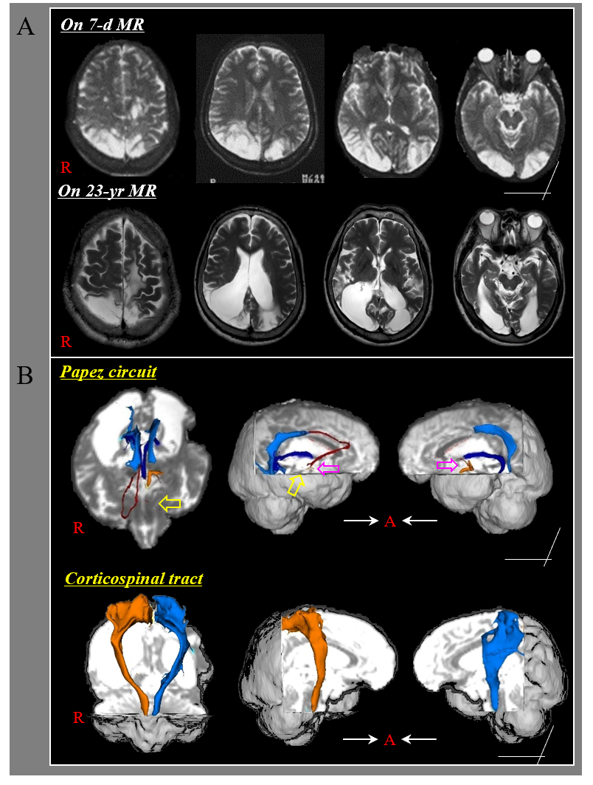
Figure 1 Serial magnetic resonance imaging and diffusion tensor tractography of a chronic patient with cognitive impairment after scrub typhus encephalitis. A: Magnetic resonance imaging shows multiple lesions in the parietal, temporal, and occipital lobes of both hemispheres. Compared with the findings of the 7-d magnetic resonance imaging, the 23-yr magnetic resonance imaging findings indicates expanded lesions of encephalomalacic changes with marked dilation of both ventricles; B: Diffusion tensor tractography of the Papez circuit and corticospinal tract reveals discontinued of the left thalamocortical and right mammillothalamic tracts in the Papez circuit (yellow arrows). In addition, the anterior part of the fornix is not observed in both hemispheres (purple arrows). The corticospinal tracts of both hemispheres appear relatively intact. MR: Magnetic resonance.
Table 1 Results of computerized neuropsychological test
Visual span |  | Digit span |  | Memory
 |  |  |  | Verbal learning |  | Visual learning
Forward (%) | Back (%) | Forward (%) | Back (%) | Frist trial (%) | Fifth trial (%) | First trial (%) | Fifth trial (%)
3 (0.5) | 2 (0.5) | 3 (0.5) | 2 (0.5) | 0 (0.5) | 5 (0.5) | 6 (18) | 7 (50)

