Name of journal: World Journal of Clinical Cases
Manuscript NO: 34104
Manuscript Type: CASE REPORT

Hydrogen peroxide ingestion with injury to upper gastrointestinal tract

Martin JV et al. Hydrogen peroxide ingestion

Jonathan V Martin, Choichi Sugawa

Jonathan V Martin, Choichi Sugawa, Michael and Marian Ilitch Department of Surgery, 6C-University Health Center, Detroit, MI 48201, United States

Author contributions: Martin JV and Sugawa C contributed to the initial drafting and editing of manuscript; Sugawa C obtained clinical data.

Institutional review board statement: This case report was exempt from the Institutional Review Board standards at Wayne State University.

Informed consent statement: Formal consent not required for case reports that have all 18 protected health information de-identified.

Conflict-of-interest statement: The authors have no conflicts of interest to disclose.

Open-Access: This article is an open-access article which was selected by an in-house editor and fully peer-reviewed by external reviewers. It is distributed in accordance with the Creative Commons Attribution Non Commercial (CC BY-NC 4.0) license, which permits others to distribute, remix, adapt, build upon this work non-commercially, and license their derivative works on different terms, provided the original work is properly cited and the use is non-commercial. See: http://creativecommons.org/licenses/by-nc/4.0/

Manuscript source: Unsolicited manuscript

Correspondence to: Choichi Sugawa, MD, Professor, Michael and Marian Ilitch Department of Surgery, 6-C University Health Center, 4201 Saint Antoine St., Detroit, MI 48201, United States. csugawa@med.wayne.edu
Telephone+1-313-5775001
Fax:+1-313-5775310

Received: March 28, 2017
Peer-review started: March 31, 2017
First decision: June 16, 2017
Revised: July 6, 2017
Accepted: August 2, 2017
Article in press:
Published online:
Abstract
Hydrogen peroxide is a common over-the-counter solution that has developed a growing body of literature regarding toxic ingestion. Intentional ingestion of high concentration hydrogen peroxide for health purposes has gained popularity in certain patient populations; purported benefits are due to the increased oxygen released into the blood stream. We present for evaluation one such case with associated imaging that presented to our urban medical center. A brief review of the literature was also performed noting current recommendations regarding both outcomes and indications for endoscopy as well as hyperbaric oxygen therapy following ingestion of hydrogen peroxide. Our patient was a 51-year-old white female who presented with foamy hematemesis after ingesting 10 drops of 35% hydrogen peroxide as part of a home remedy to cleanse her colon and improve blood oxygenation. In addition to hematemesis, she also reported diffuse abdominal pain with sore throat and hoarse voice. Her imaging demonstrated portal venous gas and gastric edema. She was admitted for hyperbaric oxygen therapy and underwent upper endoscopy demonstrating diffuse esophagitis and gastritis with white exudate and multiple petechiae. She was later discharged home in stable condition and was lost to follow-up.

Key words: Hydrogen peroxide; Caustic injury; Hyperbaric oxygen therapy; Arterial gas emboli; Ingestion of hydrogen peroxide

© The Author(s) 2017. Published by Baishideng Publishing Group Inc. All rights reserved.

Core tip: In patients presenting with unresolving epigastric and hematemesis following ingestion of hydrogen peroxide, evaluation with endoscopy is indicated. CT and/or MRI are also indicated to evaluate for formation of arterial gas emboli. Therapy is primarily supportive, ± hyperbaric oxygen therapy depending on presence of neurological symptoms, presence of gas emboli, and availability of resources.

Martin JV, Sugawa C. Hydrogen peroxide ingestion with injury to upper gastrointestinal tract. World J Clin Cases 2017; In press

INTRODUCTION
Hydrogen peroxide is a common over-the-counter solution that has developed a growing body of literature regarding toxic ingestion^{[1-5]}. The main mechanisms for toxicity include direct lipid peroxidation, oxygen gas production, and corrosive injury^{[1]}. Reported toxicities and fatalities tend to involve higher concentrations (> 35%) and pediatric patients^{[1]}.
Intentional ingestion of high concentration hydrogen peroxide for health purposes has gained popularity in certain patient populations; purported benefits are due to the increased oxygen released into the blood stream. We present for evaluation one such case with associated imaging.

CASE REPORT
A 51-year-old white female presented to our urban medical center with foamy hematemesis after ingesting 10 drops of 35% hydrogen peroxide as part of a home remedy to cleanse her colon and improve blood oxygenation. In addition to hematemesis, she also reported diffuse abdominal pain with sore throat and hoarse voice.
At the time of presentation, vitals were normal and stable. Her initial abdominal exam was benign and she was neurologically intact. Labs were within normal limits save for a leukocytosis of 12.6 thousand/mm³. CT imaging obtained at admission demonstrated portal venous gas, gastric pneumatosis, and gastric edema (Figure 1). She was given a proton-pump inhibitor and admitted for hyperbaric oxygen therapy (HBT) to be followed by upper endoscopy evaluation.
Esophagogastroduodenoscopy performed the following morning revealed a small hiatal hernia, diffuse esophagitis and gastritis with white exudate and multiple petechiae, and two areas of duodenitis (Figures 2 and 3). Gastric biopsies later demonstrated only active, chronic gastritis with marked congestion and extravasated blood. Following her endoscopy and hyperbaric oxygen therapy, patient tolerated a liquid diet and was deemed stable for discharge home later that day. Patient was lost to follow-up.

DISCUSSION
Mortality associated with hydrogen peroxide ingestion usually involves the formation of arterial gas emboli (AGE) and the development of cerebral embolism^{[1-3]}. Perforation may occur, but is not as commonly described as AGE. The most common injury noted on upper endoscopy following ingestion is a Grade I caustic mucosal injury which tends to resolve spontaneously without further sequelae^{[6]}. The “snow-white” sign may be visualized, an area of mucosa that has a blanched appearance secondary to blood being driven away by rapid oxygen production; this is demonstrated on our endoscopic image (Figure 2 left panel)^{[1]}.
Management of hydrogen peroxide ingestion consists mainly of supportive care and endoscopic evaluation if hematemesis or unresolving epigastric pain develops, typically in association with concentrated doses^{[1]}. CT/MRI imaging is indicated to evaluate for formation of AGE, especially with the development of neurological symptoms. HBT has been shown to be helpful in such cases and is generally associated with complete resolution of symptoms; delayed therapy may contribute to mortality^{[2-4]}.
While neurological symptoms are definitive indications for HBT, its role in the presence of portal venous gas is still being evaluated^{[2,3]}. Several centers with ready access to HBT have suggested that the mere presence of portal venous gas indicates need for HBT. While it would seem a prudent measure to prevent further progression of gas emboli, a case report does exist of conservatively managed portal venous gas without HBT and without subsequent negative sequelae^{[7]}.
COMMENTS
Case characteristics
Our patient presented with epigastric pain, foamy hematemesis, sore throat, and hoarseness.

Clinical diagnosis
Physical exam demonstrated a benign abdomen and no neurological deficits.

Differential diagnosis
Presentation concerning for perforation of gastrointestinal tract with possible arterial gas emboli, evaluated by computed tomography and EGD.

Laboratory diagnosis
Electrolytes and complete blood count obtained demonstrating only leukocytosis of 12.6 thousand/mm³.

Imaging diagnosis
CT Abdomen demonstrated portal venous gas, gastric pneumatosis, and gastric edema.

Pathological diagnosis
Gastric biopsy demonstrated active, chronic gastritis with marked congestion and extravasated blood.

Treatment
Patient was kept NPO; treated with IV fluids, a proton-pump inhibitor, and hyperbaric oxygen therapy; and evaluated by EGD.

Related reports
EGD demonstrated a small hiatal hernia, diffuse esophagitis and gastritis with white exudate and multiple petechiae, and two areas of duodenitis.

Experiences and lessons
Hydrogen peroxide ingestion generally requires conservative management and may benefit from hyperbaric oxygen therapy.

Peer-review
The authors demonstrated a case of 51-year-old white female presented to our urban medical center with foamy hematemesis after ingesting 10 drops of 35% hydrogen peroxide. The present study was well investigated and will give us an important information in the field of clinical gastroenterology.

REFERENCES
1 Watt BE, Proudfoot AT, Vale JA. Hydrogen peroxide poisoning. Toxicol Rev 2004; 23: 51-57 [PMID: 15298493]
2 Byrne B, Sherwin R, Courage C, Baylor A, Dolcourt B, Brudzewski JR, Mosteller J, Wilson RF. Hyperbaric oxygen therapy for systemic gas embolism after hydrogen peroxide ingestion. J Emerg Med 2014; 46: 171-175 [PMID: 24268898 DOI: 10.1016/j.jemermed.2013.08.091]
3 Hendriksen SM, Menth NL, Westgard BC, Cole JB, Walter JW, Masters TC, Logue CJ. Hyperbaric oxygen therapy for the prevention of arterial gas embolism in food grade hydrogen peroxide ingestion. Am J Emerg Med 2017; 35: 809.e5-809.e8 [PMID: 28069419 DOI: 10.1016/j.ajem.2016.12.027]
4 Ikiz MA, Yakut HI, Kurt F, Sahin S, Yalçin HN, Baştemur M, Kalkan G. Hydrogen peroxide solution ingestion caused brain death of a 3-year-old girl. Pediatr Emerg Care 2013; 29: 502-503 [PMID: 23558268 DOI: 10.1097/PEC.0b013e31828a387b]
5 Indorato F, Raffino C, Tropea FM, Barbera N, Grieco A, Bartoloni G. Fatal accidental ingestion of 35 % hydrogen peroxide by a 2-year-old female: case report and literature review. Forensic Sci Med Pathol 2014; 10: 443-447 [PMID: 24692088 DOI: 10.1007/s12024-014-9560-9]
6 Tohda G, Sugawa C, Gayer C, Chino A, McGuire TW, Lucas CE. Clinical evaluation and management of caustic injury in the upper gastrointestinal tract in 95 adult patients in an urban medical center. Surg Endosc 2008; 22: 1119-1125 [PMID: 17965918 DOI: 10.1007/s00464-007-9620-2]
7 Zengin S, Al B, Genç S, Yarbil P, Yilmaz DA, Gulsen MT. A rare case of portal vein gas: accidental hydrogen peroxide ingestion. BMJ Case Rep 2012; 2012: [PMID: 22669852 DOI: 10.1136/bcr.01.2012.5602]

P-Reviewer: Naito Y S-Editor: Qi Y L-Editor: E-Editor:
Specialty type: Medicine, Research and Experimental
Country of origin: United States
Peer-review report classification
Grade A (Excellent): 0
Grade B (Very good): B
Grade C (Good): 0
Grade D (Fair): 0
Grade E (Poor): 0

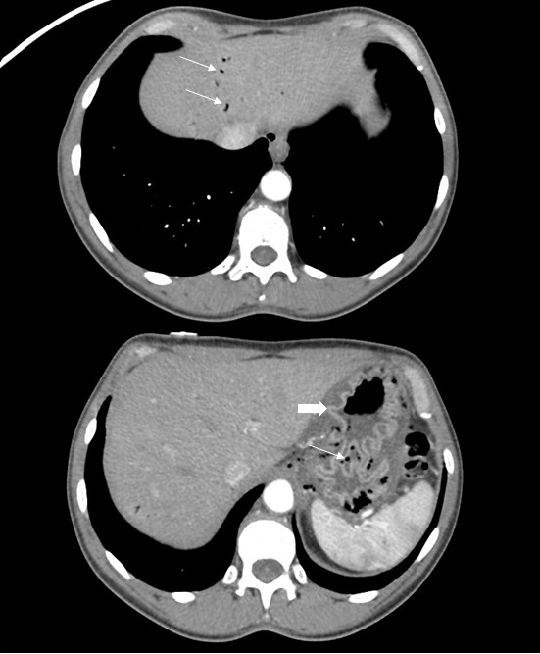

Figure 1 Computed tomography abdomen demonstrating portal venous gas as well as gastric pneumatosis and edema (portal venous gas and gastric pneumatosis noted with thin arrows, gastric edema noted with thick arrow).

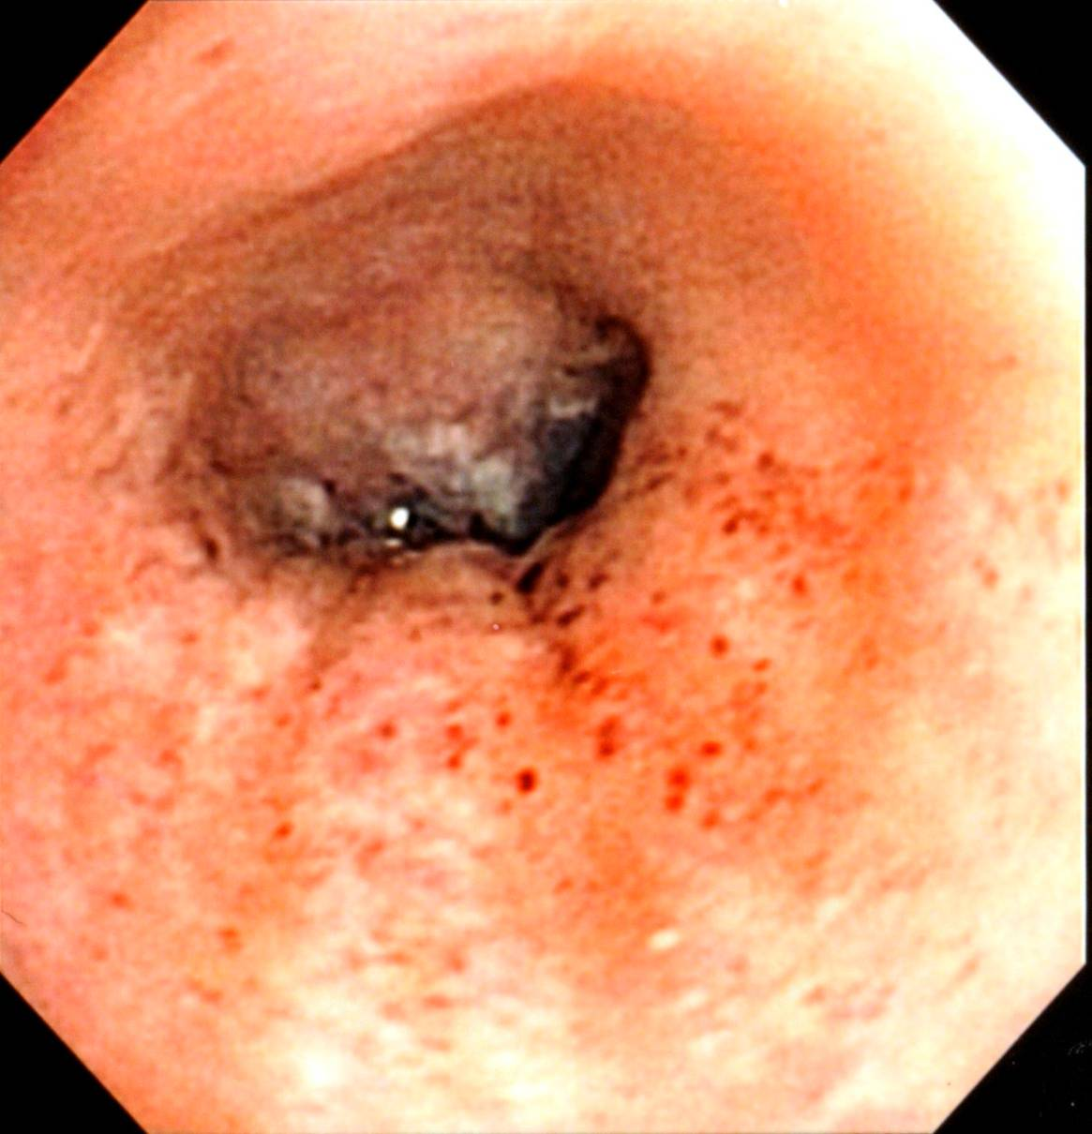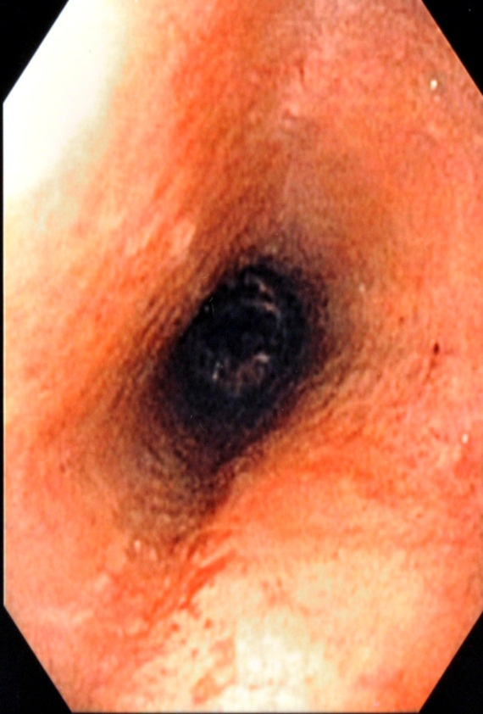

Figure 2 EGD demonstrating esophagitis with multiple petechiae and white exudate.
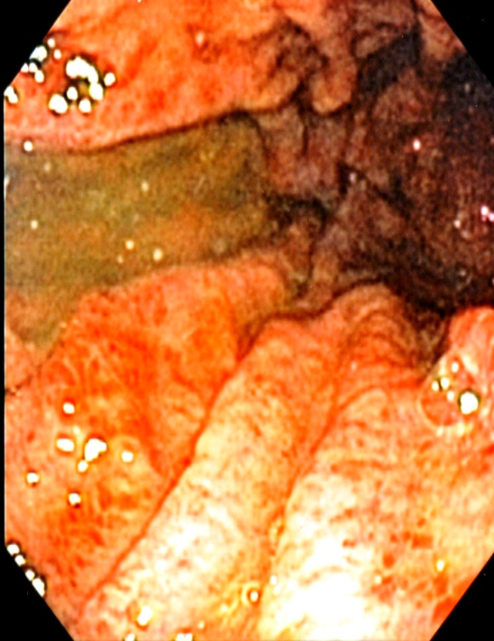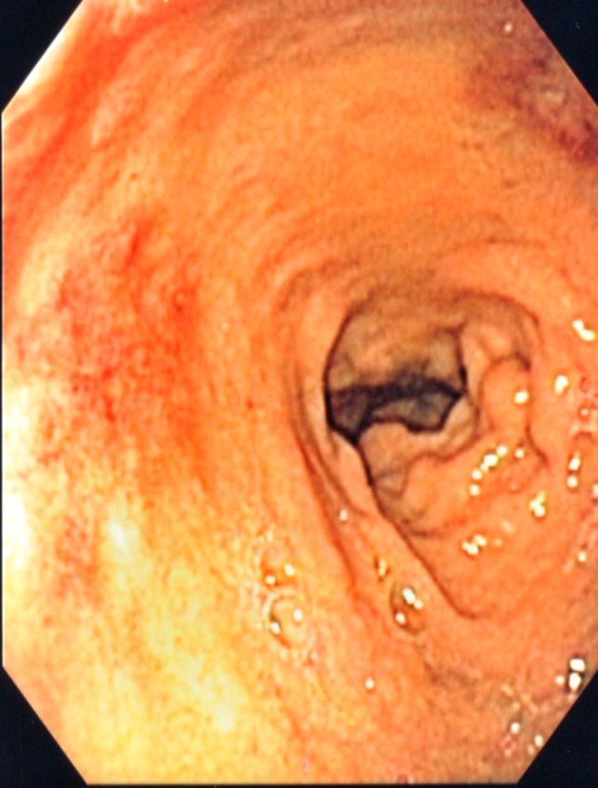

Figure 3 EGD demonstrating diffuse gastritis (Left) and areas of duodenitis (Right).

