Name of Journal: World Journal of Clinical Cases
Manuscript NO: 49335
Manuscript Type: ORIGINAL ARTICLE

Retrospective Study
Impact of intergenerational emotional support on depression in non-cohabiting parents

Jia YH et al. Depression of non-cohabiting parents

Yun-Hua Jia, Zhi-Hong Ye

Yun-Hua Jia, Zhi-Hong Ye, Department of Nursing, Affiliated Sir Run Run Shaw Hospital, Zhejiang University School of Medicine, Hangzhou 310058, Zhejiang Province, China

Yun-Hua Jia, School of Medicine, Zhejiang University City College, Hangzhou 310015, Zhejiang Province, China

ORCID number: Yun-Hua Jia (0000-0002-2213-083X); Zhi-Hong Ye (0000-0002-6890-1337).

Author contributions: Jia YH managed the literature searches and analyses and undertook the statistical analysis; Ye ZH designed the study, wrote the protocol, and wrote the first draft of the manuscript. All authors contributed to and approved the final manuscript.

Institutional review board statement: This study was reviewed and approved by the Affiliated Sir Run Run Shaw Hospital, Zhejiang University School of Medicine Ethics Committee.

Informed consent statement: All involved subjects gave their informed consent (written) prior to study inclusion.

Conflict-of-interest statement: The authors declare no conflict of interest.

Data sharing statement: No additional data are available.

Open-Access: This article is an open-access article which was selected by an in-house editor and fully peer-reviewed by external reviewers. It is distributed in accordance with the Creative Commons Attribution Non Commercial (CC BY-NC 4.0) license, which permits others to distribute, remix, adapt, build upon this work non-commercially, and license their derivative works on different terms, provided the original work is properly cited and the use is non-commercial. See: http://creativecommons.org/licenses/by-nc/4.0/

Manuscript source: Unsolicited manuscript

Corresponding author: Zhi-Hong Ye, PhD, Professor, Department of Nursing, Affiliated Sir Run Run Shaw Hospital, Zhejiang University School of Medicine, No. 3, Qingchun East Road, Hangzhou 310020, Zhejiang Province, China. yezh@zju.edu.cn
Telephone: +86-571-88015155
Fax: +86-571-3000300

Received: May 23, 2019
Peer-review started: May 23, 2019
First decision: September 9, 2019
Revised: September 21, 2019
Accepted: October 5, 2019
Article in press:
Published online:

Abstract
BACKGROUND
Mental health is one of the important dimensions of health, while depression is an important indicator of mental health evaluation.

AIM
To investigate the association between intergenerational emotional support and depression of non-cohabiting parents (≥45 years old) in China.

METHODS
We used the fourth wave data from the China Health and Retirement Longitudinal Study (2015). The data was made up of ten main modules, two associated datasets, and five constructed datasets. The first step was to select the corresponding module data according to the purpose of this study. Moreover, the data of the six modules were integrated by the unique ID code and we chose depression and non-cohabiting items as the selection conditions. A total of 4810 samples were selected, which mainly included data on intergenerational emotional support and the individual scores of depressive symptoms.

RESULTS
The average age of 4810 respondents was 60.56 ± 14.613 years old. Females accounted for more than half of the samples (52.6%). Approximately 74.0% of respondents came from rural areas and approximately 63.3% of the participants had a chronic disease. The mean value of the CESD-10 score was 13.06 ± 5.225. Both faces-to-face and phone contacts were protective factors for depression symptoms in the mid-aged and seniors in China (P < 0.05). In terms of the frequency of face-to-face contact, the more frequently you met your parents, the lower your parents' depressive score was. Also, phone contact results displayed a positive correlation completely between intergenerational contacts from children and depressive symptoms in non-cohabiting parents in China. Children’s education level and income level were also reducing the risk of depression in non-cohabiting parents. However, gender, children’s number, chronic disease, and number of chronic diseases were the risk factors.

CONCLUSION
Intergenerational emotional support is associated with depressive symptoms in non-cohabiting parents in China. However, the relationship is also affected by other variables.

Key words: Depression; Intergenerational support; Affective interaction; Emotional support

© The Author(s) 2019. Published by Baishideng Publishing Group Inc. All rights reserved.

Core tip: The increasing prevalence of depression among the mid-elderly is an emerging major public health problem in China. Intergenerational emotional support is associated with depressive symptoms in non-cohabiting parents in China. Our study aims to provide an intuitive and realizable intervention point for public campaigns or family education programs for community mental health services.

Jia YH, Ye ZH. Impact of intergenerational emotional support on depression in non-cohabiting parents. World J Clin Cases 2019; In press

Introduction
Mental health is one of the important dimensions of health, while depression is an important indicator of mental health evaluation^{[1]}. Globally, it is estimated that 4.4% of the world’s population suffer from depression, with a total number of more than 300 million (World Health Organization, 2017). The increasing prevalence of depression among the mid-elderly is an emerging major public health problem in China, and the prevalence of geriatric depression is around 17% and as high as 39.86%^{[2,3]}.
Syntheses of the available epidemiological literature indicated that depression could decrease physical function, daily life ability, cognitive ability and so on^{[4]}. Many studies have shown that depression is associated with many factors, such as gender^{[5]}, alcohol^{[6]}, economic status^{[7]}, and social capital^{[8]}. Among the many causes of depression, social capital may be particularly important^{[9,10]}. A recent study reported that emotional support was more closely related to depression than instrumental support, especially in adults aged 18 to 50 years^{[11]}. In China, population aging and massive rural-to-urban migration have changed not only the family system but also the contact mode between parents and their non-cohabiting adult children. In addition, face-to-face contact is more difficult to achieve for elderly parents whose adult children live far away from them. However, there are few studies on this topic and the results are inconsistent.
The objective of our study was to assess the association between the frequency of contact between elderly parents and non-cohabitating adult children and the risk of depression. We hypothesized that not regularly associating with non-cohabitating adult children increases the risk of subsequent depression in mid-aged and elderly parents. In other words, both face-to-face and telephone contacts have positive effects on depression in the elderly. Meanwhile, we also used a comparative method to identify whether there was a difference in effectiveness between phone contact and face-to-face contact. We expected to provide an intuitive and achievable intervention point for public activities or family education projects for community mental health service.

Materials and methods

Participants
China Health and Retirement Longitudinal Study (CHARLS) presided over by the Peking University, is a nationally representative longitudinal study of Chinese community-dwelling residents aged 45 and older and their spouses. It was designed based on the Health and Retirement Study in the United States, the English Longitudinal Study of Ageing, the Survey of Health, Ageing and Retirement in Europe, and similar longitudinal aging surveys in other countries^{[12,13]}.
The data we used come from the fourth wave of CHARLS, which was held in 2015 and publicly released on May 31, 2017, covering 21789 people (689 died) in 12236 households in 451 villages/communities. The data was made up of ten main modules, two associated datasets (sample information and cross-sectional weights), and five constructed datasets. In our study, the data selection process is as follows: The first step was to select the corresponding module data according to the purpose of this study. Data of six modules (demographic background/family information/family transfer/health status and functioning/housing characteristics/individual income) were included in the preliminary selection. Then, the data of the six modules were integrated by the unique ID code to obtain 21095 samples. Third, 20967 samples were obtained with depression items as the selection conditions. Fourth, 12131 cases were obtained by filtering with face-to-face items. Lastly, 4810 people were identified by deleting people living with children.

Assessments and measurements
Depression: In our study, depression was measured using the Chinese version 10-item short form of the Center for Epidemiologic Studies-Depression Scale (CESD-10). The 10 items consist of eight negative-oriented questions and two positive-oriented issues. Negative aspects include “I was bothered by things that do not usually bother me” and positive ones are “I felt hopeful about the future” and “I was happy”. Each item was scored on a four-point scale: 0 = rarely or none of the time (<1 d); 1 = some or a little of the time (1-2 d); 2 = occasionally or a moderate amount of the time (3-4 d); and 3 = most or all of the time (5-7 d). The two positive items were scored inversely. The CESD-10 score ranges from 0 to 30, and the severity of depressive symptoms increases with score. The scale has a good reliability and validity (Cronbach’s α = 0.81)^{[14,15]}.

Frequency of contact: Trained interviewers utilized verbal questions to assess the frequency of contact with non-cohabitating adult children, which was our primary exposure of interest. The participants were asked: “How often do you see (child’s name)?” (This question will be abbreviated as “face-to-face contact” in the text) and “How often do you contact with (child’s name) either by phone, text message, mail, or email when you did not live with (child’s name)?” (This question will be abbreviated as “phone contact”). Ten response options were available for the two questions, ranging from 1 = “almost every day”, 2 = “2-3 times a week”, 3 = “once a week”, 4 = “every two weeks”, 5 = “once a month”, 6 = “once every three months”, 7 = “once every six months”, 8 = “once a year”, and 9 = “almost never” to 10 = “other”. Up till now, there has been no specific study indicating the best critical point for effectiveness of social contact, however, previous studies have shown that face-to-face or phone contact once a month or once a week has protective effects on depression in the elderly^{[16]}. On account of the previous studies, we divided the respondents into four groups according to the frequency of their “phone” and “face-to-face” contact. The first group consisted of participants who responded that they had frequent phone contact (ranging from 1-3) and frequent face-to-face contact (ranging from 1-4). The second group was comprised of participants who responded that they had infrequent (ranging from4 to 9) phone contact and frequent face-to-face contact. The third group was comprised of participants who responded that they had frequent phone contact and infrequent face-to-face contact (ranging 5-9). The fourth group was comprised of participants who responded as having infrequent phone contact and infrequent face-to-face contact^{[17]}.

Other variables: Other variables that may affect contact frequency and depressive symptoms were also included in the analysis. These variables were divided into three categories: Demographic characteristics, socio-economic characteristics, and current health conditions.

Statistical analysis
For descriptive statistics, we used the independent-sample t-test and ANOVA to compare the variables. After testing collinearity, stepwise multiple logistic regression analysis was used to explore the correlation between various factors and depression risk of non-cohabiting parents. Statistical significance is expressed as ^{l}P < 0.05, ^{m}P < 0.01, or ^{n}P < 0.001. Data were analyzed using SPSS19.0.

Results

Characteristics of the study population
The general characteristics and each group’s contact frequency of the total participants are provided in Table S1. In the all participants, the mean value of CESD-10 score is 13.06 ± 5.225. The proportion of mid-aged and elderly persons in China that could meet their children at least once a month was 65.5%, and 50.4% could communicate with their children at least once a week by phone, text message, mail, or email. In terms of demographic factors, the average age was 60.47 ± 15.012 years old; females accounted for more than half of the samples (51.9%). The mean number of adult children was 2.77 ± 1.316. The specific classification information is as follows: 17.5% had one child, 32.2% had two, 21.3% had three, 13.4% had four, and 15.6% had five children or above. On the gender of family children, only 22.6 % of households had girls, 15.6% had boys, and more than 61.1 % had both. Regarding socio-economic and health factors, almost 100% had some formal education. Among them, 15.7% had attained primary school education (1-6 years), persons attaining junior to senior school (7-12 years) education accounted for 52.2%, and 32.0% had attained university education (over 13 years). In term of income, half (50.1%) of the children earned between 10001 and 50000 Yuan a year. Respondents from rural areas (74.0%) were more than twice of those from urban areas (25.4%). Approximately 63.3% of the participants had chronic disease, the mean number of diseases was 1.97 ± 0.846, and 62.5% of the respondents suffered from more than two chronic diseases.

Intergenerational emotional support and depressive symptoms
Results of the independent variable are shown in Table 2. The results indicated that there was a significantly positive correlation between depressive symptoms in non-cohabiting parents and intergenerational contacts from children in China (P < 0.05). In terms of the frequency of face-to-face contact, the more frequently you met your parents, the lower your parents’ depressive score was. Our study suggested that the optimal face-to-face communication to parent(s) 2-3 times a week could lower depression obviously (12.50 ± 5.478). Phone contact results displayed a positive correlation completely between intergenerational contacts from children and depressive symptoms in non-cohabiting parents in China. With the decrease of telephone contact frequency, the depression score increased significantly. As for the interaction of face-to-face and telephone contacts, there was no statistical difference between group 1 and group 3, both of which were better than those of the other two groups (group 2 and group 4), and group 4 had the highest depression score, as shown in Figure 1A and B.

Other variables and depression
In the bivariate analysis, gender and chronic diseases were associated with depression in the non-cohabiting parents (Table 3). Women had a higher depression score than men, and people with chronic diseases were more prone to depression than normal ones. There was no significant difference between residence areas.
In the multivariable (Table 3) analysis, education level (children), income (children), children’s number, number of chronic diseases, and gender of family children were statistically significantly associated with depression. Education level (children) and income (children) were the protective factors for depressive symptoms. However, children’s number and number of chronic diseases were the risk factors. In terms of age, there was no statistical association with the depression of the non-cohabiting parents in China.
In all, there was a significantly positive correlation between depressive symptoms in the non-cohabiting parents and intergenerational contact from children in China. The relationship was also affected by other variables such as demographic factors, socio-economic factors, and current health conditions. Their trend relationship with depression is shown in Figure 1C-F.

Regression analysis
We used the multivariate linear stepwise method to confirm the relationship of the ten factors with the depression of the non-cohabiting parents in China. Six models were established. We selected the model 6 (P < 0.05) to interpret the variables and depression.
According to the t-value of model 6 in Table 4, there were six items with significant levels: Number of chronic diseases, children’s education, face-to-face contact, children’s income, phone call, and gender. In addition, according to the standardized regression coefficient, the score of the number of chronic diseases was the highest, followed by children’s education, and gender was the lowest. It also can be seen from the positive and negative values of regression coefficient that three terms (children’s education level, income, and face-to-face and phone contacts) had a negative relationship with depression, which means that the higher the education level of children, the lower the score of depression. The regression coefficient of the number of chronic diseases and genders were all positive, which means that the people who have a higher number of chronic diseases are more likely to be depressed.

Discussion
This longitudinal study, after analyzing the known confounders, further identified that the risk of depression in mid-aged and elderly people in China who did not live with their adult children was related to the frequency of contact with their adult children, and the optimal frequency of association. Previous studies have indicated that the older people’s social networks affect their physical and mental health by alleviating stress and promoting health-related behaviors^{[18-20]}. How do the contact frequency and way impact on depression of the middle-aged and elderly? However, few existing studies have quantitatively assessed the effects of such important relationships, and the related conclusions are also inconsistent. Evidence from South Korea indicates that face-to-face and phone contacts are both protective factors against depression between the elderly and non-cohabitating adult children^{[17]}. However, Teixeira et al^{[21]} believed that phone call or video online is no substitute for face-to-face visits, as these connections have no effect in reducing the risk of depression in older people.
Our study found that face-to-face and phone contacts are protective factors against depression in non-cohabiting parents in China, which is basically the same as Roh et al^{[17]}’s research, but in terms of the frequency of emotional connection, we get slightly different results from theirs. Specifically, the more frequent the intergenerational communication, the lower the depression scores of middle-aged and old people. The frequency of contact between the non-cohabiting parents and their children is a two-way variable and our research suggested that the best frequency of contact is recommended to make a phone call every day and visit 2-3 times a week, and if the optimal frequency of contact is not achieved, we suggest to make at least one phone call a week and at least visit once every 2 wk, which is an intuitive and operable deadline. Considering the diversification of contact ways related to changes in technological development and the family system, our study examined the differences between phone contact and face-to-face contact as well. The results indicated that there was no statistical difference between group 1 (frequent face-to-face and frequent phone contacts) and group 3 (infrequent face-to-face and frequent phone contacts) in depression scores, and in the four-group comparison, the scores of these two groups were lower. Therefore, we can conclude that group 1 is the best mode of intergenerational emotional connection, but if condition does not allow, group 3 also can reduce the depression of middle-aged and elderly Chinese. However, group 4 (lack of both kinds of contact) showed the highest risk of depression. The results indicated that we should try our best to make face-to-face and phone contacts with our parents, and if face-to-face contact is not achieved, we should make phone contact with our parents as much as possible. Although phone contact could not be conceived as an actual activity, it has the characteristic of higher accessibility in modern China and can provide emotional support to parents. To some degree, with the increasing enrichment of economy and material, these results implied that the emotional needs of non-cohabiting parents are becoming more and more important in the intergenerational communication.
Our study also from the opposite perspective examined the relationship of adult children’s education achievement and income with depression in non-cohabiting parents in China, and the results revealed that the higher the adult children's education achievement and income, the lower the depression scores. The possible reasons are as follows: (1) Those who with higher education achievements can get more job options and may more easily get relatively satisfactory jobs and high salaries; (2) Higher income provides them with an economic foundation to filial to their parents; (3) Families with children of high achievers will receive praise and respect from the surrounding population, and the parents will feel that their children give them a good name and honor in the neighborhood and achieve a traditional sense of glory, thus gaining happiness and satisfaction in spirit; and (4) With the development of aging and urbanization, many adult children go out to work and separate from their parents, so that the phone contact and money support may be a way of compensation for living apart from their parents^{[22]}. Our study also confirmed these points.
For more reliable results, we also dealt with other variables, such as gender, residence, age, chronic diseases, and number of chronic diseases. In terms of gender and depression in older adults, our results are consistent with the existing studies^{[23-25]}, that is, women are more prone to depression than men. On residence (urban and rural areas), our study did not have the same conclusions as Hu et al^{[26,27]}. They pointed out that older people in rural areas had more depressive symptoms than those in urban areas, and also had more depressive symptoms than younger people. In terms of age, the highest scores of depression were found in those aged 45 to 50 years old, which is consistent with Weingartner et al^{[28]}’s report on Puerto Ricans. This reversal may be related to the earlier onset of chronic diseases in the population coupled with the multiple social problems of adolescent and young adult children facing the younger respondents. Our research also showed that chronic diseases and the number of chronic diseases could increase the depression scores of the non-cohabiting parents in China. Tang^{[29]}’s views on age, chronic diseases, and depression in the elderly are as follows: Age is not a direct factor affecting depression levels in the older adults, but the relationships between age and depression levels are likely to be influenced by other factors, e.g., health. With the age growing and the decline of health conditions, the depressive symptoms are increasing more. To some extent, our study corroborates this argument, and concludes that the number and kind of chronic diseases are risk factors for depression in non-cohabiting parents.
There are several limitations in this study. On the one hand, we have only used the cross-sectional associations to examine the relationship between contact frequency and depression in non-cohabiting parents in China. On the other hand, CHARLS uses self-report measures which are more prone to measurement errors than clinical or performance assessments. What’s more, contact frequency is not a quantitative variable that can fully explain the relationship between the elderly and their adult children. Therefore, we try to make up for these limitations by distinguishing between phone and face-to-face contacts. And the main variable of contact frequency can be regarded as objective rather than subjective. Therefore, in our research, we strived to minimize the distortion caused by self-report bias to ensure the authenticity of the results.
In summary, our study revealed that a higher frequency of contact from adult children was positively related to more depressive symptoms in non-cohabiting parents in China. Under the increasingly severe aging and extensive urbanization conditions in modern China, it is beneficial for the mental health of the non-cohabiting parents by phone contact with their children as much as possible in the absence of face-to-face contact. Next, based on the results of this study, we will formulate specific programs and contents of family emotional support to verify and improve the programs in further community practice, in order to provide operable suggestions for community work, family intergenerational harmony, and the promotion of physical and mental health of the elderly.

Article Highlights
Research background
China is one of the largest and fastest aging regions in the world and the increasing prevalence of geriatric depression has become a major public health problem.

Research motivation
On the dual changes of population structure and family structure, it is of great significance to explore the impact of intergenerational emotional support on mental health of middle-aged and elderly people.

Research objectives
The aim of the study was to investigate the association between intergenerational emotional support and depression of non-cohabiting parents (≥45 years old) in China.

Research methods
We used the fourth wave data from the China Health and Retirement Longitudinal Study (2015). A total of 4810 samples were selected according to the purpose of our study, which mainly included data on intergenerational emotional support and the individual scores of depressive symptoms.

Research results
The average age was 60.56 ± 14.613 years old. Females accounted for more than half of the samples (52.6%). Approximately 74.0% of respondents came from rural areas and approximately 63.3% of the participants had a chronic disease. The mean value of the CESD-10 score was 13.06 ± 5.225. Both face-to-face and phone contacts were protective factors against depression symptoms in Chinese (≥45 years old) (P < 0.05). The more frequently you met your parents, the lower your parents' depressive score was. Also, phone contact results displayed a positive correlation completely between intergenerational contacts from children and depressive symptoms in non-cohabiting parents in China. Children’s education level and income level were also reducing the risk of depression in non-cohabiting parents. However, gender, children’s number, chronic diseases, and number of chronic diseases were the risk factors.

Research conclusions
Intergenerational emotional support is associated with depressive symptoms in non-cohabiting parents in China. However, the relationship is also affected by other variables.

Research perspectives
From the perspective of parents to investigate the influence of emotional support of offspring on the mental health of their parents.

Acknowledgements
This study was based on the baseline of the China Health and Retirement Longitudinal Study (CHARLS). We would like to thank everyone who devoted his/her time and effort to the CHARLS project. And we also appreciated the person who have made suggestions for revision and assistance to this paper.

References
1 Timur S, Sahin NH. The prevalence of depression symptoms and influencing factors among perimenopausal and postmenopausal women. Menopause 2010; 17: 545-551 [PMID: 20400922 DOI: 10.1097/gme.0b013e3181cf8997]
2 Li N, Chen G, Zeng P, Pang J, Gong H, Han Y, Zhang Y, Zhang E, Zhang T, Zheng X. Prevalence of depression and its associated factors among Chinese elderly people: A comparison study between community-based population and hospitalized population. Psychiatry Res 2016; 243: 87-91 [PMID: 27376667 DOI: 10.1016/j.psychres.2016.05.030]
3 Yu J, Li J, Cuijpers P, Wu S, Wu Z. Prevalence and correlates of depressive symptoms in Chinese older adults: a population-based study. Int J Geriatr Psychiatry 2012; 27: 305-312 [PMID: 21538538 DOI: 10.1002/gps.2721]
4 de Paula JJ, Diniz BS, Bicalho MA, Albuquerque MR, Nicolato R, de Moraes EN, Romano-Silva MA, Malloy-Diniz LF. Specific cognitive functions and depressive symptoms as predictors of activities of daily living in older adults with heterogeneous cognitive backgrounds. Front Aging Neurosci 2015; 7: 139 [PMID: 26257644 DOI: 10.3389/fnagi.2015.00139]
5 Van de Velde S, Bracke P, Levecque K. Gender differences in depression in 23 European countries. Cross-national variation in the gender gap in depression. Soc Sci Med 2010; 71: 305-313 [PMID: 20483518 DOI: 10.1016/j.socscimed.2010.03.035]
6 Åhlin J, Hallgren M, Öjehagen A, Källmén H, Forsell Y. Adults with mild to moderate depression exhibit more alcohol related problems compared to the general adult population: a cross sectional study. BMC Public Health 2015; 15: 542 [PMID: 26051511 DOI: 10.1186/s12889-015-1837-8]
7 Bobak M, Pikhart H, Pajak A, Kubinova R, Malyutina S, Sebakova H, Topor-Madry R, Nikitin Y, Marmot M. Depressive symptoms in urban population samples in Russia, Poland and the Czech Republic. Br J Psychiatry 2006; 188: 359-365 [PMID: 16582063 DOI: 10.1192/bjp.188.4.359]
8 Ferlander S, Stickley A, Kislitsyna O, Jukkala T, Carlson P, Mäkinen IH. Social capital - a mixed blessing for women? A cross-sectional study of different forms of social relations and self-rated depression in Moscow. BMC Psychol 2016; 4: 37 [PMID: 27449106 DOI: 10.1186/s40359-016-0144-1]
9 Ehsan AM, De Silva MJ. Social capital and common mental disorder: a systematic review. J Epidemiol Community Health 2015; 69: 1021-1028 [PMID: 26179447 DOI: 10.1136/jech-2015-205868]
10 Steptoe A, Shankar A, Demakakos P, Wardle J. Social isolation, loneliness, and all-cause mortality in older men and women. Proc Natl Acad Sci U S A 2013; 110: 5797-5801 [PMID: 23530191 DOI: 10.1073/pnas.1219686110]
11 Gariépy G, Honkaniemi H, Quesnel-Vallée A. Social support and protection from depression: systematic review of current findings in Western countries. Br J Psychiatry 2016; 209: 284-293 [PMID: 27445355 DOI: 10.1192/bjp.bp.115.169094]
12 Li J, Cacchione PZ, Hodgson N, Riegel B, Keenan BT, Scharf MT, Richards KC, Gooneratne NS. Afternoon Napping and Cognition in Chinese Older Adults: Findings from the China Health and Retirement Longitudinal Study Baseline Assessment. J Am Geriatr Soc 2017; 65: 373-380 [PMID: 27995615 DOI: 10.1111/jgs.14368]
13 Zhao Y, Hu Y, Smith JP, Strauss J, Yang G. Cohort profile: the China Health and Retirement Longitudinal Study (CHARLS). Int J Epidemiol 2014; 43: 61-68 [PMID: 23243115 DOI: 10.1093/ije/dys203]
14 Wu Y, Dong W, Xu Y, Fan X, Su M, Gao J, Zhou Z, Niessen L, Wang Y, Wang X. Financial transfers from adult children and depressive symptoms among mid-aged and elderly residents in China - evidence from the China health and retirement longitudinal study. BMC Public Health 2018; 18: 882 [PMID: 30012123 DOI: 10.1186/s12889-018-5794-x]
15 Li LW, Liu J, Xu H, Zhang Z. Understanding Rural-Urban Differences in Depressive Symptoms Among Older Adults in China. J Aging Health 2016; 28: 341-362 [PMID: 26100620 DOI: 10.1177/0898264315591003]
16 Penninx BWJH, Comijs HC. Depression and Other Common Mental Health Disorders in Old Age. In: Newman A, Cauley J. The Epidemiology of Aging. Springer, Dordrecht, 2012: 583-598
17 Roh HW, Lee Y, Lee KS, Chang KJ, Kim J, Lee SJ, Back JH, Chung YK, Lim KY, Noh JS, Son SJ, Hong CH. Frequency of contact with non-cohabitating adult children and risk of depression in elderly: a community-based three-year longitudinal study in Korea. Arch Gerontol Geriatr 2015; 60: 183-189 [PMID: 25442783 DOI: 10.1016/j.archger.2014.09.007]
18 Kawachi I, Berkman LF. Social ties and mental health. J Urban Health 2001; 78: 458-467 [PMID: 11564849 DOI: 10.1093/jurban/78.3.458]
19 House JS, Landis KR, Umberson D. Social relationships and health. Science 1988; 241: 540-545 [PMID: 3399889 DOI: 10.1126/science.3399889]
20 Kosterina I. Young Married Women in the Russian Countryside: Women's Networks, Communication and Power. Europe-Asia Studies 2012; 64: 1870-1892 [DOI: 10.1080/09668136.2012.717360]
21 Teixeira AR, Wender MH, Gonçalves AK, Freitas Cde L, Santos AM, Soldera CL. Dizziness, Physical Exercise, Falls, and Depression in Adults and the Elderly. Int Arch Otorhinolaryngol 2016; 20: 124-131 [PMID: 27096016 DOI: 10.1055/s-0035-1566304]
22 Silverstein M, Cong Z, Li S. Intergenerational transfers and living arrangements of older people in rural China: consequences for psychological well-being. J Gerontol B Psychol Sci Soc Sci 2006; 61: S256-S266 [PMID: 16960239 DOI: 10.1093/geronb/61.5.S256]
23 Riumallo-Herl CJ, Kawachi I, Avendano M. Social capital, mental health and biomarkers in Chile: assessing the effects of social capital in a middle-income country. Soc Sci Med 2014; 105: 47-58 [PMID: 24495808 DOI: 10.1016/j.socscimed.2013.12.018]
24 Tiedt AD. The gender gap in depressive symptoms among Japanese elders: evaluating social support and health as mediating factors. J Cross Cult Gerontol 2010; 25: 239-256 [PMID: 20552391 DOI: 10.1007/s10823-010-9122-x]
25 Alexopoulos GS. Depression in the elderly. Lancet 2005; 365: 1961-1970 [PMID: 15936426 DOI: 10.1016/S0140-6736(05)66665-2]
26 Hu JS, Xiao J, Bai SY. Subjective well-being of rural elderly. Zhongguo Laonianxue Zazhi 2006; 3: 314-317
27 Hu Z, Chen RL, Xu XC. Survey on prevalence of geriatric depression and associated factors in rural community. Zhongguo Gonggong Weisheng Zazhi 2007; 23: 257-258
28 Weingartner K, Robison J, Fogel D, Gruman C. Depression and substance use in a middle aged and older Puerto Rican population. J Cross Cult Gerontol 2002; 17: 173-193 [PMID: 14617972 DOI: 10.1023/A:1015861002809]
29 Tang D. The Mediating Effect of Urban and Rural Residence in the Model of Depression among Chinese Elderly. Population Research 2010; 34: 53-63

P-Reviewer: Wang YP S-Editor: Dou Y L-Editor: Wang TQ E-Editor:
Specialty type: Medicine, Research and Experimental
Country of origin: China
Peer-review report classification
Grade A (Excellent): 0
Grade B (Very good): B
Grade C (Good): 0
Grade D (Fair): 0
Grade E (Poor): 0

A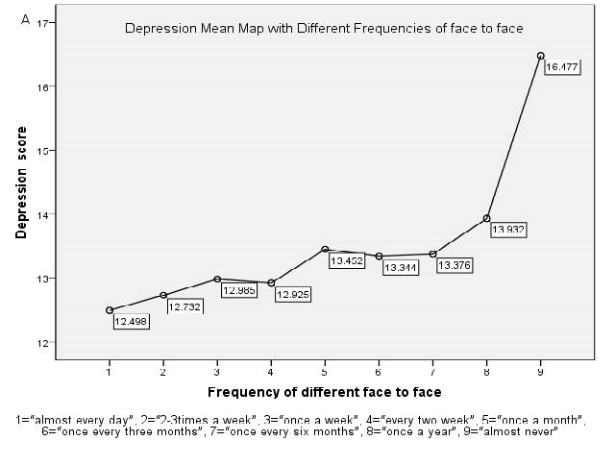
B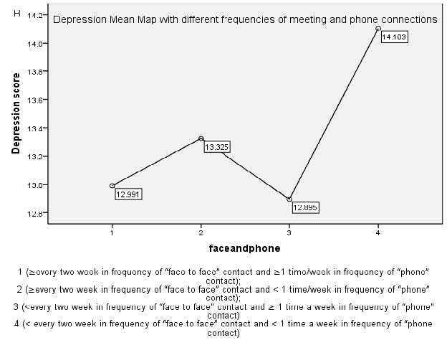
C 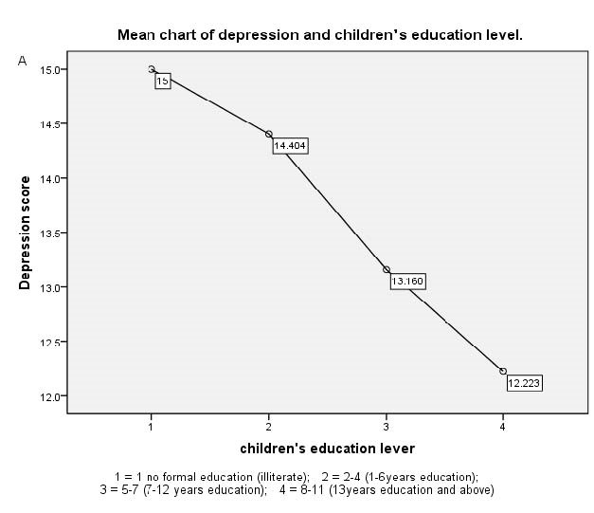
D 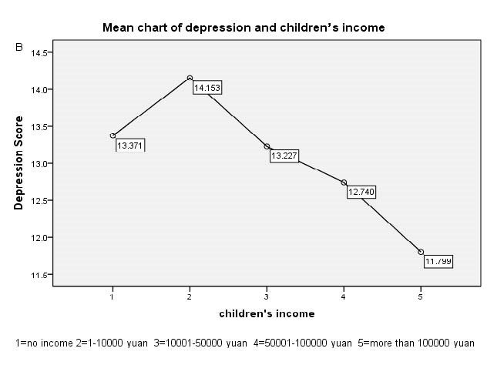
E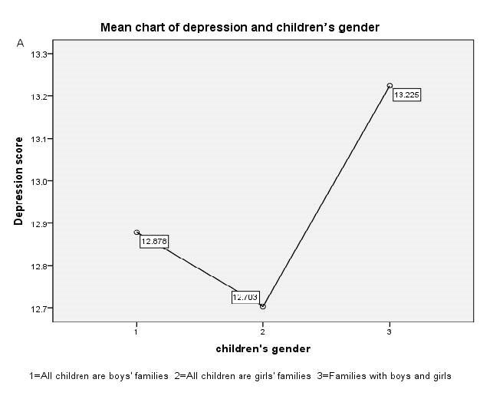
F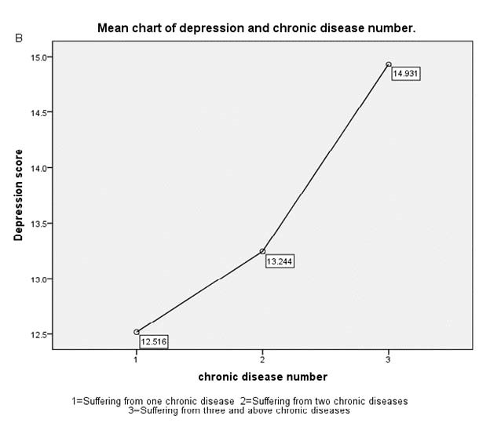
Figure 1 Association of depression with various variables. A: Association of depression with the frequency of face-to-face contact; B: Association of depression with face-to-face and phone contacts; C: Association of depression with children’s education level; D: Association of depression with children’s income; E: Association of depression with children’s gender; F: Association of depression with the number of chronic diseases.

Table 1 Descriptive statistics of the study sample (4810)
Variable |  | Mean/n (%) | SD
Dependent variable | Depressive symptoms (cesd-10¹ score) (0-30) | 13.06 | 5.225
Independent variable | Face-to-face contact | 3.94 | 2.546
 | Almost every day | 1224 (25.4)
 | 2-3 times a week | 448 (9.3)
 | Once a week | 532 (10.9)
 | Every two weeks | 434 (9)
 | Once a month | 526 (10.9)
 | Once every three months | 494 (10.3)
 | Once every six months | 502 (10.4)
 | Once a year | 516 (10.7)
 | Almost never | 33 (0.7)
 | Missing | 110 (2.3)
 | Phone contact | 2.95 | 2.302
 | Almost every day | 531 (11)
 | 2-3 times a week | 809 (16.8)
 | Once a week | 1086 (22.6)
 | Every two weeks | 655 (13.6)
 | Once a month | 471 (9.8)
 | Once every three months | 108 (2.2)
 | Once every six months | 47 (1)
 | Once a year | 15 (0.3)
 | Almost never | 301 (6.3)
 | Missing | 787 (16.4)
Demographic factor | Age | 60.47 | 15.012
 | 45-50 (ref.) | 583 (12.1)
 | 51-60 | 1479 (30.7)
 | 61-70 | 1543 (32.1)
 | 71- | 1011 (21)
 | Missing | 194 (4)
 | Gender
 | Male (ref.) | 2310 (48)
 | Female | 2494 (51.9)
 | Missing | 6 (0.1)
 | Children’s number | 2.77 | 1.316
 | 1 child | 842 (17.5)
 | 2 children | 1548 (32.2)
 | 3 children | 1024 (21.3)
 | 4 children | 644 (13.4)
 | 5 and above | 752 (15.6)
 | Gender of family children²
 | Male | 1086 (22.6)
 | Female | 748 (15.6)
 | Both | 2940 (61.1)
 | Missing | 36 (0.7)
Socio-economic factor | Education level³ (children)
 | Illiterate | 1 (0.0)
 | 1-6 years of education | 756 (15.7)
 | 7-12 years of education | 2509 (52.2)
 | 13 years of education and above | 1538 (32.0)
 | Missing | 6 (0.1)
 | Income (children)⁴ | 2.96 | 1.215
 | No income | 946 (19.7)
 | 1-10000 yuan | 271 (5.6)
 | 10001-50000 yuan | 2139 (44.5)
 | 50001-100000 yuan | 920 (19.1)
 | More than 100000 yuan | 534 (11.1)
 | Areas of China
 | Urban | 1224 (25.4)
 | Rural (ref.) | 3559 (74.0)
 | Missing | 27 (0.6)
Current health conditions | Chronic diseases
 | No | 1767 (36.7)
 | Yes | 3043 (63.3)
 | Number of chronic diseases⁵ | 1.97 | 0.846
 | 1 | 1143 (37.6)
 | 2 | 860 (28.3)
 | 3 and above | 1040 (34.2)
¹CEDS-10: Center for Epidemiologic Studies Depression Scale (range, 0-30; mean = 13.06, SD = 5.225); ²Gender of family children: 1 = male, 2 = female, and 3 = both; ³Education level: 1 = no formal education (illiterate), 2 = did not finish primary school but could read and/or write, 3 = sishu/home school, 4 = elementary school, 5 = middle school, 6 = high school, 7 = vocational school, 8 = two or three-year college/associate degree, 9 = four-year college/bachelor degree, 10 = master degree, and 11 = doctoral degree/PH.D. (were grouped into four groups based on the quartiles: 1 = no formal education (illiterate), 2 = 2-4 (1-6 years of education), 3 = 5-7 (7-12 years of education), and 4 = 8-11 (13 years of education and above)); ⁴Income: total income of children in the past year, ranging from 1 (no income) to 12 (more than 300000 yuan); ⁵Number of chronic diseases: total number of diagnosed chronic diseases (hypertension, dyslipidemia, diabetes or high blood glucose, cancer or malignant tumor, chronic lung diseases, liver disease, heart attack, stroke, kidney disease, stomach or other digestive disease, emotional or psychiatric problems, memory-related diseases, arthritis or rheumatism, and asthma) (range, 0-14; mean = 1.97, SD = 0.846).

Table 2 Impact of intergenerational emotional support on depressive symptoms
Variable |  | Depressive symptoms (CESD-10 score) (0-30)¹ | F | P-value²
Dependent variable | Depressive symptoms | 13.06 ± 5.225
Independent variable | Face-to-face contact |  | 6.622 | 0.000ª
 | Almost every day | 12.50 ± 5.478
 | 2-3 times a week | 12.73 ± 5.158
 | Once a week | 12.99 ± 4.764
 | Every two weeks | 12.92 ± 5.290
 | Once a month | 13.45 ± 5.107
 | Once every three months | 13.34 ± 5.043
 | Once every six months | 13.38 ± 4.895
 | Once a year | 13.93 ± 5.353
 | Almost never | 16.48 ± 6.723
 | Phone contact |  | 5.334 | 0.000ª
 | Almost every day | 12.97 ± 4.804
 | 2-3 times a week | 12.90 ± 4.872
 | Once a week | 13.14 ± 4.915
 | Every two weeks | 13.83 ± 5.261
 | Once a month | 14.13 ± 5.492
 | Once every three months | 14.13 ± 6.148
 | Once every six months | 13.91 ± 5.790
 | Once a year | 12.70 ± 4.773
 | Almost never | 12.20 ± 6.815
 | Frequency of contact³ |  | 5.717 | 0.001ª
 | Group 1: (both) (ref) | 12.99 ± 5.071
 | Group 2: (face-to-face) | 13.33 ± 4.958
 | Group 3: (phone) | 12.90 ± 6.103
 | Group 4: (neither) | 14.28 ± 5.987
¹Values are the mean ± SD; ²Interval ªP < 0.001; ³Group 1 (≥ every two weeks in frequency of “face-to-face” contact and ≥ 1 time/wk in frequency of “phone” contact); group 2 (≥ every two weeks in frequency of “face-to-face” contact and < 1 time/wk in frequency of “phone” contact); group 3 (< every two weeks in frequency of “face-to-face” contact and ≥ 1 time a week in frequency of “phone” contact) and group 4 (< every two weeks in frequency of “face-to-face” contact and < 1 time a week in frequency of “phone” contact).

Table 3 Associations between other variables and depression
Variables |  | Depressive symptoms (CESD-10 score) (0-30)¹ | F or t | P-value⁶
Demographic factor | Age (yr) |  | 0.600 | 0.615
 | 45-50 (ref.) | 12.81 ± 5.070
 | 51-60 | 13.14 ± 5.141
 | 61-70 | 13.02 ± 5.290
 | 71- | 13.09 ± 5.245
 | Gender |  | 4.641 | 0.03ª
 | Male (ref.) | 12.85 ± 5.123
 | Female | 13.24 ± 5.314
 | Children’s number |  | 7.775 | 0.000^{b}
 | 1 child | 12.20 ± 4.628
 | 2 children | 13.22 ± 4.903
 | 3 children | 13.46 ± 5.354
 | 4 children | 13.20 ± 5.037
 | 5 and above | 13.00 ± 6.279
 | Gender of family children² |  | 3.881 | 0.021ª
 | Male | 12.88 ± 4.863
 | Female | 12.70 ± 4.936
 | Both | 13.22 ± 5.403
Socio- economic factor | Education level³ (children) |  | 30.738 | 0.000^{b}
 | Illiterate | 15.00
 | 1-6 years of education | 14.40 ± 5.669
 | 7-12 years of education | 13.16 ± 5.264
 | 13 years of education and above | 12.22 ± 4.76
 | Income (children)⁴ |  | 13.112 | 0.000^{b}
 | No income | 13.37 ± 5.481
 | 1-10000 yuan | 14.15 ± 5.754
 | 10001-50000 yuan | 13.23 ± 5.384
 | 50001-100000 yuan | 12.74 ± 4.781
 | More than 100000 yuan | 11.80 ± 4.238
 | Areas of China |  | 0.678 | 0.498
 | Urban | 13.14 ± 5.181
 | Rural (ref.) | 13.03 ± 5.248
Current health condition | Chronic diseases |  | -8.627 | 0.000^{b}
 | No | 12.21 ± 4.734
 | Yes | 13.55 ± 5.431
 | Number of chronic diseases⁵ |  | 57.750 | 0.000^{b}
 | 1 | 12.52 ± 5.049
 | 2 | 13.24 ± 5.004
 | 3 and above | 14.93 ± 5.871
¹CEDS-10: Center for Epidemiologic Studies Depression Scale (range, 0-30); ²Gender of family children: 1 = male, 2 = female, and 3 = both; ³Education level: 1 = no formal education (illiterate), 2 = did not finish primary school but could read and/or write, 3 = sishu/home school, 4 = elementary school, 5 = middle school, 6 = high school, 7 = vocational school, 8 = two or three-year college/associate degree, 9 = four-year college/bachelor degree, 10 = master degree, and 11 = doctoral degree/PH.D. (were grouped into four groups based on the quartiles: 1 = no formal education (illiterate), 2 = 2-4 (1-6 years of education), 3 = 5-7 (7-12 years of education), and 4 = 8-11 (13 years of education and above)); ⁴Income: total income of children in the past year, ranging from 1 (no income) to 12 (more than 300000 yuan), mean = 3.01, SD = 0.996; ⁵Number of chronic diseases: total number of diagnosed chronic diseases (hypertension, dyslipidemia, diabetes or high blood glucose, cancer or malignant tumor, chronic lung diseases, liver disease, heart attack, stroke, kidney disease, stomach or other digestive disease, emotional or psychiatric problems, memory-related diseases, arthritis or rheumatism, and asthma) (range, 0-14; mean = 2.21, SD = 1.305); ⁶Interval ªP < 0.05, ^{b}P < 0.001.
Table 4 Results of stepwise multiple linear regression
Model | Independent variabl | Regression coefficient |  | t | Sig¹
 |  | B | Beta
Model 1 | Constant | 11.301 | 0.270 | 41.902 | 0.000^{b}
 | Chronic disease number | 1.249 | 0.126 | 9.921 | 0.000^{b}
Model 2 | Constant | 14.778 | 0.570 | 25.929 | 0.000^{b}
 | Chronic disease number | 1.207 | 0.125 | 9.667 | 0.000^{b}
 | Children’s education | -1.084 | 0.157 | -6.907 | 0.000^{b}
Model 3 | Constant | 13.797 | 0.595 | 23.186 | 0.000^{b}
 | Chronic disease number | 1.229 | 0.124 | 9.889 | 0.000^{b}
 | Children’s education | -1.093 | 0.156 | -7.006 | 0.000^{n}
 | Face-to-face contact | 0.228 | 0.042 | 5.410 | 0.000^{b}
Model 4 | Constant | 14.504 | 0.616 | 23.551 | 0.000^{b}
 | Chronic disease number | 1.245 | 0.124 | 10.052 | 0.000^{b}
 | Children’s education | -0.946 | 0.159 | -5.935 | 0.000^{b}
 | Face-to-face contact | 0.216 | 0.042 | 5.129 | 0.000^{b}
 | Children’s income | -0.380 | 0.089 | -4.258 | 0.000^{b}
Model 5 | Constant | 15.414 | 0.696 | 22.136 | 0.000^{b}
 | Chronic disease number | 1.261 | 0.124 | 10.178 | 0.000^{b}
 | Children’s education | -1.019 | 0.161 | -6.317 | 0.000^{b}
 | Face-to-face contact | 0.202 | 0.042 | 4.758 | 0.000^{b}
 | Children’s income | -0.421 | 0.090 | -4.668 | 0.000^{b}
 | Phone contact | -0.146 | 0.053 | -2.787 | 0.005^{b}
Model 6 | Constant | 14.752 | 0.765 | 19.290 | 0.000^{b}
 | Chronic disease number | 1.253 | 0.124 | 10.120 | 0.000^{b}
 | Children’s education | -1.026 | 0.161 | -6.365 | 0.000^{b}
 | Face-to-face contact | 0.203 | 0.042 | 4.795 | 0.000^{b}
 | Children’s income | -0.417 | 0.090 | -4.620 | 0.000^{b}
 | Phone contact | -0.142 | 0.053 | -2.707 | 0.007ª
 | Gender | 0.438 | 0.210 | 2.090 | 0.037
¹Interval ªP < 0.05, ^{b}P < 0.001.

