Name of Journal: World Journal of Gastroenterology
Manuscript NO: 50263
Manuscript Type: ORIGINAL ARTICLE

Basic Study
Insulin-like growth factor 2 mRNA-binding protein 1 promotes cell proliferation via activation of AKT and is directly targeted by microRNA-494 in pancreatic cancer

Wan BS et al. IGF2BP1 promotes cell proliferation in pancreatic cancer

Bai-Shun Wan, Ming Cheng, Ling Zhang

Bai-Shun Wan, Ling Zhang, Department of Hepatobiliary and Pancreatic Surgery, the Affiliated Cancer Hospital of Zhengzhou University, Zhengzhou 450008, Henan Province, China

Ming Cheng, Department of Information, the First Affiliated Hospital of Zhengzhou University, Zhengzhou 450000, Henan Province, China

ORCID number: Bai-Shun Wan (0000-0002-0590-3896); Ming Cheng (0000-0001-5220-963X); Ling Zhang (0000-0001-7219-4252).

Author contributions: Wan BS and Zhang L designed the research and critically revised the manuscript for important intellectual content; Cheng M helped with the statistical analysis; all authors read and approved the final manuscript.

Supported by the National Natural Science Foundation of China, No. 61802350.

Institutional review board statement: This study was approved by the Institutional Review Board of the Affiliated Cancer Hospital of Zhengzhou University.

Institutional animal care and use committee statement: All procedures involving animals were reviewed and approved by the Institutional Animal Care and Use Committee of the Affiliated Cancer Hospital of Zhengzhou University.

Conflict-of-interest statement: All authors declare no competing financial interests.

Data sharing statement: No additional data are available.

ARRIVE guidelines statement: The manuscript was prepared and revised according to the ARRIVE guidelines.

Open-Access: This is an open-access article that was selected by an in-house editor and fully peer-reviewed by external reviewers. It is distributed in accordance with the Creative Commons Attribution Non Commercial (CC BY-NC 4.0) license, which permits others to distribute, remix, adapt, build upon this work non-commercially, and license their derivative works on different terms, provided the original work is properly cited and the use is non-commercial. See: http://creativecommons.org/licenses/by-nc/4.0/

Manuscript source: Unsolicited manuscript

Corresponding author: Ling Zhang, MD, Professor, Department of Hepatobiliary and Pancreatic Surgery, the Affiliated Cancer Hospital of Zhengzhou University, No. 127, Dongming Road, Zhengzhou 450008, Henan Province, China. zzuzhangling@163.com
Telephone: +86-371-65587787
Fax: +86-371-65587787

Received: July 13, 2019
Peer-review started: July 16, 2019
First decision: August 18, 2019
Revised: September 3, 2019
Accepted: September 27, 2019
Article in press: September 28, 2019
Published online: October 28, 2019

Abstract
BACKGROUND
Studies have shown that insulin-like growth factor 2 mRNA-binding protein 1 (IGF2BP1) plays critical roles in the genesis and development of human cancers.

AIM
To investigate the clinical significance and role of IGF2BP1 in pancreatic cancer.

METHODS
Expression levels of IGF2BP1 and microRNA-494 (miR-494) were mined based on Gene Expression Omnibus datasets and validated in both clinical samples and cell lines by quantitative real-time polymerase chain reaction and Western blot. The relationship between IGF2BP1 expression and clinicopathological factors of pancreatic cancer patients was analyzed. The effect and mechanism of IGF2BP1 on pancreatic cancer cell proliferation were investigated in vitro and in vivo. Analyses were performed to explore underlying mechanisms of IGF2BP1 upregulation in pancreatic cancer and assays were carried out to verify the post-transcriptional regulation of IGF2BP1 by miR-494.

RESULTS
We found that IGF2BP1 was upregulated and associated with a poor prognosis in pancreatic cancer patients. We showed that downregulation of IGF2BP1 inhibited pancreatic cancer cell growth in vitro and in vivo via the AKT signaling pathway. Mechanistically, we showed that the frequent upregulation of IGF2BP1 was attributed to the downregulation of miR-494 expression in pancreatic cancer. Furthermore, we discovered that reexpression of miR-494 could partially abrogate the oncogenic role of IGF2BP1.

CONCLUSION
Our results revealed that upregulated IGF2BP1 promotes the proliferation of pancreatic cancer cells via the AKT signaling pathway and confirmed that the activation of IGF2BP1 is partly due to the silencing of miR-494.

Key words: Pancreatic cancer; Insulin-like growth factor 2 mRNA-binding protein 1; Proliferation; MicroRNA-494

© The Author(s) 2019. Published by Baishideng Publishing Group Inc. All rights reserved.

Core tip: Insulin-like growth factor 2 mRNA-binding protein 1 (IGF2BP1) exerts vital roles in the development of various cancers; however, the expression, functional role, and regulatory mechanisms of IGF2BP1 in pancreatic cancer remain unclear. In this study, the expression levels of IGF2BP1 and miR-494 were mined based on Gene Expression Omnibus datasets and validated in both clinical samples and cell lines. The relationship between IGF2BP1 expression and clinicopathological factors of pancreatic cancer patients was analyzed. The effect of IGF2BP1 on pancreatic cancer cell proliferation and underlying regulatory mechanism were investigated. Our study suggests that IGF2BP1 may be a new therapeutic target for pancreatic cancer.

Wan BS, Cheng M, Zhang L. Insulin-like growth factor 2 mRNA-binding protein 1 promotes cell proliferation via activation of AKT and is directly targeted by microRNA-494 in pancreatic cancer. World J Gastroenterol 2019; 25(40): 6063-6076
URL: https://www.wjgnet.com/1007-9327/full/v25/i40/6063.htm
DOI: https://dx.doi.org/10.3748/wjg.v25.i40.6063

INTRODUCTION
Pancreatic ductal adenocarcinoma (PDAC) is one of the most common causes of cancer-related deaths worldwide^{[1]}. Currently, the treatment options for patients with inoperable pancreatic cancer are very limited, and the clinical outcomes remain unsatisfactory^{[2,3]}. Although some understanding of the molecular pathogenesis of pancreatic cancer development and progression was obtained^{[4-6]}, new therapy targets are necessary to improve the survival rate of pancreatic cancer patients. Insulin-like growth factor 2 mRNA-binding protein 1 (IGF2BP1), also known as IMP-1 or CRD-BP, belongs to a conserved family of oncofetal RNA-binding proteins, which include IGF2BP2 and IGF2BP3^{[7,8]}. IGF2BP1 controls the translation and stability of its target RNAs by posttranscriptional regulation^{[9]}. Increasing evidence indicates that the IGF2BP family plays critical roles in the genesis and development of human cancers. IGF2BP2 expression predicts poor outcomes in gallbladder cancer patients and high tumor growth rates in xenograft models^{[10]}. IGF2BP1 reduces the metastatic potential of breast cancer in a mouse model^{[11]}, regulates the expression and activity of GLI1 in the development of basal cell carcinoma^{[12]}, and acts as an adaptor protein that recruits the CCR4-NOT complex and thereby initiates the degradation of the long noncoding RNA (lncRNA) highly upregulated in liver cancer (HULC) in hepatocarcinoma^{[13]}. Currently, very little is known regarding IGF2BP1 expression in PDAC and its role in genesis or progression of this malignancy.
MicroRNAs (miRNAs) play important roles in cellular differentiation and proliferation in embryo development and cancer progression. MiRNAs bind to the 3’ untranslated region (3'-UTR) of the target mRNAs, which results in mRNA cleavage or translational repression ^{[14,15]}. This miRNA-mediated gene silencing, which has been shown in numerous studies, plays critical roles in pancreatic cancer development and progression. MiR-381 targeted the chemokine receptor-4 mRNA 3’-UTR to aggravate PDAC carcinogenesis^{[16]}, and miR-1181 inhibited cell invasion and proliferation via STAT3 in pancreatic cancer^{[17]}.
In this study, we demonstrated that IGF2BP1 was overexpressed in PDAC when compared to its expression in matched normal control tissues. IGF2BP1 promoted PDAC cell proliferation both in vitro and in vivo through the AKT signaling pathway. We also determined that dysregulation of miR-494 contributed to the upregulation of IGF2BP1. Thus, our results provide a new molecular mechanism of oncogenesis and suggest a potential therapeutic target for pancreatic cancer.

MATERIALS AND METHODS
Tissue samples and ethics statement
Surgical specimens of pancreatic tumors and adjacent nontumor tissues were collected between January 2015 and December 2015 from 30 patients with histologically confirmed pancreatic adenocarcinomas from Henan Cancer Hospital (Zhengzhou, China). None of these patients received preoperative chemotherapy or radiotherapy. Normal pancreatic tissues from three patients with benign pancreatic diseases were also collected and histologically classified. This study was approved by the Human Research Ethics Committee of Zhengzhou University.

Cell culture and transfection
Human pancreatic cancer cell lines (Capan-2, Mia PaCa-2, Panc-1, and Panc 0327) were purchased from the American Typical Culture Center (Manassas, VA, United States), and the immortalized human pancreatic ductal epithelial (HPDE) cell line was purchased from the Cell Repository of the Chinese Academy of Sciences (Shanghai, China). Cells were cultured in RPMI 1640 (Capan-2, Panc 0327, and HPDE) or DMEM (Mia PaCa-2 and Panc-1) supplemented with 10% fetal bovine serum (Gibco, Carlsbad, CA, United States) in a humidified atmosphere with 5% CO₂ at 37 ℃. All cells in our study were authenticated using short tandem repeat DNA profiling within 2 mo. All mature miRNA mimics, inhibitors, primers, and siRNAs were purchased from RiboBio company (Guangzhou, China). Cell transfection was conducted using Lipofectamine 2000 (Invitrogen, Carlsbad, United States) according to the manufacturer’s instructions.

Immunohistochemistry (IHC)
Formalin-fixed and paraffin-embedded tissue sections were deparaffinized in xylene and rehydrated in a graded series of alcohol solutions, followed by antigen retrieval and blockage with 3% bovine serum albumin for 30 min. Tissue sections were incubated with primary antibodies at optimal concentrations overnight at 4 ℃. Then, the biotinylated sections were incubated with the secondary antibody (Boster, Wuhan, China) for 1 h at room temperature. Finally, the sections were stained with a diaminobenzidine (DAB) kit (Boster, Wuhan, China) and counterstained with hematoxylin (Boster, Wuhan, China). Staining was independently assessed by two experienced pathologists at the The Affiliated Cancer Hospital of Zhengzhou University. Images were obtained using a microscope (Olympus, Tokyo, Japan). IGF2BP1 staining intensity was classified as 0 (negative), 1 (weak), 2 (moderate), or 3 (strong). The staining proportion was quantified as 0 (negative), 1 (0.01%–50%), and 2 (51%–100%). The staining score of each sample was calculated as the proportional score × intensity score. Patients were grouped as low IGF2BP1 expression when the staining score was ≤ 2, and as high IGF2BP1 expression when the score was ≥ 3.

Lentivirus, reagents, and antibodies
The lentiviral vectors for human IGF2BP1 overexpression (Lv-IGF2BP1) and knockdown (Lv-sh-IGF2BP1) and control empty vectors were constructed and synthesized by GeneChem Corporation (Shanghai, China). Lentiviral infection was performed according to the manufacturer’s protocol. The primary antibodies included IGF2BP1 (ab124930, Abcam), pan-AKT (C67E7, CST), p-AKT (D9E, CST), and GAPDH (Boster, Wuhan, China).

Reverse transcription real-time quantitative polymerase chain reaction (RT-qPCR)
Total RNA isolation was performed using a TRIzol kit (Invitrogen, Carlsbad, CA, United States) according to the manufacturer’s instructions. For cDNA synthesis, equal amounts of RNA were transcribed, and random primers (Takara Bio, Inc., Dalian, China) were used for reverse transcription according to the manufacturer’s instructions. RT-qPCR assays of mRNA expression levels were performed using a SYBR Green PCR Kit (RR420A; Takara, Dalian, China) on an ABI Prism 7500 (Applied Biosystems, Foster City, CA, United States) according to the manufacturer’s instructions. The housekeeping genes GAPDH and U6 were used as reference genes. The primers used were: GAPDH forward, 5’-AGAAGGCTGGGGCTCATTTG-3’ and reverse: 5’-TGAGAGCTGTCCATTGGTAG AG-3’; IGF2BP1 forward, 5’-CAAAGGAGCCGGAAAATTCAAAT-3’ and reverse, 5’-CGTCTCACTC TCGGTGTTCA-3’. The relative gene expression was quantified and analyzed by the 2^{−ΔΔCt} method.

Western blot analysis
Tissue and cell proteins were extracted using RIPA buffer (Beyotime Biotechnology, Shanghai, China) containing protease and phosphatase inhibitors. After protein concentration determination and denaturation, the samples were subjected to sodium dodecyl-polyacrylamide gel electrophoresis, and then transferred onto polyvinylidene fluoride (PVDF) membranes (Millipore, Bedford, MA, United States) as described^{[9]}. After incubation with relevant primary and secondary antibodies (Boster, Wuhan, China), the blots were visualized by enhanced chemiluminescence (Boster, Wuhan, China).

Cell Counting Kit-8 (CCK-8) assay
One thousand pancreatic cancer cells were cultured in 96-well plates in triplicate and were maintained in complete medium. After transfection, cell viability was measured by the CCK-8 assay (Dojindo Laboratories, Kumamoto, Japan) according to the manufacturer’s instructions.

Flow cytometry
After transfection, cell apoptosis was detected using a FACSCalibur flow cytometer (BD Biosciences, MA, United States) after staining using the Annexin V/PI apoptosis kit (MultiSciences, Hangzhou, China) according to the manufacturer’s instructions. For cell cycle analysis, transfected pancreatic cancer cells were harvested, washed with cold PBS, fixed in 70% ethanol at -20 ℃ for 24 h, and stained with a cell cycle kit (MultiSciences, Hangzhou, China).

Subcutaneous xenograft model
Six-week-old female BALB/c nude mice were purchased from HFK Bioscience (Beijing, China). All mice were maintained under specific pathogen-free conditions in the Central Animal Laboratory of Zhengzhou University. For subcutaneous xenograft model creation, 5 × 10⁶ cells suspended in 100 μL of PBS were injected into the flank of mice. Tumor volume and mouse weight were calculated every week. Tumor volume was calculated using the formula length × width²/2. Animal studies were conducted under the principles and procedures outlined in the NIH Guide for the Care and Use of Laboratory Animals and approved by the Ethics Committee of Zhengzhou University.

Dual-luciferase reporter gene assay
The 3’-UTR and the 3’-UTR mutant of human IGF2BP1 were constructed and synthesized by GeneChem RiboBio Corporation (Guang zhou, China). For the reporter assays, pancreatic cancer cells were cotransfected with wild-type reporter plasmid and miR-494 mimics. After transfection for 48 h, luciferase activity was measured using the Dual-Glo Luciferase Reporter System according to the manufacturer’s instructions.

Gene expression omnibus (GEO) and gene set enrichment analysis (GSEA)
GSE15471, GSE32678, and GSE62165 datasets were downloaded from GEO. Gene expression profiling was analyzed with R software (version 3.3.3) using the limma package to calculate the differentially expressed mRNAs and miRNAs. GSEA was conducted using GSEA 3.0 software (Broad Institute, Cambridge, MA, United States) to identify the biologically associated gene sets.

Statistical analysis
All experiments were carried out in three biological replicates at least. Statistical analyses were performed using SPSS 17.0 software (IBM Corp., Armonk, NY, United States). The log-rank test was used to analyze the effect of expression on patients’ overall survival (OS). ANOVA and student’s t-test were used to compare differences between groups. P < 0.05 was considered statistically significant.

RESULTS
IGF2BP1 upregulation in pancreatic cancer is associated with a poor prognosis in pancreatic cancer patients
To study the expression of IGF2BP1 in pancreatic cancer, we analyzed the mRNA expression levels of IGF2BP1 in the GEO dataset GSE15471. The results indicated that the mRNA expression level of IGF2BP1 in the pancreatic cancer samples was much higher than that in the normal tissue samples (Figure 1A). Next, we confirmed elevated IGF2BP1 mRNA and protein levels in pancreatic cancer samples by RT-qPCR and immunoblotting (Figure 1B and C and Supplementary Figure 1). To investigate the clinical implication of IGF2BP1 during the development of pancreatic cancer, we performed IHC staining in 30 pairs of pancreatic cancer and matched nontumor specimens (Figure 1D; Table 1). Quantitative analysis of the IHC data revealed that IGF2BP1 was upregulated in cancer tissues compared with adjacent nontumor tissues (Figure 1E). Clinicopathological correlation analysis showed that overexpression of IGF2BP1 was correlated with tumor size (Table 1). Kaplan-Meier survival analysis showed that patients with tumoral overexpression of IGF2BP1 demonstrated a shorter OS time than patients with low expression (Figure 1F; 10 mo vs 19 mo; log-rank test, P < 0.05). The mRNA and protein levels of IGF2BP1 were also examined in several pancreatic cancer cell lines. We found that IGF2BP1 mRNA and protein levels were aberrantly upregulated in human pancreatic cancer cell lines compared to the HPDE cell line (Figure 1G and H). Collectively, we conclude that IGF2BP1 is overexpressed in pancreatic cancer and predicts a poor prognosis.

Knockdown of IGF2BP1 inhibits pancreatic cancer cell proliferation in vitro
To investigate the biological function of IGF2BP1 in pancreatic cancer, we knocked down IGF2BP1 expression in two IGF2BP1-high-expressing (Panc-1 and Panc 0327) cell lines by siRNA transfection and ectopic expression in the IGF2BP1-low-expressing Mia PaCa-2 cell line. The transfection efficiency was measured by RT-qPCR and Western blot (Figure 2A-F). CCK-8 assays revealed that knockdown of IGF2BP1 markedly inhibited the growth of both Panc-1 and Panc 0327 cells (Figure 2G and H), whereas overexpression of IGF2BP1 significantly accelerated the growth of Mia PaCa-2 cells (Figure 2I). These results suggest that IGF2BP1 promotes pancreatic cancer cell proliferation in vitro.

IGF2BP1 promotes pancreatic cancer cell proliferation by inhibiting apoptosis and inducing cell cycle progression
To understand the potential mechanism by which IGF2BP1 promotes pancreatic cancer cell proliferation, we conducted GSEA based on a published pancreatic cancer dataset GSE62165. IGF2BP1 upregulation was found to be positively correlated with the transcription of RNA polymerase promoter III, the mitotic cell cycle, and the response to DNA damage stimulus (Figure 3A-C). We further examined whether the inhibition of cell proliferation was due to a perturbation of the cell cycle or increased apoptosis by flow cytometry. Depletion of IGF2BP1 induced the apoptosis of Panc-1 and Panc 0327 cells (Figure 3D and Supplementary Figure 2). Overexpression of IGF2BP1 decreased the apoptosis of Mia PaCa-2 cells (Figure 3E and Supplementary Figure 3). Depletion of IGF2BP1 increased the proportion of Panc-1 and Panc 0327 cells in the G1 phase and reduced the proportions in the S and G2 phases (Figure 3F and 3H). Additionally, overexpression of IGF2BP1 promoted the transition of Mia PaCa-2 cells in G1 to enter the S and G2 phases compared with control cells (Figure 3G and H). Overall, the present results demonstrated that IGF2BP1 promotes pancreatic cancer cell growth by inducing apoptosis and accelerating the G1 to S phase transition.

IGF2BP1 enhances pancreatic cancer cell proliferation via the AKT signaling pathway
It has been reported that AKT activation is necessary for cancer progression. To determine whether IGF2BP1 activates AKT in pancreatic cancer, Western blot was performed. As presented in Figure 4A and B, silencing of IGF2BP1 in Panc-1 and Panc 0327 cells resulted in notably decreased phosphorylation of AKT. To verify the above findings in vivo, a subcutaneous xenograft model was established in nude mice (Figure 4C). Mice of the IGF2BP1 knockdown group showed a slower increase in tumor volume and less weight loss compared with the control group (Figure 4D and E). In addition, Ki-67 and p-AKT staining was also reduced in the IGF2BP1 knockdown group (Figure 4F). Taking these results together, our study demonstrated that IGF2BP1 promotes pancreatic cancer growth by activating the AKT signaling pathway.

IGF2BP1 is a direct target of miR-494
Whether IGF2BP1 is regulated at the posttranscriptional level in pancreatic cancer remains unknown. To identify the potential miRNAs targeting IGF2BP1, two online bioinformatics tools, microRNA.org and TargetScan, were used, and the prediction results were comprehensively analyzed. After searching the GEO dataset GSE32678, we found that only two miRNAs, miR-494 and miR-326, were downregulated (Figure 5A). The more frequent low expression of miR-494 was further validated by RT-qPCR in our cohort of pancreatic cancer patients (Figure 5B, n = 30). Thus, we speculated that miR-494 exhibited the greatest potential to regulate IGF2BP1, and the predicted binding site is shown in Figure 5C. To verify whether IGF2BP1 is a direct target of miR-494, wild-type (WT) and mutated (Mut) IGF2BP1 3’-UTR-coupled luciferase reporters were designed. Panc-1 and Panc 0327 cells were transfected with miR-494 mimics, inhibitors, or control sequences (Figure 5D). IGF2BP1 mRNA was markedly downregulated by the miR-494 mimics and upregulated by the miR-494 inhibitors (Figure 5E and F). In both cell lines, the luciferase activity was notably suppressed by the miR-494 mimics and enhanced by the miR-494 inhibitors in the WT group, with no significant change observed in the Mut group (Figure 5G and H). Therefore, our results showed that IGF2BP1 is a direct target of miR-494 in pancreatic cancer.

MiR-494 is involved in IGF2BP1-mediated pancreatic cancer cell proliferation
To confirm whether IGF2BP1 is a functional target of miR-494, rescue experiments were performed in Mia PaCa-2 cells. The growth promotion caused by IGF2BP1 reexpression was partly reversed by the miR-494 mimics as demonstrated by the CCK-8 assays (Figure 6A). Cell apoptosis analysis revealed that reexpression of miR-494 induced apoptosis of Mia PaCa-2 cells, which was preserved by the regulation of IGF2BP1 (Figure 6B). Cell cycle analysis revealed that Mia PaCa-2 cells accumulated in the G1 phase due to upregulated IGF2BP1, and the cells partially transitioned into the S/G2 phase following cotransfection with the miR-494 mimics (Figure 6C). Furthermore, cotransfection of miR-494 reduced phosphorylation levels of AKT (Ser473), which was mediated by IGF2BP1 overexpression (Figure 6D). Furthermore, a negative correlation between IGF2BP1 and miR-494 expression was observed in our clinical samples (Figure 6E, n = 30). Kaplan–Meier curves demonstrated that pancreatic cancer patients with high miR-494 expression (n = 15) had a better OS than those with low miR-494 expression (n = 15) (Figure 6F; 12 mo vs 23 mo, log-rank test, P < 0.05). These findings suggested that miR-494 modulates the function of IGF2BP1, and could influence pancreatic cancer cell survival by regulating IGF2BP1.

DISCUSSION
In this study, upregulation of IGF2BP1 was observed in the GEO samples and validated in an expanded cohort. We identified IGF2BP1 as a prognostic indicator and a vital factor in the development of pancreatic cancer via the AKT signaling pathway. Additionally, the upregulation of IGF2BP1 was due to miR-494 dysregulation. Therefore, IGF2BP1 might be a novel therapeutic target for the treatment of pancreatic cancer in the future.
IGF2BP1 is a well-known oncofetal protein linked to several human cancers. High IGF2BP1 expression is a poor prognostic marker in basal cell carcinoma with an activated Hedgehog signaling pathway^{[12]}. IGF2BP1 leads to an increased lncRNA HULC half-life and higher steady-state expression to promote the carcinogenesis of hepatomas^{[13]}. Here, we demonstrated that stable knockdown of IGF2BP1 drastically inhibited pancreatic cancer cell proliferation and reduced tumor formation in nude mice, whereas reexpression of IGF2BP1 increased pancreatic cancer cell tumorigenesis. Accordingly, upregulation of IGF2BP1 in human pancreatic cancer was observed and associated with a more aggressive clinicopathological phenotype and poorer prognosis. These findings together suggest that IGF2BP1 is an oncogene in pancreatic cancer.
Previous studies have shown that dysregulation of miRNAs profoundly influences the expression of IGF2BP1. For example, miRNA-196b inhibits cell proliferation and induces apoptosis in HepG2 cells by targeting IGF2BP1^{[18]}. MiR-506 inhibits cell proliferation and invasion by targeting IGF2BP1 in glioblastoma^{[19]}. MiR-625 functions as an anti-metastatic miRNA and plays an important role in hepatocellular carcinoma progression by modulating the IGF2BP1/PTEN pathway^{[20]}. MiRNA-873 suppresses glioblastoma tumorigenesis and metastasis by inhibiting the expression of IGF2BP1^{[21]}. Based on these studies, we considered the possible involvement of miRNA in regulating IGF2BP1 expression. We identified downregulated miR-494 as a negative regulator of IGF2BP1. MiR-494 interacted with the IGF2BP1 3’-UTR in a seed sequence-dependent manner and repressed IGF2BP1 expression. MiR-494 is a frequently downregulated miRNA in human pancreatic cancer and is negatively associated with IGF2BP1 expression in human pancreatic cancer, implying that loss of miR-494 stabilizes IGF2BP1 and thereby contributes to its upregulation.
MiR-494 has been found to be a tumor-suppressive miRNA that is downregulated in various types of solid tumors. It inhibits cellular proliferation, migration, and invasion by targeting SIRT1 and is a potential prognostic marker in epithelial ovarian cancer^{[22]}. However, there are also reports about the tumor promotor function of miR-494 in cancers. MiR-494 promotes cervical cancer proliferation through the regulation of PTEN^{[23]}, and is an independent prognostic marker and promotes cell migration and invasion of colorectal cancer cells by directly targeting PTEN^{[24]}. In the present study, we found that miR-494 was downregulated in pancreatic cancer and was associated with the prognosis of pancreatic cancer patients. Next, bioinformatics analysis found a complementary sequence between the 3’-UTR of IGF2BP1 and miR-494. Then, we used RT-qPCR and a dual-luciferase reporter assay to confirm that IGF2BP1 is a target of miR-494. These findings indicate that miR-494 is downregulated and exerts a tumor suppressive role in pancreatic cancer.
In this work, we demonstrated that IGF2BP1 is an oncogene which is important for pancreatic cancer tumor growth. Frequent upregulation of IGF2BP1 results from a posttranscriptional activating mechanism.

ARTICLE HIGHLIGHTS
Research background
Pancreatic cancer is one of the most common causes of cancer-related deaths worldwide. Current treatment options for patients with pancreatic cancer are very limited, and the clinical outcomes remain unsatisfactory. New therapy targets are necessary to improve the survival rates of pancreatic cancer patients. Insulin-like growth factor 2 mRNA-binding protein 1 (IGF2BP1) plays critical roles in the genesis and development of human cancers. Little is known regarding IGF2BP1 expression and its role in the carcinogenesis or progression of PDAC.

Research motivation
Our findings will provide a new therapeutic target for pancreatic cancer.

Research objectives
To study the expression, function, and regulatory mechanisms of IGF2BP1 in pancreatic cancer.

Research methods
We detected the expression levels of IGF2BP1 and miR-494 in Gene Expression Omnibus datasets and validated in clinical samples by quantitative real-time polymerase chain reaction and Western blot. The relationship between IGF2BP1 expression and clinicopathological factors of pancreatic cancer patients was analyzed. The effect and mechanism of IGF2BP1 on pancreatic cancer cell proliferation were investigated in vitro and in vivo. Analyses were performed to explore underlying mechanisms of IGF2BP1 upregulation in pancreatic cancer and assays were carried out to verify the post- transcriptional regulation of IGF2BP1 by miR-494.

Research results
In the present study, we found that IGF2BP1 was upregulated and associated with a poor prognosis of pancreatic cancer patients. We showed that knockdown of IGF2BP1 reduced pancreatic cancer cell proliferation in vitro and in vivo via the AKT signaling pathway. Meanwhile, the frequent upregulation of IGF2BP1 was attributed to the downregulation of miR-494 expression in pancreatic cancer.

Research conclusions
IGF2BP1 is upregulated and promotes the proliferation of pancreatic cancer via the AKT signaling pathway. Upregulation of IGF2BP1 is partly due to the silencing of miR-494.

Research perspectives
This study provides insight into the role of IGF2BP1 in promoting pancreatic cancer development by activating AKT. IGF2BP1 might be a new therapeutic target for pancreatic cancer.

REFERENCES
1 Miller KD, Siegel RL, Lin CC, Mariotto AB, Kramer JL, Rowland JH, Stein KD, Alteri R, Jemal A. Cancer treatment and survivorship statistics, 2016. CA Cancer J Clin 2016; 66: 271-289 [PMID: 27253694 DOI: 10.3322/caac.21349]
2 Tamtaji OR, Mirhosseini N, Reiter RJ, Behnamfar M, Asemi Z. Melatonin and pancreatic cancer: Current knowledge and future perspectives. J Cell Physiol 2019; 234: 5372-5378 [PMID: 30229898 DOI: 10.1002/jcp.27372]
3 McGuigan A, Kelly P, Turkington RC, Jones C, Coleman HG, McCain RS. Pancreatic cancer: A review of clinical diagnosis, epidemiology, treatment and outcomes. World J Gastroenterol 2018; 24: 4846-4861 [PMID: 30487695 DOI: 10.3748/wjg.v24.i43.4846]
4 Tanase CP, Neagu AI, Necula LG, Mambet C, Enciu AM, Calenic B, Cruceru ML, Albulescu R. Cancer stem cells: involvement in pancreatic cancer pathogenesis and perspectives on cancer therapeutics. World J Gastroenterol 2014; 20: 10790-10801 [PMID: 25152582 DOI: 10.3748/wjg.v20.i31.10790]
5 Tanase CP, Neagu M, Albulescu R, Hinescu ME. Advances in pancreatic cancer detection. Adv Clin Chem 2010; 51: 145-180 [PMID: 20857621 DOI: 10.1016/S0065-2423(10)51006-0]
6 Pistol-Tanase C, Raducan E, Dima SO, Albulescu L, Alina I, Marius P, Cruceru LM, Codorean E, Neagu TM, Popescu I. Assessment of soluble angiogenic markers in pancreatic cancer. Biomark Med 2008; 2: 447-455 [PMID: 20477422 DOI: 10.2217/17520363.2.5.447]
7 Degrauwe N, Suvà ML, Janiszewska M, Riggi N, Stamenkovic I. IMPs: an RNA-binding protein family that provides a link between stem cell maintenance in normal development and cancer. Genes Dev 2016; 30: 2459-2474 [PMID: 27940961 DOI: 10.1101/gad.287540.116]
8 Bell JL, Wächter K, Mühleck B, Pazaitis N, Köhn M, Lederer M, Hüttelmaier S. Insulin-like growth factor 2 mRNA-binding proteins (IGF2BPs): post-transcriptional drivers of cancer progression? Cell Mol Life Sci 2013; 70: 2657-2675 [PMID: 23069990 DOI: 10.1007/s00018-012-1186-z]
9 Gutschner T, Hämmerle M, Pazaitis N, Bley N, Fiskin E, Uckelmann H, Heim A, Groβ M, Hofmann N, Geffers R, Skawran B, Longerich T, Breuhahn K, Schirmacher P, Mühleck B, Hüttelmaier S, Diederichs S. Insulin-like growth factor 2 mRNA-binding protein 1 (IGF2BP1) is an important protumorigenic factor in hepatocellular carcinoma. Hepatology 2014; 59: 1900-1911 [PMID: 24395596 DOI: 10.1002/hep.26997]
10 Kessler SM, Lederer E, Laggai S, Golob-Schwarzl N, Hosseini K, Petzold J, Schweiger C, Reihs R, Keil M, Hoffmann J, Mayr C, Kiesslich T, Pichler M, Kim KS, Rhee H, Park YN, Lax S, Obrist P, Kiemer AK, Haybaeck J. IMP2/IGF2BP2 expression, but not IMP1 and IMP3, predicts poor outcome in patients and high tumor growth rate in xenograft models of gallbladder cancer. Oncotarget 2017; 8: 89736-89745 [PMID: 29163784 DOI: 10.18632/oncotarget.21116]
11 Nwokafor CU, Sellers RS, Singer RH. IMP1, an mRNA binding protein that reduces the metastatic potential of breast cancer in a mouse model. Oncotarget 2016; 7: 72662-72671 [PMID: 27655671 DOI: 10.18632/oncotarget.12083]
12 Noubissi FK, Kim T, Kawahara TN, Aughenbaugh WD, Berg E, Longley BJ, Athar M, Spiegelman VS. Role of CRD-BP in the growth of human basal cell carcinoma cells. J Invest Dermatol 2014; 134: 1718-1724 [PMID: 24468749 DOI: 10.1038/jid.2014.17]
13 Hämmerle M, Gutschner T, Uckelmann H, Ozgur S, Fiskin E, Gross M, Skawran B, Geffers R, Longerich T, Breuhahn K, Schirmacher P, Stoecklin G, Diederichs S. Posttranscriptional destabilization of the liver-specific long noncoding RNA HULC by the IGF2 mRNA-binding protein 1 (IGF2BP1). Hepatology 2013; 58: 1703-1712 [PMID: 23728852 DOI: 10.1002/hep.26537]
14 Zhou Y, Huang T, Siu HL, Wong CC, Dong Y, Wu F, Zhang B, Wu WK, Cheng AS, Yu J, To KF, Kang W. IGF2BP3 functions as a potential oncogene and is a crucial target of miR-34a in gastric carcinogenesis. Mol Cancer 2017; 16: 77 [PMID: 28399871 DOI: 10.1186/s12943-017-0647-2]
15 Tang H, Zhu J, Du W, Liu S, Zeng Y, Ding Z, Zhang Y, Wang X, Liu Z, Huang J. CPNE1 is a target of miR-335-5p and plays an important role in the pathogenesis of non-small cell lung cancer. J Exp Clin Cancer Res 2018; 37: 131 [PMID: 29970127 DOI: 10.1186/s13046-018-0811-6]
16 Gao S, Cai Y, Zhang H, Hu F, Hou L, Xu Q. Long noncoding RNA DLEU1 aggravates pancreatic ductal adenocarcinoma carcinogenesis via the miR-381/CXCR4 axis. J Cell Physiol 2019; 234: 6746-6757 [PMID: 30382579 DOI: 10.1002/jcp.27421]
17 Wang J, Guo XJ, Ding YM, Jiang JX. miR-1181 inhibits invasion and proliferation via STAT3 in pancreatic cancer. World J Gastroenterol 2017; 23: 1594-1601 [PMID: 28321160 DOI: 10.3748/wjg.v23.i9.1594]
18 Rebucci M, Sermeus A, Leonard E, Delaive E, Dieu M, Fransolet M, Arnould T, Michiels C. miRNA-196b inhibits cell proliferation and induces apoptosis in HepG2 cells by targeting IGF2BP1. Mol Cancer 2015; 14: 79 [PMID: 25889892 DOI: 10.1186/s12943-015-0349-6]
19 Luo Y, Sun R, Zhang J, Sun T, Liu X, Yang B. miR-506 inhibits the proliferation and invasion by targeting IGF2BP1 in glioblastoma. Am J Transl Res 2015; 7: 2007-2014 [PMID: 26692944]
20 Zhou X, Zhang CZ, Lu SX, Chen GG, Li LZ, Liu LL, Yi C, Fu J, Hu W, Wen JM, Yun JP. miR-625 suppresses tumour migration and invasion by targeting IGF2BP1 in hepatocellular carcinoma. Oncogene 2015; 34: 965-977 [PMID: 24632613 DOI: 10.1038/onc.2014.35]
21 Wang RJ, Li JW, Bao BH, Wu HC, Du ZH, Su JL, Zhang MH, Liang HQ. MicroRNA-873 (miRNA-873) inhibits glioblastoma tumorigenesis and metastasis by suppressing the expression of IGF2BP1. J Biol Chem 2015; 290: 8938-8948 [PMID: 25670861 DOI: 10.1074/jbc.M114.624700]
22 Yang A, Wang X, Yu C, Jin Z, Wei L, Cao J, Wang Q, Zhang M, Zhang L, Zhang L, Hao C. microRNA-494 is a potential prognostic marker and inhibits cellular proliferation, migration and invasion by targeting SIRT1 in epithelial ovarian cancer. Oncol Lett 2017; 14: 3177-3184 [PMID: 28927063 DOI: 10.3892/ol.2017.6501]
23 Yang YK, Xi WY, Xi RX, Li JY, Li Q, Gao YE. MicroRNA-494 promotes cervical cancer proliferation through the regulation of PTEN. Oncol Rep 2015; 33: 2393-2401 [PMID: 25738254 DOI: 10.3892/or.2015.3821]
24 Sun HB, Chen X, Ji H, Wu T, Lu HW, Zhang Y, Li H, Li YM. miR-494 is an independent prognostic factor and promotes cell migration and invasion in colorectal cancer by directly targeting PTEN. Int J Oncol 2014; 45: 2486-2494 [PMID: 25270723 DOI: 10.3892/ijo.2014.2665]
P-Reviewer: Barreto SG, Tanase C
S-Editor: Tang JZ L-Editor: Wang TQ E-Editor: Zhang YL
Specialty type: Gastroenterology and hepatology
Country of origin: China
Peer-review report classification
Grade A (Excellent): 0
Grade B (Very good): B
Grade C (Good): C
Grade D (Fair): 0
Grade E (Poor): 0

Table 1 Characteristics of the subjects enrolled in the immunohistochemistry study
Factor | n | High | Low | P-value
Sex |  | 15 | 15 | 0.475
Female | 13 | 7 | 6
Male | 17 | 8 | 9
Age, yr |  |  |  | 0.368
<50 | 20 | 14 | 6
≥50 | 10 | 6 | 4
Tumor size |  |  |  | <0.01
≥2.5 cm | 13 | 9 | 4
<2.5 cm | 17 | 5 | 12
Cancer stage was evaluated by the American Joint Committee on Cancer 7th edition.

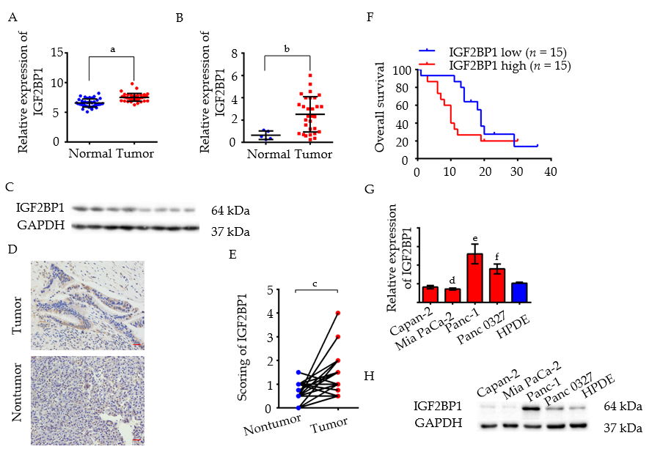
Figure 1 Insulin-like growth factor 2 mRNA-binding protein 1 overexpression correlates with a poor prognosis in pancreatic cancer. A: The mRNA level of insulin-like growth factor 2 mRNA-binding protein 1 (IGF2BP1) was analyzed in the GSE15471 pancreatic cancer dataset; B: The mRNA level of IGF2BP1 was determined by reverse transcription real-time quantitative polymerase chain reaction in 30 cancerous tissues and five normal pancreatic tissues from patients at The Affiliated Cancer Hospital of Zhengzhou University. GAPDH served as the internal reference; C: The protein level of IGF2BP1 was determined by immunoblotting in five cancerous tissues and three normal pancreatic tissues; D: Representative images of IGF2BP1 in pancreatic cancer tissues and their corresponding nontumor tissues by immunohistochemistry. Scale bar = 25 μm (red line); E: Quantitative analysis of the IGF2BP1 expression score in pancreatic cancer tissues and adjacent nontumor tissues; F: Kaplan-Meier analysis of overall survival of patients with pancreatic cancer according to the expression level of IGF2BP1; G-H: The mRNA and protein expression levels of IGF2BP1 in four pancreatic cancer cell lines compared with the expression levels in immortalized human pancreatic ductal epithelial cells (HPDE). GAPDH served as the loading control. All data are expressed as the mean ± standard deviation from three independent experiments at least and P < 0.05 was considered statistically significant. ªP < 0.001 vs normal group; ^{b}P < 0.05 vs normal group; ^{c}P < 0.001 vs nontumor group; ^{d}P < 0.05 vs HPDE, ^{e}P < 0.05 vs HPDE, ^{f}P < 0.05 vs HPDE. HPDE: Human pancreatic ductal epithelial cells; IGF2BP1: Insulin-like growth factor 2 mRNA-binding protein 1.

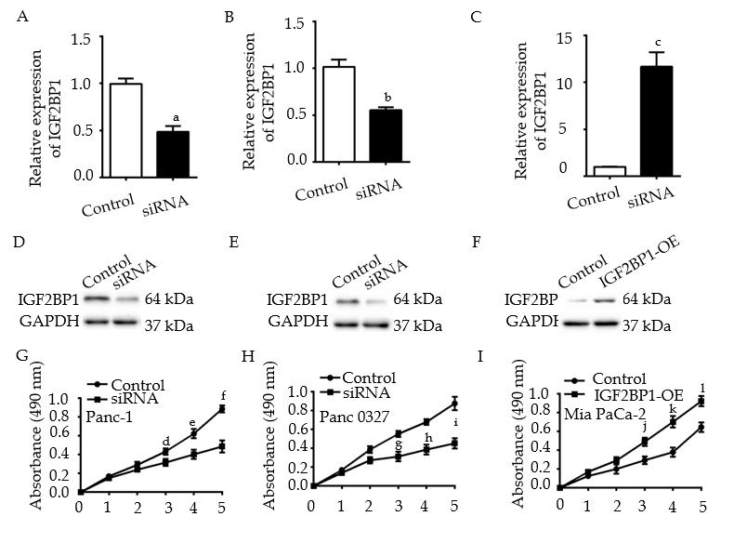
Figure 2 Knockdown of insulin-like growth factor 2 mRNA-binding protein 1 inhibits pancreatic cancer cell proliferation in vitro. A-C: Insulin-like growth factor 2 mRNA-binding protein 1 (IGF2BP1) levels were determined by quantitative reverse transcription polymerase chain reaction analysis 48 h after transfection; D-F: IGF2BP1 levels were determined by Western blot analysis 48 h after transfection; G-I: CCK-8 assays were performed to compare the proliferation of IGF2BP1 knockdown or overexpressing cells vs the control cells. GAPDH served as the loading control. All data are expressed as the mean ± standard deviation from three independent experiments at least and P < 0.05 was considered statistically significant. ªP < 0.05 vs siRNA group; ^{b}P < 0.05 vs normal group; ^{c}P < 0.01 vs IGF2BP1-OE group; ^{d}P < 0.05 vs siRNA at day 3; ^{e}P < 0.01 vs siRNA at day 4; ^{f}P < 0.01 vs siRNA at day 5; ^{g}P < 0.01 vs siRNA at day 3; ^{h}P < 0.01 vs siRNA at day 4; ^{i}P < 0.01 vs siRNA at day 5; ^{j}P < 0.05 vs siRNA at day 3; ^{k}P < 0.01 vs siRNA at day 4; ^{l}P < 0.01 vs siRNA at day 5. IGF2BP1: Insulin-like growth factor 2 mRNA-binding protein 1.

Figure 3 Knockdown of insulin-like growth factor 2 mRNA-binding protein 1 inhibits pancreatic cancer cell proliferation by inducing apoptosis and G1-phase arrest. A-C: Enrichment plots of gene expression signatures in the GSE62165 dataset according to insulin-like growth factor 2 mRNA-binding protein 1 (IGF2BP1) mRNA expression levels; D: Knockdown of IGF2BP1 induced apoptosis in Panc-1 and Panc 0327 cells; E: Overexpression of IGF2BP1 reduced apoptosis in Mia PaCa-2 cells; F-H: Knockdown of IGF2BP1 induced G0/G1 phase arrest in Panc-1 and Panc 0327 cells and overexpression of IGF2BP1 promoted cell cycle progression in Mia PaCa-2 cells. All data are expressed as the mean ± standard deviation from three independent experiments at least and P < 0.05 was considered statistically significant. ªP < 0.01 vs control group of Panc-1 cells; ^{b}P < 0.01 vs control group of Panc 0327 cells; ^{c}P < 0.001 vs control group of Mia PaCa-2 cells; ^{d}P < 0.05 vs control group of Panc-1 cells; ^{e}P < 0.05 vs control group of Panc 0327 cells; ^{f}P < 0.05 vs control group of Mia PaCa-2 cells. IGF2BP1: Insulin-like growth factor 2 mRNA-binding protein 1.

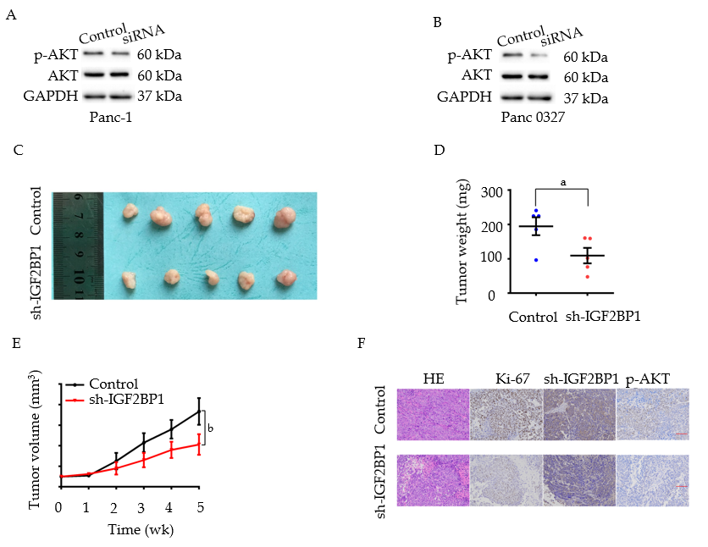
Figure 4 Insulin-like growth factor 2 mRNA-binding protein 1 enhances pancreatic cancer cell proliferation via the AKT signaling pathway. A and B: Western blot analysis of AKT and p-AKT (Ser473) expression in the indicated cells and their corresponding control cells; C: Panc-1 sh-insulin-like growth factor 2 mRNA-binding protein 1 (IGF2BP1) or control cells were subcutaneously injected into BALB/c nude mice for xenograft assays; D-E: The average weights and tumor growth curves of each group; F: Immunohistochemistry staining of the xenograft tumors. Scale bar = 25 μm (red line). P < 0.05 was considered statistically significant. ªP < 0.05 vs control group; ^{b}P < 0.05 vs sh-IGF2BP1 group. IGF2BP1: Insulin-like growth factor 2 mRNA-binding protein 1.

Figure 5 Insulin-like growth factor 2 mRNA-binding protein 1 is a target of miR-494. A: Intersections among miRNA target prediction algorithms; B: Pancreatic cancer tissues displayed significantly lower miR-494 and miR-326 levels than the matched adjacent nontumor tissues; C: A schematic diagram of miR-494 binding sites in the 3’ untranslated region of insulin-like growth factor 2 mRNA-binding protein 1 (IGF2BP1) from TargetScan; D: MiR-494 mimics or inhibitors were transfected into Panc-1 and Panc 0327 cells, respectively, and miR-494 expression was determined by quantitative reverse transcription polymerase chain reaction (RT-qPCR). U6 served as the internal reference; E-F: IGF2BP1 expression was determined by RT-qPCR after transfection in Panc-1 and Panc 0327 cells. GAPDH served as the internal reference; G-H: The relative luciferase activity was measured in Panc-1 and Panc 0327 cells after cotransfection. All data are expressed as the mean ± standard deviation from three independent experiments at least and P < 0.05 was considered statistically significant. ªP < 0.05 vs normal group, ^{b}P < 0.001 vs normal group; ^{c}P < 0.001 vs control group of Panc-1 cells; ^{d}P < 0.001 vs control group of Panc 0327 cells; ^{e}P < 0.01 vs control group of Panc-1 cells; ^{f}P < 0.01 vs control group of Panc 0327 cells; ^{g}P < 0.01 vs control group; ^{h}P < 0.05 vs control group; ^{i}P < 0.05 vs control group; ^{j}P < 0.01 vs control group; ^{k}P < 0.05 vs WT group; ^{l}P < 0.01 vs WT group; ^{m}P < 0.01 vs WT group; ^{n}P < 0.01 vs WT group. IGF2BP1: Insulin-like growth factor 2 mRNA-binding protein 1; 3’-UTR: 3’-untranslated region; Wt: Wild-type; Mut: Mutated.

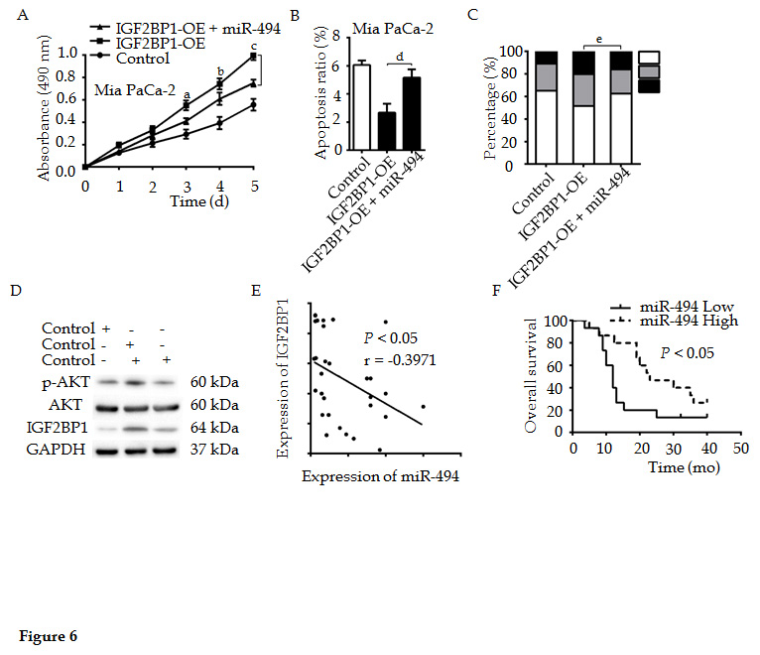
Figure 6 MiR-494 reexpression partly abrogates the oncogenic effect of insulin-like growth factor 2 mRNA-binding protein 1 in pancreatic cancer. A: Enhanced cell viability of Mia PaCa-2 cells due to insulin-like growth factor 2 mRNA-binding protein 1 (IGF2BP1) overexpression was partly reduced following the reexpression of miR-494, which was detected by CCK-8 assays; B: Cell apoptosis was analyzed by flow cytometry when IGF2BP1-overexpressing Mia PaCa-2 cells were cotransfected with miR-494 mimics or their corresponding controls; C: The cell cycle was analyzed by flow cytometry when IGF2BP1-overexpressing Mia PaCa-2 cells were co-transfected with miR-494 mimics or control; D: Western blot analysis of AKT and p-AKT (Ser473) expression in the indicated cells and their corresponding control group; E: Correlations between the expression of miR-494 and IGF2BP1 in 30 pancreatic cancer specimens were determined by Pearson's correlation analysis; F: Kaplan-Meier analysis indicated that low miR-494 expression predicts a poorer overall survival rate than high miR-494 expression. All data are expressed as the mean ± standard deviation from three independent experiments at least and P < 0.05 was considered statistically significant. ªP < 0.05 vs IGF2BP1-OE + miR-494 group at day 3; ^{b}P < 0.05 vs IGF2BP1-OE + miR-494 group at day 4; ^{c}P < 0.05 vs IGF2BP1-OE + miR-494 group at day 5; ^{d}P < 0.01 vs IGF2BP1-OE + miR-494 group; ^{e}P < 0.05 vs IGF2BP1-OE + miR-494 group. IGF2BP1: Insulin-like growth factor 2 mRNA-binding protein 1; 3’-UTR: 3’-untranslated region; Wt: Wild-type; Mut: Mutated.

