Name of Journal: World Journal of Clinical Cases
Manuscript NO: 86493
Manuscript Type: CASE REPORT

Successful resolution of gastric perforation caused by a severe complication of pancreatic walled-off necrosis: A case report

Noh BG et al. Resolution of pancreatic walled-off necrosis

Byeong Gwan Noh, Myunghee Yoon, Young Mok Park, Hyung-Il Seo, Suk Kim, Seung Baek Hong, Jae Kyun Park, Moon Won Lee

Byeong Gwan Noh, Myunghee Yoon, Young Mok Park, Hyung-Il Seo, Jae Kyun Park, Department of Surgery, Pusan National University School of Medicine, Biomedical Research Institute, Pusan National University Hospital, Busan 49241, South Korea

Suk Kim, Seung Baek Hong, Department of Radiology, Pusan National University School of Medicine, Biomedical Research Institute, Pusan National University Hospital, Busan 49241, South Korea

Moon Won Lee, Department of Internal Medicine, Pusan National University School of Medicine, Biomedical Research Institute, Pusan National University Hospital, Busan 49241, South Korea

Author contributions: Noh BG, Yoon M, Park YM, Seo HI, Kim S, Hong SB, Park JK, and Lee MW contributed to the acquisition of data for this study; Noh BG analyzed the data and wrote the manuscript; Yoon M designed the case report; and all authors have read and approved the final manuscript.

Supported by the Clinical Research Grant from Pusan National University Hospital in 2023.

Corresponding author: Myunghee Yoon, MD, PhD, Professor, Department of Surgery, Pusan National University School of Medicine, Biomedical Research Institute, Pusan National University Hospital, 179 Gudeok-Ro, Seo-Gu, Busan 49241, South Korea. ymh@pusan.ac.kr

Received: June 21, 2023
Revised: August 11, 2023
Accepted: August 23, 2023
Published online:

Abstract
BACKGROUND
Pancreatic walled-off necrosis (WON) rarely causes critical gastric necrosis and perforation, which may develop when pancreatic WON squashes against the stomach. The Atlanta 2012 guidelines were introduced for acute pancreatitis and its related clinical entities. However, there are few reported cases describing the clinical course and resolution of pancreatic WON.

CASE SUMMARY
We report the case of a 45-year-old man who presented to the urgent emergency department with gastric perforation caused by a severe complication of pancreatic WON on computed tomography. The patient underwent an emergency distal pancreatectomy, splenectomy, and gastric wedge resection. Postoperative findings showed re-perforation of the gastric wall at a previously resected margin. Furthermore, endoscopic examination revealed an ulcerative area with a defect in the fundus. After diagnostic endoscopy, endoscopic vacuum-assisted closure was performed, and continuous suction was transferred over all tissues in contact with the sponge surface. The patient recovered without any further complications and was discharged in good condition at postoperative week 8. No recurrence occurred during the 6-mo follow-up period.

CONCLUSION
When managing a patient with serious gastric perforation complicated by pancreatic WON, a multidisciplinary treatment approach should be considered.

Key Words: Acute necrotizing pancreatitis; Endoscopy; Vacuum assisted closure; Gastric rupture; Surgery; Case report

Noh BG, Yoon M, Park YM, Seo HI, Kim S, Hong SB, Park JK, Lee MW. Successful resolution of gastric perforation caused by a severe complication of pancreatic walled-off necrosis: A case report. World J Clin Cases 2023; In press

Core Tip: Pancreatic walled-off necrosis (WON) rarely causes critical gastric necrosis and perforation. Cases of successful resolution of gastric perforation complicated by pancreatic WON are hardly encountered. Due to their rarity, discussing each clinical experience is necessary.

INTRODUCTION
Pancreatic walled-off necrosis (WON) developing in the course of necrotizing pancreatitis occurs 4 or more weeks after its onset^{[1]}. Although systemic inflammation commonly wanes 14 d after the onset of symptoms, infected necrosis progresses in approximately 30% of patients with necrotizing pancreatitis^{[2]}. Gastric complication related to pancreatic WON is a rare complication of acute pancreatitis. To date, cases of gastric perforation, a serious complication of pancreatic WON, are hardly encountered and similar cases to ours are few^{[3-5]}. Successful resolution in cases of gastric perforation complicated by pancreatic WON is hardly seen. Due to their rarity, discussing each clinical experience is necessary. Moreover, we are eager that clinicians will gain a better understanding of the clinical course of gastric complications related to WON.

CASE PRESENTATION
Chief complaints
A 45-year-old man, drinking at least 3 times a week for 3 mo due to social and personal issues, presented with abdominal pain for 21 d.

History of present illness
The patient reported no present illness.

History of past illness
The patient reported no past illness.

Personal and family history
The patient reported no relevant medical or family history.

Physical examination
Upon presentation, the patient’s vital signs were stable. However, he showed paleness. Physical examination revealed signs of peritoneal irrigation such as a distended abdomen with rigidity and tenderness in the epigastric region.

Laboratory examinations
Table 1 reveals biochemistry values upon admission.

Imaging examinations
Contrast-enhanced computed tomography (CT) showed, adjacent to the huge WON, wall defect, demonstrating a perforation in the stomach fundus and splenic infarction. Contrast-enhanced CT scanning demonstrated the huge WON at the intra- and extrapancreatic areas (Figure 1A and B).

FINAL DIAGNOSIS
Based on the preoperative CT and histopathology results, the final diagnosis was gastric perforation caused by a severe complication of pancreatic WON.

TREATMENT
Ceftriaxone and metronidazole were initially administered. After identifying the organisms, piperacillin-tazobactam, fluconazole, and vancomycin were administered after consultation with infectious disease specialists. Postoperative serum amylase and lipase levels were within the normal range. Drain fluid amylase was 1052 U/L at postoperative day (POD) 1 and 17.6 U/L at POD 7. After necrosectomy, the patient received supportive medical treatment, including parenteral nutrition and diet, starting on POD 7. Thereafter, the patient suddenly experienced unsuspected abdominal discomfort at POD 18. Follow-up CT (Figure 1C and D) and endoscopy revealed a 3-cm gastric perforation at the anastomotic site (Figure 2A). Reoperation was not an option due to severe inflammation. Based on discussions with gastroenterologists, endoscopic vacuum-assisted closure (EVAC) was performed, and continuous suction was applied to the perforated site through a nasogastric drainage tube with a polyurethane sponge (KCI Inc., San Antonio, TX, United States) (Figure 2B). Surgical drain was removed due to maintaining a negative pressure on sponge. Drain fluid amylase level was 3.0 U/L and had an output of < 20 mL. EVAC treatment was continued for 3 wk with sponge exchange every 72 h until the wound cavity had healed (Figure 2C and D). Follow-up upper gastrointestinal series showed no contrast leakage from the stomach (Figure 2E). The patient was discharged in good condition at postoperative week 8.

OUTCOME AND FOLLOW-UP
At the 3-mo follow-up, CT showed significant improvement (Figure 1E and F). The patient was followed up as an outpatient for 6 mo without showing recurrence or readmission event including glucose control, and is doing well at work after getting a job.

DISCUSSION
The Atlanta Symposium (2012) introduced guidelines to globalize the definitions of acute pancreatitis and related clinical entities^{[6]}. Of all the entities, necrotizing pancreatitis most commonly manifests as necrosis involving both the pancreatic and peripancreatic tissues^{[7]}. Pancreatic necrosis constitutes substantial additional morbidity, with mortality rates as high as 20%-30%^{[8]}. Surgical volumes of interventions have significantly decreased over the years, as minimally invasive strategies have proven effective^{[9]}. However, emergency surgery, irrespective of time, is indicated for cases of gastrointestinal perforation caused by necrotizing pancreatitis^{[10]}. Pancreatic WON is a mature, encapsulated, acute necrotic collection with a well-defined inflammatory wall observed on contrast-enhanced CT. Our patient showed a heterogeneous, fully encapsulated collection with small air pockets inside the cyst and near the peritoneal space. Conventional management of infected WON depends on the availability of expertise and severity of the comorbid medical status. Endoscopic drainage is a commonly used procedure in patients without gastrointestinal perforation. However, there is a high complication rate and longer hospital stay associated with drainage procedures^{[11]}. From the point of view of surgical management of necrotizing pancreatitis, a previous report has emphasized that formal resection should be avoided to lower the event of bleeding and fistula formation and protect normal tissue. Thus, repeated debridements with continuous drainage were commonly performed. However, those procedures could be usually associated with immediate and long-term complications such as gastrointestinal perforation, infection, organ failure, and fistula. Morbidity rates of 34%-95% have been reported^{[7,9]}. In our case, we initially performed formal distal pancreatectomy and adjacent necrotic tissue resection with surgical drainage (Figure 3). Cholecystectomy was not performed because there was no evidence of gallstone pancreatitis. Regarding gastric perforation with pancreatic WON, there are no surgical guidelines due to the rarity of this disease entity. We suggest that formal resection would be a better procedure for removing necrotic tissue as much as possible without further surgical debridement. Reperforation occurred during postoperative care with proper conservative care, including nutritional support and antibacterial therapy with antifungal agents. In terms of complications, suitable treatment in patients with gastric perforation requires collaboration among surgeons, radiologists, and gastroenterologists. Endoscopic closure techniques are promising alternatives to surgical treatment^{[12]}. A retrospective study including 71 patients compared stent placement with EVAC for nonsurgical closure of intrathoracic leakage. The overall closure rate was higher in the EVAC group (84.4%) than in the stent group (53.8%). EVAC appears to be an effective alternative to other methods for treating anastomotic leaks^{[13]}. After diagnostic endoscopy, the sponge was placed at the leakage site and released using a pusher. Our patient changed sponges seven times over 3 wk. After successful resolution, the patient was initiated on an oral diet without complications. Clinical cases showing resolution of pancreatic WON with gastric perforation is hardly reported. Therefore, discussing multidisciplinary clinical approaches is essential.

CONCLUSION
Encountering a patient with serious gastric perforation complicated by pancreatic WON, formal distal pancreatectomy, adjacent necrotic tissue resection, and surgical drainage with a multidisciplinary treatment approach could be considerable options for improving the therapeutic outcome.

REFERENCES
1 Beger HG, Rau BM. Severe acute pancreatitis: Clinical course and management. World J Gastroenterol 2007; 13: 5043-5051 [PMID: 17876868 DOI: 10.3748/wjg.v13.i38.5043]
2 Besselink MG, van Santvoort HC, Boermeester MA, Nieuwenhuijs VB, van Goor H, Dejong CH, Schaapherder AF, Gooszen HG; Dutch Acute Pancreatitis Study Group. Timing and impact of infections in acute pancreatitis. Br J Surg 2009; 96: 267-273 [PMID: 19125434 DOI: 10.1002/bjs.6447]
3 Rieger A, Bachmann J, Schulte-Frohlinde E, Burzin M, Nährig J, Friess H, Martignoni ME. Total gastric necrosis subsequent to acute pancreatitis. Pancreas 2012; 41: 325-327 [PMID: 22343979 DOI: 10.1097/MPA.0b013e318227b04b]
4 Madhyastha SP, Banda GR, Acharya RV, Balaraju G. Spontaneous rupture of pancreatic pseudocyst into the stomach. BMJ Case Rep 2021; 14 [PMID: 34301710 DOI: 10.1136/bcr-2021-244839]
5 Bansal A, Gupta P, Singh H, Samanta J, Mandavdhare H, Sharma V, Sinha SK, Dutta U, Kochhar R. Gastrointestinal complications in acute and chronic pancreatitis. JGH Open 2019; 3: 450-455 [PMID: 31832543 DOI: 10.1002/jgh3.12185]
6 Banks PA, Bollen TL, Dervenis C, Gooszen HG, Johnson CD, Sarr MG, Tsiotos GG, Vege SS; Acute Pancreatitis Classification Working Group. Classification of acute pancreatitis--2012: revision of the Atlanta classification and definitions by international consensus. Gut 2013; 62: 102-111 [PMID: 23100216 DOI: 10.1136/gutjnl-2012-302779]
7 Freeman ML, Werner J, van Santvoort HC, Baron TH, Besselink MG, Windsor JA, Horvath KD, vanSonnenberg E, Bollen TL, Vege SS; International Multidisciplinary Panel of Speakers and Moderators. Interventions for necrotizing pancreatitis: summary of a multidisciplinary consensus conference. Pancreas 2012; 41: 1176-1194 [PMID: 23086243 DOI: 10.1097/MPA.0b013e318269c660]
8 Yang Y, Zhang Y, Wen S, Cui Y. The optimal timing and intervention to reduce mortality for necrotizing pancreatitis: a systematic review and network meta-analysis. World J Emerg Surg 2023; 18: 9 [PMID: 36707836 DOI: 10.1186/s13017-023-00479-7]
9 Kokosis G, Perez A, Pappas TN. Surgical management of necrotizing pancreatitis: an overview. World J Gastroenterol 2014; 20: 16106-16112 [PMID: 25473162 DOI: 10.3748/wjg.v20.i43.16106]
10 El Boukili I, Boschetti G, Belkhodja H, Kepenekian V, Rousset P, Passot G. Update: Role of surgery in acute necrotizing pancreatitis. J Visc Surg 2017; 154: 413-420 [PMID: 29113713 DOI: 10.1016/j.jviscsurg.2017.06.008]
11 Hookey LC, Debroux S, Delhaye M, Arvanitakis M, Le Moine O, Devière J. Endoscopic drainage of pancreatic-fluid collections in 116 patients: a comparison of etiologies, drainage techniques, and outcomes. Gastrointest Endosc 2006; 63: 635-643 [PMID: 16564865 DOI: 10.1016/j.gie.2005.06.028]
12 Rogalski P, Daniluk J, Baniukiewicz A, Wroblewski E, Dabrowski A. Endoscopic management of gastrointestinal perforations, leaks and fistulas. World J Gastroenterol 2015; 21: 10542-10552 [PMID: 26457014 DOI: 10.3748/wjg.v21.i37.10542]
13 Brangewitz M, Voigtländer T, Helfritz FA, Lankisch TO, Winkler M, Klempnauer J, Manns MP, Schneider AS, Wedemeyer J. Endoscopic closure of esophageal intrathoracic leaks: stent versus endoscopic vacuum-assisted closure, a retrospective analysis. Endoscopy 2013; 45: 433-438 [PMID: 23733727 DOI: 10.1055/s-0032-1326435]

Footnotes
Informed consent statement: Informed written consent was obtained from the patient for publication of this report and any accompanying images.

Conflict-of-interest statement: The authors declare that they have no conflict of interest to disclose.

CARE Checklist (2016) statement: The authors have read the CARE Checklist (2016), and the manuscript was prepared and revised according to the CARE Checklist (2016).

Open-Access: This article is an open-access article that was selected by an in-house editor and fully peer-reviewed by external reviewers. It is distributed in accordance with the Creative Commons Attribution NonCommercial (CC BY-NC 4.0) license, which permits others to distribute, remix, adapt, build upon this work non-commercially, and license their derivative works on different terms, provided the original work is properly cited and the use is non-commercial. See: https://creativecommons.org/Licenses/by-nc/4.0/

Provenance and peer review: Unsolicited article; Externally peer reviewed.
Peer-review model: Single blind

Peer-review started: June 21, 2023
First decision: July 28, 2023
Article in press:

Specialty type: Surgery
Country/Territory of origin: South Korea
Peer-review report’s scientific quality classification
Grade A (Excellent): 0
Grade B (Very good): B
Grade C (Good): C, C, C
Grade D (Fair): 0
Grade E (Poor): E

P-Reviewer: Angst E, United States; Cabezuelo AS, Spain; Giacomelli L, Italy S-Editor: Chen YL L-Editor: Wang TQ P-Editor: Chen YL
Figure Legends
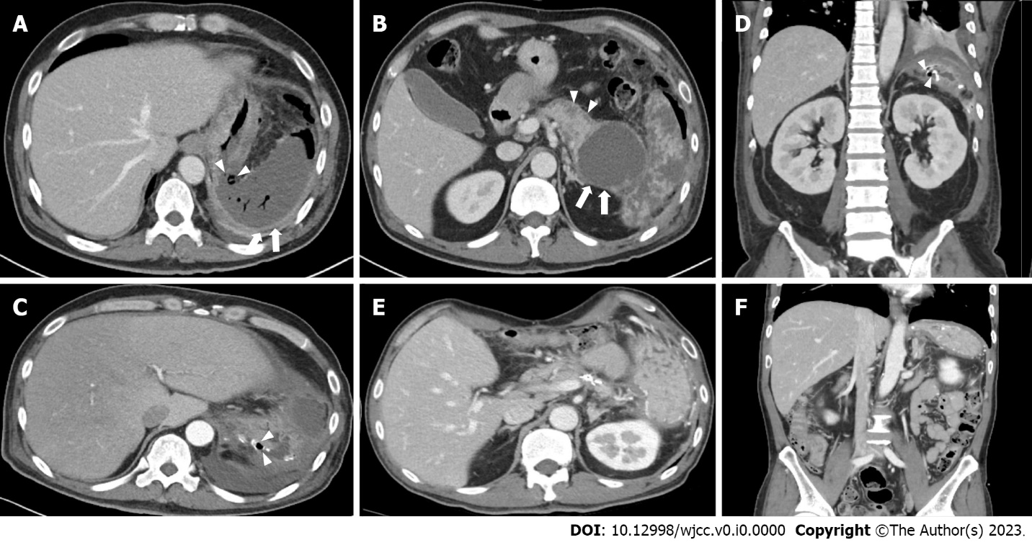
Figure 1 Abdominal contrast-enhanced computed tomography images in a 45-year-old man. A: Adjacent to the huge walled-off necrosis, there is a wall defect, demonstrating perforation of the stomach fundus (arrowheads) and splenic infarction (white arrow); B: Contrast-enhanced computed tomography (CT) scanning demonstrated the huge walled-off necrosis at the intra- (arrowheads) and extrapancreatic areas (white arrows); C: Coronary view of portal venous phase CT on postoperative day 18 shows significant wall defect on previous staple line (arrowheads); D: Axial view of contrast-enhanced CT image; E and F: Axial and coronary views of portal venous phase CT at the 3-mo follow-up. CT images show improved process of loculated fluid collection with air bubble at pancreatic bed and left subphrenic space.
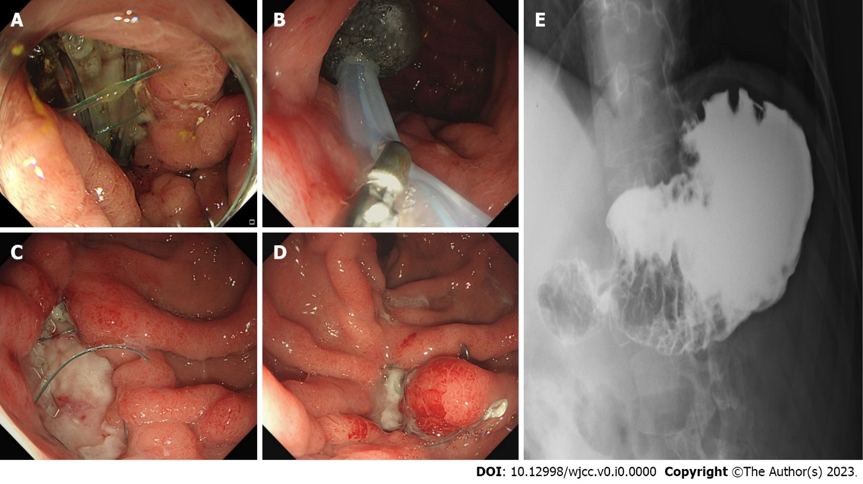
Figure 2 Treatment. A: 45-year-old man is diagnosed with a 3-cm gastric perforation at the anastomosis site on postoperative day 18; B: A polyurethane sponge is inserted into the cavity of the anastomotic leak with nasogastric continuous suction; C: The perforation site is downsized with granulation tissue during the fourth endoscopic vacuum-assisted closure (EVAC); D: The cavity is closed after seven EVAC procedures; E: Follow-up upper gastrointestinal radiography shows no contrast leakage from the stomach.

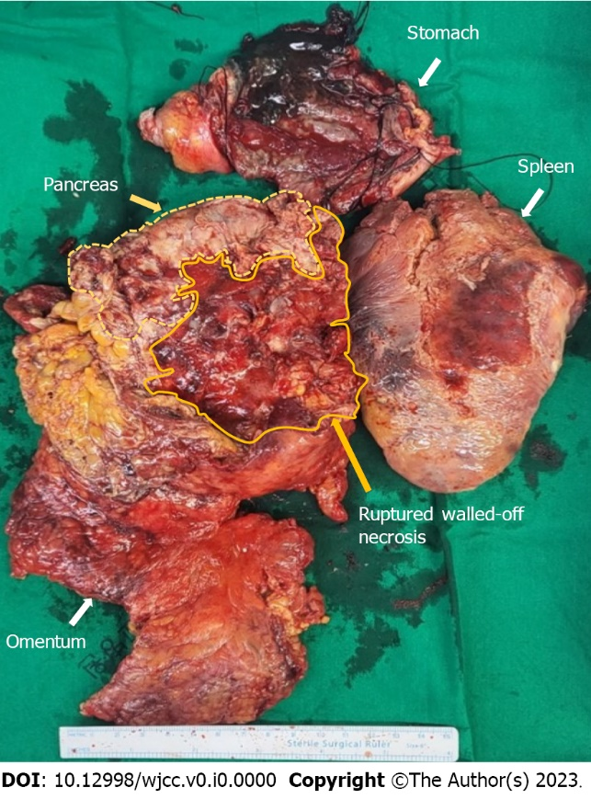
Figure 3 Surgical specimen after distal pancreatectomy, splenectomy, and gastric wedge resection. Note that the pancreatic walled-off necrosis is ruptured during operation. Each specimen is resected separately.

Table 1 Biochemistry values upon admission
Value | Unit | Reference range | On admission
White blood cell count | 10⁹/uL | 3.8-11.0 | 12.78
Neutrophil count | 10⁹/uL | 1.5-7.0 | 9.25
Hemoglobin | g/dL | 13.5-17.5 | 8.40
Hematocrit | % | 39.0-53.0 | 25.00
Platelet count | 10⁹/uL | 140-420 | 697.00
C-reactive protein | mg/dL | 0-0.5 | 9.24
Lactate dehydrogenase | U/L | 135-225 | 274.00
Lactic acid | mmol/L | 0.7-2.5 | 2.20
Sodium | mmol/L | 138-148 | 119.00
Potassium | mmol/L | 3.5-5.3 | 3.69
Serum amylase | U/L | 36-128 | 29.30
Serum lipase | U/L | 22-51 | 80.10

