Name of Journal: World Journal of Clinical Cases
Manuscript NO: 71903
Manuscript Type: CASE REPORT

Middle thyroid vein tumor thrombus in metastatic papillary thyroid microcarcinoma: A case report and review of literature

Gui Y et al. Vein tumor thrombus in thyroid carcinoma

Yan Gui, Jun-Yi Wang, Xu-Dong Wei

Yan Gui, Department of Otorhinolaryngology Head and Neck Surgery, The First Hospital of Lanzhou University, Lanzhou 730000, Gansu Province, China

Jun-Yi Wang, Department of Thyroid and Neck Tumor, Key Laboratory of Cancer Prevention and Therapy of Tianjin, Tianjin Medical University Cancer Institute and Hospital, National Clinical Research Center for Cancer, Tianjin 300060, China

Xu-Dong Wei, Department of Otorhinolaryngology Head and Neck Surgery, Gansu Provincial Hospital, Lanzhou 730000, Gansu Province, China

Author contributions: Gui Y is responsible for reviewing literature and writing article; Wang JY is responsible for surgery and collecting clinical data; Wei XD is responsible for providing overall thinking.

Corresponding author: Jun-Yi Wang, MD, PhD, Associate Chief Physician, Department of Thyroid and Neck Tumor, Key Laboratory of Cancer Prevention and Therapy of Tianjin, Tianjin Medical University Cancer Institute and Hospital, National Clinical Research Center for Cancer, West Huan-Hu Rd, Ti Yuan Bei, Hexi District, Tianjin 300060, China. jzxsya@163.com

Received: November 3, 2021
Revised: January 7, 2022
Accepted: February 23, 2022
Published online:

Abstract
BACKGROUND
Although papillary thyroid microcarcinoma (PTMC) is not considered a threatening tumor, in some cases, it can be aggressive. Metastatic thrombosis of papillary thyroid carcinoma, follicular thyroid carcinoma, Hürthle cell carcinoma, poorly differentiated thyroid carcinoma and anaplastic thyroid carcinoma have been reported in the literature, but there have been no reports about PTMC.

CASE SUMMARY
A 45-year-old woman presented with a thyroid mass and thrombosis in a middle thyroid vein during a physical examination. She had no symptoms, and the physical examination showed no positive signs. Subsequent ultrasonography-guided fine-needle aspiration biopsy results indicated an atypical lesion of ambiguous significance, with some actively growing cells (TBSRTC III) and the BRAF^{V600E} mutation not present. This patient underwent left thyroidectomy, isthmus lobectomy, prophylactic central lymph node dissection and thromboembolectomy. Postoperative pathology showed papillary microcarcinoma of the left thyroid, and the thrombus in the middle thyroid vein was a tumor thrombus.

CONCLUSION
Middle thyroid vein tumor thrombus is an extremely rare condition in PTMC, but it does exist. Lobectomy and thromboembolectomy may be an option for patients with thrombi in the middle vein of the thyroid, and we strongly suggest close follow-up of these patients.

Key Words: Thyroid neoplasms; Papillary carcinoma; Thyroid vein; Venous thrombosis; Surgery; Case report

Gui Y, Wang JY, Wei XD. Middle thyroid vein tumor thrombus in metastatic papillary thyroid microcarcinoma: A case report and review of literature. World J Clin Cases 2022; In press

Core Tip: We report the case of a 45-year-old woman presented with a thyroid mass and thrombosis in a middle thyroid vein during a physical examination. This patient underwent left thyroidectomy, isthmus lobectomy, prophylactic central lymph node dissection and thromboembolectomy. Postoperative pathology showed papillary microcarcinoma of the left thyroid, and the thrombus in the middle thyroid vein was a tumor thrombus. Middle thyroid vein tumor thrombus is an extremely rare condition in papillary thyroid microcarcinoma, but it does exist. Lobectomy and thromboembolectomy may be an option for patients with thrombi in the middle vein of the thyroid, and we strongly suggest close follow-up of these patients.
INTRODUCTION
Papillary thyroid microcarcinoma (PTMC) is a variant of papillary thyroid carcinoma (PTC) that is defined by the World Health Organization as less than or equal to 1 cm in diameter^{[1]}. Although PTMC is not considered a threatening tumor, in some cases, it can be aggressive. Metastatic thrombosis of PTC, follicular thyroid carcinoma (FTC), Hürthle cell carcinoma (HCC), poorly differentiated thyroid carcinoma (PDTC) and anaplastic thyroid carcinoma (ATC) have been reported in the literature, but there have been no reports about PTMC. We report the case of a 45-year-old woman with a middle thyroid vein thrombus. She underwent successful resection, and postoperative pathology showed papillary microcarcinoma of the left thyroid and a tumor thrombus in the middle thyroid vein. We reviewed the literature to identify reports of tumor thrombus and distant metastasis of PTMC.

CASE PRESENTATION
Chief complaints
A 45-year-old woman presented with a thyroid mass (Figure 1) and thrombosis (Figure 2) in a middle thyroid vein during a physical examination.

History of present illness
The patient came to hospital because of thyroid mass found in physical examination 3 mo before. She had no symptoms. The patient requested surgery because of the stress.

History of past illness
The patient was health in the past.

Personal and family history
The patient had no family history of thyroid carcinoma and no history of radiation exposure in childhood.

Physical examination
The physical examination showed no positive signs.

Laboratory examinations
Laboratory tests showed that triiodothyronine, free triiodothyronine, thyroxine, thyroglobulin, and thyroid-stimulating hormone levels were within the normal limits.

Imaging examinations
A solid nodule in the left lobe of the thyroid by ultrasound examination. Ultrasound examination revealed a medially echoic mass in the middle thyroid vein.

Ultrasonography-guided fine-needle aspiration biopsy
Subsequent ultrasonography-guided fine-needle aspiration biopsy results indicated an atypical lesion of ambiguous significance, with some actively growing cells (TBSRTC III) and the BRAF^{V600E} mutation not present.

FINAL DIAGNOSIS
PTMC (pT1aN0M?). Middle thyroid vein tumor thrombus.

TREATMENT
The patient and her family were fully informed of the advantages and disadvantages of total thyroidectomy and lobectomy prior to surgery. The patient declined to undergo a total thyroidectomy. Intraoperative exploration showed that the mass was located in the middle and upper left lobe of the thyroid gland, adjacent to the capsule, but the capsule was not invaded. There was a round mass in the middle thyroid vein with a diameter of 0.8 cm. The middle thyroid vein was ligated distal to the mass and cut off. Rapid freezing pathological examination showed that both the left thyroid mass and the left middle thyroid vein mass were carcinomas. These results were communicated to the patient’s family, and total thyroidectomy was again declined. Therefore, the patient underwent left thyroidectomy, isthmus lobectomy and prophylactic central lymph node dissection. Postoperative pathology showed papillary microcarcinoma of the left thyroid (single lesion, maximum diameter of 0.9 cm) (Figure 3), and the thrombus in the middle thyroid vein was a tumor (diameter of 0.6 cm) (Figure 4).

OUTCOME AND FOLLOW-UP
No metastases were observed in the central lymph nodes. Initial TSH suppression was treated with 75 μg levothyroxine. Three months later, ¹⁸F-FDG positron emission tomography-computed tomography scanning did not detect local recurrence or distant metastasis (Figure 5). No complications occurred. Fearing recurrence and metastasis, the patient underwent genetic testing at a third-party testing facility. No genetic variation was detected in BRAF^{V600}, BRAF^{K601}, TERT, KRAS, NRAS, EIFIAX or RET. No gene fusion mutations were detected in PAX8/PPARγ, RET/PTC1, or RET/PTC3. Six months after surgery, the patient had no obvious discomfort, and no tumor recurrence or distant metastasis was observed. The patient took 50 μg levothyroxine once daily, and the serum TSH was 0.49 mIU/L.

DISCUSSION
Thyroid carcinoma that causes tumor thrombus is rare. Forty-seven cases have been reported in the English literature since May 1, 2021. The details of these cases are shown in Table 1. The patients included 12 males and 35 females; their ages ranged from 26 years to 84 years, and the median age was 62 years. The location of the thrombus included the brachiocephalic vein, internal jugular vein, superior vena cava, subclavian vein, innominate vein, middle cerebral artery, pulmonary vein, external jugular veins, axillary vein, right atrium, ascending aorta, pulmonary artery, valvular endocardium and right ventricle. In almost all cases, the thrombus was located in the large vessels. Our patient had a thrombus in the middle thyroid vein, which may represent early-stage disease. Early-stage diagnosis and treatment are of great significance to patient prognosis.
Pathological types included PTC, FTC, HCC, ATC and PDTC. Ten of these cases were PTC (one of the follicular variants of PTC, FVPTC), 24 were FTC, 3 were HCC, 1 was PDTC, 5 were ATC, 1 was ATC with HCC and 3 were not described in the literature. Most of these case reports did not describe the size of the thyroid lesion. From the 12 cases with size data available, the maximum diameter of the lesions ranged from 2 cm to 17 cm (the average was 6.6 ± 5.2 cm). Our patient had PTMC (the maximum diameter was 0.8 cm), which had not been previously reported. Middle thyroid vein tumor thrombus in metastatic PTMC is extremely rare. It is necessary to consider how to perform TNM staging for such cases. Kawano et al^{[34]} suggested setting management criteria. Unfortunately, there are still no related standards or guidelines for such criteria. Here, we emphasize the importance of aggressive treatment and close follow-up for these patients. Tumor cells are exposed to the circulatory system in this clinical presentation, and embolus shedding may also cause serious complications, such as pulmonary embolism. While there is a lack of objective clinical data to support this hypothesis, we will continue to monitor future occurrences.
In terms of treatment for tumor thrombi in metastatic PTMC, there is also no standard. Treatments include surgery, RAI therapy, external beam radiation therapy and chemotherapy. Most patients choose surgery combined with radioiodine therapy. Kavanal et al^{[41]} reported that ¹³¹I therapy as a single modality may be considered for a subset of patients who have been rigorously screened. If the pathologic type is PDTC with no surgical opportunity and refractory to radioactive iodine, targeted therapy such as tyrosine kinase inhibitors may be another choice for this subset of patients^{[42]}.
Overall, we have demonstrated a middle thyroid vein tumor thrombus in PTMC. Our patient will continue to attend follow-up appointments. In the absence of other risk factors, lobectomy and thromboembolectomy may be an option for patients with thrombi in the middle vein of the thyroid. We strongly suggest a close follow-up of these patients.

CONCLUSION
Middle thyroid vein tumor thrombus is an extremely rare condition in PTMC, but it does exist. Lobectomy and thromboembolectomy may be an option for patients with thrombi in the middle vein of the thyroid, and we strongly suggest close follow-up of these patients.

ACKNOWLEDGEMENTS
We thank the thyroid and neck tumor specialist, ultrasound specialist and pathologist of the Tianjin Medical University Cancer Institute and Hospital for their valuable help.

REFERENCES
1 Rosai J, Fagin JA, Piana S, Albores Saavedra J, Franssila KO, Prasad ML. Papillary thyroid carcinoma. In: Lloyd R, Osamura R, Klöppel G, Rosai J. WHO classification of tumours of endocrine organs. Lyon: IARC, 2017: 81-91
2 Banerjee AK, Chopra JS. Cerebral embolism from a thyroid carcinoma. Report of a case. Arch Neurol 1972; 27: 186-187 [PMID: 5040636 DOI: 10.1001/archneur.1972.00490140090014]
3 Thompson NW, Brown J, Orringer M, Sisson J, Nishiyama R. Follicular carcinoma of the thyroid with massive angioinvasion: extension of tumor thrombus to the heart. Surgery 1978; 83: 451-457 [PMID: 635781]
4 Perez D, Brown L. Follicular carcinoma of the thyroid appearing as an intraluminal superior vena cava tumor. Arch Surg 1984; 119: 323-326 [PMID: 6696626 DOI: 10.1001/archsurg.1984.01390150061014]
5 Sirota DK. Axillary vein thrombosis as the initial symptom in metastatic papillary carcinoma of the thyroid. Mt Sinai J Med 1989; 56: 111-113 [PMID: 2747668]
6 Thomas S, Sawhney S, Kapur BM. Case report: bilateral massive internal jugular vein thrombosis in carcinoma of the thyroid: CT evaluation. Clin Radiol 1991; 43: 433-434 [PMID: 2070592 DOI: 10.1016/s0009-9260(05)80580-x]
7 Onaran Y, Terzioğlu T, Oğuz H, Kapran Y, Tezelman S. Great cervical vein invasion of thyroid carcinoma. Thyroid 1998; 8: 59-61 [PMID: 9492155 DOI: 10.1089/thy.1998.8.59]
8 Bussani R, Silvestri F. Neoplastic thrombotic endocarditis of the tricuspid valve in a patient with carcinoma of the thyroid. Report of a case. Pathol Res Pract 1999; 195: 121-124 [PMID: 10093832 DOI: 10.1016/S0344-0338(99)80084-3]
9 Wiseman O, Preston PG, Clarke JM. Presentation of thyroid carcinoma as a thrombosed external jugular vein, with intraluminal tumour thrombus in the great veins. Eur J Surg Oncol 2000; 26: 816-817 [PMID: 11087652 DOI: 10.1053/ejso.2000.1011]
10 Koike E, Yamashita H, Watanabe S, Yamashita H, Noguchi S. Brachiocephalic vein thrombus of papillary thyroid cancer: report of a case. Surg Today 2002; 32: 59-62 [PMID: 11871819 DOI: 10.1007/s595-002-8114-7]
11 Yoshimura M, Kawamoto A, Nakasone K, Kakizaki D, Tsutsui H, Serizawa H, Abe K. Gallium-67 accumulation to the tumor thrombus in anaplastic thyroid cancer. Ann Nucl Med 2003; 17: 689-691 [PMID: 14971612 DOI: 10.1007/BF02984976]
12 Panzironi G, Rainaldi R, Ricci F, Casale A, De Vargas Macciucca M. Gray-scale and color Doppler findings in bilateral internal jugular vein thrombosis caused by anaplastic carcinoma of the thyroid. J Clin Ultrasound 2003; 31: 111-115 [PMID: 12539254 DOI: 10.1002/jcu.10132]
13 Gross M, Mintz Y, Maly B, Pinchas R, Muggia-Sullam M. Internal jugular vein tumor thrombus associated with thyroid carcinoma. Ann Otol Rhinol Laryngol 2004; 113: 738-740 [PMID: 15453533 DOI: 10.1177/000348940411300912]
14 Sugimoto S, Doihara H, Ogasawara Y, Aoe M, Sano S, Shimizu N. Intraatrial extension of thyroid cancer: a case report. Acta Med Okayama 2006; 60: 135-140 [PMID: 16680191 DOI: 10.18926/AMO/30734]
15 Taib NA, Hisham AN. Follicular thyroid carcinoma with direct tumour extension into the great cervical veins and right atrium: is transcervical thrombectomy a safe option? Asian J Surg 2007; 30: 216-219 [PMID: 17638642 DOI: 10.1016/s1015-9584(08)60025-1]
16 Tripathi M, Sharma R, Jaimini A, Singh N, Saw SK, Mishra AK, Mondal A. Metastatic follicular carcinoma of the thyroid with tumor thrombus in the superior vena cava and right brachiocephalic and internal jugular veins: FDG-PET/CT findings. Clin Nucl Med 2008; 33: 426-428 [PMID: 18496455 DOI: 10.1097/RLU.0b013e318170d508]
17 Yamagami Y, Tori M, Sakaki M, Ohtake S, Nakahara M, Nakao K. Thyroid carcinoma with extensive tumor thrombus in the atrium. Gen Thorac Cardiovasc Surg 2008; 56: 555-558 [PMID: 19002756 DOI: 10.1007/s11748-008-0307-y]
18 Hyer SL, Dandekar P, Newbold K, Haq M, Wechalakar K, Thway K, Harmer C. Thyroid cancer causing obstruction of the great veins in the neck. World J Surg Oncol 2008; 6: 36 [PMID: 18387194 DOI: 10.1186/1477-7819-6-36]
19 Agrawal A, Agrawal R, Asopa R. Detection of metastases to internal jugular vein and superior vena cava on 131-I scan. Clin Nucl Med 2009; 34: 934-935 [PMID: 20139840 DOI: 10.1097/RLU.0b013e3181bed1aa]
20 Wada N, Masudo K, Hirakawa S, Woo T, Arai H, Suganuma N, Iwaki H, Yukawa N, Uchida K, Imoto K, Rino Y, Masuda M. Superior vena cava (SVC) reconstruction using autologous tissue in two cases of differentiated thyroid carcinoma presenting with SVC syndrome. World J Surg Oncol 2009; 7: 75 [PMID: 19825162 DOI: 10.1186/1477-7819-7-75]
21 Sanioglu S, Sokullu O, Ozgen A, Demirci D, Sargin M, Bilgen F. Unusual metastasis of the papillary thyroid adenocarcinoma. Ann Thorac Surg 2009; 87: 1928-1930 [PMID: 19463626 DOI: 10.1016/j.athoracsur.2008.10.045]
22 Mugunthan N, Kumar AR, Thomas P. Tumor thrombus in the great veins from papillary carcinoma of the thyroid: 131I scan findings. J Clin Endocrinol Metab 2010; 95: 2527-2528 [PMID: 20525903 DOI: 10.1210/jc.2009-2031]
23 Bukhari H, Ayad M, Rosenthal A, Block M, Cortelli M. Superior vena cava syndrome secondary to thyroid cancer. J Surg Case Rep 2011; 2011: 7 [PMID: 24950045 DOI: 10.1093/jscr/2011.7.7]
24 Nakashima T, Nakashima A, Murakami D, Toh S, Shiratsuchi H, Yasumatsu R, Tominaga R, Komune S. Follicular carcinoma of the thyroid with massive invasion into the cervical and mediastinum great veins: our own experience and literature review. Laryngoscope 2012; 122: 2855-2857 [PMID: 22951943 DOI: 10.1002/lary.23690]
25 Babu S, Salih S, Kumar V, Satheeshan B. Intravenous tumour thrombus from papillary carcinoma of thyroid- a case report & review of literature. Indian J Surg Oncol 2012; 3: 206-207 [PMID: 23997507 DOI: 10.1007/s13193-012-0126-6]
26 Onoda N, Nakamura M, Hosono M, Sasaki Y, Kawajiri H, Takashima T, Ishikawa T, Hirakawa K. Successful surgical treatment of advanced follicular thyroid carcinoma with tumor thrombus infiltrating the superior vena cava: report of a case. Surg Today 2012; 42: 185-190 [PMID: 22072150 DOI: 10.1007/s00595-011-0033-4]
27 Stickel JS, Mayer F, Vollmer JP, Zürn CS, Gawaz M, Kanz L, Bauer A. Ventricular thrombus and thrombocytopenia as first presentation of anaplastic thyroid carcinoma. J Clin Oncol 2013; 31: e194-e196 [PMID: 23478056 DOI: 10.1200/JCO.2012.43.4894]
28 do Nascimento BB, de Sá Camargo Etchebehere EC, Montalli Assumpção LV, Tincani AJ, de Oliveira Santos A, Baracat J, Zantut-Wittmann DE, Dario Ramos C. Follicular thyroid carcinoma metastasis to the internal jugular vein demonstrated by 131I SPECT/CT. Clin Nucl Med 2014; 39: e270-e273 [PMID: 24566419 DOI: 10.1097/RLU.0b013e3182952959]
29 Al-Jarrah Q, Abou-Foul A, Heis H. Intravascular extension of papillary thyroid carcinoma to the internal jugular vein: A case report. Int J Surg Case Rep 2014; 5: 551-553 [PMID: 25044067 DOI: 10.1016/j.ijscr.2014.06.005]
30 Dikici AS, Yıldırım O, Er ME, Kılıç F, Tutar O, Kantarcı F, Mihmanlı I. A Rare Complication of the Thyroid Malignancies: Jugular Vein Invasion. Pol J Radiol 2015; 80: 360-363 [PMID: 26236418 DOI: 10.12659/PJR.894057]
31 Luo H, Tulpule S, Alam M, Patel R, Sen S, Yousif A. A Rare Silent Killer: Right Atrial Metastasis of Thyroid Hürthle Cell Carcinoma. Case Rep Oncol 2015; 8: 233-237 [PMID: 26078743 DOI: 10.1159/000430948]
32 Franco IF, Gurrado A, Lissidini G, Di Meo G, Pasculli A, Testini M. Floating left innominate vein neoplastic thrombus: a rare case of mediastinal extension of follicular thyroid carcinoma. Phlebology 2015; 30: 140-144 [PMID: 24335091 DOI: 10.1177/0268355513515209]
33 Manik G, Jose J, Hygriv Rao B. Follicular thyroid carcinoma with tumour thrombus extending into superior vena cava and right atrium - A case report. Indian Heart J 2016; 68 Suppl 2: S146-S147 [PMID: 27751268 DOI: 10.1016/j.ihj.2016.05.016]
34 Kawano F, Tomita M, Tanaka H, Nagahama H, Tashiro K, Nakao H, Kataoka H, Nakamura K. Thyroid carcinoma with extensive tumor thrombus in the superior vena cava: A case report. Int J Surg Case Rep 2016; 29: 25-29 [PMID: 27810607 DOI: 10.1016/j.ijscr.2016.10.037]
35 Chiofalo MG, D'Anna R, Di Gennaro F, Setola SV, Marotta V. Great veins invasion in follicular thyroid cancer: single-centre study assessing prevalence and clinical outcome. Endocrine 2018; 62: 71-75 [PMID: 29749566 DOI: 10.1007/s12020-018-1622-4]
36 Jain PV, Sharan R, Manikantan K, Biswas G, Ray S, Arun P. Unusual loco-regional presentation in papillary carcinoma of thyroid: A case series. Indian J Cancer 2019; 56: 325-329 [PMID: 31607701 DOI: 10.4103/ijc.IJC_368_18]
37 Khoo ACH, Chen SL. A rare case of minimally invasive follicular thyroid cancer with intraluminal superior vena cava and right atrium metastases. World J Nucl Med 2019; 18: 301-303 [PMID: 31516376 DOI: 10.4103/wjnm.WJNM_43_18]
38 Lad PP, Kumar J, Sarvadnya J, Powar AS. Staged surgical management of follicular thyroid carcinoma with extensive thrombus reaching up to right atrium - A case report. Int J Surg Case Rep 2020; 66: 48-52 [PMID: 31805428 DOI: 10.1016/j.ijscr.2019.10.050]
39 Cassar MP, Stirrup J. Left atrial tumor thrombus in metastatic thyroid cancer. J Cardiovasc Comput Tomogr 2020; 14: e155-e156 [PMID: 31836413 DOI: 10.1016/j.jcct.2019.12.005]
40 Čolović Z, Ivanišević P, Bulat C, Barić A, Kontić M, Punda H, Poljak NK, Punda A. Treatment Approach to Follicular Thyroid Carcinoma Tumor Thrombus in the Internal Jugular Vein and Brachiocephalic Vein. Acta Clin Croat 2020; 59: 149-152 [PMID: 34219898 DOI: 10.20471/acc.2020.59.s1.20]
41 Kavanal AJ, Singh D, Sood A, Kumar SB, Satapathy S, Mittal BR. Radioactive Iodine as a Single-Modality Treatment in a Tumor Thrombus Arising from Follicular Thyroid Carcinoma. J Nucl Med Technol 2021; 49: 82-83 [PMID: 32887767 DOI: 10.2967/jnmt.120.247122]
42 Molinaro E, Viola D, Viola N, Falcetta P, Orsolini F, Torregrossa L, Vagli P, Ribechini A, Materazzi G, Vitti P, Elisei R. Lenvatinib Administered via Nasogastric Tube in Poorly Differentiated Thyroid Cancer. Case Rep Endocrinol 2019; 2019: 6831237 [PMID: 31641541 DOI: 10.1155/2019/6831237]

Footnotes
Informed consent statement: Consent from the patient was obtained before publication.

Conflict-of-interest statement: There are no conflicts of interest or funding to disclose concerning this case report.

CARE Checklist (2016) statement: The authors have read the CARE Checklist (2016), and the manuscript was prepared and revised according to the CARE Checklist (2016).

Open-Access: This article is an open-access article that was selected by an in-house editor and fully peer-reviewed by external reviewers. It is distributed in accordance with the Creative Commons Attribution NonCommercial (CC BY-NC 4.0) license, which permits others to distribute, remix, adapt, build upon this work non-commercially, and license their derivative works on different terms, provided the original work is properly cited and the use is non-commercial. See: https://creativecommons.org/Licenses/by-nc/4.0/

Provenance and peer review: Unsolicited article; Externally peer reviewed.
Peer-review model: Single blind

Peer-review started: November 3, 2021
First decision: December 27, 2021
Article in press:

Specialty type: Medicine, research and experimental
Country/Territory of origin: China
Peer-review report’s scientific quality classification
Grade A (Excellent): 0
Grade B (Very good): 0
Grade C (Good): C, C
Grade D (Fair): 0
Grade E (Poor): 0

P-Reviewer: Goloni-Bertollo EM, Jain M S-Editor: Gao CC L-Editor: P-Editor:
Figure Legends
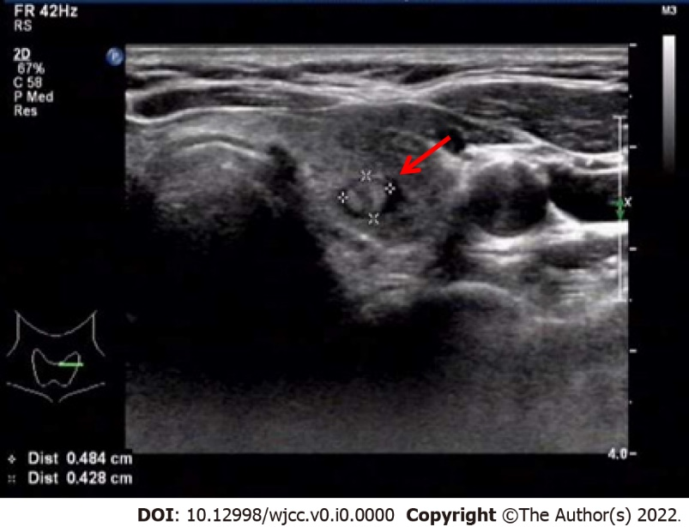
Figure 1 A solid nodule in the left lobe of the thyroid by ultrasound examination.

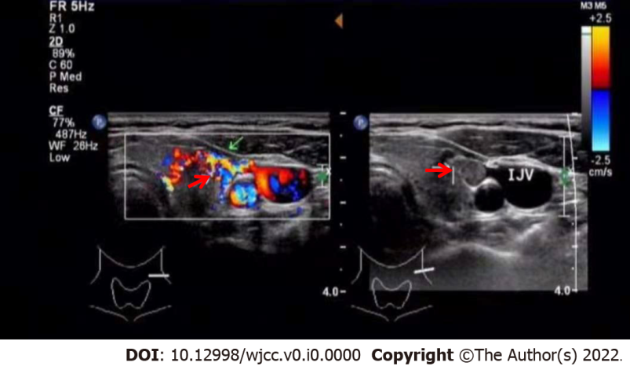
Figure 2 Ultrasound examination revealed a medially echoic mass in the middle thyroid vein.

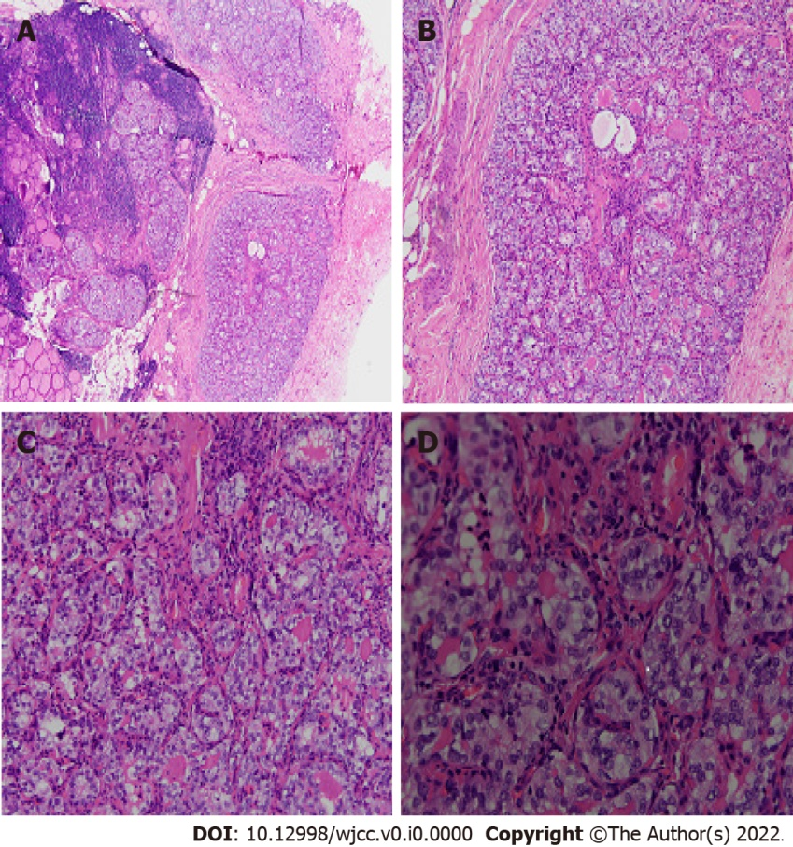
Figure 3 Hematoxylin and eosin staining of left lobe thyroid mass, it shows papillary thyroid microcarcinoma. A: 4×; B: 10×; C: 20×; D: 40×.

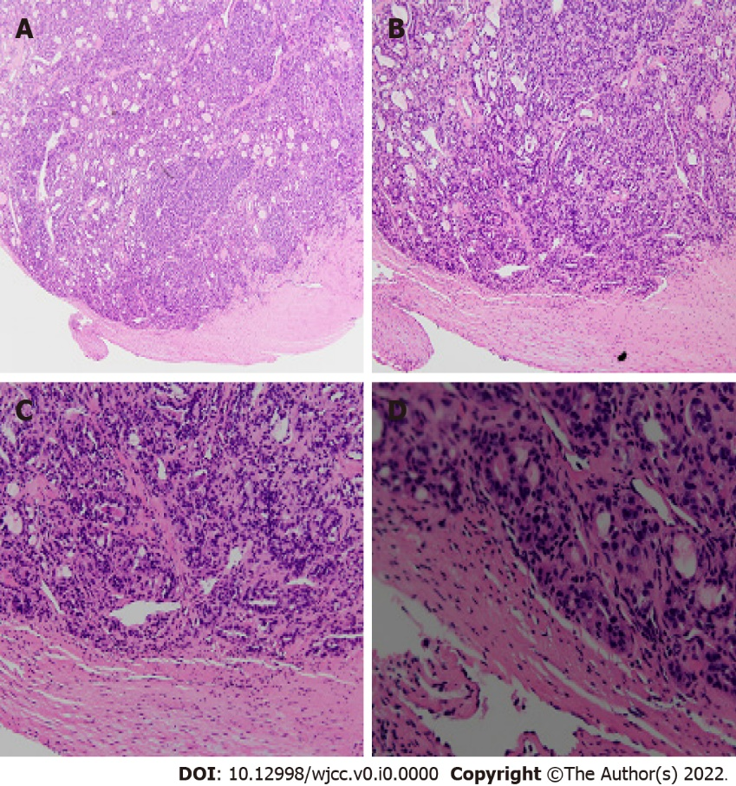
Figure 4 Hematoxylin and eosin staining of the thrombus, it shows carcinoma tissues. A: 4×; B: 10×; C: 20×; D: 40×.

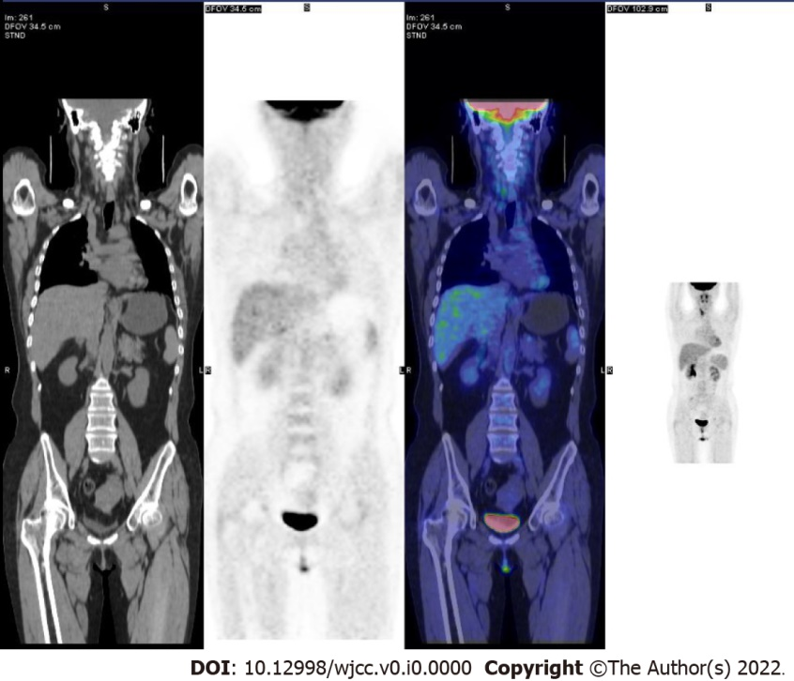
Figure 5 Systemic positron emission tomography metabolism imaging showed no obvious signs of malignancy.
Table 1 Reported cases of vein tumor thrombus in thyroid carcinoma
Ref. | Sex | Age | Lesion size (cm) | Pathology | Blood vessel of thrombus
Banerjee and Chopra^{[2]}, 1972 | F | 60 | - | FTC | Middle cerebral artery
Thompson et al^{[3]}, 1978 | F | 67 | - | FTC | JV, BV, SVC, RA
Perez and Brown^{[4]}, 1984 | F | 48 | - | FTC | SVC
Sirota^{[5]} , 1989 | F | 61 | - | PTC | Axillary vein
Thomas et al^{[6]}, 1991 | M | 60 | - | PDTC | Bilateral IJV
Onaran et al^{[7]}, 1998 | M | 48 | - | HCC | IJV
Onaran et al^{[7]}, 1998 | F | 48 | - | - | IJV
Onaran et al^{[7]}, 1998 | F | 69 | - | HCC | IJV
Bussani and Silvestri^{[8]}, 1999 | F | 67 | - | FTC | Pulmonary artery, valvular  endocardium
Wiseman et al^{[9]}, 2000 | M | 84 | - | - | IJV, BV
Koike et al^{[10]}, 2002 | F | 26 | 7.8 | PTC | BV
Yoshimura et al^{[11]}, 2003 | F | 65 | - | ATC | IJV, SV
Panzironi et al^{[12]}, 2003 | F | 68 | - | ATC | Bilateral IJV
Gross et al^{[13]}, 2004 | M | 49 | 3.2 × 2.5 × 3 | ATC, HCC | IJV
Sugimoto et al^{[14]}, 2006 | M | 61 | - | ATC | BV, SVC, RA
Taib and Hisham^{[15]}, 2007 | F | 45 | - | FTC | IJV
Taib and Hisham^{[15]}, 2007 | F | 62 | - | FTC | RA
Taib and Hisham^{[15]}, 2007 | F | 66 | - | FTC | IJV, SVC, RA
Tripathi et al^{[16]}, 2008 | F | 48 | - | FTC | BV, SVC, IJV
Yamagami et al^{[17]}, 2008 | M | 74 | 2 | PTC | JV, IV, SVC, atrium
Hyer et al^{[18]}, 2008 | F | 81 | - | FTC | IJV, SVC
Agrawal et al^{[19]}, 2009 | M | 48 | - | FVPTC | IJV, SVC, SV
Wada et al^{[20]}, 2009 | M | 64 | - | FTC | IJV, BV, SVC
Sanioglu et al^{[21]}, 2009 | M | 64 | 2 × 1.5 | PTC | Ascending aorta
Wada et al^{[20]}, 2009 | F | 74 | - | PTC | BV, SVC
Mugunthan et al^{[20]}, 2010 | F | 51 | - | PTC | IJV,SVC,RA
Bukhari et al^{[23]}, 2011 | M | 67 | - | FTC | SVC
Nakashima et al^{[24]}, 2012 | F | 54 | - | FTC | IJV, SV, BV
Babu et al^{[25]}, 2012 | F | 68 | - | PTC | IJV
Onoda et al^{[26]}, 2012 | F | 70 | 7 | FTC | IJV, SVC
Stickel et al^{[27]}, 2013 | F | 77 | - | ATC | RV
do Nascimento et al^{[28]}, 2014 | F | 54 | - | FTC | IJV
Al-Jarrah et al^{[29]}, 2014 | F | 62 | 3×5 | PTC | IJV
Dikici et al^{[30]}, 2015 | F | 52 | 5.5×5.5 | PTC | IJV, IV
Luo et al^{[31]}, 2015 | F | 57 | - | HCC | RA
Franco et al^{[32]}, 2015 | F | 59 | - | FTC | IV
Manik et al^{[33]}, 2016 | F | 65 | - | FTC | SVC, RA
Kawano et al^{[34]}, 2016 | F | 75 | 4.5 × 3 | ATC | IJV, IV, SUV, sigmoid sinus
Chiofalo et al^{[35]}, 2018 | M | 58 | 5 | FTC | IJV
Chiofalo et al^{[35]}, 2018 | F | 64 | 3 × 17 | FTC | IJV
Chiofalo et al^{[35]}, 2018 | F | 75 | 3.5 × 2.3 | FTC | IJV, IV
Jain et al^{[36]}, 2019 | F | 44 | - | - | IJV
Khoo and Chen^{[37]}, 2019 | F | 57 | 17 | FTC | SVC, RA
Lad et al^{[38]}, 2020 | F | 52 | - | FTC | IJV, SVC, RA
Cassar and Stirrup^{[39]}, 2020 | F | 75 | - | FTC | Inferior pulmonary vein, left atrium
Čolović et al^{[40]}, 2020 | M | 67 | - | FTC | IJV,BV
Kavanal et al^{[41]}, 2021 | F | 64 | - | FTC | BV
F: Female; M: Male; PTC: Papillary thyroid carcinoma; FTC: Follicular thyroid carcinoma; HCC: Hürthle cell carcinoma; PDTC: Poorly differentiated thyroid carcinoma; ATC: Anaplastic thyroid carcinoma; FVPTC: Follicular variant of papillary thyroid carcinoma; IJV: Internal jugular vein; SVC: Superior vena cava; SV: Subclavian vein; RA: Right atrium; RV: Right ventricle; IV: Innominate vein; BV: Brachiocephalic vein; JV: Jugular vein.

