Name of Journal: World Journal of Hepatology

Manuscript NO: 40647
Manuscript Type: Original Article

Retrospective Cohort Study

Spleen stiffness mirrors changes in portal hypertension after successful interferon-free therapy in chronic-hepatitis C virus patients

Ravaioli F et al. Spleen stiffness measurement and PH after DAAs

Federico Ravaioli, Antonio Colecchia, Elton Dajti, Giovanni Marasco, Luigina Vanessa Alemanni, Maria Rosa Tamè, Francesco Azzaroli, Stefano Brillanti, Giuseppe Mazzella, Davide Festi

Federico Ravaioli, Antonio Colecchia, Elton Dajti, Giovanni Marasco, Luigina Vanessa Alemanni, Maria Rosa Tamè, Francesco Azzaroli, Stefano Brillanti, Giuseppe Mazzella, Davide Festi, Gastroenterology Unit, Sant’Orsola-Malpighi University Hospital, Department of Medical and Surgical Sciences (DIMEC), University of Bologna, Bologna 40138, Italy

Antonio Colecchia, Unit of Gastroenterology, Borgo Trento University Hospital, Verona 37100, Italy

ORCID number: Federico Ravaioli (0000-0002-1142-8585); Antonio Colecchia (0000-0002-8384-801X); Elton Dajti (0000-0003-2905-1146); Giovanni Marasco (0000-0001-7167-8773); Luigina Vanessa Alemanni (0000-0003-3013-7772); Maria Rosa Tamè (0000-0002-6299-216X); Francesco Azzaroli (0000-0003-3675-8545); Stefano Brillanti (0000-0003-4181-795X); Giuseppe Mazzella (0000-0001-8656-8112); Davide Festi (0000-0001-9534-1745).

Authors contributions: Ravaioli F, Dajti E, Marasco G and Alemanni V collected data, analysed data, wrote the manuscript, approved the final manuscript; Tamè MR, Azzaroli F, Brillanti S and Mazzella G analysed data and contributed to the drafting and final approval of the manuscript; Colecchia A, Mazzella G and Festi D provided overall oversight of the study, analysed data and contributed to the drafting and final approval of the manuscript.

Institutional review board statement: This study was approved by the National Institutional Review Board of the Italian Medicines Agency committee. Local IRB [Institutional Ethics Committee of Sant’Orsola-Malpighi University Hospital (Bologna, Italy)] approval was authorized.

Informed consent statement: Patients were not required to give informed consent to the study because the analysis used anonymous data that were obtained after each patient agreed to treatment by written consent.

Conflict of interest statement: The authors disclose no conflicts.

STROBE statement: The guidelines of the STROBE statement have been adopted and a fulfilled version of the checklist has been attached with the submission of the manuscript.

Open-Access: This article is an open-access article which was selected by an in-house editor and fully peer-reviewed by external reviewers. It is distributed in accordance with the Creative Commons Attribution Non Commercial (CC BY-NC 4.0) license, which permits others to distribute, remix, adapt, build upon this work non-commercially, and license their derivative works on different terms, provided the original work is properly cited and the use is non-commercial. See: http://creativecommons.org/licenses/by-nc/4.0/

Manuscript source: Invited manuscript

Correspondence to: Antonio Colecchia, MD, Assistant Professor, Chief Doctor, Unit of Gastroenterology, Borgo Trento University Hospital, Verona 37100, Italy. antonio.colecchia@aovr.veneto.it
Telephone: +39-335-5876834
Fax: +39-51-2144111

Received: July 3, 2018
Peer-review started: July 3, 2018
First decision: July 24, 2018
Revised: July 27, 2018
Accepted: August 12, 2018
Article in press:
Published online:

Abstract
Aim
to investigate changes in spleen stiffness measurements (SSMs) and other non-invasive tests (NITs) after treatment with direct-acting-antivirals (DAAs) and identify predictors of SSM change after sustained virological response (SVR).

Methods
We retrospectively analysed 146 advanced-chronic-liver-disease (ACLD) patients treated with DAA with available paired SSM at baseline (BL) and SVR24. Liver stiffness (LSM), spleen diameter (SD), platelet count (PLT) and liver stiffness-spleen diameter-to-platelet count ratio score (LSPS) were also investigated. LSM ≥ 21 kPa was used as a cut-off to rule-in clinically significant portal hypertension (CSPH). SSM reduction > 20% from BL was defined as significant.

Results
SSM significantly decreased at SVR24, in both patients with and without CSPH; in 44.8% of cases SSM reduction was > 20%. LSPS significantly improved in entire cohort at SVR24; SD and PLT changed significantly only in patients without CSPH. LSM significantly decreased in 65.7% of patients; also in 2/3 patients in whom SSM did not decrease. The independent predictor of SSM decrease was median relative change of LSM. CSPH persisted in 54.4% patients after SVR. Delta LSM and baseline SSM were independent factors associated with CSPH persistence.

Conclusion
SSM and other NITs significantly decrease after SVR, although differently according to the patient's clinical condition. SSM faithfully reflects changes in portal hypertension and could represent a useful NIT for the follow-up of these patients.

Key words: Spleen stiffness measurement; Advanced chronic liver disease; clinically significant portal hypertension; non-invasive test; Portal hypertension, Direct-acting-antivirals; Hepatitis C

© The Author(s) 2018. Published by Baishideng Publishing Group Inc. All rights reserved.

Core tip: Liver stiffness measurement (LSM) and spleen stiffness measurement (SSM) are widely validated surrogates of portal hypertension (PH) and its complications. Their role in the assessment of therapy response, such as treatment with direct-acting antivirals (DAAs) of HCV patients, is still under investigation. We demonstrated in a large cohort that not only LSM, but also SSM, is reduced six months after successful DAA therapy. As opposed to LSM, SSM directly reflects PH and is less influenced by the immediate reduction of liver necro-inflammation. We believe that SSM could represent a helpful tool for the clinician in the follow-up of these patients.

Ravaioli F, Colecchia A, Dajti E, Marasco G, Alemanni LV, Tamè MR, Azzaroli F, Brillanti S, Mazzella G, Festi D. Spleen stiffness mirrors changes in portal hypertension after successful interferon-free therapy in chronic-hepatitis C virus patients. World J Hepatol 2018; In press

INTRODUCTION
Chronic hepatitis C virus (HCV) infection represents one of the major causes of liver disease and is a leading cause of liver transplantation^{[1,2]}. Recently, the introduction of the highly effective interferon-free direct-acting antivirals (DAAs) has enormously increased the number of patients who have achieved sustained viral response (SVR), even in patients with liver cirrhosis^{[3–5]}.
Although studies mostly from the interferon era have shown that achieving SVR improves liver function^{[6,7]}, liver histology^{[8]} and overall clinical outcomes^{[9]}, the real impact of SVR in the DAA-era in terms of changes in portal hypertension (PH), risk of decompensation on immediate follow-up, is not completely known, especially in patients with advance chronic liver diseases (ACLD). PH is a progressive condition that represents a key point in the natural history of liver diseases^{[10]}; therefore its assessment by hepatic venous pressure gradient (HVPG) measurement is fundamental in ACLD patients^{[11–14]}. Indeed, the development of clinically significant portal hypertension (CSPH) in patients with compensated ACLD (cACLD)^{[11]} is highly associated with the risk of clinical decompensation events (ascites, variceal bleeding, jaundice and hepatic encephalopathy)^{[10]}.
To date, several studies have demonstrated a significant reduction in HVPG (> 10%-20%) after achieving SVR, both after interferon-based^{[15–17]} and DAA-based regimen^{[18–21]}. Although HVPG measurement is the gold standard to assess PH^{[11]}, it remains an invasive method^{[22]} and its use is still limited only to highly specialized centres^{[12]}; thus its repeated measurements during the follow-up would be result hardly applicable.
Consequently, in the last decade, a lot of non-invasive tests (NITs), including liver and spleen stiffness measurement (LSM and SSM), as well as liver stiffness to spleen/platelet score (LSPS) have been developed and validated to accurately assess PH degree and its complications^{[11,22–29]}. In fact, recently, the Baveno VI Consensus recommended LSM values of 10 kPa to rule out cACLD patients, and values of 20-25 kPa to accurately identify patients with CSPH in patients with chronic viral hepatitis^{[11]}. However, to date, few studies have evaluated the role of NITs in PH assessment in SVR patients after DAA treatment and their role in the follow-up. Even if, most studies agree on the fact that LSM rapidly decreases after virus eradication^{[18,19,30–32]}, controversial data have emerged regarding the changes of SSM after SVR^{[30–32]}.

MATERIALS AND METHODS
Aims of the study
We aimed to: (1) investigate the possible effect of HCV-DAA treatment on PH evaluated by spleen stiffness changes as mirror of PH; (2) as well as those of other NITs, after HCV-DAA treatment; moreover, we aimed to (3) identify the presence of predictors of the SSM changes in SVR patients after DAA therapy.

Study design and population
This is a retrospective analysis of prospectively collected data of HCV-related cACLD patients treated with DAAs between January 2015 and September 2017 at our department, with valid measurement of LSM and SSM by transient elastography (TE) at baseline (BL) and at 6 mo after end of DAA treatment (SVR24).
According to the Baveno VI Criteria^{[11]}, values of LSM > 10 kPa at TE were considered suggestive of having cACLD and whom with LSM ≥ 21 kPa were defined to rule-in CSPH as previously described^{[33,34]}. At baseline, laboratory values, Model for End-Stage Liver Disease (MELD) and Child-Turcotte Pugh (CTP) scores were also reported for each patient.
We excluded patients who (1) had incomplete response to surgical resection or loco-regional ablation of previous HCC; (2) developed HCC during antiviral treatment; (3) developed variceal bleeding and/or endoscopic EV banding legation (EBL) during study period; and (4) initiated or changed dosage of non-selective beta-blockers (NSBB) or had portal vein thrombosis, transjugular intrahepatic portosystemic shunt (TIPS) and non-cirrhotic PH. A subgroup of the patients who did not achieve SVR were separately investigated.

Antiviral treatment
Eligibility for treatment of HCV patients with DAAs was assessed following the priority criteria established in the protocol approved by the Italian Medicines Agency committee (AIFA). The choice of DAA and treatment duration (12 or 24 wk) was based on viral genotype and stage of disease, according to the guidelines available at the time of enrolment^{[35]}. SVR was defined as undetectable HCV-RNA, using real-time PCR, with detection limit of 15 IU/mL, at 12-wk post-treatment follow-up visit.

NITs for PH assessments
LSM values were assessed by expert operators, using the FibroScan® apparatus with “M” probe (Echosens®, Paris, France) after overnight fasting and after a complete abdominal US examination. LSM values were obtained as previously reported^{[16]} and the reliability criteria considered were according to the last EFSUMB Guidelines and Recommendations on the Clinical Use of Ultrasound^{[36]}. SSM was assessed on the same day as LSM assessment, with the same probe utilized to perform LSM using the FibroScan® apparatus, as previously described^{[24]}. Since no specific literature is present, translating data from HVPG experience^{[11]}, we defined significant a SSM reduction > 20% from BL. LSPS was calculated as liver stiffness × (spleen diameter/platelet count)^{[37]}. Spleen diameter (SD) was considered as bipolar diameter of the spleen assessed by ultrasound.

Statistical analysis
Categorical data are expressed as numbers (percentages) and continuous variables as medians (IQR or range). For group comparison, the Mann-Whitney U test was used for continuous variables and the chi² test for categorical variables. Group comparisons among NITs at BL and SVR24 were evaluated with Friedman’s non-parametric test, and Bonferroni-corrected alphas were used for post hoc pairwise comparison. Demographic, clinical, functional and elastometric variables were evaluated with univariate and multivariate Logistic Regression models in order to assess the predictive factors associated with PH improvement assessed by SSM. After evaluation of multicollinearity, variables with a p-value < 0.10 at univariate analysis were included in several multivariate Logistic Regression models with stepwise backward procedures. Prevalence of esophageal varices (EV) was not included in the multivariate analysis due to the limited number of patients with available (within 6 mo from TE assessment) EGD data. The estimated hazard ratios (HRs) with their 95% confidence intervals (CIs), LR chi² and Area under ROC Curve (AUROC) were presented. For each multivariable logistic regression, the model discrimination and calibration were reported together with AIC (Akaike information criterion) and BIC (Bayesian information criterion) measures for comparing maximum likelihood models. Only P-values less than 0.05 were considered statistically significant. The statistical analysis was conducted using Stata/SE (Version 14.0; Stata Corp, Texas, United States).

Ethics
The DAAs-treatment protocol was approved by the National Institutional Review Board (IRB) of the Italian Medicines Agency committee. Local IRB [Institutional Ethics Committee of Sant’Orsola-Malpighi University Hospital (Bologna, Italy)] approval was authorized.

RESULTS
Patients characteristics
One hundred-ninety-seven cACLD patients treated with DAAs and with available valid baseline LS and SS measurements were evaluated. The following patients were excluded: 2 (1%) had HCC occurrence and 3 (1.5%) presented active HCC, 1 (0.5%) underwent EBL during study period, 4 (2%) had previous EBL, 2 (1%) patients presented complete portal vein thrombosis, 1 (0.5%) required increase of NSBB dosage and 1 (0.5%) previous TIPS placement. Additional 37 (18.8%) patients were excluded: 22 (out of 197, 11.2%) due to lacked follow-up and 15 (out of 197, 7.6%) due to unfeasible SSM at follow-up. Accordingly, a total of 134 patients with paired LSM and SSM at BL and SVR24 was included in the final analysis; 12 (6%) patients who did not achieve SVR were separately analysed (Figure 1).
Table 1 depicts baseline characteristics of the study cohort. Regarding main NITs, the median values at BL were LSM 19.3 kPa (14.1-27 kPa) and SSM 58.8 kPa (42.2-75 kPa). In a sub-analysis, patients with CSPH (LSM ≥ 21 kPa) differed significantly for MELD score, platelet count, total serum bilirubin, INR, SSM, LSM, SSM and LSPS.

Changes in SSM and LSM after SVR
In the patients who achieved SVR, the median of SSM significantly decreased from 58.8 kPa to 38.2 kPa (p = 0.001), with a median delta change in SSM of – 12.3%. The decrease in SSM was statistically significant in both groups, CSPH and not (Figure 2a); the median delta SSM was higher in patients without CSPH at baseline if compared to patients with CSPH (-20.4% vs -4.7%), although this difference did not reach statistical significance. Decrease in SSM values was found in 92 (68.7%) patients, of whom the majority had a decrease of > 10% and of > 20%, respectively 73 (54.5%) and 60 (44.8%) (Table 2 and Figure 3a). LSM values also decreased after SVR, with respective median values of 19.3 kPa and 13.8 kPa at BL and SVR24 (p < 0.0001). The median delta LSM was -30%, with similar changes in both groups LSM decreased in 114 (85.1%) patients, of whom 88 (65.7%) had a decrease of > 20% (Table 2 and Figure 3a).
A LSM decrease was found in almost all patients in whom SSM decrease (95.3%). On the other hand, LSM significantly decreased (p = 0.022) in 2/3 of the patients in whom SSM did not decrease, with a median delta LSM of -28.3%. (Figure 3b).

Changes in other NITs after SVR
The median spleen diameter (SD) at BL and SVR24 were respectively 14 cm and 13.2 cm. Although the reduction was not statistically significant in the overall population, it reached significance in the subgroup of patients without CSPH. The increase of PLT (from 110 10⁹/L to 130 10⁹/L) did not reach statistical significance in the entire cohort too, but only in patients without CSPH (Figure 2b). Moreover, median LSPS differed significantly between BL (2.78) and SVR (1.34); also in both subgroups.

Non-SVR patients
Twelve patients did not achieve SVR in our cohort. Baseline characteristics did not statistically differ from the patients included in the final analysis. In particularly, in non-SVR patients a LSM decrease (23.2 kPa at BL vs 21.6 kPa at FU24), a SSM increase (45.6 kPa at BL vs 57.8 kPa at FU24) and a PLT decrease (128 × 10⁹/L at BL vs 100 × 10⁹/L at FU24) were observed; none of these changes reached statistical significance (Supplementary Table 1).

Predictors of significant SSM Decrease (> 20%)
Table 3 shows the differences observed between patients who had a SSM decrease of > 20% and those who did not. In the entire cohort, patients with significant SSM reduction differed in prevalence of EV, MELD score, albumin levels as well as BL SSM, LSPS values and LSM-related variables. At multivariate analysis, relative LSM change remained as the only independent predictor of SSM decrease > 20%. Furthermore, predictors of SSM decrease > 20% (Supplementary Table 2) were investigated among patients with CSPH at BL. Once again, higher prevalence of EV, higher creatinine levels, lower LSM values at SVR24 and higher delta LSM were observed among patients with SSM decrease > 20%. At multivariate analysis, higher serum creatinine levels and delta LSM > 20% were the predictors of significant SSM decrease.

Changes of CSPH-state after SVR
Figure 4 showed that 60 (44.8%) patients presented with CSPH at BL, defined as LSM ≥ 21 kPa. After 6 mo of follow-up, none of the 74 patients without CSPH at BL progressed to CSPH. In patients with CSPH, 46.7% of them reduced LSM under the CSPH threshold after treatment. Supplementary Table 3 shows the predictors of CSPH persistence after DAA treatment.

DISCUSSION
The main aim of our study was to evaluate PH changes assessed by non- invasive methods after successful viral eradication in patients treated with DAAs. Our data shows that SSM and LSM significantly decrease after SVR, according to the baseline clinical patient condition.
The IFN-free regimens are highly effective, allowing to treat and achieve SVR also in patients with ACLD^{[4,38]}. However, the individual clinical benefit in these patients is still under debate, especially in terms of changes in PH and CSPH-driven complications^{[39–41]}. While results from the interferon era might not necessarily be translatable to DAA regimens^{[21]}, also recent studies have unanimously demonstrated that HVPG significantly decreases after SVR in all its degree^{[18–21]}. Although many studies have shown that LSM rapidly decreases after DAA treatment^{[42,43]}, not much is known about the changes of PH surrogate NITs, such as SSM and LSPS, after viral eradication. In fact, NITs have yet to be validated in SVR patients and their role in the clinical follow-up is still to be determined.
The main finding of this study is that SSM significantly changes after 24 wk of SVR in patients with cACLD, with a median relative change of -12.3% (Table 2). To our knowledge, only two complete papers^{[30,32]} and one letter to editor^{[39]} have investigated the changes in SSM after SVR, with opposite results. In fact, only in the study by Pons et al^{[32]} SSM was found to rapidly decrease at only 4 wk after therapy initiation in 41 patients, with no ulterior significant changes until 48 wk of follow-up; the other studies concluded that SSM did not significantly decrease at SVR24^{[30,32]}.
In our study that analyzed a large cohort of cACLD patients, we demonstrated that SSM significantly decreased after DAA-treatment. These results confirm previous studies in which PH was assessed by paired HVPG measurements^{[18–21]}. Moreover, our study is the first to assess and demonstrate the improvement of LSPS, another accurate surrogate of PH, after SVR24. Moreover, in the 8 patients who did not achieve SVR, SSM and other NITs did not significantly differ during follow-up measurements (Supplementary Table 1).
We classified patients with and without CSPH according to LSM cut-off 21 kPa^{[33,34]}. Interestingly, the relative changes in SSM and LSM performed differently in patients with and without CSPH. In fact, while the median delta LSM in patients with and without CSPH was very similar (-28.3% vs -30.8%), the reduction of SSM was much more evident in patients without CSPH (-20.4% vs -4.7%). This last result is coherent with the HVPG relative changes described by Mandorfer et al^{[18]}. Moreover, the other surrogates of PH as platelets and spleen diameter significantly changed only when split by CSPH presence. Regarding the different changes of NITs in patients with and without CSPH, we could speculate that this behaviour can reflect the different stage of underlying PH pathogenetic mechanisms. Indeed, determinants of portal pressure affecting SSM, such as intrahepatic resistance and liver necro-inflammation^{[44]} improve in both subgroups. However, in CSPH, other major actors of PH, such as extra-hepatic hemodynamic factors^{[34]} and spleen structural changes^{[45]}, might not ameliorate in the short-term follow-up (6 mo after SVR). This hypothesis could explain why we found a less prominent SSM decrease (-4.7% vs -20.4%) even if liver necro-inflammation reduction, assessed by delta LSM (-28.3% vs -30.8%), is the same.
SSM reduction was present in 68.7% of patients after 6 mo of follow-up. We found that the only independent predictor of a significant PH improvement, as reflected by SSM decrease > 20% was the relative change in LSM (Table 3), confirming previous studies with HVPG^{[18,21]}. However, when we assessed PH improvement, reflected by SSM in our study, as PH surrogate, and by HVPG in the study by Lens et al^{[21]}, we noticed similar portions of patients with a significant response (> 20%) only comparing SSM and HVPG (38.3% vs 39.8%, respectively), and not LSM and HVPG (66.7% vs 39.8%, respectively) (Figure 3a). Even if a correlation between HVPG and SSM changes after DAA-treatment has not been demonstrated yet, our data may suggest that a SSM reduction > 20% could be a more accurate non-invasive predictor of a significant HVPG reduction^{[11]}.
A statement of the Baveno VI consensus was that the main target in patients with mild PH (6-9 mmHg) is to prevent CSPH development^{[11]}. In our cohort, none of the patients who achieved SVR progressed to CSPH. More challenging instead, due to its clinical implications, is the concept of assessment of CSPH presence/absence after SVR, because there is not sufficient evidence showing that the cut-offs after DAAs are the same as the ones used in the pre-treatment phase^{[23,46]}. However, promising data documented that LSM 20-25 kPa could be an accurate cut-off to rule-in CSPH after DAA therapy^{[21]}. Accordingly, we also investigated CSPH persistence after SVR (Figure 4). Using these cut-offs, we found that 53% of the patients with CSPH at baseline presented CSPH at SVR24. At multivariate analysis, higher baseline values of SSM, indicating a more severe PH, and lower LSM relative changes were found to be predictors of CSPH persistence (Supplementary Table 3). These results are in line another study^{[21]}, in which higher BL HVPG and relative LSM changes were predictors of CSPH persistence after DAA treatment.
All the above results seem to reflect the different dynamics in LSM and SSM changes after achieving SVR. LSM consensually decreases in almost all patients (95.2%) with SSM reduction, while the opposite was not found true. In fact, LSM significantly decreased, with median delta -28.3%, in 2/3 of the patients in whom no SSM reduction was found. This result emphasizes the fact that, being LSM heavily influenced by the reduction of liver necro-inflammation^{[44]} after SVR, changes in LSM might not be the most adequate predictors of PH changes in this context. On the other hand, SSM decrease > 20% could identify patients who significantly clinically benefit from viral eradication. When looking at the bigger picture, SSM could represent a feasible tool to monitor therapy response and assess its benefit. This is also supported by a recent study by Buechter et al^{[47]} that investigated LSM and SSM changes after TIPS placement.
The present study has some limitations: Its retrospective nature, even though SSM and LSM were prospectively collected according to AIFA eligibility criteria for treatment of HCV patients with DAAs, and the absence of a gold-standard reference. However, according to Baveno VI consensus^{[11]}, we could considered NITs, as LSM, good surrogates of invasive methods, as liver biopsy and HVPG. The time of follow-up was too short to fully correlate SSM changes after viral eradication, with clinical outcomes, for instance events of decompensation after SVR^{[48]}. As in previous studies including SSM, the upper limit of 75 kPa for SSM affects the possibility to detect changes in patient with severe PH^{[49,50]}; in fact, BL and SVR24 values were both 75 kPa in 7 (5.2%) of them.
In conclusion, SSM could be an accurate and useful NIT for the follow-up of patients after SVR, as it faithfully reflects changes in PH better than other NITs including LSM. Further prospective studies are required in order to confirm the accuracy and usefulness of SSM and other NITs in the follow-up of patients with ACLD and its correlation with clinical outcomes.

Article Highlights
Research background
The long-term benefits of achieving sustained viral response (SVR) in cirrhotic patients are still to be established. Non-invasive tests (NITs), such as liver (LSM) and especially spleen stiffness (SSM), are widely validated in hepatology as portal hypertension (PH) surrogates. However, the use in SVR patients and their changes after virus eradication is still under discussion.

Research motivation
Many studies have reported rapid LSM decrease after achieving SVR. However, only a few have investigated changes in SSM in such patients, with contrasting results. Given that there is a decrease in SSM after therapy, means that SSM could be exploited to assess changes in PH and PH-driven complication after achieving SVR.

Research objectives
The main objective of the study was to investigate changes in PH after successful eradication of HCV-infection, as reflected by its non-invasive assessment by SSM and other NITs.

Research methods
This is retrospective study of prospectively collected data. Patients with available paired SSM assessment, at baseline (BL) and 6 mo after end-of therapy (SVR24), were included in the study.

Research results
Our main result is that a significant SSM decreases at SVR24 was demonstrated in a large cohort of 134 patients. This is the first study that also reveals a decrease in LSPS after SVR. SSM reduction differed according to the patient's clinical condition, especially when divided by presence of clinically significant PH. An LSM decrease of > 20% was evident in the majority of patients, also in patients in whom no SSM reduction was present. This finding probably reflects the reduction in liver necro-inflammation rather than PH improvement.

Research conclusions
PH, reflected by NITs, improves after achieving SVR in cirrhotic patients. SSM is a direct surrogate of PH and less influenced by liver necro-inflammation, as opposed to LSM. Its decrease (> 20%) could help the clinician to stratify the risk for PH-related complication after DAA therapy.

Research perspectives
Future prospective studies should investigate whether changes in SSM are predictive of clinical decompensation or other complications of cirrhosis after viral eradication. SSM could become a helpful and accurate method to assess therapy response and risk of complications.

REFERENCES
1 Hajarizadeh B, Grebely J, Dore GJ. Epidemiology and natural history of HCV infection. Nat Rev Gastroenterol Hepatol 2013; 10: 553-562 [PMID: 23817321 DOI: 10.1038/nrgastro.2013.107]
2 Millman AJ, Nelson NP, Vellozzi C. Hepatitis C: Review of the Epidemiology, Clinical Care, and Continued Challenges in the Direct Acting Antiviral Era. Curr Epidemiol Rep 2017; 4: 174-185 [PMID: 28785531 DOI: 10.1007/s40471-017-0108-x]
3 Manns M, Samuel D, Gane EJ, Mutimer D, McCaughan G, Buti M, Prieto M, Calleja JL, Peck-Radosavljevic M, Müllhaupt B, Agarwal K, Angus P, Yoshida EM, Colombo M, Rizzetto M, Dvory-Sobol H, Denning J, Arterburn S, Pang PS, Brainard D, McHutchison JG, Dufour JF, Van Vlierberghe H, van Hoek B, Forns X; SOLAR-2 investigators. Ledipasvir and sofosbuvir plus ribavirin in patients with genotype 1 or 4 hepatitis C virus infection and advanced liver disease: a multicentre, open-label, randomised, phase 2 trial. Lancet Infect Dis 2016; 16: 685-697 [PMID: 26907736 DOI: 10.1016/S1473-3099(16)00052-9]
4 Ferenci P, Kozbial K, Mandorfer M, Hofer H. HCV targeting of patients with cirrhosis. J Hepatol 2015; 63: 1015-1022 [PMID: 26100497 DOI: 10.1016/j.jhep.2015.06.003]
5 Babatin MA, Alghamdi AS, Albenmousa A, Alaseeri A, Aljarodi M, Albiladi H, Alsahafi A, Almugharbal M, Alothmani HS, Sanai FM, Bzeizi KI. Efficacy and Safety of Simeprevir or Daclatasvir in Combination With Sofosbuvir for the Treatment of Hepatitis C Genotype 4 Infection. J Clin Gastroenterol 2018; 52: 452-457 [PMID: 28767462 DOI: 10.1097/MCG.0000000000000896]
6 Charlton M, Everson GT, Flamm SL, Kumar P, Landis C, Brown RS Jr, Fried MW, Terrault NA, O'Leary JG, Vargas HE, Kuo A, Schiff E, Sulkowski MS, Gilroy R, Watt KD, Brown K, Kwo P, Pungpapong S, Korenblat KM, Muir AJ, Teperman L, Fontana RJ, Denning J, Arterburn S, Dvory-Sobol H, Brandt-Sarif T, Pang PS, McHutchison JG, Reddy KR, Afdhal N; SOLAR-1 Investigators. Ledipasvir and Sofosbuvir Plus Ribavirin for Treatment of HCV Infection in Patients With Advanced Liver Disease. Gastroenterology 2015; 149: 649-659 [PMID: 25985734 DOI: 10.1053/j.gastro.2015.05.010]
7 Deterding K, Höner Zu Siederdissen C, Port K, Solbach P, Sollik L, Kirschner J, Mix C, Cornberg J, Worzala D, Mix H, Manns MP, Cornberg M, Wedemeyer H. Improvement of liver function parameters in advanced HCV-associated liver cirrhosis by IFN-free antiviral therapies. Aliment Pharmacol Ther 2015; 42: 889-901 [PMID: 26250762 DOI: 10.1111/apt.13343]
8 Cammà C, Di Bona D, Schepis F, Heathcote EJ, Zeuzem S, Pockros PJ, Marcellin P, Balart L, Alberti A, Craxì A. Effect of peginterferon alfa-2a on liver histology in chronic hepatitis C: a meta-analysis of individual patient data. Hepatology 2004; 39: 333-342 [PMID: 14767986 DOI: 10.1002/hep.20073]
9 van der Meer AJ, Veldt BJ, Feld JJ, Wedemeyer H, Dufour JF, Lammert F, Duarte-Rojo A, Heathcote EJ, Manns MP, Kuske L, Zeuzem S, Hofmann WP, de Knegt RJ, Hansen BE, Janssen HL. Association between sustained virological response and all-cause mortality among patients with chronic hepatitis C and advanced hepatic fibrosis. JAMA 2012; 308: 2584-2593 [PMID: 23268517 DOI: 10.1001/jama.2012.144878]
10 D'Amico G, Garcia-Tsao G, Pagliaro L. Natural history and prognostic indicators of survival in cirrhosis: a systematic review of 118 studies. J Hepatol 2006; 44: 217-231 [PMID: 16298014 DOI: 10.1016/j.jhep.2005.10.013]
11 de Franchis R; Baveno VI Faculty. Expanding consensus in portal hypertension: Report of the Baveno VI Consensus Workshop: Stratifying risk and individualizing care for portal hypertension. J Hepatol 2015; 63: 743-752 [PMID: 26047908 DOI: 10.1016/j.jhep.2015.05.022]
12 Groszmann RJ, Wongcharatrawee S. The hepatic venous pressure gradient: anything worth doing should be done right. Hepatology 2004; 39: 280-282 [PMID: 14767976 DOI: 10.1002/hep.20062]
13 Abraldes JG, Tarantino I, Turnes J, Garcia-Pagan JC, Rodés J, Bosch J. Hemodynamic response to pharmacological treatment of portal hypertension and long-term prognosis of cirrhosis. Hepatology 2003; 37: 902-908 [PMID: 12668985 DOI: 10.1053/jhep.2003.50133]
14 Bosch J, Abraldes JG, Berzigotti A, García-Pagan JC. The clinical use of HVPG measurements in chronic liver disease. Nat Rev Gastroenterol Hepatol 2009; 6: 573-582 [PMID: 19724251 DOI: 10.1038/nrgastro.2009.149]
15 Rincon D, Ripoll C, Lo Iacono O, Salcedo M, Catalina MV, Alvarez E, Nuñez O, Matilla AM, Clemente G, Bañares R. Antiviral therapy decreases hepatic venous pressure gradient in patients with chronic hepatitis C and advanced fibrosis. Am J Gastroenterol 2006; 101: 2269-2274 [PMID: 17032192 DOI: 10.1111/j.1572-0241.2006.00743.x]
16 Roberts S, Gordon A, McLean C, Pedersen J, Bowden S, Thomson K, Angus P. Effect of sustained viral response on hepatic venous pressure gradient in hepatitis C-related cirrhosis. Clin Gastroenterol Hepatol 2007; 5: 932-937 [PMID: 17544878 DOI: 10.1016/j.cgh.2007.02.022]
17 Reiberger T, Payer BA, Ferlitsch A, Sieghart W, Breitenecker F, Aichelburg MC, Schmied B, Rieger A, Trauner M, Peck-Radosavljevic M; Vienna Hepatic Hemodynamic Lab and Vienna HIV & Liver Study Group. A prospective evaluation of pulmonary, systemic and hepatic haemodynamics in HIV-HCV-coinfected patients before and after antiviral therapy with pegylated interferon and ribavirin. Antivir Ther 2012; 17: 1327-1334 [PMID: 22948263 DOI: 10.3851/IMP2349]
18 Mandorfer M, Kozbial K, Schwabl P, Freissmuth C, Schwarzer R, Stern R, Chromy D, Stättermayer AF, Reiberger T, Beinhardt S, Sieghart W, Trauner M, Hofer H, Ferlitsch A, Ferenci P, Peck-Radosavljevic M. Sustained virologic response to interferon-free therapies ameliorates HCV-induced portal hypertension. J Hepatol 2016; 65: 692-699 [PMID: 27242316 DOI: 10.1016/j.jhep.2016.05.027]
19 Mauro E, Crespo G, Montironi C, Londoño MC, Hernández-Gea V, Ruiz P, Sastre L, Lombardo J, Mariño Z, Díaz A, Colmenero J, Rimola A, Garcia-Pagán JC, Brunet M, Forns X, Navasa M. Portal pressure and liver stiffness measurements in the prediction of fibrosis regression after sustained virological response in recurrent hepatitis C. Hepatology 2018; 67: 1683-1694 [PMID: 28960366 DOI: 10.1002/hep.29557]
20 Afdhal N, Everson GT, Calleja JL, McCaughan GW, Bosch J, Brainard DM, McHutchison JG, De-Oertel S, An D, Charlton M, Reddy KR, Asselah T, Gane E, Curry MP, Forns X. Effect of viral suppression on hepatic venous pressure gradient in hepatitis C with cirrhosis and portal hypertension. J Viral Hepat 2017; 24: 823-831 [PMID: 28295923 DOI: 10.1111/jvh.12706]
21 Lens S, Alvarado-Tapias E, Mariño Z, Londoño MC, LLop E, Martinez J, Fortea JI, Ibañez L, Ariza X, Baiges A, Gallego A, Bañares R, Puente A, Albillos A, Calleja JL, Torras X, Hernández-Gea V, Bosch J, Villanueva C, Forns X, García-Pagán JC. Effects of All-Oral Anti-Viral Therapy on HVPG and Systemic Hemodynamics in Patients With Hepatitis C Virus-Associated Cirrhosis. Gastroenterology 2017; 153: 1273-1283.e1 [PMID: 28734831 DOI: 10.1053/j.gastro.2017.07.016]
22 Berzigotti A. Non-invasive evaluation of portal hypertension using ultrasound elastography. J Hepatol 2017; 67: 399-411 [PMID: 28223101 DOI: 10.1016/j.jhep.2017.02.003]
23 European Association for Study of Liver; Asociacion Latinoamericana para el Estudio del Higado. EASL-ALEH Clinical Practice Guidelines: Non-invasive tests for evaluation of liver disease severity and prognosis. J Hepatol 2015; 63: 237-264 [PMID: 25911335 DOI: 10.1016/j.jhep.2015.04.006]
24 Colecchia A, Montrone L, Scaioli E, Bacchi-Reggiani ML, Colli A, Casazza G, Schiumerini R, Turco L, Di Biase AR, Mazzella G, Marzi L, Arena U, Pinzani M, Festi D. Measurement of spleen stiffness to evaluate portal hypertension and the presence of esophageal varices in patients with HCV-related cirrhosis. Gastroenterology 2012; 143: 646-654 [PMID: 22643348 DOI: 10.1053/j.gastro.2012.05.035]
25 Ma X, Wang L, Wu H, Feng Y, Han X, Bu H, Zhu Q. Spleen Stiffness Is Superior to Liver Stiffness for Predicting Esophageal Varices in Chronic Liver Disease: A Meta-Analysis. PLoS One 2016; 11: e0165786 [PMID: 27829057 DOI: 10.1371/journal.pone.0165786]
26 Abraldes JG, Bureau C, Stefanescu H, Augustin S, Ney M, Blasco H, Procopet B, Bosch J, Genesca J, Berzigotti A; Anticipate Investigators. Noninvasive tools and risk of clinically significant portal hypertension and varices in compensated cirrhosis: The "Anticipate" study. Hepatology 2016; 64: 2173-2184 [PMID: 27639071 DOI: 10.1002/hep.28824]
27 Voutilainen S, Kivisaari R, Lohi J, Jalanko H, Pakarinen MP. A Prospective Comparison of Noninvasive Methods in the Assessment of Liver Fibrosis and Esophageal Varices in Pediatric Chronic Liver Diseases. J Clin Gastroenterol 2016; 50: 658-663 [PMID: 27105175 DOI: 10.1097/MCG.0000000000000532]
28 Chon YE, Jung ES, Park JY, Kim DY, Ahn SH, Han KH, Chon CY, Jung KS, Kim SU. The accuracy of noninvasive methods in predicting the development of hepatocellular carcinoma and hepatic decompensation in patients with chronic hepatitis B. J Clin Gastroenterol 2012; 46: 518-525 [PMID: 22688146 DOI: 10.1097/MCG.0b013e31825079f1]
29 Colecchia A, Ravaioli F, Marasco G, Colli A, Dajti E, Di Biase AR, Bacchi Reggiani ML, Berzigotti A, Pinzani M, Festi D. A combined model based on spleen stiffness measurement and Baveno VI criteria to rule out high-risk varices in advanced chronic liver disease. J Hepatol 2018; 69: 308-317 [PMID: 29729368 DOI: 10.1016/j.jhep.2018.04.023]
30 Knop V, Hoppe D, Welzel T, Vermehren J, Herrmann E, Vermehren A, Friedrich-Rust M, Sarrazin C, Zeuzem S, Welker MW. Regression of fibrosis and portal hypertension in HCV-associated cirrhosis and sustained virologic response after interferon-free antiviral therapy. J Viral Hepat 2016; 23: 994-1002 [PMID: 27500382 DOI: 10.1111/jvh.12578]
31 Verlinden W, Francque S, Michielsen P, Vanwolleghem T. Successful antiviral treatment of chronic hepatitis C leads to a rapid decline of liver stiffness without an early effect on spleen stiffness. Hepatology 2016; 64: 1809-1810 [PMID: 27118145 DOI: 10.1002/hep.28610]
32 Pons M, Santos B, Simón-Talero M, Ventura-Cots M, Riveiro-Barciela M, Esteban R, Augustin S, Genescà J. Rapid liver and spleen stiffness improvement in compensated advanced chronic liver disease patients treated with oral antivirals. Therap Adv Gastroenterol 2017; 10: 619-629 [PMID: 28835776 DOI: 10.1177/1756283X17715198]
33 Llop E, Berzigotti A, Reig M, Erice E, Reverter E, Seijo S, Abraldes JG, Bruix J, Bosch J, García-Pagan JC. Assessment of portal hypertension by transient elastography in patients with compensated cirrhosis and potentially resectable liver tumors. J Hepatol 2012; 56: 103-108 [PMID: 21827733 DOI: 10.1016/j.jhep.2011.06.027]
34 Vizzutti F, Arena U, Romanelli RG, Rega L, Foschi M, Colagrande S, Petrarca A, Moscarella S, Belli G, Zignego AL, Marra F, Laffi G, Pinzani M. Liver stiffness measurement predicts severe portal hypertension in patients with HCV-related cirrhosis. Hepatology 2007; 45: 1290-1297 [PMID: 17464971 DOI: 10.1002/hep.21665]
35 European Association for Study of Liver. EASL Clinical Practice Guidelines: management of hepatitis C virus infection. J Hepatol 2014; 60: 392-420 [PMID: 24331294 DOI: 10.1016/j.jhep.2013.11.003]
36 Dietrich CF, Bamber J, Berzigotti A, Bota S, Cantisani V, Castera L, Cosgrove D, Ferraioli G, Friedrich-Rust M, Gilja OH, Goertz RS, Karlas T, de Knegt R, de Ledinghen V, Piscaglia F, Procopet B, Saftoiu A, Sidhu PS, Sporea I, Thiele M. EFSUMB Guidelines and Recommendations on the Clinical Use of Liver Ultrasound Elastography, Update 2017 (Long Version). Ultraschall Med 2017; 38: e16-e47 [PMID: 28407655 DOI: 10.1055/s-0043-103952]
37 Kim BK, Han KH, Park JY, Ahn SH, Kim JK, Paik YH, Lee KS, Chon CY, Kim DY. A liver stiffness measurement-based, noninvasive prediction model for high-risk esophageal varices in B-viral liver cirrhosis. Am J Gastroenterol 2010; 105: 1382-1390 [PMID: 20087336 DOI: 10.1038/ajg.2009.750]
38 Chayama K, Suzuki F, Karino Y, Kawakami Y, Sato K, Atarashi T, Naganuma A, Watanabe T, Eguchi Y, Yoshiji H, Seike M, Takei Y, Kato K, Alves K, Burroughs M, Redman R, Pugatch DL, Pilot-Matias TJ, Krishnan P, Oberoi RK, Xie W, Kumada H. Efficacy and safety of glecaprevir/pibrentasvir in Japanese patients with chronic genotype 1 hepatitis C virus infection with and without cirrhosis. J Gastroenterol 2018; 53: 557-565 [PMID: 28948366 DOI: 10.1007/s00535-017-1391-5]
39 Sack J, Garcia-Tsao G. Variceal Hemorrhage in a Patient With Hepatitis C Virus Cirrhosis in Whom Liver Synthetic Function had Normalized After Viral Elimination. Hepatology 2016; 63: 1733-1735 [PMID: 26806550 DOI: 10.1002/hep.28470]
40 Dailey F, Ayoub WS. Hepatitis C Virus Therapy for Decompensated and Posttransplant Patients. J Clin Gastroenterol 2017; 51: 215-222 [PMID: 28178089 DOI: 10.1097/MCG.0000000000000701]
41 Saadi T, Khoury J. Is There a Relationship Between Treatment With Direct Antiviral Agents for HCV Infection and the Development of Malignancies? J Clin Gastroenterol 2018; 52: 353-359 [PMID: 28590324 DOI: 10.1097/MCG.0000000000000853]
42 Singh S, Facciorusso A, Loomba R, Falck-Ytter YT. Magnitude and Kinetics of Decrease in Liver Stiffness After Antiviral Therapy in Patients With Chronic Hepatitis C: A Systematic Review and Meta-analysis. Clin Gastroenterol Hepatol 2018; 16: 27-38.e4 [PMID: 28479504 DOI: 10.1016/j.cgh.2017.04.038]
43 Facciorusso A, Del Prete V, Turco A, Buccino RV, Nacchiero MC, Muscatiello N. Long-term liver stiffness assessment in hepatitis C virus patients undergoing antiviral therapy: Results from a 5-year cohort study. J Gastroenterol Hepatol 2018; 33: 942-949 [PMID: 28976021 DOI: 10.1111/jgh.14008]
44 Pinzani M. Liver Fibrosis in the Post-HCV Era. Semin Liver Dis 2015; 35: 157-165 [PMID: 25974901 DOI: 10.1055/s-0035-1550056]
45 Mejias M, Garcia-Pras E, Gallego J, Mendez R, Bosch J, Fernandez M. Relevance of the mTOR signaling pathway in the pathophysiology of splenomegaly in rats with chronic portal hypertension. J Hepatol 2010; 52: 529-539 [PMID: 20206401 DOI: 10.1016/j.jhep.2010.01.004]
46 Castera L. Non-invasive tests for liver fibrosis progression and regression. J Hepatol 2016; 64: 232-233 [PMID: 26603523 DOI: 10.1016/j.jhep.2015.10.011]
47 Buechter M, Manka P, Theysohn JM, Reinboldt M, Canbay A, Kahraman A. Spleen stiffness is positively correlated with HVPG and decreases significantly after TIPS implantation. Dig Liver Dis 2018; 50: 54-60 [PMID: 29102174 DOI: 10.1016/j.dld.2017.09.138]
48 Colecchia A, Colli A, Casazza G, Mandolesi D, Schiumerini R, Reggiani LB, Marasco G, Taddia M, Lisotti A, Mazzella G, Di Biase AR, Golfieri R, Pinzani M, Festi D. Spleen stiffness measurement can predict clinical complications in compensated HCV-related cirrhosis: a prospective study. J Hepatol 2014; 60: 1158-1164 [PMID: 24607624 DOI: 10.1016/j.jhep.2014.02.024]
49 Ravaioli F, Montagnani M, Lisotti A, Festi D, Mazzella G, Azzaroli F. Noninvasive Assessment of Portal Hypertension in Advanced Chronic Liver Disease: An Update. Gastroenterol Res Pract 2018; 2018: 4202091 [PMID: 29977287 DOI: 10.1155/2018/4202091]
50 Colecchia A, Ravaioli F, Marasco G, Festi D. Spleen Stiffness by Ultrasound Elastography. In: Diagnostic Methods for Cirrhosis and Portal Hypertension. Cham: Springer International Publishing; 2018: 113-137

P-Reviewer: Ferraioli G, Furuichi Y, Kahraman A S-Editor: Gong ZM
L-Editor: E-Editor:
Specialty type: Gastroenterology and hepatology
Country of origin: Italy
Peer-review report classification
Grade A (Excellent): 0
Grade B (Very good): B
Grade C (Good): C
Grade D (Fair): D
Grade E (Poor): 0

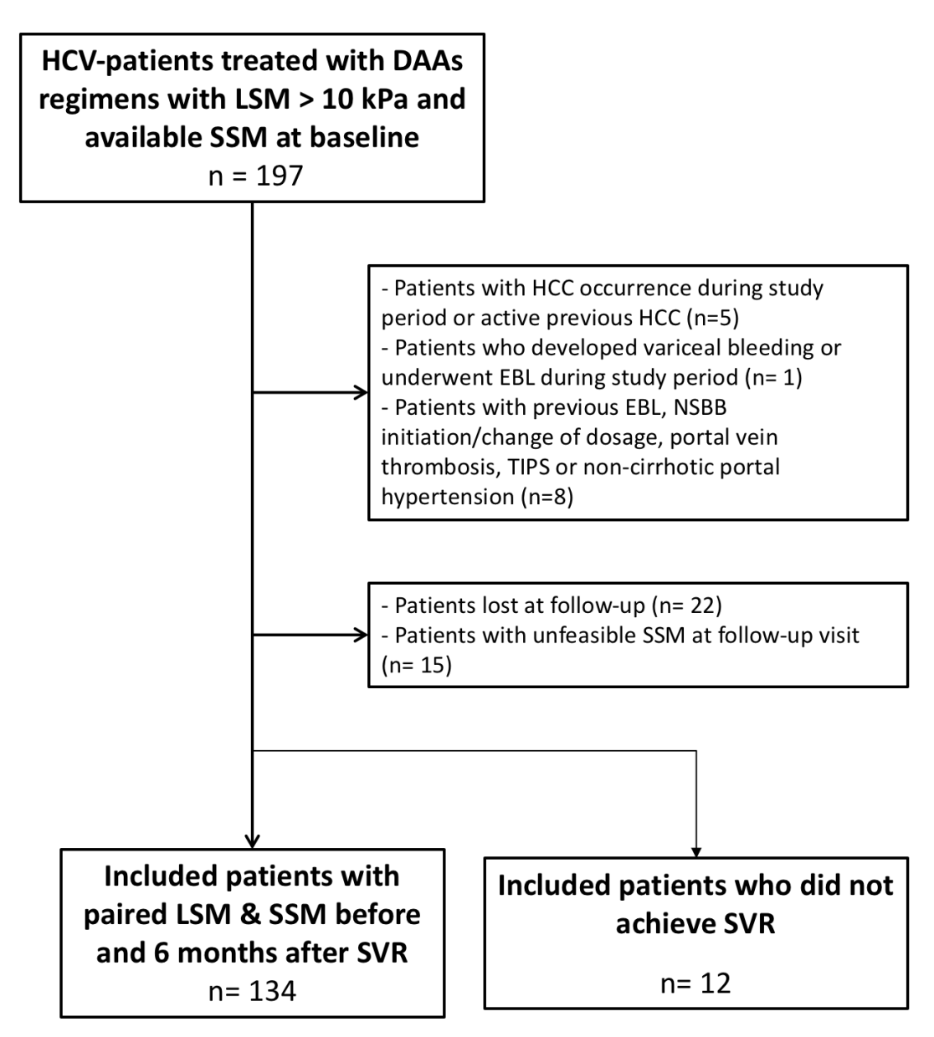
Figure 1 Flowchart of study design. DAA: Direct-acting antiviral; EBL: Endoscopic band ligation; HCC: Hepatocellular carcinoma; HCV: Hepatitis C virus; LSM: Liver stiffness measurement; NSBB: Non-Selective Beta-Blocker; SSM: Spleen stiffness measurement; SVR: Sustained viral response; TIPS: Transjugular intrahepatic portosystemic shunt.

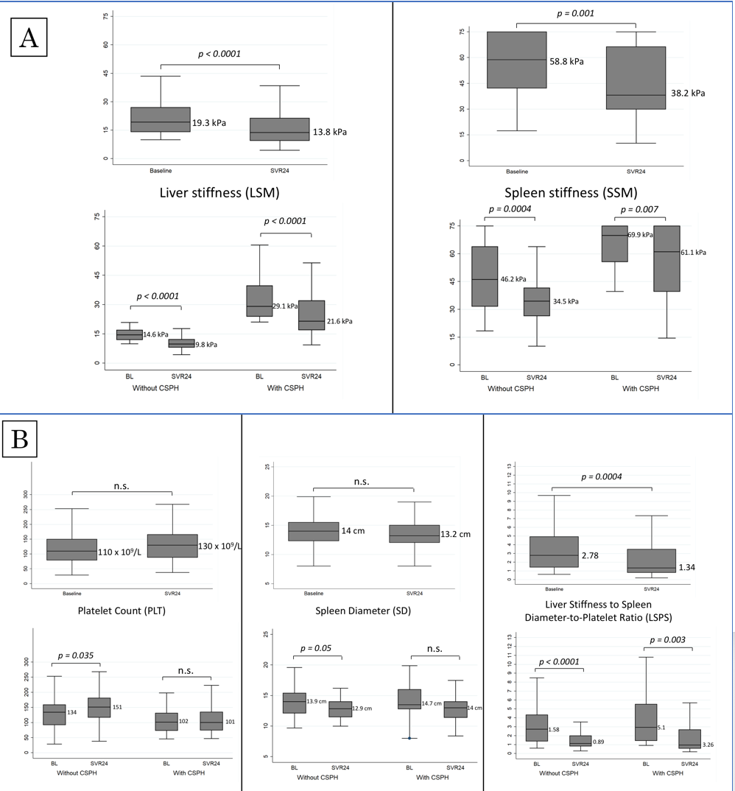
Figure 2 Non-invasive tests changes after sustained viral response, by clinically significant portal hypertension presence. A: LSM and SSM changes; B: PLT, SD, LSPS changes. CSPH: Clinically significant portal hypertension; LSM: Liver stiffness measurement; SSM: Spleen stiffness measurement; PLT: Platelets count; SD: spleen diameter; LSPS: Liver stiffness-spleen diameter-to-platelet count ratio score.

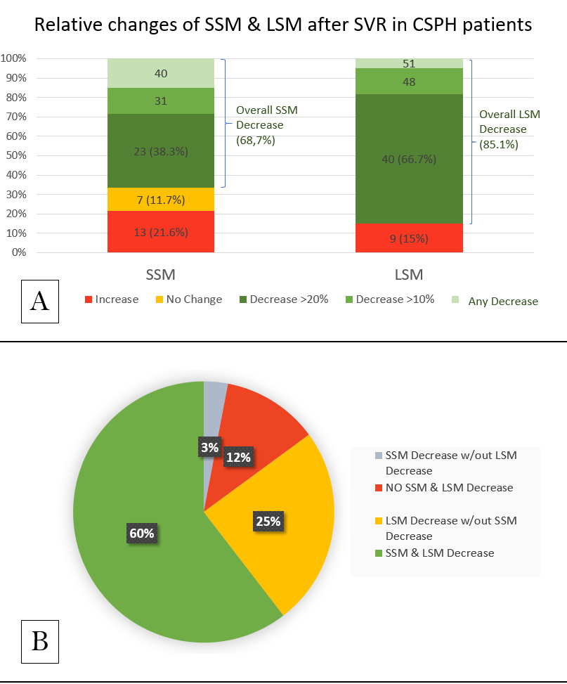
Figure 3 Spleen and liver stiffness measurement decrease after sustained viral response (A) and liver stiffness measurement decrease in patients without spleen stiffness measurement improvement (B). BL: Baseline; CSPH: Clinically significant portal hypertension; LSM: Liver stiffness measurement; SSM: Spleen stiffness measurement; SVR: Sustained viral response.

Figure 4 Clinically significant portal hypertension presence, according Baveno VI (liver stiffness measurement ≥ 21 kPa) at baseline and after SVR24. CSPH: Clinically significant portal hypertension; LSM: Liver stiffness measurement; SSM: Spleen stiffness measurement; SVR: Sustained viral response.

Table 1 Baseline characteristics of included patients
Variable | Overall (n = 134) | CSPH (LSM ≥ 21 kPa) (n = 60) | No CSPH (LSM < 21 kPa) (n = 74)
Age (yr) | 60 (51-69) | 57 (50.5-65) | 61.5 (51-70)
Male | 92 (68.7) | 42 (70) | 50 (67.6)
HCV-genotype
1 | 95 (70.9) | 41 (68.3) | 54 (72.5)
2 | 12 (8.9) | 4 (6.7) | 8 (10.8)
3 | 20 (14.9) | 11 (18.3) | 9 (12.2)
4 | 7 (5.3) | 4 (6.7) | 3 (4.5)
Treatment regimen
SOF/RBV | 33 (24.6) | 10 (16.7) | 23 (31.1)
SOF/SMV | 29 (21.6) | 15 (25) | 14 (18.9)
SOF/DCV | 38 (28.4) | 19 (31.6) | 19 (25.6)
SOF/LDV | 16 (12) | 7 (11.7) | 9 (12.2)
Other | 18 (13.4) | 9 (15) | 9 (12.2)
Child Pugh Score
A | 115 (85.8) | 52 (86.7) | 63 (85.1)
B | 19 (14.2) | 8 (13.3) | 11 (14.9)
MELD Score | 8 (7-10) | 9 (8-10) | 8 (7-10)
Spleen Diameter (cm) | 14 (12.3-15.5) | 14.7 (12.8-15.8) | 13.9 (12.1-15)
Laboratory results
Platelets (cells × 10⁹/L) | 110 (79-150) | 102 (74-132) | 134 (92-159)
ALT (U/L) | 58 (39-95) | 55 (39-84) | 60 (38-105)
Bilirubin (mg/dL) | 0.9 (0.67-1.29) | 1 (0.84-1.52) | 0.8 (0.6-1.1)
Albumin (g/dL) | 3.8 (3.6-4.1) | 3.8 (3.5-4.1) | 3.8 (3.6-4.1)
Creatinine (mg/dL) | 0.8 (0.7-0.98) | 0.8 (0.70-0.96) | 0.85 (0.71-1.08)
INR | 1.1 (1.06-1.2) | 1.17 (1.1-1.21) | 1.08 (1.04-1.13)
NITs
SSM (kPa) | 58.8 (42.2-75) | 69.9 (55.7-75) | 46.2 (31.6-63.9)
LSM (kPa) | 19.3 (14.1-27) | 29.1 (23.9-39.7) | 14.6 (12-17)
LSPS | 2.78 (1.4-4.94) | 5.1 (3.05-7.48) | 1.58 (1.09-2.79)
Qualitative data were expressed as number and perceptual (%); quantitative data were expressed as median (25%-75% quantiles). ALT: Alanine aminotransferase; AST: Aspartate aminotransferase; CSPH: Clinical significant portal hypertension; DCV: Daclatasvir; HRV: High risk varices; INR: International normalized ratio; LDV: Ledipasvir; LSM: Liver stiffness measurement; LSPS: Liver stiffness to spleen/platelet score; MELD: Model for End-Stage Liver Disease; NITs: Non-invasive tests; RBV: Ribavirin; SMV: Simeprevir; SOF: Sofosbuvir; SVR: Sustained viral response; SSM: Spleen stiffness measurement.
Table 2 Liver and Spleen stiffness measurement decrease after sustained viral response
Variable | Overall (n = 134) | CSPH (LSM ≥ 21 kPa) (n = 60) | No CSPH (LSM < 21 kPa) (n = 74)
Relative SSM decrease (%) | 12.3 (0-36.3) | 4.7 (0-32.5) | 20.4 (0-39.7)
Overall SSM decrease | 92 (68.7) | 40 (66.7) | 52 (70.3)
> 10% | 73 (54.5) | 31 (51.7) | 42 (56.8)
> 20% | 60 (44.8) | 23 (38.3) | 37 (50)
Relative LSM decrease (%) | 30 (13.5-42.4) | 28.3 (11.4-41.9) | 30.8 (13.9-42.4)
Overall LSM decrease | 114 (85.1) | 51 (85) | 63 (85.1)
> 10% | 108 (80.6) | 48 (80) | 60 (81.1)
> 20% | 88 (65.7) | 40 (66.7) | 48 (64.9)
PLT Increase (%) | 12.4 (-10.1 to 29.6) | 5.5 (-15.6 to 25.9) | 17.4 (-0.67 to 35.6)
CSPH: Clinical significant portal hypertension; LSM: Liver stiffness measurement; PLT: Platelets count; SSM: Spleen stiffness measurement.
Table 3 Univariate and multivariate analysis of factors associated with SSM decrease > 20%
Entire Population (n = 134)
Variable | Univariate analysis |  |  |  | Multivariate analysis
 |  |  |  |  | LR Chi-2 = 16.48  AUROC = 0.6821 | AIC = 171.8  BIC = 177.6
 | SSM Decrease > 20% (n = 60) | No SSM Decrease > 20% (n = 74) | OR (95%CI) | p value | OR (95%CI) | p value
Age (yr) | 62 (52-69) | 56 (50-68) | 1.005 (0.975-1.037) | 0.727
Sex (male) | 21 (28.4) | 21 (35) | 1.359 (0.653-2.828) | 0.412
Presence varices (n = 67) (yes) | 9 (34.2) | 24 (82.8) | 0.110 (0.031-0.388) | 0.001
Spleen diameter (cm) | 13.6 (11.65-15.15) | 14.5 (13-16) | 0.800 (0.660-0.970) | 0.023
Child Pugh Score | 5 (5-6) | 5 (5-6) | 0.885 (0.601-1.303) | 0.535
Child Pugh Score B (yes) | 8 (13.3) | 11 (14.9) | 0.881 (0.330-2.352) | 0.801
MELD score | 8 (7-10) | 9 (8-10) | 0.786 (0.648-0.954) | 0.015
MELD > 10 | 12 (20) | 30 (40.5) | 0.367 (0.167-0.804) | 0.012
AST (U/L) | 54.5 (38-85) | 56 (35.5-87) | 0.996 (0.987-1.004) | 0.322
ALT (U/L) | 62 (37 - 105) | 53 (40 - 90) | 1.002 (0.995-1.008) | 0.620
ALT ≥ 2 × ULN at BL | 59.5 (37.5-101) | 54 (40-91.5) | 1.326 (0.597-2.944) | 0.489
INR | 1.09 (1.05-1.17) | 1.12 (1.09-1.21) | 0.127 (0.001-0.551) | 0.023
Bilirubin (mg/dl) | 0.85 (0.65-1.16) | 1.02 (0.71-1.52) | 0.903 (0.535-1.525) | 0.703
Albumin (g/dl) | 3.8 (3.52-4.12) | 3.78 (3.52-4.12) | 2.096 (0.959-4.581) | 0.063
Creatinine (mg/d) | 0.8 (0.7-1) | 0.81 (0.69-0.93) | 0.327 (0.674-1.585) | 0.165
Platelet count (10^9/L) | 118 (92-154) | 91 (74-137) | 1.002 (0.996-1.007) | 0.579
LSM BL (kPa) | 18 (14.6-25.7) | 21.1 (14-38.5) | 0.988 (0.962-1.015) | 0.391
LSM SVR24 (kPa) | 12.4 (9.4-18) | 17.5 (10.4-32.4) | 0.944 (0.908-0.981) | 0.004
SSM BL (kPa) | 60.4 (45.7-70.7) | 53.2 (37.4-75) | 1.012 (0.992-1.032) | 0.225
LSPS BL | 2.17 (1.33-3.77) | 4.15 (1.65-6.26) | 0.817 (0.684-0.975) | 0.025
LSM decrease (Delta, %) | 33 (18.1 – 44.6) | 19.4 (0 – 31.3) | 0.0332 (0.005-0.225) | < 0.0001 | 0.0332 (0.005-0.225) | < 0.0001
LSM decrease > 10% (yes) | 54 (90) | 54 (73) | 3.333 (1.242-8.946) | 0.017
LSM decrease > 20% (yes) | 47 (78.3) | 41 (55.4) | 2.910 (1.352-6.262) | 0.006
Qualitative data were expressed as number and perceptual (%); quantitative data were expressed as median (25%-75% quantiles). AIC: Akaike information criterion; ALT: Alanine aminotransferase; AUROC: Area under curve roc; AST: Aspartate aminotransferase; BIC: Bayesian information criterion; CSPH: Clinical significant portal hypertension; DCV: Daclatasvir; HRV: High risk varices; INR: International normalized ratio; LDV: Ledipasvir; LR: Like-hood ratio; LSM: Liver stiffness measurement; LSPS: Liver stiffness to spleen/platelet score; MELD: Model for End-Stage Liver Disease; NITs: Non-invasive tests; RBV: Ribavirin; SMV: Simeprevir; SOF: Sofosbuvir; SVR: Sustained viral response; SSM: Spleen stiffness measurement.

