Name of Journal: World Journal of Clinical Cases
ESPS Manuscript No: 11808
Columns: Case Report

Importance of cardiological evaluation for first seizures

Choong H et al. Cardiac Assessment of Seizures

Ho Choong, Ibrahim Hanna, Roy Beran

Ho Choong, Ibrahim Hanna, Roy Beran, Department of Neurology and Neurophysiology Liverpool Hospital, Liverpool BC, NSW 1871, Australia

Roy Beran, Griffith University, School of Medicine, Southport, Queensland 4222, Australia

Roy Beran, Strategic Health Evaluators, Chastwood NSW 2067, Australia

Author contributions: Choong H and Hanna I collected patients’ clinical data; Choong H searched for relevant references from pubmed; Choong H and Beran R wrote the paper.

Ethics approval: The nature of the presentation is not such that ethics approval is required; it is not a clinical trial and is NOT ethically sensitive.

Informed consent: There is no need to involve informed consent as it is a de-identified report and NOT involving any patient in any research project or study; it reports clinical experience and all clinicians involved have consented to its release.

Conflict-of-interest: There is no conflict of interest for any of the authors.

Open-Access: This article is an open-access article which was selected by an in-house editor and fully peer-reviewed by external reviewers. It is distributed in accordance with the Creative Commons Attribution Non Commercial (CC BY-NC 4.0) license, which permits others to distribute, remix, adapt, build upon this work non-commercially, and license their derivative works on different terms, provided the original work is properly cited and the use is non-commercial. See: http://creativecommons.org/licenses/by-nc/4.0/

Correspondence to: Roy Beran, Professor, Strategic Health Evaluators, Suite 5, 6th Floor, 12 Thomas Street, Chastwood, NSW 2067, Australia. roy.beran@unsw.edu.au

Telephone: +61-2-94153800

Received: June 5, 2014
Peer-review started: June 8, 2014
First decision: June 27, 2014
Revised: January 20, 2015
Accepted: February 4, 2015
Article in press:
Published online:

Abstract
This paper reports two cases of long QT syndrome (LQTS) which presented with seizures as their initial feature. Case 1, AB was seen in emergency department with post-partum seizure, discharged and re-presented following cardiac arrest associated with LQTS. Case 2, CD presented initially with tonic-clonic seizure and because of experience with AB, CD was assessed for LQTS which was subsequently confirmed. The legal medicine experience re Dobbler v Halverson, which involved a young boy with LQTS, who suffered cardiac arrest without prior diagnosis of LQTS, has reinforced the requirement to seriously consider LQTS as an aetiological factor in first seizure presentations.

Key words: Long QT syndrome; Prolonged QT; Torsades de pointes; Seizure; Epilepsy

© The Author(s) 2015. Published by Baishideng Publishing Group Inc. All rights reserved.

Core tip: Long QT syndrome (LQTS), with subsequent cerebral ischemia due to cardiac dysrhythmia, may cause seizures. It is imperative to consider LQTS in patients presenting with first seizure so as to avoid possible brain damage from prolonged cerebral hypoxemia. Failure to recognise LQTS may result in successful suit for negligence if not properly investigated and managed.

Choong H, Hanna I, Beran R. Importance of cardiological evaluation for first seizures. World J Clin Cases 2015; In press

INTRODUCTION
Long QT syndrome (LQTS) represents channelopathies of cardiac potassium/sodium ion channels. Channelopathies may present with seizures and/or risk sudden death because ventricular dysrhythmia known as torsades de pointes (TdP).

CASE REPORT
Case 1 (Year: 2008)
AB was a 26 years old Asian female, 6 wk post-partum with emergency lower cesarean section at 38 wk into her first pregnancy because of pre-eclempsia and fetal distress. Past medical and family histories were unremarkable and she was not on regular medication.
She had acute “dizziness” when rising from the sitting to standing position, and then collapsed to the floor and was witnessed to be cyanosed. Her husband performed cardiopulmonary resuscitation until the ambulance arrived. Her Glasgow Coma Scale improved with stable vital signs at that time. The paramedics witnessed an episode of generalised tonic-clonic seizure associated with tongue biting that lasted for a few minutes whilst en-route to Liverpool Hospital. In the Emergency
Department, she was sedated and intubated because of post-ictal aggression. She was afebrile, blood pressure 127/78 mmHg and pulse rate 70 beats/min. Blood tests were unremarkable with normal computed tomography (CT) pulmonary angiogram, CT brain and CT cerebral venogram. Her electrocardiogram (ECG) showed corrected QT interval (QTc) of 526 ms (Figure 1A), which was above the normal limit for her gender (QTc < 460 ms). She was extubated 24 hours later and was back to her normal state. Full neurological examination was unremarkable. No antiepileptic medication was prescribed as this was her first seizure. Electroencephalogram (EEG) and magnetic resonance imaging (MRI) of the brain were organised but she refused to stay in hospital for those investigations and was to be followed by the neurologist.
She was re-admitted the next day after being found unconscious. She was in ventricular fibrillation requiring cardioversion by the paramedics. Her ECG was similar to the previous recording, demonstrating abnormal QTc of 505 ms (Figure 1B) and hence prompting a diagnosis of long QT syndrome (LQTS). She had further symptomatic polymorphic ventricular tachycardia suggestive of torsades de pointes (TdP) that required cardioversion (Figure 1C). She was subsequently started on beta-blocker therapy and had implantable cardioverter-defibrillator (ICD) for secondary prevention.

Case 2 (Year: 2012)
CD was a 50 years old Caucasian male with no regular medication. His father died at 57 years old in his sleep.
He presented to Liverpool Hospital with 2 minutes of witnessed generalised tonic-clonic seizure. This was associated with post-ictal drowsiness but no tongue biting or incontinence. Previously he had three episodes of unconsciousness. The first two were 30 years ago resulting in his being prescribed carbamazepine which he took for a few years but had not taken same for approximately 20 years. He was unable to provide adequate further history nor could he offer more detailed information regarding specific investigations related to those events. Full neurological and cardiological examinations, blood tests, EEG, MRI brain and echocardiography were all unremarkable. ECG showed QTc of 566 ms which was above the normal limit for his gender (QTc < 450 ms) (Figure 2) prompting a diagnosis of LQTS. Beta-blocker therapy was commenced. ICD was indicated due to his family history and possible ventricular dysrhythmias that could have accounted for his previous events of loss of consciousness thought possibly to be misdiagnosed as epileptic seizures.

DISCUSSION
Both patients in Cases 1 and 2 presented with generalised convulsive “seizures”. AB was initially discharged with conservative management and LQTS was diagnosed on representation. CD was diagnosed because of the experience with AB. This demonstrates that LQTS crosses age, gender and racial boundaries (AB being a young Asian female and CD a middle-aged Caucasian male) demanding a high index of suspicion and consideration of LQTS in all first seizures.
LQTS is a collection of genetically distinct arrhythmogenic disorders resulting in abnormal cardiac potassium and sodium ion channels causing delayed cardiac depolarization^{[1]}. LQTS affects approximately 1 in 2000 people^{[2,3]} and symptomatic cases may present with syncope, seizures or sudden death due to ventricular dysrhythmia known as torsades de pointes (TdP). These cases are often “erroneously” diagnosed as a primary seizure disorder, having unexplained syncope, or having ill defined “spells”^{[4,5]} which could potentially lead to expensive legal-medicine consequences, such as the Dobler v Halverson case of 2006. This Australian, NSW Court of Appeal, case involved LQTS in a young boy diagnosed by a neurologist as a “faint” without further investigation. Halverson was then managed by his general practitioner (GP), Dr Dobler. Halverson experienced cardiac arrest with severe brain damage and the GP was found negligent for not performing an ECG nor organizing for cardiological assessment.
There is increasing support that seizures, in LQTS, are not solely due to acute cerebral hypoxic-ischemic event secondary to ventricular arrhythmias. It has been proposed that the aetiologies of LQTS and epilepsy may partly overlap via a possible link between the cardiac and neural ion channelopathies. It has been demonstrated that patients with LQTS type 2 are more commonly associated with epilepsy, hence supporting the possibility that mutation of KCNH2 gene responsible for LQTS type 2 may also predispose to seizure activity^{[5]}. Similarly, various case reports and observational studies have suggested that mutation in the SCN5A gene, responsible for LQTS type 3, is also associated with epilepsy^{[6,7]}. It follows that initial diagnosis of seizure disorder or epilepsy, with subsequent neurological investigations and antiepileptic treatment, may be inadequate if it does not also include cardiological evaluation. ECG, Holter monitoring and formal cardiological evaluation should become an integral part of a seizure/epilepsy assessment, to identify a subset of patients who also have concomitant LQTS. Failure to do so may predispose the patient to very serious or even fatal consequences and the treating clinician to subsequent personal and legal medicine ramifications.

COMMENTS
Case characteristics
Two cases presenting to hospital after witnessed generalised seizures.

Clinical diagnosis
Both cases had normal physical examination but had prolonged QTc on their electrocardiograms (ECGs), and evidence of torsades de pointes on the ECG for Case 1, prompting the diagnosis of long QT syndrome (LQTS).

Differential diagnosis
Convulsive syncope, secondary to cardiogenic causes; primary or secondary generalised seizure disorder.

Laboratory diagnosis
Both cases had normal routine blood tests, echocadiogram and EEG.

Imaging diagnosis
Both cases had normal computed tomography and magnetic resonance imaging brain.

Treatment
Beta-blocker medication and implantable cardioverter-defibrillator insertion were instigated after the diagnosis of LQTS in both cases.

Related reports
There is a possible link between the cardiac and neural ion channelopathies, hence patients with LQTS may have concurrent primary epilepsy disorder causing seizures rather than solely from the consequences of the ventricular arrhythmias.

Term explanation
TdP refers to Tordes de Pointes which is an uncommon and distinctive form of polymorphic ventricular tachycardia characterized by a gradual change in the amplitude and twisting of the QRS complexes around the isoelectric line; Channelopathies are diseases caused by disturbed function of ion channel subunits or the proteins that regulate them; and KCNH2 and SCN5A are genetic abnormalities found to occur in both inherited epilepsies and LQTS.

Experiences and lessons
Initial diagnosis of seizure disorder or epilepsy, with subsequent neurological investigations and antiepileptic treatment, may be inadequate if it does not also include cardiological evaluation.

Peer-review
The viewpoint of this paper is useful in clinical practice.

REFERENCES
1 Ackerman MJ. The long QT syndrome: ion channel diseases of the heart. Mayo Clin Proc 1998; 73: 250-269 [PMID: 9511785]
2 Modi S, Krahn AD. Sudden cardiac arrest without overt heart disease. Circulation 2011; 123: 2994-3008 [PMID: 21709072 DOI: 10.1161/CIRCULATIONAHA.110.981381]
3 Anderson JH, Bos JM, Meyer FB, Cascino GD, Ackerman MJ. Concealed long QT syndrome and intractable partial epilepsy: a case report. Mayo Clin Proc 2012; 87: 1128-1131 [PMID: 23058853 DOI: 10.1016/j.mayocp.2012.07.019]
4 Vincent GM, Timothy KW, Leppert M, Keating M. The spectrum of symptoms and QT intervals in carriers of the gene for the long-QT syndrome. N Engl J Med 1992; 327: 846-852 [PMID: 1508244]
5 Johnson JN, Hofman N, Haglund CM, Cascino GD, Wilde AA, Ackerman MJ. Identification of a possible pathogenic link between congenital long QT syndrome and epilepsy. Neurology 2009; 72: 224-231 [PMID: 19038855 DOI: 10.1212/01.wnl.0000335760.02995.ca]
6 Parisi P, Oliva A, Coll Vidal M, Partemi S, Campuzano O, Iglesias A, Pisani D, Pascali VL, Paolino MC, Villa MP, Zara F, Tassinari CA, Striano P, Brugada R. Coexistence of epilepsy and Brugada syndrome in a family with SCN5A mutation. Epilepsy Res 2013; 105: 415-418 [PMID: 23538271 DOI: 10.1016/j.eplepsyres.2013.02.024]
7 Heron SE, Hernandez M, Edwards C, Edkins E, Jansen FE, Scheffer IE, Berkovic SF, Mulley JC. Neonatal seizures and long QT syndrome: a cardiocerebral channelopathy? Epilepsia 2010; 51: 293-296 [PMID: 19863579 DOI: 10.1111/j.1528-1167.2009.02317.x]

P-Reviewer: Tanaka N, Tang FR S-Editor: Ji FF L-Editor: E-Editor:
A 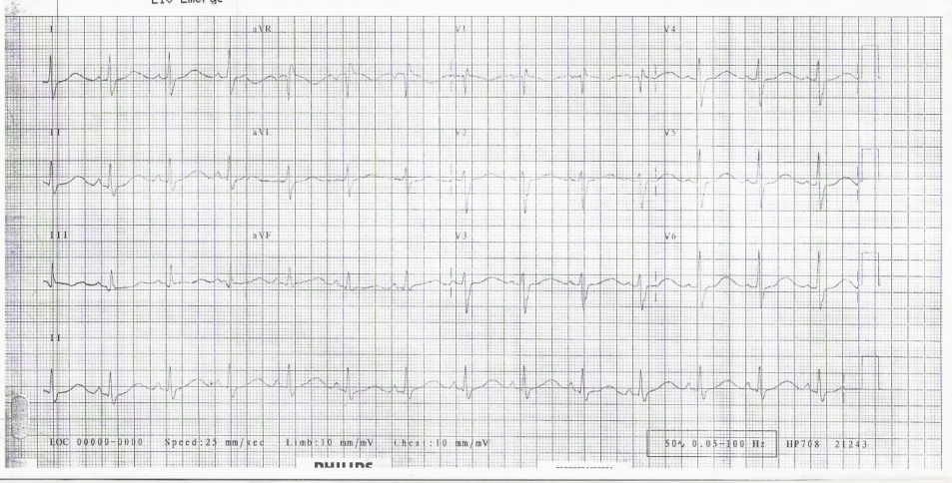
B 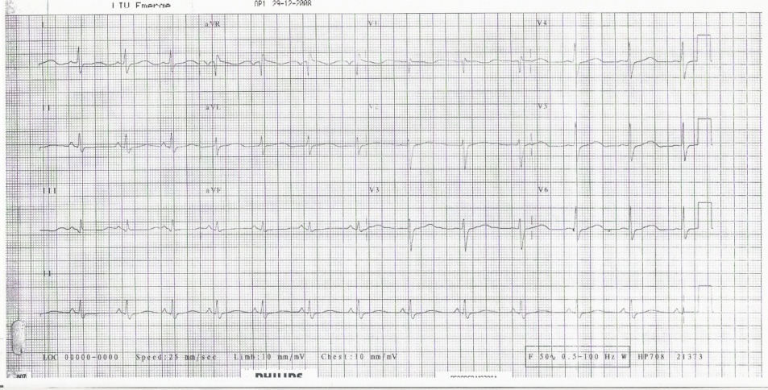
C 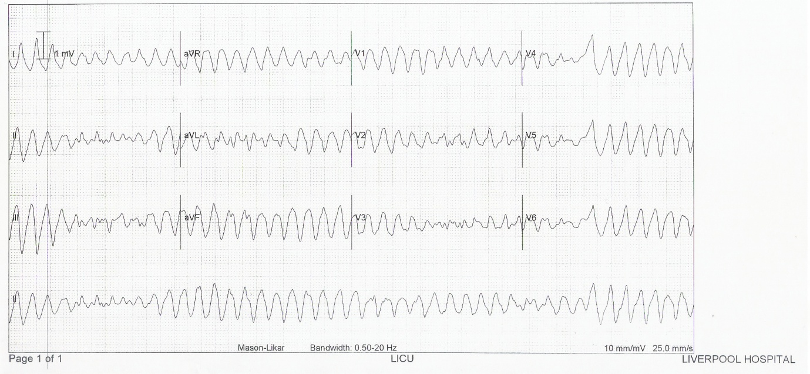
Figure 1 Electrocardiogram of AB. A: Electrocardiogram (ECG) of AB on first presentation showed sinus rhythm, incomplete right bundle branch block (RBBB) and prolonged QTc interval (QTc 526 ms); B: ECG of AB on second presentation showed sinus rhythm, incomplete RBBB and prolonged QTc interval (QTc 505 ms); C: ECG of AB during a syncopal episode on her second admission showed torsades de pointes.

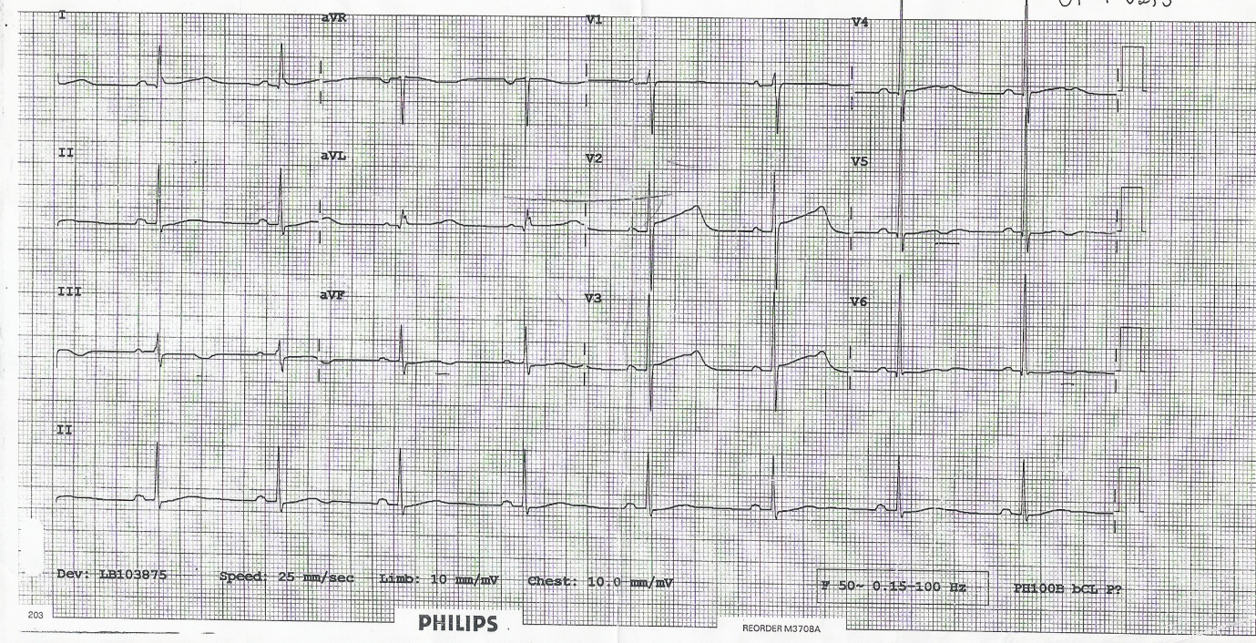

Figure 2 Electrocardiogram of CD showed sinus rhythm and prolonged QTc (QTc 566 ms).

