Name of Journal: World Journal of Clinical Cases
Manuscript NO: 52316
Manuscript Type: CASE REPORT

Total endovascular repair of an intraoperative stent-graft deployed in the false lumen of Stanford type A aortic dissection: A case report

Li XR et al. Endovascular repair of incorrect stent implantation

Xu-Ran Li, Yuan-Hao Tong, Xiao-Qiang Li, Chang-Jian Liu, Chen Liu, Zhao Liu

Xu-Ran Li, Yuan-Hao Tong, Xiao-Qiang Li, Chang-Jian Liu, Chen Liu, Zhao Liu, Department of Vascular Surgery, Nanjing Drum Tower Hospital, The Affiliated Hospital of Nanjing University Medical School, Nanjing 210008, Jiangsu Province, China

Author contributions: Li XR and Tong YH wrote the paper; Liu Z and Liu C contributed equally to this work; Liu Z and Liu C designed the study; Li XQ, Liu CJ performed the operations.

Supported by National Natural Science Foundation of China, No. 81600375.

Corresponding author: Zhao Liu, MD, PhD, Associate Chief Physician, Department of Vascular Surgery, Nanjing Drum Tower Hospital, The Affiliated Hospital of Nanjing University Medical School, No. 321 Zhongshan Road, Nanjing 210008, Jiangsu Province, China. liuzhao83@hotmail.com

Received: November 3, 2019
Revised: January 14, 2020
Accepted: February 15, 2020
Published online:

Abstract
Background
A 46-year-old male underwent ascending aortic replacement, total arch replacement, and descending aortic stent implantation for Stanford type A aortic dissection in 2016. However, an intraoperative stent-graft was deployed in the false lumen inadvertently. This caused severe iatrogenic thoracic and abdominal aortic dissection, and the dissection involved many visceral arteries.

Case summary
The patient had pain in the chest and back for 1 mo. A computed tomography scan showed that the patient had secondary thoracic and abdominal aortic dissection. The ascending aortic replacement, total arch replacement, and descending aortic stent implantation for Stanford type A aortic dissection were performed 2 years prior. An intraoperative stent-graft was deployed in the false lumen. Endovascular aneurysm repair was performed to address this intractable situation. An occluder was used to occlude the proximal end of the true lumen, and a covered stent was used to direct blood flow back to the true lumen. A three-dimensional printing technique was used in this operation to guide pre-fenestration. The computed tomography scan at the 1st mo after surgery showed that the thoracic and abdominal aortic dissection was repaired, with all visceral arteries remaining patent. There patient did not develop renal failure or neurological complications after surgery.

Conclusion
The total endovascular repair for false lumen stent-graft implantation was feasible and minimally invasive. Our procedures provided a new solution for stent-graft deployed in the false lumen, and other departments may be inspired by this case when they need to rescue a disastrous stent implantation.

Key words: Type A dissection; False lumen stent graft implantation; Endovascular repair; 3D printing; Thoracoabdominal aortic dissection; Case report

Li XR, Tong YH, Li XQ, Liu CJ, Liu C, Liu Z. Total endovascular repair of an intraoperative stent-graft deployed in the false lumen of Stanford type A aortic dissection: A case report. World J Clin Cases 2020; In press

Core tip: In this work, we report an extremely rare case of repair for intraoperative stent-graft deployed in the false lumen of Stanford type A aortic dissection. This is very rare because the patient survived this catastrophic thoracic surgery for 2 years. We performed a well-designed total endovascular repair to draw blood back to the true lumen. Our report presents a new solution for incorrect stent-graft implantation. Other departments may be inspired by this case when they need to rescue an incorrect stent implantation. Moreover, we discuss regular rescue methods and preventive measures used for stent implantation of the false lumen.

INTRODUCTION
The use of elephant trunk stent can prevent distal residual dilation and anastomotic leakage after total arch replacement and shows survival benefits^{[1,2]}. Unfortunately, when the true lumen is too compressed to identify, the stent may enter the false lumen. The prevalence of intraoperative stent-graft deployed in the false lumen is relatively rare. However, malignant stent implantation is also a complication of thoracic endovascular aortic repair. Therefore, every surgeon should pay more attention to its treatment. We report our experience with total endovascular repair of an intraoperative stent-graft deployed in the false lumen.

CASE PRESENTATION
Chief complaints
At 2 years after surgery for aortic dissection, chest tightness lasted for 1 mo.

History of present illness
The patient was admitted to the department of cardiothoracic surgery of our hospital 2 years prior due to repeated chest tightness. He underwent ascending aortic replacement, total arch replacement, and descending aortic stent implantation for Stanford type A aortic dissection on January 2016. The patient recovered well after the operation and the symptom of chest tightness was slightly relieved. However, 1 mo ago, the patient felt chest tightness after a little exercise, accompanied by left limb paresthesia, and it was only slightly relieved after rest. The patient had no chest or back lancinate pain or radiating pain, and no nausea, vomiting or other discomfort.

History of past illness
The patient underwent surgery for aortic dissection 2 years prior. He had hypothyroidism for 2 years and was treated with Euthyrox. In addition, he had a history of coronary heart disease for 1 mo.

Personal and family history
The patient’s parents were healthy and his personal history was normal.

Physical examination upon admission
On admission, the patient's body temperature was 36.8℃, pulse was 95 times/min, and blood pressure was 159/77 mm/Hg. His breathing was steady, averaging 18 breaths per minute. The patient had an old surgical scar in the middle of chest, no deformity of chest and breath sounds in both lungs were normal. There was no abnormal uplift in his precardiac region, and no obvious expansion of his cardiac dullness boundary. His heart rate was 95 beats/min, with a regular rhythm and no pathological murmurs. The patient has a weak carotid pulse on the right side. There were no positive signs in abdomen and no swelling in the lower limbs.

Laboratory examinations
There was no significant abnormality in preoperative blood routine and stool routine examination, and the occult blood test was negative. The patient had hypothyroidism, presenting with elevated thyrotrophin (83.41 mIU/L) and multiple positive thyroid antibodies. Biochemical examination showed that the estimated glomerular filtration rate was 77.2 mL/min/1.73 m², and urine protein was weakly positive in urine analysis, indicating slightly abnormal renal function.

Imaging examinations
Vascular ultrasound revealed dissection in the right carotid artery and the blood was decreased in the right internal carotid artery. The stenosis of the innominate artery was approximately 50%-69%. There was no obvious abnormality in the right subclavian artery. An intraoperative stent-graft was deployed in the false lumen inadvertently in the surgery 2 years prior. This caused severe iatrogenic thoracic and abdominal aortic dissection, and the dissection involved many visceral arteries. The computed tomography angiography (CTA) showed that the blood supply of celiac artery and superior mesenteric artery came from the true lumen and the blood supply of both renal arteries came from the true and false lumen (Figure 1). CTA examination of the neck revealed that the stent of the innominate artery was located in the false lumen, and the right internal carotid artery also formed dissection. The patient survived after the wrong stent implantation, because there were a large number of intimal tears in the distal aorta which communicated between the true and false lumens. A series of endovascular operations were performed to address the intractable situation (Table 1).

FINAL DIAGNOSIS
Thoracic aortic dissection (after stent implantation), coronary heart disease, hypothyroidism, and cholecystolithiasis.

TREATMENT
Stage 1
In July 2018, left subclavian artery-right carotid artery artificial vascular bypass surgery was performed to repair the right common carotid artery dissection (Figure 2A). After 1 mo, thoracic endovascular aortic repair was performed. Under general anesthesia, an occluder (28 mm, WBFDQ-I 16, Shanghai memory alloy) was used to occlude the true lumen (Figure 2B). A covered stent (32 mm × 200 mm, Ankura, Ankura company, China) was deployed through the intimal tear to overlap with the original stent in the false lumen for approximately 3 cm. The proximal end of the covered stent was in the false lumen and the distal end was in the true lumen. It drew the blood flow back to the true lumen successfully (Figure 2C). A CTA examination 3 mo after surgery showed that the descending aortic dissection was completely repaired (Figure 2D-F).

Stage 2
The patient underwent the second stage of surgery in December 2018. Before surgery, the positions of the visceral arteries were located by the three-dimensional (3D) printing technique. The 3D printing guide plate was designed by Geomagic Design Direct 2014 software. During the operation, the covered stent (28 mm × 24 mm × 160 mm, Ankura, Ankura Company, China) was fenestrated at the positions of the celiac trunk artery, superior mesenteric artery, and bilateral renal arteries according to the custom 3D printing model. A very short-branched stent was sutured at the position of left renal artery to avoid endoleak (Figure 3A, B). The customized stent was deployed in the true lumen of abdominal aorta from the right femoral approach. Then two branched stents were deployed in the superior mesenteric artery, and the right renal artery and balloons were used to expand these branched stents. Another two covered stents were deployed at the distal end of the fenestrated stent to deal with endoleak (Figure 3C, D). The thoracic and abdominal aortic dissection was successfully repaired, with all the visceral arteries preserved. The operation lasted approximately 7.5 h and the radiation dose was 1529 mGy. The volume of intraoperative hemorrhage was approximately 500 mL and the blood transfusion volume was approximately 600 mL.
Patients were given oral antihypertensive drugs to control their blood pressure every day after discharge. The patient received long-term antiplatelet management with rivaroxaban (5 mg/d) and aspirin (100 mg/d) to prevent in-stent restenosis. In addition, regular examination of aortic CTA was necessary.

OUTCOME AND FOLLOW-UP
The patient suffered from acute renal failure after the thoracic aortic stent implantation and interventional occlusion operation. However, he did not develop renal failure or spinal cord injury after the second EVAR. A computed tomography scan was performed at 3 mo after the operation. The results showed that all of the stents were in the right positions and all of the branch arteries were patent (Figure 3E).

DISCUSSION
Inappropriate deployment of the stent-graft into the false lumen may lead to hypoperfusion of important viscera and lethal aortic rupture during or after surgery. This patient survived after previous catastrophic stent implantation because there were a large number of intimal tears, which communicated between the true and false lumens but eventually led to severe aortic disease. There are many ways to rescue incorrect stent implantation. Conventional open surgery can be adopted to replace the relevant aortic segments. However, this kind of surgery is very dangerous in high-risk patients and requires extracorporeal circulation^{[3,4]}. EVAR was proved to be minimally invasive and had lower perioperative morbidity and mortality than open surgery^{[5-7]}. However, this less invasive approach still has several complications such as spinal cord injury, renal failure, and neurological complications^{[8,9]}. Thus, operations need to be well designed to reduce these complications (Figure 4).
This operation had several technical challenges. First, we need to divert blood to the true lumen. Ma et al^{[10]} adopted fenestration technique to puncture the septum between lumens, artificially creating a break to connect the true and false lumens. Then, a covered stent was deployed through the break to connect the true and false lumens. In this way, the blood was drawn back into the true lumen. In our case, fenestration did not need to be performed because there was already a break at the distal end of the aorta. A balloon was used to expand the break, and a covered stent was used to connect the elephant trunk stent in the original false lumen with the true lumen. An occluder was deployed at the proximal end of the true lumen to repair the anastomotic leakage to avoid high-risk fenestration of the aortic arch. Second, personalized stent was the key to retain visceral blood supply. After the first stage of surgery, we repaired the abdominal aortic dissection with a custom stent graft, which was fenestrated with 3D printing guidance. During the surgery, the stent was released in the 3D-printed vascular model and the positions of fenestration were accurately determined by the model.
With the development of endovascular techniques, there have been many reports about successful rescue after false lumen stent-graft implantation. However, there are serious complications because of incorrect stent implantation including death from intraoperative or postoperative aortic rupture; a large amount of blood flowing into the false lumen and less blood in the true lumen, which eventually leads to multiple organ failure and death; and the pressure in the false lumen being too great, leading to the formation of a dissecting aneurysm at the distal end. Eventually the aneurysm ruptures and patients die. Thus, preventing stents from being deployed in the false lumen is the most crucial step. Some cardiac surgery departments have grasped the concept of modern hybrid aortic surgery. The guide wires can be used to locate the positions of stents and perform angiography at any time. In addition, another stent can be implanted at the distal end of elephant trunk stent to avoid possible complications. Furthermore, the hemodynamic changes in complicated dissections and position of the septum can be assessed using intravascular ultrasound^{[11,12]}. Most importantly, the true and false lumens should be carefully identified by preoperative computed tomography. Usually the true lumen is smaller and the false lumen is larger. The beak sign and a large cross-sectional area indicate a false lumen. Intimal calcification is common in the true lumen and mural thrombus is more common in the false lumen.
The length and size of the stents should be carefully selected according to the aortic diameter and the position of the tears before surgery. This could reduce the risk of stent rupture into the false lumen^{[13]}. It is very important to ensure that the guide wire was in the true lumen. Angiography should be performed before the guide wire and catheter reach the target position and before the stents are released. We should avoid the guide wire passing between the true and false lumens and confirm both ends of the stent were in the true lumen before release.

CONCLUSION
Total endovascular repair for incorrect stent-graft implantation was feasible and minimally invasive. Personalized operation planning is very important to success. Further research is still needed to evaluate its clinical effect.

ACKNOWLEDGEMENTS
There are no contributors to the conduct of the study or preparation of the manuscript other than the co-authors.

References
1 Roselli EE, Bakaeen FG, Johnston DR, Soltesz EG, Tong MZ. Role of the frozen elephant trunk procedure for chronic aortic dissection. Eur J Cardiothorac Surg 2017; 51: i35-i39 [PMID: 28108567 DOI: 10.1093/ejcts/ezw338]
2 Chen Y, Ma WG, Zhi AH, Lu L, Zheng J, Zhang W, Liu YM, Zhu JM, Elefteriades JA, Sun LZ. Fate of distal aorta after frozen elephant trunk and total arch replacement for type A aortic dissection in Marfan syndrome. J Thorac Cardiovasc Surg 2018 [PMID: 30635189 DOI: 10.1016/j.jtcvs.2018.07.096]
3 Follis F, Filippone G, Stabile A, Montalbano G, Floriano M, Finazzo M, Follis M. Endovascular graft deployment in the false lumen of type B dissection. Interact Cardiovasc Thorac Surg 2010; 10: 597-599 [PMID: 20118121 DOI: 10.1510/icvts.2009.223040]
4 Zhang R, Kofidis T, Baus S, Klima U. Iatrogenic type A dissection after attempted stenting of a descending aortic aneurysm. Ann Thorac Surg 2006; 82: 1523-1525 [PMID: 16996974 DOI: 10.1016/j.athoracsur.2006.02.002]
5 Maurel B, Delclaux N, Sobocinski J, Hertault A, Martin-Gonzalez T, Moussa M, Spear R, Le Roux M, Azzaoui R, Tyrrell M, Haulon S. The impact of early pelvic and lower limb reperfusion and attentive peri-operative management on the incidence of spinal cord ischemia during thoracoabdominal aortic aneurysm endovascular repair. Eur J Vasc Endovasc Surg 2015; 49: 248-254 [PMID: 25575833 DOI: 10.1016/j.ejvs.2014.11.017]
6 Cheng D, Martin J, Shennib H, Dunning J, Muneretto C, Schueler S, Von Segesser L, Sergeant P, Turina M. Endovascular aortic repair versus open surgical repair for descending thoracic aortic disease a systematic review and meta-analysis of comparative studies. J Am Coll Cardiol 2010; 55: 986-1001 [PMID: 20137879 DOI: 10.1016/j.jacc.2009.11.047]
7 Hagan PG, Nienaber CA, Isselbacher EM, Bruckman D, Karavite DJ, Russman PL, Evangelista A, Fattori R, Suzuki T, Oh JK, Moore AG, Malouf JF, Pape LA, Gaca C, Sechtem U, Lenferink S, Deutsch HJ, Diedrichs H, Marcos y Robles J, Llovet A, Gilon D, Das SK, Armstrong WF, Deeb GM, Eagle KA. The International Registry of Acute Aortic Dissection (IRAD): new insights into an old disease. JAMA 2000; 283: 897-903 [PMID: 10685714 DOI: 10.1001/jama.283.7.897]
8 Rocha RV, Friedrich JO, Elbatarny M, Yanagawa B, Al-Omran M, Forbes TL, Lindsay TF, Ouzounian M. A systematic review and meta-analysis of early outcomes after endovascular versus open repair of thoracoabdominal aortic aneurysms. J Vasc Surg 2018; 68: 1936-1945.e5 [PMID: 30470373 DOI: 10.1016/j.jvs.2018.08.147]
9 Neuhauser B, Greiner A, Jaschke W, Chemelli A, Fraedrich G. Serious complications following endovascular thoracic aortic stent-graft repair for type B dissection. Eur J Cardiothorac Surg 2008; 33: 58-63 [PMID: 18024145 DOI: 10.1016/j.ejcts.2007.10.010]
10 Ma X, Fu W, Ma YT, Karmacharya U, Zhao J. Successful endoluminal rescue of an endovascular graft unintentionally deployed in the false lumen of Stanford type B aortic dissection. J Thorac Cardiovasc Surg 2016; 151: e41-e45 [PMID: 26651956 DOI: 10.1016/j.jtcvs.2015.10.083]
11 Guo B, Guo D, Shi Z, Dong Z, Fu W. Intravascular Ultrasound-Assisted Endovascular Treatment of Mesenteric Malperfusion in a Multichannel Aortic Dissection with Full True Lumen Collapse. J Endovasc Ther 2019; 26: 83-87 [PMID: 30547707 DOI: 10.1177/1526602818815821]
12 Koschyk DH, Nienaber CA, Knap M, Hofmann T, Kodolitsch YV, Skriabina V, Ismail M, Franzen O, Rehders TC, Dieckmann C, Lund G, Reichenspurner H, Meinertz T. How to guide stent-graft implantation in type B aortic dissection? Comparison of angiography, transesophageal echocardiography, and intravascular ultrasound. Circulation 2005; 112: I260-I264 [PMID: 16159828 DOI: 10.1161/CIRCULATIONAHA.104.525972]
13 Liu Z, Zhang Y, Liu C, Huang D, Zhang M, Ran F, Wang W, Shang T, Qiao T, Zhou M, Liu C. Treatment of serious complications following endovascular aortic repair for type B thoracic aortic dissection. J Int Med Res 2017; 45: 1574-1584 [PMID: 28701057 DOI: 10.1177/0300060517708893]

Footnotes
Informed consent statement: Informed written consent was obtained from the patient for publication of this report and any accompanying images.

Conflict-of-interest statement: The authors declare no potential conflicts of interest with respect to the research, authorship, and/or publication of this article.

CARE Checklist (2016) statement: The authors have read the CARE Checklist (2016), and the manuscript was prepared and revised according to the CARE Checklist (2016).

Open-Access: This article is an open-access article that was selected by an in-house editor and fully peer-reviewed by external reviewers. It is distributed in accordance with the Creative Commons Attribution NonCommercial (CC BY-NC 4.0) license, which permits others to distribute, remix, adapt, build upon this work non-commercially, and license their derivative works on different terms, provided the original work is properly cited and the use is non-commercial. See: http://creativecommons.org/licenses/by-nc/4.0/

Manuscript source: Unsolicited manuscript

Peer-review started: November 3, 2019
First decision: December 4, 2019
Article in press:

Specialty type: Medicine, research and experimental
Country of origin: China
Peer-review report classification
Grade A (Excellent): 0
Grade B (Very good): B
Grade C (Good): C, C, C
Grade D (Fair): 0
Grade E (Poor): E

P-Reviewer: Chiu KW, Ghoch ME, Manenti A, Movahed A, Vaudo G S-Editor: Zhang L L-Editor: Filipodia E-Editor:

Figure Legends
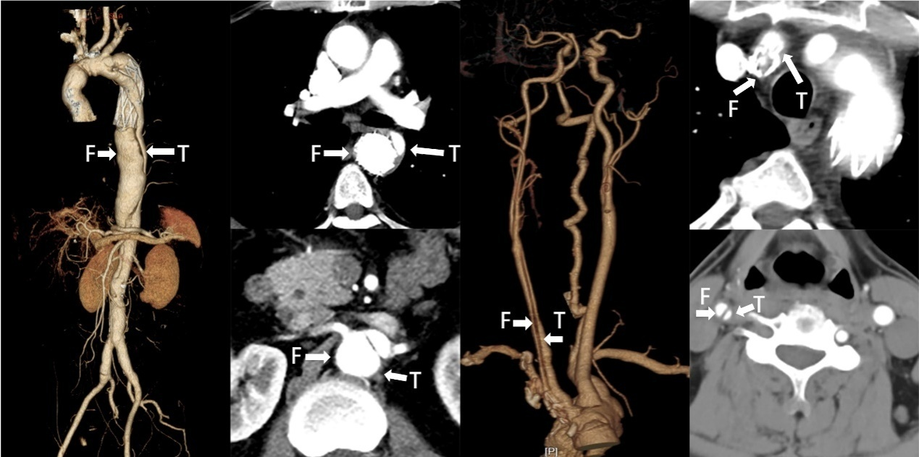
Figure 1 Preoperative computed tomography: The stents of innominate artery and thoracic aorta were located in the false lumen. There was carotid dissection, and the distal true lumen of the aorta became smaller. T: True lumen; F: False lumen.

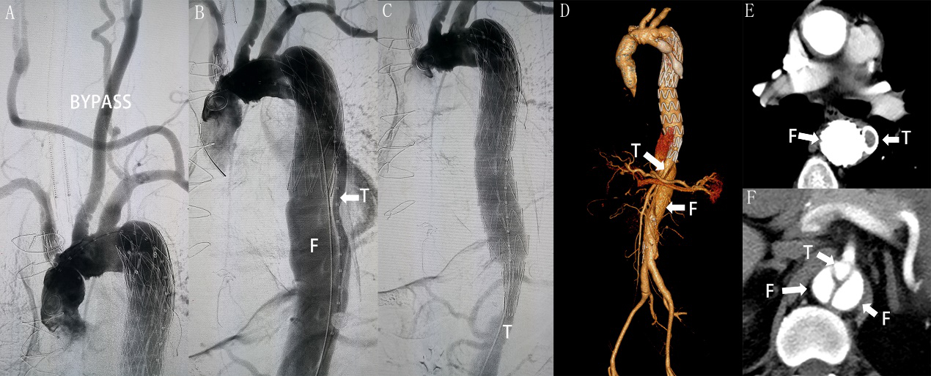
Figure 2 Treatment stage 1 computed tomography. A: Angiography after the left subclavian artery-right carotid artery bypass; B: Preoperative angiography of the aorta showed that the stent was located in the false lumen and the true lumen was small; C: During the operation, the true lumen of aorta was sealed with an occluder and a conical stent was used to connect the proximal stent with the distal true lumen; D-F: Postoperative computed tomography showed good proximal repair and an enlarged distal false lumen. T: True lumen; F: False lumen.

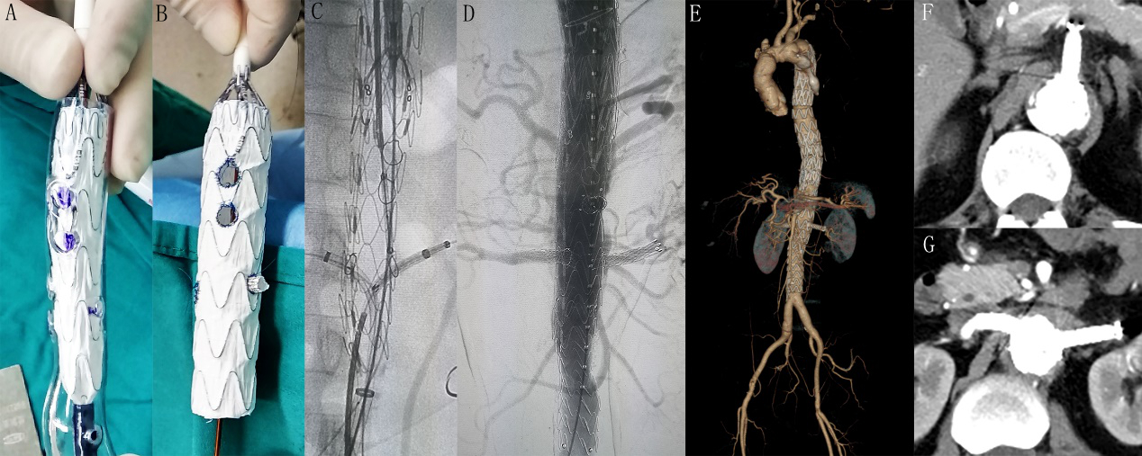
Figure 3 3D printing model, angiography, and computed tomography scan. A, B: Release the stent in the 3D printing model and modify the stent on the stage; C, D: Intraoperative and postoperative angiography; E-G: Postoperative computed tomography scan that demonstrates successful thoracic and abdominal aortic dissection repair with patency of all target vessels.

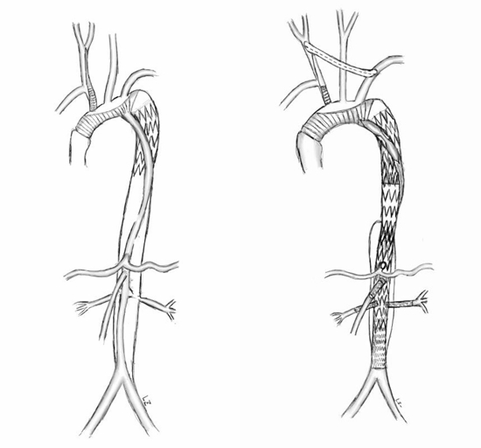
Figure 4 Operation diagram.

Table 1 Timeline
Date | July 16, 2018 | July 18, 2018 | August 1, 2018 | December 10, 2018
Operation | Aortography | Left subclavian artery-right carotid artery artificial vascular bypass surgery | Thoracic aortic stent implantation and Interventional occlusion operation | Abdominal aortic stent implantation

