Name of journal: World Journal of Hepatology
ESPS Manuscript No.: 12444
Columns: Retrospective Study

Evaluation of hepatocellular carcinoma development in patients with chronic hepatitis C by EOB-MRI

Nojiri S et al. Evaluation of HCC development by EOB-MRI

Shunsuke Nojiri, Kei Fujiwara, Noboru Shinkai, Mio Endo, Takashi Joh

Shunsuke Nojiri, Kei Fujiwara, Noboru Shinkai, Mio Endo, Takashi Joh, Department of Gastroenterology and Metabolism, Nagoya City University Graduate School of Medical Sciences, Nagoya, Aichi 467-8601, Japan

Author contributions: Nojiri S is the author; Fujiwara K, Shinkai N, Endo M and Joh T contributed to collecting data.

Correspondence to: Shunsuke Nojiri, MD, PhD, Department of Gastroenterology and Metabolism, Nagoya City University Graduate School of Medical Sciences, Kawasumi 1, Mizuho-cho, Mizuho-ku, Nagoya, Aichi 467-8601, Japan. snojiri@med.nagoya-cu.ac.jp

Telephone: +81-52-8538211 Fax: +81-52-8520952

Received: July 9, 2014 Revised: October 22, 2014
Accepted: November 17, 2014

Published online:

Abstract
AIM: To evaluate the efficacy of ethoxibenzyl-magnetic resonance imaging (EOB-MRI) as a predictor of hepatocellular carcinoma (HCC) development.

METHODS: Between August 2008 and 2009, we studied 142 HCV-infected patients (male 70, female 72), excluding those with HCC or a past history, who underwent EOB-MRI in our hospital. The EOB-MRI index [liver-intervertebral disc ratio (LI)] was calculated as: (post-liver intensity/post-intervertebral disc intensity)/(pre-liver intensity/pre-intervertebral disc intensity).

RESULTS: The median follow-up period was 3.1 years and the patients were observed until the end of the study period (31 December, 2012). In the follow-up period, HCC occurred in 21 patients. The cumulative occurrence rates were 2.1%, 9.1%, and 14.1% at 1, 2, and 3 years, respectively.
Using the optimal cut-off value of LI 1.46, on univariate analysis, age, aspartate amino transferase (AST), α-fetoprotein (AFP) ≥ 10, albumin, total cholesterol, prothrombin time, platelets, and LI < 1.46 were identified as independent factors, but on multivariate analysis, LI < 1.46: risk ratio 6.05 (1.34-27.3, P = 0.019) and AFP ≥10: risk ratio 3.1 (1.03-9.35, P = 0.045) were identified as independent risk factors. LI and Fib-4 index have higher area under the receiver operating characteristic curves than other representative fibrosis evaluation methods, such as Forn’s index and AST-to-platelet ratio index.

CONCLUSION: LI is associated with the risk of HCC occurrence in hepatitis C patients. LI may be a substitute for liver biopsy when evaluating this risk and its combined use with Fib-4 is a better predictive method of HCC progression.

© 2014 Baishideng Publishing Group Inc. All rights reserved.

Key words: Ethoxibenzyl-magnetic resonance imaging; Hepatocellular carcinoma; Risk factor; Fibrosis

Core tip: This manuscript addresses a method of hepatocellular carcinoma (HCC) prediction by using a new technique that evaluates hepatic fibrosis using a noninvasive method (reported recently). This is the first reported study to consider a possible substitute for liver biopsy by using an MRI method (a widespread method in public medical services) for evaluating the risk of occurrence. We propose that this method will become one of the most popular and precise noninvasive methods to predict the occurrence of HCC, and the combination of this MRI method and Fib-4 index may provide a better predictive method of HCC progression.

Nojiri S, Fujiwara K, Shinkai N, Endo M, Joh T. Evaluation of hepatocellular carcinoma development in patients with chronic hepatitis C by EOB-MR imaging. World J Hepatol 2014; In press

INTRODUCTION
The major cause of cirrhosis globally is chronic hepatitis C. The risk of hepatocellular carcinoma (HCC) development is related to this, as reported in several papers^{[1-3]}, and advanced fibrosis increases the risk of carcinogenesis^{[1]}. The prognosis of HCC is not good, even when detected and treated at an early stage^{[4-6]}. Thus, it is important to determine outpatients’ fibrotic stage in order to identify the risk of HCC occurrence in the management of patients with chronic liver disease. Even now, to determine the grade of fibrosis, the gold standard is liver biopsy, but it is associated with certain problems such as sample error and severe complications^{[7-10]}. Previously, noninvasive methods to evaluate fibrosis were reported, such as Forn’s index^{[11]}, the Fibro index^{[12]}, and aspartate amino transferase-to-platelet ratio index (APRI)^{[13]}. Using laboratory data, it has been reported that the Fibrotest is a useful prognostic factor for hepatitis C patients^{[14]}. On the other hand, specific methods, such as transient elastography^{[15]}, magnetic resonance (MR) elastography^{[16]}, and acoustic radiation force impulse^{[17]}, have been reported to evaluate fibrosis as surrogates of liver biopsy. Transient elastography is reported to indicate a wide-ranging risk of HCC incidence. We recently reported the accuracy of staging fibrosis in chronic hepatitis in HCV infection using ethoxibenzyl-magnetic resonance imaging (EOB-MRI)^{[18]}, but there are no reports about a predictor of HCC incidence using this new method. Here, we report a study to evaluate the efficacy of EOB-MRI as a predictor of HCC development.

MATERIALS AND METHODS
Patients
Between August 2008 and December 2009, we studied 142 hepatitis C virus (HCV)-infected patients, excluding those with HCC or a past history, who underwent EOB-MRI in our hospital. Clinical data were obtained within one month of EOB-MRI information being obtained. The definition of HCV infection was determined by a positive anti-HCV antibody and detection of quantitative or qualitative HCV RNA. Exclusion criteria were as follows: (1) infection with hepatitis B or human immunodeficiency viruses; (2) alcohol abuse; (3) the presence of numerous liver tumors; and (4) having previously undergone partial splenic arterial embolization or splenectomy. During the follow-up period, the history of interferon (IFN) therapies and associated responses was examined. We defined a sustained virological response (SVR) as undetectable HCV-RNA for at least 24 wk after IFN therapy. The study protocol conformed to the ethics guidelines of the 1975 Helsinki Declaration and was approved a priori by the institution’s human research committee. All blood tests were performed within 1 wk before or after MRI.

Follow-up of patients and HCC diagnosis
The screening of HCC occurrence was carried out by enhanced MRI or enhanced computed tomography (CT). Outpatients were followed up with blood tests, tumor markers for HCC, and image analysis, such as ultrasonography, enhanced CT, or enhanced MRI, every 3 to 6 mo. The diagnosis of HCC was determined by enhanced CT or enhanced MRI, considering enhancement in the arterial phase and washout in the earlier delayed venous phase as a classical sign of HCC^{[19,20]}. When the diagnosis of HCC was not clear in CT or MRI, a histological diagnosis was performed by tumor biopsy^{[21]}. Cases that were diagnosed as HCC within 6 mo from the first MRI trial were excluded because there should have been only small HCC when the first MRI was performed. This study was continued until December 31, 2012.

MR imaging techniques
A 1.5-Tesla MR system (Philips Co., Amsterdam, the Netherlands) was used: 0.025 mmol/kg body weight gadoxetate disodium was intravenously injected and quantitative measurements were performed using unenhanced and gadoxetate disodium-enhanced imaging at 20, 35, 70, and 180 s, and the imaging at 15, 20, and 25 min was obtained as hepatobiliary phases. Imaging parameters were as follows: repetition time/echo time = 4.17/2.05 ms. Then, 1-2 cm² regions of interest of the mean signal intensity value of the liver were measured. At each MRI, the means of three different regions of right anterior, right posterior, and left lateral segments of the liver devoid of large vessels or severe artifacts were calculated. Using the liver to intervertebral disk signal intensity (LISI) and liver signal intensity/intervertebral disk signal intensity, we calculated the post-enhanced LISI/pre-enhanced LISI [described as liver-intervertebral disc ratio (LI)], as detailed in our previous report^{[18]}. We used hepatobiliary phase data at 20 min because this is most commonly used globally and the data showed no significant difference from the value at 25 min. As we reported previously, because cut-off values of 1.31 and 1.80 are representative values of liver cirrhosis and significant fibrosis of the liver, we divided all patients into < 1.31, 1.311 to 1.38, 1.381 to 1.50, 1.501 to 1.60, and > 1.601. Age, sex, aspartate aminotransferase (AST), alanine aminotransferase (ALT), serum albumin level, total bilirubin (T.Bil), gamma-glutamyl transpeptidase (γGTP), total cholesterol, and platelet count (Plt) were examined. The prothrombin time (PT) was measured as a percentage of the daily internal control.

Statistical analysis
Baseline data are presented as the mean ± SD with the range in parentheses for quantitative variables. The best models derived from the categorical variables were compared by the χ² or Fisher’s exact test, whereas Wilcoxon rank sum test (nonparametric) for continuous variables and the unpaired Student’s t test (parametric) were used to evaluate differences in age, sex, albumin, T.Bil, PT, Plt, AST, ALT, γGTP, total cholesterol, and α-fetoprotein (AFP) at the time of entry. The results are reported as hazard ratios with 95%CI. P < 0.05 in a two-tailed test was considered significant for all analyses. Patients were censored when they died without HCC development, when they stopped visiting, or when the study period ended. Cumulative occurrence curves were analyzed using the Kaplan-Meier method and tested by Wilcoxon’s method. The Cox proportional hazard regression model was used to estimate the risk factors for hepatocarcinogenesis using the following variables in univariate and multivariate analyses: sex, albumin, T.Bil, PT, Plt, AST, ALT, γGTP, alkaline phosphatase (ALP), total cholesterol, AFP (≥ 10 ng/mL), LI (< 1.46) at the time of entry, and the history of IFN therapy [with or without, and sustained virologic response (SVR) or non-SVR].
All statistical analyses were performed using IBM SPSS Statistics 21 software (IBM, Chicago, IL, United States).

RESULTS
Patient characteristics
A total of 145 patients who had undergone EOB-MRI were examined. Three patients were excluded because they developed HCC within 6 mo.
Patient characteristics at the time of EOB-MRI are shown in Table 1. There were 70 men and 72 women, with a mean age of 66.1 ± 12.4 years. The mean AFP level was 14.5 ng/mL and the median was 5 ng/mL. Thirty-seven patients (26%) had an AFP level of ≥ 10. Thirty-nine patients received IFN and 27 patients achieved SVR in the follow-up period.

Occurrence of HCC and patient follow-up
The median follow-up period was 3.1 years, during which 14 (9.8%) patients were lost to follow-up and were censored at the time of the last visit. Nine patients died of liver failure, one died of gastroenterological varices rupture, and nine died of liver-unrelated causes, and they were censored when they died. The remaining patients were observed until the end of the study period (31 December, 2012). During the follow-up period, HCC occurred in 21 patients. The cumulative HCC occurrence rates were 2.1%, 9.1%, and 14.1% at 1, 2, and 3 years, respectively, by the Kaplan-Meier method. Baseline characteristics were compared in patients with and without HCC occurrence (Table 2). There were no significant differences between the no-HCC occurrence group and the HCC occurrence group in terms of age, sex, ALT level, gamma-GT, T.Bil, the performance of IFN therapy, and the achievement of SVR, while AST, ALP, and AFP were higher and albumin, T.Chol, PT, platelets, and LI were lower in the HCC occurrence group than in the no-HCC occurrence group.

Occurrence rate of HCC stratified by LI
The cumulative occurrence rates at 1, 2, and 3 years in each LI group were 0%, 0%, and 2% in patients with LI ≥ 1.601; 0%, 5.8%, and 5.8% in patients with LI 1.501-1.600; 0%, 7.1%, and 14.3% in patients with LI 1.381-1.500; 0%, 11.8%, and 23.5% in patients with LI 1.311-1.380; and 12.5%, 29.2%, and 33.3% in patients with LI ≤ 1.310, respectively (Figure 1). The occurrence rates differed significantly among the 5 LI groups (P = 0.0031), increasing with decreasing LI.
The receiver operating characteristic curve (ROC) curve was used to evaluate the cumulative incidence of LI and a cut-off value of 1.46 was determined [area under the receiver operating characteristic curve (AUROC): 0.765 ± 0.05, 0.669-0.861] by calculating the highest accuracy value (0.63) and likelihood ratio (2.19). The use of this cut-off value resulted in sensitivity: 90.5%, specificity: 58.7%, positive predictive value: 27.5%, and negative predictive value: 97.3%. We compared these results with several representative fibrosis evaluation methods reported previously (Figure 2). The AUROC for each was: Forn’s index, 0.733 ± 0.05, 0.627-0.840; APRI, 0.752 ± 0.05, 0.648-0.856; and Fib-4, 0.765 ± 0.05, 0.665-0.861. Comparing these results, MRI is as effective as the Fib-4 method and more effective than Forn’s index and APRI.

Prognostic Factors of HCC occurrence risk by univariate and multivariate analyses
On univariate analysis, LI < 1.46, AFP ≥ 10, age (per year of age), AST (per 1 U/L), serum albumin (per 1 g/dL), ALP (per 1 U/L), T.chol (per 1 mg/dL), PT (per 1%), platelets (per 1 x 10³/μL), and receiving IFN were identified as risk factors for the occurrence of HCC. The risk of HCC occurrence increased in accordance with LI decrease. On multivariate analysis, LI < 1.46 (P = 0.019) and AFP ≥ 10 ng/mL (P = 0.045) were identified as independent factors; LI: risk ratio: 6.05 (1.34-27.3, P = 0.019) and AFP: 3.1 (1.03-9.35, P = 0.045) (Table 3). The LI contributions to HCC occurrence risk were also evaluated in subgroup analyses. We investigated whether higher LI was a significant risk factor with several other factors (Table 4). High LI was a significant risk factor even with low or high values of age, Plt, albumin, ALT, and male or not, IFN-treated or not, and SVR achieved or not. The LI contribution was greater at age ≥ 69 (older group) and with platelets ≥ 120 x 10³/μL (less fibrosis). In the IFN-untreated group and the SVR-unachieved group, there was a significant risk in low LI, but in the IFN-treated group and SVR not-achieved group, there were no significant differences because the sample numbers were very small.

Relationship between occurrence rate and LI or AFP
The occurrence rate in patients with LI < 1.46 was significantly higher than in those with LI ≥ 1.46 (Wilcoxon P < 0.0001) (Figure 3A); in addition, in those with serum AFP ≥ 10 ng/mL, it was significant higher than in those with serum AFP <10 ng/mL (Wilcoxon P < 0.0001) (Figure 3B).

DISCUSSION
It is known that liver fibrosis is the strongest prognostic factor of chronic liver disease and liver biopsy is now recognized as the best method for evaluating this condition^{[22]}, although it has problems such as complications. Several risk factors for HCC occurrence or recurrence have been reported, such as age, sex^{[1]}, serum albumin level^{[23,24]}, AFP level^{[25]}, and high transaminase^{[25]}. Our study showed almost the same results as these previous reports. In particular, the progression of fibrosis may increase the risk of HCC incidence, so it is very important to determine the stage of liver damage^{[26,27]}. Various methods have been reported for the evaluation of liver fibrosis and have been divided into two groups: ultrasonographic methods^{[15,17,28,29]} and others^{[16,18]}. Although Gd-EOB-DTPA-enhanced MRI is one of the most sensitive methods to detect HCC development, it is also a very important method to evaluate liver fibrosis as a noninvasive investigation^{[19,30]}. We used Gd-EOB-DTPA-enhanced MRI and the LI: EOB-MRI index = (post-liver intensity/post-disc intensity)/(pre-liver intensity/pre-disc intensity) because it has the highest accuracy of all of the calculation methods using EOB-MRI^{[18]}. In this study, we used the 20-min hepatobiliary phase because many institutions accept the hepatobiliary phase as being 20 min after injection and it has also been accepted by consensus of the International Forum for Liver MRI^{[31]}. In our previous study, the data between 20 and 25 min showed no significant difference (data not shown).
LI constantly decreased as the fibrosis stage progressed to a higher stage, but many values overlapped between close fibrous stages, so we decided that the best cut-off point was 1.46 on the ROC curve by calculating the accuracy value and likelihood ratio. Using this cut-off value, LI < 1.46 always showed a high risk, with both low and high risks for several other factors, showing that lower LI is a strong independent risk factor and can complement other risk factors. LI may reflect not only the fibrosis stage but also functional aspects of the liver because it is decided by various factors, such as decreased hepatocytes, deficient hepatocyte function, and indocyanine green clearance^{[32-34]}. The uptake and excretion of gadoxetate disodium are carried out by the anion-transporting polypeptides Oatp1 and Mrp2^{[35]}. The balance of these effects may regulate the signal intensity of liver parenchyma in the hepatobiliary phase followed by a decrease of its signal upon hepatic damage or deteriorating cirrhosis^{[36-38]}. Viewed from this perspective, LI could be an outstanding predictor that reflects the occurrence of HCC and prognosis, in comparison to other methods that can assess only fibrosis.
In the present study, two patients developed HCC in the higher-LI group. According to their clinical data, both had significant splenomegaly and varices, and their actual pathology obtained from surgery was F4. OATP1B1/1B3 are hepatocyte-specific transporters determining the uptake of Gd-EOB-DTPA during MR, and genetic polymorphisms of their polypeptides might influence hepatic enhancement^{[39]}, but their actual influence is relatively small and the intensity in the second case was extremely high, so it was thought to be difficult to explain this discrepancy completely. In particular, one of the two patients achieved SVR during observation but developed HCC. AFP of the two patients did not change even when HCC developed. The occurrence of HCC after IFN therapy is a rare but important problem, as some studies have reported recently^{[40,41]}. Chang et al^{[40]} advocated calculating the HCC prediction score after IFN therapy and, using this method, the score of our case was 5 in the so-called medium-risk group. Because the AUROC value of Fib-4 is as high as that of LI, the cut-off value (4.0) of Fib-4 was determined because the highest accuracy (0.669) was obtained, with sensitivity: 80.9%, specificity: 64.5%, positive predictive value: 28.3%, and negative predictive value: 95.1%. Using this cut-off value, 4 patients developed HCC at < 4. Interestingly, although LI and Fib-4 have similar ROC, there are relatively weak correlations between these two methods (Pearson, r = -0.303, P = 0.0002), so it is thought that they complement each other. Our two cases in which HCC development initially could not be predicted were finally predicted using Fib-4. Therefore, a combination of these two methods is a better predictive method than using a single predictive method as they complement each other and, in addition to information on clinical advanced liver fibrosis, such as low Plt, splenomegaly, and the existence of obvious varices, they will enable more accurate prediction of HCC progression.
Methods such as LI using EOB-MRI and transient elastography may be strong predictors of the HCC occurrence risk. Fibroscan is more cost-effective than MRI, but the equipment is very expensive and is restricted for use in specific hospitals because it can be used only to evaluate tissue elasticity and is ineffective in patients who are obese or have ascites. On the other hand, MRI can evaluate patients who have ascites and/or are obese and is used in many general hospitals, so it is a widely available method.
Our study revealed that the EOB-MRI index is associated with the risk of HCC occurrence in hepatitis C patients and may become a substitute for liver biopsy when evaluating the risk in these patients, even when their condition is not appropriate for other noninvasive methods, and the combination of EOB-MRI index and Fib-4 may become a better predictive method of HCC progression.

COMMENTS
Background
The major cause of cirrhosis is chronic hepatitis C and it is well known that the risk of occurrence of hepatocellular carcinoma increases as fibrosis progresses. Therefore, it is important to reveal the fibrosis stages of outpatients.

Research frontiers
The gold standard test to investigate the fibrous stage of the liver is needle biopsy, but it is potentially harmful, so other noninvasive methods are needed and several have been reported.

Innovations and breakthroughs
This method can predict the hepatocellular carcinoma (HCC) incidence noninvasively and has the advantage of being suitable for some individuals for whom other methods are unavailable due to several factors, such as the presence of ascites.

Applications
This method uses pictures that are typically obtained to detect HCC in outpatients, so it does not require the preparation of special equipment.

Peer review
The authors evaluated the development of HCC in hepatitis C virus patients using ethoxibenzyl-magnetic resonance imaging (EOM-MRI), and observed that EOM-MRI is a highly sensitive and predictive method. This study was well performed, and the manuscript is overall well written and easy to understand.

ACKNOWLEDGMENTS
We thank all of the doctors who participated in this study.

REFERENCES
1 Yoshida H, Shiratori Y, Moriyama M, Arakawa Y, Ide T, Sata M, Inoue O, Yano M, Tanaka M, Fujiyama S, Nishiguchi S, Kuroki T, Imazeki F, Yokosuka O, Kinoyama S, Yamada G, Omata M. Interferon therapy reduces the risk for hepatocellular carcinoma: national surveillance program of cirrhotic and noncirrhotic patients with chronic hepatitis C in Japan. IHIT Study Group. Inhibition of Hepatocarcinogenesis by Interferon Therapy. Ann Intern Med 1999; 131: 174-181 [PMID: 10428733 DOI: 10.7326/0003-4819-131-3-199908030-00003]
2 Tsukuma H, Hiyama T, Tanaka S, Nakao M, Yabuuchi T, Kitamura T, Nakanishi K, Fujimoto I, Inoue A, Yamazaki H. Risk factors for hepatocellular carcinoma among patients with chronic liver disease. N Engl J Med 1993; 328: 1797-1801 [PMID: 7684822 DOI: 10.1056/NEJM199306243282501]
3 Ikeda K, Saitoh S, Koida I, Arase Y, Tsubota A, Chayama K, Kumada H, Kawanishi M. A multivariate analysis of risk factors for hepatocellular carcinogenesis: a prospective observation of 795 patients with viral and alcoholic cirrhosis. Hepatology 1993; 18: 47-53 [PMID: 7686879 DOI: 10.1002/hep.1840180109]
4 Cottone M, Turri M, Caltagirone M, Parisi P, Orlando A, Fiorentino G, Virdone R, Fusco G, Grasso R, Simonetti RG. Screening for hepatocellular carcinoma in patients with Child's A cirrhosis: an 8-year prospective study by ultrasound and alphafetoprotein. J Hepatol 1994; 21: 1029-1034 [PMID: 7535323 DOI: 10.1016/S0168-8278(05)80613-0]
5 Oka H, Kurioka N, Kim K, Kanno T, Kuroki T, Mizoguchi Y, Kobayashi K. Prospective study of early detection of hepatocellular carcinoma in patients with cirrhosis. Hepatology 1990; 12: 680-687 [PMID: 1698703 DOI: 10.1002/hep.1840120411]
6 Zoli M, Magalotti D, Bianchi G, Gueli C, Marchesini G, Pisi E. Efficacy of a surveillance program for early detection of hepatocellular carcinoma. Cancer 1996; 78: 977-985 [PMID: 8780534]
7 Bedossa P, Dargère D, Paradis V. Sampling variability of liver fibrosis in chronic hepatitis C. Hepatology 2003; 38: 1449-1457 [PMID: 14647056 DOI: 10.1016/j.hep.2003.09.022]
8 Perrault J, McGill DB, Ott BJ, Taylor WF. Liver biopsy: complications in 1000 inpatients and outpatients. Gastroenterology 1978; 74: 103-106 [PMID: 618417]
9 Wong JB, Koff RS. Watchful waiting with periodic liver biopsy versus immediate empirical therapy for histologically mild chronic hepatitis C. A cost-effectiveness analysis. Ann Intern Med 2000; 133: 665-675 [PMID: 11074899 DOI: 10.7326/0003-4819-133-9-200011070-00008]
10 Rockey DC, Caldwell SH, Goodman ZD, Nelson RC, Smith AD. Liver biopsy. Hepatology 2009; 49: 1017-1044 [PMID: 19243014 DOI: 10.1002/hep.22742]
11 Forns X, Ampurdanès S, Llovet JM, Aponte J, Quintó L, Martínez-Bauer E, Bruguera M, Sánchez-Tapias JM, Rodés J. Identification of chronic hepatitis C patients without hepatic fibrosis by a simple predictive model. Hepatology 2002; 36: 986-992 [PMID: 12297848 DOI: 10.1053/jhep.2002.36128]
12 Koda M, Matunaga Y, Kawakami M, Kishimoto Y, Suou T, Murawaki Y. FibroIndex, a practical index for predicting significant fibrosis in patients with chronic hepatitis C. Hepatology 2007; 45: 297-306 [PMID: 17256741 DOI: 10.1002/hep.21520]
13 Wai CT, Greenson JK, Fontana RJ, Kalbfleisch JD, Marrero JA, Conjeevaram HS, Lok AS. A simple noninvasive index can predict both significant fibrosis and cirrhosis in patients with chronic hepatitis C. Hepatology 2003; 38: 518-526 [PMID: 12883497 DOI: 10.1053/jhep.2003.50346]
14 Ngo Y, Munteanu M, Messous D, Charlotte F, Imbert-Bismut F, Thabut D, Lebray P, Thibault V, Benhamou Y, Moussalli J, Ratziu V, Poynard T. A prospective analysis of the prognostic value of biomarkers (FibroTest) in patients with chronic hepatitis C. Clin Chem 2006; 52: 1887-1896 [PMID: 16931569 DOI: 10.1373/clinchem.2006.070961]
15 Castéra L, Vergniol J, Foucher J, Le Bail B, Chanteloup E, Haaser M, Darriet M, Couzigou P, De Lédinghen V. Prospective comparison of transient elastography, Fibrotest, APRI, and liver biopsy for the assessment of fibrosis in chronic hepatitis C. Gastroenterology 2005; 128: 343-350 [PMID: 15685546 DOI: 10.1053/j.gastro.2004.11.018]
16 Rouvière O, Yin M, Dresner MA, Rossman PJ, Burgart LJ, Fidler JL, Ehman RL. MR elastography of the liver: preliminary results. Radiology 2006; 240: 440-448 [PMID: 16864671 DOI: 10.1148/radiol.2402050606]
17 Rizzo L, Calvaruso V, Cacopardo B, Alessi N, Attanasio M, Petta S, Fatuzzo F, Montineri A, Mazzola A, L'abbate L, Nunnari G, Bronte F, Di Marco V, Craxì A, Cammà C. Comparison of transient elastography and acoustic radiation force impulse for non-invasive staging of liver fibrosis in patients with chronic hepatitis C. Am J Gastroenterol 2011; 106: 2112-2120 [PMID: 21971536 DOI: 10.1038/ajg.2011.341]
18 Nojiri S, Kusakabe A, Fujiwara K, Shinkai N, Matsuura K, Iio E, Miyaki T, Joh T. Noninvasive evaluation of hepatic fibrosis in hepatitis C virus-infected patients using ethoxybenzyl-magnetic resonance imaging. J Gastroenterol Hepatol 2013; 28: 1032-1039 [PMID: 23432660 DOI: 10.1111/jgh.12181]
19 Bruix J, Sherman M. Management of hepatocellular carcinoma. Hepatology 2005; 42: 1208-1236 [PMID: 16250051 DOI: 10.1002/hep.20933]
20 Torzilli G, Minagawa M, Takayama T, Inoue K, Hui AM, Kubota K, Ohtomo K, Makuuchi M. Accurate preoperative evaluation of liver mass lesions without fine-needle biopsy. Hepatology 1999; 30: 889-893 [PMID: 10498639 DOI: 10.1002/hep.510300411]
21 Edmondson HA, Steiner PE. Primary carcinoma of the liver: a study of 100 cases among 48,900 necropsies. Cancer 1954; 7: 462-503 [PMID: 13160935]
22 Dienstag JL. The role of liver biopsy in chronic hepatitis C. Hepatology 2002; 36: S152-S160 [PMID: 12407589 DOI: 10.1002/hep.1840360720]
23 Ikeda K, Saitoh S, Suzuki Y, Kobayashi M, Tsubota A, Koida I, Arase Y, Fukuda M, Chayama K, Murashima N, Kumada H. Disease progression and hepatocellular carcinogenesis in patients with chronic viral hepatitis: a prospective observation of 2215 patients. J Hepatol 1998; 28: 930-938 [PMID: 9672166 DOI: 10.1016/S0168-8278(98)80339-5]
24 Nojiri S, Kusakabe A, Shinkai N, Matsuura K, Iio E, Miyaki T, Joh T. Factors influencing distant recurrence of hepatocellular carcinoma following combined radiofrequency ablation and transarterial chemoembolization therapy in patients with hepatitis C. Cancer Manag Res 2011; 3: 267-272 [PMID: 21847355 DOI: 10.2147/CMR.S22073]
25 Inoue A, Tsukuma H, Oshima A, Yabuuchi T, Nakao M, Matsunaga T, Kojima J, Tanaka S. Effectiveness of interferon therapy for reducing the incidence of hepatocellular carcinoma among patients with type C chronic hepatitis. J Epidemiol 2000; 10: 234-240 [PMID: 10959605 DOI: 10.2188/jea.10.234]
26 El-Serag HB, Rudolph KL. Hepatocellular carcinoma: epidemiology and molecular carcinogenesis. Gastroenterology 2007; 132: 2557-2576 [PMID: 17570226 DOI: 10.1053/j.gastro.2007.04.061]
27 Fattovich G, Stroffolini T, Zagni I, Donato F. Hepatocellular carcinoma in cirrhosis: incidence and risk factors. Gastroenterology 2004; 127: S35-S50 [PMID: 15508101]
28 Masuzaki R, Tateishi R, Yoshida H, Goto E, Sato T, Ohki T, Imamura J, Goto T, Kanai F, Kato N, Ikeda H, Shiina S, Kawabe T, Omata M. Prospective risk assessment for hepatocellular carcinoma development in patients with chronic hepatitis C by transient elastography. Hepatology 2009; 49: 1954-1961 [PMID: 19434742 DOI: 10.1002/hep.22870]
29 Yada N, Kudo M, Morikawa H, Fujimoto K, Kato M, Kawada N. Assessment of liver fibrosis with real-time tissue elastography in chronic viral hepatitis. Oncology 2013; 84 Suppl 1: 13-20 [PMID: 23428853 DOI: 10.1159/000345884]
30 Watanabe H, Kanematsu M, Goshima S, Kondo H, Onozuka M, Moriyama N, Bae KT. Staging hepatic fibrosis: comparison of gadoxetate disodium-enhanced and diffusion-weighted MR imaging--preliminary observations. Radiology 2011; 259: 142-150 [PMID: 21248234]
31 Tanimoto A, Lee JM, Murakami T, Huppertz A, Kudo M, Grazioli L. Consensus report of the 2nd International Forum for Liver MRI. Eur Radiol 2009; 19 Suppl 5: S975-S989 [PMID: 19851766 DOI: 10.1007/s00330-009-1624-y]
32 Motosugi U, Ichikawa T, Tominaga L, Sou H, Sano K, Ichikawa S, Araki T. Delay before the hepatocyte phase of Gd-EOB-DTPA-enhanced MR imaging: is it possible to shorten the examination time? Eur Radiol 2009; 19: 2623-2629 [PMID: 19471935 DOI: 10.1007/s00330-009-1467-6]
33 Tschirch FT, Struwe A, Petrowsky H, Kakales I, Marincek B, Weishaupt D. Contrast-enhanced MR cholangiography with Gd-EOB-DTPA in patients with liver cirrhosis: visualization of the biliary ducts in comparison with patients with normal liver parenchyma. Eur Radiol 2008; 18: 1577-1586 [PMID: 18369632 DOI: 10.1007/s00330-008-0929-6]
34 Ryeom HK, Kim SH, Kim JY, Kim HJ, Lee JM, Chang YM, Kim YS, Kang DS. Quantitative evaluation of liver function with MRI Using Gd-EOB-DTPA. Korean J Radiol 2004; 5: 231-239 [PMID: 15637473 DOI: 10.3348/kjr.2004.5.4.231]
35 van Montfoort JE, Stieger B, Meijer DK, Weinmann HJ, Meier PJ, Fattinger KE. Hepatic uptake of the magnetic resonance imaging contrast agent gadoxetate by the organic anion transporting polypeptide Oatp1. J Pharmacol Exp Ther 1999; 290: 153-157 [PMID: 10381771]
36 Nakai K, Tanaka H, Hanada K, Ogata H, Suzuki F, Kumada H, Miyajima A, Ishida S, Sunouchi M, Habano W, Kamikawa Y, Kubota K, Kita J, Ozawa S, Ohno Y. Decreased expression of cytochromes P450 1A2, 2E1, and 3A4 and drug transporters Na+-taurocholate-cotransporting polypeptide, organic cation transporter 1, and organic anion-transporting peptide-C correlates with the progression of liver fibrosis in chronic hepatitis C patients. Drug Metab Dispos 2008; 36: 1786-1793 [PMID: 18515332 DOI: 10.1124/dmd.107.020073]
37 Ogasawara K, Terada T, Katsura T, Hatano E, Ikai I, Yamaoka Y, Inui K. Hepatitis C virus-related cirrhosis is a major determinant of the expression levels of hepatic drug transporters. Drug Metab Pharmacokinet 2010; 25: 190-199 [PMID: 20460825 DOI: 10.2133/dmpk.25.190]
38 Hinoshita E, Taguchi K, Inokuchi A, Uchiumi T, Kinukawa N, Shimada M, Tsuneyoshi M, Sugimachi K, Kuwano M. Decreased expression of an ATP-binding cassette transporter, MRP2, in human livers with hepatitis C virus infection. J Hepatol 2001; 35: 765-773 [PMID: 11738104 DOI: 10.1007/s11605-011-1484-z]
39 Okubo H, Ando H, Kokubu S, Miyazaki A, Watanabe S, Fujimura A. Polymorphisms in the organic anion transporting polypeptide genes influence liver parenchymal enhancement in gadoxetic acid-enhanced MRI. Pharmacogenomics 2013; 14: 1573-1582 [PMID: 24088128 DOI: 10.2217/pgs.13.132]
40 Chang KC, Wu YY, Hung CH, Lu SN, Lee CM, Chiu KW, Tsai MC, Tseng PL, Huang CM, Cho CL, Chen HH, Hu TH. Clinical-guide risk prediction of hepatocellular carcinoma development in chronic hepatitis C patients after interferon-based therapy. Br J Cancer 2013; 109: 2481-2488 [PMID: 24084770 DOI: 10.1038/bjc.2013.564]
41 Izumi N, Asahina Y, Kurosaki M, Yamada G, Kawai T, Kajiwara E, Okamura Y, Takeuchi T, Yokosuka O, Kariyama K, Toyoda J, Inao M, Tanaka E, Moriwaki H, Adachi H, Katsushima S, Kudo M, Takaguchi K, Hiasa Y, Chayama K, Yatsuhashi H, Oketani M, Kumada H. Inhibition of hepatocellular carcinoma by PegIFNá-2a in patients with chronic hepatitis C: a nationwide multicenter cooperative study. J Gastroenterol 2013; 48: 382-390 [PMID: 22875473 DOI: 10.1007/s00535-012-0641-9]

P- Reviewer: Chua MS S- Editor: Gong XM
L- Editor: E- Editor:

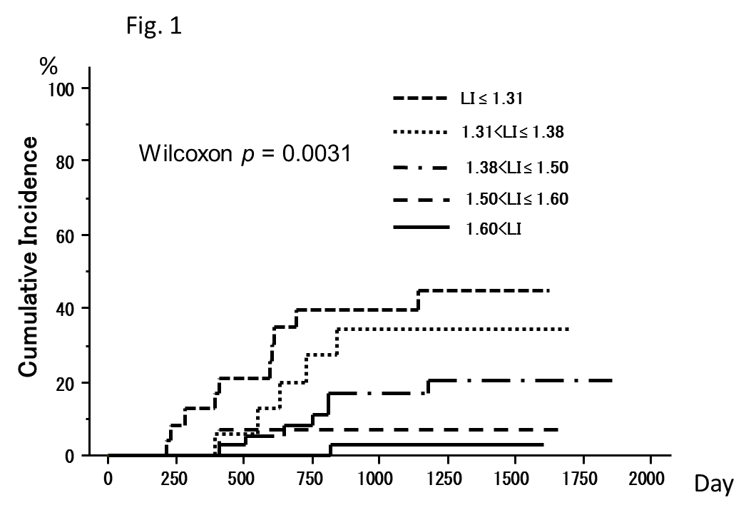
Figure 1 Cumulative incidence of HCC occurrence stratified by LI. Cumulative occurrence rates increased gradually in an LI-independent manner. HCC: Hepatocellular carcinoma; LI: Liver-intervertebral disc ratio.

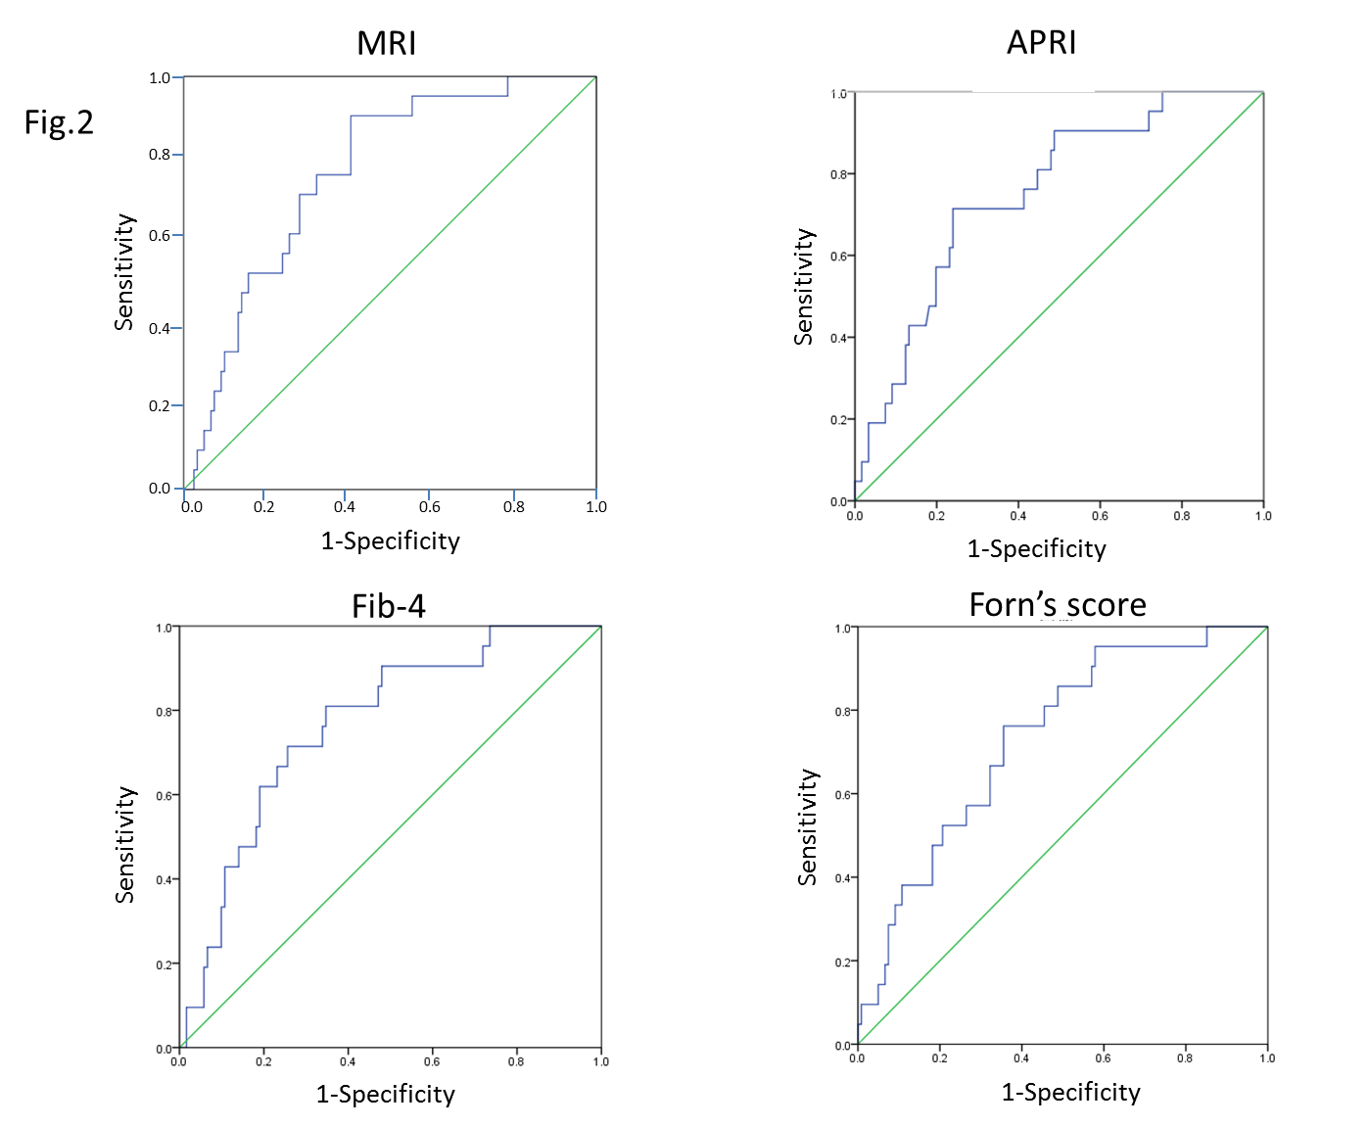
Figure 2 Receiver operating characteristic curve evaluating the cumulative incidence of LI, APRI, Fib-4, and Forn’s index. LI: Liver-intervertebral disc ratio; APRI: aspartate amino transferase-to-platelet ratio index.

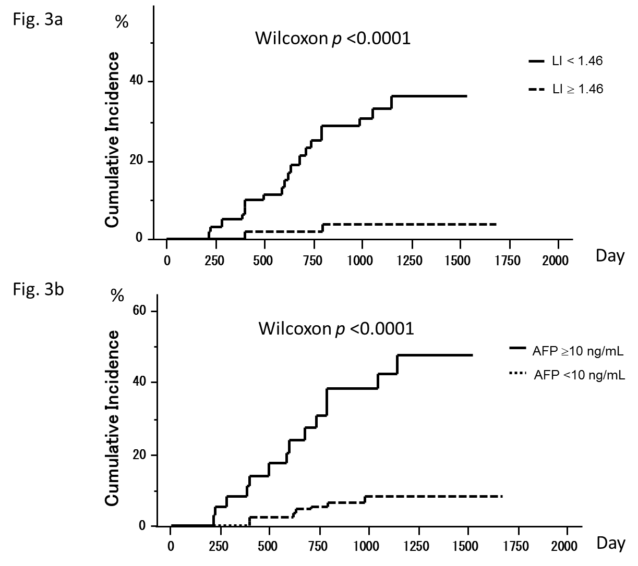
Figure 3 Relationship between cumulative occurrence rates and LI (A), cumulative occurrence rates and serum AFP level (B). A: Occurrence rates with LI < 1.46 were significantly higher than those with LI ≥ 1.46; B: Occurrence rates with serum AFP ≥ 10 ng/mL were significantly higher than in those with serum AFP < 10 ng/mL. LI: Liver-intervertebral disc ratio; AFP: α-fetoprotein.

Table 1 Baseline characteristics of 142 patients with chronic hepatitis C
Variables | Mean ± SD
Age (yr) | 66.1 ± 12.4 (28-87)
Male (M/F) | 70/72
AST (U/L) | 48.9 ± 23.4 (11-155)
ALT (U/L) | 51.7 ± 34.1 (10-228)
Serum albumin (g/dL) | 4.1 ± 0.5 (2.4-5)
Gamma-GT(IU/L) | 67 ± 92 (14-811)
ALP (U/L) | 331 ± 171 (141-1206)
T.chol (mg/dL) | 175 ± 36 (90-280)
T.Bil (mg/dl) | 0.86 ± 0.42 (0.3-2.9)
PT (%) | 93 ± 15.2 (55.2-134)
Platelet (x10³/μL) | 136 ± 60 (42-338)
AFP (ng/mL) | 14.5 ± 27.5 (1.6-235)
LI | 1.51 ± 0.19 (1.11-2.15)
Patients who received IFN, n (%) | 39 (27.5)
Patients who achieved SVR, n (%) | 27 (19.0)

AST: Aspartate amino transferase; ALT: Alanine aminotransferase; Gamma-GT: Gamma-glutamyl transpeptidase; T.Chol: Total cholesterol; T.Bil: Total bilirubin; PT: Prothrombin time; AFP: α-fetoprotein; LI: Liver-intervertebral disc ratio; IFN: Interferon; SVR: Sustained virologic response.

Table 2 Comparison of baseline characteristics between patients who have no HCC occurrence and HCC occurrence

Variables | No HCC occurrence n = 121 | HCC occurrence n = 21 | P value
Age (yr) | 65.4 ± 12.9 (28-87) | 70.3 ± 7.9 (51-79) | 0.094
Sex (M/F) | 59/62 | 11/10 | 0.759
AST (U/L) | 46.0 ± 20.4 (11-110) | 65.5 ± 31.6 (34-155) | 0.0003
ALT (U/L) | 49.5 ± 32.5 (10-228) | 64.4 ± 40.5 (31-205) | 0.063
Serum albumin (g/dL) | 4.1 ± 0.5 (2.4-5) | 3.8 ± 0.5 (2.6-4.7) | 0.03
Gamma-GT(IU/L) | 67 ± 97 (14-811) | 62 ± 43 (16-226) | 0.829
ALP (U/L) | 315 ± 158 (141-1206) | 426 ± 212 (150-1006) | 0.006
T.chol (mg/dL) | 178 ± 36 (90-280) | 159 ± 35 (93-260) | 0.029
T.Bil (mg/dl) | 0.86 ± 0.42 (0.3-2.9) | 0.86 ± 0.42 (0.3-2.9) | 0.287
PT (%) | 94 ± 15.5 (55.2-134) | 86.8 ± 12.0 (67-110) | 0.045
Platelet (x10³/μL) | 142 ± 61 (42-338) | 104 ± 40 (46-166) | 0.0064
AFP (ng/mL) | 11.7 ± 26.3 (1.6-235) | 30.3 ± 31.6 (4.2-116) | 0.0044
LI | 1.53 ± 0.20 (1.11-2.15) | 1.37 ± 0.10 (1.23-167) | 0.0004
Patients who received IFN, n (%) | 37 (30.6) | 2 (9.5) | 0.062
Patients who achieved SVR, n (%) | 25 (20.7) | 2 (9.5) | 0.366

HCC: Hepatocellular carcinoma; AST: Aspartate amino transferase; ALT: Alanine aminotransferase; Gamma-GT: Gamma-glutamyl transpeptidase; ALP: Alkaline phosphatase; T.Chol: Total cholesterol; T.Bil: Total bilirubin; PT: Prothrombin time; AFP: α-fetoprotein; LI: Liver-intervertebral disc ratio; IFN: Interferon; SVR: Sustained virologic response.

Table 3 Risk factors contributing to HCC incidence
Variable | Univariate analysis |  |  |  | Multivariate analysis
 | Risk ratio | 95%CI | P-Value |  | Risk ratio | 95%CI | P-Value
Age (per 1 year old) | 1.04 | 1.01-1.09 | 0.045 |  | 1.05 | 0.99-1.11 | 0.139
Sex (F) | 0.74 | 0.31-1.73 | 0.483
AST (U/L) | 1.02 | 1.01-1.03 | < 0.001 |  | 1.01 | 0.99-1.03 | 0.2
ALT (U/L) | 1.01 | 0.99-1.02 | 0.12
Serum albumin (g/dL) | 0.27 | 0.12-0.60 | 0.001 |  | 0.62 | 0.17-2.26 | 0.469
Gamma-GT(IU/L) | 1 | 0.99-1.01 | 0.942
ALP (U/L) | 1.002 | 1.001-1.004 | 0.006 |  | 1 | 0.99-1.01 | 0.504
T.chol (mg/dL) | 0.98 | 0.97-0.99 | 0.01 |  | 0.99 | 0.98-1.01 | 0.483
T.Bil (mg/dl) | 2.01 | 0.77-5.25 | 0.153
PT (1 %) | 0.97 | 0.94-0.99 | 0.018 |  | 1.01 | 0.97-1.05 | 0.621
Platelet (1x10³/μL) | 0.98 | 0.97-0.99 | 0.003 |  | 0.99 | 0.98-1.01 | 0.281
AFP (≥ 10 ng/mL) | 7.39 | 2.97-18.37 | < 0.001 |  | 3.1 | 1.03-9.35 | 0.045
LI (< 1.46) | 11.63 | 2.71-49.9 | 0.001 |  | 6.05 | 1.34-27.3 | 0.019
≥ 1.601 | 1
1.501 to 1.60 | 2.68 | 0.17-42.9 | 0.48
1.381 to 1.50 | 7.24 | 0.89-58.9 | 0.06
1.311 to 1.38 | 11.5 | 1.2-103 | 0.02
≤ 1.31 | 17.34 | 2.16-138.7 | 0.007
Patients who received IFN | 0.2 | 0.04-0.87 | 0.032 |  | 1.09 | 0.21-5.62 | 0.917
Patients who achieved SVR | 0.35 | 0.81-1.51 | 0.158
HCC: Hepatocellular carcinoma; AST: Aspartate amino transferase; ALT: Alanine aminotransferase; Gamma-GT: Gamma-glutamyl transpeptidase; ALP: Alkaline phosphatase; T.Chol: Total cholesterol; T.Bil: Total bilirubin; PT: Prothrombin time; AFP: α-fetoprotein; LI: Liver-intervertebral disc ratio; IFN: Interferon; SVR: Sustained virologic response.

Table 4 Analyses of LI contributions to HCC occurrence risk divided by other risk factors

 | Subgroup | n | Risk ratio | 95%CI | P-Value
Age | ≥ 69 | 75 | 12.51 | 1.63-95.82 | 0.015
 | < 69 | 67 | 9.2 | 1.11-76.58 | 0.041
Sex | Male | 70 | 8.4 | 1.08-65.18 | 0.042
 | female | 72 | 7.024 | 1.49-33.14 | 0.014
Platelet (x10³/μL) | < 120 | 67 | 4.48 | 1.01-19.89 | 0.048
 | ≥ 120 | 75 | 14.96 | 1.89-118.2 | 0.013
Alb (g/dL) | < 4.2 | 72 | 9.7 | 1.27-74.24 | 0.029
 | ≥ 4.2 | 70 | 10.79 | 1.29-89.7 | 0.028
ALT ( U/L) | ≥ 50 | 88 | 10.98 | 1.39-86.7 | 0.023
 | < 50 | 54 | 12.7 | 1.62-99.63 | 0.016
IFN | - | 103 | 13.35 | 1.78-100.1 | 0.011
 | + | 39 | 3.498 | 0.22-55.96 | 0.376
SVR | - | 115 | 15.98 | 2.13-119.7 | 0.007
 | + | 27 | 3.795 | 0.28-60.74 | 0.346

LI: Liver-intervertebral disc ratio; HCC: Hepatocellular carcinoma; ALT: Alanine aminotransferase; IFN: Interferon; SVR: Sustained virologic response.

