Name of Journal: World Journal of Gastroenterology

Manuscript NO: 44801

Manuscript Type: FRONTIER

Endoscopic foregut surgery and interventions: The future is now

Chang KJ. The state-of-the-art and my personal journey

Kenneth J Chang

Kenneth J Chang, H.H. Chao Comprehensive Digestive Disease Center, University of California, Irvine Medical Center, Orange, CA 92868, United States

ORCID number: Kenneth J Chang (0000-0001-9897-277X).

Author contributions: Chang KJ designed the overall concept, outline of this manuscript and was responsible for writing, and editing of the manuscript.

Conflict-of-interest statement: There’s no conflict of interest to declare.

Open-Access: This is an open-access article that was selected by an in-house editor and fully peer-reviewed by external reviewers. It is distributed in accordance with the Creative Commons Attribution Non Commercial (CC BY-NC 4.0) license, which permits others to distribute, remix, adapt, build upon this work non-commercially, and license their derivative works on different terms, provided the original work is properly cited and the use is non-commercial. See: http://creativecommons.org/licenses/by-nc/4.0/

Manuscript source: Invited manuscript

Corresponding author: Kenneth J Chang, FACG, FASGE, MD, Professor, Gastroenterology and Hepatology Division, H.H. Chao Comprehensive Digestive Disease Center, University of California, Irvine Medical Center, 101 The City Drive, Orange, CA 92868, United States. kchang@uci.edu
Telephone: +1-714-4566187
Fax: +1-714-4567520

Received: November 28, 2018

Peer-review started: November 28, 2018

First decision: December 5, 2018

Revised: December 13, 2018

Accepted: December 14, 2018

Article in press: December 14, 2018

Published online: January 7, 2019

Abstract
In this paper, I reviewed the emerging field of endoscopic surgery and present data supporting the contention that endoscopy can now be used to treat many foregut diseases that have been traditionally treated surgically. Within each topic, the content will progress as follows: “lessons learned”, “technical considerations” and “future opportunities”. Lessons learned will provide a brief background and update on the most current literature. Technical considerations will include my personal experience, including tips and tricks that I have learned over the years. Finally, future opportunities will address current unmet needs and potential new areas of development. The foregut is defined as “the upper part of the embryonic alimentary canal from which the pharynx, esophagus, lung, stomach, liver, pancreas, and part of the duodenum develop”. Foregut surgery is well established in treating conditions such as gastroesophageal reflux disease (GERD), achalasia, esophageal diverticula, Barrett’s esophagus (BE) and esophageal cancer, stomach cancer, gastric-outlet obstruction, and obesity. Over the past decade, remarkable progress in interventional endoscopy has culminated in the conceptualization and practice of endoscopic foregut surgery for various clinical conditions summarized in this paper. Regarding GERD, there are now several technologies available to effectively treat it and potentially eliminate symptoms, and the need for long-term treatment with proton pump inhibitors. For the first time, fundoplication can be performed without the need for open or laparoscopic surgery. Long-term data going out 5-10 years are now emerging showing extended durability. In respect to achalasia, per-oral endoscopic myotomy (POEM) which was developed in Japan, has become an alternative to the traditional Heller’s myotomy. Recent meta-analysis show that POEM may have better results than Heller, but the issue of post-POEM GERD still needs to be addressed. There is now a resurgence of endoscopic treatment of Zenker’s diverticula with improved technique (Z-POEM) and equipment; thus, patients are choosing flexible endoscopic treatment as opposed to open or rigid endoscopy options. In regard to BE, endoscopic submucosal dissection (ESD) well established in Asia, is now becoming more mainstream in the West for the treatment of BE with high grade dysplasia, as well as early esophageal cancer. In combination with all the ablation technologies (radiofrequency ablation, cryotherapy, hybrid argon plasma coagulation), the entire spectrum of Barrett’s and related dysplasia and early cancer can be managed predominantly by endoscopy.
Importantly, in regard to early gastric cancer and submucosal tumors (SMTs) of the stomach, ESD and full thickness resection (FTR) can excise these lesions en-bloc and endoscopic suturing is now used to close large defects and perforations. For treatment of patients with malignant gastric outlet obstruction (GOO), endoscopic gastro-jejunostomy is now showing better results than enteral stenting. G-POEM is also emerging as a treatment option for patients with gastroparesis. Obesity has become an epidemic in many western countries and is becoming also prevalent in Asia. Endoscopic sleeve gastroplasty (ESG) is now becoming an established treatment option, especially for obese patients with body mass index between 30 and 35. Data show an average weight loss of 16 kg after ESG with long-term data confirming sustainability. Finally, in respect to endo-hepatology, there are many new endoscopic interventions that have been developed for patients with liver disease. Endoscopic ultrasound (EUS)-guided liver biopsy and EUS-guided portal pressure measurement are exciting new frontiers for the endo-hepatologists.

Key words: Endoscopy; Foregut diseases; Endoscopic sleeve gastroplasty; Endoscopic submucosal dissection; Per-oral endoscopic myotomy; Endo-hepatology

© The Author(s) 2019. Published by Baishideng Publishing Group Inc. All rights reserved.

Core tip: In this paper, we demonstrate how foregut diseases, such as gastroesophageal reflux disease, achalasia, Barrett’s esophagus with dysplasia and early cancer of the esophagus and stomach, Zenker’s diverticulum, obesity, gastric outlet obstruction, and gastroparesis, which have been traditionally treated surgically are now being diagnosed and treated endoscopically. For each section, I will review “lessons learned”, then discuss some “technical considerations” and consider “future opportunities”.

Citation: Chang KJ. Endoscopic foregut surgery and interventions: The future is now. The state-of-the-art and my personal journey. World J Gastroenterol 2019; 25(1): 1-41
URL: https://www.wjgnet.com/1007-9327/full/v25/i1/1.htm
DOI: https://dx.doi.org/10.3748/wjg.v25.i1.1

BIOGRAPHY
Kenneth J Chang (Figure 1), FACG, FASGE, MD is Professor of Medicine and Chief, Division of Gastroenterology at the University of California, Irvine, School of Medicine. He is also Executive Director of the H.H. Chao Comprehensive Digestive Disease Center and Vincent and Anna Kong Endowed Chair in GI Endoscopic Oncology.
Dr. Chang received his MD degree from the Brown University Medical School, Providence, Rhode Island in 1985. He completed internship and residency in General Internal Medicine at the Rhode Island Hospital, Providence, Rhode Island in 1988, and an academic fellowship in gastroenterology and hepatology at the University of California, Irvine, 1988-1991. From 1991 to the present, he had academic appointments as an assistant, associate and full professor of medicine, respectively, at the University of California, Irvine, at the Department of Medicine; and as a Professor in Clinical Radiological Sciences, Department of Radiological Sciences. He is board certified in Medicine and Gastroenterology; is a Fellow of the American College of Gastroenterology and a Fellow of the American Society of Gastrointestinal Endoscopy. He served 2009 - 2015 as Governor of the American College of Gastroenterology, Southern California B, and served in various capacities in the American Society of Gastrointestinal Endoscopy (EUS Committee, Postgraduate Education Committee Member, Scientific Program Committee Member and Chair, and the Technology Assessment Committee Member). He was a Founding Member of the American Endosonography Club, and recently was invited to be a founding Board Member of the newly formed American Foregut Society.
Dr. Chang is internationally recognized for his advanced expertise in gastrointestinal endoscopy and new technologies. He developed and pioneered endoscopic ultrasound (EUS)-guided fine needle aspiration (FNA), which broke the critical technology barrier and enabled a world-wide application of this technique. He then developed novel techniques for EUS-guided fine needle injection (FNI), including delivery of anti-tumor agents, paving the way to interventional endoscopy and interventional EUS. More recently, he has made major contributions to in vivo identification and diagnosing of pancreatic cystic neoplasms with needle-based confocal laser endomicroscopy, and developed a new method of EUS-guided portal pressure gradient measurement in humans with a simple novel device. Dr. Chang’s career passion has been to expand the use of endoscopy within the field of oncology. This has stemmed the entire spectrum of early and precise detection of cancer and pre-cancerous lesions in the esophagus and pancreas, accurate local staging of gastrointestinal (GI) malignancies, complete eradication of pre-cancerous Barrett’s esophagus (BE), and the delivery of novel therapeutics. One of the most widely used endoscopic device world-wide is the Barrx90 radiofrequency (RF) device, which bears the name “Chang Cap”. More recently, his focus has included the endoscopic treatment of conditions that predispose patients to cancer, namely gastroesophageal reflux disease (GERD) and obesity.
He has authored over 170 scientific papers, including papers in The New England Journal of Medicine, Nature Genetics, Gastroenterology, Nature Clinical Practice Gastroenterology and Hepatology, Cancer, Endoscopy, American Journal of Gastroenterology, Gastrointestinal Endoscopy, Clinical Cancer Research, Digestive Diseases and Sciences, Digestive Endoscopy, Gastrointestinal Endoscopic Clinics of North America, Journal of Clinical Imaging Science, Journal of Clinical Oncology, Journal of Gastroenterology and Hepatology, Journal of Physiology and Pharmacology, Journal of Hepatobiliary and Pancreatic Science, Journal of Hepatobiliary Pancreatic Surgery, Annals of Surgery, Annals of Surgical Oncology, Pancreas, United European Gastroenterology Journal, World Journal of Gastroenterology and others. He authored 3 books, 3 CD-ROM teaching programs distributed world-wide, 200 abstracts and had over 480 presentations at local and national meetings (DDW/AGA/ASGE/ACG) including numerous papers at plenary sessions. He has 5 United States patents: (1) Methods of Using Nitroxides in Conjunction with Photosensitizers and Sonosenitizers; (2) Fluoroscopy-Free Guide Wire System and Methods; (3) Percutaneous Transgastric Gastroplication and Transgastric Minimally Invasive Surgery; (4) Ring Magnets for Surgical Procedures; and (5) Hood Method and Device for Endoscopic Submucosal Dissection. Dr. Chang was the key-note speaker at prestigious international meetings in Australia, Austria, Brazil, China, France, Hong Kong, Hungary, India, Japan, South Korea, Taiwan, Thailand and the United European Gastroenterology Week meetings. He received numerous awards including American College of Gastroenterology Senior Governor Award and the National Cancer Institute Clinician award. He has consistently been included in Best Doctors in America, which recognizes the top 5% of physicians in the country. He has mentored 42 Advanced Endoscopy Fellows, of whom 23 currently hold prominent academic positions in the United States, and 11 are respected faculty in Japan, South Korea, and Australia.

INTRODUCTION
In this paper, I reviewed the emerging field of endoscopic surgery and present data supporting the contention that endoscopy can now be used to treat many foregut diseases that have been traditionally treated surgically. Within each topic, the content will progress as follows: “lessons learned”, “technical considerations” and “future opportunities”. Lessons learned will provide a brief background and update on the most current literature. Technical considerations discuss procedural issues including my personal experience - tips and tricks that I have learned over the years. Finally, future opportunities will address current unmet needs and potential new areas of development.
The foregut is defined as “the upper part of the embryonic alimentary canal from which the pharynx, esophagus, lung, stomach, liver, pancreas, and part of the duodenum develop”. Foregut surgery is well established in treating conditions such as gastroesophageal reflux disease (GERD), achalasia, esophageal diverticula, Barrett’s esophagus (BE) and esophageal cancer, stomach cancer, gastric-outlet obstruction, and obesity. Over the past decade, remarkable progress in interventional endoscopy has culminated in the conceptualization and practice of endoscopic foregut surgery for various clinical conditions summarized in this paper.

GERD
Lessons learned
GERD is the most prevalent gastrointestinal (GI) disorder in the United States^{[1]} and the extent of anatomical alterations underlying the mechanism of GERD can be viewed as a spectrum from normal to a single anatomic alteration [e.g., weak lower esophageal sphincter (LES)] to multiple anatomic alterations such as weak LES, open diaphragmatic hiatus, hiatal hernia (Figure 2)^{[2,3]}. The degree of anatomical alterations also appear to correlate with the complications of GERD, namely degree of esophagitis, the presence of Barrett’s metaplasia^{[4]}, dysplasia and its progression to esophageal adenocarcinoma. Thus, as GERD is a spectrum disorder, then treatment should be individualized to the anatomic alterations of each patient. While medical and surgical therapy have been the mainstay of treatment for GERD, there are currently several Food and Drug Administration (FDA)-approved devices available for endoscopic treatment of GERD, thus filling in the therapeutic gap between medications and surgery. Endoscopic treatment options are now considered appropriate treatment in patients early in the GERD spectrum.
The first group in the spectrum would include patients with a normal LES tone, no hiatal hernia, and a closed diaphragmatic hiatus. This has been called “Dynamic Failure” (Hill Grade I). These patients have the phenotype of daytime reflux, no esophagitis or Barrett’s, and on ambulatory pH monitoring will have predominantly upright reflux. The main mechanism for GERD in these patients is inappropriate transient LES relaxation (tLESRs). The major stimulus for tLESRs is distension of the proximal stomach^{[3]}. Interventions that decrease the distensibility of the proximal stomach have been shown to decrease tLESRs. This is one of the predominant mechanisms for endoscopic radiofrequency (RF) treatment for GERD (Stretta; Figure 3)^{[5]}. With this device, RF energy is delivered endoscopically to the muscle of the LES and the gastric cardia. The hypothesis that Stretta alters esophageal gastric junction (EGJ) resistance dynamically was established in a double-blind randomized crossover study of Stretta and sham treatment in 22 patients with GERD^{[6]}. Stretta decreased EGJ compliance, while administration of sildenafil normalized EGJ compliance back to pre-Stretta level, arguing against EGJ fibrosis as the underlying mechanism. The authors concluded that decreased EGJ compliance, which reflects altered LES neuromuscular function, may contribute to symptomatic benefit by decreasing refluxate volume. A number of clinical trials have confirmed that Stretta effectively improves GERD symptoms and reduces, but does not normalize esophageal acid exposure^{[7,8]}. There have also been several meta-analysis papers similarly showing that Stretta is effective for symptom relief, is safe and well tolerated, and allows patients to decrease intake of proton pump inhibitors (PPI) medications^{[9,10]}. Interestingly, the durability of Stretta’s effects may reach beyond 10 years^{[11,12]}. Some of the Stretta related issues and pathophysiology were elegantly elaborated upon by Triadafilopoulos^{[13]}.

Lessons learned for Stretta
I have been performing Stretta procedures for over 15 years. In my opinion, it is the least invasive procedure for GERD, takes about 25 min to perform, and if performed on the appropriate patient, has high effectiveness in symptom relief with the majority of patients able to come off PPIs. The main caveat is that the patients in this first group (dynamic failure) are the most suitable candidates for Stretta. These are the upright refluxers with minimal esophagitis (non-erosive reflux disease, or NERD).

Technical considerations for Stretta
The procedural goal of Stretta is to precisely deliver RF energy to the LES and the cardia. Other than placement, practically every other parameter is automated and self-regulated - including needle electrode temperature, mucosal temperature, 60 second application, and impedance. After the first 2 levels in the esophagus, I routinely re-insert the endoscope to see if the RF marks are properly placed starting at 1 cm proximal to the EGJ. If the marks are too distal, I will adjust the 2 levels accordingly. However, it is my strong belief that the most important RF energy delivery is to the cardia. The 2 treatment levels at the cardia are done with the balloon inflated in the stomach and then the catheter is gently pulled back so the balloon fits snug up against the cardia. During the 3 applications at each level in the cardia, I find it useful to unhook the suction from the device, allowing the balloon to slide freely into position. The suction is applied just prior to advancing the needle electrodes. At the end of a successful procedure, a retroflexed view of the EGJ should demonstrate a cluster of RF marks around the cardia, creating a “swollen lip” appearance, with little to no “stray” RF marks (Figure 4A and 4B).

Lessons learned for TIF
The second group of the spectrum (Figure 2) would include patients with a low LES basal pressure, with no hiatal hernia, but the presence of a loose diaphragmatic hiatus (Hill Grade II). These patients have the phenotype of both daytime and nighttime reflux, with possible grade A or B esophagitis, and on ambulatory pH monitoring will have both upright and supine reflux. The mechanisms for GERD in these patients are an incompetent LES and/or an open diaphragmatic hiatus. These patients would be ideally suited for trans-oral incisionless fundoplication (TIF), using the Esophyx device (Figure 6). There have been 3 recent randomized control clinical trials using TIF 2.0, which employs the most advanced technique, similar to laparoscopic anti-reflux surgery. The first, known as the TEMPO trial, consisted of 63 patients randomized to TIF (40 patients) vs high dose PPI (23 patients)^{[14]}. The primary outcome was elimination of daily troublesome regurgitation or extraesophageal symptoms. Secondary outcomes were normalization of esophageal acid exposure, PPI usage, and healing of esophagitis. At the 6-mo follow-up, troublesome regurgitation was eliminated in 97% of TIF patients versus 50% of PPI patients (RR = 1.9, 95%CI, P = 0.006). Globally, 62% of TIF patients experienced elimination of regurgitation and extraesophageal symptoms versus 5% of PPI patients (RR = 12.9, CI: 1.9-88.9, P = 0.009). Esophageal acid exposure was normalized in 54% of TIF patients versus 52% of PPI patients (RR = 1.0, 95%CI: 0.6-1.7, P = 0.914). 90% of TIF patients were off PPIs. The authors concluded that at the 6-mo follow-up, TIF was more effective than maximum standard dose PPI therapy in eliminating troublesome regurgitation and extraesophageal symptoms of GERD. The second clinical trial studying TIF 2.0 against PPIs was the RESPECT trial^{[15]}, which was a prospective, sham-controlled trial to determine if TIF reduced troublesome regurgitation to a greater extent than PPIs in patients with GERD. 696 patients with troublesome regurgitation despite daily PPI with 3 validated GERD-specific symptom scales, on and off PPIs, were initially screened. 87 patients with GERD and hiatal hernias ≤ 2 cm were randomly assigned to groups that underwent TIF and then received 6 mo of placebo, or sham surgery and 6 mo of once- or twice-daily omeprazole (controls, n = 42). Patients were blinded to therapy during the follow-up period and reassessed at 2, 12, and 26 wk. At 6 mo, patients underwent 48-h esophageal pH monitoring and esophagoduodenoscopy. By intention-to-treat analysis, TIF eliminated troublesome regurgitation in a larger proportion of patients (67%) than PPIs (45%) (P = 0.023). A larger proportion of controls had no response at 3 mo (36%) than patients who received TIF (11%) (P = 0.004). Control of esophageal pH improved after TIF (mean 9.3% before and 6.3% after; P < 0.001), but not after sham surgery (mean 8.6% before and 8.9% after). Patients from both groups who completed the protocol had similar reduction in GERD symptom scores. The authors concluded that TIF was an effective treatment for patients with GERD symptoms, particularly in those with persistent regurgitation despite PPI therapy, based on evaluation 6 mo after the procedure.
The third clinical trial performed in a European study^{[16]} was a double-blind sham-controlled study in GERD patients who were chronic PPI users. Forty-four patients were randomized equally to 22 patients in each group. The primary effectiveness endpoint was the proportion of patients in clinical remission after 6-mo follow-up. Secondary outcomes were: PPI consumption, esophageal acid exposure, reduction in Quality of Life in Reflux and Dyspepsia and Gastrointestinal Symptom Rating Scale scores and healing of reflux esophagitis. Results showed that the time in remission after TIF procedure (197 d) was significantly longer compared to those submitted to the sham intervention (107 d), P < 0.001. After 6 mo, 13/22 (59%) of the chronic GERD patients remained in clinical remission after TIF. A recent meta-analysis^{[17]} was conducted using data only from these 3 randomized studies that assessed the TIF 2.0 procedure compared to a control. The purpose of the meta-analysis was to determine the efficacy and long-term outcomes associated with performance of the TIF 2.0 procedure in patients with chronic long-term refractory GERD on optimized PPI therapy, including esophageal pH, PPI utilization and quality of life. Results from this meta-analysis, including data from 233 patients, demonstrated that TIF subjects at 3 years had improved esophageal pH, a decrease in PPI utilization, and improved quality of life. Recent publications are also showing favorable durability with long-term outcomes at 5 years^{[18,19]} and even preliminary data at 10 years^{[20]}. The FDA has recently expanded the device label to include concomitant laparoscopic hernia repair with TIF in patients with hiatal hernias greater than 2 cm in height.
Thus, with both Stretta and TIF showing level 1 data with durability, being FDA approved and commercially available, with category 1 CPT codes and reimbursement by many payors, the endoscopic foregut surgery for GERD patients is now a reality. With the emergence of effective endoscopic treatment for GERD, and the simultaneous public concern over long-term PPI use, we have seen a dramatic growth in our GERD referrals. To meet this growing demand, we recently established a Comprehensive Heartburn Center at the University of California Irvine Medical Center, which allows patients easy access to medical, endoscopic and surgical options under a one-stop-shop individualized approach to patients with GERD.

Technical considerations for TIF
The EsophyXTM device (Figure 5) is composed of the following: a handle with controls; an 18 mm diameter frame through which control channels can run and a standard front-view 9 mm diameter endoscope can be introduced; the tissue invaginator, which consists of side holes stationed on the distal part of the frame, and to which external suction can be applied; the tissue mold, which pushes tissue against the shaft of the device; a helical screw, which is advanced into the tissue and allowed for the retraction of the tissue between the tissue mold and the shaft; two stylets, which puncture the plicated tissue and tissue mold, and over which polypropylene H-shaped fasteners can be deployed; and a cartridge, which holds 20 fasteners. In the TIF2 technique, the device is introduced over the endoscope and into the stomach, and CO₂ is used to insufflate the gastric cavity (Figure 6A-G). The endoscope is positioned in retroflexion, and the lesser curve and the greater curve are located at 12 and 6 o’clock positions, respectively. The tissue mold is retroflexed, closed against the device, rotated to 11 (posterior, Figure 6D), and withdrawn such that the tip may be located at the EGJ. Once this is accomplished, the helical screw is advanced to engage tissue just below the squamocolumnar junction. Traction is then applied to allow the gastric cardia and distal esophagus to slide downward into the tissue mold. Plication is then achieved by deploying multiple H-shaped fasteners while rotating the tissue mold such that it slides the stomach over the esophagus. This results in a circumferential tightening of the newly-created valve > 240 degrees. Twenty fasteners over ten plications are necessary to construct an adequate gastroesophageal valve (3 plications in each of the posterior and anterior corners, and 4 plications on the greater curve). The mechanism of action of the TIF procedure in many ways mirrors that of the Laparoscopic Anti-reflux surgery Nissen (LARS)^{[21]}. One paper, published by Rinsma et al^{[22]} characterizes such mechanisms. In their study involving fifteen patients, they performed 90-min postprandial combined with high-resolution manometry and impedance-pH monitoring followed by an ambulatory 24-h pH-impedance monitoring. EGJ distensibility was evaluated using an endoscopic functional luminal imaging probe using the endoscopic functional lumen imaging probe (EndoFLIP) before and directly after the procedures. The patients were followed for 6 mo. With regards to the stationary esophageal manometry and impedance-pH monitoring performed directly after the procedure, TIF resulted in a marked reduction of both the number of transient LES relaxation (tLESRs) (16.8 ± 1.5 vs 9.2 ± 1.3; P < 0.01) and the number of tLESRs associated with liquid-containing reflux after the procedure (from 11.1 ± 1.6 vs 5.6 ± 0.6; P < 0.01). TIF also led to a decrease in the number and proximal extent of reflux episodes and an improvement of acid exposure in the upright position; conversely, TIF had no effect on the number of gas reflux episodes, corroborating the low incidence of post-TIF gas-bloat symptoms. EGJ distensibility was reduced after the procedure (2.4 ± 0.3 mm²/mmHg vs 1.6 ± 0.2 mm²/mmHg; P < 0.05). Also of note, the basal LES pressure in the fasted state was increased after TIF (from 13.9 ± 1.0 to 20.5 ± 1.8 mmHg; P < 0.01). Thus, TIF reduces EGJ distensibility, thereby decreasing tLESRs, which is the main mechanism for upright refluxers. It also creates a 3-cm high pressure zone at the distal esophagus in the configuration of a flap valve, which should decrease both upright and supine reflux. However, since it is a 270° partial fundoplication, and the flap valve luminal diameter is controlled by the diameter of the device (prevents over-tightening), gas can still escape from the stomach into the esophagus, minimizing the side-effect of gas-bloat.

Future opportunities for endoscopic treatment of GERD
We are now exploring the role of TIF among patients with BE - including non-dysplastic Barrett’s, and those patients with previous history of Barrett’s dysplasia, who have now reached complete remission of intestinal metaplasia (CRIM) by endoscopic resection and/or ablation, but are destined to life-long PPIs. In addition, TIF after per-oral endoscopic myotomy (POEM) is a very exciting area of exploration - as the benefits of POEM over laparoscopic Heller myotomy (LHM) with partial fundoplication for patients with achalasia may be outweighed by the incidence of post-POEM GERD. If, however, post-POEM GERD can be controlled either by PPI or TIF, then it would tip the balance strongly to POEM as the procedure of choice for achalasia patients. This will be discussed more extensively in the next section.
We are also developing new techniques and technologies for endoscopic treatment of GERD among patients with altered anatomy (esophagectomy, sleeve gastrectomy, gastric bypass, failed Nissen fundoplication) using endoscopic suturing alone (Apollo Overstitch) and in combination with mucosal ablation and endoscopic resection. We reported the first case series of 10 patients who underwent endoscopic augmentation of the EGJ using the Apollo OverStitch endoscopic suturing system in patients with GERD^{[23]}. Using a double-channel gastroscope affixed to the endoscopic suturing platform, interrupted (individual) sutures were placed on the gastric side of the EGJ in 2 layers in order to create a narrowed and elongated EGJ (Figure 7A-F). Technical success was achieved in all patients, including those with a history of previous anti-reflux procedures (n = 7) and those with a hiatal hernia (n = 6). Patients with prior esophagectomy and sleeve gastrectomy were also included. The median pre-procedure GERD-Health Related Quality of Life Questionnaire improved from 20 (range: 11-45) to a post-procedure score of 6 (range: 3-25) (P = 0.001). The median duration of GERD symptom improvement after the procedure, however, was only 1 month (range: 0.5-4). Adverse events were limited to one patient who developed self-limited nausea and vomiting. From this preliminary pilot study, we concluded that the technique using a commercially available device for suturing to create a gastro-gastric plication was feasible and appeared safe, especially among patients with altered anatomy which would have precluded all other available surgical or endoscopic options. However, it became apparent that the durability was inadequate. The sutures were not predictably placed through the muscularis propria (MP) and over time the sutures would easily cut through the mucosa and cause loosening of the plication. In addition, since this was a mucosa to mucosa approximation, adhesion would not be expected to occur, thus leading to a shortened durability. A potential solution was to ablate the mucosa with argon plasma coagulation (APC), a technique we use for gastric bypass revisions where we ablate the gastric mucosa prior to placing a purse-string suture around the pouch anastomosis to narrow the outlet. We termed this technique mucosal ablation and suturing of the EGJ (MASE), and conducted a pilot trial in 27 patients with a typical procedural length of 25 min^{[24]} (Figure 8A-F). The mean follow-up time was 124 days. The indications for the procedure included either poorly controlled symptoms (48%) or a desire to discontinue their medication (52%). Seven patients (26%) had altered anatomy from prior surgery: Fundoplication (n = 4), Billroth II (n = 1), Roux-en-Y (n = 1), and Sleeve gastrectomy (n = 1). Pre-procedure, 22 patients (82%) were on once or twice daily PPI therapy and 5 patients were on H2-receptor antagonists/topical antacids. Of the 22 patients on daily PPI, 13 patients (59%) were able to discontinue their medication, and 3 patients (14%) were able to reduce their dose. Of the 7 patients with altered anatomy, 4 patients (57%) were able to discontinue or reduce their PPI after the procedure. With regards to tolerance, the most common side effect was self-limited epigastric pain post-procedure (22%). One patient required an overnight stay in hospital for intravenous pain control. There were no other early or late complications. Our experience thus far suggests that mucosal ablation prior to suturing helps to increase its durability. The other variation of this method is to perform endoscopic mucosal resection (EMR) prior to suturing. EMR or endoscopic submucosal dissection (ESD) has been shown in a small series to create scarring at the EGJ, which then decreases EGJ distensibility and improve reflux. This has been named anti-reflux mucosectomy (ARM) and in a small series of ten patients showed improvement of esophageal acid exposure^{[25]}. Combining EMR and suturing was the next step and this was done in a series of 10 patients with GERD^{[26]} with over-all improvement of GERD symptoms and 8 of 10 patients were able to stop their PPI medications. This is called the resection and plication (RAP) procedure. We recently performed a combination gastric-bypass revision plus RAP in an obese patient who gained weight after previous gastric-bypass and also had GERD, which was only partially responsive to PPI (Figure 9A-D). We are currently performing both the MASE and RAP procedures to examine the clinical benefits and nuances of each procedure. Since both can be done in an antegrade fashion, and may be the only option for GERD patients with altered anatomy, I anticipate that both of these techniques or a variation thereof, will be helpful in these special situations. They also may become reasonable options in patients who are in group 1 of the GERD spectrum, i.e. the upright-predominant phenotype without significant esophagitis.

ACHALASIA - POEM
Lessons learned
The LHM has been the standard of care for definitive treatment of achalasia for many years^{[27,28]}. POEM was first described by Inoue in 2010^{[29]} and is now considered the procedure of choice for treating achalasia in most tertiary centers^{[30-35]}. POEM has also been shown to be an effective rescue procedure in patients who have previously failed LHM^{[30,36,37]}. Recent meta-analysis show that POEM may have better results than LHM^{[38-41]}, but the issue of post-POEM GERD being higher than post-LHM still needs to be addressed^{[42]}. We need to keep in mind that LHM alone has a incidence of post-operative GERD of approximately 50%, while LHM in combination with a partial fundoplication reduces post-operative GERD to approximately 10%^{[43]}. Therefore, most surgeons will automatically perform both operations together. If a substantial number of patients require anti-reflux surgery after POEM, then it could tip the balance back towards LHM plus partial fundoplication as the preferred first line option. Fortunately, there may be an endoscopic solution to post-POEM GERD - namely the TIF procedure^{[44]}. In our experience of over 60 consecutive POEM procedures, only 3 patients were refractory to PPI medications and the TIF procedure was able to control GERD symptoms and esophagitis in all 3 patients. Further studies examining both efficacy and durability of TIF post POEM are underway. The other consideration between POEM versus LHM plus fundoplication is - while the durability of the myotomy (with both POEM and LHM) should be very long, perhaps several decades, the durability of the partial fundoplication may be more limited, probably less than 10 years. At the point of fundoplication loosening, these patients would require either chronic PPI, a revision fundoplication, or the TIF procedure. Ideally, a POEM with possible TIF among those patients refractory to PPI will prove effective, as a repeat TIF is much easier to perform than the revision of a fundoplication.
The POEM procedure has also now extended to other motility disorders such as Jackhammer esophagus^{[45-48]} and distal esophageal spasm^{[49,50]}, which are categorized under spastic esophageal disorders (SED)^{[51]}.

Technical considerations
We are currently performing, on average 4-6 POEM procedures per month. On average, it takes 45-90 min to perform the procedure. We also include physiologic compliance measurements at the EGJ (EndoFlip) immediately pre- and post-POEM procedure. We also routinely perform a pre-procedure timed barium esophagram, and repeat it 4-6 wk post procedure. We are currently examining whether the timed barium swallow and/or the EGJ physiologic measurements will predict both response to treatment of dysphagia (Eckart Score), as well as the risk of post-POEM GERD. Based on current literature and personal experience, our current protocol for type 1 achalasia (aperistalsis and failure of LES relaxation) and type 2 achalasia (aperistalsis, pan-esophageal pressurization and failure of LES relaxation) is to perform an 8 cm myotomy in the esophagus (5 cm circular only, then 3 cm full thickness) and only 1.5-2 cm in the stomach (full thickness) (Figure 10). This protocol seems to strike a good balance between maximal relief of dysphagia while minimizing GERD. For type 3 achalasia (aperistalsis, failure of LES relaxation, and simultaneous contractions in the esophageal body), a much longer myotomy is usually required, based on high resolution esophageal manometry (MREM), barium esophagram, and endoscopic observance of spasm. We routinely use the Erbe i-knife for mucosal incision, tunneling, and circular myotomy (Figure 10A-E). However, for full thickness myotomy at the EGJ, we prefer using the Olympus stag beetle (SB) knife (Figure 10F and G)^{[52]} as in my experience it decreases the rate of spontaneous bleeding (from vessels arising from the MP) and therefore is more expedient. I also use the SB knife for submucosal tunneling if I encounter large or abundant blood vessels in the submucosa (Figure 10H and I). We have published our initial experience using the SB knife for a small series of POEM cases^{[52]}.
As for closure of the submucosal tunnel, we have performed almost equal numbers of clip closure (Figure 10H and I) vs suturing (Figure 11C and D). The cost differential depends somewhat on the number of clips vs the number of sutures used, with a trend towards lower cost for using clips^{[53]}. The best configuration for suturing is to perform the initial mucosal incision in a horizontal direction (Figure 11B-D). However, the best configuration for clipping is a vertical incision. The issue with a vertical incision is that traction of the scope pushing inside the tunnel can actual cause unintended elongation of the mucosotomy. This may result is difficulty maintaining CO₂ within the tunnel for optimal visualization as well a longer closure process. We have found that a horizontal incision actually is optimal for either closure method, while decreasing the risk of elongating the mucosotomy. The best technique for clipping in this scenario is to identify the most distal midpoint of the incision (Figure 10H) and place the first clip 1mm distal to that point. This creates an elevated crease and all subsequent clips can be placed adjacently (Figure 10I). Confirmation of adequate extension into the stomach can sometimes be challenging, and mere fluid injection into the tunnel with subsequent endoscopic evaluation in retroflexed position in the stomach may not be adequate. In our center, we are routinely placing a slim scope (4.9 mm) alongside the gastroscope and advancing into the stomach in retroflexed position. Once in the stomach, the light can be turned off on the slim scope and the light from the standard gastroscope within the submucosal tunnel can be confirmed easily (Figure 10I).

Future opportunities
Technical and device refinements are still evolving with POEM. A single center, prospective randomized trial in 63 patients suggested no difference between an anterior versus a posterior myotomy^{[54]}, although larger studies with longer follow-up are needed to validate this. Similarly, partial full-thickness myotomy versus circular myotomy only has been compared in a small single center study and appears not to affect clinical outcomes, although the a partial full-thickness myotomy took less time^{[55]}. The extent of myotomy in the proximal stomach is also being evaluated, with a tendency towards 1.5-2 cm as compared to the initial 3 cm. The issue of post-POEM GERD has already been addressed, and this will continue to fuel both technique refinements to minimize GERD as well as endoscopic solutions, such as TIF, in cases that require further anti-reflux intervention.

ZENKER’S DIVERTICULUM - Z-POEM
Lessons learned
Zenker’s diverticulum has historically been treated by head and neck surgeons using either an open or rigid endoscopic approach with a stapler. A recent meta-analysis compared open to rigid endoscopic stapling approaches and found that failure of open and endoscopic approaches was 4.2% and 18.4%, respectively, and corresponding complication rates were 11% and 7%^{[56]}. Similarly, another meta-analysis concluded that compared with the open surgical approach, the rigid endoscopic treatment appeared to result in a shorter length of procedure and hospitalization, earlier diet introduction, and lower rates of complications, but in higher rates of symptom recurrence^{[57]}. Flexible endoscopy, largely in the hands of interventional gastroenterologists has emerged as a viable alternative for open or rigid endoscopic approaches. A recent meta-analysis which included twenty studies with a total of 813 patients showed that the pooled success, adverse events, and recurrence rates were 91%, 11.3%, and 11%, respectively^{[58]}. A more recent meta-analysis examining thirteen studies including 589 patients showed a response rate, overall complication, bleeding and perforation of 88%, 13%, 5% and 7%, respectively^{[59]}. However, the pooled data still demonstrated an overall recurrence rate of 14% (95%CI: 9%-21%). Diverticulum size of ≥ 4 cm and < 4 cm demonstrated pooled adverse event rates of 17% and 7%, respectively. Starting with a basic needle knife, and progressing to more specialized knives (such as the hook knife)^{[60,61]} and endoscopic scissors^{[62-66]}, have led to some improvement in clinical outcomes. The challenge is to perform a complete myotomy of the cricopharyngeus muscle, without increasing the risk of mediastinitis or perforation. The issue surrounds the fact that most of these techniques involve cutting the entire septum (mucosa and muscle) from proximal to distal with no precise visual cue as to when the myotomy is complete. The most recent advances include various tunneling methods, similar to POEM, where the mucosal incision is either proximal or superficial to the myotomy^{[67-70]}.

Technical considerations
This Z-POEM technique allows for complete excision of the muscle, while minimizing the risk of mediastinitis or perforation due to the tunneling mechanism. We currently employ a modified tunneling approach, with mucosal incision at the apex of the septum (Figure 12B-D), followed by submucosal tunneling on both the esophageal and diverticular sides of the muscle (Figure 12E). This allows for optimal visualization, precise control of complete myotomy (Figure 12F), and closure of the short tunnel with mucosal clips (Figure 12G).

Future opportunities
With these technical and device improvements, flexible endoscopy may become the treatment of choice for most patients with Zenker’s diverticulum. Further prospective trials are necessary to compare this most recent technique compared with standard flexible and rigid instrument techniques.

BE AND EARLY ESOPHAGEAL CANCER
Lessons learned
It was not that long ago that the standard of care for treating BE with high grade dysplasia (HGD) was esophagectomy^{[71-74]}. Initial endoscopic approaches to treat Barrett’s included photodynamic therapy (PDT), multipolar electrocoagulation (MPEC) and argon-plasma coagulation (APC). While these sparked initial enthusiasm, they were not able to achieve high rates of complete eradication while minimizing complications^{[75]}. The emergence of RF ablation (RFA) completely changed the landscape and transformed our approach to Barrett’s, with the expectation that Barrett’s can be completely eliminated by endoscopic treatment in the vast majority of cases. I have been using RFA technology since 2004. At that time, there was only a 360-degree balloon device available for treatment. Given my experience with PDT (Figure 13) and using ND:YAG laser delivered through a sapphire contact probe (Figure 14A and B), I was able to “touch-up” any small areas of residual Barrett’s post PDT. With this conceptual construct of devices for wide field treatment as well as devices for focal treatment, the Barrx Halo 90 device was conceived. My contributions were acknowledged by having the product “nick named” the Chang Cap (Figure 15). With the combination of the 360 device and the focal device (Figure 16), published clinical trials mounted to over 100 articles establishing the efficacy and safety of this technology with the over-all rate of CRIM of 77%, complete response of low grade dysplasia of 90%, and complete response of HGD of 81%^{[76]}. In this seminal NEJM study, patients who received RFA had less disease progression (3.6% vs 16.3%, P = 0.03) and fewer cancers (1.2% vs 9.3%, P = 0.045). There are now multiple different RFA probes available for circumferential, focal, long and short segment, as well as through the scope applications (Figure 17).
More recently, cryotherapy has emerged as an alternative means of treating Barrett’s. There are now two delivery systems available: a spray catheter^{[77-86]} and a balloon based device^{[87-89]}. While the number of published trials using cryotherapy currently pales in comparison to RFA, the potential theoretical advantages of cryotherapy may be better patient tolerance^{[80]}, slightly less stricture rate^{[90]} and deeper penetration of cold energy^{[91]} . Spray cryotherapy appears to be able to salvage approximately 50% of dysplastic Barrett’s cases refractory to RFA^{[92]} and provide a reasonable complete remission of dysplasia (CR-D) in 76% of naïve patients^{[77]}. However, the CRIM of 46% in non-dysplastic BE is considerably lower than the established rate with RFA. Therefore, RFA still remains the standard of care for treatment of flat dysplastic Barrett’s. The more recent development of a balloon-based cryotherapy, using nitrous oxide to cool the temperature within the balloon (Figure 18), is quite intriguing with preliminary data suggesting very respectable treatment and safety outcomes (CR-D of 95% and CRIM of 88%)^{[87]}.
The newest emerging ablation technology is argon plasma coagulation (APC) preceded by high pressure needleless submucosal injection of saline via a built-in water jet within the same catheter (called Hybrid APC). An initial ex-vivo study showed that submucosal saline injection decreased depth of coagulation by half^{[93]}. This was followed by an initial series of 50 Barrett’s patients in whom 78% achieved complete remission after a median of 3.5 APC sessions with a stricture rate of 2%^{[94]}. We recently presented our initial Hybrid APC series of 17 patients with biopsy proven non-dysplastic BE (NDBE) 59%, low grade dysplasia 18% and HGD 24%^{[95]}. Of these patients, 59% had undergone prior RFA, 18% prior EMR, 12% prior cryotherapy and 35% were naive. The average procedure time was 21 min. The pain scores were low (2.39 at day 1, and 0.42 on day 7) with only one treatment-related stricture (4.2%). Our protocol has been modified from the European reports, in that we utilize an EMR cap in order to provide stable visibility and precise focal distance for application of APC (Figure 19). After submucosal injection of saline (Figure 19B), APC is applied evenly to all visible Barrett’s areas (Figure 19C and D). Then after removing the coagulated tissue using the ESD cap and washing (with scope water jet), this is followed by a second application of APC at a lower energy setting (Figure 19F and G). The final visual result should be a tan colored, dry appearance similar to that achieved after RFA. Long-term outcomes and larger studies are underway. Therefore, while RFA remains “king of the hill” as standard of care for flat dysplastic Barrett’s, cryotherapy and Hybrid APC may eventually contend for a subset of Barrett’s patients. I predict that spray cryotherapy may be useful in patients with nodular dysplasia or early cancer that are not suitable candidates for resection techniques (severe scarring, etc.), while balloon cryotherapy and Hybrid APC may be viable options for patients with short segment Barrett’s and for focal “touch-up” treatments. Capital equipment and disposable accessory costs may become a deciding factor if outcomes are equivalent.
Any nodular lesion should be treated, if possible, by endoscopic resection. This is mostly accomplished with EMR, often requiring multiple piecemeal resections. Some drawbacks of piecemeal EMR include depth of resection and inability to adequately determine resection margins. Endoscopic Submucosal Dissection (ESD) while initially developed for gastric and then colonic lesions, is now being used more frequently for early esophageal cancer. The indications for ESD in esophageal squamous cancer include: HGD to well (G1) to moderately (G2) differentiated, Paris 0-II lesions, with suspected superficial invasion (m1-m2) with two thirds or less of the esophageal circumference involved^{[96]}. The expanded indications include m3 or sm < 200 micron involvement, any size, with clinically N0 staging. While the role for ESD in early esophageal squamous cell carcinoma (ESCC) is well established, the role of ESD for esophageal adenocarcinoma (EAC) arising from BE has been less studied until recently. This can be attributed to the low incidence of Barrett’s associated cancer in Asia and the relatively recent adoption of ESD by endoscopists in western countries. In a recent German study ESD was performed on 111 early esophageal cancers (87 EACs and 24 ESCCs)^{[97]}. En bloc resection rates were 95.4% for EAC and 100% for ESCC (P = 0.575), and R0 resection rates were 83.9% and 91.7 %, respectively (P = 0.515). The R0 resection rate was higher in Barrett’s ≤ M3 vs > M3 (90% vs 70.4%; P = 0.029). The curative resection rate was 72.4% for EAC vs 45.8% for ESCC (P = 0.026). Endoluminal recurrence was observed in 2.4% of EACs (8% in Barrett’s > M3, 0%in Barrett’s ≤ M3), and 0% of ESCCs. Complications included strictures (11.7%) and bleedings (0.9%), but no perforation. Disease-specific survival was 97.7% (EAC) and 95.8% (ESCC), and overall survival was 96.6% (EAC) and 66.7% (ESCC) with over 2-year follow-up. These results are similar to an Asian single center experience with 91 patients with Barrett’s associated EAC^{[98]}.
Therefore, within the confines of these guiding principles, endoscopic treatment is now the preferred approach for both BE and early esophageal cancer. In our center, we have been gravitating more towards endoscopic resection - certainly for nodular Barrett’s, but also for flat Barrett’s where based on narrow-band imaging (NBI) mucosal pattern or advanced imaging (endomicroscopy or optical coherence tomography), there is suspicion for HGD or intramucosal carcinoma. For nodular lesions larger than 1.5 cm, we are routinely performing ESD (Figure 20) instead of EMR, with the caveat of avoiding circumferential resection.

Technical considerations
Considerations for ablation: The goal for ablation, irrespective of modality, is to eliminate all Barrett’s epithelium, including buried Barrett’s, while minimizing the risk of stricture and patient discomfort. Ablation in the proximal esophagus and length of treatment area seem to correlate with more patient discomfort during the healing phase. In my experience, the addition of post-procedure sucralfate (as an oral suspension taken 4 times a day for 4 wk) seems to reduce pain and promote quality healing. In patients with long segment BE, one could consider treating the proximal 50% of the lesion during the first session, in order to “test” the patient’s tolerance to treatment and to potentially decrease risk of stricture. For RFA, excellent contact between the electrode surface and BE is critical. While recent studies have shown that the routine removal of the device to clean the electrode surface is not required, in my experience if the coagulation effect does not appear adequate on endoscopic viewing, I would remove and clear the device surface of undesirable coagulum. For both RFA and Hybrid APC, the final endoscopic appearance of a relatively “dry”, tan colored surface, indicates an adequate ablation affect. For balloon-base cryotherapy, using the new foot pedal control gives the physician much more control of all aspects of balloon and spray nozzle movement and positioning. Since visualization is accomplished through the inflated balloon, good contact between the therapeutic endoscope lens and the balloon surface is important. When the balloon is inflated, sometimes focal areas of Barrett’s can be difficult to visualize. Therefore, I routinely mark the focal areas using the tip of a snare to create coagulation spots on the mucosa which facilitates targeting through the balloon (Figure 18A).

Considerations for ESD
For ESD in the esophagus, our technique begins with marking the perimeter of the lesion. A submucosal injection of carboxymethylcellulose (artificial tears) is used for the initial lift. This is followed by mucosal incision using the hybrid i-knife (Erbe), which has the ability of high pressure saline injection through the center of the needle. This allows for sequential inject-cut-inject without the need for device exchange. Other devices for concurrent energy delivery with water injection (mostly through the catheter as opposed to the needle itself) are emerging. While the mucosal incision is usually straight-forward, the submucosal dissection can be more challenging. Changing the energy settings, creating traction of the lesion, and the tunneling method^{[99]} can often make the dissection go more smoothly. While forced coagulation is the usual setting for dissection, I have found that spray coagulation, similar to my preferred POEM technique, can often speed up the dissection. Counter-traction can be achieved with a variety of methods involving clips and sutures^{[100,101]} . In the esophagus I prefer the “yo-yo” technique^{[102,103]}: place an endoscopic clip at the edge of the specimen, capturing the excised mucosa/submucosa, the remove scope; place a soft rubber nasal airway trumpet (Robertazzi Style) into the nasal cavity, guide a standard snare catheter with a plastic tape at the distal tip to create a “fin” for grasping - advanced through the nasal trumpet into the proximal esophagus, advance endoscope along the snare catheter, grab the fin with a grasping forceps and guide to proximal edge of specimen, where snare can capture the clip. This allows for traction in either forward or backward directions. Finally, if the lesion is long and wide, consider using the tunnel technique^{[99]}, similar to the POEM procedure, to start the submucosal dissection. Since tunneling does not require any traction for visibility, this can save quite a bit of time.

Future opportunities
Treatment of Barrett’s and early esophageal cancer - this area has seen tremendous progress in the past decade, and future areas of refinement will include indications for treatment, the optimal modality for specific and individual situations, and pushing the envelope with endoscopic resection. These resection and tunneling techniques may also be employed to remove submucosal tumors (SMTs), such as leiomyoma, by submucosal tunneling endoscopic resection (STER) technique^{[104-107]}.
Detection and staging Barrett’s - while endoscopic treatment of Barrett’s and early esophageal cancer has progressed rapidly, the endoscopic detection and staging of Barrett’s has not progressed to the same extent. We still live in the world of uncertainty regarding who and how to screen for Barrett’s. There are 4 “buckets” of unmet needs: (1) in patients with possible ultra-short segment Barrett’s, we need to be confident in either ruling in or ruling out Barrett’s; (2) in patients with established Barrett’s, we need to be able to detect the presence or absence of dysplasia with high accuracy; (3) in patients with known dysplasia, we need to predict which patients will respond to RFA or other ablative modalities and separate out those patient who would require deeper and more aggressive treatment, such as endoscopic resection; and (4) among patients undergoing endoscopic treatment for Barrett’s, we need to detect residual Barrett’s that is not obvious by white light or narrow band imaging (e.g., Buried Barrett’s, or residual neoplasm in the gastroesophageal junction) and risk stratify patients who are more likely to have early recurrence of Barrett’s and dysplasia. Improved imaging with high resolution white light, narrow band imaging, acetic acid and chromoendoscopy, in addition to new technologies such as endomicroscopy (CellVizio) and optical coherence tomography/volumetric laser endomicroscopy (VLE) show promise in addressing the needs within these 4 buckets - but we still have not fully addressed these important issues. The use of probe based confocal laser endomicroscopy (pCLE) (Figure 21) in the evaluation of BE has been recognized for a list of clinical situations, including its use in conjunction with narrow band imaging^{[108,109]}, the surveillance of BE dysplasia in patients undergoing follow-up^{[110-114]} and the definition of the lateral extent of neoplasia prior to therapy^{[108,115]}. The pCLE-targeted biopsies appear to reduce the number of physical biopsies and to increase the accuracy of the procedure, in real time^{[108,115-117]}. As a result, the yield for neoplasia is higher than that of white light endoscopy and random biopsies. However, the additional cost, skill, and time for performing pCLE has limited its widespread use in clinical practice. I have been involved with pCLE clinical and translational research^{[108,118-122]} and training since 2009 and in our practice, we use pCLE routinely for “buckets” 1 and 2.
VLE is a wide-field, second-generation optical coherence tomography endoscopic platform commercially available for advanced imaging in BE (Figure 22). We recently published a review article summarizing current clinical data and knowledge gaps^{[123]}. Based on ex-vivo studies, criteria have been established for identifying BE-associated neoplasia. In addition, recent studies, case series, and case reports have demonstrated that VLE is well tolerated, efficacious, and can target neoplasia. The current system has the capability of placing laser markings in real-time in order to pin-point and biopsy areas of concern on VLE^{[124]}. The following are needed to establish VLE's clinical role: studies showing incremental yield of dysplasia detection using VLE are emerging^{[125]}, studies to determine VLE's in-vivo diagnostic accuracy for identifying and classifying BE-associated neoplasia, and studies on the cost-efficacy of VLE. In-vivo diagnostic imaging criteria should be available soon, and may be augmented by the artificial intelligence (AI) analysis^{[126,127]}. In my experience, the use of VLE can detect wide-field abnormalities very quickly, both within and below the surface epithelium. Figure 22 illustrates this nicely - a patient with BE and HGD where VLE showed atypical glands covered by normal squamous epithelium, ie buried Barrett’s (Figure 22A and B). I performed endoscopic resection and the pathology showed moderately differentiated adenocarcinoma in the background of HGD and BE. The malignant glandular structures were buried beneath squamous epithelium.

EARLY GASTRIC CANCER AND SUBMUCOSAL TUMORS (SMTs) OF THE STOMACH
Lessons learned
ESD has become standard of care in Asia and is the most effective treatment for early gastric cancer when performed within established guidelines, including both absolute and expanded indications^{[128-132]} . ESD is absolutely indicated in mucosal differentiated carcinomas without ulceration and a diameter of < 2 cm. Expanded indications include differentiated carcinomas limited to the mucosa without ulcer and > 2 cm in diameter or with ulceration but < 3 cm, as well as small undifferentiated carcinomas (< 2 cm). Lymphovascular infiltration must to be absent in all cases. ESD has been established in Asia to be superior to EMR for treating early gastric cancer. However, outcomes from centers in Asia may not be representative of the western experience^{[133]}. In a recent article by Daoud et al^{[134]}, reviewed and compared outcomes of ESD between Eastern and Western countries. Their meta-analysis included 238 publications and 84318 patients who had ESD. The 90% of the studies were conducted in Eastern countries (Japan, China, South Korea, Taiwan) and only 10% of the studies reporting ESD outcomes in 2216 lesions were from Western countries (United States and Europe). The percentage of curative, en bloc, and R0 resection was higher “in the Eastern studies; 82% (CI: 81%-84%), 95% (CI: 94%-96%) and 89% (CI: 88%-91%) compared to Western studies; 71% (CI: 61%-81%), 85% (CI: 81%-89%) and 74% (CI: 67%-81%), respectively”. Also, the percentage of perforation requiring surgery was significantly increased in the Western countries (0.53%; CI: 0.10-1.16) compared to Eastern countries (0.01%; CI: 0%-0.05%). ESD procedure times were longer in Western countries (110 min vs 77 min). They concluded that “that ESD performed in Eastern countries is associated with better outcomes than studies reported from Western countries with regard to R0, en bloc and curative resection rates”. Moreover, perforations requiring surgery are more common in Western studies. The clinical decision-making for or against ESD vs EMR should consider regional outcomes and locally available expertise as well as the necessity for resection according to oncologic standard based on the risk for cancer versus pre-cancerous lesions.” The differences in outcomes may be partly related to the skills of the endoscopist, as case volume and ESD mentors are more limited, and training in ESD is still in its developmental stage. My learning curve was initially quite slow, but I had the great fortune of having advanced fellows from Japan stay in my unit for 2-3 years at a time continuously since 2005. This afforded me ongoing in-house training and refinement. In addition, our Digestive Disease Center at the University of California Irvine, Medical Center in Orange, CA is situated in a relatively high density Asian population in Southern California. Finally, having ready access to an animal lab, new techniques and devices can be adopted very quickly. Therefore, the training for ESD in western countries must take into consideration these factors and adopt a model that incorporates hands-on ex-vivo, live animal, and a regional mentor/coach as described well in an article by Draganov et al^{[135]}.
More recently, Submucosal Tunneling Endoscopic Resection (STER) and Full thickness resection (FTR) have emerged for the endoscopic treatment of SMTs. The STER technique has predominantly been used to treat esophageal SMT’s, namely leiomyoma and GIST lesions. For gastric SMT’s, techniques include either FTR or a combination of ESD and FTR. For example, a gastric SMT arising from the MP can be approached by initially performing an ESD until reaching the central attachment of the tumor to the MP. At this point, FTR can be performed, but with a smaller diameter than a de-novo FTR. For smaller lesions, FTR can be accomplished using the FTRD device (Ovesco), which integrates a large suction cap with both over-the-scope clip (OTSC) and snare (similar to some EMR devices). Using this device, FTRs in the stomach can potentially be accomplished with great efficiency. We recently used FTRD to perform en block resection of a gastric SMT (Figure 23) which turned out to be a neuroendocrine tumor.

Technical considerations
For gastric ESD, lesions in the antrum and body along the greater curve tend to be easier, while lesions in the proximal third of the stomach and those along the lesser curve tend to be more difficult^{[136]}. We tend to utilize traction techniques^{[137-140]} especially in the more difficult areas. Our most common traction technique for the stomach and colon is what we call the multi-loop (M-loop) technique (Figure 24): create 3 loops using either suture or dental floss (can tie loops around a 3-mL syringe for sizing), grab one end of the loop with clip, pass the clip with M-loop through the scope channel (Figure 24C), open the clip and grasp the proximal edge of the specimen (Figure 24E) and release the clip and string, then using a second clip, grasp and secure the distal loop to the opposite wall (Figure 24F), if needed, to tighten or change angle of traction, use 3rd clip to grasp and secure middle loop to another spot (Figure 24G and H). This is a simple method that does not require scope removal nor any additional equipment other than clips and string.

Future opportunities
Although the instrumentation and energy sources have made tremendous progress, we are still quite far from the instrumentation available to the laparoscopic or robotic surgeon. There are a number of scissor-type cutting and coagulation devices emerging that may be helpful. For the stomach, we routinely use the i-knife and in some cases will also employ the SB knife^{[141]}. This device can both coagulate and cut tissue using a scissor motion. It is useful for mucosal incision around “corners”, but mostly for quick and efficient submucosal dissection. Scissor-type instruments that can cut and coagulate without using heat energy (e.g., harmonic energy) would be a great advancement. Traction for the endoscopic surgeon is still at its infancy. New devices, such as magnets are emerging which may be useful, especially in areas where good traction is paramount^{[142]}. And finally, closure of large defects and FTR will require robust endoscopic wound closure. ESD for duodenal lesions have recently been shown to benefit from complete closure^{[143]} as the risk of post ESD delayed bleeding and more importantly, delayed perforation (possibly caused by the high concentration of bile and digestive enzymes) can be catastrophic. Complete closure for colonic ESD is also being employed by expert centers who have reported accelerated mucosal healing^{[144]}, decreased delayed bleeding^{[145]}, as well as decreased need for post-ESD hospitalization^{[146]}. For many of these larger closures, suturing is emerging as an alternative to clip closure^{[147]}. And for FTRs, suturing is becoming a must (Figure 25). In my ESD practice, closure, especially with sutures is to be avoided if possible if there is a possibility of residual neoplastic tissue. The mucosal healing and scar formation make subsequent endoscopic resections quite difficult. Small defects in the muscle layer are best treated with clips. Otherwise, large defects in the stomach, duodenum, and colon, where-ever technically possible, should be closed with suturing. In Figure 25, I share a case of a patient with a gastric neuroendocrine tumor who have previous attempts at EMR. The scarring was so severe I had to proceed with a full thickness strategy. Using the Overstitch device, closure in the posterior aspect of the stomach is quite suitable. However, closure along the lesser curve or anterior wall is much more difficult due to the scope stiffness. The technique for suturing adheres to surgical principles - such as the distance from the suture to the wound edge should be approximately equal to the thickness of the tissue, etc. If there is concern for possible uneven edge approximation after the initial suture is placed, I will place a second layer of suture. For POEM closure, I sometimes use sutures if the mucosal incision is uneven. And in these cases, I routinely place double sutures. Technologies are also emerging for more flexible suturing devices and those that do not require a double channel therapeutic scope.

GASTRIC OUTLET OBSTRUCTION AND GASTRIC POEM
Lessons learned
For malignant gastric outlet obstruction (GOO), endoscopic gastro-jejunostomy is now showing better results than enteral stenting in treating these patients^{[148]} and may have similar results to laparoscopic gastro-jejunostomy^{[149]}. In patients with benign GOO, namely gastroparesis contributed by a tight pylorus, gastric POEM (G-POEM) of the pylorus is now emerging as a treatment option. After the initial case report of G-POEM in a patient with gastroparesis^{[150]}, there have been a number of small series^{[151-160]} showing safety, feasibility, and good clinical outcomes with approximately 70% patients showing improvement in their quality of life scores at 1 year^{[152]}. One non-randomized study compared laparoscopic pyloroplasty (LP) vs G-POEM and found that patients who underwent LP had a longer average length of stay (4.6 d vs 1.4 d, P = 0.003), operative time (99.3 min vs 33.9 min, P < 0.001), and estimated blood loss (12.9 mL vs 0.4 mL, P < 0.001). There were also more complications in the LP cohort (16.7% vs 3.3%, P = 0.086), which included surgical site infection (6.7% vs 0%, P = 0.153), pneumonia (6.7% vs 0.0%, P = 0.153), and unplanned intensive care unit (ICU) admission (10.0% vs 0.0%, P = 0.078). LP and G-POEM both resulted in similar, significant improvements in both in GCSI scores and objective gastric emptying.

Technical considerations
The procedure begins with a mucosal incision approximately 5 cm from the pylorus along the greater curve (Figure 26A-C). The submucosal tunnel is then extended until the pylorus is reached (Figure 26D and E). A hook knife is used to carefully excise the pylorus muscle (Figure 26F) and then extended proximally into the antrum (Figure 26G). Closure can be accomplished with either clips or suturing (Figure 26H), although in this situation I prefer suturing, as positioning of the device is easy and the sutures can be placed deep into the gastric wall.

Future opportunities
While the procedure is quite similar to POEM for achalasia, the patient selection and prediction of response to treatment is much less developed. The mechanisms leading to symptoms in patients with gastroparesis is still unclear and can be variable. The amount of delay in gastric emptying does not seem to predict symptoms or relief of symptoms post treatment. While “pylorospasm” may be one possible mechanism for patients with gastroparesis^{[161]}, other factors may include fundic accommodation as well as central nervous system factors. Although we routinely perform EndoFLIP to measure luminal geometry and pressure before and after each G-POEM, the parameters to predict clinical response have not yet been established. If a patient has had a response, even if temporary, to botox injection to the pylorus, we consider this somewhat predictive of positive response to G-POEM.

OBESITY
Lessons learned
Obesity has become an epidemic is many western countries and is becoming more prevalent in Asia as well. Laparoscopic bariatric surgery with sleeve gastrectomy and Roux-n-y gastric by-pass are the standard of care options for patients with BMI > 40 alone, or in patients with BMI > 35 and concurrent co-morbidity. However, for obese patients with BMI between 30 and 35 who don’t qualify for bariatric surgery, a growing number of endoscopic treatment options are now available, including intra-gastric balloons^{[162-165]}. Among the endoscopic bariatric devices and procedures that I offer my patients, most will choose the endoscopic sleeve gastroplasty (ESG), which I believe is currently the most effective endoscopic option. This procedure falls squarely in the paradigm of endoscopic foregut surgery. A recent large international multicenter study of 112 consecutive patients with baseline BMI 37.9 ± 6.7 kg/m² underwent ESG^{[166]}. At 1, 3, and 6 mo, Δweight was 9.0 ± 4.6 kg (Total Body Weight Loss - TBWL 8.4% ± 4.1%), 12.9 ± 6.4 kg (TBWL 11.9% ± 4.5%), and 16.4 ± 10.7 kg (TBWL 14.9% ± 6.1%), respectively. Three (2.7%) severe adverse events were observed. Another multicenter study with 248 patients showed robust clinical outcomes with a 24-month follow-up^{[167]}. Baseline BMI was 37.8 ± 5.6 kg/m². At 6 and 24 mo, %TBWL was 15.2 (95%CI: 14.2-16.3) and 18.6 (15.7-21.5), respectively. At 24 mo, % of patients achieving ≥ 10% TBWL was 84.2 and 53% with PP and ITT analyses, respectively. On multivariable linear regression analysis, only %TBWL at 6 mo strongly predicted %TBWL at 24 mo (adjusted for age, gender, and baseline BMI, β = 1.21, P < 0.001). This is in contrast to %TBWL of 20-30 in patients who undergo bariatric surgery and about 10% TBWL for intra-gastric balloons^{[167]}. Moreover, intra-gastric balloons are all removed after 6 mo, and only 2/3 of the weight loss is sustained at 1 year^{[168]}. Thus, I explain to my patients that they can expect to lose approximately 35-50 pounds with the procedure, and if they are successful at 6 mo, they can also expect to maintain or lose more weight out to 2 years. In some select cases, I have performed ESG “touch-up” or revisions after 6 mo in successful patients in order to achieve further weight reduction. These are technically even easier than the initial ESG.

Technical considerations
There are some slight differences in techniques among experts performing ESG. My technique (Figure 27) starts with marking the anterior and posterior wall of the stomach using APC starting from the level of the incisura all the way back to the proximal fundus, approximately 3-4 cm from the EG junction (Figure 27A). The first running suture starts by taking a bite at the anterior marking adjacent to the incisura, followed by a bite at the greater curve, then over the posterior marking (Figure 27B). Next, I move about 2 cm proximally and cross over to take the 4th bite along the anterior wall, then greater curve, and posterior wall again. The suture anchor is then released and the suture is tightened, crimped and cut with the accessory device. The second suture is then placed in a similar “Z” pattern, starting approximately 2 cm more proximally and taking between 6 to 8 bites. Usually a total of 6 to 8 sutures are placed to create an adequate length sleeve (Figure 27C and E). I have modified this technique to include a tight entrance to the sleeve portion. This is accomplished by placing a final suture in a purse-string fashion around an inflated 8mm balloon to prevent complete closure (Figure 27D). I have even added mucosal ablation in the cuff just prior to suture placement to maximize narrowing at the neck of the sleeve. This modification results in a proximal “pouch” (Figure 27F) which typically will hold about 50-60 mL of water. The rationale behind this technique is as follows: the pouch functions similar to a gastric by-pass, causing restriction of oral intake with a rapid sense of satiety after a very small portion; the pouch then empties through a very small opening at the neck of the sleeve, again similar to a gastric bypass or a laparoscopy band placement, which then causes severely delayed gastric emptying (Figure 27H). This helps patients feel a prolonged period of satiety. Then food passes through a long, narrow sleeve. The tight sleeve neck prevents reflux back into the pouch. Then finally, food lands in the antrum where grinding function is intact. In select patients who also suffer from GERD, I may perform an anti-reflux procedure at the same time - either MASE, RAP or even TIF can be performed on the same session. For ESG plus TIF combination, I start with the TIF first as it requires the device and scope to maneuver into a retroflexed position, which is difficult after ESG. The MASE and RAP procedures can be accomplished immediately before or after ESG, although I prefer the latter. These patients usually stay overnight, in our own short-stay unit for 23-hours observation, intravenous hydration, and as-needed anti-emetics and analgesics. The patient shown in Figure 27 started with a weight of 327 and has lost 100 pounds over a 1 year period, has no reflux or gastroparesis symptoms and remains off PPI medications.

Future opportunities
Endoscopic bariatrics is still early in its development. There are ample opportunities to explore innovative techniques and devices in this space, including those that target gastric restriction, bypassing the duodenum, as well as duodenal resurfacing^{[162-165,169,170]}.

ENDO-HEPATOLOGY
Lessons learned
Endo-Hepatology is a term that I coined in a published paper where I described many of the emerging endoscopic techniques and devices which may be useful in the diagnosis and treatment of liver disease (Figure 28)^{[171]}. Among these, EUS-guided liver biopsy and EUS-guided portal pressure measurement are exciting new frontiers for the endo-hepatologists. I wish to share my personal perspective on how these techniques and devices evolved over the past 30 years. My faculty career began in the early 1990’s with the development of EUS-guided FNA^{[172-182]} having reported the first case of EUS-guided FNA to a diagnose a small pancreatic cancer in 2004^{[172]}, followed the same year by a series of 38 patients who underwent EUS-guided FNA (Figure 29)^{[173]}. Many papers followed ^{[174-182]}, with application of EUS-guided FNA diagnosing and staging pancreatic tumors[^{174, 176]}, aspiration of pleural and ascitic fluid^{[175]}, left adrenal gland ^{[178]}, mediastinal tumors and lymph nodes ^{[181]} and liver lesions ^{[182]}. I subsequently joined forces with the other early pioneers of EUS-guided FNA in the United States and Europe^{[183]} to publish the first multicenter study on EUS-guided FNA. After establishing EUS-guided FNA, I started developing EUS-guided FNI (fine needle injection), including the delivery of anti-tumor agents and EUS-guided brachytherapy^{[184-197]}. This then led to EUS-guided fine needle imaging with through-the-needle fiber optic probe combined with endomicroscopy in the evaluation of pancreatic cystic neoplasia^{[118,119,198-203]}. EUS-guided FNA eventually become the mainstream modality for the tissue diagnosis of pancreatic cancer^{[185,204-209]}. At this point, I coined a new term “Interventional EUS” in 1997^{[210]} since we had moved away from mere diagnostic imaging to tissue acquisition and intervention. The next iteration for tissue acquisition was to move from EUS-FNA to EUS-FNB (fine needle biopsy). Larger gauge needles and needles designed to obtain histologically intact core specimen began to emerge^{[211-220]}. EUS-guided FNA in the liver began with targeting local lesions - those suspicious of metastatic or primary tumors^{[182]}. However, with the development of specialized histology needles, we started to explore the possibility of EUS-guided liver biopsy for benign liver disease^{[221-223]}. We published the first case report of autoimmune hepatitis diagnosed using a new 19G histology needle^{[211]} in 2012. Over the past few years, many studies^{[224-232]} have supported the current notion that EUS-guided liver biopsy is as good as percutaneous biopsy^{[233]} and may be better than trans-jugular biopsy^{[227]}.
Moving from the EUS-guided liver biopsy, I innovated the possibility of performing EUS-guided porto-systemic pressure gradient (EUS-PPG) measurement. Working together with the engineers at Cook Medical, I was able to help develop (through bench and animal testing) a simple compact hand-held manometer that attaches to a 25G FNA needle. The background and rationale for this development is as follows. Portal hypertension (PH) is a serious adverse event of liver cirrhosis. The hepatic venous pressure gradient or portosystemic pressure gradient (PPG) accurately reflects the degree of PH and is the single best prognostic factor in liver disease. This is usually obtained by interventional radiology (IR) via a transjugular approach requiring radiation and intravenous contrast exposure. The transjugular PPG measurement is not routinely performed as a stand-alone diagnostic test, and in most instances is done only in conjunction with transjugular intrahepatic portosystemic shunt (TIPS). In the animal study, we tested this novel EUS-guided system using a 25G FNA needle and compact manometer to directly measure PPG and evaluated its performance against the current gold standard - transjugular hepatic venous pressure gradient^{[234]}. Manometry was performed in venous (baseline and PH) and arterial (aorta) systems. The PH model was created by rapid Dextran-40 infusion peripherally. Under EUS guidance a 25G FNA needle with attached compact manometer was used to puncture (transgastric-transhepatic approach) and measure pressures in the portal vein, right hepatic vein (RHV), inferior vena cava (IVC), and aorta. With the IR approach, RHV (free and wedged), IVC, and aorta pressure were measured with an occlusion balloon. Pressure correlation was divided into 3 groups; low pressure (baseline), medium pressure (noncirrhotic portal hypertensive model), and high pressure (arterial). Correlation between the 2 methods of measurement was charted in scatter plots, and the Pearson’s correlation coefficient (R) was calculated. Our results showed that EUS identification, access, and manometry was successful in all targeted vessels. There was excellent correlation (R: 0.985-0.99) between EUS and IR methods in all pressure ranges. No adverse event occurred. We then went on to conduct a human pilot study performing EUS-PPG measurement on 28 patients with suspected cirrhosis^{[235]}. The portal vein and hepatic vein (or inferior vena cava) were targeted using a transgastric-transduodenal approach. Clinical parameters of PH were evaluated in each patient. Feasibility was defined as successful PPG measurement in each patient. Our results showed 100% technical success and no adverse events. EUS-PPG values ranged from 1.5 to 19 mmHg and had excellent correlation with clinical parameters of PH including the presence of varices (P = 0.0002), PH gastropathy (P = 0.007), and thrombocytopenia (P = 0.036). EUS-PPG was increased in patients with high clinical evidence of cirrhosis (P = 0.005). We concluded that “This novel technique of EUS-PPGM is feasible and safe. Given the availability of EUS and the simplicity of the manometry setup, EUS-guided PPG may represent a promising breakthrough for procuring indispensable information in the management of patients with liver disease”.

Technical considerations
We recently published a comprehensive video article which includes animal and human data as well as equipment set-up and an illustrative case^{[236]}. The procedure itself takes only about 20 min (Figure 30). Identifying the vascular structures within the liver is key^{[237]}. The hepatic veins all converge into the inferior vena cava (IVC). The middle hepatic vein is usually best suited for EUS-PPG given its size and angle to the FNA needle (Figure 30A and B). The 25G needle (primed with heparin) is advanced through liver parenchyma which stabilizes the needle and also tamponades the needle tract upon withdrawal (Figure 30C). Once in the vessel, the needle is flushed (few drops) and the pressure is measured by the compact hand-held manometer (Figure 30C). This measurement is repeated for a total of 3 consecutive measurements. The needle is then slowly withdrawn into the liver parenchyma, and Doppler flow is applied to make sure there is no blood flow within the needle tract. Once this is established, the needle is withdrawn. Next, the portal vein is identified. The umbilical portion of the left portal vein is the most common target (Figure 30D and E), with its characteristic pulse wave showing a continuous venous hum. The needle is then advanced through liver parenchyma into the left portal vein (Figure 30F), where 3 consecutive manometry pressure measurements are taken in a similar fashion. The EUS-PPG is then calculated by calculating the difference between the mean pressures of each vessel.

Future opportunities
Both EUS-guided liver biopsy and EUS-guided PPG measurements are new and exciting new technologies within endo-hepatology. The fact that both of these procedures can be combined in the same session makes it very appealing^{[238]}. The potential application of these techniques is substantial. In an editorial to our EUS-PPG publication, Adler et al^{[239]} mention some of these possible applications: pre-operative risk stratification, variceal management, and primary hemorrhage prevention are on their list. Patients who are started on non-selective beta blockers as primary prevention would have a more precise and liver-specific paradigm for titrating medication dosages. New therapeutic drugs for liver disease, including anti-viral, anti-fibrosis, and anti-inflammatory medications, perhaps may employ EUS-PPG as an objective outcome measure in clinical trials. Patients with hepatocellular carcinoma and cirrhosis may benefit from EUS-PPG in determining liver function prior making the decision between lobectomy versus liver transplantation.

CONCLUSION
In conclusion, I have been truly blessed with a career in GI endoscopy that spans 3 decades of discovery, teaching, healing, and collaboration. I have been an eye witness to the evolution of endoscopy from diagnosis to tissue acquisition and staging, to advanced imaging, and finally, endoscopic surgery. As we consider where we’ve been and the current acceleration of advancements, the future is full of promise and opportunities for new developments that will impact many patients and their families. The future for endoscopic foregut surgery is now!

ACKNOWLEDGMENTS
I thank Professor Andrzej S Tarnawski, my mentor and friend, for encouraging me to write this Frontier article. I also thank Dr. Amrita Ahluwalia, Senior Research Scientist, for outstanding work in the formatting and submission of the manuscript.

REFERENCES
1 Richter JE, Rubenstein JH. Presentation and Epidemiology of Gastroesophageal Reflux Disease. Gastroenterology 2018; 154: 267-276 [PMID: 28780072 DOI: 10.1053/j.gastro.2017.07.045]
2 Lord RV, DeMeester SR, Peters JH, Hagen JA, Elyssnia D, Sheth CT, DeMeester TR. Hiatal hernia, lower esophageal sphincter incompetence, and effectiveness of Nissen fundoplication in the spectrum of gastroesophageal reflux disease. J Gastrointest Surg 2009; 13: 602-610 [PMID: 19050984 DOI: 10.1007/s11605-008-0754-x]
3 Tack J, Pandolfino JE. Pathophysiology of Gastroesophageal Reflux Disease. Gastroenterology 2018; 154: 277-288 [PMID: 29037470 DOI: 10.1053/j.gastro.2017.09.047]
4 Schlottmann F, Andolfi C, Herbella FA, Rebecchi F, Allaix ME, Patti MG. GERD: Presence and Size of Hiatal Hernia Influence Clinical Presentation, Esophageal Function, Reflux Profile, and Degree of Mucosal Injury. Am Surg 2018; 84: 978-982 [PMID: 29981634]
5 Kim MS, Holloway RH, Dent J, Utley DS. Radiofrequency energy delivery to the gastric cardia inhibits triggering of transient lower esophageal sphincter relaxation and gastroesophageal reflux in dogs. Gastrointest Endosc 2003; 57: 17-22 [PMID: 12518124 DOI: 10.1067/mge.2003.23]
6 Arts J, Sifrim D, Rutgeerts P, Lerut A, Janssens J, Tack J. Influence of radiofrequency energy delivery at the gastroesophageal junction (the Stretta procedure) on symptoms, acid exposure, and esophageal sensitivity to acid perfusion in gastroesophagal reflux disease. Dig Dis Sci 2007; 52: 2170-2177 [PMID: 17436101 DOI: 10.1007/s10620-006-9695-y]
7 Corley DA, Katz P, Wo JM, Stefan A, Patti M, Rothstein R, Edmundowicz S, Kline M, Mason R, Wolfe MM. Improvement of gastroesophageal reflux symptoms after radiofrequency energy: a randomized, sham-controlled trial. Gastroenterology 2003; 125: 668-676 [PMID: 12949712]
8 Coron E, Sebille V, Cadiot G, Zerbib F, Ducrotte P, Ducrot F, Pouderoux P, Arts J, Le Rhun M, Piche T, Bruley des Varannes S, Galmiche JP; Consortium de Recherche Indépendant sur le Traitement et L'exploration du Reflux Gastro-oesophagien et de L'endobrachyoesophage (CRITERE). Clinical trial: Radiofrequency energy delivery in proton pump inhibitor-dependent gastro-oesophageal reflux disease patients. Aliment Pharmacol Ther 2008; 28: 1147-1158 [PMID: 18616516 DOI: 10.1111/j.1365-2036.2008.03790.x]
9 Perry KA, Banerjee A, Melvin WS. Radiofrequency energy delivery to the lower esophageal sphincter reduces esophageal acid exposure and improves GERD symptoms: a systematic review and meta-analysis. Surg Laparosc Endosc Percutan Tech 2012; 22: 283-288 [PMID: 22874675 DOI: 10.1097/SLE.0b013e3182582e92]
10 Fass R, Cahn F, Scotti DJ, Gregory DA. Systematic review and meta-analysis of controlled and prospective cohort efficacy studies of endoscopic radiofrequency for treatment of gastroesophageal reflux disease. Surg Endosc 2017; 31: 4865-4882 [PMID: 28233093 DOI: 10.1007/s00464-017-5431-2]
11 Dughera L, Rotondano G, De Cento M, Cassolino P, Cisarò F. Durability of Stretta Radiofrequency Treatment for GERD: Results of an 8-Year Follow-Up. Gastroenterol Res Pract 2014; 2014: 531907 [PMID: 24959175 DOI: 10.1155/2014/531907]
12 Noar M, Squires P, Noar E, Lee M. Long-term maintenance effect of radiofrequency energy delivery for refractory GERD: a decade later. Surg Endosc 2014; 28: 2323-2333 [PMID: 24562599 DOI: 10.1007/s00464-014-3461-6]
13 Triadafilopoulos G. Stretta: a valuable endoscopic treatment modality for gastroesophageal reflux disease. World J Gastroenterol 2014; 20: 7730-7738 [PMID: 24976710 DOI: 10.3748/wjg.v20.i24.7730]
14 Trad KS, Barnes WE, Simoni G, Shughoury AB, Mavrelis PG, Raza M, Heise JA, Turgeon DG, Fox MA. Transoral incisionless fundoplication effective in eliminating GERD symptoms in partial responders to proton pump inhibitor therapy at 6 months: the TEMPO Randomized Clinical Trial. Surg Innov 2015; 22: 26-40 [PMID: 24756976 DOI: 10.1177/1553350614526788]
15 Hunter JG, Kahrilas PJ, Bell RC, Wilson EB, Trad KS, Dolan JP, Perry KA, Oelschlager BK, Soper NJ, Snyder BE, Burch MA, Melvin WS, Reavis KM, Turgeon DG, Hungness ES, Diggs BS. Efficacy of transoral fundoplication vs omeprazole for treatment of regurgitation in a randomized controlled trial. Gastroenterology 2015; 148: 324-333.e5 [PMID: 25448925 DOI: 10.1053/j.gastro.2014.10.009]
16 Håkansson B, Montgomery M, Cadiere GB, Rajan A, Bruley des Varannes S, Lerhun M, Coron E, Tack J, Bischops R, Thorell A, Arnelo U, Lundell L. Randomised clinical trial: transoral incisionless fundoplication vs. sham intervention to control chronic GERD. Aliment Pharmacol Ther 2015; 42: 1261-1270 [PMID: 26463242 DOI: 10.1111/apt.13427]
17 Gerson L, Stouch B, Lobonţiu A. Transoral Incisionless Fundoplication (TIF 2.0): A Meta-Analysis of Three Randomized, Controlled Clinical Trials. Chirurgia (Bucur) 2018; 113: 173-184 [PMID: 29733015 DOI: 10.21614/chirurgia.113.2.173]
18 Trad KS, Barnes WE, Prevou ER, Simoni G, Steffen JA, Shughoury AB, Raza M, Heise JA, Fox MA, Mavrelis PG. The TEMPO Trial at 5 Years: Transoral Fundoplication (TIF 2.0) Is Safe, Durable, and Cost-effective. Surg Innov 2018; 25: 149-157 [PMID: 29405886 DOI: 10.1177/1553350618755214]
19 Stefanidis G, Viazis N, Kotsikoros N, Tsoukalas N, Lala E, Theocharis L, Fassaris A, Manolakopoulos S. Long-term benefit of transoral incisionless fundoplication using the esophyx device for the management of gastroesophageal reflux disease responsive to medical therapy. Dis Esophagus 2017; 30: 1-8 [PMID: 27868281 DOI: 10.1111/dote.12525]
20 Testoni PA, Distefano G, Mazzoleni G, Testoni SG, Fanti L, Antonelli M, Passaretti S. Transoral incisionless fundoplication with Esophyx (TIF 2.0) for gastro-esophageal reflux disease: three to ten year outcomes in a prospective observational single-center study. Gastrointest endosc 2018; 87: AB262-263
21 Jobe BA, O'Rourke RW, McMahon BP, Gravesen F, Lorenzo C, Hunter JG, Bronner M, Kraemer SJ. Transoral endoscopic fundoplication in the treatment of gastroesophageal reflux disease: the anatomic and physiologic basis for reconstruction of the esophagogastric junction using a novel device. Ann Surg 2008; 248: 69-76 [PMID: 18580209 DOI: 10.1097/SLA.0b013e31817c9630]
22 Rinsma NF, Smeets FG, Bruls DW, Kessing BF, Bouvy ND, Masclee AA, Conchillo JM. Effect of transoral incisionless fundoplication on reflux mechanisms. Surg Endosc 2014; 28: 941-949 [PMID: 24149854 DOI: 10.1007/s00464-013-3250-7]
23 Han J, Chin M, Fortinsky KJ, Sharaiha R, Gostout CJ, Chang KJ. Endoscopic augmentation of gastroesophageal junction using a full-thickness endoscopic suturing device. Endosc Int Open 2018; 6: E1120-E1125 [PMID: 30211301 DOI: 10.1055/a-0603-3693]
24 Fortinsky KJ, Shimizu T, Chin M, Kim J, Samarasena JB, Chang KJ. Mucosal Ablation And Suturing at the esophagogastric junction (MASE): A novel procedure for the management of patients with Gastroesophageal Reflux Disease. Gastroinest Endosc 2018; 87: AB552
25 Inoue H, Ito H, Ikeda H, Sato C, Sato H, Phalanusitthepha C, Hayee B, Eleftheriadis N, Kudo SE. Anti-reflux mucosectomy for gastroesophageal reflux disease in the absence of hiatus hernia: a pilot study. Ann Gastroenterol 2014; 27: 346-351 [PMID: 25330784]
26 Benias PC, D'Souza L, Lan G, Gluckman C, Inamdar S, Trindade AJ, Miller LS, Carr-Locke DL. Initial experience with a novel resection and plication (RAP) method for acid reflux: a pilot study. Endosc Int Open 2018; 6: E443-E449 [PMID: 29607397 DOI: 10.1055/s-0044-101453]
27 Moonen A, Annese V, Belmans A, Bredenoord AJ, Bruley des Varannes S, Costantini M, Dousset B, Elizalde JI, Fumagalli U, Gaudric M, Merla A, Smout AJ, Tack J, Zaninotto G, Busch OR, Boeckxstaens GE. Long-term results of the European achalasia trial: a multicentre randomised controlled trial comparing pneumatic dilation versus laparoscopic Heller myotomy. Gut 2016; 65: 732-739 [PMID: 26614104 DOI: 10.1136/gutjnl-2015-310602]
28 Persson J, Johnsson E, Kostic S, Lundell L, Smedh U. Treatment of achalasia with laparoscopic myotomy or pneumatic dilatation: long-term results of a prospective, randomized study. World J Surg 2015; 39: 713-720 [PMID: 25409838 DOI: 10.1007/s00268-014-2869-4]
29 Inoue H, Minami H, Kobayashi Y, Sato Y, Kaga M, Suzuki M, Satodate H, Odaka N, Itoh H, Kudo S. Peroral endoscopic myotomy (POEM) for esophageal achalasia. Endoscopy 2010; 42: 265-271 [PMID: 20354937 DOI: 10.1055/s-0029-1244080]
30 Zhang X, Modayil RJ, Friedel D, Gurram KC, Brathwaite CE, Taylor SI, Kollarus MM, Modayil S, Halwan B, Grendell JH, Stavropoulos SN. Per-oral endoscopic myotomy in patients with or without prior Heller's myotomy: comparing long-term outcomes in a large U.S. single-center cohort (with videos). Gastrointest Endosc 2018; 87: 972-985 [PMID: 29122601 DOI: 10.1016/j.gie.2017.10.039]
31 Li QL, Wu QN, Zhang XC, Xu MD, Zhang W, Chen SY, Zhong YS, Zhang YQ, Chen WF, Qin WZ, Hu JW, Cai MY, Yao LQ, Zhou PH. Outcomes of per-oral endoscopic myotomy for treatment of esophageal achalasia with a median follow-up of 49 months. Gastrointest Endosc 2018; 87: 1405-1412.e3 [PMID: 29108981 DOI: 10.1016/j.gie.2017.10.031]
32 Inoue H, Shiwaku H, Iwakiri K, Onimaru M, Kobayashi Y, Minami H, Sato H, Kitano S, Iwakiri R, Omura N, Murakami K, Fukami N, Fujimoto K, Tajiri H. Clinical practice guidelines for peroral endoscopic myotomy. Dig Endosc 2018; 30: 563-579 [PMID: 30022514 DOI: 10.1111/den.13239]
33 Greenleaf EK, Winder JS, Hollenbeak CS, Haluck RS, Mathew A, Pauli EM. Cost-effectiveness of per oral endoscopic myotomy relative to laparoscopic Heller myotomy for the treatment of achalasia. Surg Endosc 2018; 32: 39-45 [PMID: 29218664 DOI: 10.1007/s00464-017-5629-3]
34 Nabi Z, Ramchandani M, Chavan R, Kalapala R, Darisetty S, Rao GV, Reddy N. Per-oral endoscopic myotomy for achalasia cardia: outcomes in over 400 consecutive patients. Endosc Int Open 2017; 5: E331-E339 [PMID: 28484733 DOI: 10.1055/s-0043-105517]
35 Kahrilas PJ, Katzka D, Richter JE. Clinical Practice Update: The Use of Per-Oral Endoscopic Myotomy in Achalasia: Expert Review and Best Practice Advice From the AGA Institute. Gastroenterology 2017; 153: 1205-1211 [PMID: 28989059 DOI: 10.1053/j.gastro.2017.10.001]
36 Tyberg A, Sharaiha RZ, Familiari P, Costamagna G, Casas F, Kumta NA, Barret M, Desai AP, Schnoll-Sussman F, Saxena P, Martínez G, Zamarripa F, Gaidhane M, Bertani H, Draganov PV, Balassone V, Sharata A, Reavis K, Swanstrom L, Invernizzi M, Seewald S, Minami H, Inoue H, Kahaleh M. Peroral endoscopic myotomy as salvation technique post-Heller: International experience. Dig Endosc 2018; 30: 52-56 [PMID: 28691186 DOI: 10.1111/den.12918]
37 Kristensen HØ, Kirkegård J, Kjær DW, Mortensen FV, Kunda R, Bjerregaard NC. Long-term outcome of peroral endoscopic myotomy for esophageal achalasia in patients with previous Heller myotomy. Surg Endosc 2017; 31: 2596-2601 [PMID: 27699518 DOI: 10.1007/s00464-016-5267-1]
38 Schlottmann F, Luckett DJ, Fine J, Shaheen NJ, Patti MG. Laparoscopic Heller Myotomy Versus Peroral Endoscopic Myotomy (POEM) for Achalasia: A Systematic Review and Meta-analysis. Ann Surg 2018; 267: 451-460 [PMID: 28549006 DOI: 10.1097/SLA.0000000000002311]
39 Awaiz A, Yunus RM, Khan S, Memon B, Memon MA. Systematic Review and Meta-Analysis of Perioperative Outcomes of Peroral Endoscopic Myotomy (POEM) and Laparoscopic Heller Myotomy (LHM) for Achalasia. Surg Laparosc Endosc Percutan Tech 2017; 27: 123-131 [PMID: 28472017 DOI: 10.1097/SLE.0000000000000402]
40 Zhang Y, Wang H, Chen X, Liu L, Wang H, Liu B, Guo J, Jia H. Per-Oral Endoscopic Myotomy Versus Laparoscopic Heller Myotomy for Achalasia: A Meta-Analysis of Nonrandomized Comparative Studies. Medicine (Baltimore) 2016; 95: e2736 [PMID: 26871816 DOI: 10.1097/MD.0000000000002736]
41 Marano L, Pallabazzer G, Solito B, Santi S, Pigazzi A, De Luca R, Biondo FG, Spaziani A, Longaroni M, Di Martino N, Boccardi V, Patriti A. Surgery or Peroral Esophageal Myotomy for Achalasia: A Systematic Review and Meta-Analysis. Medicine (Baltimore) 2016; 95: e3001 [PMID: 26962813 DOI: 10.1097/MD.0000000000003001]
42 Repici A, Fuccio L, Maselli R, Mazza F, Correale L, Mandolesi D, Bellisario C, Sethi A, Khashab MA, Rösch T, Hassan C. GERD after per-oral endoscopic myotomy as compared with Heller's myotomy with fundoplication: a systematic review with meta-analysis. Gastrointest Endosc 2018; 87: 934-943.e18 [PMID: 29102729 DOI: 10.1016/j.gie.2017.10.022]
43 Richards WO, Torquati A, Holzman MD, Khaitan L, Byrne D, Lutfi R, Sharp KW. Heller myotomy versus Heller myotomy with Dor fundoplication for achalasia: a prospective randomized double-blind clinical trial. Ann Surg 2004; 240: 405-12; discussion 412-5 [PMID: 15319712]
44 Tyberg A, Choi A, Gaidhane M, Kahaleh M. Transoral incisional fundoplication for reflux after peroral endoscopic myotomy: a crucial addition to our arsenal. Endosc Int Open 2018; 6: E549-E552 [PMID: 29756011 DOI: 10.1055/a-0584-6802]
45 Bechara R, Ikeda H, Inoue H. Peroral endoscopic myotomy for Jackhammer esophagus: to cut or not to cut the lower esophageal sphincter. Endosc Int Open 2016; 4: E585-E588 [PMID: 27274539 DOI: 10.1055/s-0042-105204]
46 Dawod E, Saumoy M, Xu MM, Kahaleh M. Peroral endoscopic myotomy (POEM) in jackhammer esophagus: a trick of the trade. Endoscopy 2017; 49: E254-E255 [PMID: 28759922 DOI: 10.1055/s-0043-115887]
47 Kandulski A, Fuchs KH, Weigt J, Malfertheiner P. Jackhammer esophagus: high-resolution manometry and therapeutic approach using peroral endoscopic myotomy (POEM). Dis Esophagus 2016; 29: 695-696 [PMID: 24460870 DOI: 10.1111/dote.12182]
48 Ko WJ, Lee BM, Park WY, Kim JN, Cho JH, Lee TH, Hong SJ, Cho JY. Jackhammer esophagus treated by a peroral endoscopic myotomy. Korean J Gastroenterol 2014; 64: 370-374 [PMID: 25530589]
49 Tang X, Ren Y, Huang S, Zhang X, Gong W. Gastrointestinal: Peroral endoscopic myotomy for distal esophageal spasm. J Gastroenterol Hepatol 2017; 32: 1536 [PMID: 28845589 DOI: 10.1111/jgh.13659]
50 Takahashi K, Sato H, Sato Y, Takeuchi M, Takeda SR, Mizuno K, Hashimoto S, Hasegawa G, Kobayashi M. Education and Imaging. Gastroenterology: Histopathological investigation of distal esophageal spasm (DES) using per-oral endoscopic myotomy (POEM). J Gastroenterol Hepatol 2015; 30: 1113 [PMID: 26094661 DOI: 10.1111/jgh.12926]
51 Estremera-Arévalo F, Albéniz E, Rullán M, Areste I, Iglesias R, Vila JJ. Efficacy of peroral endoscopic myotomy compared with other invasive treatment options for the different esophageal motor disorders. Rev Esp Enferm Dig 2017; 109: 578-586 [PMID: 28617027 DOI: 10.17235/reed.2017.4773/2016]
52 Fortinsky KJ, Shimizu T, Samarasena JB, Chang KJ. Early Experience Using A Scissor-type knife in Per-oral Endoscopic Myotomy. Gastroinest Endosc 2018; 87: AB572
53 Pescarus R, Shlomovitz E, Sharata AM, Cassera MA, Reavis KM, Dunst CM, Swanström LL. Endoscopic suturing versus endoscopic clip closure of the mucosotomy during a per-oral endoscopic myotomy (POEM): a case-control study. Surg Endosc 2016; 30: 2132-2135 [PMID: 26275552 DOI: 10.1007/s00464-015-4464-7]
54 Tan Y, Lv L, Wang X, Zhu H, Chu Y, Luo M, Li C, Zhou H, Huo J, Liu D. Efficacy of anterior versus posterior per-oral endoscopic myotomy for treating achalasia: a randomized, prospective study. Gastrointest Endosc 2018; 88: 46-54 [PMID: 29571969 DOI: 10.1016/j.gie.2018.03.009]
55 Li C, Gong A, Zhang J, Duan Z, Ge L, Xia N, Leng J, Li M, Liu Y. Clinical Outcomes and Safety of Partial Full-Thickness Myotomy versus Circular Muscle Myotomy in Peroral Endoscopic Myotomy for Achalasia Patients. Gastroenterol Res Pract 2017; 2017: 2676513 [PMID: 28316620 DOI: 10.1155/2017/2676513]
56 Verdonck J, Morton RP. Systematic review on treatment of Zenker's diverticulum. Eur Arch Otorhinolaryngol 2015; 272: 3095-3107 [PMID: 25194579 DOI: 10.1007/s00405-014-3267-0]
57 Albers DV, Kondo A, Bernardo WM, Sakai P, Moura RN, Silva GL, Ide E, Tomishige T, de Moura EG. Endoscopic versus surgical approach in the treatment of Zenker's diverticulum: systematic review and meta-analysis. Endosc Int Open 2016; 4: E678-E686 [PMID: 27556078 DOI: 10.1055/s-0042-106203]
58 Ishaq S, Hassan C, Antonello A, Tanner K, Bellisario C, Battaglia G, Anderloni A, Correale L, Sharma P, Baron TH, Repici A. Flexible endoscopic treatment for Zenker's diverticulum: a systematic review and meta-analysis. Gastrointest Endosc 2016; 83: 1076-1089.e5 [PMID: 26802196 DOI: 10.1016/j.gie.2016.01.039]
59 Li LY, Yang YT, Qu CM, Liang SW, Zhong CQ, Wang XY, Chen Y, Spandorfer RM, Christofaro S, Cai Q. Endoscopic needle-knife treatment for symptomatic esophageal Zenker's diverticulum: A meta-analysis and systematic review. J Dig Dis 2018; 19: 204-214 [PMID: 29675866 DOI: 10.1111/1751-2980.12588]
60 Pugliese F, Dioscoridi L, Forgione A, Forti E, Cintolo M, Mutignani M. Cricopharyngeal myotomy with flexible endoscope for Zenker's diverticulum using hook knife and endoclips (with video describing an objective measurement of the cutting length). Esophagus 2018; 15: 122-126 [PMID: 29892938 DOI: 10.1007/s10388-018-0606-z]
61 Rouquette O, Abergel A, Mulliez A, Poincloux L. Usefulness of the Hook knife in flexible endoscopic myotomy for Zenker's diverticulum. World J Gastrointest Endosc 2017; 9: 411-416 [PMID: 28874962 DOI: 10.4253/wjge.v9.i8.411]
62 González N, Debenedetti D, Taullard A. Endoscopic retreatment of Zenker's diverticulum using novel endoscopic scissors - The Clutch Cutter device. Rev Esp Enferm Dig 2017; 109: 669 [PMID: 28689425 DOI: 10.17235/reed.2017.4789/2016]
63 Neumann H, Löffler S, Rieger S, Kretschmer C, Nägel A. Endoscopic therapy of Zenker's diverticulum using a novel endoscopic scissor - the Clutch Cutter device. Endoscopy 2015; 47 Suppl 1 UCTN: E430-E431 [PMID: 26397855 DOI: 10.1055/s-0034-1392658]
64 Gölder SK, Brueckner J, Ebigbo A, Messmann H. Double incision and snare resection in symptomatic Zenker's diverticulum: a modification of the stag beetle knife technique. Endoscopy 2018; 50: 137-141 [PMID: 28954303 DOI: 10.1055/s-0043-119286]
65 Martín-Guerrero JM, Belda-Cuesta A, Lamilla-Fernández A. Endoscopic treatment of Zenker's diverticulum using a stag beetle knife. Endoscopy 2017; 49: E223-E224 [PMID: 28759927 DOI: 10.1055/s-0043-111715]
66 Goelder SK, Brueckner J, Messmann H. Endoscopic treatment of Zenker's diverticulum with the stag beetle knife (sb knife) - feasibility and follow-up. Scand J Gastroenterol 2016; 51: 1155-1158 [PMID: 27218662 DOI: 10.1080/00365521.2016.1186729]
67 Ishaq S, Sultan H, Siau K, Kuwai T, Mulder CJ, Neumann H. New and emerging techniques for endoscopic treatment of Zenker's diverticulum: State-of-the-art review. Dig Endosc 2018; 30: 449-460 [PMID: 29423955 DOI: 10.1111/den.13035]
68 Hernández Mondragón OV, Solórzano Pineda MO, Blancas Valencia JM. Zenker's diverticulum: Submucosal tunneling endoscopic septum division (Z-POEM). Dig Endosc 2018; 30: 124 [PMID: 28875504 DOI: 10.1111/den.12958]
69 Brieau B, Leblanc S, Bordacahar B, Barret M, Coriat R, Prat F, Chaussade S. Submucosal tunneling endoscopic septum division for Zenker's diverticulum: a reproducible procedure for endoscopists who perform peroral endoscopic myotomy. Endoscopy 2017; 49: 613-614 [PMID: 28464200 DOI: 10.1055/s-0043-105574]
70 Li QL, Chen WF, Zhang XC, Cai MY, Zhang YQ, Hu JW, He MJ, Yao LQ, Zhou PH, Xu MD. Submucosal Tunneling Endoscopic Septum Division: A Novel Technique for Treating Zenker's Diverticulum. Gastroenterology 2016; 151: 1071-1074 [PMID: 27664512 DOI: 10.1053/j.gastro.2016.08.064]
71 Deb SJ, Shen KR, Deschamps C. An analysis of esophagectomy and other techniques in the management of high-grade dysplasia of Barrett's esophagus. Dis Esophagus 2012; 25: 356-366 [PMID: 21518102 DOI: 10.1111/j.1442-2050.2011.01186.x]
72 Fernando HC, Murthy SC, Hofstetter W, Shrager JB, Bridges C, Mitchell JD, Landreneau RJ, Clough ER, Watson TJ; Society of Thoracic Surgeons. The Society of Thoracic Surgeons practice guideline series: guidelines for the management of Barrett's esophagus with high-grade dysplasia. Ann Thorac Surg 2009; 87: 1993-2002 [PMID: 19463651 DOI: 10.1016/j.athoracsur.2009.04.032]
73 Maynard ND. High-grade dysplasia in Barrett's oesophagus. The case for oesophageal resection. Ann R Coll Surg Engl 2007; 89: 588-590 [PMID: 18210668]
74 Sujendran V, Sica G, Warren B, Maynard N. Oesophagectomy remains the gold standard for treatment of high-grade dysplasia in Barrett's oesophagus. Eur J Cardiothorac Surg 2005; 28: 763-766 [PMID: 16188449 DOI: 10.1016/j.ejcts.2005.08.018]
75 Spechler SJ, Fitzgerald RC, Prasad GA, Wang KK. History, molecular mechanisms, and endoscopic treatment of Barrett's esophagus. Gastroenterology 2010; 138: 854-869 [PMID: 20080098 DOI: 10.1053/j.gastro.2010.01.002]
76 Shaheen NJ, Sharma P, Overholt BF, Wolfsen HC, Sampliner RE, Wang KK, Galanko JA, Bronner MP, Goldblum JR, Bennett AE, Jobe BA, Eisen GM, Fennerty MB, Hunter JG, Fleischer DE, Sharma VK, Hawes RH, Hoffman BJ, Rothstein RI, Gordon SR, Mashimo H, Chang KJ, Muthusamy VR, Edmundowicz SA, Spechler SJ, Siddiqui AA, Souza RF, Infantolino A, Falk GW, Kimmey MB, Madanick RD, Chak A, Lightdale CJ. Radiofrequency ablation in Barrett's esophagus with dysplasia. N Engl J Med 2009; 360: 2277-2288 [PMID: 19474425 DOI: 10.1056/NEJMoa0808145]
77 Visrodia K, Zakko L, Singh S, Leggett CL, Iyer PG, Wang KK. Cryotherapy for persistent Barrett's esophagus after radiofrequency ablation: a systematic review and meta-analysis. Gastrointest Endosc 2018; 87: 1396-1404.e1 [PMID: 29476849 DOI: 10.1016/j.gie.2018.02.021]
78 Trindade AJ, Pleskow DK, Sengupta N, Kothari S, Inamdar S, Berkowitz J, Kaul V. Efficacy of liquid nitrogen cryotherapy for Barrett's esophagus after endoscopic resection of intramucosal cancer: A multicenter study. J Gastroenterol Hepatol 2018; 33: 461-465 [PMID: 28770555 DOI: 10.1111/jgh.13909]
79 Thota PN, Arora Z, Dumot JA, Falk G, Benjamin T, Goldblum J, Jang S, Lopez R, Vargo JJ. Cryotherapy and Radiofrequency Ablation for Eradication of Barrett's Esophagus with Dysplasia or Intramucosal Cancer. Dig Dis Sci 2018; 63: 1311-1319 [PMID: 29524114 DOI: 10.1007/s10620-018-5009-4]
80 Solomon SS, Kothari S, Smallfield GB, Inamdar S, Stein P, Rodriguez VA, Sima AP, Bittner K, Zfass AM, Kaul V, Trindade AJ. Liquid Nitrogen Spray Cryotherapy is Associated With Less Postprocedural Pain Than Radiofrequency Ablation in Barrett's Esophagus: A Multicenter Prospective Study. J Clin Gastroenterol 2018; : [PMID: 29351156 DOI: 10.1097/MCG.0000000000000999]
81 Trindade AJ, Inamdar S, Kothari S, Berkowitz J, McKinley M, Kaul V. Feasibility of liquid nitrogen cryotherapy after failed radiofrequency ablation for Barrett's esophagus. Dig Endosc 2017; 29: 680-685 [PMID: 28303613 DOI: 10.1111/den.12869]
82 Suchniak-Mussari K, Dye CE, Moyer MT, Mathew A, McGarrity TJ, Gagliardi EM, Maranki JL, Levenick JM. Efficacy and safety of liquid nitrogen cryotherapy for treatment of Barrett's esophagus. World J Gastrointest Endosc 2017; 9: 480-485 [PMID: 28979713 DOI: 10.4253/wjge.v9.i9.480]
83 Ramay FH, Cui Q, Greenwald BD. Outcomes after liquid nitrogen spray cryotherapy in Barrett's esophagus-associated high-grade dysplasia and intramucosal adenocarcinoma: 5-year follow-up. Gastrointest Endosc 2017; 86: 626-632 [PMID: 28235596 DOI: 10.1016/j.gie.2017.02.006]
84 Das KK, Falk GW. Long-term outcomes for cryotherapy in Barrett's esophagus with high-grade dysplasia: just cracking the ice. Gastrointest Endosc 2017; 86: 633-635 [PMID: 28917343 DOI: 10.1016/j.gie.2017.03.1540]
85 ASGE Technology Committee., Parsi MA, Trindade AJ, Bhutani MS, Melson J, Navaneethan U, Thosani N, Trikudanathan G, Watson RR, Maple JT. Cryotherapy in gastrointestinal endoscopy. VideoGIE 2017; 2: 89-95 [PMID: 29905303 DOI: 10.1016/j.vgie.2017.01.021]
86 Canto MI. Cryotherapy for Barrett's Esophagus. Gastrointest Endosc Clin N Am 2017; 27: 503-513 [PMID: 28577771 DOI: 10.1016/j.giec.2017.03.004]
87 Canto MI, Shaheen NJ, Almario JA, Voltaggio L, Montgomery E, Lightdale CJ. Multifocal nitrous oxide cryoballoon ablation with or without EMR for treatment of neoplastic Barrett's esophagus (with video). Gastrointest Endosc 2018; 88: 438-446.e2 [PMID: 29626424 DOI: 10.1016/j.gie.2018.03.024]
88 Canto MI, Abrams JA, Künzli HT, Weusten B, Komatsu Y, Jobe BA, Lightdale CJ. Nitrous oxide cryotherapy for treatment of esophageal squamous cell neoplasia: initial multicenter international experience with a novel portable cryoballoon ablation system (with video). Gastrointest Endosc 2018; 87: 574-581 [PMID: 28720474 DOI: 10.1016/j.gie.2017.07.013]
89 Schölvinck DW, Künzli HT, Kestens C, Siersema PD, Vleggaar FP, Canto MI, Cosby H, Abrams JA, Lightdale CJ, Tejeda-Ramirez E, DeMeester SR, Greene CL, Jobe BA, Peters J, Bergman JJ, Weusten BL. Treatment of Barrett's esophagus with a novel focal cryoablation device: a safety and feasibility study. Endoscopy 2015; 47: 1106-1112 [PMID: 26158241 DOI: 10.1055/s-0034-1392417]
90 Ghorbani S, Tsai FC, Greenwald BD, Jang S, Dumot JA, McKinley MJ, Shaheen NJ, Habr F, Coyle WJ. Safety and efficacy of endoscopic spray cryotherapy for Barrett's dysplasia: results of the National Cryospray Registry. Dis Esophagus 2016; 29: 241-247 [PMID: 25708903 DOI: 10.1111/dote.12330]
91 Greenwald BD, Dumot JA, Abrams JA, Lightdale CJ, David DS, Nishioka NS, Yachimski P, Johnston MH, Shaheen NJ, Zfass AM, Smith JO, Gill KR, Burdick JS, Mallat D, Wolfsen HC. Endoscopic spray cryotherapy for esophageal cancer: safety and efficacy. Gastrointest Endosc 2010; 71: 686-693 [PMID: 20363410 DOI: 10.1016/j.gie.2010.01.042]
92 Sengupta N, Ketwaroo GA, Bak DM, Kedar V, Chuttani R, Berzin TM, Sawhney MS, Pleskow DK. Salvage cryotherapy after failed radiofrequency ablation for Barrett's esophagus-related dysplasia is safe and effective. Gastrointest Endosc 2015; 82: 443-448 [PMID: 25887715 DOI: 10.1016/j.gie.2015.01.033]
93 Manner H, Neugebauer A, Scharpf M, Braun K, May A, Ell C, Fend F, Enderle MD. The tissue effect of argon-plasma coagulation with prior submucosal injection (Hybrid-APC) versus standard APC: A randomized ex-vivo study. United European Gastroenterol J 2014; 2: 383-390 [PMID: 25360316 DOI: 10.1177/2050640614544315]
94 Manner H, May A, Kouti I, Pech O, Vieth M, Ell C. Efficacy and safety of Hybrid-APC for the ablation of Barrett's esophagus. Surg Endosc 2016; 30: 1364-1370 [PMID: 26104794 DOI: 10.1007/s00464-015-4336-1]
95 Shimizu T, Samarasena J, Fortinsky KJ, Chin M, Chang KJ. Efficacy, tolerance, and safety of Hybrid Argon Plasma Coagulation for the treatment of Barrett's Esophagus: A single center pilot study. Gastroinest Endosc 2018; 87: AB292
96 Draganov PV, Wang AY, Othman MO, Fukami N. American Gastroenterological Association Institute Clinical Practice Update: Endoscopic Submucosal Dissection in the United States. Clin Gastroenterol Hepatol 2018; Epub ahead of print [PMID: 30077787 DOI: 10.1016/j.cgh.2018.07.041]
97 Probst A, Aust D, Märkl B, Anthuber M, Messmann H. Early esophageal cancer in Europe: endoscopic treatment by endoscopic submucosal dissection. Endoscopy 2015; 47: 113-121 [PMID: 25479563 DOI: 10.1055/s-0034-1391086]
98 Shimizu T, Fujisaki J, Omae M, Yamasaki A, Horiuchi Y, Ishiyama A, Yoshio T, Hirasawa T, Yamamoto Y, Tsuchida T. Treatment Outcomes of Endoscopic Submucosal Dissection for Adenocarcinoma Originating from Long-Segment Barrett's Esophagus versus Short-Segment Barrett's Esophagus. Digestion 2018; 97: 316-323 [PMID: 29539629 DOI: 10.1159/000486197]
99 Wang J, Zhu XN, Zhu LL, Chen W, Ma YH, Gan T, Yang JL. Efficacy and safety of endoscopic submucosal tunnel dissection for superficial esophageal squamous cell carcinoma and precancerous lesions. World J Gastroenterol 2018; 24: 2878-2885 [PMID: 30018482 DOI: 10.3748/wjg.v24.i26.2878]
100 Xie X, Bai JY, Fan CQ, Yang X, Zhao XY, Dong H, Yang SM, Yu J. Application of clip traction in endoscopic submucosal dissection to the treatment of early esophageal carcinoma and precancerous lesions. Surg Endosc 2017; 31: 462-468 [PMID: 27126625 DOI: 10.1007/s00464-016-4939-1]
101 Jin P, Fu KI, Yu Y, He YQ, Wei Z, Wang X, Cai Q, Sheng JQ. Traction using a clip-with-line is a preferred method for trainees in performing esophageal endoscopic submucosal dissection: an animal model study. Therap Adv Gastroenterol 2017; 10: 343-351 [PMID: 28491139 DOI: 10.1177/1756283X16687926]
102 Baldaque-Silva F, Vilas-Boas F, Velosa M, Macedo G. Endoscopic submucosal dissection of gastric lesions using the "yo-yo technique". Endoscopy 2013; 45: 218-221 [PMID: 23212725 DOI: 10.1055/s-0032-1325868]
103 Qin Z, Linghu EQ. Endoscopic submucosal dissection of gastric lesions using the "yo-yo technique". Endoscopy 2013; 45: 853 [PMID: 24068590 DOI: 10.1055/s-0033-1344226]
104 Cai MY, Zhu BQ, Xu MD, Qin WZ, Zhang YQ, Chen WF, Ooi M, Li QL, Yao LQ, Zhou PH. Submucosal tunnel endoscopic resection for extraluminal tumors: a novel endoscopic method for en bloc resection of predominant extraluminal growing subepithelial tumors or extra-gastrointestinal tumors (with videos). Gastrointest Endosc 2018; 88: 160-167 [PMID: 29499127 DOI: 10.1016/j.gie.2018.02.032]
105 Chiu PW, Inoue H, Rösch T. From POEM to POET: Applications and perspectives for submucosal tunnel endoscopy. Endoscopy 2016; 48: 1134-1142 [PMID: 27855465 DOI: 10.1055/s-0042-119395]
106 Eleftheriadis N, Inoue H, Ikeda H, Onimaru M, Maselli R, Santi G. Submucosal tunnel endoscopy: Peroral endoscopic myotomy and peroral endoscopic tumor resection. World J Gastrointest Endosc 2016; 8: 86-103 [PMID: 26839649 DOI: 10.4253/wjge.v8.i2.86]
107 Tang X, Ren Y, Huang S, Gao Q, Zhou J, Wei Z, Jiang B, Gong W. Endoscopic Submucosal Tunnel Dissection for Upper Gastrointestinal Submucosal Tumors Originating from the Muscularis Propria Layer: A Single-Center Study. Gut Liver 2017; 11: 620-627 [PMID: 28335098 DOI: 10.5009/gnl15424]
108 Wang KK, Carr-Locke DL, Singh SK, Neumann H, Bertani H, Galmiche JP, Arsenescu RI, Caillol F, Chang KJ, Chaussade S, Coron E, Costamagna G, Dlugosz A, Ian Gan S, Giovannini M, Gress FG, Haluszka O, Ho KY, Kahaleh M, Konda VJ, Prat F, Shah RJ, Sharma P, Slivka A, Wolfsen HC, Zfass A. Use of probe-based confocal laser endomicroscopy (pCLE) in gastrointestinal applications. A consensus report based on clinical evidence. United European Gastroenterol J 2015; 3: 230-254 [PMID: 26137298 DOI: 10.1177/2050640614566066]
109 Jayasekera C, Taylor AC, Desmond PV, Macrae F, Williams R. Added value of narrow band imaging and confocal laser endomicroscopy in detecting Barrett's esophagus neoplasia. Endoscopy 2012; 44: 1089-1095 [PMID: 23188660 DOI: 10.1055/s-0032-1325734]
110 Caillol F, Godat S, Poizat F, Auttret A, Pesenti C, Bories E, Ratone JP, Giovannini M. Probe confocal laser endomicroscopy in the therapeutic endoscopic management of Barrett's dysplasia. Ann Gastroenterol 2017; 30: 295-301 [PMID: 28469359 DOI: 10.20524/aog.2017.0138]
111 Gupta A, Attar BM, Koduru P, Murali AR, Go BT, Agarwal R. Utility of confocal laser endomicroscopy in identifying high-grade dysplasia and adenocarcinoma in Barrett's esophagus: a systematic review and meta-analysis. Eur J Gastroenterol Hepatol 2014; 26: 369-377 [PMID: 24535597 DOI: 10.1097/MEG.0000000000000057]
112 Bertani H, Frazzoni M, Dabizzi E, Pigò F, Losi L, Manno M, Manta R, Bassotti G, Conigliaro R. Improved detection of incident dysplasia by probe-based confocal laser endomicroscopy in a Barrett's esophagus surveillance program. Dig Dis Sci 2013; 58: 188-193 [PMID: 22875309 DOI: 10.1007/s10620-012-2332-z]
113 Gaddam S, Mathur SC, Singh M, Arora J, Wani SB, Gupta N, Overhiser A, Rastogi A, Singh V, Desai N, Hall SB, Bansal A, Sharma P. Novel probe-based confocal laser endomicroscopy criteria and interobserver agreement for the detection of dysplasia in Barrett's esophagus. Am J Gastroenterol 2011; 106: 1961-1969 [PMID: 21946283 DOI: 10.1038/ajg.2011.294]
114 Canto MI, Anandasabapathy S, Brugge W, Falk GW, Dunbar KB, Zhang Z, Woods K, Almario JA, Schell U, Goldblum J, Maitra A, Montgomery E, Kiesslich R; Confocal Endomicroscopy for Barrett's Esophagus or Confocal Endomicroscopy for Barrett's Esophagus (CEBE) Trial Group. In vivo endomicroscopy improves detection of Barrett's esophagus-related neoplasia: a multicenter international randomized controlled trial (with video). Gastrointest Endosc 2014; 79: 211-221 [PMID: 24219822 DOI: 10.1016/j.gie.2013.09.020]
115 Fugazza A, Gaiani F, Carra MC, Brunetti F, Lévy M, Sobhani I, Azoulay D, Catena F, de'Angelis GL, de'Angelis N. Confocal Laser Endomicroscopy in Gastrointestinal and Pancreatobiliary Diseases: A Systematic Review and Meta-Analysis. Biomed Res Int 2016; 2016: 4638683 [PMID: 26989684 DOI: 10.1155/2016/4638683]
116 Nguyen VX, Nguyen CC, De Petris G, Sharma VK, Das A. Confocal endomicroscopy (CEM) improves efficiency of Barrett surveillance. J Interv Gastroenterol 2012; 2: 61-65 [PMID: 23687587 DOI: 10.4161/jig.22175]
117 Sharma P, Meining AR, Coron E, Lightdale CJ, Wolfsen HC, Bansal A, Bajbouj M, Galmiche JP, Abrams JA, Rastogi A, Gupta N, Michalek JE, Lauwers GY, Wallace MB. Real-time increased detection of neoplastic tissue in Barrett's esophagus with probe-based confocal laser endomicroscopy: final results of an international multicenter, prospective, randomized, controlled trial. Gastrointest Endosc 2011; 74: 465-472 [PMID: 21741642 DOI: 10.1016/j.gie.2011.04.004]
118 Samarasena JB, Ahluwalia A, Shinoura S, Choi KD, Lee JG, Chang KJ, Tarnawski AS. In vivo imaging of porcine gastric enteric nervous system using confocal laser endomicroscopy &amp;molecular neuronal probe. J Gastroenterol Hepatol 2016; 31: 802-807 [PMID: 26482711 DOI: 10.1111/jgh.13194]
119 Samarasena JB, Tarnawski AS, Ahluwalia A, Shinoura S, Choi KD, Lee JG, Chang KJ. EUS-guided in vivo imaging of the porcine esophageal enteric nervous system by using needle-based confocal laser endomicroscopy. Gastrointest Endosc 2015; 82: 1116-1120 [PMID: 26318831 DOI: 10.1016/j.gie.2015.06.048]
120 Nguyen DL, Lee JG, Parekh NK, Samarasena J, Bechtold ML, Chang K. The current and future role of endomicroscopy in the management of inflammatory bowel disease. Ann Gastroenterol 2015; 28: 331-336 [PMID: 26130373]
121 Nakai Y, Isayama H, Shinoura S, Iwashita T, Samarasena JB, Chang KJ, Koike K. Confocal laser endomicroscopy in gastrointestinal and pancreatobiliary diseases. Dig Endosc 2014; 26 Suppl 1: 86-94 [PMID: 24033351 DOI: 10.1111/den.12152]
122 Nakai Y, Shinoura S, Ahluwalia A, Tarnawski AS, Chang KJ. Molecular imaging of epidermal growth factor-receptor and survivin in vivo in porcine esophageal and gastric mucosae using probe-based confocal laser-induced endomicroscopy: proof of concept. J Physiol Pharmacol 2012; 63: 303-307 [PMID: 22791645]
123 Trindade AJ, Leggett CL, Chang KJ. Volumetric laser endomicroscopy in the management of Barrett's esophagus. Curr Opin Gastroenterol 2017; 33: 254-260 [PMID: 28402993 DOI: 10.1097/MOG.0000000000000366]
124 Swager AF, de Groof AJ, Meijer SL, Weusten BL, Curvers WL, Bergman JJ. Feasibility of laser marking in Barrett's esophagus with volumetric laser endomicroscopy: first-in-man pilot study. Gastrointest Endosc 2017; 86: 464-472 [PMID: 28161451 DOI: 10.1016/j.gie.2017.01.030]
125 Alshelleh M, Inamdar S, McKinley M, Stewart M, Novak JS, Greenberg RE, Sultan K, Devito B, Cheung M, Cerulli MA, Miller LS, Sejpal DV, Vegesna AK, Trindade AJ. Incremental yield of dysplasia detection in Barrett's esophagus using volumetric laser endomicroscopy with and without laser marking compared with a standardized random biopsy protocol. Gastrointest Endosc 2018; 88: 35-42 [PMID: 29410080 DOI: 10.1016/j.gie.2018.01.032]
126 Swager AF, van der Sommen F, Klomp SR, Zinger S, Meijer SL, Schoon EJ, Bergman JJGHM, de With PH, Curvers WL. Computer-aided detection of early Barrett's neoplasia using volumetric laser endomicroscopy. Gastrointest Endosc 2017; 86: 839-846 [PMID: 28322771 DOI: 10.1016/j.gie.2017.03.011]
127 Swager AF, Faber DJ, de Bruin DM, Weusten BL, Meijer SL, Bergman JJ, Curvers WL, van Leeuwen TG. Quantitative attenuation analysis for identification of early Barrett's neoplasia in volumetric laser endomicroscopy. J Biomed Opt 2017; 22: 86001 [PMID: 28777838 DOI: 10.1117/1.JBO.22.8.086001]
128 Nishizawa T, Yahagi N. Long-Term Outcomes of Using Endoscopic Submucosal Dissection to Treat Early Gastric Cancer. Gut Liver 2018; 12: 119-124 [PMID: 28673068 DOI: 10.5009/gnl17095]
129 Kim SG, Park CM, Lee NR, Kim J, Lyu DH, Park SH, Choi IJ, Lee WS, Park SJ, Kim JJ, Kim JH, Lim CH, Cho JY, Kim GH, Lee YC, Jung HY, Lee JH, Chun HJ, Seol SY. Long-Term Clinical Outcomes of Endoscopic Submucosal Dissection in Patients with Early Gastric Cancer: A Prospective Multicenter Cohort Study. Gut Liver 2018; 12: 402-410 [PMID: 29588436 DOI: 10.5009/gnl17414]
130 Tanabe S, Hirabayashi S, Oda I, Ono H, Nashimoto A, Isobe Y, Miyashiro I, Tsujitani S, Seto Y, Fukagawa T, Nunobe S, Furukawa H, Kodera Y, Kaminishi M, Katai H. Gastric cancer treated by endoscopic submucosal dissection or endoscopic mucosal resection in Japan from 2004 through 2006: JGCA nationwide registry conducted in 2013. Gastric Cancer 2017; 20: 834-842 [PMID: 28205058 DOI: 10.1007/s10120-017-0699-4]
131 Ono H, Yao K, Fujishiro M, Oda I, Nimura S, Yahagi N, Iishi H, Oka M, Ajioka Y, Ichinose M, Matsui T. Guidelines for endoscopic submucosal dissection and endoscopic mucosal resection for early gastric cancer. Dig Endosc 2016; 28: 3-15 [PMID: 26234303 DOI: 10.1111/den.12518]
132 Tanabe S, Ishido K, Higuchi K, Sasaki T, Katada C, Azuma M, Naruke A, Kim M, Koizumi W. Long-term outcomes of endoscopic submucosal dissection for early gastric cancer: a retrospective comparison with conventional endoscopic resection in a single center. Gastric Cancer 2014; 17: 130-136 [PMID: 23576197 DOI: 10.1007/s10120-013-0241-2]
133 Bourke MJ, Neuhaus H, Bergman JJ. Endoscopic Submucosal Dissection: Indications and Application in Western Endoscopy Practice. Gastroenterology 2018; 154: 1887-1900.e5 [PMID: 29486200 DOI: 10.1053/j.gastro.2018.01.068]
134 Daoud DC, Suter N, Durand M, Bouin M, Faulques B, von Renteln D. Comparing outcomes for endoscopic submucosal dissection between Eastern and Western countries: A systematic review and meta-analysis. World J Gastroenterol 2018; 24: 2518-2536 [PMID: 29930473 DOI: 10.3748/wjg.v24.i23.2518]
135 Coman RM, Gotoda T, Draganov PV. Training in endoscopic submucosal dissection. World J Gastrointest Endosc 2013; 5: 369-378 [PMID: 23951392 DOI: 10.4253/wjge.v5.i8.369]
136 Konuma H, Matsumoto K, Ueyama H, Komori H, Akazawa Y, Ueyama M, Nakagawa Y, Morimoto T, Takeda T, Matsumoto K, Asaoka D, Hojo M, Nagahara A, Yao T, Miyazaki A, Watanabe S. Procedure Time for Gastric Endoscopic Submucosal Dissection according to Location, considering Both Mucosal Circumferential Incision and Submucosal Dissection. Gastroenterol Res Pract 2016; 2016: 9183793 [PMID: 28077944 DOI: 10.1155/2016/9183793]
137 Zhang Q, Yao X, Wang Z. A modified method of endoclip-and-snare to assist in endoscopic submucosal dissection with mucosal traction in the upper GI tract. VideoGIE 2018; 3: 137-141 [PMID: 29917027 DOI: 10.1016/j.vgie.2018.01.002]
138 Soga K, Shimomura T, Suzuki T, Tei T, Usui T, Inagaki Y, Kassai K, Itani K. Usefulness of the modified clip-with-line method for endoscopic mucosal treatment procedure. J Gastrointestin Liver Dis 2018; 27: 317-320 [PMID: 30240476 DOI: 10.15403/jgld.2014.1121.273.shi]
139 Shimamura Y, Inoue H, Ikeda H, Sumi K, Goda K. Multipoint traction technique in endoscopic submucosal dissection. VideoGIE 2018; 3: 207-208 [PMID: 30128390 DOI: 10.1016/j.vgie.2018.03.013]
140 Lupu A, Jacques J, Rivory J, Rostain F, Pontette F, Ponchon T, Pioche M. Endoscopic submucosal dissection with triangulated traction with clip and rubber band: the "wallet" strategy. Endoscopy 2018; 50: E256-E258 [PMID: 29954005 DOI: 10.1055/a-0624-1721]
141 Kuwai T, Yamaguchi T, Imagawa H, Miura R, Sumida Y, Takasago T, Miyasako Y, Nishimura T, Iio S, Yamaguchi A, Kouno H, Kohno H, Ishaq S. Endoscopic submucosal dissection for early esophageal neoplasms using the stag beetle knife. World J Gastroenterol 2018; 24: 1632-1640 [PMID: 29686470 DOI: 10.3748/wjg.v24.i15.1632]
142 Matsuzaki I, Hattori M, Hirose K, Esaki M, Yoshikawa M, Yokoi T, Kobayashi M, Miyahara R, Hirooka Y, Goto H. Magnetic anchor-guided endoscopic submucosal dissection for gastric lesions (with video). Gastrointest Endosc 2018; 87: 1576-1580 [PMID: 29352971 DOI: 10.1016/j.gie.2018.01.015]
143 Kato M, Tsujii Y, Takehara T. Underwater endoscopic mucosal resection of a duodenal adenoma with biopsy scars. Dig Endosc 2018; 30: 405-406 [PMID: 29420839 DOI: 10.1111/den.13034]
144 Osada T, Sakamoto N, Ritsuno H, Murakami T, Ueyama H, Matsumoto K, Shibuya T, Ogihara T, Watanabe S. Closure with clips to accelerate healing of mucosal defects caused by colorectal endoscopic submucosal dissection. Surg Endosc 2016; 30: 4438-4444 [PMID: 26895895 DOI: 10.1007/s00464-016-4763-7]
145 Ogiyama H, Tsutsui S, Murayama Y, Maeda S, Satake S, Nasu A, Umeda D, Miura Y, Tominaga K, Horiki M, Sanomura T, Imanaka K, Iishi H. Prophylactic clip closure may reduce the risk of delayed bleeding after colorectal endoscopic submucosal dissection. Endosc Int Open 2018; 6: E582-E588 [PMID: 29756016 DOI: 10.1055/a-0581-8886]
146 Kantsevoy SV, Bitner M, Mitrakov AA, Thuluvath PJ. Endoscopic suturing closure of large mucosal defects after endoscopic submucosal dissection is technically feasible, fast, and eliminates the need for hospitalization (with videos). Gastrointest Endosc 2014; 79: 503-507 [PMID: 24332082 DOI: 10.1016/j.gie.2013.10.051]
147 Kukreja K, Chennubhotla S, Bhandari B, Arora A, Singhal S. Closing the Gaps: Endoscopic Suturing for Large Submucosal and Full-Thickness Defects. Clin Endosc 2018; 51: 352-356 [PMID: 29502382 DOI: 10.5946/ce.2017.117]
148 Jang S, Stevens T, Lopez R, Bhatt A, Vargo JJ. Superiority of Gastrojejunostomy Over Endoscopic Stenting for Palliation of Malignant Gastric Outlet Obstruction. Clin Gastroenterol Hepatol 2018; : [PMID: 30391433 DOI: 10.1016/j.cgh.2018.10.042]
149 Khashab MA, Bukhari M, Baron TH, Nieto J, El Zein M, Chen YI, Chavez YH, Ngamruengphong S, Alawad AS, Kumbhari V, Itoi T. International multicenter comparative trial of endoscopic ultrasonography-guided gastroenterostomy versus surgical gastrojejunostomy for the treatment of malignant gastric outlet obstruction. Endosc Int Open 2017; 5: E275-E281 [PMID: 28382326 DOI: 10.1055/s-0043-101695]
150 Khashab MA, Stein E, Clarke JO, Saxena P, Kumbhari V, Chander Roland B, Kalloo AN, Stavropoulos S, Pasricha P, Inoue H. Gastric peroral endoscopic myotomy for refractory gastroparesis: first human endoscopic pyloromyotomy (with video). Gastrointest Endosc 2013; 78: 764-768 [PMID: 24120337 DOI: 10.1016/j.gie.2013.07.019]
151 Xu J, Chen T, Elkholy S, Xu M, Zhong Y, Zhang Y, Chen W, Qin W, Cai M, Zhou P. Gastric Peroral Endoscopic Myotomy (G-POEM) as a Treatment for Refractory Gastroparesis: Long-Term Outcomes. Can J Gastroenterol Hepatol 2018; 2018: 6409698 [PMID: 30425974 DOI: 10.1155/2018/6409698]
152 Mekaroonkamol P, Dacha S, Wang L, Li X, Jiang Y, Li L, Li T, Shahnavaz N, Sakaria S, LeVert FE, Keilin S, Willingham F, Christie J, Cai Q. Gastric Peroral Endoscopic Pyloromyotomy Reduces Symptoms, Increases Quality of Life, and Reduces Health Care Use For Patients With Gastroparesis. Clin Gastroenterol Hepatol 2018; : [PMID: 29660525 DOI: 10.1016/j.cgh.2018.04.016]
153 Malik Z, Kataria R, Modayil R, Ehrlich AC, Schey R, Parkman HP, Stavropoulos SN. Gastric Per Oral Endoscopic Myotomy (G-POEM) for the Treatment of Refractory Gastroparesis: Early Experience. Dig Dis Sci 2018; 63: 2405-2412 [PMID: 29468376 DOI: 10.1007/s10620-018-4976-9]
154 Koul A, Dacha S, Mekaroonkamol P, Li X, Li L, Shahnavaz N, Keilin S, Willingham FF, Christie J, Cai Q. Fluoroscopic gastric peroral endoscopic pyloromyotomy (G-POEM) in patients with a failed gastric electrical stimulator. Gastroenterol Rep (Oxf) 2018; 6: 122-126 [PMID: 29780600 DOI: 10.1093/gastro/gox040]
155 Xue HB, Fan HZ, Meng XM, Cristofaro S, Mekaroonkamol P, Dacha S, Li LY, Fu XL, Zhan SH, Cai Q. Fluoroscopy-guided gastric peroral endoscopic pyloromyotomy (G-POEM): a more reliable and efficient method for treatment of refractory gastroparesis. Surg Endosc 2017; 31: 4617-4624 [PMID: 28409375 DOI: 10.1007/s00464-017-5524-y]
156 Santos-Antunes J, Marques M, Pereira P, Rodrigues S, Gaspa R, Barbosa J, Costa EL, Pereira A, Costa Maia J, Macedo G. Endoscopic Pyloromyotomy for the Treatment of Severe Refractory Diabetic Gastroparesis. Am J Gastroenterol 2017; 112: 16 [PMID: 28050040 DOI: 10.1038/ajg.2016.331]
157 Rodriguez JH, Haskins IN, Strong AT, Plescia RL, Allemang MT, Butler RS, Cline MS, El-Hayek K, Ponsky JL, Kroh MD. Per oral endoscopic pyloromyotomy for refractory gastroparesis: initial results from a single institution. Surg Endosc 2017; 31: 5381-5388 [PMID: 28567693 DOI: 10.1007/s00464-017-5619-5]
158 Khashab MA, Ngamruengphong S, Carr-Locke D, Bapaye A, Benias PC, Serouya S, Dorwat S, Chaves DM, Artifon E, de Moura EG, Kumbhari V, Chavez YH, Bukhari M, Hajiyeva G, Ismail A, Chen YI, Chung H. Gastric per-oral endoscopic myotomy for refractory gastroparesis: results from the first multicenter study on endoscopic pyloromyotomy (with video). Gastrointest Endosc 2017; 85: 123-128 [PMID: 27354102 DOI: 10.1016/j.gie.2016.06.048]
159 Gonzalez JM, Benezech A, Vitton V, Barthet M. G-POEM with antro-pyloromyotomy for the treatment of refractory gastroparesis: mid-term follow-up and factors predicting outcome. Aliment Pharmacol Ther 2017; 46: 364-370 [PMID: 28504312 DOI: 10.1111/apt.14132]
160 Shlomovitz E, Pescarus R, Cassera MA, Sharata AM, Reavis KM, Dunst CM, Swanström LL. Early human experience with per-oral endoscopic pyloromyotomy (POP). Surg Endosc 2015; 29: 543-551 [PMID: 25106716 DOI: 10.1007/s00464-014-3720-6]
161 Lee AA, Hasler WL. G-POEM for Gastroparesis: Is There Pressure to Go with the Flow? Dig Dis Sci 2018; 63: 2165-2167 [PMID: 29855769 DOI: 10.1007/s10620-018-5116-2]
162 Sullivan S, Edmundowicz SA, Thompson CC. Endoscopic Bariatric and Metabolic Therapies: New and Emerging Technologies. Gastroenterology 2017; 152: 1791-1801 [PMID: 28192103 DOI: 10.1053/j.gastro.2017.01.044]
163 Kumbhari V, Hill C, Sullivan S. Bariatric endoscopy: state-of-the-art. Curr Opin Gastroenterol 2017; 33: 358-365 [PMID: 28682794 DOI: 10.1097/MOG.0000000000000383]
164 Jirapinyo P, Thompson CC. Endoscopic Bariatric and Metabolic Therapies: Surgical Analogues and Mechanisms of Action. Clin Gastroenterol Hepatol 2017; 15: 619-630 [PMID: 27989851 DOI: 10.1016/j.cgh.2016.10.021]
165 Abu Dayyeh BK, Edmundowicz S, Thompson CC. Clinical Practice Update: Expert Review on Endoscopic Bariatric Therapies. Gastroenterology 2017; 152: 716-729 [PMID: 28147221 DOI: 10.1053/j.gastro.2017.01.035]
166 Sartoretto A, Sui Z, Hill C, Dunlap M, Rivera AR, Khashab MA, Kalloo AN, Fayad L, Cheskin LJ, Marinos G, Wilson E, Kumbhari V. Endoscopic Sleeve Gastroplasty (ESG) Is a Reproducible and Effective Endoscopic Bariatric Therapy Suitable for Widespread Clinical Adoption: a Large, International Multicenter Study. Obes Surg 2018; 28: 1812-1821 [PMID: 29450845 DOI: 10.1007/s11695-018-3135-x]
167 Lopez-Nava G, Sharaiha RZ, Vargas EJ, Bazerbachi F, Manoel GN, Bautista-Castaño I, Acosta A, Topazian MD, Mundi MS, Kumta N, Kahaleh M, Herr AM, Shukla A, Aronne L, Gostout CJ, Abu Dayyeh BK. Endoscopic Sleeve Gastroplasty for Obesity: a Multicenter Study of 248 Patients with 24 Months Follow-Up. Obes Surg 2017; 27: 2649-2655 [PMID: 28451929 DOI: 10.1007/s11695-017-2693-7]
168 Courcoulas A, Abu Dayyeh BK, Eaton L, Robinson J, Woodman G, Fusco M, Shayani V, Billy H, Pambianco D, Gostout C. Intragastric balloon as an adjunct to lifestyle intervention: a randomized controlled trial. Int J Obes (Lond) 2017; 41: 427-433 [PMID: 28017964 DOI: 10.1038/ijo.2016.229]
169 Rothstein RI. Bariatric and Metabolic Endoscopy. Gastrointest Endosc Clin N Am 2017; 27: xv-xvi [PMID: 28292413 DOI: 10.1016/j.giec.2017.01.006]
170 Klobucar Majanovic S, Brozovic B, Stimac D. Bariatric endoscopy: current state of the art, emerging technologies, and challenges. Expert Rev Med Devices 2017; 14: 149-159 [PMID: 28081657 DOI: 10.1080/17434440.2017.1281741]
171 Chang KJ, Samarasena JB, Iwashita T, Nakai Y, Lee JG. Endo-hepatology: a new paradigm. Gastrointest Endosc Clin N Am 2012; 22: 379-385, xi [PMID: 22632959 DOI: 10.1016/j.giec.2012.04.010]
172 Chang KJ, Albers CG, Erickson RA, Butler JA, Wuerker RB, Lin F. Endoscopic ultrasound-guided fine needle aspiration of pancreatic carcinoma. Am J Gastroenterol 1994; 89: 263-266 [PMID: 8304315]
173 Chang KJ, Katz KD, Durbin TE, Erickson RA, Butler JA, Lin F, Wuerker RB. Endoscopic ultrasound-guided fine-needle aspiration. Gastrointest Endosc 1994; 40: 694-699 [PMID: 7859967]
174 Chang KJ. Endoscopic ultrasound-guided fine needle aspiration in the diagnosis and staging of pancreatic tumors. Gastrointest Endosc Clin N Am 1995; 5: 723-734 [PMID: 8535620]
175 Chang KJ, Albers CG, Nguyen P. Endoscopic ultrasound-guided fine needle aspiration of pleural and ascitic fluid. Am J Gastroenterol 1995; 90: 148-150 [PMID: 7801920]
176 Cahn M, Chang K, Nguyen P, Butler J. Impact of endoscopic ultrasound with fine-needle aspiration on the surgical management of pancreatic cancer. Am J Surg 1996; 172: 470-472 [PMID: 8942546 DOI: 10.1016/S0002-9610(96)00222-X]
177 Chang KJ. Endoscopic ultrasound: moving toward permanence. Gastrointest Endosc 1996; 44: 502-504 [PMID: 8905382]
178 Chang KJ, Erickson RA, Nguyen P. Endoscopic ultrasound (EUS) and EUS-guided fine-needle aspiration of the left adrenal gland. Gastrointest Endosc 1996; 44: 568-572 [PMID: 8934163]
179 Chang KJ, Nguyen P, Erickson RA, Durbin TE, Katz KD. The clinical utility of endoscopic ultrasound-guided fine-needle aspiration in the diagnosis and staging of pancreatic carcinoma. Gastrointest Endosc 1997; 45: 387-393 [PMID: 9165320]
180 Chang KJ. Endoscopic ultrasound (EUS)-guided fine needle aspiration (FNA) in the USA. Endoscopy 1998; 30 Suppl 1: A159-A160 [PMID: 9765114]
181 Serna DL, Aryan HE, Chang KJ, Brenner M, Tran LM, Chen JC. An early comparison between endoscopic ultrasound-guided fine-needle aspiration and mediastinoscopy for diagnosis of mediastinal malignancy. Am Surg 1998; 64: 1014-1018 [PMID: 9764715]
182 Nguyen P, Feng JC, Chang KJ. Endoscopic ultrasound (EUS) and EUS-guided fine-needle aspiration (FNA) of liver lesions. Gastrointest Endosc 1999; 50: 357-361 [PMID: 10462656 DOI: 10.1053/ge.1999.v50.97208]
183 Wiersema MJ, Vilmann P, Giovannini M, Chang KJ, Wiersema LM. Endosonography-guided fine-needle aspiration biopsy: diagnostic accuracy and complication assessment. Gastroenterology 1997; 112: 1087-1095 [PMID: 9097990]
184 Chang KJ, Nguyen PT, Thompson JA, Kurosaki TT, Casey LR, Leung EC, Granger GA. Phase I clinical trial of allogeneic mixed lymphocyte culture (cytoimplant) delivered by endoscopic ultrasound-guided fine-needle injection in patients with advanced pancreatic carcinoma. Cancer 2000; 88: 1325-1335 [PMID: 10717613 DOI: 10.1002/(SICI)1097-0142(20000315)88:6<1325::AID-CNCR8>3.0.CO;2-T]
185 Alasadi R, Chang KJ. Endoscopic ultrasound of the pancreas: tissue acquisition and intervention. Curr Opin Gastroenterol 2002; 18: 574-580 [PMID: 17033336]
186 Klapman JB, Chang KJ. Endoscopic ultrasound-guided fine-needle injection. Gastrointest Endosc Clin N Am 2005; 15: 169-177, x [PMID: 15555959 DOI: 10.1016/j.giec.2004.07.009]
187 Lah JJ, Kuo JV, Chang KJ, Nguyen PT. EUS-guided brachytherapy. Gastrointest Endosc 2005; 62: 805-808 [PMID: 16246706 DOI: 10.1016/j.gie.2005.07.019]
188 Chang KJ. EUS-guided fine needle injection (FNI) and anti-tumor therapy. Endoscopy 2006; 38 Suppl 1: S88-S93 [PMID: 16802235 DOI: 10.1055/s-2006-946664]
189 Chang KJ, Lee JG, Holcombe RF, Kuo J, Muthusamy R, Wu ML. Endoscopic ultrasound delivery of an antitumor agent to treat a case of pancreatic cancer. Nat Clin Pract Gastroenterol Hepatol 2008; 5: 107-111 [PMID: 18253139 DOI: 10.1038/ncpgasthep1033]
190 Chang KJ. Technique and status of EUS-guided fine-needle injection. Gastrointest Endosc 2009; 69: S192-S193 [PMID: 19179155 DOI: 10.1016/j.gie.2008.12.027]
191 Chang KJ, Irisawa A; EUS 2008 Working Group. EUS 2008 Working Group document: evaluation of EUS-guided injection therapy for tumors. Gastrointest Endosc 2009; 69: S54-S58 [PMID: 19179171 DOI: 10.1016/j.gie.2008.10.057]
192 Chang KJ. Interventional endoscopic ultrasound. Gastrointest Endosc Clin N Am 2012; 22: xv-xvi [PMID: 22632961 DOI: 10.1016/j.giec.2012.04.021]
193 Chang KJ, Reid T, Senzer N, Swisher S, Pinto H, Hanna N, Chak A, Soetikno R. Phase I evaluation of TNFerade biologic plus chemoradiotherapy before esophagectomy for locally advanced resectable esophageal cancer. Gastrointest Endosc 2012; 75: 1139-46.e2 [PMID: 22520270 DOI: 10.1016/j.gie.2012.01.042]
194 Hecht JR, Farrell JJ, Senzer N, Nemunaitis J, Rosemurgy A, Chung T, Hanna N, Chang KJ, Javle M, Posner M, Waxman I, Reid A, Erickson R, Canto M, Chak A, Blatner G, Kovacevic M, Thornton M. EUS or percutaneously guided intratumoral TNFerade biologic with 5-fluorouracil and radiotherapy for first-line treatment of locally advanced pancreatic cancer: a phase I/II study. Gastrointest Endosc 2012; 75: 332-338 [PMID: 22248601 DOI: 10.1016/j.gie.2011.10.007]
195 Jin Z, Chang KJ. Endoscopic ultrasound-guided fiducial markers and brachytherapy. Gastrointest Endosc Clin N Am 2012; 22: 325-331, x [PMID: 22632954 DOI: 10.1016/j.giec.2012.04.012]
196 Nakai Y, Chang KJ. Endoscopic ultrasound-guided antitumor agents. Gastrointest Endosc Clin N Am 2012; 22: 315-324, x [PMID: 22632953 DOI: 10.1016/j.giec.2012.04.014]
197 Herman JM, Wild AT, Wang H, Tran PT, Chang KJ, Taylor GE, Donehower RC, Pawlik TM, Ziegler MA, Cai H, Savage DT, Canto MI, Klapman J, Reid T, Shah RJ, Hoffe SE, Rosemurgy A, Wolfgang CL, Laheru DA. Randomized phase III multi-institutional study of TNFerade biologic with fluorouracil and radiotherapy for locally advanced pancreatic cancer: final results. J Clin Oncol 2013; 31: 886-894 [PMID: 23341531 DOI: 10.1200/JCO.2012.44.7516]
198 Nakai Y, Shinoura S, Ahluwalia A, Tarnawski AS, Chang KJ. In vivo visualization of epidermal growth factor receptor and survivin expression in porcine pancreas using endoscopic ultrasound guided fine needle imaging with confocal laser-induced endomicroscopy. J Physiol Pharmacol 2012; 63: 577-580 [PMID: 23388473]
199 Konda VJ, Meining A, Jamil LH, Giovannini M, Hwang JH, Wallace MB, Chang KJ, Siddiqui UD, Hart J, Lo SK, Saunders MD, Aslanian HR, Wroblewski K, Waxman I. A pilot study of in vivo identification of pancreatic cystic neoplasms with needle-based confocal laser endomicroscopy under endosonographic guidance. Endoscopy 2013; 45: 1006-1013 [PMID: 24163192 DOI: 10.1055/s-0033-1344714]
200 Nakai Y, Iwashita T, Park DH, Samarasena JB, Lee JG, Chang KJ. Diagnosis of pancreatic cysts: EUS-guided, through-the-needle confocal laser-induced endomicroscopy and cystoscopy trial: DETECT study. Gastrointest Endosc 2015; 81: 1204-1214 [PMID: 25634486 DOI: 10.1016/j.gie.2014.10.025]
201 Samarasena JB, Ahluwalia A, Tarnawski AS, Shinoura S, Choi KD, Lee JG, Chang KJ. Expression of nerve growth factor, its TrkA receptor, and several neuropeptides in porcine esophagus. Implications for interactions between neural, vascular and epithelial components of the esophagus. J Physiol Pharmacol 2015; 66: 415-420 [PMID: 26084223]
202 Tsujino T, Yan-Lin Huang J, Nakai Y, Samarasena JB, Lee JG, Chang KJ. In vivo identification of pancreatic cystic neoplasms with needle-based confocal laser endomicroscopy. Best Pract Res Clin Gastroenterol 2015; 29: 601-610 [PMID: 26381305 DOI: 10.1016/j.bpg.2015.06.006]
203 Tsujino T, Chang KJ. Cyst-Within-Cyst Found on EUS-Guided Cystoscopy of a Pancreatic Mucinous Cystic Neoplasia. Am J Gastroenterol 2016; 111: 1089 [PMID: 27481409 DOI: 10.1038/ajg.2016.149]
204 Hawes RH, Xiong Q, Waxman I, Chang KJ, Evans DB, Abbruzzese JL. A multispecialty approach to the diagnosis and management of pancreatic cancer. Am J Gastroenterol 2000; 95: 17-31 [PMID: 10638554 DOI: 10.1111/j.1572-0241.2000.01699.x]
205 Powis ME, Chang KJ. Endoscopic ultrasound in the clinical staging and management of pancreatic cancer: its impact on cost of treatment. Cancer Control 2000; 7: 413-420 [PMID: 11000610 DOI: 10.1177/107327480000700503]
206 Klapman JB, Chang KJ, Lee JG, Nguyen P. Negative predictive value of endoscopic ultrasound in a large series of patients with a clinical suspicion of pancreatic cancer. Am J Gastroenterol 2005; 100: 2658-2661 [PMID: 16393216 DOI: 10.1111/j.1572-0241.2005.00315.x]
207 Chang KJ. Imaging is overrated: early and frequent use of FNA in pancreatic tumors. Gastrointest Endosc 2009; 69: S157-S158 [PMID: 19179146 DOI: 10.1016/j.gie.2008.12.038]
208 Nakai Y, Isayama H, Chang KJ, Yamamoto N, Hamada T, Uchino R, Mizuno S, Miyabayashi K, Yamamoto K, Kawakubo K, Kogure H, Sasaki T, Hirano K, Tanaka M, Tada M, Fukayama M, Koike K. Slow pull versus suction in endoscopic ultrasound-guided fine-needle aspiration of pancreatic solid masses. Dig Dis Sci 2014; 59: 1578-1585 [PMID: 24429514 DOI: 10.1007/s10620-013-3019-9]
209 Huang JY, Chang KJ. Improvements and innovations in endoscopic ultrasound guided fine needle aspiration. J Hepatobiliary Pancreat Sci 2015; 22: E37-E46 [PMID: 25762125 DOI: 10.1002/jhbp.232]
210 Chang KJ, Wiersema MJ. Endoscopic ultrasound-guided fine-needle aspiration biopsy and interventional endoscopic ultrasonography. Emerging technologies. Gastrointest Endosc Clin N Am 1997; 7: 221-235 [PMID: 9101263]
211 Nakai Y, Samarasena JB, Iwashita T, Park DH, Lee JG, Hu KQ, Chang KJ. Autoimmune hepatitis diagnosed by endoscopic ultrasound-guided liver biopsy using a new 19-gauge histology needle. Endoscopy 2012; 44 Suppl 2 UCTN: E67-E68 [PMID: 22396285 DOI: 10.1055/s-0031-1291567]
212 Iwashita T, Nakai Y, Samarasena JB, Park DH, Zhang Z, Gu M, Lee JG, Chang KJ. High single-pass diagnostic yield of a new 25-gauge core biopsy needle for EUS-guided FNA biopsy in solid pancreatic lesions. Gastrointest Endosc 2013; 77: 909-915 [PMID: 23433596 DOI: 10.1016/j.gie.2013.01.001]
213 Iglesias-Garcia J, Poley JW, Larghi A, Giovannini M, Petrone MC, Abdulkader I, Monges G, Costamagna G, Arcidiacono P, Biermann K, Rindi G, Bories E, Dogloni C, Bruno M, Dominguez-Muñoz JE. Feasibility and yield of a new EUS histology needle: results from a multicenter, pooled, cohort study. Gastrointest Endosc 2011; 73: 1189-1196 [PMID: 21420083 DOI: 10.1016/j.gie.2011.01.053]
214 Bang JY, Hebert-Magee S, Trevino J, Ramesh J, Varadarajulu S. Randomized trial comparing the 22-gauge aspiration and 22-gauge biopsy needles for EUS-guided sampling of solid pancreatic mass lesions. Gastrointest Endosc 2012; 76: 321-327 [PMID: 22658389 DOI: 10.1016/j.gie.2012.03.1392]
215 Iwashita T, Nakai Y, Samarasena JB, Park DH, Lee JG, Chang KJ. High single-pass diagnostic yield (cytology and histology) of a novel 25-gauge biopsy needle for Endoscopic ultrasound-guided fine needle aspiration and biopsy (EUS-FNAB) in pancreatic solid lesions Gastroinest Endosc 2012: DDW 2012
216 Larghi A, Iglesias-Garcia J, Poley JW, Monges G, Petrone MC, Rindi G, Abdulkader I, Arcidiacono PG, Costamagna G, Biermann K, Bories E, Doglioni C, Dominguez-Muñoz JE, Hassan C, Bruno M, Giovannini M. Feasibility and yield of a novel 22-gauge histology EUS needle in patients with pancreatic masses: a multicenter prospective cohort study. Surg Endosc 2013; 27: 3733-3738 [PMID: 23644834 DOI: 10.1007/s00464-013-2957-9]
217 Madhoun MF, Wani SB, Rastogi A, Early D, Gaddam S, Tierney WM, Maple JT. The diagnostic accuracy of 22-gauge and 25-gauge needles in endoscopic ultrasound-guided fine needle aspiration of solid pancreatic lesions: a meta-analysis. Endoscopy 2013; 45: 86-92 [PMID: 23307148 DOI: 10.1055/s-0032-1325992]
218 Strand DS, Jeffus SK, Sauer BG, Wang AY, Stelow EB, Shami VM. EUS-guided 22-gauge fine-needle aspiration versus core biopsy needle in the evaluation of solid pancreatic neoplasms. Diagn Cytopathol 2014; 42: 751-758 [PMID: 24550162 DOI: 10.1002/dc.23116]
219 Attili F, Petrone G, Abdulkader I, Correale L, Inzani F, Iglesias-Garcia J, Hassan C, Andrade Zurita S, Rindi G, Dominguez-Muñoz JE, Costamagna G, Larghi A. Accuracy and inter-observer agreement of the Procore™ 25 gauge needle for endoscopic ultrasound-guided tissue core biopsy. Dig Liver Dis 2015; 47: 943-949 [PMID: 26216067 DOI: 10.1016/j.dld.2015.07.003]
220 Bang JY, Hawes R, Varadarajulu S. A meta-analysis comparing ProCore and standard fine-needle aspiration needles for endoscopic ultrasound-guided tissue acquisition. Endoscopy 2016; 48: 339-349 [PMID: 26561917 DOI: 10.1055/s-0034-1393354]
221 Gleeson FC, Clayton AC, Zhang L, Clain JE, Gores GJ, Rajan E, Smyrk TC, Topazian MD, Wang KK, Wiersema MJ, Levy MJ. Adequacy of endoscopic ultrasound core needle biopsy specimen of nonmalignant hepatic parenchymal disease. Clin Gastroenterol Hepatol 2008; 6: 1437-1440 [PMID: 19081532 DOI: 10.1016/j.cgh.2008.07.015]
222 Dewitt J, McGreevy K, Cummings O, Sherman S, Leblanc JK, McHenry L, Al-Haddad M, Chalasani N. Initial experience with EUS-guided Tru-cut biopsy of benign liver disease. Gastrointest Endosc 2009; 69: 535-542 [PMID: 19231495 DOI: 10.1016/j.gie.2008.09.056]
223 Gleeson FC, Levy MJ. EUS Trucut biopsy liver parenchyma acquisition and yield are comparable to that of a transjugular liver biopsy. Gastrointest Endosc 2009; 70: 1046; author reply 1046-1046; author reply 1047 [PMID: 19879410 DOI: 10.1016/j.gie.2009.03.030]
224 Stavropoulos SN, Im GY, Jlayer Z, Harris MD, Pitea TC, Turi GK, Malet PF, Friedel DM, Grendell JH. High yield of same-session EUS-guided liver biopsy by 19-gauge FNA needle in patients undergoing EUS to exclude biliary obstruction. Gastrointest Endosc 2012; 75: 310-318 [PMID: 22248599 DOI: 10.1016/j.gie.2011.09.043]
225 DeWitt J, Cho CM, Lin J, Al-Haddad M, Canto MI, Salamone A, Hruban RH, Messallam AA, Khashab MA. Comparison of EUS-guided tissue acquisition using two different 19-gauge core biopsy needles: a multicenter, prospective, randomized, and blinded study. Endosc Int Open 2015; 3: E471-E478 [PMID: 26528504 DOI: 10.1055/s-0034-1392222]
226 Diehl DL, Johal AS, Khara HS, Stavropoulos SN, Al-Haddad M, Ramesh J, Varadarajulu S, Aslanian H, Gordon SR, Shieh FK, Pineda-Bonilla JJ, Dunkelberger T, Gondim DD, Chen EZ. Endoscopic ultrasound-guided liver biopsy: a multicenter experience. Endosc Int Open 2015; 3: E210-E215 [PMID: 26171433 DOI: 10.1055/s-0034-1391412]
227 Nakanishi Y, Mneimneh WS, Sey M, Al-Haddad M, DeWitt JM, Saxena R. One hundred thirteen consecutive transgastric liver biopsies for hepatic parenchymal diseases: a single-institution study. Am J Surg Pathol 2015; 39: 968-976 [PMID: 25970688 DOI: 10.1097/PAS.0000000000000449]
228 Parekh PJ, Majithia R, Diehl DL, Baron TH. Endoscopic ultrasound-guided liver biopsy. Endosc Ultrasound 2015; 4: 85-91 [PMID: 26020041 DOI: 10.4103/2303-9027.156711]
229 Sey MS, Al-Haddad M, Imperiale TF, McGreevy K, Lin J, DeWitt JM. EUS-guided liver biopsy for parenchymal disease: a comparison of diagnostic yield between two core biopsy needles. Gastrointest Endosc 2016; 83: 347-352 [PMID: 26278654 DOI: 10.1016/j.gie.2015.08.012]
230 Nieto J, Khaleel H, Challita Y, Jimenez M, Baron TH, Walters L, Hathaway K, Patel K, Lankarani A, Herman M, Holloman D, Saab S. EUS-guided fine-needle core liver biopsy sampling using a novel 19-gauge needle with modified 1-pass, 1 actuation wet suction technique. Gastrointest Endosc 2018; 87: 469-475 [PMID: 28551024 DOI: 10.1016/j.gie.2017.05.013]
231 Shah ND, Sasatomi E, Baron TH. Endoscopic Ultrasound-guided Parenchymal Liver Biopsy: Single Center Experience of a New Dedicated Core Needle. Clin Gastroenterol Hepatol 2017; 15: 784-786 [PMID: 28126424 DOI: 10.1016/j.cgh.2017.01.011]
232 Mohan BP, Shakhatreh M, Garg R, Ponnada S, Adler DG. Efficacy and safety of EUS-guided liver biopsy: a systematic review and meta- analysis. Gastrointest Endosc 2018; : [PMID: 30389469 DOI: 10.1016/j.gie.2018.10.018]
233 Pineda JJ, Diehl DL, Miao CL, Johal AS, Khara HS, Bhanushali A, Chen EZ. EUS-guided liver biopsy provides diagnostic samples comparable with those via the percutaneous or transjugular route. Gastrointest Endosc 2016; 83: 360-365 [PMID: 26301407 DOI: 10.1016/j.gie.2015.08.025]
234 Huang JY, Samarasena JB, Tsujino T, Chang KJ. EUS-guided portal pressure gradient measurement with a novel 25-gauge needle device versus standard transjugular approach: a comparison animal study. Gastrointest Endosc 2016; 84: 358-362 [PMID: 26945557 DOI: 10.1016/j.gie.2016.02.032]
235 Huang JY, Samarasena JB, Tsujino T, Lee J, Hu KQ, McLaren CE, Chen WP, Chang KJ. EUS-guided portal pressure gradient measurement with a simple novel device: a human pilot study. Gastrointest Endosc 2017; 85: 996-1001 [PMID: 27693644 DOI: 10.1016/j.gie.2016.09.026]
236 Samarasena JB, Yu AR, Chang KJ. EUS-guided portal pressure measurement (with videos). Endosc Ultrasound 2018; 7: 257-262 [PMID: 30117489 DOI: 10.4103/eus.eus_35_18]
237 Tsujino T, Samarasena JB, Chang KJ. EUS anatomy of the liver segments. Endosc Ultrasound 2018; 7: 246-251 [PMID: 30117487 DOI: 10.4103/eus.eus_34_18]
238 Tsujino T, Huang JY, Samarasena JB, Hu KQ, Miller GC, Clouston A, Chang KJ. Safety and Feasibility of Combination EUS-Guided Portal Pressure Gradient Measurement and Liver Biopsy: The Realization of Endo-Hepatology. Gastrointest endosc 2016; 83: AB415-416
239 Adler DG, Pham T. New common ground: EUS-guided portal pressure measurements as a bridge between endoscopy and hepatology. Gastrointest Endosc 2017; 85: 1002-1004 [PMID: 28411754 DOI: 10.1016/j.gie.2016.11.004]

P-Reviewer: Afzal M, Chow WK, Yan SL
S-Editor: Ma RY L-Editor: A E-Editor: Huang Y
Specialty type: Gastroenterology and hepatology
Country of origin: United States
Peer-review report classification
Grade A (Excellent): A, A, A
Grade B (Very good): 0
Grade C (Good): 0
Grade D (Fair): 0
Grade E (Poor): 0

Figure 1 Kenneth J Chang, FACG, FASGE, MD.

Figure 2 Anatomic spectrum of gastroesophageal reflux disease. LES: Lower esophageal sphincter.

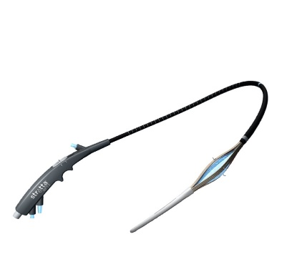
Figure 3 Stretta radiofrequency catheter.

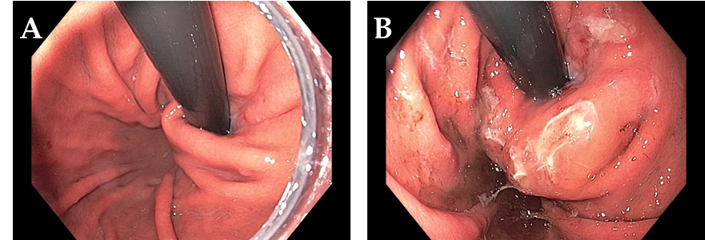
Figure 4 Endoscopic retroflex image of esophageal gastric junction prior to Stretta (A) and after Stretta treatment (B). The esophageal gastric junction and cardia have a typical “swollen lip” appearance.

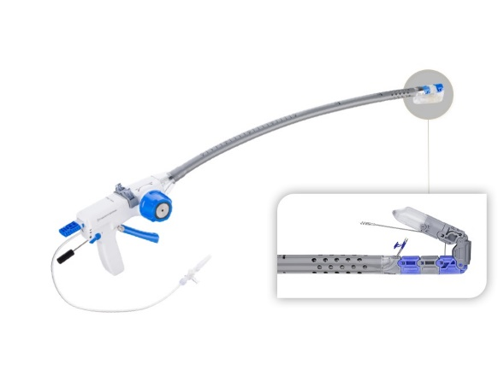
Figure 5 Esophyx® Z device used for transoral incisionless fundoplication.

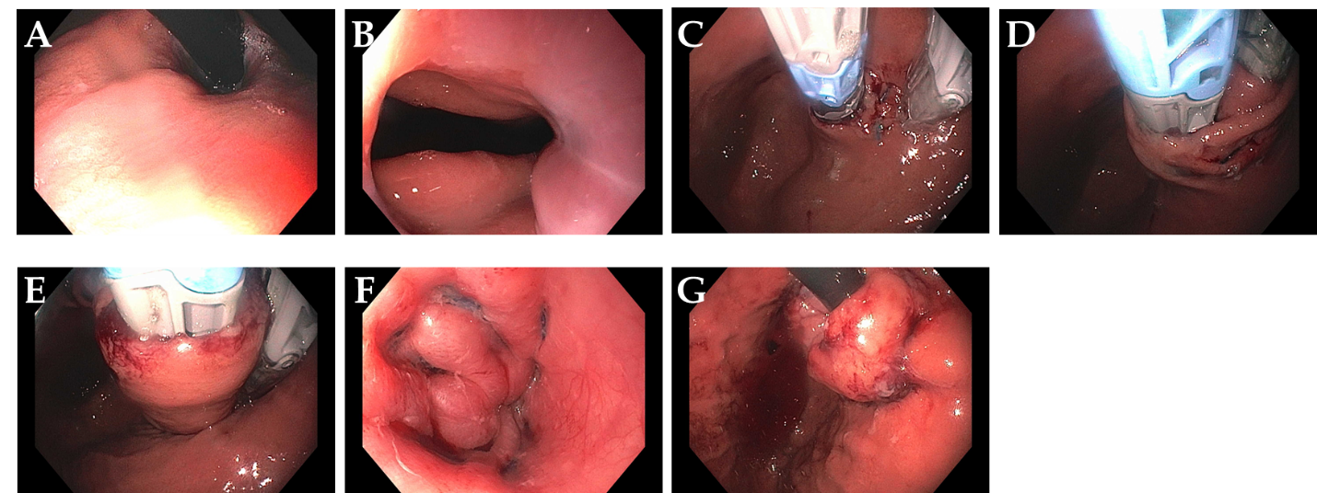
Figure 6 Transoral incisionless fundoplication 2 technique. A: Baseline Hill Grade 2 Valve; B: Baseline patulous lower esophageal sphincter; C: Building short lip valve along lesser curve at 12 o’clock; D: Rotating the device clockwise to create a partial fundoplication on the posterior side; E: Rotating the device counter-clockwise to create a partial fundoplication on the anterior side; F: After placement of 36 fasteners, a 3-4 cm length flap valve is created; G: Fasteners can be seen extending 3-4 cm in the distal esophagus.

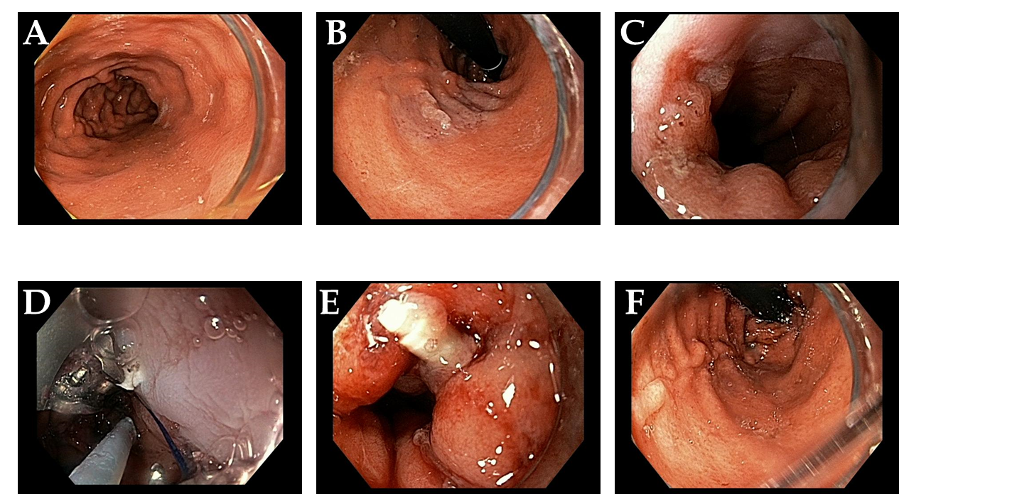
Figure 7 Endoscopic Suturing for gastroesophageal reflux disease in a patient post-Sleeve gastrectomy. A: Narrowed gastric body post gastrectomy; B: Retroflex view of loose esophageal gastric junction (EGJ); C: Patulous lower esophageal sphincter (LES); D: Suturing at EGJ; E: Post-suturing with tightened LES; F: Retroflex view of tightened EGJ post-suturing.

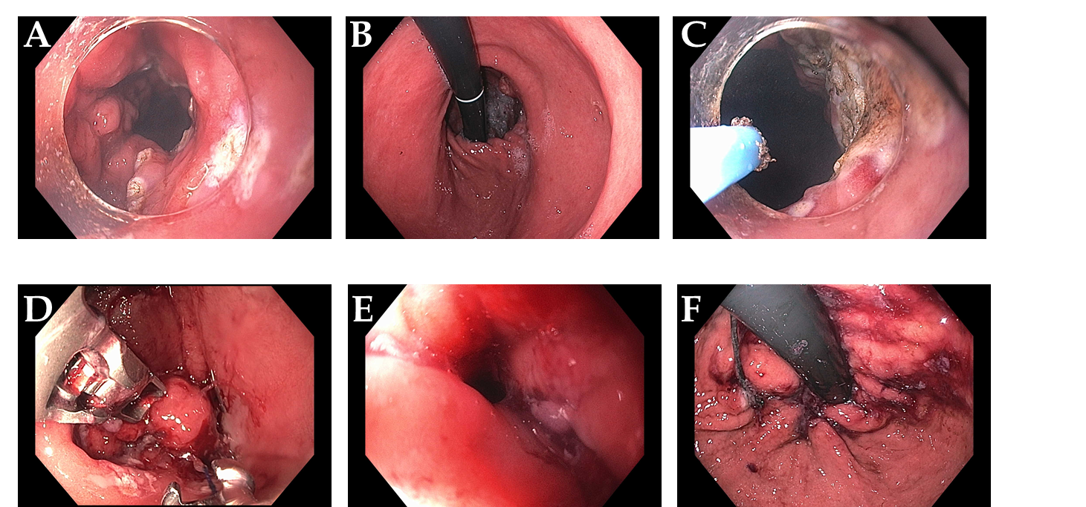
Figure 8 Mucosal ablation and suturing of the esophageal gastric junction in a patient with gastroesophageal reflux disease post-esophagectomy. A: Wide open anastomosis along with unchecked reflux; B: Retroflex view showing open anastomosis; C: Ablation of gastric mucosa at the anastomosis using argon plasma coagulation; D: Suturing at the anastomosis; E: Post-mucosal ablation and suturing of the esophageal gastric junction (MASE) tightening of anastomosis; F: Post-MASE retroflex view showing tightened anastomosis.

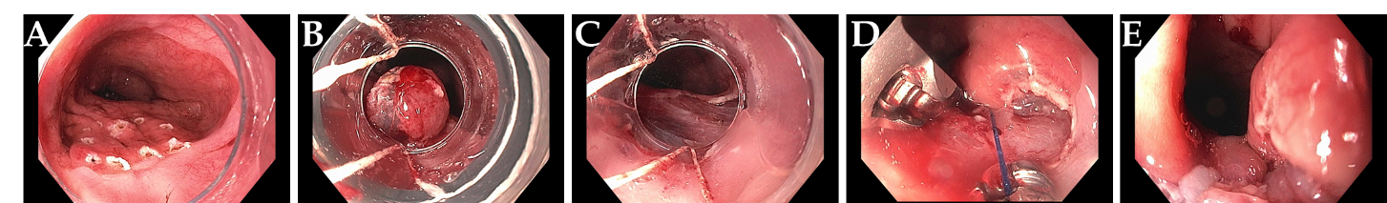
Figure 9 Resection and plication technique for gastroesophageal reflux disease in a patient after gastric by-pass. A: Endoscopic revision of anastomosis was performed followed by marking area for endoscopic mucosal resection (EMR) at the esophageal gastric junction (EGJ); B: EMR performed using band ligation technique; C: Exposure of muscularis propria accomplished; D: Sutures now deeply placed through muscle layer; E: Post-resection and plication appearance of tightened EGJ.

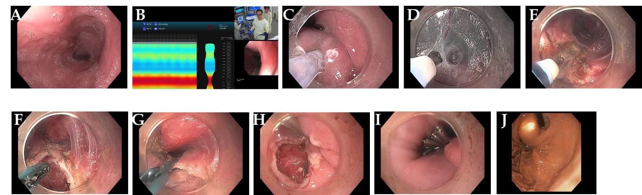
Figure 10 Per-oral endoscopic myotomy procedure on 40-year-old female with type 1 achalasia, s/p pneumatic dilation 20-years prior, now with dysphagia and chest pain/spasms (Eckardt Score 8). A: Dilated esophageal body; B: Endoscopic functional lumen imaging probe (Endo-Flip) 2.0 showing distensibility of 1.5; C: Initial mucosal incision; D: Submucosal tunnel with coagulation of vessel using Hybrid i-knife; E: Circular myotomy using Hybrid i-knife; F and G: Full thickness myotomy with scissor-type stag beetle (SB) knife; H and I: Closure of mucosotomy using 5 endoscopic clips; J: Thin scope retroflex view of esophageal gastric junction showing light from standard gastroscope within the per-oral endoscopic myotomy tunnel.

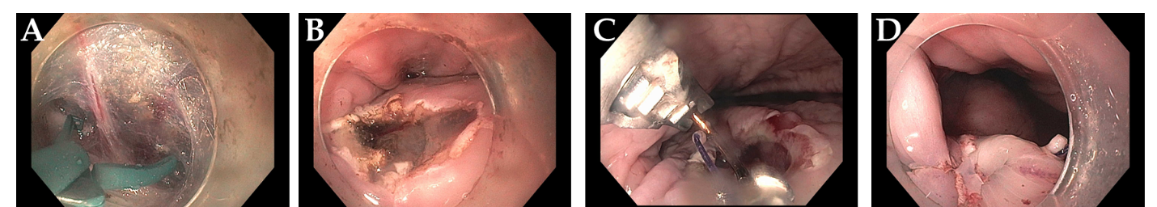
Figure 11 Per-oral endoscopic myotomy procedure on 43-year-old female with type 2 achalasia for 25 years, s/p prior failed Heller Myotomy and Botox injection. A: Abundant submucosal vessels coagulated with stag beetle knife; B: Mucosal incision made in horizontal orientation facilitates closure with endoscopic suturing; C: Double layer suturing, starting with initial bite just left of incision, then middle and right; D: Second running suture from right to left for completion of double layer closure.

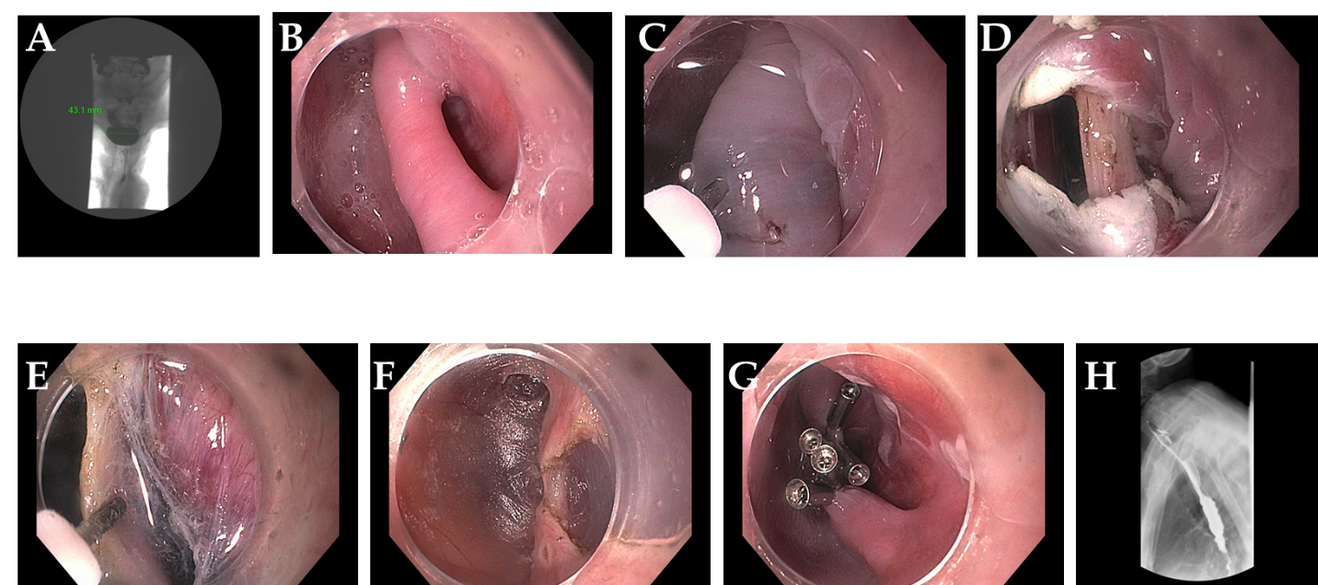
Figure 12 Zenker’s - per-oral endoscopic myotomy procedure in a 91-year-old female with 4-cm Zenker’s diverticulum and dysphagia, including solids, pills, and liquids. A: Pre- Zenker’s - per-oral endoscopic myotomy procedure (Z-POEM) esophagram showing 4.3 cm Zenker’s; B: Septum identified, with diverticulum on left, and esophageal lumen on right; C: Start of mucosal incision (horizontal) over the septum; D: Mucosal incision completed with exposure of cricopharyngeus muscle (CPM); E: Submucosal tunnel on each side of the CPM; F: Near completion of myotomy; G: Mucosal closure with 5 clips; H: Follow-up esophagram 2 mo post Z-POEM, contrast flows freely, and patient has complete resolution of dysphagia.

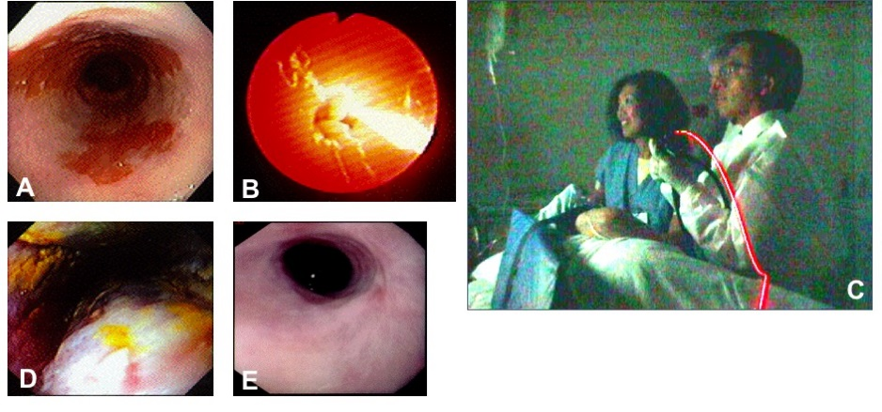
Figure 13 Photodynamic therapy in a patient with Barrett’s esophagus and high grade dysplasia, performed by Dr. Chang and assistant (who consented to publishing this figure); photo taken in 1997. A: Endoscopic image of 4 cm Barrett’s esophagus (BE) with high grade dysplasia (HGD); B: Photoactivation of photofrin with 630 nm diffuser fiber; C: Room view of diffuser fiber advanced through endoscope; D: Forty-eight hours post photodynamic therapy - endoscopic view of mucosal necrosis; E: Complete eradication of BE and HGD with mild stricture.

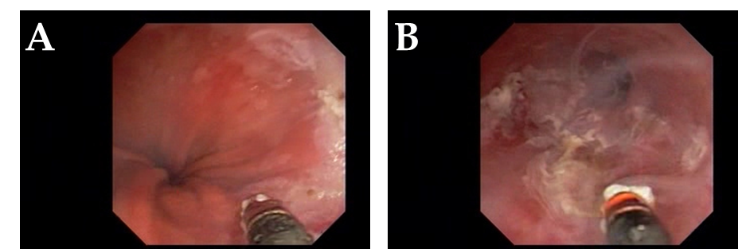
Figure 14 ND:YAG laser for treatment of Barrett’s esophagus with low grade dysplasia. A: Endoscopy showing sapphire contact probe back-loaded into scope channel; B: Focal ablation of Barrett’s esophagus using ND:YAG contact probe.

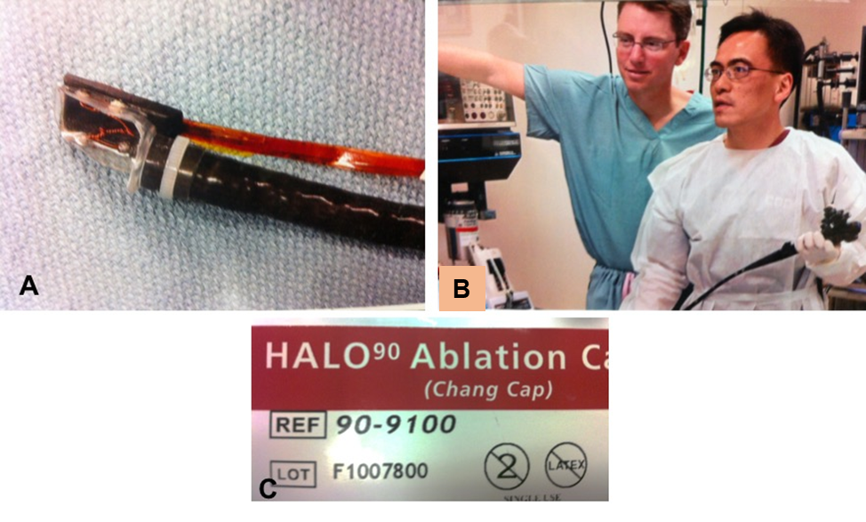
Figure 15 Radiofrequency ablation for Barrett’s using focal device (Halo90), photo taken in 2004. A: Prototype focal ablation device; B: Dr. Chang working closely with Medical Director of Barrx Medical, Dr. David Utley, to refine technical aspects of focal device; C: Focal ablation device, Halo90, nicknamed “Chang Cap” from 2004 to present. (Dr. Utley gave consent to publish this Figure).

Figure 16 Radiofrequency ablation mechanism and technique. A: Tightly spaced electrodes (250 µm apart) with pre-set energy and power densities, generator turns off when a pre-determined resistance level in the ablated tissues is reached (mean of 0.3 s); B and C: Circumferential radiofrequency ablation (RFA) delivered by balloon electrode to treat 4 cm segment with single activation; D and E: The catheter is advanced to the next segment with slight overlap; F-I: Focal RFA delivered with Barrx90 device which is secured onto scope tip and endoscopically directed over Barrett’s lesion.

Figure 17 Radiofrequency ablation device “family”. A: Barrx 360 express, 4 cm self-sizing balloon device; B: Barrx 90 Ultra - 40 mm × 13 mm platform; C: Barrx 90 (Chang Cap) - 20 x 13 mm platform; D: Barrx 60 - 15-10 mm platform; E: Barrx channel catheter - fits through biopsy channel, 15.7 mm × 7.5 mm platform when “wings” expanded.

Figure 18 Cryotherapy using nitrous oxide within balloon. A: Endoscopic view of focal cryoablation of multiple islands of Barrett’s epithelium; marking around the lesion with a snare tip helps with targeting; B: In-room view of hand-held control (by Dr. Chang) with nitrous oxide cartridges; C: New foot pedal console which controls nitrous oxide flow as well as vertical and left-right rotational movement of the spray orifice.

Figure 19 Hybrid argon plasma coagulation to treat residual diffuse, multi-focal Barrett’s after endoscopic submucosal dissection for early esophageal cancer. A: Endoscopic view of multiple residual Barrett’s islands; B: Needle-free high pressure water jet to create saline cushion in the submucosal space; C: Pass 1 of argon plasma coagulation (APC) ablation with energy settings of Pulsed APC flow rate 0.8 L/min 60 W; endoscopic submucosal dissection (ESD) cap used for visibility, traction and maintaining precise focal distance for even application; D: Completion of Pass 1; E: Repeat water jet into submucosa; F: Pass 2 of APC ablation with energy settings of pulsed APC flow rate 0.8 L/min 40 W; G: Completion of Pass 2 with desired tan colored surface; H: Follow-up endoscopy 6 months post hybrid APC treatment, with biopsy and WATS brushing confirming complete response of intestinal metaplasia.

Figure 20 Endoscopic submucosal dissection of early esophageal adenocarcinoma arising from Barrett’s esophagus. A: Nodular, polypoid (Paris IIa) lesion within long segment Barrett’s esophagus; B: Endoscopic submucosal dissection completed; C: En-bloc resected specimen; D: Histology showing poorly differentiated adenocarcinoma (blue dots), T1b pathologic staging, lateral and deep margins negative (> 300 microns), no lymphovascular invasion.

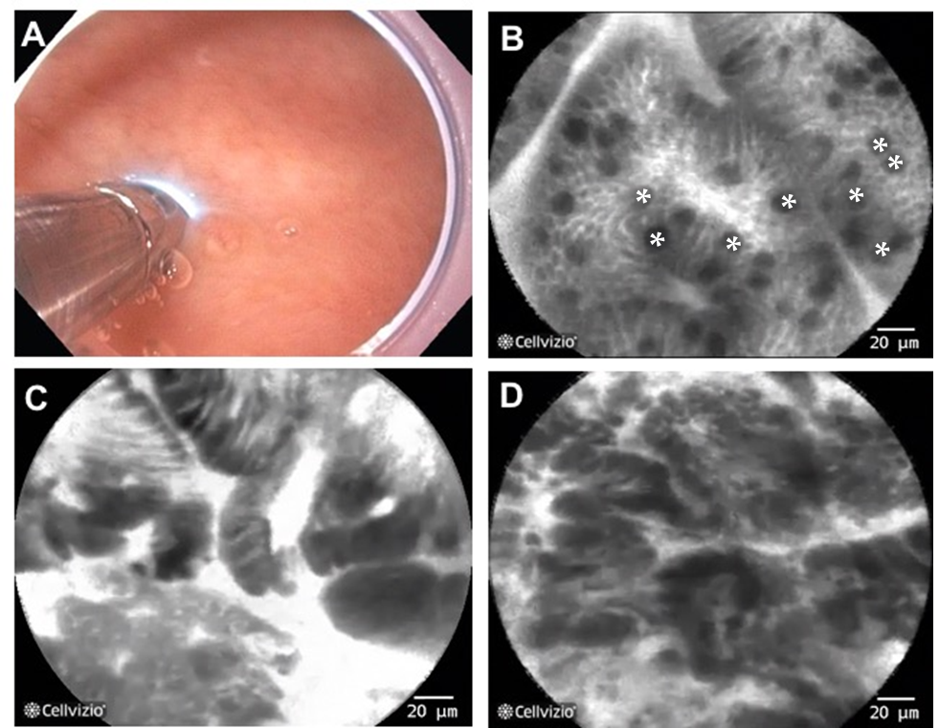
Figure 21 Probe-based confocal laser endomicroscopy in patients with Barrett’s esophagus. A: the probe is advanced through the biopsy channel, while stabilizing the scope against the mucosa, the probe makes gentle contact with the surface epithelium; B: Probe-based confocal laser endomicroscopy (pCLE) image showing non-dysplastic Barrett’s esophagus (BE). *goblet cells; C: pCLE image showing BE with high grade dysplasia; D: pCLE image showing early adenocarcinoma arising from BE.
Figure 22 Volumetric laser endomicroscopy in patient with Barrett’s esophagus and high grade dysplasia. A: Volumetric laser endomicroscopy showing an area of atypical glands covered by normal squamous epithelium; B: Magnification of region of interest (dotted box in image A) showing presence of 2 atypical glands; C: This area underwent endoscopic resection with pathology showing moderately differentiated adenocarcinoma in the background of high grade dysplasia and Barrett’s esophagus. The malignant glandular structures (arrows) were buried beneath squamous epithelium.

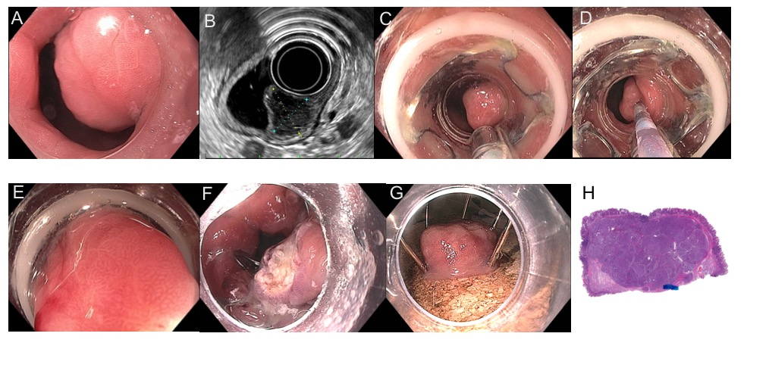
Figure 23 Full thickness resection using FTRD Device for submucosal tumor in the gastric pylorus. A: One point five centimeters submucosal tumor at the level of pylorus; B: Endoscopic ultrasound showing 1.3 cm × 1.1 cm submucosal tumor concerning for neuroendocrine tumor; C: Lesion viewed through double channel therapeutic scope with 21-mm transparent cap; D: Helical retractor was used to secure the lesion and pull it into the cap; E: Entire lesion is now within the cap; F: The entire wall was captured in the large clip and resection was completed above the closed clip; G: Lesion resected en bloc; H: Histologic specimen showing complete specimen with negative deep and lateral margins.

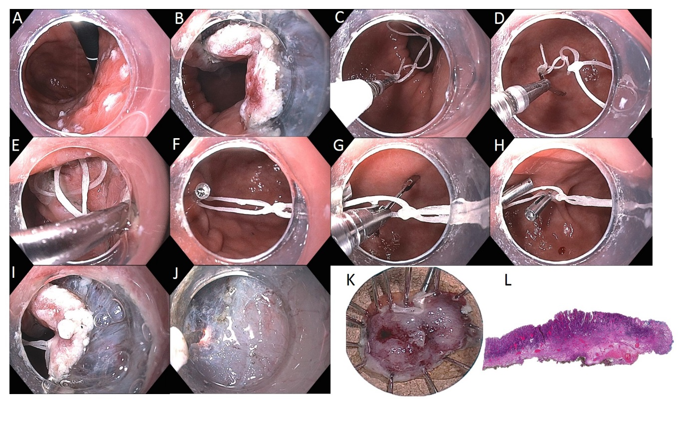Figure 24 Endoscopic submucosal dissection of 15-mm IIa+c intramucosal carcinoma of stomach along lesser curve body using multi-loop technique. A: The lesion is marked using spot coagulation; B: Circumferential incision is performed using the i-knife, however the angle of approach on the proximal side is difficult for submucosal entry and dissection; C: Three loops are created using dental floss, captured with a clip passed through the biopsy channel (no need for scope removal or additional equipment); D: The clip is opened (the string can be pre-tied to one leg of the clip) and positioned to grasp the proximal edge of the specimen; E: The 1st clip is released, anchoring the string to the specimen; F: A 2nd clip is used to catch the distal loop and anchor to opposite wall of stomach; G: If necessary, a 3rd clip can be used to grasp the middle loop; H: This can be helpful to further tighten or re-direct the traction angle; I: the submucosal space is much easier to enter with multi-loop traction; J: submucosal dissection in the antegrade approach is greatly facilitated; K: The specimen is resected en bloc; L: Histology confirmed a well differentiated grade 1 adenocarcinoma with invasion to the muscularis mucosa with negative deep and lateral margins, no lymphovascular invasion.
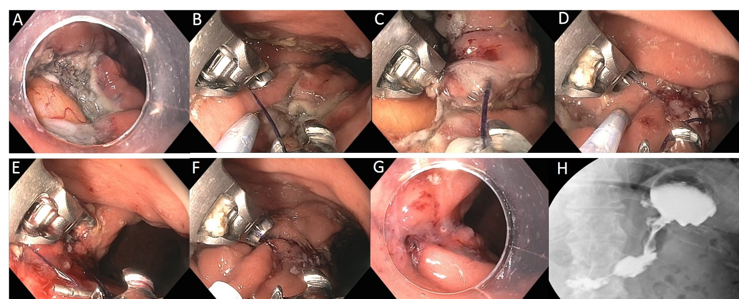
Figure 25 Large gastric defect after full thickness resection of neuroendocrine tumor closed with endoscopic suturing. A: Four-centimeter full thickness wound in posterior body of stomach, omental fat seen at base of defect; B: First suture - use helical tissue retractor to grab left edge of distal defect; C: After taking first bite on distal left (needle going from mucosa to serosa), second bite on distal right (needle going from serosa to mucosa); D: Approximately 8 bites are taken, alternating from left to right, with the last bite having the needle from mucosa-serosa-mucosa in single throw; E: First continuous running suture completed and needle anchor released for tightening and suture release; F: Second row of running suture placed for double reinforcement; G: Double suture closure completed; H: Contrast study shows luminal narrowing with no leak.

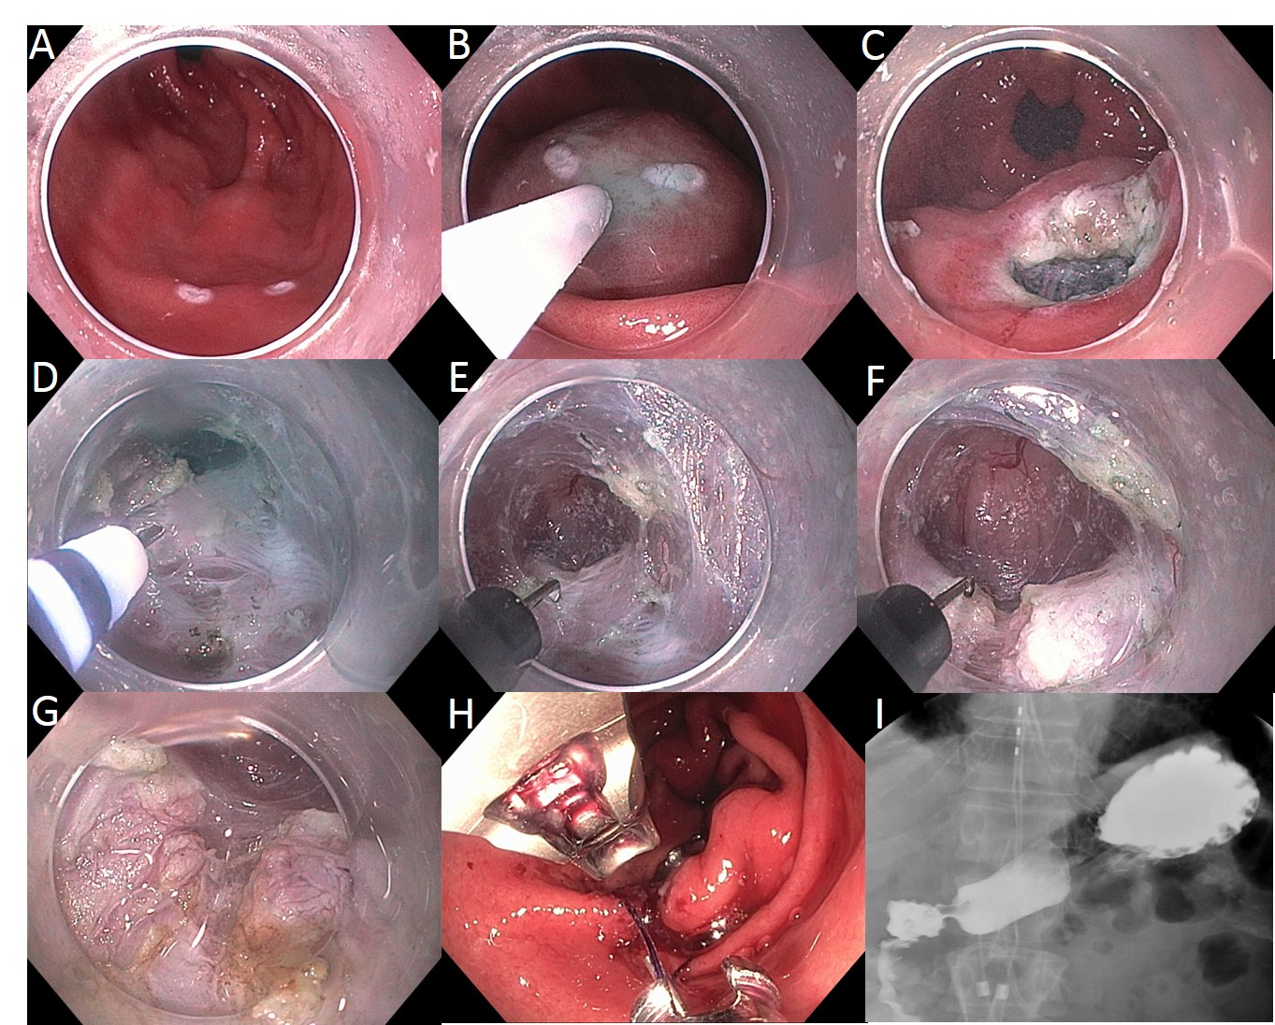
Figure 26 Gastric per-oral endoscopic pyloromyotomy in a patient with severe gastroparesis. A: Markings made for mucosal incision on the antrum greater curve, 4-5 cm proximal to the pylorus; B: Submucosal injection; C: Initial mucosal incision; D: Submucosal tunnel extended with i-knife until pylorus muscle is identified; E: The hook knife is then used to carefully cut the pylorus muscle; F: Myotomy of the pylorus; G: The myotomy is extended proximally for approximately 2 cm along the antrum; H: Closure of the mucosotomy is accomplished with Overstitch suturing device; I: Upper gastrointestinal contrast X-ray study shows no leak, with free flow of contrast through the pylorus.

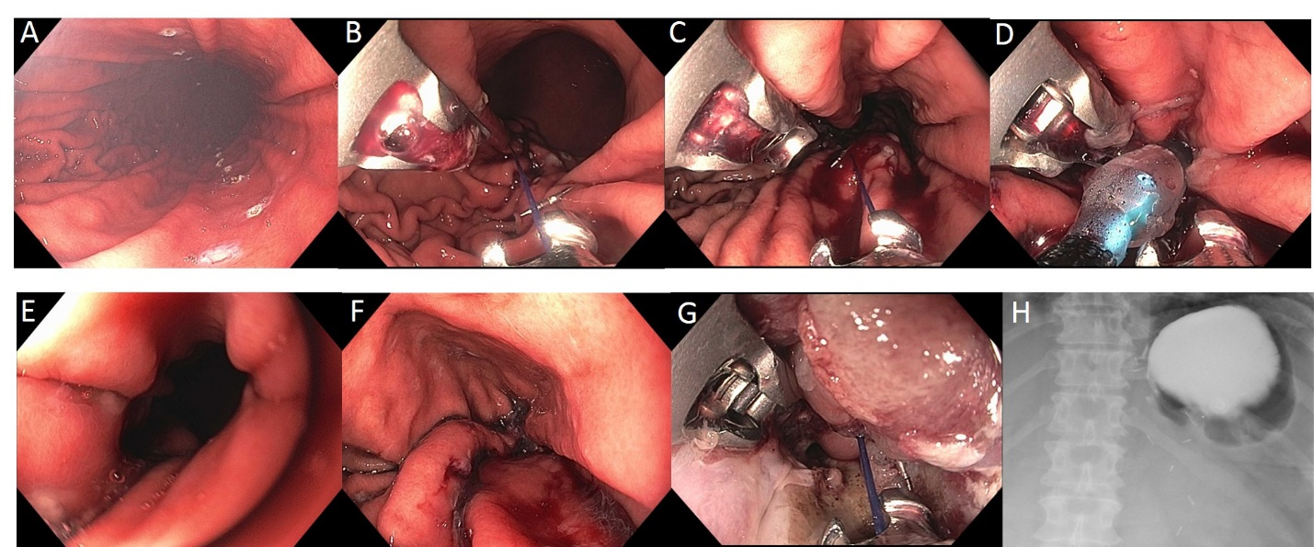
Figure 27 Endoscopic sleeve gastroplasty plus mucosal ablation and suturing of the esophageal gastric junction in a 45-year-old female with super morbid obesity, gastroparesis and gastroesophageal reflux disease. Her body mass index was 51 (327 lb) and she declined bariatric surgery. A: Markings created along anterior and posterior gastric wall to guide suture placement; B: First suture placed by taking bites at anterior, greater curve, posterior wall × 2; C: Total of 8 running sutures placed to complete the “sleeve”; D: At the very proximal aspect of the sleeve, a final suture is placed in a purse-string fashion around an 8 mm balloon to prevent complete closure; E: Endoscopic appearance within the completed sleeve; F: Endoscopic appearance of the proximal “pouch” which filled up with approximately 60 mL of water; G: Mucosal ablation and suturing of the esophageal gastric junction (MASE) procedure was performed as well, using 3 additional sutures, to treat her gastroesophageal reflux disease; H: UGI X-ray with contrast 1 d post endoscopic sleeve gastroplasty and MASE shows contrast filling the small gastric pouch with little to no passage through the sleeve at 1 h.

Figure 28 A promising new paradigm “Endo-Hepatology” intersects and integrates endoscopy in the diagnosis and treatment of liver disease. This includes: evaluation of the liver surface [by endoscopic ultrasound (EUS)], elastography to determine liver stiffness and fibrosis, contrast enhanced harmonic EUS to detect focal lesions, EUS-guided intrahepatic porto-systemic shunt, EUS-guided liver biopsy, endoscopic variceal band ligation and intra-variceal injection with glue +/- coil (by EUS), evaluation of the portal circulation and EUS-guided portosystemic pressure gradient, and detection of ascites with EUS-guided paracentesis. EUS: Endoscopic ultrasound; PPG: Portosystemic pressure gradient; IPSS: Intrahepatic porto-systemic shunt.

Figure 29 Endoscopic ultrasound guided fine needle aspiration initial series of 38 patients reported in 1994. A: Diagram of endoscopic ultrasound (EUS) guided fine needle aspiration (FNA) created on first generation Apple Macintosh computer; B: Black and white photo of prototype 23G 4-cm FNA needle attached to Teflon tubing; C: Photo of needle specimen, much of which was probably blood clot; D: Early linear array EUS image showing needle coming from left side, as established by ultrasound convention at the time, into a pancreatic tumor; E: EUS image of FNA needle into a 1.5-cm celiac lymph node. (Reprinted with permission from reference 173).

Figure 30 Endoscopic aultrasound guided portosystemic pressure gradient measurement in a patient with suspected cirrhosis. A: Diagram showing fine needle aspiration (FNA) needle within the middle hepatic vein; B: Endoscopic ultrasound (EUS) image of middle hepatic vein with Doppler wave form demonstrating 4 phases (ASVD); C: 25G needle placed directly through liver parenchyma into the middle hepatic vein; compact hand-held manometer showing a pressure of 13 mmHg; D: Diagram FNA needle within the left portal vein; E: EUS image of left portal vein (umbilical portion); typical Doppler waveform showing venous hum; F: 25G needle placed directly through liver parenchyma into the left portal vein; compact hand-held manometer showing a pressure of 15 mmHg. Thus, the EUS-portosystemic pressure gradient measurement is 2 mmHg, which is within normal range.

