Name of Journal: World Journal of Clinical Cases
Manuscript NO: 70345
Manuscript Type: CASE REPORT

Primary orbital monophasic synovial sarcoma with calcification: A case report

Ren MY et al. Orbital monophasic synovial sarcoma

Ming-Yu Ren, Jing Li, Rui-Miao Li, Yi-Xiang Wu, Rui-Juan Han, Chi Zhang

Ming-Yu Ren, Rui-Miao Li, Yi-Xiang Wu, Rui-Juan Han, Chi Zhang, Department of Orbital Disease and Ocular Tumor, Hebei Eye Hospital, Xingtai 054001, Hebei Province, China

Jing Li, Intensive Care Unit, Xingtai Third Hospital, Xingtai 054001, Hebei Province, China

Author contributions: Ren MY conceptualized this study, made the literature review and wrote the first draft of this paper; Li J, Li RM, Wu YX, Han RJ, and Zhang C made the literature review; all authors revised the paper and approved the final version for submission.

Supported by the Science and Technology Planning Project of Xingtai, No.2019ZC246.

Corresponding author: Ming-Yu Ren, MMed, Associate Chief Physician, Department of Orbital Disease and Ocular Tumor, Hebei Eye Hospital, No. 399 Quanbeidong, Xingtai 054001, Hebei Province, China. 147237583@qq.com

Received: July 31, 2021
Revised: October 28, 2021
Accepted: December 28, 2021
Published online: February 16, 2022

Abstract
BACKGROUND
Synovial sarcoma is a malignant mesenchymal neoplasm with variable epithelial differentiation. Most synovial sarcoma cases are reported in young adults and can arise in any body site. Primary orbital synovial sarcoma is rare.

CASE SUMMARY
An 8-year-old east Asian girl with 1-mo history of gradual painless proptosis and lacrimation of the right eye was admitted. The patient presented with painless proptosis, downward eyeball displacement, and upward movement disorders. According to clinical manifestations, imaging examinations and postoperative immunohistochemical examinations, the diagnosis was monophasic synovial sarcoma with calcification. The patient underwent anterior orbitotomy for removal of the right orbital mass under general anesthesia. The diagnosis of monophasic synovial sarcoma with calcification was confirmed through histological and immunohistochemical examination. The follow-up period was 6 mo, and no recurrence was observed during this period.

CONCLUSION
Primary orbital monophasic synovial sarcoma is rare. Surgical resection with adjuvant or neoadjuvant radiotherapy is highly effective for localized tumors.

Key Words: Orbital tumor; Synovial sarcoma; Calcification; Histological; Case report

©The Author(s) 2022. Published by Baishideng Publishing Group Inc. All rights reserved.

Citation: Ren MY, Li J, Li RM, Wu YX, Han RJ, Zhang C. Primary orbital monophasic synovial sarcoma with calcification: A case report. World J Clin Cases 2022; 10(5): 1623-1629
URL: https://www.wjgnet.com/2307-8960/full/v10/i5/1623.htm
DOI: https://dx.doi.org/10.12998/wjcc.v10.i5.1623

Core Tip: We describe a patient with 1-mo history of gradual painless proptosis and lacrimation of the right eye. The patient underwent anterior orbitotomy for removal of the right orbital mass under general anesthesia. The diagnosis of monophasic synovial sarcoma with calcification was confirmed through histological and immunohistochemical examination. The follow-up period was 6 mo, and no recurrence was observed during this period. This case illustrates that the tumor may present with similar features as a benign tumor. Comprehensive analysis of clinical, radiological and pathological findings is important for making the right diagnosis.

INTRODUCTION
Synovial sarcoma is a malignant mesenchymal neoplasm with variable epithelial differentiation. It mainly occurs in young adults and can arise at several sites^{[1]}. It mainly commonly occurs in deep soft tissue of the extremities in adolescents and young adults^{[2]}. Synovial sarcoma of the head and neck region is rare, and only a few cases of sarcoma arising from the orbit have been reported^{[3,4]}. The current study reports a case of primary orbital monophasic synovial sarcoma which was characterized by calcification in an 8-year-old patient.

CASE PRESENTATION
Chief complaints
An 8-year-old East Asian girl with 1-mo history of gradual painless proptosis and lacrimation of the right eye was admitted to our hospital.

History of present illness
The patient presented with gradual painless proptosis and lacrimation of the right eye for 1 mo. The proptosis was gradual and painless. No special treatment was performed, and there was no other significant change in ocular symptoms.

History of past illness
The patient had no history of any previous disease.

Personal and family history
There was no family history of malignant neoplasm.

Physical examination
Physical examination showed no neurological signs. The patient presented with painless proptosis, downward eyeball displacement, and upward movement disorders. Ocular examination showed that the binocular best-corrected visual acuity was 20/20. Eye examination did not show any significant eyelid, conjunctival, corneal and lenticular abnormalities, and fundus examination did not show any abnormalities. Hertel exophthalmometry analysis showed that the right eye was 18 mm and whereas the left eye was 13 mm, and the interorbital distance was 91 mm. Intraocular pressure was 13 mmHg in the right eye and 11 mmHg in the left eye.

Laboratory examinations
Blood and urine tests were normal.

Imaging examinations
A/B-scan showed moderate echogenic lesions in the right eye orbital. Echoes were uneven, well-distributed and sound transmission was normal. Patchy strong echoes and sound shadows were detected (Figure 1). Orbital computed tomography showed a well-defined soft tissue density mass in the right orbit, with flaky high-density shadows observed inside the right orbit. The size of the mass was approximately 20 mm × 20 mm × 19 mm, and exophthalmos; extraocular muscles and optic nerve were compressed (Figure 2). Orbital magnetic resonance imaging showed a circular-like mass in the right orbital. T1-weighted imaging (T1WI) showed moderate signals, whereas T2-weighted imaging (T2WI) showed mixed signals, with a high number of moderately high signals. T1WI and T2WI were characterized by low-signal regions. Most of the lesion was significantly and unevenly enhanced, whereas local lesions did not exhibit any enhancement (Figure 3).

Primary diagnosis
Based on the findings described above, the preliminary diagnosis was rhabdomyosarcoma or other malignant neoplasm.

FINAL DIAGNOSIS
Histological examination showed that the tumor was monophasic synovial sarcoma with calcification. Immunohistochemical analysis showed positive staining for CD34, CD99, Bcl-2, CKpan, TLE1, INI-1 and Ki-67 (25%), and negative staining for SMA, vimentin, myogenin, myoglobin, Syn, CgA, NSE, S-100, PGP9.5, EMA, CK7, CK (AE1/AE3), CD65, calretinin, TTF1 and MUC-4 (Figure 4).

TREATMENT
After preoperative examination, the patient underwent anterior orbitotomy for removal of the right orbital mass under general anesthesia. The operation showed an oval tumor above the optic nerve in the right orbit. The tumor margins were well defined; however, the tumor was large, reddish, unmovable, and adhesive to the levator palpebrae muscle (Figure 5). The levator palpebrae muscle was cut along its path, and the tumor was carefully separated from the muscle and removed. The levator palpebrae muscle was sutured before the end of the operation. After treatment, the patient was transferred to the tumor hospital and underwent systemic chemotherapy.

OUTCOME AND FOLLOW-UP
The follow-up period was 6 mo, and no recurrence was observed during this period.

DISCUSSION
Synovial sarcoma accounts for 10%–20% of soft tissue sarcomas. It is a high-grade soft-tissue sarcoma occurring mainly in older children and young adults. Approximately 7% of soft tissue sarcomas occur in the head and neck region, and synovial sarcoma represents < 0.1% of all head and neck cancers^{[5,6]}. Orbital synovial sarcoma is a rare malignancy. Therefore, diagnosis of orbital synovial sarcoma in clinical practice is challenging, and requires an integrated approach that incorporates specific clinical, histological, immunohistochemical and molecular analyses.
Synovial sarcoma is a rare orbital tumor and the clinical characteristics have not been fully elucidated. Clinical manifestations include gradual painless proptosis, eyelid swelling, a palpable painless mass, epiphora, ptosis, and periorbital spontaneous pain or tenderness. However, these clinical manifestations are not unique to synovial sarcoma. Characteristic findings are not reported in current imaging studies due to the small number of cases. A case of monophasic synovial sarcoma primarily arising in the left superonasal orbital region was reported in a 24-year-old woman, which was clinically mistaken for a periocular cyst^{[6]}. However, the lesion was characterized by calcification similar to the current case.
The calcification can be pathologically divided into dystrophic and metastatic. In the current case, the growth of the lesion was rapid, resulting in ischemia and necrosis of the tumor. Significant calcification of the lesion may be caused by dystrophic calcification. Occurrence of a lesion with calcification in the orbit of a pediatric patient, orbital vascular lesions or malformations, and orbital malignancies should be explored when carrying out diagnosis. Irregular calcification is common in malignant and partially benign tumors. Orbital tumors in children are associated with a higher incidence of rhabdomyosarcoma^{[7]}. In addition, most common soft-tissue sarcomas in children are reported in the head and neck, with 10% of all cases occurring in the orbit. A detailed history is essential if a child is suspected to have rhabdomyosarcoma^{[8]}. A case of recurrent primary orbital calcified synovial sarcoma in a young woman was previously reported^{[4]}. In addition, diagnosis should distinguish the primary lesion from metastatic lesions, as metastatic synovial sarcomas are characterized by poor prognosis^{[9]}. The current case showed no other systemic lesions and was a primary tumor and not a recurrent case.
Orbital vascular lesions or malformations, other benign lesions and orbital malignancies should be considered when there is a lesion characterized by calcification in the orbit during childhood. Irregular calcification is common in malignant and partially benign lesions. In the current case, orbital computed tomography and magnetic resonance imaging showed a well-defined soft tissue dense mass in the right orbit. The tumor may present with similar features as benign tumors. Differential diagnosis may identify findings that do not fit preliminary diagnosis of benign tumors. In such cases, comprehensive consideration of clinical, radiological and pathological findings is important^{[10]}.
Synovial sarcoma is a highly malignant soft tissue sarcoma, with poor survival of patients. Conventional treatment approach is surgical resection with adjuvant or neoadjuvant radiotherapy, which are highly effective for localized tumors. Synovial sarcoma is sensitive to chemotherapy. Ifosfamide alone and ifosfamide combinations are effective for treatment of synovial sarcoma^{[5,11,12]}. Combination of doxorubicin and ifosfamide is the preferred first-line therapy for patients with metastatic tumors. Sequential doxorubicin and ifosfamide can be considered for localized tumors. Pazopanib and trabectedin are effective as second-line therapy and for subsequent treatment^{[11]}.
A previous study reported high local recurrence rates despite surgery and postoperative radiotherapy and adjuvant chemotherapy, and distant metastasis rates were not reduced by these approaches^{[2]}. The disease is characterized by early and late recurrences, and the 10-year disease-free survival is ~50%^{[5]}. Several new approaches for treatment of metastatic synovial sarcoma are currently under investigation, both at preclinical and clinical levels, including receptor tyrosine kinase inhibitors, epigenetic modulators, compounds interfering with DNA damage response, and immunotherapy^{[11]}.
Histological analysis shows that synovial sarcoma is monophasic, biphasic, or poorly differentiated and exhibits a specific chromosomal translocation t (X; 18) (p11.2; q11.2) in > 95% of cases^{[6]}. Genetic analysis shows that synovial sarcoma tumors have a characteristic fusion protein, SS18–SSX, implicated in promoting disease development. BRD9 is a component of SS18–SSX containing BAF complexes in synovial sarcoma cells. Studies report that BRD9 is implicated in oncogenic mechanisms underlying the SS18–SSX fusion in synovial sarcoma and targeted degradation of BRD9 is a potential therapeutic approach for treatment of synovial sarcoma^{[13]}.

CONCLUSION
These findings show that primary orbital synovial sarcoma with calcification is rare, and clinical manifestations and imaging results are not specific. The tumor may exhibit similar features as a benign tumor. Therefore, these cases require comprehensive clinical, radiological and pathological analysis to achieve the right diagnosis. The conventional treatment is surgical resection with adjuvant or neoadjuvant radiotherapy, which are highly effective for localized tumors. However, a longer follow-up time is required to determine effectiveness of the treatment.

REFERENCES
1 Thway K, Fisher C. Synovial sarcoma: defining features and diagnostic evolution. Ann Diagn Pathol 2014; 18: 369-380 [PMID: 25438927 DOI: 10.1016/j.anndiagpath.2014.09.002]
2 Gervasio KA, Ramesh S, Sivalingam MD, Markovitz M, Milman T. Primary Synovial Sarcoma of the Orbit: A Case Report and Update on Diagnostic Techniques. Ophthalmic Plast Reconstr Surg 2021; 37: e155-e157 [PMID: 33587418 DOI: 10.1097/IOP.0000000000001937]
3 Xu P, Chen J. Primary Synovial Sarcoma of the Orbit. Ophthalmol Eye Dis 2017; 9: 1179172117701732 [PMID: 28469480 DOI: 10.1177/1179172117701732]
4 Shukla PN, Pathy S, Sen S, Purohit A, Julka PK, Rath GK. Primary orbital calcified synovial sarcoma: a case report. Orbit 2003; 22: 299-303 [PMID: 14685906 DOI: 10.1076/orbi.22.4.299.17246]
5 Nielsen TO, Poulin NM, Ladanyi M. Synovial sarcoma: recent discoveries as a roadmap to new avenues for therapy. Cancer Discov 2015; 5: 124-134 [PMID: 25614489 DOI: 10.1158/2159-8290.CD-14-1246]
6 Portelli F, Pieretti G, Santoro N, Gorelli G, De Giorgi V, Massi D, Dei Tos AP, Mazzini C. Primary Orbital Synovial Sarcoma Mimicking a Periocular Cyst. Am J Dermatopathol 2019; 41: 655-660 [PMID: 30624245 DOI: 10.1097/DAD.0000000000001351]
7 Dai XZ, Wang LY, Shan Y, Qian J, Xue K, Ye J. Clinicopathological analysis of 719 pediatric and adolescents' ocular tumors and tumor-like lesions: a retrospective study from 2000 to 2018 in China. Int J Ophthalmol 2020; 13: 1961-1967 [PMID: 33344197 DOI: 10.18240/ijo.2020.12.18]
8 Jurdy L, Merks JH, Pieters BR, Mourits MP, Kloos RJ, Strackee SD, Saeed P. Orbital rhabdomyosarcomas: A review. Saudi J Ophthalmol 2013; 27: 167-175 [PMID: 24227982 DOI: 10.1016/j.sjopt.2013.06.004]
9 Wladis EJ, Farber MG, Nepo AG. Metastatic synovial sarcoma to the orbit. Ophthalmic Plast Reconstr Surg 2012; 28: e131-e132 [PMID: 22743696 DOI: 10.1097/IOP.0b013e3182467e11]
10 Fujibuchi T, Miyawaki J, Kidani T, Imai H, Kiyomatsu H, Kitazawa R, Miura H. Intraosseous synovial sarcoma of the distal ulna: a case report and review of the literature. BMC Cancer 2019; 19: 116 [PMID: 30709383 DOI: 10.1186/s12885-019-5325-x]
11 Desar IME, Fleuren EDG, van der Graaf WTA. Systemic Treatment for Adults with Synovial Sarcoma. Curr Treat Options Oncol 2018; 19: 13 [PMID: 29516254 DOI: 10.1007/s11864-018-0525-1]
12 Ferrari A, De Salvo GL, Brennan B, van Noesel MM, De Paoli A, Casanova M, Francotte N, Kelsey A, Alaggio R, Oberlin O, Carli M, Ben-Arush M, Bergeron C, Merks JH, Jenney M, Stevens MC, Bisogno G, Orbach D. Synovial sarcoma in children and adolescents: the European Pediatric Soft Tissue Sarcoma Study Group prospective trial (EpSSG NRSTS 2005). Ann Oncol 2015; 26: 567-572 [PMID: 25488687 DOI: 10.1093/annonc/mdu562]
13 Brien GL, Remillard D, Shi J, Hemming ML, Chabon J, Wynne K, Dillon ET, Cagney G, Van Mierlo G, Baltissen MP, Vermeulen M, Qi J, Fröhling S, Gray NS, Bradner JE, Vakoc CR, Armstrong SA. Targeted degradation of BRD9 reverses oncogenic gene expression in synovial sarcoma. Elife 2018; 7 [PMID: 30431433 DOI: 10.7554/eLife.41305]

Footnotes
Informed consent statement: Informed written consent was obtained from the patient for publication of this report and any accompanying images.

Conflict-of-interest statement: The authors declare that they have no conflict of interest.

CARE Checklist (2016) statement: The authors have read the CARE Checklist (2016), and the manuscript was prepared and revised according to the CARE Checklist (2016).

Open-Access: This article is an open-access article that was selected by an in-house editor and fully peer-reviewed by external reviewers. It is distributed in accordance with the Creative Commons Attribution NonCommercial (CC BY-NC 4.0) license, which permits others to distribute, remix, adapt, build upon this work non-commercially, and license their derivative works on different terms, provided the original work is properly cited and the use is non-commercial. See: https://creativecommons.org/Licenses/by-nc/4.0/

Provenance and peer review: Unsolicited article; Externally peer reviewed.
Peer-review model: Single blind

Peer-review started: July 31, 2021
First decision: October 25, 2021
Article in press: December 28, 2021

Specialty type: Ophthalmology
Country/Territory of origin: China
Peer-review report’s scientific quality classification
Grade A (Excellent): A
Grade B (Very good): 0
Grade C (Good): 0
Grade D (Fair): 0
Grade E (Poor): 0

P-Reviewer: Maglangit SACA S-Editor: Guo X L-Editor: Kerr C P-Editor: Guo X

Figure Legends
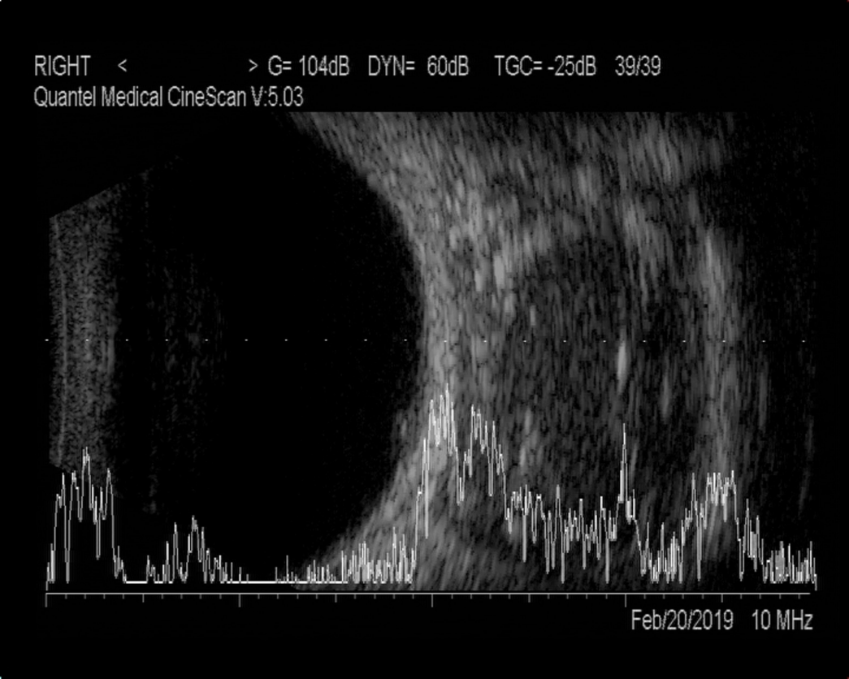
Figure 1 A/B-scan showed moderate echogenic lesions in the right orbit.
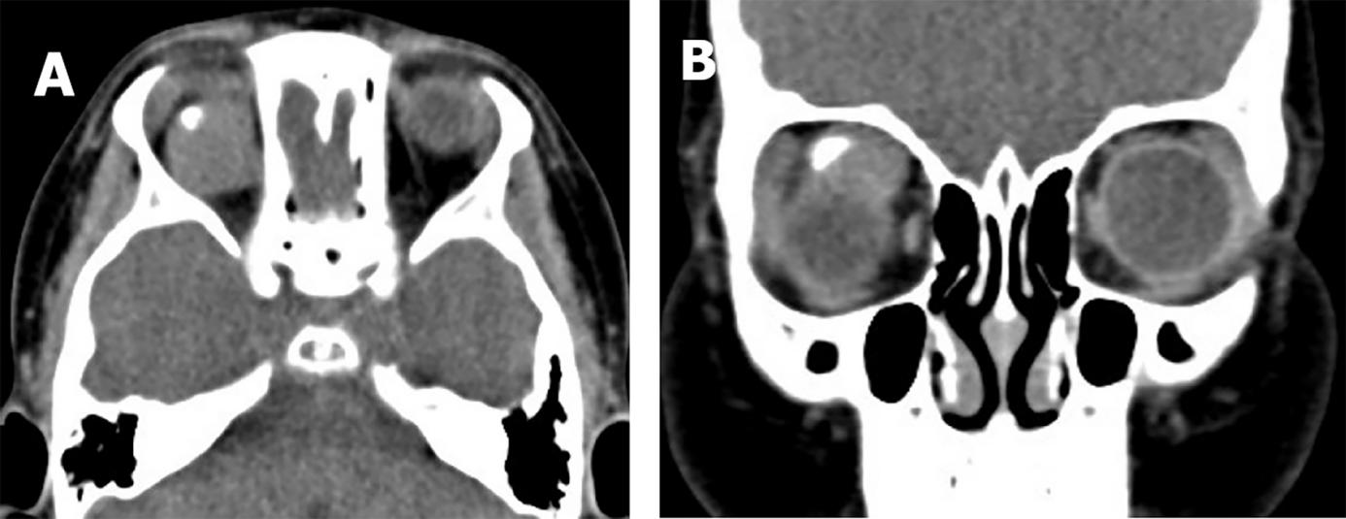
Figure 2 Orbital computed tomography showed a well-defined soft tissue density mass in the right orbit, with a hyperdense speck suggestive of coarse calcification. A: Axial computed tomography (CT); B: Coronal CT.
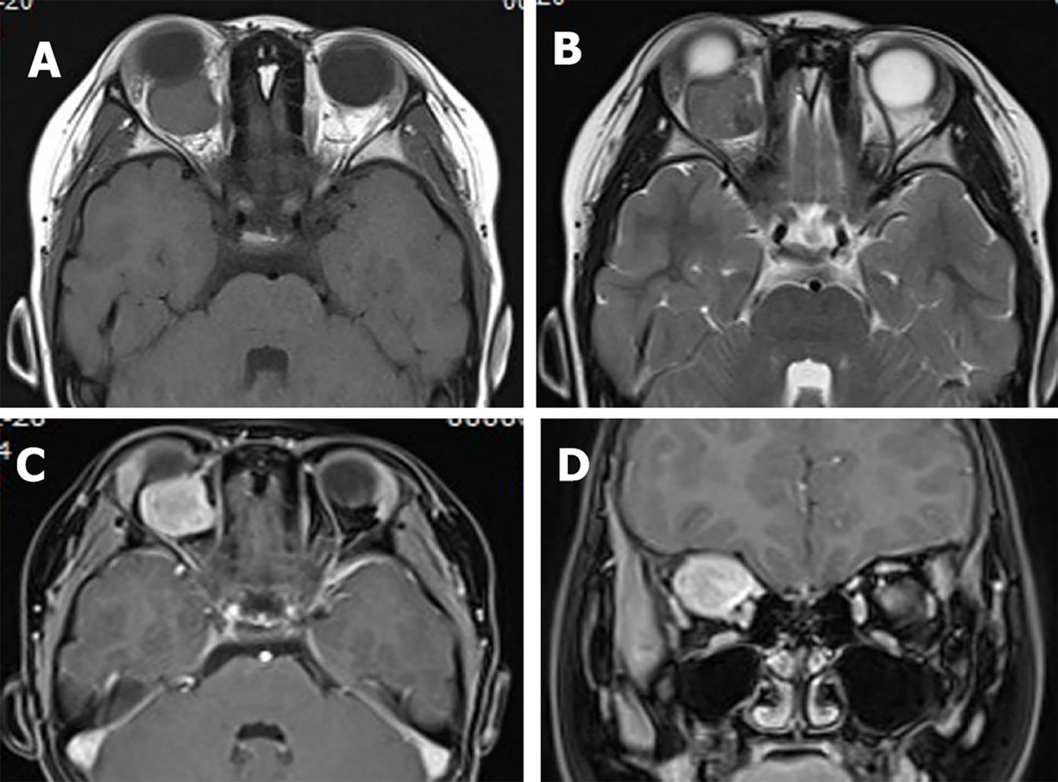
Figure 3 Orbital magnetic resonance imaging showed a circular-like mass in the right orbit. A: T1-weighted imaging showed moderate signals, mixed with low-signal regions; B: T2-weighted imaging showed mixed signals, with high number of moderately high signals, and mixed with low-signal regions; C and D: Most of the lesion was significantly and unevenly enhanced, whereas local lesions did not exhibit any enhancement.

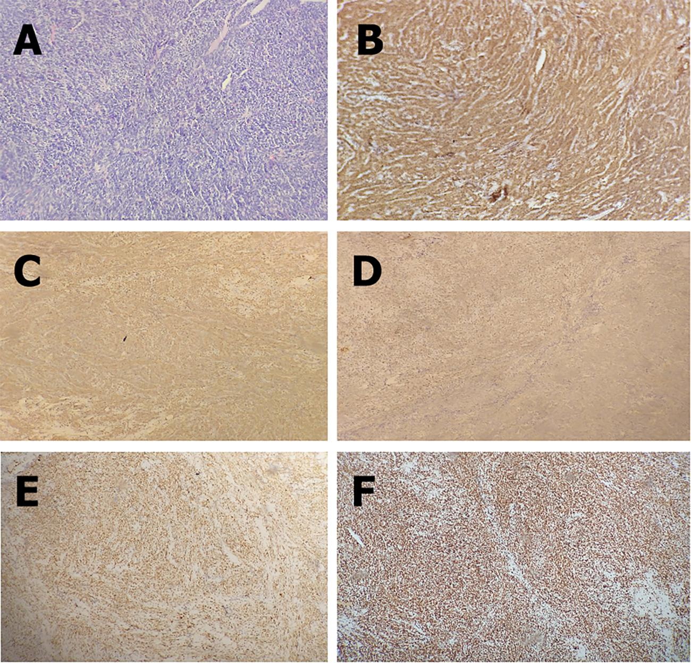
Figure 4 Histological and immunohistochemical examination. A: The tumor was confirmed as monophasic synovial sarcoma with calcification based on histological analysis (hematoxylin and eosin, 200×); B–F: Immunohistochemical study revealed positive staining for Bcl-2 (B), CD99 (C), CKpan (D), TLE1 (E), and INI-1 (F) (100×).
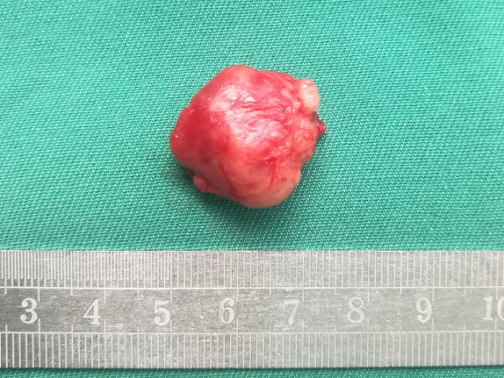
Figure 5 Tumor presented as a well-defined, reddish lesion, with irregularly shaped soft tissue density mass.

Published by Baishideng Publishing Group Inc
7041 Koll Center Parkway, Suite 160, Pleasanton, CA 94566, USA
Telephone: +1-925-3991568
E-mail: bpgoffice@wjgnet.com
Help Desk: https://www.f6publishing.com/helpdesk
https://www.wjgnet.com

© 2022 Baishideng Publishing Group Inc. All rights reserved.

