Name of Journal: World Journal of Clinical Cases
Manuscript NO: 56702
Manuscript Type: ORIGINAL ARTICLE

Retrospective Study
Retroperitoneal vs transperitoneal laparoscopic lithotripsy of 20-40 mm renal stones within horseshoe kidneys

Chen X et al. Retroperitoneal vs transperitoneal laparoscopic lithotripsy

Xin Chen, Yi Wang, Liang Gao, Jin Song, Jin-You Wang, Deng-Dian Wang, Jia-Xing Ma, Zhi-Qiang Zhang, Liang-Kuan Bi, Dong-Dong Xie, De-Xin Yu

Xin Chen, Yi Wang, Jin Song, Jin-You Wang, Deng-Dian Wang, Jia-Xing Ma, Zhi-Qiang Zhang, Liang-Kuan Bi, Dong-Dong Xie, De-Xin Yu, Department of Urology, The Second Hospital of Anhui Medical University, Hefei 230032, Anhui Province, China

Liang Gao, Center of Experimental Orthopaedics, Saarland University Medical Center, Homburg 66421, Germany

Author contributions: Chen X, Wang Y, Wang JY and Yu DX performed the surgery; Song J, Gao L, Bi LK and Xie DD completed the figure illustration; Wang DD, Ma JX and Zhang ZQ finished the statistical analyses; all authors contributed to writing and revising this report; Chen X is the main author and Yu DX is the senior author; all authors issued final approval for the version to be submitted.

Supported by the National Natural Science Foundation of China, No. 81572507.

Corresponding author: De-Xin Yu, MD, Chief Doctor, Surgeon, Department of Urology, The Second Hospital of Anhui Medical University, No. 678 Furong Road, Hefei 230032, Anhui Province, China. yudx_urology@126.com

Received: May 21, 2020
Revised: June 22, 2020
Accepted: September 1, 2020
Published online:

Abstract
BACKGROUND
Horseshoe kidney (HK) with renal stones is challenging for urologists. Although both retroperitoneal and transperitoneal laparoscopic approaches have been reported in some case reports, the therapeutic outcome of retroperitoneal compared with transperitoneal laparoscopic lithotripsy is unknown.

AIM
To assess the efficacy of laparoscopic lithotripsy for renal stones in patients with HK.

METHODS
This was a retrospective study of 12 patients with HK and a limited number (n ≤ 3) of 20-40 mm renal stones treated with either retroperitoneal or transperitoneal laparoscopic lithotripsy (June 2012 to May 2019). The perioperative data of both groups were compared including operation time, estimated blood loss, postoperative fasting time, perioperative complications and stone-free rate (SFR).

RESULTS
No significant difference was observed for age, gender, preoperative symptoms, body mass index, preoperative infection, hydronephrosis degree, largest stone diameter, stone number and isthmus thickness. The mean postoperative fasting time of the patients in the retroperitoneal group and the transperitoneal group was 1.29 ± 0.49 and 2.40 ± 0.89 d, respectively (P = 0.019). There was no significant difference in operation time (194.29 ± 102.48 min vs 151.40 ± 39.54 min, P = 0.399), estimated blood loss (48.57 ± 31.85 mL vs 72.00 ± 41.47 mL, P = 0.292) and length of hospital stay (12.14 ± 2.61 d vs 12.40 ± 3.21 d, P = 0.881) between the retroperitoneal and transperitoneal groups. All patients in both groups had a complete SFR and postoperative renal function was within the normal range. The change in estimated glomerular filtration rate (eGFR) from the preoperative stage to postoperative day 1 in the retroperitoneal group and the transperitoneal group was -3.86 ± 0.69 and -2.20 ± 2.17 mL/(min·1.73 m²), respectively (P = 0.176). From the preoperative stage to the 3-mo follow-up, the absolute change in eGFR values for patients in the retroperitoneal group and the transperitoneal group was -3.29 ± 1.11 and -2.40 ± 2.07 mL/(min·1.73 m²), respectively (P = 0.581).

CONCLUSION
Both retroperitoneal and transperitoneal laparoscopic lithotripsy seem to be safe and effective for HK patients with a limited number of 20-40 mm renal stones.

Key words: Horseshoe kidney; Retroperitoneal; Transperitoneal; Laparoscopic lithotripsy; Renal stones

Chen X, Wang Y, Gao L, Song J, Wang JY, Wang DD, Ma JX, Zhang ZQ, Bi LK, Xie DD, Yu DX. Retroperitoneal vs transperitoneal laparoscopic lithotripsy of 20-40 mm renal stones within horseshoe kidneys. World J Clin Cases 2020; In press

Core tip: This was a retrospective study of 12 patients with horseshoe kidney (HK) and a limited number (n ≤ 3) of 20-40 mm renal stones treated by either retroperitoneal or transperitoneal laparoscopic lithotripsy. The mean postoperative fasting time of patients in the retroperitoneal group and the transperitoneal group was 1.29 ± 0.49 and 2.40 ± 0.89 d, respectively (P = 0.019). All patients in both groups had a complete SFR and postoperative renal function was within the normal range. Both retroperitoneal and transperitoneal laparoscopic lithotripsy seem to be safe and effective for HK patients with a limited number of 20-40 mm renal stones.

INTRODUCTION
Horseshoe kidney (HK) is a major congenital kidney anomaly which occurs in approximately 0.25% of the general population^{[1]}. Pathological fusion of the lower kidney moiety gives rise to ureteropelvic junction obstruction (UPJO) in up to 35% of HK patients^{[2,3]}, and distortion of the ureteropelvic junction naturally leads to renal stones. For large renal stones (largest stone diameter > 20 mm), flexible ureteroscopy, laparoscopic lithotripsy, percutaneous nephrolithotomy (PCNL) and extracorporeal shock wave lithotripsy (ESWL) have been successfully performed in selected specific cases^{[4,5]}. PCNL is the preferred procedure for large renal stones (largest stone diameter > 40 mm), while ESWL and flexible ureteroscopy are feasible and safe for small renal stones (largest stone diameter < 20 mm). However, no studies have investigated the best surgical approach for HK with a limited number of 20-40 mm renal stones, which is commonly found.
Laparoscopic lithotripsy was proposed as a promising technique for renal stones in HK patients^{[4-10]}. However, in most of the reported cases treatment was performed using the transperitoneal approach^{[6-9]}. Comparisons between retroperitoneal and transperitoneal laparoscopic approaches for HK with renal stones have not yet been performed. The present study aimed to report our single center experience of laparoscopic stone management via both retroperitoneal and transperitoneal approaches in HK patients with a limited number (n ≤ 3) of 20-40 mm renal stones.

MATERIALS AND METHODS
Patient characteristics
Patients with HK and renal stones in our clinic who were treated laparoscopically between July 2012 and May 2019 were retrospectively reviewed. The exclusion criteria included bilateral renal stones, staghorn stones, small (< 20 mm) or large (> 40 mm) stones, stone number > 3, other abnormal upper urinary tract anatomies including duplex kidney and ectopic kidney, severe obstruction of the urinary tract, history of open surgery of the upper abdomen, and concomitant renal tumor. The study was approved by the Ethics Committee of Anhui Medical University, Hefei, China and carried out in accordance with the Helsinki Declaration.
Perioperative data were reviewed including operation time, estimated blood loss, perioperative complications, and postoperative fasting time. Rates of minor and major complications were evaluated according to the Clavien-Dindo classification^{[11]}. Perioperative total renal function was calculated as the estimated glomerular filtration rate (eGFR) using the Modified Diet in Renal Disease equation^{[12]} preoperatively and on postoperative day 1 and 30, respectively. All patients underwent X-ray kidney-ureter-bladder radiography as the imaging examination preoperatively on postoperative day 30, to evaluate the stone-free rate (SFR). Isthmus thickness was determined by routine preoperative three-dimensional computed tomography (CT) and CT angiography in all patients. Perioperative hydronephrosis degree was evaluated by renal ultrasound and classified according to the Society for Fetal Urology guideline (Grade 0: No renal pelvic dilatation; Grade 1: Renal pelvic dilatation with only visualized small calyces; Grade 2: Renal pelvic dilatation with some visualized large calyces; Grade 3: Renal pelvic dilatation with all visualized calyces and a normal parenchyma; Grade 4: Renal pelvic dilatation with all visualized calyces and a thin parenchyma)^{[13]}.
All patients received laparoscopic isthmusectomy concomitantly with lithotripsy. Depending on patient status and surgeon preference, a retroperitoneal or transperitoneal approach was performed.

Retroperitoneal protocol
Under general anesthesia, patients were placed in the semi-lateral decubitus position with the ipsilateral side up. The laparoscopic port placements are shown in Figure 1A. After entering the retroperitoneal space, the retroperitoneal fat was separated first, the Gerota fascia was then uncovered at the lower pole, and the perinephric fat was eliminated to expose the renal hilum. As the isthmus existed in the lower poles in all our cases, we released the lower pole of the kidney to expose the isthmus (Figure 2A). When the isthmus was isolated with a stapler (Endopath, Ethicon Endo-Surgery, United States) (Figure 2B), we dissected the renal pelvis to extract the stones (Figure 2C and D). Distilled water was applied to flush the renal pelvis to promote stone removal. After a Double-J ureteral stent was inserted into the ureter (Figure 2E), renal pelvic anastomoses were performed with a 4-0 absorbable V-LOC suture. A flexible cystoscope was used in one patient to view all small calyces to guarantee complete clearance of renal stones.

Transperitoneal protocol
Patients were placed in the supine position and the laparoscopic ports were located as shown in Figure 1B. The Toldt line was incised first, and the colon was mobilized medially to expose the aorta and Gerota fascia. The Gerota fascia was dissected and the isthmus was completely released (Figure 2F). Following exposure of the isthmus, a 3-0 absorbable V-LOC suture was applied on both sides of the narrowest isthmus moiety for renal parenchymal anastomoses and the isthmus was isolated using Mayo scissors (Figure 2G and H). The nephrolithotomy procedure was performed as described in the retroperitoneal approach (Figure 2I and J).

Statistical analysis
Statistical analyses were performed with SPSS Statistics v. 22.0 (SPSS Inc., Chicago, IL, United States). All continuous data are shown as mean ± SD and were compared by the Student’s t-test. The Wilcoxon signed-rank test was used to compare perioperative eGFR changes. Categorical data were compared by the Chi-square test. A P value < 0.05 was considered statistically significant.

RESULTS
Twelve patients (seven adult females, four adult males, and one boy) were enrolled into our cohorts. Demographic data of these patients were systematically reviewed and are summarized in Table 1. The mean patient age was 35.25 ± 13.69 years (range, 12-55 years). Nine patients (75.0%) presented with a history of moderate to severe flank pain, two patients (16.7%) presented with abdominal pain and the remaining patient (8.3%) complained of moderate hematuria (Table 1). Five patients (41.7%) with preoperative urinary infection recovered after antibiotic treatment for three days. Nine patients (75.0%) had renal stones on the left side, while three (25.0%) had renal stones on the right side. All patients had an extra-renal pelvis.
Seven of 12 patients (58.3%) were included in the retroperitoneal group while the other five (41.7%) were included in the transperitoneal group. There were no statistically significant differences between the retroperitoneal and transperitoneal groups regarding age, gender, body mass index, side of renal stones, and preoperative infection (Table 1). The mean stone diameter in the retroperitoneal group (26.71 ± 4.27 mm) was smaller than that in the transperitoneal group (28.40 ± 4.04 mm) without reaching statistical significance (P = 0.507). Stone number in the retroperitoneal group was comparable to that in the transperitoneal group (P = 0.125). Isthmus thickness in the retroperitoneal group and transperitoneal group was 4.07 ± 1.10 vs 4.18 ± 0.75 cm, respectively (P = 0.853) (Table 1).
Mean postoperative fasting time in patients in both groups was 1.29 ± 0.49 and 2.40 ± 0.89 d, respectively (P = 0.019). No significant differences were found in terms of operation time (194.29 ± 102.48 min vs 151.40 ± 39.54 min, P = 0.399), estimated blood loss (48.57 ± 31.85 mL vs 72.00 ± 41.47 mL, P = 0.292) and length of hospital stay (12.14 ± 2.61 d vs 12.40 ± 3.21 d, P = 0.881) between the two groups (Table 1).
eGFR values in patients in both groups were recorded: preoperative period: 143.00 ± 24.34 mL/(min·1.73 m²) vs 126.00 ± 40.48 mL/(min·1.73 m²); postoperative day 1: 139.14 ± 23.97 mL/(min·1.73 m²) vs 123.80 ± 40.67 mL/(min·1.73 m²), postoperative day 30: 139.71 ± 26.23 mL/(min·1.73 m²) vs 123.60 ± 39.42 mL/(min·1.73 m²) (Table 1). The eGFR values assessed at each time point were comparable between the two groups (P = 0.383, P = 0.428 and P = 0.398, respectively) (Table 1). Although the postoperative eGFR values in both groups on postoperative day 1 and 30 were worse than the preoperative values, these differences were not statistically significant (P = 0.176 and P = 0.581, respectively) (Table 2).
None of the patients received a perioperative transfusion, and no major complications (grade III-V) occurred according to the Clavien-Dindo classification. Only one patient in the retroperitoneal group had low blood pressure, which improved after sufficient liquid compensation, while one patient in the transperitoneal group experienced postoperative fever, which subsided after antibiotic treatment for three days. Postoperative drainage, a catheter and a Double-J stent were placed for 3 d, 3 d and one month, respectively. No statistically significant differences were observed between the two groups in terms of the mean follow-up period (29.42 ± 23.87 mo vs 27.79 ± 21.75 mo, P = 0.906). The SFR in both groups was 100% (Table 1 and Figure 3).

DISCUSSION
Origin of renal stones
HK is the most common renal fusion malformation which develops within 7-9 gestational weeks. An isthmus of the two lower renal poles exists in almost 90% of patients and is generally located anterior to the aorta and vena cava^{[3]}. Due to the connection of the lower or upper poles of two individual kidneys, the isthmus induces renal malrotation and renal pelvic anteposition. As a result of kidney rotation, the ureter atypically passes through the anterior surface of the isthmus and contributes to UPJO, which further promotes renal stone formation. Furthermore, metabolic abnormalities may also contribute to the high incidence (21.0%-60.0%) of renal stones in HK^{[14,15]}.

Therapeutic options for renal stones in patients with HK
Although flexible ureteroscopy is recommended by the European Association of Urology guideline for small renal stones in HK patients^{[16]}, large and/or multiple renal stones are still challenging for urologists. PCNL has been reported to be applicable for large or multiple renal stones in HK patients, including pediatric patients, with a SFR of 75.0%-89.0%^{[5,17-20]}. However, the complication rate varied from 13.0% to 29.2%, whilst the complications included significant hematuria requiring blood transfusion and colonic injury. Furthermore, renal stones in specific locations (such as the lower calyx and isthmus) cannot be reached by the nephroscope. These renal stones can potentially be treated by laparoscopy. In addition, laparoscopic lithotripsy may also be effective for renal stones with a limited stone number (n ≤ 3) and stone size (stone largest diameter within the range of 20-40 mm).

Advantages of the retroperitoneal and transperitoneal approach
The present study revealed that both the retroperitoneal and transperitoneal approach might provide a satisfactory outcome for renal stones in patients with HK. Use of the retroperitoneal approach may avoid entering the peritoneal cavity and minimally affect intestinal function. In our cohort, patients in the retroperitoneal group had a shorter postoperative fasting time than patients in the transperitoneal group. Furthermore, urologists are more familiar with the retroperitoneal space and identifying the isthmus safely after exposing the ureter. According to our experience, this approach is more appropriate for a non-isthmus stone. However, the transperitoneal approach offers considerable space, direct access to vasculature and feasible suturing for renal parenchymal anastomoses. Therefore, it is more cost-effective than the retroperitoneal approach. In addition, the operation time was shorter than that in the retroperitoneal group, although the difference was not significant. Thus, it was theoretically feasible for treating bilateral renal stones. We consider that the operation time was more dependent on the surgeon’s experience rather than the surgical approach. The limited retroperitoneal space did not result in a significant difference in operation time (Table 1). Both approaches avoided a high complication rate (14.3% vs 20.0%, P = 1.000).

Treatment of the isthmus
Although isthmusectomy is not recommended by European and United States surgeons for HK patients^{[21]}, Chinese surgeons prefer isthmusectomy as they consider that it may reset the anatomic location of abnormal kidneys and resolve the UPJO-induced hydronephrosis^{[4]}. All patients in our cohort underwent isthmusectomy. This was due to the fact that hydronephrosis in our cohort was caused by isthmic compression on the ureter, and hydronephrosis grades were comparably low (n ≤ 2). Our decision on technical choice was consistent with the recommendation by Jarzemski et al^{[22]}. Both parenchymal suturing and stapling can avoid hemorrhage. A stapler was recommended for isthmus division in the retroperitoneal approach, as the contralateral kidney is free and complex to complete renal parenchymal anastomoses, and the estimated blood loss can also be reduced.

Renal stones removal
Improvement in the SFR is still a vital part of renal stone treatment in HK patients. In our study, the SFR did not differ between the two groups (100% vs 100%, P = 1.000). Renal pelvic stones could be removed directly after pelvis dissection due to the dilated renal pelvis. In cases with lower calyceal stones, it was difficult to reach the stones by laparoscopy, and distilled water was applied to flush the pelvis. In one patient with three renal stones in the lower calyx, a flexible cystoscope was used for the renal stones. Our results indicated that the flexible cystoscope was effective for aiding complete stone removal, which was in accordance with the study by Kramer et al^{[6]}. Similarly, a flexible ureteroscope has also been proposed to improve the renal stone removal rate in lithotripsy^{[23]}.

Limitations
Several drawbacks of this study should be acknowledged. First, this is a retrospective study and the patient number was limited. The rigorous exclusion criteria in our study determined the limited therapeutic spectrum of this laparoscopic approach. However, the SFR in both groups was satisfactory (100% vs 100%, P = 1.000), and was attributed to the limited number of renal stones (n ≤ 3) and the extra-renal pelvis. More prospective clinical trials are needed to identify whether the laparoscopic technique is suitable for a greater number (n > 3) of renal stones. In cases with an intra-renal pelvis, a complete exploration of all calyces is challenging. A flexible cystoscope or flexible ureteroscope may be beneficial for stone removal within the intra-renal pelvis. Second, as a higher degree of hydronephrosis (> 2) and renal stones are found in HK patients, lithotripsy concomitant with pyeloplasty can be performed. More experience of laparoscopic lithotripsy and pyeloplasty should be accumulated. Third, the laparoscopic technique for stone removal in HK patients is a demanding procedure that requires considerable surgical expertise.

CONCLUSION
Both retroperitoneal and transperitoneal laparoscopic lithotripsy seem to be safe and effective for HK patients with a limited number of 20-40 mm renal stones.

ARTICLE HIGHLIGHTS
Research background
Horseshoe kidney (HK) with renal stones is challenging for urologists. No studies have investigated the best surgical approach for HK with a limited number of 20-40 mm renal stones, which is commonly found.

Research motivation
Laparoscopic treatment was reported in some case reports; however, the therapeutic outcome of the retroperitoneal compared with the transperitoneal approach is unknown. The possible therapeutic differences between these two approaches was worthy of study.

Research objectives
This study aimed to investigate the clinical characteristics and outcomes of patients with HK and renal stones, who underwent retroperitoneal or transperitoneal laparoscopic treatment.

Research methods
We performed a retrospective study of 12 patients treated with retroperitoneal or transperitoneal laparoscopy for HK and a limited number of 20-40 mm renal stones. The baseline characteristics and postoperative outcomes of these patients were summarized and analyzed. Statistical analyses were performed with SPSS Statistics v. 22.0.

Research results
The mean postoperative fasting time of patients in the retroperitoneal group was shorter than that in the transperitoneal group. There was no significant difference in operation time, estimated blood loss and length of hospital stay between the retroperitoneal group and transperitoneal group. All patients in both groups achieved a complete stone-free rate and postoperative renal function was within the normal range. The change in estimated glomerular filtration rate from the preoperative stage to postoperative day 1 and 3-mo in the retroperitoneal group and transperitoneal group was not statistically significant.

Research conclusions
Both retroperitoneal and transperitoneal laparoscopic lithotripsy are safe and effective surgical approaches for HK patients with a limited number (n ≤ 3) of 20-40 mm renal stones. Laparoscopic lithotripsy is an effective clinical alternative to percutaneous nephrolithotomy and flexible ureteroscopy.

Research perspectives
More attention should be paid to the treatment of HK patients with a limited number of medium-sized renal stones. The ideal choice of retroperitoneal or transperitoneal laparoscopy should be patient-individualized and further elucidated by more prospective clinical trials.

REFERENCES
1 Allen AC. Horseshoe kidney. In: The Kidney: Medical and surgical diseases. New York Grune; 1951: 94-96
2 Yohannes P, Smith AD. The endourological management of complications associated with horseshoe kidney. J Urol 2002; 168: 5-8 [PMID: 12050480 DOI: 10.1016/s0022-5347(05)64819-7]
3 Khan A, Myatt A, Palit V, Biyani CS, Urol D. Laparoscopic heminephrectomy of a horseshoe kidney. JSLS 2011; 15: 415-420 [PMID: 21985738 DOI: 10.4293/108680811X13125733356512]
4 Wang P, Xia D, Ma Q, Wang S. Retroperitoneal laparoscopic management of ureteropelvic junction obstruction in patients with horseshoe kidney. Urology 2014; 84: 1351-1354 [PMID: 25242437 DOI: 10.1016/j.urology.2014.07.029]
5 Symons SJ, Ramachandran A, Kurien A, Baiysha R, Desai MR. Urolithiasis in the horseshoe kidney: a single-centre experience. BJU Int 2008; 102: 1676-1680 [PMID: 18782315 DOI: 10.1111/j.1464-410X.2008.07987.x]
6 Kramer BA, Hammond L, Schwartz BF. Laparoscopic pyelolithotomy: indications and technique. J Endourol 2007; 21: 860-861 [PMID: 17867941 DOI: 10.1089/end.2006.0410]
7 Myint M, Luke S, Louie-Johnsun M. Laparoscopic pyelolithotomy and pyeloplasty in a horseshoe kidney. ANZ J Surg 2015; 85: 492-493 [PMID: 24251980 DOI: 10.1111/ans.12458]
8 Shadpour P, Akhyari HH, Maghsoudi R, Etemadian M. Management of ureteropelvic junction obstruction in horseshoe kidneys by an assortment of laparoscopic options. Can Urol Assoc J 2015; 9: E775-E779 [PMID: 26600883 DOI: 10.5489/cuaj.3111]
9 Nambirajan T, Jeschke S, Albqami N, Abukora F, Leeb K, Janetschek G. Role of laparoscopy in management of renal stones: single-center experience and review of literature. J Endourol 2005; 19: 353-359 [PMID: 15865527 DOI: 10.1089/end.2005.19.353]
10 Nadu A, Schatloff O, Morag R, Ramon J, Winkler H. Laparoscopic surgery for renal stones: is it indicated in the modern endourology era? Int Braz J Urol 2009; 35: 9-17; discussion 17-8 [PMID: 19254393 DOI: 10.1590/s1677-55382009000100003]
11 Dindo D, Demartines N, Clavien PA. Classification of surgical complications: a new proposal with evaluation in a cohort of 6336 patients and results of a survey. Ann Surg 2004; 240: 205-213 [PMID: 15273542 DOI: 10.1097/01.sla.0000133083.54934.ae]
12 Stevens LA, Manzi J, Levey AS, Chen J, Deysher AE, Greene T, Poggio ED, Schmid CH, Steffes MW, Zhang YL, Van Lente F, Coresh J. Impact of creatinine calibration on performance of GFR estimating equations in a pooled individual patient database. Am J Kidney Dis 2007; 50: 21-35 [PMID: 17591522 DOI: 10.1053/j.ajkd.2007.04.004]
13 Fernbach SK, Maizels M, Conway JJ. Ultrasound grading of hydronephrosis: introduction to the system used by the Society for Fetal Urology. Pediatr Radiol 1993; 23: 478-480 [PMID: 8255658 DOI: 10.1007/BF02012459]
14 Evans WP, Resnick MI. Horseshoe kidney and urolithiasis. J Urol 1981; 125: 620-621 [PMID: 7230330 DOI: 10.1016/s0022-5347(17)55139-3]
15 Gambaro G, Fabris A, Puliatta D, Lupo A. Lithiasis in cystic kidney disease and malformations of the urinary tract. Urol Res 2006; 34: 102-107 [PMID: 16416113 DOI: 10.1007/s00240-005-0019-z]
16 Türk TKC, Petrik A, Sarica K, Skolarikos A, Straub M, Seitz C. Guidelines on Urolithiasis. 2015
17 Al-Otaibi K, Hosking DH. Percutaneous stone removal in horseshoe kidneys. J Urol 1999; 162: 674-677 [PMID: 10458339 DOI: 10.1097/00005392-199909010-00009]
18 Purkait B, Sankhwar SN, Kumar M, Patodia M, Bansal A, Bhaskar V. Do Outcomes of Percutaneous Nephrolithotomy in Horseshoe Kidney in Children Differ from Adults? A Single-Center Experience. J Endourol 2016; 30: 497-503 [PMID: 26791336 DOI: 10.1089/end.2015.0794]
19 Shokeir AA, El-Nahas AR, Shoma AM, Eraky I, El-Kenawy M, Mokhtar A, El-Kappany H. Percutaneous nephrolithotomy in treatment of large stones within horseshoe kidneys. Urology 2004; 64: 426-429 [PMID: 15351557 DOI: 10.1016/j.urology.2004.04.018]
20 Raj GV, Auge BK, Weizer AZ, Denstedt JD, Watterson JD, Beiko DT, Assimos DG, Preminger GM. Percutaneous management of calculi within horseshoe kidneys. J Urol 2003; 170: 48-51 [PMID: 12796642 DOI: 10.1097/01.ju.0000067620.60404.2d]
21 Kölln CP, Boatman DL, Schmidt JD, Flocks RH. Horseshoe kidney: a review of 105 patients. J Urol 1972; 107: 203-204 [PMID: 5061443 DOI: 10.1016/s0022-5347(17)60983-2]
22 Jarzemski P, Listopadzki S. Laparoscopic horseshoe kidney isthmusectomy: four case reports. Wideochir Inne Tech Maloinwazyjne 2014; 9: 115-120 [PMID: 24729821 DOI: 10.5114/wiitm.2011.35740]
23 Tsuru N, Mugiya S, Kurita Y, Sato S, Hirano Y. Laparoscopic Pyeloplasty for Ureteropelvic Junction Obstruction in an Incompletely Duplicated Collecting System in a Patient with a Horseshoe Kidney. Urol Case Rep 2016; 9: 55-57 [PMID: 27733990 DOI: 10.1016/j.eucr.2016.09.003]

Footnotes
Institutional review board statement: The study was approved by the Ethics Committee of Anhui Medical University, Hefei, China and carried out in accordance with the Helsinki Declaration.

Informed consent statement: All study participants, or their legal guardian, provided informed written consent prior to study enrollment.

Conflict-of-interest statement: The authors declare that they have no conflict of interest.

Data sharing statement: Not available.

Open-Access: This article is an open-access article that was selected by an in-house editor and fully peer-reviewed by external reviewers. It is distributed in accordance with the Creative Commons Attribution NonCommercial (CC BY-NC 4.0) license, which permits others to distribute, remix, adapt, build upon this work non-commercially, and license their derivative works on different terms, provided the original work is properly cited and the use is non-commercial. See: http://creativecommons.org/Licenses/by-nc/4.0/

Manuscript source: Unsolicited manuscript

Peer-review started: May 21, 2020
First decision: June 7, 2020
Article in press:

Specialty type: Medicine, research and experimental
Country/Territory of origin: China
Peer-review report’s scientific quality classification
Grade A (Excellent): 0
Grade B (Very good): B
Grade C (Good): 0
Grade D (Fair): 0
Grade E (Poor): 0

P-Reviewer: Gupta N S-Editor: Yan JP L-Editor: Webster JR P-Editor:
Figure Legends
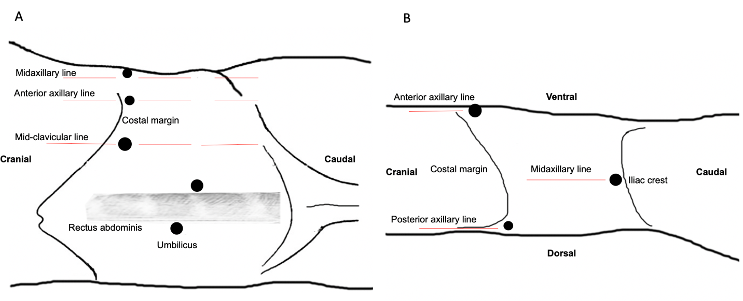
Figure 1 The trocar position during laparoscopic treatment. A: Transperitoneal procedure: Two 10-mm trocars were placed, one at the umbilicus and the other 2 cm below the umbilicus adjacent to the rectus sheath, respectively. The trocar at the umbilicus was the camera port. A 12-mm trocar was inserted 2 cm below the costal margin in the mid-clavicular line. The other two 5-mm trocars were placed 2 cm below the costal margin in the anterior axillary line and midaxillary line, respectively; B: Retroperitoneal procedure: One 10-mm trocar was located 1 cm above the level of the iliac crest in the midaxillary line as the camera port. One 12-mm trocar was placed 2 cm below the costal margin in the anterior axillary line. One 5-mm trocar was inserted 1 cm below the costal margin in the posterior axillary line.

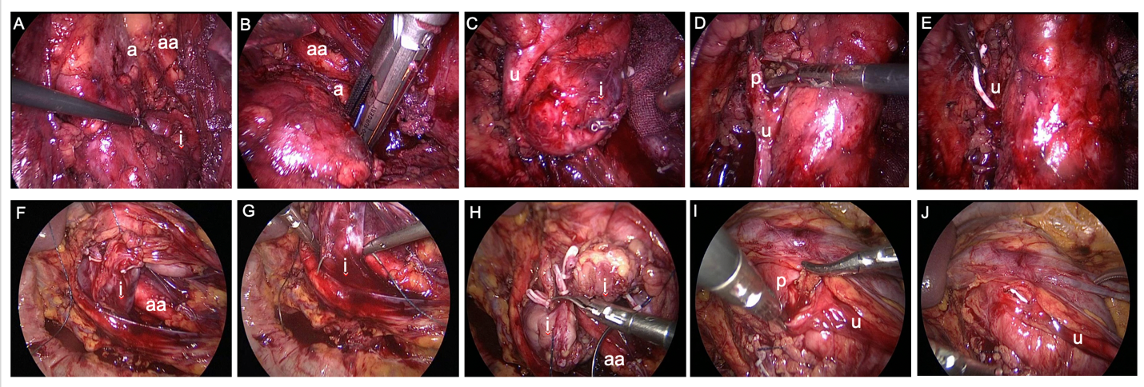
Figure 2 Key operative steps in representative cases of the retroperitoneal group (A-E) and the transperitoneal group (F-J). In the upper row: (A) The isthmus (i) was supplied by an aberrant artery (a) from the abdominal aorta (aa). (B) The isthmus was completely isolated with a stapler. (C) The isthmus (i) was moved back to expose the ureter (u). (D) At the guideline of the ureter (u), the pelvis (p) was exposed and dissected to remove the stone. (E) A Double-J stent was inserted into the ureter (u). In the bottom row: (F) The isthmus (i) was exposed. (G) Anastomosis of the isthmus (i). (H) The isthmus was dissected by Mayo scissors. (I) The pelvis (p) was exposed and dissected to remove the stone. (J) A Double-J stent was inserted into the ureter (u).

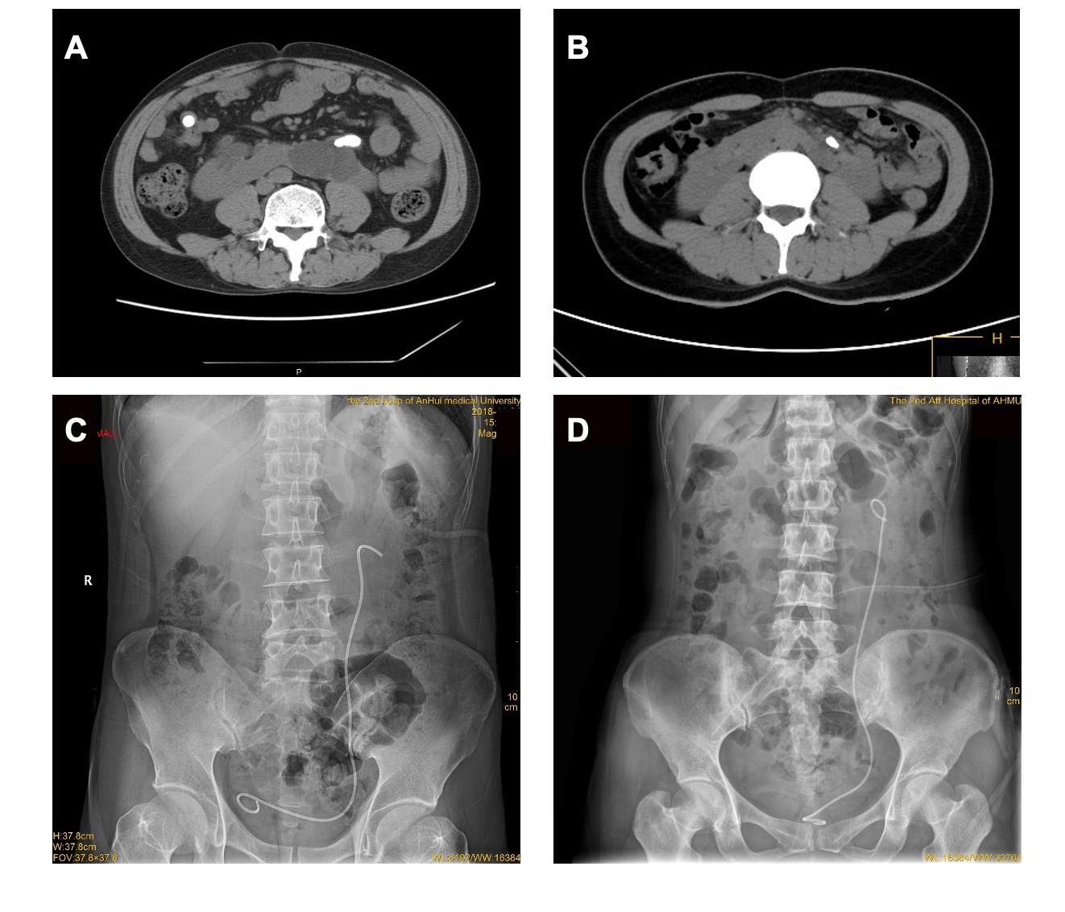
Figure 3 Preoperative and postoperative imaging examination. A and C: Preoperative imaging examination; B and D: Postoperative imaging examination.

Table 1 Demographic data of the included patients
 | Retroperitoneal group (n = 7) | Transperitoneal group (n = 5) | P value
Age (yr) | 37.29 ± 13.30 | 32.40 ± 15.24 | 0.567
Gender |  |  | 1.000
Male, n (%) | 3 (42.9) | 2 (40.0)
Female, n (%) | 4 (57.1) | 3 (60.0)
Laterality |  |  | 1.000
Left, n (%) | 5 (71.4) | 4 (80.0)
Right, n (%) | 2 (28.6) | 1 (20.0)
BMI (kg/m²) | 21.69 ± 1.86 | 22.65 ± 2.43 | 0.457
Preoperative symptoms |  |  | 0.559
Flank pain, n (%) | 5 (71.4) | 4 (80.0)
Abdominal pain, n (%) | 1 (14.3) | 1 (20.0)
Hematuria, n (%) | 1 (14.3) | 0 (0.0)
Preoperative infection |  |  | 0.558
No, n (%) | 5 (71.4) | 2 (40.0)
Yes, n (%) | 2 (28.6) | 3 (60.0)
Hydronephrosis degree |  |  | 1.000
≤ 1, n (%) | 3 (42.9) | 3 (60.0)
2, n (%) | 4 (57.1) | 2 (40.0)
Maximal stone diameter (mm) | 26.71 ± 4.27 | 28.40 ± 4.04 | 0.507
Stone number |  |  | 0.125
1, n (%) | 4 (57.1) | 2 (40.0)
2, n (%) | 3 (42.9) | 1 (20.0)
3, n (%) | 0 (0.0) | 2 (40.0)
Isthmus thickness (cm) | 4.07 ± 1.10 | 4.18 ± 0.75 | 0.853
Operation time (min) | 194.29 ± 102.48 | 151.40 ± 39.54 | 0.399
Estimated blood loss (mL) | 48.57 ± 31.85 | 72.00 ± 41.47 | 0.292
Postop fasting time (d) | 1.29 ± 0.49 | 2.40 ± 0.89 | 0.019
Hospital stay (d) | 12.14 ± 2.61 | 12.40 ± 3.21 | 0.881
Minor complications, n (%) | 1 (14.3) | 1 (20.0) | 1.000
Major complications, n (%) | 0 (0.0) | 0 (0.0) | N/A
eGFR [mL/(min·1.73 m²)]
Preoperative | 143.00 ± 24.34 | 126.00 ± 40.48 | 0.383
Postoperative day 1 | 139.14 ± 23.97 | 123.80 ± 40.67 | 0.428
Postoperative day 30 | 139.71 ± 26.23 | 123.60 ± 39.42 | 0.398
Mean follow-up | 29.42 ± 23.87 | 27.79 ± 21.75 | 0.906
SFR, n (%) | 7 (100.0) | 5 (100.0) | 1.000
P values were calculated for intergroup comparisons using the Student’s t-test and Chi-square test. BMI: Body mass index; eGFR: Estimated glomerular filtration rate; SFR: Stone-free rate; N/A: Not applicable.

Table 2 Intergroup comparisons of postoperative estimated glomerular filtration rate change relative to preoperative levels
eGFR [mL/(min·1.73 m²)] | Retroperitoneal group (n = 7) | Transperitoneal group (n = 5) | P value
Postoperative day 1 | -3.86 ± 0.69 | -2.20 ± 2.17 | 0.176
Postoperative day 30 | -3.29 ± 1.11 | -2.40 ± 2.07 | 0.581
Values are expressed as mean ± SD. P values were calculated for intergroup comparisons using the Wilcoxon signed-rank test. eGFR: Estimated glomerular filtration rate.

