Name of Journal: World Journal of Gastrointestinal Oncology
Manuscript NO: 81670
Manuscript Type: FIELD OF VISION

Machine learning algorithm to construct cuproptosis- and immune-related prognosis prediction model for colon cancer

Huang YY et al. Machine learning algorithm for colon cancer

Yuan-Yi Huang, Ting-Yu Bao, Xu-Qi Huang, Qi-Wen Lan, Ze-Min Huang, Yu-Han Chen, Zhi-De Hu, Xu-Guang Guo

Yuan-Yi Huang, Ting-Yu Bao, Xu-Qi Huang, Qi-Wen Lan, Ze-Min Huang, Yu-Han Chen, Xu-Guang Guo, Department of Clinical Laboratory Medicine, The Third Affiliated Hospital of Guangzhou Medical University, Guangzhou 510150, Guangdong Province, China

Yuan-Yi Huang, Department of Clinical Medicine, The First Clinical School of Guangzhou Medical University, Guangzhou 511436, Guangdong Province, China

Ting-Yu Bao, Ze-Min Huang, Yu-Han Chen, Xu-Guang Guo, Department of Clinical Medicine, The Third Clinical School of Guangzhou Medical University, Guangzhou 511436, Guangdong Province, China

Xu-Qi Huang, Department of Clinical Medicine, The Sixth Clinical School of Guangzhou Medical University, Guangzhou 511436, Guangdong Province, China

Qi-Wen Lan, Department of Medical Imageology, The Second Clinical School of Guangzhou Medical University, Guangzhou 511436, Guangdong Province, China

Zhi-De Hu, Department of Laboratory Medicine, The Affiliated Hospital of Inner Mongolia Medical University, Hohhot 010010, Inner Mongolia Autonomous Region, China

Xu-Guang Guo, Guangdong Provincial Key Laboratory of Major Obstetric Diseases, The Third Affiliated Hospital of Guangzhou Medical University, Guangzhou 510150, Guangdong Province, China

Xu-Guang Guo, Key Laboratory of Reproduction and Genetics of Guangdong Higher Education Institutes, The Third Affiliated Hospital of Guangzhou Medical University, Guangzhou 510150, Guangdong Province, China

Xu-Guang Guo, Guangzhou Key Laboratory for Clinical Rapid Diagnosis and Early Warning of Infectious Diseases, King Med School of Laboratory Medicine, Guangzhou Medical University, Guangzhou 511436, Guangdong Province, China

Author contributions: Huang YY collected and assessed the data; Huang YY, Bao TY, and Huang XQ wrote the manuscript; Lan QW and Huang ZM participated in revising the manuscript; Chen YH and Hu ZD worked together to finalize the submission; Guo XG proposed and designed the study; All authors contributed to the article and approved the submitted version.

Corresponding author: Xu-Guang Guo, MD, PhD, Associate Professor, Department of Clinical Laboratory Medicine, The Third Affiliated Hospital of Guangzhou Medical University, No. 63 Duobao Road, Liwan District, Guangzhou 510150, Guangdong Province, China. gysygxg@gmail.com

Received: November 23, 2022
Revised: December 22, 2022
Accepted: February 15, 2023
Published online:

Abstract
BACKGROUND
Over the past few years, research into the pathogenesis of colon cancer has progressed rapidly, and cuproptosis is an emerging mode of cellular apoptosis. Exploring the relationship between colon cancer and cuproptosis benefits in identifying novel biomarkers and even improving the outcome of the disease.

AIM
To look at the prognostic relationship between colon cancer and the genes associated with cuproptosis and the immune system in patients. The main purpose was to assess whether reasonable induction of these biomarkers reduces mortality among patients with colon cancers.

METHOD
Data obtained from The Cancer Genome Atlas and Gene Expression Omnibus and the and the Genotype-Tissue Expression were used in differential analysis to explore differential expression genes associated with cuproptosis and immune activation. The least absolute shrinkage and selection operator and Cox regression algorithm was applied to build a cuproptosis- and immune-related combination model, and the model was utilized for principal component analysis and survival analysis to observe the survival and prognosis of the patients. A series of statistically meaningful transcriptional analysis results demonstrated an intrinsic relationship between cuproptosis and the micro-environment of colon cancer.

RESULTS
Once prognostic characteristics were obtained, the CDKN2A and DLAT genes related to cuproptosis were strongly linked to colon cancer: The first was a risk factor, whereas the second was a protective factor. The finding of the validation analysis showed that the comprehensive model associated with cuproptosis and immunity was statistically significant. Within the component expressions, the expressions of HSPA1A, CDKN2A, and UCN3 differed markedly. Transcription analysis primarily reflects the differential activation of related immune cells and pathways. Furthermore, genes linked to immune checkpoints inhibitor were expressed differently between the subgroups, which may reveal the mechanism of worse prognosis and the different sensitivities of chemotherapy.

Key Words: Cuproptosis; Immune; Colon cancer; Prognosis models; Immune infiltration analysis

Huang YY, Bao TY, Huang XQ, Lan QW, Huang ZM, Chen YH, Hu ZD, Guo XG. Machine learning algorithm to construct cuproptosis- and immune-related prognosis prediction model for colon cancer. World J Gastrointest Oncol 2023; In press

Core Tip: We comprehensively analyzed the effect of cuproptosis and immunity on the prognosis of colon cancer based on the close association between the three. Scrupulously, a variety of algorithms were applied to analyze and construct a three-gene prognostic model whose efficacy was statistically significant in both the training set and the external validation set. Moreover, in order to provide help for prognosis assessment and personalized treatment of colon cancer, we performed immunoinfiltration analysis and immunocheckpoint inhibitor-related genes expression analysis in different risk groups according to the cuproptosis- and immune-related combination model.

INTRODUCTION
Colon cancer is among the most serious cancers worldwide and is genetically complex^{[1,2]}. According to the World Health Organization (WHO), over 940000 cases are reported worldwide, and almost 500000 people die annually of colon cancer^{[3]}. As with other solid cancers, colon cancer is infested with various types of immune cells. Among these, factors favoring tumors are the inflammatory reaction of B cells, innate immune cells and numerous T cell subtypes. Unlike other epithelial cancers, many inflammatory T cells that infiltrate colon cancer are specific for the commensal microbiota, rather than specific tumor antigens or autoantigens. Therefore, they do not directly kill cancer cells. However, natural killer (NK) cells, CD8⁺ T cells and CD4⁺ T cells are still the main immune monitors^{[4,5]}. At the same time, CD11b⁺Gr1⁺ cells recruited in the late stage contribute to the suppression of the antitumor immune response and tumor angiogenesis, which share characteristics with monocytes, macrophages, neutrophils and dendritic cells^{[5]}. The tumor microenvironment (TME) formed in the tumor development process consists mostly of stroma and immune cells^{[6,7]}. Changes in their composition and proportion will affect the immunosuppressive effect of tumors and subsequently affect pathological state, treatment and prognosis. At present, further research on immune biomarkers is required to provide evidence for immune checkpoint blockade therapy in colon cancer, which is more appropriate for the majority of colon cancers^{[6-8]}.
Copper, the micronutrient essential to human health, is an essential cofactor of biological function. However, it becomes toxic when its concentration exceeds the threshold maintained by evolutionary conservative homeostatic mechanisms^{[9]}. Cuproptosis occurs when copper accumulates. Too much copper binds to the lipid components of the tricarboxylic acid (TCA) cycle, resulting in the accumulation of lipoprotein and the loss of iron-sulfur tuft, eventually leading to protein-toxic stress and cell death^{[10]}. Studies have shown that cuproptosis may have a high cytotoxic effect on tumor cells. Abnormal copper levels can affect tumor growth by causing irreversible damage to organelles and consequently inducing tumor cell death through multiple mechanisms, which could be used as new targets for anticancer therapy^{[11-13]}. Meanwhile, to adapt to adverse microenvironments, several copper chaperones are upregulated in cancer cells, which bind to cytoplasmic copper and transfer to SOD1, supporting antioxidant function and indirectly mediating cancer cell metastasis^{[14]}. In the relationship between excessive copper and immunity, excessive copper can induce splenomegaly, disorder of the white medulla in the spleen, expansion of the red medulla and accumulation of dead cells, decrease the number of thymocytes, inhibit the proliferation of lymphocytes in other tissues and induce their necrosis and apoptosis^{[15]}. At the same time, serum Cu and ferroxidase ceruloplasmin were positively correlated with inflammation^{[16]}.
To further study the effect of cuproptosis and immunity on colon cancer, we built a prognostic model based on the currently known genes, which is likely to provide guidance for the treatment of colon cancer.

MATERIALS AND METHODS
Study flow chart
The idea of this study is shown in Figure 1 in the form of a flow chart, and it aims to help readers better understand the research process of the article.

Data collection and handling
RNA-seq data of colon cancer patients and 41 normal controls and clinical information from 443 of these patients were downloaded from The Cancer Genome Atlas (TCGA) (https://portal.gdc.com). We acquired the gene profile data of normal tissues from Genotype-Tissue Expression (GTEx) (http://commonfund.nih.gov/GTEx), and we obtained differentially expressed genes (DEGs) with the “Limma” package of R software. For external validation purpose, we downloaded the GSE39582 dataset containing 568 colon cancer samples from the Gene Expression Omnibus (GEO) database (http://www.ncbi.nlm.nih.gov/geo/). Clinical information about the training set and validation set is shown in Table 1.

Screening cuproptosis- and immune-related differentially expressed genes independently associated with prognosis
We collected ten cuproptosis-related genes (CRGs) from existing reports^{[10]}, and the differently expressed cuproptosis-related genes (CR-DEGs) were obtained by intersecting them with the DEGs (Fold Change > 1.2 and p.adjust < 0.05) between colon cancer and normal samples from GTEx. Through the GeneCards database (https://www.genecards.org/), 1793 immune-related genes (IRGs) with a score ≥ 7 were obtained^{[17]} and intersected with the DEGs (Fold Change > 2 and p.adjust < 0.05) in TCGA to obtain immune-related differentially expressed genes (IR-DEGs). The “Survival with Forestplot” package in R was used to perform univariate and multivariate Cox regression analyses on CR-DEGs and IR-DEGs, respectively, to screen out candidate signatures with significant independent predictive values for the prognosis of colon cancer (P < 0.05).

Construction and external validation of prognostic risk score models
We utilized the least absolute shrinkage and selection operator (LASSO) regression algorithm to construct three risk scoring models with candidate signatures using 10-fold cross-validation. This method was implemented with the “glmnet” package^{[18,19]}. On the basis of the median risk score, the cancer samples were divided into two groups: The high-risk group was greater than the median, and the low-risk group was less than the median. Then, we applied the “survminer” package to determine the optimal cutoff value for survival analysis and to compare overall survival (OS) in different subgroups using the Kaplan-Meier method and the log-rank test. The “timeROC” package was applied for receiver operating characteristic (ROC) analysis to evaluate the performance of the model. Finally, we used the GSE39582 dataset for external validation of the integrated cuproptosis- and immune-related model.

Principal component analysis and construction of nomograms
We performed principal component analysis (PCA) on colon cancer patients based on the cuproptosis- and immune-related model and used the “ggplot2” package for visualization. According to the results of multivariate Cox proportional hazards analysis, nomograms including risk score and other clinical predictors were built using the “rms” package to predict 1-, 3-, and 5-year OS^{[20]}.

Functional enrichment and immune profiling
Based on the cuproptosis- and immune-related model, we carried out Gene Ontology (GO), Kyoto Encyclopedia of Genes and Genomes (KEGG), and gene set enrichment analysis (GSEA) for analyses of DEGs between the high- and low-risk groups. To explore the immune profiles of the high- and low-risk groups, we applied the CIBERSORT and EPIC algorithms to calculate the abundance of infiltrating immune cells in separate subgroups. We compared the expression of genes associated with immune checkpoint inhibitors between the subgroups and displayed the results with great significance (P < 0.05).

RESULTS
Acquisition of cuproptosis-related and immune-related differentially expressed genes
A heatmap and volcano map present the results of gene differential expression analysis in TCGA (Figure 2A and B). Four CR-DEGs were obtained by intersecting the CRGs and DEGs (Figure 2C), suggesting that these genes may be involved in the development of colon cancer. Similarly, 299 IR-DEGs were obtained (Figure 2D).

Identification of prognostic features and construction of risk scoring models
Univariate analysis of four CR-DEGs showed that two genes were significant (P < 0.05). Among them, CDKN2A was a risk factor (HR > 1), while DLAT was a protective factor (HR < 1) (Figure 2E). Multivariate analysis showed that both were still significant (Figure 2F), indicating that they may be independent factors affecting the OS of colon cancer. LASSO regression analysis screened the coefficients of the predictors (Figure 3A), and a colon cancer prognostic risk score model related to copper death was constructed. The model is a formula, and the optimal model is taken when λ_{min}= 0.002: Riskscore = (0.1582) × (expression of CDKN2A) + (-0.3203) × (expression of DLAT).
Analogous results were obtained in the analysis of 299 IR-DEGs. We showed 20 IR-DEGs associated with prognosis at P < 0.05, 4 of which had independent effects, except for UCN3 as a protective factor (HR < 1). HSPA1A, ULBP2 and FABP4 were all risk factors (HR > 1). (Figure 3B and C) When λ_{min}= 0.0017 (Figure 3D), the best immune-related colon cancer prognostic risk score model was as follows: Riskscore = (0.2507) * (expression of HSPA1A) + (0.1563) × (expression of ULBP2) + (0.1065) × (expression of FABP4) + (-0.1704) × (expression of UCN3).
After multivariate analysis of CDKN2A, DLAT, UCN3, HSPA1A, ULBP2 and FABP4, the results showed that CDKN2A and HSPA1A may be independent risk factors for colon cancer prognosis (HR > 1), while UCN3 is an independent protective factor (HR < 1) (Figure 3E and F). After coefficient screening, when λ_{min} = 0.0044, the optimal cuproptosis- and immune-related prognostic model was constructed, namely: Riskscore = (0.2391) × (expression of HSPA1A) + (0.1849) × (expression of CDKN2A) + (-0.1784) × (expression of UCN3).

Model evaluation and external validation
Figure 4A shows the risk score and survival time of patients in the model based on two CR-DEGs. The KM curve in Figure 4B shows that patients with lower risk scores had a better prognosis. The ROC curves demonstrated that the area under the curve (AUC) of the model was greater than 0.6 at 1, 3, and 5 years (Figure 4C). This indicates that the model has good predictive performance for prognosis. We performed the same analysis on two other models and obtained similar results (Figures 4D-F and 5A-C). In parallel, the cuproptosis- and immune-related risk scoring model was validated in an external dataset. Both the KM curve and the ROC curve drawn using the 568 patients with colon cancer in GSE39582 were meaningful (Figure 5D-F). Therefore, we concentrated on the analysis of this model at a later stage.

PCA and the independent predictive value of the risk score
The PCA showed that different subgroups could be clearly distinguished in the cuproptosis- and immune-related models. (Figure 6A and B) Univariate and multivariate Cox regression analyses of the risk score and other clinical features, such as age and pTNM stage, were carried out. Cuproptosis- and immune-related risk scores were independently related to the OS of patients with colon cancer, indicating that they can serve as independent prognostic predictors. (Figure 6C and D) Afterwards, nomograms were drawn to make it possible to derive a score for each factor from information about a specific patient and finally to estimate the probability of survival for that patient based on the total score (Figure 6E).

Functional enrichment and immune profiling
The differential expression of the three genes is presented in Figure 6F. Among them, CDKN2A and HSPA1A were upregulated, while UCN3 was downregulated in the high-risk group. Functional enrichment revealed that the DEGs between the two distinct groups were enhanced in the tumor immune microenvironment (Figures 6G and 7A-C). Therefore, we performed immune cell infiltration analysis. The heatmap in Figure 7D shows the infiltration abundance of different immune cells in different subgroups, among which memory B cells, endothelial cells, NK cells and so on were significantly different (Figure 7D and E). The differential expression results of immune checkpoint inhibitors (ICIs) showed that the expression of mRNA expression of perforin (PRF1) and TBX2 in the high-risk group was higher than that in the low-risk group, which may be associated with stronger tumor immune escape in the high-risk group (Figure 7F and G).

DISCUSSION
Colon cancer is the third most common cancer and the second most common cause of global cancer mortality^{[21-23]}. During the past decades, the incidence and mortality of this cancer have progressively increased^{[21]}, making it imperative and urgent to identify potential biomarkers to evaluate its prognosis and treatment.
A recent study reported that cuproptosis, as a novel type of cell death, is relevant to the development and progression of malignancy^{[10]}. Cuproptosis may have a high cytotoxic effect on tumor cells, and abnormal copper levels can affect tumor growth by causing irreversible damage to organelles and consequently inducing tumor cell death through multiple mechanisms, which could be used as new targets for anticancer therapy^{[11-13]}. Another study found that immune cell infiltration was associated with a variety of reactions to the prognosis and treatment of colon cancer^{[24]}.
In our research, we constructed a cuproptosis- and immune-related prognostic risk model, combined with HSPA1A, CDKN2A and UCN3, which significantly differed between the low-risk and high-risk groups for colon cancer. HSPA1A and CDKN2A exhibited carcinogenesis, and their overexpression was associated with poorer prognosis and survival in colon cancer patients, whereas high expression of the UCN3 gene showed a tumor suppressor profile, which was associated with better prognosis and survival. As one of the HSP70 family members, extracellular HSPA1A is thought to elicit antitumor immune responses^{[25]}. Previous studies have shown that the extracellular environment Hsp70 acts as a risk-associated molecular pattern (DAMP) and increases cytokine production, which can form an inflammatory microenvironment conducive to tumor progression^{[26]}. In addition, Hsp70 promotes tumor invasion by binding to Toll‐like receptors 2 and 4^{[27]}. CDKN2A has been declared to be associated with gene mutation and cancer progression, such as colon and breast cancers^{[28]}. CDKN2A is upregulated in colon cancer through two potential mechanisms: Immunosuppression and progression of epithelial-mesenchymal transition (EMT), leading to poor prognosis^{[29]}. UCN3 might participate in local inflammatory stress response pathways to assist in the maintenance of tissue integrity and homeostasis^{[30]}. In undifferentiated epithelial cells of colonic crypts and colon cancer cell lines, corticotropin-releasing factor 2 (CRF2) protein is expressed preferentially. UCN3-induced CRF2 signaling decreases the expression of transcription factors involved in intestinal epithelial cell differentiation and modifies the cytoplasmic and transcellular permeability of related cells^{[31]}.
Functional enrichment analysis between the high- and low-risk groups were enriched in oxygen transport, cellular response to monosaccharide stimulus, intermediate filament cytoskeleton, G protein-coupled receptor binding, receptor-ligand activity, and structural constituent of cytoskeleton. It seems that the cellular response may be altered in different risk groups^{[32]}. In a previous study, the basal epithelial intermediate filament cytoskeleton was confirmed to be necessary for mass invasion of cancer^{[33]}. G protein-coupled receptor binding has been implicated in the tumorigenesis, progression, and metastasis of cancers^{[34]}. Of the many factors, mediating disease ligands and receptor activity may be implicated in cancers^{[35]}. Through research on multiple cancer datasets, the regulation of the actin cytoskeleton signaling pathways has been identified as a cancer-related factor^{[36]}. KEGG enrichment analysis showed that bile secretion, neuroactive ligand-receptor interaction and the PPAR signaling pathway were significantly enriched. Several studies have investigated whether the secretion of bile might be linked to the pathogenesis of colon cancers^{[37]}. Recent studies have reported that neuroactive ligand-receptor interaction pathways are relevant to colorectal cancers^{[38]}. GSEA showed that immature to mature B lymphocytes, dendritic cell maturation, and silenced by the TME were mainly enriched. However, as antigen-presenting cells (APCs), both dendritic cells and B-lymphocytes can deliver antigens to T-lymphocytes, thus activating immature T-lymphocytes to induce an antitumor immunization effect, which can consequently affect the prognosis of tumors^{[39-41]}. Consequently, the prognosis for colon cancer may be regarded as being related to changes in immune cells and the TME. Meanwhile, a growing number of studies on the TME have shown that tumor-infiltrating immune cells play a vital role in cancer progression and aggressiveness, and their molecular quantitative traits are increasingly considered to have predictive value and correlate with the prognosis of colon cancer, so we followed up with an immune infiltration analysis for high-risk and low-risk groups^{[42,43]}.
B-cell memory, endothelial cells, and macrophage infiltration were higher in the high-risk group, and since it has been shown that tumor tissue infiltrating B cells are mainly B-cell memory and that macrophages and endothelial cells can contribute to cancer development and malignant progression by stimulating angiogenesis, tumor cell invasion, and intravascular infiltration, such infiltration is related to poor prognosis and reduced survival in most cancers^{[44-47]}. The low-risk group, on the other hand, had more activated CD4⁺ memory T cells, CD8⁺ T cells, and NK cells. CD4⁺ T cells can recognize tumor antigens presented by APCs and secrete specific cytokines and costimulatory signaling molecules to stimulate CD8⁺ T cells to proliferate and differentiate into tumor effector T cells or memory T cells, which have strong tumor cytotoxic and immunosurveillance functions^{[48,49]}. In addition, NK cells can produce a large number of cytotoxic granule proteins and cytokines without prestimulation to induce apoptosis, which can rapidly exert a tumor-cytotoxicity effect at the early stage of lesions and can complement and coordinate with the immunosurveillance function of cytotoxic T lymphocytes to inhibit the development of tumor cells^{[50,51]}, so their infiltration is mostly associated with a better prognosis. Genes related to immune checkpoint inhibitors, such as PRF1 and TBX2, suggest that patients in the high-risk score group are more likely to experience immune escape and may be more sensitive to the immunotherapy^{[52]}. It has been shown that immune cytolytic activity (CYT) is an immune indicator of cancer that is based on the PRF1 and granzyme A^{[53]}. Tumors with high CYT have a high mutational load, which predisposes them to microsatellite instability. Unstable microsatellite colorectal tumors can overexpress several immune checkpoint molecules triggering immune evasion and immunosuppression, which are associated with poorer prognosis^{[54]}. There is a significant correlation between tumor TBX2 overexpression and distant tumor metastasis as well as late-stage and recurrence^{[54,55]}. However, the specific mechanisms by which TBX2 promotes tumorigenesis and progression are currently unclear. According to the available studies, TBX2 may inhibit the cellular senescence program by participating in the regulation of cyclin kinase inhibitor p19 ARF and p21, as well as providing cells with the ability to bypass the cytokinesis block, which leads to increased genomic instability^{[56-58]}. Therefore, TBX2 may act as an immortalizing gene that avoids cellular senescence to participate in the regulation of cyclin and thus influence tumor progression and prognosis^{[54]}.
In this study, based on cuproptosis- and immune-related genes, we identified prognostic signatures for colon cancer and validated them by using an external dataset. Nevertheless, additional confirmation and experimental validation is necessary.

CONCLUSION
The prognosis of the high-risk group evaluated in the combined model was poorer, and cuproptosis was highly correlated with the prognosis of colon cancer. It is possible that we may be able to improve patients’ prognosis by regulating the gene expression to intervene the risk score.

ACKNOWLEDGEMENTS
We sincerely acknowledge TCGA, GTEx, NCBI GEO, and GeneCards database for offering their platform and their valuable datasets.

REFERENCES
1 Chen H, Luo J, Guo J. Development and validation of a five-immune gene prognostic risk model in colon cancer. BMC Cancer 2020; 20: 395 [PMID: 32375704 DOI: 10.1186/s12885-020-06799-0]
2 Cappell MS. Pathophysiology, clinical presentation, and management of colon cancer. Gastroenterol Clin North Am 2008; 37: 1-24, v [PMID: 18313537 DOI: 10.1016/j.gtc.2007.12.002]
3 Fabregas JC, Ramnaraign B, George TJ. Clinical Updates for Colon Cancer Care in 2022. Clin Colorectal Cancer 2022; 21: 198-203 [PMID: 35729033 DOI: 10.1016/j.clcc.2022.05.006]
4 Schmitt M, Greten FR. The inflammatory pathogenesis of colorectal cancer. Nat Rev Immunol 2021; 21: 653-667 [PMID: 33911231 DOI: 10.1038/s41577-021-00534-x]
5 Shawki S, Ashburn J, Signs SA, Huang E. Colon Cancer: Inflammation-Associated Cancer. Surg Oncol Clin N Am 2018; 27: 269-287 [PMID: 29496089 DOI: 10.1016/j.soc.2017.11.003]
6 Chen W, Huang J, Xiong J, Fu P, Chen C, Liu Y, Li Z, Jie Z, Cao Y. Identification of a Tumor Microenvironment-Related Gene Signature Indicative of Disease Prognosis and Treatment Response in Colon Cancer. Oxid Med Cell Longev 2021; 2021: 6290261 [PMID: 34497681 DOI: 10.1155/2021/6290261]
7 Ruan H, Leibowitz BJ, Zhang L, Yu J. Immunogenic cell death in colon cancer prevention and therapy. Mol Carcinog 2020; 59: 783-793 [PMID: 32215970 DOI: 10.1002/mc.23183]
8 Stein A, Folprecht G. Immunotherapy of Colon Cancer. Oncol Res Treat 2018; 41: 282-285 [PMID: 29705788 DOI: 10.1159/000488918]
9 Al-Ansari RF, Al-Gebori AM, Sulaiman GM. Serum levels of zinc, copper, selenium and glutathione peroxidase in the different groups of colorectal cancer patients. Caspian J Intern Med 2020; 11: 384-390 [PMID: 33680379 DOI: 10.22088/cjim.11.4.384]
10 . Erratum for the Research Article "Copper induces cell death by targeting lipoylated TCA cycle proteins," by P. Tsvetkov et al Science 2022; 378: eadf5804 [PMID: 36356160 DOI: 10.1126/science.adf5804]
11 Fatfat M, Merhi RA, Rahal O, Stoyanovsky DA, Zaki A, Haidar H, Kagan VE, Gali-Muhtasib H, Machaca K. Copper chelation selectively kills colon cancer cells through redox cycling and generation of reactive oxygen species. BMC Cancer 2014; 14: 527 [PMID: 25047035 DOI: 10.1186/1471-2407-14-527]
12 Gul NS, Khan TM, Chen M, Huang KB, Hou C, Choudhary MI, Liang H, Chen ZF. New copper complexes inducing bimodal death through apoptosis and autophagy in A549 cancer cells. J Inorg Biochem 2020; 213: 111260 [PMID: 33039746 DOI: 10.1016/j.jinorgbio.2020.111260]
13 Jiang Y, Huo Z, Qi X, Zuo T, Wu Z. Copper-induced tumor cell death mechanisms and antitumor theragnostic applications of copper complexes. Nanomedicine (Lond) 2022; 17: 303-324 [PMID: 35060391 DOI: 10.2217/nnm-2021-0374]
14 Gao W, Huang Z, Duan J, Nice EC, Lin J, Huang C. Elesclomol induces copper-dependent ferroptosis in colorectal cancer cells via degradation of ATP7A. Mol Oncol 2021; 15: 3527-3544 [PMID: 34390123 DOI: 10.1002/1878-0261.13079]
15 Mitra S, Keswani T, Dey M, Bhattacharya S, Sarkar S, Goswami S, Ghosh N, Dutta A, Bhattacharyya A. Copper-induced immunotoxicity involves cell cycle arrest and cell death in the spleen and thymus. Toxicology 2012; 293: 78-88 [PMID: 22239859 DOI: 10.1016/j.tox.2011.12.013]
16 Hackler J, Heller RA, Sun Q, Schwarzer M, Diegmann J, Bachmann M, Moghaddam A, Schomburg L. Relation of Serum Copper Status to Survival in COVID-19. Nutrients 2021; 13 [PMID: 34072977 DOI: 10.3390/nu13061898]
17 Zhang Q, Guan G, Cheng P, Cheng W, Yang L, Wu A. Characterization of an endoplasmic reticulum stress-related signature to evaluate immune features and predict prognosis in glioma. J Cell Mol Med 2021; 25: 3870-3884 [PMID: 33611848 DOI: 10.1111/jcmm.16321]
18 Zheng S, Zou Y, Liang JY, Xiao W, Yang A, Meng T, Lu S, Luo Z, Xie X. Identification and validation of a combined hypoxia and immune index for triple-negative breast cancer. Mol Oncol 2020; 14: 2814-2833 [PMID: 32521117 DOI: 10.1002/1878-0261.12747]
19 Friedman J, Hastie T, Tibshirani R. Regularization Paths for Generalized Linear Models via Coordinate Descent. J Stat Softw 2010; 33: 1-22 [PMID: 20808728]
20 Blanche P, Dartigues JF, Jacqmin-Gadda H. Estimating and comparing time-dependent areas under receiver operating characteristic curves for censored event times with competing risks. Stat Med 2013; 32: 5381-5397 [PMID: 24027076 DOI: 10.1002/sim.5958]
21 Labianca R, Beretta GD, Kildani B, Milesi L, Merlin F, Mosconi S, Pessi MA, Prochilo T, Quadri A, Gatta G, de Braud F, Wils J. Colon cancer. Crit Rev Oncol Hematol 2010; 74: 106-133 [PMID: 20138539 DOI: 10.1016/j.critrevonc.2010.01.010]
22 Yaghoubi A, Khazaei M, Avan A, Hasanian SM, Soleimanpour S. The bacterial instrument as a promising therapy for colon cancer. Int J Colorectal Dis 2020; 35: 595-606 [PMID: 32130489 DOI: 10.1007/s00384-020-03535-9]
23 Huerta S, Goulet EJ, Livingston EH. Colon cancer and apoptosis. Am J Surg 2006; 191: 517-526 [PMID: 16531147 DOI: 10.1016/j.amjsurg.2005.11.009]
24 Peng D, Wang L, Li H, Cai C, Tan Y, Xu B, Le H. An immune infiltration signature to predict the overall survival of patients with colon cancer. IUBMB Life 2019; 71: 1760-1770 [PMID: 31301220 DOI: 10.1002/iub.2124]
25 Finkernagel F, Reinartz S, Schuldner M, Malz A, Jansen JM, Wagner U, Worzfeld T, Graumann J, von Strandmann EP, Müller R. Dual-platform affinity proteomics identifies links between the recurrence of ovarian carcinoma and proteins released into the tumor microenvironment. Theranostics 2019; 9: 6601-6617 [PMID: 31588238 DOI: 10.7150/thno.37549]
26 Somensi N, Brum PO, de Miranda Ramos V, Gasparotto J, Zanotto-Filho A, Rostirolla DC, da Silva Morrone M, Moreira JCF, Pens Gelain D. Extracellular HSP70 Activates ERK1/2, NF-kB and Pro-Inflammatory Gene Transcription Through Binding with RAGE in A549 Human Lung Cancer Cells. Cell Physiol Biochem 2017; 42: 2507-2522 [PMID: 28848092 DOI: 10.1159/000480213]
27 Vostakolaei MA, Hatami-Baroogh L, Babaei G, Molavi O, Kordi S, Abdolalizadeh J. Hsp70 in cancer: A double agent in the battle between survival and death. J Cell Physiol 2021; 236: 3420-3444 [PMID: 33169384 DOI: 10.1002/jcp.30132]
28 Andersson U, Wibom C, Cederquist K, Aradottir S, Borg A, Armstrong GN, Shete S, Lau CC, Bainbridge MN, Claus EB, Barnholtz-Sloan J, Lai R, Il’yasova D, Houlston RS, Schildkraut J, Bernstein JL, Olson SH, Jenkins RB, Lachance DH, Wrensch M, Davis FG, Merrell R, Johansen C, Sadetzki S; Gliogene Consortium, Bondy ML, Melin BS. Germline rearrangements in families with strong family history of glioma and malignant melanoma, colon, and breast cancer. Neuro Oncol 2014; 16: 1333-1340 [PMID: 24723567 DOI: 10.1093/neuonc/nou052]
29 Kang N, Xie X, Zhou X, Wang Y, Chen S, Qi R, Liu T, Jiang H. Identification and validation of EMT-immune-related prognostic biomarkers CDKN2A, CMTM8 and ILK in colon cancer. BMC Gastroenterol 2022; 22: 190 [PMID: 35429970 DOI: 10.1186/s12876-022-02257-2]
30 Kavalakatt S, Khadir A, Madhu D, Hammad M, Devarajan S, Abubaker J, Al-Mulla F, Tuomilehto J, Tiss A. Urocortin 3 Levels Are Impaired in Overweight Humans With and Without Type 2 Diabetes and Modulated by Exercise. Front Endocrinol (Lausanne) 2019; 10: 762 [PMID: 31781037 DOI: 10.3389/fendo.2019.00762]
31 Ducarouge B, Pelissier-Rota M, Powell R, Buisson A, Bonaz B, Jacquier-Sarlin M. Involvement of CRF2 signaling in enterocyte differentiation. World J Gastroenterol 2017; 23: 5127-5145 [PMID: 28811708 DOI: 10.3748/wjg.v23.i28.5127]
32 Kang MK, Kim RH, Kim SJ, Yip FK, Shin KH, Dimri GP, Christensen R, Han T, Park NH. Elevated Bmi-1 expression is associated with dysplastic cell transformation during oral carcinogenesis and is required for cancer cell replication and survival. Br J Cancer 2007; 96: 126-133 [PMID: 17179983 DOI: 10.1038/sj.bjc.6603529]
33 Cheung KJ, Gabrielson E, Werb Z, Ewald AJ. Collective invasion in breast cancer requires a conserved basal epithelial program. Cell 2013; 155: 1639-1651 [PMID: 24332913 DOI: 10.1016/j.cell.2013.11.029]
34 Wu X, Li J, Zhu M, Fletcher JA, Hodi FS. Protein kinase C inhibitor AEB071 targets ocular melanoma harboring GNAQ mutations via effects on the PKC/Erk1/2 and PKC/NF-κB pathways. Mol Cancer Ther 2012; 11: 1905-1914 [PMID: 22653968 DOI: 10.1158/1535-7163.MCT-12-0121]
35 Zhang F, Zhang J, Liu M, Zhao L, LingHu R, Feng F, Gao X, Jiao S, Zhao L, Hu Y, Yang J. Combating HER2-overexpressing breast cancer through induction of calreticulin exposure by Tras-Permut CrossMab. Oncoimmunology 2015; 4: e994391 [PMID: 25949918 DOI: 10.4161/2162402X.2014.994391]
36 Zhao F, Ge YZ, Zhou LH, Xu LW, Xu Z, Ping WW, Wang M, Zhou CC, Wu R, Jia RP. Identification of hub miRNA biomarkers for bladder cancer by weighted gene coexpression network analysis. Onco Targets Ther 2017; 10: 5551-5559 [PMID: 29200870 DOI: 10.2147/OTT.S146479]
37 Tian J, Xue W, Yin H, Zhang N, Zhou J, Long Z, Wu C, Liang Z, Xie K, Li S, Li L, Wu Z, Daria V, Zhao Y, Wang F, Wang M. Differential Metabolic Alterations and Biomarkers Between Gastric Cancer and Colorectal Cancer: A Systematic Review and Meta-Analysis. Onco Targets Ther 2020; 13: 6093-6108 [PMID: 32612370 DOI: 10.2147/OTT.S247393]
38 Abdallah MOE, Algizouli UK, Suliman MA, Abdulrahman RA, Koko M, Fessahaye G, Shakir JH, Fahal AH, Elhassan AM, Ibrahim ME, Mohamed HS. EBV Associated Breast Cancer Whole Methylome Analysis Reveals Viral and Developmental Enriched Pathways. Front Oncol 2018; 8: 316 [PMID: 30151354 DOI: 10.3389/fonc.2018.00316]
39 Lee YS, Radford KJ. The role of dendritic cells in cancer. Int Rev Cell Mol Biol 2019; 348: 123-178 [PMID: 31810552 DOI: 10.1016/bs.ircmb.2019.07.006]
40 Wculek SK, Cueto FJ, Mujal AM, Melero I, Krummel MF, Sancho D. Dendritic cells in cancer immunology and immunotherapy. Nat Rev Immunol 2020; 20: 7-24 [PMID: 31467405 DOI: 10.1038/s41577-019-0210-z]
41 Downs-Canner SM, Meier J, Vincent BG, Serody JS. B Cell Function in the Tumor Microenvironment. Annu Rev Immunol 2022; 40: 169-193 [PMID: 35044794 DOI: 10.1146/annurev-immunol-101220-015603]
42 Yahaya MAF, Lila MAM, Ismail S, Zainol M, Afizan NARNM. Tumour-Associated Macrophages (TAMs) in Colon Cancer and How to Reeducate Them. J Immunol Res 2019; 2019: 2368249 [PMID: 30931335 DOI: 10.1155/2019/2368249]
43 Matarrese P, Mattia G, Pagano MT, Pontecorvi G, Ortona E, Malorni W, Carè A. The Sex-Related Interplay between TME and Cancer: On the Critical Role of Estrogen, MicroRNAs and Autophagy. Cancers (Basel) 2021; 13 [PMID: 34209162 DOI: 10.3390/cancers13133287]
44 Salmi M. [Macrophages and cancer]. Duodecim 2017; 133: 829-837 [PMID: 29239591]
45 Maishi N, Hida K. Tumor endothelial cells accelerate tumor metastasis. Cancer Sci 2017; 108: 1921-1926 [PMID: 28763139 DOI: 10.1111/cas.13336]
46 Mierke CT. Endothelial cell’s biomechanical properties are regulated by invasive cancer cells. Mol Biosyst 2012; 8: 1639-1649 [PMID: 22498801 DOI: 10.1039/c2mb25024a]
47 Hu Q, Hong Y, Qi P, Lu G, Mai X, Xu S, He X, Guo Y, Gao L, Jing Z, Wang J, Cai T, Zhang Y. Atlas of breast cancer infiltrated B-lymphocytes revealed by paired single-cell RNA-sequencing and antigen receptor profiling. Nat Commun 2021; 12: 2186 [PMID: 33846305 DOI: 10.1038/s41467-021-22300-2]
48 Borst J, Ahrends T, Bąbała N, Melief CJM, Kastenmüller W. CD4(+) T cell help in cancer immunology and immunotherapy. Nat Rev Immunol 2018; 18: 635-647 [PMID: 30057419 DOI: 10.1038/s41577-018-0044-0]
49 Melssen M, Slingluff CL Jr. Vaccines targeting helper T cells for cancer immunotherapy. Curr Opin Immunol 2017; 47: 85-92 [PMID: 28755541 DOI: 10.1016/j.coi.2017.07.004]
50 Björkström NK, Ljunggren HG, Michaëlsson J. Emerging insights into natural killer cells in human peripheral tissues. Nat Rev Immunol 2016; 16: 310-320 [PMID: 27121652 DOI: 10.1038/nri.2016.34]
51 Busà R, Bulati M, Badami E, Zito G, Maresca DC, Conaldi PG, Ercolano G, Ianaro A. Tissue-Resident Innate Immune Cell-Based Therapy: A Cornerstone of Immunotherapy Strategies for Cancer Treatment. Front Cell Dev Biol 2022; 10: 907572 [PMID: 35757002 DOI: 10.3389/fcell.2022.907572]
52 Wang Y, Lin K, Xu T, Wang L, Fu L, Zhang G, Ai J, Jiao Y, Zhu R, Han X, Cai H. Development and validation of prognostic model based on the analysis of autophagy-related genes in colon cancer. Aging (Albany NY) 2021; 13: 19028-19047 [PMID: 34315829 DOI: 10.18632/aging.203352]
53 Roufas C, Georgakopoulos-Soares I, Zaravinos A. Molecular correlates of immune cytolytic subgroups in colorectal cancer by integrated genomics analysis. NAR Cancer 2021; 3: zcab005 [PMID: 34316699 DOI: 10.1093/narcan/zcab005]
54 Zaravinos A, Roufas C, Nagara M, de Lucas Moreno B, Oblovatskaya M, Efstathiades C, Dimopoulos C, Ayiomamitis GD. Cytolytic activity correlates with the mutational burden and deregulated expression of immune checkpoints in colorectal cancer. J Exp Clin Cancer Res 2019; 38: 364 [PMID: 31429779 DOI: 10.1186/s13046-019-1372-z]
55 Abrahams A, Parker MI, Prince S. The T-box transcription factor Tbx2: its role in development and possible implication in cancer. IUBMB Life 2010; 62: 92-102 [PMID: 19960541 DOI: 10.1002/iub.275]
56 Jacobs JJ, Keblusek P, Robanus-Maandag E, Kristel P, Lingbeek M, Nederlof PM, van Welsem T, van de Vijver MJ, Koh EY, Daley GQ, van Lohuizen M. Senescence bypass screen identifies TBX2, which represses Cdkn2a (p19(ARF)) and is amplified in a subset of human breast cancers. Nat Genet 2000; 26: 291-299 [PMID: 11062467 DOI: 10.1038/81583]
57 Vance KW, Carreira S, Brosch G, Goding CR. Tbx2 is overexpressed and plays an important role in maintaining proliferation and suppression of senescence in melanomas. Cancer Res 2005; 65: 2260-2268 [PMID: 15781639 DOI: 10.1158/0008-5472.CAN-04-3045]
58 Davis E, Teng H, Bilican B, Parker MI, Liu B, Carriera S, Goding CR, Prince S. Ectopic Tbx2 expression results in polyploidy and cisplatin resistance. Oncogene 2008; 27: 976-984 [PMID: 17700536 DOI: 10.1038/sj.onc.1210701]

Footnotes
Conflict-of-interest statement: The authors report having no conflict of interest.

Open-Access: This article is an open-access article that was selected by an in-house editor and fully peer-reviewed by external reviewers. It is distributed in accordance with the Creative Commons Attribution NonCommercial (CC BY-NC 4.0) license, which permits others to distribute, remix, adapt, build upon this work non-commercially, and license their derivative works on different terms, provided the original work is properly cited and the use is non-commercial. See: https://creativecommons.org/Licenses/by-nc/4.0/

Provenance and peer review: Unsolicited article; Externally peer reviewed.
Peer-review model: Single blind

Peer-review started: November 23, 2022
First decision: December 9, 2022
Article in press:

Specialty type: Gastroenterology and hepatology
Country/Territory of origin: China
Peer-review report’s scientific quality classification
Grade A (Excellent): 0
Grade B (Very good): B
Grade C (Good): C
Grade D (Fair): 0
Grade E (Poor): 0

P-Reviewer: Feng SL, China; Vietri MT, Italy S-Editor: Chen YL L-Editor: Filipodia P-Editor:
Figure Legends
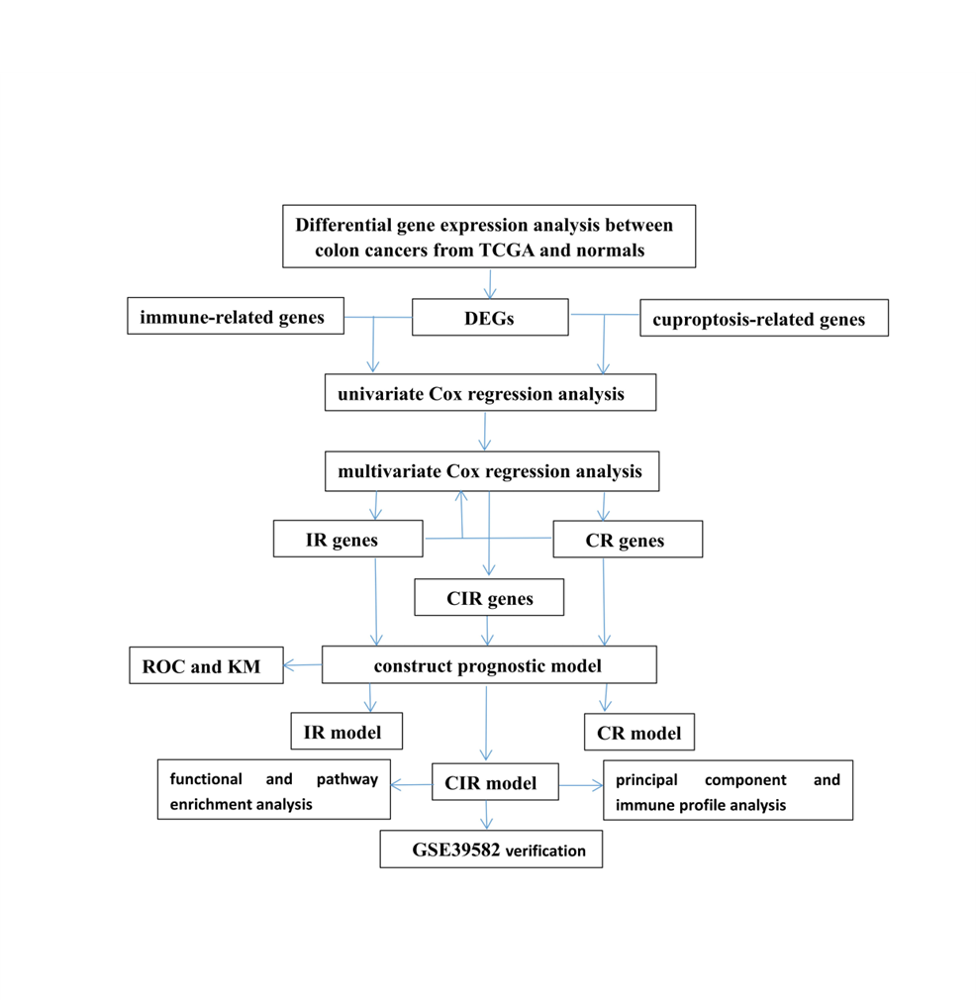
Figure 1 Brief flowchart of the study. CR: Cuproptosis-related; DEG: Differentially expressed gene; IR: Immune-related; ROC: Receiver operating characteristic; TCGA: The Cancer Genome Atlas.

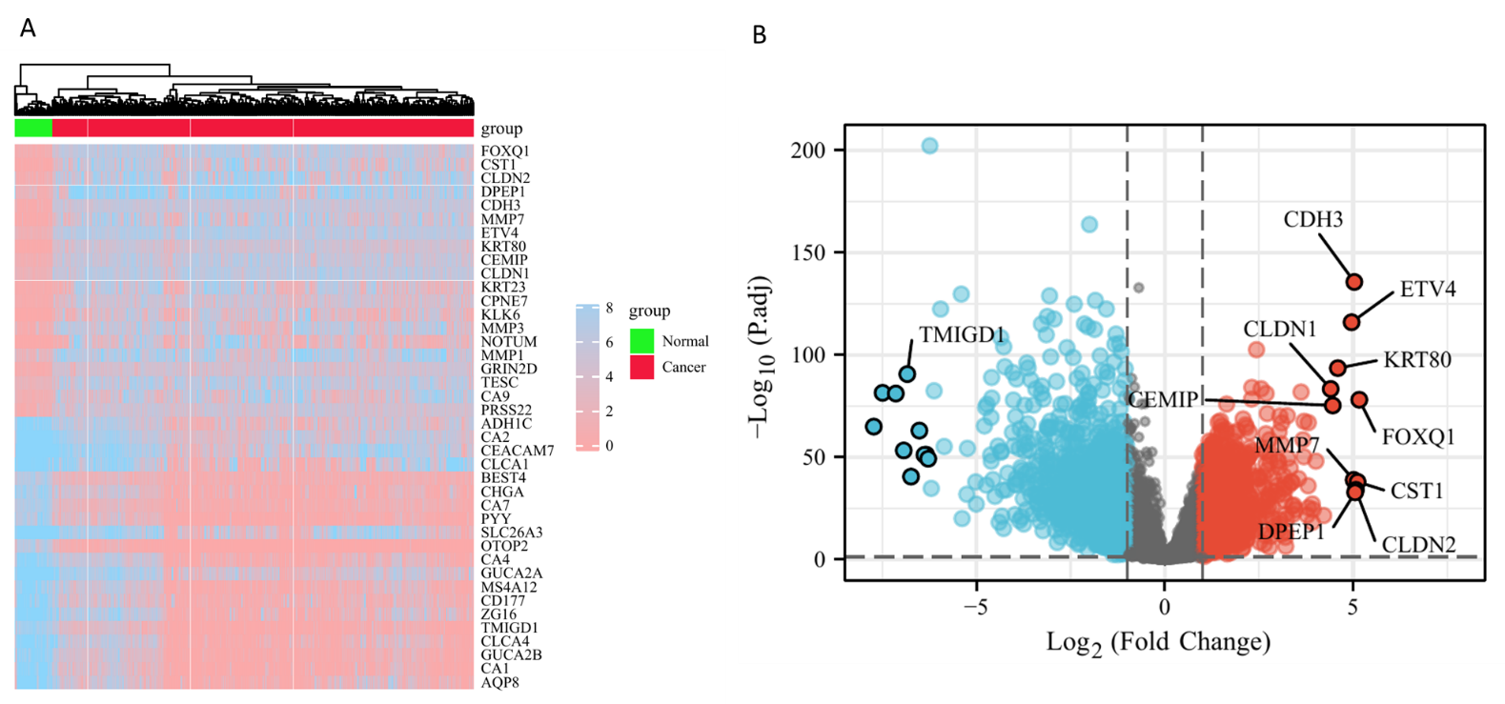
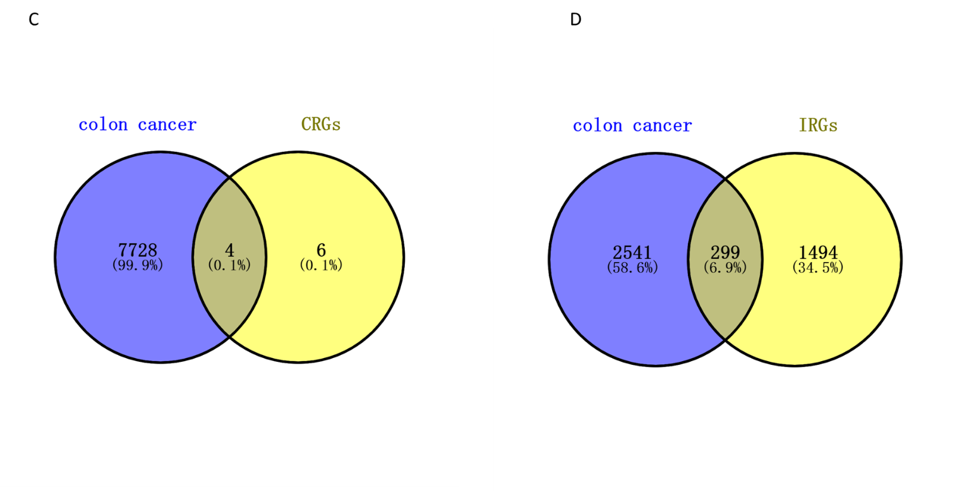
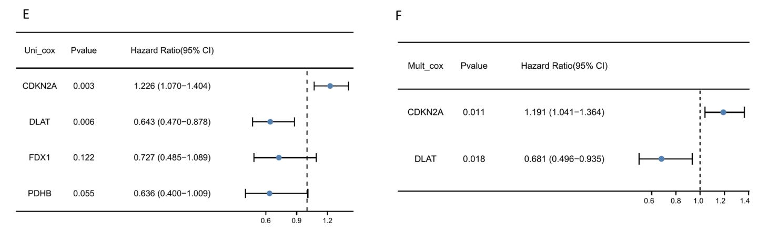
Figure 2 Acquisition of cuproptosis-related and immune-related differentially expressed genes. A: Heatmap of differentially expressed genes in The Cancer Genome Atlas colon cancer patients compared with normal controls; B: Volcano plot of differentially expressed genes (DEGs), where blue represents downregulated genes and red represents upregulated genes; C: Ten cuproptosis-related genes (CRGs) DEGs (CR-DEGs) were calculated by taking the intersection of DEGs (fold change > 1.2 and P.adjust < 0.05) and CRGs; D: DEGs with |log₂FC| > 1 and p.adjust < 0.05 were intersected with immune-related genes (IRGs) to obtain IR-DEGs; E: Result of univariate Cox regression analysis of CR-DEGs; F: The result of multivariate Cox regression analysis of CR-DEGs.

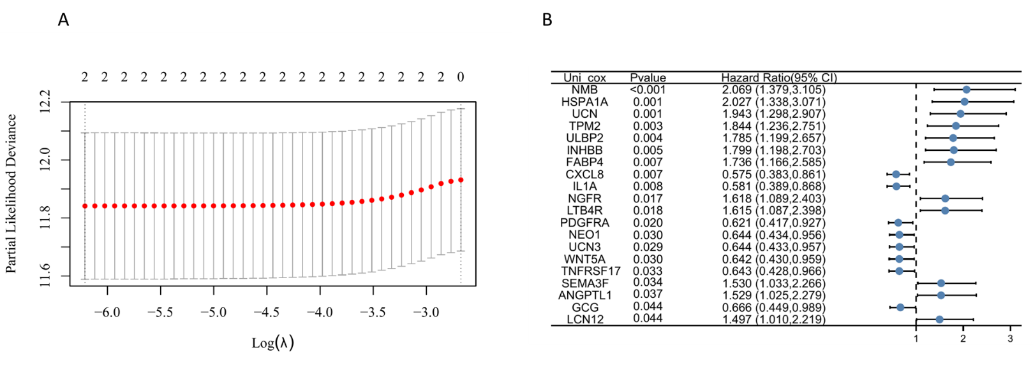
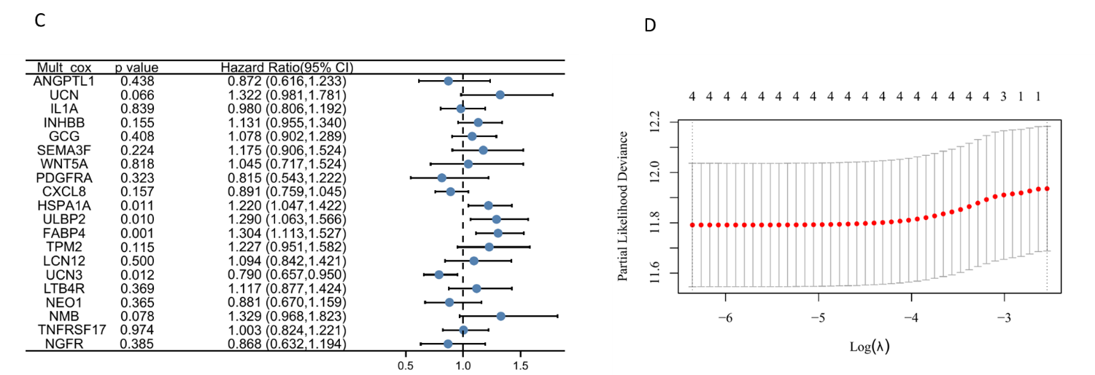
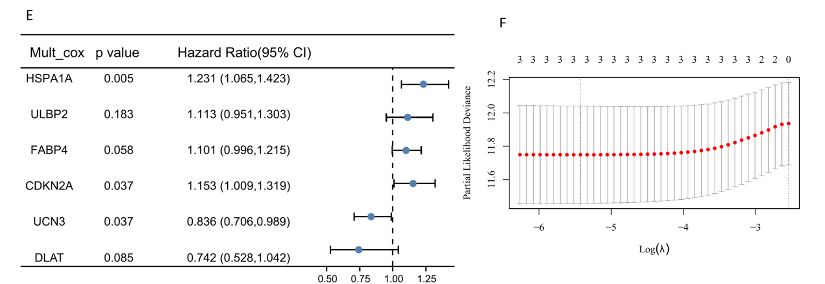
Figure 3 Identification of prognostic features and construction of risk scoring models. A: Coefficient screening plot generated when the model was constructed using least absolute shrinkage and selection operator (LASSO) regression analysis with CDKN2A and DLAT as variables. When λ takes the minimum value, it is the best model; B: Univariate Cox regression analysis of immune-related differentially expressed genes (IR-DEGs) showed significant results; C: Multivariate Cox regression analysis of IR-DEGs identified four genes independently associated with prognosis; D: Coefficient screening plots generated when the model was constructed using LASSO regression analysis with UCN3, HSPA1A, ULBP2, and FABP4 as variables. When λ takes the minimum value, it is the best model; E: Multivariate Cox regression analysis of two cuproptosis-related (CR)-DEGs and four IR-DEGs. CIR-DEGs with P < 0.05 were independently associated with prognosis; F: Coefficient screening plots when the model was constructed with the selected CDKN2A, HSPA1A, and UCN3 variables.
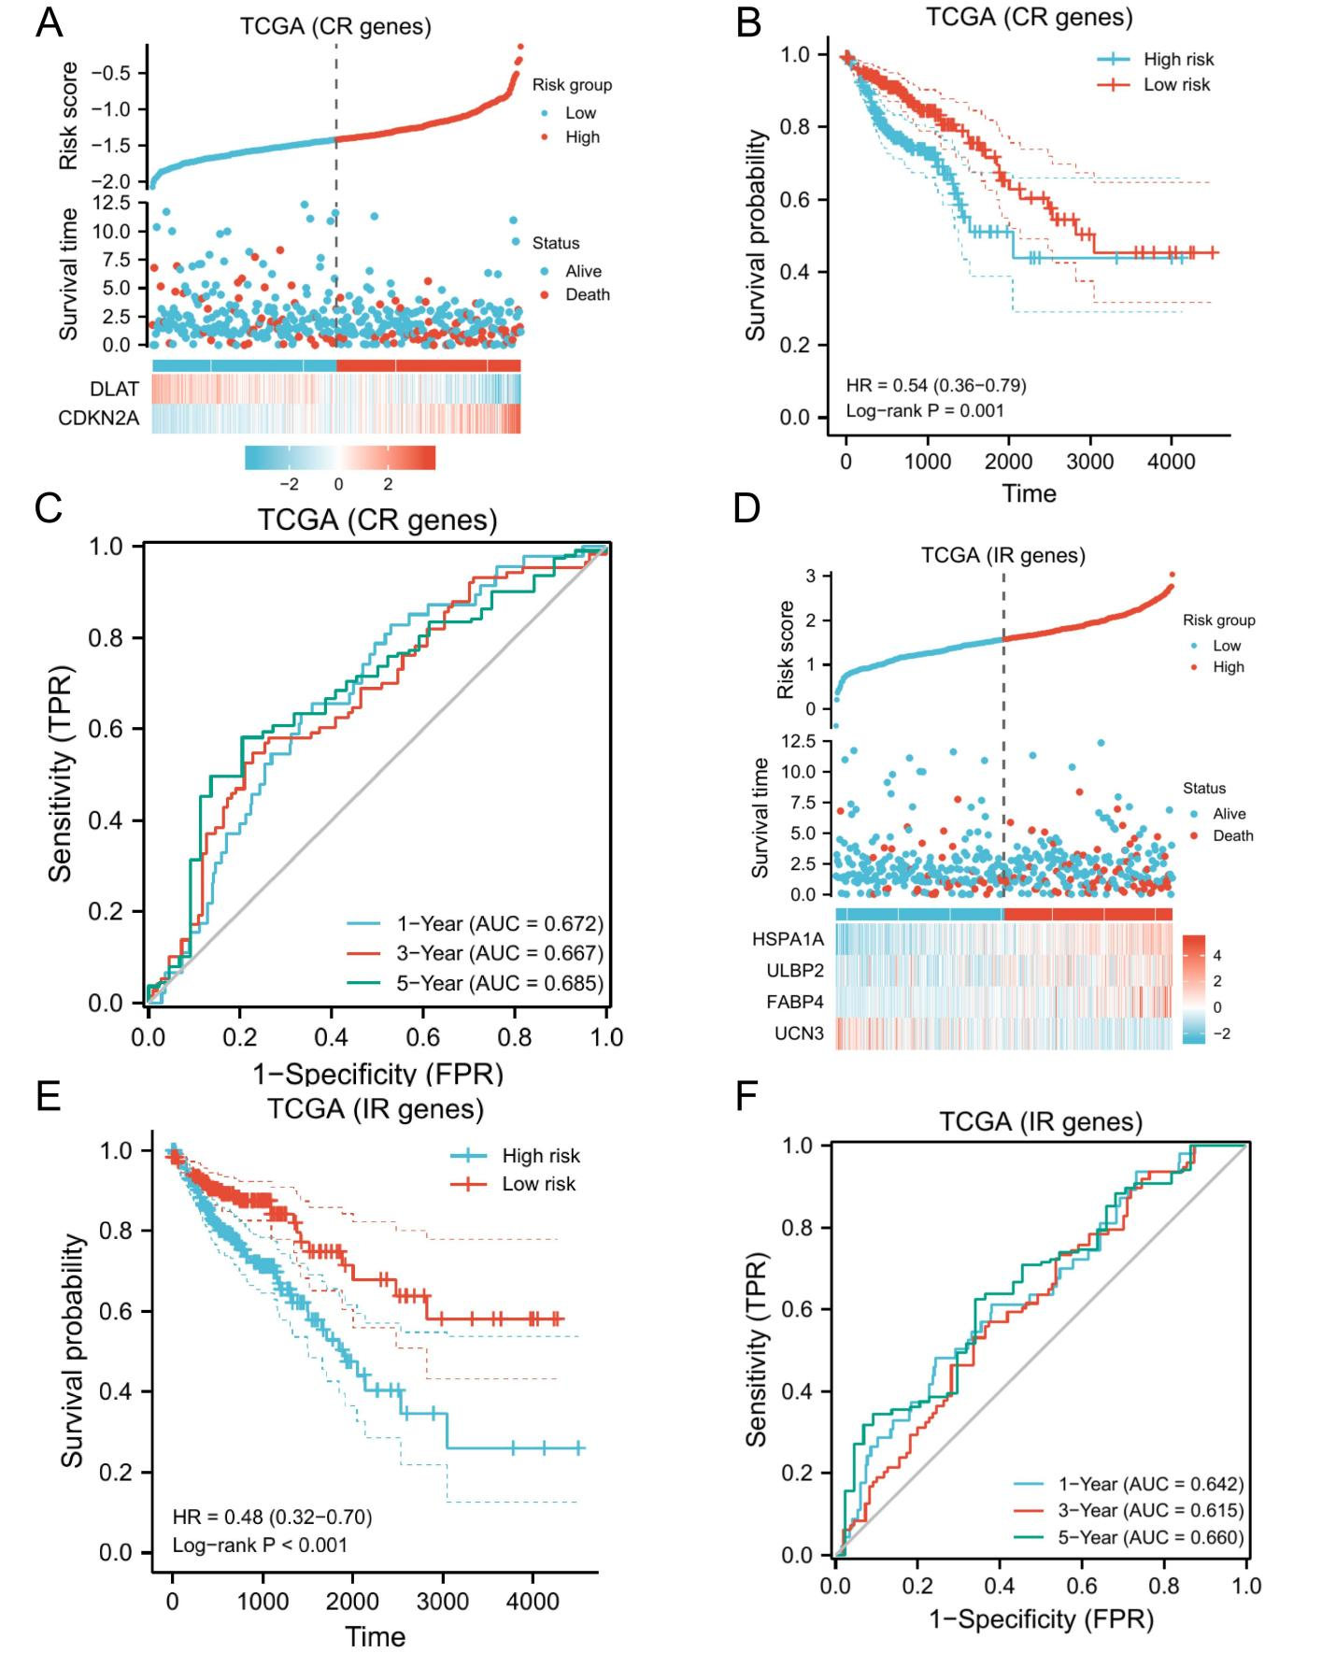
Figure 4 Model evaluation. A: Expression differences of DLAT and CDKN2A in high- and low-risk groups and the risk scores and survival time of different subgroups are shown; B: KM curve of the cuproptosis-related (CR) model. The higher the CR risk score was, the worse the prognosis. In the figure, high-risk group was taken as the control group, so the low-risk score is a protective factor with the HR < 1; C: Receiver operating characteristic (ROC) curve of the CR model, and the size of the area under the curve can reveal the quality of the model. In the figure, the area under the curve (AUC) values in years 1, 3, and 5 are all greater than 0.6, indicating that the model has strong predictive ability; D: Expression differences of the four immune-related (IR) differentially expressed genes used to construct the model in the high- and low-risk groups and the risk scores and survival times of different subgroups are shown; E: KM curve of the IR model; the higher the risk score was, the worse the prognosis; F: ROC curve of the IR model, and its AUC values at 1, 3, and 5 years were all greater than 0.6. TCGA: The Cancer Genome Atlas database.

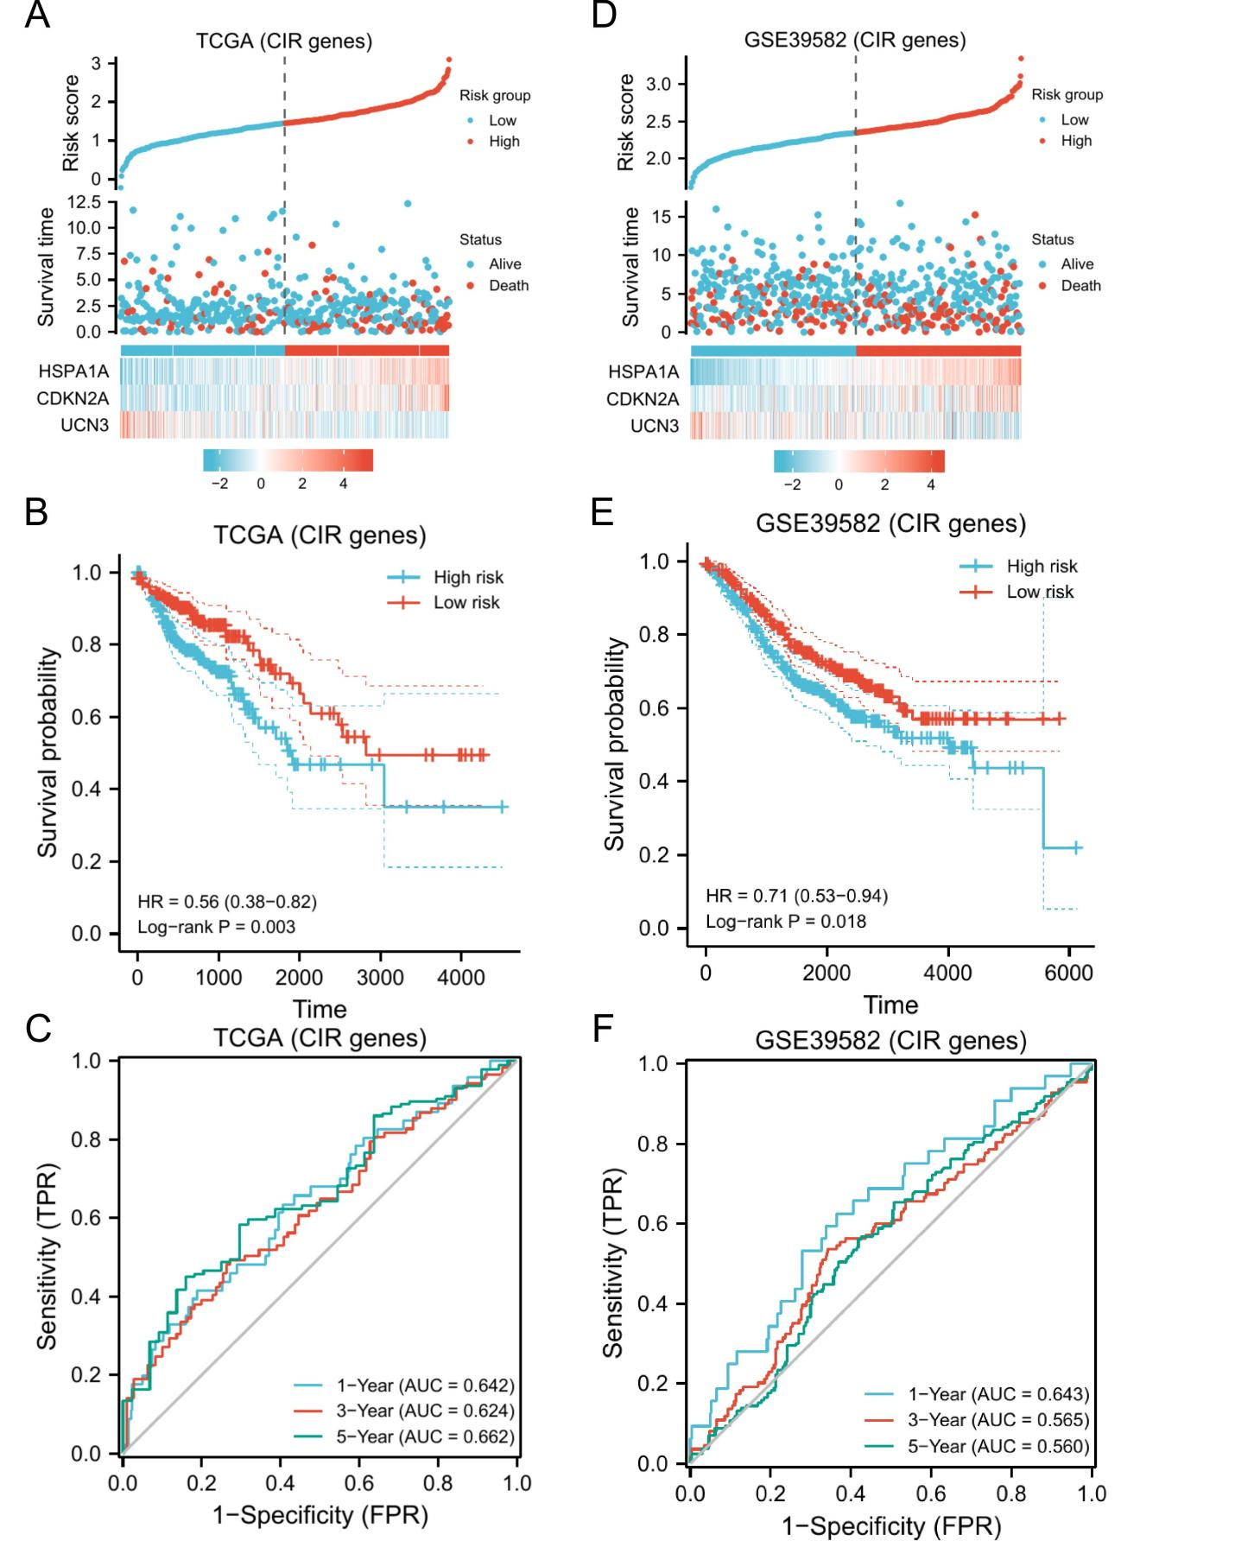
Figure 5 External validation. Based on CDKN2A, HSPA1A, and UCN3, a cuproptosis- and immune-related prognostic model was constructed. In samples of The Cancer Genome Atlas (TCGA) database. A: Expression differences of these three genes in high- and low-risk groups and the risk score and survival time of different subgroups; B: KM curve indicates that the higher the score is, the worse the prognosis; C: Receiver operating characteristic curve shows that the model has area under the curve values greater than 0.6 in years 1, 3, and 5; D-F: In the Gene Expression Omnibus database, the model obtained similar results, and P < 0.05.

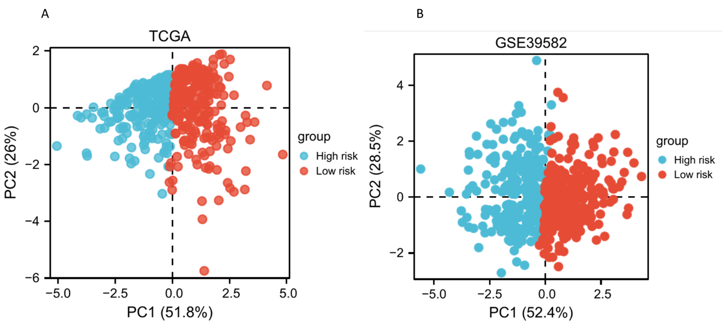
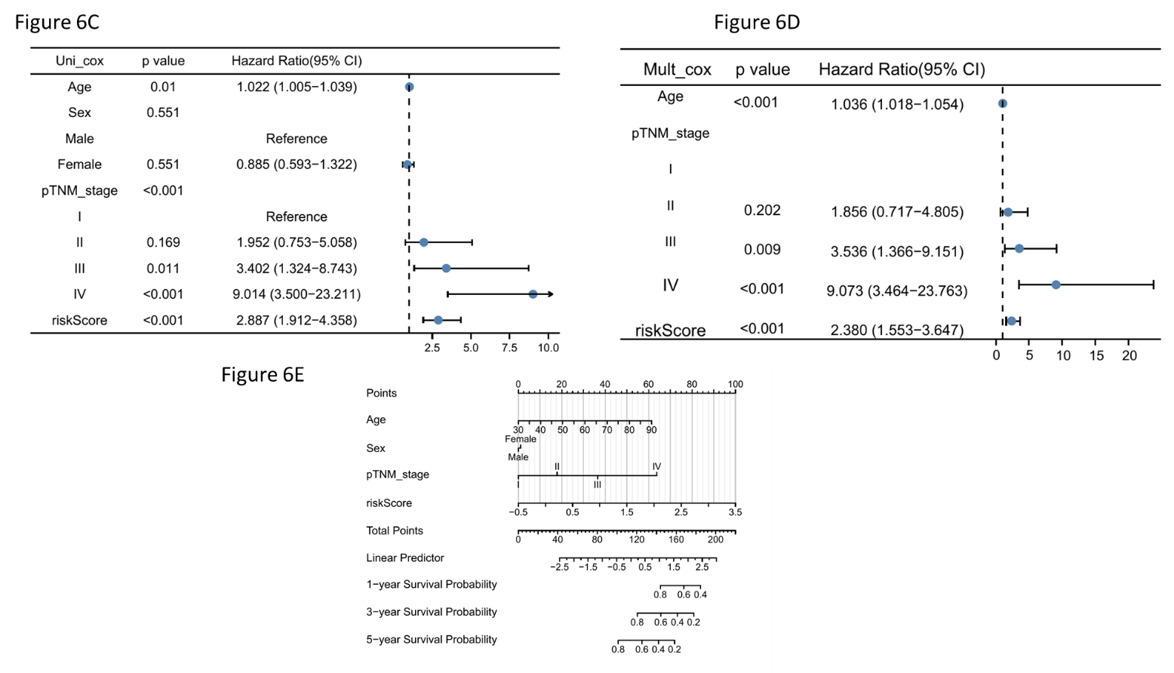
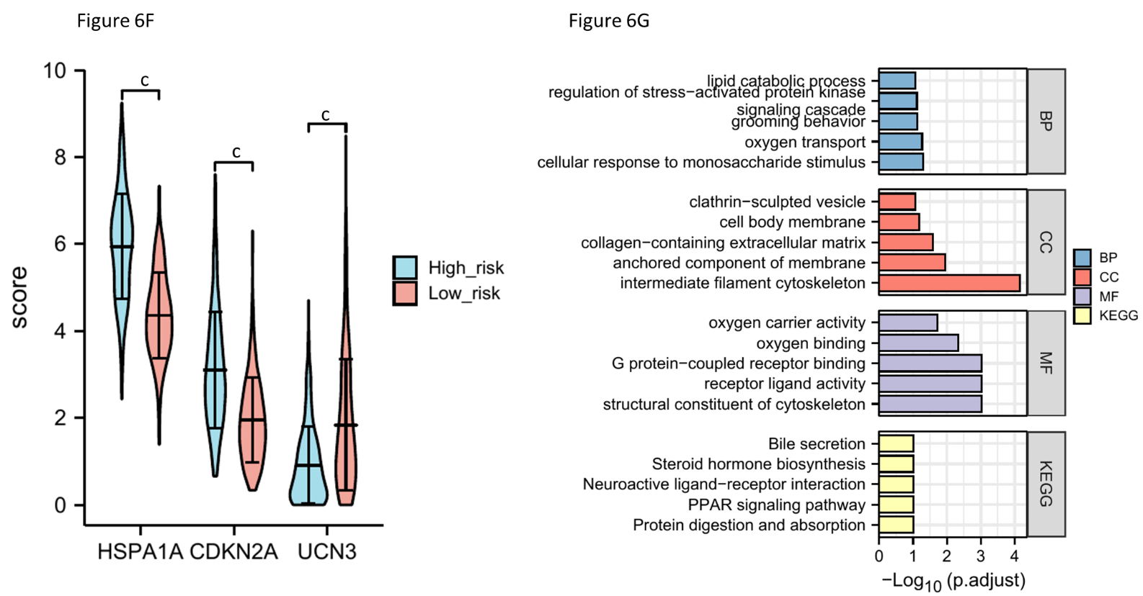
Figure 6 Principal component analysis and the independent predictive value of the risk score. A and B: The principal component analysis plots in The Cancer Genome Atlas (TCGA) and Gene Expression Omnibus, respectively, and both high- and low-risk groups can be obviously distinguished; C and D: Univariate and multivariate Cox regression analyses of the cuproptosis- and immune-related risk score and other clinical features to screen for factors independently associated with prognosis; E: A nomogram helps predict a patient’s prognosis based on the patient’s information; F: Differential expression of CDKN2A, HSPA1A, and UCN3 in the high- and low-risk groups; G: Functional enrichment consequences of differentially expressed genes in the high- and low-risk groups. ^{c}P < 0.001.

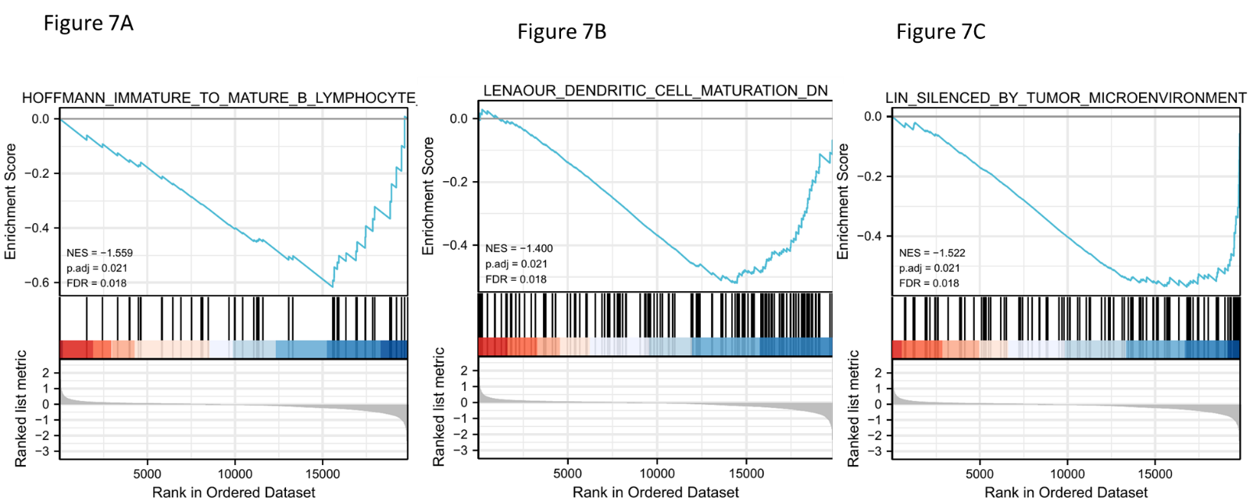
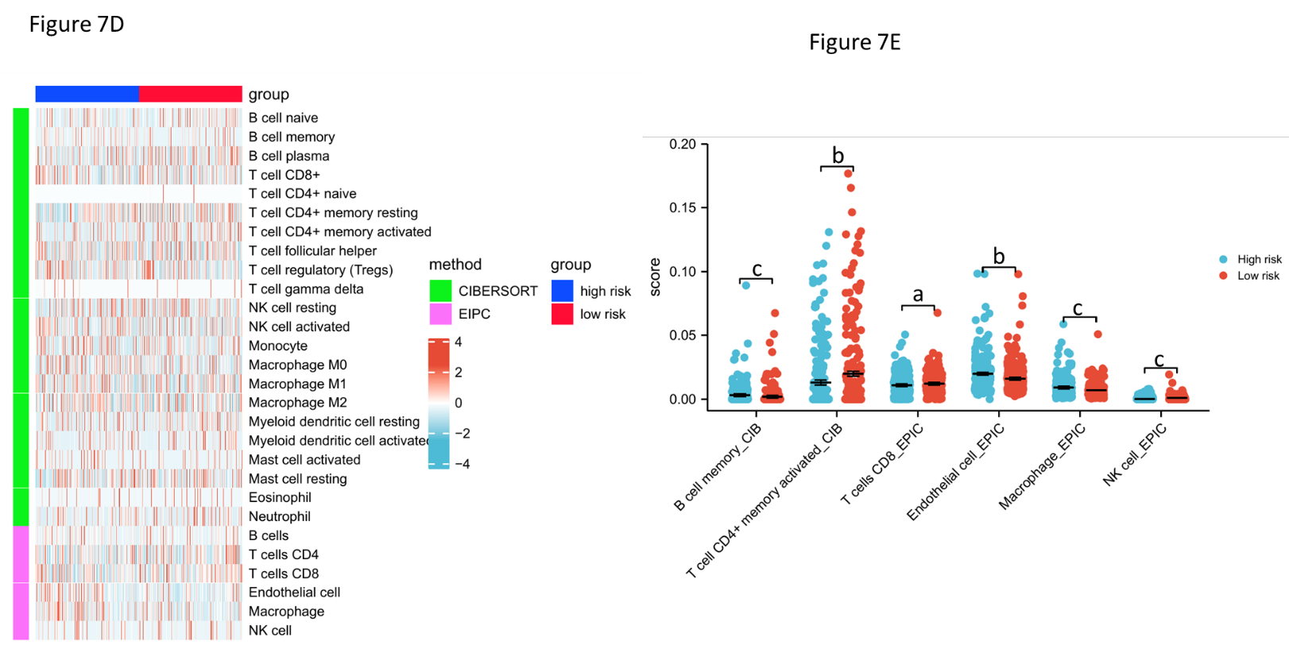
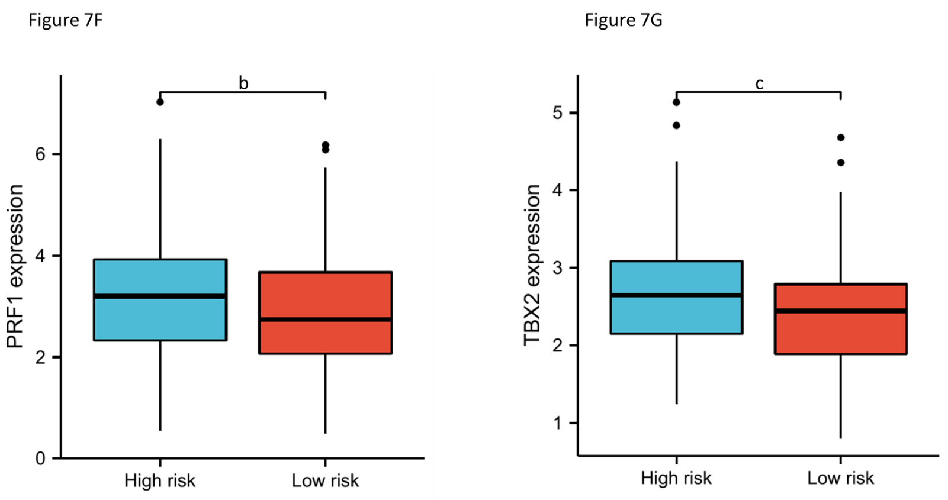
Figure 7 Functional enrichment and immune profiling. A-C: Gene set enrichment analysis functional enrichment results of differentially expressed genes in the high- and low-risk groups; D: Heatmap showing the infiltrating abundance of different immune cells in different groups analyzed by CIBERSORT and EPIC algorithms; E: Significant (P < 0.05) results presented in immune infiltration analysis; F and G: Differential expression of immune checkpoint inhibitors in the high- and low-risk groups. Both were highly expressed in the high-risk group. ªP < 0.05; ^{b}P < 0.01; ^{c}P < 0.001.

Table 1 Clinical information of The Cancer Genome Atlas and Gene Expression Omnibus samples
 | Charar | TCGA (n = 443) | GSE39582 (n = 568)
Status | Alive | 346 | 382
 | Dead | 97 | 186
Age | Mean (SD) | 66.9 (13.1) | 66.8 (13.2)
 | Median [MIN, MAX] | 68 [31,90] | 68 [22,97]
Sex | FEMALE | 211 | 257
 | MALE | 232 | 311
pTNM_stage | I | 75 | 40
 | II | 176 | 265
 | III | 128 | 203
 | IV | 64 | 60
TCGA: The Cancer Genome Atlas.

