Name of Journal: World Journal of Clinical Oncology
Manuscript NO: 85839
Manuscript Type: CASE REPORT

Splenic lymphangioma masquerading as splenic abscess managed by laparoscopic splenectomy: A case report

Thorat S et al. Rare case report of splenic lymphangioma

Santosh Thorat, Febin Mohammed Shaji

Santosh Thorat, Febin Mohammed Shaji, Department of General Surgery, Pimpri Chinchwad Municipal Corporation's Postgraduate Institute and Yashwantrao Chavan Memorial Hospital, Pune 411018, Maharashtra, India

Author contributions: Thorat S performed the surgery and was the chief consultant surgeon; Shaji FM assisted the case and compiled the information and created the manuscript.

Corresponding author: Febin Mohammed Shaji, MBBS, Surgeon, Department of General Surgery, Pimpri Chinchwad Municipal Corporation's Postgraduate Institute and Yashwantrao Chavan Memorial Hospital, Sant Tukaram Nagar, Pimpri, Pune 411018, Maharashtra, India. febinmshaji@gmail.com

Received: May 26, 2023
Revised: July 19, 2023
Accepted: September 19, 2023
Published online: October 24, 2023

Abstract
BACKGROUND
Primary benign splenic tumours are unique and account for < 0.007% of all tumours identified during surgery and autopsy. Splenic lymphangiomas are rarely seen in adults. Splenic lymphangiomas may be asymptomatic, or may present with upper left abdominal pain, splenomegaly, hypersplenism, or splenic rupture with haemorrhagic shock. The clinical and radiological features of these lesions are not specific. This case report serves to remind the clinician to consider the rare but important differential diagnosis of splenic lymphangioma while treating splenic lesions.

CASE SUMMARY
We report a case of splenic lymphangioma in a 22-year-old woman who presented with left upper quadrant abdominal pain for three months. Initial investigations were unremarkable; however, computed tomography later revealed multiple splenic micro-abscesses. The patient underwent laparoscopic splenectomy, and histopathological examination revealed splenic lymphangioma. The patient was discharged on postoperative day three. One month after surgery, the abdominal pain resolved completely, with no new complaints. Splenic lymphangiomas present clinically as splenomegaly or left upper quadrant abdominal pain; prompt intervention is necessary for avoiding complications.

CONCLUSION
This case report concludes that splenic lymphangiomas should be considered in the differential diagnosis of splenomegaly or left upper quadrant pain, even in adults, because they are amenable to curative treatment. Delays in surgical intervention may lead to severe complications, such as infection, rupture, and hemorrhage. Such lesions can be safely managed with laparoscopy, involving less postoperative pain and early patient discharge with excellent cosmetic outcomes.

Key Words: Spleen; Lymphangioma; Oncology; Rare; Laparoscopic Splenectomy; Hamartomatous process; Case report

©The Author(s) 2023. Published by Baishideng Publishing Group Inc. All rights reserved.

Citation: Thorat S, Shaji FM. Splenic lymphangioma masquerading as splenic abscess managed by laparoscopic splenectomy: A case report. World J Clin Oncol 2023; 14(10): 440-444
URL: https://www.wjgnet.com/2218-4333/full/v14/i10/440.htm
DOI: https://dx.doi.org/10.5306/wjco.v14.i10.440

Core Tip: We present the rare case report of splenic lymphangioma in an adult female. This is a very rare entity with only around 200 cases reported between 1970 to 2017. Isolated splenic lymphangioma is very rare and should be considered in the differential diagnosis of splenomegaly, for early intervention and prevention of potential complications.

INTRODUCTION
Lymphangiomas are benign congenital malformations of the lymphatic vessels, commonly localised to the head, neck, and axillary regions. Intra-abdominal localisation is rare and occurs preferentially in the mesentery. Splenic lymphangiomas occur mainly in children and rarely in adults. Between 1939 and 2017, only 209 cases of splenic lymphangiomas in adults have been reported in the literature^{[1]}. The rarity of lymphangiomas and their uncommon localisation pose a challenge for clinicians in making accurate preoperative diagnosis.

CASE PRESENTATION
Chief complaints
Complaints of intermittent left upper quadrant abdominal pain and fever for the three months.

History of present illness
Complaints of intermittent left upper quadrant abdominal pain and fever for the past three months, for which she had consulted multiple medical practitioners with no relief from her agony.

History of past illness
No history of any significant illness in the past.

Personal and family history
No significant personal or family history.

Physical examination
Physical examination results were unremarkable, except for mild tenderness on deep palpation in the left upper abdomen.

Laboratory examinations
Initial investigations, including blood tests, were unremarkable, except for a slight elevated white blood cell count.
The patient was investigated for possible sources of infection; blood cultures, urine cultures, sputum cultures were performed. Additionally, an infection panel screening was performed, and the result was negative. Cultures were also negative for the presence of any infection.

Imaging examinations
Abdominal ultrasonography revealed multiple splenic micro-abscesses. Further workup with contrast-enhanced computed tomography of the abdomen revealed splenomegaly and multiple hypodense lesions in the splenic parenchyma (the largest measuring 15 mm × 15 mm), suggestive of multiple splenic abscesses/cysts (Figure 1). The splenic vein and distal Superior Mesenteric Artery were dilated, indicating portal hypertension. Other findings included a right-sided hemorrhagic ovarian cyst. Upper gastrointestinal endoscopy was performed for portal hypertension, which showed mild gastritis and a Hill’s grade 1 hiatal hernia.

FINAL DIAGNOSIS
Splenic lymphangioma.

TREATMENT
Laparoscopic splenectomy.

OUTCOME AND FOLLOW-UP
The patient was admitted to our hospital and prepared for laparoscopic splenectomy (Figure 2). She was started on intravenous third generation cephalosporins and metronidazole to provide aerobic and anaerobic coverage, respectively, and administered vaccinations (including meningococcal, pneumococcal, and H. Influenza vaccines) 14 d before the surgery.
The patient underwent laparoscopic splenectomy. She was placed in the supine position, and the surgeon was positioned at the right lower side.
The spleen was removed using a Pfannenstiel incision, which was closed cosmetically with subcuticular sutures.
The total operative time was 160 min, with an estimated blood loss of 110 mL. Drains were placed at the postoperative site because the spleen formed adhesions with the pancreas. The drains were kept in place to check for any leakage, and they were removed on postoperative day (POD) two. The postoperative period was uneventful, and the patient was discharged on POD three.
The splenectomy specimen was sent for histopathological examination (Figure 3A). The spleen weighed 247 g. Histological examination findings revealed lymphangioma of the spleen, with areas of congestive splenomegaly (Figure 3B).
Postoperatively, all precautions were taken to prevent hospital acquired infections. The patient was advised to immediately present to the hospital in case fever develops after hospital discharge. One month after surgery, the abdominal pain resolved completely, with no new complaints.

DISCUSSION
Splenic lymphangioma is an uncommon malformation of the lymphatics of spleen mainly seen in children and rarely in adults. Although its aetiology is unclear, it is widely regarded as a hamartomatous change rather than a neoplasm^{[2]}. Histologically, splenic lymphangiomas are characterised by cystic spaces lined by attenuated endothelial cells^{[3]}. This condition may present involving only the spleen. However, in most cases, it is part of a systemic involvement of the lymphatic channels affecting multiple organs (systemic lymphangiomatosis)^{[4]}. Most lesions are detected in imaging studies incidentally, whereas larger lesions can cause compression symptoms due to pressure on adjacent organs.

CONCLUSION
This case report concludes that in patients presenting with splenomegaly and left upper abdominal pain, splenic lymphangioma should be considered as an important differential diagnosis. Missed diagnosis and delayed treatment can lead to serious complications such as rupture and hemorrhage^{[5]}. Such lesions can be safely managed with laparoscopy, involving less postoperative pain and early patient discharge with excellent cosmetic outcomes.

REFERENCES
1 Duvvada S, Senapati D, Challa SR, Kalluri T. Cystic lymphangioma of spleen in adults. BMJ Case Rep 2017; 2017 [PMID: 28122799 DOI: 10.1136/bcr-2016-216267]
2 Jindal R, Sullivan R, Rodda B, Arun D, Hamady M, Cheshire NJ. Splenic malformation in a patient with Klippel-Trenaunay syndrome: a case report. J Vasc Surg 2006; 43: 848-850 [PMID: 16616249 DOI: 10.1016/j.jvs.2005.11.059]
3 Perez A, Perez MEC, Yuga AC, Viray BAG. Splenic lymphangioma in adulthood: A case report. Int J Surg Case Rep 2020; 67: 250-253 [PMID: 32086147 DOI: 10.1016/j.ijscr.2020.01.061]
4 Chang WC, Liou CH, Kao HW, Hsu CC, Chen CY, Yu CY. Solitary lymphangioma of the spleen: dynamic MR findings with pathological correlation. Br J Radiol 2007; 80: e4-e6 [PMID: 17267469 DOI: 10.1259/bjr/93530580]
5 Avigad S, Jaffe R, Frand M, Izhak Y, Rotem Y. Lymphangiomatosis with splenic involvement. JAMA 1976; 236: 2315-2317 [PMID: 989835]

Footnotes
Informed consent statement: The study participant, provided informed written consent prior to study enrollment.

Conflict-of-interest statement: No conflicts of interest declared.

CARE Checklist (2016) statement: The authors have read the CARE Checklist (2016), and the manuscript was prepared and revised according to the CARE Checklist (2016).

Open-Access: This article is an open-access article that was selected by an in-house editor and fully peer-reviewed by external reviewers. It is distributed in accordance with the Creative Commons Attribution NonCommercial (CC BY-NC 4.0) license, which permits others to distribute, remix, adapt, build upon this work non-commercially, and license their derivative works on different terms, provided the original work is properly cited and the use is non-commercial. See: https://creativecommons.org/Licenses/by-nc/4.0/

Provenance and peer review: Unsolicited article; Externally peer reviewed.

Peer-review model: Single blind

Peer-review started: May 26, 2023
First decision: July 6, 2023
Article in press: September 19, 2023

Specialty type: Oncology
Country/Territory of origin: India
Peer-review report’s scientific quality classification
Grade A (Excellent): 0
Grade B (Very good): 0
Grade C (Good): C, C, C
Grade D (Fair): 0
Grade E (Poor): 0

P-Reviewer: Gad EH, Egypt; Luo W, China; Tenreiro N, Portugal S-Editor: Fan JR L-Editor: A P-Editor: Zhang XD

Figure Legends
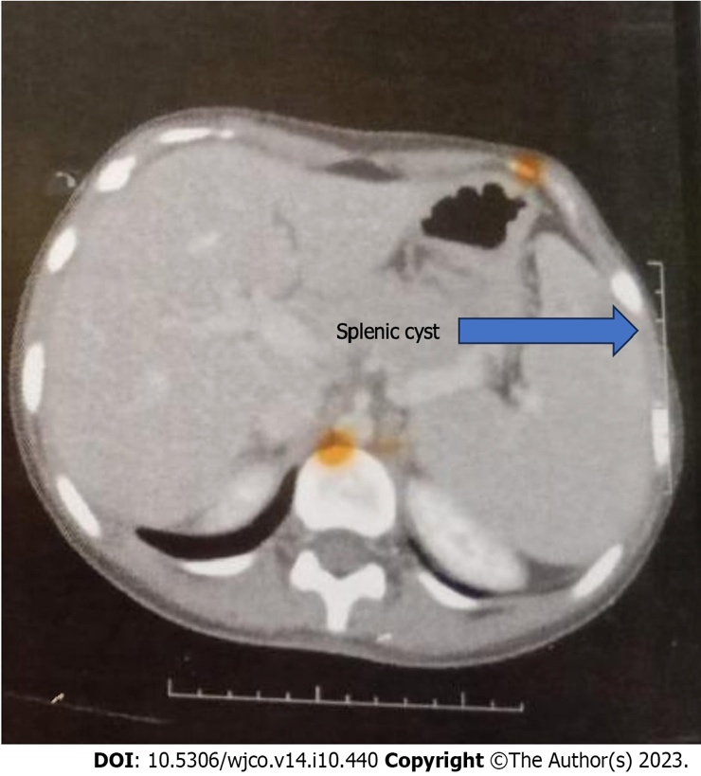
Figure 1 Contrast-enhanced computed tomography film showing splenic cyst.

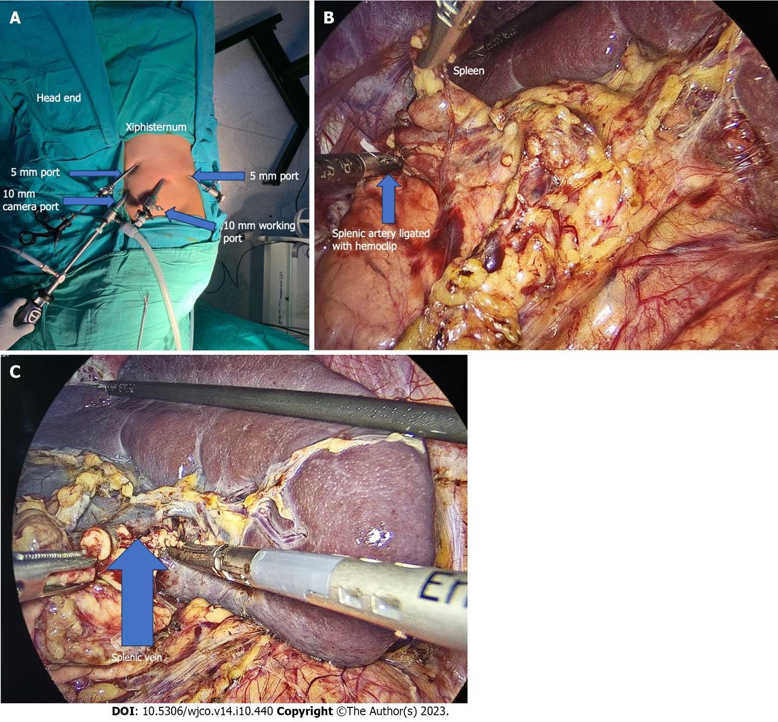
Figure 2 Laparoscopic splenectomy. A: Port placement for laparoscopic splenectomy; B: Intraoperative view of the splenic artery ligated with a haemoclip at the upper border of the pancreas; C: Intraoperative view of the spleen.

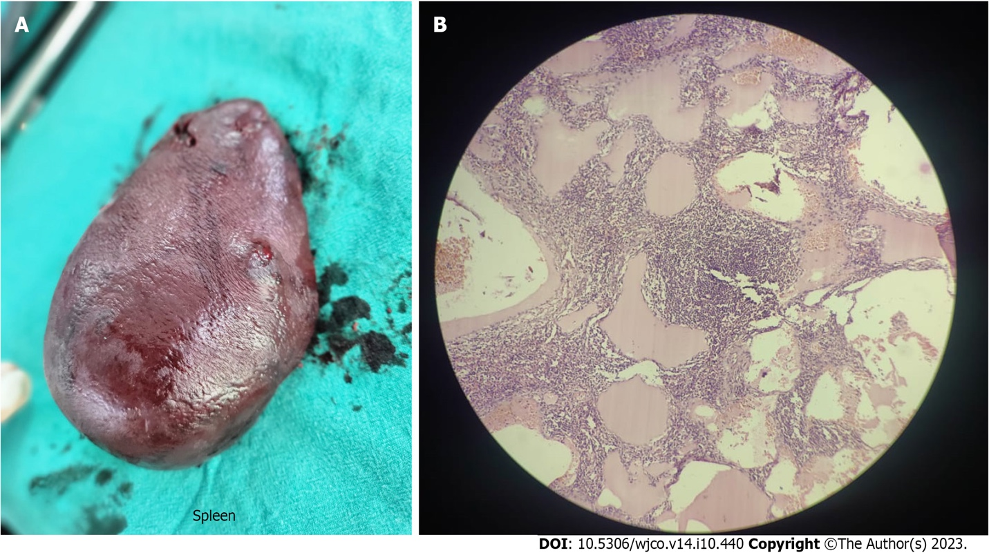
Figure 3 Splenectomy specimen and histopathological slide. A: Splenectomy specimen; B: Histopathological slide showing multiple cystic spaces filled with eosinophilic proteinaceous material.

Published by Baishideng Publishing Group Inc
7041 Koll Center Parkway, Suite 160, Pleasanton, CA 94566, USA
Telephone: +1-925-3991568
E-mail: bpgoffice@wjgnet.com
Help Desk: https://www.f6publishing.com/helpdesk
https://www.wjgnet.com

© 2023 Baishideng Publishing Group Inc. All rights reserved.

