Name of journal: World Journal of Orthopedics
ESPS Manuscript NO: 5405
Columns: BRIEF ARTICLE

Comparative induction of controlled circulation by magnesium and remifentanil in spine surgery

Ghodraty MR et al. Magnesium and remifentanil in PSF

Mohammad R Ghodraty, Mohammad M Homaee, Kourosh Farazmehr, Ali R Nikzad-Jamnani, Masoud Soleymani-Dodaran, Ali R Pournajafian, Nader D Nader

Mohammad R Ghodraty, Department of Anesthesiology, Tehran University of Medical Sciences, Tehran 1336616357, Iran

Mohammad M Homaee, Department of Anesthesiology, Tehran University of Medical Sciences, Tehran 1336616357, Iran

Kourosh Farazmehr, Department of Anesthesiology, Tehran University of Medical Sciences, Tehran 1336616357, Iran

Ali R Nikzad-Jamnani, Department of Anesthesiology, Tehran University of Medical Sciences, Tehran 1336616357, Iran

Masoud Soleymani-Dodaran, Department of Public Health, Tehran University of Medical Sciences, Tehran 1336616357, Iran

Ali R Pournajafian, Department of Anesthesiology, Tehran University of Medical Sciences, Tehran 1336616357, Iran

Nader D Nader, Department of Anesthesiology, University at Buffalo, Buffalo, NY 14215, United States

Author contributions: Ghodraty MR and Nader ND contributed to the experimental design; Ghodraty MR and Homaee MM participated in the conduct of the experiments and all authors except Nader ND were involved in patient care and obtaining informed consents; Farazmehr K and Nader ND contributed in data analysis and management and manuscript preparation.

Correspondence to: Nader D Nader, MD, PhD, Department of Anesthesiology, University at Buffalo, VA Western NY Healthcare Sys, Rm. 202C, 3495 Bailey Ave, Buffalo, NY 14215, United States. nnader@buffalo.edu

Telephone: +1-716-8628707 Fax: +1-716-3412715
Received: September 5, 2013 Revised: December 10, 2013
Accepted: December 17, 2013
Published online:

Abstract
AIM: To evaluate the efficacy of magnesium sulfate in comparison with remifentanil for induction of relative hypotension in posterior fusion of spine (PSF).

Methods: In this randomized clinical trial, 40 patients with the American Society of Anesthesiologists I and II physical status undergoing lumbar PSF were randomized to receive remifentanil (REM) 0.15 µg/kg or magnesium sulfate (MGS) 50 mg/kg for controlled hypotension. The administering anesthesiologist was blinded to the medication. Continuous infusion was maintained at a fixed volume rate to deliver precalculated doses of either study drugs. All other aspects of anesthesia and surgery were similar in two groups. The target mean arterial pressure (MAP) range used in this study was 60-70 mmHg. In the course of surgery the hemodynamic variables, volume of blood loss, urine output, fluid intake and surgeon’s satisfaction were recorded. Data was analyzed with SPSS version 13.0 and p values less than 0.05 were considered significant.

Results: Twenty patients in the MGS group and 19 patients in the REM group were studied. There was no difference between two groups according to the hemodynamic variables, blood loss, urine output, fluid requirement and surgeon’s satisfaction for exposure. The target mean arterial pressure was achieved in 75% of Mg and 58% of remifentanil groups. Although, a higher number of patients in REM group required nitroglycerin (42.1%) to reach target MAP than those in MGS group (25%), this difference wasn’t statistically significant (p = 0.32).

Conclusion: Our findings showed that in patients undergoing lumbar PSF surgery, remifentanil and magnesium sulfate have similar hypotensive effect and comparable amount of blood loss without any significant adverse effects.

© 2013 Baishideng Publishing Group Co., Limited. All rights reserved.

Key words: Controlled hypotension; Magnesium sulfate; Remifentanil; Spine surgery; Blood loss

Core tip: We conducted a relatively small size prospective randomized clinical trial comparing intravenous infusion of remifentanil with magnesium in controlling blood pressure during posterior spine fusion in order to decrease the intraoperative blood loss. Our experiments showed mainly no difference between two administered regimens in reducing mean arterial blood pressure and intraoperative blood loss and satisfaction of the operating surgeons.

Ghodraty MR, Homaee MM, Farazmehr K, Nikzad-Jamnani AR, Soleymani-Dodaran M, Pournajafian AR, Nader ND. Comparative induction of controlled circulation by magnesium and remifentanil in spine surgery. World J Orthop 2013;
Available from: URL:
DOI:

INTRODUCTION
In lumbar spine surgery, especially in the posterior spinal fusion, a dry surgical field not only results in convenience of the surgeon, but also better hemostasis reduced the likelihood of transfusion, and its complication. Also it decrease operation time and thereby avoids complications of prolong surgery, particularly in prone position, such as eyes injuries and nerve damage due to pressure, tongue edema and airway inflammation^{[1,2]}.
Induced hypotension is one of the most effective methods for reduction of bleeding during surgery that is known as controlled hypotension. Using this method during anesthesia for major spinal surgeries result in lesser bleeding and the need for blood transfusion^{[3]}. Different methods for controlled hypotension has been described that, in total can be divided into two main groups: First: traditional style that keeps the patient in a light anesthesia with a secure airway and complete monitoring under a ganglion blocker or a vasodilator with a direct effect, in this way it is preferred to use a beta blocker simultaneously^{[4]}. And in the second method is tried to control blood pressure without hypotensive drugs with increasing the depth of anesthesia, adequate ventilation and optimal position^{[5]}.
Reduction in bleeding not only is important to maintain the hemodynamic balance, but also creates better visibility for the surgeon during surgery, this issue is especially important (significant) in spinal cord surgery, because important neuronal structures are located in the field. In major surgical procedures such as scoliosis correction or posterior fusion, excessive bleeding occurs during or after surgery, so controlled hypotension is considered as a way to reduce bleeding and improve surgical conditions^{[2,3]}.
Various drugs have been used to reduce blood pressure including vasodilators (nitroprusside, nicardipine), Alpha-2 receptor agonists (clonidine, dexmedetomidine), beta-adrenergic antagonists (propranolol, esmolol) and alpha and beta antagonists (labetalol)^{[6-10]}. However hypotensive agents have several disadvantages such as; reflex tachycardia and tachyphylaxis^{[9]}. Therefore, it is necessary to use compounds that its dose-response effects be predictable^{[11]}. In recent years, remifentanil as a short acting opioid receptor agonist has been used for this purpose. In order to mild to moderate reduce of blood pressure and as an effective agent for controlled hypotension^{[12]}. Nevertheless, high doses of remifentanil during surgery have its limits, which can be pointed to pain management after surgery and hyperalgesia in these patients^{[13]}. Currently, remifentanil with propofol is used for total intravenous anesthesia (TIVA). Compared with other opioid drugs such as fentanyl and alfentanil, remifentanil can provide better hemodynamic stability in stressful events of surgery and can minimize changes in cerebral blood flow^{[14-17]}.
Magnesium sulfate is a noncompetitive antagonist of NMDA receptor with analgesic effect and is essential for release of acetylcholine from the presynaptic terminals^{[18,19]}, and also, similar to calcium channel blockers (CCB) can prevent the entry of calcium into the cell. According to previous studies, magnesium can cause hypotension with vasodilatory effect. The vasodilatory effects of this ion are due to increased construction of prostacyclines and inhibition of angiotensin converting enzyme. So it seems that, this product could be applied for lowering blood pressure during various surgical procedures^{[20,21]}.
With the best of our knowledge, there has not been any study made comparing controlled hypotension by magnesium and remifentanil in lumbar spine fusion surgery. So we decided to compare their efficacy, blood loss and likely hemodynamic complications in a prospective study in candidates for lumbar spine fusion surgery. We hypothesized that magnesium is as effective as remifentanil in deliberate induction of hypotension used to reduce surgical blood loss.

MATERIALS AND METHODS
The study was designed as a prospective double- blind randomized trial. The experimental design and complete study protocol was reviewed and approved by the Medical Research Ethics Committee at Tehran University of Medical Sciences. The study was also registered with the national Iranian Registry of Clinical Trials (http://www.irct.ir), IRCT201111138091N1 in accordance with world health organization’s requirements and the International Committee of Medical Journal Editors’ initiative.
The study population included orthopedic and neurological patients admitted in Tehran’s University Hospital (Firoozgar center) from 2010 to 2011. Patients between 20 to 60 years old undergoing posterior lumbar spine fusion were surveyed based on inclusion and exclusion criteria. Eligible patients [American Society of Anesthesiologists (ASA) physical status 1 or 2, operation time of 3 to 5 h and mentally competent] were approached and signed informed consent after complete explanation of the details of the research project and its potential risks.
Exclusion criteria were as follows: operation time more than 5 h, allergic reaction to drugs, patients with history of liver, renal, heart and vascular failure, and also cardiac conduction disturbance, opium addiction, any drug or substance abuse and chronic treatment with opium, NSAIDS and calcium channel blockers.
Patients were randomized with block randomization (four pieces blocks) into two groups: magnesium sulfate (MGS) and remifentanil (REM). Someone who was not informed to the study developed list of replacement, and then according to entry of each sample to study, treatment groups of patients were determined. Upon arrival to the operating room, standard monitoring including end-tidal carbon dioxide (ETCO₂), pulse oximetry (SpO₂), non-invasive blood pressure (NIBP) and 5-lead electrocardiography (ECG) were connected and baseline hemodynamic variables were recorded. After establishing IV line and administration of 500cc normal saline before induction of anesthesia, patients were preoxygenated with 100% oxygen for 5 min. All patients in both groups received midazolam 0.03 mg/kg and fentanyl 3 µg/kg upon arrival in the operating room. For induction of anesthesia patients received 1.5-2.0 mg/kg propofol, and atracurium 0.5 mg/kg was used for muscle relaxation, and intubation. After induction of anesthesia radial arterial line from non-dominant hand for continuous monitoring of mean arterial pressure (MAP) were obtained. All patients were mechanically ventilated with a mixture of oxygen and nitrous oxide (fraction of inspired oxygen was 50%) at a tidal volume of 8 mL/kg (ideal body weight), I/E ratio of 1/3 and the respiratory rates were adjusted in the 9–14 breaths/min range to maintain end-tidal concentration of carbon dioxide between 30 and 40 mmHg. Continuous infusion of propofol with dose of 100-120 µg/kg per minute and bolus doses of atracurium every 20 to 30 min was used for maintenance of anesthesia that was similar in both groups. Also in the first 30 min after the position, morphine sulfate was infused 0.1 mg/kg within 20 min.
After establishing prone position and ensuring hemodynamic stability, for the MGS group, a loading dose of 50 mg/kg magnesium diluted in 100cc saline infused within 10 min, and then magnesium infusion continued with dose of 15 mg/kg per hour throughout surgery. In the REM group, remifentanil (loading dose 1 µg/kg; maintenance infusion, 0.25 µg/kg per minute) was administered during anesthesia. A research pharmacist prepared both magnesium and remifentanil solutions to make sure the volumes of infusion were the same for each group in order to maintain the blinding process for the administering anesthesiology team.
Our goal was to maintain MAP between 60 to 70 mmHg. Using the above method, if in every case, couldn’t reach the optimum MAP in 10 min after skin incision, nitroglycerin (NTG) 10 to 20 µg/min was applied and increased if needed. Duration and frequency of NTG use was recorded as a measurement of failure in the primary goal for comparison between groups. If the blood pressure drop below the target range, the infusion rate of propofol was reduced to half and in cases that hypotension continued, ephedrine was injected in bolus doses of 5 mg. Possible complication such as arrhythmia, hypotension, hypertension, bradycardia and measures necessary to treat these complication were recorded in both groups. Operation time, approximate amount of bleeding, urine output, volume of fluids and the need for transfusion were recorded on special forms. Blood transfusion was determined based on primary hemoglobin and calculation of maximum allowable blood loss (Target hemoglobin = 10 g/dL).
For reducing the chance of prolonged muscle relaxation by magnesium, study drug infusion was stopped about half an hour before the end of surgery (after fixation of rods and starting repair of wounds) and propofol and remifentanil infusion was reduced to the half. Finally after surgery and changing patients position from prone to supine position, muscle relaxant effects was reversed and in order to ensure adequate reversal of muscle relaxation, nerve stimulator and DBS (double burst stimulation) was applied. (DBS > 90%)
After removing the endotracheal tube, patients were transferred to Post-Anesthesia Care Unit (PACU) where they were monitored for signs of hypermagnesemia (respiratory depression, decreased deep tendon reflexes, electrocardiographic changes) every 15 min in addition to routine cardiorespiratory monitoring. Serum magnesium concentrations were obtained if there was any clinical sign of hypermagnesemia.
Surgeries were performed in two center with the two teams were almost constant. Surgeon's satisfactions were recorded using Likert technique or scale at the end of surgery. (1 = very dissatisfied to 5 = completely satisfied) The research team member who recorded data during surgery, patients administering and surgeons were blinded to type of intervention.

Statistical analysis
The data analyzed with SPSS 18.0 software. Quantitative data as the means and standard deviation and qualitative data presented as frequency. Categorical data were analyzed using the chi square test and Fisher’s exact test; continuous variables were analyzed by Student t-test when data complied with normal distribution and were expressed as mean ± SD. Otherwise, non-parametric tests were used (Wilcoxon Rank test) and data were expressed as median and interquartile range. ANOVA with repeated measures was used to analyze hemodynamic variables at different time points. Null hypotheses were rejected if p-values were less than 0.05.

Results
The study was completed with 39 patients. One patient from REM group was excluded from study because of unusual type of surgery and prolonged duration of operation. The average age was 41.2 ± 14.4 years old and body mass index (BMI) was 30.8 ± 9.2 kg/m². Demographic variables (Age, gender, ASA physical status and body habitus) were comparable in MGS and REM groups (Table 1).
Total intra-operative fluid administration was 3.6 ± 0.9 liters in the MGS group and 3.3 ± 1.0 liters in the REM group (p = 0.39) (Table 2). Average bleeding in MGS and REM groups was 650 ± 335.9 mL and 681 ± 312.8 mL respectively, (p = 0.77). Three patients in MGS group (15%) and 5 patients in REM group (25%) required blood transfusion that was not significant statistically (p = 0.21). Maximum blood transfusion in patients was 2 packed cell bags. There was no difference in urine output between the two study arms (p = 0.56). The satisfaction scores from the surgeons regarding exposure of the surgical field between groups were similar. In both groups these values were higher than 3 (good satisfaction).
The baseline heart rate was 84 ± 18 bpm in MGS group and 81 ± 13 bpm in the REM group (p = 0.67). The mean heart rate changes at different time-points during surgery are shown in Figure 1. Theses changes were similar in two groups. The baseline mean arterial pressure was 102 ± 12 mmHg and 99 ± 11 mmHg in MGS and REM groups; respectively. Changes in MAP were similar in 2 groups (Figure 2). Five patients in MGS group (25%) and 8 patients in REM group (42.1%) failed to reach the target blood pressures and required nitroglycerin (NTG) infusion at doses ranging 0.5-1 µg/kg per minute (p = 0.32).
There were 4 episodes of hypotension (MAP ≤ 60) in MGS group and 3 episodes in REM group requiring pharmacologic intervention (Ephedrine boluses) (p = 0.732). There were no reported arrhythmias/tachycardia in either group. A total of 3 patients in MGS group (15%) and 1 patient in REM group, received atropine due to bradycardia (HR ≤ 50 b/min), which was not significant (p = 0.61). Clinical assessment and neuromuscular monitoring of patients revealed a full recovery from remaining effects of neuromuscular blocking drugs in all patients. Additionally, there was no patient with signs and symptoms of hypermagnesemia, post-operatively.

Discussion
We have shown that magnesium is as effective as remifentanil in inducing controlled hypotension during lumbar fusion surgery. Magnesium has been able to reduce MAP (60-70 mmHg) similar to remifentanil. Equal number patients needed supplemental nitroglycerine infusion to decrease the blood pressures to preset target levels. There was no incident of life-threatening bradycardia, arrhythmias or hypotension in either group.
Controlled circulation, formerly known as deliberate hypotension, is used to reduce bleeding during surgery and to reduce blood transfusion. Surgical procedures on bone and some other vessel-rich area where direct compression of the blood vessels is not feasible due to anatomical reasons, significant bleeding may occur. Therefore, a controlled hypotension may reduce bleeding and improve the surgical exposure in these patients. Our findings showed that magnesium have similar efficacy in reducing of bleeding compared with remifentanil, in lumbar fusion surgeries. Additionally, surgeon satisfaction scores were used to subjectively assess the surgical bleeding and exposure. A five point Likert scale was used to do this assessment. Likert scales may be subject to central tendency bias, where the respondents agree to neutral answers; acquiescence bias, where they agree with statements as presented; or social desirability bias, where they try to portray themselves or their organization in a more favorable light.
Previously, Ryu et al^{[22]} compared the efficacy of remifentanil with magnesium to induced controlled hypotension in middle ear surgery. These authors demonstrated that magnesium and remifentanil were comparable in inducing controlled hypotension; however, the patients reported less post-operative pain in the magnesium group. Additionally, magnesium was associated with a lower incidence of postoperative nausea and/or vomiting and shivering during emergence from anesthesia when compared to those receiving remifentanil. Our findings confirmed the results reported by these investigators. Analgesic effects of magnesium were attributed to its ability to inhibit NMDA receptors in a non- competitive way. Although we did not study the analgesic effects of magnesium particularly, intraoperative pain profile and requirement for morphine supplement was similar to remifentanil. Several other investigators also showed that the use of magnesium reduced the amount of analgesic requirement after surgery^{[19,23,24]}.
Magnesium is used to induce controlled hypotension due to its inherent vasodilatory effects. Yosry et al^{[25]}, successfully used magnesium to induce controlled hypotension for choroid melanoma (as a highly vascular tumor with a tendency to bleed) surgery. They compared magnesium to nitroprusside and eloquently demonstrated that choroidal blood flow as measured by laser Doppler flowmetery was reduced with magnesium comparable to nitroprusside. There was no need to pharmacologic supplement in either group in order to decrease the blood pressure to the target levels. Although we needed to supplement our patients with intravenous NTG in 25% of patients to attain the preset target mean arterial pressures down to 60-70 mmHg range, there was no difference between REM and MGS groups in the amount of surgical bleeding. Similarly, Goral et al^{[26]} demonstrated that magnesium significant decrease the amount of surgical bleeding following lumbar discectomy surgery and improved the surgical exposure compared to normal saline controls. These authors used normal saline as controls, a strategy that we could not establish for both therapeutic and ethical reasons.
Cerebral perfusion is the main point of concern when deliberate hypotension is used in clinical settings. Although an intact auto-regulation is supposed to maintain blood flow to the brain constant as long as mean arterial pressures are maintain equal or greater than 50 mmHg, the adequacy of perfusion depends on cerebral metabolic rates. Controversy remains regarding the effects of magnesium on cerebral blood flow. While magnesium has been shown to increases cerebral blood flow in patients with preeclampsia, Wong et al^{[27]} were unable to show any increase in regional cerebral blood flow using perfusion MRIs among 12 patients following acute subarachnoid hemorrhage following intravenous magnesium sulfate infusion. In experimental settings, magnesium treatment preserves the ischemia-induced reduction in S-100 protein possibly by restoration of blood brain permeability during hypoxia^{[28]}. Additionally, Mori et al have described neuro-protective effects following intrathecal infusion of magnesium in a rat model of subarachnoid hemorrhage. Neuroprotective effects of magnesium are considered advantageous during controlled hypotension.
Cardiovascular complications associated with magnesium infusion such as arrhythmia, hypotension, bradycardia and tachycardia were similar between MGS and REM groups in our study. Although the number of patients studied in our series was not powered to comment about the safety of magnesium, the incidence of these complications in patients after similar dose of magnesium was rare in the literature. Moreover; the previous researches showed that magnesium might in fact was beneficial in reducing post myocardial infarction incidence of dysrhythmias, pump dysfunction, and death^{[29]}. Even the issue of retention of muscle relaxant drugs after surgery was not also very concerning^{[30]}.

COMMENTS
Background
Bleeding becomes an important intraoperative issue when surgery is bening performed on bone and other non-compressible tissues. Lumbar spine surgery, especially in the posterior spinal fusion is not an exception to this complication. While other methods of hemostasis are rendered ineffective, deliberate reduction of the blood pressure has been effective in decreasing the surgical bleeding and the likelihood of transfusion.

Research frontiers
Various drugs have been used to reduce blood pressure including vasodilators, alpha-2 receptor agonists, alpha-1 antagonists and beta-adrenergic antagonists. However hypotensive agents have several disadvantages such as; reflex tachycardia and tachyphylaxis. Therefore, it is necessary to use compounds that its dose-response effects be predictable. In recent years, remifentanil as a short acting opioid receptor agonist has been used for this purpose. This agent was used as a treatment arm in this study.

Innovations and breakthroughs
We concluded that administration of intravenous magnesium could be used as a good alternative to induce controlled hypotension, decrease surgical bleeding and provide a better surgical exposure in spine surgeries. Although pharmaco-economical comparison was not our main objective in this study, the lower cost of magnesium compared to the other pharmacologic alternatives may have been more cost effective.

Applications
It can be pointed to the lack of control group that received no magnesium and/or remifentanil as a limitation of this study. The authors have shown that magnesium is as effective as remifentanil in inducing controlled hypotension during lumbar fusion surgery. Magnesium has been able to reduce mean arterial pressure (60-70 mmHg) similar to remifentanil. There was no incident of life-threatening bradycardia, arrhythmias or hypotension in either group.

Peer review
Manuscript is well prepared and well designed clinical trial. The study has been reviewed and approved by IRB and followed the ethical guidelines of human research. The only possible deficiency is the choice of remifentanil for induced hypotension because this is not a commonly used hypotensive agent.

REFERENCES
1 Sollevi A. Hypotensive anesthesia and blood loss. Acta Anaesthesiol Scand Suppl 1988; 89: 39-43 [PMID: 3067488 DOI: 10.1111/j.1399-6576.1988.tb02841.x]
2 Patel NJ, Patel BS, Paskin S, Laufer S. Induced moderate hypotensive anesthesia for spinal fusion and Harrington-rod instrumentation. J Bone Joint Surg Am 1985; 67: 1384-1387 [PMID: 4077909]
3 Malcolm-Smith NA, McMaster MJ. The use of induced hypotension to control bleeding during posterior fusion for scoliosis. J Bone Joint Surg Br 1983; 65: 255-258 [PMID: 6841391]
4 Salem MR, Ivankovic AD. The place of beta-adrenergic blocking drugs in the deliberate induction of hypotension. Anesth Analg 1970; 49: 427-434 [PMID: 4396644 DOI: 10.1213/00000539-197005000-00023]
5 LARSON AG. DELIBERATE HYPOTENSION. Anesthesiology 1964; 25: 682-706 [PMID: 14218200 DOI: 10.1097/00000542-196409000-00018]
6 Blau WS, Kafer ER, Anderson JA. Esmolol is more effective than sodium nitroprusside in reducing blood loss during orthognathic surgery. Anesth Analg 1992; 75: 172-178 [PMID: 1352949 DOI: 10.1213/00000539-199208000-00004]
7 Hersey SL, O'Dell NE, Lowe S, Rasmussen G, Tobias JD, Deshpande JK, Mencio G, Green N. Nicardipine versus nitroprusside for controlled hypotension during spinal surgery in adolescents. Anesth Analg 1997; 84: 1239-1244 [PMID: 9174299]
8 Pilli G, Güzeldemir ME, Bayhan N. Esmolol for hypotensive anesthesia in middle ear surgery. Acta Anaesthesiol Belg 1996; 47: 85-91 [PMID: 8869676]
9 Porter SS, Asher M, Fox DK. Comparison of intravenous nitroprusside, nitroprusside-captopril, and nitroglycerin for deliberate hypotension during posterior spine fusion in adults. J Clin Anesth 1988; 1: 87-95 [PMID: 3152422 DOI: 10.1016/0952-8180(88)90027-X]
10 Saarnivaara L, Klemola UM, Lindgren L. Labetalol as a hypotensive agent for middle ear microsurgery. Acta Anaesthesiol Scand 1987; 31: 196-201 [PMID: 3577641 DOI: 10.1111/j.1399-6576.1987.tb02549.x]
11 Degoute CS. Controlled hypotension: a guide to drug choice. Drugs 2007; 67: 1053-1076 [PMID: 17488147 DOI: 10.2165/00003495-200767070-00007]
12 Degoute CS, Ray MJ, Manchon M, Dubreuil C, Banssillon V. Remifentanil and controlled hypotension; comparison with nitroprusside or esmolol during tympanoplasty. Can J Anaesth 2001; 48: 20-27 [PMID: 11212044 DOI: 10.1007/BF03019809]
13 Guy J, Hindman BJ, Baker KZ, Borel CO, Maktabi M, Ostapkovich N, Kirchner J, Todd MM, Fogarty-Mack P, Yancy V, Sokoll MD, McAllister A, Roland C, Young WL, Warner DS. Comparison of remifentanil and fentanyl in patients undergoing craniotomy for supratentorial space-occupying lesions. Anesthesiology 1997; 86: 514-524 [PMID: 9066316 DOI: 10.1097/00000542-199703000-00002]
14 Davis PJ, Lerman J, Suresh S, McGowan FX, Coté CJ, Landsman I, Henson LG. A randomized multicenter study of remifentanil compared with alfentanil, isoflurane, or propofol in anesthetized pediatric patients undergoing elective strabismus surgery. Anesth Analg 1997; 84: 982-989 [PMID: 9141919]
15 Fodale V, Schifilliti D, Praticò C, Santamaria LB. Remifentanil and the brain. Acta Anaesthesiol Scand 2008; 52: 319-326 [PMID: 18269383 DOI: 10.1111/j.1399-6576.2007.01566.x]
16 Philip BK, Scuderi PE, Chung F, Conahan TJ, Maurer W, Angel JJ, Kallar SK, Skinner EP, Jamerson BD. Remifentanil compared with alfentanil for ambulatory surgery using total intravenous anesthesia. The Remifentanil/Alfentanil Outpatient TIVA Group. Anesth Analg 1997; 84: 515-521 [PMID: 9052293 DOI: 10.1097/00000539-199703000-00009]
17 Schüttler J, Albrecht S, Breivik H, Osnes S, Prys-Roberts C, Holder K, Chauvin M, Viby-Mogensen J, Mogensen T, Gustafson I, Lof L, Noronha D, Kirkham AJ. A comparison of remifentanil and alfentanil in patients undergoing major abdominal surgery. Anaesthesia 1997; 52: 307-317 [PMID: 9135180 DOI: 10.1111/j.1365-2044.1997.24-az0051.x]
18 Koinig H, Wallner T, Marhofer P, Andel H, Hörauf K, Mayer N. Magnesium sulfate reduces intra- and postoperative analgesic requirements. Anesth Analg 1998; 87: 206-210 [PMID: 9661575]
19 Tramer MR, Schneider J, Marti RA, Rifat K. Role of magnesium sulfate in postoperative analgesia. Anesthesiology 1996; 84: 340-347 [PMID: 8602664 DOI: 10.1097/00000542-199602000-00011]
20 Elsharnouby NM, Elsharnouby MM. Magnesium sulphate as a technique of hypotensive anaesthesia. Br J Anaesth 2006; 96: 727-731 [PMID: 16670112 DOI: 10.1093/bja/ael085]
21 James MF, Beer RE, Esser JD. Intravenous magnesium sulfate inhibits catecholamine release associated with tracheal intubation. Anesth Analg 1989; 68: 772-776 [PMID: 2735543 DOI: 10.1213/00000539-198906000-00015]
22 Ryu JH, Sohn IS, Do SH. Controlled hypotension for middle ear surgery: a comparison between remifentanil and magnesium sulphate. Br J Anaesth 2009; 103: 490-495 [PMID: 19687032 DOI: 10.1093/bja/aep229]
23 Levaux C, Bonhomme V, Dewandre PY, Brichant JF, Hans P. Effect of intra-operative magnesium sulphate on pain relief and patient comfort after major lumbar orthopaedic surgery. Anaesthesia 2003; 58: 131-135 [PMID: 12562408 DOI: 10.1046/j.1365-2044.2003.02999.x]
24 Telci L, Esen F, Akcora D, Erden T, Canbolat AT, Akpir K. Evaluation of effects of magnesium sulphate in reducing intraoperative anaesthetic requirements. Br J Anaesth 2002; 89: 594-598 [PMID: 12393361 DOI: 10.1093/bja/aef238]
25 Yosry M, Othman IS. Controlled hypotension in adults undergoing choroidal melanoma resection: comparison between the efficacy of nitroprusside and magnesium sulphate. Eur J Anaesthesiol 2008; 25: 891-896 [PMID: 18538047 DOI: 10.1017/S0265021508004584]
26 Göral N, Ergil J, Alptekin A, Ozkan D, Gürer B, Dolgun H, Gümüs H. Effect of magnesium sulphate on bleeding during lumbar discectomy. Anaesthesia 2011; 66: 1140-1145 [PMID: 21974796 DOI: 10.1111/j.1365-2044.2011.06898.x]
27 Wong GK, Kwok R, Tang K, Yeung D, Ahuja A, King AD, Poon WS. Effects of magnesium sulfate infusion on cerebral perfusion in patients after aneurysmal SAH. Acta Neurochir Suppl 2010; 106: 133-135 [PMID: 19812935 DOI: 10.1007/978-3-211-98811-4_23]
28 Goñi-de-Cerio F, Alvarez A, Alvarez FJ, Rey-Santano MC, Alonso-Alconada D, Mielgo VE, Gastiasoro E, Hilario E. MgSO4 treatment preserves the ischemia-induced reduction in S-100 protein without modification of the expression of endothelial tight junction molecules. Histol Histopathol 2009; 24: 1129-1138 [PMID: 19609860]
29 Gyamlani G, Parikh C, Kulkarni AG. Benefits of magnesium in acute myocardial infarction: timing is crucial. Am Heart J 2000; 139: 703 [PMID: 10740162 DOI: 10.1016/S0002-8703(00)90051-6]
30 Ghodraty MR, Saif AA, Kholdebarin AR, Rokhtabnak F, Pournajafian AR, Nikzad-Jamnani AR, Shah A, Nader ND. The effects of magnesium sulfate on neuromuscular blockade by cisatracurium during induction of anesthesia. J Anesth 2012; 26: 858-863 [PMID: 22752440 DOI: 10.1007/s00540-012-1439-x]

P- Reviewers: Do SH, Nader ND, Peng BG S- Editor: Ma YJ L- Editor: E- Editor:

Table 1 Demographic data
P value | REM  n = 19 | MGS  n = 20
0.42 | 43.1 ± 15.6 | 39.3 ± 13.2 | Age (yr)
0.98 | 10 (52%) | 11 (55%) | Gender; male (%)
0.72 | 31.3 ± 12.4 | 30.2 ± 4.6 | Body mass index (kg/m²)
0.86 | 5 (27%) | 5(25%) | ASA PS-1
 | 14 (73%) | 15 (75%) | ASA PS-2
0.89 | 4.2 ± 0.6 | 4.3 ± 1.1 | Satisfaction score
MGS: magnesium sulfate; REM: remifentanil; ASA: American society of anesthesiologists.

Table 2 Perioperative variables
 | MGS  n = 20 | REM  n = 19 | P value
Duration of surgery (min) | 168 ± 54 | 162 ±42 | 0.32
Lowest recorded MAP (mmHg) | 52 ± 13 | 55 ± 15 | 0.72
Intravenous fluids (L) | 3.6 ± 0.9 | 3.3 ± 1.02 | 0.39
Urine output (ml) | 959 ± 368 | 1043 ± 508 | 0.56
Intraoperative blood loss (mL) | 650 ± 336 | 681 ± 313 | 0.77
Transfusion frequency (%) | 3 (15%) | 5 (26%) | 0.21
PRBC transfused (units) | 1.75 ± 0.46 | 1.50 ± 0.54 | 0.33
Preop. serum magnesium (mEq/L) | 2.16 ± 0.21 | 2.18 ± 0.19 | 0.76
MGS: Magnesium sulfate; REM: Remifentanil; MAP: mean arterial pressure; PRBC: packed red blood cell.
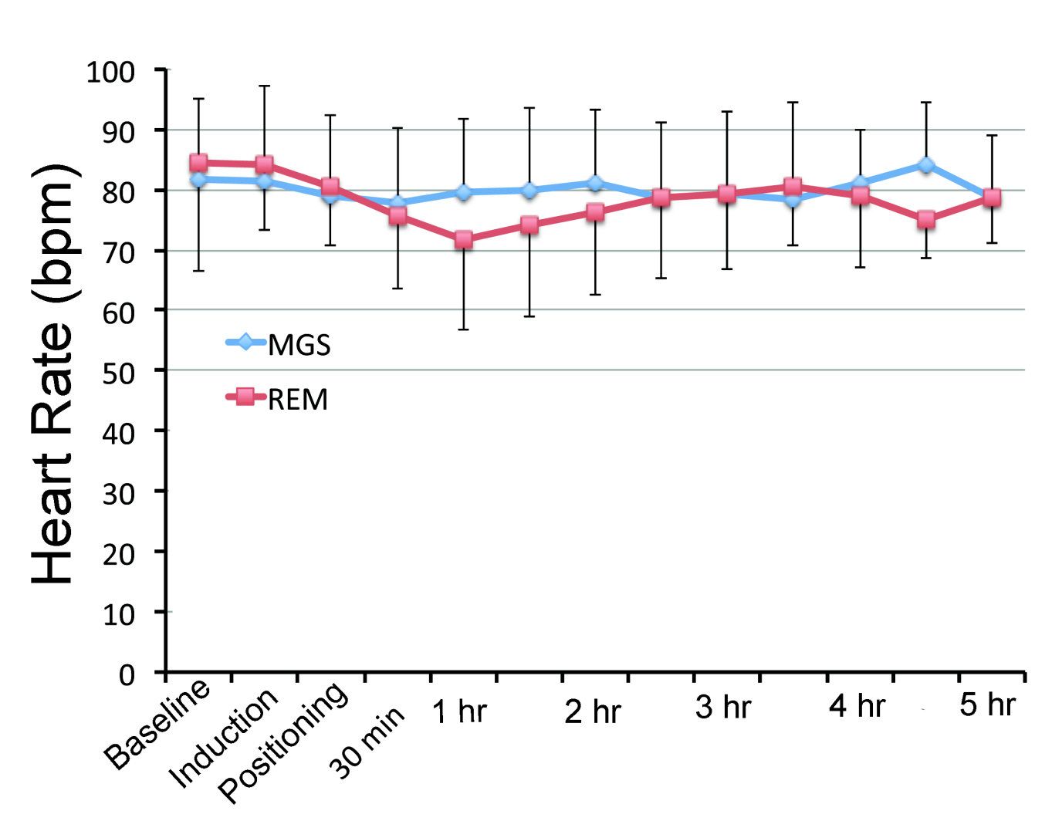
Figure 1 Temporal changes of the heart rate in both groups at the baseline, the induction of anesthesia, positioning, following 30 min and every one hour thereafter. MGS: Magnesium sulfate; REM: Remifentanil.
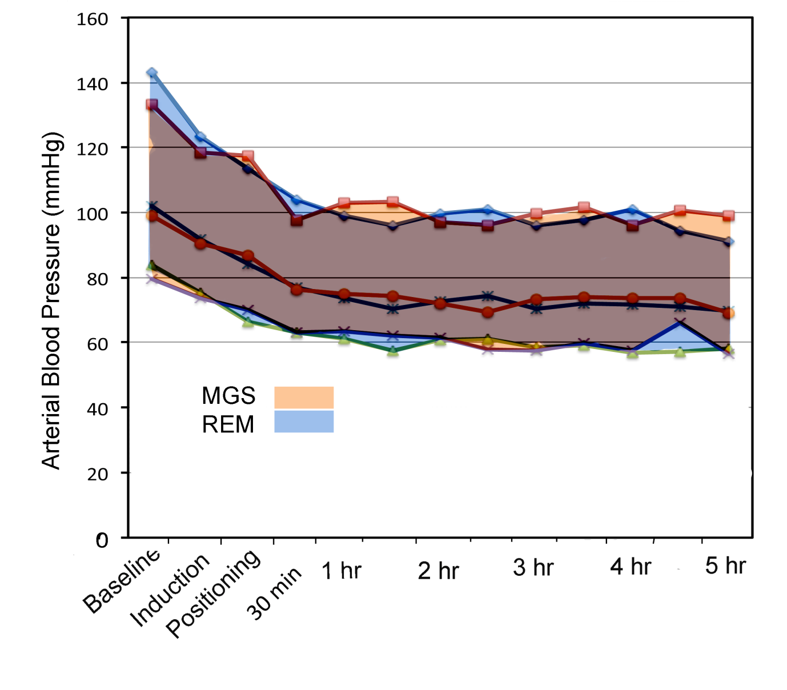

Figure 2 Temporal changes of the systolic, diastolic and mean arterial pressure in both groups at the baseline, the induction of anesthesia, positioning, following 30 min and every one-hour thereafter. MGS: Magnesium sulfate; REM: Remifentanil.

