Name of journal: World Journal of Gastroenterology
ESPS Manuscript NO: 3670
Columns: BRIEF ARTICLE

Emergency balloon-occluded retrograde transvenous obliteration of ruptured gastric varices

Sonomura T et al. Emergency BRTO of ruptured gastric varices

Tetsuo Sonomura, Wataru Ono, Morio Sato, Shinya Sahara, Kouhei Nakata, Hiroki Sanda, Nobuyuki Kawai, Hiroki Minamiguchi, Motoki Nakai, Kazushi Kishi

Tetsuo Sonomura, Morio Sato, Kouhei Nakata, Hiroki Sanda, Nobuyuki Kawai, Hiroki Minamiguchi, Motoki Nakai, Kazushi Kishi, Department of Radiology, Wakayama Medical University, 811-1 Kimiidera, Wakayama 641-8510, Japan

Wataru Ono, Department of Gastroenterology, Kishiwada Tokushukai Hospital, 4-27-1, Kamori-cho, Kishiwada 596-8522, Japan

Shinya Sahara, Department of Radiology, Kishiwada Tokushukai Hospital, 4-27-1, Kamori-cho, Kishiwada 596-8522, Japan

Author contributions: Sonomura T designed the research; Sonomura T, Ono W, Sahara S, Nakata K and Sanda H performed the clinical study; Sonomura T, Kawai N, Minamiguchi H and Nakai M acquired data and researched literatures; Sonomura T, Kishi K and Sato M drafted the manuscript and edited it.
Correspondence to: Tetsuo Sonomura, MD, PhD, Department of Radiology, Wakayama Medical University, 811-1 Kimiidera, Wakayama 641-8510, Japan.
sonomura@wakayama-med.ac.jp

Telephone: + 81-73-4410605 Fax: +81-73-4443110
Received: May 13, 2013 Revised: June 13, 2013
Accepted: July 4, 2013
Published online:

Abstract
AIM: To evaluate the effectiveness and safety of emergency balloon-occluded retrograde transvenous obliteration (BRTO) for ruptured gastric varices.

METHODS: Emergency BRTO was performed in 17 patients with gastric varices and gastrorenal or gastrocaval shunts within 24 h of hematemesis and/or tarry stool. The gastric varices were confirmed by endoscopy, and the gastrorenal or gastrocaval shunts were identified by contrast-enhanced computed tomography (CE-CT). A 6 Fr balloon catheter (Cobra type) was inserted into the gastrorenal shunt via the right internal jugular vein, or into the gastrocaval shunt via the right femoral vein, depending on the varices drainage route. The sclerosant, 5% ethanolamine oleate iopamidol, was injected into the gastric varices through the catheter during balloon occlusion. In patients with incomplete thrombosis of the varices after the first BRTO, a second BRTO was performed the following day. Patients were followed up by endoscopy and CE-CT at 1 d, 1 wk, and 1, 3, and 6 mo after the procedure, and every 6 mo thereafter.

RESULTS: Complete thrombosis of the gastric varices was not achieved with the first BRTO in 7/17 patients because of large gastric varices. These patients underwent a second BRTO on the next day, and additional sclerosant was injected through the catheter. Complete thrombosis which led to disappearance of the varices was achieved in 16/17 patients, while the remaining patient had incomplete thrombosis of the varices. None of the patients experienced rebleeding or recurrence of the gastric varices after a median follow-up of 1130 d (range 8-2739 d). No major complications occurred after the procedure. However, esophageal varices worsened in 5/17 patients after a mean follow-up of 8.6 mo.

CONCLUSION: Emergency BRTO is an effective and safe treatment for ruptured gastric varices.

© 2013 Baishideng. All rights reserved.

Key words: Emergency balloon-occluded retrograde transvenous obliteration; Gastric varices; Bleeding; Portal hypertension; Ethanolamine oleate

Core tip: As ruptured gastric varices are associated with high rates of recurrent bleeding and mortality, quick treatment is essential. Balloon-occluded retrograde transvenous obliteration (BRTO) is a minimally invasive treatment for gastric varices with a high success rate and a low recurrence rate. Emergency BRTO is an effective and safe treatment, providing temporary hemostasis of ruptured gastric varices can be achieved, allowing the sclerosant to accumulate in the varices.

Sonomura T, Ono W, Sato M, Sahara S, Nakata K, Sanda H, Kawai N, Minamiguchi H, Nakai M, Kishi K. Emergency balloon-occluded retrograde transvenous obliteration of ruptured gastric varices. World J Gastroenterol 2013;
Available from: URL: http://www.wjgnet.com/esps/
DOI: http://dx.doi.org/10.3748/wjg.v19.i0.0000

INTRODUCTION
As gastric varices have greater blood flow compared with esophageal varices, ruptured gastric varices can cause massive hemorrhage, and are associated with high rates of recurrent bleeding and mortality (45%–55%)^{[1,2]}. Therefore, ruptured gastric varices must be treated as quickly as possible. Balloon-occluded retrograde transvenous obliteration (BRTO) is a minimally invasive treatment for gastric varices, with a high success rate and a low recurrence rate^{[3-7]}. However, few reports have evaluated emergency BRTO for ruptured gastric varices^{[8,9]}. In this study, we report the long-term outcomes of emergency BRTO performed within 24 h of hematemesis and/or tarry stool.

MATERIALS AND METHODS
The effectiveness and safety of emergency BRTO for ruptured gastric varices were evaluated retrospectively. Between March 1998 and December 2008, BRTO was performed for gastric varices with gastrorenal or gastrocaval shunts in 79 patients. Of these patients, emergency BRTO was performed for ruptured gastric varices within 24 h of hematemesis and/or tarry stool in 17 patients. The patients’ ages ranged from 33 to 79 years, and the mean age was 58.8 years. All patients had liver cirrhosis corresponding to Child–Pugh class A in 2 patients, class B in 12 patients, and class C in 3 patients. The etiologies of liver cirrhosis were hepatitis C in seven patients, hepatitis B in three patients, alcoholic liver disease in four patients, primary biliary cirrhosis in one patient, and unknown in two patients. Mean creatinine value before BRTO was 0.82 mg/dL (normal range: 0.64-1.11 mg/dL), and we had no patients with renal dysfunction. Informed consent for BRTO was obtained from all patients.
The gastric varices were confirmed by endoscopy. According to Sarin classification^{[2]}, isolated varices in the fundus of the stomach were found in 13 of 17 patients, and gastroesophageal varices in the remaining 4 patients. Also, white plugs which indicated bleeding sites were found in 7 patients, and oozing in 3 patients. Temporary hemostasis was achieved spontaneously in 9/17 patients and by balloon compression in 8/17 patients. The presence and diameter of the gastrorenal or gastrocaval shunts were evaluated by contrast-enhanced computed tomography (CE-CT). The gastric varices drained via the gastrorenal shunt in 16 patients, and by the gastrocaval shunt in 1 patient. An 8Fr sheath (Cobra type; Medikit, Tokyo, Japan) was inserted into the left renal vein through the right internal jugular vein with ultrasound-guided puncture while an 8Fr sheath (Straight type; Medikit) was inserted into the inferior vena cava through the right femoral vein. A 6Fr balloon catheter (Cobra type; Clinical Supply, Gifu, Japan) was inserted into the gastrorenal or gastrocaval shunt. The balloon diameter was 13 or 20 mm. In patients with a shunt diameter ≥ 13 mm, a 20 mm diameter balloon was used. A sclerosing agent, 5% ethanolamine oleate iopamidol (EOI), was infused through a balloon catheter or a microcatheter placed close to the gastric varices during balloon occlusion. In the 13 most recent cases, microcatheters were used to decrease the sclerosant dose. We prepared 5% EOI by mixing 10 mL of contrast material with 10 mL of 10% ethanolamine oleate (Oldamin; Glelan Pharmaceutical, Tokyo, Japan). The infusion of 5% EOI was continued until the entire gastric varices and feeding veins were rendered opaque. The mean dose of 5% EOI per procedure was 21.3 mL (range 2–40 mL). The balloon occlusion time ranged from 12 to 48 h. The catheters were fixed in place using sterilized tape (Hogy Medical, Tokyo, Japan). The morning after BRTO, thrombosis of the gastric varices was evaluated by CE-CT. In patients with incomplete thrombosis after the first BRTO, a second BRTO was performed the following day^{[7]}. After complete thrombosis of gastric varices was confirmed by CE-CT, the catheters were removed. To prevent renal damage caused by EOI-related hemolysis, 4000 units of haptoglobin (Mitsubishi Pharma, Osaka, Japan) was intravenously administered to all patients^{[10,11]}. Patients underwent endoscopy and CE-CT at 1 d, 1 wk, and 1, 3, and 6 mo after the procedure, and every 6 mo thereafter.

RESULTS
Complete thrombosis of the gastric varices was not achieved with the first BRTO in 7/17 patients because of large gastric varices. These patients underwent a second BRTO on the next day, and additional sclerosant was injected through the catheter^{[7]}. Complete thrombosis which led to disappearance of the varices was achieved in 16/17 patients (Figures 1 and 2), while the other patient had incomplete thrombosis of the varices. None of the patients experienced rebleeding or recurrence of the gastric varices during a median follow-up of 1130 d (range 8–2739 d). However, esophageal varices worsened in 5/17 patients during a mean follow-up of 8.6 mo^{[12-14]} (Table 1). In two of these five patients, red-colored esophageal varices were treated by endoscopic sclerotherapy. Reddening of the variceal mucosa is associated with a high risk of variceal bleeding^{[15]}.
All of the complications were transient^{[16]}, and included sclerosant-induced hematuria (7/17 patients), abdominal pain (8/17), high fever (6/17), sclerosant-induced blood pressure elevation (1/17), headache (2/17), pleural effusion (15/17), and ascites (12/17). Although extravasation of the sclerosant occurred in one patient during BRTO, the procedure was continued and achieved complete thrombosis of the varices. No major complications, such as renal failure, pulmonary embolism, or liver failure, occurred after the procedure.

DISCUSSION
The cumulative risk for hemorrhage from gastric fundal varices has been reported to be 16%, 36%, and 44% at 1, 3, and 5 years, respectively^{[17]}. Ruptured gastric varices are also associated with high rates of rebleeding and mortality (45%–55%)^{[1,2]}. Therefore, ruptured gastric varices must be treated as quickly as possible.
As most patients with ruptured gastric varices are in a critical state because of hypovolemic shock, surgical treatment and transjugular intrahepatic portosystemic shunts (TIPS) are too invasive and risky. The mortality of patients with esophageal varices undergoing emergency surgery was reported to be 38.4%^{[18]}. Although TIPS is a treatment for potal hypertension to decrease the portal pressure, Catchpole^{[19]} reported some of the problems of TIPS, which included technical failure, restenosis or occlusion of the shunt, dislocation of the stent, and hepatic encephalopathy. Overall, 21% of patients (86/416) died because of bleeding, liver failure, or multiple organ failure. Only 50% of patients had improvements in gastric fundal varices after TIPS^{[20]}. Furthermore, the cumulative gastric variceal bleeding rate at 1 year was 20% in patients who underwent TIPS compared with 2% in patients who underwent transcatheter sclerotherapy (P < 0.01) (Kaplan-Meier method and log-rank test)^{[21]}. Although percutaneous transhepatic obliteration (PTO) may achieve temporary embolization of gastric varices, the varices recur very quickly^{[22]}. Because gastric varices usually have many feeding veins, it is difficult to embolize all of them by PTO. Arai et al^{[23]} reported that PTO achieved a success rate of 44% (8/18) but the recurrence rate of gastric varices was 38% (3/8). By contrast, BRTO had a success rate of 81% (75/93) and the recurrence rate of gastric varices was just 4% (3/75). Although Baveno Consensus^{[24]} suggests endoscopic cyanoacrylate injection for bleeding from isolated gastric varices, it is also difficult to apply endoscopic methods, such as endoscopic injection sclerotherapy (EIS), endoscopic variceal ligation (EVL), and sclerotherapy using cyanoacrylate, to ruptured gastric varices because of their extensive blood supply. Additionally, the mortality rate of EIS in patients with bleeding gastric varices was 55%^{[1]}. EVL using a rubber band^{[25]} was also associated with a high risk of adverse outcomes for treating ruptured gastric varices, as it often causes re-rupture during the procedure, and has a high incidence of rebleeding. The rebleeding rate of EVL was significantly higher than that of endoscopic obturation using cyanoacrylate (54% vs 31%; P = 0.0005)^{[26]}. Endoscopic-guided injection of cyanoacrylate into the varices may induce multiple organ embolisms, such as cerebral infarction^{[27]} and pulmonary embolisms^{[28,29]}, which are caused by leakage of the sclerosant into the systemic circulation. Furthermore, cyanoacrylate treatment of gastric variceal bleeding has a high rate of early bleeding (15.5%–20.5%)^{[30,31]}. By contrast, BRTO is a minimally invasive treatment of gastric varices that is associated with a high success rate and a low recurrence rate^{[3-7]}. Therefore, it may be much more effective than surgery, TIPS, PTO, or endoscopic treatment for critical patients.
Ethanolamine oleate is a sclerosant that damages endothelial cells and induces thrombus formation in the vessel. EOI was prepared by mixing ethanolamine oleate with contrast medium to monitor the movement of EOI under fluoroscopy. To prevent EOI-related complications caused by excess sclerosant, we believe that < 40 mL of 5% EOI should be used during individual BRTO procedures. If complete thrombosis of large gastric varices is not achieved, a second BRTO can be performed the following day, and additional sclerosant can be injected through the catheter that was left in place overnight^{[7]}. To decrease the sclerosant dose, 50% glucose solution^{[32]} or polidocanol foam^{[33]} may be used during BRTO procedures. Haptoglobin was also intravenously administered to prevent renal failure^{[10,11]}.
In our study, the BRTO procedure achieved temporary hemostasis in all of the patients. If active bleeding from the gastric varices continues during the procedure, then 5% EOI may be unable to control the bleeding, because it will leak into the gastric lumen. This displaces the sclerosant and prevents it from accumulating in the gastric varices. In such situations, transportal or transesophageal sclerotherapy with cyanoacrylate and coils may be necessary. The coils serve as a scaffold to trap the cyanoacrylate preventing pulmonary embolism^{[34-36]}. If temporary hemostasis by balloon compression is achieved, we perform BRTO. On the other hand, if temporary hemostasis by balloon compression is not achieved and the gastric varices continue to spurt blood, we perform transportal or transesophageal sclerotherapy with cyanoacrylate and coils.
Esophageal varices worsened in 5/17 patients in this study. The occlusion of a gastrorenal shunt probably induced the esophageal varices through another collateral route. BRTO was reported to significantly increase the portal systemic pressure gradient^{[13]} and increase the bleeding rates of coexisting esophageal varices^{[12]}. Other major risk factors for worsening of esophageal varices after BRTO were the presence of esophageal varices, higher Child–Pugh class, and higher resistance index assessed by endoscopic color Doppler ultrasonography before BRTO^{[14]}. Therefore, esophageal varices should be endoscopically checked every 6 mo after BRTO.
As ruptured gastric varices are associated with high rates of recurrent bleeding and mortality, quick treatment is essential. BRTO is a minimally invasive treatment for gastric varices with a high success rate and a low recurrence rate. Emergency BRTO is an effective and safe treatment, providing temporary hemostasis of ruptured gastric varices can be achieved, allowing the sclerosant to accumulate in the varices.

COMMENTS
Background
As gastric varices have greater blood flow compared with esophageal varices, ruptured gastric varices can cause massive hemorrhage, and are associated with high rates of recurrent bleeding and mortality. Therefore, ruptured gastric varices must be treated as quickly as possible.

Research frontiers
In this study, the authors demonstrate the long-term results of emergency balloon-occluded retrograde transvenous obliteration (BRTO) for ruptured gastric varices.

Innovations and breakthroughs
Sixteen of 17 patients had complete thrombosis leading to disappearance of gastric varices. One patient had incomplete thrombosis leading to reduction of varices.

Applications
Patients who have ruptured gastric varices and gastrorenal or gastrocaval shunts can be treated with emergency BRTO within 24 h of hematemesis and/or tarry stool.

Terminology
Emergency BRTO is a procedure where a balloon catheter inserted into a draining vein of gastric varices, and the sclerosant can be injected into the varices through the catheter during balloon occlusion. The sclerosant damages endothelial cells of the varices resulting in the thrombosis and disappearance of the varices.

Peer review
The authors reported the results of a retrospective study on patients who underwent emergency BRTO for ruptured gastric varices. Emergency BRTO is an effective and safe treatment, providing temporary hemostasis of ruptured gastric varices can be achieved, allowing the sclerosant to accumulate in the varices.

REFERENCES
1 Trudeau W, Prindiville T. Endoscopic injection sclerosis in bleeding gastric varices. Gastrointest Endosc 1986; 32: 264-268 [PMID: 3488937]
2 Sarin SK, Lahoti D, Saxena SP, Murthy NS, Makwana UK. Prevalence, classification and natural history of gastric varices: a long-term follow-up study in 568 portal hypertension patients. Hepatology 1992; 16: 1343-1349 [PMID: 1446890 DOI: 10.1002/hep.1840160607]
3 Kanagawa H, Mima S, Kouyama H, Gotoh K, Uchida T, Okuda K. Treatment of gastric fundal varices by balloon-occluded retrograde transvenous obliteration. J Gastroenterol Hepatol 1996; 11: 51-58 [PMID: 8672742 DOI: 10.1111/j.1440-1746.1996.tb00010.x]
4 Koito K, Namieno T, Nagakawa T, Morita K. Balloon-occluded retrograde transvenous obliteration for gastric varices with gastrorenal or gastrocaval collaterals. AJR Am J Roentgenol 1996; 167: 1317-1320 [PMID: 8911204 DOI: 10.2214/ajr.167.5.8911204]
5 Sonomura T, Sato M, Kishi K, Terada M, Shioyama Y, Kimura M, Suzuki K, Kutsukake Y, Ushimi T, Tanaka J, Hayashi S, Tanaka S. Balloon-occluded retrograde transvenous obliteration for gastric varices: a feasibility study. Cardiovasc Intervent Radiol 1998; 21: 27-30 [PMID: 9473542]
6 Hirota S, Matsumoto S, Tomita M, Sako M, Kono M. Retrograde transvenous obliteration of gastric varices. Radiology 1999; 211: 349-356 [PMID: 10228513]
7 Sonomura T, Ono W, Sato M, Sahara S, Nakata K, Sanda H, Kawai N, Minamiguchi H, Nakai M, Kishi K. Three benefits of microcatheters for retrograde transvenous obliteration of gastric varices. World J Gastroenterol 2012; 18: 1373-1378 [PMID: 22493551 DOI: 10.3748/wjg.v18.i12.1373]
8 Kitamoto M, Imamura M, Kamada K, Aikata H, Kawakami Y, Matsumoto A, Kurihara Y, Kono H, Shirakawa H, Nakanishi T, Ito K, Chayama K. Balloon-occluded retrograde transvenous obliteration of gastric fundal varices with hemorrhage. AJR Am J Roentgenol 2002; 178: 1167-1174 [PMID: 11959725 DOI: 10.2214/ajr.178.5.1781167]
9 Arai H, Abe T, Shimoda R, Takagi H, Yamada T, Mori M. Emergency balloon-occluded retrograde transvenous obliteration for gastric varices. J Gastroenterol 2005; 40: 964-971 [PMID: 16261433 DOI: 10.1007/s00535-005-1654-4]
10 Hashizume M, Kitano S, Yamaga H, Sugimachi K. Haptoglobin to protect against renal damage from ethanolamine oleate sclerosant. Lancet 1988; 2: 340-341 [PMID: 2899760 DOI: 10.1016/S0140-6736(88)92400-2]
11 Miyoshi H, Ohshiba S, Matsumoto A, Takada K, Umegaki E, Hirata I. Haptoglobin prevents renal dysfunction associated with intravariceal infusion of ethanolamine oleate. Am J Gastroenterol 1991; 86: 1638-1641 [PMID: 1951242]
12 Choi YS, Lee JH, Sinn DH, Song YB, Gwak GY, Choi MS, Koh KC, Paik SW, Yoo BC. Effect of balloon-occluded retrograde transvenous obliteration on the natural history of coexisting esophageal varices. J Clin Gastroenterol 2008; 42: 974-979 [PMID: 18528292 DOI: 10.1097/MCG.0b013e318126c154]
13 Tanihata H, Minamiguchi H, Sato M, Kawai N, Sonomura T, Takasaka I, Nakai M, Sahara S, Nakata K, Shirai S. Changes in portal systemic pressure gradient after balloon-occluded retrograde transvenous obliteration of gastric varices and aggravation of esophageal varices. Cardiovasc Intervent Radiol 2009; 32: 1209-1216 [PMID: 19688368 DOI: 10.1007/s00270-009-9679-3]
14 Elsamman MK, Fujiwara Y, Kameda N, Okazaki H, Tanigawa T, Shiba M, Tominaga K, Watanabe T, Oshitani N, Arafa UA, El-Sayed AA, Nakamura K, Arakawa T. Predictive factors of worsening of esophageal varices after balloon-occluded retrograde transvenous obliteration in patients with gastric varices. Am J Gastroenterol 2009; 104: 2214-2221 [PMID: 19319121 DOI: 10.1038/ajg.2008.140]
15 Idezuki Y. General rules for recording endoscopic findings of esophagogastric varices (1991). Japanese Society for Portal Hypertension. World J Surg 1995; 19: 420-42; discussion 423 [PMID: 7638999 DOI: 10.1007/BF00299178]
16 Shimoda R, Horiuchi K, Hagiwara S, Suzuki H, Yamazaki Y, Kosone T, Ichikawa T, Arai H, Yamada T, Abe T, Takagi H, Mori M. Short-term complications of retrograde transvenous obliteration of gastric varices in patients with portal hypertension: effects of obliteration of major portosystemic shunts. Abdom Imaging 2005; 30: 306-313 [PMID: 15688111 DOI: 10.1007/s00261-004-0270-8]
17 Kim T, Shijo H, Kokawa H, Tokumitsu H, Kubara K, Ota K, Akiyoshi N, Iida T, Yokoyama M, Okumura M. Risk factors for hemorrhage from gastric fundal varices. Hepatology 1997; 25: 307-312 [PMID: 9021939 DOI: 10.1053/jhep.1997.v25.pm0009021939]
18 Hassab MA. Gastroesophageal decongestion and splenectomy in the treatment of esophageal varices in bilharzial cirrhosis: further studies with a report on 355 operations. Surgery 1967; 61: 169-176 [PMID: 6016965]
19 Miller-Catchpole R. Diagnostic and therapeutic technology assessment. Transjugular intrahepatic portosystemic shunt (TIPS). JAMA 1995; 273: 1824-1830 [PMID: 7776491 DOI: 10.1001/jama.1995.03520470032014]
20 Sanyal AJ, Freedman AM, Luketic VA, Purdum PP, Shiffman ML, DeMeo J, Cole PE, Tisnado J. The natural history of portal hypertension after transjugular intrahepatic portosystemic shunts. Gastroenterology 1997; 112: 889-898 [PMID: 9041251 DOI: 10.1053/gast.1997.v112.pm9041251]
21 Ninoi T, Nakamura K, Kaminou T, Nishida N, Sakai Y, Kitayama T, Hamuro M, Yamada R, Arakawa T, Inoue Y. TIPS versus transcatheter sclerotherapy for gastric varices. AJR Am J Roentgenol 2004; 183: 369-376 [PMID: 15269027 DOI: 10.2214/ajr.183.2.1830369]
22 Lunderquist A, Vang J. Transhepatic catheterization and obliteration of the coronary vein in patients with portal hypertension and esophageal varices. N Engl J Med 1974; 291: 646-649 [PMID: 4546968 DOI: 10.1056/NEJM197409262911303]
23 Arai H, Abe T, Takagi H, Mori M. Efficacy of balloon-occluded retrograde transvenous obliteration, percutaneous transhepatic obliteration and combined techniques for the management of gastric fundal varices. World J Gastroenterol 2006; 12: 3866-3873 [PMID: 16804972]
24 de Franchis R. Evolving consensus in portal hypertension. Report of the Baveno IV consensus workshop on methodology of diagnosis and therapy in portal hypertension. J Hepatol 2005; 43: 167-176 [PMID: 15925423 DOI: 10.1016/j.jhep.2005.05.009]
25 Stiegmann GV, Sun JH, Hammond WS. Results of experimental endoscopic esophageal varix ligation. Am Surg 1988; 54: 105-108 [PMID: 3341642]
26 Lo GH, Lai KH, Cheng JS, Chen MH, Chiang HT. A prospective, randomized trial of butyl cyanoacrylate injection versus band ligation in the management of bleeding gastric varices. Hepatology 2001; 33: 1060-1064 [PMID: 11343232 DOI: 10.1053/jhep.2001.24116]
27 Sée A, Florent C, Lamy P, Lévy VG, Bouvry M. [Cerebrovascular accidents after endoscopic obturation of esophageal varices with isobutyl-2-cyanoacrylate in 2 patients]. Gastroenterol Clin Biol 1986; 10: 604-607 [PMID: 3781162]
28 Hwang SS, Kim HH, Park SH, Kim SE, Jung JI, Ahn BY, Kim SH, Chung SK, Park YH, Choi KH. N-butyl-2-cyanoacrylate pulmonary embolism after endoscopic injection sclerotherapy for gastric variceal bleeding. J Comput Assist Tomogr 2001; 25: 16-22 [PMID: 11176287 DOI: 10.1097/00004728-200101000-00003]
29 Singer AD, Fananapazir G, Maufa F, Narra S, Ascher S. Pulmonary embolism following 2-octyl-cyanoacrylate/lipiodol injection for obliteration of gastric varices: an imaging perspective. J Radiol Case Rep 2012; 6: 17-22 [PMID: 22690282 DOI: 10.3941/jrcr.v6i2.845]
30 Kind R, Guglielmi A, Rodella L, Lombardo F, Catalano F, Ruzzenente A, Borzellino G, Girlanda R, Leopardi F, Pratticò F, Cordiano C. Bucrylate treatment of bleeding gastric varices: 12 years' experience. Endoscopy 2000; 32: 512-519 [PMID: 10917182 DOI: 10.1055/s-2000-3817]
31 Marques P, Maluf-Filho F, Kumar A, Matuguma SE, Sakai P, Ishioka S. Long-term outcomes of acute gastric variceal bleeding in 48 patients following treatment with cyanoacrylate. Dig Dis Sci 2008; 53: 544-550 [PMID: 17597405 DOI: 10.1007/s10620-007-9882-5]
32 Yamagami T, Kato T, Hirota T, Yoshimatsu R, Matsumoto T, Nishimura T. Infusion of 50% glucose solution before injection of ethanolamine oleate during balloon-occluded retrograde transvenous obliteration. Australas Radiol 2007; 51: 334-338 [PMID: 17635469 DOI: 10.1111/j.1440-1673.2007.01746.x]
33 Koizumi J, Hashimoto T, Myojin K, Itou C, Kagawa T, Nishibe T, Janne d'Othée B. Balloon-occluded retrograde transvenous obliteration of gastric varices: use of CT-guided foam sclerotherapy to optimize technique. AJR Am J Roentgenol 2012; 199: 200-207 [PMID: 22733913 DOI: 10.2214/AJR.11.7002]
34 Kiyosue H, Matsumoto S, Yamada Y, Hori Y, Okino Y, Okahara M, Mori H. Transportal intravariceal sclerotherapy with N-butyl-2-cyanoacrylate for gastric varices. J Vasc Interv Radiol 2004; 15: 505-509 [PMID: 15126663 DOI: 10.1097/01.RVI.0000126809.59487.88]
35 Kwak HS, Han YM. Percutaneous transportal sclerotherapy with N-butyl-2-cyanoacrylate for gastric varices: technique and clinical efficacy. Korean J Radiol 2008; 9: 526-533 [PMID: 19039269 DOI: 10.3348/kjr.2008.9.6.526]
36 Binmoeller KF, Weilert F, Shah JN, Kim J. EUS-guided transesophageal treatment of gastric fundal varices with combined coiling and cyanoacrylate glue injection (with videos). Gastrointest Endosc 2011; 74: 1019-1025 [PMID: 21889139 DOI: 10.1016/j.gie.2011.06.030]

P-Reviewers Khattab MA, Li YY, Maluf F, Sato T S-Editor Gou SX
L-Editor E-Editor

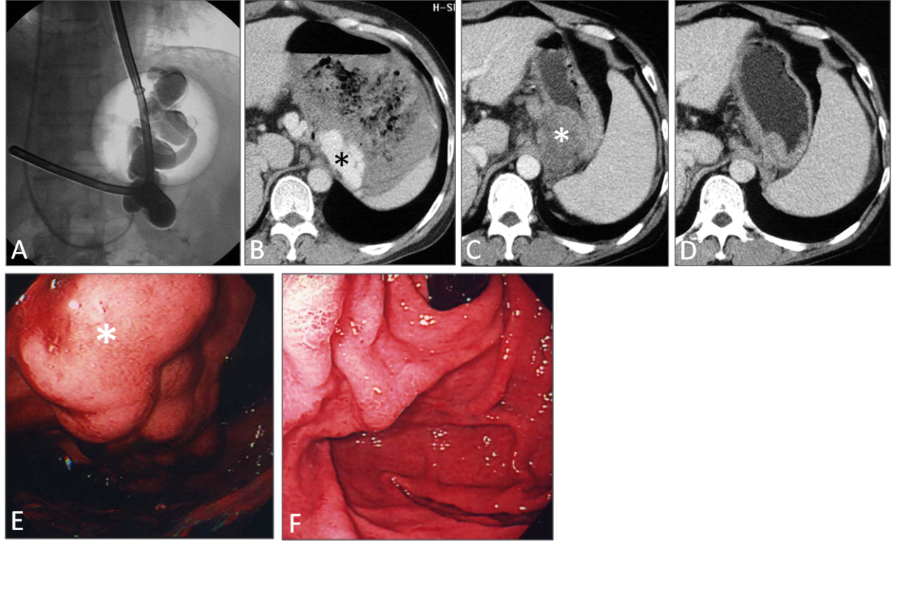
Figure 1 Gastric varices with a gastrorenal shunt (case 15). A: Balloon-occluded retrograde transvenous obliteration (BRTO) was performed 11 h after hematemesis. The gastric varices and a gastrorenal shunt were filled with 36 mL of 5% ethanolamine oleate iopamidol. A Sengstaken–Blakemore tube was inserted into the stomach for temporary hemostasis; B: Contrast-enhanced computed tomography (CE-CT) image taken before BRTO shows gastric varices (asterisk) with a massive hematoma; C: CE-CT image taken 1 wk after BRTO shows complete thrombosis of the varices (asterisk); D: CE-CT image taken 6 mo after BRTO shows complete disappearance of the varices; E: Endoscopy performed before BRTO shows gastric varices (asterisk) with oozing; F: Endoscopy performed 6 mo after BRTO shows complete disappearance of the varices.

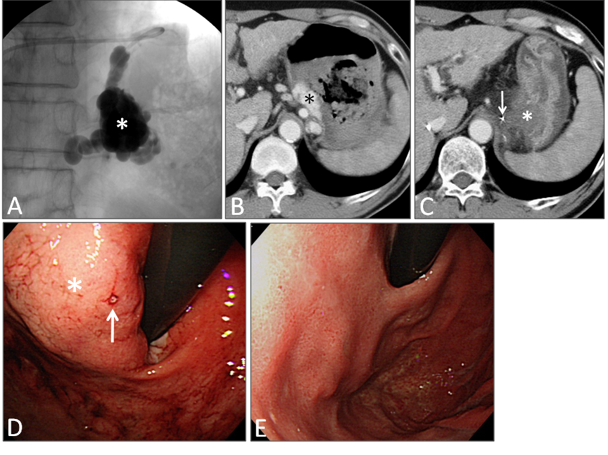

Figure 2 Gastric varices with a gastrocaval shunt (case 8). A: A balloon catheter was inserted into a gastrocaval shunt and 18 mL of 5% EOI was injected through the microcatheter that had been advanced close to the gastric varices; B: Contrast-enhanced computed tomography (CE-CT) image taken before balloon-occluded retrograde transvenous obliteration (BRTO) shows gastric varices (asterisk) with a massive hematoma; C: CE-CT image taken the day after BRTO shows complete thrombosis of the varices (asterisk) and that the tip of the microcatheter (arrow) is close to the varices; D: Endoscopy performed before BRTO shows bleeding site (arrow) of the gastric varices (asterisk); E: Endoscopy performed 3 mo after BRTO shows complete disappearance of the varices.

Table 1 Patient characteristics and clinical outcomes
Case | Age | Sex | Cause of LC | Child–Pugh class | Temporary  hemostasis | Drainage  route | Dose of 5% EOI (mL) | Eradication  of GV | Worsening of EV | Follow-up time (d) | Clinical  outcome
1 | 63 | M | HCV | B | Spontaneous | GR | 30 | Complete | – | 205 | Alive
2 | 59 | M | HBV | B | Spontaneous | GR | 40 | Complete | + | 2229 | Alive
3 | 58 | F | PBC | A | Spontaneous | GR | 18 | Complete | – | 2197 | HF¹
4 | 67 | M | HCV | A | Spontaneous | GR | 12 | Complete | – | 2529 | HCC²
5 | 79 | F | Unknown | C | Spontaneous | GR | 35 | Complete | – | 135 | HF¹
6 | 46 | M | HCV | B | Balloon | GR | 36 | Complete | – | 388 | Alive
7 | 66 | F | Alcohol | B | Spontaneous | GR | 10+17 | Complete | + | 2739 | HF¹
8 | 59 | M | Alcohol | B | Spontaneous | GC | 18 | Complete | – | 1501 | Alive
9 | 70 | M | HCV | B | Spontaneous | GR | 17 | Complete | – | 8 | Alive
10 | 33 | F | Unknown | B | Balloon | GR | 30+10 | Complete | – | 1293 | Alive
11 | 46 | M | HBV | C | Balloon | GR | 36+23 | Complete | – | 41 | Alive
12 | 57 | M | HBV | B | Balloon | GR | 30+28 | Complete | + | 164 | HF¹
13 | 66 | M | Alcohol | B | Balloon | GR | 18+13 | Partial | – | 14 | HF¹
14 | 65 | F | HCV | B | Balloon | GR | 10+8 | Complete | – | 1130 | Alive
15 | 51 | M | HCV | B | Balloon | GR | 36 | Complete | + | 2466 | HF¹
16 | 53 | M | Alcohol | C | Balloon | GR | 15 | Complete | + | 545 | HF¹
17 | 62 | F | HCV | B | Spontaneous | GR | 20+2 | Complete | – | 1835 | Alive
¹Died of hepatic failure (HF); ²Died of hepatocellular carcinoma (HCC). LC: Liver cirrhosis; PBC: Primary biliary cirrhosis; HCV: Hepatitis C virus; HBC: Hepatitis B virus; GR: Gastrorenel shunt; GC: Gastrocaval shunt; EOI: Ethanolamine oleate iopamidol; GV: Gastric varices; EV: Esophageal varices.

