Name of journal: World Journal of Gastrointestinal Surgery
ESPS Manuscript NO: 24148
Manuscript Type: ORIGINAL ARTICLE
Basic Study

Fibrinogen-thrombin collagen patch reinforcement of high-risk colonic anastomoses in rats

Suárez-Grau JM et al. Prevention of colonic leak in a rat model

Juan Manuel Suárez-Grau, Carlos Bernardos García, Carmen Cepeda Franco, Cristina Mendez García, Salud García Ruiz, Fernando Docobo Durantez, Salvador Morales-Conde, Javier Padillo Ruiz

Juan Manuel Suárez-Grau, Department of General and Digestive Surgery, Riotinto Hospital, 21660 Huelva Seville, Spain

Juan Manuel Suárez-Grau, Division of General and Laparoscopic Surgery, Clinic Quiron Sagrado Corazon, 41013 Seville, Spain

Juan Manuel Suárez-Grau, Institute of Biomedicine of Seville Research center, University Hospital Virgen del Rocio, 41013 Seville, Spain

Carlos Bernardos García, Division of General Surgery, Hospital of San Juan de Dios, 41930 Bormujos, Seville, Spain

Carmen Cepeda Franco, Fernando Docobo Durantez, Salvador Morales-Conde, Javier Padillo Ruiz, Department of General and Digestive Surgery, University Hospital Virgen del Rocio, 41013 Seville, Spain

Cristina Mendez García, Department of General surgery, Hospital of Jerez, 11407 Jerez de la Frontera, Cadiz, Spain
Salud García Ruiz, Division of Surgery, Clinic Quiron Donostia, 20012 Donostia, Gipuzkoa, Spain

Salvador Morales-Conde, Clinic Quiron Sagrado Corazón, 41013 Seville, Spain

Author contributions: Suárez-Grau JM, Bernardos Garcia C, Cepeda Franco C, Mendez Garcia C and García Ruiz S performed the experiments and participated equally in treatment of animals; Suárez-Grau JM and Bernardos Garcia C analyzed the data and reviewed the manuscript; Docobo Durantez F, Morales-Conde S and Padillo Ruiz J designed and coordinated the research; Suárez-Grau JM and Bernardos Garcia C wrote the paper.

Institutional review board statement: The appropriate approvals were obtained from the relevant Institutional Review Board of General and Digestive Surgery Department of University Hospital of Virgen del Rocío (Seville) and Riotinto Hospital (Huelva) and in the research ethics committee of both hospital.

Institutional animal care and use committee statement: The study was approved by the Ethics Committee for experimental studies and experimental surgery Research Center, Institute of Biomedicine of Seville (IBIS), and were cared for animals at all times by qualified care professionals.

Conflict-of-interest statement: There is no conflict of interest in performing this study by either of the authors; the material has been donated by the Department of General and Digestive Surgery of the Riotinto Hospital and Virgen del Rocío Hospital.

Data sharing statement: an independient statistical empoyee of University Hospital Virgen del Rocío performed the blinded data satatistical analysis.

Open-Access: This article is an open-access article which was selected by an in-house editor and fully peer-reviewed by external reviewers. It is distributed in accordance with the Creative Commons Attribution Non Commercial (CC BY-NC 4.0) license, which permits others to distribute, remix, adapt, build upon this work non-commercially, and license their derivative works on different terms, provided the original work is properly cited and the use is non-commercial. See: http://creativecommons.org/licenses/by-nc/4.0/

Manuscript source: Invited manuscript

Correspondence to: Juan Manuel Suárez-Grau, MD, Phd, Department of General and Digestive Surgery. Riotinto Hospital. Avda. La esquila, 5 Minas de riotinto, 21660 Huelva, Spain. graugrau@gmail.com
Telephone: +34-62-9739398
Fax: +34-95-9252250

Received: January 18, 2016
Peer-review started: January 20, 2016
First decision: February 15, 2016
Revised: July 6, 2016
Accepted: July 20, 2016
Article in press:
Published online:

Abstract
AIM: To evaluate the effectiveness of the human fibrinogen-thrombin collagen patch (Tachosil®) in the reinforcement of high-risk colon anastomoses.

Methods: A quasi-experimental study was conducted in Wistar rats (n = 56) that all underwent high-risk anastomoses (anastomosis with only two sutures) after colectomies. The rats were divided in two randomised groups: Control group (24 rats) and Treatment group (24 rats). In the Treatment group the high-risk anastomosis was reinforced with Tachosil® (a piece of Tachosil® was applied over this high-risk anastomosis, covering the gap). Leak incidence, overall survival, intraabdominal adhesions and histologic healing of the anastomoses were analysed. The survivors were divided into two subgroups and euthanised at 15 and 30 d after the intervention in order to analyse the adhesions and histologic changes.

Results: The overall survival was 71.4% and 57.14% in the Tachosil® group and Control group, respectively (P = 0.29); four rats died from other causes, and six rats in the Treatment group and 10 in the Control group experienced colonic leakage (P > 0.05) The intraabdominal adhesions score was similar in both groups with no differences between subgroups. We found non-significant differences in the healing process according to the histologic score used in both groups (P = 0.066).

Conclusion: In our study, the use of Tachosil® was associated with a non-statistically significant reduction in the rate of leakage in high-risk anastomoses. It is a safe product because it does not affect the histologic healing process and does not increase intraabdominal adhesions.

Key words: colon; rats; anastomosis; leak; Tachosil®; surgery

© The Author(s) 2016. Published by Baishideng Publishing Group Inc. All rights reserved.

Core tip: Anastomotic leakage is one of the most important complications in gastrointestinal surgery. We have done pioneering risk anastomosis procedure (performed with a high risk of leakage), to test the use of thrombin and fibrinogen patch for reinforcement and prevention of potential leakage. We have obtained a reduction in the mortality rate significantly without adding comorbidity. Its application is simple and does not exceed the operating time. Its use can be extremely useful in emergency surgery or in special situations provide for a high possibility of anastomosis dehiscence.

Suárez-Grau JM, Bernardos Garcia C, Cepeda Franco C, Mendez Garcia C, García Ruiz S, Docobo Durantez F, Morales-Conde S, Padillo Ruiz J. Fibrinogen-thrombin collagen patch reinforcement of high-risk colonic anastomoses in rats. World J Gastrointest Surg 2016; In press

Introduction
Anastomotic leakage is a severe postoperative complication that can threaten a patient’s life. It has a mean incidence published in the literature of 4-8%, and its mortality can reach up to 22%^{[1,2]}. Several methods have been used to attempt to reduce anastomotic leakage associated with colonic surgery with diverse results. As some authors have reported, staplers are the only method that maintains the incidence of anastomotic leakage under 10%^{[3]}. Others authors have used glues and tissue sealants to reinforce the suture. Cyanoacrylates and fibrin glues are used most and studies have shown varying results, with some authors stating the efficacy and advantages of the use of cyanoacrylates and fibrin sealants in this kind of surgery^{[4,5]}. In contrast, other studies have failed to demonstrate benefits^{[6]}. Few studies have analysed other materials such as human fibrinogen and thrombin patches (Tachosil®). Tachosil® contents Human Fibrinogen and Human Thrombin and excipients (Equine collagen, Human albumin, Riboflavine (E101), Sodium chloride, Sodium citrate (E331), L-arginine-hydrochloride). Tachosil® is indicated in adults for supportive treatment in surgery for improvement of haemostasis, to promote tissue sealing, and for suture support in vascular surgery where standard techniques are insufficient. Experimental studies have tried to assess if this product can improve the results of colonic anastomoses, with diverse results^{[7-10]}. An important aspect of this topic is the definition of high-risk anastomoses. Tebala et al^{[5]} defined this kind of anastomoses as including emergency surgery, ischemic or inflammatory tissues, esophagus or extraperitoneal rectus, and immunosuppression.
We hypothesised that a colonic anastomosis carried out under poor conditions can be improved with the use of this product by decreasing anastomotic leakage and its complications.

Materials and Methods
Study design
A prospective, comparative, semi-experimental study in animals was conducted to analyse the effects of the application of a human fibrinogen-thrombin patch (Tachosil®) over high-risk anastomosis sites. The hypothesis was that this product would decrease the incidence and severity of colonic leakage. We compared the results with a control group in which there was only a high-risk anastomosis. The study was carried out under the conditions established by The Helsinki Statement, which regulate the terms and conditions for animal experiments. There was no competing interest for any of the authors. The authors did not receive any grant or sponsorship for this study. The materials were donated by the Department of Surgery of the University Hospital Virgen del Rocío, and Riotinto Hospital.

Animals
This study was performed on 56 white Wistar rats of both sexes and 250-350 g of weight. Animals were divided into two groups of 28 animals each (Control group and Treatment group). A high-risk anastomosis was performed in all rats. A piece of the fibrinogen-thrombin sealant was added covering the entire anastomosis site in the Treatment group.

Technical procedure
Anaesthesia was induced with intraperitoneal ketamine (20 mg/kg), after which a laparotomy was performed. We then performed a partial colectomy of 2-3 cm just after the cecum, which was closed with an anastomosis with only two stitches of 4-0 monocryl (in the mesenteric and antimesenteric borders of the colon). In addition, a 2 cm × 2 cm piece of Tachosil® was applied over the anastomosis with light compression using a small wet gauze in the Treatment group. Each piece was lightly wet with 0.9% saline. The gauze was gently removed, and the anastomosis site was checked after 5 min to ensure the Tachosil® was in the proper location. The laparotomy was closed with 3-0 vicryl suture in a simple continuous suture for the muscle plane and 3-0 silk in a simple interrupted suture for the skin (Figure 1).
The early deceased animals underwent a necropsy in order to establish the cause of the death. The survivors were euthanised at 15 and 30 d postoperatively (after a randomized process). During the necropsy the formation of intraabdominal adhesions was quantified with a numeric scale (Table 1) to compare both groups at 15 and 30 d postoperatively. In all animals, the colonic anastomosis was retrieved to analyse the histopathologic healing process, according to Biert’ scheme (Table 2), which analysed nine parameters. The histologic analysis (hematoxylin eosin staining) was performed by a pathologist blinded for the two groups.

Statistical analysis
The program used for statistical analysis was SPSS v16 for Windows, and the statistical review was performed by a biomedical statistician. Numerical results were analysed by using means and standard deviations. The Kaplan-Meier method was used to assess survival. Leakage incidence was analysed with the Chi-squared test for dichotomous variables. The intraabdominal adhesions score was compared between groups with the Mann-Whitney test as the variable was qualitative. The histopathologic healing process was analysed with the Student’s t-test (sub-analysis was performed with Mann-Whitney test when necessary). A P value < 0.05 was considered significant.

Results
Survival and leakage incidence
The number of events (defined as death as a consequence of colonic leakage) was 10 (35.7%) in the Control group and six (21.4%) in the Tachosil® group. All deaths happened before the fourth postoperative day. Four animals per group died because of other causes (haemorrhage, post-anaesthesia and bowel obstruction in the Control and Tachosil® groups with no relation to the experimental study). The mean survival per groups was 19.5 ± 2.6 (Control) and 23.7 ± 2.2 d (Tachosil®). With these results, the overall survival was 57.14% and 71.4% in the Control and Tachosil® groups, respectively (P = 0.29) (Figure 2), with no significant differences between groups.

Intraabdominal adhesions
The results are shown in Table 3. We did comparisons according to both the time (15 d vs 30 d) and also to the group [Control (16 rats) vs Tachosil® ( 20 rats)]. Distribution of Animals sacrified: Control-15 d = 9 rats, Control-30 d = 7 rats; Tachosil-7 d = 10 rats, Tachosil-15 d = 10 rats. The adhesions score was significantly different when comparing all groups according to the time, and showed a much better score in animals euthanised at day 30. When comparing groups we did not find any differences at day 15 or at day 30.

Histopathologic healing process
The healing of the anastomoses was analysed following the Biert’ scheme. The global results are shown in Figures 3 and 4.
Only four parameters (Table 4) showed significant differences between the Control and Tachosil® groups with the Student’s t-test and were always worse in the Tachosil® group polymorphonuclear cells 0.21 ± 0.42 vs 0.78 ± 0.64; P = 0.01; macrophages 0.50 ± 0.65 vs 0.89 ± 0.47; P = 0.026; oedema 0.43 ± 0.64 vs 0.94 ± 0.63; p = 0.017 and epithelium regeneration 0.64 ± 0.92 vs 1.11 ± 0.58; P = 0.031). The rest of parameters were similar between groups.
When we applied the total score for this analysis (the sum of all values of each parameter) we found nearly significant differences between groups. Among all survivors, the Control group had a mean total healing score of 6.21 ± 3.21 whereas the Tachosil® group had a mean of 8 ± 2.05 (P = 0.066) (Figure 3).
The subanalysis of this total healing process score according to the postoperative day (15 and 30 d) did not show statistically significant differences, but we did see a trend towards a worse healing process in the Tachosil® group, especially at the end of the period. On the 15th and 30th days the results were 7.5 vs 9.5 (P = 0.39) and 6.17 vs 9.9 (P = 0.112) in the Control group vs the Tachosil® group (mean ranges) (Figure 5). There were no differences when the analysis was done between groups (global analysis) (7.15 vs 10.75; P = 0.13).

Discussion
The failure of a colonic anastomosis can be a life threatening complication following colonic surgery. Over time, many efforts have been made to improve the results of this procedure and to define the risk factors for anastomosis failure^{[1,2,11]}. Systemic factors, such as diabetes and steroid use, and local factors, such as radiotherapy and tension or haemorrhage in the suture, can lead to a poor result in the healing process of the colon^{[12-14]}. The period in which a leak occurs is usually between the 5th and 6th postoperative days. Before this period the strength of the anastomosis is mainly held by the suture, but after the 5th or 6th day the healing process of the colonic wall (especially the collagen formation) is most important because the suture material loses efficacy at that time. A lot of products^{[6,15-19]} have been used to reinforce intestinal anastomoses (cyanoacrylate, fibrin sealants, amniotic, collagen and dura mater membranes, mechanical staplers, etc.), all of them with different results. The application of a fibrinogen and thrombin patch over a colonic anastomoses is a relatively new idea^{[7]}. Some authors^{[19,20]} used the classical caecal puncture model to define a high-risk anastomosis (the sepsis model)^{[20-24]}. Up to now, there has not been any consensus of the definition of a high-risk anastomosis, and to our knowledge, there are a few studies that have studied the application of Tachosil® over colonic anastomoses^{[7-10,20-24]} with only one carried out over a high-risk anastomosis^{[10]}. These studies showed that this is a safe and feasible method. However, some results have been controversial. Ozel et al^{[7]} showed that this product increased the inflammatory reaction and led to a worse healing process with less mechanical strength. In contrast, Stumpf et al^{[9]} found that it led to a better histopathologic healing process as a consequence of the decrease in suture material in the anastomotic line and that a suture-free anastomosis is reliable. Nordentoft^{[8,22]} studied this product applied over normal small-bowel anastomoses and found no differences in the mechanical strength, degree of stenosis or healing process; the incidence of anastomotic leakage was also similar between groups. In our study we noted an evident reduction of the anastomotic leakage incidence (31.7% vs 21.4% in Control and Tachosil® groups, respectively) but these differences were not significant (P = 0.29). Even when a potentially injurious agent (5-fluorouracil) is used it has been verified that applying the anastomosis Tachosil® confers greater resistance, acting as a protective agent^{[24]}. Pantelis et al^{[10]}, in their study in mice, achieved a statistically significant difference in lethality and leakage rate in the group that received Tachosil®. The use of Tachosil® did not increase the formation of intraabdominal adhesions. They did not find any differences between groups. In the studies that analysed the use of Tachosil® in bowel anastomoses, Nordentoft et al^{[8]} reported there were no differences between groups. In contrast, Ozel et al^{[7]} noted that Tachosil® increased the formation of peri-anastomotic adhesions. Regarding the histopathologic healing process, we neither found advantages nor disadvantages when Tachosil® was applied. However, we analysed this process with both individual and global scores, and individually some were statistically different in function of the group (Control or Treatment), but when the global score was compared, no differences were observed. Some authors, such as Ozel, affirmed that if Tachosil® is used, the neutrophilic granulocyte count can increase, and this carries a worse prognosis for healing as a result of the excessive metalloproteinases. These results were also observed by van der Ham et al^{[21]}. In contrast, Pantelis observed that if Tachosil® is applied in a high-risk anastomosis, an improvement in the healing process can be observed. In our study, the healing process is exacerbated when we use TachoSil® compared to the control group. There are increased inflammatory parameters. However it does not affect the creation of a useful anastomosis, only to higher growth of tissue in the area where it is applied, accompanied by obvious signs of inflammation. It has not affected the result of the study and the rate of leakage has decreased, therefore we believe that even a stronger healing process, is useful in reinforcing the consistency of the anastomosis.
We think that, despite the worse healing in some individual parameters in the Tachosil® group, the improvement in leak incidence can be explained by the sealant effect of the collagen patch (i.e., the mechanical sealant achieved by this sponge which is a well-established effect of this product)^{[7,8,23]}.
In conclusion, our study showed that the application of Tachosil® led to a non-statistically significant decrease in both the mortality and anastomotic leakage rates. Furthermore, the use of this product did not affect the histopathologic healing process and did not increase the formation of adhesions, so it is a very safe product. We focused on the importance of the mechanical effect of Tachosil® to seal the anastomosis gap. The use of Tachosil® is not justified in routine colonic surgery due to low colonic anastomotic leakage rates in those procedures. We demonstrated that Tachosil® does not decrease the complication rate in high-risk anastomoses but based on the controversial data existing in the literature, we think that clinical studies should be performed to clarify this topic as it can have potentially important effects in surgery.

COMMENTS
Background
Experimental study to test an absorbable product (Tachosil®) in risk anastomosis in rats. The hypothesis to be tested is decreasing anastomotic leaks using this product. The results (triple-blind comparative) confirm a decrease in leakage anastomotic.

Research frontiers
The main frontier of the study is the reduction of the anastomosis leakage in anastomosis with risk factors.

Innovations and breakthrough
Decreasing the rate of leaks in the anastomosis using an absorbable sheet involved the own anastomosis when the procedure could be in risk conditions.

Applications
The results can be applied in digestive surgery (intestinal and colorectal anastomosis), especially in emergency surgeries and patients with high comorbidities.

Peer-review
This manuscript showed potential application of Tachosil® to suture of colon after surgery. The study was straight forward, and rationale. The application apparently had some merits.

References
1 Matthiessen P, Hallböök O, Rutegård J, Simert G, Sjödahl R. Defunctioning stoma reduces symptomatic anastomotic leakage after low anterior resection of the rectum for cancer: a randomized multicenter trial. Ann Surg 2007; 246: 207-214 [PMID: 17667498 DOI: 10.1097/SLA.0b013e3180603024]
2 Matthiessen P, Hallböök O, Andersson M, Rutegård J, Sjödahl R. Risk factors for anastomotic leakage after anterior resection of the rectum. Colorectal Dis 2004; 6: 462-469 [PMID: 15521937 DOI: 10.1111/j.1463-1318.2004.00657.x]
3 Smith LE. Anastomosis with EEA stapler after anterior colonic resection. Dis Colon Rectum 1981; 1: 160–167 [DOI: 10.1007/bf02641867]
4 Coover HW, Joyner FB, Sheareer NH, Wicner TH. Chemistry and performance of cyanocryalate adhesive. J Soc Plast Enf 1959; 15: 413-417
5 Tebala GD, Ceriati F, Ceriati E, Vecchioli A, Nori S. The use of cyanoacrylate tissue adhesive in high-risk intestinal anastomoses. Surg Today 1995; 25: 1069-1072 [PMID: 8645945 DOI: 10.1007/BF00311697]
6 Nursal TZ, Anarat R, Bircan S, Yildirim S, Tarim A, Haberal M. The effect of tissue adhesive, octyl-cyanoacrylate, on the healing of experimental high-risk and normal colonic anastomoses. Am J Surg 2004; 187: 28-32 [PMID: 14706582 DOI: 10.1016/j.amjsurg.2003.02.007]
7 Ozel SK, Kazez A, Akpolat N. Does a fibrin-collagen patch support early anastomotic healing in the colon? An experimental study. Tech Coloproctol 2006; 10: 233-236 [PMID: 16969611 DOI: 10.1007/s10151-006-0285-y]
8 Nordentoft T, Rømer J, Sørensen M. Sealing of gastrointestinal anastomoses with a fibrin glue-coated collagen patch: a safety study. J Invest Surg 2007; 20: 363-369 [PMID: 18097878 DOI: 10.1080/08941930701772173]
9 Stumpf M, Junge K, Rosch R, Krones C, Klinge U, Schumpelick V. Suture-free small bowel anastomoses using collagen fleece covered with fibrin glue in pigs. J Invest Surg 2009; 22: 138-147 [PMID: 19283617 DOI: 10.1080/08941930802713001]
10 Pantelis D, Beissel A, Kahl P, Wehner S, Vilz TO, Kalff JC. The effect of sealing with a fixed combination of collagen matrix-bound coagulation factors on the healing of colonic anastomoses in experimental high-risk mice models. Langenbecks Arch Surg 2010; 395: 1039-1048 [PMID: 20680329 DOI: 10.1007/s00423-010-0703-5]
11 Peeters KC, Tollenaar RA, Marijnen CA, Klein Kranenbarg E, Steup WH, Wiggers T, Rutten HJ, van de Velde CJ. Risk factors for anastomotic failure after total mesorectal excision of rectal cancer. Br J Surg 2005; 92: 211-216 [PMID: 15584062 DOI: 10.1002/bjs.4806]
12 Tagart RE. Colorectal anastomosis: factors influencing success. J R Soc Med 1981; 74: 111-118 [PMID: 7009860]
13 Goligher JC, Graham NG, De Dombal FT. Anastomotic dehiscence after anterior resection of rectum and sigmoid. Br J Surg 1970; 57: 109-118 [PMID: 5467147 DOI: 10.1002/bjs.1800570208]
14 Daly JM, Vars HM, Dudrick SJ. Effects of protein depletion on strength of colonic anastomoses. Surg Gynecol Obstet 1972; 134: 15-21 [PMID: 5007170]
15 Eryilmaz R, Samuk M, Tortum OB, Akcakaya A, Sahin M, Goksel S. The role of dura mater and free peritoneal graft in the reinforcement of colon anastomosis. J Invest Surg 2007; 20: 15-21 [PMID: 17365403 DOI: 10.1080/08941930601126108]
16 Schreinemacher MH, Bloemen JG, van der Heijden SJ, Gijbels MJ, Dejong CH, Bouvy ND. Collagen fleeces do not improve colonic anastomotic strength but increase bowel obstructions in an experimental rat model. Int J Colorectal Dis 2011; 26: 729-735 [PMID: 21344301 DOI: 10.1007/s00384-011-1158-z]
17 Elemen L, Sarimurat N, Ayik B, Aydin S, Uzun H. Is the use of cyanoacrylate in intestinal anastomosis a good and reliable alternative? J Pediatr Surg 2009; 44: 581-586 [PMID: 19302863 DOI: 10.1016/j.jpedsurg.2008.08.033]
18 Nandakumar G, Richards BG, Trencheva K, Dakin G. Surgical adhesive increases burst pressure and seals leaks in stapled gastrojejunostomy. Surg Obes Relat Dis 2010; 6: 498-501 [PMID: 20176513 DOI: 10.1016/j.soard.2009.11.016]
19 Byrne DJ, Hardy J, Wood RA, McIntosh R, Hopwood D, Cuschieri A. Adverse influence of fibrin sealant on the healing of high-risk sutured colonic anastomoses. J R Coll Surg Edinb 1992; 37: 394-398 [PMID: 1491373]
20 Uludag M, Citgez B, Ozkaya O, Yetkin G, Ozcan O, Polat N, Isgor A. Effects of amniotic membrane on the healing of normal and high-risk colonic anastomoses in rats. Int J Colorectal Dis 2009; 24: 809-817 [PMID: 19280199 DOI: 10.1007/s00384-009-0691-5]
21 van der Ham AC, Kort WJ, Weijma IM, van den Ingh HF, Jeekel J. Effect of fibrin sealant on the healing colonic anastomosis in the rat. Br J Surg 1991; 78: 49-53 [PMID: 1998864 DOI: 10.1002/bjs.1800780117]
22 Nordentoft T. Sealing of gastrointestinal anastomoses with fibrin glue coated collagen patch. Dan Med J 2015; 62: [PMID: 26050838]
23 Tallón-Aguilar L, Lopez-Bernal Fde A, Muntane-Relat J, García-Martínez JA, Castillo-Sanchez E, Padillo-Ruiz J. The use of TachoSil as sealant in an experimental model of colonic perforation. Surg Innov 2015; 22: 54-60 [PMID: 24902692 DOI: 10.1177/1553350614535853]
24 Sabino FD, Campos CF, Caetano CE, Trotte MN, Oliveira AV, Marques RG. Effects of TachoSil and 5-fluorouracil on colonic anastomotic healing. J Surg Res 2014; 192: 375-382 [PMID: 24976442 DOI: 10.1016/j.jss.2014.05.067]

P-Reviewer: Kok VC, Tomizawa M S-Editor: Gong ZM
L-Editor: E-Editor:

Table 1 Adhesive score
Adhesive Score
0: No adhesions
1: Extremely soft adhesions
2: Stronger adhesions, but dissectible with dull dissection
3: Stronger adhesions only dissectible with sharpen tools
4: Stenosis
Table 2 Histopathologic Biert’ scheme
Parameters | Score
 | 0 | 1 | 2 | 3
Necrosis | No | Small patches | Big Pathes | Massive
PMNs | Normal | Sligthy increased | Strong infiltration | Massive infiltration
Lymphocytes | Normal | Sligthy increased | Strong infiltration | Massive infiltration
Macrophages | Normal | Sligthy increased | Strong infiltration | Massive infiltration
Edema | No | Sligth | Strong | Massive
Epithelium | Glandular normal | Cubic normal | Cubic incomplete | Absent
Submucosa-muscular | Good bridges | Mild bridges | Few bridges | Bridges abscence
Angiogenesis | Extensive | Strong | Sligth | Absent
Fibrosis | Extensive | Strong | Sligth | Absent
PMNs: polymorphonuclear cells.
Table 3 Intrabdominal adhesion score in survivors animals
 | Mann-Withney mean ranges | p value
Survivors (15 d vs 30 d) | 25.11 vs 11.12 | 0.0012
Control (15 d vs 30 d) | 10.53 vs 5.5 | 0.017
Tachosil (15 d vs 30 d) | 14.75 vs 6.25 | 0.001
Control vs Tachosil (15 d) | 9.5 vs 10.45 | 0.685
Control vs Tachosil (30 d) | 9.71 vs 8.50 | 0.584

Table 4 histopathologic analysis most relevant parameters (mean ± SD)
 | Control | Tachosil | p value
PMNs | 0.21 ± 0.42 | 0.78 ± 0.64 | 0.010
Macrophages | 0.50 ± 0.65 | 0.89 ± 0.47 | 0.026
Edema | 0.43 ± 0.64 | 0.94 ± 0.63 | 0.017
Epithelium regeneration | 0.64 ± 0.92 | 1.11 ± 0.58 | 0.031
PMNs: polymorphonuclear cells.

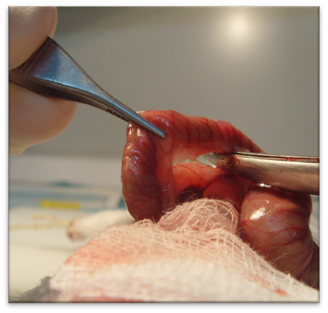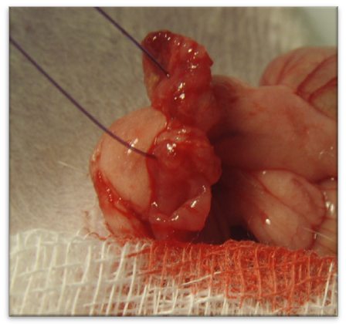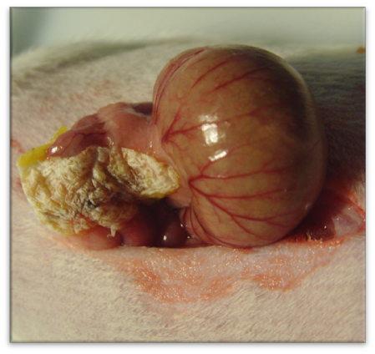
Figure 1 Surgical technique.
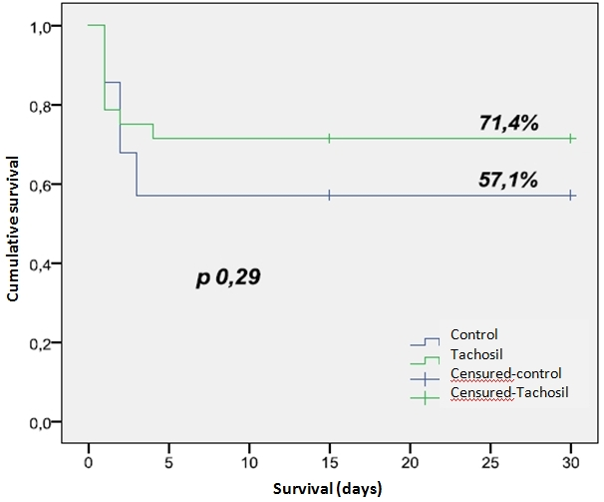
Figure 2 Survival in both groups.
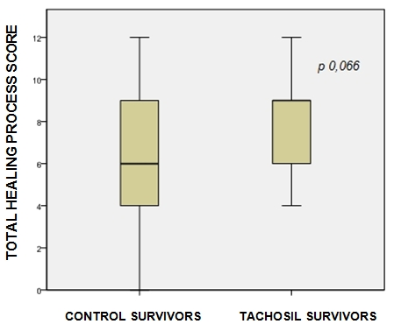
Figure 3 Healing of the anastomoses in both groups.
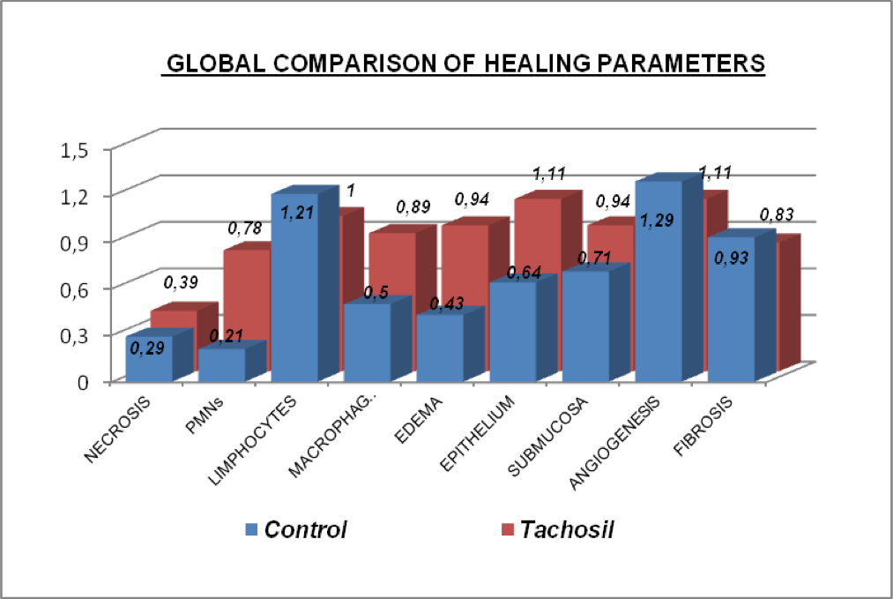
Figure 4 Global comparison of healing parameters.
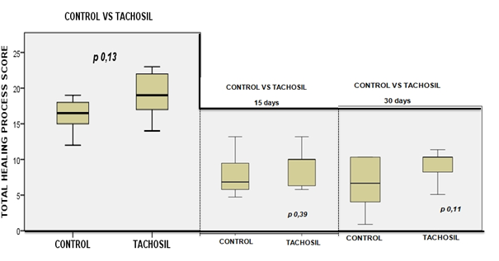
Figure 5 Healing process score at 15, 30 d and global analysis in survivors animals.

