Name of Journal: World Journal of Radiology
ESPS Manuscript NO: 21527
Manuscript Type: Review

Incremental value of thoracic ultrasound in intensive care unit: Indications, uses and application

Liccardo B et al. Thoracic ultrasound in ICU

Biagio Liccardo, Francesca Martone, Paolo Trambaiolo, Sergio Severino, Gian Alfonso Cibinel, Antonello D’Andrea

Biagio Liccardo, Francesca Martone, Sergio Severino, Antonello D’Andrea, Second University of Naples, AORN “dei Colli”, Monaldi Hospital, 80122 Naples, Italy

Paolo Trambaiolo, Intensive Care Unit, Sandro Pertini Hospital, 00157 Rome, Italy

Gian Alfonso Cibinel, Emergency Medicine Unit, ASL TO3, Pinerolo, 10064 Turin, Italy

Author contributions: All authors equally contributed to this paper with conception and design of the study, literature review and analysis, drafting, critical revision, editing, and final approval of the final version.

Conflict-of-interest statement: No potential conflicts of interest.

Open-Access: This article is an open-access article which was selected by an in-house editor and fully peer-reviewed by external reviewers. It is distributed in accordance with the Creative Commons Attribution Non Commercial (CC BY-NC 4.0) license, which permits others to distribute, remix, adapt, build upon this work non-commercially, and license their derivative works on different terms, provided the original work is properly cited and the use is non-commercial. See: http://creativecommons.org/licenses/by-nc/4.0/

Correspondence to: Antonello D’Andrea, MD, PhD, Chair of Cardiology, Second University of Naples, AORN “dei Colli”, Monaldi Hospital, Via M. Schipa, 44, 80122 Naples, Italy. antonellodandrea@libero.it
Telephone: +39-081-7062355
Fax: +39-081-7064234

Received: July 19, 2015
Peer-review started: July 19, 2015
First decision: September 30, 2015
Revised: January 25, 2016
Accepted: February 14, 2016
Article in press:
Published online:
Abstract
Emergency physicians are usually called to care for unstable patients with life-threatening conditions, and to take both rapid and sharp decisions about unclear clinical pictures. The concept of using ultrasound as a real-time bedside clinical tool for the clinician, added to the irreplaceable historical and physical examination, in the emergency setting, is obtaining a growing consensus. B-mode sonography is an old technology proposed for medical applications more than 50 years ago. Its application in the diagnostic procedures of thoracic diseases has always been considered limited by the presence of air contained inside the lung, and by the presence of the bones of the thoracic cage, which prevent the progression of the ultrasound beam. However, the close relationship between air and water in the lung causes a variety of artifacts seen by ultrasound. At the bedside, thoracic ultrasound is based primarily on the analysis of these artifacts. The goals are to improve accuracy and safety in the diagnostic and therapeutic approach of variety of pulmonary pathologic diseases which are predominantly “water-rich” or “air-rich” conditions. The indications, contraindications, advantages, disadvantages, and technique of thoracic ultrasound, and related procedures will be analyzed in the present review.

Key words: Thoracic ultrasound; Intensive care unit; Heart failure; Pleural effusion; Pneumothorax; Echocardiography

© The Author(s) 2016. Published by Baishideng Publishing Group Inc. All rights reserved.

Core tip: The close relationship between air and water in the lung causes a variety of artifacts seen by ultrasound. At the bedside, thoracic ultrasound is based primarily on the analysis of these artifacts. The goals are to improve accuracy and safety in the diagnostic and therapeutic approach of variety of pulmonary pathologic diseases which are predominantly “water-rich” or “air-rich” conditions. The indications, contraindications, advantages, disadvantages, and technique of thoracic ultrasound, and related procedures will be analyzed in the present review.

Liccardo B, Martone F, Trambaiolo P, Severino S, Cibinel GA, D’Andrea A. Incremental value of thoracic ultrasound in intensive care unit: Indications, uses and application. World J Radiol 2016; In press

INTRODUCTION
Emergency clinicians are often implied to take care of critically patients with life-threatening settings; more over physicians are called to take both quickly and precisely choices about clinical conditions usually unclear^{[1-3]}.
In this contest, the idea of utilized ultrasound as a real-time bedside clinical instrument for the emergency physician, added to the irreplaceable historical and physical examination, in the emergency conditions, is getting an increasing consent.
As a matter of fact, even though bedside portable chest radiography (CR) is relatively inexpensive, available in most hospital, and provides useful information, it has been shown to be inaccurate in many situations and has a few limitations^{[4]}. Over the technical limitations of the tool (movement, and breath holding during the X-ray exposure, cassette placed posteriorly the thorax, etc.) that may lead the incorrect assessment of the most frequent pulmonary disease (such as alveolar interstitial syndrome, pulmonary consolidation, and pleural effusion)^{[5]}, the time required to achieved a bedside ordinary CR, and to compile a report, may bring to retard the diagnosis, and extended the staying of the patient in the emergency department, contributing to overcrowding of the department. Nevertheless, the CR is not ever helpful for diagnosis of pneumothorax in ill patient staying in intensive care unit (ICU) during non invasive ventilation.
However, chest’s computer tomography (CCT) could be assessed the best tool for the imaging diagnosis of most of the thoracic settings, but it is costly, not usable in the ICU, and exposes ill patient to a strength unsafe transport to the radiology unit^{[6]}. Moreover, CCT set out patient to high dose of radiation, which obviously restricts the possibility to repeat the proceeding, and makes not available the tool for pregnancy, and for pediatric patients^{[7,8]}.
Ultrasound is an old technology and its use in the diagnostic proceedings of chest illness has ever been considered restricted by the presence of air contained inside the lung, and by the presence of the bones structure, which prevent the progression of the ultrasound^{[9-12]}.
As matter of fact, in the textbook “Harrison, Principles of Internal Medicine” about thoracic ultrasound (TUS) they say^{[13]}:
“Because ultrasound energy is rapidly dissipated in air, ultrasound imaging is not useful for evaluation of the pulmonary parenchyma. However, it is helpful in the detection and localization of pleural abnormalities and is often used as a guide to placement of a needle for sampling of pleural liquid (i.e., for thoracentesis)”.
But thanks, firstly to the pioneering work of a French intensivist Daniel Lichtenstein, and after to others, they understated that ultrasound applied on chest and lung generate sonographic artifacts, and that those artifacts patterns are correlated with clinical, and radiologic diagnosis in ICU.
Lichtenstein, in fact, proposed the basis and utility of TUS formulated in few basic principles. Firstly, the intimate relationship between air and water in the lung causes a variety of artifacts seen by ultrasound. Because air and, consequently the lung, cannot be visualized by sonography, thoracic ultrasound, TUS is based primarily on the valuations of these artifacts. Secondly, air and water have opposing gravitational dynamics. Consequently, a variety of pathologic conditions (pleural effusions, consolidations) is predominantly “water-rich”. These pathologies are generally found in the posterior aspects of a supine patient. On the other hand, there are several “air-rich” conditions (pneumothorax) and, as a result, are predominantly found in the anterior aspects of a supine patient (Table 1)^{[14]}.
This review focus on potential clinical application of TUS.

ULTRASOUND MACHINE REQUIREMENTS
Ultrasound machines should be lightweight, battery-powered, hand-carried, compact, and simply to move, permitting the valuation of many patient straight bedside. Moreover, ultrasound instruments should be provided with an hard disk and a USB door saving and unloading images and clips, and a paper recorder^{[15-17]}.
Moreover, ultrasound machines is used for many patients, probes can be carrier for resistant germs that could be present in the ICU. As matter of fact, ultrasound instruments and probes should be treated with frequently decontamination proceedings^{[18]}.
PROBES
The ultrasound equipment suitable for TUS imaging must been provided with 3.5-MHz, 5-MHz, 7.5-MHz, or 10-MHz convex, linear, and sector transducers; each probe has its inherent advantages and disadvantages.
A convex or linear transducer, better than a sector scanner, has a large vision of the range; for this reason is preferred for the initial valuation and for the screening. The curved array convex probe (3.5-MHz) has the profit of allowing view of deeper lesions, rapid assessment of the lateral thoracic cavity for signs of pleural fluid in the supine patient. However, due to its large footprint, only a small portion of the intercostal space is accessible. Furthermore, the low frequency does not allow for detailed assessment of the most important zone in thoracic ultrasound, such as pleural line. The high-frequency linear array probe (5-MHz or 7.5-MHz) give best resolutions of close structures, allows for detailed examination of the pleura and provides rapid assessment of superficial lesions interesting the chest wall and pleura, such as pneumothorax. Its large footprint, however, hinders access to larger areas of lung tissue because of the interference of the ribs. Furthermore, the high-frequency sacrifices depth-of-penetration, preventing assessment of deeper structures such as atelectasis, consolidation, and large pleural effusions. For injuries with a short ultrasound view or a really limited intercostal space, anyway, a sector probe is in general choosed, moreover cardiac probe allows simultaneous examination of heart and lung.

SCANNING PROCEDURE
Each TUS study should started obtaining patient’s history and a clinical evaluation.
Commonly, TUS may be performed by two different approaches: a systematic approach, or a focused approach that starts on the area of chest distress^{[19]}.
During TUS systematic examination, patients is valuated in a seated laying from anterior lateral, posterior, and supraclavicular approach, to scan both posterior and anterior areas of the thorax; by this approach patient should stay with both arms lifted over the head^{[20]}.
On the other hand, in ICU a methodical procedure is not always possible, because is a proceeding that needs time, and frequently patients clinical condition are really severe. Current reviews have pointed out the simpler procedures feasible on patients independent from their position and from respiration, looking for sonographic signs easier to been acquired.
In both approaches, thoracic cage can be divided in different zones^{[10,11,21,22]}.
In the chest we can distinguish three different wall: the anterior, the lateral and the posterior wall; more of the diagnostic proceedings of TUS interest the anterior, and lateral parts of the chest cage. The anterior wall is delimitated from the sternum to the anterior axillary row, while the lateral wall is delimitated from the anterior to the posterior axillary row, and the posterior wall is delimitated from the paravertebral row, the scapularis row and the posterior axillary row^{[11,22-24]}.
Thoracic parts are obviously the same on both areas, but the presence of the heart on the left side, reduces the helpful scansion on the left side.
The real limitation of ultrasound is when TUS needs to be applied to the posterior zone of the chest of bedridden patient, immobilized patient, intubated patient, or unconsciousness patient. In these conditions, little probes may be useful, because can be placed between the patient, and bed. Infants, and small children, to obtain better images, can be evaluated by placing the babies in supine or in oblique position. The transducer can slide behind the patients back, and aim up roughly perpendicular to the chest wall^{[14,25]}.
Lower portions of the chest may be evaluated from an abdominal sight. The right lung can be seen passing across the liver, while the left lung can be seen by passing across the spleen, in both conditions diaphragm will be crossed and visualized^{[19]}.
By moving the probe in an upper or downer way, the pleura is represent under the ribs, moving during inspiration and expiration, synchronized with breathing motions.
The probe is shift in transverse, or longitudinal way to better see the lung using the intercostal spaces like an ultrasound windows, preventing the ribs. Both the longitudinal and the convex probes allows the visualization of couple ribs and the pleural row between this two bones. This proceeding is the first and most significant passage of chest evaluation, because it permit an easier and a more accurate valuation of the pleural row. When the pleural line has been seen, placing and turning the probe in the intercostal space, transverse scan can be obtained to a best visualization of the pleura and its artifacts^{[11,12]}.
A completely TUS evaluation included the scansion of both emidiaphragms, normal zone included, to compared normal with pathological areas.

ULTRASOUND NORMAL APPEARANCE AND TERMINOLOGY
Normal lung parenchyma is not visualized because it is composed primarily of air, which scatters, and impedes the transmission of sound waves. The dramatic difference in the acoustic characteristics of smooth tissues and the lung makes the chest surface a particularly strong reflector of ultrasound waves, and is responsible for creating a number of reverberation artifacts that lend valuable information about the lung’s current pathophysiology.
Ultrasound picture of the thoracic cage typically displays smooth-tissue echogenicity with multiple layers of fascia, sub-cutaneous, and muscle of different thickness depending of patient constitution.
The transducer can be positioned both perpendicular to the ribs, and transverse, over the intercostal spaces.
The longitudinal approach, perpendicular to the ribs, consent a view of the lower and the upper ribs and, a little more profound, the pleural line (Figure 1), while the oblique approach, with the probe placed in the intercostals space, consent the view of a bigger part of the pleural line, not hidden by the rib shadows^{[25]}.
Leaning the transducer on each intercostal space, in longitudinal approach, three fundamental structure can be highlight: the pleural line, the thoracic cage, and the pulmonary artifact.
The depth should be adjusted to the patient size, to the patient habitus, and depending on the structure we would seen: in fact, to visualize the pleural line in obese, or in muscled patients, or in very thick ribcages, higher depths are needed, while in children or very thin patients, littler depth are required. Depth should also be correct by the objective of our valuation: if we are searching for pneumothorax, for a better visualization of the pleural line, and to assess the sliding, the depth should be shorter; while if we need to value a pleural effusion, the depth should be higher. Typically the focus should be placed at the pleural row level, for a better visualization of artifacts.
Different portions of the thoracic cage may be highlight through TUS, but the more significant structures visualized by TUS are the margins of the ribs. They seems as a line with uninterrupted echogenicity, like the physiological pleural row, but without any movements; moreover the margin of the normal ribs produces an acoustic shadow that masked in part the structures above, except for the cartilage zone of the ribs that consent the transmission of the ultrasound beam, showing the pleura underling and its sliding. TUS may be also used in the diagnosis of chest wall pathologies (such as fractures after resuscitation cardio-pulmonary, or trauma), but this is not in the scope of our review.
The second structure to highlight is the pleural row; it seems as a thin echogenic row, under the ribs. This row represents the visceral and parietal layers, seen together. Typically, the pleural lines are smooth and thick (less than 2 mm of thickness); between two rows there is the pleural space (less than 0.3/0.4 mm). The near ribs, the upper and the lower, with the pleural line below them, delineate a typically ultrasound sign named “Bat sign”, better shown by convex probe, due to its curvilinear shape (both the near ribs are the wings of the bat and, the pleural line under them is the backside of the bat). The recognition of this sign is important, since it simply consent the finding of the pleural row (Figure 2).
The pleural row moving through respiration, and its movement is synchronized with respiration^{[3]}. This movements is named lung sliding or gliding^{[25]}, and its recognitions is a significant passage in chest evaluation, since is a sign of physiologic moving of pleura.
Moreover, the heart beats caused another movement called the lung puls, that is the moving of the pleural row synchronous with the cardiac beam. Is a vertical movement that is easier to see on the left hemithorax, and is produced by the transmission of heart rhythm.
The presence of intrapleural air (like in pneumothorax) avoids the transmission of any kind of moving (both vertical and horizontal) to the parietal pleura. As matter of fact, visualizing the lung pulse, is it possible to exclude pneumothorax.
Moreover the M-mode can be used to document lung sliding, recordings a mark named seashore sign (Figure 3)^{[26]}. In this kind of picture, below the pleural line of the phisiological lung, is it possible to see the pulmonary artifact made of a steady background pattern, finely sparkling, and with several linear artifacts. On the setting, sparkling artifact are created when the ultrasound beam is no uniformly mirrored back to the transuder by the microspheric surfaces of air that are trapped in the alveoli^{[9,10]}.
Moreover, linear artifacts can be distinguished in two different kinds, vertical and horizontal.
The horizontal artifacts are hyperechogenic row showed at standard intervals from the pleural row, as repetition, and are called A-lines (Figure 4). When mached with physiological lung sliding, these reverberation artifacts represent a sign of the physiological presence of air in the alveoli^{[21,25]}.
A-lines occur when sound waves pass through the superficial soft tissues, and cross the pleural line encountering air, or tissue that is almost completely composed of air, as in normal lung. These waves are reflected strongly by this tissue/air interface, and bounce back and forth, between the transducer, and lung surface; each volley of sound waves returns to the transducer after a longer period of time, and is thus represented as a bright horizontal line deeper and deeper on the display screen. As this is a classic reverberation artefact, the distance from the skin to the pleural row equals the distance from the pleural row to the first A-line, the first A-line to the second A-line, and so forth.
The vertical artifacts are echogenic beams that come from the pleural row, arriving to the opposite way of the screen in the absence of interruptions and with synchronous movements with lung sliding and respiratory frequency. They are well-defined, laser-like, hyperechoic, and they erases A-lines^{[26]}.
In the normal lung vertical artifacts are generally not more than 2-3 per chest parts per emithorax, preferentially at the bases of the lung^{[11,23,27]}; they are named B-lines, or comet tails, (Figure 5)^{[12,28,29]}.
The B-lines image are connected with a little water-rich structure, under the resolution of the sonographic beam enclosed by air, and when this structure is been stricken by ultrasound beam generates this kind of artifacts.

PULMONARY INVOLVEMENT IN CARDIAC DISEASES
When we have a clinical setting characterized by damaged lung with an enhanced of free-water^{[30]}, vertical artifacts growing up from the pleura and continuing to the opposite way of the dislpay^{[31]}, as already said, are named B-lines The quantity of the comet tails is related with the increased free-water and the lung aeration leak^{[32]}.
It is important to don’t forget, as mentioned above, that some B-lines (one or two) may be view ordinarily in bottom dependent lung regions, such as normally aerated lung bases^{[23]}.
It has been demonstrated that many B-lines (nearest then 7 mm) are determinated by thickened interlobular septa featuring interstitial edema. On the opposite site, multiple B-lines (nearest then 3 mm or fewer) are produced by alveolar edema. As matter of fact, the amount of B-lines rises with the grade of leak of aeration.
Moreover, the usefulness of TUS is to assess lung reareation after antimicrobial therapy^{[33]} or after non invasive ventilation.
The cardio-pulmonary system is so complex and interrelated, that an integrated method (lung ultrasound assessment additional to echocardiography) is fundamental to the assessment of pulmonary involvement in acute and chronic cardiac failure^{[34]}.
As a matter of fact, the evidence of many, diffuse, and in both the emithorax of comete-tails correlated with left ventricular dysfunction or valvular disease is most suggestive of cardiac pulmonary cause of the pulmonary edema^{[35-37]}.
On the other hand, the evidence of B-lines, related with normal systolic and diastolic function, suggest a non-cardiogenic cause of the congestion, but a lung disease, such as pneumonia, acute respiratory distress syndrome, acute lung injury, or particularly in chronic setting, pulmonary fibrosis.
On the opposite side, focal multiplex comet tails can be present in physiologic lungs, or in different pathologic such as pleural distress, lung disease, focal pneumonia, pulmonary neoplasia lung contusion, or lung infarction.
This highlight the significance of integrate results obtain trough TUS, echocardiography with patients’ anamnesis, clinical setting, and all instrumental information we can find^{[38]}.

PLEURAL EFFUSION
Ultrasound imaging is the better tool for the diagnose of pleural effusion, the easiest and the more specific instrument; moreover is very useful to differentiate the nature of pleural fluid^{[39,40]}.
Pleural effusion is really easy to find out by ultrasound as an echo-free zone (black area). As matter of fact, pleural effusion plays as an acoustic window, and when pleural effusion is enough abundant to compress the lung, it will appear as consolidated, and moving inside the pleural effusion (Figure 6).
Pleural effusion should be searched in declivous pulmonary zone.
The first passage is to discriminate pleural effusion’s nature: if is a transudate or an exudate.
Transudates appear as anaechoic, with an echo-free pattern, even if sometimes cured transudate pleural effusion that characterized congestive heart disease may be echogenic^{[41]}.
On the other hand, exudates appear often echoic, with small moving dots that represent the presence of cells (like macrophages, erythrocytes, or leukocytes), or little spots (such as protein, or fibrin). Inflammatory pleural illnesses produce a characteristic effusion that holds fibrous strings and septations with encapsulated liquid (loculated that could be mobile or immobile) (Figure 7)^{[42]}.
In the valuation of pleural effusion, the second passage is to quantify its size. Various formulas have been used for the valuation of volume of the pleural effusion, and lung ultrasound method has been suggested for its quantification.
In supine setting, an inter-pleural space at the lung base, of about 50 mm (between lung and posterior chest cage) is suggesting of a pleural effusion of about 500 mL^{[43]}.
Quantification of the inter-pleural space can be done at either end-expiration or end-inspiration phase, without any difference. All studies accord that ultrasound valuation of the inter-pleural distance is not precise enough to quantify little (< 500 mL) and big (> 1000 mL) pleural effusions^{[44-46]}.
Valuation of pleural effusion needs care on the left side to the spleen, while on the right side on the liver, and on both sides on the diaphragm, in particular when pleural puncture is considered. Thoracentesis and biopsy of the pleura sometimes have been necessary for diagnosis of some disease^{[47-49]} and TUS is required to increase the safety of this procedures performed at bedside^{[50,51]}.
TUS permit the secure chest drainage of little and/or loculated pleural effusions; moreover TUS allows to highlight pleural adherences that may complicate thoracocentesis. TUS may also decrease the risk of intra-fissural or intra-parenchymal placing of pleural tubes^{[20,33]}.

PNEUMOTHORAX
Pneumothorax (PNT) is defined by the presence of air, or any different kind of gas, in the pleural space, between visceral and parietal pleural layers; accordingly of this interposition, lung sliding is stopped, because ultrasounds can’t pass across the air present in the pleural space, due to the lung disease. Moreover B-lines are no more visualizable, while only horizontal A-lines can be seen^{[23]}.
Different studies have recently underline that bedside TUS is more specific than CR for the diagnosis of PNT in critically ill patient^{[21,52-54]}. In fact bedside CR may underdiagnose up to 30% of conditions^{[55]}.
As matter of fact, radiographically “occult” PNT may quickly develop to tension PNT, in particular in patients who received mechanical ventilation (both invasive and non invasive), in which missed, or delayed diagnosis may be fatal.
Failure of lung sliding is the first passage to diagnose PNT.
In general, PNT should be searched firstly at the least gravitationally dependent zone.
The presence of lung sliding permits to likely rule out PNT; in fact its negative predictive value is about 100%^{[55]}.
Moreover in the PNT, the absence of lung sliding can be also assessed by M-mode, which displays a characteristic setting, called “stratosphere sign”, that is a picture opposite to the physiological seashore sign (Figure 8).
Anyway, the absence of lung sliding does not ever imply PNT. Different other conditions can cause the absence of lung sliding, like severe pulmonary fibrosis, pleural adherences, massive atelectasis, bullous emphysema, advanced chronic obstructive pulmonary disease, presence of thoracic tube, high-frequency ventilation, etc. Moreover, the absence of B-lines is another state needed for a thoracic ultrasound diagnosis of PNT: in fact, the presence of B-line allows prompt to ruling out the diagnosis of PNT^{[31]}.
As matter of fact, the only pathognomonic lung ultrasound sign of PNT is the called “lung point”, that permits to confirm PNT diagnosis (specificity of 100%, and sensitivity of 65%). Lung point is the exact zone of the thoracic wall, where the normal lung sliding displaced the PNT characteristics setting. It represents the area where visceral and parietal pleura layers recover one with the other. Also M-mode done at the lung point, demonstrates an evident shift from one setting to the other (normal seashore sign changed in the stratosphere sign characteristic of the PNT pattern) (Figure 9)^{[7,38,56]}.

DIAPHRAGMATIC FUNCTION
The diaphragm is the most important respiratory brawn^{[57,58]}.
Ultrasound assessment of the diaphragm has not long ago become to grown up in the ICU as characteristic necessity for valuation of diaphragmatic role gain in different clinical settings. In fact, pathological diaphragmatic movement is seen in different situations like in patients in critical conditions who are using mechanical ventilation (invasive and non invasive)^{[59]}, after cardiac, or abdominal surgery^{[57]}, and also in phrenic nerve injury, or neuromuscular diseases.
Since diaphragmatic movement performs a fundamental part in spontaneous respiration, valuation of the diaphragm motion seems necessary.
In the ICU patients, ultrasound can assess physiological and pathological motion in different kind of clinical settings. The study of the diaphragm using ultrasound is made using a 3.5-MHz, 5-MHz transducer, placing the transuder under the left or right costal margin in the mid-clavicular row, or in the left or right anterior axillary row and directing medially, cranial and caudal; as consequence the ultrasound beam will arrived perpendicularly the third back of the hemi-diaphragm.
The 2-dimensional mode is firstly employed to get the better approach while the M-mode is made to show the movement of the anatomical formations over the selected plane^{[60]}.
Preferentially, patients are examinated over the long axis of the intercostal spaces, the hole right hemidiaphragm is seen by ultrasound; in fact the liver allowed a perfect transmission of the beam, filling the dome entirely, while the left acoustic window is littler because the spleen fills only half of the corresponding hemidiaphragm^{[20]}.
Left and right hemidiaphragms respiratory motion should always be evaluated; physiological inspiratory diaphragmatic motion is caudal, because the diaphragm go toward the transducer, while physiological expiratory movement is cephalic, as the diaphragm shift apart from the transducer. As consequence of this movements, in the M-mode we can measured: diaphragmatic shift (displacement, cm), velocity of diaphragmatic contraction (slope, cm/s), inspiratory time (Tinsp, s) and lenght of the cycle (Ttot, s) (Figure 10).
In mechanically ventilated patients, the assessment of diaphragmatic movement occasionally could need to shortly disengage the patient from the ventilator to best asses spontaneous breathing stresses. A lot of ICU patients may also be affected by pulmonary consolidation, atelectasis, or pleural effusions, which allow a better valuation of the hemidiaphragms. The values of diaphragmatic movement in healthful subjects were indicate to be 1.8 ± 0.3, 7.0 ± 0.6 and 2.9 ± 0.6 cm for men, and 1.6 ± 0.3, 5.7 ± 1.0, and 2.6 ± 0.5 cm for women, respectively during rest, deep breathing and volunteer sniffing^{[61]}.
The excurtion of the diaphragm dome valuated using M-mode ultrasound is useful for predicting extubation outcomes^{[62]}.
Diaphragm thickening during inspiration represents diaphragm shortening and is analogous to the “ejection fraction” of the heart.

INTEGRATED CARDIO-PULMONARY ULTRASOUND - THE BLUE PROTOCOL
Acute respiratory distress is a really severe setting. The correction and immediate reorganization of acute respiratory failure, are two fundamental steps for the correct management patients in critical conditions in ICU and to avoid initial mistakes and their deleterious consequences.
A study published in 2008 by Lichtenstein et al^{[63]} assess the utility of TUS in patients allowed to the ICU with respiratory distress.
It deduced that TUS can help the physician to make a easiest diagnosis in patients with acute respiratory distress; Lichtenstein called this protocol the BLUE protocol (meaning Bedside Lung Ultrasound in Emergency).
This observational study was conducted performing ultrasonography on 260 consecutive dyspnoetic patients whose access to the ICU for acute respiratory distress; the conclusion of the ultrasound evaluation at the first presentation of the dyspnoetic patient to the ICU, were match with the last diagnosis at the resignation. Unclear diagnoses and uncommon patterns (frequency less than 2%) were excluded from their study. Three fundamental elements were evaluated: artifacts (A-lines or B-lines), lung sliding, and alveolar consolidation and/or pleural effusion; all this items were combined with venous analysis, and at the end were clustered to value ultrasound outline (Table 2).
In the BLUE protocol, the first step is to check anterior lung sliding. Its presence rules out the diagnosis of PNT.
The A’ profile (A-profile with absence of lung sliding) and lung point showed PNT (81% sensitivity and 100% specificity), while if lung point is not present, additional diagnosis modalities are necessary.
The second step is looking for anterior B-lines.
The B profile (presence of anterior lung sliding with lung comet tails) indicated the presence of acute pulmonary edema (97% sensitivity and 95% specificity).
The B’ profile (B profile with absence of lung sliding), A/B profile (anterior prevailing B-lines on one side, and prevailing A-lines on the other), and C profile (identifies anterior alveolar consolidations) suggest the presence of pneumonia (89% sensitivity and 94% specificity).
The A profile (characterized by anterior lung sliding with A-lines) suggest an investigation for depth venous thrombosis, and if is show, pulmonary embolism is assessed (81% sensitivity and 99% specificity). If the depth venous thrombosis is absent, PLAPS (posterior and/or lateral alveolar and/or pleural syndrome) is valued. The setting combining A-profile, free veins, and PLAPS is named A-V-PLAPS-profile and is a characteristic setting suggesting pneumonia.
An A-profile with the absence of DVT or PLAPS (called the “nude profile”) whit lung sliding preserved is probably to be an exacerbation of COPD or severe asthma (89% sensitivity and 97% specificity).
The application of these settings would have present the right diagnoses in about 90.5% of conditions.
The procedure used a convex or a sector probe (or any type of probe you have!).
Obviously, to give better results, BLUE protocol must initiate just after the physical examination and must be integrated into the clinical approach; moreover cardiac analysis, through by echocardiography, completes this approach.
A recent multicenter study enrolling 1.005 patients assay the thesis that an integrated method implementing TUS with clinical examination would have superior diagnostic precision than a standard valuation in discriminating acute decompensated heart failure from non-cardiogenic dyspnea in the ICU. The TUS-implemented method had a prominently superior precision (sensitivity, 97%; specificity, 97.4%) in differentiating heart distress from non-cardiac pattern of acute dyspnea than the early clinical examination (sensitivity, 85.3%; specificity, 90%), CR sole (sensitivity, 69.5%; specificity, 82.1%), and natriuretic peptides (sensitivity, 85%; specificity, 61.7%)^{[64]}.

LIMITATIONS OF THE TECHNIQUE
TUS has many advantages (Table 3), and also some limitations that may be distinguished in physician, patient and disease limitation.
About physician limitation, thoracic ultrasound is restricted by inter-observer variability and needs time to be acquired. Moreover, TUS valuation and the right valuation of the following images, requires training direct to getting the expertise and abilities. Due to the strong consequence of TUS on patient management, any emergency clinician and intensivist should be formed^{[19]}.
About patient limitations in ICU, patients who are under mechanical ventilation, as a consequence of the presence between the heart and the thoracic wall of the inflated lung, the sonographic imaging could be non adequate; other elements that can limit imaging acquisition are related to surgical injury and chest dressings that can alter or preclude the transmission of ultrasound beams to the lung, moreover also obesity and COPD can worsen the quality of the images^{[7]}.
Also, absence of patient compliance, and the difficulty to move patients into the best position make several studies technically non adequate^{[65]}.
About disease limitations, lung disease can be shown by TUS only if the location of pulmonary disease is peripheral and grow up to the pleura; secondly if air is not present in the pleural space, subcutaneous air, and if the lesion is not covered under a bones. This physical limitation are especially significant when ruling out consolidations (especially for tumors) that can be placed in a medially position or bordered by normally aerated lung. In fact, is significant to underline that centrally placed lesions tipically avoid to ultrasound examination, and this is the most important limitiation of TUS ^{[25]}.

CONCLUSION
TUS permit accurate, bedside, fast, and easier valuation of the more important acute respiratory distress (Tables 4 and 5)^{[19,26,66]}.
TUS is fast, non-invasive, not expensive, reliable, flexibility, bedside availability, and repeatable, does not employ radiation, and contrast medium; for all these reason TUS may be used on every patients, independently from their age, during pregnancy, with renal failure, or allergic setting. Finally, movable ultrasound machine also permit ultrasound examination in any moment and in any site, thanks to its transportability, and the possibility to execute moving imaging^{[20]}.
TUS represents a new and useful item for the emergency physician to be used at all steps of the diagnosis and for the management of the critically ill patient; moreover TUS is really important for the differential diagnosis of the patient who access to the ICU, to differentiate different setting like dyspnea^{[38]}, pulmonary consolidation, pleural effusion, alveolar-interstitial syndrome, and pneumothorax that could have similar clinical presentations.
TUS done by clinician in charge of ICUs looks to be one of the more hopeful skills for respiratory monitoring, for therapeutic monitoring, and for avoid any kind of delay on the management of critically patient.
For all this reason TUS is rapidly expanding in our departments^{[7]} and is fast becoming an essential part of the emergency patient assessment and of the armamentarium in the ICU^{[19,67]}.

ACKNOWLEDGEMENTS
The authors are grateful to Dr. Ilario de Sio and Lucia Morelli for their cooperation for the figures section.

REFERENCES
1 Elia F, Panero F, Molino P, Ferrari G, Aprà F. Ultrasound to reduce cognitive errors in the ED. Am J Emerg Med 2012; 30: 2030-2033 [PMID: 22795417 DOI: 10.1016/j.ajem.2012.04.008]
2 American College of Emergency Physicians. Emergency ultrasound guidelines. Ann Emerg Med 2009; 53: 550-570 [PMID: 19303521 DOI: 10.1016/j.annemergmed.2008.12.013]
3 Volpicelli G, Elbarbary M, Blaivas M, Lichtenstein DA, Mathis G, Kirkpatrick AW, Melniker L, Gargani L, Noble VE, Via G, Dean A, Tsung JW, Soldati G, Copetti R, Bouhemad B, Reissig A, Agricola E, Rouby JJ, Arbelot C, Liteplo A, Sargsyan A, Silva F, Hoppmann R, Breitkreutz R, Seibel A, Neri L, Storti E, Petrovic T. International evidence-based recommendations for point-of-care lung ultrasound. Intensive Care Med 2012; 38: 577-591 [PMID: 22392031 DOI: 10.1007/s00134-012-2513-4]
4 Bekemeyer WB, Crapo RO, Calhoon S, Cannon CY, Clayton PD. Efficacy of chest radiography in a respiratory intensive care unit. A prospective study. Chest 1985; 88: 691-696 [PMID: 4053711 DOI: 10.1378/chest.88.5.691]
5 Zanobetti M, Poggioni C, Pini R. Can chest ultrasonography replace standard chest radiography for evaluation of acute dyspnea in the ED? Chest 2011; 139: 1140-1147 [PMID: 20947649 DOI: 10.1378/chest.10-0435]
6 Beckmann U, Gillies DM, Berenholtz SM, Wu AW, Pronovost P. Incidents relating to the intra-hospital transfer of critically ill patients. An analysis of the reports submitted to the Australian Incident Monitoring Study in Intensive Care. Intensive Care Med 2004; 30: 1579-1585 [PMID: 14991102 DOI: 10.1007/s00134-004-2177-9]
7 Bouhemad B, Zhang M, Lu Q, Rouby JJ. Clinical review: Bedside lung ultrasound in critical care practice. Crit Care 2007; 11: 205 [PMID: 17316468 DOI: 10.1186/cc5668]
8 Raimondi F, Cattarossi L, Copetti R. Pediatric chest ultrasound versus conventional radiology: experimental evidence first. Pediatr Radiol 2014; 44: 900 [PMID: 24619220 DOI: 10.1007/s00247-014-2930-3]
9 Herth FJ, Becker HD. Transthoracic ultrasound. Respiration 2003; 70: 87-94 [PMID: 12584397 DOI: 10.1159/000068420]
10 Lichtenstein DA. Ultrasound in the management of thoracic disease. Crit Care Med 2007; 35: S250-S261 [PMID: 17446785 DOI: 10.1097/01.CCM.0000260674.60761.85]
11 Volpicelli G, Mussa A, Garofalo G, Cardinale L, Casoli G, Perotto F, Fava C, Frascisco M. Bedside lung ultrasound in the assessment of alveolar-interstitial syndrome. Am J Emerg Med 2006; 24: 689-696 [PMID: 16984837 DOI: 10.1016/j.ajem.2006.02.013]
12 Volpicelli G, Silva F, Radeos M. Real-time lung ultrasound for the diagnosis of alveolar consolidation and interstitial syndrome in the emergency department. Eur J Emerg Med 2010; 17: 63-72 [PMID: 20945542 DOI: 10.1097/MEJ.0b013e3283101685]
13 Fauci AS. Harrison's principles of internal medicine. 17th ed. New York: McGraw-Hill, 2008
14 Turner JP, Dankoff J. Thoracic ultrasound. Emerg Med Clin North Am 2012; 30: 451-473, ix [PMID: 22487114 DOI: 10.1016/j.emc.2011.12.003]
15 Zanforlin A, Giannuzzi R, Nardini S, Testa A, Soldati G, Copetti R, Marchetti G, Valente S, Inchingolo R, Smargiassi A. The role of chest ultrasonography in the management of respiratory diseases: document I. Multidiscip Respir Med 2013; 8: 54 [PMID: 23937880 DOI: 10.1186/2049-6958-8-54]
16 Kirkpatrick AW, Breeck K, Wong J, Hamilton DR, McBeth PB, Sawadsky B, Betzner MJ. The potential of handheld trauma sonography in the air medical transport of the trauma victim. Air Med J 2005; 24: 34-39 [PMID: 15643401 DOI: 10.1016/j.amj.2004.10.012]
17 Sargsyan AE, Hamilton DR, Jones JA, Melton S, Whitson PA, Kirkpatrick AW, Martin D, Dulchavsky SA. FAST at MACH 20: clinical ultrasound aboard the International Space Station. J Trauma 2005; 58: 35-39 [PMID: 15674147 DOI: 10.1097/01.TA.0000145083.47032.78]
18 Schabrun S, Chipchase L, Rickard H. Are therapeutic ultrasound units a potential vector for nosocomial infection? Physiother Res Int 2006; 11: 61-71 [PMID: 16808087 DOI: 10.1002/pri.329]
19 Reissig A, Copetti R, Kroegel C. Current role of emergency ultrasound of the chest. Crit Care Med 2011; 39: 839-845 [PMID: 21263325 DOI: 10.1097/CCM.0b013e318206d6b8]
20 Beckh S, Bölcskei PL, Lessnau KD. Real-time chest ultrasonography: a comprehensive review for the pulmonologist. Chest 2002; 122: 1759-1773 [PMID: 12426282 DOI: 10.1378/chest.122.5.1759]
21 Lichtenstein DA, Mezière G, Lascols N, Biderman P, Courret JP, Gepner A, Goldstein I, Tenoudji-Cohen M. Ultrasound diagnosis of occult pneumothorax. Crit Care Med 2005; 33: 1231-1238 [PMID: 15942336 DOI: 10.1097/01.CCM.0000164542.86954.B4]
22 Jambrik Z, Monti S, Coppola V, Agricola E, Mottola G, Miniati M, Picano E. Usefulness of ultrasound lung comets as a nonradiologic sign of extravascular lung water. Am J Cardiol 2004; 93: 1265-1270 [PMID: 15135701 DOI: 10.1016/j.amjcard.2004.02.012]
23 Lichtenstein D, Mézière G, Biderman P, Gepner A, Barré O. The comet-tail artifact. An ultrasound sign of alveolar-interstitial syndrome. Am J Respir Crit Care Med 1997; 156: 1640-1646 [PMID: 9372688 DOI: 10.1164/ajrccm.156.5.96-07096]
24 Agricola E, Bove T, Oppizzi M, Marino G, Zangrillo A, Margonato A, Picano E. "Ultrasound comet-tail images": a marker of pulmonary edema: a comparative study with wedge pressure and extravascular lung water. Chest 2005; 127: 1690-1695 [PMID: 15888847 DOI: 10.1378/chest.127.5.1690]
25 Gargani L, Volpicelli G. How I do it: lung ultrasound. Cardiovasc Ultrasound 2014; 12: 25 [PMID: 24993976 DOI: 10.1186/1476-7120-12-25]
26 Lichtenstein DA. Lung ultrasound in the critically ill. Ann Intensive Care 2014; 4: 1 [PMID: 24401163 DOI: 10.1186/2110-5820-4-1]
27 Reissig A, Kroegel C. Transthoracic sonography of diffuse parenchymal lung disease: the role of comet tail artifacts. J Ultrasound Med 2003; 22: 173-180 [PMID: 12562122]
28 Lichtenstein D. Lung ultrasound application. In: Heilmann U, editor. General ultrasound in the critically ill. Heidelberg: Springer-Verlag, 2005: 129-133
29 Picano E, Frassi F, Agricola E, Gligorova S, Gargani L, Mottola G. Ultrasound lung comets: a clinically useful sign of extravascular lung water. J Am Soc Echocardiogr 2006; 19: 356-363 [PMID: 16500505 DOI: 10.1016/j.echo.2005.05.019]
30 Puybasset L, Cluzel P, Gusman P, Grenier P, Preteux F, Rouby JJ. Regional distribution of gas and tissue in acute respiratory distress syndrome. I. Consequences for lung morphology. CT Scan ARDS Study Group. Intensive Care Med 2000; 26: 857-869 [PMID: 10990099 DOI: 10.1007/s001340051274]
31 Lichtenstein D, Mezière G. A lung ultrasound sign allowing bedside distinction between pulmonary edema and COPD: the comet-tail artifact. Intensive Care Med 1998; 24: 1331-1334 [PMID: 9885889 DOI: 10.1007/s001340050771]
32 Lichtenstein D, Goldstein I, Mourgeon E, Cluzel P, Grenier P, Rouby JJ. Comparative diagnostic performances of auscultation, chest radiography, and lung ultrasonography in acute respiratory distress syndrome. Anesthesiology 2004; 100: 9-15 [PMID: 14695718 DOI: 10.1097/00000542-200401000-00006]
33 Bouhemad B, Liu Z, Zhang M, Lu Q, Rouby JJ. Lung ultrasound detection of lung reaeration in patients treated for ventilator associated pneumonia. Intensive Care Med 2006; 32: S221 [DOI: 10.1097/CCM.0b013e3181b08cdb]
34 Smargiassi A, Inchingolo R, Soldati G, Copetti R, Marchetti G, Zanforlin A, Giannuzzi R, Testa A, Nardini S, Valente S. The role of chest ultrasonography in the management of respiratory diseases: document II. Multidiscip Respir Med 2013; 8: 55 [PMID: 23937897 DOI: 10.1186/2049-6958-8-55]
35 Labovitz AJ, Noble VE, Bierig M, Goldstein SA, Jones R, Kort S, Porter TR, Spencer KT, Tayal VS, Wei K. Focused cardiac ultrasound in the emergent setting: a consensus statement of the American Society of Echocardiography and American College of Emergency Physicians. J Am Soc Echocardiogr 2010; 23: 1225-1230 [PMID: 21111923 DOI: 10.1016/j.echo.2010.10.005]
36 Via G, Hussain A, Wells M, Reardon R, ElBarbary M, Noble VE, Tsung JW, Neskovic AN, Price S, Oren-Grinberg A, Liteplo A, Cordioli R, Naqvi N, Rola P, Poelaert J, Guliĉ TG, Sloth E, Labovitz A, Kimura B, Breitkreutz R, Masani N, Bowra J, Talmor D, Guarracino F, Goudie A, Xiaoting W, Chawla R, Galderisi M, Blaivas M, Petrovic T, Storti E, Neri L, Melniker L. International evidence-based recommendations for focused cardiac ultrasound. J Am Soc Echocardiogr 2014; 27: 683.e1-683.e33 [PMID: 24951446 DOI: 10.1016/j.echo.2014.05.001]
37 Expert Round Table on Echocardiography in ICU. International consensus statement on training standards for advanced critical care echocardiography. Intensive Care Med 2014; 40: 654-666 [PMID: 24615559 DOI: 10.1007/s00134-014-3228-5]
38 Gargani L. Lung ultrasound: a new tool for the cardiologist. Cardiovasc Ultrasound 2011; 9: 6 [PMID: 21352576 DOI: 10.1186/1476-7120-9-6]
39 Hansell DM. Thoracic imaging. In: Brewis RAL, Corrin B, Geddes DM, Gibson GJ, editors. Respiratory medicine. 2nd ed. London, UK: WB Saunders, 1995: 282-284
40 Kinasewitz GT. Pleural fluid dynamics and effusions. In: Fishman AP, editor. Fishman's pulmonary diseases and disorders. 3rd ed. New York, NY: McGraw-Hill, 1998: 1396-1397
41 Reuss J. Sonographic imaging of the pleura: nearly 30 years experience. Eur J Ultrasound 1996; 3: 25-39
42 Mathis G. Thoraxsonography--Part I: Chest wall and pleura. Ultrasound Med Biol 1997; 23: 1131-1139 [PMID: 9372561 DOI: 10.1016/S0301-5629(97)00112-9]
43 Balik M, Plasil P, Waldauf P, Pazout J, Fric M, Otahal M, Pachl J. Ultrasound estimation of volume of pleural fluid in mechanically ventilated patients. Intensive Care Med 2006; 32: 318-321 [PMID: 16432674 DOI: 10.1007/s00134-005-0024-2]
44 Eibenberger KL, Dock WI, Ammann ME, Dorffner R, Hörmann MF, Grabenwöger F. Quantification of pleural effusions: sonography versus radiography. Radiology 1994; 191: 681-684 [PMID: 8184046 DOI: 10.1148/radiology.191.3.8184046]
45 Roch A, Bojan M, Michelet P, Romain F, Bregeon F, Papazian L, Auffray JP. Usefulness of ultrasonography in predicting pleural effusions & gt; 500 mL in patients receiving mechanical ventilation. Chest 2005; 127: 224-232 [PMID: 15653988 DOI: 10.1378/chest.127.1.224]
46 Vignon P, Chastagner C, Berkane V, Chardac E, François B, Normand S, Bonnivard M, Clavel M, Pichon N, Preux PM, Maubon A, Gastinne H. Quantitative assessment of pleural effusion in critically ill patients by means of ultrasonography. Crit Care Med 2005; 33: 1757-1763 [PMID: 16096453 DOI: 10.1097/01.CCM.0000171532.02639.08]
47 Broaddus VC, Light RW. Disorders of the pleura: general principles and diagnostic approach. In: Murray JF, Nadel JA, editors. Textbook of respiratory medicine. 2nd ed. Philadelphia, PA: WB Saunders, 1994: 2156-2160
48 Woodcock A, Viskum K. Pleural and other investigations. In: Brewis RAL, Corrin B, Geddes DM, Gibson GJ, editors. Respiratory medicine. 2nd ed. London, UK: WB Saunders, 1995: 384-385
49 Morris V, Wiggins J. Current management of pleural disease. Br J Hosp Med 1992; 47: 753-758 [PMID: 1606460]
50 Lichtenstein D, Hulot JS, Rabiller A, Tostivint I, Mezière G. Feasibility and safety of ultrasound-aided thoracentesis in mechanically ventilated patients. Intensive Care Med 1999; 25: 955-958 [PMID: 10501751 DOI: 10.1007/s001340050988]
51 Mayo PH, Goltz HR, Tafreshi M, Doelken P. Safety of ultrasound-guided thoracentesis in patients receiving mechanical ventilation. Chest 2004; 125: 1059-1062 [PMID: 15006969 DOI: 10.1378/chest.125.3.1059]
52 Dulchavsky SA, Schwarz KL, Kirkpatrick AW, Billica RD, Williams DR, Diebel LN, Campbell MR, Sargysan AE, Hamilton DR. Prospective evaluation of thoracic ultrasound in the detection of pneumothorax. J Trauma 2001; 50: 201-205 [PMID: 11242282 DOI: 10.1097/00005373-200102000-00003]
53 Liu DM, Forkheim K, Rowan K, Mawson JB, Kirkpatrick A, Nicolaou S. Utilization of ultrasound for the detection of pneumothorax in the neonatal special-care nursery. Pediatr Radiol 2003; 33: 880-883 [PMID: 13680003 DOI: 10.1007/s00247-003-0964-z]
54 Kirkpatrick AW, Sirois M, Laupland KB, Liu D, Rowan K, Ball CG, Hameed SM, Brown R, Simons R, Dulchavsky SA, Hamiilton DR, Nicolaou S. Hand-held thoracic sonography for detecting post-traumatic pneumothoraces: the Extended Focused Assessment with Sonography for Trauma (EFAST). J Trauma 2004; 57: 288-295 [PMID: 15345974 DOI: 10.1097/01.TA.0000133565.88871.E4]
55 Chiles C, Ravin CE. Radiographic recognition of pneumothorax in the intensive care unit. Crit Care Med 1986; 14: 677-680 [PMID: 3720324 DOI: 10.1097/00003246-198608000-00002]
56 Lichtenstein D, Mezière G, Biderman P, Gepner A. The "lung point": an ultrasound sign specific to pneumothorax. Intensive Care Med 2000; 26: 1434-1440 [PMID: 11126253 DOI: 10.1007/s001340000627]
57 Lerolle N, Guérot E, Dimassi S, Zegdi R, Faisy C, Fagon JY, Diehl JL. Ultrasonographic diagnostic criterion for severe diaphragmatic dysfunction after cardiac surgery. Chest 2009; 135: 401-407 [PMID: 18753469 DOI: 10.1378/chest.08-1531]
58 Tobin MJ, Laghi F, Brochard L. Role of the respiratory muscles in acute respiratory failure of COPD: lessons from weaning failure. J Appl Physiol (1985) 2009; 107: 962-970 [PMID: 19407256 DOI: 10.1152/japplphysiol.00165.2009]
59 Grosu HB, Lee YI, Lee J, Eden E, Eikermann M, Rose KM. Diaphragm muscle thinning in patients who are mechanically ventilated. Chest 2012; 142: 1455-1460 [PMID: 23364680 DOI: 10.1378/chest.11-1638]
60 Gerscovich EO, Cronan M, McGahan JP, Jain K, Jones CD, McDonald C. Ultrasonographic evaluation of diaphragmatic motion. J Ultrasound Med 2001; 20: 597-604 [PMID: 11400933]
61 Boussuges A, Gole Y, Blanc P. Diaphragmatic motion studied by m-mode ultrasonography: methods, reproducibility, and normal values. Chest 2009; 135: 391-400 [PMID: 19017880 DOI: 10.1378/chest.08-1541]
62 Kim WY, Suh HJ, Hong SB, Koh Y, Lim CM. Diaphragm dysfunction assessed by ultrasonography: influence on weaning from mechanical ventilation. Crit Care Med 2011; 39: 2627-2630 [PMID: 21705883 DOI: 10.1097/CCM.0b013e3182266408]
63 Lichtenstein DA, Mezière GA. Relevance of lung ultrasound in the diagnosis of acute respiratory failure: the BLUE protocol. Chest 2008; 134: 117-125 [PMID: 18403664 DOI: 10.1378/chest.07-2800]
64 Pivetta E, Goffi A, Lupia E, Tizzani M, Porrino G, Ferreri E, Volpicelli G, Balzaretti P, Banderali A, Iacobucci A, Locatelli S, Casoli G, Stone MB, Maule MM, Baldi I, Merletti F, Cibinel GA. Lung Ultrasound-Implemented Diagnosis of Acute Decompensated Heart Failure in the ED: A SIMEU Multicenter Study. Chest 2015; 148: 202-210 [PMID: 25654562 DOI: 10.1378/chest.14-2608]
65 Beaulieu Y, Marik PE. Bedside ultrasonography in the ICU: part 1. Chest 2005; 128: 881-895 [PMID: 16100182 DOI: 10.1378/chest.128.2.881]
66 van der Werf TS, Zijlstra JG. Ultrasound of the lung: just imagine. Intensive Care Med 2004; 30: 183-184 [PMID: 14685657 DOI: 10.1007/s00134-003-2083-6]
67 Piccoli M, Trambaiolo P, Salustri A, Cerquetani E, Posteraro A, Pastena G, Amici E, Papetti F, Marincola E, La Carruba S, Gambelli G. Bedside diagnosis and follow-up of patients with pleural effusion by a hand-carried ultrasound device early after cardiac surgery. Chest 2005; 128: 3413-3420 [PMID: 16304293 DOI: 10.1378/chest.128.5.3413]

P- Reviewer: Chello M, den Uil CA, Ferrer-Hita JJ, Lazzeri C S- Editor: Gong XM
L- Editor: E- Editor:

Table 1 Appearance of different clinical settings

Appearance of different clinical settings
Clinical setting | Artifacts
Normal lung | Almost air
Pneumothorax | Full of air
Interstitial syndrome | Air and minimal fluid
Pleural effusion | Full of fluid
Lung consolidation | Fluid and air (more fluid, tissue-like)
Table 2 BLUE protocol, profiles

Profile | Characteristic items | Diagnosis
A’ profile | Abolished lung sliding and presence of lung point | Pneumothorax
B profile | Anterior lung sliding with presence of lung comet tails | Acute pulmonary edema
B’ profile | Lung comet tails with abolished anterior lung sliding | Pneumonia
A/B profile | Anterior predominant B lines on one side, and predominant A lines on the other side | Pneumonia
C profile | Anterior alveolar consolidations | Pneumonia
A profile | Anterior lung sliding with A lines, and the presence of DVT | Pulmonary embolism
A-V-PLAPS-profile | Anterior lung sliding with A lines, PLAPS, absence of DVT | Pneumonia
Nude profile | Anterior lung sliding with A lines, absence of without DVT or PLAPS | Severe asthma or exacerbated COPD
DVT: Depth venous thrombosis; PLAPS: Posterior and/or lateral alveolar and/or pleural syndrome; COPD: Chronic obstructive pulmonary disease.
Table 3 Thoracic ultrasound advantages

Thoracic ultrasound advantages
Rapid diagnosis
No limitation with setting, patient position, and clinical conditions
Differential diagnosis (chest pain, pulmonary edema, exacerbation of chronic obstructive pulmonary disease, subpulmonary effusion, subphrenic fluid accumulation, tumors, etc.)
Diagnosis presence and nature of pleural effusions
Guide invasive procedures (thoracentesis, chest tube placement, biopsy, etc.)
Diagnosis diaphragm paralysis
Diagnosis localized pleural tumors or pleural thickening, assess the invasion of the pleura and chest wall
Diagnosis pneumothorax, drainage or verify lung expanded
Few limitation in ventilated patient
Table 4 Acute respiratory disorders

Pleural effusion | Pleural effusion is an echo-free zone (dark zone), than cause lung consolidation, and floating in the pleural effusion  TUS allows to distinguish the nature of the fluid:  - Transudate: Anaechoic, and echo-free pattern  - Exudate: Echogenic, with small moving dots (leukocytes, erythrocytes, fibrin, protein particles, etc.), fibrous strings, and mobile, or immobile septations with encapsulated liquid  TUS allows also to quantify volume of pleural effusion  US may guide thoracentesis, and biopsy of the parietal pleura
Pneumothorax | The interposition of gas between visceral and parietal pleural layers, abolish lung sliding, and B-lines; only horizontal A-lines can be seen. Stratosphere sign is the characteristic pattern of the abolition of lung sliding valuated by M-mode. The lung point is the precise area of the chest wall, where visceral and parietal pleura regain contact with each other, where the regular reappearance of the lung sliding replaces the pneumothorax pattern
Diaphragmatic function | The diaphragm study can be made by placing the probe below costal margin and using the M-mode to display the motion of the anatomical structures; normal inspiratory diaphragmatic movement is caudal, while normal expiratory trace is cranial. In the M-mode, the diaphragmatic excursion, the speed of diaphragmatic contraction, the inspiratory time, and the duration of the cycle can be measured
TUS: Thoracic ultrasound.
Table 5 Comparative table of different acute respiratory disorders

 | A-Lines | B-Lines | Lung sliding | Pulse | Particular characteristics
Normal | Present | Rare | Present | Present
Pneumothorax | Present | Never | Absent | Absent | Lung point
Pleural effusion | Absent | Absent | Absent | Absent | Presence of B-lines in case of concomitant interstitial syndrome, or pneumonia
Interstitial syndrome | Absent | Multiple | Present | Present | B-lines crowded, and confluent (white lung)

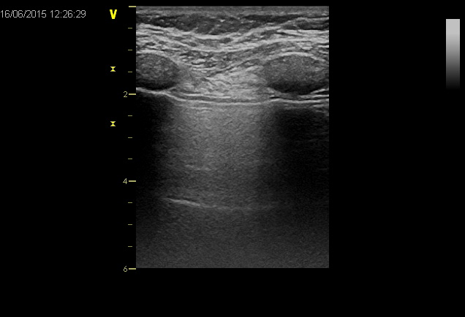
*
*
Figure 1 Longitudinal approach with longitudinal probe; allow to see upper and lower ribs (*) with their shadow’s cone, and pleural line (arrow).
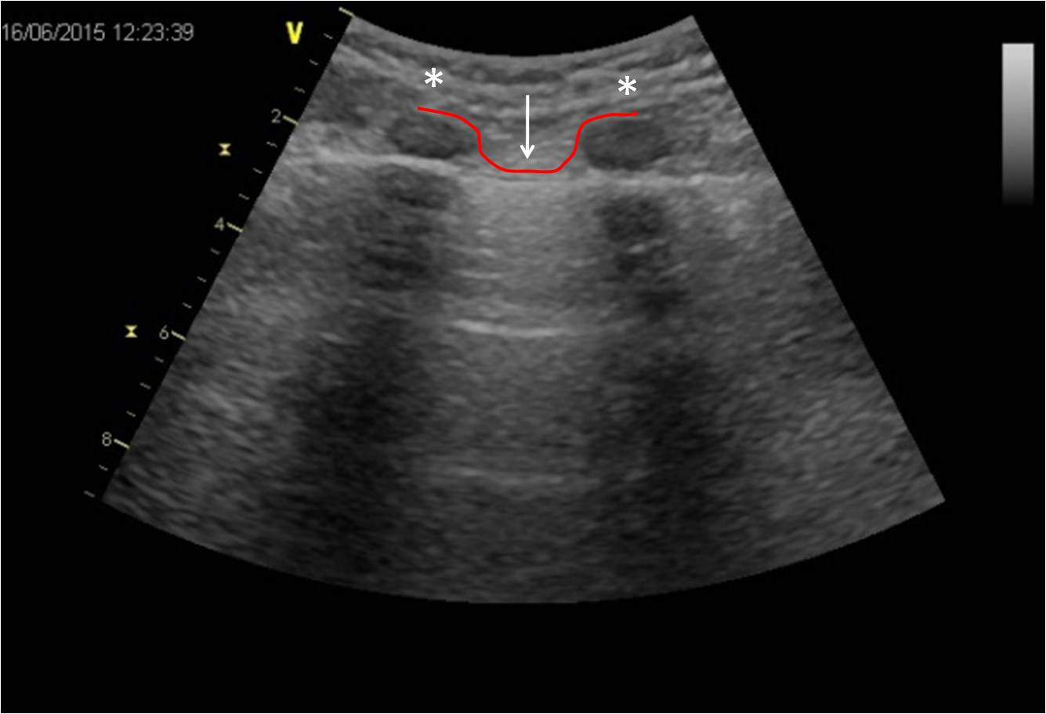
Figure 2 Bat sign with convex probe, make of two adjacent ribs with the pleural line between [upper and lower ribs are the wings of the bat* and, pleural line that is the back of the bat (arrow)]. Under the pleural line is also possible to see two A-lines.
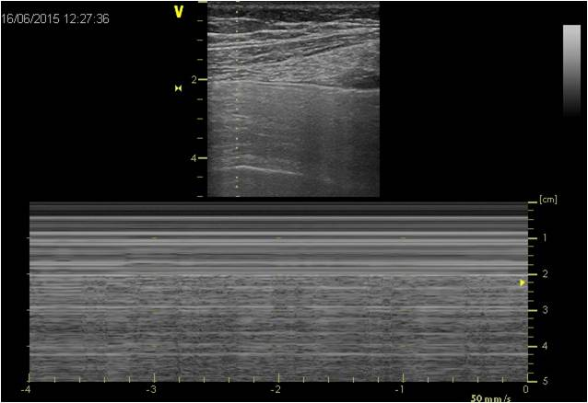
Figure 3 M-mode and seashore sign, helps to document lung sliding on a picture.

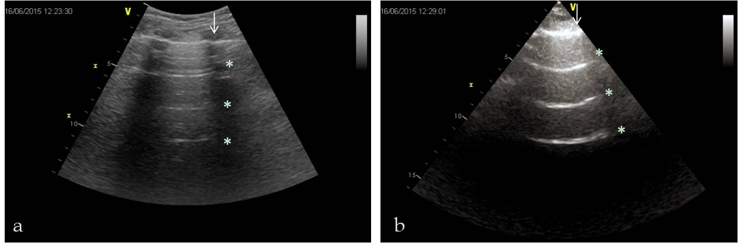

Figure 4 A-Lines. A: A-lines whit convex probe; B: A-lines whit sector probe. Arrow shows the pleural line, * shows A-lines.
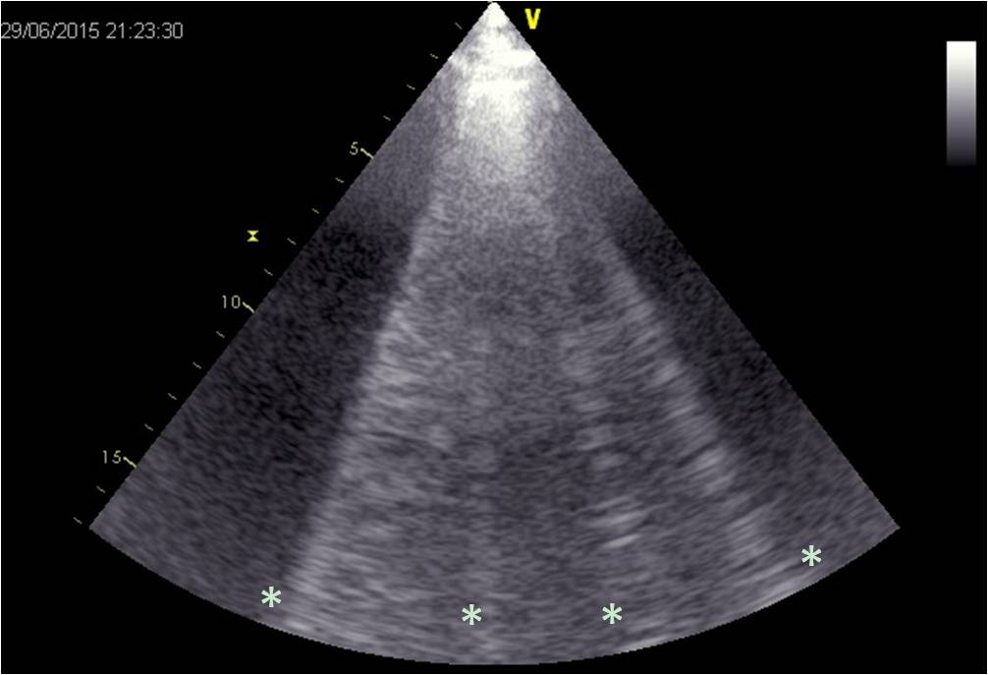
Figure 5 B-lines. *show B-lines.
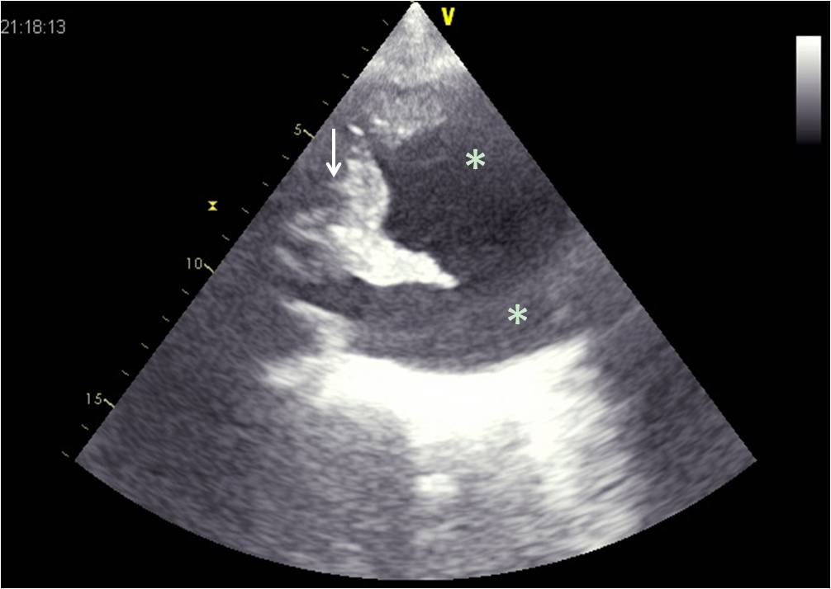
Figure 6 Pleural effusion. Pleural effusion is an echo-free (dark zone*), and determinate the compression of the lung that appear consolidated, and floating in the pleural effusion (arrow).
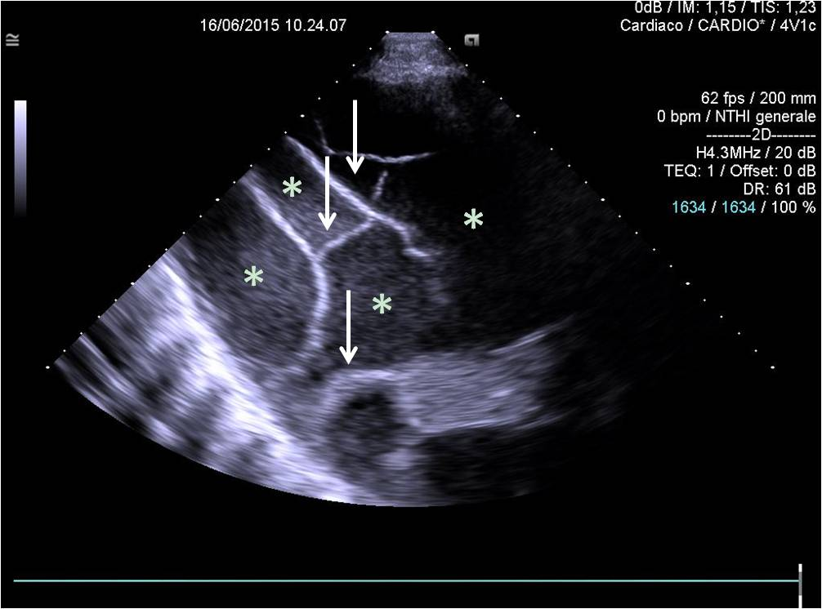
Figure 7 Loculated pleural effusion, appear as a dark zone (*) contains immobile septations (arrow) with encapsulated liquid.
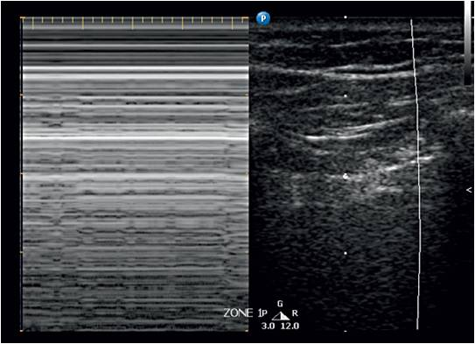
Figure 8 Stratosphere sign. Pointing M-mode in the zone characterized by the abolition of lung sliding it shows a characteristic pattern, the stratosphere sign, opposed to the normal seashore sign (by courtesy of Dr. Ilario De Sio).
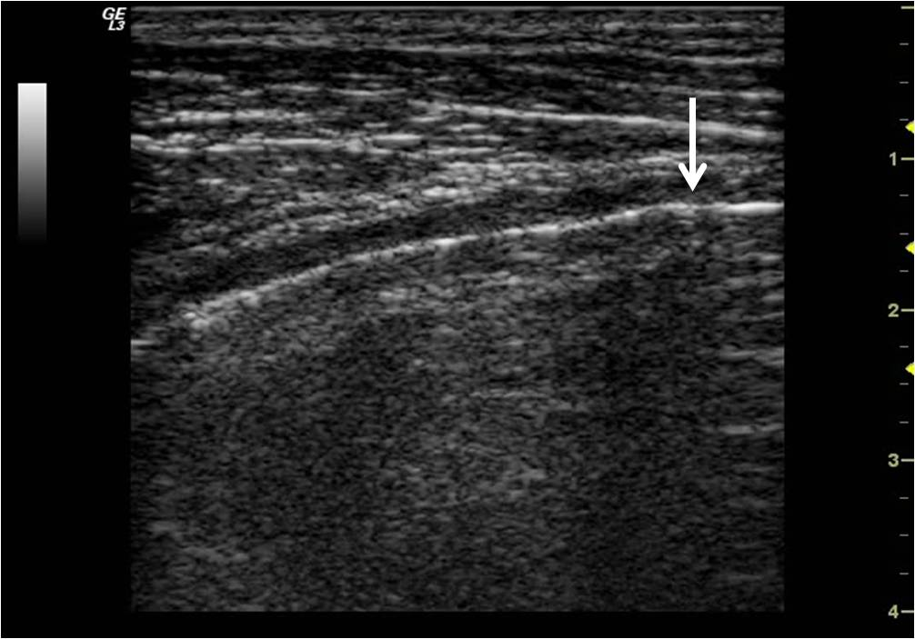
Figure 9 Lung point (arrow). Is the precise area of the chest wall, where the regular reappearance of the lung sliding replaces the pneumothorax pattern and it corresponds to the point where visceral and parietal pleura regain contact with each other (by courtesy of Dr. Lucia Morelli).
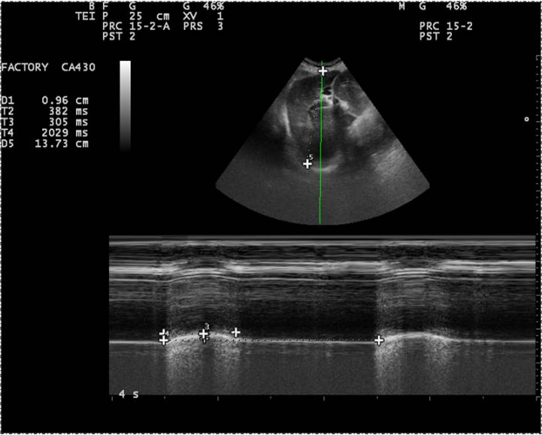
Figure 10 M-mode, diaphragmatic excursion (see the text) (by courtesy of Dr. Lucia Morelli).

