Name of Journal: World Journal of Clinical Cases
Manuscript NO: 48970
Manuscript Type: CASE REPORT

Adult intussusception caused by colonic anisakis: A case report

Choi YI et al. Anisakis and adult intussusception

Youn I Choi, Dong Kyun Park, Hyun Yee Cho, Seung Joon Choi, Jun-Won Chung, Kyung Oh Kim, Kwang An Kwon, Yoon Jae Kim

Youn I Choi, Dong Kyun Park, Hyun Yee Cho, Jun-Won Chung, Kyung Oh Kim, Kwang An Kwon, Yoon Jae Kim, Department of Gastroenterology, Gachon University, Gil Medical Center, Incheon 21565, South Korea

Seung Joon Choi, Department of Pathology, Gachon University Gil Medical Center, Incheon 21565, South Korea

ORCID number: Youn I Choi (0000-0001-6561-6752); Dong Kyun Park (0000-0002-2862-6641); Hyun Yee Cho (0000-0003-3603-5750); Seung Joon Choi (0000-0003-3861-7682); Jun-Won Chung (0000-0002-0869-7661); Kyoung Oh Kim (0000-0002-5365-2550); Kwang An Kwon (0000-0002-2947-2111); Yoon Jae Kim (0000-0001-8477-6823).

Author contributions: Choi YI, and Park DK contributed to the study concept and design; Choi YI, Cho HY, and Choi SJ analyzed and interpreted the data; Choi YI and Park DK drafed the manuscript; Park DK, Kim KO, Kwon KA, Chung JW and Kim YJ critically revised the manuscript for important intellectual content; all authors approved the final version of the manuscript submitted. All the authors do not declare any conflict of interest.

Informed consent statement: Informed written consent was obtained from the patients.

Conflict-of-interest statement: The authors declare that they have no conflict of interest.

CARE Checklist statement: The authors have read the CARE Checklist and the manuscript was prepared and revised according to the CARE Checklist.

Open-Access: This article is an open-access article which was selected by an in-house editor and fully peer-reviewed by external reviewers. It is distributed in accordance with the Creative Commons Attribution Non Commercial (CC BY-NC 4.0) license, which permits others to distribute, remix, adapt, build upon this work non-commercially, and license their derivative works on different terms, provided the original work is properly cited and the use is non-commercial. See: http://creativecommons.org/licenses/by-nc/4.0/

Manuscript source: Unsolicited Manuscript

Corresponding author: Dong Kyun Park, MD, PhD, Doctor, Professor, Department of Gastroenterology, Gachon University, Gil Medical Center, 21 Namdong-daero 774 beon-gil, Incheon 21565, South Korea. pdk66@gilhospital.com
Telephone: +82-32-4603778
Fax: +82-32-4603408

Received: May 9, 2019
Peer-review started: May 10, 2019
First decision: June 21, 2019
Revised: June 22, 2019
Accepted: July 20, 2019
Article in press:
Published online:
Abstract
BACKGROUND
Colo-colonic intussusception is an uncommon phenomenon in an adult. Adult intussusception accounts for < 5% of total cases, and the colo-colonic type is < 30% of cases. Although surgical management has been the treatment of choice for intestinal intussusception in adults, because most frequent causes for adult intussusception are malignant in origin, the importance of the roles of preoperative colonoscopic evaluation has recently been emerging.

CASE SUMMARY
We report an extremely rare case of adult colo-colonic intussusception caused by colonic anisakiasis and successfully treated by endoscopic removal of the Anisakis body. A 59-year-old man visited the emergency department due to 1 day of lower abdominal colicky pain. Abdominopelvic computed tomography (APCT) revealed the presence of mid-transverse colon intussusception without definite necrosis, which was possibly related with colorectal cancer. Because there was no evidence of necrosis at the intussusception site, a colonoscopy was performed to target the colonic lesion and obtain tissue for a histopathological diagnosis. An Anisakis body was found when inspecting the suspicious colonic lesion recorded by APCT. The Anisakis body was removed with forceps assisted by colonoscopy. The patient’s symptoms improved dramatically after removing the Anisakis. A reduced colon without any pathological findings was seen on the follow-up APCT. Without any further treatment, the patient was discharged 5 d after the endoscopy.

CONCLUSION
When colonic intussusception without necrosis occurs in an adult, physician should consider a colonoscopy to exclude causes cured by endoscopy.

Key words: Intussusception; Anisakis; Colonoscopy; Case report

© The Author(s) 2019. Published by Baishideng Publishing Group Inc. All rights reserved.

Core tip: We report an extremely rare case of adult colo-colonic intussusception caused by colonic anisakiasis and successfully treated by endoscopic removal of the Anisakis body. When colonic intussusception occurs in an adult patient and there is no evidence of necrosis of the colon, it is necessary to consider a colonoscopy to exclude causes that can be cured by endoscopy.

Choi YI, Park DK, Cho HY, Choi SJ, Chung JW, Kim KO, Kwon KA, Kim YJ. Adult intussusception caused by colonic anisakis: A case report. World J Clin Cases 2019; In press

INTRODUCTION
Eating raw marine food is popular not only in Asian countries but also in Europe and the United States, which has allowed parasitic diseases, such as anisakiasis, to emerge worldwide^{[1-3]}.
Anisakiasis is a parasitic disorder that occurs after ingesting the larval stages of ascaridoid nematodes^{[4]}. Anisakids use aquatic mammals as their definitive hosts, while humans are the incidental host after eating raw marine food infected with Anisakis third-stage larvae^{[4,5]}. The disease of anisakiasis presents after direct penetration of larvae into the gastrointestinal wall (invasive) and/or an allergic reaction (noninvasive form)^{[6]}. The invasive form of Anisakis larvae is usually found in the mucosa or submucosa of the gastric and small bowel walls, and causes problems, such as nausea, vomiting, hematemesis, and abdominal pain within a few hours after ingesting the larvae^{[6]}. Colonic anisakiasis is rare, and induces symptoms that mimic other diseases, such as acute appendicitis, ileitis, diverticulitis, cholecystitis, inflammatory bowel disease, and small bowel obstruction^{[7-10]}.
Colo-colonic intussusception is also an uncommon phenomenon in an adult^{[11]}. Adult intussusception accounts for < 5% of total cases, and the colo-colonic type is < 30% of cases, while the intestinal type accounts for most of the cases^{[11]}.
We report an extremely rare case of adult colo-colonic intussusception caused by anisakiasis, which was successfully treated by a colonoscopic intervention.

CASE PRESENTATION
Chief complaints
A 59-year-old male visited the emergency department presenting with new onset left-sided lower abdominal pain.

History of present illness
He has abdominal pain for 1 day with no febrile sense.

History of past illness
He has no known medical history.
Personal and family history
He had no specific personal or family history of cancer or cancer related disease.

Physical examination on admission
Physical examination on admission revealed that he has upper abdominal tenderness but without rebound tenderness.

Laboratory examinations
Laboratory findings, including a blood cell count, chemistry, electrolytes, C-reactive protein (CRP), and carcinoembryonic antigen (CEA) levels were within normal ranges (hemoglobin, 12.9 g/dL; white blood cell count, 7.04 × 10³/mm³; CRP, 0.04 mg/dL; and CEA, 0.69 mg/dL).

Imaging examination
He underwent a contrast enhanced abdominopelvic computed tomography scan (APCT) that showed colo-colonic intussusception in the mid-transverse colon (Figure 1). After an interdisciplinary approach on the part of the radiology, surgery, and gastroenterology departments, intussusception induced by descending colon cancer was highly suspected even though there was no definite evidence of cancer on the APCT, given that the most frequent etiology for adult colo-colonic intussusception is malignancy.

FINAL DIAGNOSIS
A multidisciplinary team decided on surgery to reduce the intussusception and treat the malignancy. Before the operation, a colonoscopy was done to target the unrevealed malignancy, as there was no definite necrosis around the colonic region with intussusception. During colonoscopic procedures, An approximately 3.0 cm sized Anisakis body, which had penetrated the colonic wall was seen in the transverse colon. The final diagnosis for patient was colo-colonic intussusception caused by colonic anisakiasis.

TREATMENT
During colonoscopy, an approximately 3.0 cm sized Anisakis body, which had penetrated the colonic wall was seen in the transverse colon (Figure 2). The Anisakis body was removed with biopsy forceps and carried to the pathology department. The final tentative diagnosis was colonic Anisakis (Figure 3).

OUTCOME AND FOLLOW-UP
After removing the Anisakis body by colonoscopy, the patient’s symptoms and lower abdominal pain completely resolved and did not require further intervention. A subsequent APCT showed successful reduction of the endoscopic intussusception (Figure 4). Without any further treatment, the patient was discharged 5 days after the endoscopy. After 6month follow up, all of the patient symptom and signs have been alleviated.

DISCUSSION
In this study, we report an extremely rare case of colo-colonic intussusception in an adult that occurred due to colonic Anisakis and was cured by endoscopic removal of Anisakis larvae.
Adult intestinal intussusception is a rare disease, which accounts for only 5% of all cases of intussusception^{[12]}. Furthermore, colo-colonic intussusception is rarer than small bowel intussusception, and accounts for < 30% of cases^{[12]}. The most common site for colo-colonic intussusception is the proximal colon, and colo-colonic intussusception in the transverse colon is particularly rare ^{[11]}.
Cases of intestinal intussusception in adults and children differ in a number of aspects, including incidence, etiology, and treatment^{[12]}. While child intussusception includes almost 95% of all intussusception cases, adult intussusception accounts for < 5% of all cases. It is the most common cause of obstruction in infants but is extremely rare in adult and accounts for < 1% of cases. While child intussusception is usually of the primary type, adult intussusception is always secondary to a benign or malignant intestinal neoplasm, stricture, or diverticulum^{[11]}. Intussusception in children is usually treated with supportive care or a contrast enema, whereas 70–90% of adult intussusceptions often require definitive treatment and surgical resection as adult intussusception is generally secondary to a benign or malignant neoplasm, diverticulum, or stricture. In this case, a rare colo-colonic intussusception occurred caused by colonic anisakiasis^{[13]}.
Intestinal anisakiasis is a parasitic disease of the gastrointestinal tract. Nematodes in the Anisakidae family cause anisakiasis^{[14]}. Humans are the incidental host in the life cycle after eating raw or uncooked fish containing Anisakis larvae^{[14]}. In this regard, intestinal anisakiasis is prevalent in Asian countries where sushi or raw fish is popular.
The mechanism that precipitates intestinal intussusception is unclear. It has generally been accepted that an injury or irritation of the intestinal wall can alter normal peristalsis of the intestine related with the process of invagination^{[13]}. Colonic Anisakis is a cause of wall injury, particularly when the Anisakis larva penetrates the colon wall; therefore, colonic Anisakis is a cause of colo-colonic intussusception even though colonic Anisakis is extremely rare. In this case, colonic Anisakis may have been the cause of the colo-colonic intussusception, as the patient’s symptoms were relieved and the colonic intussusception was reduced after removing the larva^{[7,13]}.
In contrast to previously reported cases, colo-colonic intussusception in this case was successfully resolved by endoscopic reduction in an acute setting (< 24 h), and the cause of the intussusception was promptly diagnosed. Surgical management has been the treatment of choice for intestinal intussusception in adults, because most frequent causes for adult intussusception are malignant in origin. However, a preoperative colonoscopy should be carefully considered especially for cases with no evidence of necrosis of colon in initial imaging study to detect the cause which may be amenable to endoscopic intervention and to avoid an unnecessary surgical procedure. In this case, colo-colonic intussusception, without any evidence of colonic necrosis on the initial image studies including abdominal pelvic computed tomography, was successfully resolved by endoscopic reduction in an acute setting (< 24 h). Further studies comparing endoscopic (or preoperative diagnostic endoscopy) and surgical procedures on long-term outcomes are needed.
The treatment of choice for anisakiasis is endoscopic removal of the nematode, and the clinical symptoms usually stop^{[15]}. In this case, the patient’s symptoms were relieved after endoscopic removal of the Anisakis larva^{[15]}. However, chronic cases with the evidence of the infected lesions on intestine should be considered surgical resection, and administration of tribendazole even though it is ineffective^{[16]}.

CONCLUSION
In conclusion, when colo-colonic intussusception occurs in adult patients, and without definite evidence of necrosis in the intestinal tract, a colonoscopy should be considered to exclude the cause that could be cured by endoscopy and to avoid an unnecessary surgical procedure. Further studies comparing endoscopic (or preoperative diagnostic endoscopy) and surgical procedures on long-term outcomes are needed.

REFERENCES
1 Bao M, Pierce GJ, Pascual S, González-Muñoz M, Mattiucci S, Mladineo I, Cipriani P, Bušelić I, Strachan NJ. Assessing the risk of an emerging zoonosis of worldwide concern: anisakiasis. Sci Rep 2017; 7: 43699 [PMID: 28287609 DOI: 10.1038/srep43699]
2 Bucci C, Gallotta S, Morra I, Fortunato A, Ciacci C, Iovino P. Anisakis, just think about it in an emergency! Int J Infect Dis 2013; 17: e1071-e1072 [PMID: 23850538 DOI: 10.1016/j.ijid.2013.05.008]
3 Garcia-Perez JC, Rodríguez-Perez R, Ballestero A, Zuloaga J, Fernandez-Puntero B, Arias-Díaz J, Caballero ML. Previous Exposure to the Fish Parasite Anisakis as a Potential Risk Factor for Gastric or Colon Adenocarcinoma. Medicine (Baltimore) 2015; 94: e1699 [PMID: 26448021 DOI: 10.1097/md.0000000000001699]
4 Cavallero S, Martini A, Migliara G, De Vito C, Iavicoli S, D'Amelio S. Anisakiasis in Italy: Analysis of hospital discharge records in the years 2005-2015. PLoS One 2018; 13: e0208772 [PMID: 30533066 DOI: 10.1371/journal.pone.0208772]
5 Yera H, Fréalle É, Dutoit E, Dupouy-Camet J. A national retrospective survey of anisakidosis in France (2010-2014): decreasing incidence, female predominance, and emerging allergic potential. Parasite 2018; 25: 23 [PMID: 29637891 DOI: 10.1051/parasite/2018016]
6 Sohn WM, Na BK, Kim TH, Park TJ. Anisakiasis: Report of 15 Gastric Cases Caused by Anisakis Type I Larvae and a Brief Review of Korean Anisakiasis Cases. Korean J Parasitol 2015; 53: 465-470 [PMID: 26323845 DOI: 10.3347/kjp.2015.53.4.465]
7 Tamai Y, Kobayashi K. Asymptomatic colonic anisakiasis. Intern Med 2015; 54: 675 [PMID: 25786462 DOI: 10.2169/internalmedicine.54.3649]
8 Schuster R, Petrini JL, Choi R. Anisakiasis of the colon presenting as bowel obstruction. Am Surg 2003; 69: 350-352 [PMID: 12716097]
9 Yoo HJ, Kim SH, Lee JM, Kim MA, Han JK, Choi BI. The association of anisakiasis in the ascending colon with sigmoid colon cancer: CT colonography findings. Korean J Radiol 2008; 9 Suppl: S56-S60 [PMID: 18607128 DOI: 10.3348/kjr.2008.9.s.s56]
10 Yorimitsu N, Hiraoka A, Utsunomiya H, Imai Y, Tatsukawa H, Tazuya N, Yamago H, Shimizu Y, Hidaka S, Tanihira T, Hasebe A, Miyamoto Y, Ninomiya T, Abe M, Hiasa Y, Matsuura B, Onji M, Michitaka K. Colonic intussusception caused by anisakiasis: a case report and review of the literature. Intern Med 2013; 52: 223-226 [PMID: 23318852]
11 Wang N, Cui XY, Liu Y, Long J, Xu YH, Guo RX, Guo KJ. Adult intussusception: a retrospective review of 41 cases. World J Gastroenterol 2009; 15: 3303-3308 [PMID: 19598308]
12 Honjo H, Mike M, Kusanagi H, Kano N. Adult intussusception: a retrospective review. World J Surg 2015; 39: 134-138 [PMID: 25192846 DOI: 10.1007/s00268-014-2759-9]
13 Ramos L, Alonso C, Guilarte M, Vilaseca J, Santos J, Malagelada JR. Anisakis simplex-induced small bowel obstruction after fish ingestion: preliminary evidence for response to parenteral corticosteroids. Clin Gastroenterol Hepatol 2005; 3: 667-671 [PMID: 16206499]
14 Mumoli N, Merlo A. Colonic anisakiasis. CMAJ 2013; 185: E652 [PMID: 23251024 DOI: 10.1503/cmaj.120909]
15 Kojima G, Usuki S, Mizokami K, Tanabe M, Machi J. Intestinal anisakiasis as a rare cause of small bowel obstruction. Am J Emerg Med 2013; 31: 1422.e1-1422.e2 [PMID: 23786678 DOI: 10.1016/j.ajem.2013.05.015]
16 Guardone L, Armani A, Nucera D, Costanzo F, Mattiucci S, Bruschi F. Human anisakiasis in Italy: a retrospective epidemiological study over two decades. Parasite 2018; 25: 41 [PMID: 30058531 DOI: 10.1051/parasite/2018034]

P-Reviewer: Ziogas DE S-Editor: Cui LJ L-Editor: E-Editor:

Specialty type: Medicine, research and experimental
Country of origin: South Korea
Peer-review report classification
Grade A (Excellent): 0
Grade B (Very good): B
Grade C (Good): 0
Grade D (Fair): 0
Grade E (Poor): 0

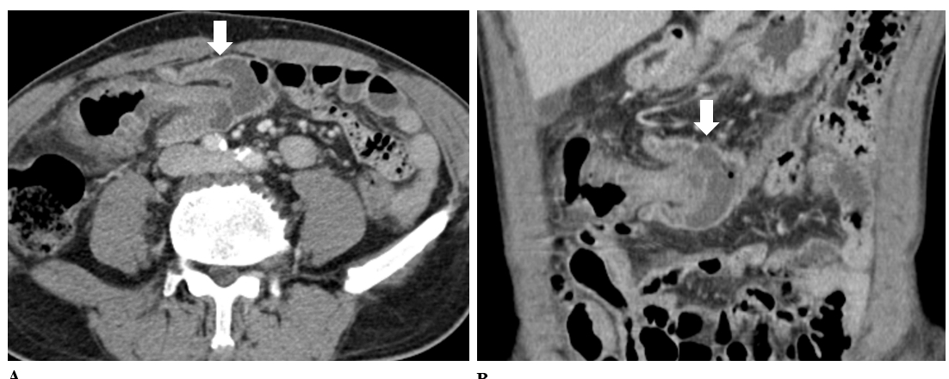
a B
Figure 1 Pre-treatment abdominopelvic computed tomography. A and B: Axial and coronal reformatted images of contrast-enhanced computed tomography show a colo-colonic intussusception with subepithelial edema in mid transverse colon (white arrows). There is no evidence of visible tumor at intussusception in computed tomography.

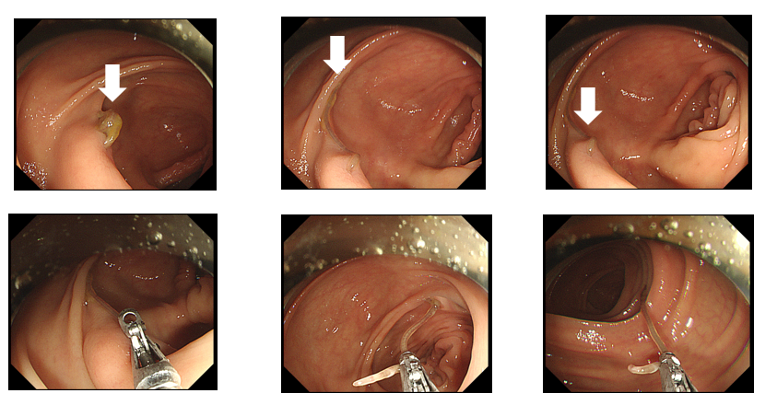Figure 2 Series of endoscopic image of descending colon demonstrating biopsy forceps removing Anisakis simplex (arrow).
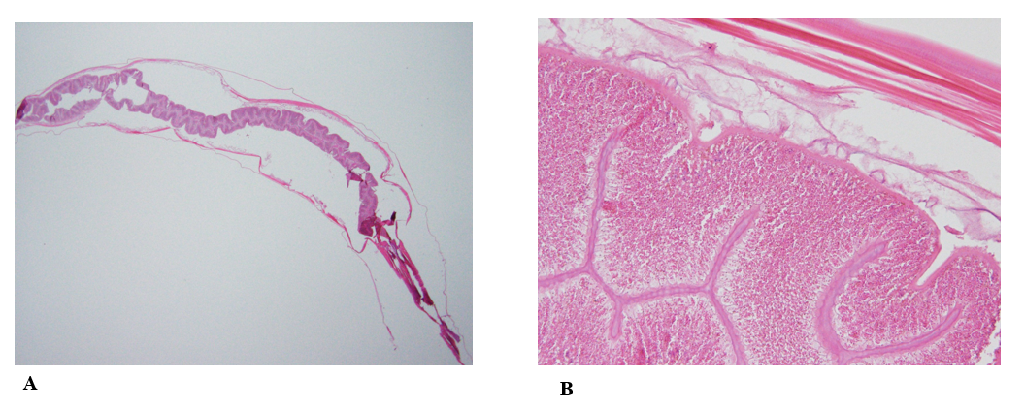Figure 3 Histopathologic images of the Anisakis body. Histopathological findings of the specimen. A: Longitudinal section of Anisakis larva. The nematode is 2.9 cm in length and 0.1 cm in width (hematoxylin and eosin stain; × 12.5); B: High magnification showing cuticle and intestine (× 200).

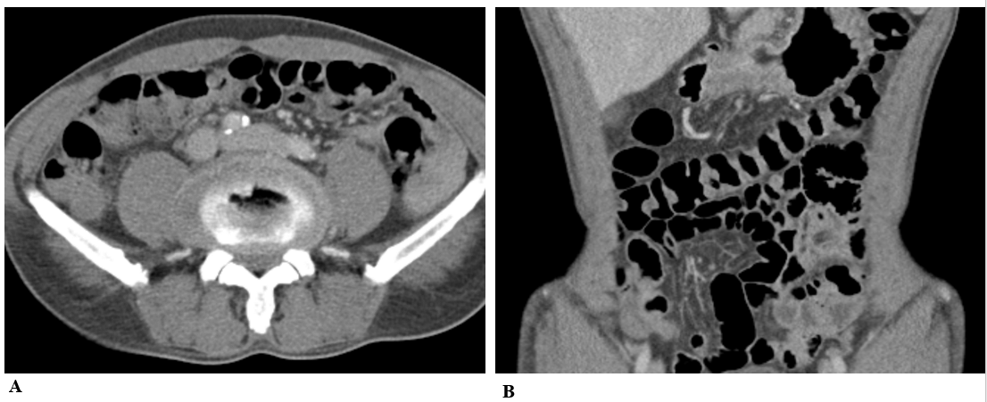Figure 4 Post treatment abdominopelvic computed tomography. A and B: After removal state of parasite, repeated computed tomography images demonstrate the disappearance of colo-colonic intussusception.

