Name of Journal: World Journal of Gastroenterology
Manuscript NO: 75788
Manuscript Type: SCIENTOMETRICS

Global research on Clostridium difficile-associated diarrhoea: A visualized study

Zyoud SH. Clostridium difficile-associated diarrhoea

Sa'ed H Zyoud

Sa'ed H Zyoud, Department of Clinical and Community Pharmacy, College of Medicine and Health Sciences, An-Najah National University, Nablus 44839, Palestine

Sa'ed H Zyoud, Poison Control and Drug Information Center, College of Medicine and Health Sciences, An-Najah National University, Nablus 44839, Palestine

Sa'ed H Zyoud, Clinical Research Centre, An-Najah National University Hospital, Nablus 44839, Palestine

Author contributions: Zyoud S developed the concept for the manuscript, reviewed the literature, formulated research questions, collected the data, conducted analyses and interpreted the data, and wrote the manuscript, the author read and approved the final manuscript.

Corresponding author: Sa'ed H Zyoud, PhD, Associate Professor, Department of Clinical and Community Pharmacy, College of Medicine and Health Sciences, An-Najah National University, Academic Street, Nablus 44839, Palestine. saedzyoud@yahoo.com

Received: February 15, 2022
Revised: March 12, 2022
Accepted: June 22, 2022
Published online:

Abstract
BACKGROUND
Clostridioides (Clostridium) difficile (C. difficile) is still the most common cause of healthcare-associated diarrhoea and is increasing in prevalence as a community-acquired infection. In addition, the emergence of antibiotic resistance in C. difficile can increase the likelihood of the disease developing and/or spreading.

AIM
To provide an up-to-date picture of the trends in publications related to C. difficile infection, together with specific insights into hot-button issues in this field.

METHODS
Publications on C. difficile infections in the field of microbiology between 2001 and 2020 were identified from the Scopus database and Reference Citation Analysis. Bibliometric indicators were determined, including the number and type of publications, countries, affiliations, funding agencies, journals and citation patterns. VOSviewer was used to determine research areas and hot-button issues by identifying recurring terms with a high relative occurrence in the title and abstract.

RESULTS
A total of 8127 documents on ‘C. difficile-associated diarrhoea’ published between 2001 and 2020 were retrieved from the Scopus database. In the last decade, there has been a significant almost fourfold increase in the number of published papers on this topic. The United States was among the countries (44.11%) with the most publications, and the most involved institution was the University of Leeds in the United Kingdom (2.50%). Three clusters of research were identified and included ‘illness spectrum and severity, as well as the signs, symptoms and clinical pathogenesis of C. difficile’; ‘laboratory diagnosis and characterization of C. difficile’ and ‘risk factors for C. difficile infection’.

CONCLUSION
This study contains the most up-to-date and comprehensive data ever compiled in this field. More international research and cross-institutional collaborations are needed to address more global C. difficile concerns and to benefit from greater sharing of expertise, which will result in higher quality or more effective studies in the future. Promising research avenues in the near future may draw the attention of relevant scientists and funding organizations and open up novel C. difficile infection–based diagnosis and treatment approaches.

Key Words: Clostridioides; Clostridium difficile; Bibliometric; Scopus; VOSviewer; Diarrhoea

Zyoud SH. Global research on Clostridium difficile-associated diarrhoea: A visualized study. World J Gastroenterol 2022; In press

Core Tip: The significance of this study lies in the fact that, to our best knowledge, there are no previous bibliometric studies on Clostridioides (Clostridium) difficile (C. difficile) infection research. This study presents the evolution of C. difficile infection-related publications over time. This bibliometric study will provide clinicians and researchers in gastroenterology and microbiology with a quantitative and timely summary of C. difficile infection-related publications. Promising research avenues in the near future may draw the attention of relevant scientists and funding organizations and open up novel C. difficile infection–based diagnosis and treatment approaches.

INTRODUCTION
Clostridium difficile (C. difficile) has been reclassified as Clostridioides difficile, although the preferred term remains C. difficile. C. difficile infections are increasing in prevalence and are among the most common healthcare-associated illnesses globally^{[1-3]}. C. difficile infections, also known as C. difficile-associated diarrhoea, are the most common signs of clinical infection and can range from mild diarrhoea to fulminant colitis^{[4]}. C. difficile is frequently linked to the use of antibiotics. C. difficile was once thought to be predominantly a nosocomial illness; however, community-acquired C. difficile has already been identified^{[3]}.
Metronidazole and vancomycin have been the primary treatments for C. difficile infections for more than three decades. However, the low number of sustained cures and the rising incidence of C. difficile infections, as well as the accompanying morbidity and death, have necessitated the development and investigation of novel treatment approaches^{[1,5]}. Despite ongoing attempts to enhance C. difficile prevention and treatment, C. difficile continues to be a major public health concern. In both hospitals and the community, C. difficile infection is still a prevalent and dangerous problem. In recent years, faecal microbial transplantation has been developed as a safe and successful method of treatment for recurrent infections^{[6-11]}. Therefore, faecal microbial transplantation will most likely become the standard therapy for recurrent infection as a novel technique^{[6-11]}.
Bibliometrics and research performance assessments have been performed in a broad range of health areas^{[12,13]}, particularly to address environmental^{[14-17]}, and toxicological^{[18]} issues. Yet, to our knowledge, a large number of bibliometric studies noticeably focused on microbiology^{[19-23]} have been conducted by using different databases for data analysis. Because of these studies^{[19-23]}, microbiology research has recently been given increased scientific attention worldwide. Still, more research efforts are needed to thoroughly review and identify the existing literature related to C. difficile infection from different aspects, including authorships, country, affiliation, journals, citation patterns, and content analysis, to determine the research areas that are hot-button issues in this field.
C. difficile infection is considered one of the most debated topics in this era. Using the bibliometric approach to C. difficile infection would affect how scientists design and conduct studies and the selection of models that estimate risk. Using a bibliometric analysis of publications in Scopus, this study provides an up-to-date picture of the trends in publications related to C. difficile infection, together with specific insights into hot-button issues in this field. The significance of this study lies in the fact that, to our best knowledge, there are no previous bibliometric studies on C. difficile infection research. Therefore, this study presents the evolution of C. difficile infection-related publications over time. This bibliometric study will provide clinicians and researchers in gastroenterology and microbiology with a quantitative and timely summary of C. difficile infection-related publications. Furthermore, it aims to provide clinicians and researchers with a resource for principles and current evidence. A detailed understanding of the historical trends in this field of research and its obstacles may help to establish a framework for future gastroenterology scholarship.

MATERIALS AND METHODS
Data acquisition
The research data were taken from the Scopus bibliographic database and Reference Citation Analysis (RCA) (https://www.referencecitationanalysis.com/). Scopus was chosen because it has a larger number of indexed journals than other databases (e.g. PubMed or Web of Science) and is completely inclusive of all journals in Medline^{[24-26]}. Scopus is the most popular set of scientific publications used in bibliometric and scientometric studies, together with PubMed or Web of Science^{[27]}. In addition, Scopus contains indexed journals in the health, social, physical and life sciences. This enhances the likelihood of retrieving as many relevant publications as is feasible. Baishideng Publishing Group Inc. owns RCA, which is an open transdisciplinary citation analysis database (Pleasanton, CA 94566, United States)^{[28]}.

Search strategy
To identify studies related to C. difficile-associated diarrhoea, we took the following steps.

Step 1: Data extraction was performed on July 25, 2021 and the results obtained within one day to avoid potential bias due to the regular updating of the database. The terms used in the search engines were applied in Title ((TITLE (Clostrid* difficile) OR TITLE(‘C. diff*’) OR TITLE(‘Cl. diff*’)))) AND Title/Abstract (TITLE-ABS(diarrh*) OR TITLE-ABS(Antibiotic) OR TITLE-ABS(infection) OR TITLE-ABS(AAD)). More precisely, in the results, the search strategy for research related to Clostridium difficile terms was limited to the title only to eliminate false-negative results. Search terms with different suffixes were truncated using an asterisk (*). The keywords used were chosen because they are commonly used in the literature related to C. difficile-associated diarrhoea^{[3,29-31]}.

Step 2: The year 2021 was omitted because the database records for this year would not have been completed at the time of the search.

Step 3: All retrieved documents were reviewed and analysed with respect to the following different bibliometric indicators, as in previous bibliometric studies^{[13,32-34]}: (1) The annual number of publications on C. difficile-associated diarrhoea indexed in Scopus and published from 2001 to 2020; (2) Prolific countries, journals, and authors in this field in relation to the number of publications; (3) Research collaboration among the most productive countries; (4) The most frequently cited publications. It is likely that certain articles were cited more frequently than others due to the considerable period that had passed since their publication. Therefore, a citation index was generated for each article to overcome the bias caused by the period that had passed since publication. The citation index is derived by dividing the average number of citations by the number of years since the article was first published; (5) Hot-button issues in this field; and (6) RCA was used to determine the impact index per article for the top ten most-cited publications.

Step 4: A network visualization map based on the publications retrieved from the Scopus database was created using VOSviewer (version 1.6.16) software (www.vosviewer.com). The output results from VOSviewer are displayed in clusters. The existing connections between the bibliometric data can be clearly visualized to analyse collaboration between countries. Furthermore, it illustrated the terms widely used in the titles and abstracts of the publications collected, showing the hot research topics.

RESULTS
General description of the retrieved publications
A total of 8127 documents on ‘C. difficile-associated diarrhoea’ published between 2001 and 2020 were retrieved from the Scopus database. From these publications, articles (n = 6062) were the most often published documents, comprising 74.59% of the total, followed by reviews (n = 1016; 12.50%) and letters (n = 384; 4.72%).

The trend of global publications
As shown in Figure 1, there was a growing trend in the number of publications on C. difficile-associated diarrhoea in the Scopus database between 2001 and 2020. It is obvious that there was an increasing number of publications mostly during two periods: From 2006 to 2013 and from 2014 to 2020. Since 2006, the number of relevant articles grew significantly, which is notable. Papers published during the last seven years (2014 to 2020) accounted for 60.16% of the total publications. As a result of these findings, the number of yearly publications grew progressively from 2014 to 2020, showing that the amount of research output increased steadily over that period.

Contributions by country
Table 1 shows that the United States was the most prolific country, whose authors published the most documents (n = 3585), followed by the United Kingdom (n = 1013), Canada (n = 556), and Germany (n = 434). The first 10 countries in Table 1 produced 89.84% of the documents published related to C. difficile-associated diarrhoea. Analysis of international collaboration was conducted on the downloaded data based on co-authorship relationships between countries (Figure 2).

Contributions by institution
The top 10 most productive institutes in terms of total papers are listed in Table 2. The major academic contributions mainly originated from University of Leeds (2.50%), Leiden University Medical Center (2.35%) and Harvard Medical School (2.25%).

Contributions by funding agency
Table 3 lists the top 10 global funding agencies that sponsored research output on C. difficile-associated diarrhoea. Among them, eight agencies were from the United States, and two were from the United Kingdom. The National Institutes of Health ranked first, supporting the highest number of studies at 884. The U.S. Department of Health and Human Services ranked second (n = 841), and the National Institute of Allergy and Infectious Diseases ranked third (n = 539).

Most active journals
The 10 most prolific journals are presented in Table 4. The most productive journal was Infection Control and Hospital Epidemiology (n = 304), followed by Anaerobe (n = 276), Clinical Infectious Diseases (n = 251) and Journal of Hospital Infection (n = 212). Thus, the first 10 journals in Table 4 produced 23.97% of the documents published related to C. difficile-associated diarrhoea.

Most cited documents
Table 5 presents the 10 most often cited articles published on C. difficile-associated diarrhoea^{[35-44]}. Furthermore, the ten most cited articles have an impact index per article of 45.6 to 313.9 (Table 5).

Most frequent topics
We studied the distribution of co-occurrence terms using VOSviewer software (the minimum number of occurrences of a term in all publications is 100 times in titles and abstracts) to detect directions and topics in C. difficile-associated diarrhoea research and understand the growth of this discipline. The size of the circle or node of a term equals that particular term's number of occurrences. For example, in Figure 3, of the 84961 terms, 385 terms occurred at least 100 times, distributed in three clusters: Cluster 1, shown by green dots, includes those terms commonly found in studies related to clinical features of C. difficile, including the illness spectrum and severity, as well as the signs, symptoms and clinical pathogenesis of C. difficile. Cluster 2, shown by blue dots, includes those terms commonly found in laboratory diagnosis and characterization studies of C. difficile. Cluster 3, indicated by red dots, includes terms commonly found in studies related to risk factors for C. difficile infections. To investigate the changes in hotspots over time, a network visualization map of the most frequent terms in the titles/abstracts of the retrieved documents was generated using VOSviewer software, and the results revealed that the topic ‘risk factors for C. difficile infection’ began to appear more frequently in the last five years (Figure 4).

DISCUSSION
The current study was a descriptive study on global research output of publications related to C. difficile infection. It is important to examine the quantity and quality of research in this field, given the changing epidemiology of C. difficile morbidity and mortality, worldwide escalation of antibiotic resistance and limited alternative preventive strategies for C. difficile infection. This bibliometric analysis will aid in revealing key milestones and progressions in this field, detecting current shortages and developing trends and directing the field's future research path. The current study showed a fourfold increase in publications in the last decade. These results reflect those of Balsells et al^{[45]} and Ofosu^{[46]}, who also stated that in recent years, there had been a growing understanding of the principle of C. difficile infection, the risk factors associated with C. difficile infection, the pathogenesis and clinical manifestation, prevention, diagnosis and C. difficile infection treatment, including new emerging therapies and faecal microbiota transplantation.
The United States was the leading country in C. difficile infection-related publications, contributing about half of all Scopus publications in this field. This is presumably due to economic prosperity and population growth, and the large number of microbiology researchers^{[47,48]}. The economic basis plays an essential part in supporting scientific research in the current study. The majority of the top 10 funding agencies were based in the United States. High-income countries have published most C. difficile infection-related publications, with limited input from low- and middle-income countries. An analysis of the countries that generated the most C. difficile infection-related publications indicates that countries with economic power indicators have the greatest say in this field. This finding broadly supports the work of other studies in different areas linking scientific research output with geographical location and financial growth^{[12,49,50]}. Various bibliometric analysis studies have also shown that the United States is the most prolific country in microbiology research output^{[19,20,23,51]}.
The current study showed that the most frequently cited article on C. difficile-associated diarrhoea, written by Cohen et al^{[35]} and published in 2010, with 2370 citations, is a guideline that updates the recommendations for epidemiology, diagnostics, therapeutics, infection control, and environmental management. The second most frequently cited paper has 2140 citations and addresses the effect of duodenal infusion of donor faeces in patients with recurrent C. difficile infection; this article, published in 2013, was written by van Nood et al^{[42]}. These two papers receive approximately 237 and 305.7 citations per year on average, respectively. However, the article with the second-highest number of citations per year, placed fourth in the ranking, was published in 2015 and was written by Lessa et al^{[44]}. This paper aimed to produce more accurate national estimates the burden of illness, incidence, recurrence and death by collecting data from a variety of health care delivery and community contexts. Note that five papers published after 2010 appear in the top 10 most cited publications between 2001 and 2020 in C. difficile-associated diarrhoea.
Although it is challenging to reveal the quality or impact of publications through bibliometric analysis, to some degree, citations are considered an indirect measure of an article's contribution to the knowledge generated in the field, i.e. the connection between the research finding and its significance for science^{[52,53]}. However, these analyses of the top 10 most cited publications will guide microbiologists interested in further studies by updating knowledge of current developments in C. difficile infection-related publications and potential future directions for study.
Analysis of the frequencies of occurrence of terms in publications can offer insights into certain fields' main and hot topics^{[54]}. The current study found that highly cited literature focused on the signs, symptoms and clinical pathogenesis of C. difficile concepts and risk factors for C. difficile infections. A clear theme to emerge from the results is that the most frequently cited publications on C. difficile infections highlighted a range of subtopics similar to the hot research topics. A recent bibliometric study^{[55]} was defined to assess global research activity on antimicrobial stewardship as one measure for efforts dedicated to containing antimicrobial resistance. This study found that C. difficile was frequently encountered as author keywords in the retrieved literature on antimicrobial stewardship. The United States Centers for Disease Control and Prevention has considered C. difficile infection an urgent danger in its 2019 Antibiotic Resistance Threats Report^{[56]}. In a European point prevalence study, C. difficile was rated sixth among bacteria responsible for healthcare-associated illnesses^{[57]}. The majority of C. difficile infections in the United States are considered hospital acquired^{[58]}.

Strengths and limitations
This study offered the first bibliometric analysis of C. difficile infections from the unique perspective of its research hotspots to determine the influential scientific areas and global trends. C. difficile infection-based publications in microbiology were collected in the online Scopus database and analysed comprehensively, thoroughly and objectively. As with all previous bibliometric studies^{[13,31,32,59]}, the current study has some limitations. First, we preferentially selected English articles from the database but lost some articles that were not in English. Second, we chose Scopus alone as the data source for C. difficile infection research because it presented the most reliable and credible information. Inevitably, any useful information from other medical sources such as PubMed and Web of Science would be overlooked. On the other hand, Scopus remains the best database available for analysing research activity and identifying research hotspots on a certain topic. Given these limitations, we believe that this study offers a qualified global view of C. difficile infection-based publications in the field of microbiology from 2001 to 2020.

CONCLUSION
The current study used a bibliometric analysis of C. difficile infection-based publications in the fields of microbiology and gastroenterology during the period 2001–2020 to determine research hotspots for possible future directions. The results showed that C. difficile-based publications have grown rapidly since 2006. Research activity on C. difficile infections has been an emerging topic during the last two decades and has been developed predominantly by scientists from the United States of America, the United Kingdom, Canada, Germany, France and China. Risk factors for C. difficile infection, laboratory diagnosis and characterization of C. difficile, signs, symptoms and clinical pathogenesis of C. difficile concepts were the main research hotspots in C. difficile infection, and related studies should pioneer these fields in the future. Promising research avenues in the near future may draw the attention of relevant scientists and funding organizations and open up novel C. difficile infection–based diagnosis and treatment approaches.

ARTICLE HIGHLIGHTS
Research background
Clostridioides (Clostridium) difficile (C. difficile) infections are growing more prevalent and are now one of the most often encountered healthcare-associated infections worldwide.

Research motivation
To our best knowledge, however, a large number of bibliometric studies notably focused on microbiology have been undertaken by using various databases for data analysis. More research efforts are still required to thoroughly analyse and identify the existing literature related to C. difficile infection from many perspectives in order to identify study area hot issues in this field.

Research objectives
This study gives an up-to-date picture of the trends in publications linked to C. difficile infection, as well as unique insights into hot topics in this field.

Research methods
This study was based on a bibliometric analysis of Scopus and Reference Citation Analysis publications.

Research results
Three clusters of research were highlighted as hot topics: ‘illness spectrum and severity, as well as signs, symptoms and clinical pathogenesis of C. difficile’; ‘laboratory diagnosis and characterization of C. difficile’ and ‘risk factors for C. difficile infection’.

Research conclusions
The current study conducted a bibliometric analysis of C. difficile-related publications in the disciplines of microbiology and gastroenterology from 2001 to 2020 to identify research hotspots for potential future directions. Results revealed that the topic ‘risk factors for C. difficile infection’ began to appear more frequently in the last five years.

Research perspectives
This bibliometric study will provide clinicians and researchers in gastroenterology and microbiology with a quantitative and timely summary of publications linked to C. difficile infection. It also intends to be a resource for clinicians and researchers on principles and current evidence.

REFERENCES
1 Beinortas T, Burr NE, Wilcox MH, Subramanian V. Comparative efficacy of treatments for Clostridium difficile infection: a systematic review and network meta-analysis. Lancet Infect Dis 2018; 18: 1035-1044 [PMID: 30025913 DOI: 10.1016/S1473-3099(18)30285-8]
2 Burke KE, Lamont JT. Clostridium difficile infection: a worldwide disease. Gut Liver 2014; 8: 1-6 [PMID: 24516694 DOI: 10.5009/gnl.2014.8.1.1]
3 Curcio D, Cané A, Fernández FA, Correa J. Clostridium difficile-associated Diarrhea in Developing Countries: A Systematic Review and Meta-Analysis. Infect Dis Ther 2019; 8: 87-103 [PMID: 30659481 DOI: 10.1007/s40121-019-0231-8]
4 Leffler DA, Lamont JT. Clostridium difficile infection. N Engl J Med 2015; 372: 1539-1548 [PMID: 25875259 DOI: 10.1056/NEJMra1403772]
5 DuPont HL. Search for the optimal antimicrobial therapy of Clostridium difficile infection. Lancet Infect Dis 2018; 18: 936-937 [PMID: 30025912 DOI: 10.1016/S1473-3099(18)30308-6]
6 Haifer C, Paramsothy S, Borody TJ, Clancy A, Leong RW, Kaakoush NO. Long-Term Bacterial and Fungal Dynamics following Oral Lyophilized Fecal Microbiota Transplantation in Clostridioides difficile Infection. mSystems 2021; 6 [PMID: 33531405 DOI: 10.1128/mSystems.00905-20]
7 Hourigan SK, Nicholson MR, Kahn SA, Kellermayer R. Updates and Challenges in Fecal Microbiota Transplantation for Clostridioides difficile Infection in Children. J Pediatr Gastroenterol Nutr 2021; 73: 430-432 [PMID: 34238831 DOI: 10.1097/MPG.0000000000003229]
8 Khoruts A, Staley C, Sadowsky MJ. Faecal microbiota transplantation for Clostridioides difficile: mechanisms and pharmacology. Nat Rev Gastroenterol Hepatol 2021; 18: 67-80 [PMID: 32843743 DOI: 10.1038/s41575-020-0350-4]
9 Li Y, Honda K. Toward the development of defined microbial therapeutics. Int Immunol 2021; 33: 761-766 [PMID: 34232990 DOI: 10.1093/intimm/dxab038]
10 D Goldenberg S, Merrick B. The role of faecal microbiota transplantation: looking beyond Clostridioides difficile infection. Ther Adv Infect Dis 2021; 8: 2049936120981526 [PMID: 33614028 DOI: 10.1177/2049936120981526]
11 Sehgal K, Khanna S. Gut microbiome and Clostridioides difficile infection: a closer look at the microscopic interface. Therap Adv Gastroenterol 2021; 14: 1756284821994736 [PMID: 33747125 DOI: 10.1177/1756284821994736]
12 Liu H, Chen H, Hong R, Liu H, You W. Mapping knowledge structure and research trends of emergency evacuation studies. Safety Sci 2020; 121: 348-361 [DOI: 10.1016/j.ssci.2019.09.020]
13 Al-Jabi SW. Arab world's growing contribution to global leishmaniasis research (1998-2017): a bibliometric study. BMC Public Health 2019; 19: 625 [PMID: 31118003 DOI: 10.1186/s12889-019-6969-9]
14 Briganti M, Delnevo CD, Brown L, Hastings SE, Steinberg MB. Bibliometric Analysis of Electronic Cigarette Publications: 2003-2018. Int J Environ Res Public Health 2019; 16: E320 [DOI: 10.3390/ijerph16030320]
15 Olisah C, Okoh OO, Okoh AI. Global evolution of organochlorine pesticides research in biological and environmental matrices from 1992 to 2018: A bibliometric approach. Emerg Contam 2019; 5: 157-167 [DOI: 10.1016/j.emcon.2019.05.001]
16 Yang B, Huang K, Sun D, Zhang Y. Mapping the scientific research on non-point source pollution: a bibliometric analysis. Environ Sci Pollut Res Int 2017; 24: 4352-4366 [PMID: 27928755 DOI: 10.1007/s11356-016-8130-y]
17 Zheng T, Li P, Shi Z, Liu J. Benchmarking the scientific research on wastewater-energy nexus by using bibliometric analysis. Environ Sci Pollut Res Int 2017; 24: 27613-27630 [PMID: 29134520 DOI: 10.1007/s11356-017-0696-5]
18 Zyoud SH, Waring WS, Al-Jabi SW, Sweileh WM, Rahhal B, Awang R. Intravenous Lipid Emulsion as an Antidote for the Treatment of Acute Poisoning: A Bibliometric Analysis of Human and Animal Studies. Basic Clin Pharmacol Toxicol 2016; 119: 512-519 [PMID: 27098056 DOI: 10.1111/bcpt.12609]
19 Sweileh WM. Global research activity on antimicrobial resistance in food-producing animals. Arch Public Health 2021; 79: 49 [PMID: 33849636 DOI: 10.1186/s13690-021-00572-w]
20 Ahmad T, Haroon, Khan M, Murad MA, Baig M, Murtaza BN, Khan MM, Harapan H, Hui J. Research trends in rabies vaccine in the last three decades: a bibliometric analysis of global perspective. Hum Vaccin Immunother 2021; 17: 3169-3177 [PMID: 33945433 DOI: 10.1080/21645515.2021.1910000]
21 Dehghanbanadaki H, Aazami H, Keshavarz Azizi Raftar S, Ashrafian F, Ejtahed HS, Hashemi E, Hoseini Tavassol Z, Ahmadi Badi S, Siadat SD. Global scientific output trend for Akkermansia muciniphila research: a bibliometric and scientometric analysis. BMC Med Inform Decis Mak 2020; 20: 291 [PMID: 33167984 DOI: 10.1186/s12911-020-01312-w]
22 Zhong H, Chen F, Li YJ, Zhao XY, Zhang ZL, Gu ZC, Yu YT. Global trends and hotspots in research of carbapenem-resistant Enterobacteriaceae (CRE): a bibliometric analysis from 2010 to 2020. Ann Palliat Med 2021; 10: 6079-6091 [PMID: 34237952 DOI: 10.21037/apm-21-87]
23 Zhu Y, Li JJ, Reng J, Wang S, Zhang R, Wang B. Global trends of Pseudomonas aeruginosa biofilm research in the past two decades: A bibliometric study. Microbiologyopen 2020; 9: 1102-1112 [PMID: 32120451 DOI: 10.1002/mbo3.1021]
24 Falagas ME, Pitsouni EI, Malietzis GA, Pappas G. Comparison of PubMed, Scopus, Web of Science, and Google Scholar: strengths and weaknesses. FASEB J 2008; 22: 338-342 [PMID: 17884971 DOI: 10.1096/fj.07-9492LSF]
25 Kokol P, Vošner HB. Discrepancies among Scopus, Web of Science, and PubMed coverage of funding information in medical journal articles. J Med Libr Assoc 2018; 106: 81-86 [PMID: 29339937 DOI: 10.5195/jmla.2018.181]
26 Barqawi A, Abushamma FA, Akkawi M, Al-Jabi SW, Shahwan MJ, Jairoun AA, Zyoud SH. Global trends in research related to sleeve gastrectomy: A bibliometric and visualized study. World J Gastrointest Surg 2021; 13: 1509-1522 [PMID: 34950437 DOI: 10.4240/wjgs.v13.i11.1509]
27 Mongeon P, Paul-Hus A. The journal coverage of Web of Science and Scopus: a comparative analysis. Scientometrics 2016; 106: 213-228 [DOI: 10.1007/s11192-015-1765-5]
28 Baishideng Publishing Group Inc. Reference Citation Analysis. 2022. [cited 10 June 2022]. Available from: https://www.referencecitationanalysis.com/
29 Nasiri MJ, Goudarzi M, Hajikhani B, Ghazi M, Goudarzi H, Pouriran R. Clostridioides (Clostridium) difficile infection in hospitalized patients with antibiotic-associated diarrhea: A systematic review and meta-analysis. Anaerobe 2018; 50: 32-37 [PMID: 29408016 DOI: 10.1016/j.anaerobe.2018.01.011]
30 Lau CS, Chamberlain RS. Probiotics are effective at preventing Clostridium difficile-associated diarrhea: a systematic review and meta-analysis. Int J Gen Med 2016; 9: 27-37 [PMID: 26955289 DOI: 10.2147/IJGM.S98280]
31 Sholeh M, Krutova M, Forouzesh M, Mironov S, Sadeghifard N, Molaeipour L, Maleki A, Kouhsari E. Antimicrobial resistance in Clostridioides (Clostridium) difficile derived from humans: a systematic review and meta-analysis. Antimicrob Resist Infect Control 2020; 9: 158 [PMID: 32977835 DOI: 10.1186/s13756-020-00815-5]
32 Al-Jabi SW. Global Trends in Aspirin Resistance-Related Research from 1990 to 2015: A Bibliometric Analysis. Basic Clin Pharmacol Toxicol 2017; 121: 512-519 [PMID: 28667787 DOI: 10.1111/bcpt.12840]
33 Al-Jabi SW. Global research trends in West Nile virus from 1943 to 2016: a bibliometric analysis. Global Health 2017; 13: 55 [PMID: 28774315 DOI: 10.1186/s12992-017-0284-y]
34 Zyoud SH, Smale S, Waring WS, Sweileh WM, Al-Jabi SW. Global research trends in microbiome-gut-brain axis during 2009-2018: a bibliometric and visualized study. BMC Gastroenterol 2019; 19: 158 [PMID: 31470803 DOI: 10.1186/s12876-019-1076-z]
35 Cohen SH, Gerding DN, Johnson S, Kelly CP, Loo VG, McDonald LC, Pepin J, Wilcox MH; Society for Healthcare Epidemiology of America; Infectious Diseases Society of America. Clinical practice guidelines for Clostridium difficile infection in adults: 2010 update by the society for healthcare epidemiology of America (SHEA) and the infectious diseases society of America (IDSA). Infect Control Hosp Epidemiol 2010; 31: 431-455 [PMID: 20307191 DOI: 10.1086/651706]
36 Kelly CP, LaMont JT. Clostridium difficile--more difficult than ever. N Engl J Med 2008; 359: 1932-1940 [PMID: 18971494 DOI: 10.1056/NEJMra0707500]
37 Loo VG, Poirier L, Miller MA, Oughton M, Libman MD, Michaud S, Bourgault AM, Nguyen T, Frenette C, Kelly M, Vibien A, Brassard P, Fenn S, Dewar K, Hudson TJ, Horn R, René P, Monczak Y, Dascal A. A predominantly clonal multi-institutional outbreak of Clostridium difficile-associated diarrhea with high morbidity and mortality. N Engl J Med 2005; 353: 2442-2449 [PMID: 16322602 DOI: 10.1056/NEJMoa051639]
38 Louie TJ, Miller MA, Mullane KM, Weiss K, Lentnek A, Golan Y, Gorbach S, Sears P, Shue YK; OPT-80-003 Clinical Study Group. Fidaxomicin vs vancomycin for Clostridium difficile infection. N Engl J Med 2011; 364: 422-431 [PMID: 21288078 DOI: 10.1056/NEJMoa0910812]
39 Pépin J, Valiquette L, Alary ME, Villemure P, Pelletier A, Forget K, Pépin K, Chouinard D. Clostridium difficile-associated diarrhea in a region of Quebec from 1991 to 2003: a changing pattern of disease severity. CMAJ 2004; 171: 466-472 [PMID: 15337727 DOI: 10.1503/cmaj.1041104]
40 Rupnik M, Wilcox MH, Gerding DN. Clostridium difficile infection: new developments in epidemiology and pathogenesis. Nat Rev Microbiol 2009; 7: 526-536 [PMID: 19528959 DOI: 10.1038/nrmicro2164]
41 Surawicz CM, Brandt LJ, Binion DG, Ananthakrishnan AN, Curry SR, Gilligan PH, McFarland LV, Mellow M, Zuckerbraun BS. Guidelines for diagnosis, treatment, and prevention of Clostridium difficile infections. Am J Gastroenterol 2013; 108: 478-98; quiz 499 [PMID: 23439232 DOI: 10.1038/ajg.2013.4]
42 van Nood E, Vrieze A, Nieuwdorp M, Fuentes S, Zoetendal EG, de Vos WM, Visser CE, Kuijper EJ, Bartelsman JF, Tijssen JG, Speelman P, Dijkgraaf MG, Keller JJ. Duodenal infusion of donor feces for recurrent Clostridium difficile. N Engl J Med 2013; 368: 407-415 [PMID: 23323867 DOI: 10.1056/NEJMoa1205037]
43 Zar FA, Bakkanagari SR, Moorthi KM, Davis MB. A comparison of vancomycin and metronidazole for the treatment of Clostridium difficile-associated diarrhea, stratified by disease severity. Clin Infect Dis 2007; 45: 302-307 [PMID: 17599306 DOI: 10.1086/519265]
44 Lessa FC, Mu Y, Bamberg WM, Beldavs ZG, Dumyati GK, Dunn JR, Farley MM, Holzbauer SM, Meek JI, Phipps EC, Wilson LE, Winston LG, Cohen JA, Limbago BM, Fridkin SK, Gerding DN, McDonald LC. Burden of Clostridium difficile infection in the United States. N Engl J Med 2015; 372: 825-834 [PMID: 25714160 DOI: 10.1056/NEJMoa1408913]
45 Balsells E, Shi T, Leese C, Lyell I, Burrows J, Wiuff C, Campbell H, Kyaw MH, Nair H. Global burden of Clostridium difficile infections: a systematic review and meta-analysis. J Glob Health 2019; 9: 010407 [PMID: 30603078 DOI: 10.7189/jogh.09.010407]
46 Ofosu A. Clostridium difficile infection: a review of current and emerging therapies. Ann Gastroenterol 2016; 29: 147-154 [PMID: 27065726 DOI: 10.20524/aog.2016.0006]
47 Elsevier. Gender in the Global Research Landscape: Analysis of Research Performance Through a Gender Lens Across 20 Years, 12 Geographies, and 27 Subject Ares. Amsterdam, the Netherlands: Elsevier B.V, 2017
48 Dehdarirad T, Sotudeh H, Freer J. Bibliometric mapping of microbiology research topics (2012-16): a comparison by socioeconomic development and infectious disease vulnerability values. FEMS Microbiol Lett 2019; 366 [PMID: 30629167 DOI: 10.1093/femsle/fnz004]
49 Demir E, Yaşar E, Özkoçak V, Yıldırım E. The evolution of the field of legal medicine: A holistic investigation of global outputs with bibliometric analysis. J Forensic Leg Med 2020; 69: 101885 [PMID: 31733463 DOI: 10.1016/j.jflm.2019.101885]
50 Clarke A, Gatineau M, Grimaud O, Royer-Devaux S, Wyn-Roberts N, Le Bis I, Lewison G. A bibliometric overview of public health research in Europe. Eur J Public Health 2007; 17 Suppl 1: 43-49 [PMID: 17666422 DOI: 10.1093/eurpub/ckm063]
51 Akintunde TY, Musa TH, Musa HH, Chen S, Ibrahim E, Muhideen S, Kawuki J. Mapping the global research output on Ebola vaccine from research indexed in web of science and scopus: a comprehensive bibliometric analysis. Hum Vaccin Immunother 2021; 17: 4246-4258 [PMID: 34270380 DOI: 10.1080/21645515.2021.1948785]
52 Durieux V, Gevenois PA. Bibliometric indicators: quality measurements of scientific publication. Radiology 2010; 255: 342-351 [PMID: 20413749 DOI: 10.1148/radiol.09090626]
53 Joshi MA. Bibliometric indicators for evaluating the quality of scientifc publications. J Contemp Dent Pract 2014; 15: 258-262 [PMID: 25095854 DOI: 10.5005/jp-journals-10024-1525]
54 van Eck NJ, Waltman L. Software survey: VOSviewer, a computer program for bibliometric mapping. Scientometrics 2010; 84: 523-538 [PMID: 20585380 DOI: 10.1007/s11192-009-0146-3]
55 Sweileh WM. Bibliometric analysis of peer-reviewed literature on antimicrobial stewardship from 1990 to 2019. Global Health 2021; 17: 1 [PMID: 33397377 DOI: 10.1186/s12992-020-00651-7]
56 Centers for Disease Control and Prevention. Antibiotic/Antimicrobial Resistance (AR/AMR). 2020. [cited 9 August 2021]. Available from: https://www.cdc.gov/DrugResistance/biggest-threats.html
57 Suetens C, Latour K, Kärki T, Ricchizzi E, Kinross P, Moro ML, Jans B, Hopkins S, Hansen S, Lyytikäinen O, Reilly J, Deptula A, Zingg W, Plachouras D, Monnet DL; The Healthcare-Associated Infections Prevalence Study Group. Prevalence of healthcare-associated infections, estimated incidence and composite antimicrobial resistance index in acute care hospitals and long-term care facilities: results from two European point prevalence surveys, 2016 to 2017. Euro Surveill 2018; 23 [PMID: 30458912 DOI: 10.2807/1560-7917.ES.2018.23.46.1800516]
58 Lessa FC, Winston LG, McDonald LC; Emerging Infections Program C. difficile Surveillance Team. Burden of Clostridium difficile infection in the United States. N Engl J Med 2015; 372: 2369-2370 [PMID: 26061850 DOI: 10.1056/NEJMc1505190]
59 Al-Jabi SW. Current global research landscape on COVID-19 and depressive disorders: Bibliometric and visualization analysis. World J Psychiatry 2021; 11: 253-264 [PMID: 34168972 DOI: 10.5498/wjp.v11.i6.253]

Footnotes
Conflict-of-interest statement: All the authors report no relevant conflicts of interest for this article.

PRISMA 2009 Checklist statement: The author has read the PRISMA 2009 Checklist, and the manuscript was prepared and revised according to the PRISMA 2009 Checklist.

Open-Access: This article is an open-access article that was selected by an in-house editor and fully peer-reviewed by external reviewers. It is distributed in accordance with the Creative Commons Attribution NonCommercial (CC BY-NC 4.0) license, which permits others to distribute, remix, adapt, build upon this work non-commercially, and license their derivative works on different terms, provided the original work is properly cited and the use is non-commercial. See: https://creativecommons.org/Licenses/by-nc/4.0/

Provenance and peer review: Invited article; Externally peer reviewed.

Peer-review model: Single blind

Peer-review started: February 16, 2022
First decision: March 9, 2022
Article in press:

Specialty type: Gastroenterology and hepatology
Country/Territory of origin: Palestine
Peer-review report’s scientific quality classification
Grade A (Excellent): 0
Grade B (Very good): 0
Grade C (Good): C, C, C
Grade D (Fair): 0
Grade E (Poor): 0

P-Reviewer: Abdelkreem E, Egypt; He XX, China; Sintusek P, Thailand S-Editor: Fan JR L-Editor: A P-Editor: Fan JR

Figure Legends
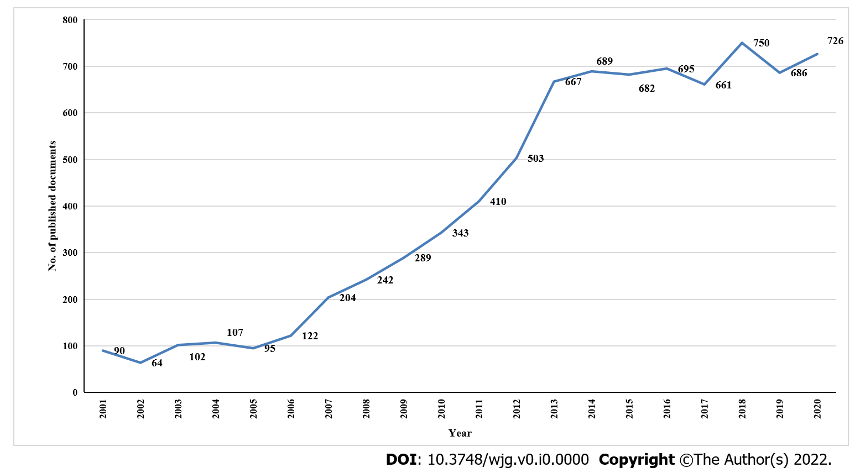
Figure 1 Annual number of publications on Clostridium difficile-associated diarrhea indexed in Scopus and published from 2001 to 2020.
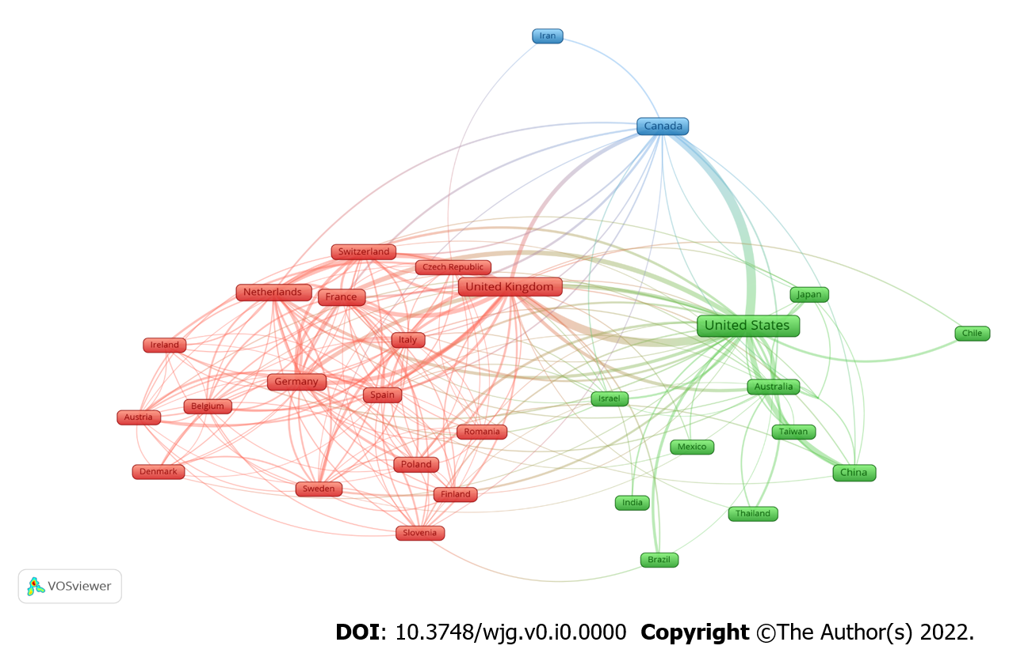
Figure 2 Network visualization map of country co-authorships. Of the 103 countries, 31 had at least 50 publications.
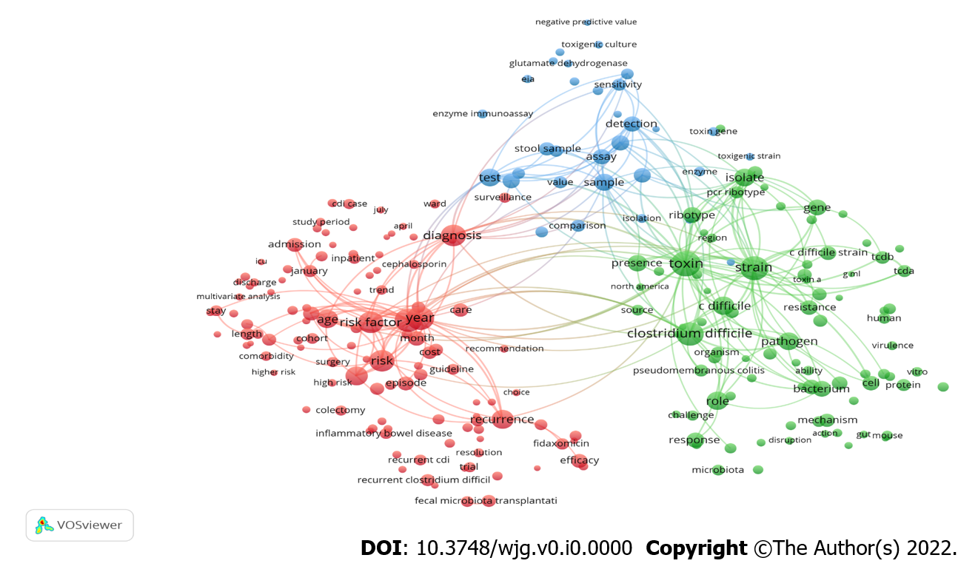
Figure 3 Network visualization map of the most frequent terms in the titles/abstracts of the retrieved documents. Of the 84961 terms, 385 had at least 100 publications. Terms with the same color represent a separate cluster (research theme).
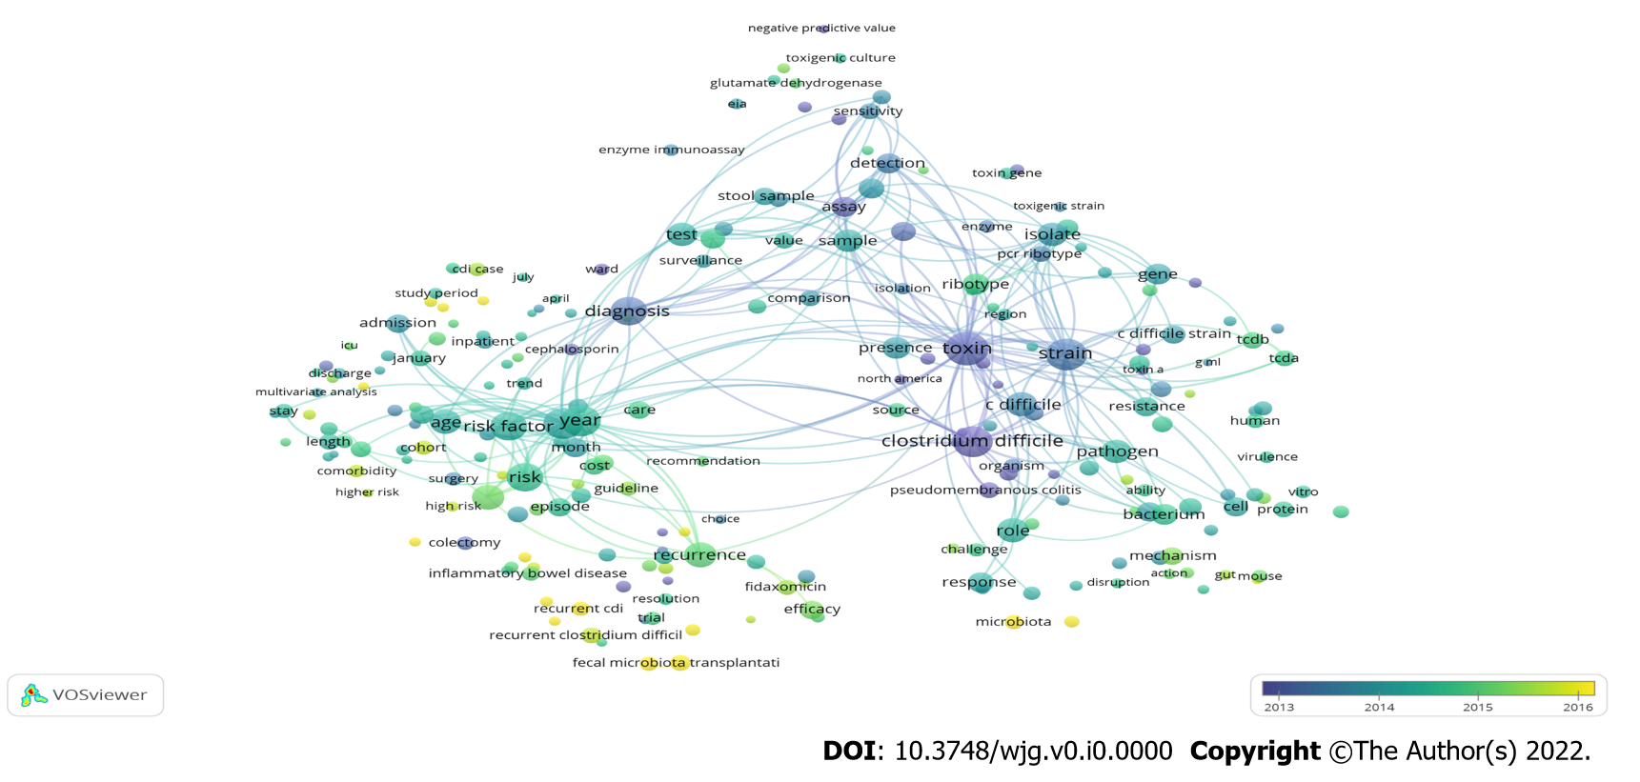
Figure 4 Overlay network visualization map of the most frequent terms in the titles/abstracts of the retrieved documents. The colors on the map reflected the period of emergence in the literature, with yellow representing terms that were relatively recent in the literature.
Table 1 Top 10 countries published Clostridium difficile-associated diarrhea between 2001 and 2020
Position | Country | No. of publication | %
1st | United States | 3585 | 44.11
2nd | United Kingdom | 1013 | 12.46
3rd | Canada | 556 | 6.84
4th | Germany | 434 | 5.34
5th | France | 383 | 4.71
6th | China | 315 | 3.88
7th | Netherlands | 273 | 3.36
8th | Australia | 261 | 3.21
9th | Italy | 244 | 3.00
10th | Spain | 238 | 2.93

Table 2 Ten most productive and influential institutions in Clostridium difficile-associated diarrhea between 2001 and 2020
Position | Institution | Country | No. of publication | %
1st | University of Leeds | United Kingdom | 203 | 2.50
2nd | Leiden University Medical Center-LUMC | Netherlands | 191 | 2.35
3rd | Harvard Medical School | United States | 183 | 2.25
4th | VA Medical Center | United States | 173 | 2.13
5th | Leeds Teaching Hospitals NHS Trust | United Kingdom | 160 | 1.97
6th | Beth Israel Deaconess Medical Center | Israel | 135 | 1.66
7th | Washington University School of Medicine in St. Louis | United States | 118 | 1.45
8th | Edward Hines Jr. VA Hospital | United States | 115 | 1.42
9th | The University of Western Australia | Australia | 109 | 1.34
10th | Baylor College of Medicine | United States | 108 | 1.33

Table 3 Top 10 related funding agencies in Clostridium difficile-associated diarrhea between 2001 and 2020
Position | Funding agencies | Country | No. of publication | %
1st | National Institutes of Health | United States | 884 | 10.88
2nd | U.S. Department of Health and Human Services | United States | 841 | 10.35
3rd | National Institute of Allergy and Infectious Diseases | United States | 539 | 6.63
4th | National Institute of Diabetes and Digestive and Kidney Diseases | United States | 239 | 2.94
5th | Merck | United States | 171 | 2.10
6th | National Center for Advancing Translational Sciences | United States | 154 | 1.89
7th | Medical Research Council | United Kingdom | 150 | 1.85
8th | National Institute of General Medical Sciences | United States | 146 | 1.80
9th | Pfizer | United States | 137 | 1.69
10th | United Kingdom Research and Innovation | United Kingdom | 132 | 1.62

Table 4 Ten most productive and influential journals in Clostridium difficile-associated diarrhea between 2001 and 2020
Position | Journal | n | % | IF¹
1st | Infection Control and Hospital Epidemiology | 304 | 3.74 | 3.254
2nd | Anaerobe | 276 | 3.4 | 3.331
3rd | Clinical Infectious Diseases | 251 | 3.09 | 9.097
4th | Journal of Hospital Infection | 212 | 2.61 | 3.926
5th | Journal of Clinical Microbiology | 183 | 2.25 | 5.948
6th | Plos One | 181 | 2.23 | 3.240
7th | American Journal of Infection Control | 169 | 2.08 | 2.918
8th | Antimicrobial Agents and Chemotherapy | 130 | 1.6 | 5.191
9th | Journal of Antimicrobial Chemotherapy | 124 | 1.53 | 5.790
10th | Clinical Microbiology and Infection | 117 | 1.44 | 8.067
¹Impact factor (IF) based on Journal Citation Reports (JCR) 2020 from Clarivate Analytics.
Table 5 Ten most cited publications and authors between 2001 and 2020 in in Clostridium difficile-associated diarrhea
Ref. | Title | Year | Source title | Cited by | Citation index | Impact index per article¹
Cohen et al^{[35]} | “Clinical practice guidelines for Clostridium difficile infection in adults: 2010 update by the Society for Healthcare Epidemiology of America (SHEA) and the Infectious Diseases Society of America (IDSA)” | 2010 | Infection Control and Hospital Epidemiology | 2370 | 237.0 | 313.9
van Nood et al^{[42]} | “Duodenal infusion of donor feces for recurrent clostridium difficile” | 2013 | New England Journal of Medicine | 2140 | 305.7 | 241.3
Loo et al^{[37]} | “A predominantly clonal multi-institutional outbreak of Clostridium difficile - Associated diarrhea with high morbidity and mortality” | 2005 | New England Journal of Medicine | 1601 | 106.7 | 88.6
Lessa et al^{[44]} | “Burden of Clostridium difficile infection in the United States” | 2015 | New England Journal of Medicine | 1430 | 286.0 | 234.3
Surawicz et al^{[41]} | “Guidelines for diagnosis, treatment, and prevention of clostridium difficile infections” | 2013 | American Journal of Gastroenterology | 1087 | 155.3 | 116.8
Louie et al^{[38]} | “Fidaxomicin versus vancomycin for Clostridium difficile infection” | 2011 | New England Journal of Medicine | 1074 | 119.3 | 91.4
Kelly and LaMont^{[36]} | “Clostridium difficile - More difficult than ever” | 2008 | New England Journal of Medicine | 1019 | 84.9 | 68.1
Rupnik et al^{[40]} | “Clostridium difficile infection: New developments in epidemiology and pathogenesis” | 2009 | Nature Reviews Microbiology | 985 | 89.5 | 73.4
Zar et al^{[43]} | “A comparison of vancomycin and metronidazole for the treatment of Clostridium difficile-associated diarrhea, stratified by disease severity” | 2007 | Clinical Infectious Diseases | 935 | 71.9 | 58.9
Pépin et al^{[39]} | “Clostridium difficile-associated diarrhea in a region of Quebec from 1991 to 2003: A changing pattern of disease severity” | 2004 | CMAJ | 916 | 57.3 | 45.6
¹The impact index per article is presented based on Reference Citation Analysis [Source: Baishideng Publishing Group Inc. (Pleasanton, CA 94566, United States)].

