Name of Journal: World Journal of Clinical Cases
Manuscript NO: 69695
Manuscript Type: CASE REPORT

Persistent fibrinogen deficiency after snake bite: A case report

Xu MH et al. Persistent fibrinogen deficiency after snake bite

Meng-Hao Xu, Jing Li, Liang Han, Chao Chen

Meng-Hao Xu, Tongji Hospital, Tongji Medical College, Huazhong University of Science and Technology, Wuhan 430030, Hubei Province, China

Jing Li, Liang Han, Department of Integrated Traditional Chinese and Western Medicine, Tongji Hospital, Tongji Medical College, Huazhong University of Science and Technology, Wuhan 430030, Hubei Province, China

Chao Chen, Department of Orthopaedics, Union Hospital, Tongji Medical College, Huazhong University of Science and Technology, Wuhan 430022, Hubei Province, China

Chao Chen, Department of Orthopaedics, Hefeng Central Hospital, Enshi 445800, Hubei Province, China

Author contributions: Xu MH and Chen C designed the research study; Xu MH, Li J and Han L performed the research; Xu MH, Li J and Chen C analyzed the data and wrote the manuscript; all authors have read and approve the final manuscript.

Corresponding author: Chao Chen, MD, PhD, Doctor, Research Fellow, Surgeon, Department of Orthopaedics, Union Hospital, Tongji Medical College, Huazhong University of Science and Technology, No. 1277 Jiefang Avenue, Wuhan 430022, Hubei Province, China. chenchao027@163.com

Received: July 8, 2021
Revised: July 30, 2021
Accepted: September 8, 2021
Published online: November 26, 2021

ABSTRACT
BACKGROUND
Venom-induced consumption coagulopathy (VICC) is characterized by coagulation dysfunction accompanied by decreased coagulation factor activity and fibrinogen (FBG) concentrations. We report a patient with VICC caused by snake bite who manifested persistent FBG deficiency without abnormal coagulation factor activity. This information may be helpful in diagnosing and treating VICC.

CASE SUMMARY
A 49-year-old man who had been bitten by a snake 13 h previously was admitted to the Emergency Department of our hospital with visible swelling of a finger and a bleeding puncture site. The provisional diagnosis was VICC, this being made based on persistent bleeding from the puncture site and subcutaneous hemorrhage. Laboratory evidence of coagulation abnormalities, including fibrinolysis, and findings on thromboelastography confirmed VICC. He had persistent afibrinogenemia requiring intravenous infusions of cryoprecipitate and fresh frozen plasma, together with continuous large doses of human FBG. After this treatment, the patient’s right upper limb swelling improved significantly and his subcutaneous hemorrhage resolved. All of his abnormal laboratory findings returned to normal by day 25. During 6 months’ of follow-up, the patient had no further hemorrhagic events.

CONCLUSION
Hemorrhagic snake venom can result in coagulation dysfunction characterized by persistent FBG deficiency without abnormal coagulation factor activity.

Key Words: Snake bite; Coagulation disorders; Venom-induced consumption coagulopathy; Fibrinogen deficiency; Fibrinogen infusion therapy; Case report

©The Author(s) 2021. Published by Baishideng Publishing Group Inc. All rights reserved.

Citation: Xu MH, Li J, Han L, Chen C. Persistent fibrinogen deficiency after snake bite: A case report. World J Clin Cases 2021; 9(33): 10355-10361
URL: https://www.wjgnet.com/2307-8960/full/v9/i33/10355.htm
DOI: https://dx.doi.org/10.12998/wjcc.v9.i33.10355

Core Tip: Venom-induced consumption coagulopathy (VICC) is characterized by decreased coagulation factor activity and fibrinogen (FBG) deficiency. Hemorrhage-inducing snake venom contains several ingredients that directly or indirectly consume fibrinogen through multiple mechanisms. We report a rare case with persistent afibrinogenemia without abnormal coagulation factor activity after snake bite. Our report may assist the diagnosis and treatment of FBG deficiency in patients with VICC.
INTRODUCTION
Snake bite is a major and often neglected public health problem. An estimated 1.8 million people are bitten by snakes annually worldwide and more than 125 000 of them die as a result^{[1]}. In China, there are approximately 50 species of poisonous snakes and 10 venomous snakes and the death rate from snake bite is 5%–10%. Coagulation dysfunction is the most common consequence of snake bite, venom-induced consumption coagulopathy (VICC) being the most important form of such coagulation dysfunction. Coagulants in venom can cause significant declines in coagulation factors, platelet counts, and fibrinogen (FBG) concentrations, resulting in failure of blood to coagulate and severe bleeding^{[2,3]}. Here, we report an uncommon case of snake-bite-induced VICC that was characterized by persistent FBG deficiency without abnormal coagulation factor activity. Treatment centered around continuous infusions of FBG was successful. Our findings may assist diagnosis and treatment of FBG deficiency in patients with VICC. To the best of our knowledge, no similar case has been reported. Because this is only a case report, the need for ethical approval was waived by the Ethics Committee of Tongji Hospital, which complies with the relevant institutional and national policies.

CASE PRESENTATION
Chief complaints
A 49-year-old man was bitten by a snake, with his chief complaint being bleeding for 13 h after that bite.

History of present illness
The patient was bitten on his right index finger by a snake (species unknown) while working on a construction site. The bite caused local swelling, pain, numbness, and bleeding, without dizziness, fever, diarrhea, consciousness disorders, or other symptoms. He was rushed to a local hospital for treatment, where he underwent puncture site drainage and antivenin injection, administration of coagulation factor supplements and other treatments. He was transferred to our hospital 13 h after the snake bite.

History of past illness
The patient was in good health, with no history of chronic or infectious diseases.

Personal and family history
The patient had no history of smoking, drinking, or familial cancers.

Physical examination
On admission, the patient’s temperature was 36.9°C, heart rate 107 bpm, respiratory rate 25 breaths/min, blood pressure 91/63 mmHg and oxygen saturation in room air 98%. There was visible swelling of the right index finger and the puncture site was still oozing blood. The patient’s right upper limb had been coated with jidesheng sheyao (a local herbal medicine, specific ingredients unknown).

Laboratory examinations
Laboratory tests for coagulation and fibrinolysis on admission showed a prothrombin time (PT) of > 120 s, international normalized ratio (INR) > 10, FBG < 0.5 g/L, activated partial thromboplastin time > 180 s, thrombin time (TT) > 240 s, D-dimer > 60 μg/mL FBG equivalent units, and FBG degradation products > 150 mg/mL. The timing and results of coagulation and fibrinolysis tests are shown in Table 1. Multiple markers were beyond the limits of detection for the first 7 d after the bite. Coagulation factor activity levels are shown in Table 2. Coagulation factor activity decreased slightly after the bite, normalizing within 4 d (Figure 1).

Imaging examinations
Vascular ultrasonography revealed intermuscular vein thrombosis in the left upper extremity and superficial vein thrombosis in the left lower extremity.

Further diagnostic work-up
Five days after the bite, thromboelastography (TEG) showed R time, 35.3 min, and no coagulation curve was formed (Figure 2A). After addition of 2 g/L FBG preparation to whole blood samples in vitro, the coagulation curve pattern was close to normal (Figure 2B): R time, 9.7 min; K time, 1.9 min; α angle, 72.1, maximum amplitude, 72.0; coagulation index (CI), −0.5; and amplitude at 30 min, 0.0.

FINAL DIAGNOSIS
The final diagnosis of the presented case was snake-bite-related VICC characterized by persistent afibrinogenemia without abnormal coagulation factor activity.

TREATMENT
The following treatment was administered. Cryoprecipitate (CRYO) 6 U, fresh frozen plasma (FFP) 600 mL, and human FBG 0.5 g were first injected intravenously 13 h after the bite. For 5 d thereafter, FFP, CRYO and FBG were administered daily as replacement therapy. Timing and specific doses are shown in Table 3.

OUTCOME AND FOLLOW-UP
During treatment, the swelling in the patient’s right upper limb improved significantly and his subcutaneous hemorrhage resolved by day 11. Twenty days after the bite, the results of TEG returned to normal. The patient’s afibrinogenemia lasted for 11 d, after which it began to improve, resolving completely by day 25 (Figure 1). All coagulation-related laboratory results returned to normal by 25 d after the bite. The patient was discharged 26 d after the bite and followed up for 12 mo after discharge. No further hemorrhagic events occurred.

DISCUSSION
Hemorrhagic snake venom can cause consumption of various coagulation factors and FBG through multiple mechanisms, leading to VICC^{[4,5]}. VICC is often characterized by undetectable PT prolongation^{[6]}, increased INR, and decreased FBG, usually accompanied by a significant increase in D-dimer concentration. Decreases in FBG concentrations occur in all types of VICC^{[4]}.
There are three main protease families in hemorrhagic snake venom: Snake venom metalloproteinases (SVMPs), serine proteinases (SVSPs), and phospholipase A2. SVMPs promote conversion of prothrombin (II) into thrombin (IIa) and activate the fibrinolytic system, resulting in rapid consumption of FBG and various coagulation factors^{[1]}. SVSPs commonly exhibit thrombin-like fibrinolytic functional activity. However, unlike thrombin, SVSPs are highly selective, acting directly on the α-chain of FBG and promoting polymerization of the resulting fibrin monomers^{[7]}. The polymerization products are unstable and easily soluble by plasmin. Therefore, SVSPs only consume FBG and do not activate the coagulation pathway, leading to FBG deficiency only and a less severe type of VICC, in which other coagulation factors are generally unaffected.
One case report described a woman who was bitten by a rattlesnake and had an FBG deficiency and low platelet count^{[2]}. In an Australian survey, 112 of 138 patients with complete VICC lacked FBG and factors V and VIII^{[3]}. Our patient had persistent FBG deficiency without detectable changes in coagulation factor activity. To the best of our knowledge, this combination has not previously been reported. TEG showed that the coagulation curve was close to normal after addition of FBG preparation^{[8]}. Given that our patient’s coagulation factors and platelet counts were normal, we believe that he had the type of coagulation dysfunction that is mediated via the above-mentioned SVSPs pathway. This type of dysfunction is characterized by FBG deficiency without abnormal coagulation factor activity. Thus, SVSPs were likely the main active components of the snake venom and responsible for the subsequent development of VICC. Our patient’s persistent afibrinogenemia may have been attributable to deposition into and subsequent slow release of some active components of snake venom from his hand, resulting in long-term toxicity. The specific mechanism of underlying persistent afibrinogenemia requires further elucidation.
The mainstays of treatment for VICC are antivenin and replacement therapy. The main replacement therapies are infusions of CRYO, FFP and FBG, and thus, directly supplementing these coagulation factors. In our case, early infusion of coagulation factors/plasma/FBG did not result in complete recovery of coagulation function, and TEG indicated that there was a serious deficiency of FBG. Therefore, continuous large doses of FBG were infused as follow-up treatment, achieving restoration of normal coagulation with FBG concentrations to 0.5–1.0 g/L and return of PT and INR to near normal range^{[4]}. Thus, FBG infusion at an early stage has a positive effect, despite its concentration recovering slowly^{[9]}.

CONCLUSION
Hemorrhagic snake venom can result in coagulation dysfunction characterized by persistent FBG deficiency without abnormal coagulation factor activity. In patients with VICC, replacement therapy centered around FBG infusion can achieve restoration of coagulation function.

ACKNOWLEDGMENTS
We thank Dr. Reynolds T, MBBS, FRACP, for editing the English text of a draft of this manuscript.

REFERENCES
1 Slagboom J, Kool J, Harrison RA, Casewell NR. Haemotoxic snake venoms: their functional activity, impact on snakebite victims and pharmaceutical promise. Br J Haematol 2017; 177: 947-959 [PMID: 28233897 DOI: 10.1111/bjh.14591]
2 Witham WR, McNeill C, Patel S. Rebound coagulopathy in patients with snakebite presenting with marked initial coagulopathy. Wilderness Environ Med 2015; 26: 211-215 [PMID: 25758759 DOI: 10.1016/j.wem.2014.11.019]
3 Isbister GK, Scorgie FE, O'Leary MA, Seldon M, Brown SG, Lincz LF; ASP Investigators. Factor deficiencies in venom-induced consumption coagulopathy resulting from Australian elapid envenomation: Australian Snakebite Project (ASP-10). J Thromb Haemost 2010; 8: 2504-2513 [PMID: 20831619 DOI: 10.1111/j.1538-7836.2010.04050.x]
4 Berling I, Isbister GK. Hematologic effects and complications of snake envenoming. Transfus Med Rev 2015; 29: 82-89 [PMID: 25556574 DOI: 10.1016/j.tmrv.2014.09.005]
5 Isbister GK. Snakebite doesn't cause disseminated intravascular coagulation: coagulopathy and thrombotic microangiopathy in snake envenoming. Semin Thromb Hemost 2010; 36: 444-451 [PMID: 20614396 DOI: 10.1055/s-0030-1254053]
6 Pongpit J, Limpawittayakul P, Juntiang J, Akkawat B, Rojnuckarin P. The role of prothrombin time (PT) in evaluating green pit viper (Cryptelytrops sp) bitten patients. Trans R Soc Trop Med Hyg 2012; 106: 415-418 [PMID: 22627102 DOI: 10.1016/j.trstmh.2012.04.003]
7 Isbister GK. Procoagulant snake toxins: laboratory studies, diagnosis, and understanding snakebite coagulopathy. Semin Thromb Hemost 2009; 35: 93-103 [PMID: 19308897 DOI: 10.1055/s-0029-1214152]
8 Nag I, Datta SS, De D, Pal P, Das SK. Role of thromboelastography in the management of snake bite: A case report from India. Transfus Apher Sci 2017; 56: 127-129 [PMID: 28540846 DOI: 10.1016/j.transci.2016.10.003]
9 Valenta J, Stach Z, Michálek P. Envenoming by Crotalid Snake Chinese Moccasin Agkistrodon Acutus Bite - A Case Report. Prague Med Rep 2015; 116: 155-160 [PMID: 26093669 DOI: 10.14712/23362936.2015.53]

Footnotes
Informed consent statement: Informed written consent was obtained from the patient for publication of this report and any accompanying images.

Conflict-of-interest statement: The authors declare that they have no conflict of interest.

CARE Checklist (2016) statement: The authors have read the CARE Checklist (2016), and the manuscript was prepared and revised according to the CARE Checklist (2016).

Open-Access: This article is an open-access article that was selected by an in-house editor and fully peer-reviewed by external reviewers. It is distributed in accordance with the Creative Commons Attribution NonCommercial (CC BY-NC 4.0) license, which permits others to distribute, remix, adapt, build upon this work non-commercially, and license their derivative works on different terms, provided the original work is properly cited and the use is non-commercial. See: http://creativecommons.org/Licenses/by-nc/4.0/

Provenance and peer review: Unsolicited article; Externally peer reviewed.

Peer-review started: July 8, 2021
First decision: July 26, 2021
Article in press: September 8, 2021

Specialty type: Medicine, research and experimental
Country/Territory of origin: China
Peer-review report’s scientific quality classification
Grade A (Excellent): 0
Grade B (Very good): 0
Grade C (Good): C, C
Grade D (Fair): 0
Grade E (Poor): 0

P-Reviewer: de Nucci G, Joalsen I S-Editor: Gao CC L-Editor: Kerr C P-Editor: Li JH

Figure Legends
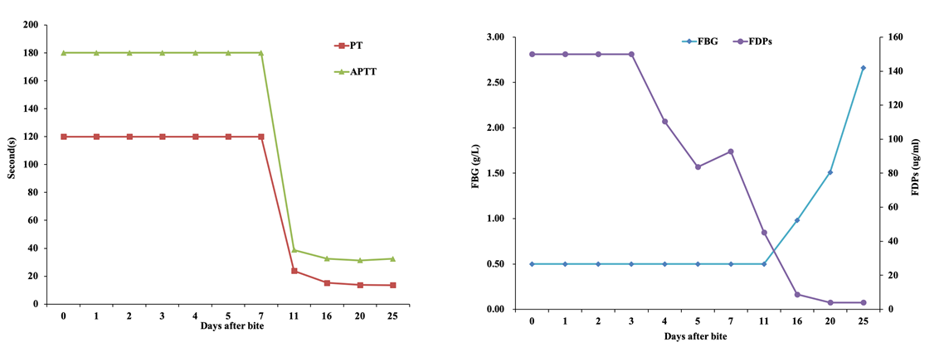
Figure 1 The result of changes in prothrombin time (PT) and activated partial thromboplastin time (APTT), fibrinogen (FBG) and FBG degradation products (FDPs) with days during treatment. A: PT and APTT; B: FBG and FBG degradation products. Indicators above the upper limit are assigned as a maximum value, whereas those below the lower limit are assigned as a minimum value.
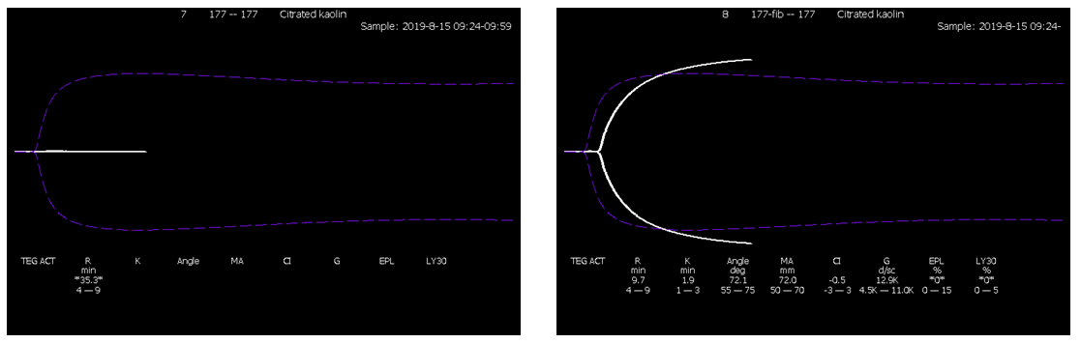
Figure 2 Thromboelastography. A: On day 5 after the snake bite; B: After adding 2 g/L fibrinogen preparation to whole blood samples.
Table 1 Results of coagulation and fibrinolysis test
Days after bite | PT | INR | FBG | APTT | TT | D-D | FDPs
 | 11.5–14.5 (s) | 0.5–1.2 | 2.0–4.0 (g/L) | 29–42 (s) | 14–19 (s) | < 0.5 (μg/L) | < 0.5 (μg/L)
0 | > 120 | > 10 | < 0.5 | > 180 | > 240 | > 60 | > 150
1 | > 120 | > 10 | < 0.5 | > 180 | > 240 | > 60 | > 150
2 | > 120 | > 10 | < 0.5 | > 180 | > 240 | > 60 | > 150
3 | > 120 | > 10 | < 0.5 | > 180 | > 240 | > 60 | > 150
4 | > 120 | > 10 | < 0.5 | > 180 | > 240 | > 60 | 110.5
5 | > 120 | > 10 | < 0.5 | > 180 | > 240 | > 60 | 83.7
7 | > 120 | > 10 | < 0.5 | > 180 | 236.3 | > 60 | 92.8
11 | 23.8 | 2.1 | < 0.5 | 38.8 | 33.3 | 27.53 | 45.3
16 | 15.2 | 1.19 | 0.98 | 32.6 | 18.7 | 2.35 | 8.8
20 | 13.7 | 1.05 | 1.51 | 31.4 | 18.2 | 0.28 | < 4.0
25 | 13.6 | 1.04 | 2.66 | 32.5 | 15.5 | < 0.22 | < 4.0
Day 0: day when the patient was bitten; INR: International normalized ratio; PT: prothrombin time; FBG: fibrinogen; APTT: activated partial thromboplastin time; D-D: D-dimer; FDPs: fibrinogen degradation products; TT: thrombin time.

Table 2 Results of coagulation factor activity level
Days after bite | II | V | VIII | X | XI | XII
 | 70%–120% | 70%–120% | 60%–150% | 70%–120% | 60%–150% | 50%–150%
0 | 55 | 41 | 246 | 59 | 85 | 51
4 | 76 | 86 | 150 | 69 | 60 | 44
7 | 82 | 79 | 94 | 73 | 79 | 49
10 | 95 | 107 | 127 | 89 | 74 | 68
15 | 89 | 101 | 112 | 99 | 83 | 72
20 | 93 | 86 | 134 | 84 | 96 | 85
25 | 113 | 94 | 129 | 105 | 95 | 103
Day 0: day when the patient was bitten.

Table 3 Dates and specific doses of replacement therapy
Days after bite | CRYO (u) | FFP (mL) | FBG (g)
0 | 6 | 600 | 0.5
1 | 16 | 1600 | 0.5
2 | 30.5 | 3450 | 1.0
3 | 11 | 1900 | 0.5
4 | 5 | 600 | 1.0
5 | — | — | 2.0
7 | — | — | 2.0
9 | — | — | 2.0
12 | — | — | 1.0
Day 0: day when the patient was bitten; CRYO: cryoprecipitation; FFP: fresh frozen plasma; FBG: fibrinogen.

Published by Baishideng Publishing Group Inc
7041 Koll Center Parkway, Suite 160, Pleasanton, CA 94566, USA
Telephone: +1-925-3991568
E-mail: bpgoffice@wjgnet.com
Help Desk: https://www.f6publishing.com/helpdesk
https://www.wjgnet.com

© 2021 Baishideng Publishing Group Inc. All rights reserved.

