Name of journal: World Journal of Orthopedics
ESPS Manuscript NO: 8984
Columns: CASE REPORT

Delayed presentation of a loose body in undisplaced paediatric talar neck fracture
Patel V et al. Delayed presentation of a loose body

Vishal Patel, Benjamin Bloch, Nicholas Johnson, Jitendra Mangwani

Vishal Patel, Benjamin Bloch, Nicholas Johnson, Jitendra Mangwani, Department of Trauma and Orthopedics, Musculoskeletal Directorate, University Hospitals of Leicester NHS Trust, Leicester Royal Infirmary, Leicester LE1 5WW, United Kingdom

Author contributions: Patel V contributed to main body of report; Bloch B contributed to discussion section; Johnson N contributed to literature search; Mangwani J is senior author, supervisor and technical advisor of the paper.

Correspondence to: Jitendra Mangwani, MBBS, FRCS, (Tr and Orth) Senior author, Department of Trauma and Orthopedics, Musculoskeletal Directorate, University Hospitals of Leicester NHS Trust, Leicester Royal Infirmary, Infirmary Square, Leicester LE15WW, United Kingdom. jitendra.mangwani@uhl-tr.nhs.uk

Telephone: +44-0300-3031573 Fax: +44-0116-2502777

Received: January 14, 2014 Revised: April 15, 2014
Accepted: June 10, 2014

Published online:

Abstract
Fractures of the talus are rare in children. A high index of suspicion is needed to avoid missing such an injury, which is not an uncommon occurrence especially with undisplaced fractures. We present an unusual case of an undisplaced talar neck fracture in a five-year-old child leading to a delayed presentation of a symptomatic osteochondral loose body in the ankle joint. To our knowledge there are no reports in the literature of osteochondral loose bodies occurring in conjunction with an associated undisplaced talar neck fracture in either children or adults. The loose body was removed using anterior ankle arthroscopy. The child had an uneventful post operative recovery and regained full range of movement and function of his ankle joint and was discharged at one year follow-up. We aim to highlight the need to have a low threshold to further evaluate symptomatic children after fracture healing of an undisplaced talar neck fracture for a possible associated loose body in the ankle joint.

© 2014 Baishideng Publishing Group Inc. All rights reserved.

Key words: Talus; Fracture; Loose body; Ankle arthroscopy; Children

Core tip: Undisplaced talar neck fractures in children rarely present with an associated osteochondral loose body. If a child remains symptomatic after fracture healing we would advocate further evaluation with magnetic resonance imaging (MRI) scan to exclude an associated loose body. If a loose body or an osteochondral lesion is identified on MRI scan it can be safely treated with anterior ankle arthroscopy.

Patel V, Bloch B, Johnson N, Mangwani J. Delayed presentation of a loose body in undisplaced paediatric talar neck fracture. World J Orthop 2014; In press

INTRODUCTION
Fractures of the talus are rare in children. Skeletally immature bone is less brittle with higher elastic resistance than adult bone. The paediatric talus can therefore sustain higher forces before fractures occur^{[1]}.
The mechanism of injury is generally as a result of axial loading of the talus against the anterior tibia with the foot in dorsiflexion and usually follows high-energy trauma such as falls from height and road traffic collisions. However recently supination has also been considered as a mechanism of injury which due to impingement of the talus against the medial malleolus^{[2]}. History and clinical examination in children can be challenging and plain radiographs may not necessarily demonstrate an obvious fracture or associated osteochondral defect (OCD)^{[3]}. Time constraints, limited resources or failure to appreciate the nature of the injury can lead to failure of establishing correct diagnosis and follow up.

CASE REPORT
A five-year boy sustained an injury to his left ankle after jumping off a bunk bed whilst on holiday abroad. He was seen at the local hospital and his parents were told that the child had sustained a simple soft tissue injury following a normal plain radiograph of his ankle.
Upon his return to the United Kingdom he was brought to the local Emergency Department (ED) two days following his injury as he was still reluctant to bear weight through his left ankle and complained of increasing pain and swelling.
Radiographs revealed an undisplaced fracture of the talar neck (Figure 1A). The child was managed conservatively in a below knee cast and kept non-weight bearing for four weeks.
After four weeks his plaster was removed and clinical examination was satisfactory. Repeat radiographs taken showed a healing talar neck fracture (Figure 1B).
Three weeks later the child returned to the ED struggling with bearing weight after a trivial injury to his left ankle caused by jumping from a standing height. Although there was no obvious swelling around the ankle there was specific tenderness over the anterior aspect of the ankle joint. Radiographs were suggestive of an osteochondral loose body in the joint space between the tibia and talus (Figure 1C).
An magnetic resonance imaging (MRI) scan confirmed a 5.5 mm loose body antero-superiorly to the left talar dome and an OCD of the distal talar dome with a healed talar neck fracture (Figure 1D).
Following discussion with the child’s parents we elected to perform an arthroscopic removal of the osteochondral loose body. Arthroscopy was performed using a 2.7 mm wrist arthroscope. Intra-operatively a fibro-cartilage cap was found covering the OCD on the talar dome and therefore there was no need to perform microfracture.
One month after the procedure the child was pain free with no tenderness on palpation of the ankle joint. At final follow up one year after injury the child remained asymptomatic and radiographs revealed no progression of the osteochondral lesion or evidence of avascular necrosis (AVN).

DISCUSSION
The reported rate of avascular necrosis in children with non-displaced talus fractures is 16 %. This is considerably higher than the reported rate in adults^{[4]}. This suggests that the immature talus may be more prone to AVN. Rammelt et al^{[4]} reported nearly half of all cases of AVN following an undisplaced talus fracture in a child occurred when the fracture had been initially missed.
The incidence of AVN following Hawkins Type III fractures of the talar neck (talar neck fracture with dislocations involving the subtalar and ankle joints) may approach 100%, particularly if diagnosis and reduction are delayed^{[5-7]}.
Most type I fractures can be treated closed unless there is loss of reduction. Hawkins’ original work in patients with a mean age of 30.4 years (8-63 years range) reported a less than 10 % association of AVN with type I fractures^{[8]}.
In this case there was an osteochondral loose body associated with an undisplaced talar neck fracture which had a delayed presentation. To our knowledge there are no reports in the literature of osteochondral loose bodies occurring in conjunction with an associated undisplaced talar neck fracture in either children or adults.
Isolated osteochondral lesions of the talar dome are a rare entity in children. The aetiology is thought to be due to either ischaemia or trauma, with the latter considered the most important. Berndt and Herty in 1959 were able to reproduce medial and lateral osteochondral defects in cadavers. Lateral OCDs were produced by a strong inversion force to a dorsi-flexed foot and medial OCDs were produced by a strong inversion force to a plantar-flexed foot with lateral rotation of the tibia^{[9]}.
Conservative management remains the mainstay of treatment of traumatic OCDs in children. Wester et al^{[10]} reported a series of 13 cases which were followed up after 24 years. Eight cases had normal follow up CT scans and clinical findings. Two cases had a loose body in the ankle joint of which one had remained symptomatic since the time of injury although it was noted that the primary OCD had healed^{[10]}.
The role of ankle arthroscopy in the management of chronic and post-traumatic ankle disorders in adults is well established. Uglow and colleagues^{[11]} reported outcomes in children following arthroscopy being comparable to adult series for the management of OCDs and anterolateral soft tissue impingement. In particular they highlighted the poor correlation between findings on MRI and intraoperative findings on arthroscopy especially in relation to small OCDs and impingements lesions.
This case highlights the need for high index of suspicion required to diagnose an undisplaced talar neck fracture in a child. If there are ongoing symptoms after fracture healing one should look for presence of an osteochondral loose body. Removal of osteochondral loose body using arthroscopic technique is safe and effective procedure.

COMMENTS
Case characteristics
Five-year-old child presenting with a symptomatic painful ankle which following a healed undisplaced talar neck fracture.

Clinical diagnosis
Painful ankle with difficulty weight bearing.

Differential diagnosis
Ligamentous injury, osteochondral defect, non-union and loose body.

Laboratory diagnosis
Normal serum Haematology and biochemistry.

Imaging diagnosis
An magnetic resonance imaging (MRI) scan confirmed a 5.5 mm loose body antero-superiorly to the left talar dome and an osteochondral defect of the distal talar dome with a healed talar neck fracture.

Pathological diagnosis
Delayed presentation of a symptomatic osteochondral loose body in the ankle joint associated with a healed undisplaced talar neck fracture

Treatment
Arthroscopic removal of the osteochondral loose body used a 2.7 mm wrist arthroscope.

Related reports
To people knowledge there are no reports in the literature of osteochondral loose bodies occurring in conjunction with an associated undisplaced talar neck fracture in either children or adults.

Experiences and lessons
Undisplaced talar neck fractures in children rarely present with an associated osteochondral loose body. If a child remains symptomatic after fracture healing we would advocate further evaluation with an MRI scan to exclude an associated loose body.

Peer review
This manuscript is suitable and worth to be published.

REFERENCES
1 Byrne AM, Stephens M. Paediatric talus fracture. BMJ Case Rep 2012; 2012: [PMID: 22605852 DOI: 10.1136/bcr.10.2011.5028]
2 Daniels TR, Smith JW. Talar neck fractures. Foot Ankle 1993; 14: 225-234 [PMID: 8359770 DOI: 10.1177/107110079301400409]
3 Letts RM, Gibeault D. Fractures of the neck of the talus in children. Foot Ankle 1980; 1: 74-77 [PMID: 7274901 DOI: 10.1177/107110078000100203]
4 Rammelt S, Zwipp H, Gavlik JM. Avascular necrosis after minimally displaced talus fracture in a child. Foot Ankle Int 2000; 21: 1030-1036 [PMID: 11139033]
5 Vallier HA, Nork SE, Barei DP, Benirschke SK, Sangeorzan BJ. Talar neck fractures: results and outcomes. J Bone Joint Surg Am 2004; 86-A: 1616-1624 [PMID: 15292407]
6 Frawley PA, Hart JA, Young DA. Treatment outcome of major fractures of the talus. Foot Ankle Int 1995; 16: 339-345 [PMID: 7550941]
7 Schulze W, Richter J, Russe O, Ingelfinger P, Muhr G. Surgical treatment of talus fractures: a retrospective study of 80 cases followed for 1-15 years. Acta Orthop Scand 2002; 73: 344-351 [PMID: 12143985]
8 Hawkins LG. Fractures of the neck of the talus. J Bone Joint Surg Am 1970; 52: 991-1002 [PMID: 5479485 DOI: 10.1055/s-0028-1100881]
9 BERNDT AL, HARTY M. Transchondral fractures (osteochondritis dissecans) of the talus. J Bone Joint Surg Am 1959; 41-A: 988-1020 [PMID: 13849029]
10 Wester JU, Jensen IE, Rasmussen F, Lindequist S, Schantz K. Osteochondral lesions of the talar dome in children. A 24 (7-36) year follow-up of 13 cases. Acta Orthop Scand 1994; 65: 110-112 [PMID: 8154273]
11 Vasukutty NV, Akrawi H, Theruvil B, Uglow M. Ankle arthroscopy in children. Ann R Coll Surg Engl 2011; 93: 232-235 [PMID: 21477438 DOI: 10.1308/003588411X564005]

P-Reviewers: Coskun A, Shafi M S-Editor: Ji FF L-Editor: E-Editor:

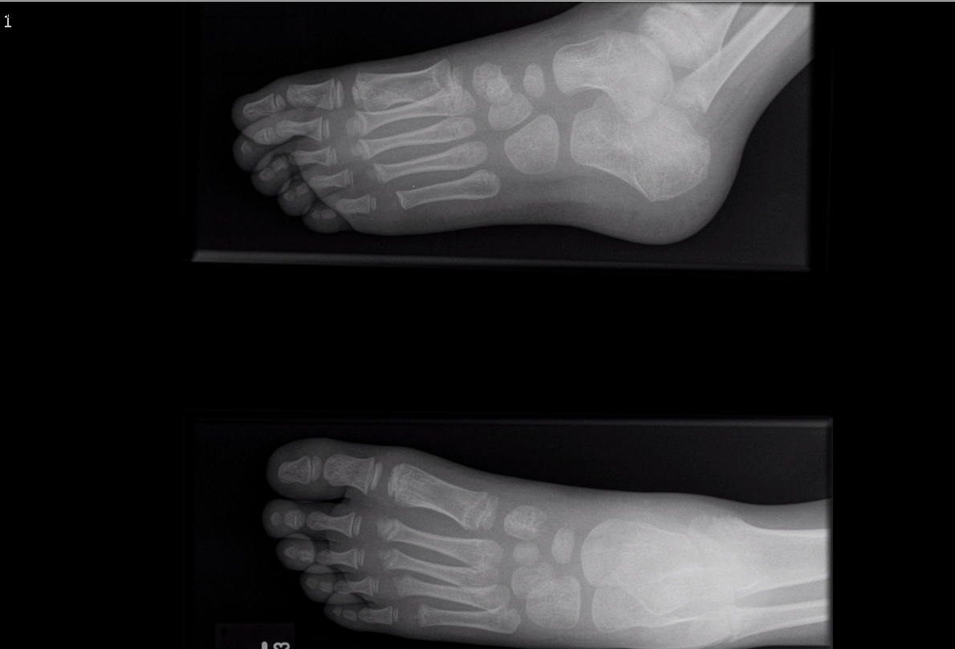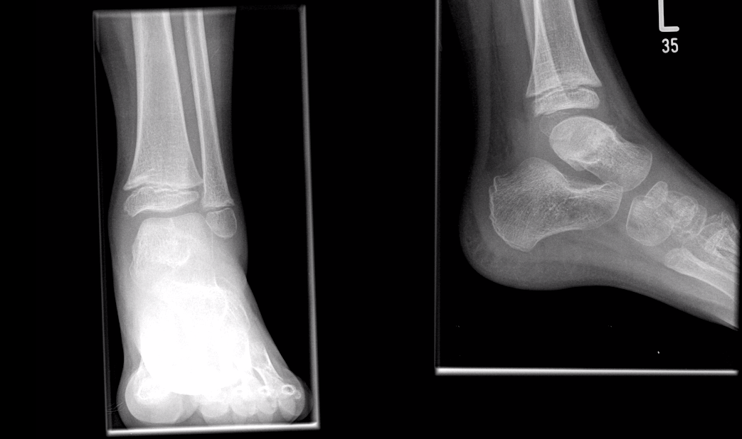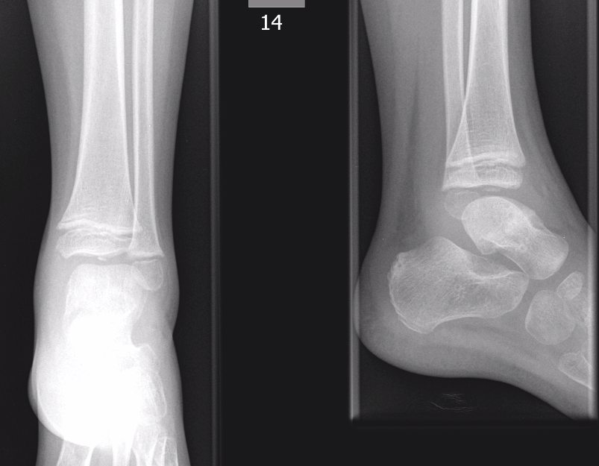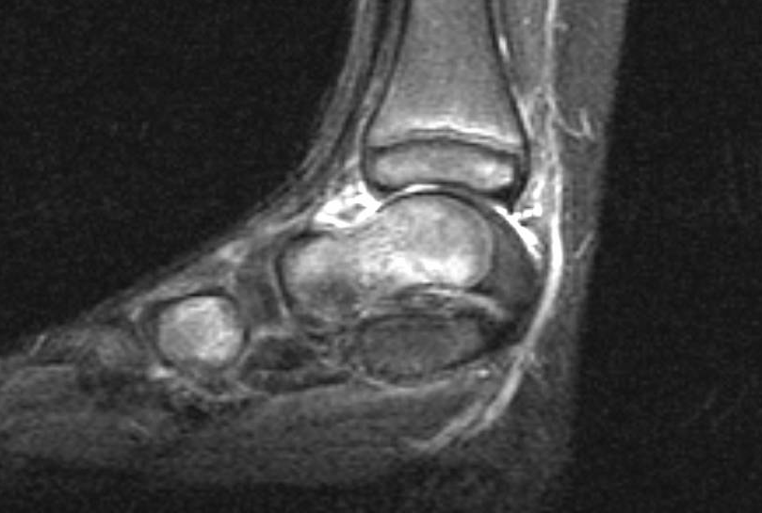
Figure 1 The magnetic resonance imaging scan for delayed presentation of a loose body in undisplaced paediatric talar neck fracture. A: Initial foot and ankle radiographs taken post injury in the UK showing an undisplaced talar neck fracture; B: Radiographs taken at four weeks following immobilisation in plaster showing a healed fracture; C: Repeat radiographs taken three weeks following discharge from clinic as patient returned symptomatic. A clear loose body in ankle joint is present; D: Pre-operative magnetic resonance imaging scan of ankle demonstrates a 5.5 mm loose body antero-superiorly to the left talar dome and an osteochondral defect (OCD) of the distal talar dome.

