Name of Journal: World Journal of Orthopedics
Manuscript NO: 74022
Manuscript Type: CASE REPORT

Extensive adhesion formation in a total knee replacement in the setting of a gastrointestinal stromal tumor: A case report

Mitchell S et al. Extensive adhesion formation in TKA in the setting of a GIST

Steven Mitchell, Anderson Lee, Ryan Stenquist, David Yatsonsky II, Megan L Mooney, Vithal B Shendge

Steven Mitchell, Anderson Lee, Ryan Stenquist, David Yatsonsky II, Megan L Mooney, Vithal B Shendge, Department of Orthopaedic Surgery, The University of Toledo Medical Center, Toledo, OH 43614, United States

Author contributions: Mitchell S, Lee A, Stenquist R, and Yatsonsky II D provided appreciable assistance with literature review, case reporting and management, and significant editing of the final manuscript; Mitchell S, Mooney M, and Shendge V participated in surgical appraisal of this case and were involved with orthopedic management of this case, as well as significant editing of the final manuscript.

Corresponding author: Vithal B Shendge, MD, Academic Research, Assistant Professor, Surgeon, Department of Orthopaedic Surgery, The University of Toledo Medical Center, 3065 Arlington Avenue, Toledo, OH 43614, United States. vithal.shendge@utoledo.edu

Received: December 12, 2021
Revised: February 4, 2022
Accepted: April 24, 2022
Published online:

Abstract
BACKGROUND
Gastrointestinal stromal tumors (GISTs) are rare primary neoplasms of the gastrointestinal tract, accounting for 1% to 2% of all gastrointestinal neoplasms worldwide. GISTs are frequently discovered incidentally during workup for other diagnosis or intestinal obstruction, as they can present with few or no symptoms. Simultaneously, GISTs confer a high degree of malignant transformation, with a progression in about 10% to 30% of cases.

CASE SUMMARY
A 63-year-old healthy female presented to our institution with complaints of right knee pain and limited passive and active motion in the setting of a previous right total knee arthroplasty (TKA). One year after TKA, the patient was incidentally diagnosed with a GIST, which was successfully removed. After removal, the patient continued to have limited range of motion of the right knee and subsequently underwent revision TKA. Intraoperatively significant fibrotic adhesions were found encapsulating the femoral and tibial components. The patient’s pain improved postoperatively, however, she continued to have decreased range of motion with difficulty ambulating.

CONCLUSION
We propose that this case may demonstrate a proinflammatory milieu arising from a GIST, which had a direct influence on the outcome of recent total knee arthroplasty. This proposed mechanism between neoplastic cytokinetic activity and adhesion formation could have implications on preoperative and postoperative orthopedic management of total knee arthroplasty.

Key Words: Gastrointestinal stromal tumor; Adhesion formation; Total knee arthroplasty; Inflammatory response; Decreased range of motion; Case report

Mitchell S, Lee A, Stenquist R, Yatsonsky II D, Mooney ML, Shendge VB. Extensive adhesion formation in a total knee replacement in the setting of a gastrointestinal stromal tumor: A case report. World J Orthop 2022; In press

Core Tip: This case demonstrated a patient who had recurrent adhesion formation resulting in reduced clinical outcomes, hypothesized to be secondary to a gastrointestinal stromal tumor (GIST) inflammatory response. Currently, there is a paucity of literature documenting GIST tumors and potential adhesion formation and decreased clinical outcomes in patients with prosthetic joints.

INTRODUCTION
Adhesion formation is a serious cause of adverse outcomes in the medical field. Several triggers of adhesion formation include inflammation, foreign body sensation and iatrogenic causes^{[1-3]}. Currently, the underlying mechanisms of adhesion remain unclear but the regulation of fibrinolytic activity, leading to fibrosis, is thought to play an important role in adhesion formation^{[1]}. Gastrointestinal stromal tumors (GISTs) are especially of interest because circulating levels of cell adhesion marker L1 Cellular Adhesion Molecule (L1CAM) which has been proposed as a prognostic marker^{[1,4]}. Cell adhesion molecule L1CAM (CD171), a 200–220 kDa type I glycoprotein of the immunoglobulin superfamily, plays a role in development of the nervous system by regulating cell interactions, including neuronal migration^{[5]}. L1CAM has also been shown to have other interactions with cell regulators such as integrins which play an important role in inflammation and fibrosis^{[6]}. This case report demonstrates a patient with GIST that presented with extensive adhesion formation status-post total knee replacement, resulting in limited range of motion and need for revision surgery.

CASE PRESENTATION
Chief complaints
Our patient is a 63-year-old female with complaints of right knee osteoarthritis causing her significant discomfort.

History of present illness
The patient has had complaints of right knee osteoarthritis since 2015. The patient’s other conditions included long-standing hypertension, controlled type II diabetes mellitus, and moderate obesity. Radiographs of the right knee demonstrated moderate tricompartmental osteoarthritis of the knee with notable valgus deformity. Initially, she was managed conservatively with non-steroidal anti-inflammatory drugs (NSAIDs), bracing, intra-articular cortisone injections, and physical therapy. After failing two years of conservative treatment, she elected to undergo right total knee arthroplasty in January 2017. The patient underwent right total knee arthroplasty with a Stryker Triathlon X3 implant system with posterior stabilization. The postoperative course was unremarkable; she was instructed to continue knee range of motion exercises and was referred to physical therapy.
In June 2018, the patient returned to the orthopedics clinic with pain and stiffness of the right knee. Physical exam revealed right knee range of motion at 95˚ flexion to full extension. Radiographs were unremarkable with no change of the components noted from the previous. The patient had been compliant with her physical therapy and was ambulating without assistive devices. The patient was instructed to continue strengthening exercises and was referred to physical therapy.
In February 2018, the patient presented to an outside facility for complaints of severe fatigue and melena. Subsequent computed tomography imaging and esophagogastroduodenoscopy revealed diffuse gastric wall thickening with a fungating mass and focal calcifications within the greater curvature of the stomach suspicious for neoplastic disease. Subsequent biopsy of this mass revealed a CD117-positive tumor, while being negative for pancytokeratin, CD20 (B-cell marker), and Helicobacter pylori, which was consistent with an ulcerated gastrointestinal stromal tumor. This tumor was successfully excised in April 2018 via open gastrectomy without complications; postoperative pathology confirmed the diagnosis of spindle-type GIST with adequate negative surgical margins. The patient was subsequently started on long-term imatinib mesylate therapy and placed on an annual surveillance program.
In November 2018, the patient elected to undergo joint manipulation under general anesthesia due to continuing knee pain. Prior to manipulation, the patient's right knee range of motion was lacking 10-15˚ of full extension and flexion to 50˚. Post-procedure range-of-motion (ROM) demonstrated significant improvement in the ROM, with full extension to 105˚ of flexion. However, the patient quickly re-developed right knee stiffness. Two months after knee manipulation under anesthesia, clinical examination revealed a fixed flexion deformity of 25° and active flexion to 65° (Figure 1A and B). Radiographs demonstrated evidence of early polyethylene wear.
In July 2020, three-and-a-half years after her initial prosthesis implantation and after multiple attempts at physical therapy, pain management, and an unsuccessful joint manipulation, the patient elected for a single-stage revision of her right knee prosthesis. Intraoperative findings demonstrated significant adhesion formation in the suprapatellar fossa extending from the anterior aspect of the patella into the intercondylar notch and posterior capsule (Figure 2A and B). Severe calcification was noted within the posterior compartment of the knee, and significant adhesions were appreciated between the polyethylene liner and the femoral component, as well as within the lateral and medial gutters (Figure 2C and D). Multiple intraoperative specimens were sent for culture demonstrating aseptic, dense fibrous tissue with abundant fibrin and chronic inflammation. After extensive debridement, the patient underwent successful revision with a Stryker Triathlon implant system including posterior stabilization (Figure 2E).

FINAL DIAGNOSIS
The final diagnosis of the presented case is tricompartmental osteoarthritis of the knee with notable valgus deformity.

TREATMENT
The patient was initially managed conservatively with NSAIDs, bracing, intra-articular cortisone injections, and physical therapy. After failing two years of conservative treatment, she elected to undergo right total knee arthroplasty in January 2017. The patient underwent right total knee arthroplasty with a Stryker Triathlon X3 implant system with posterior stabilization. One year post-operatively, the patient returned to the clinic with pain and stiffness of the right knee and elected to undergo joint manipulation under general anesthesia 18 mo after TKA. Three-and-a-half years after her initial prosthesis implantation and after multiple attempts at physical therapy, pain management, and an unsuccessful joint manipulation, the patient elected for a single-stage revision of her right knee prosthesis. After extensive debridement, the patient underwent successful revision with a Stryker Triathlon implant system including posterior stabilization.

OUTCOME AND FOLLOW-UP
Four months after TKA revision, the patient presented with moderate stiffness and was now utilizing a cane. On exam, the patient demonstrated 5˚ of total motion in her right knee with minimal pain. Radiographs obtained at this visit suggested a progressive scarring process in the posterior aspect of the knee. Due to this recurring scarring and limited outcome overall, this patient will be followed in a long-term setting with strengthening exercises and other conservative management constituting her primary treatment, as we discussed with this patient that she may have reached the maximal medical improvement following this revision surgery.

DISCUSSION
GISTs are primary neoplasms of the gastrointestinal tract that are rare, accounting for 1% to 2% of all gastrointestinal neoplasms, and are frequently discovered incidentally during workup for other diagnosis or intestinal obstruction. GISTs are often clinically silent and confer a high degree of malignant transformation, with a progression in about 10% to 30% of cases^{[1,7]}. Søreide et al^{[6]} found that the median age for GISTs was 65 with a 1:1 male to female ratio. Tumors are often 2-30 cm at time of diagnosis and cause symptoms either by mass-effect or ulcerative anemia. These tumors were not well-characterized until the 1990s, and literature suggests that GISTs have been underdiagnosed for decades^{[8]}.
Most GISTs are of sporadic etiology (97%), thought to arise from an activating mutation in either KIT or platelet-derived growth factor A^{[7]}. Typically, these tumors are composed of a nearly uniform population of spindle cells (70%), epithelioid cells (20%) or a mix of these two morphologies^{[1]}. Over 95% of GIST tumors are associated with KIT Tyrosine activity (CD117), while over 80% of GISTs are associated with BCL2, and 70% associated with CD34^{[4,5,9]}. Since there are a variety of presentations, this tumor is often mistaken with fibromatosis and leiomyosarcoma^{[10]}.
Key components in metastatic neoplastic lineages are mutations that either downregulate adhesion genes or upregulate motility-promoting genes. One such motility-promoting molecule is called L1CAM. L1CAM has been shown to promote angiogenesis and pro-fibrotic environments, and is associated with mediating overall cell survival^{[9,11,12]}. Concurrently, L1CAM has been found to be expressed in at least 74% of GISTs, with higher L1CAM concentrations being associated with worse outcomes^{[10]}. L1CAM’s extracellular domains are associated with activation of integrin-dependent processes, as well as interactions with fibroblast growth factor receptor (FGFR). Prior research utilized peptides to block the L1CAM-FGFR signaling pathway, which resulted in reduced glioma cell migration and motility^{[13]}. Double knockdown of L1CAM expression and FGFR activity in glioblastoma cells significantly reduced cellular motility (96% reduction) while knockdown of either L1CAM or FGFR displayed partially reduced cell migration^{[13]}. These studies suggested an important relationship between L1CAM-FGFR interactions and the development of metastatic disease. Due to the role that the L1CAM-FGFR interaction plays in metastatic spread and negative outcomes in gliomas and other tumors, this patient’s recurrent adhesion formation could be attributed to their underlying GIST diagnosis. Furthermore, FGFR has been shown to regulate a vast network of profibrotic mediators, including transforming growth factor beta, endothelin-1, and connective tissue growth factor amongst many other profibrotic factors^{[14-17]}. Subsequent activation of FGFRs through the L1CAM molecule that is commonly expressed in GISTs may have led to the generation of fibrotic adhesions within this patient’s prosthetic knee joint.
However, it is also possible that the multiple surgeries this patient underwent activated an inflammatory response within the knee joint, creating a fibrotic environment that resulted in the adhesions observed. While the exact underlying mechanism of intra-articular adhesions is unclear, researchers believe that many cytokines and growth factors can contribute to fibrous tissue hyperplasia which may be responsible for adhesion formation. These cytokines and growth factors are part of the inflammatory response and it is generally recognized that surgical trauma can activate this response. Additional research should clarify the exact mechanisms in which GISTs can promote adhesions in patients who undergo surgery to reduce post-operative complications as well as appropriate management and treatment of these complications. This patient demonstrates a unique case in which a GIST diagnosis may have impacted her ability to regain full motion and use of her knee after total knee arthroplasty.

CONCLUSION
Our case demonstrated a patient with extensive fibrotic scarring in a relatively new knee prosthesis in the setting of a gastrointestinal stromal tumor. This rare neoplasm has been hypothesized to induce a pro-fibrotic milieu, which has the potential to disrupt artificial devices. Further analysis of patients diagnosed with GISTs and concomitant joint arthroplasty is warranted to elucidate the exact mechanism behind the formation of these adhesions, as well as what potential therapies exist to mitigate joint complications.

ACKNOWLEDGEMENTS
The authors would like to thank the orthopedic surgery department of University of Toledo Medical Center for facilitating the resources necessary for publication of this case. We would also like to thank Dr. Vithal Shendge for his significant contributions toward this article.

REFERENCES
1 Mazur MT, Clark HB. Gastric stromal tumors. Reappraisal of histogenesis. Am J Surg Pathol 1983; 7: 507-519 [PMID: 6625048 DOI: 10.1097/00000478-198309000-00001]
2 Daluga D, Lombardi AV Jr, Mallory TH, Vaughn BK. Knee manipulation following total knee arthroplasty. Analysis of prognostic variables. J Arthroplasty 1991; 6: 119-128 [PMID: 1875202 DOI: 10.1016/s0883-5403(11)80006-9]
3 Yatsonsky Ii D, Pan K, Shendge VB, Liu J, Ebraheim NA. Linkage of microbiota and osteoporosis: A mini literature review. World J Orthop 2019; 10: 123-127 [PMID: 30918795 DOI: 10.5312/wjo.v10.i3.123]
4 Zander H, Rawnaq T, von Wedemeyer M, Tachezy M, Kunkel M, Wolters G, Bockhorn M, Schachner M, Izbicki JR, Kaifi J. Circulating levels of cell adhesion molecule L1 as a prognostic marker in gastrointestinal stromal tumor patients. BMC Cancer 2011; 11: 189:1-189:7 [PMID: 21600041 DOI: 10.1186/1471-2407-11-189]
5 Inaguma S, Wang Z, Lasota JP, Miettinen MM. Expression of neural cell adhesion molecule L1 (CD171) in neuroectodermal and other tumors: An immunohistochemical study of 5155 tumors and critical evaluation of CD171 prognostic value in gastrointestinal stromal tumors. Oncotarget 2016; 7: 55276-55289 [PMID: 27419370 DOI: 10.18632/oncotarget.10527]
6 Corless CL, Fletcher JA, Heinrich MC. Biology of gastrointestinal stromal tumors. J Clin Oncol 2004; 22: 3813-3825 [PMID: 15365079 DOI: 10.1200/JCO.2004.05.140]
7 Fletcher CD, Berman JJ, Corless C, Gorstein F, Lasota J, Longley BJ, Miettinen M, O'Leary TJ, Remotti H, Rubin BP, Shmookler B, Sobin LH, Weiss SW. Diagnosis of gastrointestinal stromal tumors: A consensus approach. Hum Pathol 2002; 33: 459-465 [PMID: 12094370 DOI: 10.1053/hupa.2002.123545]
8 Søreide K, Sandvik OM, Søreide JA, Giljaca V, Jureckova A, Bulusu VR. Global epidemiology of gastrointestinal stromal tumours (GIST): A systematic review of population-based cohort studies. Cancer Epidemiol 2016; 40: 39-46 [PMID: 26618334 DOI: 10.1016/j.canep.2015.10.031]
9 Maten MV, Reijnen C, Pijnenborg JMA, Zegers MM. L1 Cell Adhesion Molecule in Cancer, a Systematic Review on Domain-Specific Functions. Int J Mol Sci 2019; 20 [PMID: 31455004 DOI: 10.3390/ijms20174180]
10 Kaifi J, Strelow A, Schurr P. L1 (CD171) is highly expressed in gastrointestinal stromal tumors. Mod Pathol 2006; 19: 399–406 [DOI: 10.1038/modpathol.3800547]
11 Geismann C, Arlt A, Bauer I, Pfeifer M, Schirmer U, Altevogt P, Müerköster SS, Schäfer H. Binding of the transcription factor Slug to the L1CAM promoter is essential for transforming growth factor-β1 (TGF-β)-induced L1CAM expression in human pancreatic ductal adenocarcinoma cells. Int J Oncol 2011; 38: 257-266 [PMID: 21109948]
12 Lappegård KT, Bergseth G, Riesenfeld J, Pharo A, Magotti P, Lambris JD, Mollnes TE. The artificial surface-induced whole blood inflammatory reaction revealed by increases in a series of chemokines and growth factors is largely complement dependent. J Biomed Mater Res A 2008; 87: 129-135 [PMID: 18085644 DOI: 10.1002/jbm.a.31750]
13 Mohanan V, Temburni MK, Kappes JC, Galileo DS. L1CAM stimulates glioma cell motility and proliferation through the fibroblast growth factor receptor. Clin Exp Metastasis 2013; 30: 507-520 [PMID: 23212305 DOI: 10.1007/s10585-012-9555-4]
14 Sahni A, Sahni SK, Simpson-Haidaris PJ, Francis CW. Fibrinogen binding potentiates FGF-2 but not VEGF induced expression of u-PA, u-PAR, and PAI-1 in endothelial cells. J Thromb Haemost 2004; 2: 1629-1636 [PMID: 15333041 DOI: 10.1111/j.1538-7836.2004.00845.x]
15 Arung W, Meurisse M, Detry O. Pathophysiology and prevention of postoperative peritoneal adhesions. World J Gastroenterol 2011; 17: 4545-4553 [PMID: 22147959 DOI: 10.3748/wjg.v17.i41.4545]
16 Zhao S, Sun Y, Li X, Wang J, Yan L, Chen H, Wang D, Dai J, He J. Reduction of intraarticular adhesion of knee by local application of rapamycin in rabbits via inhibition of fibroblast proliferation and collagen synthesis. J Orthop Surg Res 2016; 11: 45 [PMID: 27094512 DOI: 10.1186/s13018-016-0375-0]
17 Dees C, Chakraborty D, Distler JHW. Cellular and molecular mechanisms in fibrosis. Exp Dermatol 2021; 30: 121-131 [PMID: 32931037 DOI: 10.1111/exd.14193]

Footnotes
Informed consent statement: All study participants, or their legal guardian, provided informed written consent prior to study enrollment.

Conflict-of-interest statement: The authors report no conflict of interest.

CARE Checklist (2016) statement: The authors have read the CARE Checklist (2016), and the manuscript was prepared and revised according to the CARE Checklist (2016).

Open-Access: This article is an open-access article that was selected by an in-house editor and fully peer-reviewed by external reviewers. It is distributed in accordance with the Creative Commons Attribution NonCommercial (CC BY-NC 4.0) license, which permits others to distribute, remix, adapt, build upon this work non-commercially, and license their derivative works on different terms, provided the original work is properly cited and the use is non-commercial. See: https://creativecommons.org/Licenses/by-nc/4.0/

Provenance and peer review: Unsolicited article; Externally peer reviewed.
Peer-review model: Single blind

Peer-review started: December 12, 2021
First decision: January 22, 2022
Article in press:

Specialty type: Orthopedics
Country/Territory of origin: United States
Peer-review report’s scientific quality classification
Grade A (Excellent): 0
Grade B (Very good): B, B
Grade C (Good): C
Grade D (Fair): 0
Grade E (Poor): 0

P-Reviewer: Chen D, China; Dhali A, India S-Editor: Wang JL L-Editor: A P-Editor: Wang JL

Figure Legends
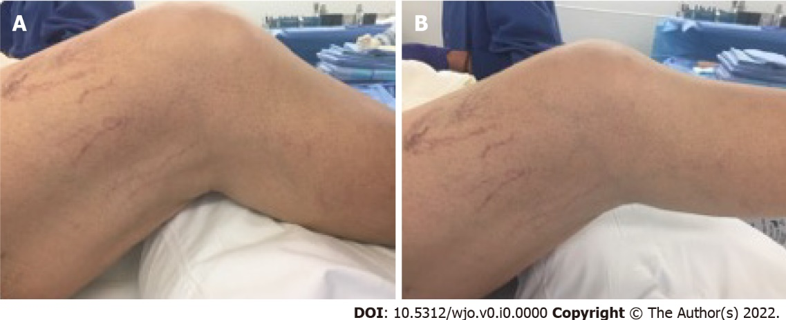
Figure 1 Preoperative flexion and extension of the right knee. A: Preoperative flexion of the right knee; B: Preoperative extension of the right knee.

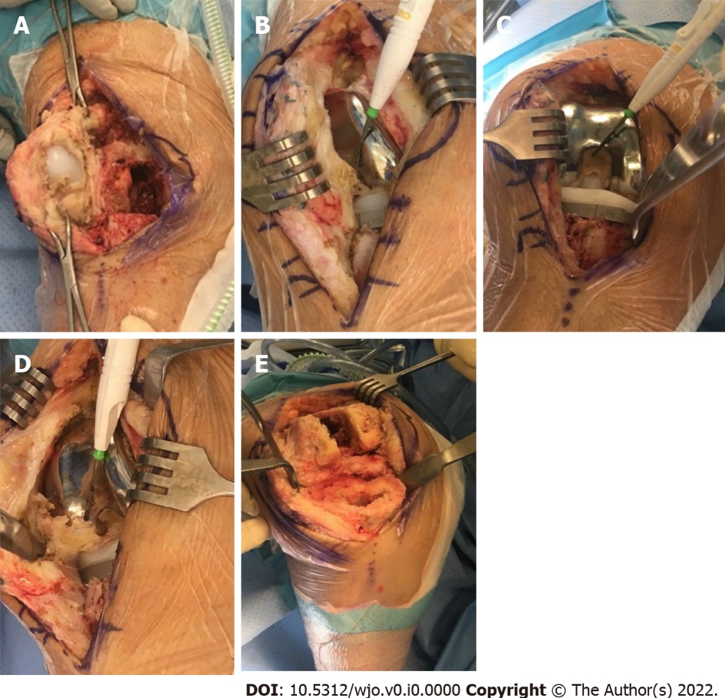
Figure 2 Images during the surgery. A: Imaging depicting parapatellar adhesions with loose patellar component; B: Intraoperative adhesions from patellar tendon into intercondylar notch; C: Intercondylar scar/fibrous tissue and tibial component; D: Tendo-notch to posterior capsular fibrous adhesions being divided with electrocautery; E: Imaging depicting femur and tibia after removal of components and subtotal synovectomy and excision of adhesions.

